Milestone 2 Report: Energy-Efficient Human Activity Recognition on the Edge
Track B: Open/Public Dataset | Target Platform: Arduino Nano 33 BLE Sense
Team: Lee Ting Sen (B00103724), Khalifa Alshamsi (B00078654), Vineetha Addanki (G00111196)

R1. Dataset Description
The task is six-class human activity recognition from wearable inertial signals. UCI HAR v1.0 is the primary controlled benchmark; WISDM Activity Prediction v1.1 is secondary validation and domain-gap support.
Table 1. UCI HAR class definitions.
Class | Definition
WALKING | Subject walks on level ground while wearing the source phone at the waist.
WALKING_UPSTAIRS | Subject walks upstairs while wearing the source phone at the waist.
WALKING_DOWNSTAIRS | Subject walks downstairs while wearing the source phone at the waist.
SITTING | Subject is seated during the labelled window.
STANDING | Subject is standing during the labelled window.
LAYING | Subject is lying down during the labelled window.
UCI HAR contains 10,299 prewindowed samples from 30 subjects aged 19 to 48, collected using a Samsung Galaxy S II worn at the waist. The public release provides 50 Hz inertial windows of 2.56 s with 50% overlap. This implementation uses total acceleration x/y/z plus body gyroscope x/y/z so gravity and posture cues remain available for static classes and the input better resembles Arduino IMU collection.
Source and terms: UCI Machine Learning Repository, Human Activity Recognition Using Smartphones, https://archive.ics.uci.edu/dataset/240/human+activity+recognition+using+smartphones. The README requires citation of Anguita et al. and states commercial use is prohibited.
WISDM classic v1.1 contains 1,098,207 parsed accelerometer rows from 36 subjects with labels Walking, Jogging, Upstairs, Downstairs, Sitting, and Standing. It is accelerometer-only and lacks LAYING, so it is not force-merged with UCI HAR. Source: https://www.cis.fordham.edu/wisdm/dataset.php. The downloaded files request citation of Kwapisz, Weiss, and Moore and do not include explicit OSI/CC license text.
Table 2. UCI HAR train/validation/test class distribution.
Class | Train | Val | Test | Total
WALKING | 888 | 338 | 496 | 1722
WALKING_UPSTAIRS | 797 | 276 | 471 | 1544
WALKING_DOWNSTAIRS | 744 | 242 | 420 | 1406
SITTING | 993 | 293 | 491 | 1777
STANDING | 1053 | 321 | 532 | 1906
LAYING | 1076 | 331 | 537 | 1944

R2. Data Card
Table 3. Track B data card.
Field | Value
Task type | Multi-class human activity classification
Dataset / URL | UCI HAR v1.0: https://archive.ics.uci.edu/dataset/240/human+activity+recognition+using+smartphones; WISDM v1.1: https://www.cis.fordham.edu/wisdm/dataset.php
Classes | 6 UCI HAR classes: WALKING, WALKING_UPSTAIRS, WALKING_DOWNSTAIRS, SITTING, STANDING, LAYING
Sensors and sampling | UCI HAR: total acceleration x/y/z plus body gyroscope x/y/z at 50 Hz; WISDM classic: accelerometer-only nominal 20 Hz
Window / overlap | UCI HAR: 2.56 s, 50% overlap, 128 readings per window
Input features | Raw prewindowed inertial sequences with shape [128, 6]; no handcrafted features for the neural baselines
Samples and split | 10,299 UCI windows; train/val/test = 5,551 / 1,801 / 2,947
Split method | Official UCI subject-disjoint test split; validation subjects held out only from training subjects
Subjects / equipment | UCI HAR: 30 subjects, Samsung Galaxy S II at waist; WISDM classic: 36 subjects, smartphone accelerometer
License / terms | UCI README permits non-commercial use with citation; WISDM downloaded files request citation/readme inclusion and no explicit OSI/CC license was found
Known limitations | UCI is smartphone-waist and preprocessed; WISDM lacks LAYING and gyroscope data; both differ from Arduino Nano 33 BLE Sense
Arduino M3 plan | Collect Nano 33 BLE Sense accelerometer + gyroscope data at 50 Hz, 2.56 s windows, 50% overlap, 3-5 users, 2 environments, at least 50 labelled windows/class
WISDM timestamp inspection found irregular effective sampling despite the nominal 20 Hz rate. Median effective rate was about 20.00 Hz, but rounded dt modes included 50 ms, 40 ms, 80 ms, 100 ms, and 60 ms; 145,865 dt values exceeded the median plus 5 IQR threshold. WISDM is therefore treated as secondary accelerometer robustness evidence, not a direct six-class UCI replacement.

R3. Preprocessing Pipeline
UCI HAR is loaded from the official inertial signal windows, using total acceleration x/y/z and body gyroscope x/y/z with input shape [128, 6]. Labels are preserved exactly. The official subject-disjoint test split is used for held-out evaluation, and validation subjects are carved only from the training subjects. Normalization statistics are computed on the training split only and then applied unchanged to validation and test. No augmentation is used in the reportable M2 runs.
For WISDM, the parser extracts subject, activity, timestamp, and x/y/z acceleration from semicolon-delimited raw rows, converts the raw scale using the dataset note that 10 equals 1g, audits timestamp dt distributions, and can resample each subject/activity stream to 20 Hz before fixed-window segmentation. Jogging is not forced into the UCI label set and LAYING is not invented.

R4. Baseline Models
Baseline A is the paper reproduction baseline: an offline TensorFlow/Keras approximation of the Sensors Journal stacking framework with five hybrid level-0 models and an XGBoost level-1 meta-learner. It is not intended for Arduino deployment. Baseline B is the lightweight TinyML-oriented path for M3 deployment and quantization.
Table 4. Model architecture and training hyperparameters.
Baseline | Architecture | Input | Output | Optimizer | Batch | Epochs | Early stopping | Loss
Baseline A: Paper Reproduction | ConvLSTM, CNN-GRU, CNN-BiGRU, CNN-BiLSTM, CNN-LSTM + XGBoost stacking | [128, 6] | 6-class softmax | Adam, lr=0.001, decay=0.01 | 50 | 20 bounded run; code supports 64 | Validation-loss early stopping | Sparse categorical cross-entropy
Baseline B: Lightweight TinyML | Depthwise-separable 1D CNN, 1,922 Keras parameters | [128, 6] | 6-class softmax | Adam, lr=0.001, decay=0.01 | 50 | 40 | Patience 8 | Sparse categorical cross-entropy

R5. Held-Out Test Results
All results below are evaluated on the official UCI HAR held-out test split with 2,947 windows from 9 test subjects; they are not training-set metrics.
Table 5. Held-out UCI HAR test-set summary.
Baseline | Run setting | Accuracy | Macro F1 | Weighted F1
Paper Reproduction Baseline | 20-epoch bounded TensorFlow run, fast XGBoost grid | 0.9135 | 0.9128 | 0.9137
Lightweight TinyML-Oriented Baseline | 40 epochs, patience 8 | 0.9169 | 0.9173 | 0.9168
Table 6. Paper reproduction baseline per-class held-out metrics.
Class | Precision | Recall | F1 | Support
WALKING | 0.9637 | 0.9093 | 0.9357 | 496
WALKING_UPSTAIRS | 0.9447 | 0.9427 | 0.9437 | 471
WALKING_DOWNSTAIRS | 0.8460 | 0.9548 | 0.8971 | 420
SITTING | 0.8091 | 0.8717 | 0.8392 | 491
STANDING | 0.9190 | 0.8102 | 0.8611 | 532
LAYING | 1.0000 | 1.0000 | 1.0000 | 537
Table 7. Lightweight TinyML baseline per-class held-out metrics.
Class | Precision | Recall | F1 | Support
WALKING | 0.9857 | 0.9718 | 0.9787 | 496
WALKING_UPSTAIRS | 0.9571 | 0.9469 | 0.9520 | 471
WALKING_DOWNSTAIRS | 0.9213 | 0.9476 | 0.9343 | 420
SITTING | 0.8273 | 0.7902 | 0.8083 | 491
STANDING | 0.8141 | 0.8477 | 0.8306 | 532
LAYING | 1.0000 | 1.0000 | 1.0000 | 537
TinyML efficiency status: the lightweight Keras model has 1,922 parameters and the generated TensorFlow Lite flatbuffer is 13,460 bytes. Current host CPU Keras latency proxy is 62.65 ms mean over 20 runs; this is for regression tracking only and is not an Arduino latency claim.
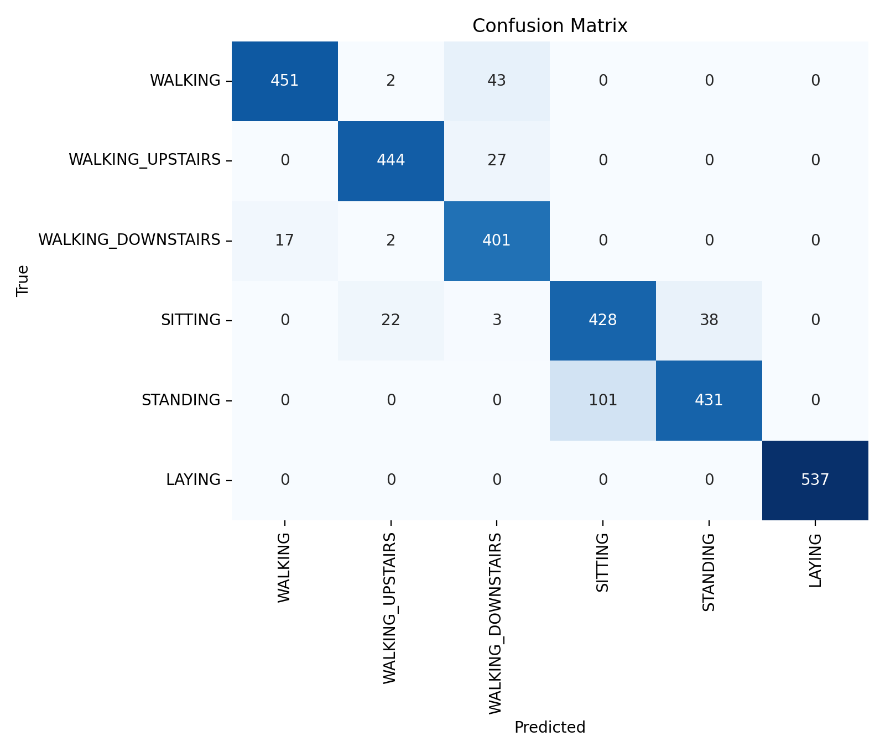
Figure 1. Paper reproduction stacking confusion matrix on the held-out UCI HAR test set.
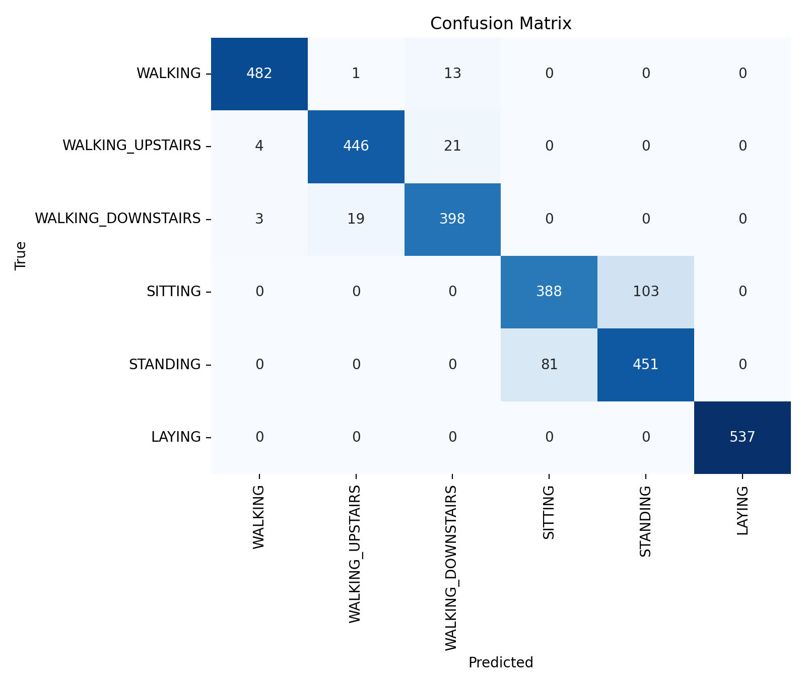
Figure 2. Lightweight TinyML baseline confusion matrix on the held-out UCI HAR test set.

R6. Error Analysis
Top lightweight confusion pairs were SITTING to STANDING (103), STANDING to SITTING (81), WALKING_UPSTAIRS to WALKING_DOWNSTAIRS (21), WALKING_DOWNSTAIRS to WALKING_UPSTAIRS (19), and WALKING to WALKING_DOWNSTAIRS (13). LAYING is perfectly classified in the reportable run. The dominant remaining error is SITTING/STANDING, which is plausible because both have low motion and can differ mainly by waist orientation and gravity posture cues.
Top paper-reproduction confusion pairs were STANDING to SITTING (101), WALKING to WALKING_DOWNSTAIRS (43), SITTING to STANDING (38), WALKING_UPSTAIRS to WALKING_DOWNSTAIRS (27), and SITTING to WALKING_UPSTAIRS (22). This is improved versus the earlier body-acceleration-only view, but the run is bounded to 20 epochs with a fast XGBoost grid and is not claimed to match the paper reported result. M3 fixes should focus on static posture separation, full IMU versus accelerometer-only ablations, Arduino calibration, and public-data versus Arduino-heldout reporting.

R7. Updated Plan for M3
The paper reproduction baseline remains the offline reference. The deployable path will use the lightweight depthwise-separable 1D CNN, quantize it to TensorFlow Lite, and port the inference path toward TensorFlow Lite Micro or equivalent C/C++ code on Arduino Nano 33 BLE Sense. This preserves the revised M1 scope: UCI HAR is primary, WISDM is secondary domain-gap evidence, and TFLite/TFLM deployment replaces non-deployable stacking for the embedded path.
Table 8. Concrete Arduino M3 data collection and adaptation plan.
Item | Plan
When | April 18 to April 24, 2026
Board / sensors | Arduino Nano 33 BLE Sense accelerometer + gyroscope
Sampling / window | 50 Hz; 2.56 s windows; 50% overlap
Classes | Same six UCI HAR activities
Amount | At least 50 labelled windows per class after segmentation
Users / environments | 3-5 users; at least 2 environments
Fallback | If domain gap is large, run calibration, accelerometer-only magnitude tests, and retrain/quantize on mixed public + Arduino data
Robustness tests will compare accelerometer+gyroscope against accelerometer-only input, measure on-device latency and memory, record model size/RAM usage, and evaluate Arduino-collected holdout data separately from public UCI/WISDM data.

Ethics & Limitations
This M2 work uses public human-activity datasets and does not claim medical, safety, or identity-inference capability. The main limitations are public-data domain shift, waist-smartphone collection rather than Arduino Nano 33 BLE Sense hardware, inherited UCI preprocessing, WISDM label mismatch, and possible performance degradation under different users, placements, clothing, pockets, or environments. The M3 Arduino collection should use voluntary participants, minimal personally identifying metadata, consistent labels, and separate public-dataset versus Arduino-heldout reporting.

Deliverables Mapping
Table 9. Milestone 2 deliverables mapping.
Deliverable | Requirement | Location
D1 | Report | This Word report plus docs/milestone2_report.pdf
D2 | Dataset v1/scripts | src/data/uci_har.py, src/data/wisdm.py, src/data/inspect_datasets.py, data/ folder layout, outputs/datacards JSON
D3 | Training code/notebook | src/training/train_lightweight.py, src/training/train_reproduction.py, notebooks/m2_model_lab.ipynb
D4 | README | README.md with setup, repo structure, training commands, current status

