Travis Weaver

April 30 – May 5, 2017

Database Systems – Final Project

Musical Recording Information System

**Conceptual Data Model:**

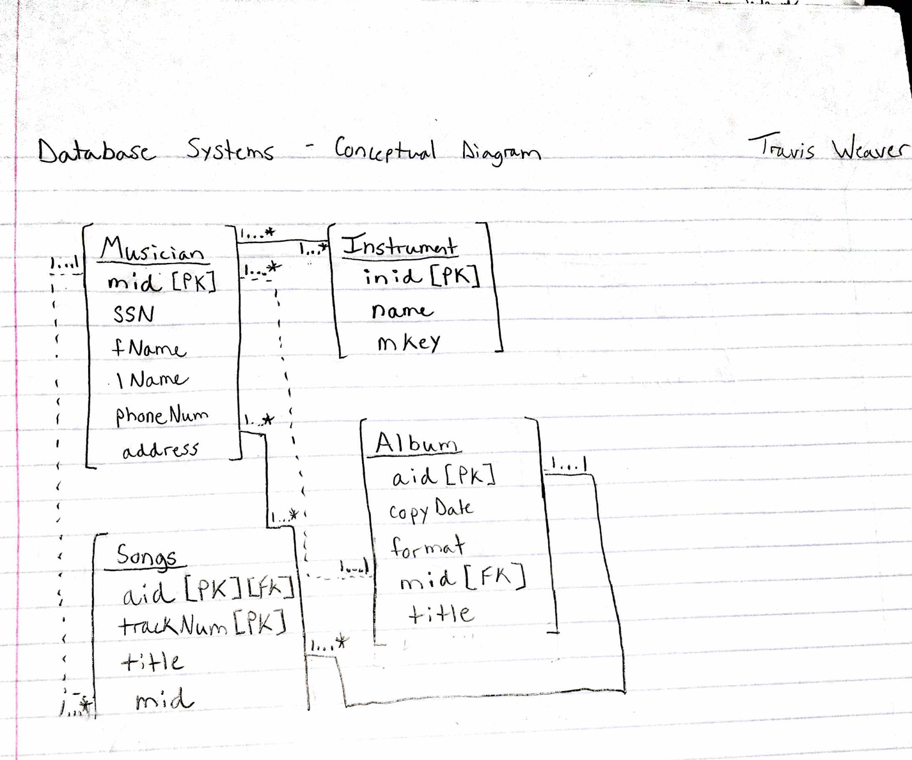

Given the relationships in my conceptual model, I determined a few key changes going forward to the logical data model. Since musicians often share the same address and no address has more than one phone number, I decided to split the *phoneNum* and *address* attributes from the *Musician* entity type into their own table. This way a given address only has to be stored once in the database. Next, since a musician can play more than one instrument and an instrument can be played by more than one musician (a characteristic of many to many relationship types), I decided to introduce an intermediary table between the tables *Musician* and *Instrument*. Similarly, since musicians can play more than one song and songs can be played by more than one musician, I decided to introduce an intermediary table between the tables *Musician* and *Songs*. Taking those primary factors into account, I developed my logical data model below.

**Logical Data Model:**

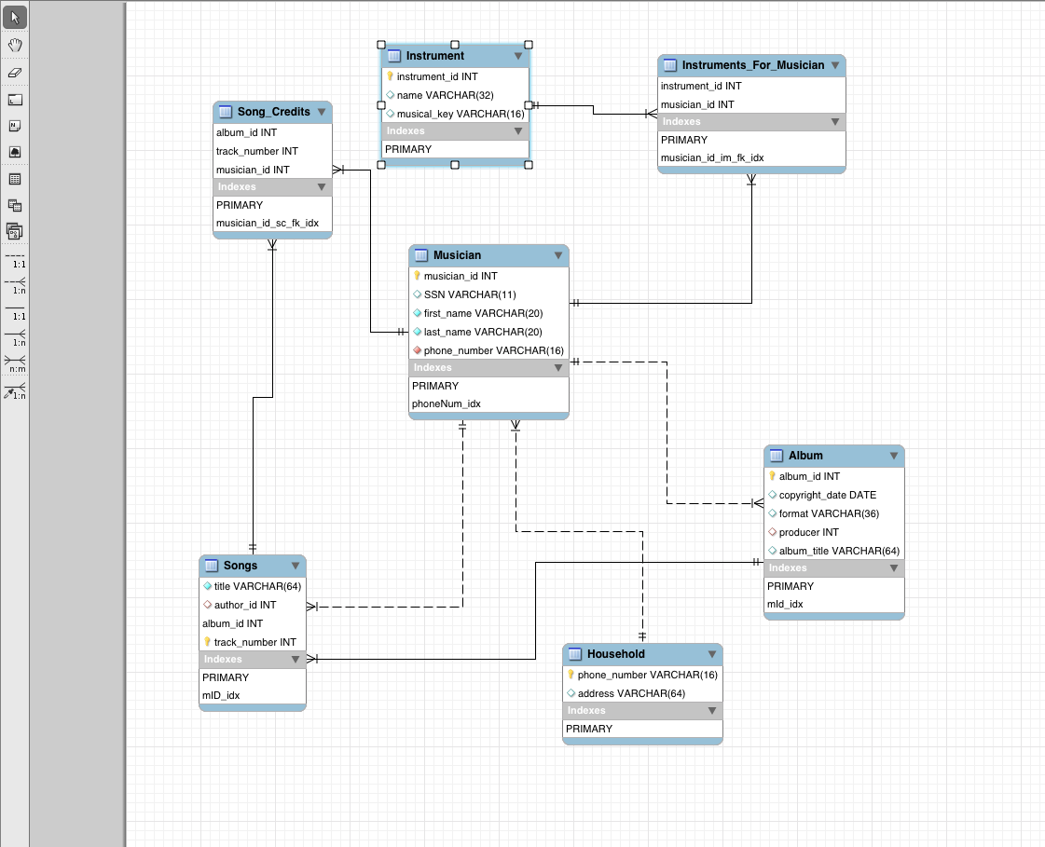

In addition to the changes made from the conceptual model to normalize to 3NF, I set each foreign key to CASCADE ON UPDATE and to CASCASE ON DELETE. Aside from primary, foreign, and candidate keys, I also determined that the first name, last name, and phone number from the *Musician* table must not be NULL. The instrument name from the *Instrument* table must also not be NULL.

My reasoning for allowing the social security number under the *Musician* table to be NULL is in case a foreign musician must be entered into the system. This is also why a musician id has been assigned to each musician in the database under the *Musician* table.

**Implementation of Logical Data Model:**

*SQL Source Code:*

CREATE SCHEMA `music_rec_info_sys` ;

-- MySQL Workbench Synchronization

-- Generated: 2017-04-30 17:49

-- Model: New Model

-- Version: 1.0

-- Project: Name of the project

-- Author: Travis Weaver

SET @OLD_UNIQUE_CHECKS=@@UNIQUE_CHECKS, UNIQUE_CHECKS=0;

SET @OLD_FOREIGN_KEY_CHECKS=@@FOREIGN_KEY_CHECKS, FOREIGN_KEY_CHECKS=0;

SET @OLD_SQL_MODE=@@SQL_MODE, SQL_MODE='TRADITIONAL,ALLOW_INVALID_DATES';

CREATE TABLE IF NOT EXISTS `music_rec_info_sys`.`Musician` (

`musician_id` INT(11) NOT NULL,

`SSN` INT(11) NULL DEFAULT NULL,

`first_name` VARCHAR(20) NOT NULL,

`last_name` VARCHAR(20) NOT NULL,

`phone_number` VARCHAR(16) NOT NULL,

PRIMARY KEY (`musician_id`),

INDEX `phoneNum_idx` (`phone_number` ASC),

CONSTRAINT `phone_number_m_fk`

FOREIGN KEY (`phone_number`)

REFERENCES `music_rec_info_sys`.`Household` (`phoneNum`)

ON DELETE NO ACTION

ON UPDATE NO ACTION)

ENGINE = InnoDB

DEFAULT CHARACTER SET = utf8;

CREATE TABLE IF NOT EXISTS `music_rec_info_sys`.`Instrument` (

`instrument_id` INT(11) NOT NULL,

`name` VARCHAR(32) NULL DEFAULT NULL,

`musical_key` VARCHAR(16) NULL DEFAULT NULL,

PRIMARY KEY (`instrument_id`))

ENGINE = InnoDB

DEFAULT CHARACTER SET = utf8;

CREATE TABLE IF NOT EXISTS `music_rec_info_sys`.`Album` (

`album_id` INT(11) NOT NULL,

`copyright_date` DATE NULL DEFAULT NULL,

`format` VARCHAR(36) NULL DEFAULT NULL,

`producer` INT(11) NULL DEFAULT NULL,

`album_title` VARCHAR(64) NULL DEFAULT NULL,

PRIMARY KEY (`album_id`),

INDEX `mId_idx` (`producer` ASC),

CONSTRAINT `musician_id_a_fk`

FOREIGN KEY (`producer`)

REFERENCES `music_rec_info_sys`.`Musician` (`musician_id`)

ON DELETE NO ACTION

ON UPDATE NO ACTION)

ENGINE = InnoDB

DEFAULT CHARACTER SET = utf8;

CREATE TABLE IF NOT EXISTS `music_rec_info_sys`.`Household` (

`phoneNum` VARCHAR(16) NOT NULL,

`address` VARCHAR(64) NULL DEFAULT NULL,

PRIMARY KEY (`phoneNum`))

ENGINE = InnoDB

DEFAULT CHARACTER SET = utf8;

CREATE TABLE IF NOT EXISTS `music_rec_info_sys`.`Songs` (

`title` VARCHAR(64) NOT NULL,

`author_id` INT(11) NULL DEFAULT NULL,

`album_id` INT(11) NOT NULL,

`track_number` INT(11) NOT NULL,

PRIMARY KEY (`album_id`, `track_number`),

INDEX `mID_idx` (`author_id` ASC),

CONSTRAINT `album_id_s_fk`

FOREIGN KEY (`album_id`)

REFERENCES `music_rec_info_sys`.`Album` (`album_id`)

ON DELETE NO ACTION

ON UPDATE NO ACTION,

CONSTRAINT `musician_id_s_fk`

FOREIGN KEY (`author_id`)

REFERENCES `music_rec_info_sys`.`Musician` (`musician_id`)

ON DELETE NO ACTION

ON UPDATE NO ACTION)

ENGINE = InnoDB

DEFAULT CHARACTER SET = utf8;

CREATE TABLE IF NOT EXISTS `music_rec_info_sys`.`Instruments_For_Musician` (

`instrument_id` INT(11) NOT NULL,

`musician_id` INT(11) NOT NULL,

PRIMARY KEY (`instrument_id`, `musician_id`),

INDEX `musician_id_im_fk_idx` (`musician_id` ASC),

CONSTRAINT `instrument_id_im_fk`

FOREIGN KEY (`instrument_id`)

REFERENCES `music_rec_info_sys`.`Instrument` (`instrument_id`)

ON DELETE NO ACTION

ON UPDATE NO ACTION,

CONSTRAINT `musician_id_im_fk`

FOREIGN KEY (`musician_id`)

REFERENCES `music_rec_info_sys`.`Musician` (`musician_id`)

ON DELETE NO ACTION

ON UPDATE NO ACTION)

ENGINE = InnoDB

DEFAULT CHARACTER SET = utf8;

CREATE TABLE IF NOT EXISTS `music_rec_info_sys`.`Song_Credits` (

`album_id` INT(11) NOT NULL,

`track_number` INT(11) NOT NULL,

`musician_id` INT(11) NOT NULL,

PRIMARY KEY (`album_id`, `track_number`, `musician_id`),

INDEX `musician_id_sc_fk_idx` (`musician_id` ASC),

CONSTRAINT `song_info_sc_fk`

FOREIGN KEY (`album_id` , `track_number`)

REFERENCES `music_rec_info_sys`.`Songs` (`album_id` , `track_number`)

ON DELETE NO ACTION

ON UPDATE NO ACTION,

CONSTRAINT `musician_id_sc_fk`

FOREIGN KEY (`musician_id`)

REFERENCES `music_rec_info_sys`.`Musician` (`musician_id`)

ON DELETE NO ACTION

ON UPDATE NO ACTION)

ENGINE = InnoDB

DEFAULT CHARACTER SET = utf8;

SET SQL_MODE=@OLD_SQL_MODE;

SET FOREIGN_KEY_CHECKS=@OLD_FOREIGN_KEY_CHECKS;

SET UNIQUE_CHECKS=@OLD_UNIQUE_CHECKS;

INSERT INTO `music_rec_info_sys`.`Household` (`phoneNum`, `address`) VALUES ('123-456-7890', '123 Cool St. Miami, FL 33133');

INSERT INTO `music_rec_info_sys`.`Household` (`phoneNum`, `address`) VALUES ('112-233-4455', '217 Live Oak Ln. Altamonte Springs, FL 32714');

INSERT INTO `music_rec_info_sys`.`Household` (`phoneNum`, `address`) VALUES ('305-000-1111', '3845 Beep Boop Rd. Miami FL, 33245');

INSERT INTO `music_rec_info_sys`.`Household` (`phoneNum`, `address`) VALUES ('786-111-0000', '8899 Big Flood Rd. Miami Beach, FL 33341');

INSERT INTO `music_rec_info_sys`.`Household` (`phoneNum`, `address`) VALUES ('407-256-4620', '3339 Virginia St. Miami, FL 33133');

INSERT INTO `music_rec_info_sys`.`Household` (`phoneNum`, `address`) VALUES ('567-923-0908', '9712 Hepatitis Ct. Austin, TX 78345');

INSERT INTO `music_rec_info_sys`.`Household` (`phoneNum`, `address`) VALUES ('1-800-555-0505', '675 Big Buck Rd. Billings, MT 82543');

-- MySQL Workbench Synchronization

-- Generated: 2017-04-30 18:02

-- Model: New Model

-- Version: 1.0

-- Project: Name of the project

-- Author: Travis Weaver

SET @OLD_UNIQUE_CHECKS=@@UNIQUE_CHECKS, UNIQUE_CHECKS=0;

SET @OLD_FOREIGN_KEY_CHECKS=@@FOREIGN_KEY_CHECKS, FOREIGN_KEY_CHECKS=0;

SET @OLD_SQL_MODE=@@SQL_MODE, SQL_MODE='TRADITIONAL,ALLOW_INVALID_DATES';

ALTER TABLE `music_rec_info_sys`.`Household`

CHANGE COLUMN `phoneNum` `phone_number` VARCHAR(16) NOT NULL ;

SET SQL_MODE=@OLD_SQL_MODE;

SET FOREIGN_KEY_CHECKS=@OLD_FOREIGN_KEY_CHECKS;

SET UNIQUE_CHECKS=@OLD_UNIQUE_CHECKS;

SET @OLD_UNIQUE_CHECKS=@@UNIQUE_CHECKS, UNIQUE_CHECKS=0;

SET @OLD_FOREIGN_KEY_CHECKS=@@FOREIGN_KEY_CHECKS, FOREIGN_KEY_CHECKS=0;

SET @OLD_SQL_MODE=@@SQL_MODE, SQL_MODE='TRADITIONAL,ALLOW_INVALID_DATES';

ALTER TABLE `music_rec_info_sys`.`Musician`

CHANGE COLUMN `SSN` `SSN` VARCHAR(11) NULL DEFAULT NULL ;

SET SQL_MODE=@OLD_SQL_MODE;

SET FOREIGN_KEY_CHECKS=@OLD_FOREIGN_KEY_CHECKS;

SET UNIQUE_CHECKS=@OLD_UNIQUE_CHECKS;

INSERT INTO `music_rec_info_sys`.`Musician` (`musician_id`, `SSN`, `first_name`, `last_name`, `phone_number`) VALUES ('1', '123-45-6789', 'John', 'Jacobs', '123-456-7890');

INSERT INTO `music_rec_info_sys`.`Musician` (`musician_id`, `SSN`, `first_name`, `last_name`, `phone_number`) VALUES ('2', '837-89-8934', 'Bill', 'Hicks', '123-456-7890');

INSERT INTO `music_rec_info_sys`.`Musician` (`musician_id`, `SSN`, `first_name`, `last_name`, `phone_number`) VALUES ('3', '228-39-9900', 'Jill', 'Butters', '567-923-0908');

INSERT INTO `music_rec_info_sys`.`Musician` (`musician_id`, `SSN`, `first_name`, `last_name`, `phone_number`) VALUES ('4', '928-11-3409', 'Trevor', 'Hendricks', '112-233-4455');

INSERT INTO `music_rec_info_sys`.`Musician` (`musician_id`, `SSN`, `first_name`, `last_name`, `phone_number`) VALUES ('5', '743-88-4755', 'Zach', 'Miller', '1-800-555-0505');

INSERT INTO `music_rec_info_sys`.`Instrument` (`instrument_id`, `name`, `musical_key`) VALUES ('1', 'Violin', 'C');

INSERT INTO `music_rec_info_sys`.`Instrument` (`instrument_id`, `name`, `musical_key`) VALUES ('2', 'Oboe', 'C');

INSERT INTO `music_rec_info_sys`.`Instrument` (`instrument_id`, `name`, `musical_key`) VALUES ('3', 'Bass', 'C');

INSERT INTO `music_rec_info_sys`.`Instrument` (`instrument_id`, `name`, `musical_key`) VALUES ('4', 'Piano', 'C');

INSERT INTO `music_rec_info_sys`.`Instrument` (`instrument_id`, `name`, `musical_key`) VALUES ('5', 'Trumpet', 'B Flat');

INSERT INTO `music_rec_info_sys`.`Instrument` (`instrument_id`, `name`, `musical_key`) VALUES ('6', 'Clarinet', 'B Flat');

INSERT INTO `music_rec_info_sys`.`Instrument` (`instrument_id`, `name`, `musical_key`) VALUES ('7', 'Soprano Saxophone', 'B Flat');

INSERT INTO `music_rec_info_sys`.`Instrument` (`instrument_id`, `name`, `musical_key`) VALUES ('8', 'Tenor Saxophone', 'B Flat');

INSERT INTO `music_rec_info_sys`.`Instrument` (`instrument_id`, `name`, `musical_key`) VALUES ('9', 'French Horn', 'F');

INSERT INTO `music_rec_info_sys`.`Instrument` (`instrument_id`, `name`, `musical_key`) VALUES ('10', 'English Horn', 'F');

INSERT INTO `music_rec_info_sys`.`Instrument` (`instrument_id`, `name`, `musical_key`) VALUES ('11', 'Flute', 'C');

INSERT INTO `music_rec_info_sys`.`Instrument` (`instrument_id`, `name`, `musical_key`) VALUES ('12', 'Tuba', 'C');

INSERT INTO `music_rec_info_sys`.`Instrument` (`instrument_id`, `name`, `musical_key`) VALUES ('13', 'Alto Saxophone', 'E Flat');

INSERT INTO `music_rec_info_sys`.`Instrument` (`instrument_id`, `name`, `musical_key`) VALUES ('14', 'Baritone Saxophone', 'E Flat');

INSERT INTO `music_rec_info_sys`.`Instrument` (`instrument_id`, `name`, `musical_key`) VALUES ('15', 'Guitar', 'C');

INSERT INTO `music_rec_info_sys`.`Instrument` (`instrument_id`, `name`, `musical_key`) VALUES ('16', 'Bass Guitar', 'C');

INSERT INTO `music_rec_info_sys`.`Instrument` (`instrument_id`, `name`, `musical_key`) VALUES ('17', 'Clarinet', 'B Flat');

INSERT INTO `music_rec_info_sys`.`Instrument` (`instrument_id`, `name`, `musical_key`) VALUES ('18', 'Piccolo Clarinet', 'A Flat');

INSERT INTO `music_rec_info_sys`.`Instrument` (`instrument_id`, `name`, `musical_key`) VALUES ('19', 'Drums', 'C');

INSERT INTO `music_rec_info_sys`.`Instrument` (`instrument_id`, `name`, `musical_key`) VALUES ('20', 'Harp', 'C');

INSERT INTO `music_rec_info_sys`.`Musician` (`musician_id`, `SSN`, `first_name`, `last_name`, `phone_number`) VALUES ('6', '892-92-8495', 'Thomas', 'Bangalter', '305-000-1111');

INSERT INTO `music_rec_info_sys`.`Album` (`album_id`, `copyright_date`, `format`, `producer`, `album_title`) VALUES ('1', '2009-01-01', 'CD', '3', 'In Rainbows');

INSERT INTO `music_rec_info_sys`.`Album` (`album_id`, `copyright_date`, `format`, `producer`, `album_title`) VALUES ('2', '2000-01-01', 'Vinyl', '3', 'Kid A');

INSERT INTO `music_rec_info_sys`.`Album` (`album_id`, `copyright_date`, `format`, `producer`, `album_title`) VALUES ('3', '2001-01-01', 'CD', '6', 'Discovery');

INSERT INTO `music_rec_info_sys`.`Album` (`album_id`, `copyright_date`, `format`, `producer`, `album_title`) VALUES ('4', '1997-01-01', 'CD', '6', 'Homework');

INSERT INTO `music_rec_info_sys`.`Album` (`album_id`, `copyright_date`, `format`, `producer`, `album_title`) VALUES ('5', '2005-01-01', 'Vinyl', '6', 'Human After All');

INSERT INTO `music_rec_info_sys`.`Album` (`album_id`, `copyright_date`, `format`, `producer`, `album_title`) VALUES ('6', '2013-01-01', 'CD', '6', 'Random Access Memories');

INSERT INTO `music_rec_info_sys`.`Album` (`album_id`, `copyright_date`, `format`, `producer`, `album_title`) VALUES ('7', '2003-01-01', 'CD', '6', 'Daft Club');

INSERT INTO `music_rec_info_sys`.`Album` (`album_id`, `copyright_date`, `format`, `producer`, `album_title`) VALUES ('8', '2012-01-01', 'EP', '2', 'Moderation');

INSERT INTO `music_rec_info_sys`.`Album` (`album_id`, `copyright_date`, `format`, `producer`, `album_title`) VALUES ('9', '2013-01-01', 'Vinyl', '1', 'Outrun');

INSERT INTO `music_rec_info_sys`.`Album` (`album_id`, `copyright_date`, `format`, `producer`, `album_title`) VALUES ('10', '2010-01-01', 'EP', '1', 'Nightcall');

INSERT INTO `music_rec_info_sys`.`Album` (`album_id`, `copyright_date`, `format`, `producer`, `album_title`) VALUES ('11', '2008-01-01', 'CD', '4', 'Los Angeles');

INSERT INTO `music_rec_info_sys`.`Album` (`album_id`, `copyright_date`, `format`, `producer`, `album_title`) VALUES ('12', '2012-01-01', 'CD', '4', 'Until the Quiet Comes');

INSERT INTO `music_rec_info_sys`.`Album` (`album_id`, `copyright_date`, `format`, `producer`, `album_title`) VALUES ('13', '2010-01-01', 'Vinyl', '4', 'Cosmogramma');

INSERT INTO `music_rec_info_sys`.`Album` (`album_id`, `copyright_date`, `format`, `producer`, `album_title`) VALUES ('14', '2007-01-01', 'CD', '5', 'Oi Oi Oi');

INSERT INTO `music_rec_info_sys`.`Album` (`album_id`, `copyright_date`, `format`, `producer`, `album_title`) VALUES ('15', '2009-01-01', 'CD', '5', 'Power');

UPDATE `music_rec_info_sys`.`Instrument` SET `name`='Banjo', `musical_key`='C' WHERE `instrument_id`='17';

INSERT INTO `music_rec_info_sys`.`Instruments_For_Musician` (`instrument_id`, `musician_id`) VALUES ('1', '1');

INSERT INTO `music_rec_info_sys`.`Instruments_For_Musician` (`instrument_id`, `musician_id`) VALUES ('4', '1');

INSERT INTO `music_rec_info_sys`.`Instruments_For_Musician` (`instrument_id`, `musician_id`) VALUES ('15', '1');

INSERT INTO `music_rec_info_sys`.`Instruments_For_Musician` (`instrument_id`, `musician_id`) VALUES ('4', '2');

INSERT INTO `music_rec_info_sys`.`Instruments_For_Musician` (`instrument_id`, `musician_id`) VALUES ('19', '2');

INSERT INTO `music_rec_info_sys`.`Instruments_For_Musician` (`instrument_id`, `musician_id`) VALUES ('20', '2');

INSERT INTO `music_rec_info_sys`.`Instruments_For_Musician` (`instrument_id`, `musician_id`) VALUES ('16', '3');

INSERT INTO `music_rec_info_sys`.`Instruments_For_Musician` (`instrument_id`, `musician_id`) VALUES ('3', '3');

INSERT INTO `music_rec_info_sys`.`Instruments_For_Musician` (`instrument_id`, `musician_id`) VALUES ('4', '3');

INSERT INTO `music_rec_info_sys`.`Instruments_For_Musician` (`instrument_id`, `musician_id`) VALUES ('5', '4');

INSERT INTO `music_rec_info_sys`.`Instruments_For_Musician` (`instrument_id`, `musician_id`) VALUES ('7', '4');

INSERT INTO `music_rec_info_sys`.`Instruments_For_Musician` (`instrument_id`, `musician_id`) VALUES ('13', '4');

INSERT INTO `music_rec_info_sys`.`Instruments_For_Musician` (`instrument_id`, `musician_id`) VALUES ('15', '4');

INSERT INTO `music_rec_info_sys`.`Instruments_For_Musician` (`instrument_id`, `musician_id`) VALUES ('5', '5');

INSERT INTO `music_rec_info_sys`.`Instruments_For_Musician` (`instrument_id`, `musician_id`) VALUES ('6', '5');

INSERT INTO `music_rec_info_sys`.`Instruments_For_Musician` (`instrument_id`, `musician_id`) VALUES ('7', '5');

INSERT INTO `music_rec_info_sys`.`Instruments_For_Musician` (`instrument_id`, `musician_id`) VALUES ('8', '5');

INSERT INTO `music_rec_info_sys`.`Instruments_For_Musician` (`instrument_id`, `musician_id`) VALUES ('19', '6');

INSERT INTO `music_rec_info_sys`.`Instruments_For_Musician` (`instrument_id`, `musician_id`) VALUES ('20', '6');

INSERT INTO `music_rec_info_sys`.`Instruments_For_Musician` (`instrument_id`, `musician_id`) VALUES ('1', '6');

INSERT INTO `music_rec_info_sys`.`Instruments_For_Musician` (`instrument_id`, `musician_id`) VALUES ('4', '6');

INSERT INTO `music_rec_info_sys`.`Songs` (`title`, `author_id`, `album_id`, `track_number`) VALUES ('Nude', '3', '1', '3');

INSERT INTO `music_rec_info_sys`.`Songs` (`title`, `author_id`, `album_id`, `track_number`) VALUES ('All I Need', '3', '1', '5');

INSERT INTO `music_rec_info_sys`.`Songs` (`title`, `author_id`, `album_id`, `track_number`) VALUES ('Jigsaw Falling Into Place', '6', '1', '9');

INSERT INTO `music_rec_info_sys`.`Songs` (`title`, `author_id`, `album_id`, `track_number`) VALUES ('Everything In Its Right Place', '3', '2', '1');

INSERT INTO `music_rec_info_sys`.`Songs` (`title`, `author_id`, `album_id`, `track_number`) VALUES ('Kid A', '3', '2', '2');

INSERT INTO `music_rec_info_sys`.`Songs` (`title`, `author_id`, `album_id`, `track_number`) VALUES ('Idioteque', '3', '2', '8');

INSERT INTO `music_rec_info_sys`.`Songs` (`title`, `author_id`, `album_id`, `track_number`) VALUES ('One More Time', '6', '3', '1');

INSERT INTO `music_rec_info_sys`.`Songs` (`title`, `author_id`, `album_id`, `track_number`) VALUES ('Harder, Better, Faster, Stronger', '6', '3', '4');

INSERT INTO `music_rec_info_sys`.`Songs` (`title`, `author_id`, `album_id`, `track_number`) VALUES ('Digital Love', '6', '3', '3');

INSERT INTO `music_rec_info_sys`.`Songs` (`title`, `author_id`, `album_id`, `track_number`) VALUES ('Fresh', '3', '4', '6');

INSERT INTO `music_rec_info_sys`.`Songs` (`title`, `author_id`, `album_id`, `track_number`) VALUES ('Around the World', '6', '4', '7');

INSERT INTO `music_rec_info_sys`.`Songs` (`title`, `author_id`, `album_id`, `track_number`) VALUES ('Television Rules the Nation', '6', '5', '8');

INSERT INTO `music_rec_info_sys`.`Songs` (`title`, `author_id`, `album_id`, `track_number`) VALUES ('Giorgio By Morodor', '6', '6', '3');

INSERT INTO `music_rec_info_sys`.`Songs` (`title`, `author_id`, `album_id`, `track_number`) VALUES ('Within', '5', '6', '4');

INSERT INTO `music_rec_info_sys`.`Songs` (`title`, `author_id`, `album_id`, `track_number`) VALUES ('Moderation', '2', '8', '1');

INSERT INTO `music_rec_info_sys`.`Songs` (`title`, `author_id`, `album_id`, `track_number`) VALUES ('Reversion', '2', '8', '2');

INSERT INTO `music_rec_info_sys`.`Songs` (`title`, `author_id`, `album_id`, `track_number`) VALUES ('Blizzard', '1', '9', '2');

INSERT INTO `music_rec_info_sys`.`Songs` (`title`, `author_id`, `album_id`, `track_number`) VALUES ('Protovision', '1', '9', '3');

INSERT INTO `music_rec_info_sys`.`Songs` (`title`, `author_id`, `album_id`, `track_number`) VALUES ('Odd Look', '1', '9', '4');

INSERT INTO `music_rec_info_sys`.`Songs` (`title`, `author_id`, `album_id`, `track_number`) VALUES ('Rampage', '1', '9', '5');

INSERT INTO `music_rec_info_sys`.`Songs` (`title`, `author_id`, `album_id`, `track_number`) VALUES ('Suburbia', '6', '9', '6');

INSERT INTO `music_rec_info_sys`.`Songs` (`title`, `author_id`, `album_id`, `track_number`) VALUES ('Nightcall', '1', '10', '1');

INSERT INTO `music_rec_info_sys`.`Songs` (`title`, `author_id`, `album_id`, `track_number`) VALUES ('Pacific Coast Highway', '1', '10', '2');

INSERT INTO `music_rec_info_sys`.`Songs` (`title`, `author_id`, `album_id`, `track_number`) VALUES ('Nightcall (Dustin N\'Guyen Remix)', '1', '10', '3');

INSERT INTO `music_rec_info_sys`.`Songs` (`title`, `author_id`, `album_id`, `track_number`) VALUES ('Pacific Coast Highway (Jackson Remix)', '1', '10', '4');

INSERT INTO `music_rec_info_sys`.`Songs` (`title`, `author_id`, `album_id`, `track_number`) VALUES ('Brainfeeder', '4', '11', '1');

INSERT INTO `music_rec_info_sys`.`Songs` (`title`, `author_id`, `album_id`, `track_number`) VALUES ('Camel', '4', '11', '4');

INSERT INTO `music_rec_info_sys`.`Songs` (`title`, `author_id`, `album_id`, `track_number`) VALUES ('SexSlaveShip', '4', '11', '14');

INSERT INTO `music_rec_info_sys`.`Songs` (`title`, `author_id`, `album_id`, `track_number`) VALUES ('All In', '4', '12', '1');

INSERT INTO `music_rec_info_sys`.`Songs` (`title`, `author_id`, `album_id`, `track_number`) VALUES ('Getting There', '4', '12', '2');

INSERT INTO `music_rec_info_sys`.`Songs` (`title`, `author_id`, `album_id`, `track_number`) VALUES ('Until the Colours Come', '6', '12', '3');

INSERT INTO `music_rec_info_sys`.`Songs` (`title`, `author_id`, `album_id`, `track_number`) VALUES ('Zodiac Shit', '4', '13', '5');

INSERT INTO `music_rec_info_sys`.`Songs` (`title`, `author_id`, `album_id`, `track_number`) VALUES ('Table Tennis', '4', '13', '16');

INSERT INTO `music_rec_info_sys`.`Songs` (`title`, `author_id`, `album_id`, `track_number`) VALUES ('& Down', '5', '14', '1');

INSERT INTO `music_rec_info_sys`.`Songs` (`title`, `author_id`, `album_id`, `track_number`) VALUES ('Shine Shine', '5', '14', '8');

INSERT INTO `music_rec_info_sys`.`Songs` (`title`, `author_id`, `album_id`, `track_number`) VALUES ('Jeffer', '5', '15', '4');

INSERT INTO `music_rec_info_sys`.`Songs` (`title`, `author_id`, `album_id`, `track_number`) VALUES ('Transmission', '6', '15', '5');

INSERT INTO `music_rec_info_sys`.`Song_Credits` (`album_id`, `track_number`, `musician_id`) VALUES ('1', '3', '3');

INSERT INTO `music_rec_info_sys`.`Song_Credits` (`album_id`, `track_number`, `musician_id`) VALUES ('1', '3', '6');

INSERT INTO `music_rec_info_sys`.`Song_Credits` (`album_id`, `track_number`, `musician_id`) VALUES ('1', '5', '3');

INSERT INTO `music_rec_info_sys`.`Song_Credits` (`album_id`, `track_number`, `musician_id`) VALUES ('1', '5', '6');

INSERT INTO `music_rec_info_sys`.`Song_Credits` (`album_id`, `track_number`, `musician_id`) VALUES ('1', '9', '3');

INSERT INTO `music_rec_info_sys`.`Song_Credits` (`album_id`, `track_number`, `musician_id`) VALUES ('1', '9', '6');

INSERT INTO `music_rec_info_sys`.`Song_Credits` (`album_id`, `track_number`, `musician_id`) VALUES ('6', '3', '6');

INSERT INTO `music_rec_info_sys`.`Song_Credits` (`album_id`, `track_number`, `musician_id`) VALUES ('6', '3', '5');

INSERT INTO `music_rec_info_sys`.`Song_Credits` (`album_id`, `track_number`, `musician_id`) VALUES ('6', '4', '6');

INSERT INTO `music_rec_info_sys`.`Song_Credits` (`album_id`, `track_number`, `musician_id`) VALUES ('6', '4', '5');

INSERT INTO `music_rec_info_sys`.`Song_Credits` (`album_id`, `track_number`, `musician_id`) VALUES ('11', '1', '4');

INSERT INTO `music_rec_info_sys`.`Song_Credits` (`album_id`, `track_number`, `musician_id`) VALUES ('11', '1', '1');

INSERT INTO `music_rec_info_sys`.`Song_Credits` (`album_id`, `track_number`, `musician_id`) VALUES ('13', '5', '4');

INSERT INTO `music_rec_info_sys`.`Song_Credits` (`album_id`, `track_number`, `musician_id`) VALUES ('13', '5', '6');

INSERT INTO `music_rec_info_sys`.`Song_Credits` (`album_id`, `track_number`, `musician_id`) VALUES ('13', '5', '2');

-- MySQL Workbench Synchronization

-- Generated: 2017-05-05 19:19

-- Model: New Model

-- Version: 1.0

-- Project: Name of the project

-- Author: Travis Weaver

SET @OLD_UNIQUE_CHECKS=@@UNIQUE_CHECKS, UNIQUE_CHECKS=0;

SET @OLD_FOREIGN_KEY_CHECKS=@@FOREIGN_KEY_CHECKS, FOREIGN_KEY_CHECKS=0;

SET @OLD_SQL_MODE=@@SQL_MODE, SQL_MODE='TRADITIONAL,ALLOW_INVALID_DATES';

ALTER TABLE `music_rec_info_sys`.`Musician`

DROP FOREIGN KEY `phone_number_m_fk`;

ALTER TABLE `music_rec_info_sys`.`Album`

DROP FOREIGN KEY `musician_id_a_fk`;

ALTER TABLE `music_rec_info_sys`.`Instruments_For_Musician`

DROP FOREIGN KEY `instrument_id_im_fk`,

DROP FOREIGN KEY `musician_id_im_fk`;

ALTER TABLE `music_rec_info_sys`.`Song_Credits`

DROP FOREIGN KEY `musician_id_sc_fk`;

ALTER TABLE `music_rec_info_sys`.`Musician`

ADD CONSTRAINT `phone_number_m_fk`

FOREIGN KEY (`phone_number`)

REFERENCES `music_rec_info_sys`.`Household` (`phone_number`)

ON DELETE CASCADE

ON UPDATE CASCADE;

ALTER TABLE `music_rec_info_sys`.`Album`

ADD CONSTRAINT `musician_id_a_fk`

FOREIGN KEY (`producer`)

REFERENCES `music_rec_info_sys`.`Musician` (`musician_id`)

ON DELETE SET NULL

ON UPDATE CASCADE;

ALTER TABLE `music_rec_info_sys`.`Instruments_For_Musician`

ADD CONSTRAINT `instrument_id_im_fk`

FOREIGN KEY (`instrument_id`)

REFERENCES `music_rec_info_sys`.`Instrument` (`instrument_id`)

ON DELETE CASCADE

ON UPDATE CASCADE,

ADD CONSTRAINT `musician_id_im_fk`

FOREIGN KEY (`musician_id`)

REFERENCES `music_rec_info_sys`.`Musician` (`musician_id`)

ON DELETE CASCADE

ON UPDATE CASCADE;

ALTER TABLE `music_rec_info_sys`.`Song_Credits`

DROP FOREIGN KEY `song_info_sc_fk`;

ALTER TABLE `music_rec_info_sys`.`Song_Credits` ADD CONSTRAINT `song_info_sc_fk`

FOREIGN KEY (`album_id` , `track_number`)

REFERENCES `music_rec_info_sys`.`Songs` (`album_id` , `track_number`)

ON DELETE CASCADE

ON UPDATE CASCADE,

ADD CONSTRAINT `musician_id_sc_fk`

FOREIGN KEY (`musician_id`)

REFERENCES `music_rec_info_sys`.`Musician` (`musician_id`)

ON DELETE CASCADE

ON UPDATE CASCADE;

SET SQL_MODE=@OLD_SQL_MODE;

SET FOREIGN_KEY_CHECKS=@OLD_FOREIGN_KEY_CHECKS;

SET UNIQUE_CHECKS=@OLD_UNIQUE_CHECKS;

**Database Application:**

*Python Source Code:*

#!/usr/bin/python

#

# Name: Travis Weaver

# Date: April 30, 2017

# Last Updated: May 1, 2017

#

# Command to install mysql connector for Python 2.7:

#

# sudo apt-get install python-pip

# pip install [--egg] mysql-connector-python-rf

from __future__ import print_function

from enum import Enum

import sys

import mysql.connector

import numpy as np

connection = mysql.connector.connect(host = '104.196.222.235',

port = '3306',

user = 'root',

password = 'root',

db = 'music_rec_info_sys')

class TableNames(Enum):

Album = 1

Household = 2

Instrument = 3

Instruments_For_Musician = 4

Musician = 5

Song_Credits = 6

Songs = 7

def welcome_message():

print("\t--- ABC Records ---")

print("Musical Recording Information System")

print("------------------------------------")

print()

def main_menu():

print("\t--- Main Menu ---")

print("Please select a category below by entering the corresponding integer.")

print("---------------------------------------------------------------------")

print("")

print("(Option) Category")

print("-----------------")

print("(1) View All Records")

print("(2) Sample Queries")

print("(3) Insert, Update, and Delete Records")

print("(0) Exit")

print("")

def view_all_records_menu():

print("\t--- View All Records ---")

print("Please select a table to view all corresponding records.")

print("--------------------------------------------------------")

print("")

print("(Option) Table")

print("-----------------")

print("(1) Album")

print("(2) Household")

print("(3) Instrument")

print("(4) Instruments_For_Musician")

print("(5) Musician")

print("(6) Song_Credits")

print("(7) Songs")

# print("(9) Main Menu")

print("(0) Exit")

print("")

def view_record(user_choice):

table = TableNames(user_choice).name

cursor = connection.cursor()

cursor.execute("SELECT * FROM %s" % table)

print("")

col_names = cursor.column_names

col_length = len(col_names)

if col_length == 1:

print("%-20s" % (col_names[0]))

print("%-20s" % ("----------"))

elif col_length == 2:

print("%-20s\t %-20s" % (col_names[0], col_names[1]))

print("%-20s\t %-20s" % ("----------", "----------"))

elif col_length == 3:

print("%-20s\t %-20s\t %-20s" % (col_names[0], col_names[1], col_names[2]))

print("%-20s\t %-20s\t %-20s" % ("----------", "----------", "----------"))

elif col_length == 4:

print("%-40s\t %-20s\t %-20s\t %-20s" % (col_names[0], col_names[1], col_names[2], col_names[3]))

print("%-40s\t %-20s\t %-20s\t %-20s" % ("----------", "----------", "----------", "----------"))

elif col_length == 5:

print("%-20s\t %-20s\t %-20s\t %-20s\t %-20s" % (col_names[0], col_names[1], col_names[2], col_names[3], col_names[4]))

print("%-20s\t %-20s\t %-20s\t %-20s\t %-20s" % ("----------", "----------", "----------", "----------", "----------"))

elif col_length == 6:

print("%-20s\t %-20s\t %-20s\t %-20s\t %-20s\t %-20s" % (col_names[0], col_names[1], col_names[2], col_names[3], col_names[4], col_names[5]))

print("%-20s\t %-20s\t %-20s\t %-20s\t %-20s\t %-20s" % ("----------", "----------", "----------", "----------", "----------", "----------"))

else:

print("Error: Unsupported number of columns")

for row in cursor:

length = len(row)

if length == 1:

print("%-20s" % (row[0]))

elif length == 2:

print("%-20s\t %-20s" % (row[0], row[1]))

elif length == 3:

print("%-20s\t %-20s\t %-20s" % (row[0], row[1], row[2]))

elif length == 4:

print("%-40s\t %-20s\t %-20s\t %-20s" % (row[0], row[1], row[2], row[3]))

elif length == 5:

print("%-20s\t %-20s\t %-20s\t %-20s\t %-20s" % (row[0], row[1], row[2], row[3], row[4]))

elif length == 6:

print("%-20s\t %-20s\t %-20s\t %-20s\t %-20s\t %-20s" % (row[0], row[1], row[2], row[3], row[4], row[5]))

else:

print("Error: Unsupported number of columns")

def view_query_menu():

print("\t--- Sample Queries ---")

print("Please select a query to perform.")

print("---------------------------------")

print("")

print("(Option) Query")

print("--------------")

print("(1) View album info for given musician")

print("(2) View details of musicians, sorted by last name, who can play given instrument")

print("(3) View details of songs in given album")

print("(4) View total number of albums with given copyright date")

print("(5) View most prolific producers in the company (greater than average produced albums)")

print("(6) View musicians who play more than two instruments")

print("(7) View total number of songs played by each musician")

# print("(9) Main Menu")

print("(0) Exit")

print("")

def view_query(user_choice):

cursor = connection.cursor()

if user_choice == 1:

mid = input("Enter musician_id: ")

cursor.execute("SELECT * FROM Album WHERE producer = %d" % mid)

col_names = cursor.column_names

print("")

print("%-40s\t %-20s\t %-20s\t %-20s" % (col_names[0], col_names[1], col_names[2], col_names[3]))

print("%-40s\t %-20s\t %-20s\t %-20s" % ("----------", "----------", "----------", "----------"))

for row in cursor:

print("%-40s\t %-20s\t %-20s\t %-20s" % (row[0], row[1], row[2], row[3]))

elif user_choice == 2:

iid = input("Enter instrument_id: ")

cursor.execute("SELECT m.* FROM Musician m, Instruments_For_Musician i WHERE i.instrument_id = %d AND i.musician_id = m.musician_id ORDER BY m.last_name;" % iid)

col_names = cursor.column_names

print("")

print("%-20s\t %-20s\t %-20s\t %-20s\t %-20s" % (col_names[0], col_names[1], col_names[2], col_names[3], col_names[4]))

print("%-20s\t %-20s\t %-20s\t %-20s\t %-20s" % ("----------", "----------", "----------", "----------", "----------"))

for row in cursor:

print("%-20s\t %-20s\t %-20s\t %-20s\t %-20s" % (row[0], row[1], row[2], row[3], row[4]))

elif user_choice == 3:

aid = input("Enter album_id: ")

cursor.execute("SELECT s.* FROM music_rec_info_sys.Album a, music_rec_info_sys.Songs s WHERE a.album_id = s.album_id AND a.album_id = %d;" % aid)

col_names = cursor.column_names

print("")

print("%-40s\t %-20s\t %-20s\t %-20s" % (col_names[0], col_names[1], col_names[2], col_names[3]))

print("%-40s\t %-20s\t %-20s\t %-20s" % ("----------", "----------", "----------", "----------"))

for row in cursor:

print("%-40s\t %-20s\t %-20s\t %-20s" % (row[0], row[1], row[2], row[3]))

elif user_choice == 4:

cpd = input("Enter copyright_date: ")

cpd = str(cpd)

query = "SELECT * FROM music_rec_info_sys.Album WHERE copyright_date LIKE %s;"

cursor.execute(query, ("%" + cpd + "%",))

col_names = cursor.column_names

print("")

print("%-20s\t %-20s\t %-20s\t %-20s\t %-20s" % (col_names[0], col_names[1], col_names[2], col_names[3], col_names[4]))

print("%-20s\t %-20s\t %-20s\t %-20s\t %-20s" % ("----------", "----------", "----------", "----------", "----------"))

for row in cursor:

print("%-20s\t %-20s\t %-20s\t %-20s\t %-20s" % (row[0], row[1], row[2], row[3], row[4]))

elif user_choice == 5:

cursor.execute("SELECT m.last_name, m.first_name, COUNT(m.musician_id) AS num_produced FROM music_rec_info_sys.Musician m, music_rec_info_sys.Album a WHERE m.musician_id = a.producer GROUP BY m.musician_id HAVING num_produced > AVG(num_produced);")

col_names = cursor.column_names

print("")

print("%-20s\t %-20s\t %-20s" % (col_names[0], col_names[1], col_names[2]))

print("%-20s\t %-20s\t %-20s" % ("----------", "----------", "----------"))

for row in cursor:

print("%-20s\t %-20s\t %-20s" % (row[0], row[1], row[2]))

elif user_choice == 6:

cursor.execute("SELECT m.last_name, m.first_name, COUNT(i.instrument_id) AS num_instruments FROM music_rec_info_sys.Musician m, music_rec_info_sys.Instruments_For_Musician i WHERE m.musician_id = i.musician_id GROUP BY m.musician_id HAVING num_instruments > 2;")

col_names = cursor.column_names

print("")

print("%-20s\t %-20s\t %-20s" % (col_names[0], col_names[1], col_names[2]))

print("%-20s\t %-20s\t %-20s" % ("----------", "----------", "----------"))

for row in cursor:

print("%-20s\t %-20s\t %-20s" % (row[0], row[1], row[2]))

elif user_choice == 7:

cursor.execute("SELECT m.last_name, m.first_name, COUNT(s.track_number) AS num_songs, m.musician_id FROM music_rec_info_sys.Musician m, music_rec_info_sys.Song_Credits s WHERE m.musician_id = s.musician_id GROUP BY m.musician_id ORDER BY m.last_name;")

col_names = cursor.column_names

print("")

print("%-40s\t %-20s\t %-20s\t %-20s" % (col_names[0], col_names[1], col_names[2], col_names[3]))

print("%-40s\t %-20s\t %-20s\t %-20s" % ("----------", "----------", "----------", "----------"))

for row in cursor:

print("%-40s\t %-20s\t %-20s\t %-20s" % (row[0], row[1], row[2], row[3]))

elif user_choice == 0:

print("Exiting...")

else:

print("Error: Invalid choice")

def change_record_menu():

print("\t--- Change Records ---")

print("Please select a record to change.")

print("---------------------------------")

print("")

print("(Option) Query")

print("--------------")

print("(1) Insert a new musician")

print("(2) Delete an existing song")

print("(3) Update the address of a musician")

# print("(9) Main Menu")

print("(0) Exit")

print("")

def change_record(user_choice):

cursor = connection.cursor()

if user_choice == 1:

mid = int(raw_input("Enter musician_id: ")) # Could change raw_input to input sans int casting

ssn = raw_input("Enter SSN: ")

f_name = raw_input("Enter first name: ")

l_name = raw_input("Enter last name: ")

phone_num = raw_input("Enter phone number: ")

address = raw_input("Enter address: ")

cursor.execute("INSERT INTO `music_rec_info_sys`.`Household`(`phone_number`, `address`) VALUES ('%s', '%s');" % (phone_num, address))

cursor.execute("INSERT INTO `music_rec_info_sys`.`Musician`(`musician_id`, `SSN`, `first_name`, `last_name`, `phone_number`) VALUES ('%d', '%s', '%s', '%s', '%s');" % (mid, ssn, f_name, l_name, phone_num))

connection.commit()

print("")

print("Musician added to database")

elif user_choice == 2:

aid = input("Enter album_id: ")

tid = input("Enter track number: ")

cursor.execute("DELETE FROM `music_rec_info_sys`.`Songs` WHERE album_id = %d AND track_number = %d;" % (aid, tid))

connection.commit()

print("")

print("Song deleted from database")

elif user_choice == 3:

mid = input("Enter musician_id: ")

address = raw_input("Enter new address: ")

cursor.execute("SELECT m.phone_number FROM music_rec_info_sys.Musician m WHERE musician_id = %d;" % mid)

row = cursor.fetchone()

cursor.execute("UPDATE `music_rec_info_sys`.`Household` SET `address`='%s' WHERE `phone_number`='%s';" % (address, row[0]))

connection.commit()

print("")

print("Address updated for musician")

elif user_choice == 0:

print("Exiting...")

else:

print("Error: Invalid option")

### Main ###

welcome_message()

user_choice = 1

while user_choice != 0:

main_menu()

user_choice = input("Enter category: ")

print("")

if user_choice == 1:

view_all_records_menu()

user_choice = input("Enter table: ")

view_record(user_choice)

print("")

elif user_choice == 2:

view_query_menu()

user_choice = input("Enter query: ")

view_query(user_choice)

print("")

elif user_choice == 3:

change_record_menu()

user_choice = input("Enter option: ")

change_record(user_choice)

print("")

elif user_choice == 0:

break;

else:

print("Error: Invalid category choice")

print("")

connection.close()

**Test Data and Sample Output:** *Results from application interacting with the database hosted on Google Cloud*

*Test Data:*

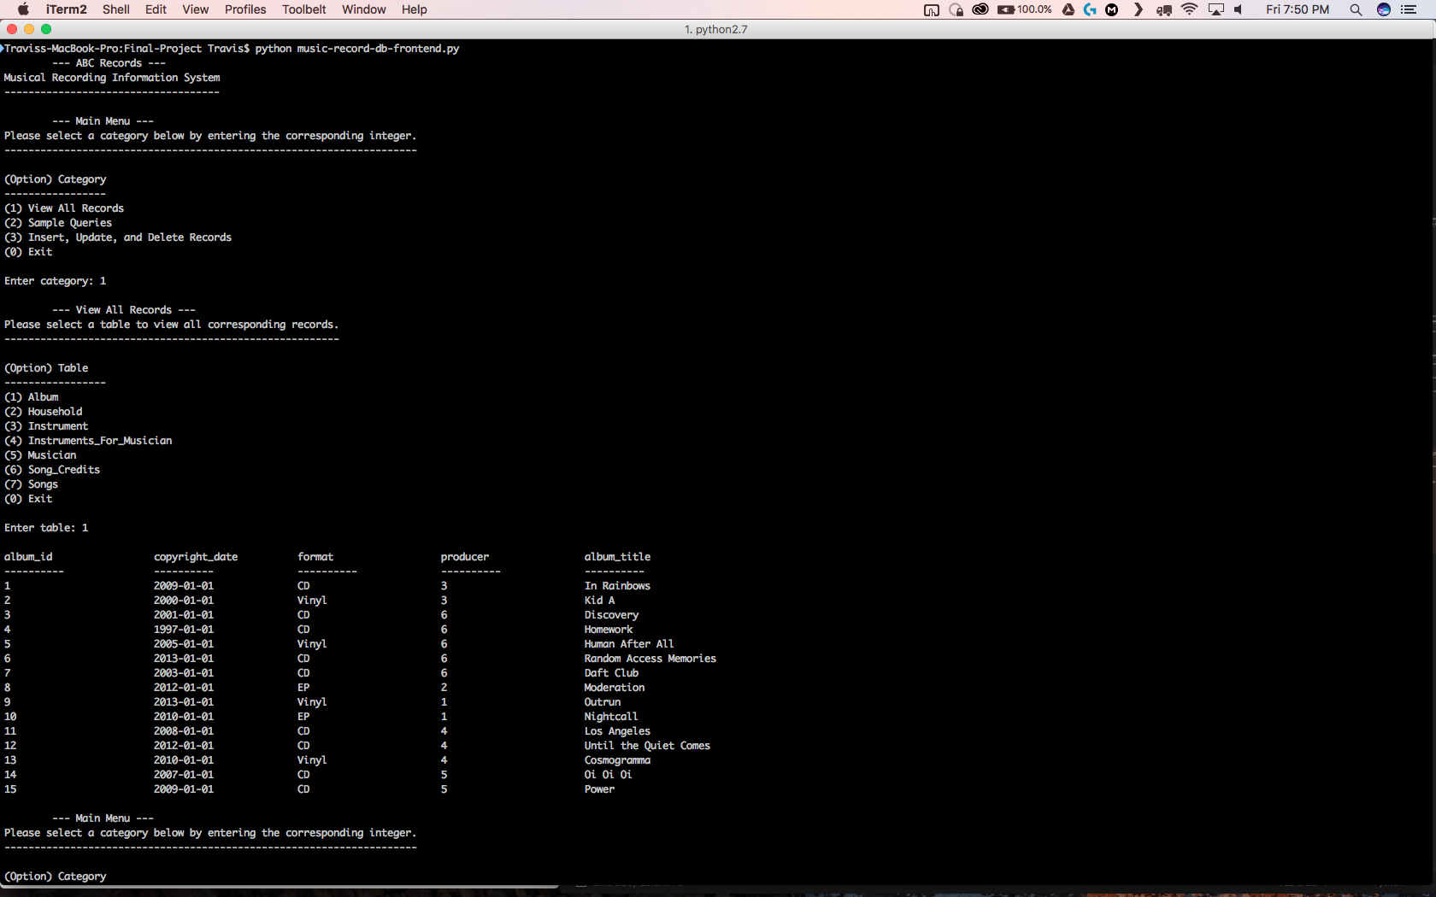

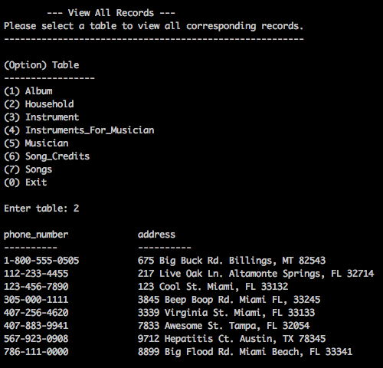

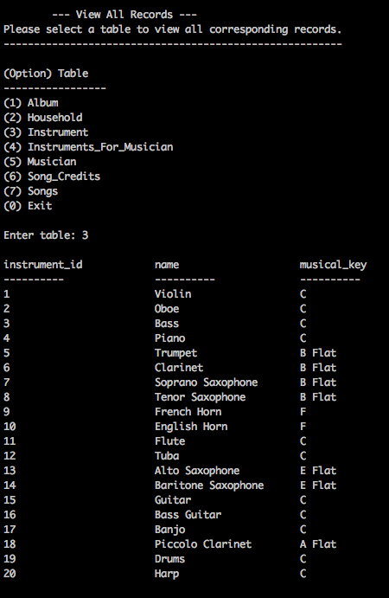

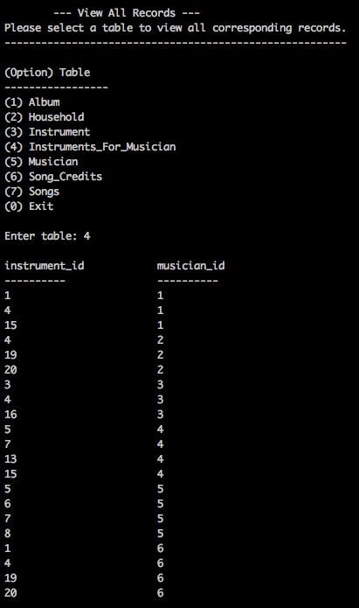

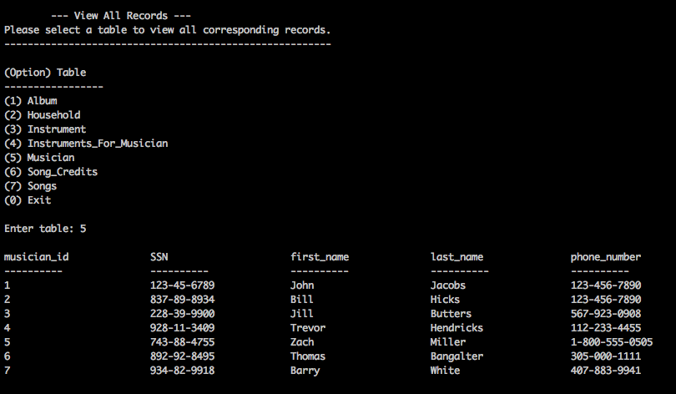

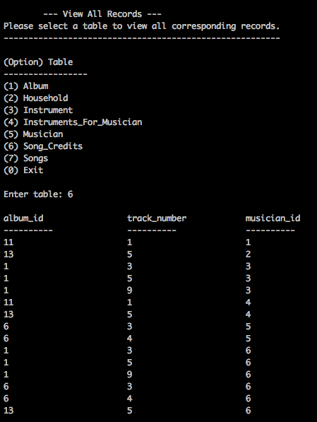

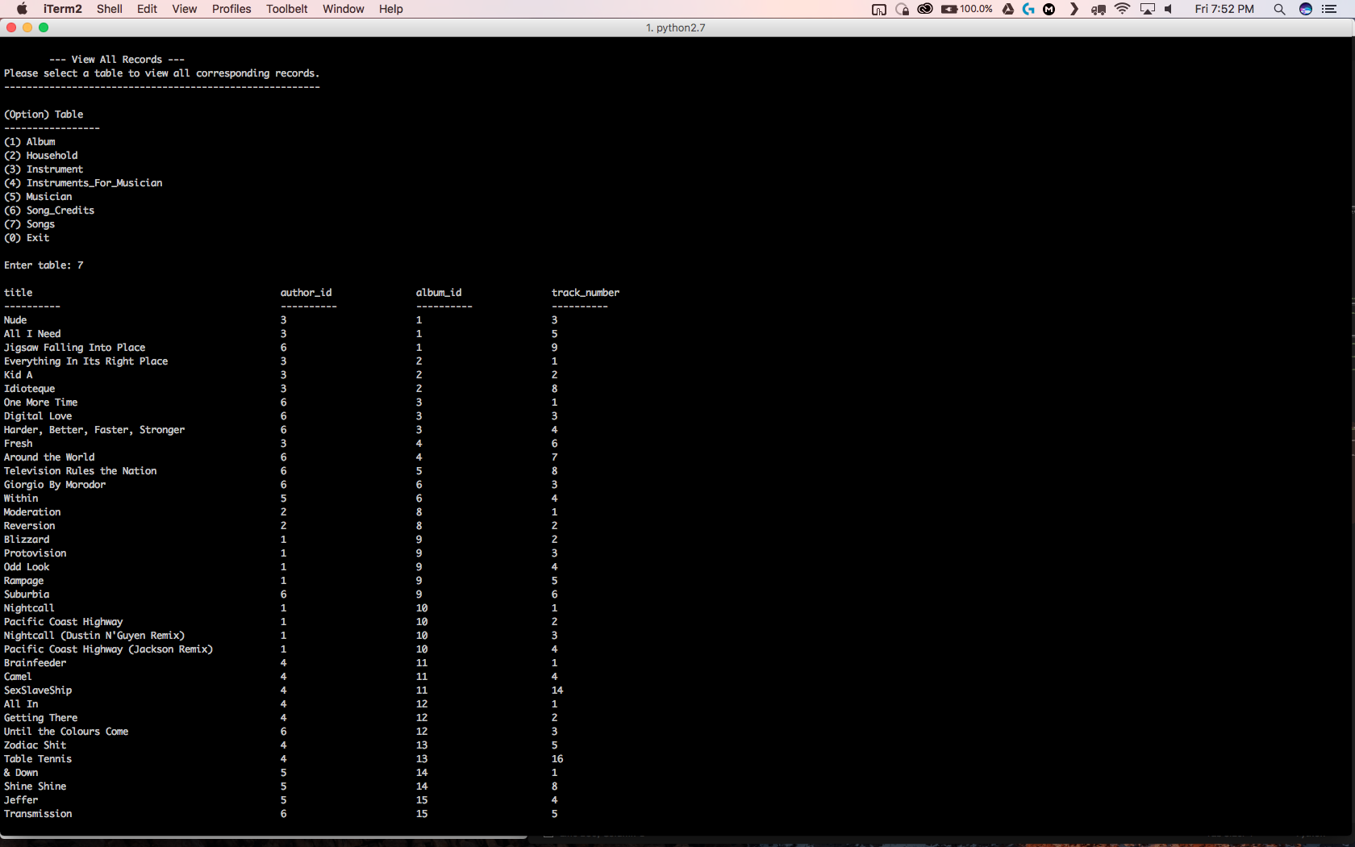

*Sample Query Output:*

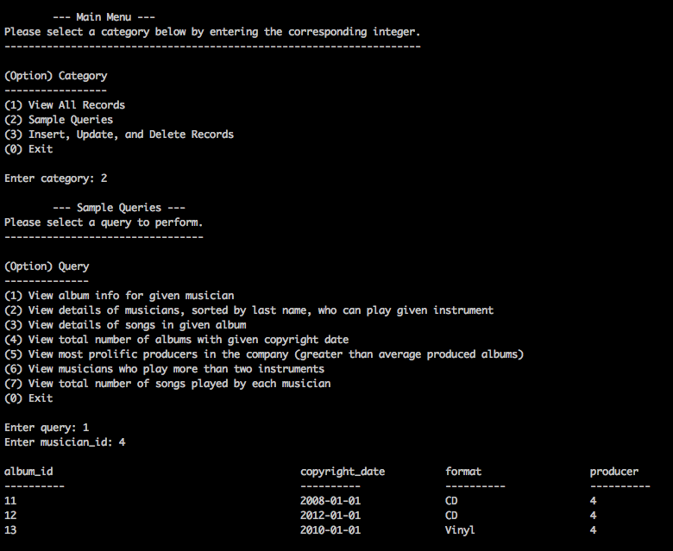

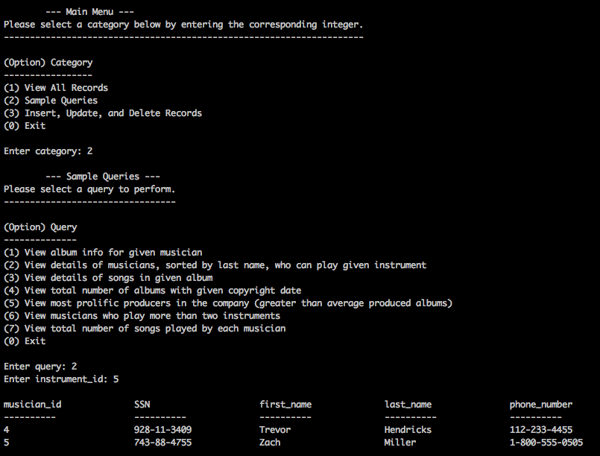

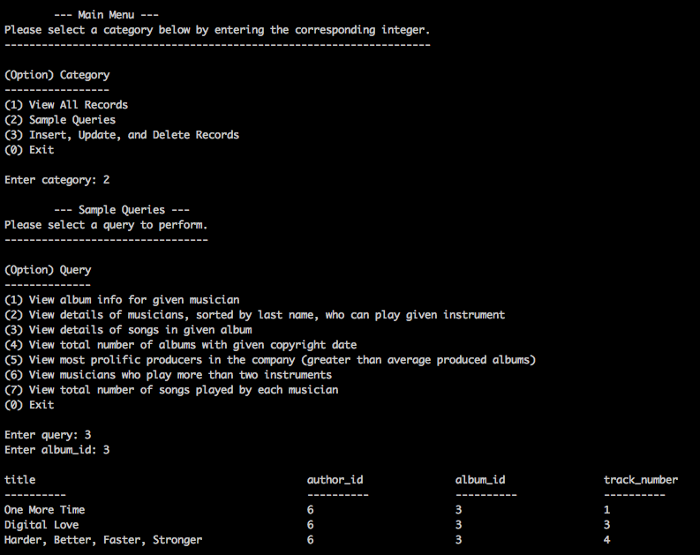

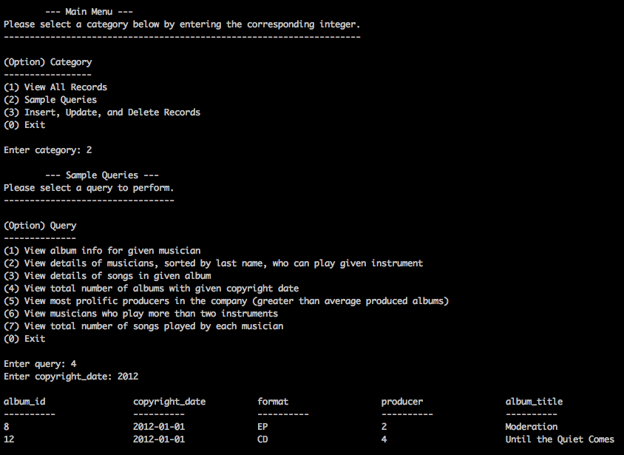

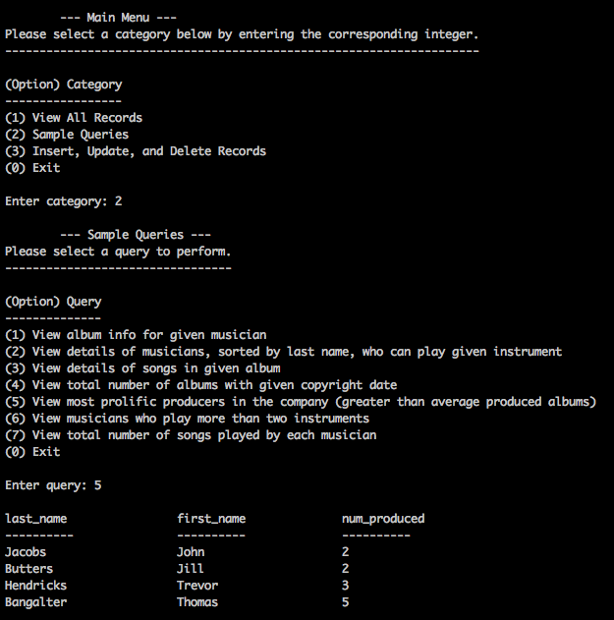

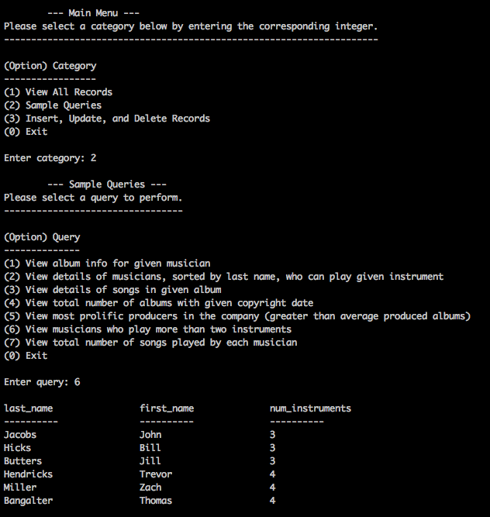

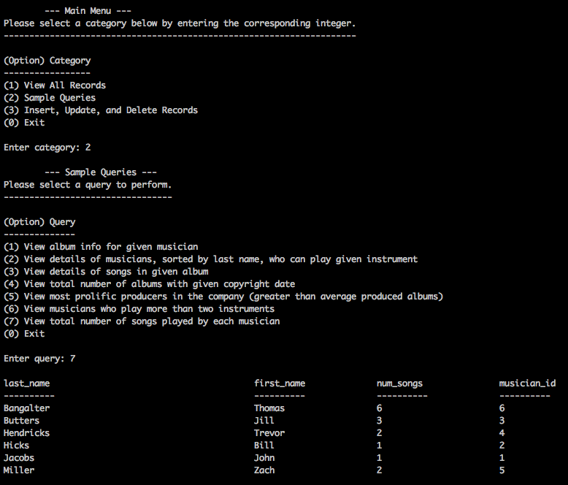

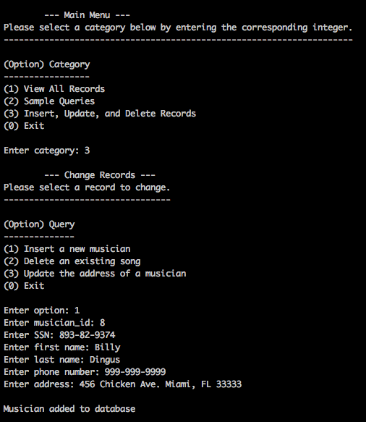

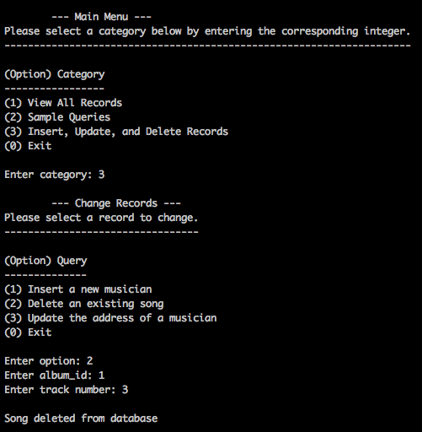

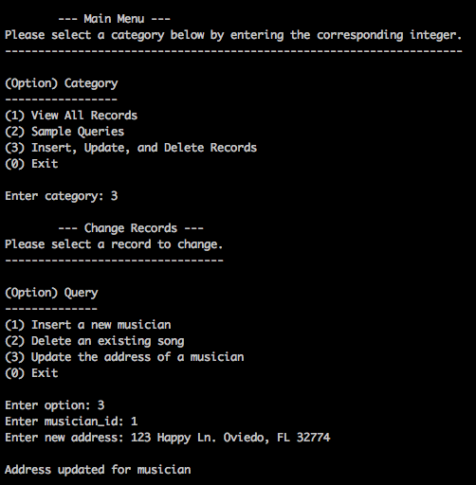

**Conclusion:**

The database and application built for the musical recording information system works very well and seems to fulfill all the necessary requirements in the third normal form. Overall, I’m very pleased with how the application turned out and it could be easily scaled up to be more feature rich, while still maintaining its ease of use.