The Effect of Digital Behavior on Mental Health
Travis Webber
Department of Computer Science and Information Systems
East Texas A&M University
Bryan, Texas, USA
twebber2@leomail.tamuc.edu

Abstract— As daily use of technology has continued to increase, concerns regarding its impact on mental health and overall wellbeing have also been on the rise. This project analyzes a digital lifestyle benchmark dataset to explore relationships between digital behavior and mental health risk, and to evaluate the effectiveness of machine learning models in predicting individuals who may be at a higher risk of poor mental health. Exploratory data analysis revealed strong associations between high digital device usage, poor sleep quality, elevated stress, anxiety, and depression scores, and increased mental health risk. Multiple supervised learning models were trained and evaluated, including tree-based and linear approaches. Tree-based models demonstrated the most consistent overall performance and interpretability, while linear models proved to perform better when trained on a reduced set of significant features. Unsupervised clustering further supported the presence of natural groupings that aligned well with high and low risk targets. Overall, the results suggest that lifestyle factors derived from digital usage data provide meaningful input for mental health risk assessment, and that machine learning approaches can be utilized to analyze these patterns for early detection and intervention.
Keywords—mental health, digital behavior, depression, high-risk, machine learning, data analysis

Data Description
The dataset used in this analysis is the Digital Lifestyle Benchmark dataset, which is publicly available on Kaggle [1]. The dataset consists of 3,500 synthetic observations designed to reflect trends commonly reported in real-world psychological and digital wellbeing research. Each entry represents an individual person and includes demographic information, digital usage behaviors, lifestyle aspects, and mental health indicators.
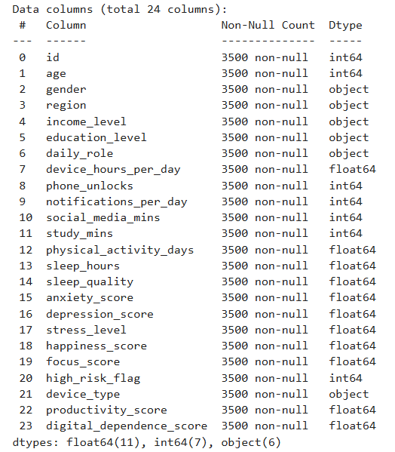
Fig. 1. Data Features
The dataset contains 23 features after removing an unnecessary identifier column for the purposes of this project. These features can be categorized into four groups: demographic attributes (age, gender, region, income level, and education level), digital behavior metrics (device usage hours, phone unlock frequency, notifications per day, and social media usage), lifestyle and wellbeing indicators (sleep duration, sleep quality, physical activity, productivity, and focus), and mental health metrics (anxiety, depression, stress, happiness, and a digital dependence score). The target variable, high_risk_flag, is a binary indicator representing whether an individual is classified as being at higher risk for negative mental health outcomes.
An initial inspection showed that the dataset contains no missing values, making it well-suited for the purposes of this project. The numeric features vary widely in scale, specifically usage-related variables such as notifications per day and social media minutes, which resulted in a need for scaling to tailor the data in a way that would fit certain machine learning models. Several categorical variables are also present, requiring encoding prior to model training.

Previous Work on Dataset
There are no published articles that utilize this specific dataset for evaluating the link between digital usage and poor mental health. However, on the webpage where the dataset can be located, there are eight posted notebooks performing work with this dataset. One of which is posted by its author Tarek Masryo [2]. Masyro performs a comprehensive analysis on the data using visualization and makes comparisons between features like device hours and sleep hours. He engineers fourteen new features to add to the dataset for model training. The top three performing models he tested were XGBoost, Random Forest, and Logistic Regression respectively. The underlying code to how he got his results is hidden, so deeper analysis is not available at this time.

Analysis Methods

Exploratory Data Analyses (EDA)
Exploratory Data Analysis was conducted using a dedicated dataframe that preserved the original features to maintain interpretability. Ordered encodings were added only for income level and education level to support ordered comparisons, while all other categorical variables remained in their original form.
Initial analysis focused on identifying outliers through boxplots across all numeric features. While many variables exhibited extreme values, these were not removed, as outliers in mental health data often represent meaningful high-risk cases rather than data errors. Feature distributions were examined using histograms and count plots, revealing a mix of approximately normal and skewed distributions.
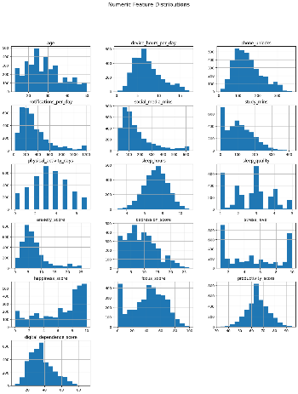
Fig. 2. Numeric Feature Distributions
To understand relationships with the target variable, numeric features were compared against the high-risk flag using grouped boxplots, while categorical variables were analyzed using stacked count plots. Correlation analysis was performed using a heatmap to identify linear relationships between numeric features and the target. Finally, a pair plot was created using a hand-picked set of features identified as potentially significant, allowing for visualization of the relationships between the features and their possible influence on the target.

Data Preprocessing
To support machine learning, a separate training dataframe was created. Ordered categorical variables (income level and education level) were mapped to integers to represent their natural ordering. Categorical variables without inherent order were converted using one-hot encoding.
Two versions of the training data were prepared. The first was intended for tree-based models and included encoded categorical features but no scaling. The second was created by applying standard scaling to all numeric features and was used for linear models, distance-based models, and clustering. The target variable was unaffected by all preprocessing steps.

Machine Learning Models
Multiple supervised learning models were trained to predict the high-risk mental health flag. Tree-based models included Decision Tree, Random Forest, and Gradient Boosting classifiers. Linear models included Logistic Regression, SGD Classifier, and Support Vector Machines. k-Nearest Neighbors was also evaluated to test a distance-based classifier.
The dataset was split into training and testing subsets using a stratified split to even out the proportion of high-risk cases. Model evaluation focused on accuracy, precision, recall, and F1-score, along with confusion matrix visualizations. Feature importance was visualized for models that support it, using feature importance for tree models and coefficient magnitudes for linear models.
Unsupervised learning was also explored through K-Means and hierarchical clustering using the smaller set of significant features. Cluster quality was evaluated using silhouette scores, and the relationship between clusters and the high-risk flag was examined using cross-tabulations.

Results

Exploratory Data Analysis Findings
EDA showed several strong relationships between digital behavior and mental health risk. Higher device usage time, frequent phone unlocks, and higher digital dependence scores were consistently associated with higher anxiety, depression, and stress levels. Sleep duration and sleep quality showed an inverse relationship with mental health risk, where individuals with fewer sleep hours and poorer sleep quality were more likely to be classified as high risk.
Correlation analysis reinforced these findings, showing device-related and sleep features as the most strongly correlated with the high-risk flag. Categorical features such as gender, region, and daily role showed minimal influence. This suggests that behavioral and lifestyle factors have more significant impact than demographics in this dataset.
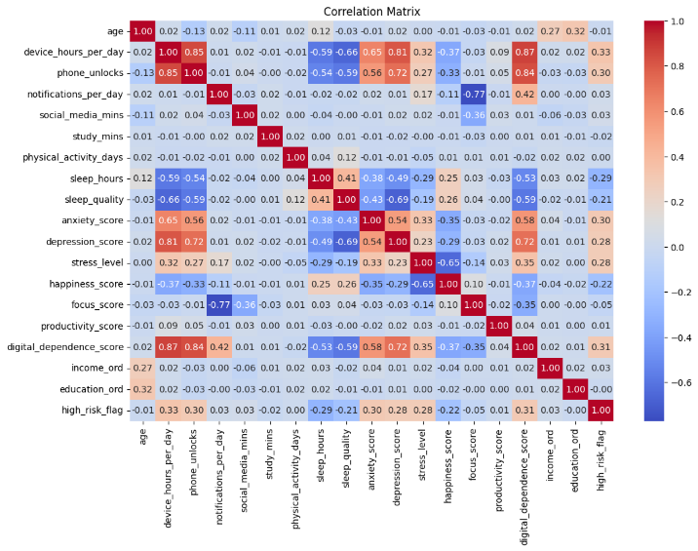
Fig. 3. Numeric Feature Correlation Matrix
Pair plots further demonstrated that combinations of high digital usage and poor sleep or high stress create clear clusters associated with higher mental health risk.

Supervised Model Performance
Tree-based models performed consistently well, with Random Forest and Gradient Boosting having the best overall balance between precision and recall. These models were particularly effective at ignoring insignificant features and acknowledging relationships between features such as device usage, sleep, and mental health scores.
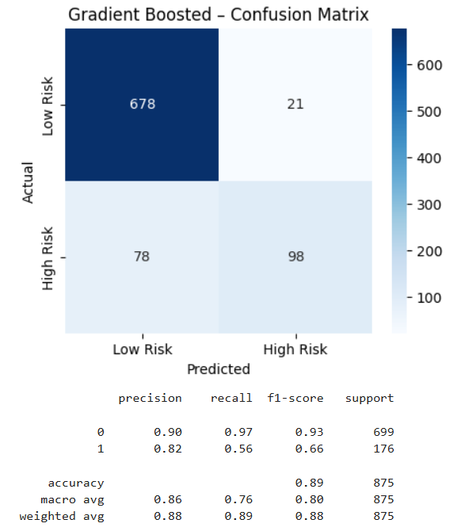
Fig. 4. Gradient Boost Results
Linear models initially underperformed when trained on the full feature set but showed improvement when restricted to the smaller set of relevant features identified during EDA. These models tended to produce fewer false negatives but more false positives compared to tree-based models, making them more sensitive but less specific in identifying high-risk cases.
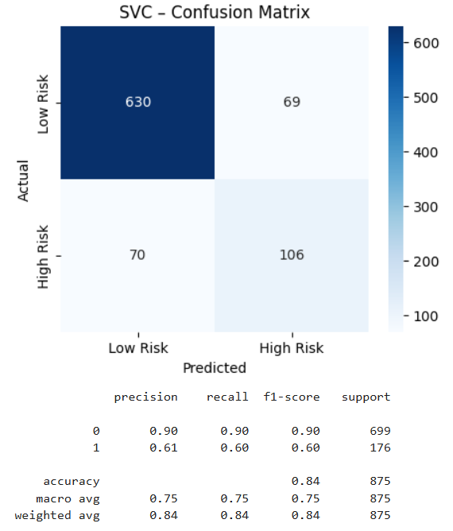
Fig. 5. SVC (rbf kernel) Results
Feature importance analysis across models consistently resulted in device usage hours, digital dependence, sleep-related features, anxiety, depression, and stress scores as the most influential predictors of mental health risk.
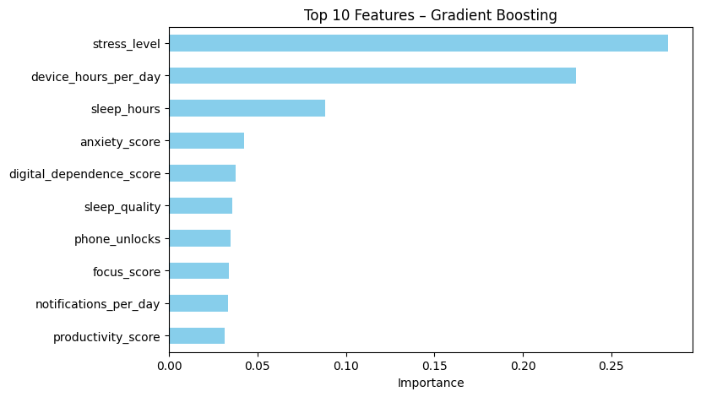
Fig. 6. Gradient Boost Feature Importance

Clustering Results
Clustering analysis showed meaningful structure within the data even without labels during training. K-Means clustering with two clusters resulted in the highest silhouette score compared to other k values. While the clusters were not entirely distinct, their distributions of target classes showed more about the actual structure of the data. Cross-tabulation showed that one cluster contained a higher proportion of high-risk individuals, meaning that the clustering was able to reveal underlying behavioral risk patterns.
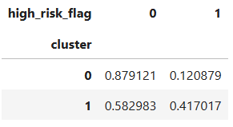
Fig. 7. K-Means Cross-Tabulation With High Risk Flag
Increasing the number of clusters resulted in lower silhouette scores, indicating weaker cluster distinction. Larger amounts of clusters would separate the two major clusters and result in less meaningful visualization and evaluation. Hierarchical clustering produced similar results, supporting that the data naturally divides into broad low-risk and high-risk groupings rather than many finely separated groups.
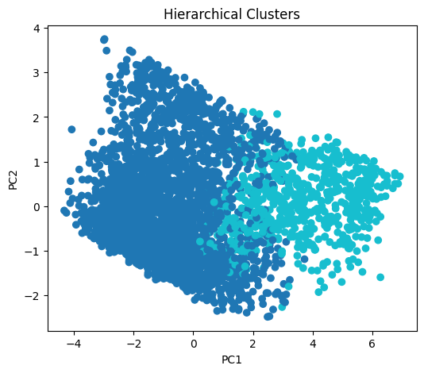
Fig. 8. Hierarchical Clusters

Next Steps
Future work could explore more advanced modeling techniques, such as ensemble stacking or neural networks, to further improve model performance. Each of the models examined in this study could also be further tuned by adjusting model creation parameters and performing hyperparameter tuning methods like grid search.
Additional feature engineering, like including some that capture the interactions between existing features may also improve model performance. Since the dataset is synthetic, validating the findings of this project on real-world digital wellbeing data would be a critical next step.

References
- T. Masryo, “Digital Lifestyle Benchmark,” Kaggle, https://www.kaggle.com/datasets/tarekmasryo/digital-health-and-mental-wellness (accessed Dec. 2, 2025).
- T. Masryo, “Predicting wellbeing risk,” Kaggle, https://www.kaggle.com/code/tarekmasryo/predicting-wellbeing-risk (accessed Dec. 3, 2025).

