The purpose of this script is to calculate the nearest neighbor distances from every cell in the cell_seg_data.txt file to its nearest neighbor of a particular phenotype for every phenotype in the cell_seg_data.txt file. **The cell_seg_data.txt file should be recoordinated before running this script.** The output will be a cell_seg_data.txt file with n number of columns appended to the back where n is the number of unique phenotypes in the Phenotype column of the cell_seg_data.txt file. The appended columns will be in the format “Distance to Phenotype” where Phenotype is the phenotype of interest.

**Classic workflow:** Recoordination.R -> Complex_Phenotype.R -> Phenotype_Distance_TT.R

1. The folder **Distance** should have two subfolders: **Files** and **Results**
   1. Check to make sure the Distance folder with the two subfolders in it is in the working directory (the stuff inside the setwd() function). There may be other subfolders but these two are the only necessary ones
      1. If it is not in the working directory, change your working directory in the areas boxed in red below to wherever the Distance folder is.
      2. Do not change the “Dist_” part. Just change everything before the last “/” in the box.

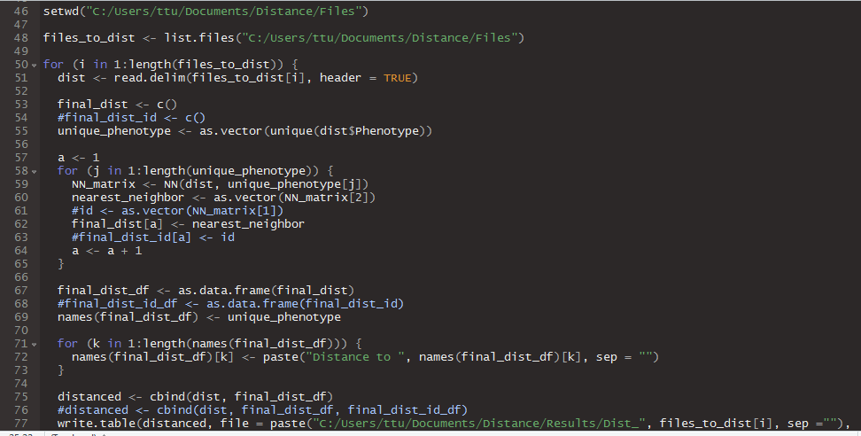

1. The **Files** subfolder should contain **cell_seg_data.txt** files. **These cell_seg_data.txt should be recoordinated before running this script** or the distances will be inaccurate. Before running the **Results** subfolder should be empty. This is where your results will go.
   1. Make sure the cell_seg_data.txt files are “Tab Delimitated”. If they are not (if they were exported from Spotfire they might be Unicode), ask Anthony or Ting-Fang for a script to change them or you can open them in Excel and “Save As”, “Save as type: **Text (Tab delimited) (*.txt)**”
2. If you want to run the nearest neighbor cell of a particular phenotype within 25 microns (50 pixels) then you can uncomment the second nearest_neighbor line in the function NN by deleting the “#” in the beginning of that line. The text should change colors from blue to white (at least with viewing format that I have set up in RStudio).
   1. You should also comment out the first nearest_neighbor line by adding a “#” to the front of that line. The text should change colors from white to blue. Commenting out basically means that the computer will ignore that line when running the code.
   2. *I generally do not use this script to run something like this. Usually I use the thresholding script or thresholding functions built into other scripts or just a filter in Spotfire to get the “within 50 pixels” part.*

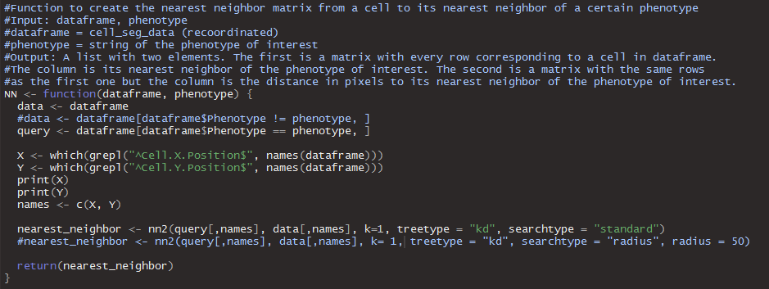

1. Click “Source” in the top right corner of RStudio to run the script! The results will be labeled with the name of the cell_seg_data.txt files you put in but with the “Dist_” tag at the beginning. This script is pretty in-line. Just stick the cell_seg_data.txt files (after recoordinating them) and then get the results.