**Recoordination.R** takes in a merged_cell_seg_data.txt file and converts the Cell.X.Position and Cell.Y.Position columns so that every cell (each row) has a unique coordinate. Before recoordination every individual high power field has the same coordinate axes and so there are many overlapping coordinates (i.e. there are multiple cells at (100, 100) but they are all in different high powered fields).

**Classic workflow:** Recoordination.R -> Complex_Phenotype.R -> Phenotype_Distance_TT.R

1. The folder **File Merging** should have three subfolders: **Files to merge, Split,** and **Recor**
   1. Check to make sure the File Merging with the three subfolders in it is in the working directory (the stuff inside the setwd() function). There may be other subfolders but these are the only necessary ones
      1. If it is not in the working directory, change your working directory in the areas boxed in red below to wherever the File Merging folder is.
      2. Do not change any tags like “Recor_” part. Just change everything before the last “/” in the box. For the directories without tags like “Recor_”, make sure to keep the “/” at the end. Part 1, 2, and 3 are shown in order below.

Part 2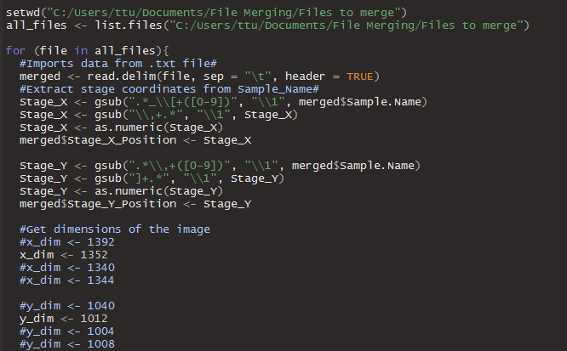

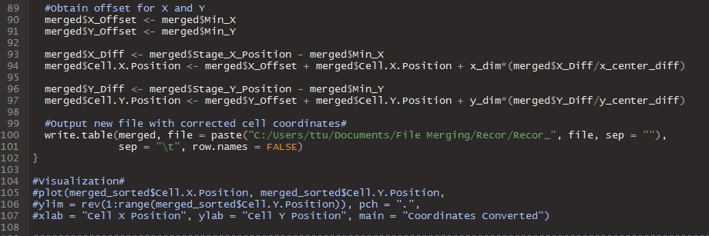

1. **Recoordination.R:** The **Files to merge** subfolder should contain **merged** **cell_seg_data.txt** files. Before running the **Recor** subfolder should be empty. This is where your results will go.
   1. Make sure the cell_seg_data.txt files are “Tab Delimitated”. If they are not (if they were exported from Spotfire they might be Unicode), ask Anthony or Ting-Fang for a script to change them or you can open them in Excel and “Save As”, “Save as type: **Text (Tab delimited) (*.txt)**”
2. **Recoordination.R:** Check the dimensions of the image that is being recoordinated. Make sure to use a **.tif file NOT an .im3** file for this.
   1. Find a tif file from the cell_seg_data that you want to recoordinate.
   2. Right click the image and click on Properties at the bottom of the menu.
   3. Click on the Details tab at the top of the window that pops up
   4. Find the dimensions of the image
      1. Formatted in width x height (i.e. 1340x 1004)
      2. In my script width = x and height = y so in the example the lines that should be used are x_dim <- 1340 and y_dim <- 1004
   5. Uncomment the lines that correspond to the **dimensions** of the image in the first and second blocks of text in the red box. Uncomment means to remove the “#”. The text should become white.
   6. Comment out all other lines in those blocks of text. Comment by adding a “#” at the beginning of the line. The text should go from white to blue at least it does in my view settings in RStudio.

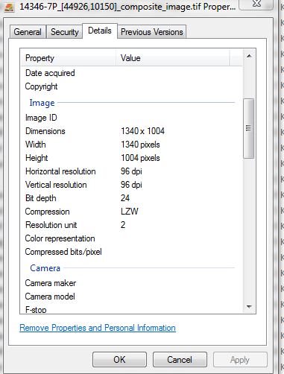

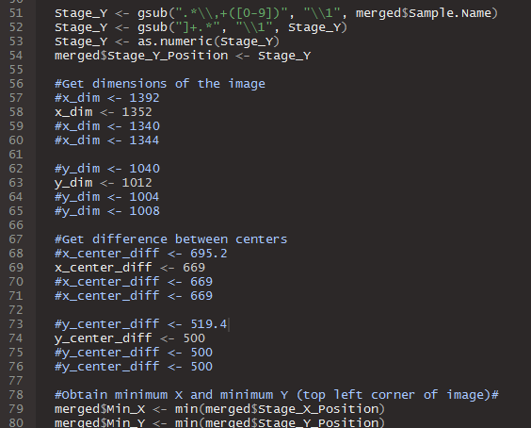

1. The x_center_diff and y_center_diff variables correspond to the difference between the stage coordinates between adjacent images. These are used to determine how many images apart two high powered fields are when recoordinating.
   1. The x_dim, y_dim, x_center_diff, and y_center_diff variables are matched up by position in the script. **If you run the first x_dim, you should be running the first y_dim, the first x_center_diff, and the first y_center_diff.**
   2. Uncomment the lines that correspond to the **difference between centers** in the x and y directions (x_center_diff and y_center_diff respectively) of the image in the third and fourth blocks of text in the red box. Uncomment means to remove the “#”. The text should become white.
   3. Comment out all other lines in those blocks of text. Comment by adding a “#” at the beginning of the line. The text should go from white to blue at least it does in my view settings in RStudio.
   4. Continuing the (1340 x 1004) example, the uncommented lines should be x_center_diff <- 669 and y_center_diff <- 500 (third line in the third and fourth blocks of code).



y_center_diff

x_center_diff

1. **If you want to add a new dimension to the code:**
   1. At the end of the first block add: x_dim <- (number)
   2. At the end of the second block add: y_dim <- (number)
   3. At the end of the third block add: x_center_diff <- (number)
   4. At the end of the fourth block add: y_center_diff <- (number)
   5. The parameter **(number)** is determined by the dimension of the image listed when you right click properties and details for the first two blocks (width and height respectively) and as depicted in the figure above for x_center_diff and y_center_diff.
      1. x_dim is width of new image dimension
      2. y_dim is height of new image dimension
      3. x_center_diff is calculated by the taking the difference between the stage coordinates of two adjacent images that have the same y-coordinate (horizontal to each other). This is usually around 700.
      4. y_center_diff is calculated by taking the difference between the stage coordinates of two adjacent images that have the same x-coordinate (vertical to each other). This is usually around 550.
2. To run each individual block of code, **hold ctrl and hit enter** until you reach the end of a section of code as denoted by the full lines of “#”s. This will run the code one line at a time so you can just run the recoordination part of the script for example. Or just click “Source” in the top right of the script window.
3. **ONE FINAL NOTE FOR RECOORDINATION**: Anthony has a script with a switch statement so you do not need to manually change that variable, but you do need to use a .tif file to let his program determine what the dimensions to be used are. I think this is all part of his inForm Assistant button now so that is useful to help figure things out.