Mothers and daughter's height

by Craig W. Slinkman

September 15, 2015

This is an analysis of the linear relationship between the height of a daughter and the height of her mother.

# the data

The data is in the **Heights** data in the **alr4** package. We load the data below:

require( alr4 ) # We need this package for the Heights data.

## Loading required package: alr4  
## Loading required package: car  
## Loading required package: effects  
##   
## Attaching package: 'effects'  
##   
## The following object is masked from 'package:car':  
##   
## Prestige

data( Heights ) # Import data.  
head( Heights ) # Verify data.

## mheight dheight  
## 1 59.7 55.1  
## 2 58.2 56.5  
## 3 60.6 56.0  
## 4 60.7 56.8  
## 5 61.8 56.0  
## 6 55.5 57.9

tail( Heights )

## mheight dheight  
## 1370 69.5 70.4  
## 1371 69.1 70.1  
## 1372 65.0 71.6  
## 1373 66.3 71.4  
## 1374 70.8 71.0  
## 1375 63.0 73.1

# Univariate analysis

## Histogram

require( ggplot2 )

## Loading required package: ggplot2

ggplot( Heights,   
 aes( x=mheight )) +  
 geom_histogram( aes( y=..density.. ),  
 binwidth=0.5,  
 color ="blue",  
 fill = "yellow" ) +  
 geom_density() +   
 xlab( "Heights of mothers (inches) " ) +  
 ylab( "Density" ) +  
 ggtitle( "Mother's heights" )

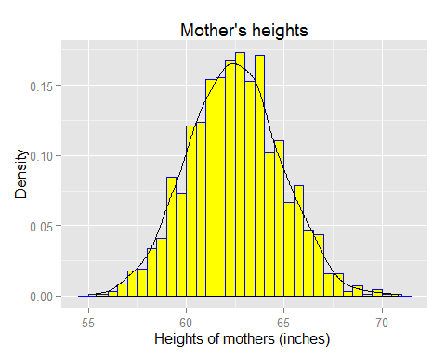

# Descriptive statistucs

summary( Heights )

## mheight dheight   
## Min. :55.40 Min. :55.10   
## 1st Qu.:60.80 1st Qu.:62.00   
## Median :62.40 Median :63.60   
## Mean :62.45 Mean :63.75   
## 3rd Qu.:63.90 3rd Qu.:65.60   
## Max. :70.80 Max. :73.10

sd( Heights$mheight )

## [1] 2.355103

# Scatterplot and regression

## SCatterplot

ggplot( Heights,  
 aes( x= mheight, y=dheight )) +  
 geom_point() +  
 geom_smooth( method=loess, color="red")

