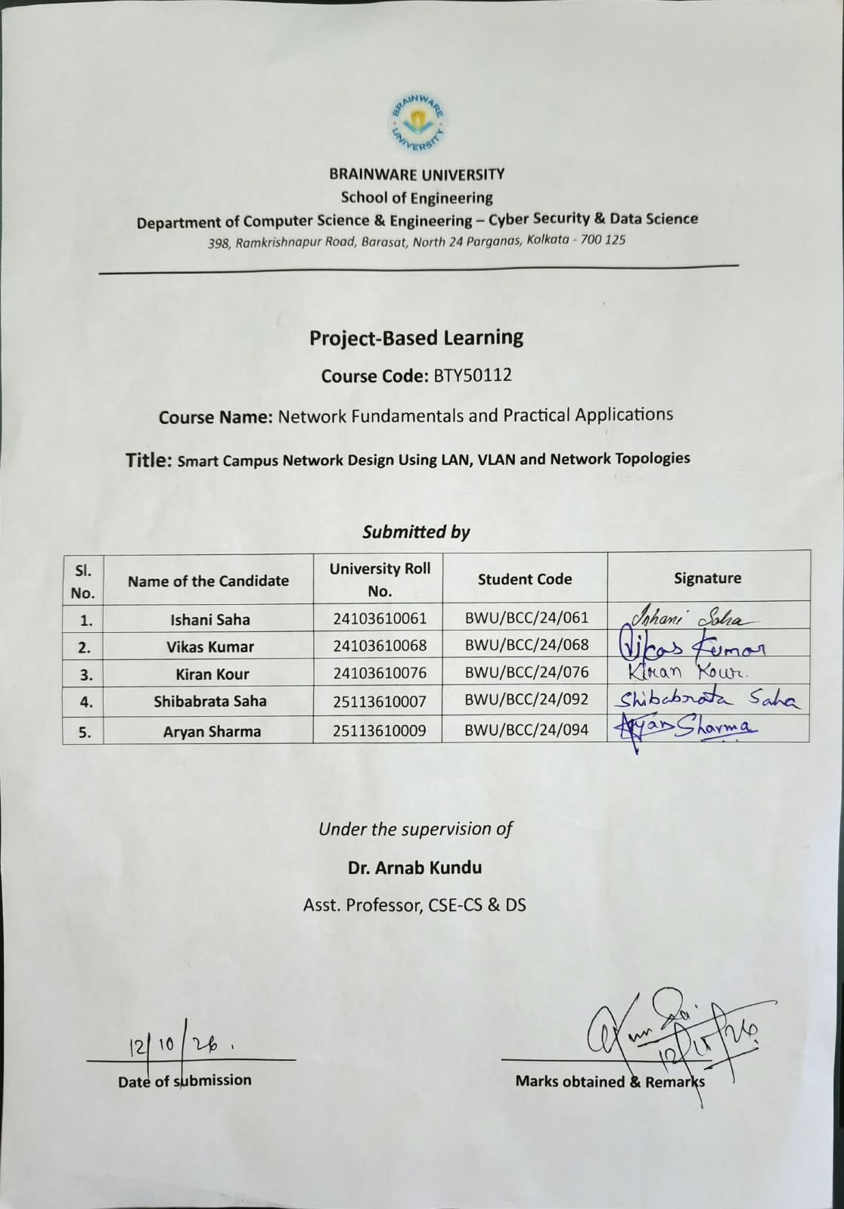
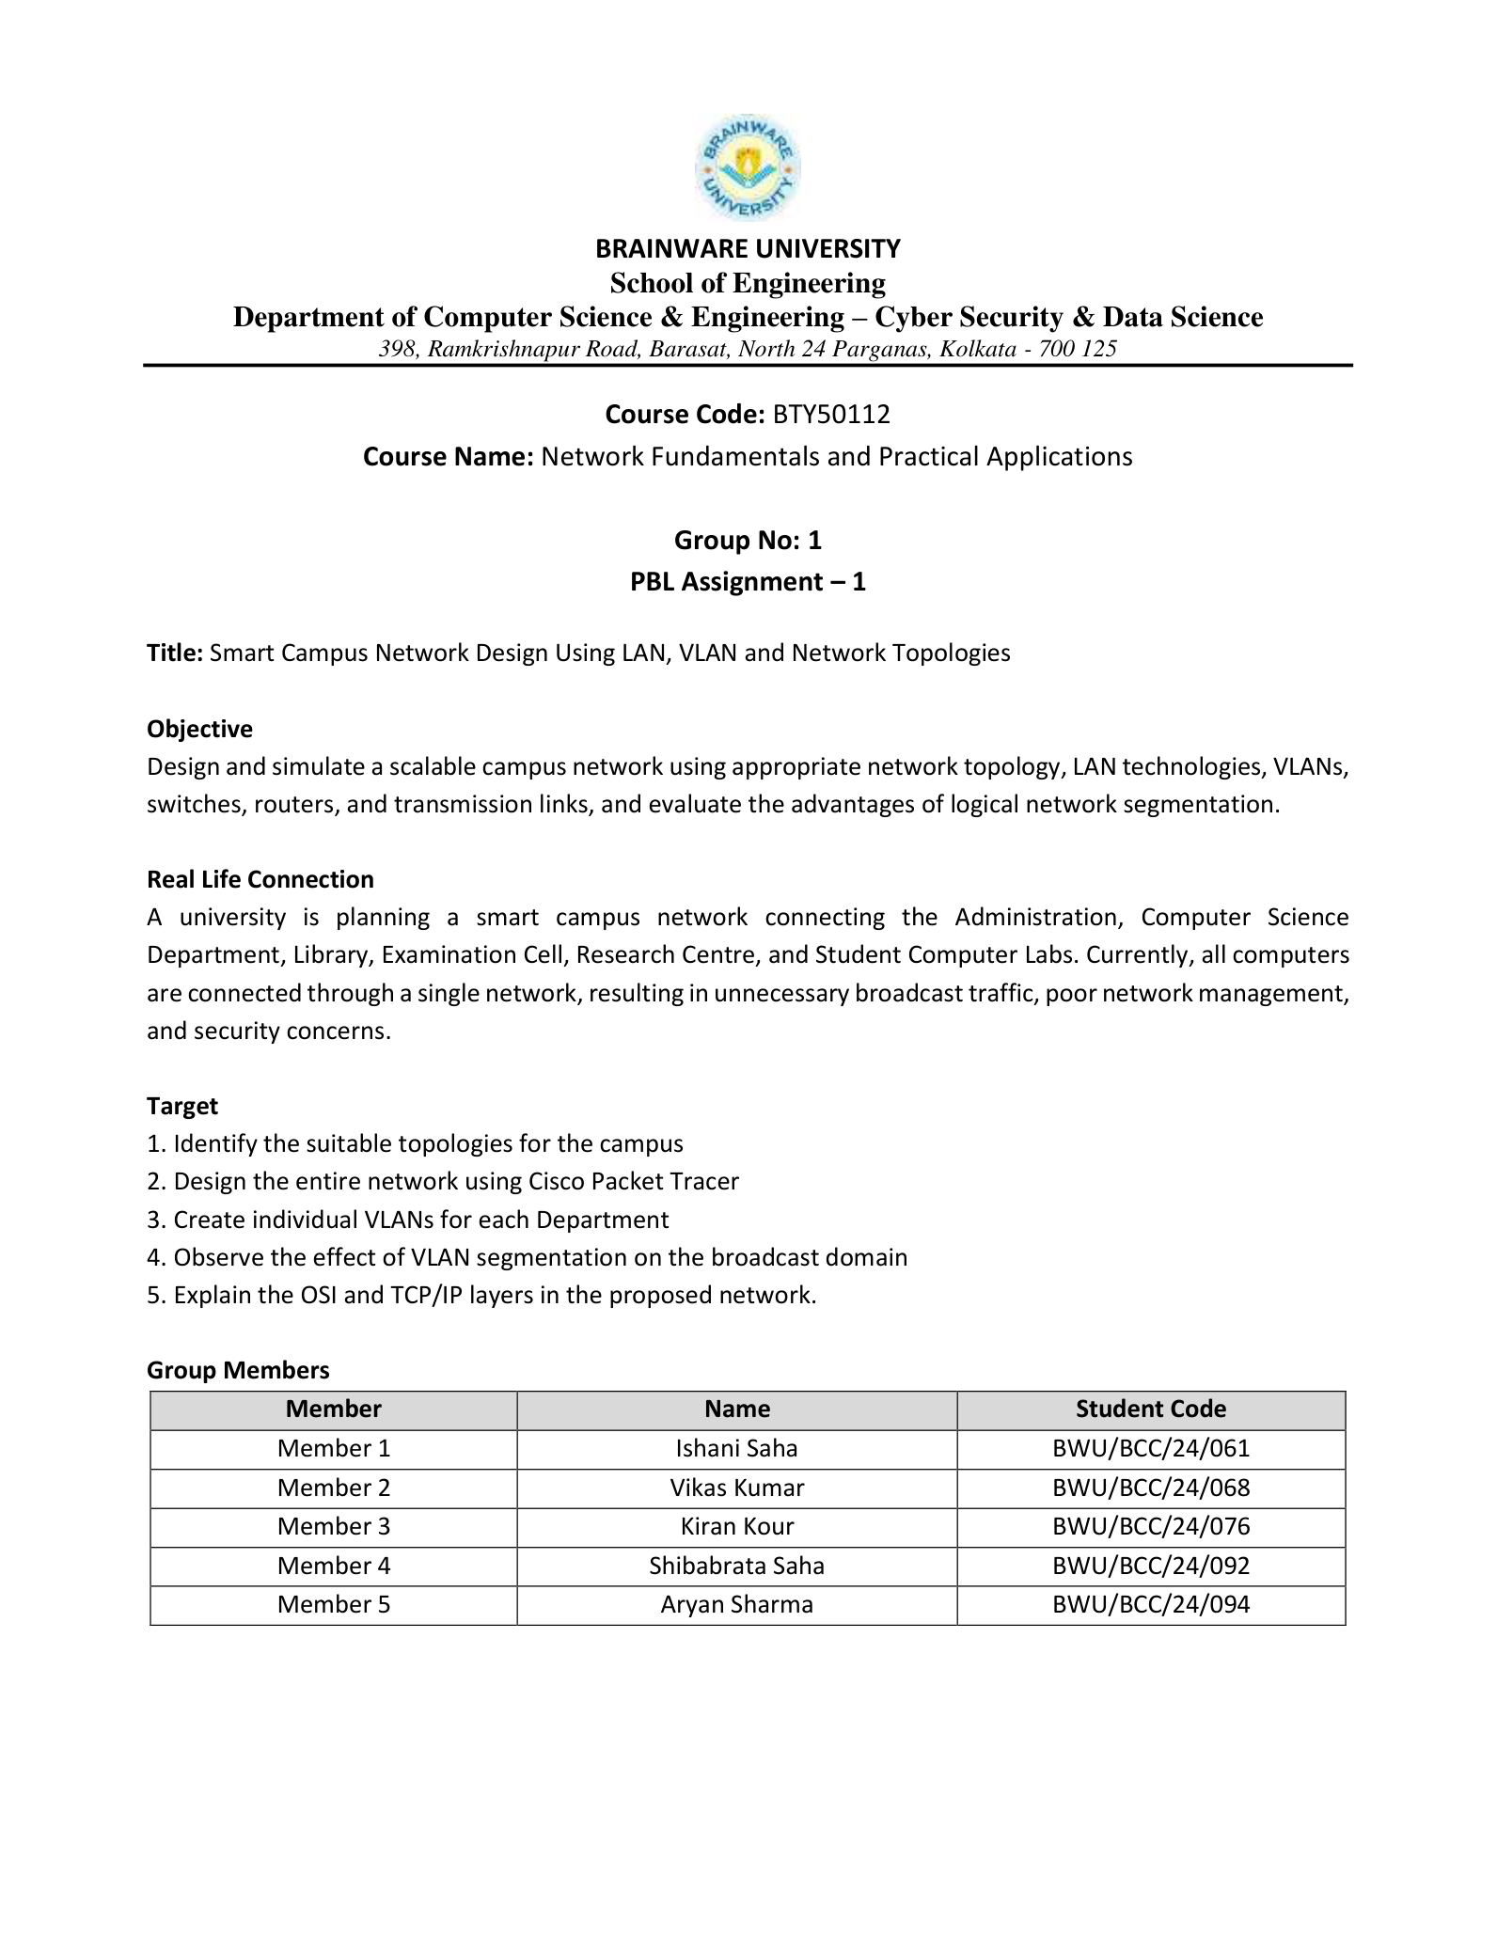
TABLE OF CONTENTS
Smart Campus Network Design Using LAN, VLAN and Network Topologies

01 Introduction 02  1.1 Project Overview 02  1.2 Objectives 02  1.3 Problem Statement 03  02 Smart Campus Network Design 04  2.1 Proposed Network Architecture 04  2.2 Core, Distribution and Access Layers 05  2.3 Network Topology 05  2.4 Major Network Devices Used 06  03 IP Addressing and VLAN Design 07  3.1 VLAN Plan 07  3.2 IP Addressing Scheme 07  3.3 Department-wise Network Allocation 08  3.4 Default Gateway Design 09  04 Core Network Configuration 10  4.1 CORE-SW1 Configuration 10  4.2 CORE-SW2 Configuration 10  4.3 Inter-VLAN Routing 11  4.4 Core-to-Core Connections 11  05 Network Redundancy and Routing 13  5.1 HSRP Configuration and Purpose 13  5.2 OSPF Configuration and Purpose 14  5.3 EtherChannel with LACP 15  5.4 Spanning Tree Protocol 16  06 Department Network Configuration 18  6.1 CYS Department 18  6.2 Data Science Department 20  6.3 Research Department 22  6.4 Management Department 24  6.5 Guest Network 27  07 Wireless and Voice Network 29  7.1 CYS Wi-Fi 29  7.2 Data Science Wi-Fi 29  7.3 Guest Wi-Fi 29  7.4 Voice VLAN 60 29 | 08 Firewall and Internet Edge 31  8.1 ASA Firewall Design 31  8.2 FW1 Configuration 31  8.3 FW2 Configuration 31  8.4 EDGE-SW Configuration 32  8.5 ISP Router Configuration 32  8.6 Campus-to-Internet Traffic Flow 33  09 OSI and TCP/IP Model Implementation 34  9.1 OSI Layers in the Project 34  9.2 TCP/IP Layers in the Project 34  9.3 Protocols Used at Different Layers 35  10 Testing and Verification 36  10.1 VLAN and Trunk Verification 36  10.2 HSRP Verification 36  10.3 OSPF Verification 36  10.4 EtherChannel and STP Verification 36  10.5 Ping and End-to-End Testing 37  10.6 Failover Testing 38  10.7 Observations 38  11 Security, Advantages and Limitations 40  11.1 Network Security Features 40  11.2 Advantages of VLAN Segmentation 40  11.3 Redundancy Benefits 40  11.4 Current Limitations 41  11.5 Future Scope and Improvements 41  12 Conclusion 42  12.1 Project Outcome 42  12.2 Learning Outcome 42  12.3 Final Conclusion 42  13 References 43  14 Appendix 44  14.1 Important Verification Commands 44  14.2 Complete IP Address Summary 44  14.3 Additional Configuration / Screenshots 45  14.4 List of Abbreviations 47

PROJECT-BASED LEARNING | GROUP 1 | BRAINWARE UNIVERSITY

1. Introduction

1.1 Project Overview
A modern campus network must connect many users and services while remaining organized, reliable and secure. A flat network where every device shares the same broadcast domain becomes difficult to manage as the number of endpoints grows. It also provides little control over communication between students, faculty, administration, guests and infrastructure devices.
Our Smart Campus Network solves this by using a hierarchical design. The campus is divided into logical VLANs for CYS, Data Science, Research, Management, Voice and Guests. Two multilayer core switches provide routing and redundancy. Distribution switches aggregate each department, while access switches connect endpoints. Firewalls and an edge switch provide a controlled path toward the ISP.
The project focuses on understanding real networking principles rather than simply placing devices in Packet Tracer. Every important design decision is linked to a technical reason: HSRP prevents a single default gateway failure, OSPF provides dynamic routing, EtherChannel provides link aggregation, STP prevents loops and VLANs provide logical separation.
The official PBL assignment requires the team to design and simulate a scalable campus network using suitable topologies, LAN technologies, VLANs, switches, routers and transmission links. The completed topology extends that requirement into a realistic hierarchical campus architecture with redundant core switching, dynamic routing, gateway redundancy, wireless access and a protected Internet edge.
Official project title: Smart Campus Network Design Using LAN, VLAN and Network Topologies.

1.2 Objectives
- Identify a suitable topology for a multi-department university campus.
- Design the complete Smart Campus Network in Cisco Packet Tracer.
- Create individual VLANs and IP subnets for different departments and user groups.
- Observe how VLAN segmentation divides broadcast domains and improves manageability.
- Explain how the OSI and TCP/IP models appear in the implemented network.
- Provide resilient default gateways using HSRP on two multilayer core switches.
- Use OSPF for dynamic route exchange between the core switches.
- Use LACP EtherChannel and Spanning Tree to support redundant Layer-2 paths without loops.
- Integrate wired, wireless, firewall and ISP components and verify connectivity using practical tests.

1.3 Problem Statement
The campus contains multiple departments with different users and requirements. If all users were placed in one network, broadcasts would reach every endpoint, troubleshooting would become difficult and guest devices could mix with administrative systems. A single core or gateway would also create a major single point of failure.
The design therefore needs to satisfy four major needs: segmentation, routing, redundancy and secure external connectivity. Segmentation is achieved through VLANs. Routing is performed by multilayer core switches. Redundancy is introduced through dual cores, HSRP and EtherChannel. Security boundaries are provided by the ASA firewalls and the separate guest VLAN.
Another motivation is academic demonstration. The topology allows students to show and explain several networking technologies in one integrated project: VLANs, trunks, inter-VLAN routing, first-hop redundancy, dynamic routing, link aggregation, spanning tree, wireless networking, firewall routing and WAN/ISP connectivity.
The assignment describes a university environment in which Administration, Computer Science, Library, Examination Cell, Research Centre and student computer laboratories were originally placed on a single network. Such a flat design creates unnecessary broadcast traffic, weak separation between user groups, difficult troubleshooting and increased security risk. The proposed Smart Campus Network addresses these issues by introducing hierarchical switching, VLAN segmentation, redundant routing and controlled edge connectivity.

2. Smart Campus Network Design

2.1 Proposed Network Architecture
The proposed architecture uses a hierarchical campus model with redundant core switches, departmental distribution switches and access switches. The edge portion is separated from the campus through two ASA firewalls and an EDGE multilayer switch. The ISP router represents the upstream provider. The design deliberately separates user switching, Layer-3 routing, redundancy and security functions so that each part can be configured and verified independently.
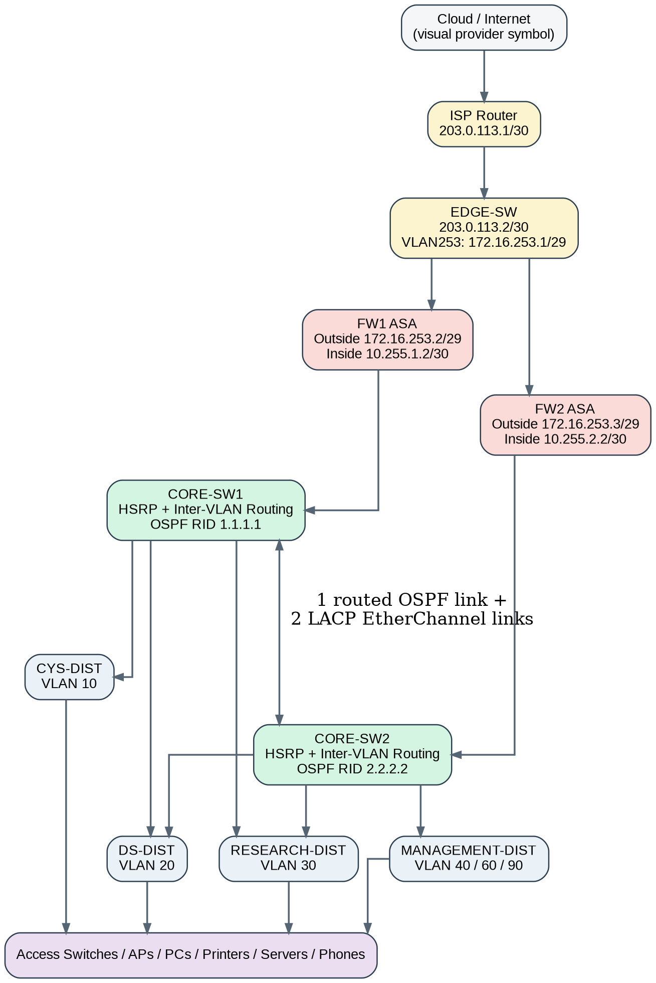
Figure 1. Logical Smart Campus architecture showing the Internet edge, firewall pair, dual core, departmental distribution layer and access layer.
The following flowchart summarizes the complete physical and logical path used in the project. It is intended as a quick visual map before the detailed device-by-device configuration that follows.
Physically, the design contains two core switches, multiple department switches, two firewalls and an ISP edge. Logically, the same cabling carries multiple VLANs through 802.1Q trunks. Layer-3 SVIs on the cores provide routing between those VLANs.
The topology deliberately uses three inter-core physical links. One link is converted to a routed Layer-3 interface for OSPF. The other two links remain Layer-2 switchports and are combined into Port-channel1 using LACP. This separation makes the Layer-3 routing path and Layer-2 VLAN transport path easy to understand and troubleshoot.
Some distribution switches have two uplinks. STP prevents a switching loop by selecting a forwarding path and keeping another path as an alternate. This behavior was explicitly verified for Research VLAN 30.

2.2 Core, Distribution and Access Layers
Core layer
CORE-SW1 and CORE-SW2 form the Layer-3 backbone. They host the VLAN SVIs, HSRP virtual gateways, OSPF adjacency and the Layer-2 Port-channel trunk between the cores.
Distribution layer
CYS-DIST, DS-DIST, RESEARCH-DIST and MANAGEMENT-DIST aggregate the access switches for each department. Data Science and Research are dual-homed to both cores, while CYS and Management currently use primary uplinks to one core each.
Access layer
2960 access switches connect PCs, printers, servers, wireless access points and selected IP phones. Access ports belong to the department data VLAN, while voice-capable ports can also advertise VLAN 60 to IP phones.
Security/edge layer
FW1 and FW2 sit between the campus core and EDGE-SW. EDGE-SW connects to the ISP router. This creates a clear inside-to-outside security boundary.
Design principle: The core performs routing and redundancy, distribution switches aggregate department links, and access switches connect end devices. This separation simplifies troubleshooting and future expansion.

2.3 Network Topology
- Identify departments and endpoint groups.
- Create a VLAN and subnet plan.
- Place two core multilayer switches for redundancy.
- Build department distribution and access layers.
- Configure VLANs, trunks and SVIs.
- Configure HSRP virtual gateways.
- Create a dedicated routed link and configure OSPF.
- Build the two-link LACP EtherChannel between the cores.
- Tune and verify Spanning Tree behavior.
- Configure wireless SSIDs and static addressing.
- Integrate ASA firewalls, EDGE-SW and ISP addressing.
- Verify each stage before moving to the next stage.
- Record errors and troubleshooting steps.
- Prepare final demonstration and documentation.
A major principle used during implementation was incremental verification. For example, after configuring a VLAN, we first checked show vlan brief, then checked trunks, then tested the virtual gateway, and only after those checks proceeded to endpoint communication. This reduced the number of variables during troubleshooting.
At the access layer, each department follows a star-like arrangement because end devices connect to local access switches. At the campus level, Data Science and Research demonstrate redundant dual-uplink paths to the cores. The two core switches themselves use both a routed link and a separate Layer-2 EtherChannel bundle. This creates a hybrid topology that combines simple star access networks with resilient core and distribution interconnections.
System model evidence: Figures 4–6 in Section 14.3 show original Packet Tracer Logical-workspace views of the core/edge, CYS/Data Science branches and Management/Guest branches. Figure 1 gives a clearer abstraction of the complete design. Both the schematic and the native screenshots should be read together.

2.4 Major Network Devices Used
The project was implemented in Cisco Packet Tracer 9.0. The topology uses devices available in the simulator and is designed to demonstrate enterprise campus concepts at an educational scale.
Device type | Role/Name | Purpose
Cisco 3560 multilayer switches | CORE-SW1, CORE-SW2, departmental distribution, EDGE-SW | Layer-2/Layer-3 switching and routing
Cisco 2960 switches | Department access switches | Endpoint access
Cisco ASA 5506-X | FW1 and FW2 | Firewall/security edge
Router-PT | ISP | WAN/ISP simulation
Cloud-PT | Cloud0 | Visual Internet/provider representation
AccessPoint-PT | CYS/DS/Guest APs | Wireless connectivity
PC/Laptop/Printer/Server | End devices | Testing departmental access
IP Phone | Management selected ports | Voice VLAN demonstration

3. IP Addressing and VLAN Design

3.1 VLAN Plan
Configuration commands used to create the campus VLANs
The VLAN database is created on both multilayer core switches so that the HSRP SVIs and core trunk can carry the same logical networks. Distribution switches only need the VLANs used by that department.
enable
configure terminal
vlan 10
name CYS
vlan 20
name DS
vlan 30
name RESEARCH
vlan 40
name MANAGEMENT
vlan 60
name VOICE
vlan 90
name GUEST
end
write memory
Verification: use `show vlan brief` to confirm that each required VLAN exists and is active.
VLAN | Name | Network | HSRP gateway | Function
10 | CYS | 10.10.10.0/24 | 10.10.10.1 | Academic CYS devices
20 | DS | 10.10.20.0/24 | 10.10.20.1 | Data Science devices
30 | RESEARCH | 10.10.30.0/24 | 10.10.30.1 | Research devices
40 | MANAGEMENT | 10.10.40.0/24 | 10.10.40.1 | IT/Admin/Exam/Admission
60 | VOICE | 10.10.60.0/24 | 10.10.60.1 | Voice services
90 | GUEST | 10.10.90.0/24 | 10.10.90.1 | Guest Wi-Fi
100 | SERVER (planned) | 10.10.100.0/24 | Planned | Central services

All user VLANs use /24 masks. This is easy to teach, gives up to 254 usable addresses per VLAN and provides sufficient capacity for the simulated departments. Infrastructure point-to-point links use smaller /30 or /29 networks where appropriate.

3.2 IP Addressing Scheme
The addressing follows a consistent pattern. The third octet normally matches the VLAN number: VLAN 10 uses 10.10.10.0/24, VLAN 20 uses 10.10.20.0/24 and so on. The HSRP virtual gateway always uses .1, CORE-SW1 normally uses .2 and CORE-SW2 uses .3. This makes the design easy to remember during troubleshooting and viva questions.
Address pattern | Typical use
x.x.x.1 | HSRP virtual gateway
x.x.x.2 | CORE-SW1 SVI
x.x.x.3 | CORE-SW2 SVI
.11-.19 | Student or first user group
.21-.29 | Faculty/second group
.31-.39 | Lab/third group
.41-.49 | Library/another group
.50-.59 | Printers and fixed peripherals
.60-.69 | Department servers
.71-.79 | Wireless clients

Addressing convention: For user networks, the third octet follows the VLAN number wherever possible. The HSRP virtual gateway is .1, CORE-SW1 uses .2, and CORE-SW2 uses .3. Point-to-point infrastructure links use /30 masks.

3.3 Department-wise Network Allocation
Table 1. Department-wise VLAN and network allocation.
Department / Purpose | VLAN | Network | Gateway | Notes
CYS | 10 | 10.10.10.0/24 | 10.10.10.1 | Students, faculty, lab, library, AP, printers and local server
Data Science | 20 | 10.10.20.0/24 | 10.10.20.1 | Students, faculty, lab, library, AP, printers and local server
Research | 30 | 10.10.30.0/24 | 10.10.30.1 | Faculty, research labs, printer and research server
Management | 40 | 10.10.40.0/24 | 10.10.40.1 | IT, Admin, Examination, Admission & Fees
Voice | 60 | 10.10.60.0/24 | 10.10.60.1 | Management IP phones retained for demonstration
Guest | 90 | 10.10.90.0/24 | 10.10.90.1 | Guest laptops, smartphones and tablets
Central Servers - planned | 100 | 10.10.100.0/24 | Planned | Future DNS/DHCP/file services

The /24 departmental networks are intentionally simple for a teaching environment. They provide sufficient simulated capacity while keeping the addressing pattern memorable. Infrastructure transit networks are kept separate from user VLANs so that routing and firewall paths can be tested independently.

3.4 Default Gateway Design
Every user VLAN uses a virtual HSRP address ending in .1 as the default gateway. The physical SVI addresses on CORE-SW1 and CORE-SW2 end in .2 and .3. End devices therefore never depend on a specific physical core. If the currently Active core is unavailable, the Standby core can assume the same virtual .1 gateway, allowing clients to continue using their existing configuration.
Table 2. HSRP virtual gateway and Active/Standby allocation.
VLAN | Virtual IP | Primary role | Secondary role
VLAN 10 | 10.10.10.1 | CORE-SW1 Active (priority 110) | CORE-SW2 Standby (100)
VLAN 20 | 10.10.20.1 | CORE-SW2 Active (110) | CORE-SW1 Standby (100)
VLAN 30 | 10.10.30.1 | CORE-SW1 Active (110) | CORE-SW2 Standby (100)
VLAN 40 | 10.10.40.1 | CORE-SW2 Active (110) | CORE-SW1 Standby (100)
VLAN 60 | 10.10.60.1 | CORE-SW1 Active (110) | CORE-SW2 Standby (100)
VLAN 90 | 10.10.90.1 | CORE-SW2 Active (110) | CORE-SW1 Standby (100)

4. Core Network Configuration

4.1 CORE-SW1 Configuration
CORE-SW1 is a Cisco 3560 multilayer switch. It provides Layer-3 switching, several HSRP gateway interfaces, a routed link to FW1, the OSPF core-to-core link and one side of the LACP EtherChannel. IP routing must be enabled before the switch can route between SVIs.
CORE-SW1 routed-interface preparation
enable
configure terminal
ip routing
interface FastEthernet0/1
description TO-FW1-INSIDE
no switchport
ip address 10.255.1.1 255.255.255.252
no shutdown
exit
interface FastEthernet0/2
description OSPF-L3-LINK-TO-CORE-SW2
no switchport
ip address 10.255.10.1 255.255.255.252
no shutdown
exit
ip route 0.0.0.0 0.0.0.0 10.255.1.2
end
write memory
CORE-SW1 verification
show ip interface brief
show interfaces trunk
show standby brief
show ip route

4.2 CORE-SW2 Configuration
CORE-SW2 mirrors the Layer-3 role of CORE-SW1 and provides redundancy. It connects to FW2, participates in OSPF and HSRP, carries the Layer-2 core Port-channel, and is the preferred Active HSRP device for VLANs 20, 40 and 90.
CORE-SW2 routed-interface preparation
enable
configure terminal
ip routing
interface FastEthernet0/1
description TO-FW2-INSIDE
no switchport
ip address 10.255.2.1 255.255.255.252
no shutdown
exit
interface FastEthernet0/2
description OSPF-L3-LINK-TO-CORE-SW1
no switchport
ip address 10.255.10.2 255.255.255.252
no shutdown
exit
ip route 0.0.0.0 0.0.0.0 10.255.2.2
end
write memory

CORE-SW2 verification
show ip interface brief
show interfaces trunk
show standby brief
show ip route

4.3 Inter-VLAN Routing
Inter-VLAN routing occurs on the two multilayer core switches. Each VLAN has an SVI on both cores. The command `ip routing` enables Layer-3 forwarding between these SVIs. HSRP then overlays a virtual .1 gateway on the two physical SVI addresses. A packet moving from CYS VLAN 10 to Management VLAN 40 is sent to the VLAN 10 virtual gateway, routed by the core and then forwarded toward VLAN 40.
Illustrative CORE-SW1 SVI routing pattern
enable
configure terminal
ip routing
interface Vlan10
ip address 10.10.10.2 255.255.255.0
no shutdown
interface Vlan20
ip address 10.10.20.2 255.255.255.0
no shutdown
! repeat for required SVIs
end
write memory
Important: End devices use the HSRP virtual gateway (.1), not the physical .2 or .3 SVI address, even though direct pings to .2 and .3 are useful for verification.

4.4 Core-to-Core Connections
Exact interface use
Dedicated OSPF routed link:
CORE-SW1 Fa0/2 = 10.255.10.1/30
CORE-SW2 Fa0/2 = 10.255.10.2/30
LACP EtherChannel member links:
CORE-SW1 Fa0/7 <-> CORE-SW2 Fa0/6
CORE-SW1 Fa0/8 <-> CORE-SW2 Fa0/7
Logical bundle: Port-channel1
This is one of the most important design questions for the presentation. The three cables do not all perform the same job.
Cable | Ports | Type | Logical use | Reason
Cable 1 | CORE-SW1 Fa0/2 <-> CORE-SW2 Fa0/2 | Layer 3 | 10.255.10.0/30 | OSPF adjacency
Cable 2 | CORE-SW1 Fa0/7 <-> CORE-SW2 Fa0/6 | Layer 2 | Po1 member | EtherChannel
Cable 3 | CORE-SW1 Fa0/8 <-> CORE-SW2 Fa0/7 | Layer 2 | Po1 member | EtherChannel

The first cable is configured with IP addresses and no switchport. It is a pure routed link used by OSPF. The second and third cables are switchports. LACP combines them into Port-channel1, which is an 802.1Q trunk carrying VLANs 10, 20, 30, 40, 60 and 90.
Separating the functions has educational value and operational clarity. If the OSPF adjacency has a problem, we inspect Fa0/2. If VLAN trunking or HSRP Layer-2 communication has a problem, we inspect Po1 and its LACP members.
Why three cables?: One physical link (Fa0/2 to Fa0/2) is a routed /30 link dedicated to OSPF. Two additional links are bundled by LACP as Port-channel1 and act as the Layer-2 VLAN trunk. Routing control and VLAN transport therefore have separate paths.

5. Network Redundancy and Routing

5.1 HSRP Configuration and Purpose
Complete HSRP SVI configuration
The clients use only the virtual .1 address. CORE-SW1 uses .2 and CORE-SW2 uses .3. Priorities are alternated so that both cores actively forward for different VLANs.
CORE-SW1
configure terminal
interface Vlan10
ip address 10.10.10.2 255.255.255.0
standby 10 ip 10.10.10.1
standby 10 priority 110
standby 10 preempt
no shutdown
interface Vlan20
ip address 10.10.20.2 255.255.255.0
standby 20 ip 10.10.20.1
standby 20 priority 100
standby 20 preempt
no shutdown
interface Vlan30
ip address 10.10.30.2 255.255.255.0
standby 30 ip 10.10.30.1
standby 30 priority 110
standby 30 preempt
no shutdown
interface Vlan40
ip address 10.10.40.2 255.255.255.0
standby 40 ip 10.10.40.1
standby 40 priority 100
standby 40 preempt
no shutdown
interface Vlan60
ip address 10.10.60.2 255.255.255.0
standby 60 ip 10.10.60.1
standby 60 priority 110
standby 60 preempt
no shutdown
interface Vlan90
ip address 10.10.90.2 255.255.255.0
standby 90 ip 10.10.90.1
standby 90 priority 100
standby 90 preempt
no shutdown
end
CORE-SW2
configure terminal
interface Vlan10
ip address 10.10.10.3 255.255.255.0
standby 10 ip 10.10.10.1
standby 10 priority 100
standby 10 preempt
no shutdown
interface Vlan20
ip address 10.10.20.3 255.255.255.0
standby 20 ip 10.10.20.1
standby 20 priority 110
standby 20 preempt
no shutdown
interface Vlan30
ip address 10.10.30.3 255.255.255.0
standby 30 ip 10.10.30.1
standby 30 priority 100
standby 30 preempt
no shutdown
interface Vlan40
ip address 10.10.40.3 255.255.255.0
standby 40 ip 10.10.40.1
standby 40 priority 110
standby 40 preempt
no shutdown
interface Vlan60
ip address 10.10.60.3 255.255.255.0
standby 60 ip 10.10.60.1
standby 60 priority 100
standby 60 preempt
no shutdown
interface Vlan90
ip address 10.10.90.3 255.255.255.0
standby 90 ip 10.10.90.1
standby 90 priority 110
standby 90 preempt
no shutdown
end
write memory
HSRP is used because an endpoint normally has only one configured default gateway. If that gateway address belonged only to one physical core and that core failed, all clients in the VLAN would lose off-subnet communication. HSRP creates a virtual IP address that can move between two routers or multilayer switches.
VLAN | Virtual IP | Primary role | Secondary role
VLAN 10 | 10.10.10.1 | CORE-SW1 Active (priority 110) | CORE-SW2 Standby (100)
VLAN 20 | 10.10.20.1 | CORE-SW2 Active (110) | CORE-SW1 Standby (100)
VLAN 30 | 10.10.30.1 | CORE-SW1 Active (110) | CORE-SW2 Standby (100)
VLAN 40 | 10.10.40.1 | CORE-SW2 Active (110) | CORE-SW1 Standby (100)
VLAN 60 | 10.10.60.1 | CORE-SW1 Active (110) | CORE-SW2 Standby (100)
VLAN 90 | 10.10.90.1 | CORE-SW2 Active (110) | CORE-SW1 Standby (100)

The Active roles are distributed between the two cores. This is a simple form of load sharing: CORE-SW1 is preferred for VLANs 10, 30 and 60, while CORE-SW2 is preferred for VLANs 20, 40 and 90.
Figure 2. HSRP failover flow: clients keep using the same virtual .1 gateway while the Standby core takes over.
HSRP verification commands
show standby brief
show ip interface brief | include Vlan

5.2 OSPF Configuration and Purpose
OSPF configuration applied on the two cores
CORE-SW1
configure terminal
router ospf 1
router-id 1.1.1.1
passive-interface default
no passive-interface FastEthernet0/2
network 10.255.10.0 0.0.0.3 area 0
network 10.10.0.0 0.0.255.255 area 0
end
write memory
CORE-SW2
configure terminal
router ospf 1
router-id 2.2.2.2
passive-interface default
no passive-interface FastEthernet0/2
network 10.255.10.0 0.0.0.3 area 0
network 10.10.0.0 0.0.255.255 area 0
end
write memory
Verification commands: `show ip ospf neighbor`, `show ip route ospf`, and `show ip protocols`. The expected core-to-core neighbor state is FULL.
OSPF was selected because the professor requested a dynamic routing protocol and because it demonstrates scalable routing behavior. Instead of configuring a static route for every possible new network, OSPF can advertise and learn prefixes automatically.
A dedicated point-to-point network 10.255.10.0/30 is used between the two cores. CORE-SW1 uses router ID 1.1.1.1 and CORE-SW2 uses router ID 2.2.2.2. The key verification condition is that the neighbor state is FULL.
Why passive interfaces are important
The campus user VLANs do not contain OSPF routers. Therefore they should be passive in OSPF. Passive interfaces still allow their connected network to be advertised, but OSPF Hello packets are not sent to PCs, printers or access points. Only the dedicated core-to-core routed link needs to form the OSPF adjacency.
Why passive-interface default?: User VLANs should be advertised into OSPF but should not attempt to form neighbor relationships with PCs, printers or access devices. Only the dedicated FastEthernet0/2 core link is made non-passive.

5.3 EtherChannel with LACP
LACP configuration
The member ports are configured first, then the Layer-2 trunk policy is applied to Port-channel1. Keeping trunk attributes consistent prevents member suspension.
CORE-SW1
configure terminal
interface range FastEthernet0/7 - 8
channel-group 1 mode active
no shutdown
exit
interface Port-channel1
switchport trunk encapsulation dot1q
switchport mode trunk
switchport trunk allowed vlan 10,20,30,40,60,90
no shutdown
end
write memory
CORE-SW2
configure terminal
interface FastEthernet0/6
channel-group 1 mode active
no shutdown
exit
interface FastEthernet0/7
channel-group 1 mode active
no shutdown
exit
interface Port-channel1
switchport trunk encapsulation dot1q
switchport mode trunk
switchport trunk allowed vlan 10,20,30,40,60,90
no shutdown
end
write memory
Verify with `show etherchannel summary`. A healthy result is Po1(SU) with each physical member marked (P).
EtherChannel groups multiple physical interfaces so that Spanning Tree and the switching logic see one logical interface. In this project, two physical FastEthernet links are bundled as Po1 using LACP.
The EtherChannel originally became suspended when VLAN 90 was added inconsistently to the Port-channel and its member interfaces. The solution was to rebuild the bundle cleanly: member links were configured for LACP first, and the trunk settings were placed on the Port-channel interface. After correction, show etherchannel summary displayed Po1(SU) and the member ports showed (P).
Device/Item | Physical ports/value | Logical interface | Protocol
CORE-SW1 | Fa0/7, Fa0/8 | Po1 | LACP
CORE-SW2 | Fa0/6, Fa0/7 | Po1 | LACP
Allowed VLANs | 10,20,30,40,60,90 | 802.1Q trunk | Current demo

EtherChannel verification
show etherchannel summary
show interfaces port-channel 1
show interfaces trunk

5.4 Spanning Tree Protocol
STP root alignment configuration
The project aligns spanning-tree root roles with preferred HSRP forwarding where practical. Research VLAN 30 uses CORE-SW1 as the preferred root. Management/Guest are intended to prefer CORE-SW2.
Example - Research VLAN 30
CORE-SW1(config)# spanning-tree vlan 30 root primary
CORE-SW2(config)# spanning-tree vlan 30 root secondary
Example - Management and Guest
CORE-SW2(config)# spanning-tree vlan 40,90 root primary
CORE-SW1(config)# spanning-tree vlan 40,90 root secondary
Verify with `show spanning-tree vlan 30`, `show spanning-tree vlan 40`, and `show spanning-tree vlan 90`.
STP is essential whenever there is more than one Layer-2 path between switches. Without STP, Ethernet frames could circulate indefinitely, creating a broadcast storm and MAC address instability.
For Research VLAN 30, CORE-SW1 was verified as the preferred root. On RESEARCH-DIST, the link toward CORE-SW1 appeared as Root Forwarding and the link toward CORE-SW2 appeared as Alternate Blocking. This is correct: one path forwards while another is available as a backup.
The project uses STP together with EtherChannel. EtherChannel itself appears as one logical link to STP, which prevents STP from blocking individual member links unnecessarily.

STP verification
show spanning-tree vlan 10
show spanning-tree vlan 20
show spanning-tree vlan 30
show spanning-tree vlan 40
show spanning-tree vlan 90

6. Department Network Configuration

6.1 CYS Department
Topology / connection
CYS-DIST connects to CORE-SW1 through FastEthernet0/1. Its four access switches connect on CYS-DIST Fa0/2-Fa0/5, and the CYS access point is connected on Fa0/6. User devices remain in VLAN 10.
VLAN, switching and access configuration
CYS configuration commands
CYS-DIST
enable
configure terminal
vlan 10
name CYS
vlan 60
name VOICE
interface FastEthernet0/1
description TO-CORE-SW1
switchport trunk encapsulation dot1q
switchport mode trunk
switchport trunk allowed vlan 10,60
no shutdown
interface range FastEthernet0/2 - 5
switchport mode access
switchport access vlan 10
no shutdown
interface FastEthernet0/6
description CYS-AP
switchport mode access
switchport access vlan 10
no shutdown
end
write memory
CYS access switch template
configure terminal
vlan 10
name CYS
interface FastEthernet0/1
description UPLINK-TO-CYS-DIST
switchport mode access
switchport access vlan 10
no shutdown
interface range FastEthernet0/2 - 24
switchport mode access
switchport access vlan 10
spanning-tree portfast
no shutdown
end
write memory
Note: for the current presentation, CYS end devices remain data-only; VLAN 60 is prepared on the CYS-DIST core uplink but phone ports are not required.
CYS uses VLAN 10 and subnet 10.10.10.0/24. The HSRP gateway is 10.10.10.1. CORE-SW1 uses 10.10.10.2 and is the preferred Active HSRP device; CORE-SW2 uses 10.10.10.3 and is Standby.
CYS port | Connected to | Role | VLANs
CYS-DIST Fa0/1 | CORE-SW1 Fa0/4 | 802.1Q trunk | VLAN 10, VLAN 60 currently prepared
CYS-DIST Fa0/2-Fa0/5 | CYS access switches | Department access | VLAN 10
CYS-DIST Fa0/6 | CYS Access Point | Wireless | VLAN 10

CYS wired and wireless clients use static addresses in the 10.10.10.0/24 subnet. A wireless laptop using 10.10.10.71 was successfully tested against the virtual gateway. The CYS access point uses SSID CYS-WIFI.
Current implementation: CYS IP phones are not required for the current demonstration. VLAN 60 can remain prepared on the distribution trunk without changing the data-only access switches.

IP-address table
Complete addressing for CYS Department.
Device | IP | Mask | Gateway | DNS
Student PC1 | 10.10.10.11 | 255.255.255.0 | 10.10.10.1 | 10.10.100.10
Student PC2 | 10.10.10.12 | 255.255.255.0 | 10.10.10.1 | 10.10.100.10
Student PC3 | 10.10.10.13 | 255.255.255.0 | 10.10.10.1 | 10.10.100.10
Student PC4 | 10.10.10.14 | 255.255.255.0 | 10.10.10.1 | 10.10.100.10
Student PC5 | 10.10.10.15 | 255.255.255.0 | 10.10.10.1 | 10.10.100.10
Student PC6 | 10.10.10.16 | 255.255.255.0 | 10.10.10.1 | 10.10.100.10
Student PC7 | 10.10.10.17 | 255.255.255.0 | 10.10.10.1 | 10.10.100.10
Student PC8 | 10.10.10.18 | 255.255.255.0 | 10.10.10.1 | 10.10.100.10
Student PC9 | 10.10.10.19 | 255.255.255.0 | 10.10.10.1 | 10.10.100.10
Faculty PC1 | 10.10.10.21 | 255.255.255.0 | 10.10.10.1 | 10.10.100.10
Faculty PC2 | 10.10.10.22 | 255.255.255.0 | 10.10.10.1 | 10.10.100.10
Faculty PC3 | 10.10.10.23 | 255.255.255.0 | 10.10.10.1 | 10.10.100.10
Faculty PC4 | 10.10.10.24 | 255.255.255.0 | 10.10.10.1 | 10.10.100.10
Faculty PC5 | 10.10.10.25 | 255.255.255.0 | 10.10.10.1 | 10.10.100.10
Faculty PC6 | 10.10.10.26 | 255.255.255.0 | 10.10.10.1 | 10.10.100.10
Faculty PC7 | 10.10.10.27 | 255.255.255.0 | 10.10.10.1 | 10.10.100.10
Faculty PC8 | 10.10.10.28 | 255.255.255.0 | 10.10.10.1 | 10.10.100.10
Faculty PC9 | 10.10.10.29 | 255.255.255.0 | 10.10.10.1 | 10.10.100.10
Lab PC1 | 10.10.10.31 | 255.255.255.0 | 10.10.10.1 | 10.10.100.10
Lab PC2 | 10.10.10.32 | 255.255.255.0 | 10.10.10.1 | 10.10.100.10
Lab PC3 | 10.10.10.33 | 255.255.255.0 | 10.10.10.1 | 10.10.100.10
Lab PC4 | 10.10.10.34 | 255.255.255.0 | 10.10.10.1 | 10.10.100.10
Lab PC5 | 10.10.10.35 | 255.255.255.0 | 10.10.10.1 | 10.10.100.10
Lab PC6 | 10.10.10.36 | 255.255.255.0 | 10.10.10.1 | 10.10.100.10
Lab PC7 | 10.10.10.37 | 255.255.255.0 | 10.10.10.1 | 10.10.100.10
Lab PC8 | 10.10.10.38 | 255.255.255.0 | 10.10.10.1 | 10.10.100.10
Lab PC9 | 10.10.10.39 | 255.255.255.0 | 10.10.10.1 | 10.10.100.10
Library PC1 | 10.10.10.41 | 255.255.255.0 | 10.10.10.1 | 10.10.100.10
Library PC2 | 10.10.10.42 | 255.255.255.0 | 10.10.10.1 | 10.10.100.10
Library PC3 | 10.10.10.43 | 255.255.255.0 | 10.10.10.1 | 10.10.100.10
Library PC4 | 10.10.10.44 | 255.255.255.0 | 10.10.10.1 | 10.10.100.10
Library PC5 | 10.10.10.45 | 255.255.255.0 | 10.10.10.1 | 10.10.100.10
Library PC6 | 10.10.10.46 | 255.255.255.0 | 10.10.10.1 | 10.10.100.10
Library PC7 | 10.10.10.47 | 255.255.255.0 | 10.10.10.1 | 10.10.100.10
Library PC8 | 10.10.10.48 | 255.255.255.0 | 10.10.10.1 | 10.10.100.10
Library PC9 | 10.10.10.49 | 255.255.255.0 | 10.10.10.1 | 10.10.100.10
Printer1 | 10.10.10.50 | 255.255.255.0 | 10.10.10.1 | 10.10.100.10
Printer2 | 10.10.10.51 | 255.255.255.0 | 10.10.10.1 | 10.10.100.10
Backup Server | 10.10.10.60 | 255.255.255.0 | 10.10.10.1 | 10.10.100.10
Wireless Laptop1 | 10.10.10.71 | 255.255.255.0 | 10.10.10.1 | 10.10.100.10
Wireless Laptop2 | 10.10.10.72 | 255.255.255.0 | 10.10.10.1 | 10.10.100.10

Verification commands
show vlan brief
show interfaces trunk
show cdp neighbors
! From a CYS PC:
ping 10.10.10.1
ping 10.10.10.2
ping 10.10.10.3

6.2 Data Science Department
Topology / connection
DS-DIST is dual-homed to the core: Fa0/1 goes to CORE-SW1 Fa0/5 and Fa0/2 goes to CORE-SW2 Fa0/5. Fa0/3 connects the DS access point and Fa0/4-Fa0/7 connect four departmental access switches.
VLAN, switching and access configuration
Data Science configuration commands
DS-DIST
configure terminal
vlan 20
name DS
vlan 60
name VOICE
interface FastEthernet0/1
description TO-CORE-SW1
switchport trunk encapsulation dot1q
switchport mode trunk
switchport trunk allowed vlan 20,60
no shutdown
interface FastEthernet0/2
description TO-CORE-SW2
switchport trunk encapsulation dot1q
switchport mode trunk
switchport trunk allowed vlan 20,60
no shutdown
interface FastEthernet0/3
description DS-AP
switchport mode access
switchport access vlan 20
no shutdown
interface range FastEthernet0/4 - 7
switchport mode access
switchport access vlan 20
no shutdown
end
write memory
DS access switch template
configure terminal
vlan 20
name DS
interface FastEthernet0/1
description UPLINK-TO-DS-DIST
switchport mode access
switchport access vlan 20
no shutdown
interface range FastEthernet0/2 - 24
switchport mode access
switchport access vlan 20
spanning-tree portfast
no shutdown
end
write memory
Data Science uses VLAN 20 and subnet 10.10.20.0/24. The virtual gateway is 10.10.20.1. CORE-SW2 is the preferred HSRP Active device for this VLAN.
Port | Connected to | Role | VLANs
DS-DIST Fa0/1 | CORE-SW1 Fa0/5 | Trunk | VLAN 20,60
DS-DIST Fa0/2 | CORE-SW2 Fa0/5 | Trunk | VLAN 20,60
DS-DIST Fa0/3 | DS AP | Wireless access | VLAN 20
DS-DIST Fa0/4-Fa0/7 | Four access switches | Endpoint access | VLAN 20

The dual uplinks give DS a redundant distribution-to-core design. STP ensures the Layer-2 topology remains loop-free. Wireless clients use SSID DS-WIFI with WPA2/AES. The corrected pre-shared key is DS@2030! because Packet Tracer requires at least eight characters.
IP-address table
Complete addressing for Data Science Department.
Device | IP | Mask | Gateway | DNS
Student PC1 | 10.10.20.11 | 255.255.255.0 | 10.10.20.1 | 10.10.100.10
Student PC2 | 10.10.20.12 | 255.255.255.0 | 10.10.20.1 | 10.10.100.10
Student PC3 | 10.10.20.13 | 255.255.255.0 | 10.10.20.1 | 10.10.100.10
Faculty PC1 | 10.10.20.21 | 255.255.255.0 | 10.10.20.1 | 10.10.100.10
Faculty PC2 | 10.10.20.22 | 255.255.255.0 | 10.10.20.1 | 10.10.100.10
Lab PC1 | 10.10.20.31 | 255.255.255.0 | 10.10.20.1 | 10.10.100.10
Lab PC2 | 10.10.20.32 | 255.255.255.0 | 10.10.20.1 | 10.10.100.10
Library PC1 | 10.10.20.41 | 255.255.255.0 | 10.10.20.1 | 10.10.100.10
Library PC2 | 10.10.20.42 | 255.255.255.0 | 10.10.20.1 | 10.10.100.10
Printer1 | 10.10.20.50 | 255.255.255.0 | 10.10.20.1 | 10.10.100.10
Printer2 | 10.10.20.51 | 255.255.255.0 | 10.10.20.1 | 10.10.100.10
Backup Server | 10.10.20.60 | 255.255.255.0 | 10.10.20.1 | 10.10.100.10
Wireless Laptop1 | 10.10.20.71 | 255.255.255.0 | 10.10.20.1 | 10.10.100.10
Wireless Laptop2 | 10.10.20.72 | 255.255.255.0 | 10.10.20.1 | 10.10.100.10

Verification commands
show vlan brief
show interfaces trunk
show spanning-tree vlan 20
! From a DS client:
ping 10.10.20.1
ping 10.10.20.2
ping 10.10.20.3

6.3 Research Department
Topology / connection
RESEARCH-DIST is dual-homed: Fa0/2 connects to CORE-SW1 Fa0/6 and Fa0/1 connects to CORE-SW2 Fa0/3. Access switches connect through Fa0/3-Fa0/5. Research uses VLAN 30, and STP was verified with the CORE-SW1 direction as the forwarding root path.
VLAN, switching and access configuration
Research configuration commands
RESEARCH-DIST
configure terminal
vlan 30
name RESEARCH
vlan 60
name VOICE
interface FastEthernet0/1
description TO-CORE-SW2
switchport trunk encapsulation dot1q
switchport mode trunk
switchport trunk allowed vlan 30,60
no shutdown
interface FastEthernet0/2
description TO-CORE-SW1
switchport trunk encapsulation dot1q
switchport mode trunk
switchport trunk allowed vlan 30,60
no shutdown
interface range FastEthernet0/3 - 5
switchport mode access
switchport access vlan 30
no shutdown
end
write memory
Research access switch template
configure terminal
vlan 30
name RESEARCH
interface FastEthernet0/1
description UPLINK-TO-RESEARCH-DIST
switchport mode access
switchport access vlan 30
no shutdown
interface range FastEthernet0/2 - 24
switchport mode access
switchport access vlan 30
spanning-tree portfast
no shutdown
end
write memory
Research uses VLAN 30 and subnet 10.10.30.0/24. The virtual gateway is 10.10.30.1. CORE-SW1 is the preferred HSRP Active device and is also the verified STP root direction for Research VLAN 30.
Port | Connected to | Role | VLANs
RESEARCH-DIST Fa0/1 | CORE-SW2 Fa0/3 | Trunk | VLAN 30,60
RESEARCH-DIST Fa0/2 | CORE-SW1 Fa0/6 | Trunk | VLAN 30,60
RESEARCH-DIST Fa0/3-Fa0/5 | Research access switches | Endpoint access | VLAN 30

The Research department contains faculty systems, two research lab groups, a research printer and a research server. End-to-end pings to 10.10.30.1, .2 and .3 were successfully tested from a Research PC.
IP-address table
Complete addressing for Research Department.
Device | IP | Mask | Gateway | DNS
Faculty PC1 | 10.10.30.21 | 255.255.255.0 | 10.10.30.1 | 10.10.100.10
Faculty PC2 | 10.10.30.22 | 255.255.255.0 | 10.10.30.1 | 10.10.100.10
Research Lab1 PC1 | 10.10.30.31 | 255.255.255.0 | 10.10.30.1 | 10.10.100.10
Research Lab1 PC2 | 10.10.30.32 | 255.255.255.0 | 10.10.30.1 | 10.10.100.10
Research Lab2 PC1 | 10.10.30.41 | 255.255.255.0 | 10.10.30.1 | 10.10.100.10
Research Lab2 PC2 | 10.10.30.42 | 255.255.255.0 | 10.10.30.1 | 10.10.100.10
Research Printer | 10.10.30.50 | 255.255.255.0 | 10.10.30.1 | 10.10.100.10
Research Server | 10.10.30.60 | 255.255.255.0 | 10.10.30.1 | 10.10.100.10

Verification commands
show vlan brief
show interfaces trunk
show spanning-tree vlan 30
! From a Research PC:
ping 10.10.30.1
ping 10.10.30.2
ping 10.10.30.3

6.4 Management Department
Topology / connection
MANAGEMENT-DIST connects to CORE-SW2 Fa0/4 through Fa0/1 and carries VLANs 40, 60 and 90. Fa0/2-Fa0/5 connect the IT Cell, Admin, Examination and Admission & Fees access switches. Fa0/6 connects the Guest switch in VLAN 90.
VLAN, switching and access configuration
Management configuration commands
MANAGEMENT-DIST
configure terminal
vlan 40
name MANAGEMENT
vlan 60
name VOICE
vlan 90
name GUEST
interface FastEthernet0/1
description TO-CORE-SW2
switchport trunk encapsulation dot1q
switchport mode trunk
switchport trunk allowed vlan 40,60,90
no shutdown
interface range FastEthernet0/2 - 5
switchport mode trunk
switchport trunk allowed vlan 40,60
no shutdown
interface FastEthernet0/6
description TO-GUEST-SW
switchport mode access
switchport access vlan 90
no shutdown
end
write memory
IT-CELL-SW
configure terminal
vlan 40
name MANAGEMENT
vlan 60
name VOICE
interface FastEthernet0/6
description TO-MANAGEMENT-DIST
switchport mode trunk
switchport trunk native vlan 1
switchport trunk allowed vlan 40,60
no shutdown
interface FastEthernet0/4
description IT-CELL-IP-PHONE
switchport mode access
switchport access vlan 40
switchport voice vlan 60
spanning-tree portfast
no shutdown
end
ADMIN-SW
configure terminal
vlan 40
name MANAGEMENT
vlan 60
name VOICE
interface FastEthernet0/5
description TO-MANAGEMENT-DIST
switchport mode trunk
switchport trunk native vlan 1
switchport trunk allowed vlan 40,60
no shutdown
interface FastEthernet0/3
description ADMIN-IP-PHONE
switchport mode access
switchport access vlan 40
switchport voice vlan 60
spanning-tree portfast
no shutdown
end
EXAM-SW
configure terminal
vlan 40
name MANAGEMENT
vlan 60
name VOICE
interface FastEthernet0/1
description TO-MANAGEMENT-DIST
switchport mode trunk
switchport trunk native vlan 1
switchport trunk allowed vlan 40,60
no shutdown
interface FastEthernet0/5
description EXAM-IP-PHONE
switchport mode access
switchport access vlan 40
switchport voice vlan 60
spanning-tree portfast
no shutdown
end
ADMISSION-SW
configure terminal
vlan 40
name MANAGEMENT
vlan 60
name VOICE
interface FastEthernet0/1
description TO-MANAGEMENT-DIST
switchport mode trunk
switchport trunk native vlan 1
switchport trunk allowed vlan 40,60
no shutdown
interface FastEthernet0/6
description ADMISSION-IP-PHONE
switchport mode access
switchport access vlan 40
switchport voice vlan 60
spanning-tree portfast
no shutdown
end
write memory
Management uses VLAN 40 and subnet 10.10.40.0/24. Its virtual gateway is 10.10.40.1 and CORE-SW2 is the preferred HSRP Active device. Management contains four internal sections: IT Cell, Admin Cell, Examination Cell and Admission & Fees.
Port | Connected device | Mode | VLANs
MANAGEMENT-DIST Fa0/1 | CORE-SW2 Fa0/4 | Trunk | 40,60,90
Fa0/2 | IT Cell switch | Trunk after voice preparation | 40,60
Fa0/3 | Admin switch | Trunk after voice preparation | 40,60
Fa0/4 | Exam switch | Trunk after voice preparation | 40,60
Fa0/5 | Admission switch | Trunk after voice preparation | 40,60
Fa0/6 | Guest switch | Access | 90

Management is the department where IP phones are retained for the demonstration. Phone-facing ports use data VLAN 40 and voice VLAN 60. The uplinks to the four Management access switches therefore carry both VLANs 40 and 60.
Current implementation: Management retains the IP phones for the demonstration. Phone-facing switch ports use data VLAN 40 plus voice VLAN 60.

IP-address table
Complete addressing for Management Department.
Device | IP | Mask | Gateway | DNS
IT Cell PC1 | 10.10.40.11 | 255.255.255.0 | 10.10.40.1 | 10.10.100.10
IT Cell PC2 | 10.10.40.12 | 255.255.255.0 | 10.10.40.1 | 10.10.100.10
IT Printer | 10.10.40.50 | 255.255.255.0 | 10.10.40.1 | 10.10.100.10
IT Server | 10.10.40.60 | 255.255.255.0 | 10.10.40.1 | 10.10.100.10
Admin PC1 | 10.10.40.21 | 255.255.255.0 | 10.10.40.1 | 10.10.100.10
Admin PC2 | 10.10.40.22 | 255.255.255.0 | 10.10.40.1 | 10.10.100.10
Admin Server | 10.10.40.61 | 255.255.255.0 | 10.10.40.1 | 10.10.100.10
Exam PC1 | 10.10.40.31 | 255.255.255.0 | 10.10.40.1 | 10.10.100.10
Exam PC2 | 10.10.40.32 | 255.255.255.0 | 10.10.40.1 | 10.10.100.10
Exam Printer | 10.10.40.52 | 255.255.255.0 | 10.10.40.1 | 10.10.100.10
Exam Server | 10.10.40.62 | 255.255.255.0 | 10.10.40.1 | 10.10.100.10
Admission PC1 | 10.10.40.41 | 255.255.255.0 | 10.10.40.1 | 10.10.100.10
Admission PC2 | 10.10.40.42 | 255.255.255.0 | 10.10.40.1 | 10.10.100.10
Admission Printer | 10.10.40.53 | 255.255.255.0 | 10.10.40.1 | 10.10.100.10
Admission Server | 10.10.40.63 | 255.255.255.0 | 10.10.40.1 | 10.10.100.10

Verification commands
show vlan brief
show interfaces trunk
show cdp neighbors
! From a Management PC:
ping 10.10.40.1
ping 10.10.40.2
ping 10.10.40.3

6.5 Guest Network
Topology / connection
The Guest switch connects to MANAGEMENT-DIST Fa0/6 as an access path in VLAN 90. The Guest AP connects to the Guest switch, and laptops, smartphones and tablets use the 10.10.90.0/24 subnet.
VLAN, switching and access configuration
Guest switching configuration
GUEST-SW
enable
configure terminal
hostname GUEST-SW
vlan 90
name GUEST
interface FastEthernet0/1
description TO-MANAGEMENT-DIST
switchport mode access
switchport access vlan 90
no shutdown
interface FastEthernet0/2
description TO-GUEST-AP
switchport mode access
switchport access vlan 90
no shutdown
end
write memory
Guest wireless settings
SSID: CAMPUS-GUEST
Security: WPA2-PSK
Encryption: AES
Pre-shared key: Guest@2030
Channel: 6
Client subnet: 10.10.90.0/24
Default gateway: 10.10.90.1
The final guest-isolation ACL is intentionally listed as future hardening; the current classroom demonstration verifies the VLAN and wireless path first.
Guest users are separated into VLAN 90, subnet 10.10.90.0/24. The HSRP gateway is 10.10.90.1. CORE-SW2 is the preferred Active gateway. Guest devices connect through GUEST-SW and a dedicated AccessPoint-PT.
Item | Value
SSID | CAMPUS-GUEST
Security | WPA2-PSK / AES
Pre-shared key | Guest@2030
Subnet | 10.10.90.0/24
Gateway | 10.10.90.1
Guest switch uplink | MANAGEMENT-DIST Fa0/6
Guest laptop, smartphone and tablet addresses are statically assigned for the current project. Guest connectivity to the HSRP gateway was verified. At present, guest-to-internal traffic is still possible because the final isolation ACL is planned after the demonstration. This limitation is clearly documented rather than hidden.
Current implementation: The guest VLAN and Wi-Fi path are working for the classroom demo. A restrictive guest-to-internal ACL is listed as a future hardening task.
IP-address table
Complete addressing for Guest Network.
Device | IP | Mask | Gateway | DNS
Guest Laptop1 | 10.10.90.11 | 255.255.255.0 | 10.10.90.1 | 10.10.100.10
Guest Laptop2 | 10.10.90.12 | 255.255.255.0 | 10.10.90.1 | 10.10.100.10
Guest Smartphone1 | 10.10.90.21 | 255.255.255.0 | 10.10.90.1 | 10.10.100.10
Guest Smartphone2 | 10.10.90.22 | 255.255.255.0 | 10.10.90.1 | 10.10.100.10
Guest Tablet1 | 10.10.90.31 | 255.255.255.0 | 10.10.90.1 | 10.10.100.10
Guest Tablet2 | 10.10.90.32 | 255.255.255.0 | 10.10.90.1 | 10.10.100.10

Verification commands
show vlan brief
show interfaces status
! From a guest client:
ping 10.10.90.1
ping 10.10.90.2
ping 10.10.90.3

7. Wireless and Voice Network

7.1 CYS Wi-Fi
CYS wireless users are bridged into VLAN 10 so that wired and wireless CYS devices share the same departmental subnet and HSRP gateway. The access point operates at Layer 2; client addressing remains static for the current demonstration.
CYS wireless settings
SSID: CYS-WIFI
Security: WPA2-PSK
Pre-shared key: CYS@2030
Client network: 10.10.10.0/24
Default gateway: 10.10.10.1
Example laptop: 10.10.10.71/24
CYS wireless verification
ping 10.10.10.1
ping 10.10.10.60

7.2 Data Science Wi-Fi
Data Science wireless users are placed in VLAN 20. WPA2-PSK with AES is used. A key length issue was corrected during implementation by changing the original short key to an eight-character-or-longer password.
Data Science wireless settings
SSID: DS-WIFI
Security: WPA2-PSK
Encryption: AES
Pre-shared key: DS@2030!
Channel: 6
Client network: 10.10.20.0/24
Default gateway: 10.10.20.1

7.3 Guest Wi-Fi
Guest wireless devices use a separate SSID and VLAN 90. This separates visitor traffic from academic and administrative VLANs at Layer 2 and provides a clean point at which a security ACL can later be applied.
Guest wireless settings
SSID: CAMPUS-GUEST
Security: WPA2-PSK
Encryption: AES
Pre-shared key: Guest@2030
Channel: 6
Client network: 10.10.90.0/24
Default gateway: 10.10.90.1

7.4 Voice VLAN 60
Voice VLAN configuration
For the current presentation, the IP phones retained in Management use VLAN 60. A switch port can carry untagged Management data traffic and tagged voice traffic at the same time.
interface FastEthernet0/<PHONE-PORT>
switchport mode access
switchport access vlan 40
switchport voice vlan 60
spanning-tree portfast
no shutdown
The HSRP voice gateway is 10.10.60.1, with CORE-SW1 10.10.60.2 Active and CORE-SW2 10.10.60.3 Standby during the current design.
Voice VLAN 60 uses subnet 10.10.60.0/24 and virtual gateway 10.10.60.1. CORE-SW1 is preferred Active with 10.10.60.2; CORE-SW2 is Standby with 10.10.60.3.
Initially, VLAN 60 SVI interfaces showed up/down and HSRP remained in Init. After bringing the SVI interfaces administratively up with no shutdown, the line protocol changed to up and HSRP converged correctly. CORE-SW1 then displayed Active and CORE-SW2 displayed Standby.
For the current presentation, Management retains selected IP phones. VLAN 60 remains prepared in the campus trunk design. CYS, DS and Research phone devices can be removed later without affecting their normal data VLANs.
Voice VLAN verification
show vlan id 60
show interfaces trunk
show standby brief

8. Firewall and Internet Edge

8.1 ASA Firewall Design
The two ASA 5506-X firewalls form separate protected paths from the two cores to the outside EDGE switch. FW1 protects the CORE-SW1 path and FW2 protects the CORE-SW2 path. Their outside interfaces share the 172.16.253.0/29 firewall-transit VLAN, while each inside interface uses a separate /30 link to its core.
Firewall interface and addressing summary.
Firewall interface | Address | Next device
FW1 Gi1/2 inside | 10.255.1.2/30 | CORE-SW1 10.255.1.1
FW1 Gi1/1 outside | 172.16.253.2/29 | EDGE-SW 172.16.253.1
FW2 Gi1/2 inside | 10.255.2.2/30 | CORE-SW2 10.255.2.1
FW2 Gi1/1 outside | 172.16.253.3/29 | EDGE-SW 172.16.253.1

Important design status: The Packet Tracer project demonstrates two protected edge paths, but a full stateful Active/Standby ASA failover pair is not being claimed. Final NAT/PAT and policy hardening remain planned work.

8.2 FW1 Configuration
FW1 essential configuration
enable
configure terminal
interface GigabitEthernet1/1
nameif outside
security-level 0
ip address 172.16.253.2 255.255.255.248
no shutdown
exit
interface GigabitEthernet1/2
nameif inside
security-level 100
ip address 10.255.1.2 255.255.255.252
no shutdown
exit
route outside 0.0.0.0 0.0.0.0 172.16.253.1
route inside 10.10.0.0 255.255.0.0 10.255.1.1
access-list OUTSIDE-IN extended permit icmp any any
access-group OUTSIDE-IN in interface outside
policy-map global_policy
class inspection_default
inspect icmp
service-policy global_policy global
write memory
FW1 uses outside address 172.16.253.2/29 and inside address 10.255.1.2/30. A default route points to EDGE-SW at 172.16.253.1, while the campus summary route points back toward CORE-SW1 at 10.255.1.1. ICMP inspection and an outside ICMP ACL are enabled to support demonstration pings.

8.3 FW2 Configuration
FW2 essential configuration
enable
configure terminal
interface GigabitEthernet1/1
nameif outside
security-level 0
ip address 172.16.253.3 255.255.255.248
no shutdown
exit
interface GigabitEthernet1/2
nameif inside
security-level 100
ip address 10.255.2.2 255.255.255.252
no shutdown
exit
route outside 0.0.0.0 0.0.0.0 172.16.253.1
route inside 10.10.0.0 255.255.0.0 10.255.2.1
access-list OUTSIDE-IN extended permit icmp any any
access-group OUTSIDE-IN in interface outside
policy-map global_policy
class inspection_default
inspect icmp
service-policy global_policy global
write memory
FW2 mirrors the protected-edge concept for CORE-SW2. Its outside address is 172.16.253.3/29 and its inside address is 10.255.2.2/30. The campus summary route points to 10.255.2.1.

8.4 EDGE-SW Configuration
EDGE-SW essential configuration
enable
configure terminal
ip routing
vlan 253
name FIREWALL-OUTSIDE
interface Vlan253
ip address 172.16.253.1 255.255.255.248
no shutdown
exit
interface FastEthernet0/1
description TO-ISP
no switchport
ip address 203.0.113.2 255.255.255.252
no shutdown
exit
ip route 10.255.1.0 255.255.255.252 172.16.253.2
ip route 10.255.2.0 255.255.255.252 172.16.253.3
ip route 0.0.0.0 0.0.0.0 203.0.113.1
end
write memory
EDGE-SW provides the firewall outside VLAN gateway at 172.16.253.1/29 and connects to the ISP on 203.0.113.0/30. Static routes return the two core/firewall transit networks through the correct ASA outside addresses, while the default route points toward the ISP router.

8.5 ISP Router Configuration
ISP router configuration
enable
configure terminal
interface FastEthernet0/0
description TO-EDGE-SW
ip address 203.0.113.1 255.255.255.252
no shutdown
exit
interface Loopback0
ip address 8.8.8.8 255.255.255.255
exit
interface Loopback1
ip address 1.1.1.1 255.255.255.255
exit
end
write memory
The ISP router uses 203.0.113.1/30 toward EDGE-SW. The Cloud-PT icon remains a visual provider symbol for the current demonstration because Packet Tracer Cloud serial/Frame Relay behavior is not required for the functioning campus edge.

8.6 Campus-to-Internet Traffic Flow
Same VLAN
If two CYS devices are in VLAN 10, their frames can be switched locally without going through inter-VLAN routing, provided they are reachable through the Layer-2 topology.
Different VLANs
If a CYS PC needs to reach a Management PC, the CYS PC sends the packet to gateway 10.10.10.1. The active HSRP core routes the packet into VLAN 40, then the frame is switched toward MANAGEMENT-DIST and the destination access switch.
Outside traffic
Traffic for an external destination uses the campus default route toward the relevant firewall inside interface, then proceeds to EDGE-SW and the ISP. Final Internet NAT/PAT is listed as future work.
Figure 3. Example packet flow from a CYS end device through switching, HSRP routing, firewall edge and ISP.
Current Internet limitation: The edge path is addressed and demonstrable, but final NAT/PAT is intentionally documented under future improvements. Therefore, the report distinguishes campus routing verification from full public Internet simulation.

9. OSI and TCP/IP Model Implementation

9.1 OSI Layers in the Project
Table 3. OSI model mapping to the Smart Campus implementation.
OSI Layer | How it appears in this project | Examples
7 - Application | User-facing network services and applications. | DNS (planned), web/application traffic, file services
6 - Presentation | Data representation, encryption and format handling. | WPA2/AES encryption for wireless traffic
5 - Session | Maintains application communication sessions. | Logical client-server sessions
4 - Transport | End-to-end transport using ports and reliability mechanisms. | TCP and UDP
3 - Network | IP addressing, routing, gateway redundancy and dynamic route exchange. | IPv4, SVIs, HSRP, OSPF, static routes
2 - Data Link | Frames, VLAN tags, trunking, switching, MAC learning and loop prevention. | Ethernet, 802.1Q, STP, EtherChannel/LACP
1 - Physical | Cables, switch/router interfaces and wireless radio links. | FastEthernet, GigabitEthernet, copper links, Wi-Fi radio

The project is especially useful for demonstrating the relationship between Layers 1, 2 and 3. A physical cable is a Layer-1 resource; VLAN membership and trunking are Layer-2 functions; and inter-VLAN routing, HSRP and OSPF operate at Layer 3. Higher-layer protocols then use the connectivity created by the lower layers.

9.2 TCP/IP Layers in the Project
Table 4. TCP/IP model mapping.
TCP/IP Layer | Corresponding OSI area | Project examples
Application | OSI 5-7 | DNS, web/application services, management utilities
Transport | OSI 4 | TCP/UDP end-to-end transport
Internet | OSI 3 | IPv4, routing, OSPF, HSRP virtual gateway concept
Network Access | OSI 1-2 | Ethernet, Wi-Fi, MAC, VLANs, 802.1Q, STP, LACP

In the TCP/IP model, the detailed OSI Data Link and Physical functions are combined into the Network Access layer. The Internet layer corresponds to IP routing, while the Transport and Application layers carry end-to-end user traffic and services.

9.3 Protocols Used at Different Layers
Table 5. Protocols and technologies used in the Smart Campus Network.
Protocol / Technology | Primary layer | Purpose in this project
Ethernet | OSI 1/2 | Wired frame transport between switches, routers and end devices
IEEE 802.1Q VLAN trunking | OSI 2 | Carries multiple VLANs over a single trunk link
STP | OSI 2 | Prevents Layer-2 switching loops
LACP EtherChannel | OSI 2 | Bundles two core links as Port-channel1
IPv4 | OSI 3 | Logical addressing and packet delivery
HSRP | OSI 3 | Provides a redundant virtual default gateway
OSPF | OSI 3 | Exchanges routes dynamically between the cores
ICMP | OSI 3 support | Used for ping verification and troubleshooting
TCP / UDP | OSI 4 | Transport for application traffic
WPA2/AES | Data protection across Wi-Fi | Protects wireless access using pre-shared keys and encryption

10. Testing and Verification

10.1 VLAN and Trunk Verification
VLAN verification confirms that the correct VLANs exist and that trunk interfaces carry only the intended VLANs. Distribution-to-core trunks and the core Port-channel are checked before endpoint testing.
VLAN and trunk verification
show vlan brief
show interfaces trunk
show interfaces switchport
Expected results include VLAN 10 for CYS, 20 for Data Science, 30 for Research, 40 for Management, 60 for Voice and 90 for Guests. The core Port-channel carries the campus VLAN set, while departmental trunks carry only the VLANs required for that department.

10.2 HSRP Verification
HSRP is verified on both core switches. The expected Active/Standby split should match the design: CORE-SW1 Active for VLANs 10, 30 and 60; CORE-SW2 Active for VLANs 20, 40 and 90. Each VLAN must show the correct virtual .1 address.
HSRP checks
show standby brief
show ip interface brief | include Vlan

10.3 OSPF Verification
The OSPF neighbor relationship between the two cores must remain in FULL state over FastEthernet0/2. The route table should contain dynamically learned OSPF routes where applicable.
OSPF checks
show ip ospf neighbor
show ip route ospf
show ip protocols
Interpretation: A neighbor in FULL state means the two core switches have successfully formed an OSPF adjacency. Temporary adjacency messages during configuration are acceptable, but the final state must be stable.

10.4 EtherChannel and STP Verification
The LACP Port-channel must show an operational bundle and its member ports should appear bundled rather than suspended. STP output is then checked for root/forwarding/alternate states on redundant departmental paths.
EtherChannel and STP checks
show etherchannel summary
show interfaces port-channel 1
show spanning-tree vlan 20
show spanning-tree vlan 30
show spanning-tree vlan 40
show spanning-tree vlan 90

10.5 Ping and End-to-End Testing
Verification command set
show vlan brief
show interfaces trunk
show standby brief
show ip interface brief
show ip ospf neighbor
show ip route
show etherchannel summary
show spanning-tree vlan 30
show cdp neighbors
Example endpoint tests
CYS PC> ping 10.10.10.1
CYS PC> ping 10.10.10.2
CYS PC> ping 10.10.10.3
DS PC> ping 10.10.20.1
Research PC> ping 10.10.30.1
Management PC> ping 10.10.40.1
Guest laptop> ping 10.10.90.1
EDGE-SW# ping 203.0.113.1
ISP# ping 203.0.113.2
Test area | Command | Expected result
VLAN database | show vlan brief | Required VLANs active
Trunks | show interfaces trunk | Correct allowed VLANs
HSRP | show standby brief | Active/Standby and virtual IPs
OSPF | show ip ospf neighbor | Neighbor FULL
EtherChannel | show etherchannel summary | Po1(SU), members (P)
STP | show spanning-tree vlan 30 | Root/alternate states correct
Layer-3 | show ip interface brief | SVIs and routed links up/up
Connectivity | ping <address> | Replies with 0% loss for expected paths

Testing should move from local to remote. First ping the local HSRP gateway, then each physical core SVI, then a device in another VLAN, then the firewall/edge path. This layered approach makes it easier to identify where communication stops.
Representative endpoint ping tests
! Example CYS tests
ping 10.10.10.1
ping 10.10.10.2
ping 10.10.10.3
! Example DS tests
ping 10.10.20.1
! Example Research tests
ping 10.10.30.1
! Example Management tests
ping 10.10.40.1
! Example Guest tests
ping 10.10.90.1

10.6 Failover Testing
Suggested HSRP failover demonstration
1. On a client, continuously ping its virtual gateway (for example 10.10.10.1).
2. Verify the normal HSRP roles with: show standby brief
3. Temporarily shut the active path/core interface during a controlled demo.
4. Observe the standby core become Active.
5. Restore the interface and allow HSRP preemption to return the preferred role.
6. Verify again with: show standby brief
Only perform shutdown tests during a controlled demonstration or lab window; save the Packet Tracer file before beginning.
A redundancy design should be tested by deliberately disabling components and observing whether backup paths take over. Because this project is being preserved for the classroom demonstration, full destructive failover tests can be performed after the presentation.
- Record the initial HSRP roles with show standby brief.
- Shut the Active core SVI or relevant uplink for one test VLAN.
- Observe the Standby core become Active.
- Ping the virtual gateway during and after convergence.
- Restore the original interface and confirm preemption.
- For EtherChannel, shut one member link and verify Po1 stays up through the remaining member.
- For a dual-homed distribution switch, shut the forwarding uplink and verify STP moves the alternate path to forwarding.
- Confirm OSPF returns to FULL after any routed-link test.
Note: Do not perform unnecessary topology changes immediately before a graded demonstration. Save a backup .pkt file first.

10.7 Observations
The following observations summarize the configuration outputs and endpoint tests recorded during development of SCN.pkt. They are not a new Packet Tracer test run or a claim that the remaining Internet and security features have been completed.
Observed area | Observation / evidence | Interpretation
VLAN and trunking | VLANs 10, 20, 30, 40, 60 and 90 were created; required 802.1Q trunks appeared in show interfaces trunk. | Configured and checked
HSRP first-hop redundancy | CORE-SW1 was Active for 10/30/60 and CORE-SW2 for 20/40/90; the .1 virtual gateways were visible in show standby brief. | Roles verified
OSPF | Fa0/2 core-to-core adjacency reached FULL. Intermittent adjacency-change messages were also seen during configuration; long-duration stability was not measured. | FULL observed
LACP EtherChannel | Po1 recovered to SU with member ports marked P after a trunk/allowed-VLAN mismatch was corrected. | Bundle verified
Spanning Tree | Research VLAN 30 showed a forwarding root path toward CORE-SW1 and an alternate blocked path toward CORE-SW2. | Path selection verified
Wired and wireless tests | Sample CYS, DS, Research and Guest devices successfully pinged their configured virtual gateways; selected local device tests passed. | Representative tests passed
Firewall, ISP and guest security | The edge interfaces and routes were prepared; end-to-end NAT/PAT and guest-to-internal restriction were not yet completed or validated. | Pending final validation
Observation summary: the prototype meets its main switching, VLAN, gateway-redundancy and routing demonstration goals. The results support the reliability benefits of HSRP and EtherChannel [3, 4, 5], while also exposing remaining work on boundary security and Internet services.
Failover demonstration caution: Perform shutdown/no shutdown tests only when the topology is saved and the instructor expects a live redundancy demonstration. Restore every interface after testing.

11. Security, Advantages and Limitations

11.1 Network Security Features
Planned guest isolation ACL (not yet part of the verified demo state)
The following is a recommended next-step policy example. It is included as planned hardening, not as a claim that it has already been deployed.
ip access-list extended GUEST-ISOLATION
deny ip 10.10.90.0 0.0.0.255 10.10.0.0 0.0.255.255
permit ip 10.10.90.0 0.0.0.255 any
!
interface Vlan90
ip access-group GUEST-ISOLATION in
The current design provides security through segmentation and firewall placement, but it is intentionally not presented as a fully hardened production network. VLAN separation reduces accidental Layer-2 mixing. The Guest network is isolated into its own VLAN, and the ASA firewalls form the inside/outside security boundary.
Security improvements planned
- Apply an inbound ACL on the Guest SVI to deny access to internal 10.10.0.0/16 networks while permitting Internet access.
- Configure NAT/PAT on the firewall/edge path.
- Restrict management access to network devices using dedicated management addresses and SSH.
- Disable unused switch ports and place them in an unused VLAN.
- Enable port-security where appropriate.
- Use DHCP snooping, Dynamic ARP Inspection and BPDU Guard in a real deployment.
- Create centralized logging and monitoring.

11.2 Advantages of VLAN Segmentation
- Each department becomes a separate broadcast domain, reducing unnecessary Layer-2 broadcasts.
- Administrative and guest devices can be controlled independently using future ACLs and firewall policies.
- Troubleshooting becomes easier because addresses and VLAN IDs identify the user group immediately.
- Departmental growth can be handled without rebuilding the entire physical topology.
- Wireless users can be mapped to the same logical department or to a dedicated guest VLAN.
- The design supports policy-based security and service separation in later phases.

11.3 Redundancy Benefits
The hierarchical design supports growth because new access switches can be added under the distribution layer without redesigning the entire core. New VLANs can be added with predictable addressing. OSPF can advertise additional routed networks, and HSRP can provide a virtual gateway for each new VLAN.
Availability is improved by dual cores, HSRP, dual-homed DS/Research distribution links and a two-member core EtherChannel. The design still has some single links at the distribution layer, such as the current CYS and Management primary uplinks. A future high-availability version could dual-home every distribution switch.
Performance is also improved by reducing broadcast domains. Instead of every endpoint receiving every Layer-2 broadcast, each department is contained in its own VLAN.
Redundancy is present at multiple layers: two core switches, HSRP virtual gateways, a two-member LACP Port-channel, dual distribution uplinks for Data Science and Research, and two protected firewall paths. These mechanisms reduce the effect of a single device or link failure and also make the project suitable for demonstrating enterprise networking concepts.

11.4 Current Limitations
Current limitations and planned status.
Item | Status | Future action
Server VLAN 100 | Planned | Create central DNS, DHCP, web/file services.
NAT/PAT | Planned | Translate private campus addresses for Internet access.
Guest ACL | Planned | Block Guest VLAN from internal departmental VLANs.
Full firewall policy | Planned | Apply least-privilege rules and logging.
All departments dual-homed | Future improvement | Remove remaining distribution single points of failure.
DHCP centralization | Optional | Keep current static clients for demo; automate later.
Monitoring | Future | SNMP/syslog/NTP and performance monitoring.
IPv6 | Future | Add dual-stack addressing and routing.
Real hardware validation | Future | Test configuration on physical Cisco equipment.

The project intentionally prioritizes the core campus functions required for the PBL demonstration. Several production-grade features are therefore documented but not yet treated as verified final configuration.

11.5 Future Scope and Improvements
- Complete VLAN 100 for central DNS, DHCP and file/application services.
- Configure NAT/PAT on the firewall/edge path for a complete inside-to-outside Internet simulation.
- Apply a Guest VLAN ACL that permits required external services but denies access to protected internal departmental subnets.
- Perform formal failover tests for core HSRP, EtherChannel member failure and dual-uplink recovery.
- Add centralized logging, NTP, SNMP/monitoring and structured management addressing.
- Introduce DHCP scopes after the static-address demonstration phase if dynamic client allocation is required.
- Add dedicated IoT/security VLANs only if they become part of the final assignment scope.
Priority order for future deployment: (1) activate the central Server VLAN 100 with documented DNS services; (2) test NAT/PAT and end-to-end ISP communication; (3) apply and test Guest VLAN ACLs; (4) perform measured HSRP/OSPF/LACP failover tests; and (5) introduce monitored device management. Each stage should be documented with screenshots and repeatable verification commands. This approach follows the modular campus guidance in [2].
Illustrative future guest ACL - not part of the currently verified demo state
! Example future guest isolation concept - adapt after final policy review
ip access-list extended GUEST-IN
deny ip 10.10.90.0 0.0.0.255 10.10.0.0 0.0.255.255
permit ip 10.10.90.0 0.0.0.255 any

12. Conclusion

12.1 Project Outcome
The Smart Campus Network successfully demonstrates a structured, segmented and redundant campus design in Cisco Packet Tracer. The main departmental VLANs are configured, HSRP provides virtual gateways, OSPF forms a full adjacency between the cores, LACP creates a working core EtherChannel, STP protects redundant Layer-2 paths, wired and wireless endpoints are organized by department, and the firewall/ISP edge is addressed and connected for demonstration.

12.2 Learning Outcome
- Planning VLANs, IP subnets and default gateways before configuration.
- Understanding the difference between access links, 802.1Q trunks and routed ports.
- Configuring multilayer switches for inter-VLAN routing.
- Using HSRP to remove a single default-gateway dependency.
- Building and verifying an OSPF neighbor relationship.
- Using LACP EtherChannel and STP together in a redundant Layer-2 design.
- Configuring departmental access/distribution switches and wireless endpoints.
- Understanding firewall inside/outside transit networks and static routing.
- Troubleshooting native VLAN mismatch, suspended EtherChannel members, SVI state and wireless configuration issues.
- Relating the practical network to the OSI and TCP/IP models.

12.3 Final Conclusion
The Smart Campus Network successfully demonstrates the integration of multiple networking technologies in a single Cisco Packet Tracer project. VLANs organize the campus, multilayer switching provides inter-VLAN routing, HSRP gives each VLAN a resilient default gateway, OSPF provides dynamic routing between the two core switches, EtherChannel provides a resilient Layer-2 core trunk and STP prevents loops on redundant paths.
The project also demonstrates practical troubleshooting. Problems such as suspended EtherChannel links, HSRP Init state, native VLAN mismatches, wireless addressing errors and Cloud provider limitations were investigated rather than hidden. These experiences are important because real networking work depends as much on verification and troubleshooting as on initial configuration.
For the classroom presentation, the principal campus functions are ready. The remaining tasks - central server VLAN, NAT/PAT, guest isolation ACLs and final failover testing - form a clear roadmap for extending the prototype into a more complete production-style design.
The final design meets the central PBL objective of replacing a flat campus network with a logically segmented and scalable architecture. It also goes beyond basic VLAN creation by demonstrating gateway redundancy, dynamic routing, loop prevention, link aggregation, Wi-Fi segmentation and a protected edge. The remaining enhancements are clearly separated as future work so that the report reflects the actual demonstrated state of the Packet Tracer project.
In conclusion, this is a demonstrated educational prototype rather than a fully commissioned production network. The documented evidence confirms logical segmentation, working sampled gateway tests, HSRP role assignment, OSPF FULL adjacency and LACP/STP operation. Full Internet NAT/PAT, Guest ACL enforcement, central VLAN 100 services and formal failover measurements remain the stated future scope [2-5].

13. References
[1] Brainware University. (2026). PBL Assignment 1: Smart Campus Network Design Using LAN, VLAN and Network Topologies. Group 1, course BTY59116, Network Fundamentals and Practical Applications. (Assignment handout; local project source.)
[2] Cisco Systems. (2020). Campus LAN and Wireless LAN Solution Design Guide. Cisco Validated Designs. https://www.cisco.com/c/en/us/td/docs/solutions/CVD/Campus/cisco-campus-lan-wlan-design-guide.html
[3] Moy, J. (1998). OSPF Version 2. RFC 2328, Internet Engineering Task Force. https://www.rfc-editor.org/info/rfc2328/
[4] Li, T., Cole, B., Morton, P., & Li, D. (1998). Cisco Hot Standby Router Protocol (HSRP). RFC 2281, Internet Engineering Task Force. https://www.rfc-editor.org/info/rfc2281/
[5] IEEE. (2020). IEEE Std 802.1AX-2020: IEEE Standard for Local and Metropolitan Area Networks—Link Aggregation. https://doi.org/10.1109/IEEESTD.2020.9105034
[6] Kurose, J. F., & Ross, K. W. (2021). Computer Networking: A Top-Down Approach (8th ed.). Pearson. ISBN 9780136681557. Google Scholar: https://scholar.google.com/scholar?q=Kurose+Ross+Computer+Networking+A+Top+Down+Approach+8th+edition
[7] IEEE. (2022). IEEE Std 802.1Q: IEEE Standard for Local and Metropolitan Area Networks—Bridges and Bridged Networks (VLAN and bridge concepts). IEEE Standards Association. Google Scholar: https://scholar.google.com/scholar?q=IEEE+802.1Q+Bridges+and+Bridged+Networks
[8] Perlman, R. (1985). An Algorithm for Distributed Computation of a Spanning Tree in an Extended LAN. ACM SIGCOMM Computer Communication Review, 15(4), 44–53. https://doi.org/10.1145/318951.319004 | Google Scholar: https://scholar.google.com/scholar?q=Radia+Perlman+1985+spanning+tree+extended+LAN
[9] Cisco Packet Tracer 9.0. SCN.pkt, Group 1 Smart Campus Network simulation file and previously captured Logical-workspace screenshots (primary project evidence; not a scholarly publication).

14. Appendix

14.1 Important Verification Commands
CORE-SW1# show standby brief
CORE-SW1# show ip ospf neighbor
CORE-SW1# show etherchannel summary
CORE-SW1# show interfaces trunk
CORE-SW1# show vlan brief
CORE-SW1# show spanning-tree vlan 30
CORE-SW1# show ip interface brief
Suggested live sequence: show topology -> show HSRP -> show OSPF FULL -> show Po1 EtherChannel -> show trunks and VLANs -> ping gateways from endpoints -> show Guest Wi-Fi -> explain firewalls and ISP path.
Recommended command sequence for a classroom demonstration
show vlan brief
show interfaces trunk
show standby brief
show ip ospf neighbor
show etherchannel summary
show spanning-tree vlan 30
show ip interface brief
show ip route
show cdp neighbors

14.2 Complete IP Address Summary
Complete core, HSRP and WAN addressing summary.
Device | Interface | IP address | Purpose
CORE-SW1 | Vlan10 | 10.10.10.2/24 | CYS SVI
CORE-SW2 | Vlan10 | 10.10.10.3/24 | CYS SVI
HSRP | Vlan10 | 10.10.10.1 | CYS gateway
CORE-SW1 | Vlan20 | 10.10.20.2/24 | DS SVI
CORE-SW2 | Vlan20 | 10.10.20.3/24 | DS SVI
HSRP | Vlan20 | 10.10.20.1 | DS gateway
CORE-SW1 | Vlan30 | 10.10.30.2/24 | Research SVI
CORE-SW2 | Vlan30 | 10.10.30.3/24 | Research SVI
HSRP | Vlan30 | 10.10.30.1 | Research gateway
CORE-SW1 | Vlan40 | 10.10.40.2/24 | Management SVI
CORE-SW2 | Vlan40 | 10.10.40.3/24 | Management SVI
HSRP | Vlan40 | 10.10.40.1 | Management gateway
CORE-SW1 | Vlan60 | 10.10.60.2/24 | Voice SVI
CORE-SW2 | Vlan60 | 10.10.60.3/24 | Voice SVI
HSRP | Vlan60 | 10.10.60.1 | Voice gateway
CORE-SW1 | Vlan90 | 10.10.90.2/24 | Guest SVI
CORE-SW2 | Vlan90 | 10.10.90.3/24 | Guest SVI
HSRP | Vlan90 | 10.10.90.1 | Guest gateway
CORE-SW1 | Fa0/1 | 10.255.1.1/30 | To FW1
FW1 | Gi1/2 | 10.255.1.2/30 | Inside
CORE-SW2 | Fa0/1 | 10.255.2.1/30 | To FW2
FW2 | Gi1/2 | 10.255.2.2/30 | Inside
CORE-SW1 | Fa0/2 | 10.255.10.1/30 | OSPF link
CORE-SW2 | Fa0/2 | 10.255.10.2/30 | OSPF link
EDGE-SW | Vlan253 | 172.16.253.1/29 | Firewall outside gateway
FW1 | Gi1/1 | 172.16.253.2/29 | Outside
FW2 | Gi1/1 | 172.16.253.3/29 | Outside
ISP | Fa0/0 | 203.0.113.1/30 | ISP side
EDGE-SW | Fa0/1 | 203.0.113.2/30 | Campus edge side

Department and user-network summary.
Department / Purpose | VLAN | Network | Gateway | Notes
CYS | 10 | 10.10.10.0/24 | 10.10.10.1 | Students, faculty, lab, library, AP, printers and local server
Data Science | 20 | 10.10.20.0/24 | 10.10.20.1 | Students, faculty, lab, library, AP, printers and local server
Research | 30 | 10.10.30.0/24 | 10.10.30.1 | Faculty, research labs, printer and research server
Management | 40 | 10.10.40.0/24 | 10.10.40.1 | IT, Admin, Examination, Admission & Fees
Voice | 60 | 10.10.60.0/24 | 10.10.60.1 | Management IP phones retained for demonstration
Guest | 90 | 10.10.90.0/24 | 10.10.90.1 | Guest laptops, smartphones and tablets
Central Servers - planned | 100 | 10.10.100.0/24 | Planned | Future DNS/DHCP/file services

14.3 Additional Configuration / Screenshots
The following images are genuine screenshots captured from Cisco Packet Tracer while building the same SCN.pkt campus model. They show the real device placement and physical links in Logical workspace at the corresponding stage of configuration. Because they are build-stage snapshots, interface indicators and phone connections may differ from the final saved configuration. The original SCN.pkt is retained as the authoritative editable simulation.
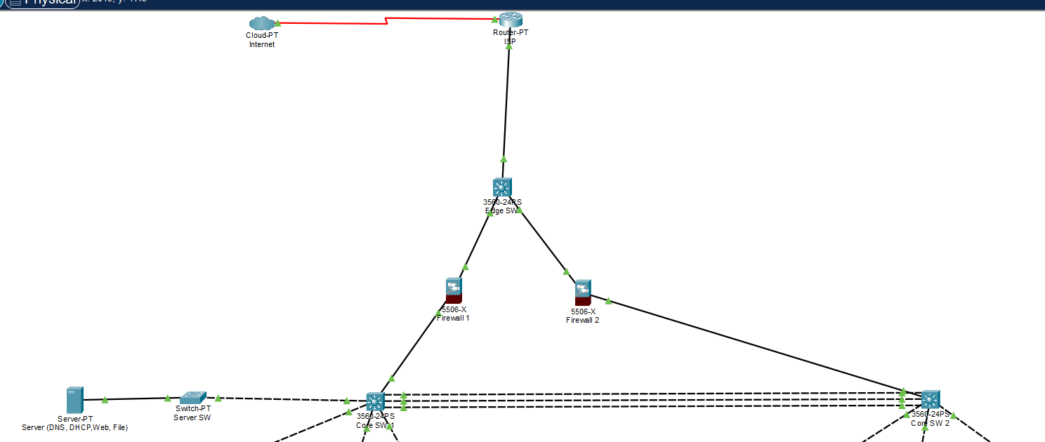
Figure 4. Cisco Packet Tracer Logical workspace: ISP, EDGE-SW, FW1/FW2 and CORE-SW1/CORE-SW2 during the campus build.
Design interpretation: the ISP, firewall pair and two multilayer core switches form the security edge and campus backbone; actual interface addresses and HSRP/OSPF settings are specified in Sections 4, 5 and 8.
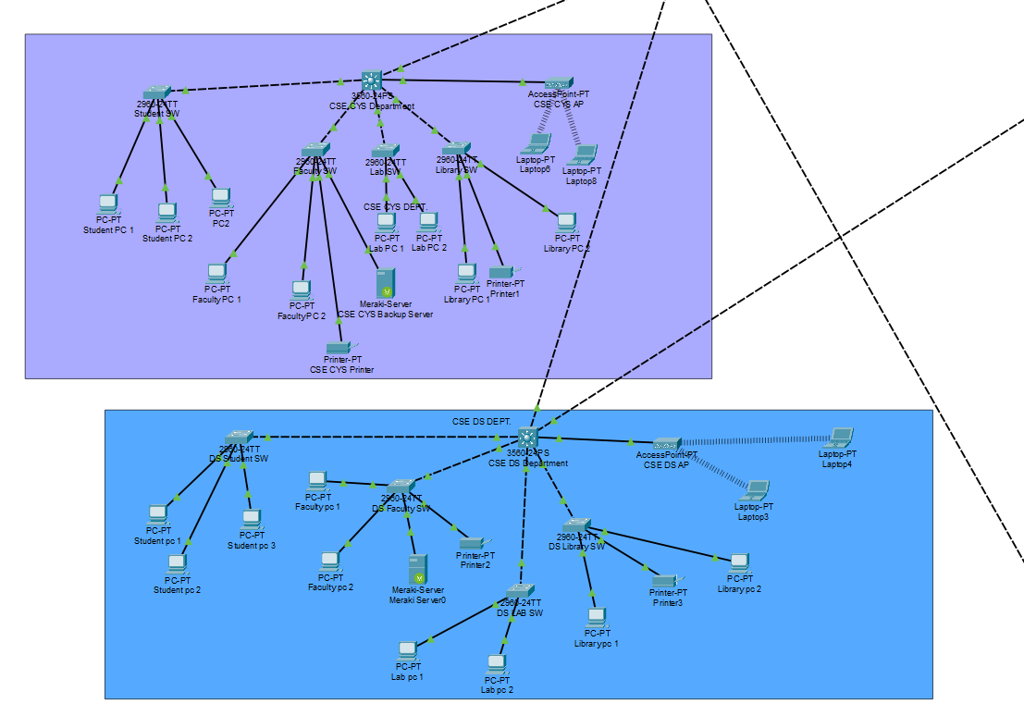
Figure 5. Cisco Packet Tracer Logical workspace: CYS and Data Science distribution/access networks, PCs, APs and server endpoints during configuration.
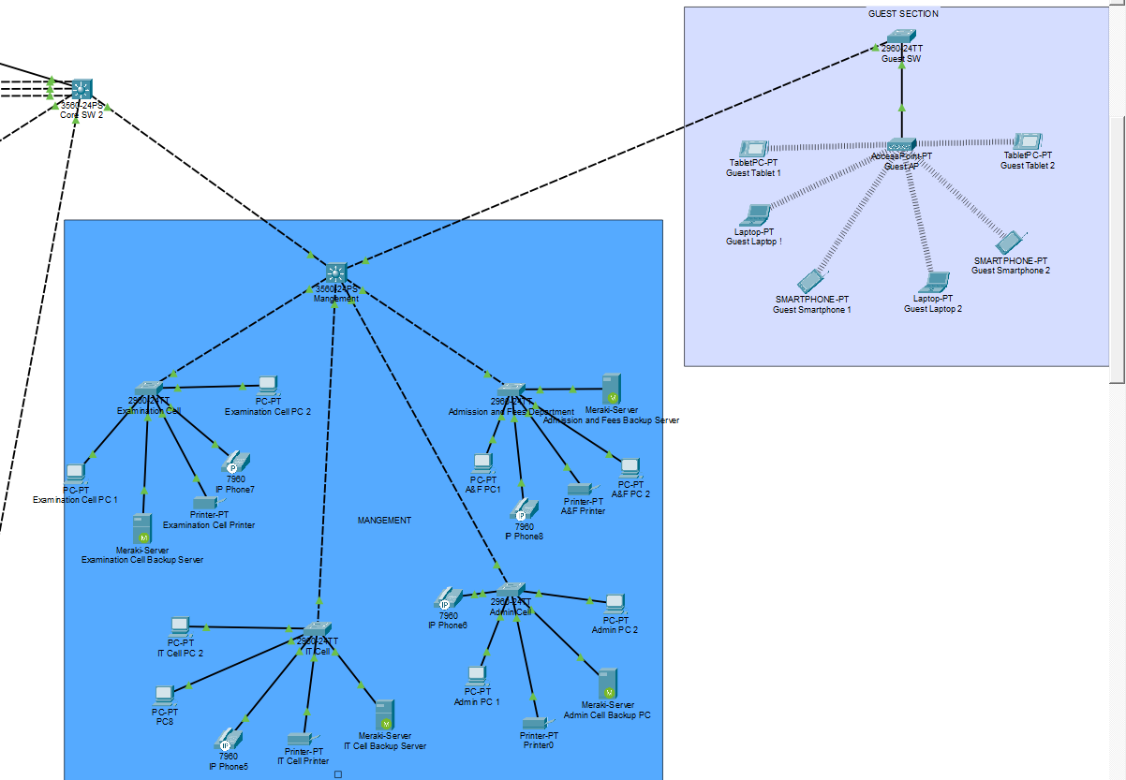
Figure 6. Cisco Packet Tracer Logical workspace: Management IT, Admin, Examination, Admission and Guest wireless network branches.
Evidence note: screenshots document the Packet Tracer design workspace. Exact working states are supported separately by the CLI verification records and tests summarized in Sections 10.1–10.7; screenshots alone do not prove current end-to-end connectivity.

14.4 List of Abbreviations
Abbreviation | Meaning | Use in Smart Campus Project
ACL | Access Control List | A set of permit/deny rules used to control which devices or networks can communicate. In our project, ACLs can be used to restrict Guest VLAN users from accessing internal departmental networks.
AES | Advanced Encryption Standard | An encryption algorithm used to protect wireless communication. It is used with WPA2 on the campus Wi-Fi networks to keep wireless traffic secure.
ASA | Adaptive Security Appliance | Cisco firewall device used between the internal campus network and the outside network. FW1 and FW2 provide security between the core network and EDGE/ISP side.
CDP | Cisco Discovery Protocol | Cisco protocol used to discover directly connected Cisco devices and identify neighboring device names, ports and connections. It was useful for identifying switch uplink ports during configuration.
DHCP | Dynamic Host Configuration Protocol | Automatically provides IP address, subnet mask, gateway and DNS information to clients. Most current campus clients use static addressing, while DHCP can be introduced later for centralized address management.
DNS | Domain Name System | Converts domain names into IP addresses. A central DNS server is planned at 10.10.100.10 in Server VLAN 100.
HSRP | Hot Standby Router Protocol | Provides gateway redundancy using a shared virtual IP address. CORE-SW1 and CORE-SW2 share virtual gateways such as 10.10.10.1, so another core can take over if the active gateway fails.
LACP | Link Aggregation Control Protocol | A protocol used to combine multiple physical Ethernet links into one logical EtherChannel. It is used between the two core switches for redundancy and improved link availability.
LAN | Local Area Network | A network covering a limited area such as a building or campus department. Each department in the project forms part of the overall campus LAN.
NAT/PAT | Network/Port Address Translation | Translates private internal IP addresses into an outside/public address. PAT allows many campus devices to share one public address by using different port numbers. It is planned for final Internet connectivity.
OSPF | Open Shortest Path First | A dynamic routing protocol used to exchange routing information automatically. CORE-SW1 and CORE-SW2 form an OSPF neighbor relationship over the dedicated Layer-3 link.
Po1 | Port-channel 1 | The logical EtherChannel interface created by combining two physical links between CORE-SW1 and CORE-SW2 using LACP.
STP | Spanning Tree Protocol | Prevents Layer-2 switching loops when redundant links exist. It selects forwarding and backup paths between switches.
SVI | Switched Virtual Interface | A virtual Layer-3 interface associated with a VLAN on a multilayer switch. For example, Vlan10 on the core switches provides Layer-3 connectivity for CYS VLAN 10.
VLAN | Virtual Local Area Network | Logically separates users into different broadcast domains. The project uses VLAN 10 for CYS, 20 for DS, 30 for Research, 40 for Management, 60 for Voice and 90 for Guest users.
WPA2 | Wi-Fi Protected Access 2 | Wireless security standard used to authenticate users and encrypt Wi-Fi traffic. It is used for CYS, Data Science and Guest wireless networks.

