 |  | 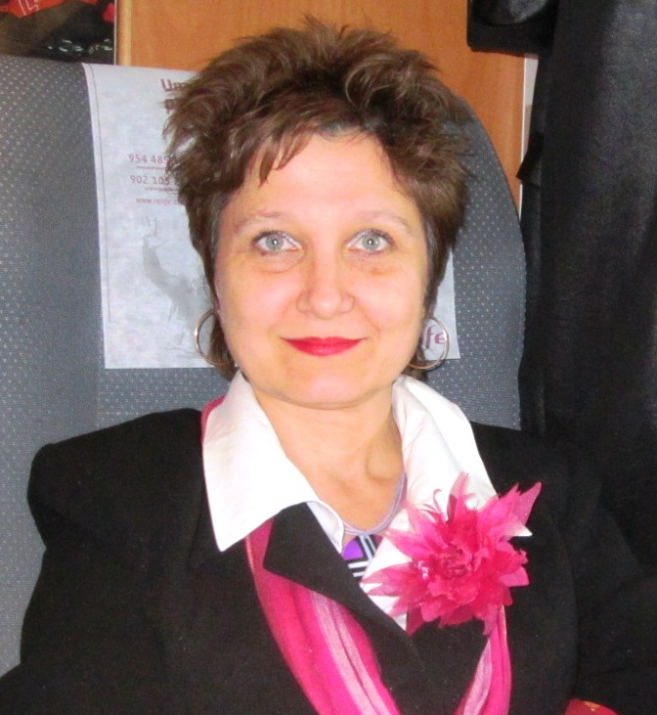
Europass
CV

Personal information

Name |  | Doncheva Julia georgieva
Address |  | ”Petrohan” str., № 96, bl.” V. Bikovski”, p.к.19, Rousse city, post code - 7005
Telephone number |  | 0889 418 514
Fax
E-mail |  | jdoncheva@uni-ruse.bg

Nationality |  | Bulgarian

Date of birth |  | February 13th, Borovo city, Rousse district

work experience

• Dates (from-to) |  | From 1994 to 2008 year ; 2014 year
• Name and address of employer |  | Kindergarten „Rusalka”, „Shumnatica” str. № 4 – to August 31th 2008 year;  Kindergarten „Ralitsa”, “Iskar” str. № 41 – from 01.09.2008 to 01.06.2012 year;  University of Rousse „Angel Kanchev” – from 23. 01. 2010 year – lecturer;  University of Rousse „Angel Kanchev” – from 01.06. 2012 year – basic employment contract
• Type of business or sector |  | Secondary education system  Higher education system
• Position |  | Teacher  Lecturer  Chief assistant, Pedagogy Doctor (Theory of education and didactics)
• Main activities and responsibilities |  | Upbringing and education of preschool children  „Pedagogy of mastering the basic mathematical notions” –as a lecturer  Holder of the following subjects:  „Pedagogy of interaction “child - environment””;  „Methodology of teaching “Man and society””;  “Development of social-pedagogical project”  Methodist at hospetirane, current teaching practice and pre-graduation teaching practice in elementary school and kindergarten.

education and training

• Dates (from-to) |  | Masters in Preschool Education - 1994 year;  First degree retraining protected – 2001 year;  Masters in Psychology and Sociology in Management – 2008 year;  PhD in University of Sofia - department „Theory of Education” – 2008 year;  Protected educational and scientific degree „Doctor” in professional field of „Pedagogy” – 2011 year.
• Name and type of education organization |  | Veliko Tarnovo University "St. Cyril and Methodius "- both Masters;  Department of information and improvement of teachers – Sofia – First Degree Retraining;  University of Sofia „St. Kliment Ohridski” – Doctor of professional field “Pedagogy”
• Principal subjects/professional skills |  | Preschool teacher;  Psychology and sociology in Management;  Doctor of Education (Theory of education and didactics);
• Title of qualification |  | Children’s teacher  Human resources manager  Lecturer

Mother language | Bulgarian language
Foreign languages
Self-evaluation |  | Knowing |  |  |  | Conversation |  |  |  | Writing
European level (*) |  | Listening |  | Reading |  | Conversation participation |  | Monologues
Russian |  | С1 | Free level holding | С2 | Free level holding | С1 | Free level holding | С1 | Free level holding | С1 | Free level holding
English |  | B1 | Separately level holding | B2 | Separately level holding | B1 | Separately level holding | B1 | Separately level holding | B1 | Separately level holding
Romanian |  | А1 | Thoroughly level holding | А1 | Thoroughly level holding | А1 | Thoroughly level holding
 | (*) Единни европейски критерии за познания по езици

social skills and competences  Living and working with other people, in multicultural environments, in situations where communication and teamwork is essential (for example culture and sports), etc.. |  | Work with parents as an educator of children from minority backgrounds inevitably contributes to social skills and competencies by me in favor of fruitful collaboration.

organizational skills and competences  Coordination and administration of people, projects and budgets in professional field, in voluntary work (for example culture and sports) and at home, etc.. |  | chairman of section trade union workplace from 2000 to 2008 year.  Participation in training seminars and conferences to acquire organizational skills and competence in the legal framework in secondary education. Project development.

Technical skills and competences  Work with computers, specific kind equipment, machinery, etc. |  | computer skills in implement programs МS Office WindowsХP Pro  [Word & Ecxel, PowerPoit] Internet - /virtual communication /,  Personal blog - http://julia13.blog.bg/,  Personal website - http://juliadoncheva.com  /виртуално общуване/.
Artistic skills and competences  Music, writing, design, ets.. |  | sheet music literacy and playing musical instruments – accordion;  application design of small sculpture and decoration.

other skills and competences  Competences, not mentioned above. |  | - Won a national competition to write an article on the occasion of the anniversary of the journal "Pre-school education" – 2002 year;  - April 2007 - awarded the National Award on the occasion of anniversary of the magazine "Pre-school Education”;  - Member of the Union of Scientists in Bulgaria - Rousse branch. Adopted on 15.11.2007;  - 126 popular publications at home and abroad (USA);  - Over 27 articles (in magazines) and 23 papers in national conferences with international participation to 2013;  - Training of foreign students under the "Erasmus" (2010 -2011 school year) chose the course Methods of Teaching "Man and Society";  - Delivering lectures from 15 September to 22 September 2012 year. Teacher Training, Teaching Programme Lifelong Learning Programme, Teacher Mobility 2011-2012, ERASMUS Programme, в Comenius Teacher Training Faculty University of Miskolc, Sárospatak, Hungary.  - Training of foreign students under the "Erasmus" (2011 -2012 school year) chose the course Methods of Teaching "Man and Society";  - From 2012 - a member of the Balkan Society for Pedagogy and Education, Branch Bulgaria.  - Education programs of teaching and non-teaching staff (education) and elsewhere on topics requested the Centre for Continuing Education at the University of Rousse "Angel Kanchev”;  - International specialization in Malaga (Spain, 8 April to 12 April 2013) by Sector Program "Study Visits" to the National Agency of the Center for Human Resources Development. Program "Lifelong Learning", topic „Professional profile of teachers today” (Teachers’ and trainers’ continuing professional development and career opportunities);  - Author of Guide seminars in pedagogy interaction "Child - environment," 2012;  - Released in authorship, textbook Pedagogy of interaction "Child - environment," April 2013;  - Participation in “Students practice” - project funded under the Operational Programme "Human Resources Development", co-financed by the European Social Fund. Period 2013 - 2014 year, position - academic mentor.  - Participation in project "Qualification of pedagogical specialists" of the Ministry of Education and Science on Expert position - Module trainer "training teaching professionals for the formation of knowledge, skills and competencies of students appreciate."

