**Study Buddy**

**Tony Ratliff**

**Trayvon McKnight**

**J’lesa Carr**

**User Manual**

**Server Installation**

The server software was written using the Java SE programming language. While the distribution software was compiled with Java 1.8.111, it was designed to be Java 7 compatible as no advanced features from Java 8 was used in this production. To run the software, an "IBM-compatible" machine with an x86 or x64 processor will be required. The system can either be physical or virtual, but should have at least 8 cores at 2.2 GHz or higher, at least 16GB of ram, and at minimum a 500GB hard drive. While the Java programming language is cross-platform, a Linux OS gives the best results when it comes to multiple threads running at highest efficiency. For this report, Ubuntu Server 16.04 is used.

The Study Buddy server is comprised of ten different classes all working in tandem to create a central hub allowing multiple users to communicate with each other. Nine of these classes can run with only the Java JRE, but the class handling the calls to the database requires a database management system. The software was designed around MySQL Server 5.7. This version or latter should be installed on the server machine after Ubuntu Server has been installed and updated. Once MySQL has been installed, a database user should be added which will be used by the server software to access the database. This user does not have to be the root user, the only permissions required are to be able to create the schema, insert into tables, and alter table data. There are no operations such as dropping tables or working in any other database schemas.

While there are many classes in the server software, the entire solution has been packaged into an easy to execute java .jar file named ‘server.jar’. This file, along with other supporting files, are placed into a folder named ‘StudyBuddy’. This folder should be placed on the root of Ubuntu Server file system by copying the folder over from a flash drive or some other type of removable device which can be mounted. The contents of the folder and content descriptions are shown below:

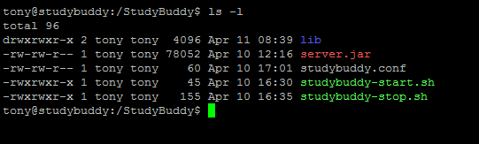

1. **Lib** - Contains the ODBC Driver to communication between Java and MySQL.
2. **Server.jar** - The server executable. This file contains all the different parts of the server software.
3. **Studybuddy.conf** - UPStart config file for starting the server at system startup.
4. **Studybuddy-start.sh** - Bash start script for starting the server.
5. **Studybuddy-stop.sh** - Bash stop script for killing the server process.

After installing the OS, MySQL , Java JRE 7 (or higher), and copying the contents of the StudyBuddy folder to the root directory, the server may now be started. For the purposes of troubleshooting any issues that may arise on the first startup, it is recommended to initially start the software from the command line to address any issues which may not allow the server to start with the system on startup. The server will start by running the start script with the following command: ./studybuddy-start.sh from the StudyBuddy folder. A successful start should appear as the following:

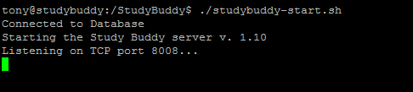

However, there are four possible issues which may cause the server not to start.

1. **ODBC Driver Missing** – this error results when the contents of the lib folder are missing or not available. To correct this error, please verify the folder exists and has not been moved or accidently deleted.
2. **Database Server Not Running** – this error results when the MySQL server is either not installed, its service is not started, or the server is running on a port other than the default 3306. Please verify MySQL installation and that the DBMS is running. Avoid configuring the server for any other port.
3. **Incorrect User or Password** – this error results when the DBMS is available, but the studybuddy user has either not been set up, or the password is incorrect. Please verify these two issues have been resolved.
4. **Port In Use** – this error results when port 8008 is being used by another application. This error could also show when trying to start the server again after it is already running. Please ensure no other instances of the server is running.

Any of the above issues will prevent the server from starting, however if there are no problems and the server starts as it does in the image above, the server is now ready and listening for incoming connections from the Study Buddy Client. The software looks for the correct tables used by the application. If the tables are not present, the database schema is created as well as all the required tables for the software to properly run. The following image shows a server log file from normal operation:

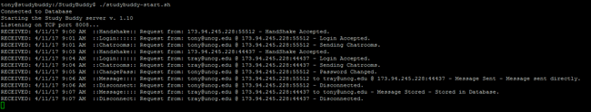

While the log is displayed in the shell, the log is also stored in a file when the shell is not available. Once the server accepts and correctly processes incoming connections, the software should now be set to run when the system is started regardless if there is a user logged into the machine or not.

Within the StudyBuddy folder, there is a file named ‘studybuddy.conf’. The shell user should log in as the root user on the Ubuntu server. Once logged in as root, copy the file from the StudyBuddy folder over to the /etc/init folder. Restart the Ubuntu system and the Study Buddy server software should run whenever the system is started.

**User Manual:**

**How to Install on Device:**

Since Study Buddy is currently not an app on the Google Play Store, there are a few extra steps that must be taken before the app can be installed.

1. Go to Settings
2. Navigate to General Setting (if needed)
3. Navigate to Security
4. Check Unknown Sources
5. Then go to studybuddy.uncg.edu

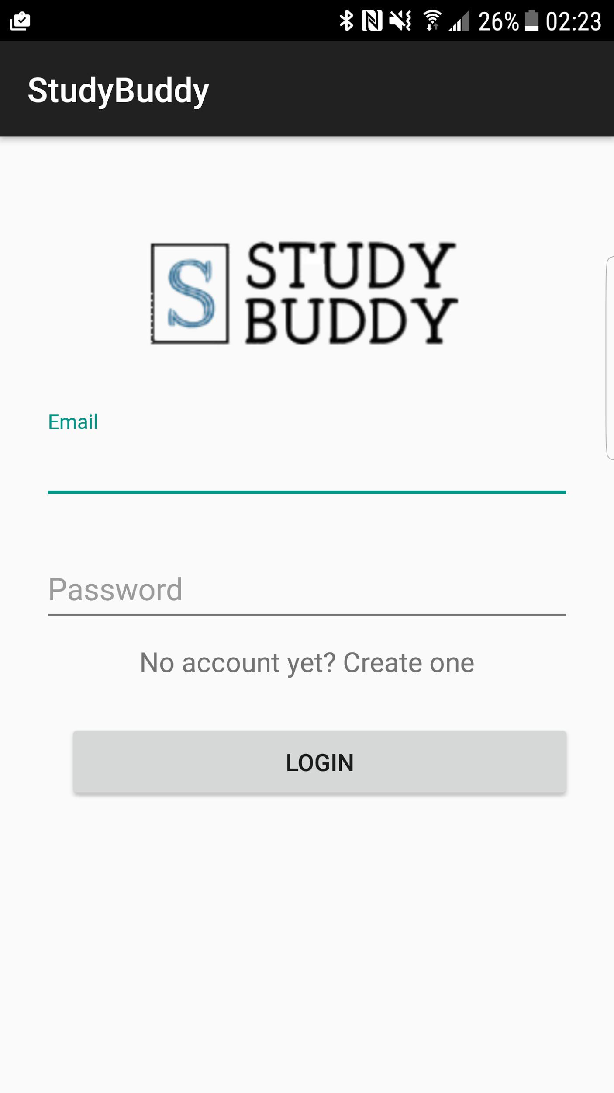

If you have already used this app before, or have registered previously, enter your email and password and tap the Login button to log into Study Buddy. Otherwise, tap the “No account yet? Create one” link.

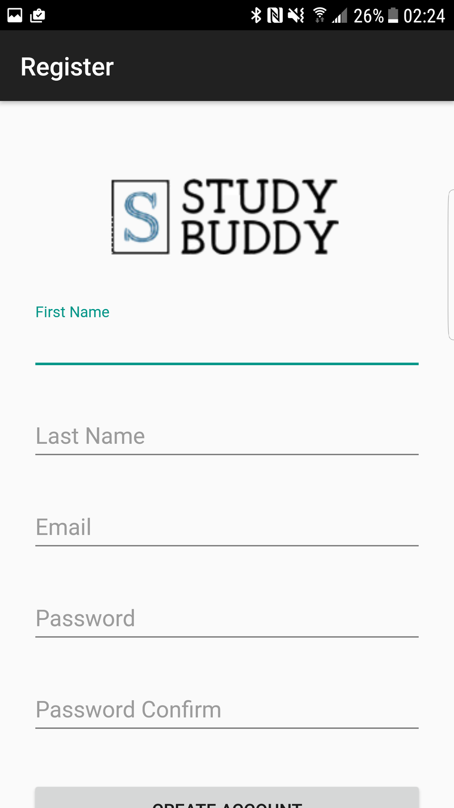

To register for Study Buddy, fill out the form and tap the Create Account button. If you already have an account, tap the “Already a member? Login” link.

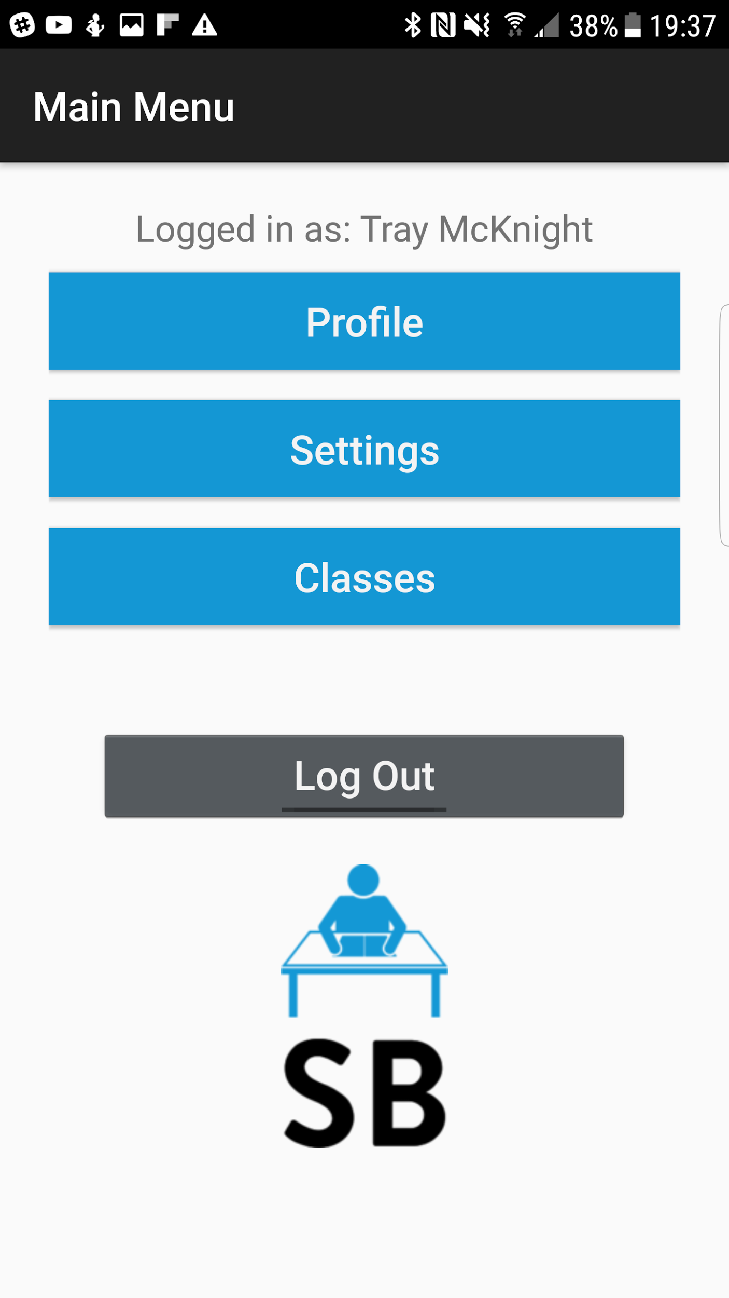

The main menu offers a central location where you can navigate to all the Study Buddy’s features. From the main menu you can look at your profile, go into the settings, look at the classes you are taking, or logout.

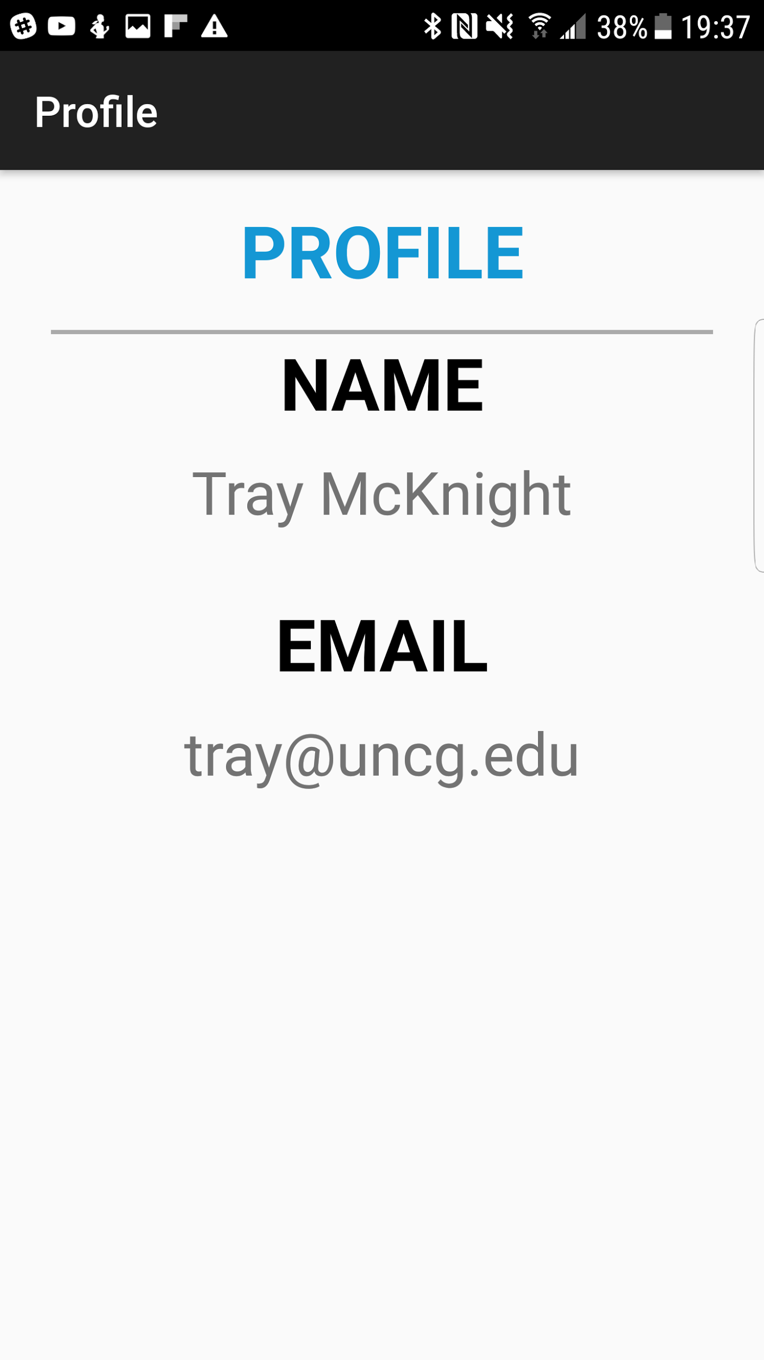

Clicking on the profile button takes you to a profile page that displays basic information about the user.

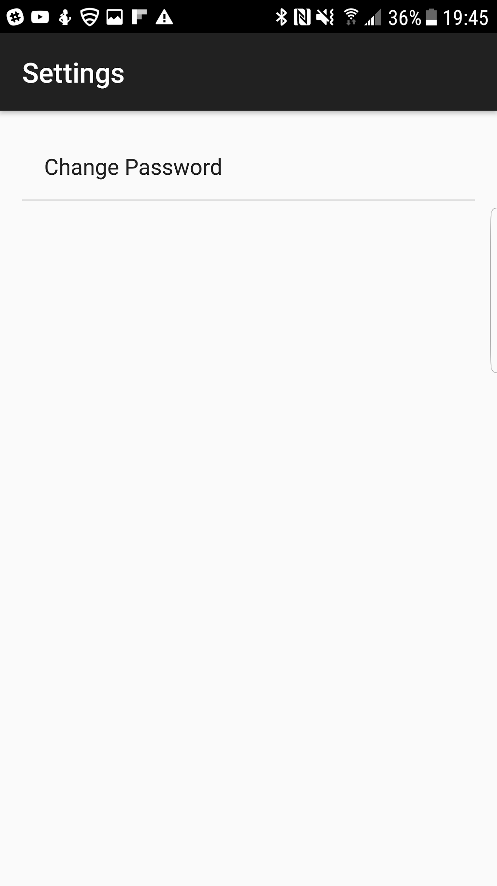

In the settings menu you have the ability to change your password.

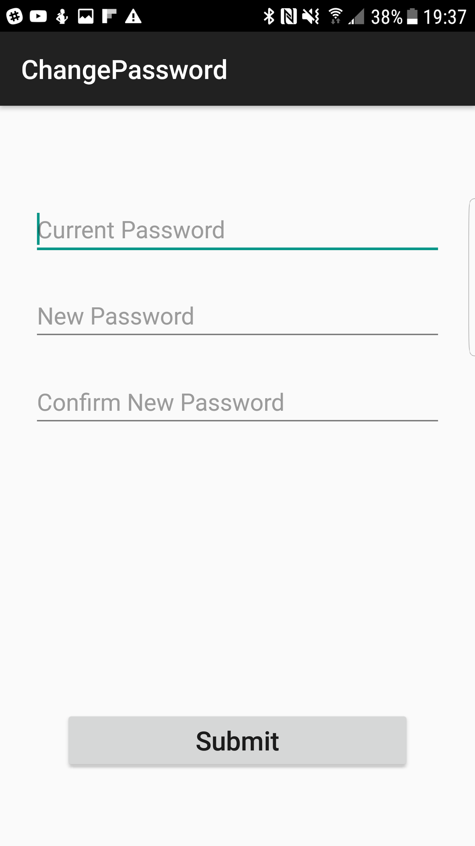

To change your password, simply enter your current password, and the new password.

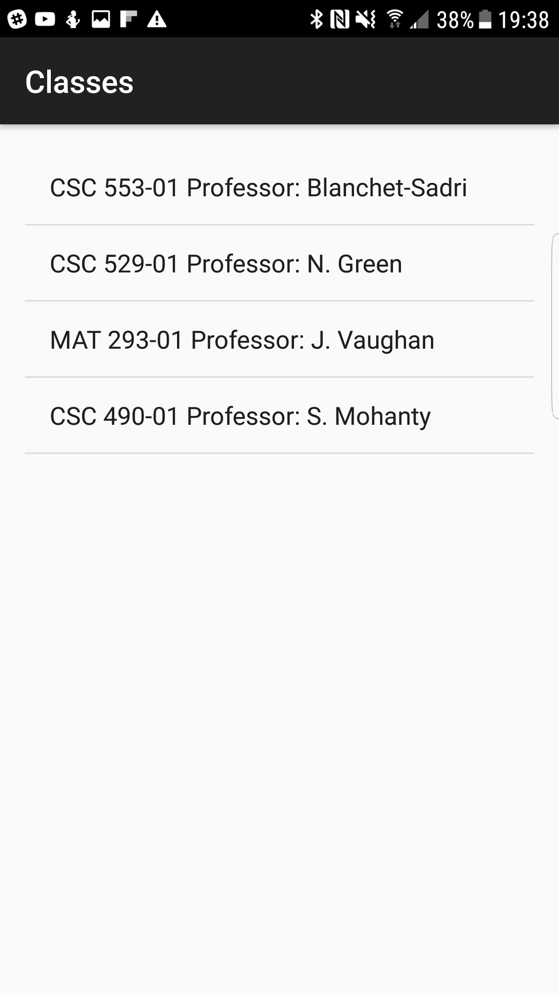

If you choose classes from the main menu, you will have all of the classes you are currently enrolled in displayed in a list.

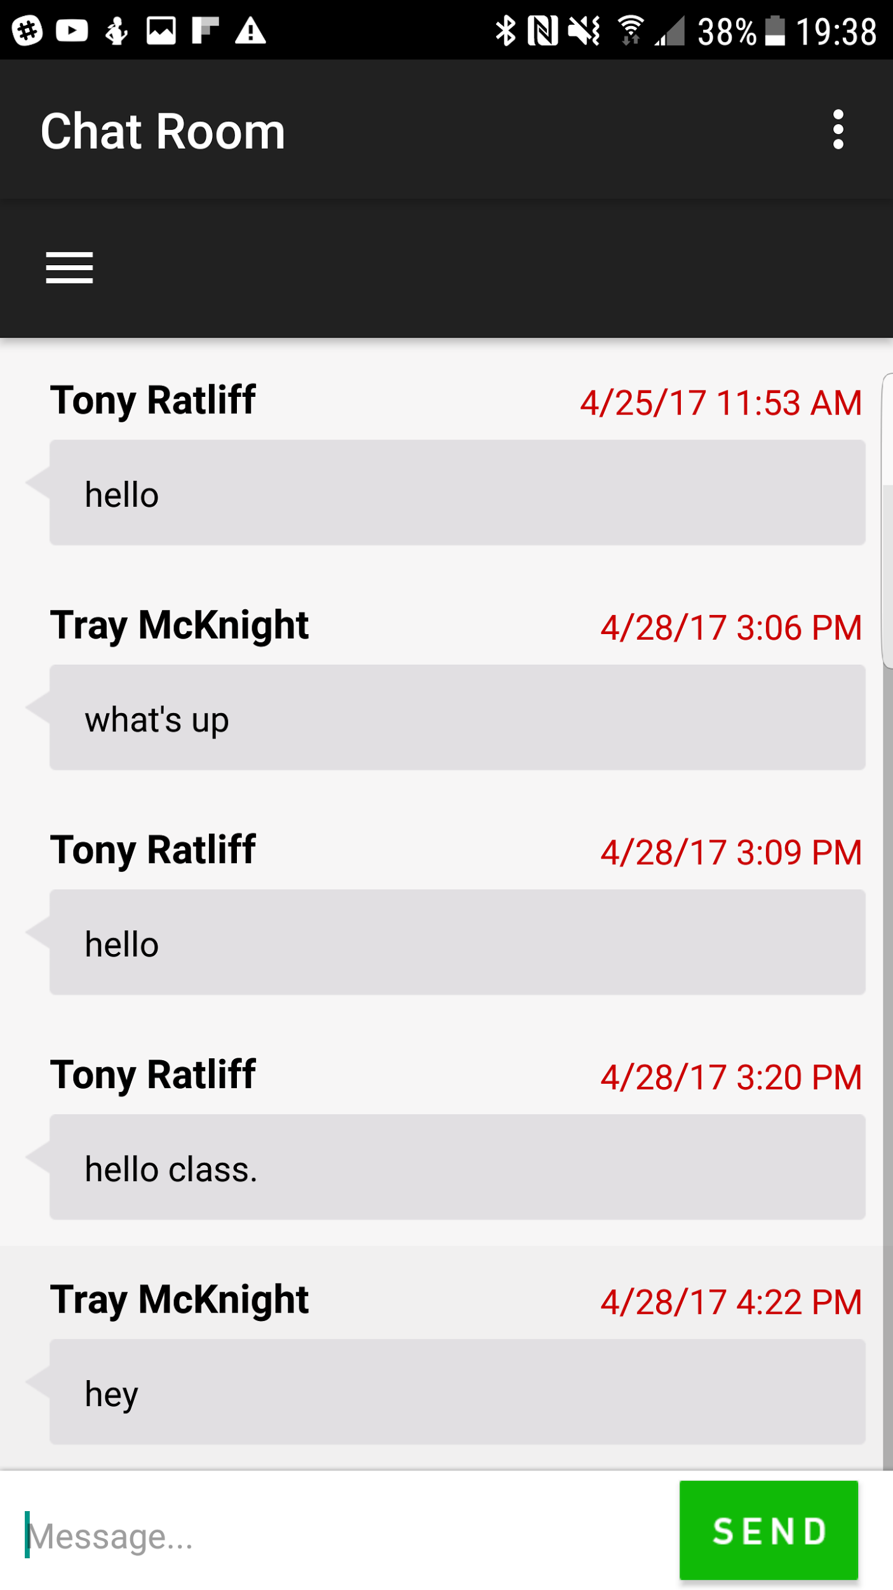

Upon selecting a class from the classes menu, you will be taken into the chat room for that class. The chat room is accessible by every student who is enrolled in that particular class. To type a message, tap the text box at the bottom of the screen. After entering a message, tap the green SEND button.

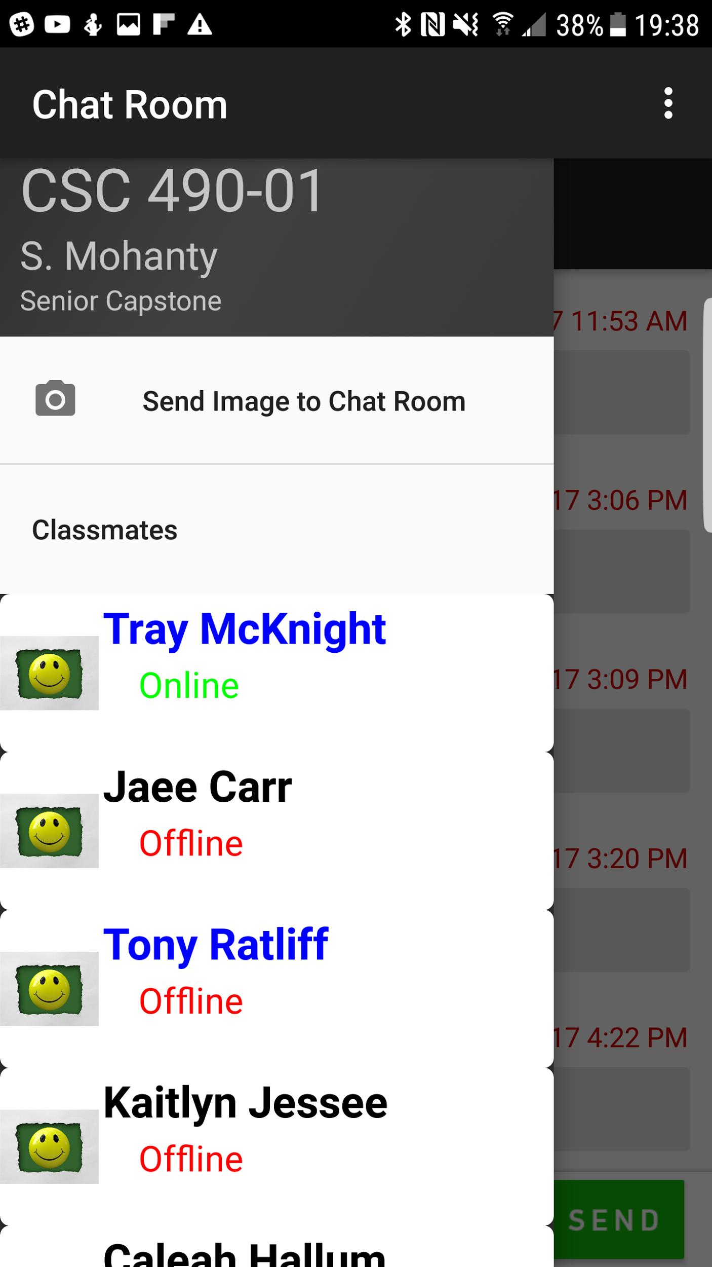

Tapping the menu icon in the top left corner of the Chat room opens the drawer. In the drawer, every student in the chat room is listed. The drawer tells you who is currently online and who is not. It also tells you who was present in class the last time attendance was taken, giving the user an idea of who to ask or send notes to. Names in blue were present, while names in black were absent. Tapping the send image icon will allow you to capture a photo to send in the chat room. Tapping on a user opens up a private chat between you and the other user.

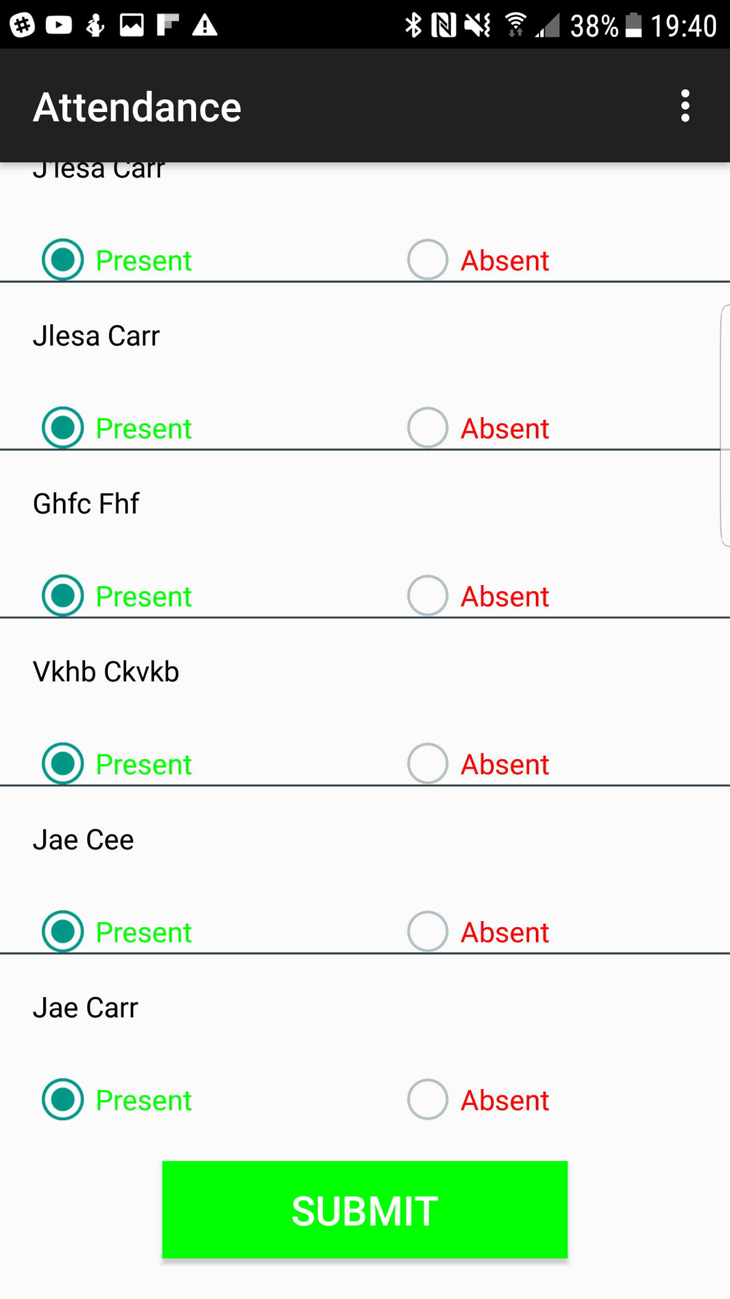

If a professor logs in, their Main Menu will contain an attendance button. The attendance button opens up a class list(similar to the students) of all the classes the professor teaches. If a class is selected, the professor will have the option to take attendance. Upon submitting, on the next login, the attendance changes will be reflected in the Chatroom drawer.