Jared Kelnhofer

Polynomial Regression

3-7-2020

**What I did:**

For this project, I relied heavily on the book that we are using in class, and the documentation of Numpy. I used a lot of visualization tools, and verbose print() statements during the project, so that I could track the changes do different variables.

**Challenges I encountered:**

The most challenging thing for me with this project was wrapping my head around what was actually going on behind the scenes. It took a long time for me to understand how the underlying data structure worked, and I made a few false starts with different algorithms. Once I had my project as far along as I was able to get it, my largest challenge was choosing good hyperparameter values. I manually tweaked them, as I wasn’t really sure how to optimize those, unless it was with gradient decent, and that seemed a bit like circular dependence. I also had to deal with the fact that certain numbers of iterations were too slow for the computer to handle, so I couldn’t really explore those routes.

**The end result:**

I would say that I am now able to get my thetas to within 60-70% accuracy on average, with a lot of hand-tuning. It’s definitely not ideal, but this is the best version of the project that I have created so far. Below is the prediction that my fifth-degree polynomial created of a third-degree function:

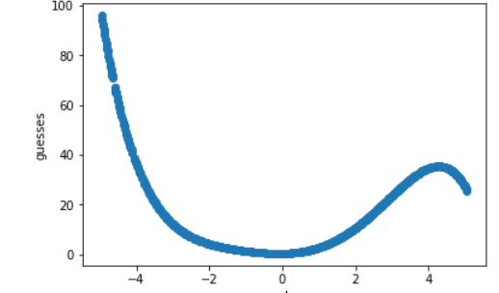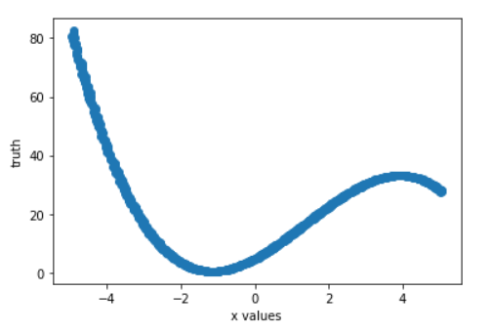

**Final thoughts:**

I definitely had a tough time with this assignment, but it helped me to understand a lot more about what is going on behind the scenes with our algorithms, and gain a bit of intuition regarding matrices and vectors. I really like the idea of plotting the cost of a function at different locations and finding the lowest point. It’s pretty mind-blowing.