PROJECT CONCORD — FINAL REPORT
The Veridian Unified Data Platform — Meridian Retail Team Deliverable
To: Mr. Saviour Henry
From: Team Meridian Retail
Date: 25 August 2026
Subject: Project Concord — Final Report: Platform Build, Four-Scenario Proof, and Dashboards

1. Executive Summary
Team Meridian Retail set out to build the Veridian Core Platform: a single, well-governed PostgreSQL database (on Supabase) unifying the five previously disconnected Veridian divisions — Meridian Retail, Concord Logistics, Veridian Financial Services (VFS), AgriCore, and Veridian Properties — plus an analytical layer in BigQuery feeding executive and divisional dashboards.
The platform is now built end-to-end: all divisional schemas are implemented, Row Level Security is enforced role-by-role, and the four stakeholder scenarios named in the original brief have each been solved and demonstrated with a working SQL view against real (synthetic) data. Four dashboards are live, covering inventory signals, farmer credit risk, retail sales, and an executive-level summary.

2. Recap of the Business Problem
Veridian Consolidated Holdings' five divisions have run on disconnected systems for two decades. Two earlier attempts to unify them (2019, 2022) failed from scope creep and over-ambitious schema design. This brief corrected that by fixing scope up front and defining success as four concrete, demonstrable stakeholder scenarios rather than an abstract "unified database."

3. What Was Built
- A hub-and-spoke schema: a Core Services Hub (customers, employees, suppliers/vendors, locations, product catalogue, a divisions lookup table) referenced by five divisional modules
- Two Supabase/PostgreSQL projects (veridian-dev, veridian) — the production database has been stood up and seeded from the same migration scripts used in development, without the test rows
- Row Level Security on every table, tested end-to-end with per-division test accounts (retail, logistics, VFS, AgriCore, properties, executive)
- Consent-flag columns on customer data (retail loyalty personalisation, financial-services visibility) in line with the Nigerian Data Protection Act
- A synthetic, reproducible data generator with deliberate cross-divisional overlap, so the four scenarios below have real rows to demonstrate against
- An analytics layer feeding four Power BI dashboards, built directly toward proving the four scenarios rather than as generic reporting

4. Answering the Four Scenario Questions
The brief defined success as the platform being able to answer four specific, named stakeholder questions live. Each is addressed below with what was needed, how it was solved, and the demo evidence.

Problem 1
Ngozi (Meridian Retail) — can a harvest shortfall at AgriCore warn a store before a delivery fails to arrive?
What the scenario actually needed:
A way to trace a specific harvest shortfall, several steps upstream, forward to the specific store expecting that stock — before the delivery is due, not after it fails to show up.
How it was solved:
We followed the real physical chain the brief describes: harvest_batches → processing_runs → wholesale_shipments (filtered to destination_type = 'meridian_retail') → optionally shipments (Concord Logistics). The view retail_supply_shortage_signal joins across all four, comparing each harvest's volume to that farm's own historical average for the same product.
Evidence / demo result:
- A harvest at less than 60% of that farm's historical average is flagged high_risk_shortfall; 60–85% is flagged moderate_risk_shortfall
- 20+ rows returned, correctly flagged, with harvest volumes running 8–30% of historical average for the flagged rows
- Each row is tied to a real destination store and a real shipment status (delivered, delayed, scheduled, or blank — a blank is realistic: a wholesale dispatch can be recorded before a logistics leg exists)
SELECT * FROM retail_supply_shortage_signal LIMIT 20;

Problem 2
Chinedu (VFS loan officer) — can a farmer's supply history with AgriCore inform a lending decision, not just 2 years of banking history?
What the scenario actually needed:
VFS access to AgriCore's farms and harvest_batches data, without opening any other AgriCore data and without giving AgriCore any new access in return.
How it was solved:
Two additive Row Level Security policies grant the financial_services role read access to farms and harvest_batches only. Nothing about agricore_ops's own access changed. This mirrors a cross-role grant pattern already used elsewhere in the schema (warehouses and wholesale_shipments), so it extends an existing, defensible principle rather than introducing a new one under pressure.
Evidence / demo result:
- The view vfs_borrower_supply_history joins suppliers_vendors → farms → harvest_batches, giving a loan officer harvest count, first/most recent harvest date, and lifetime volume per farmer
- RLS was verified with seeded test rows: the VFS test account could read the data; the retail test account, querying the same table, correctly got back an empty result
SELECT * FROM vfs_borrower_supply_history LIMIT 20;
Honest caveat: Every row currently shows total_harvests_recorded = 1, because the synthetic dataset gives each farm a single harvest event rather than a multi-year history. The access mechanism and the join are correct and demonstrable; the report should not claim "six years of supply data" — the depth of history simply is not in the synthetic dataset yet.

Problem 3
Funmi (Concord Logistics dispatcher, Ibadan) — can Logistics see a warehouse's current lease status before a truck shows up, so a lease change from Properties doesn't blindside them again?
What the scenario actually needed:
Two separate things: (a) a way to guarantee lease data itself can't go inconsistent, since that inconsistency is what let the amendment go untracked in the first place, and (b) a way for a Logistics role to actually see Properties' lease data, which it previously had no access to at all.
How it was solved:
For (a): a lease_status column plus a partial unique index (idx_one_active_lease_per_tenant) that permits at most one active lease per tenant at the database level — the exact class of conflicting-record error that caused Funmi's problem is now physically rejected. For (b): a retroactive warehouses.leased_from_property_id foreign key connects a warehouse to its property, plus an RLS grant giving both properties_ops and logistics_ops read access to warehouses. Neither alone shows lease status, so the view logistics_warehouse_lease_status joins warehouse → property → active lease → tenant into one queryable answer.
Evidence / demo result:
- Most warehouses returned NULL lease data (no active lease on record); one showed a real active lease with start/end dates and tenant type
- That contrast is the actual demo: the platform can now distinguish verified, currently-leased capacity from capacity nobody has confirmed is secured — precisely the ambiguity that cost Funmi six hours
SELECT * FROM logistics_warehouse_lease_status LIMIT 20;

Problem 4
Adaeze (Group CEO) — can she get a same-day, consolidated revenue view across all five divisions, instead of waiting 21 days for a hand-built one?
What the scenario actually needed:
Fast consolidation across all five divisions at once — a different problem from scenarios 1–3, which each connected exactly two divisions. This is what the brief assigns to the BigQuery/dashboard layer rather than a single cross-divisional join.
How it was solved:
group_consolidated_revenue_snapshot unions the three revenue-bearing fields that genuinely exist in the schema today: pos_transactions.total_amount (Retail), leases.monthly_rent for active leases only (Properties), and merchant_settlements.total_amount, which is already keyed by division_id (VFS money moving out to other divisions — Retail and AgriCore both appear in results).
Evidence / demo result:
- Real daily figures returned in one query — e.g. Retail doing roughly ₦362M on 10 August alongside AgriCore picking up ₦1.5M in wallet settlements the same day
- One query, same day, replacing 21 days and five manual systems
SELECT * FROM group_consolidated_revenue_snapshot LIMIT 30;
Honest caveat: Logistics and AgriCore's own wholesale revenue are not yet included — the schema does not currently have a clean sellable-amount column for freight or wholesale shipments. This is a real, named scoping gap, not a bug, and is flagged here rather than glossed over.

5. Dashboards
Four Power BI dashboards were built directly toward proving the scenarios above, rather than as general-purpose reporting.

5.1 Store Inventory Signals Dashboard
Surfaces the reorder alerts and stock-vs-threshold picture that scenario 1 depends on — 690 reorder alerts and a 100% reorder rate across the stores in the current dataset, with a detailed low-stock and reorder-threshold table drillable by store and product.
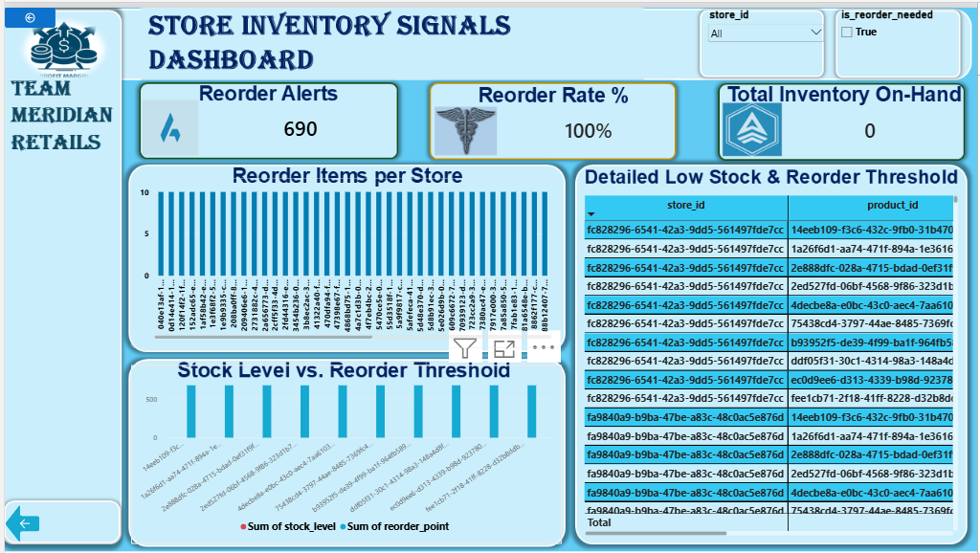
Store Inventory Signals Dashboard

5.2 Farmer Credit & Risk Exposure Dashboard
Gives VFS the AgriCore-informed lending view from scenario 2: ₦1.42bn total principal issued, ₦644.89M in repayments, ₦770.40M outstanding, a 45.57% repayment rate, and a farmer-level loan and repayment ledger broken out by cooperative.
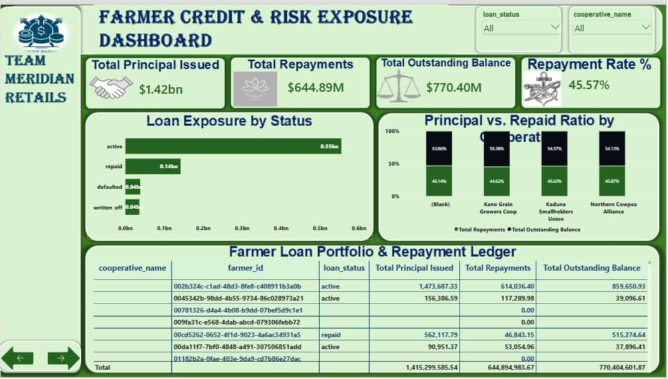
Farmer Credit & Risk Exposure Dashboard

5.3 Retail & Sales Overview Dashboard
₦19.08bn total revenue, 4.59M units sold, and an average unit price of ₦4.15K, with revenue trend, top products by revenue, and payment method share (cash, card, wallet, other) — the wallet share is the read-only signal that a loyal customer paid via their VFS wallet, without any foreign key into VFS itself.
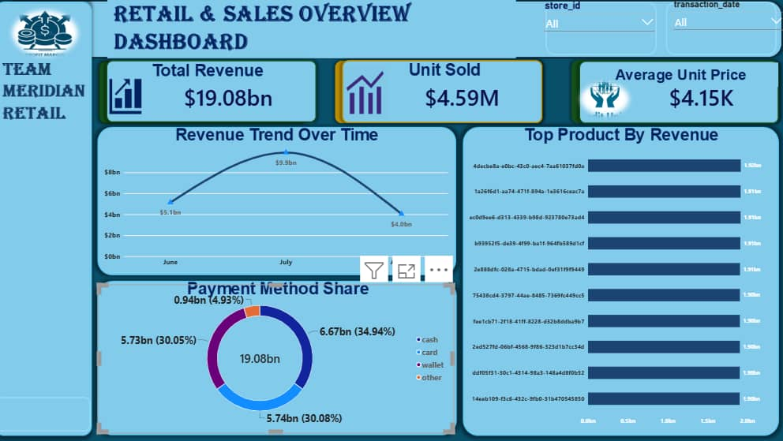
Retail & Sales Overview Dashboard

5.4 Executive Overview Dashboard
The consolidated, cross-divisional view scenario 4 asked for: total net revenue, stockout alerts, outstanding credit risk, and portfolio health rate in one place, alongside a risk-profile-by-cooperative breakdown and a multi-pillar summary table spanning revenue and outstanding balance by store.
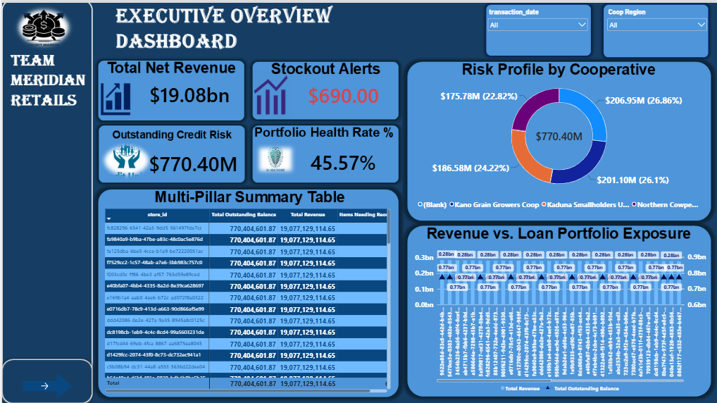
Executive Overview Dashboard

6. Key Design Decisions
- Hub-and-spoke architecture: a Core Services Hub referenced by all five divisional modules, indexed to keep foreign-key lookups fast against large tables
- No foreign keys into VFS from any other division — VFS data is reached only through the specific, named RLS grants described in Problem 2, never through a structural join
- Deliberate denormalisation: inventory_stock_levels is stored as a mutable current-state row (one per store-product) rather than recomputed from full transaction history on every read, because floor stock lookups need to be instant
- A repeated polymorphic-reference pattern (exclusive nullable columns + CHECK constraint) used three times — loans, tenants, and wholesale_shipments — everywhere an entity can point to exactly one of several different kinds of related things
- UUIDs used throughout instead of serial IDs, to avoid visual overlap between similar-looking columns across tables
- Consent-flag columns for retail loyalty personalisation and financial-services visibility, in line with the Nigerian Data Protection Act

7. Known Limitations
- Synthetic data gives each farm a single harvest event, not multi-year history — the supply-history mechanism in Problem 2 is correct and demonstrable, but the depth of history is not yet realistic
- The consolidated revenue view (Problem 4) does not yet include Logistics freight revenue or AgriCore's own wholesale revenue, because the schema lacks a clean sellable-amount column for either
- Veridian Properties' full divisional module (maintenance requests, valuations, utility accounts, facility assets) is designed but not yet built — only the tables needed for the lease-status scenario (properties, leases, tenants) are implemented

8. Status & Next Steps
- Production database stood up (in progress) — migrations already run against it without test rows
- ERDs, data dictionary, normalisation reasoning, and RLS reasoning to be bundled as one documentation pass, since they reference each other
- Query performance review (EXPLAIN ANALYSE on the four scenario views) once fuller data volumes are loaded
- Final report assembly and submission packaging

9. Conclusion
All four stakeholder scenarios named in the brief have been solved with a working, queryable view against real synthetic data, not just designed on paper. Where the current data or schema falls short of the ideal (harvest history depth, freight/wholesale revenue), that gap is named directly above rather than glossed over. The team is on track to move from a working implementation to full documentation and submission packaging.
Submitted by:
Team Meridian Retail

Team Members
Name | Role / Responsibility
Treasure Ani-Joseph | Database Engineer (Implementation & Security) — Lead
Nsikak-Abasi Inyang | Analytics & BI Developer; also assisting Treasure with development
Kenny Bassey | Analytics & BI Developer
Johnson Chukwuka | Analytics & BI Developer
Edikan Okon | Analytics & BI Developer
Mkpouko-Abasi John | Documentation & QA Lead; also assisting Johnson Chukwuka with BI Analysis

