PMC Managers
Response to the Commercial & Institutional Review
Governance · Security · Implementation · Commercial terms
Prepared 02 November 2026 · www.pmcmanagers.com
Covering note
Dear [Reviewer name],
Thank you for your careful review of the PMC Managers proposition and for the twelve points you raised. We agree that buyers, governments, development institutions, lenders and auditors will ask exactly these questions, and we would rather answer them with evidence than with assurances.
This reply takes each point in turn. For each one we explain how the platform works today, show the screen where it happens, and say clearly where a control is automatic, where it can be independently checked, where the buyer remains responsible, and where work is still in progress. We have followed your recommendation and grouped the answers into the three sections you proposed: A. Governance, Compliance and Integrity; B. Technology, Security and Operational Reliability; and C. Implementation, Accountability and Commercial Sustainability. Part D then walks through one tender from start to finish, with a screenshot of every step, and Part E sets out the responsibility matrix you asked for.
Yours sincerely,
[Name]
Chairman, PMC Managers
How to read this reply
You asked us to distinguish what the platform enforces automatically, what can be independently verified, and what remains the buyer's responsibility. Every answer below is labelled accordingly:
- [ENFORCED] built into the software; a user cannot skip or switch it off from the screen.
- [VERIFIABLE] an outside party (auditor, bidder, lender) can check it without relying on our word.
- [BUYER] the platform supports it, but the decision or obligation stays with the buyer.
- [IN PROGRESS] partly built, or being connected; we state plainly what is not yet live.
- [TO CONFIRM] a contractual or commercial commitment PMC Managers will confirm in writing; not a software feature.
All screenshots were taken from the PMC Managers platform on 02 November 2026 using clearly marked demonstration records (shown as “Demo”). No live buyer or supplier data is shown.

Summary of answers
# | Your point | Where answered | Position today
1 | Legal & regulatory compliance | A1 | ENFORCED (register, country rules) + BUYER (local law)
2 | Cybersecurity & data protection | B1 | ENFORCED; independent test IN PROGRESS
3 | Independent oversight committee | A2 | ENFORCED (workflow) + TO CONFIRM (charter)
4 | Dispute resolution | A3 | ENFORCED (debrief, window, holds) + IN PROGRESS (formal appeals)
5 | System integrity | B2 | ENFORCED + VERIFIABLE
6 | Technical evaluation & conflicts | A4 | ENFORCED
7 | Integration capabilities | B3 | ENFORCED (exports, webhooks) + IN PROGRESS (ERP connectors)
8 | Service levels & continuity | B4 | ENFORCED (published standard) + TO CONFIRM (contract SLA)
9 | Implementation & onboarding | C1 | ENFORCED (guided onboarding, manuals)
10 | Insurance & liability | C2 | TO CONFIRM
11 | Commercial pricing clarity | C3 | ENFORCED (fee engine) + TO CONFIRM (tier table)
12 | Independent validation | B5 | IN PROGRESS

Section A — Governance, Compliance and Integrity
Why buyers, boards, lenders and auditors can have confidence in how a tender is run.
A1. Legal and regulatory compliance (your point 1)
Raised: How PMC Manager adapts to different national procurement laws, public procurement regulations, data protection requirements and electronic signature legislation.
- [ENFORCED] Every tender is created for a specific country. The country decides which tender templates, fee rules, date rules and currency apply, and the AI tender builder drafts sections against that country's master template.
- [ENFORCED] A per-country legal register, visible to the board, records whether PMC Managers is legally cleared to operate in each country (approved / pending / blocked), who gave the opinion, and a full change history.
- [ENFORCED] Buyers can be classified as public or private. One officer classifies and a different officer must verify; the person who classified cannot verify their own entry.
- [ENFORCED] Data protection: suppliers can export or permanently anonymise (“forget”) their own data from their account. Documents are visible only to the roles that need them.
- [ENFORCED] Electronic signatures: committee members sign each bid opening electronically inside the platform (name, time and network address are recorded). Escrow releases and contracts use DocuSign, which provides a signature certificate recognised under the major e-signature laws (for example the US ESIGN Act and the EU eIDAS Regulation for advanced/simple signatures).
- [BUYER] Whether a particular procurement must follow a specific national statute (thresholds, mandatory advertising periods, domestic preference rules) remains the buyer's legal decision. The platform makes these settings available per tender; it does not replace the buyer's legal adviser.
- [TO CONFIRM] Formal legal opinions for each target country, and a data-processing agreement template for buyers, will be supplied with the contract.
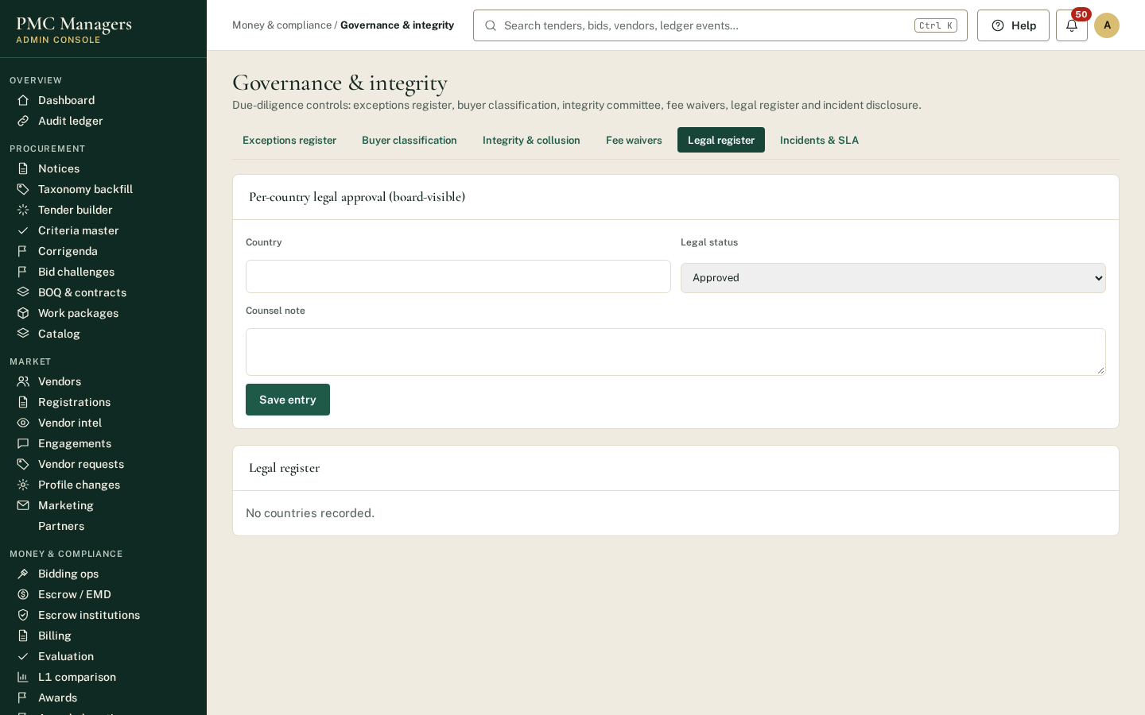
Figure 1. Board-visible per-country legal register (Governance & integrity → Legal register).
A2. Independent oversight — the Procurement Integrity Committee (your point 3)
Raised: Composition, appointment, independence, responsibilities and authority of the Independent Procurement Integrity Committee.
What the software enforces today:
- [ENFORCED] Any officer can place an integrity hold on a tender. The committee reviews and votes; a case follows a fixed sequence (raised → under review → resolved) and a resolved case cannot be quietly reopened or changed.
- [ENFORCED] A senior officer can overrule the committee only on the record: the override, its author and the reason are written to the audit ledger, logged in the exceptions register and flagged as publicly disclosable.
- [ENFORCED] A collusion-indicator scan highlights bidders on the same tender who share an email domain, phone, address or bank account, or who repeatedly bid together. These are prompts for review, not findings of wrongdoing.
What PMC Managers proposes to adopt as the committee charter (for confirmation):
Item | Proposed position
Composition | [3] members: [1] independent chair with procurement or audit background, [1] legal member, [1] member nominated by the buyer or lender. No member may work on the tenders they oversee.
Appointment | Appointed by the PMC Managers board for [2] years, renewable once; independent chair approved by [the board / the lender].
Independence | Annual declaration of interests; recusal on any tender involving a related party; no remuneration linked to tender volumes.
Authority | Can suspend any tender, require re-evaluation, refer to the buyer's audit body, and publish a finding. Overrides by management are recorded and reported to the board.
Reporting | Quarterly report to the board and, where agreed, to lenders: holds raised, cases resolved, overrides, collusion indicators reviewed.

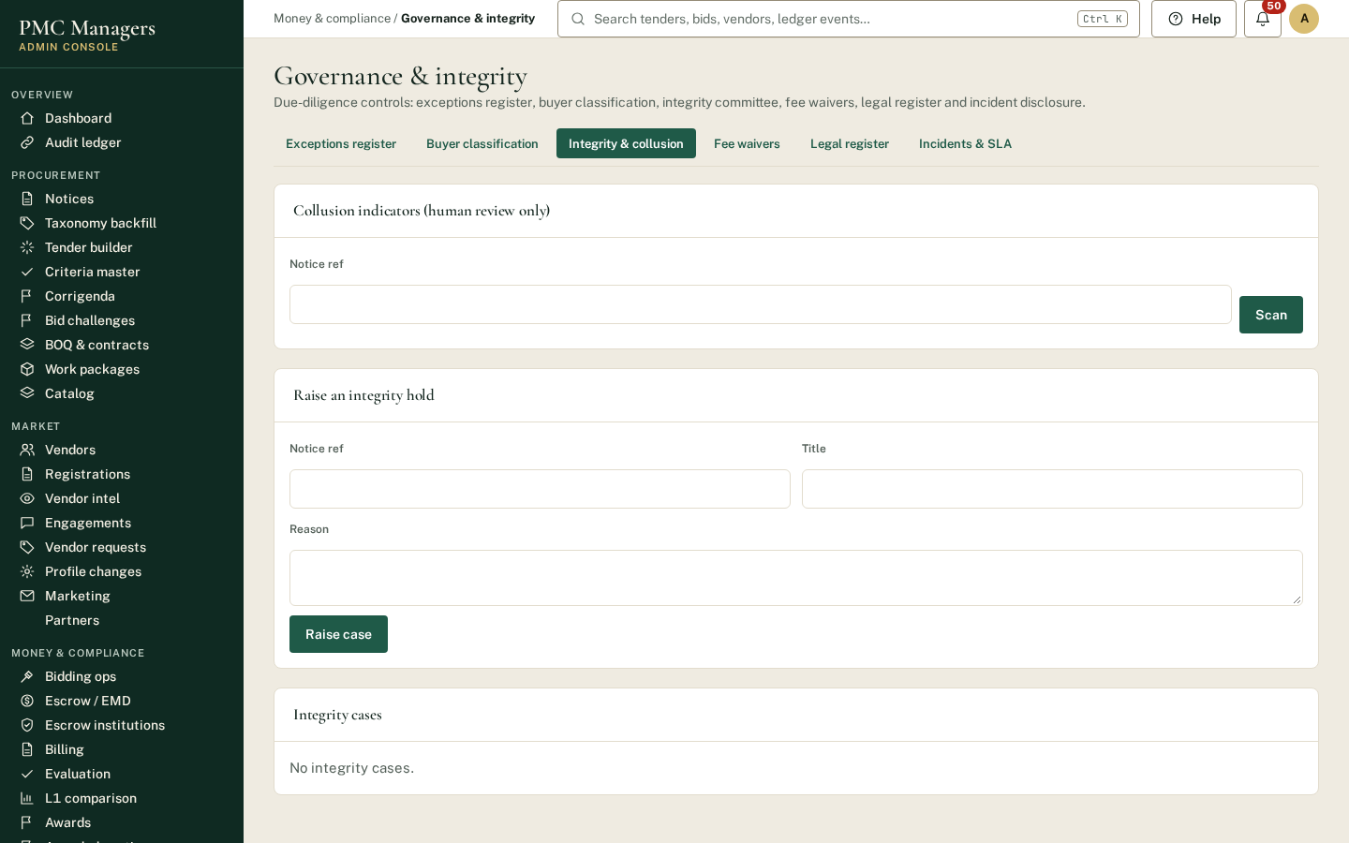
Figure 2. Integrity & collusion: raise a hold, run the collusion-indicator scan, review cases.
A3. Dispute resolution (your point 4)
Raised: Procedures for supplier complaints, bid challenges, procurement disputes, suspected irregularities and appeals.
- [ENFORCED] Before the deadline: suppliers raise clarification questions on the tender; answers are published to all bidders, and any change to the tender is issued as a numbered corrigendum.
- [ENFORCED] After qualification and award: every supplier automatically receives a result notice. Losing bidders can open a private debrief page showing their own criteria results, proof-review decisions and rank, and the reason they were not selected. They never see another bidder's details.
- [ENFORCED] Complaint window: the debrief invites the supplier to raise a clarification or complaint within 5 days of the result, through the platform's Messages, so every complaint is time-stamped and kept with the tender file.
- [ENFORCED] Suspected irregularities: any officer can place an integrity hold (A2). A supplier barred from bidding can lodge an appeal with evidence; the decision and reason are recorded.
- [IN PROGRESS] A formal multi-stage bid-challenge procedure (standstill period before contract signature, review by the Integrity Committee, then appeal to an external body or arbitration) is being built. Until then the standstill and appeal stages are run under the buyer's own rules.
- [BUYER] The final appeal body and the governing law for disputes are set by the buyer's procurement rules and the contract.
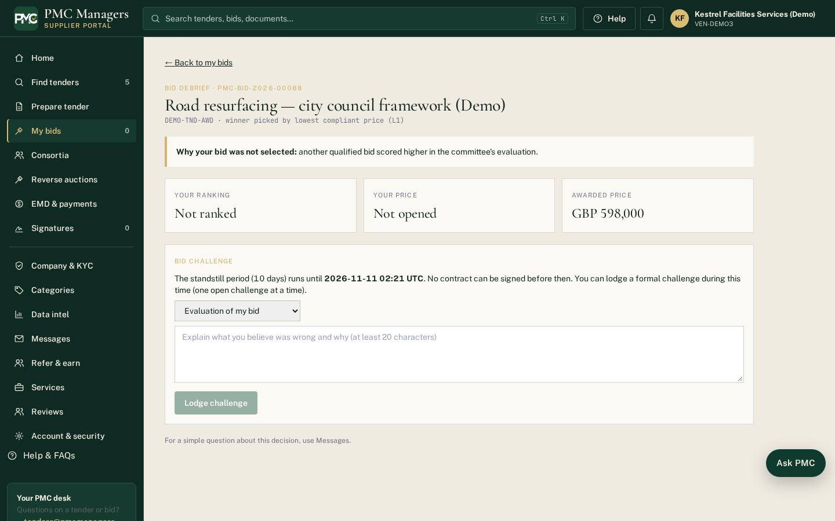
Figure 3. Bidder debrief page seen by a losing supplier (only their own result; note the 5-day complaint window).
A4. Technical evaluation, separation and conflicts of interest (your point 6)
Raised: How technical and commercial evaluations are conducted, documented and separated, including conflicts of interest and evaluator accountability.
- [ENFORCED] Two sealed envelopes. Technical and commercial (price) parts of each bid are encrypted on upload and kept sealed. Price is removed by the server itself, not merely hidden on screen, until the commercial opening.
- [ENFORCED] Order is fixed. The commercial envelope cannot be opened until the technical envelopes have been opened, at least one bid has passed technical evaluation, and every doubt raised by the committee has been resolved. This applies to administrators as well.
- [ENFORCED] Criteria are set per tender before publishing (mandatory and optional, drawn from a criteria master). At the technical opening the system checks every bid against them and records pass or fail with the reason, for example “Fail: 400,000 GBP is below the required 500,000 GBP”.
- [ENFORCED] AI reads each proof document and flags mismatches (for example “accounts show 400,000; vendor declared 750,000”). The AI only flags. Every committee member must agree to accept or reject each proof and record a comment. The AI never sees prices.
- [ENFORCED] Conflict of interest: each evaluator must declare any conflict before scoring, and each opening signature includes the statement “I have no conflict of interest”. Declarations go to the audit ledger.
- [ENFORCED] Ranking (lowest compliant price, weighted score, or the method chosen for the tender) runs only among qualified bids. Award to the lowest-ranked bid (L1) is one recorded action.
- [BUYER] Choosing competent, independent evaluators and the weightings for a tender is the buyer's decision.
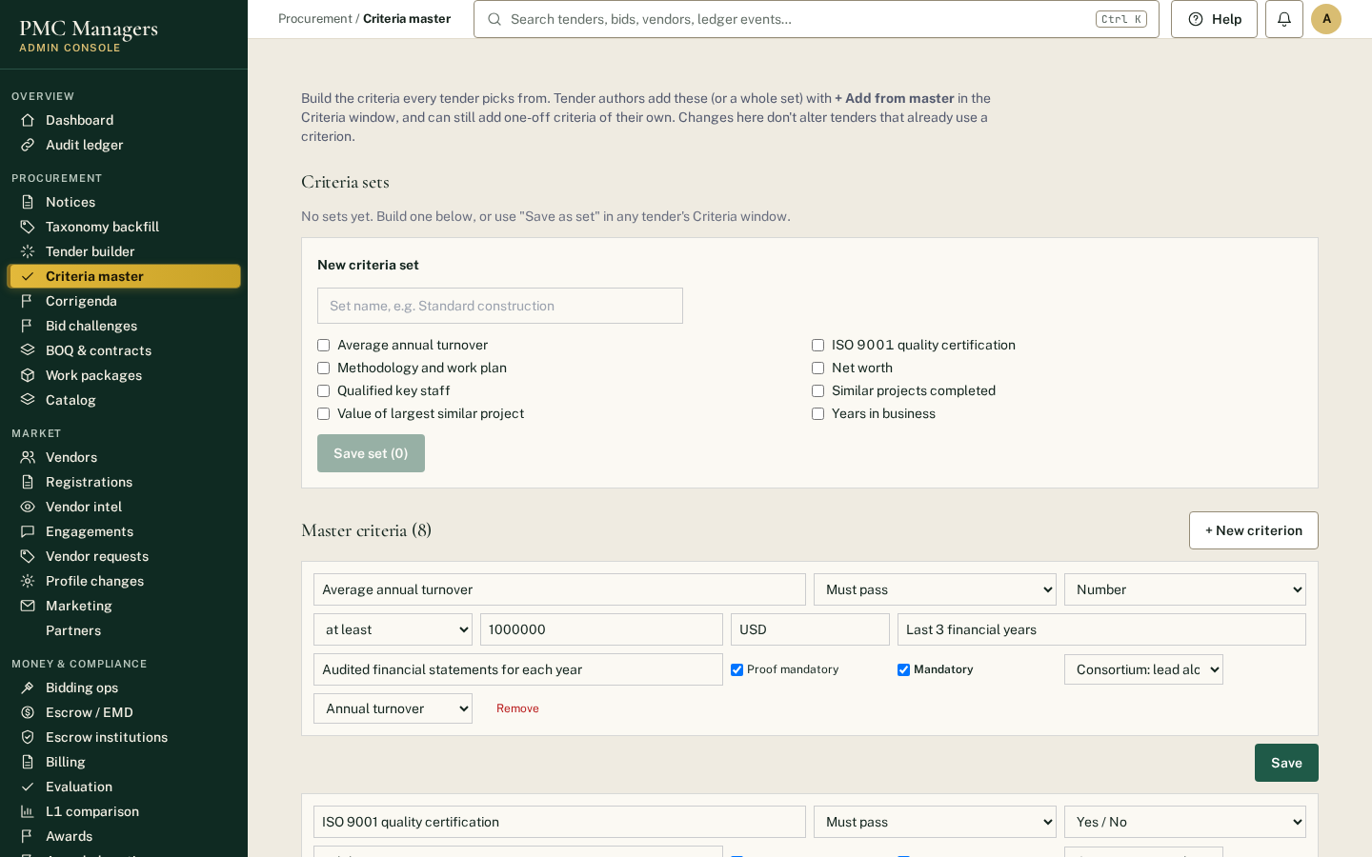
Figure 4. Criteria master: reusable mandatory and optional criteria, with rules for consortium bids.
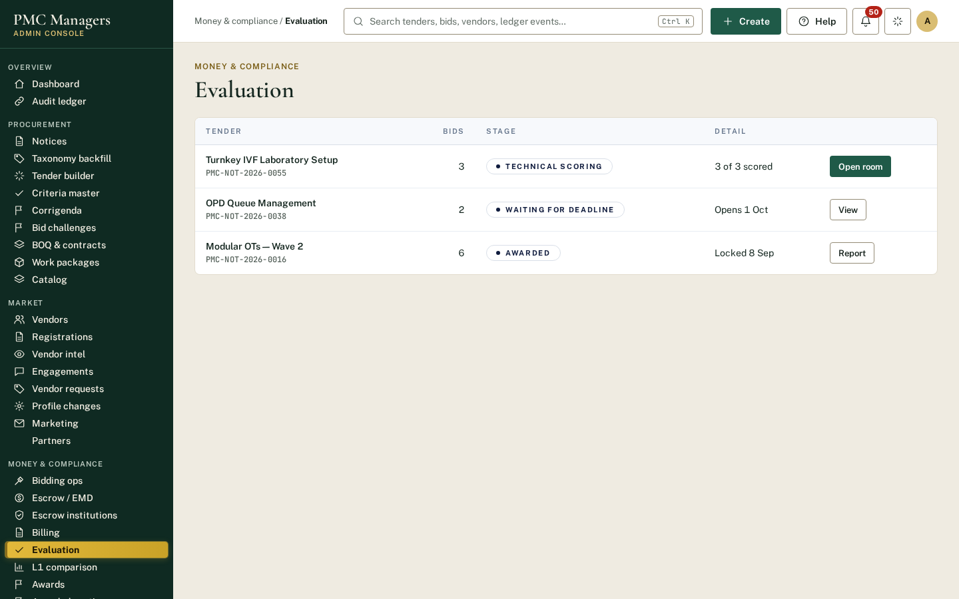
Figure 5. Evaluation: committee scoring, declarations and the evaluation record.
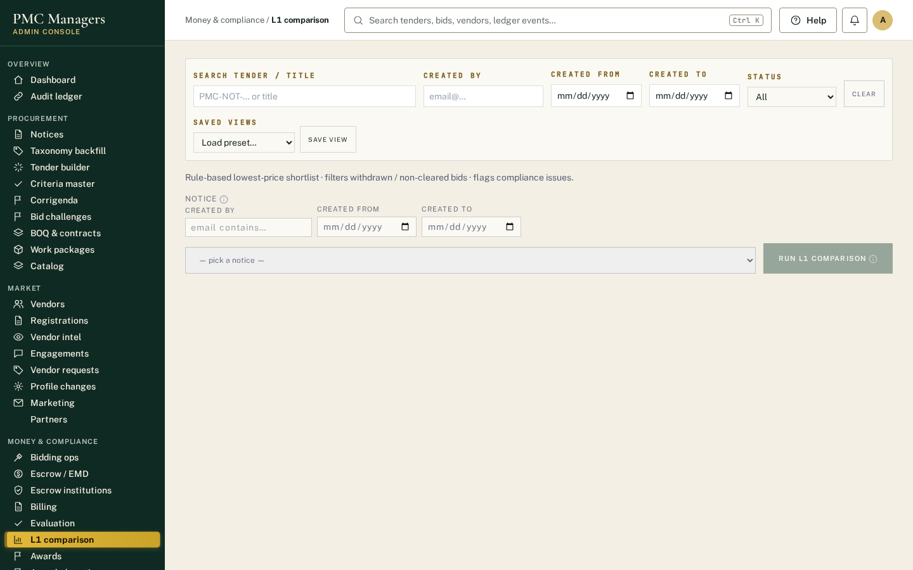
Figure 6. L1 comparison: ranking among qualified bids only, with one-click award to L1.

Section B — Technology, Security and Operational Reliability
Why the platform can be trusted with sensitive international procurement.
B1. Cybersecurity and data protection (your point 2)
Raised: Encryption, access controls, cybersecurity monitoring, independent security testing, disaster recovery and protection of confidential bids.
Control | How it works today | Status
Encryption in transit | All traffic is served over HTTPS (TLS). | ENFORCED
Encryption of bids at rest | Technical and commercial envelopes are encrypted with a server key (AES with an integrity check) when uploaded, and stay sealed until the committee opening. | ENFORCED
Passwords | Stored only as salted bcrypt hashes. Reset links are single-use, expire after one hour and are rate-limited. | ENFORCED
Access control | Role-based permissions for every screen and action (admin, reviewer, committee, escrow, legal, accounts, auditor, supplier, partner). Staff accounts cannot be given admin rights by mistake. | ENFORCED
Two-factor sign-in | Authenticator-app (TOTP) two-factor sign-in is available to all users. Making it compulsory for high-risk roles (escrow, legal, accounts) is a setting we will switch on for institutional buyers. | ENFORCED (available) / TO CONFIRM (compulsory)
Session protection | Time-limited sessions with cross-site request forgery protection on every change. | ENFORCED
Release safeguards | Every software release is scanned automatically and blocked if it contains a password or access key. | ENFORCED
Monitoring & incidents | Incidents affecting a deadline or opening are logged and, where bidders are affected, disclosed publicly. | ENFORCED
Hosting | Amazon Web Services (Elastic Beanstalk application hosting, CloudFront delivery). | ENFORCED
Backups & disaster recovery | Database backups with documented restore. Recovery point / recovery time objectives: RPO [24 hours], RTO [4 hours]. | TO CONFIRM
Independent penetration test | Not yet carried out. Commissioning an accredited (CREST or equivalent) test before institutional launch. | IN PROGRESS

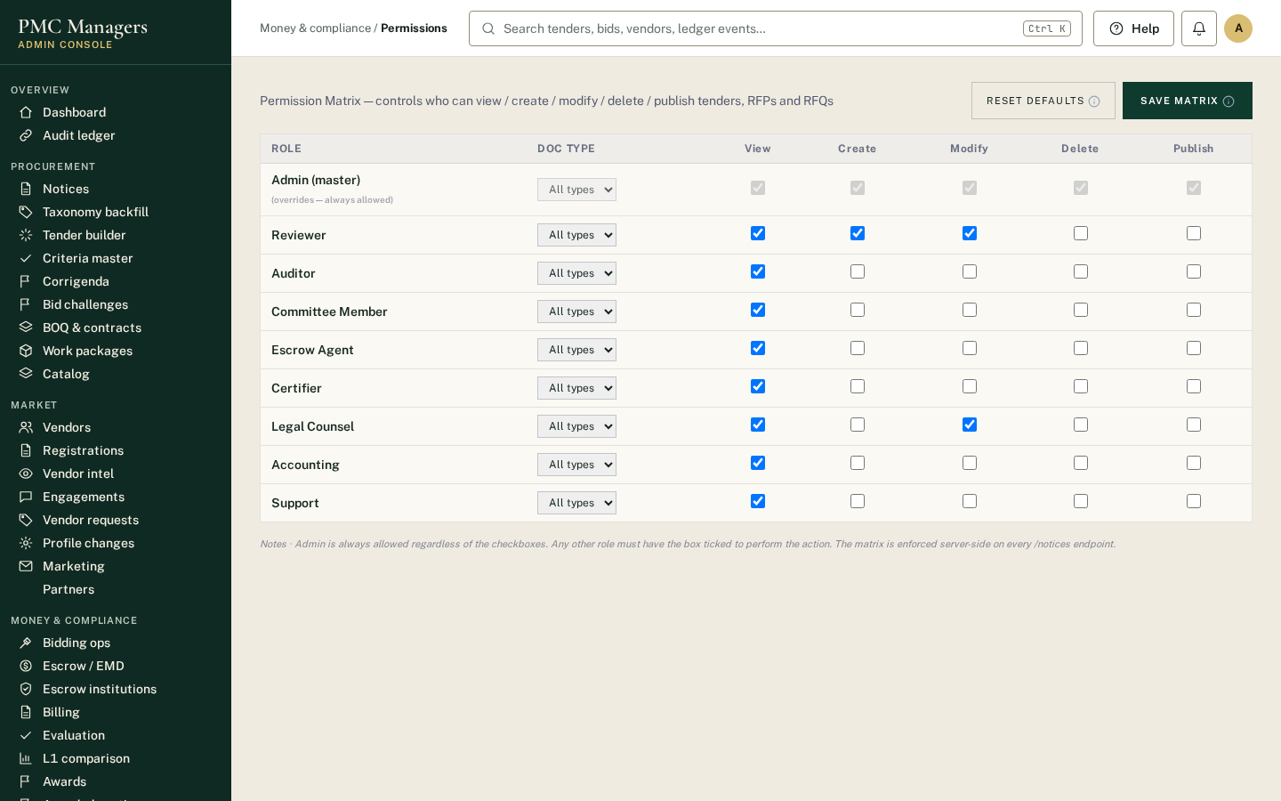
Figure 7. Permissions: role-by-role access to every screen and action.
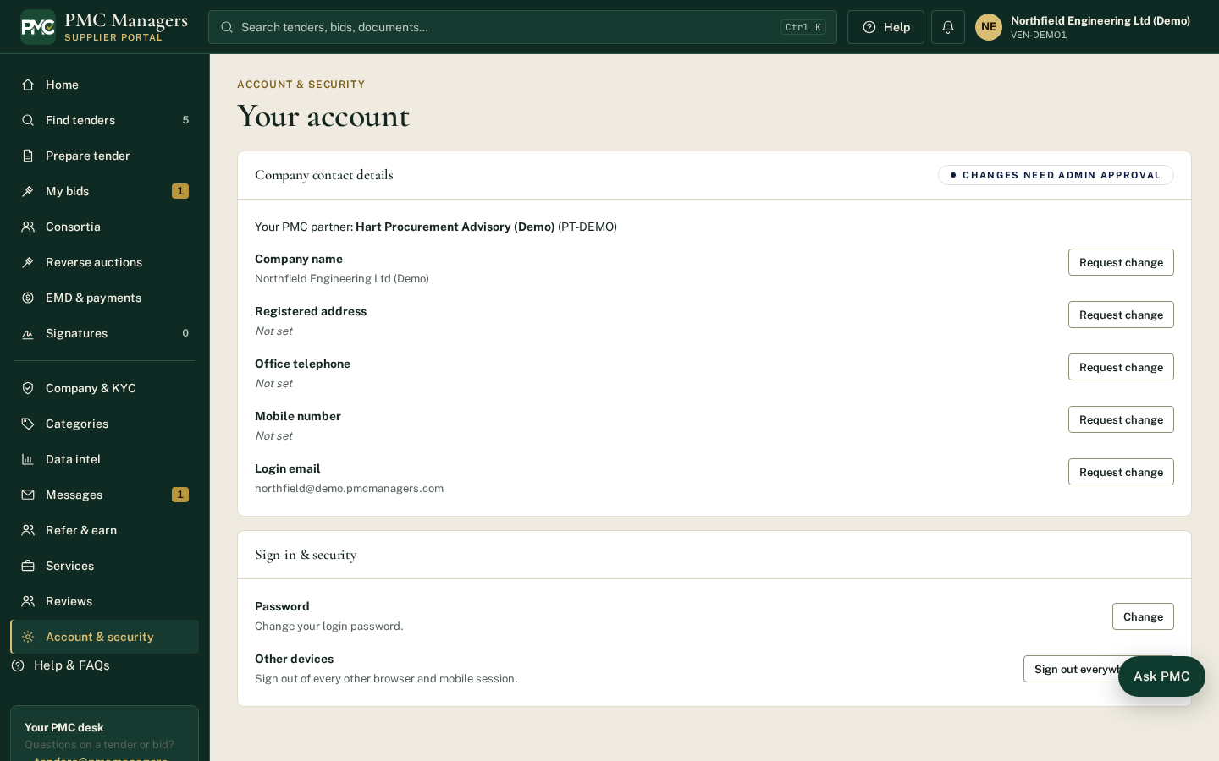
Figure 8. Account & security: two-factor sign-in, password and data controls for each user.
B2. System integrity — opening times, unalterable records, proof of no interference (your point 5)
Raised: How opening times are enforced, how records are protected against alteration, and how the platform demonstrates that no unauthorised access or intervention occurred.
- [ENFORCED] Deadline: bids are accepted up to the published deadline to the second, using the server's clock, not the user's computer.
- [ENFORCED] Opening: the server refuses to open any envelope while submission is still open, before the published opening date and time, or before every member of the tender's committee has signed the opening electronically. Only committee members can sign, and each can sign once.
- [ENFORCED] Records: every significant action (sign-in, upload, opening, decision, award, payment instruction) is written to an append-only audit ledger. Each entry is sealed with a SHA-256 hash of the previous entry, so changing any past record breaks the chain at that exact point.
- [VERIFIABLE] Proof: the chain is re-verified automatically and the result is published on the public Trust & security page (events recorded, breaks found). Any auditor or bidder can check a single record themselves with “Verify a record”, without signing in.
- [ENFORCED] Exceptions: every manual bypass, waiver or override is copied to a single exceptions register naming the officer and the reason, so the absence of an entry is itself meaningful evidence.
A note on precision: we describe the ledger as tamper-evident rather than tamper-proof. It shows, and pinpoints, any alteration; it does not physically prevent a database administrator from attempting one.
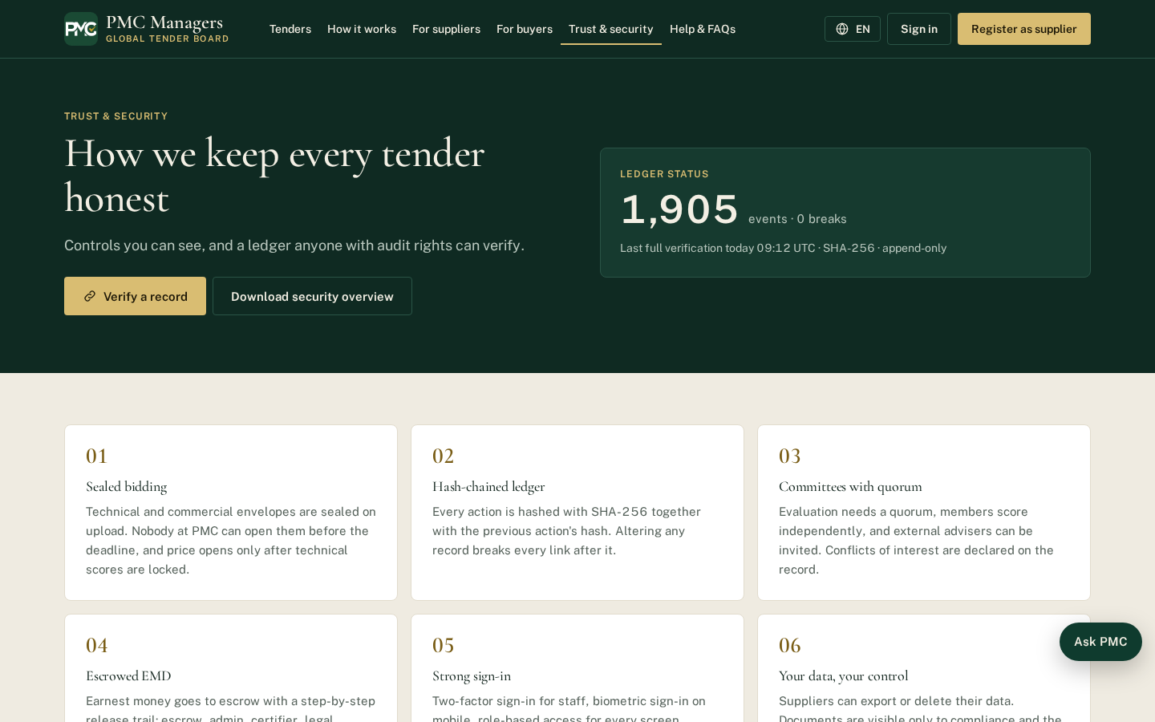
Figure 9. Public Trust & security page: live ledger status and “Verify a record” for outside parties.
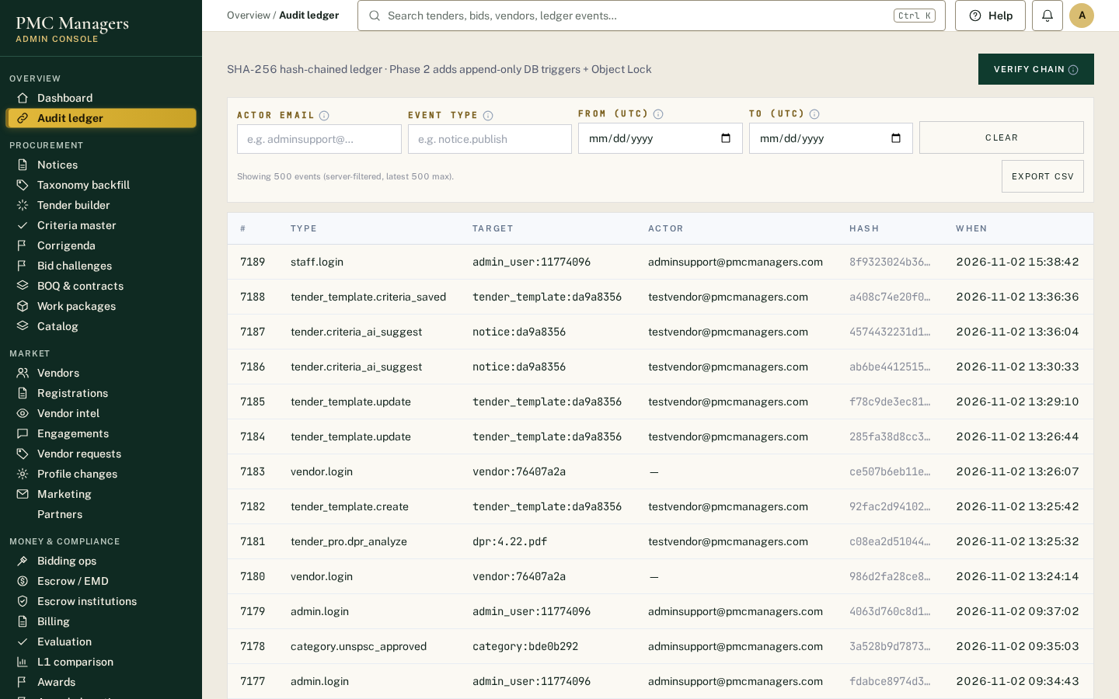
Figure 10. Audit ledger: every action, who did it and when.
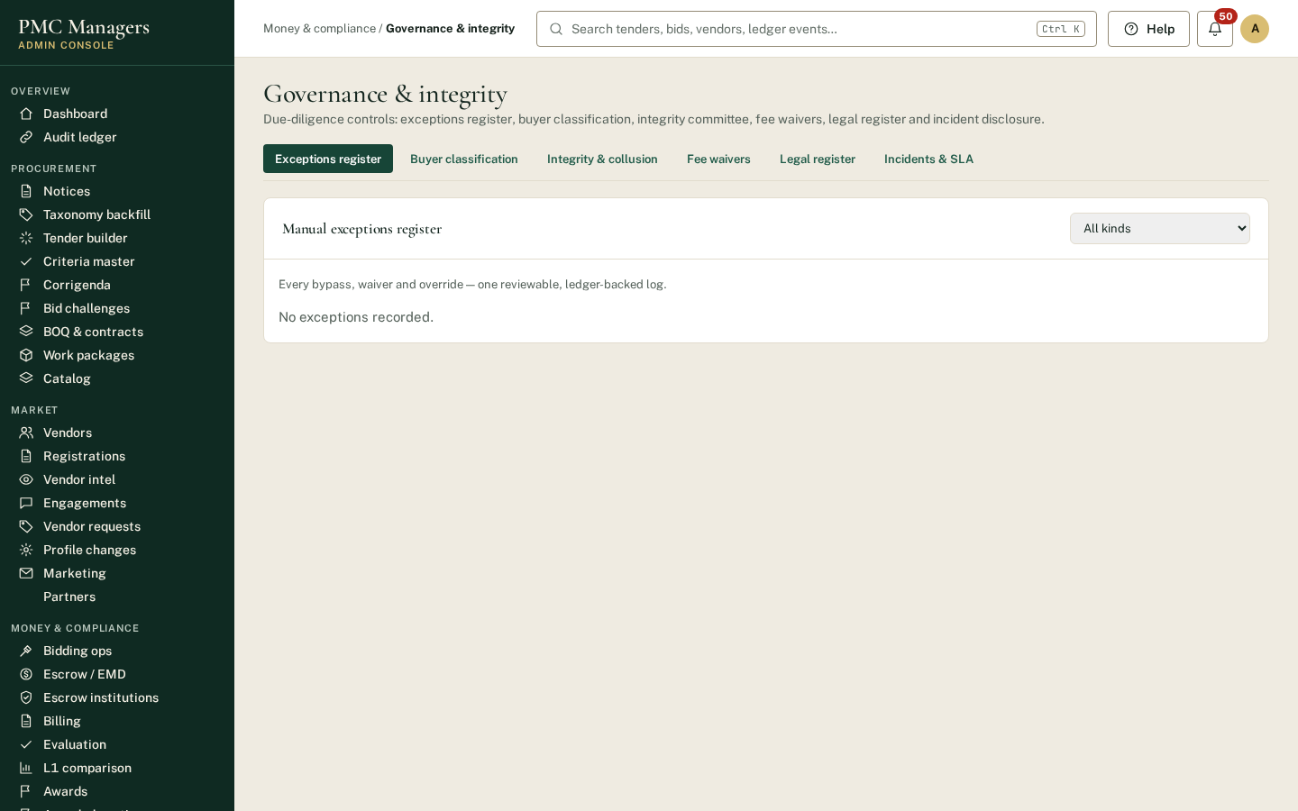
Figure 11. Exceptions register: every manual bypass or override, with officer and reason.
B3. Integration capabilities (your point 7)
Raised: How PMC Manager connects with existing ERP, accounting, financial management, banking and project management systems.
- [ENFORCED] Standard exports available today: comparative statement (Excel), escrow releases (CSV), consortium payment instructions (CSV), contracts list (CSV), bills of quantities (Excel/PDF), tender documents and proof-review reports (PDF). These import directly into most ERP and accounting systems.
- [ENFORCED] Live connections already in use: card and bank payments (Stripe), e-signature (DocuSign), email notifications and WhatsApp alerts.
- [IN PROGRESS] Sanctions screening through Refinitiv World-Check One (LSEG) is planned and will be connected once the subscription is signed; until then checks are made manually during supplier verification.
- [IN PROGRESS] The platform is built on a documented web interface (REST/JSON), so direct connectors can be added for a buyer's ERP (for example SAP, Oracle, Microsoft Dynamics) or project management tools. These are scoped per buyer during implementation.
- [ENFORCED] Banking: payments to suppliers are not moved automatically. After a dual-signed escrow release the platform issues a payment instruction; the bank transfer is made by the authorised bank and its reference is recorded back against the instruction. We regard this separation as a control, not a gap.
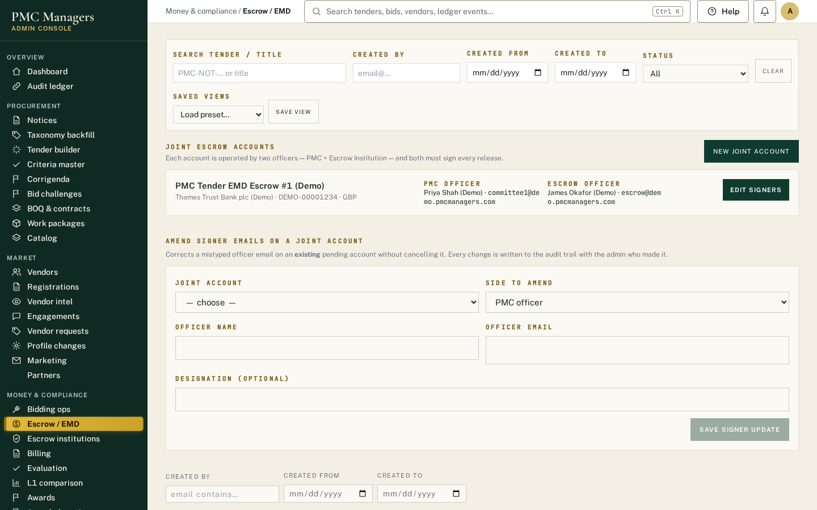
Figure 12. Escrow / EMD: dual-signed releases, payment instructions and downloadable reports.
B4. Service levels and business continuity (your point 8)
Raised: Platform availability, technical support, response times, maintenance, incident management and business continuity.
Published service standard (shown publicly today):
- [ENFORCED] Bids accepted until the published deadline to the second, server-timestamped.
- [ENFORCED] Live bid-opening availability target: 99.5% per month.
- [ENFORCED] If live streaming of an opening fails, it continues automatically on a fallback connection; if that fails, it closes on a manual, audited record, so no bid is lost.
- [ENFORCED] Critical incidents (deadline or opening affected) acknowledged within 1 hour, and disclosed where bidders are affected.
Contractual service levels proposed (for confirmation):
Item | Proposed commitment
Overall platform availability | [99.5%] per calendar month, excluding scheduled maintenance
Scheduled maintenance | [Sundays 00:00–04:00 UTC], announced [72 hours] ahead; never during a published deadline or opening
Support hours | [Monday–Friday, 08:00–18:00 GST / UK time]; critical line 24/7
Response times | Critical [1 hour] · High [4 hours] · Normal [1 business day]
Deadline protection | If an outage affects a deadline, the deadline is extended by corrigendum and all bidders are told
Continuity | Backups and restore as in B1; tested restore [quarterly]

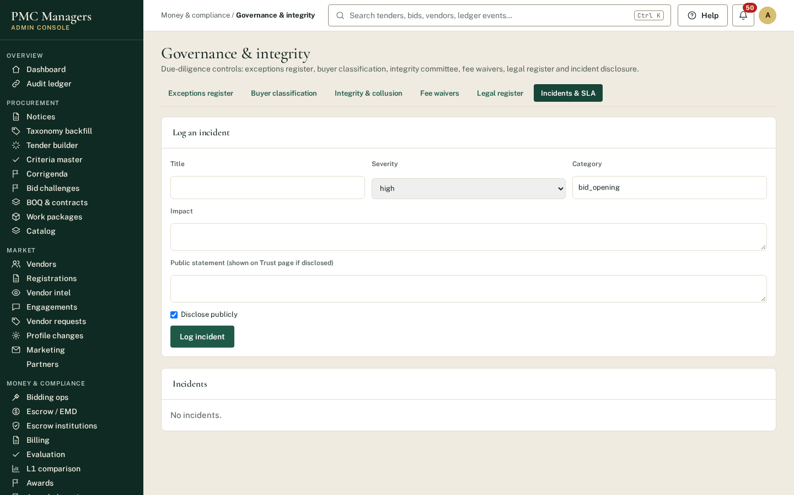
Figure 13. Incidents & service standard: incident log and the published standard.
B5. Independent validation (your point 12)
Raised: Independent technical, cybersecurity, governance and procurement-process assessments.
We agree this is essential for institutional buyers. Our position, stated plainly:
- [ENFORCED] Internal: the controls in this document are covered by automated tests that run on every release (for example: price never reaches the AI tool; an officer cannot verify their own classification or approve their own fee waiver; a resolved integrity case cannot be changed). These are our own tests, not an independent assessment.
- [VERIFIABLE] Outside parties can already verify audit records themselves (B2).
- [IN PROGRESS] Planned independent assessments: (1) accredited penetration test; (2) ISO/IEC 27001 readiness review; (3) independent review of the procurement process against the UNCITRAL Model Law on Public Procurement, World Bank Procurement Regulations and OECD integrity principles; (4) annual governance review of the Integrity Committee. Target dates: [to be confirmed].
We will not describe the platform as certified or independently assessed until these reports are issued.

Section C — Implementation, Accountability and Commercial Sustainability
C1. Implementation and onboarding (your point 9)
Raised: How a new organisation moves from initial registration to operational use, including configuration, training and implementation support.
Step | What happens | Who
1. Register | Organisation registers online, or downloads a blank registration form. | Buyer / supplier
2. Verify | Company documents and KYC checked; account activated only after verification. | PMC compliance
3. Configure | Country, currency, departments, committee members, roles, criteria library and fee rules are set up. | PMC + buyer
4. Train | Role-based training using the 104-page screenshot manual, in-portal Help linked to the right manual section, and a guided first tender. | PMC
5. First tender | First tender run with PMC staff alongside (criteria, publication, opening, award). | Buyer, supported
6. Go live | Buyer runs tenders independently; dashboard shows each tender's stage so delays are visible. | Buyer

Typical timeline from signature to first live tender: [4–6 weeks] (to be confirmed per buyer).
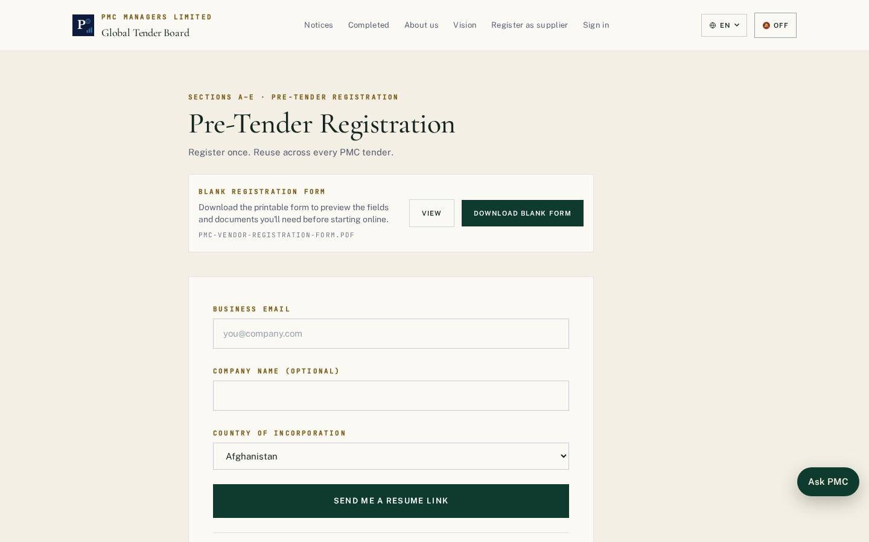
Figure 14. Step 1 — online pre-tender registration (or a downloadable blank form).
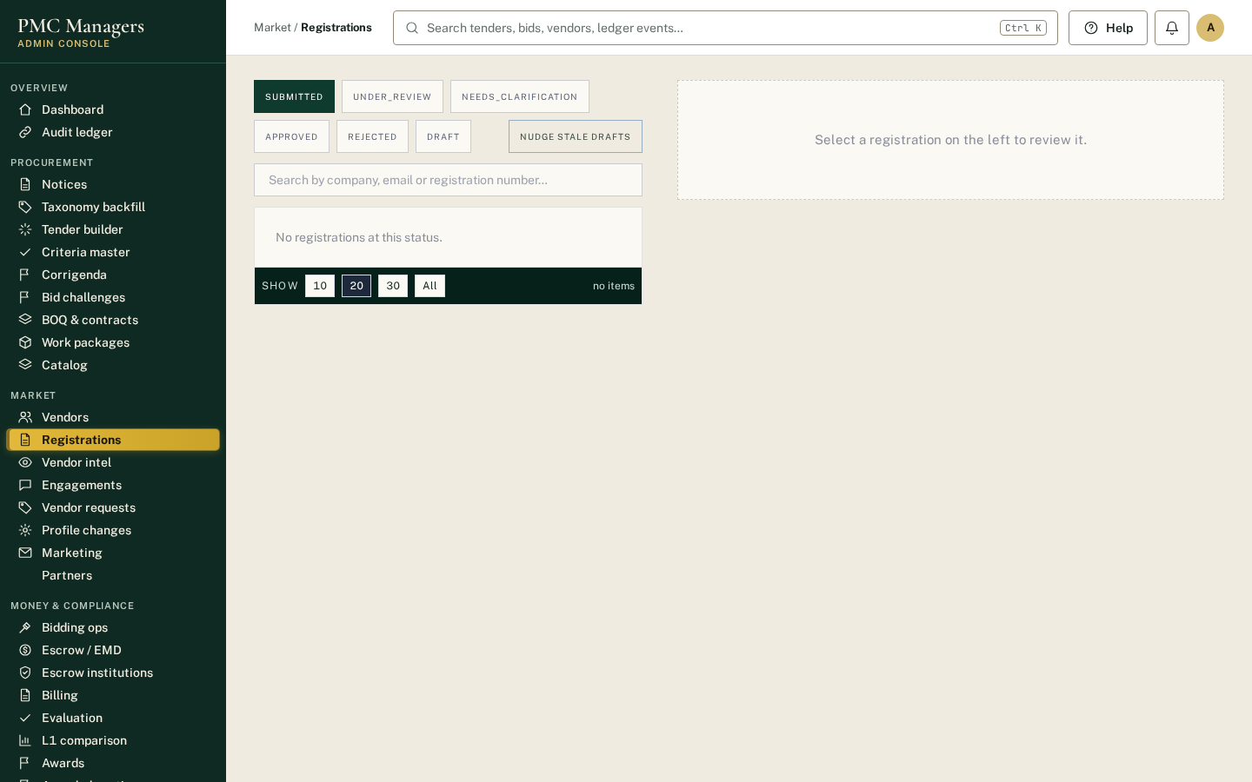
Figure 15. Step 2 — registrations reviewed and verified by PMC compliance.
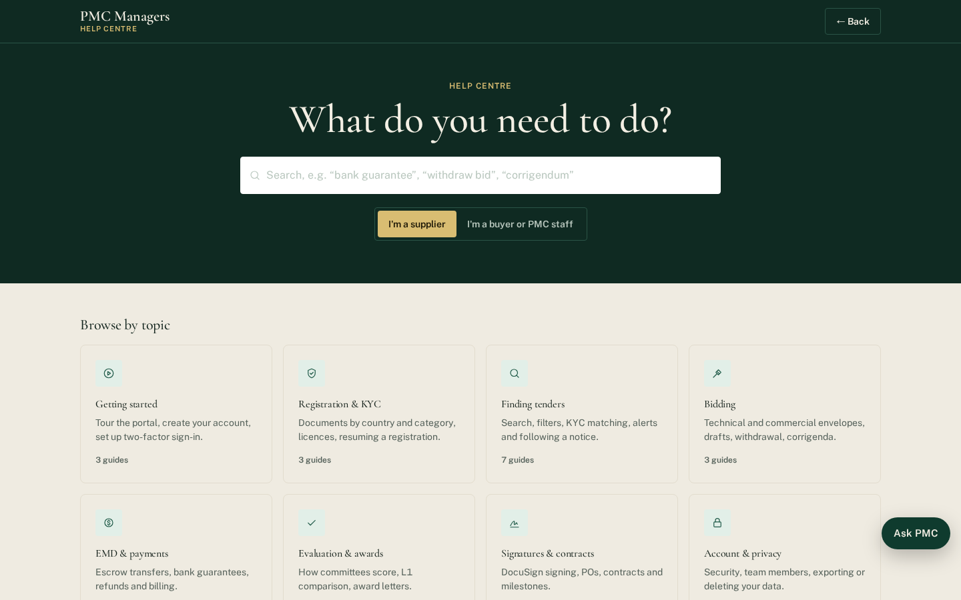
Figure 16. Step 4 — Help centre linked to the training manual sections.
C2. Insurance and liability (your point 10)
Raised: Contractual responsibilities, professional liability, cyber insurance, indemnities and limitations of liability.
These are contractual matters rather than software controls. PMC Managers will confirm them in the master services agreement. The proposed framework is:
Item | Proposed position (to be confirmed)
Professional indemnity insurance | [Amount] per claim, insurer [name]
Cyber liability insurance | [Amount] per claim, insurer [name]
PMC Managers responsible for | Platform availability, security of stored data, correct operation of the controls described here, confidentiality of sealed bids
Buyer responsible for | Tender content, choice of criteria and evaluators, award decision, compliance with its own procurement law, payment to suppliers
Supplier responsible for | Truth of declarations and authenticity of proof documents
Limitation of liability | [e.g. fees paid in the previous 12 months], with standard exclusions (fraud, wilful misconduct, data-protection breach)
Indemnities | Mutual indemnities for breach of confidentiality and data protection

C3. Commercial pricing clarity (your point 11)
Raised: The three figures shown for each tier, which price applies to which buyer category, the transaction-fee calculation, caps, minimum thresholds, currency conversion and taxes.
How the platform calculates fees (built in today):
- [ENFORCED] Fee types are kept in one master list: tender fee (paid upfront), tender management fee, tender hosting fee, and transaction fee (a percentage of the awarded value, charged on completion).
- [ENFORCED] Each fee can be fixed or a percentage, and can vary by tender-value band (“slab”), by country and by industry category. The amount due is calculated by the system from the tender value; nobody types it in by hand.
- [ENFORCED] Fees are charged in the tender's currency. Waivers need a second officer's approval and are recorded in the exceptions register.
Pricing table to replace the three figures in the presentation (for completion by PMC Managers):
Tier | Private-sector buyer | Public-sector buyer | Development institution / NGO
[Tier 1] | [price] | [price] | [price]
[Tier 2] | [price] | [price] | [price]
[Tier 3] | [price] | [price] | [price]

Transaction fee rule | Proposed position
Calculation | [x]% of the awarded contract value
Minimum fee | [amount] per tender
Cap | [amount] per tender
Threshold | No transaction fee below an awarded value of [amount]
Currency conversion | Charged in the tender currency; conversion, where needed, at [source] rate on the award date
Taxes | Prices exclude VAT / GST, added at the rate applicable in the buyer's country

Example: a GBP 1,000,000 award at [1]% would be GBP [10,000], subject to the minimum and cap above.
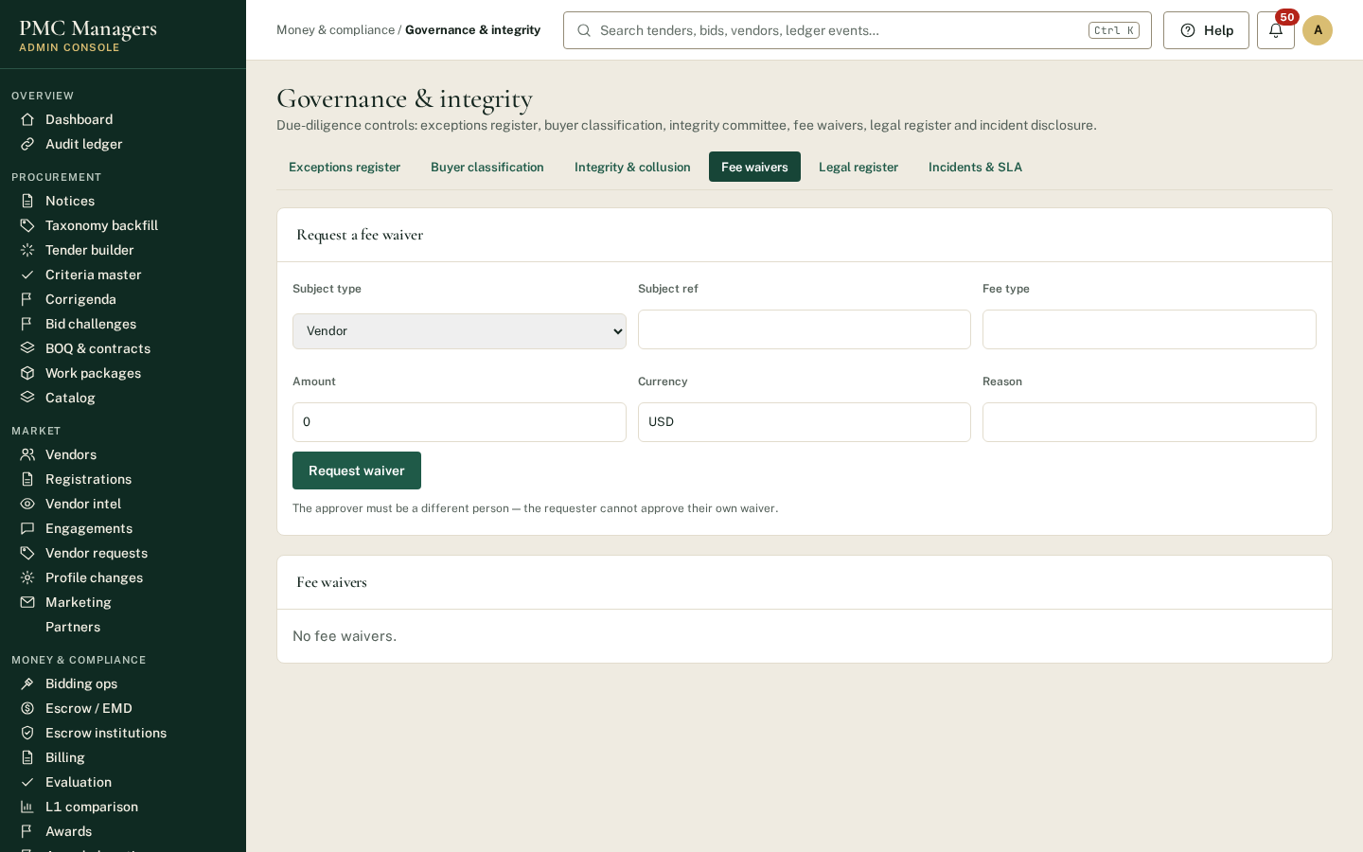
Figure 17. Fee waivers: a second officer must approve, and every waiver is recorded.

Part D — One tender, end to end (evidence)
The screens below follow one tender through the platform in order. Each step names the control that applies.
Step 1
- [ENFORCED] Dashboard: every live tender with its stage (criteria → bids → opening → proof review → price → L1 → award), so delays are visible.
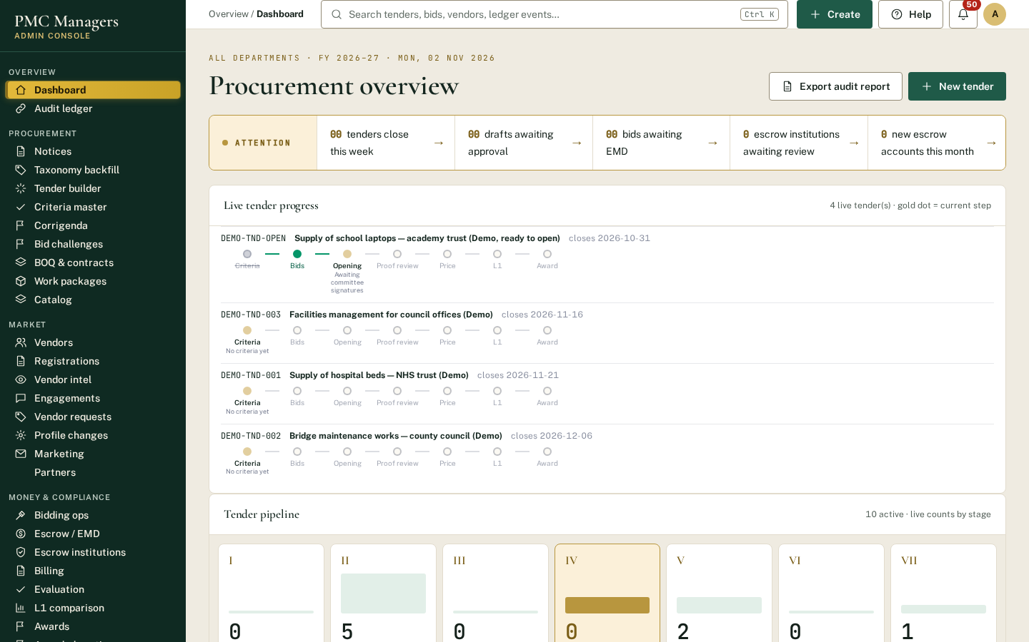
Figure 18. Dashboard.
Step 2
- [ENFORCED] Notices: tender created for a country; criteria and the publish checklist (document, dates, at least one mandatory criterion) must be complete before Publish is enabled.
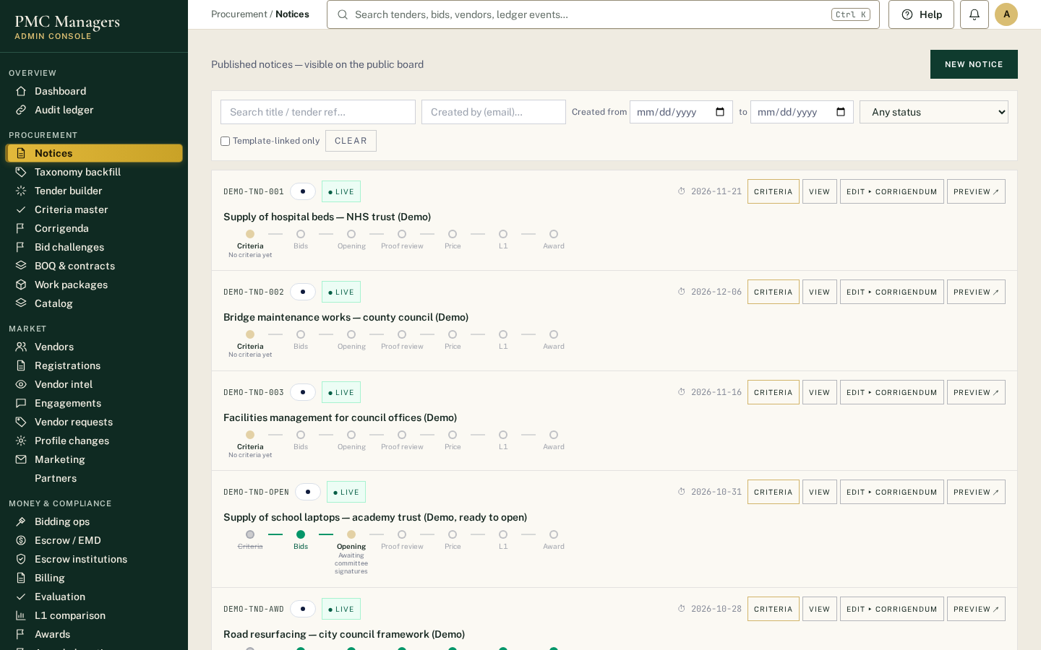
Figure 19. Notices.
Step 3
- [ENFORCED] Supplier's bids: technical and price envelopes are encrypted and sealed on upload. The supplier sees only their own bid.
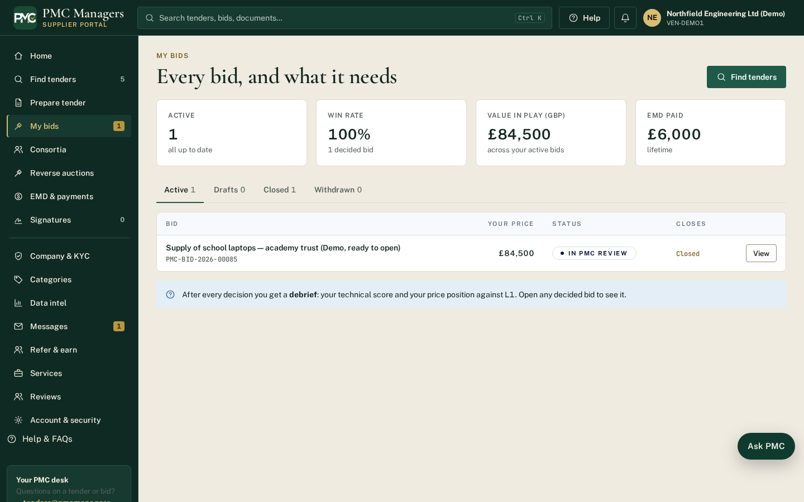
Figure 20. Supplier's bids.
Step 4
- [ENFORCED] Bidding operations: the opening is refused until the deadline and opening time have passed and every committee member has signed electronically.
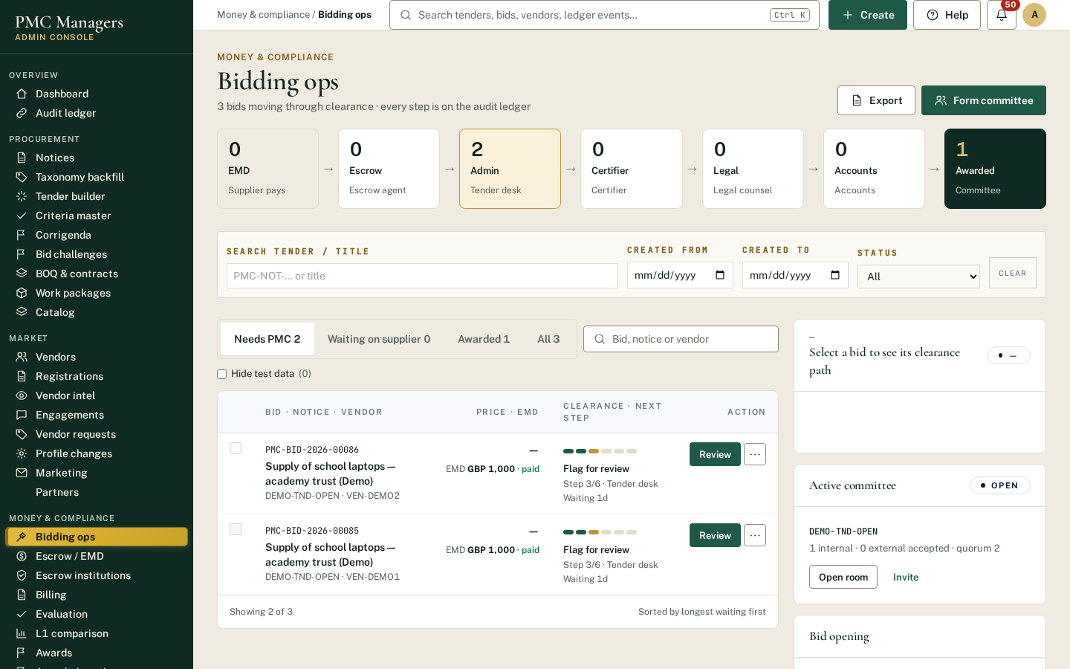
Figure 21. Bidding operations.
Step 5
- [ENFORCED] Technical evaluation: automatic criteria check, AI proof flags, unanimous committee decision with comments, conflict declarations.
Figure 22. Technical evaluation.
Step 6
- [ENFORCED] Price opening and ranking among qualified bids only; award to L1 in one recorded step.
Figure 23. Price opening and ranking among qualified bids only; award to L1 in one recorded step..
Step 7
- [ENFORCED] Award: winning and losing bidders are notified with their own rank and reason.
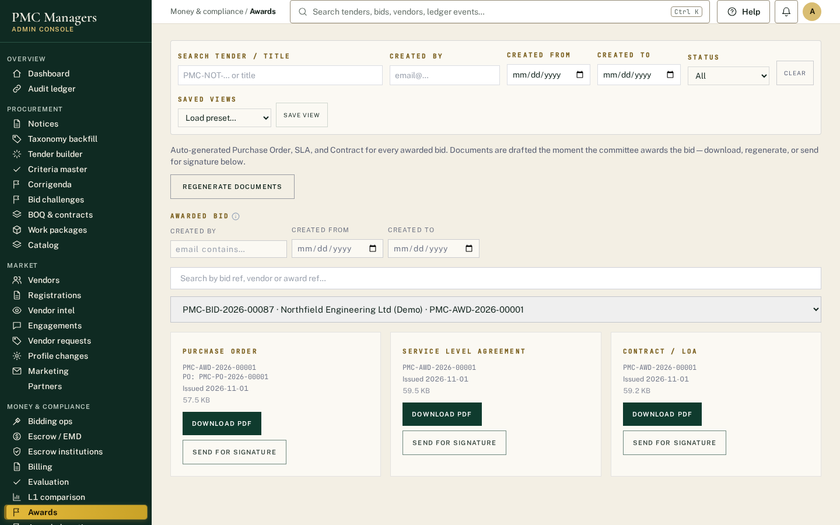
Figure 24. Award.
Step 8
- [ENFORCED] Losing supplier's view: the bid shows as not selected, with a Debrief link.
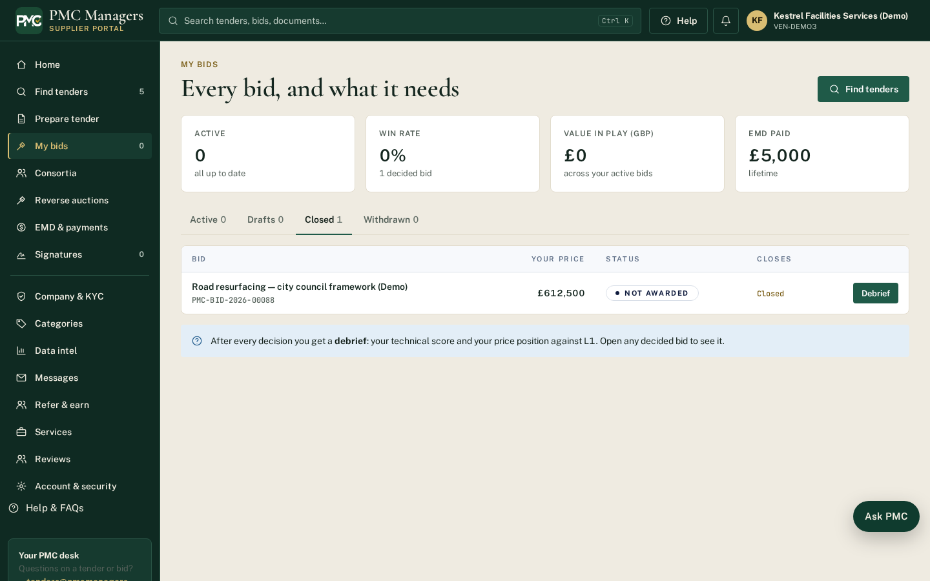
Figure 25. Losing supplier's view.
Step 9
- [ENFORCED] Debrief: own result, reason and the 5-day complaint window.
Figure 26. Debrief.
Step 10
- [ENFORCED] Contract and release signatures via DocuSign, with two independent signers.
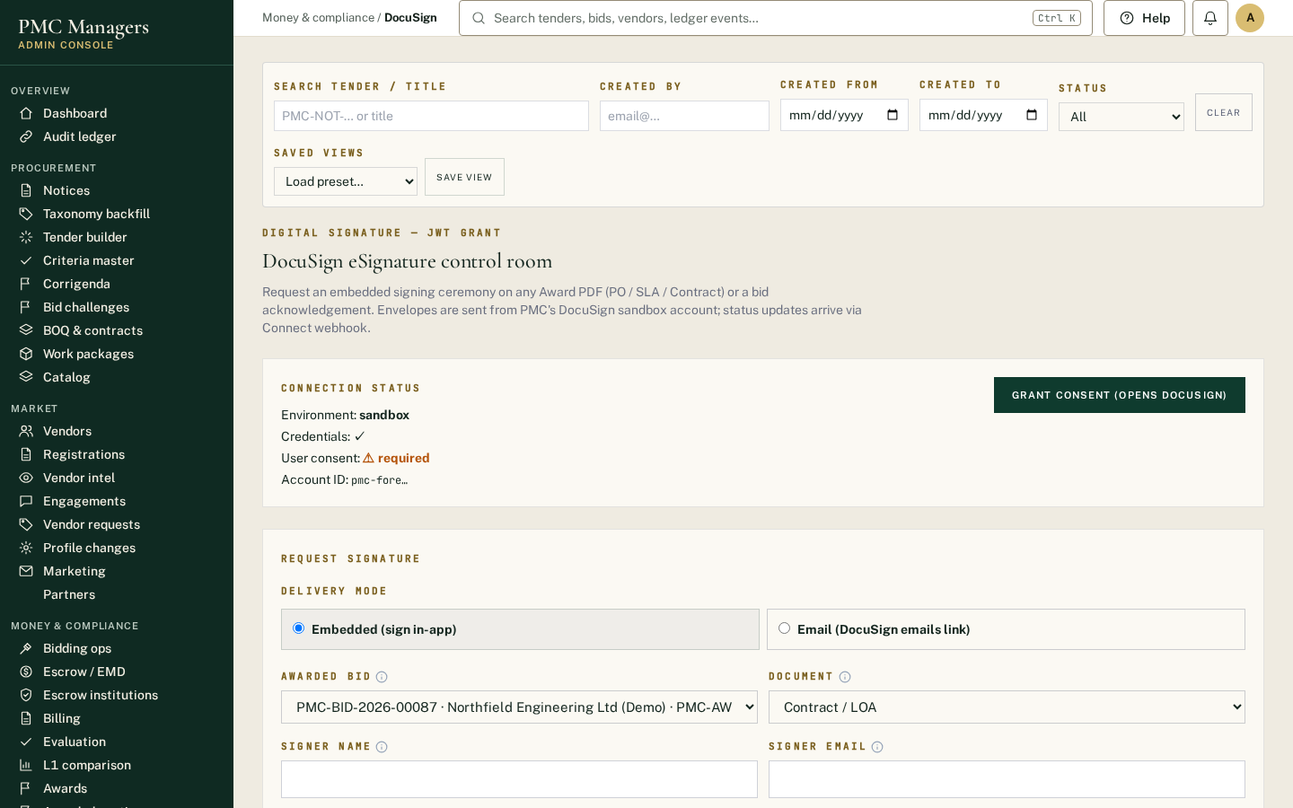
Figure 27. Contract and release signatures via DocuSign, with two independent signers..
Step 11
- [ENFORCED] Escrow release: both signatures required before a payment instruction is issued; the bank's transfer reference is recorded.
Figure 28. Escrow release.
Step 12
- [ENFORCED] Stakeholder reports for the buyer, board and lenders.
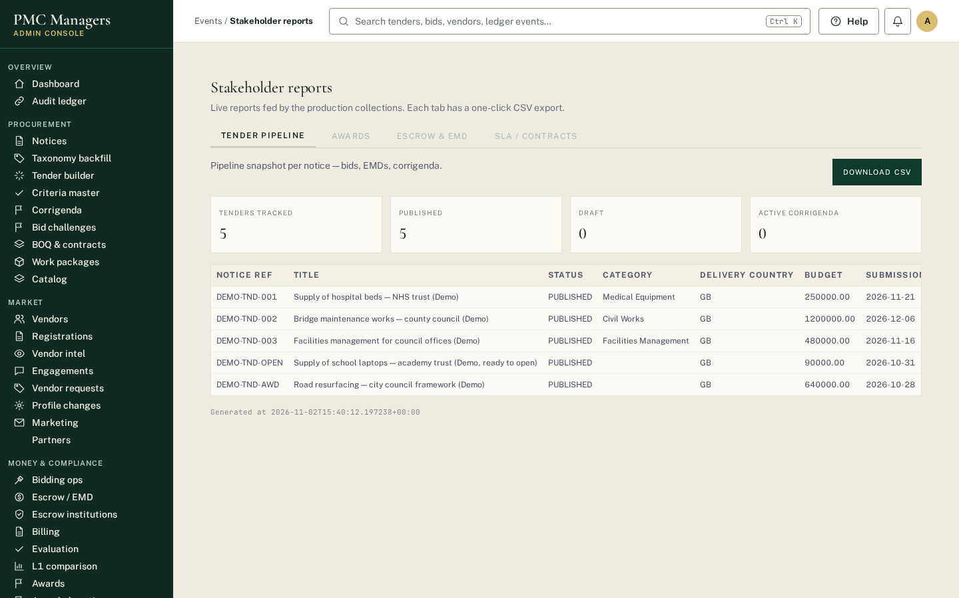
Figure 29. Stakeholder reports for the buyer, board and lenders..
Step 13
- [VERIFIABLE] Public verification: anyone with audit rights can check that the record has not been altered.
Figure 30. Public verification.

Part E — Who is responsible for what
You rightly asked us to separate what the platform enforces, what is independently verified, and what remains the buyer's responsibility.
Area | Enforced by the platform | Independently verifiable | Buyer's responsibility
Tender rules | Country templates, mandatory criteria, publish checklist | — | Choosing the procurement law, thresholds and criteria
Bid confidentiality | Encryption, sealed envelopes, price withheld by the server | Planned penetration test | Keeping committee credentials secure
Opening | Deadline, opening time, all-member e-signature | Audit ledger + public verification | Appointing the committee
Evaluation | Criteria check, AI flags, unanimous proof decisions, conflict declarations, price only after technical | Audit ledger | Competent evaluators; final judgement
Award | Ranking among qualified bids; recorded award; notices to all bidders | Audit ledger | The award decision and contract
Complaints | Debrief, 5-day window, integrity holds, recorded appeals | Audit ledger | Final appeal body and governing law
Payments | Dual-signed escrow release, payment instruction, reference trail | Bank statement + ledger | Making the bank transfer
Records | Append-only, hash-chained ledger; exceptions register | Public “Verify a record” | Retention period under local law

Items requiring PMC Managers' written confirmation
- [TO CONFIRM] Integrity Committee charter (A2)
- [TO CONFIRM] Formal bid-challenge procedure and standstill period (A3)
- [TO CONFIRM] Contractual SLA figures (B4)
- [TO CONFIRM] Recovery point / time objectives (B1)
- [TO CONFIRM] Penetration test and other independent assessments, with dates (B5)
- [TO CONFIRM] Insurance cover and liability terms (C2)
- [TO CONFIRM] Final pricing tiers, transaction-fee figures and taxes (C3)
- [TO CONFIRM] Country legal opinions and data-processing agreement (A1)
We would welcome the opportunity to walk you through the live platform.

