Bugs of PMC

- In Tender Builder - clone as draft is not working - throwing error 500

+ch
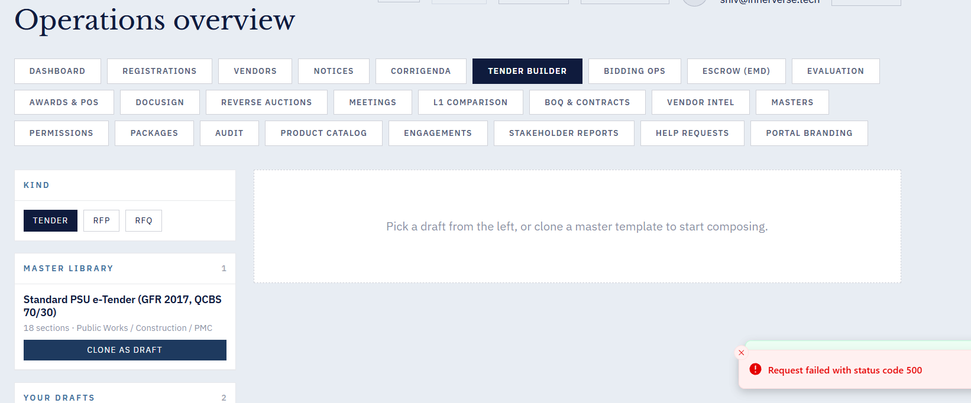

- After submitting NEW BOQ template , could not see it in list.

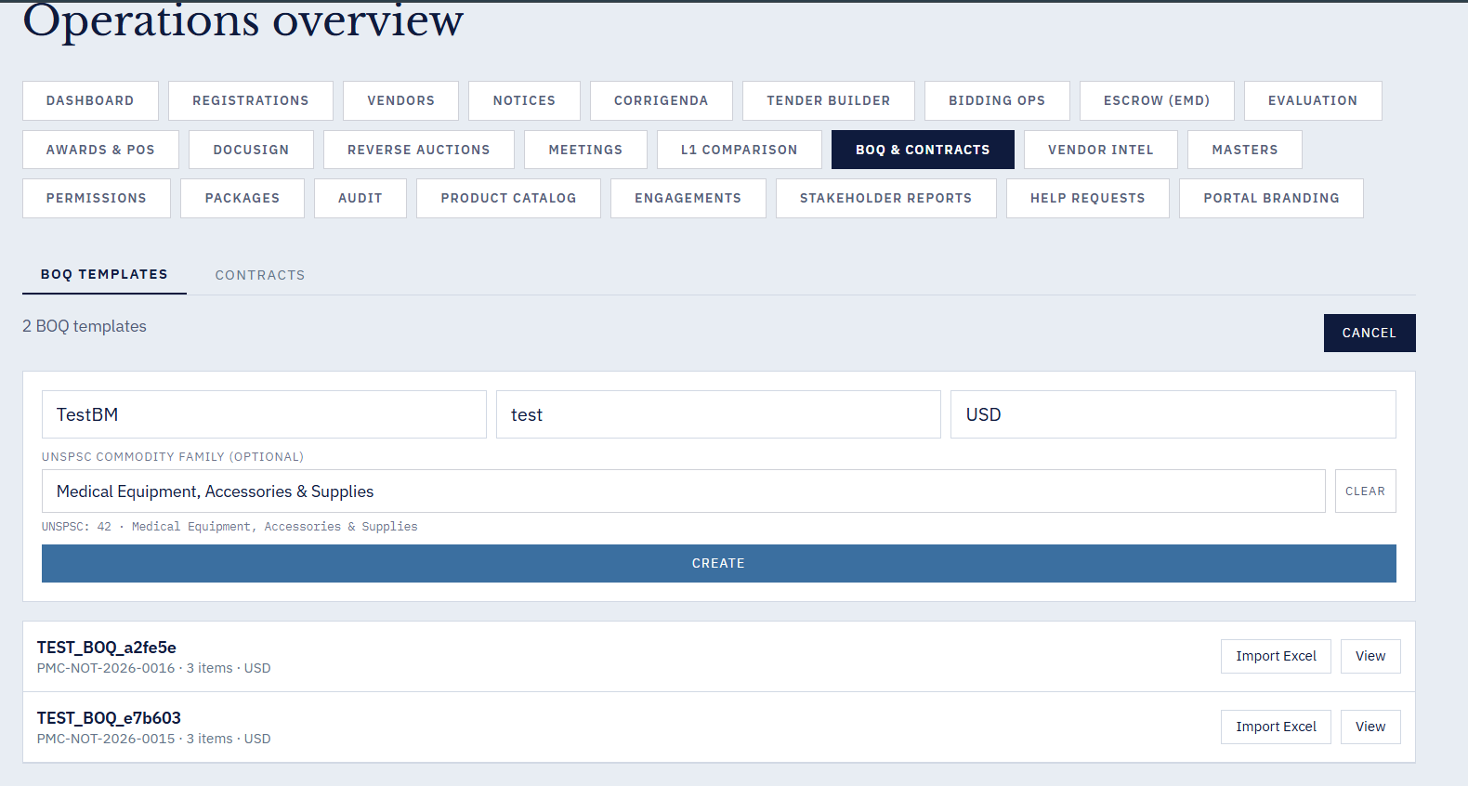

- when Biding ops button is clicked, the application logs out.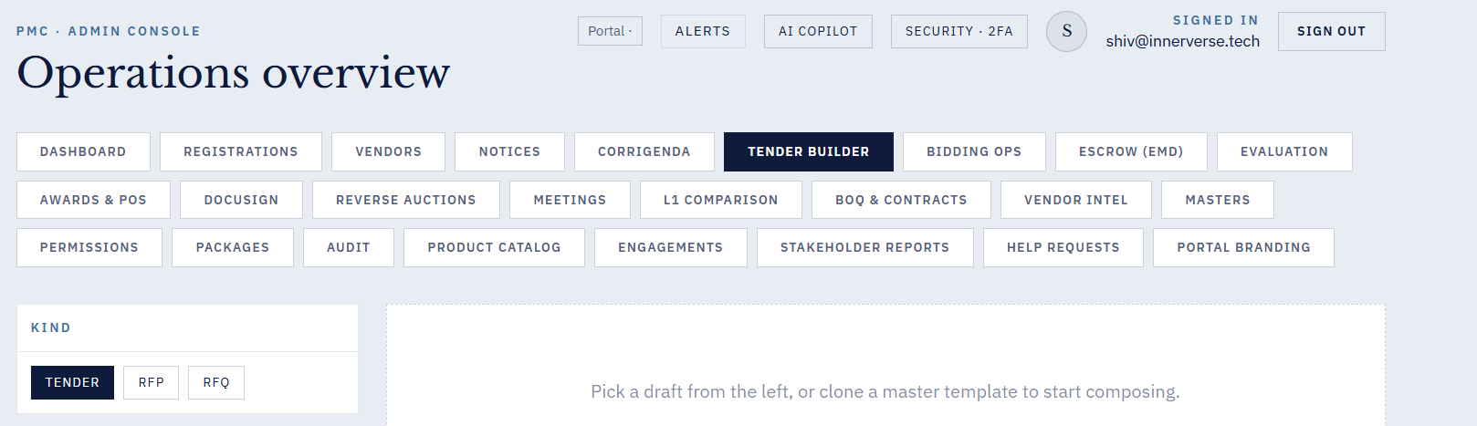

4. For new Vendor Sign in - in Pre tender registration - Download blank form is giving the following error

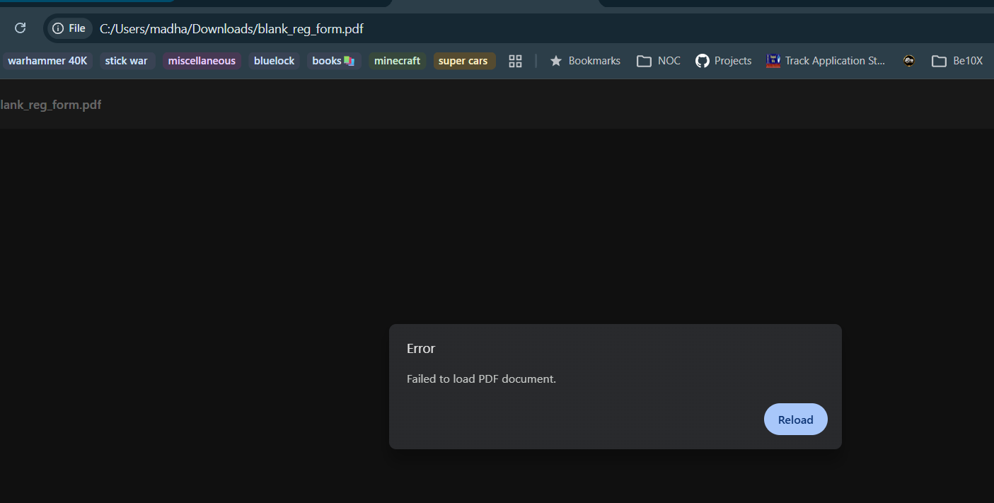

5. Creating a new notice from admin login - madhavi not working.
_Comments from Ramya: I checked this, and it is working fine. We are able to create a notice successfully. However, I’m not able to find where the unpublished notices are displayed. Could you please let me know where I can view the unpublished notices? Please check the screenshot below for reference. 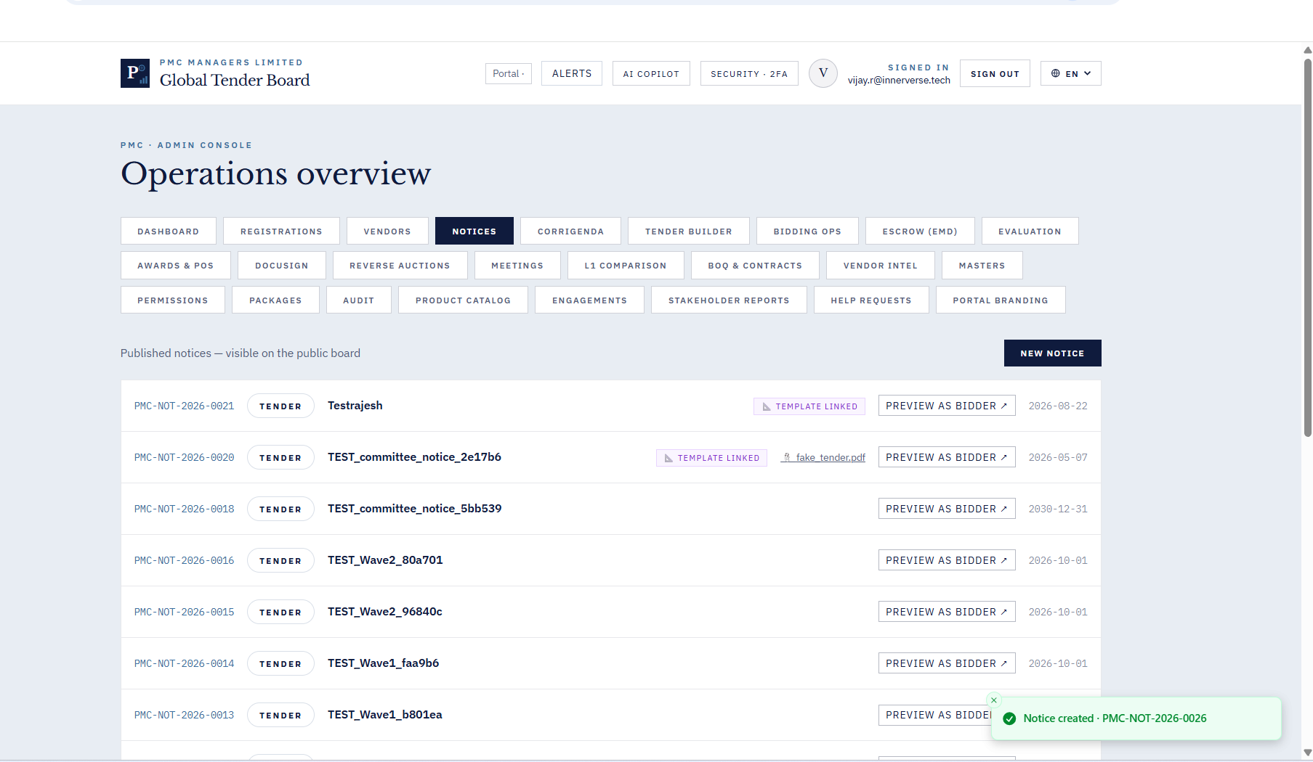

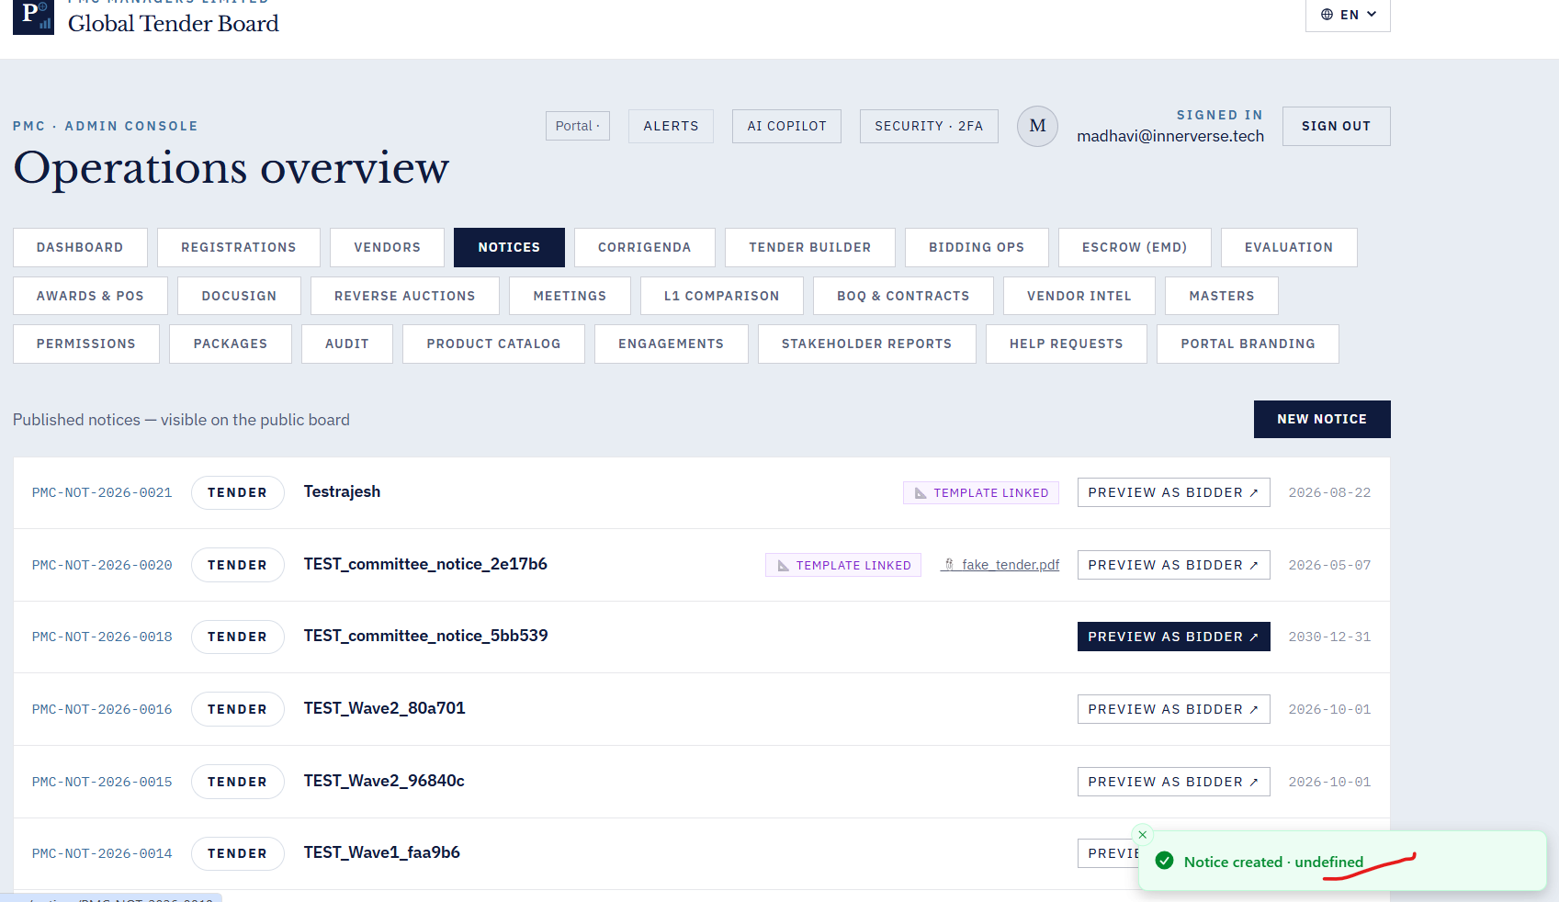

6. Mailing Address is added. Still receiving the error message while registering the vendor .
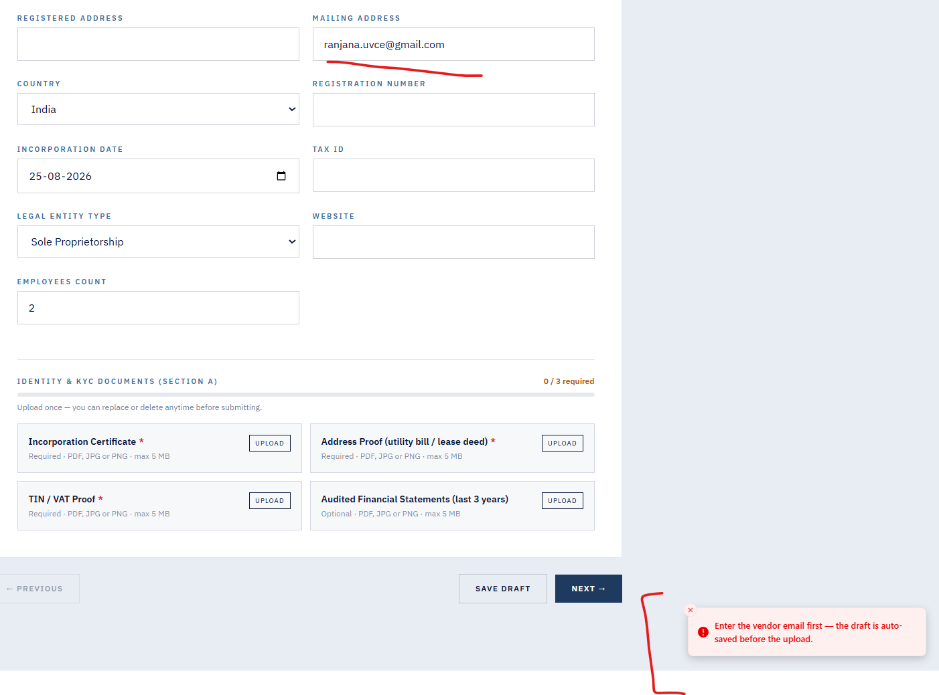
7. Resume link not sent to mail id provided although message on portal says sent the secure link to mail id.
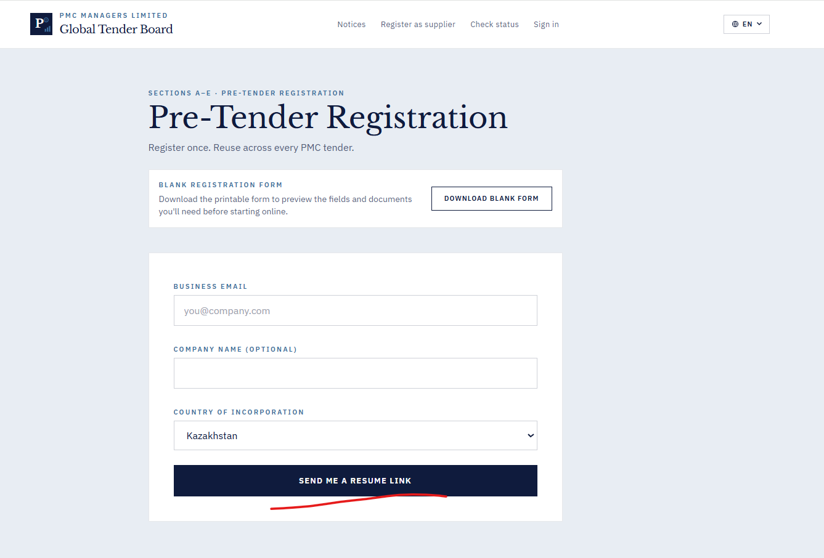

8. Invite vendor not working.
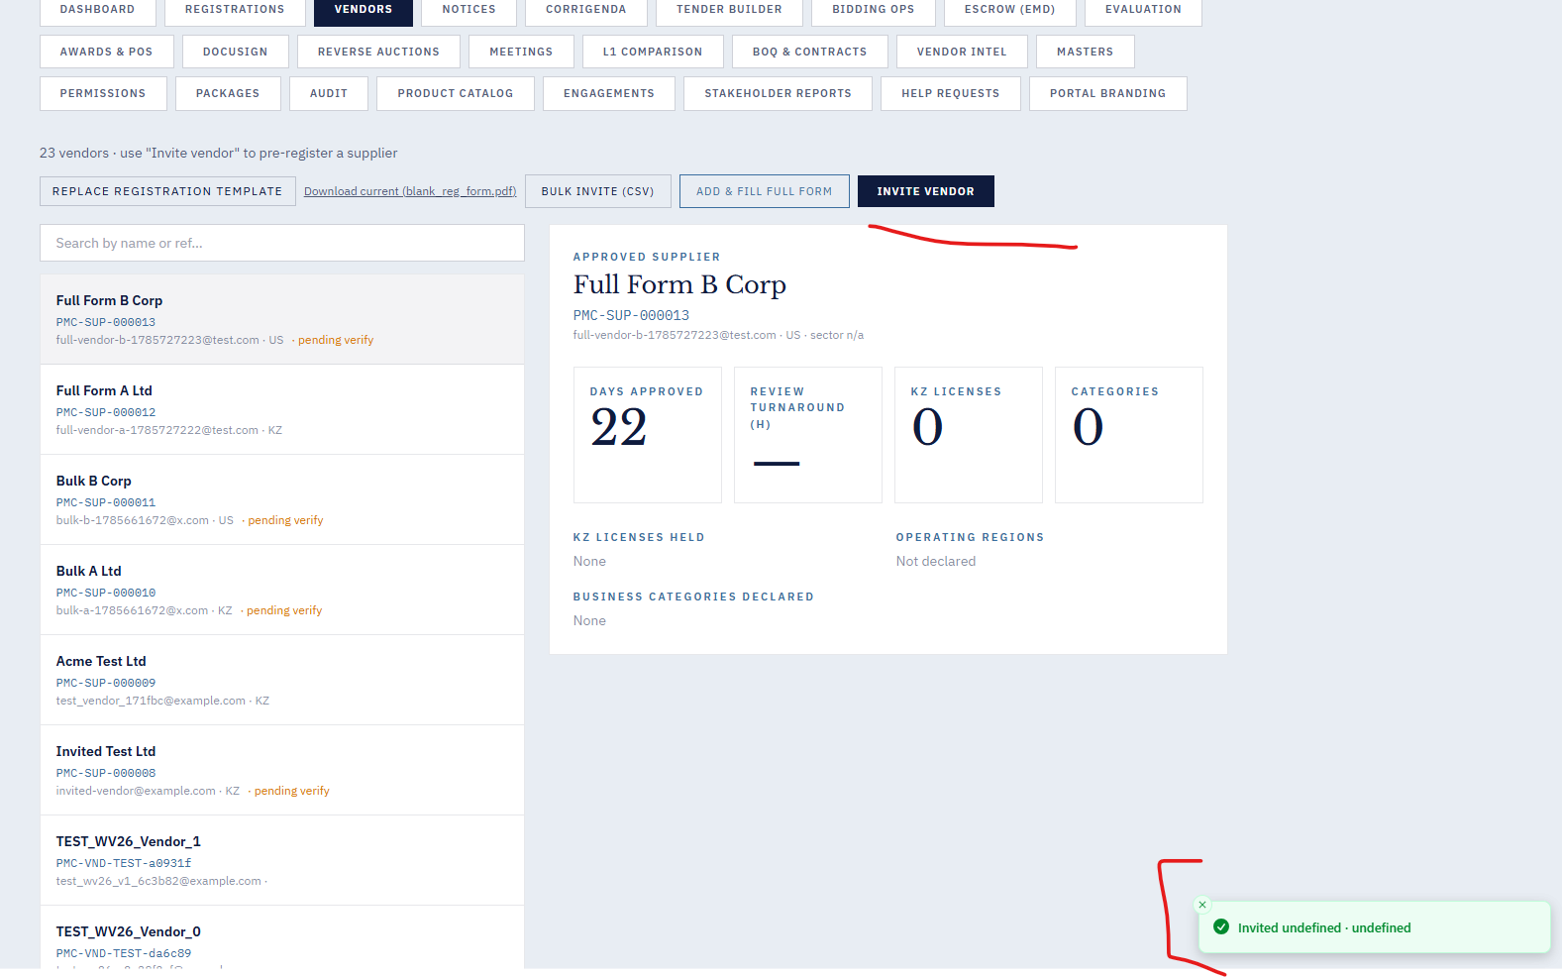
9. Vendor creation from “Vendor fill form” not working

11. On click of “Run L1 Comparision” the page hangs.
12. Newly created BOQ template and Contract shows the message as created . But they are not listed on the screen along with others.

13. On Click of “Masters” hangs the page.

14. ESCROW option when we click on new joint account without filling any details it is getting created
15. AI BID ANOMALY in DASHBOARD , Score and deviation remains same not showing anything.
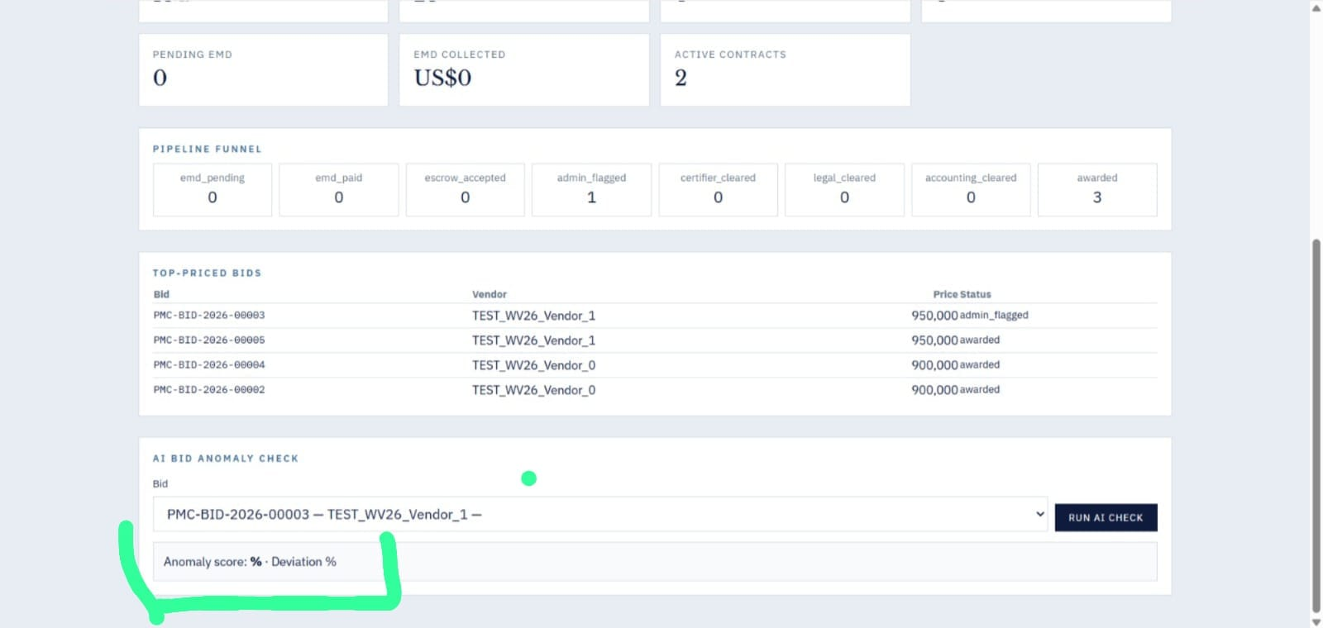

16. Registration Filter State Issue -- Previously selected company details remain displayed even after switching between registration status tabs.

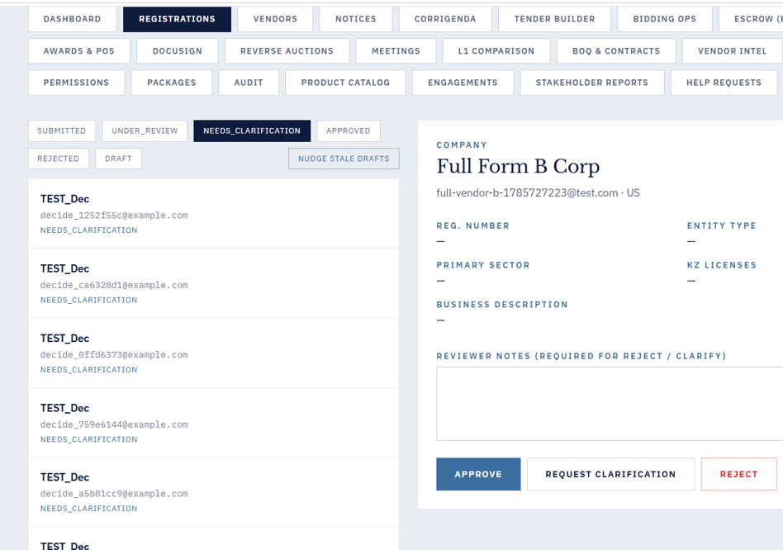
17. Got a email from PMC Managers, dse_demo@docusign.net to my email account . 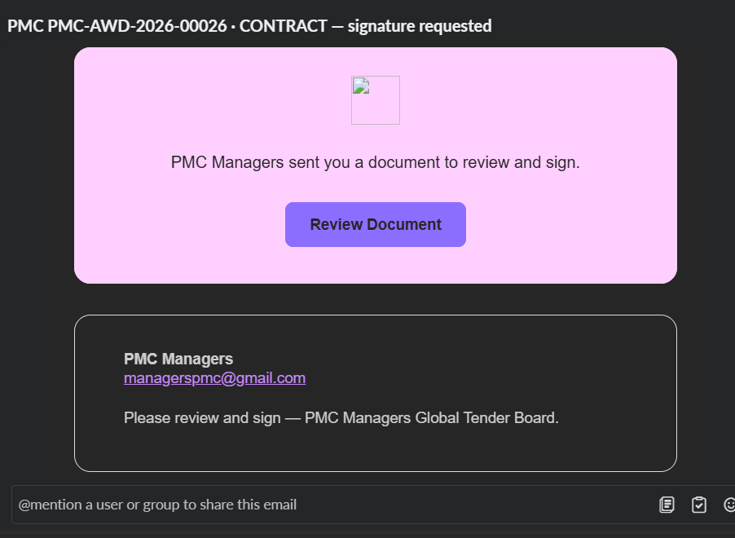when Review document is clicked and followed few steps at end getting the below error.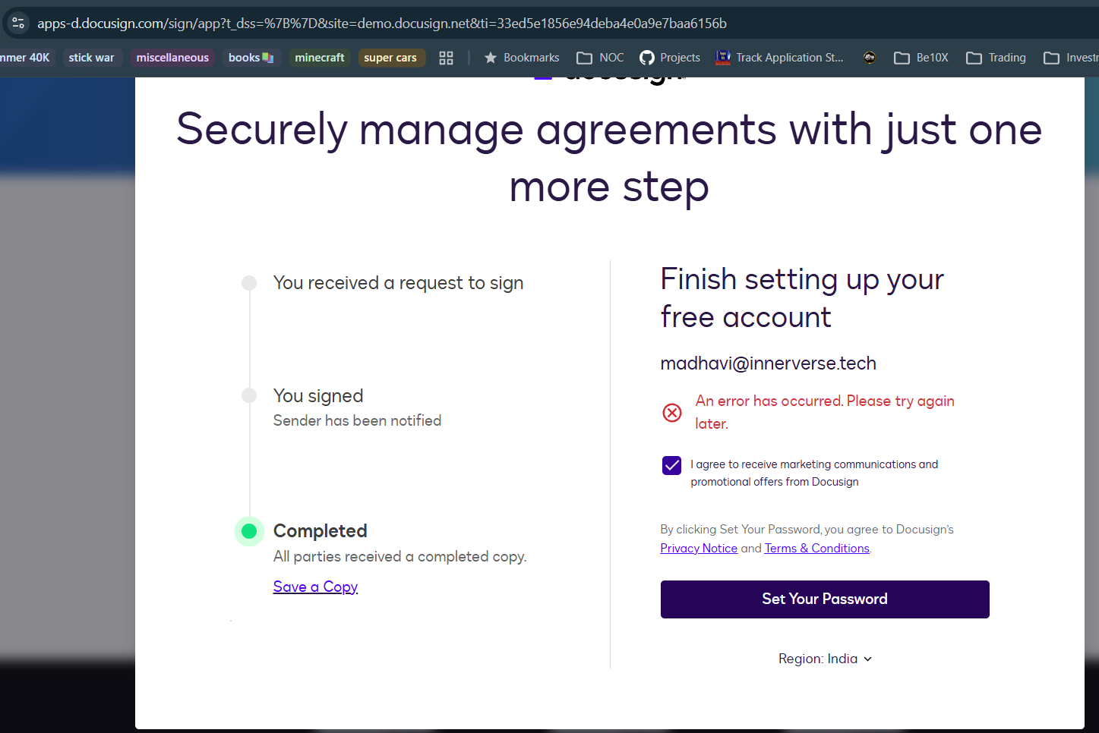

18. Accepts negative number for Budget:
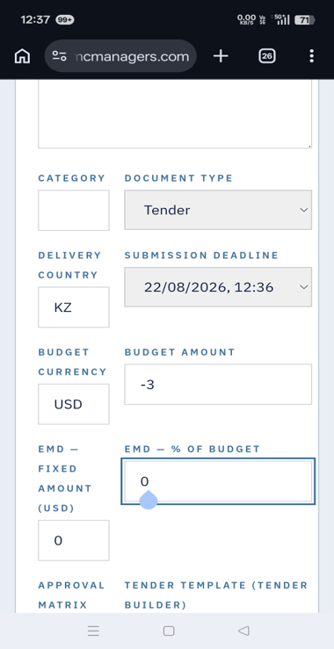

19. Package created message is seen but not listed below.
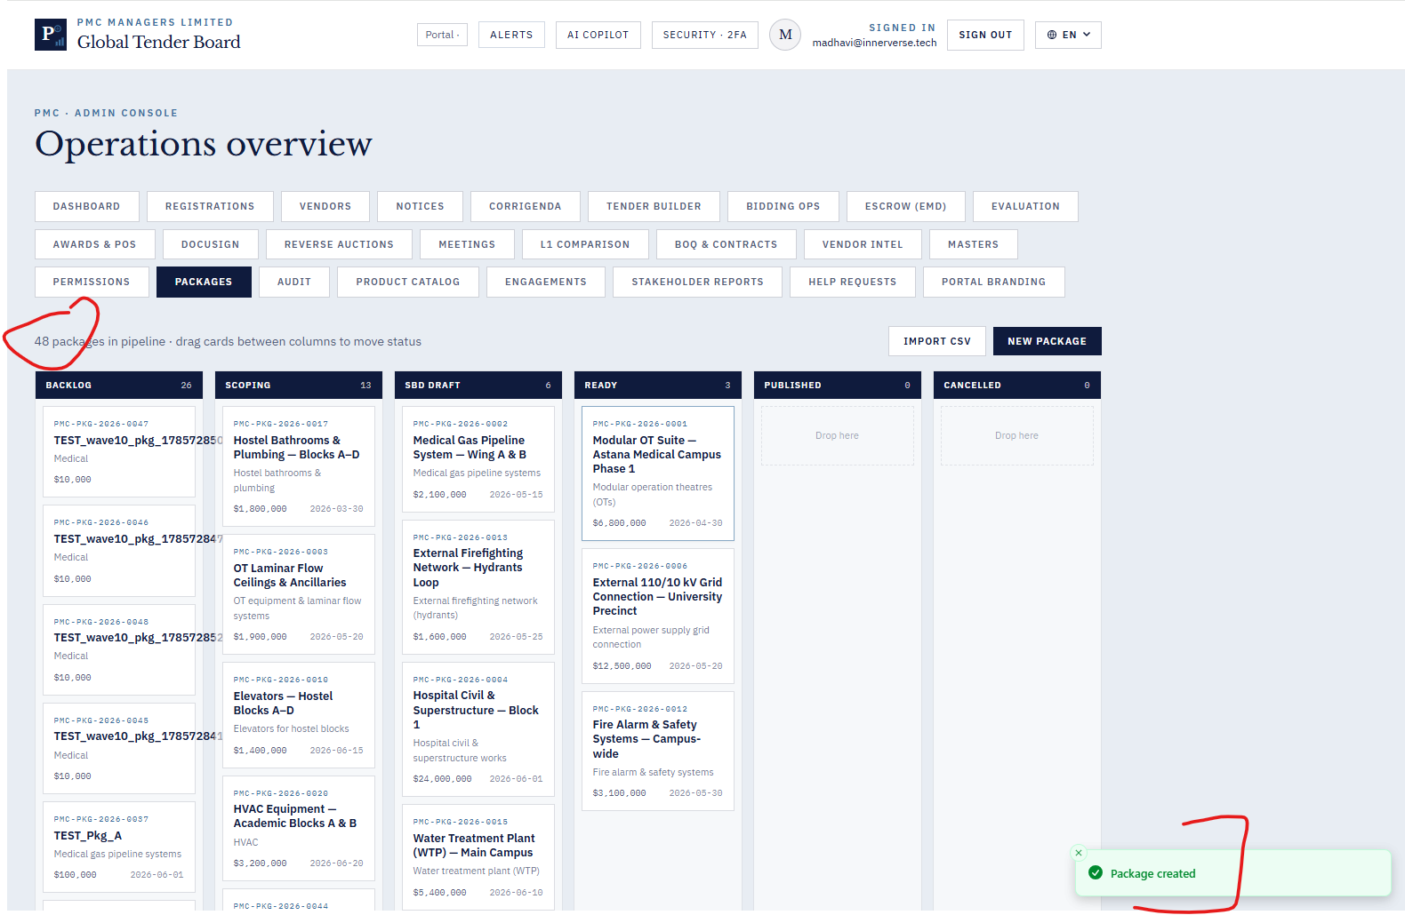

20.
From the landing page without logging in navigate to the Check status and give the token from the email we received from PMC application, it does not show any status or warning message like invalid token.
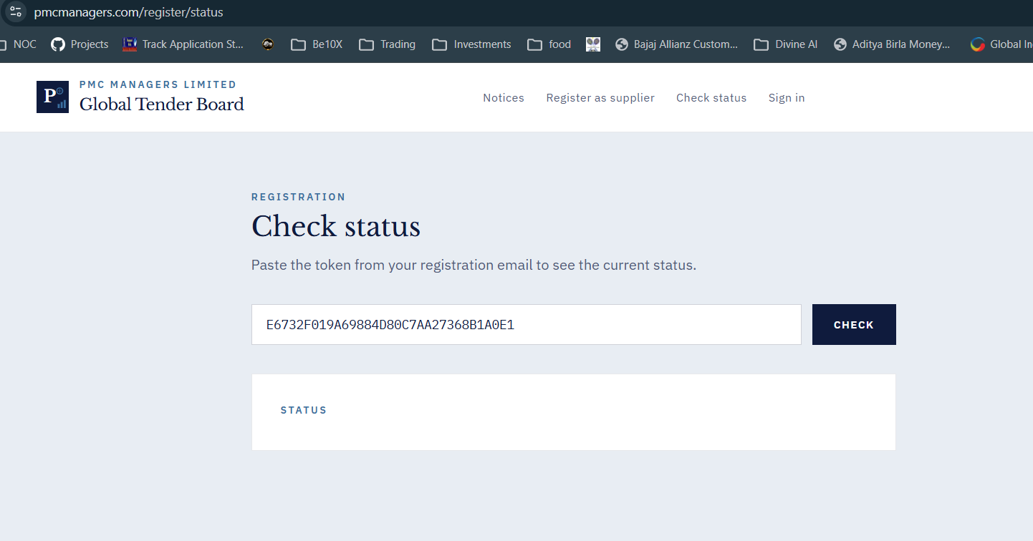

21. While trying to login the application , getting the following error in the inspect, console tab.

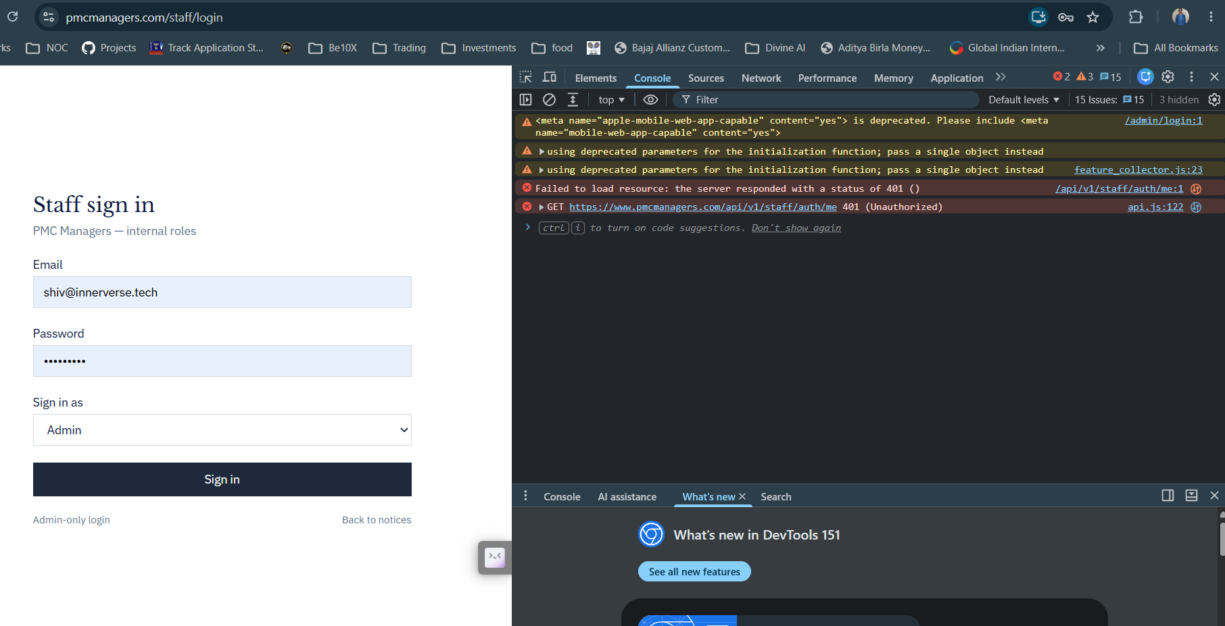
22. Notices Module :
After creating a notice, clicking New Notice again without refreshing retains the previous notice details in other fields; the form should be completely reset.
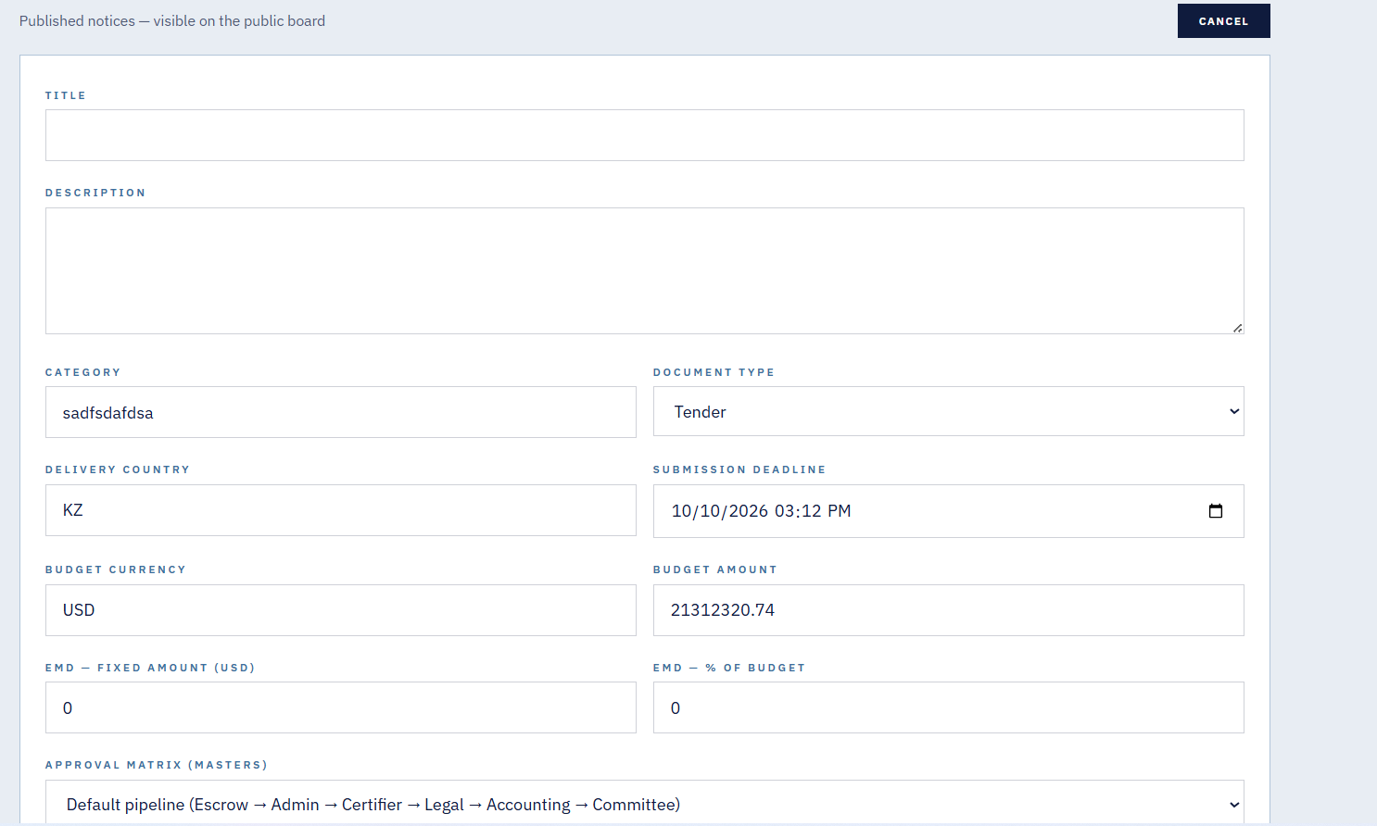
23.The validation toast message is unclear because it does not specify whether the Title or Description field requires a minimum of 10 characters.
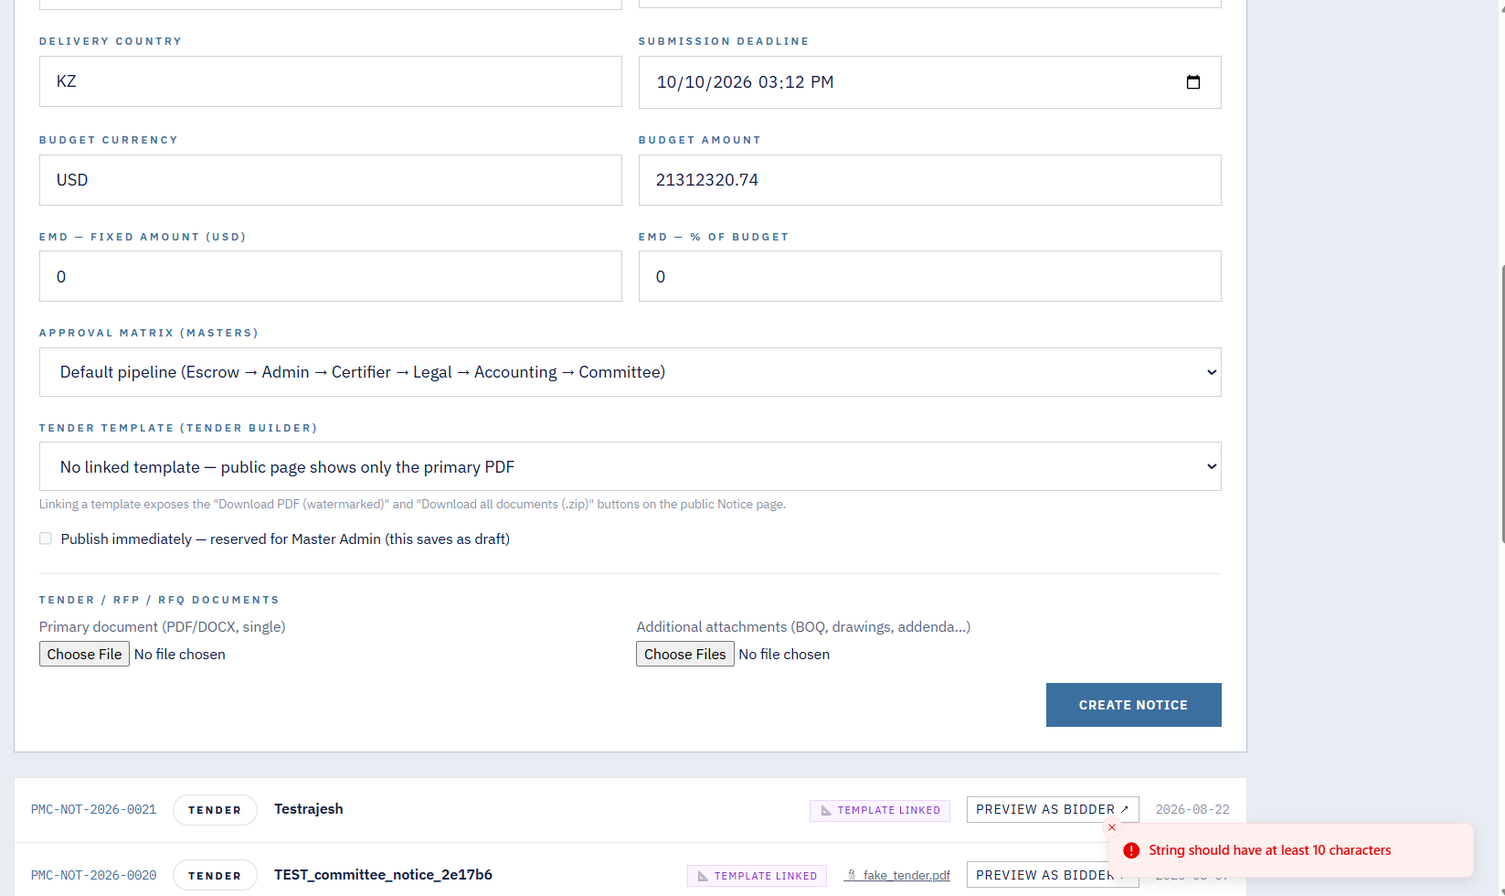
24.Even though I am logged in as a Master Admin, I am unable to select the Publish checkbox, as it appears disabled or unavailable.
25. Even after withdrawing a Corrigenda notice, it is still visible under the Notices section as an active notice; withdrawn notices should no longer be displayed as active.
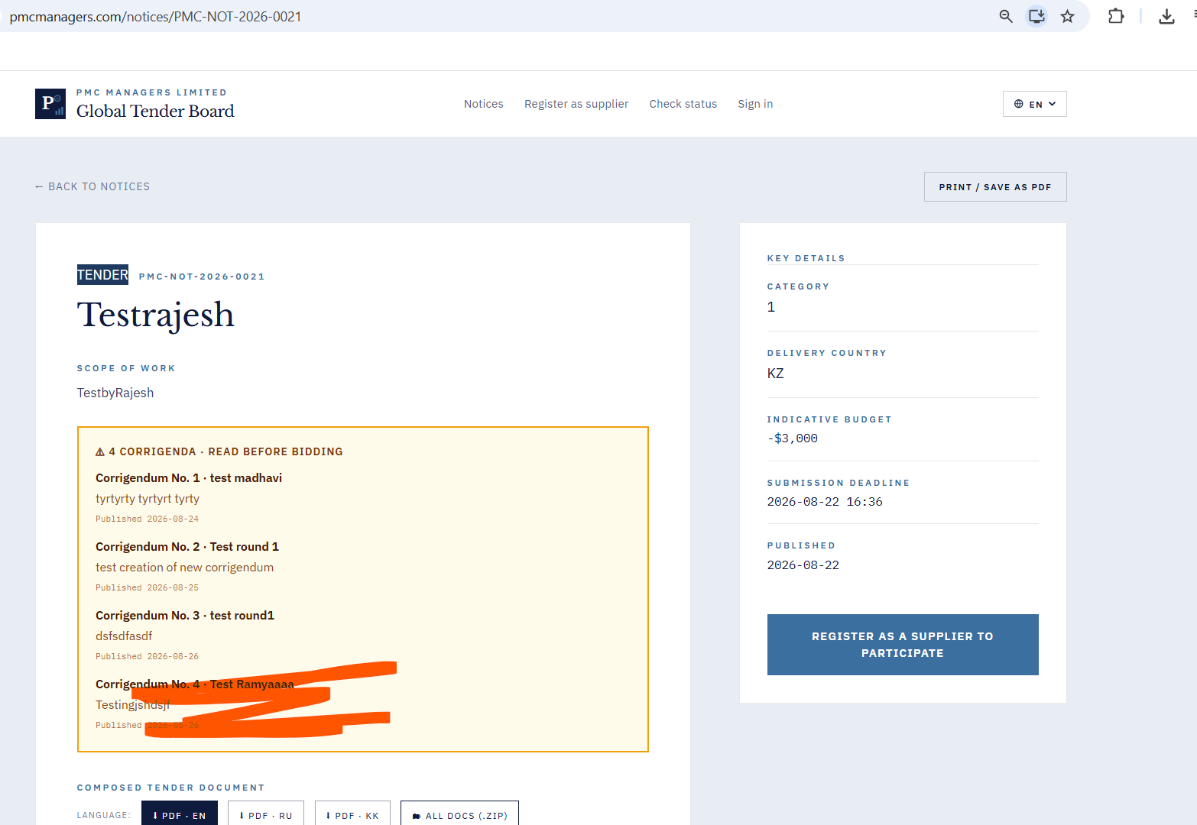
26. After clicking Withdraw, the Corrigenda status is not updated to Withdrawn, and the Withdraw button still appears, making it unclear whether the notice has been withdrawn.
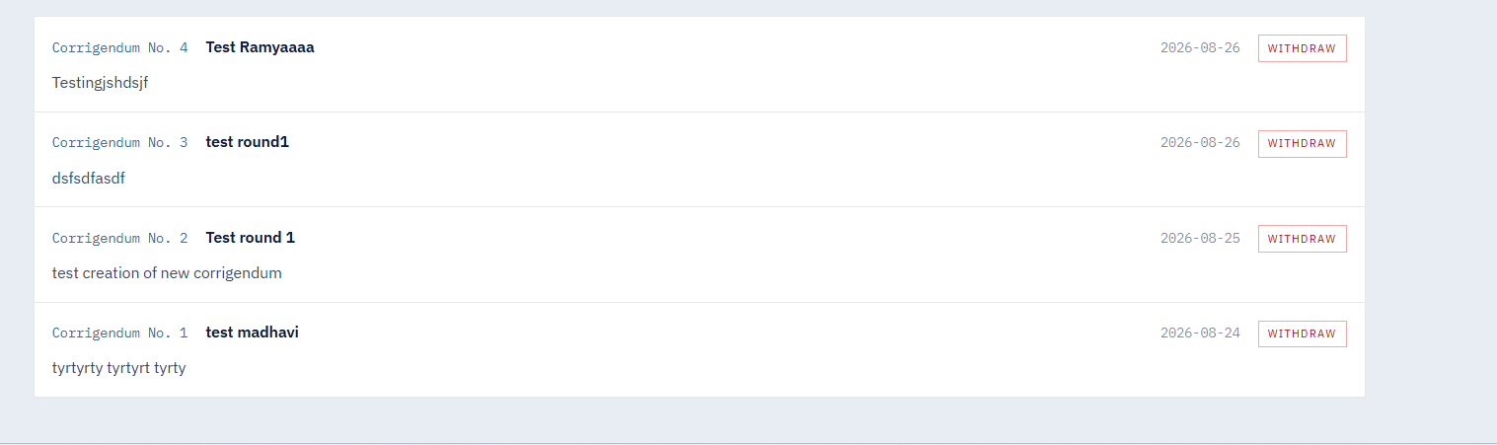
27.After approving, rejecting, or requesting clarification for a supplier, the action is not being saved—when I return to the Registration tab, it still shows the options to Approve, Reject, or Request Clarification again.
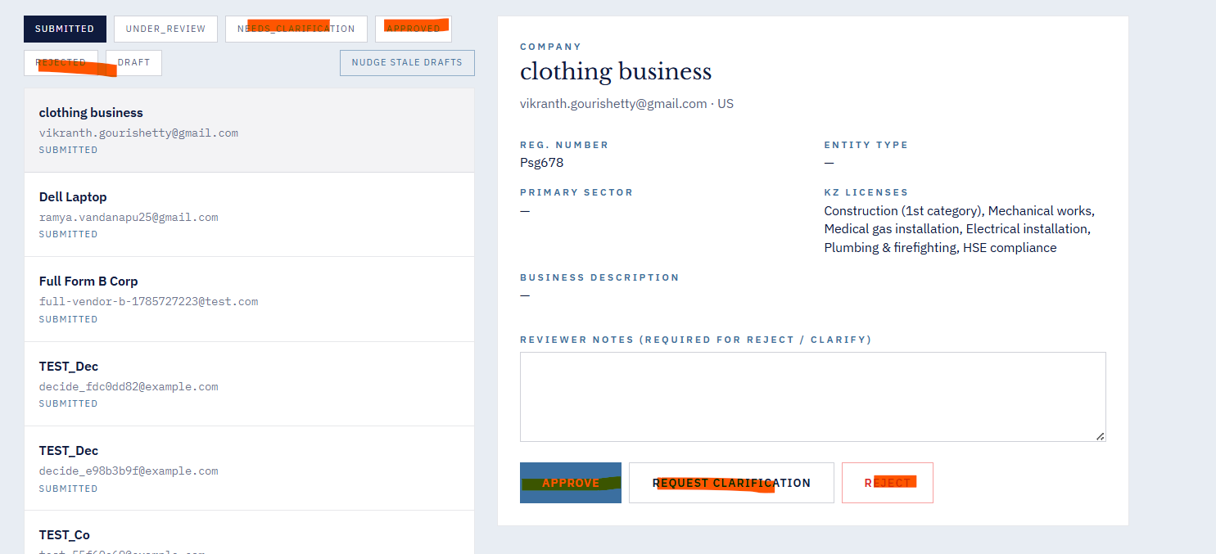
28. In the Vendors module, after clicking the Invite button under Bulk Invite CSV, the page either goes blank or signs me out.
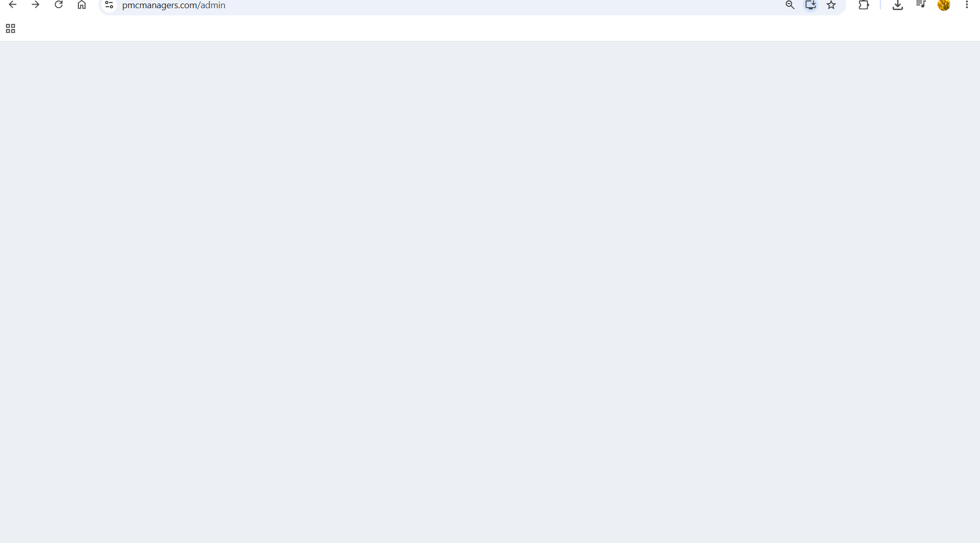
29. In the Vendors module, when I replace the Registration Template, an “undefined” toast message is displayed and not able to download template ( not showing the name in brackets also)
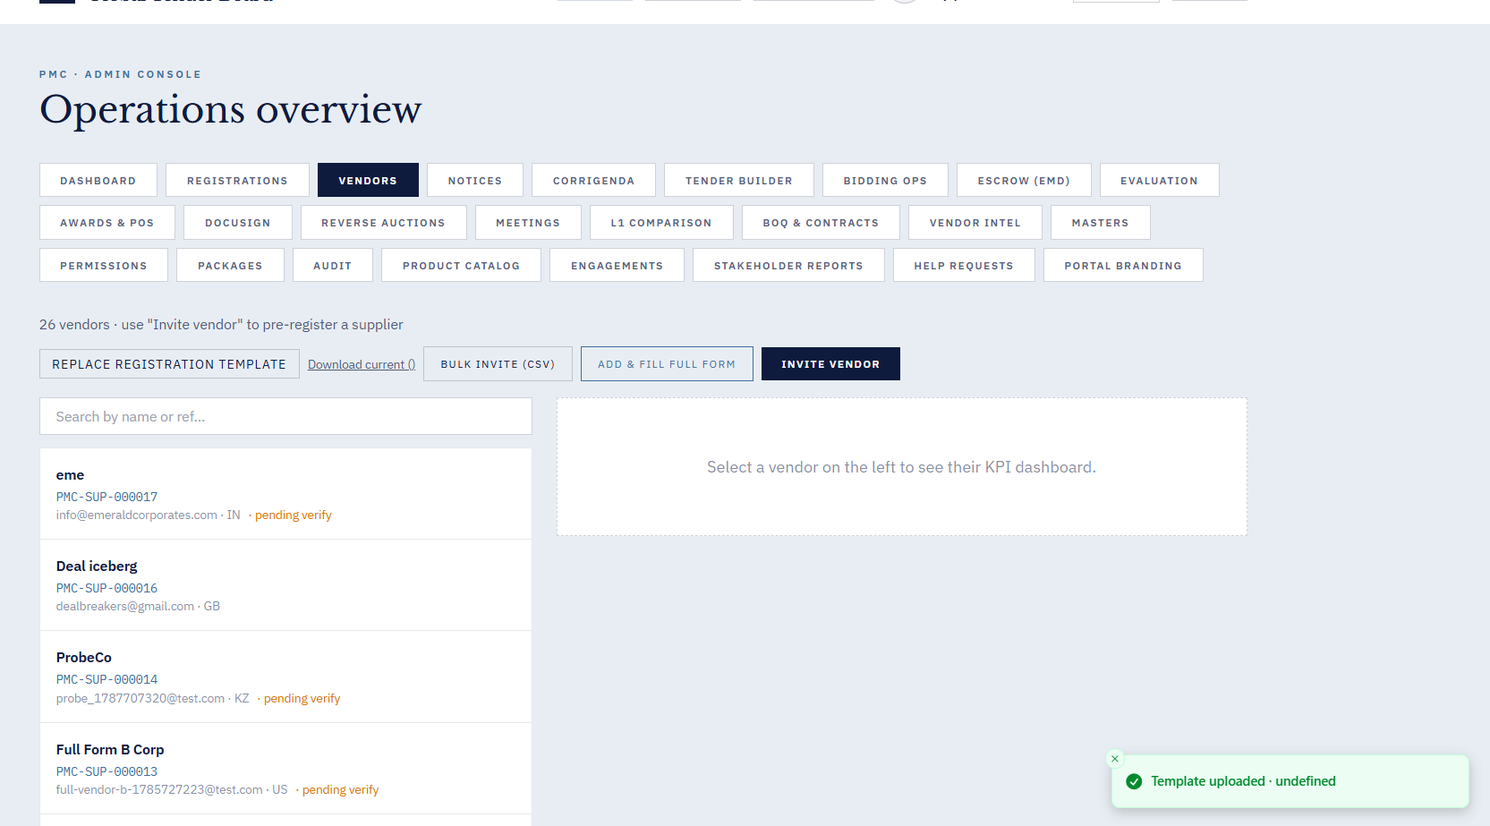
30. In the Vendors module, after adding a new vendor and activating it from the Activation tab, the newly created vendor is not appearing in the Vendors table.
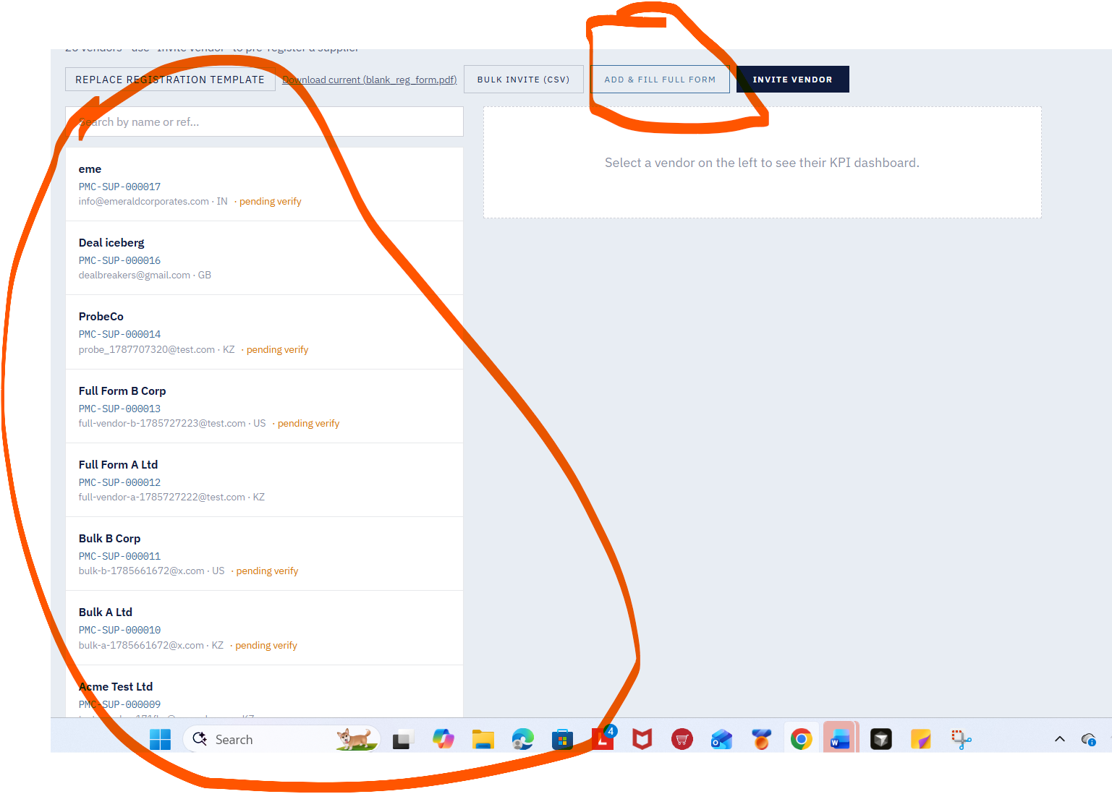
31. It is not converting all modules to respectives languages 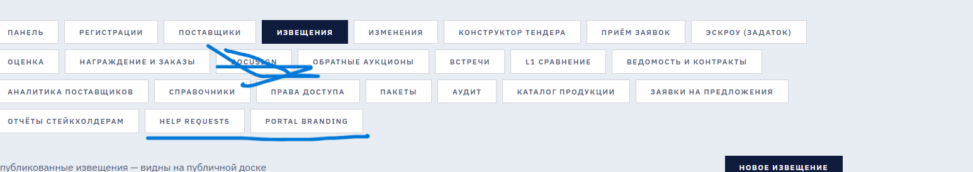
32In the Profile module, the uploaded image is saved successfully, but after logging in again in a new tab, the profile image is not displayed. 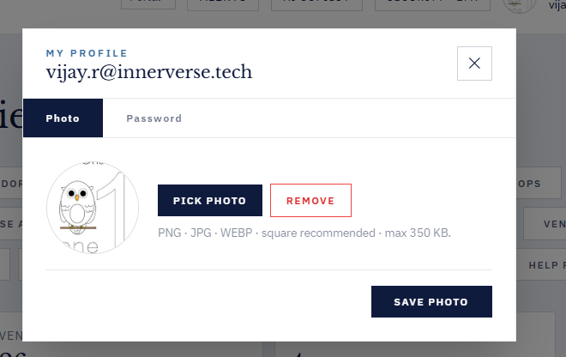

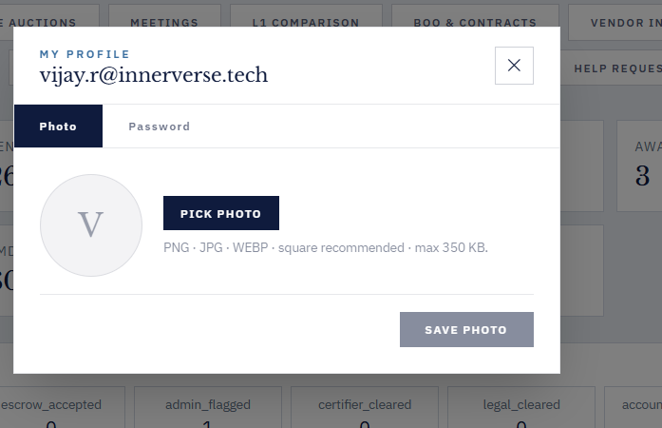

33. Across the forms, there is no proper validation for Email and Mobile Number fields; the Email field accepts invalid formats, and the Mobile Number field allows characters instead of numbers only.

34. Not able to save existing product catalog a;though it shows “Saved Procurement Strategy”
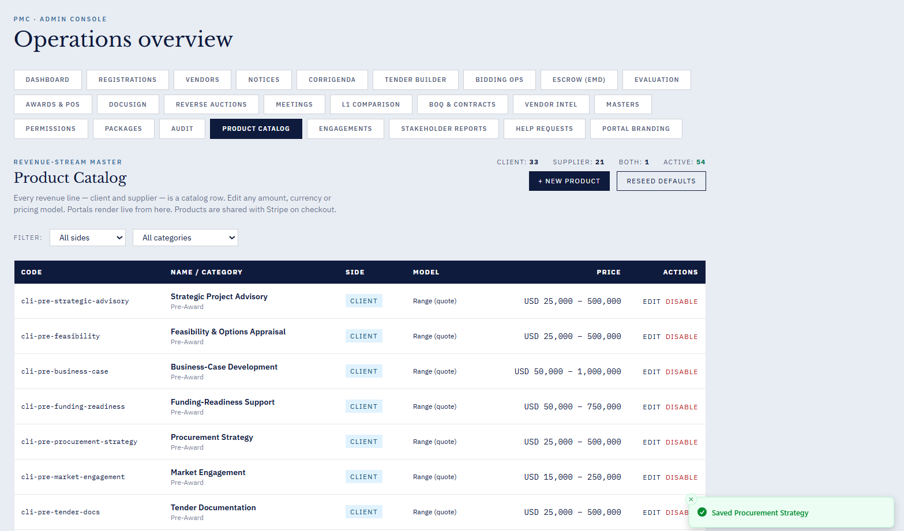

35. Create Product Catalog - shows message created successfully but not listed in the table
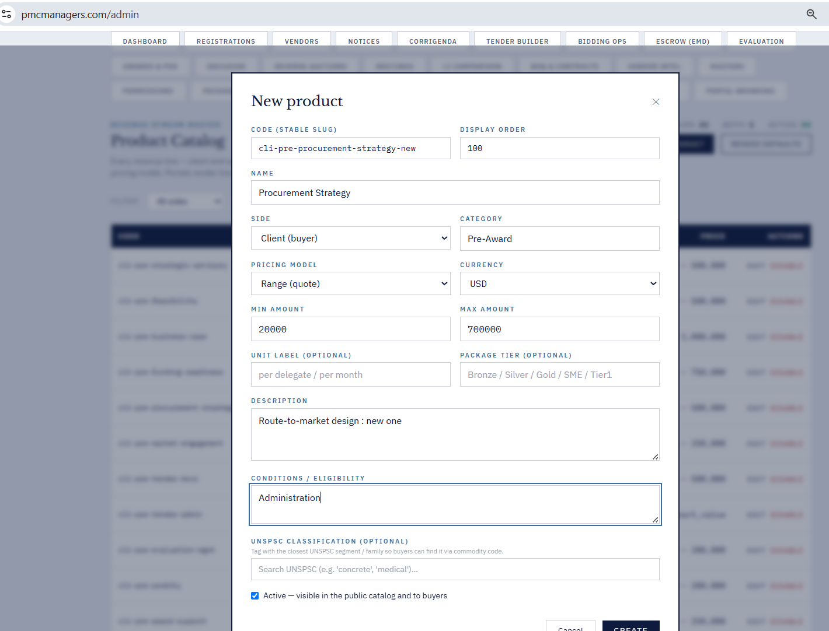

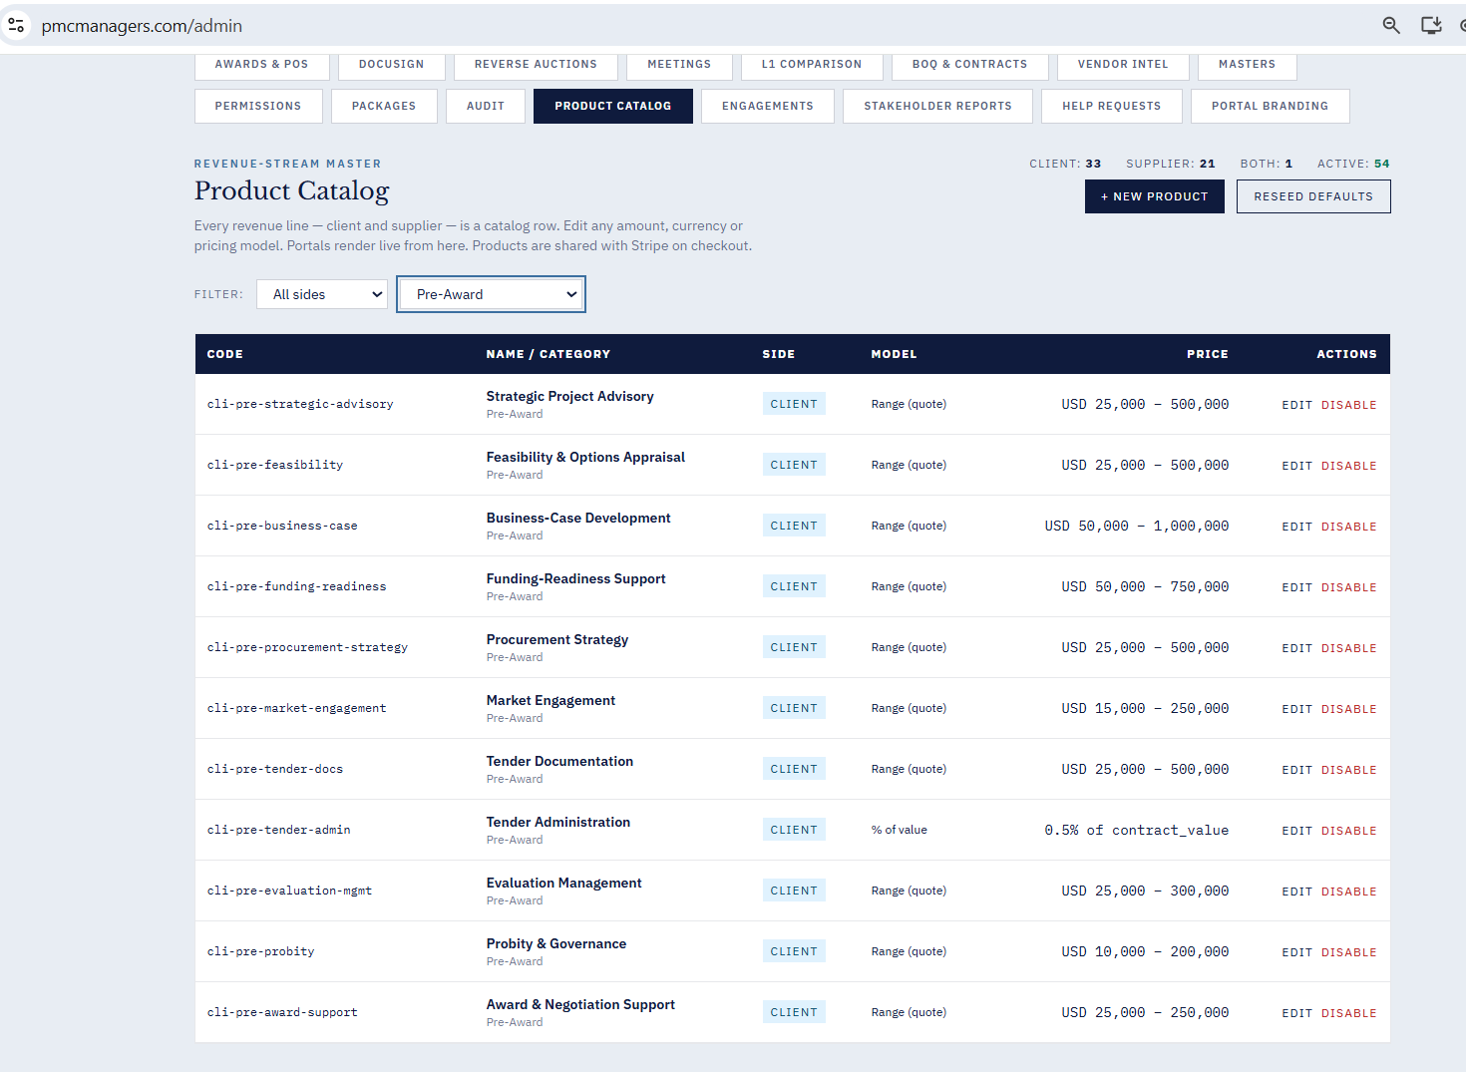

36. Click on “Audit” , hangs the portal.
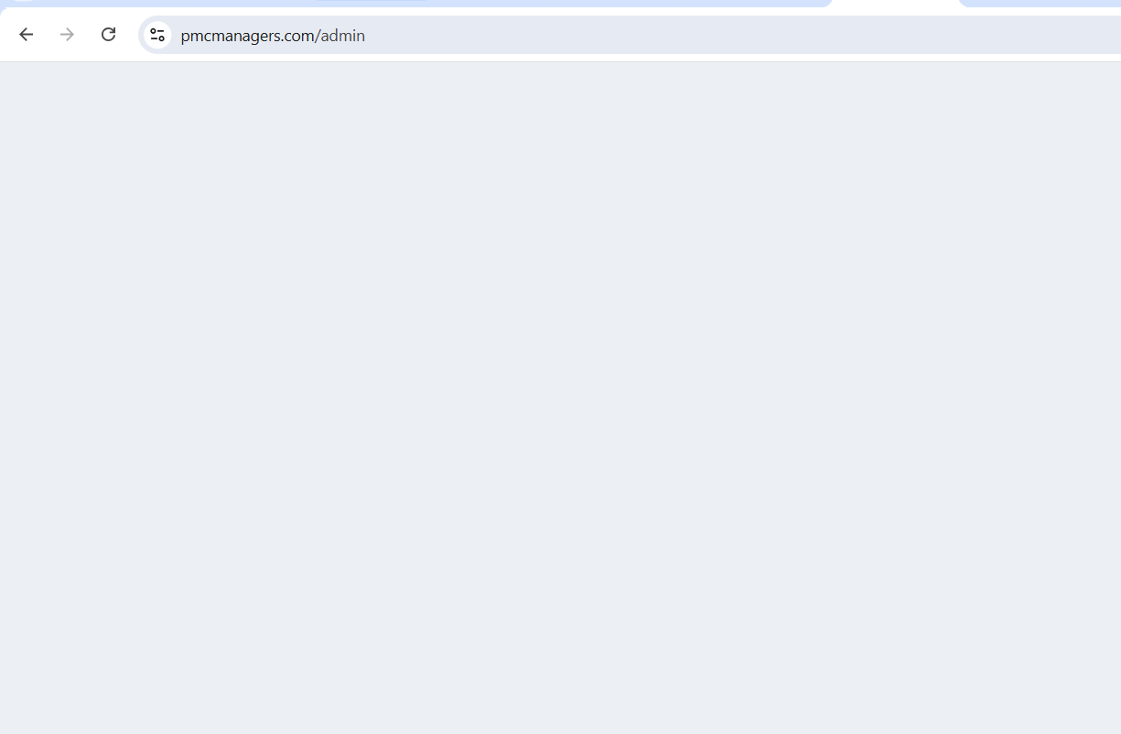

37. The new package is not listed in the table below. Although it shows a package created successfully.

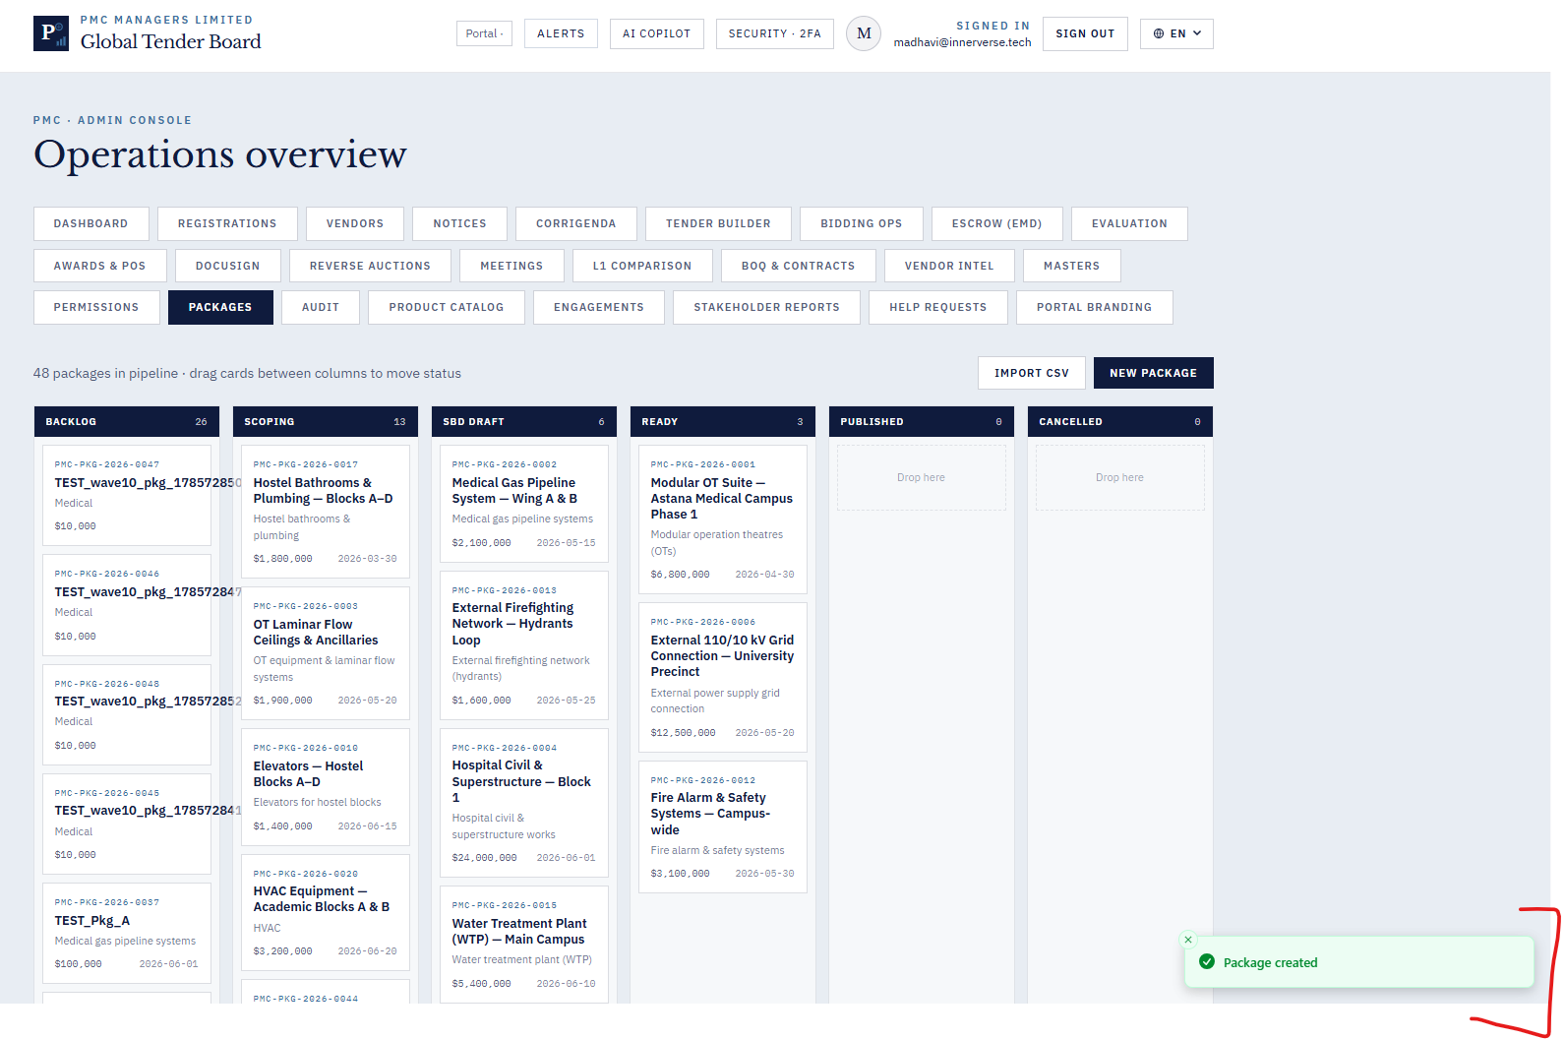
38 .Tender Builder content does not update when switching between Tender, RFP, and RFQ tabs
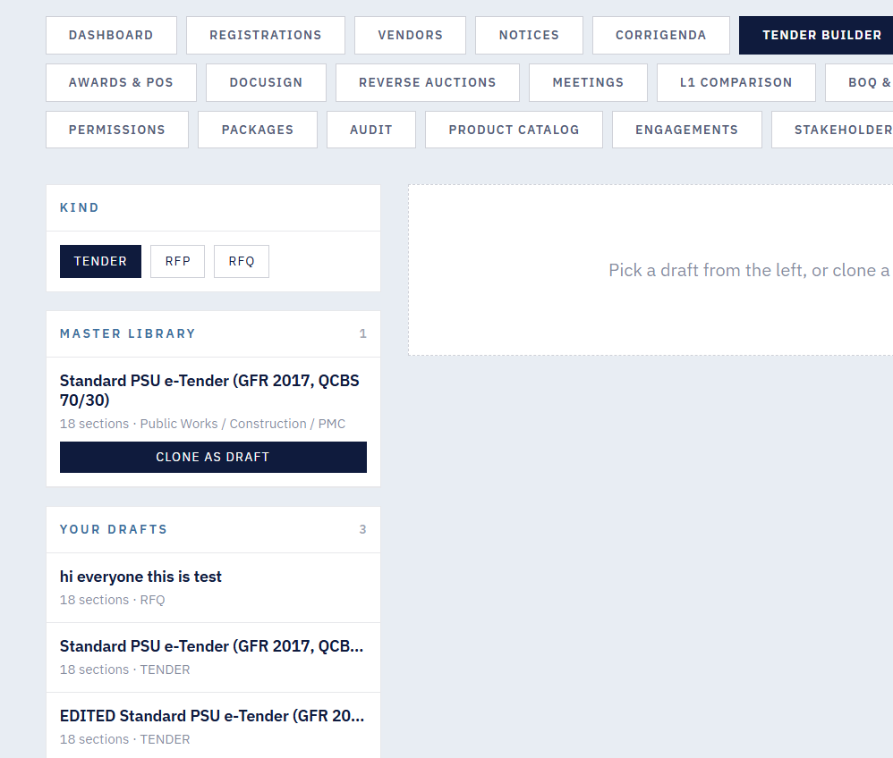
39. Evaluation Tab - Click on “Generate Award Report” hangs the portal.

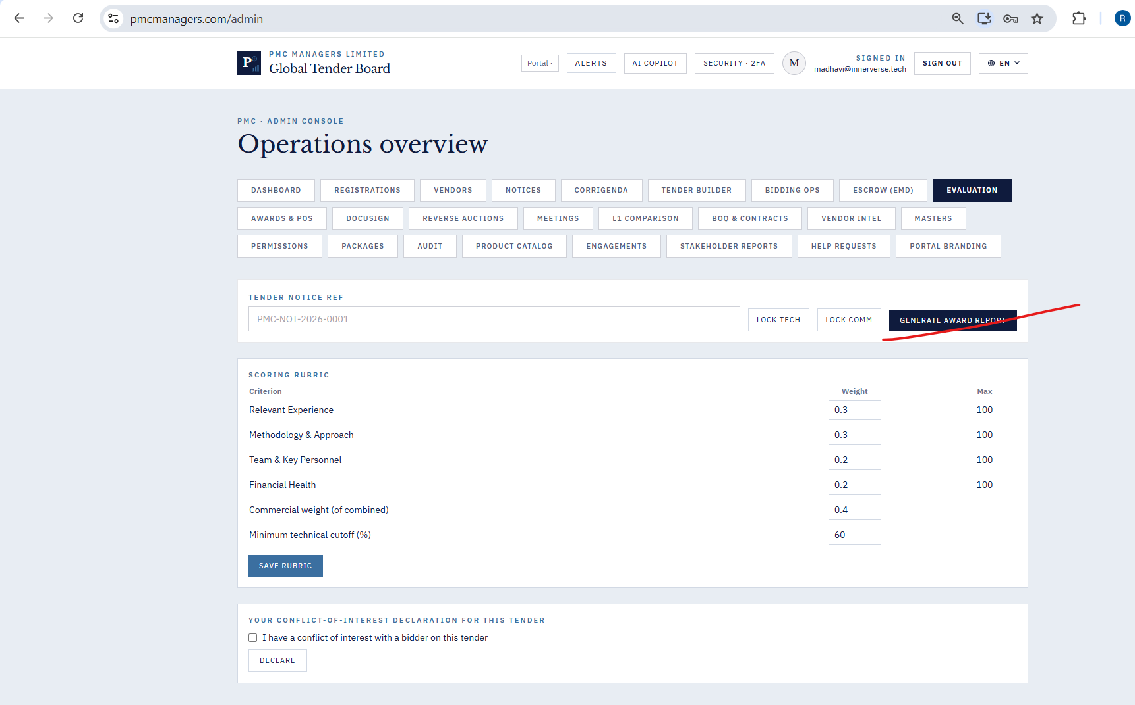

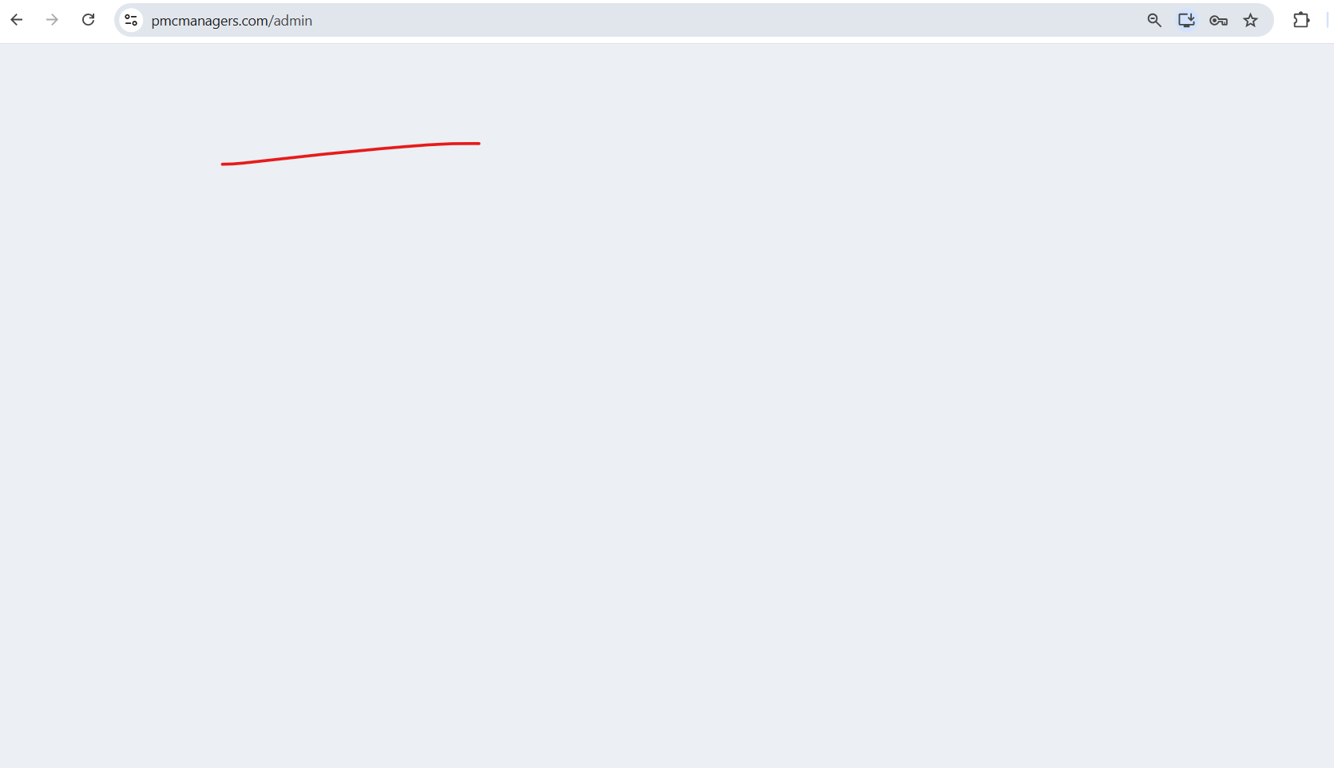

40. In “L1 comparision” tab the drop down does not list the notices.
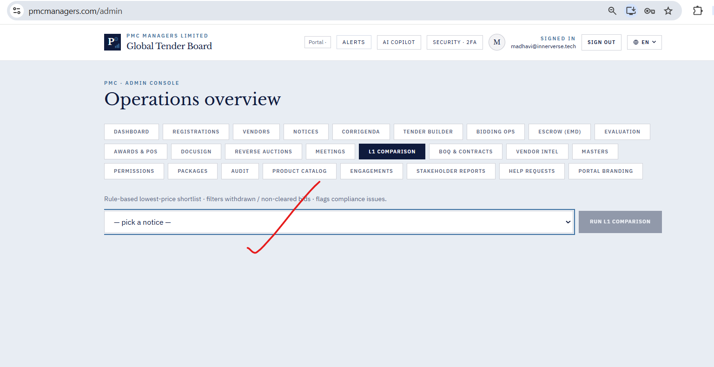

41. Regenerate documents do not work as expected under the Awards & POS tab.
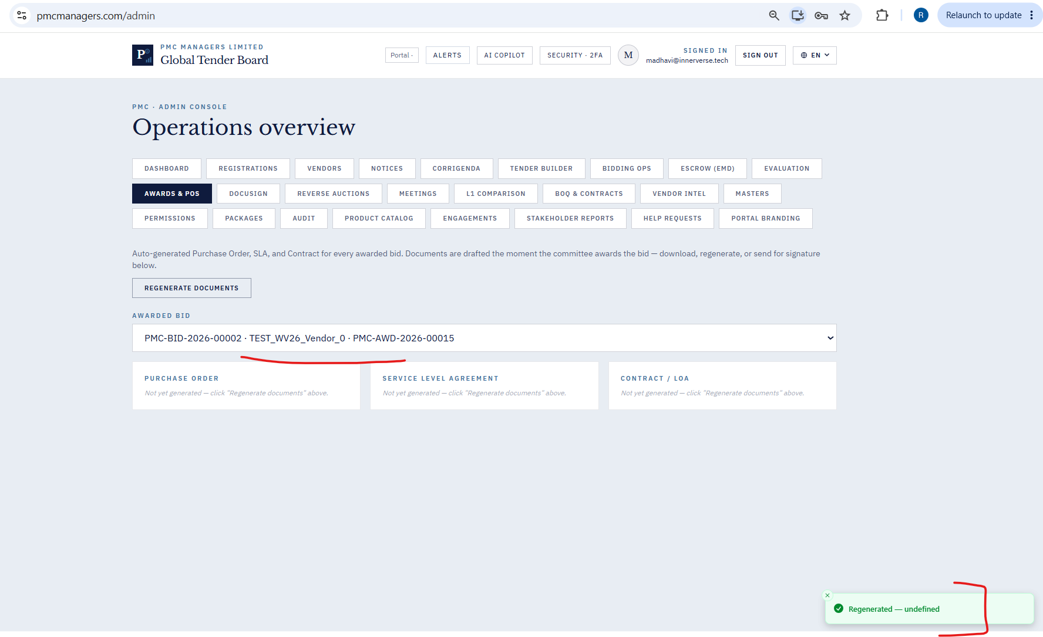

42. On click of “New Reverse Auction” in the Reverse Auction tab newly created auction is not listed as draft.
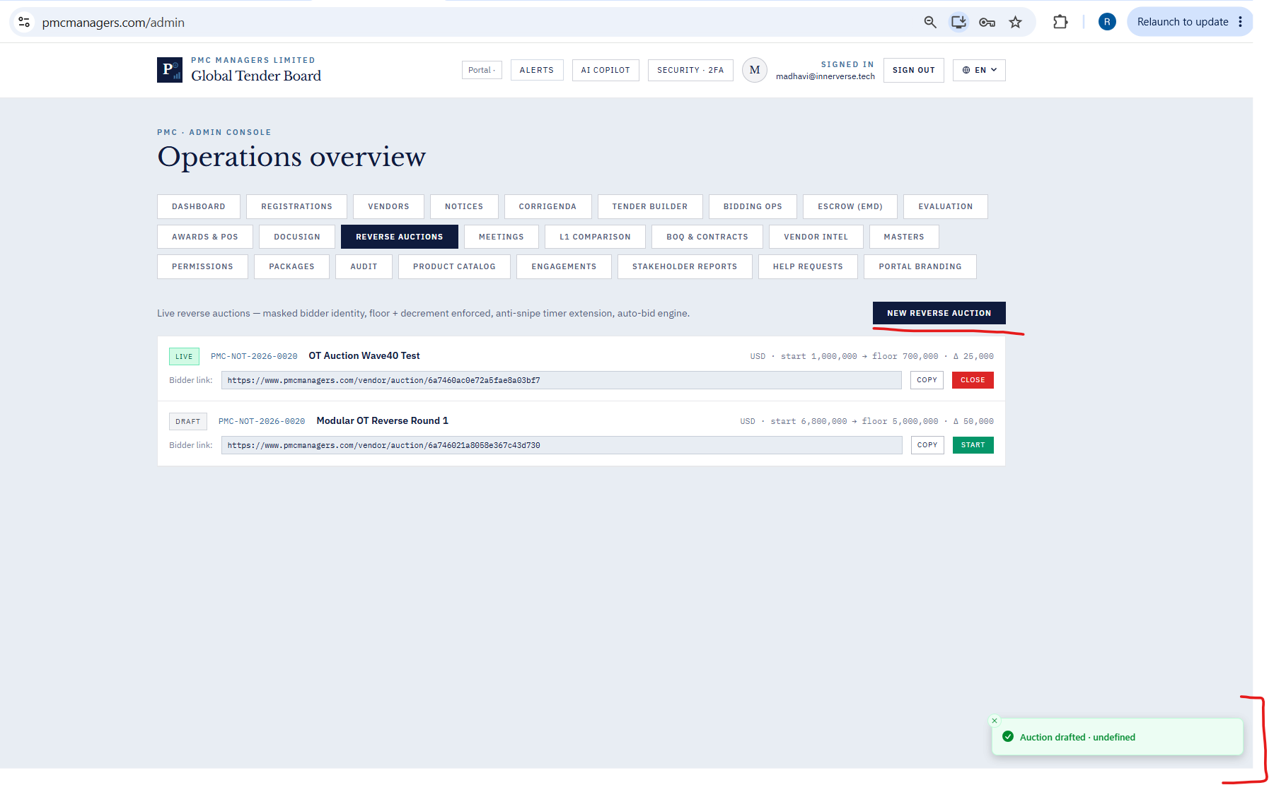

43. On clicking the “Start” button does not make the notice go live.
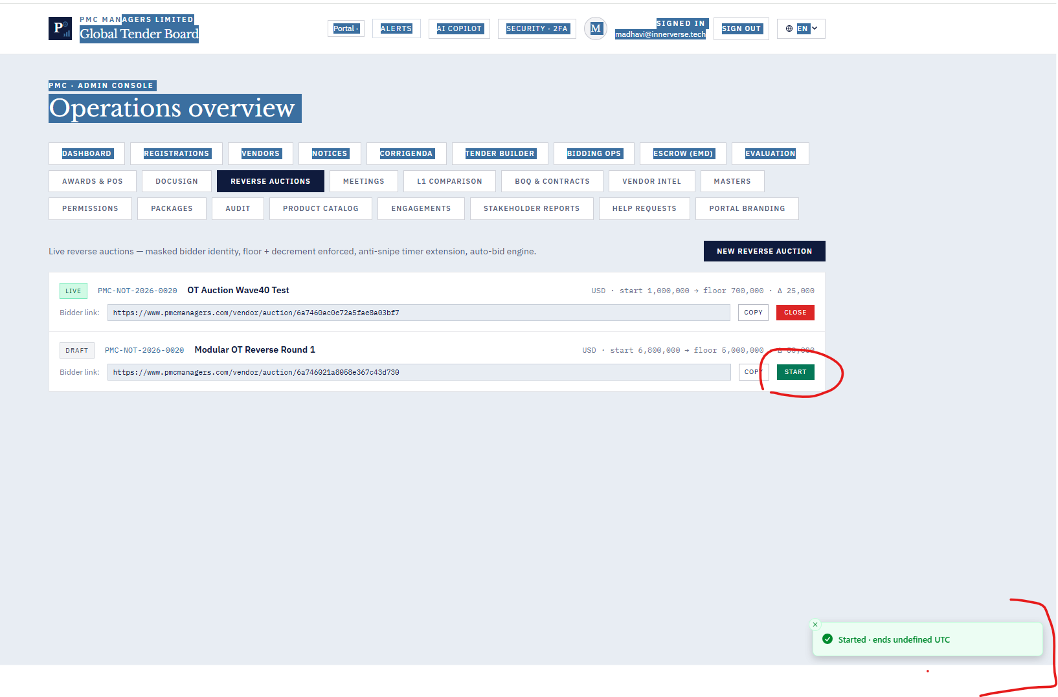
44. On clicking the “Close” button auction is not getting closed.
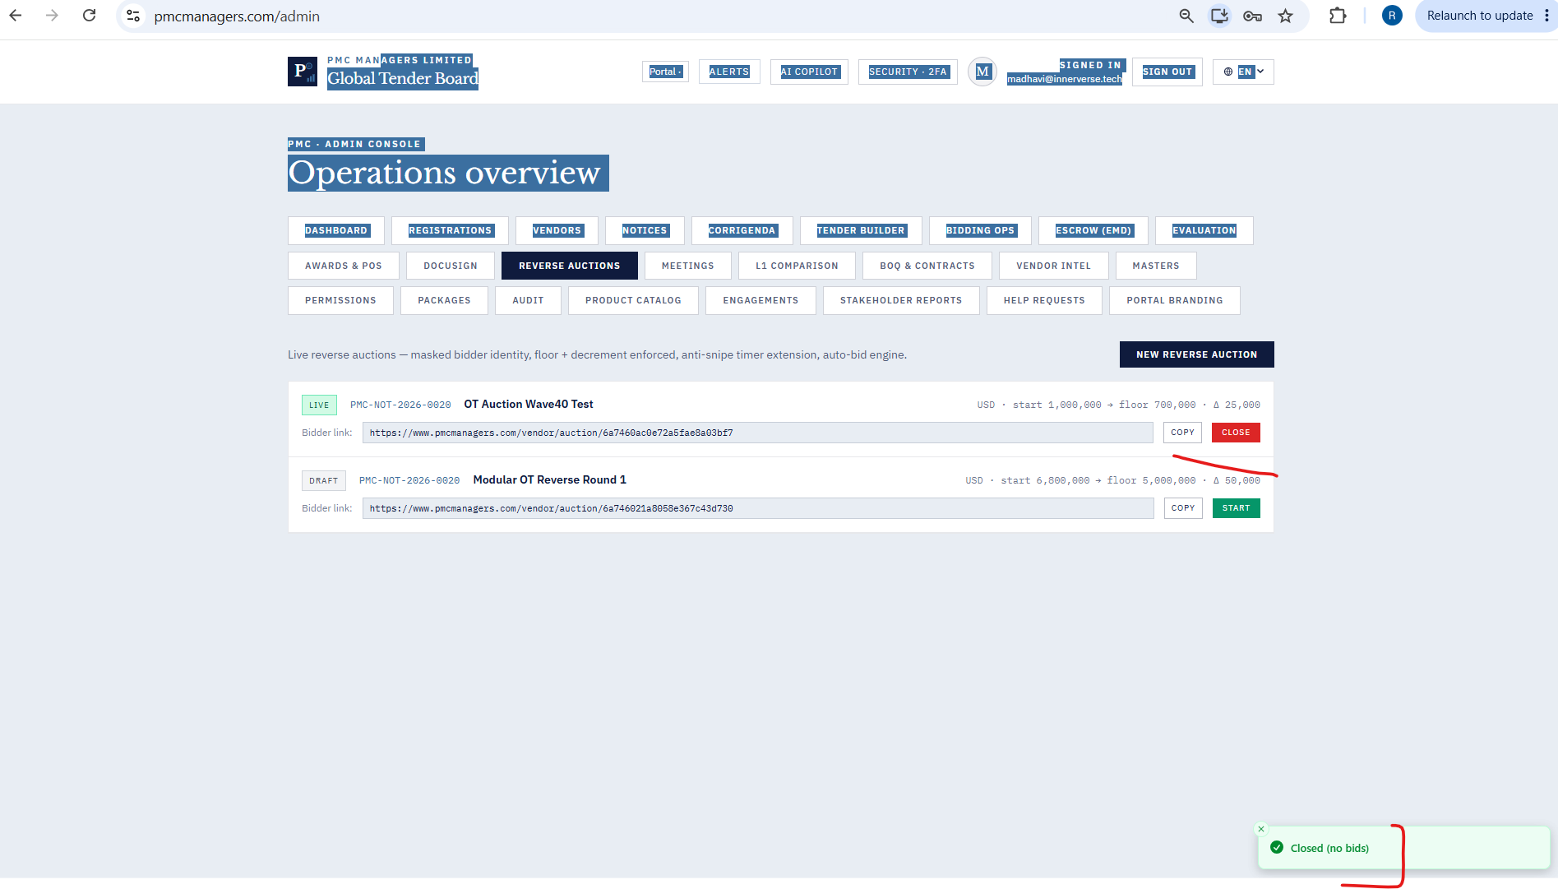

45. Registrations Tab - Rejected a company. But it is not listed under Rejected list.

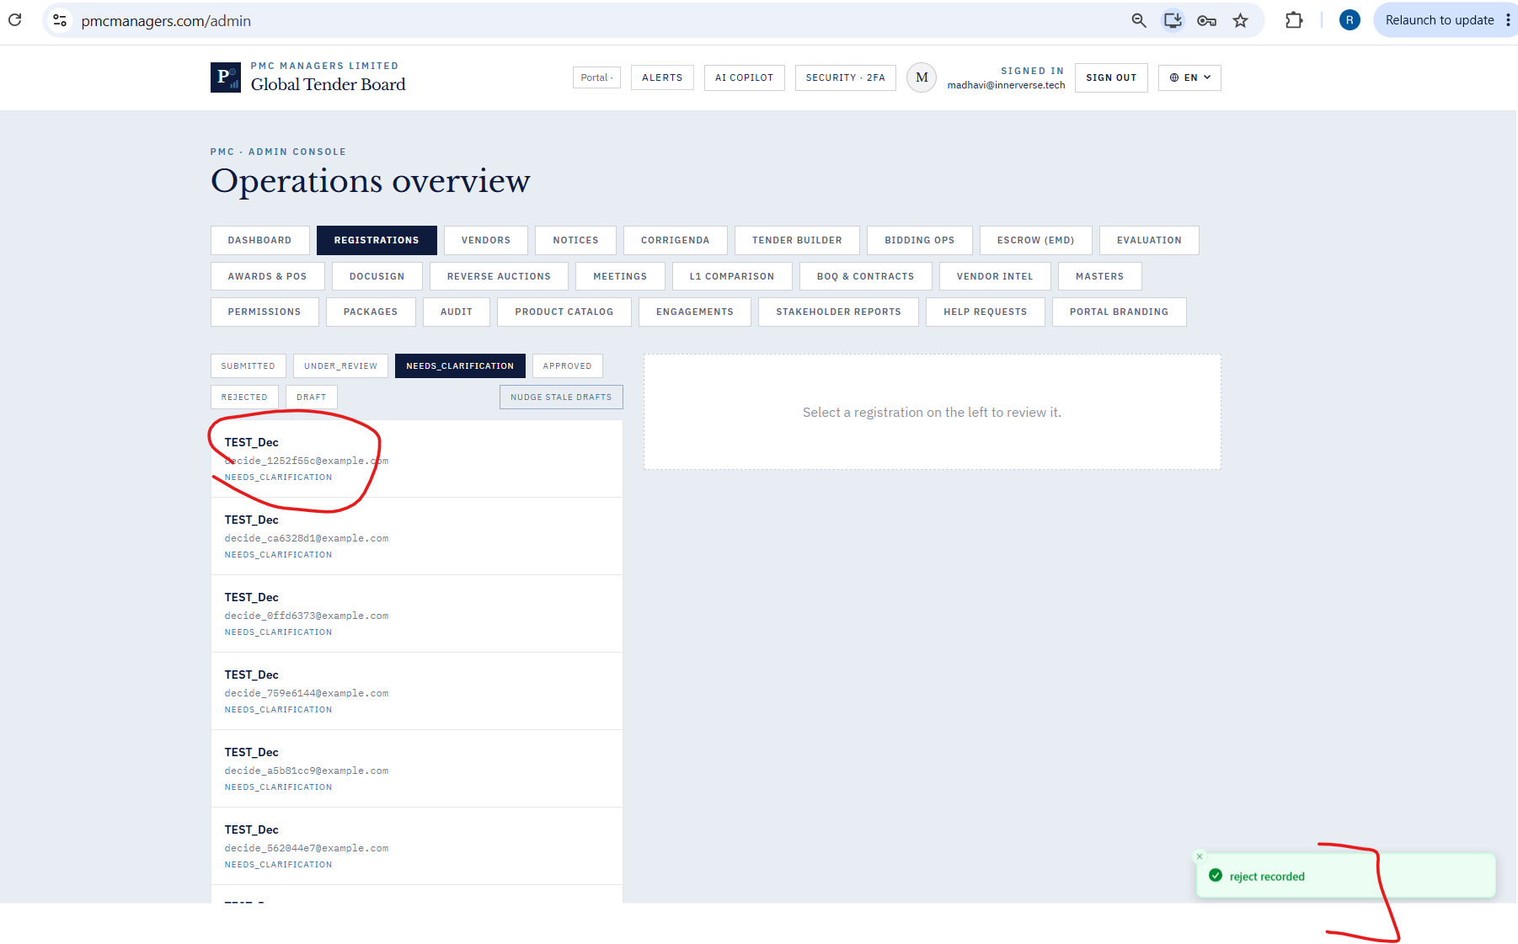

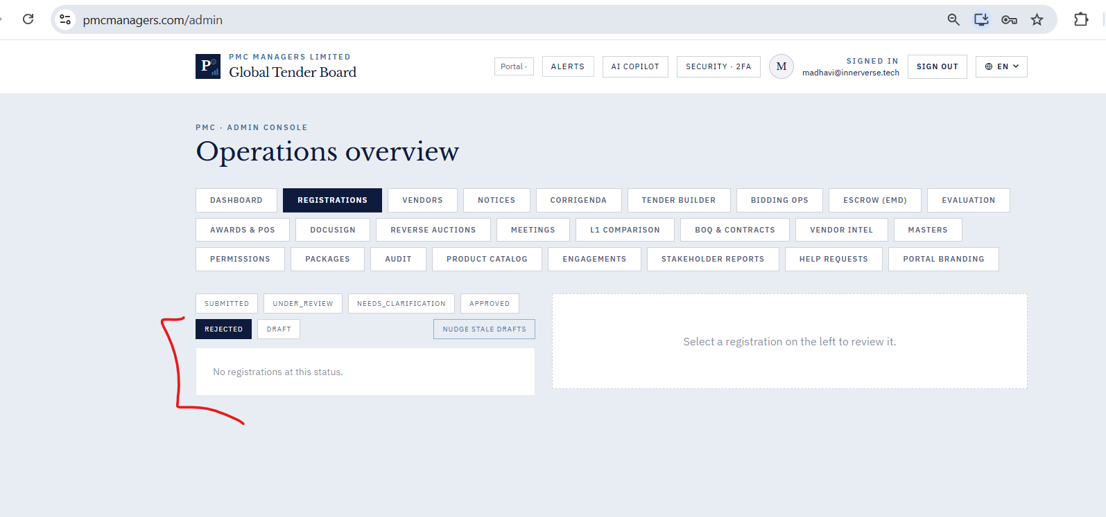

46. Registration Tab - Nudge Stale Drafts shows success message which is not correct.
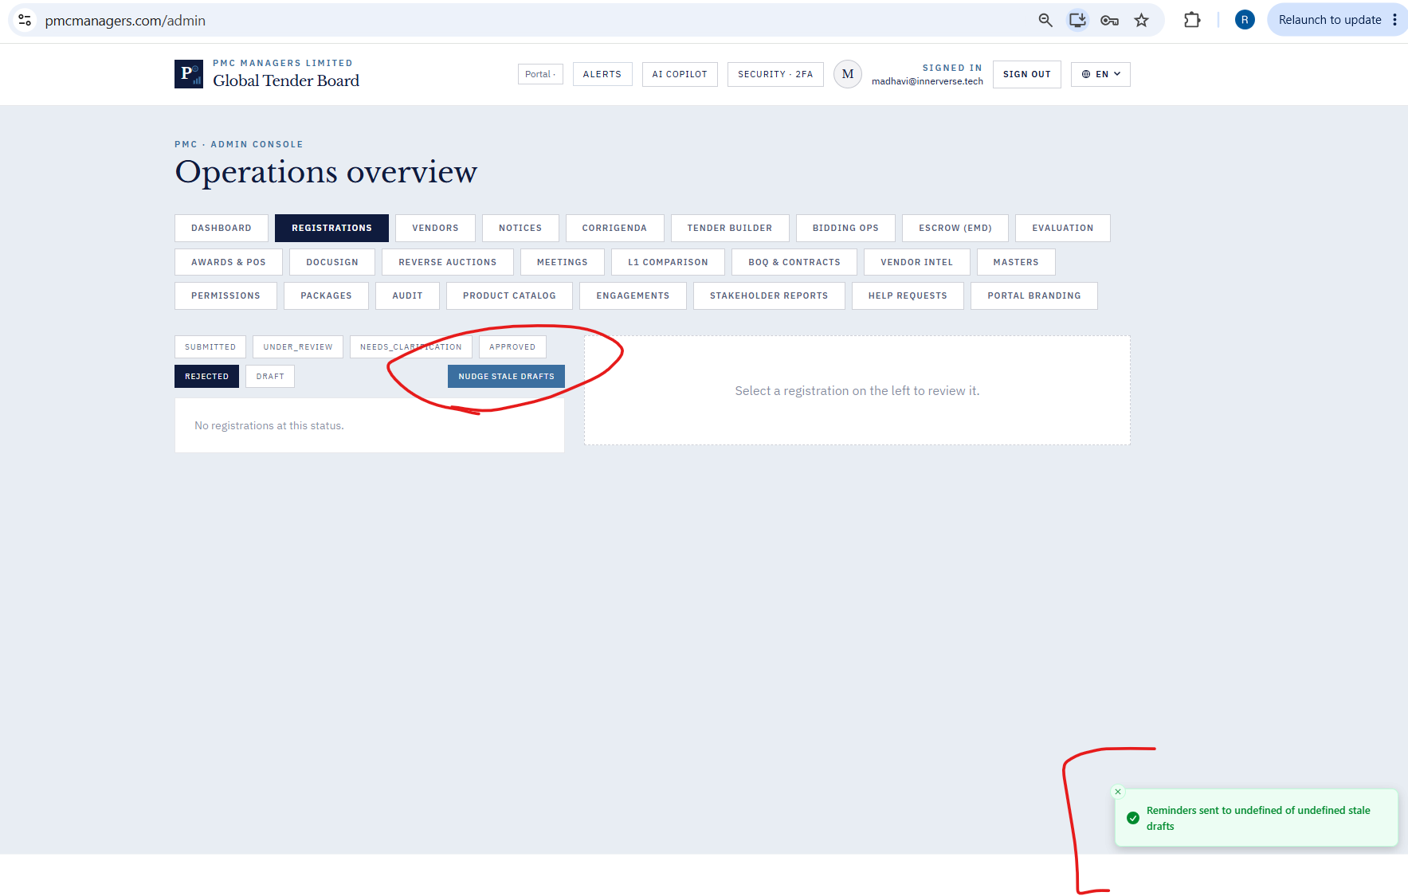

47. Can go to “contact and signatory without even fully entering necessary information in “identity and basic information”.
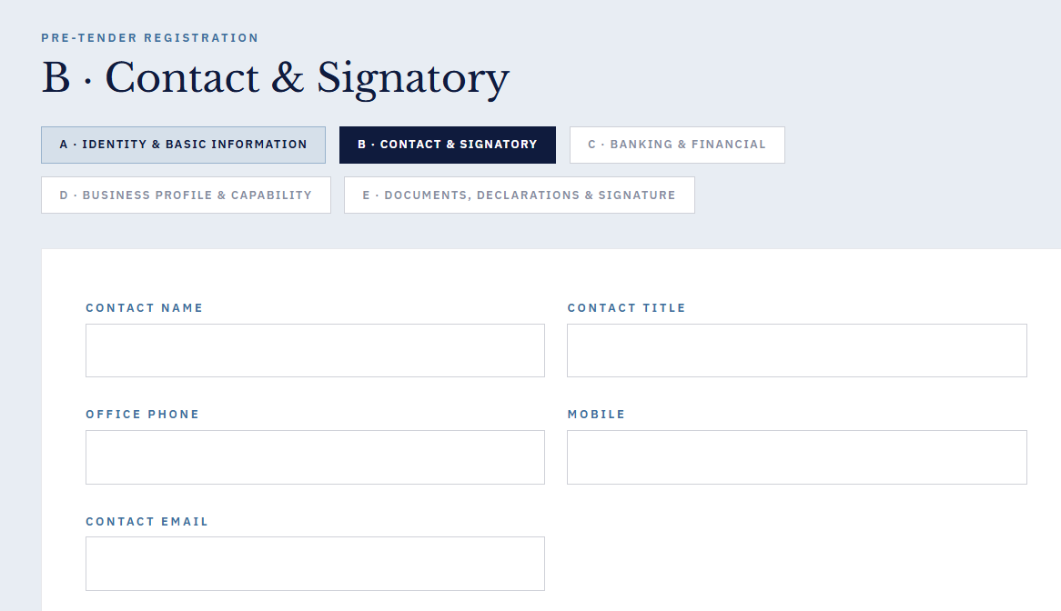
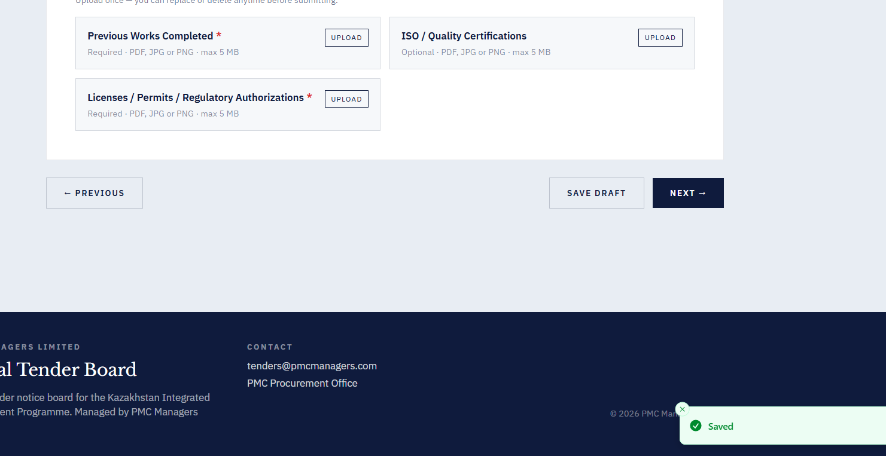

48. Unable to download blank registration form.
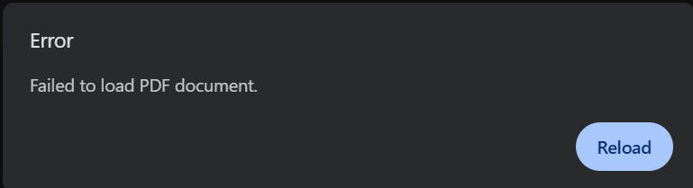
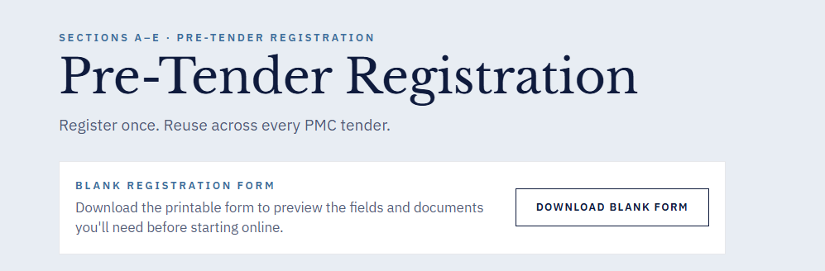
49 .Save snapshot to repo fails with JSON parsing error , in the Stakeholder Reports
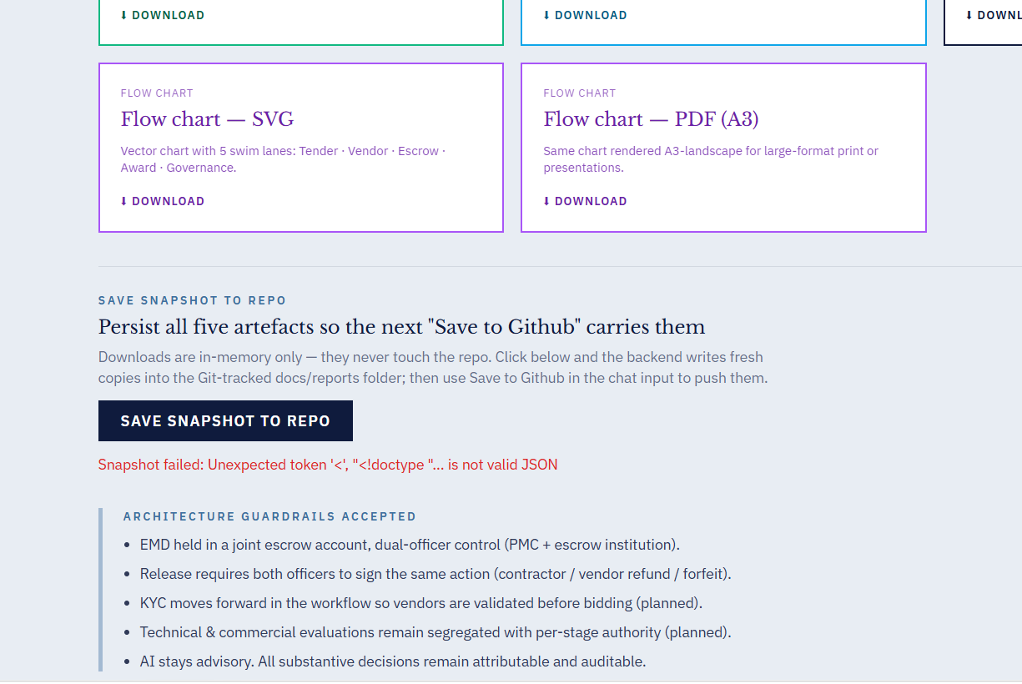

50. When requested clarification, the submitted draft isnt shown in the needs_clarification tab. It should read “clarification recorded” instead of “clarify recorded”.
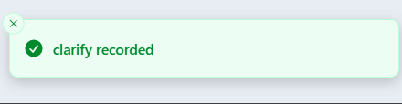

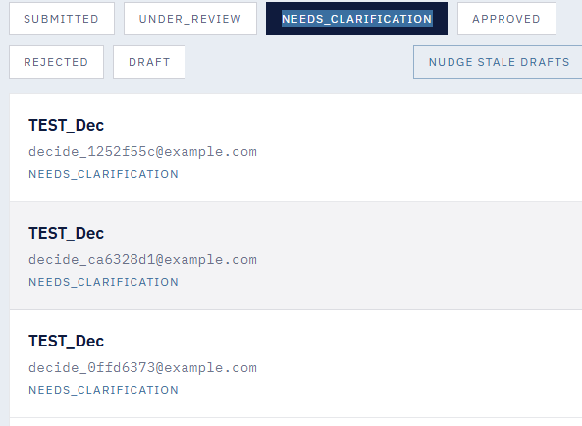

51. No notifications sent after nudging stale drafts
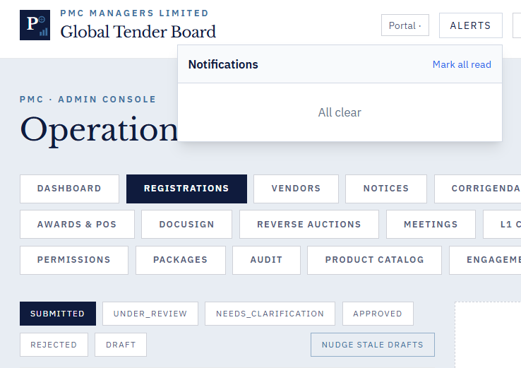

52. Screen goes blank after sending a bulk invite

54. In the meetings , even after cancelling a meeting its not disappearing .
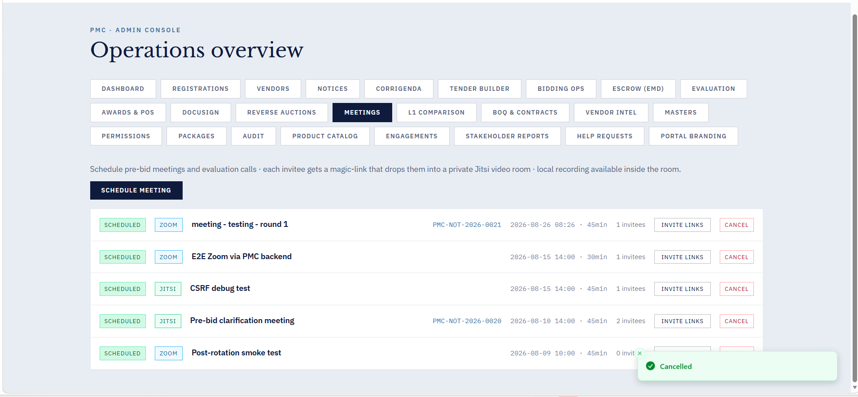
55. Can create joint escrow account even without entering any information.
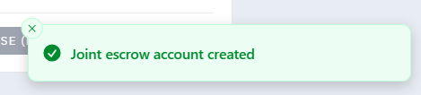

56. Says rubric saved even after entering values more than maximum
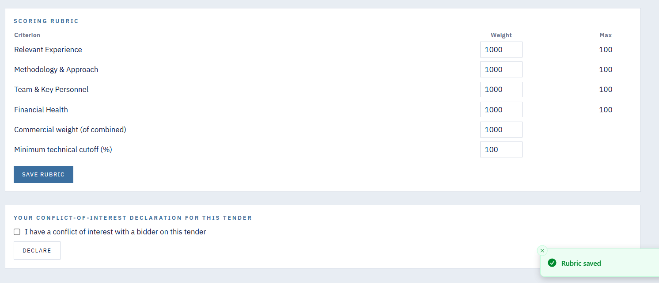

57. Screen goes blank after clicking on generate award report.
58. Everytime screen goes blank, we have to go back to website homepage and log in with our credentials.
60. Corrigendum is still visible after withdrawing.
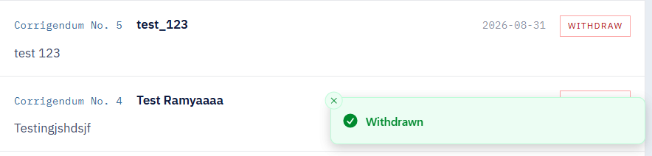
61. After creating an Escrow Joint Account, the newly created account is not appearing in the Escrow module.
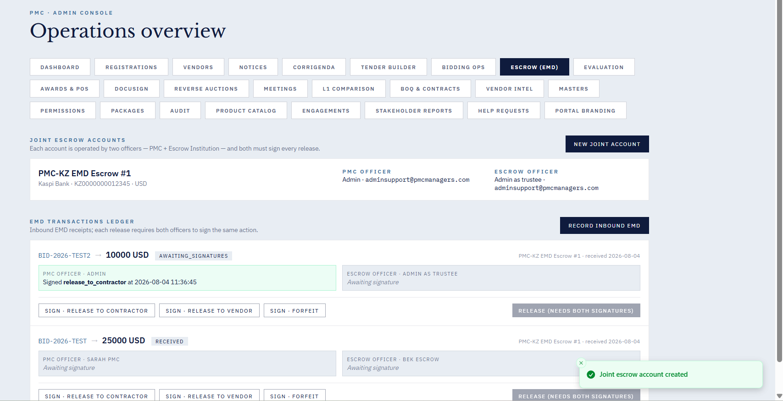
62 . After signing in as the Contractor in the Escrow module, the system allows the same operation to be performed multiple times and do other operations alos
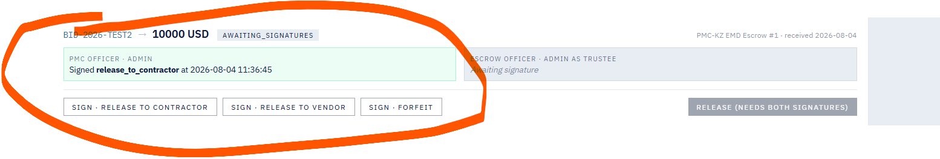
63.In the EMD Transactions ledger, the transaction shows “Successful Creation”, but the corresponding receipt is not displayed after the transaction is successfully created.
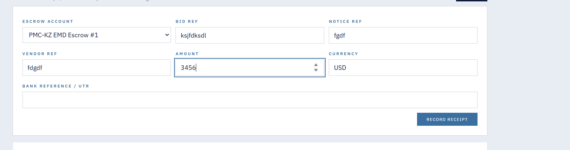
64 . After locking evaluation (Lock Tech / Lock Comm), re-entering the same Bid ID does not show the saved report. The system allows re-evaluation and generates a new report instead of displaying the locked result. 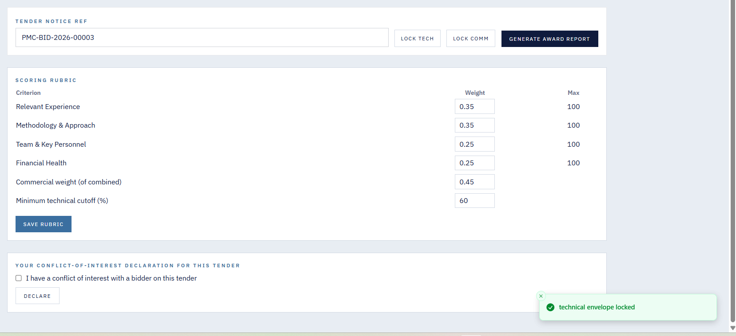
66. Pending-verify vendor displays “Approved Supplier” and “Days Approved”
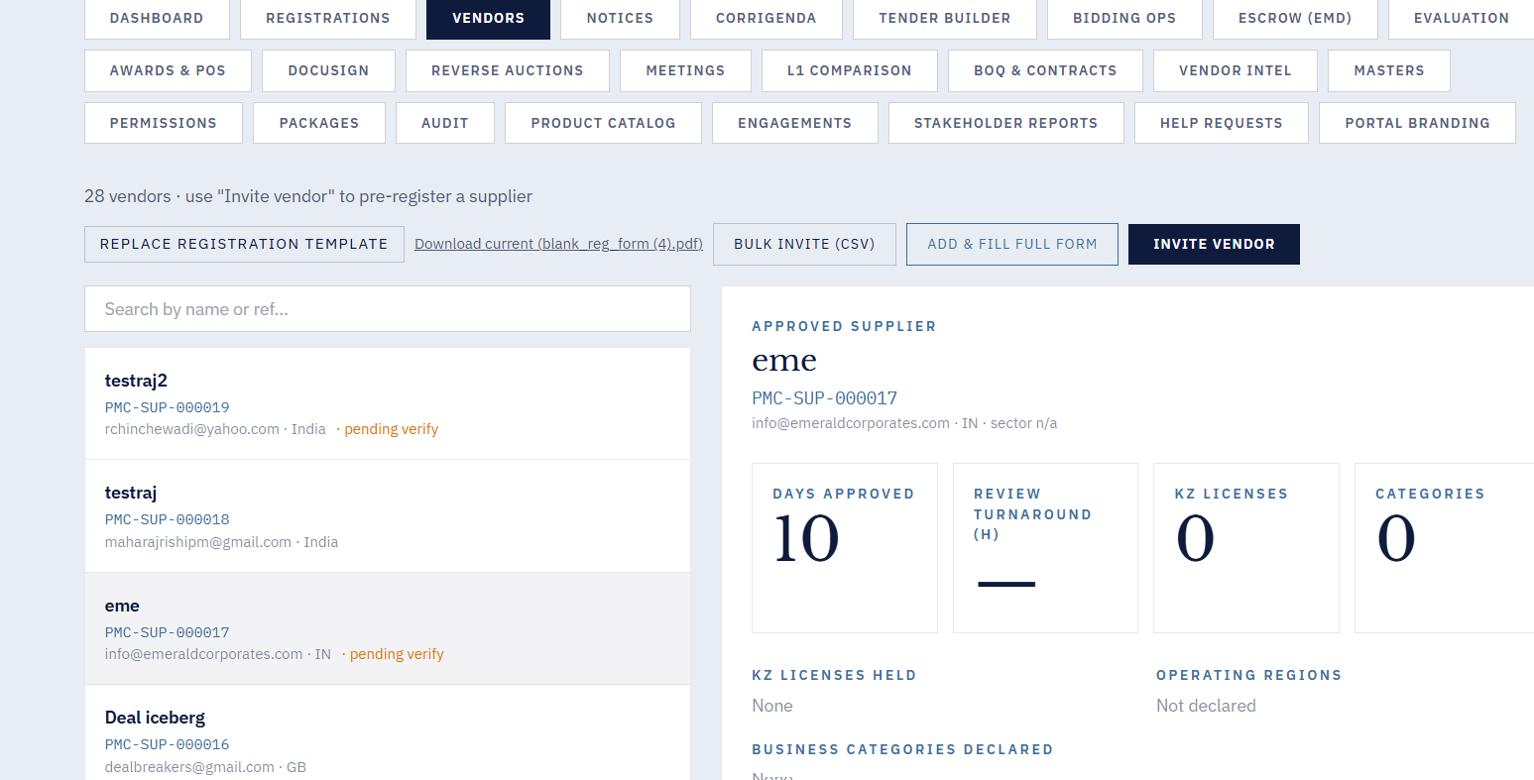

Testing Round 2 - Defects Using Admin Login

- Vendors - Click the “Invite Vendor” button gives the success message “Invite Undefined - Undefined”. No email is received.
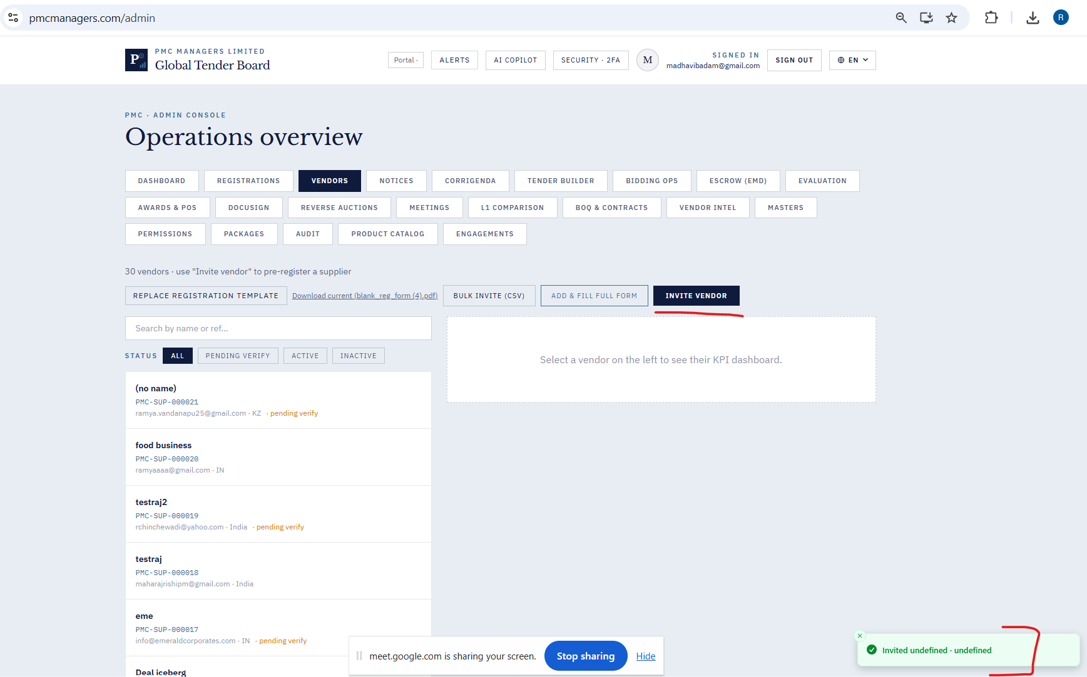

- In the public Portal - Click Register as Supplier, Click Download Blank Registration Form, File is downloaded , but not opening.
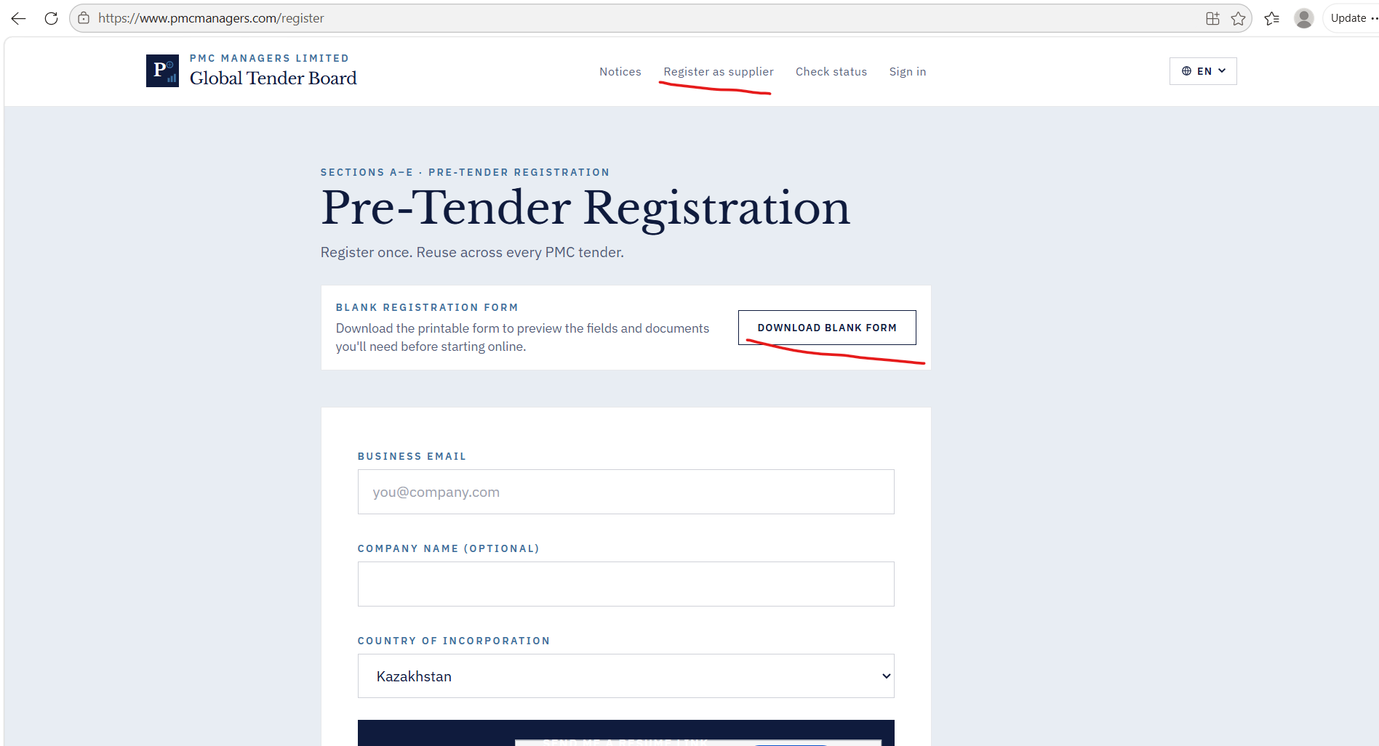

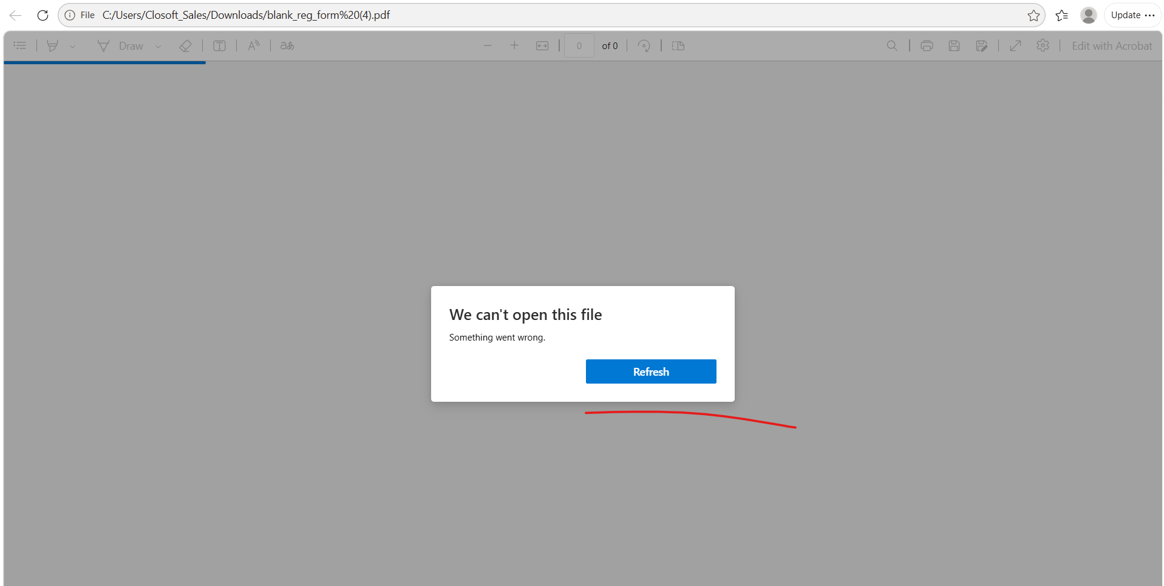

- Registrations - Status not changing from “Submitted” to “Approved” state on click of APPROVE button. There is a success message, but still no update is visible in the portal for selected registration.
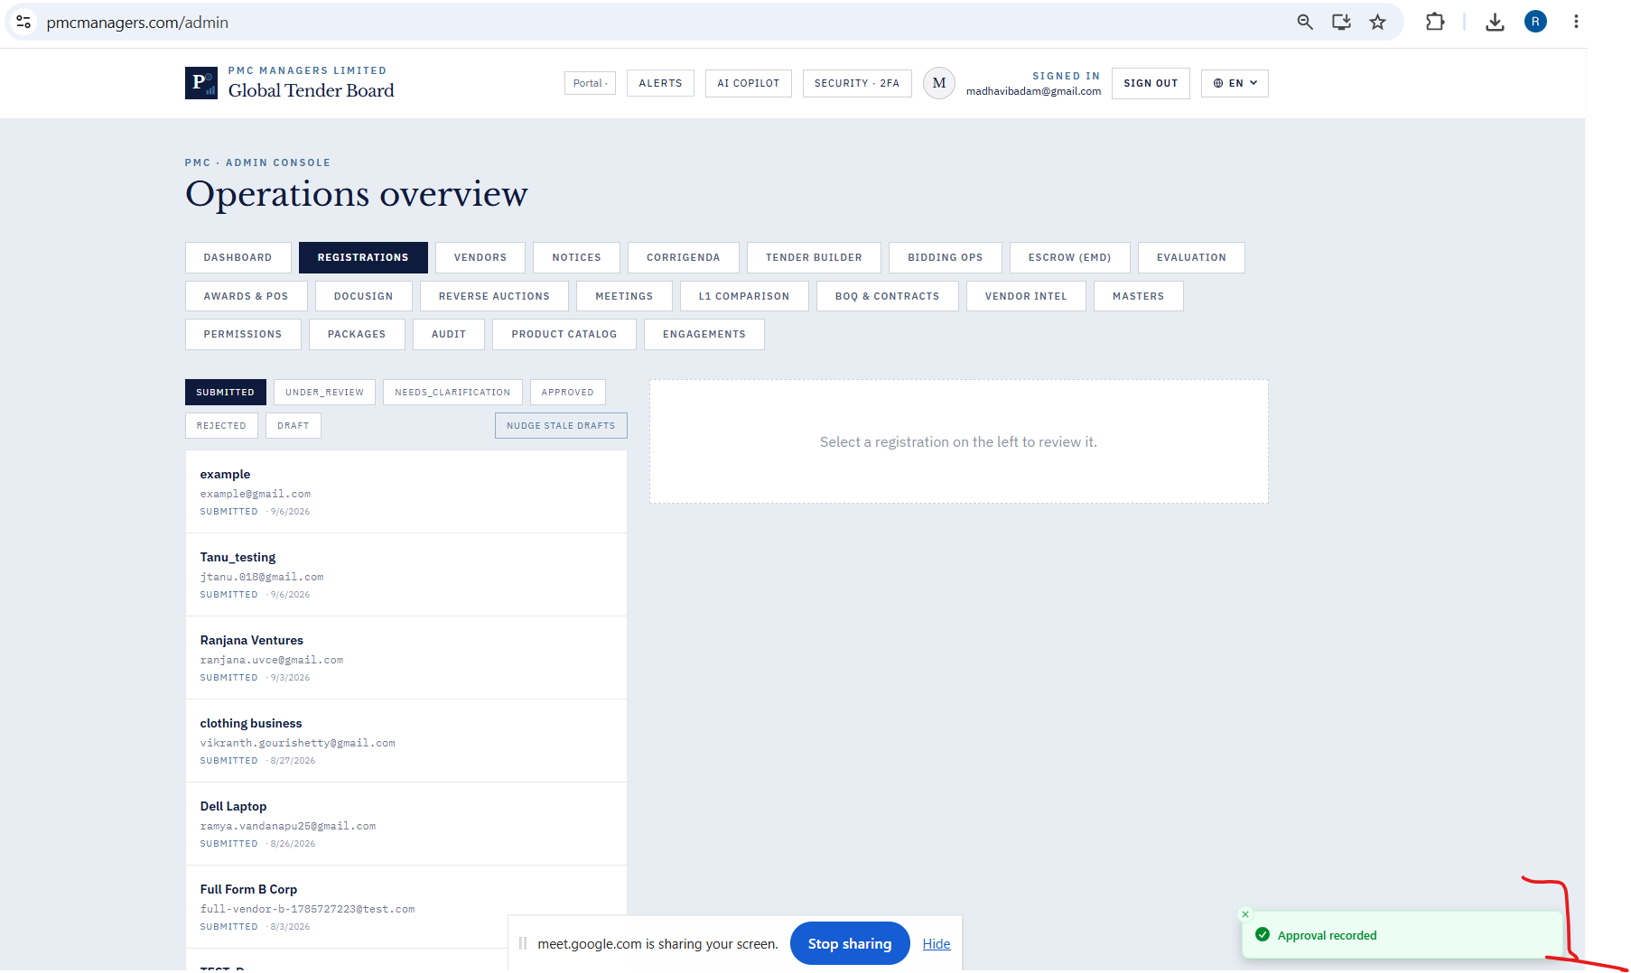
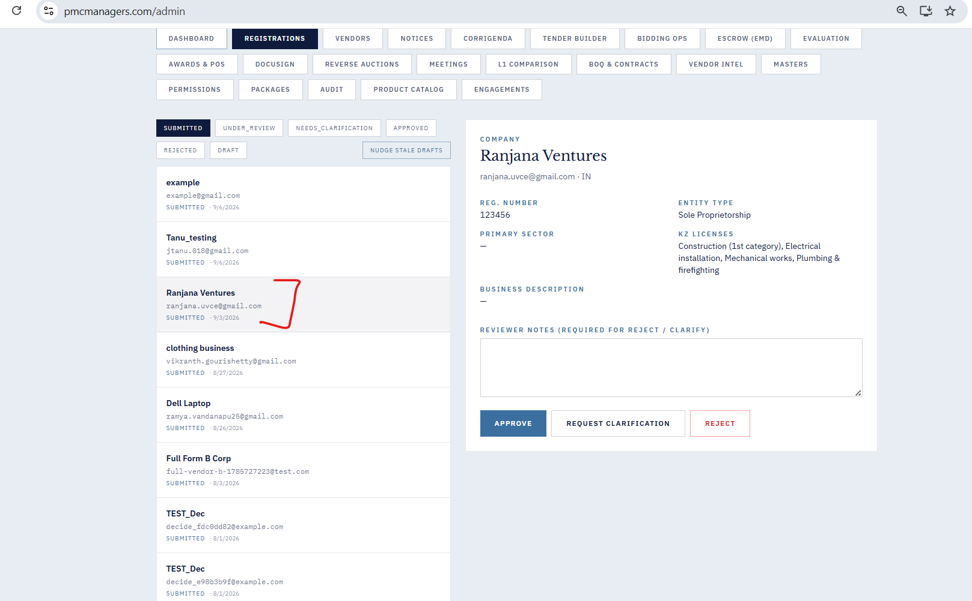

- Vendors - Bulk invite CSV gives an error message as below.
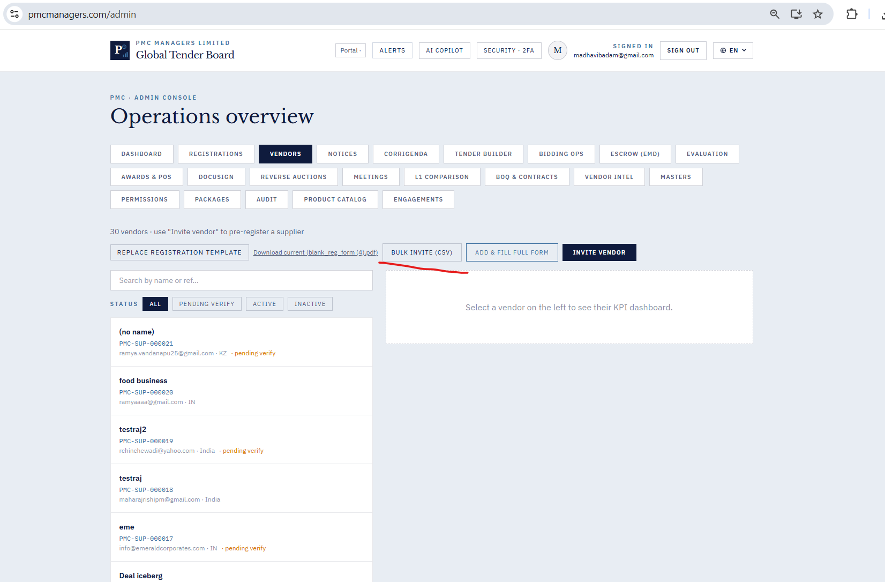

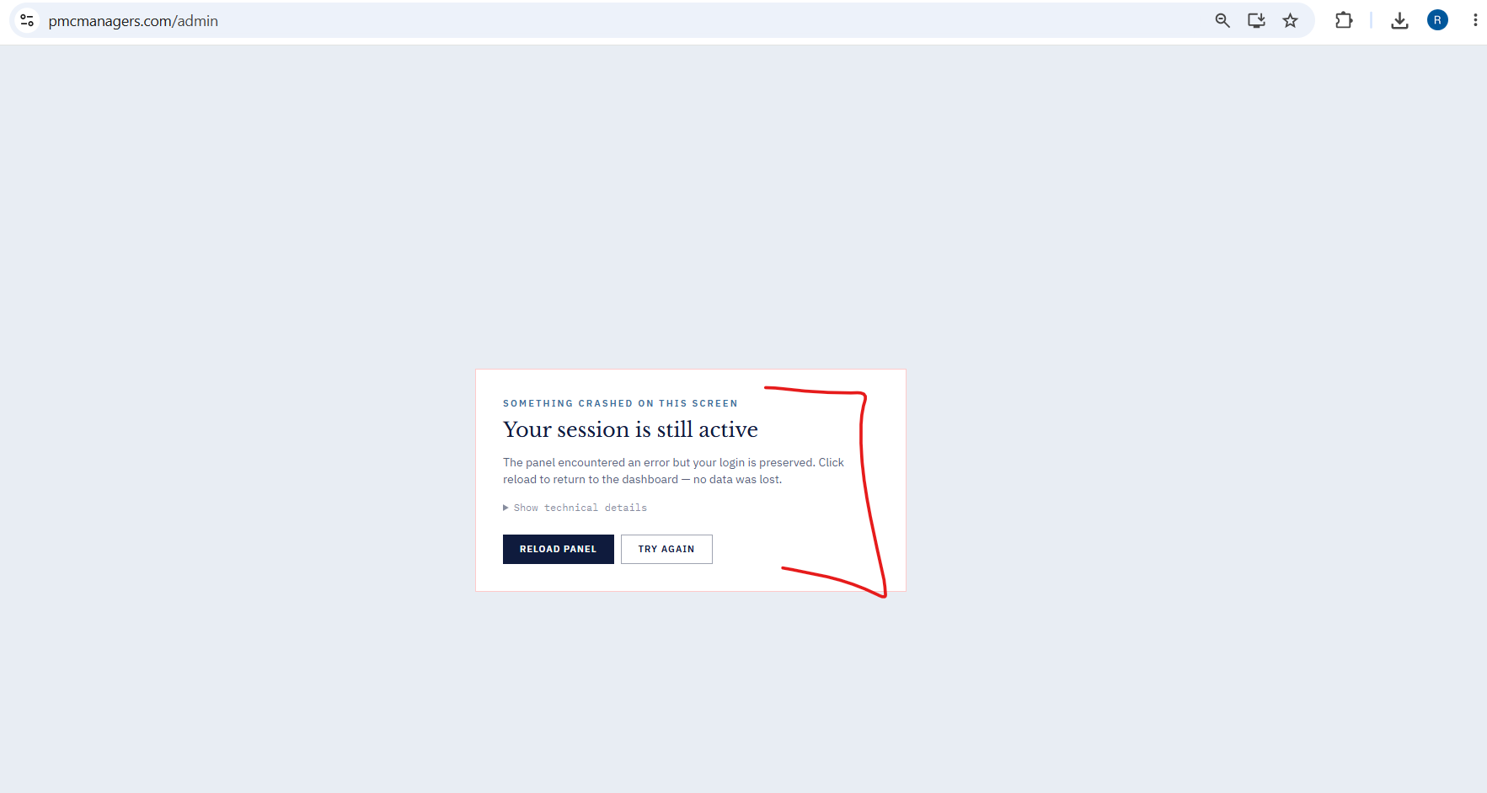

- Vendors - Add Fill Full Form - Active Immediately gives success message. But the user id is not lised in the Vendors list.
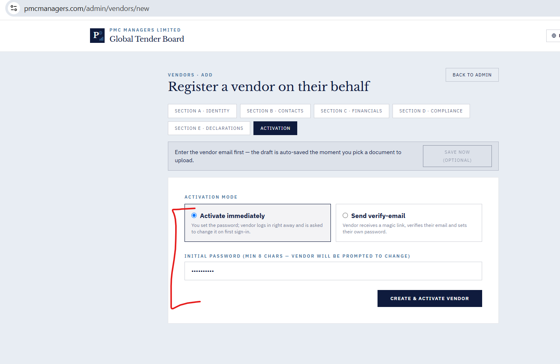

- Registrations - Click on “Reject” gives success message as “Reject Recorded”. Still it is showing as submitted.
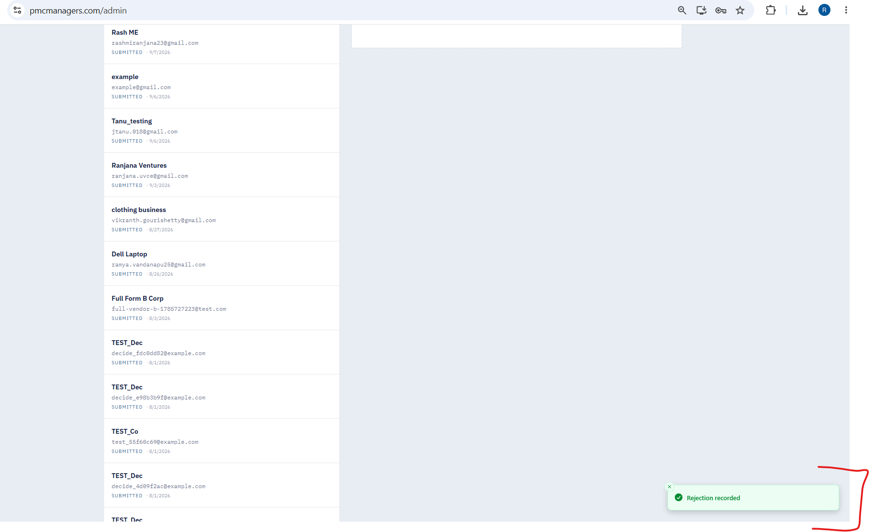
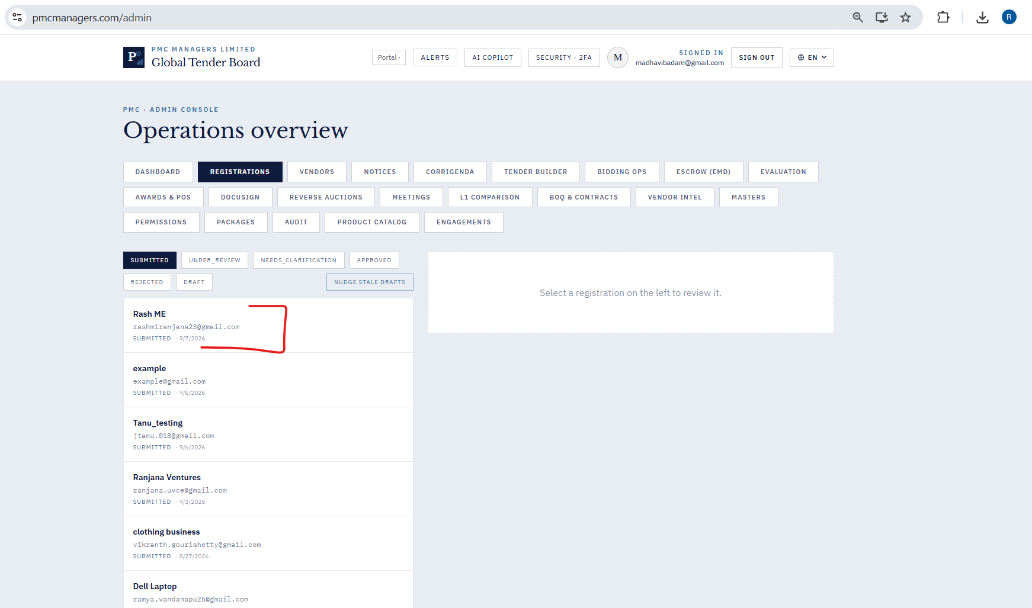

- Registrations - Click on “Request Clarification” gives a success message as “Clarification Recorded”. Still it is showing as submitted.
- Notices - New Notice is created successfully with the Notice ID. The counter on the dashboard for Notices card is increased by 1, still the Notice is not listed under the Notices tab as a draft. (Checkbox to select Publish Immediately is not enabled , can be done only by Master Admin)
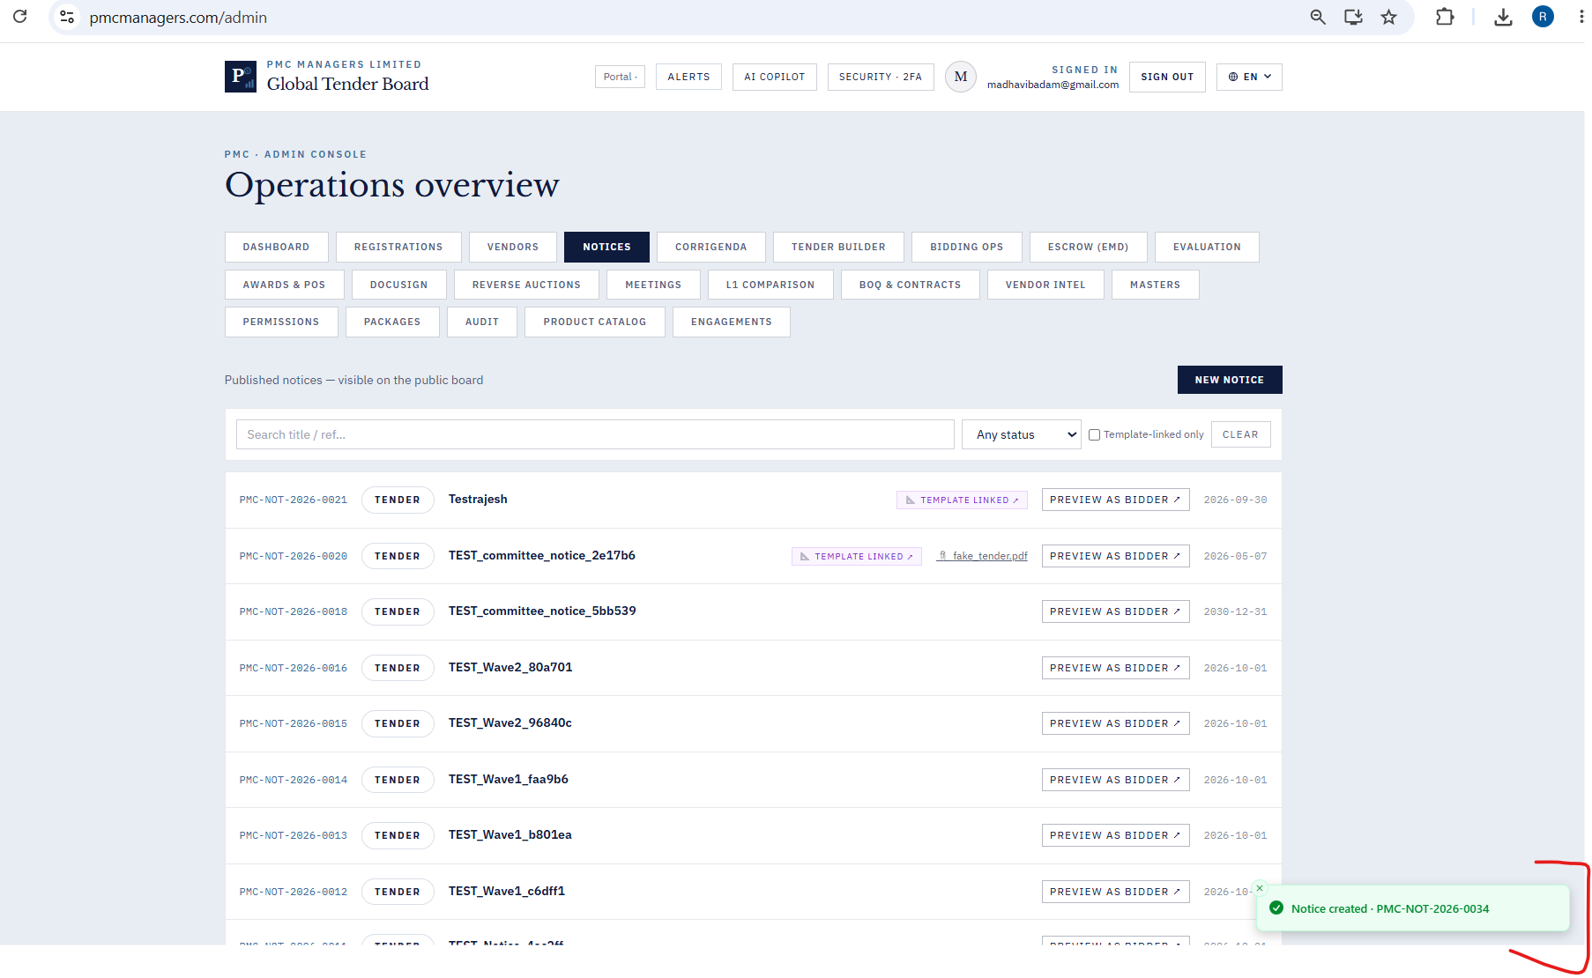
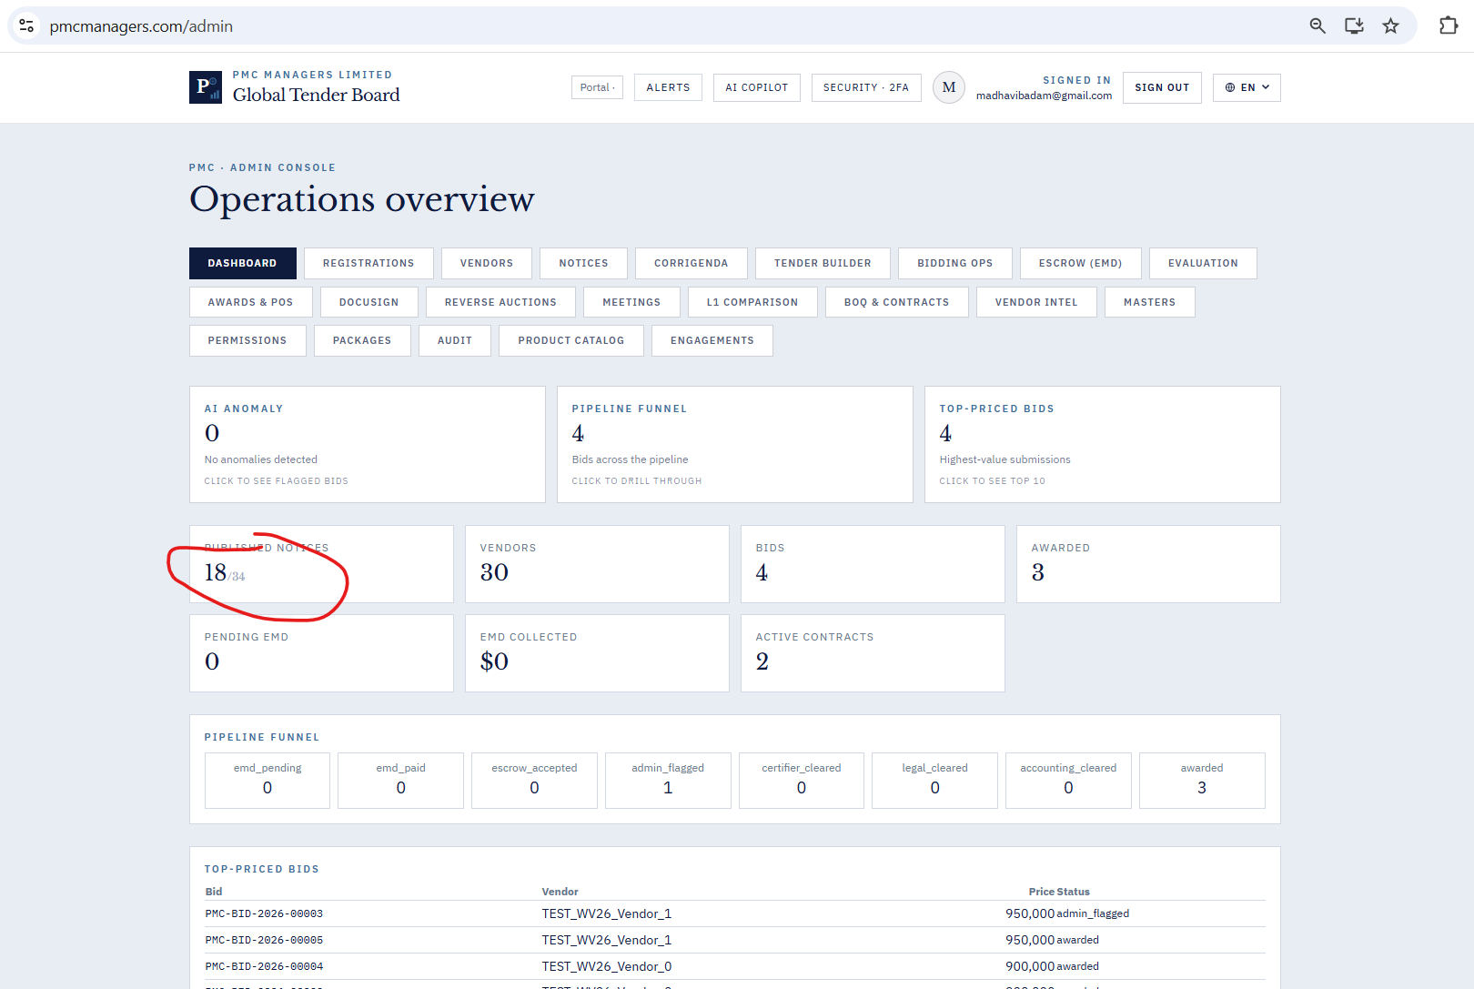

- Corrigenda - Withdrawal of a Corrigendum is successful, still lists it under the list of corrigendum created for a particular notice.
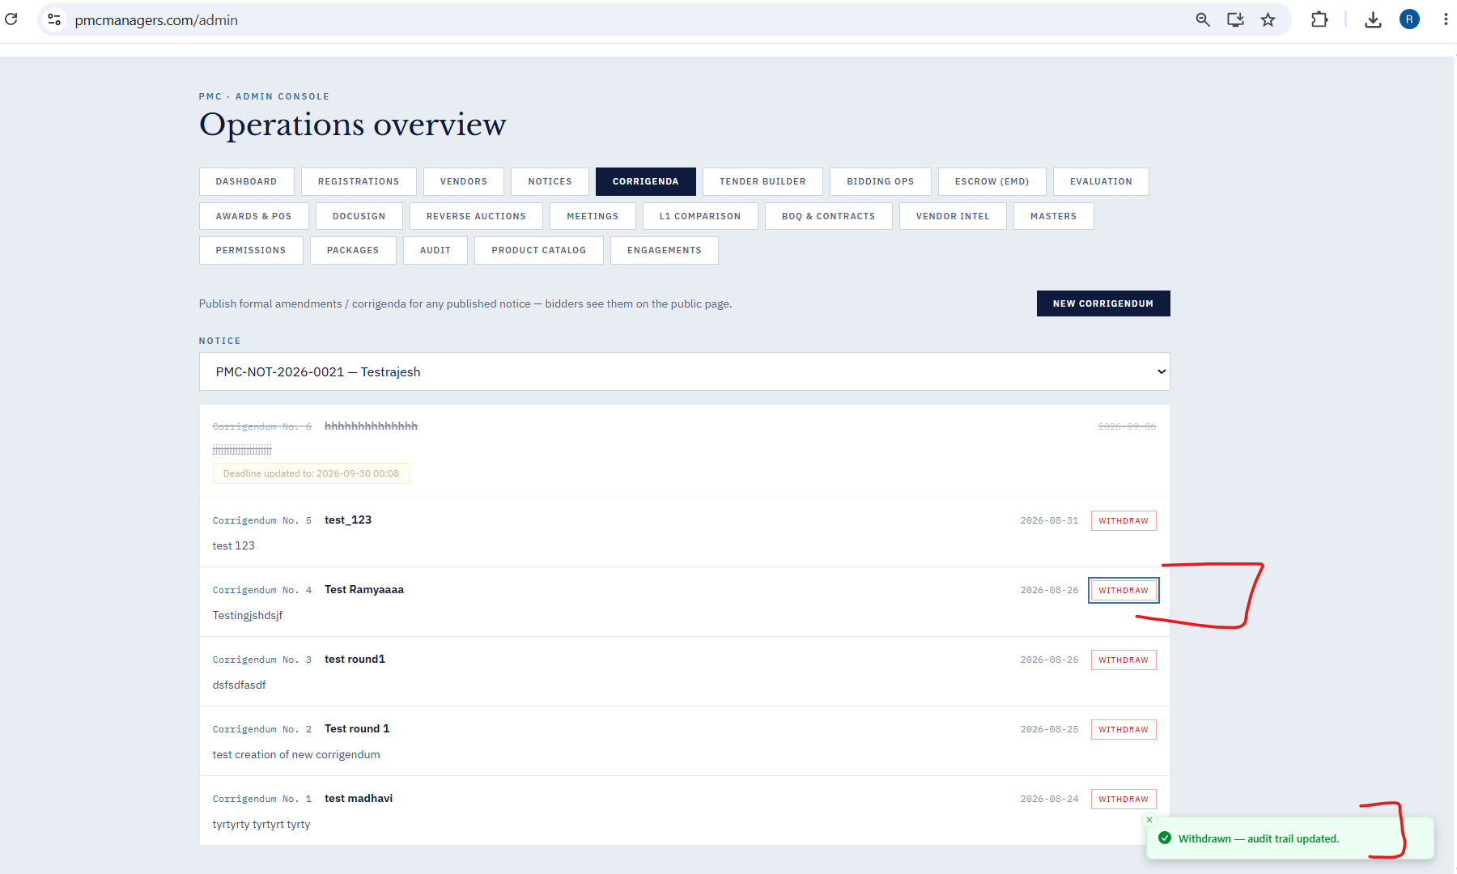
- Audit - Click of Audit Tab crashes the application.
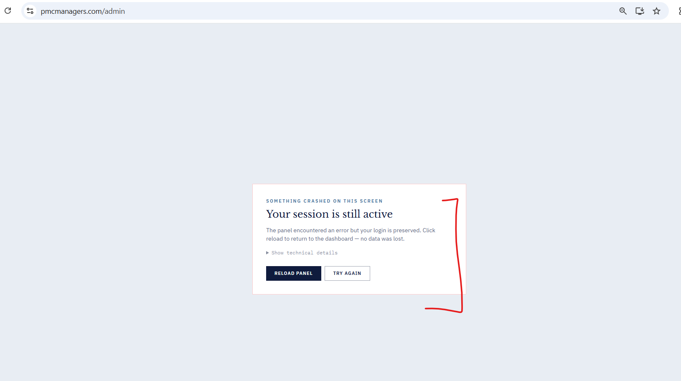

- Tender Builder - Clone as Draft gives success message “Draft Created”. Throws an error message with error code 500.
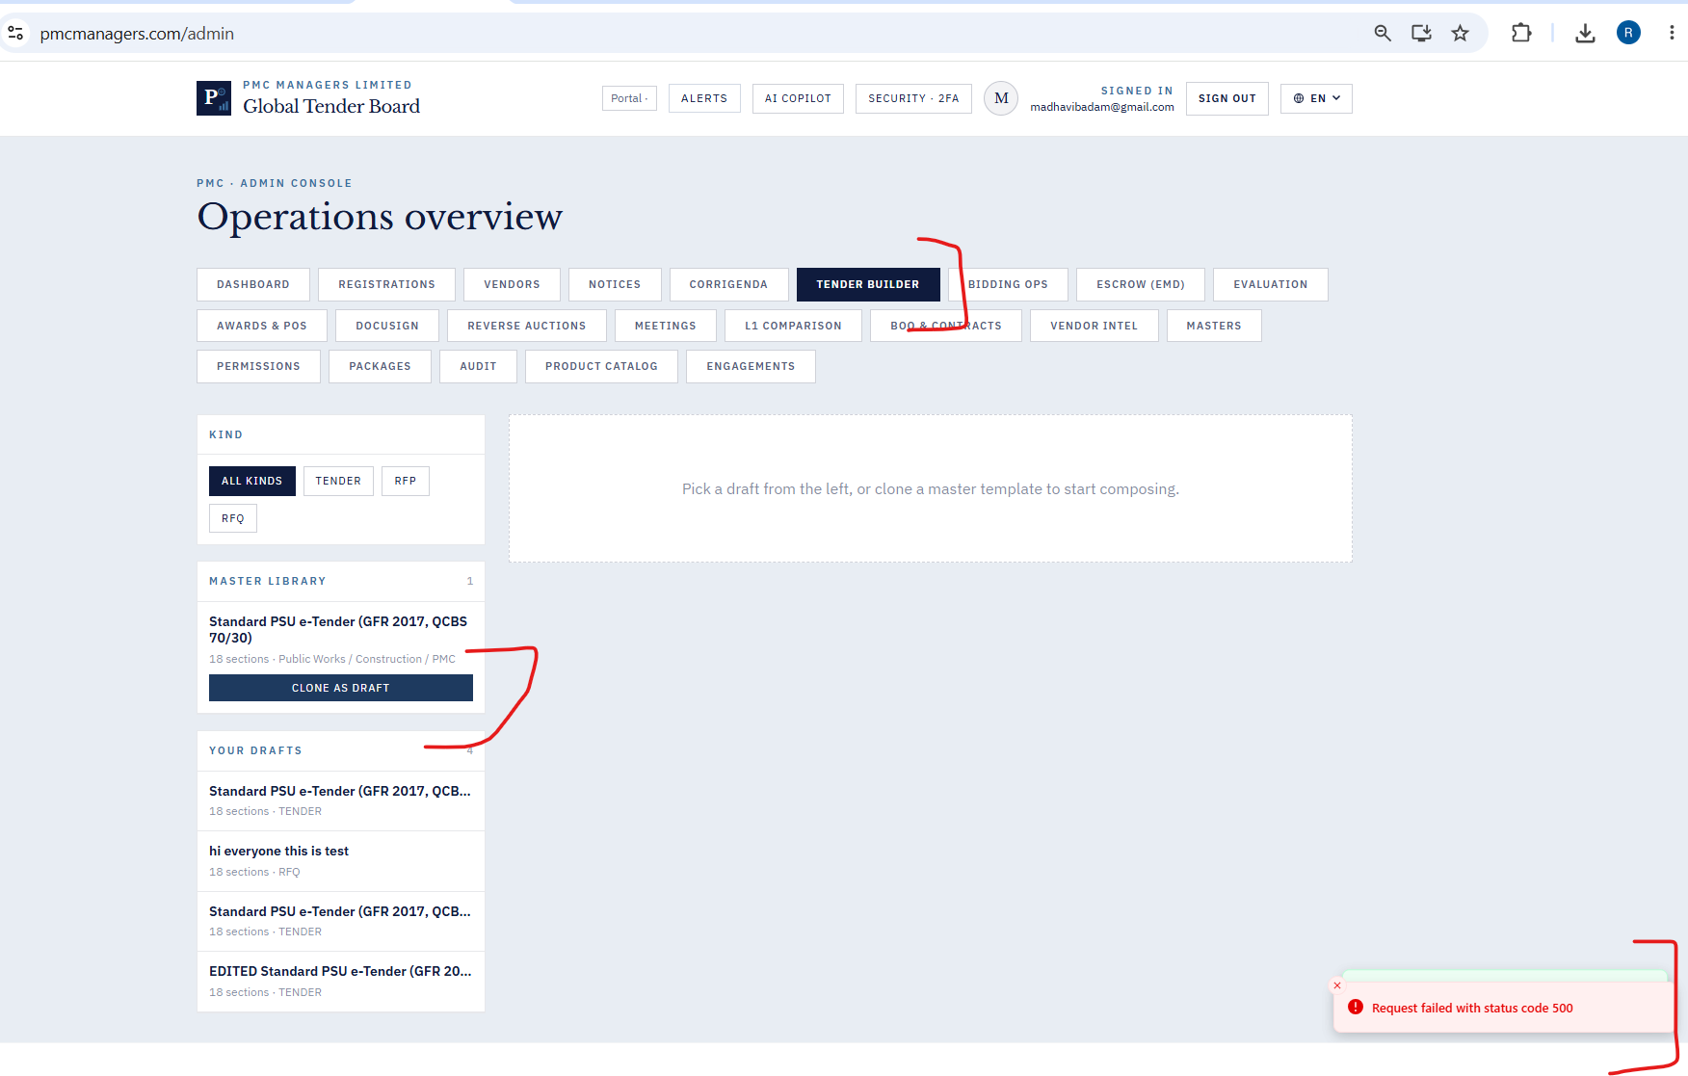

- Tender Builder - On click of “DELETE” success message is received as “Deleted”. Yet the draft is listed under “Your Drafts”

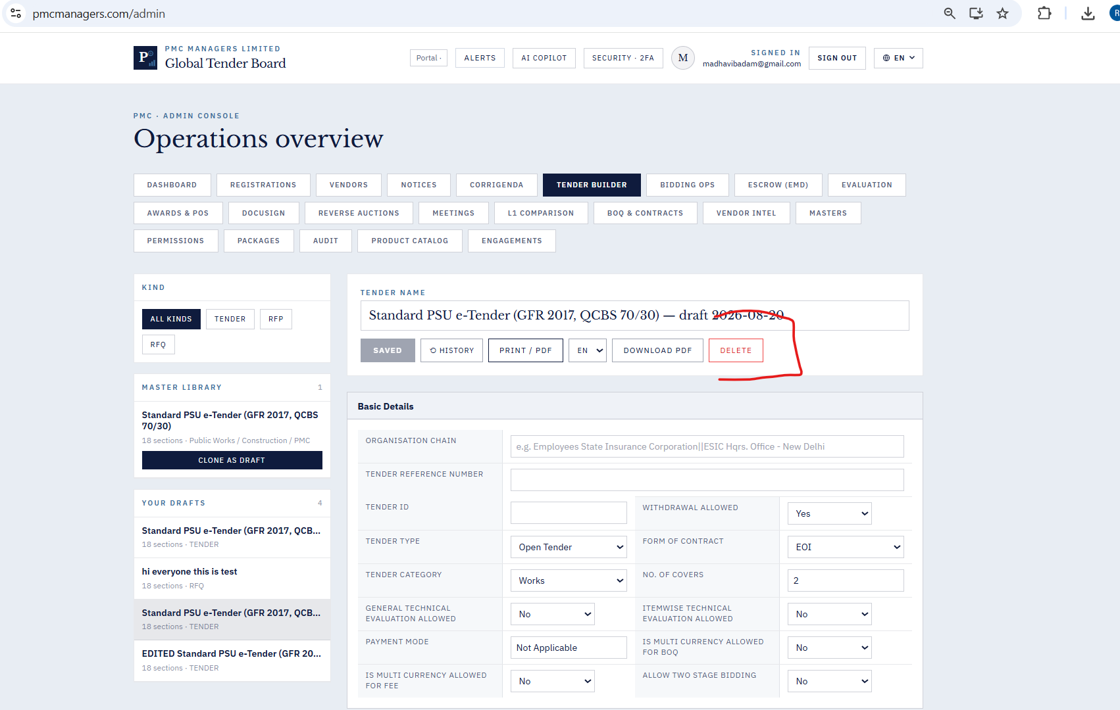

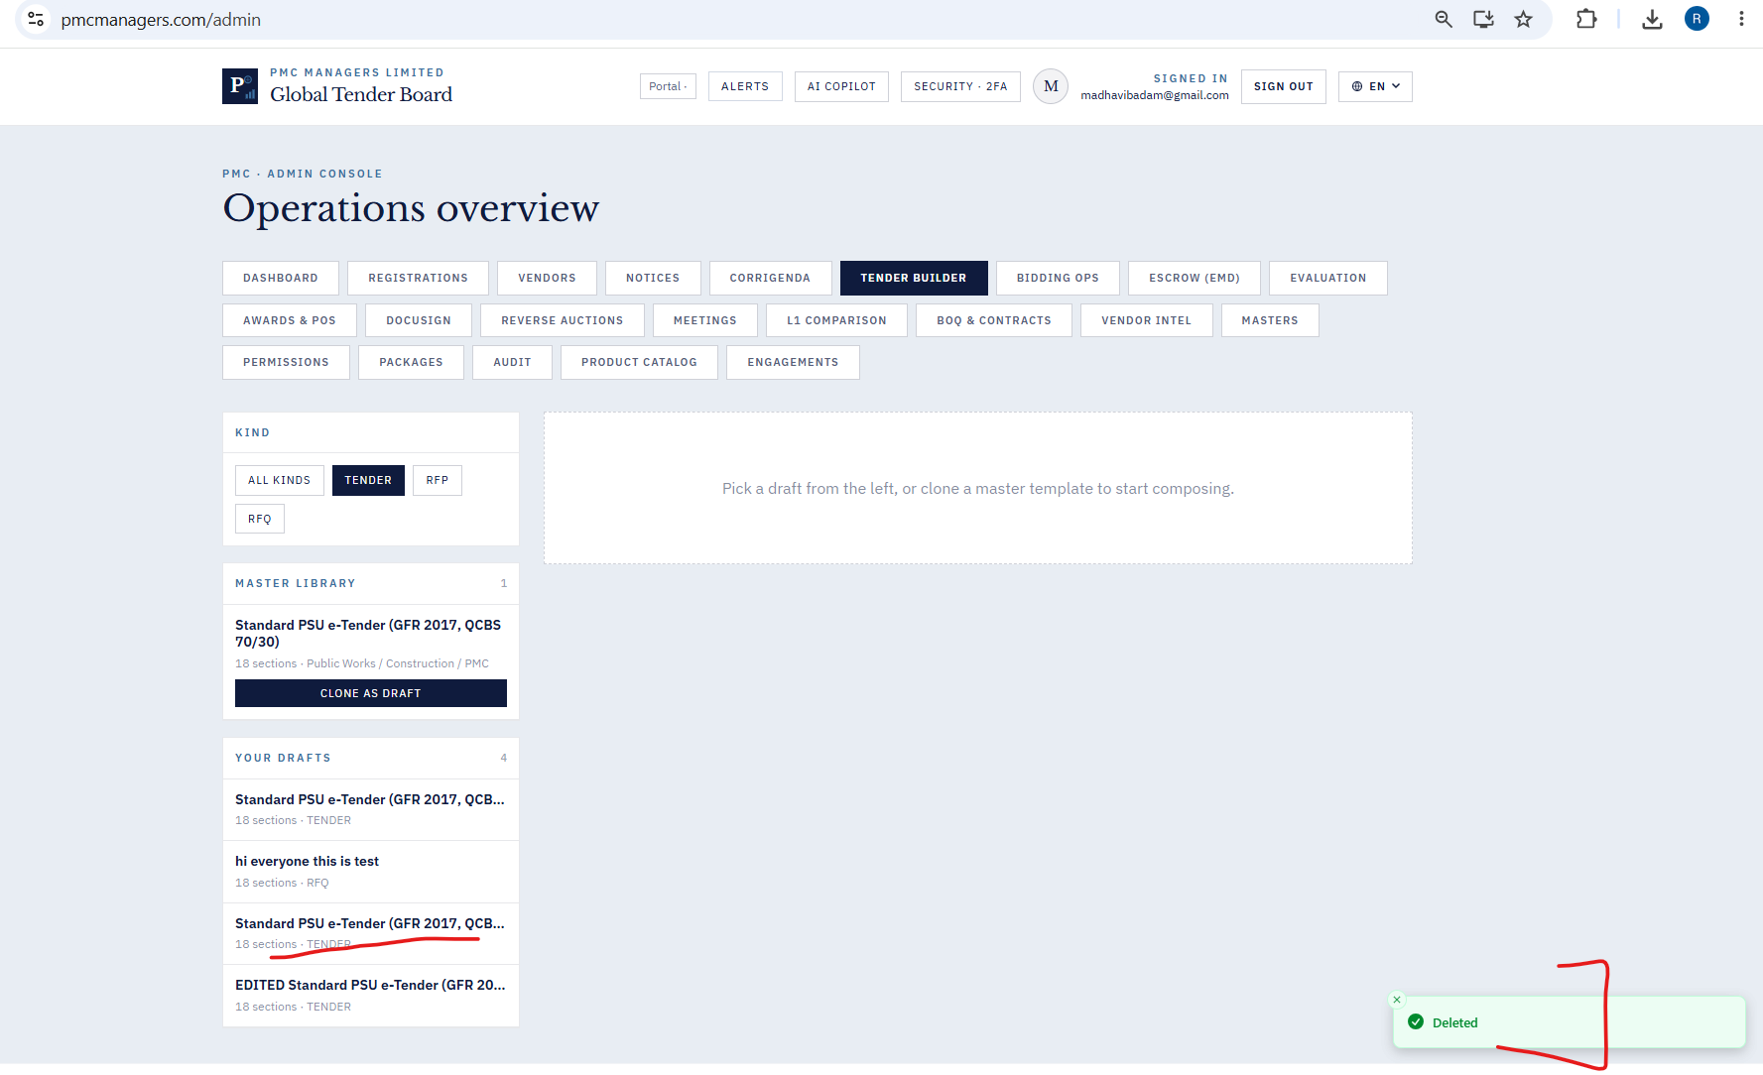

- Tender Builder - Saved / History / Translation not working as expected.
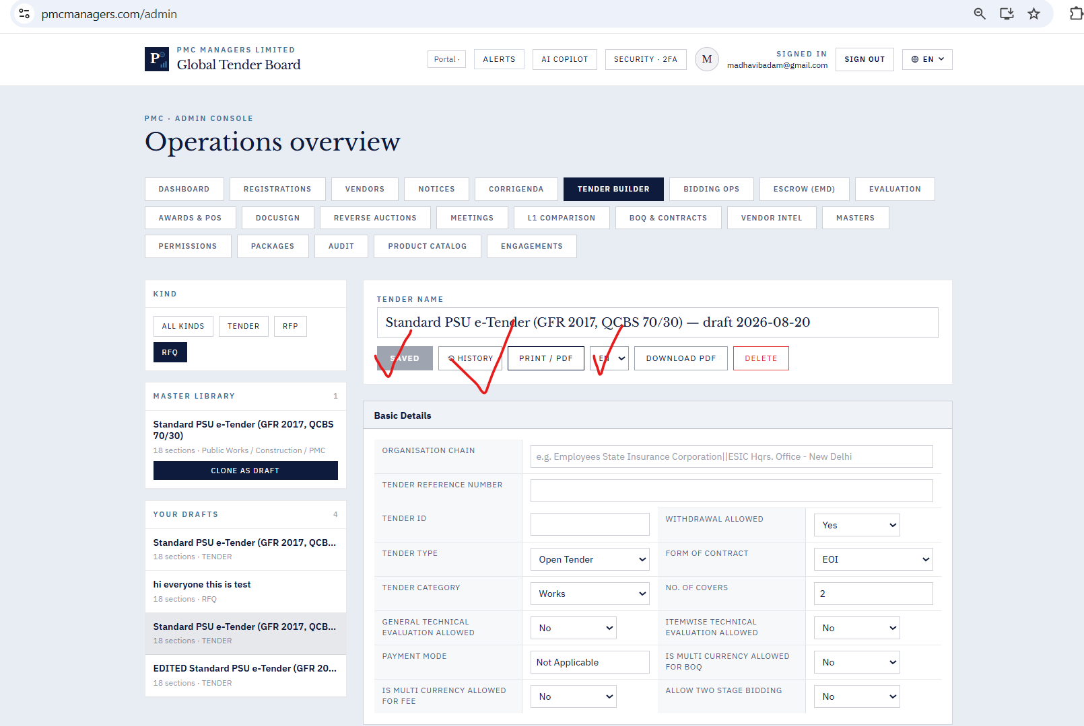

- Bidding Ops - This tab is not opening as expected. The portal is crashed.
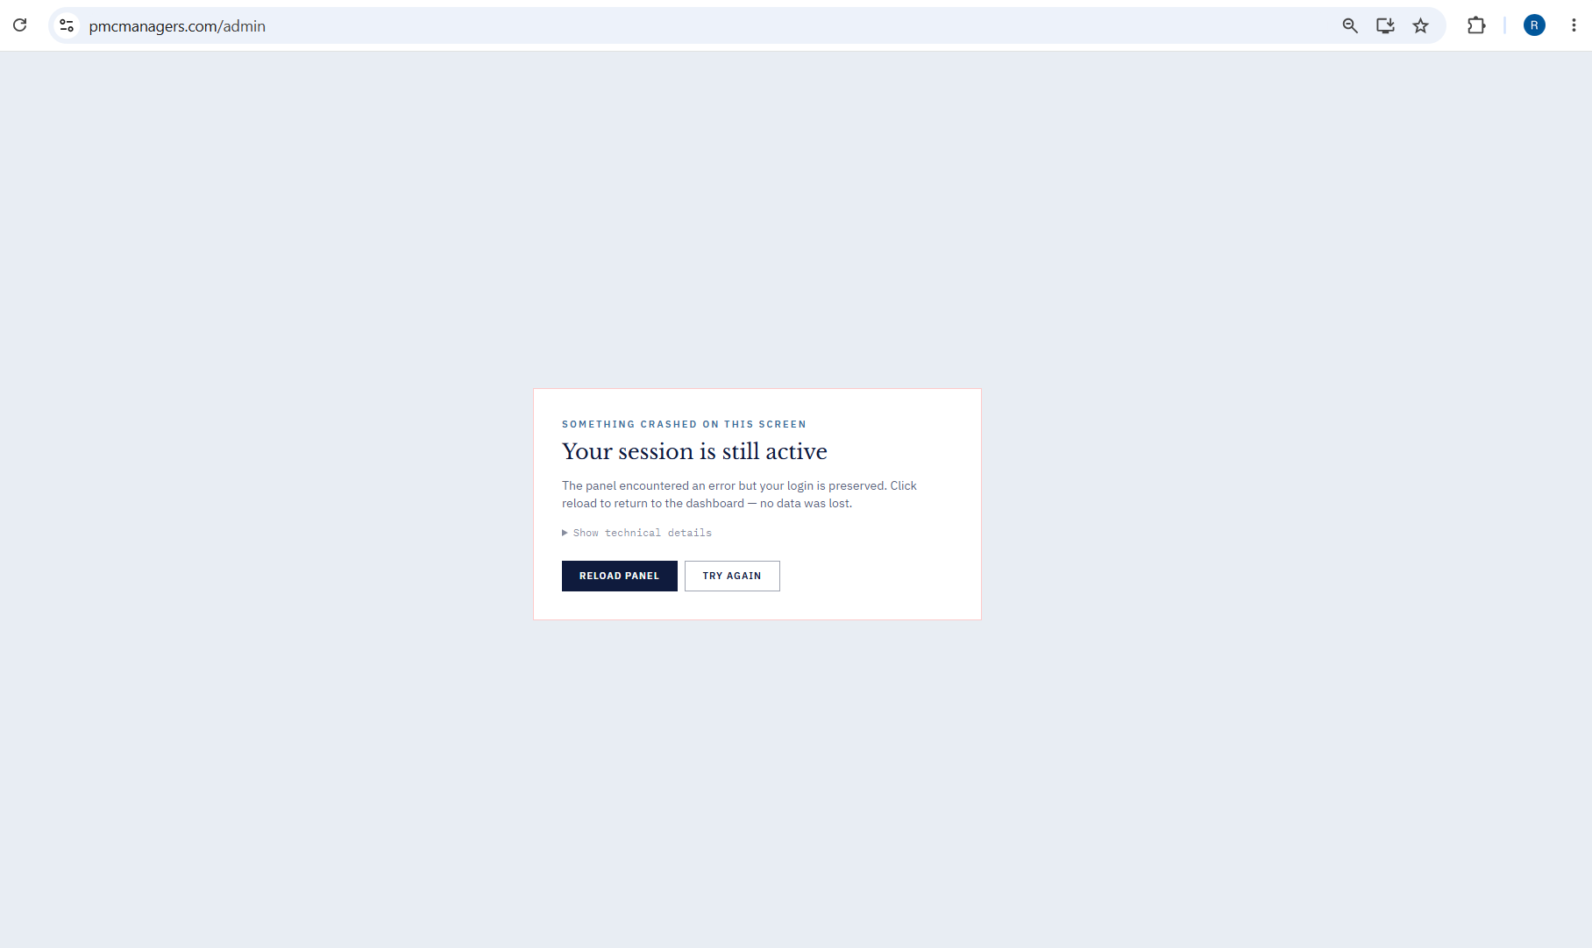

- Escrow (EMD) - New Joint Account is created without any validation for input fields

.
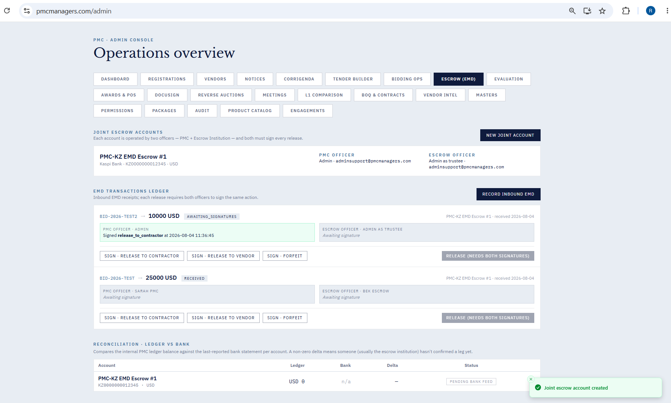

- Escrow (EMD) - Success message is received but Joint Account is not displayed - even when the input fields data are correct.
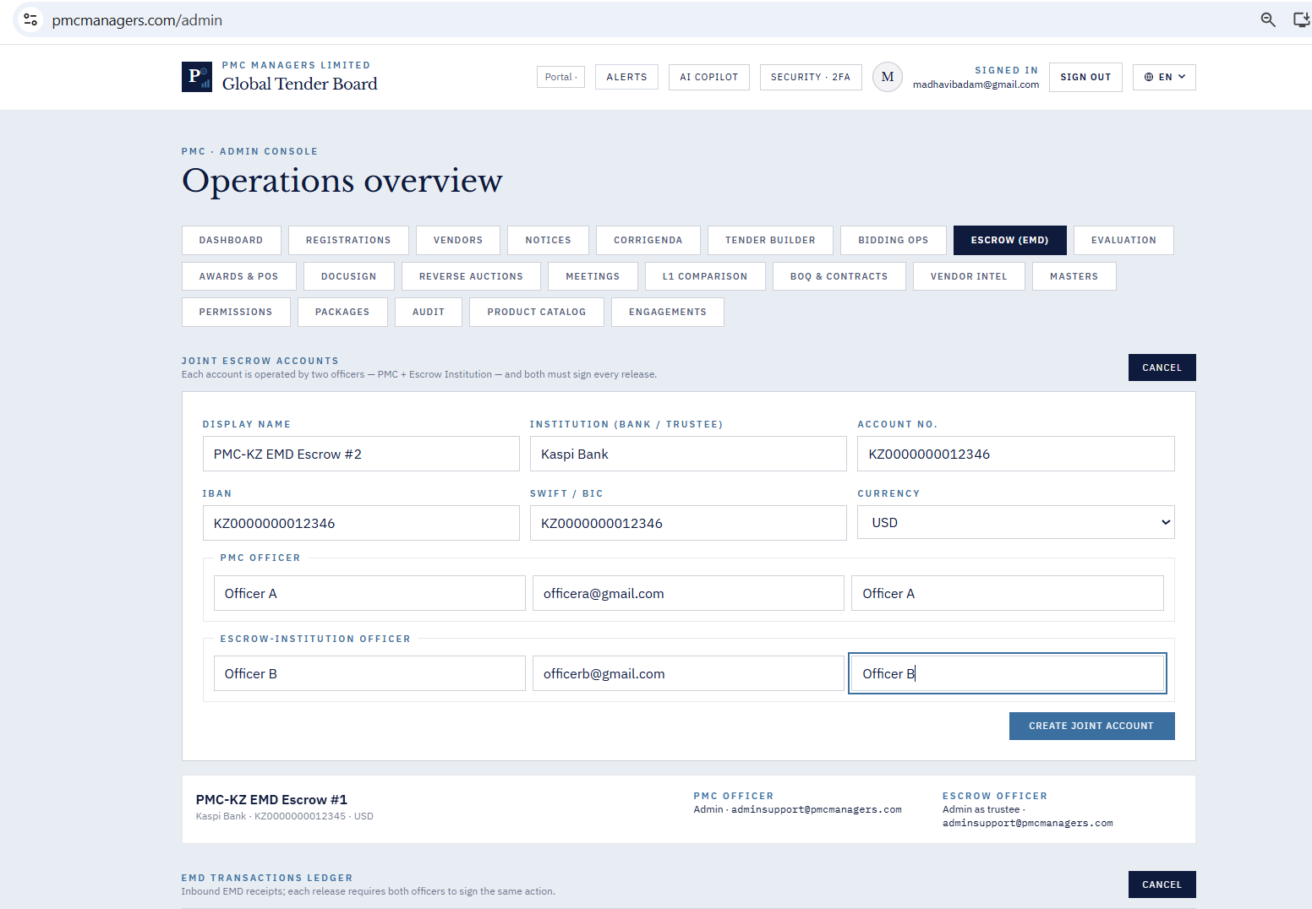

- Escrow {Emd) - Newly created account is not listed in the dropdown
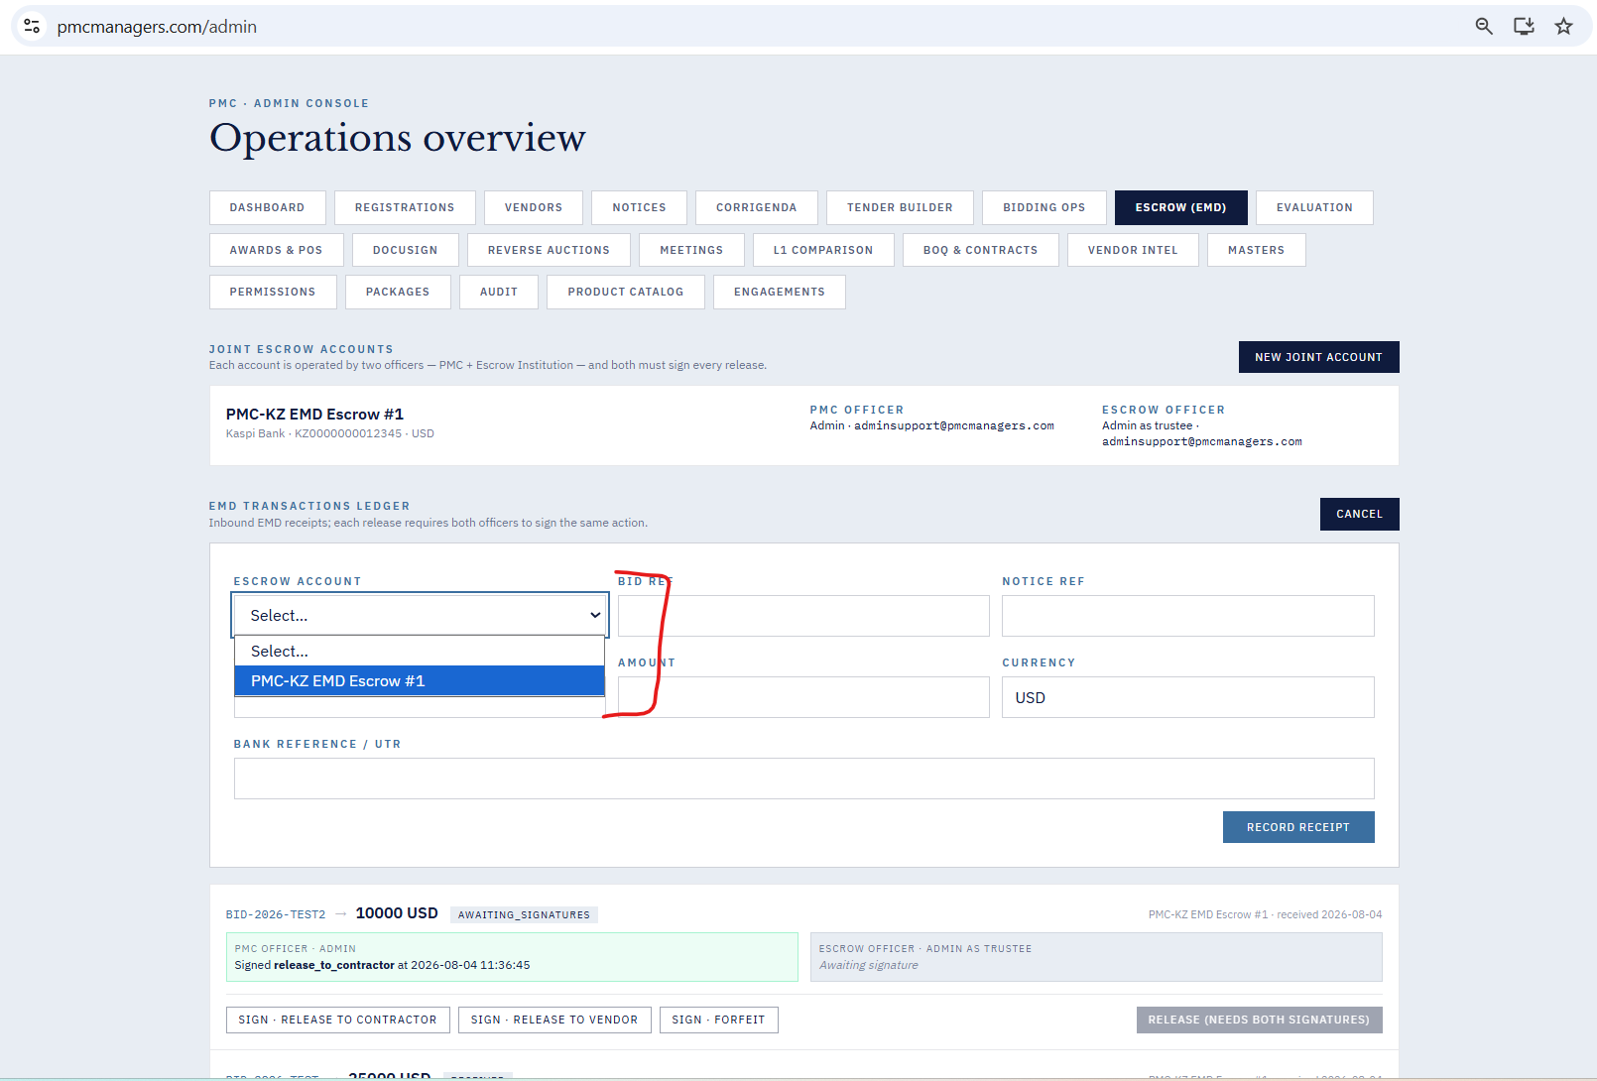

- Vendors - on creation of new vendors , another vendor existing documents are linked to the new vendor
- Sdfs
- Sdaf
- Sdf
- Sadf
- adf
- Sfd
- Sdfgd
- Sdfs
- Sfg
- Sdf
- Vendors - on creation of new vendors , another vendor existing documents are linked to the new vendor
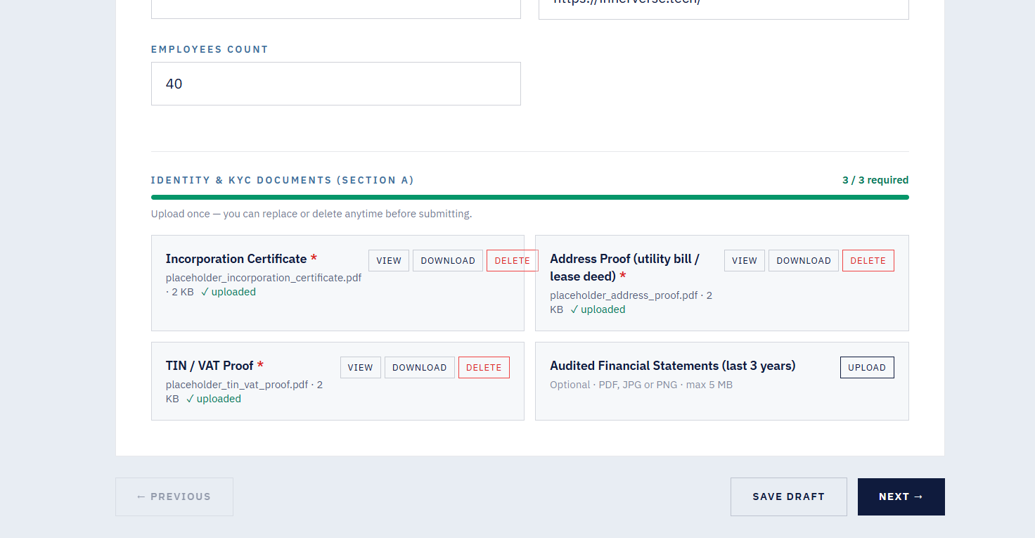

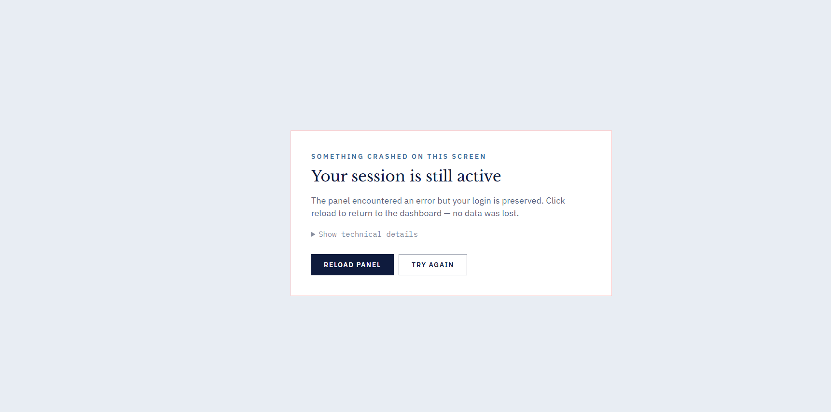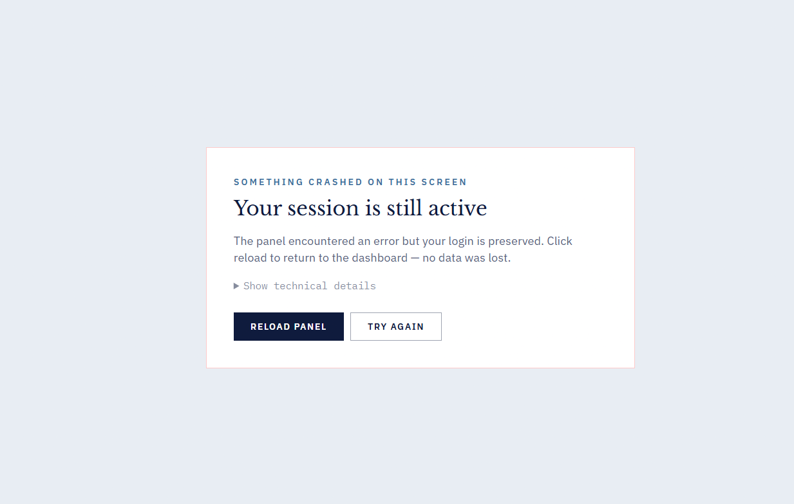
67th error

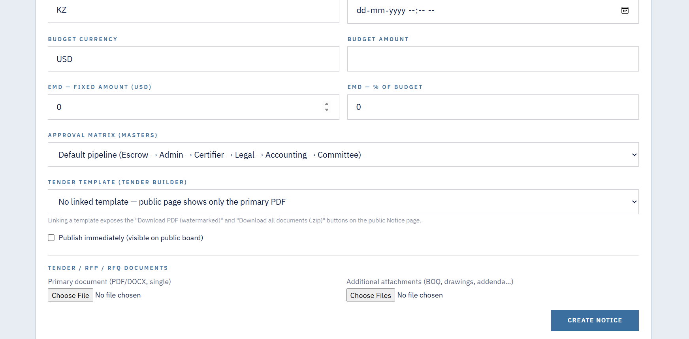
68th bug

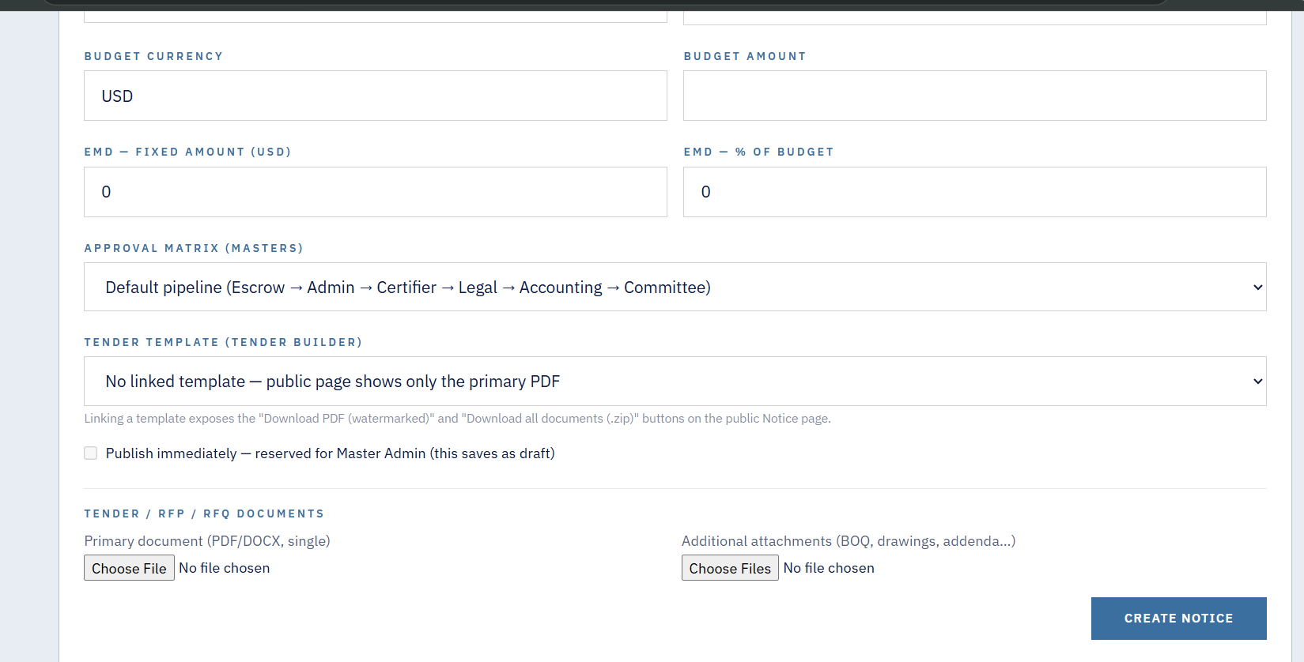
69th bug

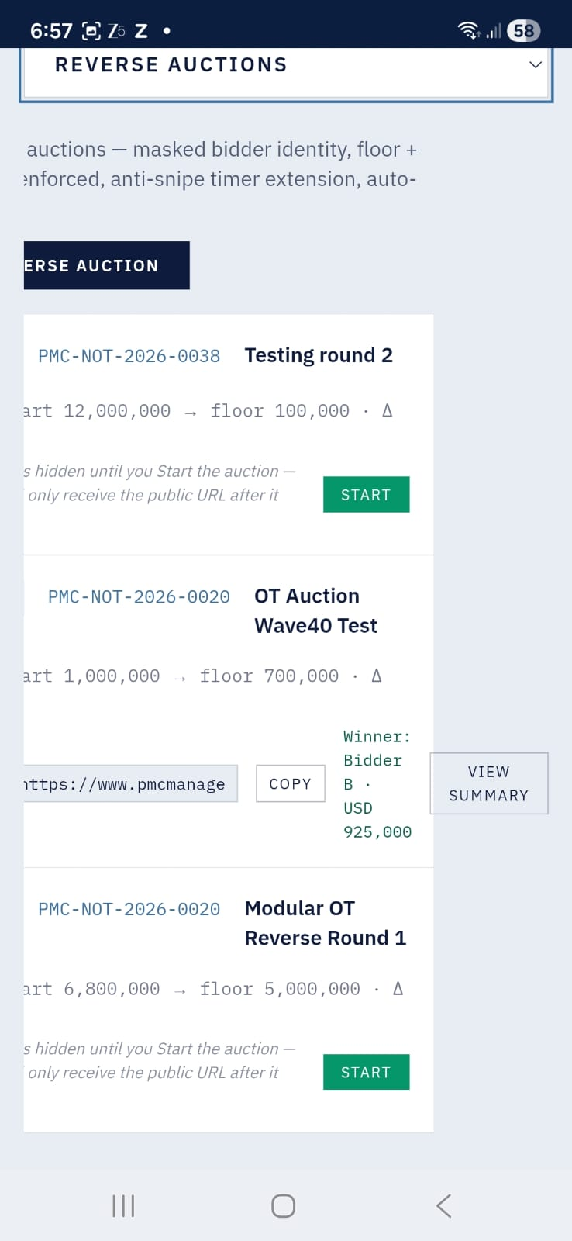
83rd bug

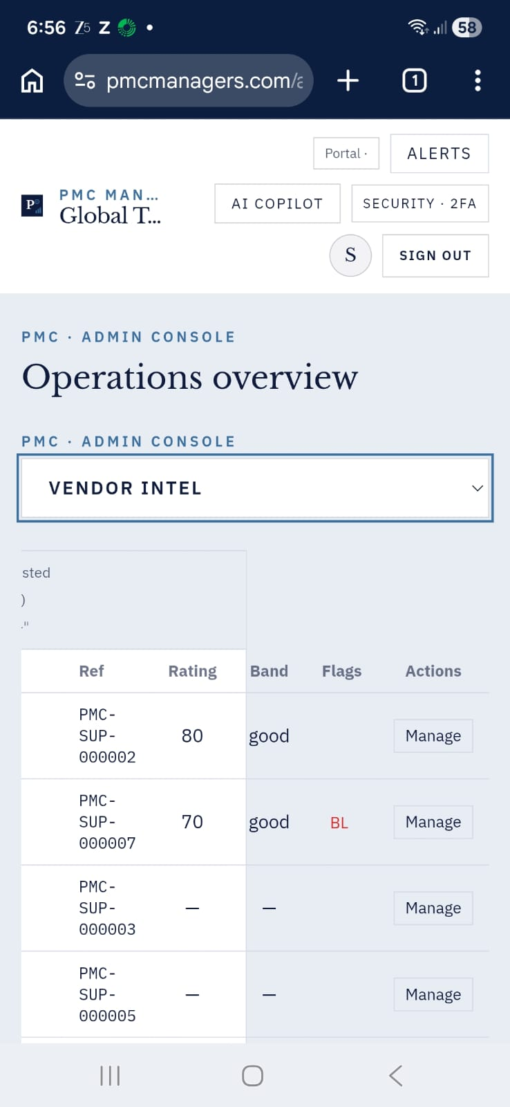
84th bug

