PMC Managers
Bug & Enhancement Clearance Report
Release v56s · 21 Oct 2026

Executive summary
This report covers the current testing round across two batches: the re-verification and fix of the production bug-sheet items (Batch 1), and the new procurement-taxonomy, Go-Live and public-board filtering work (Batch 2). Every item below was implemented and verified in the preview environment; the backend test suite for the taxonomy / Go-Live work passes 14/14 and the Batch 1 fixes pass 8/8.
At a glance: 8 fixed · 3 new capabilities · 2 verified-already-correct · 2 deferred by request.
Please note: items marked Fixed/New are verified in the preview build. They move to fully-closed once the production build is deployed (and CloudFront invalidated) and you have confirmed them on your side.

Status legend
Status | Meaning
FIXED | Fixed & verified in preview — pending production deploy + your sign-off
NEW | New capability built & verified in preview — pending production deploy + your sign-off
VERIFIED | Confirmed already correct in preview — no code change needed
DEFERRED | Intentionally left unchanged per your instruction

Detailed clearance log

Batch 1 — Production bug-sheet re-verification (v56o)
Ref | Module | Observation | Resolution | Status
#58 | Product Catalog | Disabling an existing product throws an error. | Added PATCH /api/v1/products/{id}/active (was returning 422). Enable/disable now persists; invalid id → 400, missing → 404. | FIXED
#44 | Evaluation | Technical scoring always computes 0 → 'no bid qualifies'. | _load_rubric_config now falls back to DEFAULT_TECH_CRITERIA when no rubric is saved, so scored bids show their real technical %. | FIXED
#17 | Admin DocuSign | Vendor side stays 'submitted/pending' until two conditions are met. | list_my_envelopes now matches bids by str(_id) (was referencing a non-existent 'id' field), so the vendor status updates correctly. | FIXED
#23 | Corrigenda | A rejected corrigendum publish could leave an orphan record / moved deadline. | All validation (require_future + amendment + _validate_tender_chain) now runs BEFORE any DB write — a rejected publish leaves no orphan. | FIXED
#36 | Public Notice | Bid buttons still active on closed/awarded tenders. | NoticeDetail gates both 'Start bid' buttons behind a closed flag (status closed/awarded or past deadline) → disabled 'Bidding closed'. | FIXED
#72 | Escrow magic-link | Invalid/expired escrow link shows a raw axios 404. | Friendly 'link invalid or expired' message shown instead of the raw error. | FIXED

Batch 2 — Taxonomy, Go-Live & public filters (v56q–v56s)
Ref | Module | Observation | Resolution | Status
#13 | Escrow Institutions | Institutions that start but never finish registration are never chased; no dormancy handling. | Platform cron (.emergent/crons.yml) e-mails the institution's primary contact (all signatories CC'd) every 7 days while incomplete; at 30 days the record is marked dormant with a re-registration warning. Verified end-to-end in preview with temporary records (reminder at 10d, dormant at 35d, 7-day cadence guard, provider HTTP 200). | FIXED
#71 | Events & Alerts | Notification body shows literal HTML tags (e.g. <p>…</p>) instead of readable text. | Admin Events now render readable text safely (no raw tags, no unsafe HTML injection). Verified in preview: HAS_RAW_P_TAG_LITERAL = False. | FIXED
NEW | Procurement Taxonomy | No structured Sector / Contract-Type / commodity classification on vendors, categories, notices or the public board. | New persistent masters: Sectors (25) and Contract Types (30, grouped) kept separate from the 105 UNSPSC categories. Wired as cascading pickers into vendor registration (Section D), vendor category requests, and notice create/edit; stored and returned on each record. | NEW
NEW | Admin Go-Live Switch | Need a single switch to make Sector/Contract-Type optional during onboarding and mandatory at go-live. | New admin Go-Live toggle (Masters). OFF by default — Sector & Contract Type stay optional. When ON, the backend blocks new registration/notice workflows that omit them. Existing vendors are untouched. | NEW
NEW | Public Tender Board | Public board has no way to filter by Sector, Contract Type, commodity or country; filters are not shareable. | Added Sector, Contract Type, Category (UNSPSC), Country and free-text filters. Live filter state is mirrored into the URL so a filtered view is a shareable deep-link (e.g. ?sector=power&country=IN). | NEW
#6 | Vendor Registration | Mandatory-field marker (thin red asterisk) is easy to miss. | Confirmed the current marker is a bold red 'REQUIRED' pill on every mandatory field — clear and prominent. Retained as-is per review. | VERIFIED
#15 | Admin Registrations | Previously-selected company detail lingers after switching the status tab. | Confirmed the review panel clears the current selection whenever the status tab changes, so no stale company detail is shown. Working as intended in preview. | VERIFIED
#11 | Help Text | Field help text wording. | Left unchanged — explicitly deferred by user instruction. | DEFERRED
#69 | Help Text | Field help text wording. | Left unchanged — explicitly deferred by user instruction. | DEFERRED

Preview evidence
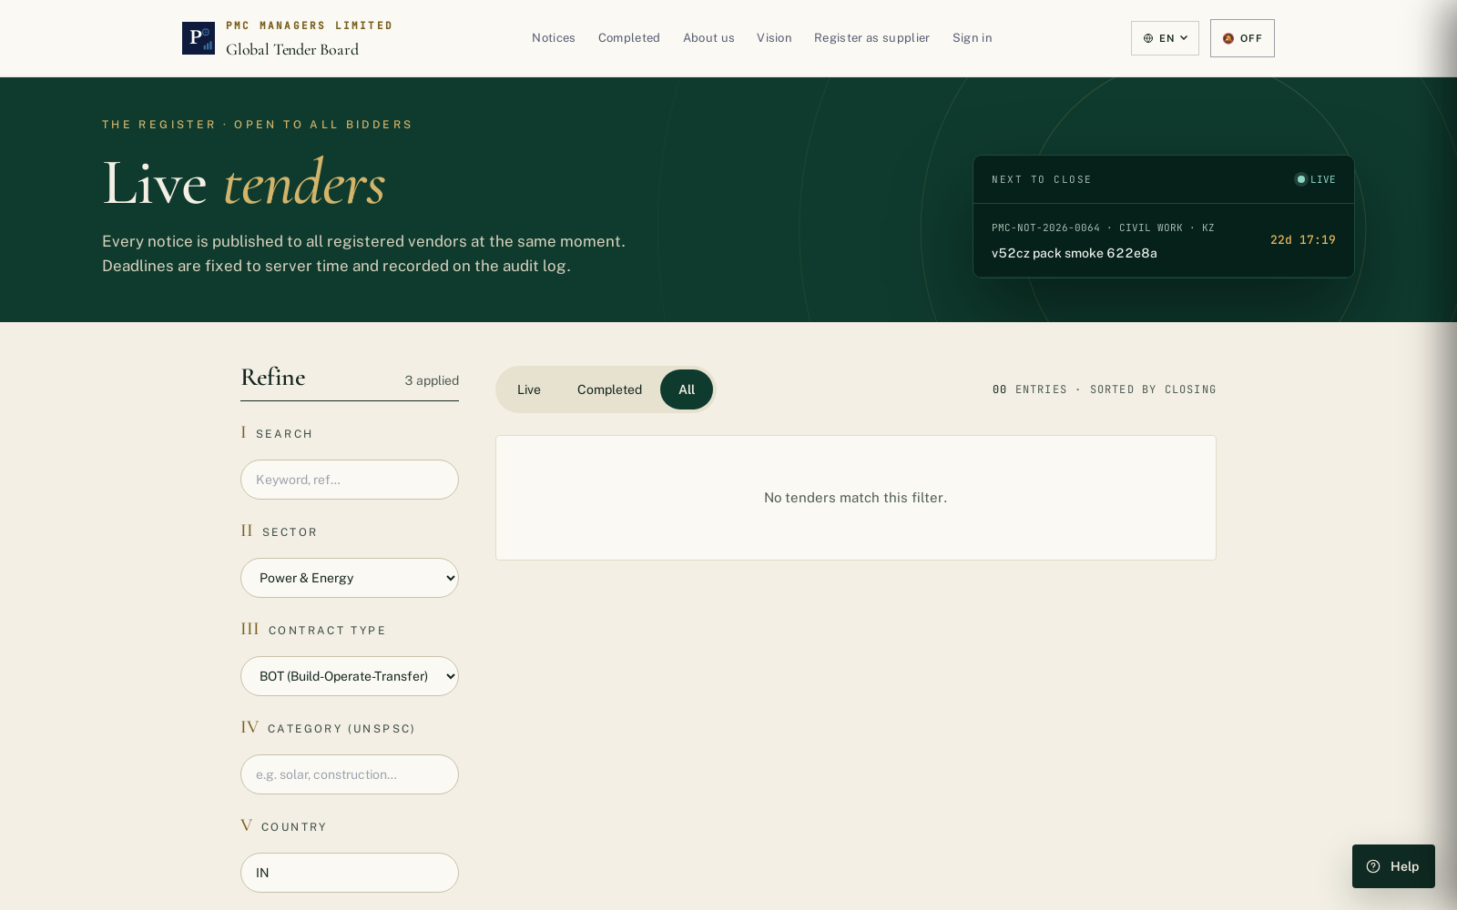
Public tender board — Sector / Contract Type / Category / Country filters with a shareable deep-link URL.

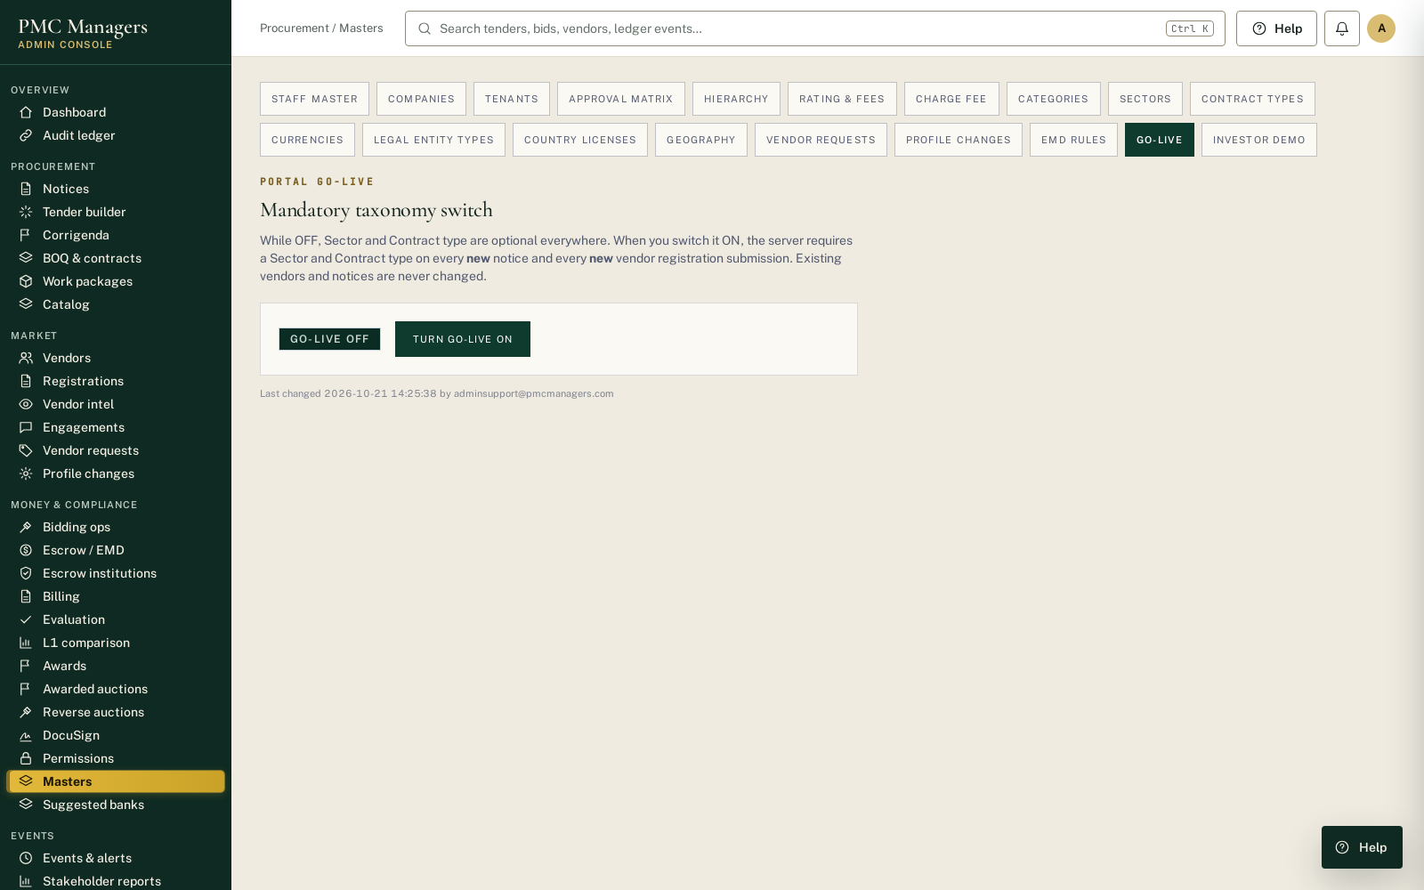
Admin Masters — Go-Live switch (OFF by default).

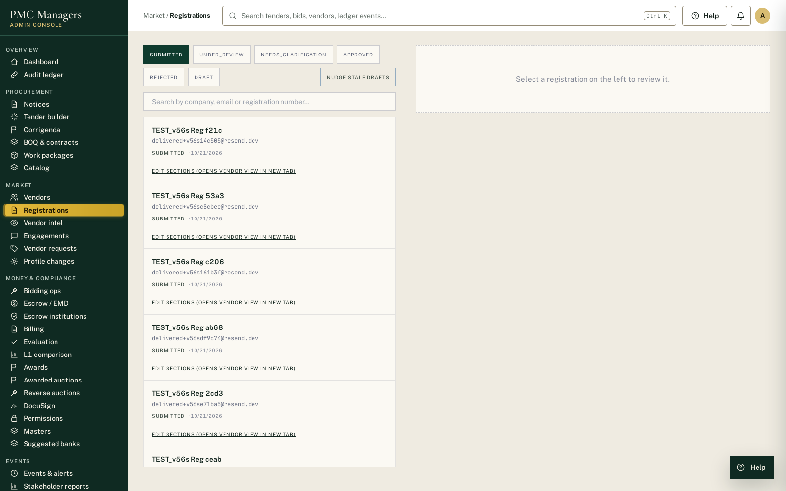
Admin Registrations — review panel; selection clears on status-tab switch.

