PMC Managers v2 — Master Training Manual
Definitive edition · v1 · Operations · QA · Management

Generated September 04, 2026

This document supersedes every earlier PMC training manual (v1 → v3.2 handbook · Screenshot Training Manual v1 · every observation-response iteration).

For each logical module in the portal you get four consumer-specific tracks in the same document:
Overview — one-paragraph story · who uses it · where it sits in the workflow
Operations Team — 'how to use' step-by-step for trainee ops staff
QA Team — numbered test cases · expected outcomes · data-testid selectors
Management Team — governance controls · KPIs · reports

Contents

# | Module | Audience
1 | Access, Roles & Login | Ops · QA · Mgmt
2 | Public Notice Board | Ops · Mgmt
3 | Vendor Registration & KYC | Ops · QA
4 | Registrations Admin | Ops · Mgmt
5 | Notices Admin | Ops · QA · Mgmt
6 | Corrigenda | Ops · Mgmt
7 | Tender Builder | Ops · QA · Mgmt
8 | Bidding Ops · Pipeline | Ops · QA
9 | Bidding Ops · Committee | Ops · QA · Mgmt
10 | Reverse Auctions | Ops · QA
11 | Escrow (EMD) | Ops · QA · Mgmt
12 | Evaluation & Scoring | Ops · QA · Mgmt
13 | L1 Comparison | Ops · QA · Mgmt
14 | Awards & POs | Ops · QA · Mgmt
15 | DocuSign · Envelope Log | Ops · QA
16 | BOQ & Contracts | Ops · QA · Mgmt
17 | Meetings | Ops · QA
18 | Vendor Intel | Ops · Mgmt
19 | Product Catalog | Ops · Mgmt
20 | Engagements (Quotes) | Ops · QA · Mgmt
21 | Masters · Roles & Permissions | Ops · QA · Mgmt
22 | Portal Branding | Ops · Mgmt
23 | Reports · Asked-vs-Delivered + Flowcharts | Mgmt
24 | Stakeholder Reports · G4 rebuild | Mgmt · Ops
25 | Help Requests | Ops · Mgmt
26 | Audit Log | Ops · Mgmt
27 | Governance Guardrails | Mgmt · QA
28 | Dashboard · Analytics & Drill-through | Ops · Mgmt
29 | Sign-out & Exit | Ops · QA

Chapter 1 · Access, Roles & Login
Understand who logs in as what and where they land.
Audience: Ops · QA · Mgmt
OVERVIEW
PMC Managers v2 is a multi-tenant global tender platform. Every user authenticates through the same URL and lands on the console that matches their role. Cookies are HTTPOnly + CSRF double-submit for admin; vendor and public flows use short-lived resume tokens sent by email.

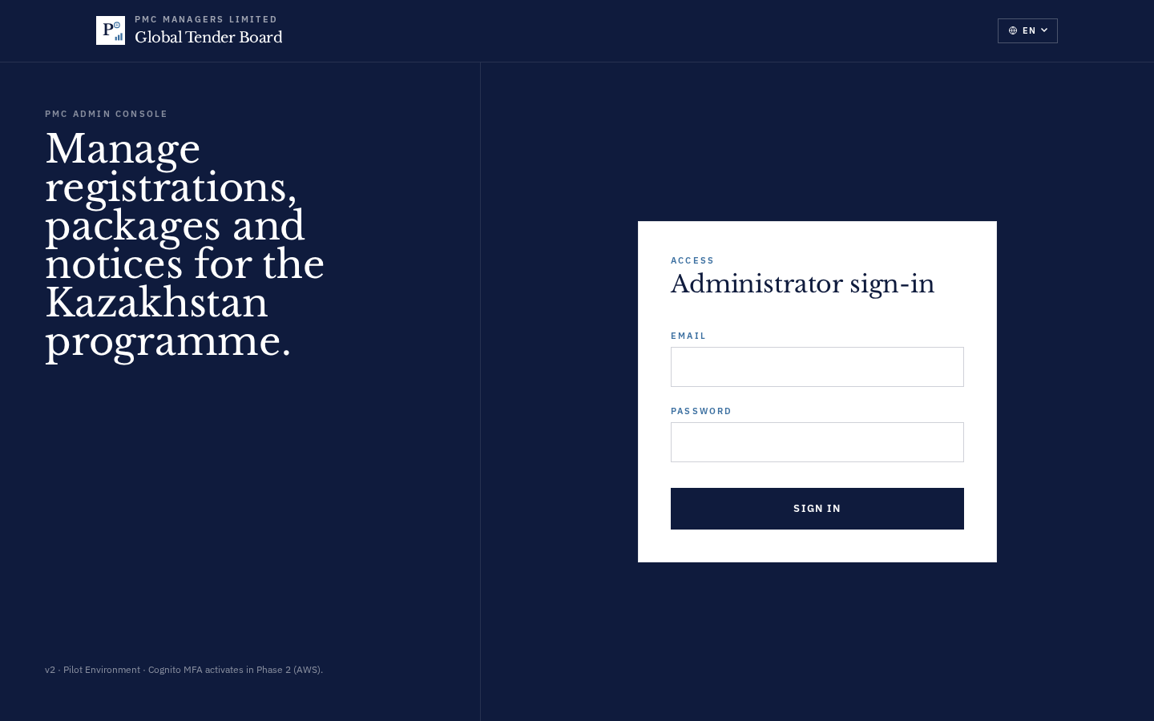
OPERATIONS TEAM · HOW TO USE
- Admins go to https://www.pmcmanagers.com/admin/login and enter their PMC email + password.
- Vendors register from the public site https://www.pmcmanagers.com/register — no admin approval needed to start a draft.
- Support / Auditor accounts are read-only; they see every tab but cannot mutate.
- If you see a 403 toast on any screen, check Masters → Permissions for your role's matrix row.
- Session cookies expire after 12 h of inactivity — save drafts frequently.
QA TEAM · TEST CASES
# | Test step | Expected outcome
1 | Login with wrong password 5× | 6th attempt returns HTTP 429 with lockout timer  data-testid: admin-login-submit
2 | Login with correct credentials | Redirects to /admin within 1 s; me endpoint returns 200 with role  data-testid: admin-login-submit
3 | Reload page after login | Session persists via HTTPOnly cookie; no re-auth needed  data-testid: admin-topbar
MANAGEMENT · GOVERNANCE · KPIS
- Nine role types shipped: Admin, Reviewer, Escrow, Certifier, Legal, Accounting, Committee, Support, Auditor.
- Access-control merges Permissions Matrix + Hierarchy Level via GET /api/v1/permissions/effective/{role} (single source of truth).
- Level 0 = Admin (full write) → Level 3 = Support/Auditor (read-only).
- Every login is logged to `audit_log` — actor, IP, user-agent, timestamp.

Chapter 2 · Public Notice Board
External entry-point where bidders discover open tenders.
Audience: Ops · Mgmt
OVERVIEW
Public list of every published notice across every tenant. Filters by type (tender/RFP/RFQ), country, and category. Deep-links to the notice detail page with document downloads + QA thread + register-to-bid CTA.

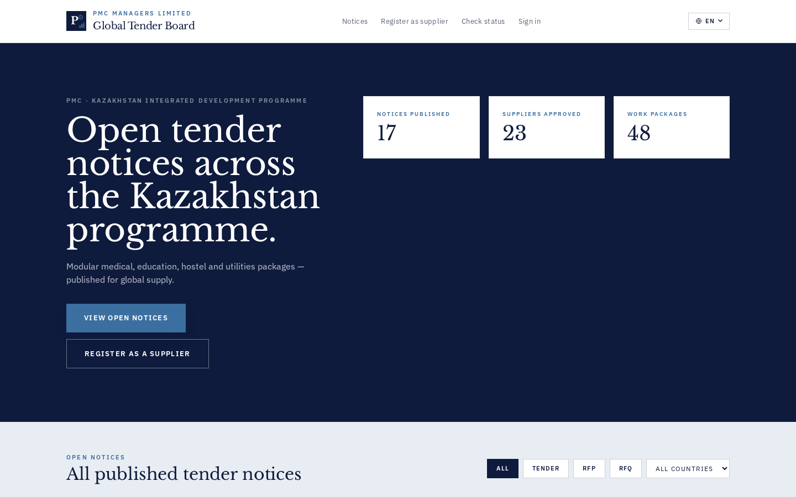
OPERATIONS TEAM · HOW TO USE
- Vendors browse notices without login.
- Clicking a card opens the notice detail: description, deadline, downloads, corrigenda list.
- The 'Register interest' CTA takes vendors to /register with the notice pre-filled.
QA TEAM · TEST CASES
# | Test step | Expected outcome
1 | Load /notices with no filters | Only notices where is_published=true render  data-testid: public-notice-card
2 | Filter by country | List narrows within 300ms; count updates  data-testid: public-notice-filter-country
3 | Click a notice card | Detail page renders; downloads work; QA thread loads  data-testid: public-notice-card
MANAGEMENT · GOVERNANCE · KPIS
- Draft notices are never surfaced publicly.
- Every notice has: budget_amount (validated ≥ 0), budget_currency, delivery_country, submission_deadline.
- KPI: median time-to-first-bid per notice — surfaced in Stakeholder Reports / Tenders.

Chapter 3 · Vendor Registration & KYC
5-section wizard that captures identity, structure, financials, docs, references.
Audience: Ops · QA
OVERVIEW
Vendors self-register through the 5-section wizard (A Identity, B Structure, C Financials, D Documents, E References). As soon as any field is filled, a silent draft is created + a resume-link is emailed. Vendors can pause and come back to /register/status with the resume token.

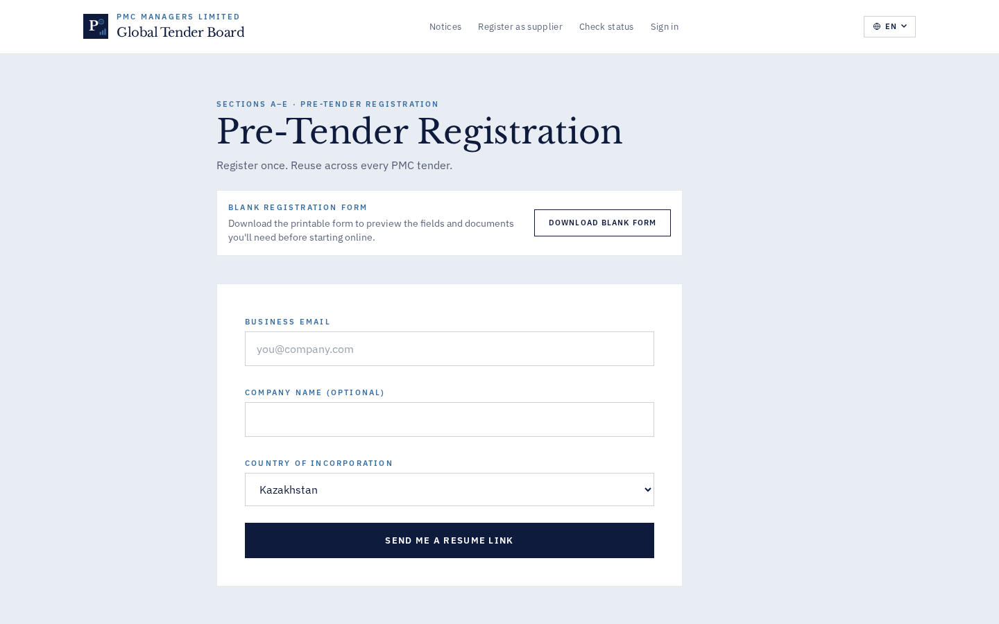
OPERATIONS TEAM · HOW TO USE
- Section A: company name, contact, email, phone, country (all required).
- Sections B-D can be paused — the resume link is sent after Section A.
- Section E supports up to 3 references; each reference generates its own reachback email once approved.
- Nudge Stale Drafts (admin) — sends a follow-up mail to any draft untouched for 14 days.
QA TEAM · TEST CASES
# | Test step | Expected outcome
1 | Fill Section A and close the tab | Resume email arrives within 30s; token is a URL-safe 24-char string  data-testid: reg-section-a
2 | Paste an invalid resume token at /register/status | Toast: 'Token invalid or expired — request a new resume link…' (Bug 7 fix)  data-testid: status-token
3 | Upload a 15 MB PDF to the KYC slot | Upload progresses; if server limit is 10 MB, backend returns HTTP 413 with clear message  data-testid: reg-upload-kyc
MANAGEMENT · GOVERNANCE · KPIS
- GDPR-compliant: KYC docs stored server-side with tenant-scoped ACL.
- KPI: draft-to-submitted conversion rate — surfaced in Stakeholder Reports / Vendors funnel.
- Rejected registrations get a reason ≥5 chars logged to audit; rejection email carries the reason.

Chapter 4 · Registrations Admin
Review incoming vendors, approve / reject / clarify with reason.
Audience: Ops · Mgmt
OVERVIEW
Admin-side triage of every submitted vendor registration. Sorted oldest-first by default so the daily workflow chews through the pipeline. Every action requires a reason capture and is logged to audit.

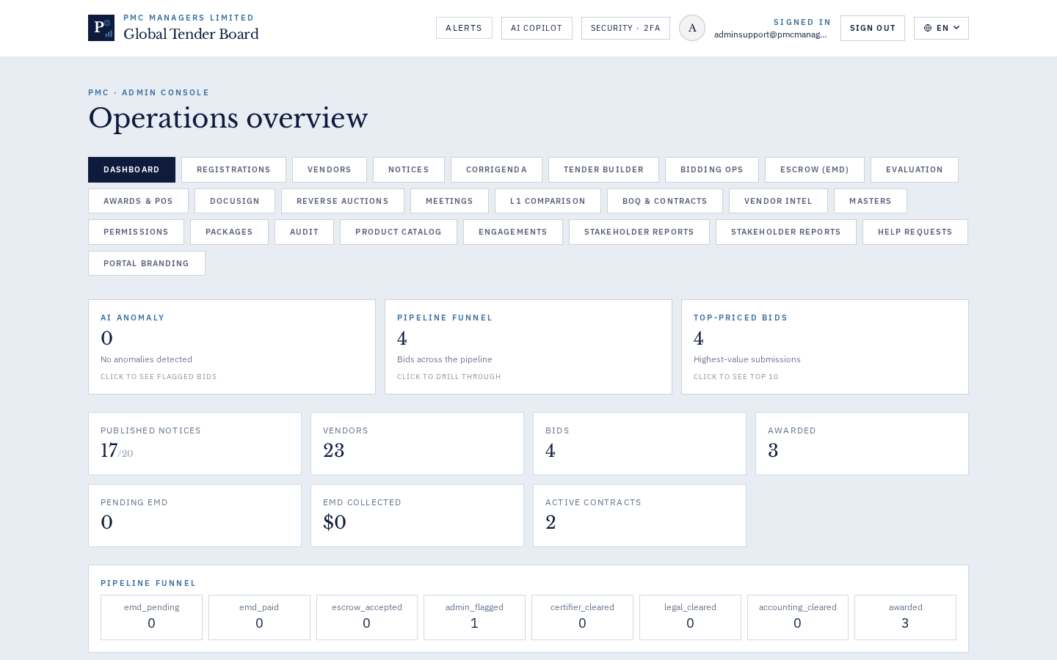
OPERATIONS TEAM · HOW TO USE
- Sort by 'Submitted date' (default, oldest first) to work the queue.
- Click a row → review each section → Approve / Reject / Request Clarification.
- Reject or Clarify require a reason ≥5 chars — surfaced to the vendor in the outbound email.
- Bulk Invite CSV supports pre-loading known vendors; sample CSV downloadable from the modal.
QA TEAM · TEST CASES
# | Test step | Expected outcome
1 | Approve a vendor with a valid PAN doc | vendor doc created + welcome email sent; row moves to 'Approved' tab  data-testid: reg-row-approve
2 | Nudge Stale Drafts | Three-branch toast: 'no drafts' / 'none stale' / 'n emails sent'  data-testid: reg-nudge-stale
3 | Upload malformed CSV to Bulk Invite | Backend returns per-row error array; other rows still succeed  data-testid: vendors-bulk-invite-csv
MANAGEMENT · GOVERNANCE · KPIS
- Aging report: rows show submission date; daily digest highlights >30-day drafts.
- Every approval is a matrix action (create) — restricted per role.
- KPI: median approval turnaround per tenant, exposed in Stakeholder Reports.

Chapter 5 · Notices Admin
Create, publish, filter and manage every tender / RFP / RFQ.
Audience: Ops · QA · Mgmt
OVERVIEW
The single source of truth for a live tender. Notices link to a Tender Builder template, drive the public notice board, and gate every downstream flow (bids, escrow, awards). Reviewers save drafts; only Master Admin publishes.

OPERATIONS TEAM · HOW TO USE
- '+ New notice' opens the wizard: Title, Description, Category, Country, Deadline.
- Pick a Tender Builder template to prefill; toggle 'Publish immediately' (Master Admin only).
- Use the filter bar: search by title/ref, filter by status (any/published/draft/expired), toggle 'Template-linked only'.
- Corrigenda re-notify bidders — you cannot delete a published notice, you must issue a corrigendum.
QA TEAM · TEST CASES
# | Test step | Expected outcome
1 | Publish a notice with budget_amount = -1 | HTTP 400 (NoticeIn validates ge=0) — Bug 4 fix  data-testid: notices-form-submit
2 | Filter by 'Template-linked only' | List narrows to notices with tender_template_id set  data-testid: notices-filter-template-only
3 | Reviewer saves a draft notice | HTTP 200; reviewer.create=True (Bug #5 fix); no 'undefined' toast  data-testid: notices-form-submit
MANAGEMENT · GOVERNANCE · KPIS
- Every publish is audited with actor + tenant + notice_ref.
- Budget currency defaults to tenant primary currency but supports any ISO 4217 code.
- KPI: notices-published-per-month, average time from creation to publish.

Chapter 6 · Corrigenda
Formal amendments to published tenders — every change is auditable.
Audience: Ops · Mgmt
OVERVIEW
Corrigenda re-open the bidder window after a tender is public. Every corrigendum has an auto-number (`PMC-COR-YYYY-####`), a mandatory reason ≥8 chars, and can reset the submission deadline. Withdrawal is capped at 3 per notice.
OPERATIONS TEAM · HOW TO USE
- '+ New corrigendum' from Notices detail → describe the amendment.
- Optionally push a new deadline — bidders are notified.
- Withdraw requires a reason ≥8 chars.
QA TEAM · TEST CASES
# | Test step | Expected outcome
1 | Withdraw with a 3-char reason | HTTP 400 'reason must be at least 8 characters'  data-testid: corrigenda-withdraw
2 | Create 4th corrigendum on a notice with 3 already | HTTP 400 'withdrawal capped at 3 per notice'  data-testid: corrigenda-create
3 | Publish corrigendum | audit_log entry with reason + all bidders receive email notif  data-testid: corrigenda-publish
MANAGEMENT · GOVERNANCE · KPIS
- Legal-grade audit: reason text is preserved on the notice record + audit log.
- Corrigenda count is a red-flag KPI — high count on one notice indicates poor initial drafting.

Chapter 7 · Tender Builder
Compose 30-page tenders from orderable sections + annexures.
Audience: Ops · QA · Mgmt
OVERVIEW
Master templates ship for GFR 2017 QCBS 70/30. Clone a master into a draft, fill each section with the rich editor, attach annexures via drag-drop, preview + export via WeasyPrint. Every save is snapshotted (max 20 rolling).

OPERATIONS TEAM · HOW TO USE
- Left column → pick a Kind (Tender / RFP / RFQ). Switching Kind resets the right pane (Bug 31c fix).
- Click a master → Clone → draft appears under 'Draft YYYY-MM-DD'.
- Drag annexure PDFs onto the bulk uploader — filenames auto-match (annex-VIII_bank.pdf → Annexure VIII, longest-code wins).
- ✨ AI Draft menu: tone (formal/plain/strict) × length (short/medium/long); shows word-diff before overwriting.
- ⟲ History drawer restores any of the last 20 snapshots (restore is itself snapshotted).
QA TEAM · TEST CASES
# | Test step | Expected outcome
1 | Save section body 3 times in a row | Version count increments; History drawer shows all 3  data-testid: tender-section-save
2 | Switch Kind tab after making unsaved changes | Right pane resets; selectedId cleared (Bug 31c)  data-testid: tender-kind-tab
3 | Export to PDF before publish | PDF has diagonal DRAFT watermark until associated notice is_published=true  data-testid: tender-export-pdf
MANAGEMENT · GOVERNANCE · KPIS
- Language pack: EN / RU / KK labels ship with WeasyPrint.
- Section-level auditor role can veto — legal counsel gets a distinct notif.
- KPI: average edit-cycle length; teams > 40 edits per template may need training.

Chapter 8 · Bidding Ops · Pipeline
Track every bid through the multi-role approval pipeline.
Audience: Ops · QA
OVERVIEW
The pipeline: EMD → Escrow → Admin flag → Certifier → Legal → Accounting → Committee. Each role clears their stage; stuck bids surface in the daily audit report. Rejection at any stage requires a note.

OPERATIONS TEAM · HOW TO USE
- Filter by status (submitted/emd_paid/admin_flagged/certified/legal_cleared/accounting_ok/committee_approved/awarded/rejected).
- Click a bid → full timeline of every stage transition.
- Assign a certifier from the Assign modal; date + location required.
- Reject requires a note ≥10 chars.
QA TEAM · TEST CASES
# | Test step | Expected outcome
1 | Bidder submits without EMD | Status stays 'submitted'; escrow tab shows the pending EMD  data-testid: bid-row-status
2 | Reject with a 5-char note | HTTP 400 'note must be at least 10 characters'  data-testid: bid-reject
3 | Assign certifier | Inspection record created + email dispatched with signed accept-link  data-testid: assign-certifier
MANAGEMENT · GOVERNANCE · KPIS
- Every stage transition is an audit event with actor + previous state + new state.
- KPI: median bid cycle-time (submitted → awarded).
- SLA threshold: >7 days at any single stage triggers a daily nudge.

Chapter 9 · Bidding Ops · Committee
Form evaluation committees with chair + members + quorum + external invitees.
Audience: Ops · QA · Mgmt
OVERVIEW
One open committee per tender. Members are picked via checkbox grid (Bug 58 fix). Chair dropdown auto-filters to selected members only (Bug 58c). Quorum caps at ≤ member count (Bug 58d). Committee can be dissolved with a reason ≥8 chars, and per-invitee 'Resend' buttons regenerate the accept-token.

OPERATIONS TEAM · HOW TO USE
- Tick members from the checkbox grid — chair dropdown auto-narrows.
- Set quorum; input caps at the number of ticked members.
- Add external invitees (name + email + designation) → they receive an accept-link email.
- Dissolve committee: reason ≥8 chars; committee status becomes 'dissolved' and is preserved for audit.
QA TEAM · TEST CASES
# | Test step | Expected outcome
1 | Tick 3 members, pick chair from 4th (unpicked) | Chair dropdown does not offer the 4th; chair auto-clears if unpicked after  data-testid: committee-chair
2 | Enter quorum = 10 with 4 members ticked | Input capped at 4 with live hint  data-testid: committee-quorum
3 | Dissolve committee with 6-char reason | HTTP 400 'dissolve reason must be at least 8 characters'  data-testid: committee-dissolve
4 | Resend invite to pending external | New accept-token generated; email sent; old link now 404  data-testid: committee-resend
MANAGEMENT · GOVERNANCE · KPIS
- COI check: evaluations.submit_score returns 400 unless the scorer has recorded a COI declaration for that notice (G2 governance).
- Chair change post-formation is a governance event — audited separately.
- KPI: median committee formation → first score < 3 business days.

Chapter 10 · Reverse Auctions
Live reverse-auction rooms with masked bidder identities.
Audience: Ops · QA
OVERVIEW
Masked identity auction (Bidder A/B/C…) with min-decrement, hard price floor, and anti-snipe extension. Draft auctions never expose the public bidder link (G5 fix). Participant validation blocks duplicates + non-registered emails.

OPERATIONS TEAM · HOW TO USE
- '+ New auction' → set min-decrement (currency), price floor, anti-snipe seconds.
- Draft mode: bidder URL hidden; explanatory hint shown instead.
- Go live → the /vendor/auction/:aid room polls every 2 s.
QA TEAM · TEST CASES
# | Test step | Expected outcome
1 | Add a duplicate email to participants | HTTP 400 'duplicate participant email'  data-testid: auction-participants
2 | Open draft auction detail | Bidder URL not shown; explanatory text present  data-testid: auction-bidder-link
3 | Close a live auction | status='closed'; last valid bid becomes winning_price  data-testid: auction-close
MANAGEMENT · GOVERNANCE · KPIS
- Anti-snipe extends deadline by N seconds if a bid lands in the final N seconds — anti-manipulation.
- Winning price is written to the linked bid record for downstream award.

Chapter 11 · Escrow (EMD)
Joint escrow accounts with dual-signature EMD releases.
Audience: Ops · QA · Mgmt
OVERVIEW
Every EMD instrument flows through a joint account operated by one PMC officer + one escrow-institution officer. Both must sign before release (G1 fix). Aging days per transaction; SLA breach flag when >7 days pending. Reconciliation summary in Stakeholder Reports.

OPERATIONS TEAM · HOW TO USE
- '+ Account' — two named officers required; backend rejects if pmc_officer.email == vendor_officer.email.
- '+ Transaction' → sign your side → wait for the other side.
- Release fires only after BOTH signatures; otherwise HTTP 409.
QA TEAM · TEST CASES
# | Test step | Expected outcome
1 | Create account with same email on both sides | HTTP 400 'PMC officer and escrow officer must be different people' (G1)  data-testid: escrow-account-create
2 | Sign PMC side but not vendor side, then click Release | HTTP 409 'awaiting escrow-officer signature'  data-testid: escrow-release
3 | Open Stakeholder Reports / Escrow | aging_days per tx; sla_breach=true when >7d  data-testid: stakeholder-escrow
MANAGEMENT · GOVERNANCE · KPIS
- G1 governance: same-login-both-sides is architecturally blocked.
- SLA threshold configurable per tenant (default 7 days).
- KPI: median release cycle-time; SLA breach count per week.

Chapter 12 · Evaluation & Scoring
Committee scoring with per-criterion weights + COI enforcement.
Audience: Ops · QA · Mgmt
OVERVIEW
Committee members score each bid against the rubric set on the notice. Weighted totals compute live. Every score requires an outstanding COI declaration for that (scorer, notice) tuple — enforcement is HTTP 400 at submit_score.

OPERATIONS TEAM · HOW TO USE
- Pick a bid → enter scores 0-100 per criterion.
- COI tick box: 'I have no conflict of interest with this bidder on this notice'.
- Weighted total updates live; committee median becomes the technical score.
QA TEAM · TEST CASES
# | Test step | Expected outcome
1 | Score without ticking COI | HTTP 400 'COI declaration required' (G2)  data-testid: eval-submit
2 | Enter score > 100 | HTTP 400 'score must be between 0 and 100'  data-testid: eval-score-input
3 | Rubric with weights not summing to 100 | HTTP 400 at rubric save (Bug 56)  data-testid: eval-rubric-save
MANAGEMENT · GOVERNANCE · KPIS
- G2 governance: no committee score can be submitted without an existing COI record.
- Rubric is set once per notice and locked at first score.
- KPI: score-dispersion per bid (high dispersion = need for deliberation).

Chapter 13 · L1 Comparison
Rule-based lowest-compliant winner selection.
Audience: Ops · QA · Mgmt
OVERVIEW
Distinct from Evaluation scoring: L1 filters technically-compliant bids and picks the lowest total price. Empty state lists exclusion reasons (technical not scored / non-compliant / withdrawn / notice status).

OPERATIONS TEAM · HOW TO USE
- Open L1 → the eligible set + active ranking rule badge display.
- If empty, the panel lists why each excluded bid is out.
QA TEAM · TEST CASES
# | Test step | Expected outcome
1 | Run L1 with all bids under technical cutoff | Empty state with reason 'non-compliant' + count per reason  data-testid: l1-empty-state
2 | Open L1 with no closed notices | 'No eligible notices' shown; ranking rule badge hidden  data-testid: l1-panel
MANAGEMENT · GOVERNANCE · KPIS
- Ranking rule badge shows: 'lowest-compliant price wins' (transparency requirement).
- CSV export via /api/v1/stakeholder-reports/awards.csv.

Chapter 14 · Awards & POs
Draft Purchase Order, SLA, Contract PDFs on award.
Audience: Ops · QA · Mgmt
OVERVIEW
Awarding a bid drafts three PDFs: PO (`PMC-PO-YYYY-#####`), SLA, Contract — all with a diagonal DRAFT watermark until countersigned. Regenerate requires confirmation and pushes {regenerated_at, regenerated_by} into bid.award_regenerations[].

OPERATIONS TEAM · HOW TO USE
- 'Award' → confirms; three PDFs are generated + stored server-side.
- 'Regenerate' → confirmation dialog + audit toast with timestamp.
- Send to DocuSign to lift the DRAFT watermark on countersign.
QA TEAM · TEST CASES
# | Test step | Expected outcome
1 | Regenerate documents | Confirmation dialog appears; on OK the toast shows timestamp + admin email; award_regenerations[] gains 1 entry  data-testid: awards-regenerate
2 | Award an already-awarded bid | HTTP 409 'bid already awarded'  data-testid: awards-award
MANAGEMENT · GOVERNANCE · KPIS
- Every regeneration is a governance event — audit log flags 'suspicious' if >3 regenerations on the same bid.
- KPI: median time-to-award (committee approval → award).

Chapter 15 · DocuSign · Envelope Log
JWT Grant DocuSign integration + authoritative-envelope flag.
Audience: Ops · QA
OVERVIEW
PO / SLA / Contract PDFs go out via DocuSign either as Embedded (in-app iframe) or Email (hosted signing). Envelope Log per (bid_id, sub_kind) flags the authoritative envelope: status=completed wins, break ties by created_at.

OPERATIONS TEAM · HOW TO USE
- First run → 'Grant DocuSign consent' redirects to DocuSign, then comes back.
- Envelope Log rows show status + delivery mode + is_authoritative badge.
- Resend for envelopes in 'sent' status.
QA TEAM · TEST CASES
# | Test step | Expected outcome
1 | Filter Envelope Log by bid_id + sub_kind | Only relevant envelopes; exactly one row has is_authoritative=true  data-testid: envelope-log-filter
2 | Two envelopes both status=completed | The one with the later created_at wins is_authoritative=true  data-testid: envelope-log-row
MANAGEMENT · GOVERNANCE · KPIS
- Authoritative envelope is the single source of truth for legal downstream — audit ties to that envelope_id.
- Consent expires per DocuSign policy (usually 1 year) — dashboard warns 30 days out.

Chapter 16 · BOQ & Contracts
Bill-of-Quantities templates + Contract lifecycle.
Audience: Ops · QA · Mgmt
OVERVIEW
BOQ templates are imported via Excel (Sl.No | Description | Unit | Quantity | Unit Rate | Remarks). Vendors quote against the template. Only awarded bids can spawn a contract (`PMC-CON-YYYY-####`). Contracts export CSV + per-contract version timeline (creation + milestone completions + variation orders).

OPERATIONS TEAM · HOW TO USE
- Import Excel BOQ template; validate columns are exact.
- Vendors submit BOQ answers as part of the bid.
- Awarded bid → create contract; add milestones + variation orders as needed.
- Contracts sub-tab: filter by status/vendor/query; export CSV; view version timeline.
QA TEAM · TEST CASES
# | Test step | Expected outcome
1 | Export contracts.csv with status=active filter | CSV downloads with correct row count; Content-Disposition: attachment header  data-testid: contracts-export-csv
2 | Open version timeline for a contract with 2 milestones + 1 VO | 3 events sorted by 'at' ASC; each shows event type + amount + by  data-testid: contract-versions
MANAGEMENT · GOVERNANCE · KPIS
- Every variation order is auditable {at, by, amount_delta, reason}.
- Milestone hit-rate feeds Stakeholder Reports / SLA.

Chapter 17 · Meetings
Schedule Jitsi / Zoom meetings tied to a notice OR marked internal.
Audience: Ops · QA
OVERVIEW
Every meeting either references a notice_ref OR is explicitly flagged as an 'Internal meeting'. Backend rejects create with HTTP 400 otherwise. Cancelled meetings are hidden by default (include_cancelled=true toggle to show).

OPERATIONS TEAM · HOW TO USE
- '+ Schedule' → pick provider (Jitsi/Zoom), subject, time, invitees.
- Tick 'Internal meeting' to skip the notice dropdown (e.g. team standup).
- Otherwise, pick a notice — invitees receive a signed accept-link.
QA TEAM · TEST CASES
# | Test step | Expected outcome
1 | Create meeting without notice_ref and is_internal=false | HTTP 400 'notice_ref required unless is_internal=true' (Bug 48b)  data-testid: mtg-create
2 | Tick 'Internal meeting' | Notice dropdown disables + clears; create succeeds without notice_ref  data-testid: mtg-is-internal
MANAGEMENT · GOVERNANCE · KPIS
- Every meeting join is logged with invitee token + timestamp.
- Zoom uses JWT app credentials; Jitsi is self-hosted (no credentials).

Chapter 18 · Vendor Intel
Bulk vendor risk register with BL / WL flags.
Audience: Ops · Mgmt
OVERVIEW
Imported watch-lists + blacklists — used to alert Committee scorers when a bidder appears on any list. Anonymised entries (—) support imports from law-enforcement feeds where identities cannot be disclosed.

OPERATIONS TEAM · HOW TO USE
- Legend bar at the top: BL = Blacklisted, WL = Watch-list, — = anonymised.
- Add entry manually OR bulk-import CSV.
QA TEAM · TEST CASES
# | Test step | Expected outcome
1 | Score a bid where the vendor is on BL | Committee scorer sees an inline red BL badge on the bidder card  data-testid: eval-vendor-badge
MANAGEMENT · GOVERNANCE · KPIS
- BL entries block auto-award; committee must override with a reason.
- Anonymised entries mask the vendor name but preserve match-hash for detection.

Chapter 19 · Product Catalog
SKU catalog feeding Stripe checkout + price-history log.
Audience: Ops · Mgmt
OVERVIEW
Products drive the public checkout page (Stripe). Every price change is written to price_history[] with {old_price, new_price, changed_by, changed_at}.

OPERATIONS TEAM · HOW TO USE
- '+ Product' → name, price, currency, description, image URL.
- Edit → save changes → history entry auto-created.
QA TEAM · TEST CASES
# | Test step | Expected outcome
1 | Change product price 3 times | price_history[] has 3 entries with distinct changed_at  data-testid: product-edit-save
MANAGEMENT · GOVERNANCE · KPIS
- Price changes are a governance event — dashboard flags >30% change.
- KPI: gross checkout revenue per SKU per month.

Chapter 20 · Engagements (Quotes)
Public quote-requests through to invoicing + aging report.
Audience: Ops · QA · Mgmt
OVERVIEW
State machine: quote_requested → quoted → invoiced → paid (or cancelled with reason ≥5 chars). Aging summary buckets receivables by age (0-7/8-30/31-60/61+ days).

OPERATIONS TEAM · HOW TO USE
- New quote requests land as engagements from the public site.
- Set quoted amount → 'Invoice' generates a Stripe checkout link.
- Cancel requires reason ≥5 chars.
QA TEAM · TEST CASES
# | Test step | Expected outcome
1 | Cancel an engagement with 3-char reason | HTTP 400 'reason must be at least 5 characters' (Bug 35)  data-testid: eng-cancel
2 | GET /engagements/aging/summary | Returns 0-7/8-30/31-60/61+ buckets with counts  data-testid: eng-aging
MANAGEMENT · GOVERNANCE · KPIS
- Aging report drives receivables collection.
- KPI: quote → paid conversion rate; median days to payment.

Chapter 21 · Masters · Roles & Permissions
Single source of truth for who can do what.
Audience: Ops · QA · Mgmt
OVERVIEW
Permissions Matrix + hierarchy Level are now unified via GET /api/v1/permissions/effective/{role} (Wave G2). One call returns {role, level, level_label, tabs, actions} — drives menu visibility + button disabled-state everywhere.

OPERATIONS TEAM · HOW TO USE
- Masters → Permissions → tick/untick actions per role per document type.
- Every save writes updated_at + updated_by; visible in the header.
- Level (0..3) is set on the Staff Master screen.
QA TEAM · TEST CASES
# | Test step | Expected outcome
1 | GET /api/v1/permissions/effective/reviewer | Returns {level:1, level_label:'deputy', tabs:[…], actions:{view:true, create:true, modify:true, delete:false, publish:false}}  data-testid: permissions-effective
2 | Reviewer tries to publish a notice | HTTP 403 'insufficient permissions to publish'  data-testid: notices-publish-checkbox
MANAGEMENT · GOVERNANCE · KPIS
- G3 governance: closed — single access-control endpoint.
- Full audit on matrix mutations.

Chapter 22 · Portal Branding
Tenant-level logo + theme + rolling logo history.
Audience: Ops · Mgmt
OVERVIEW
Every tenant gets primary_color + accent_color + favicon + logo. Every new logo upload appends to logo_history[] (max 10 rolling); GET /logo-history to fetch.

OPERATIONS TEAM · HOW TO USE
- Upload a new logo → history entry auto-created.
- PATCH /api/v1/branding/{tid}/theme with primary_color, accent_color (#RRGGBB), favicon_data_url.
QA TEAM · TEST CASES
# | Test step | Expected outcome
1 | Upload 11 logos sequentially | logo_history[] contains only the last 10 entries  data-testid: branding-logo-upload
2 | PATCH theme with primary_color='red' | HTTP 422 'primary_color must match #RRGGBB'  data-testid: branding-theme-save
MANAGEMENT · GOVERNANCE · KPIS
- Branding changes are audited — no silent tenant re-brand.

Chapter 23 · Reports · Asked-vs-Delivered + Flowcharts
Development / scope-completion snapshot for engineering handoff.
Audience: Mgmt
OVERVIEW
Original 39-page Enterprise CRM & e-Tender Revised Integrated Report is reduced to a live 'asked vs delivered' statement + three swim-lane flowcharts (platform / user guide / testing). Snapshot to /app/docs/reports/ writes all 9 artefacts + a manifest.

OPERATIONS TEAM · HOW TO USE
- 'Snapshot to disk' → 9 files land in /docs/reports/.
- Bug 38 fix: each artefact is wrapped in try/except so one failure returns errors[] instead of a 500.
QA TEAM · TEST CASES
# | Test step | Expected outcome
1 | POST /api/v1/reports/snapshot | {ok:true, files:[…9 items], errors:[]}  data-testid: reports-snapshot
MANAGEMENT · GOVERNANCE · KPIS
- Deliverable for investor code review + engineering handoff.
- Zero-error snapshot = build health.

Chapter 24 · Stakeholder Reports · G4 rebuild
Four operational reports for procurement stakeholders.
Audience: Mgmt · Ops
OVERVIEW
G4 was rebuilt in v15/v18: four live JSON + CSV reports keyed off real collections. Tenders (pipeline snapshot), Awards (PO + contract value), Escrow (aging + SLA breach), SLA (contracts + milestone hit-rate).

OPERATIONS TEAM · HOW TO USE
- Tab through the four reports; each has a CSV download button.
- Escrow report highlights SLA breach count in the top row.
QA TEAM · TEST CASES
# | Test step | Expected outcome
1 | Open Stakeholder Reports / Escrow | aging_days per tx; sla_breach=true when >7d; header shows breach count  data-testid: stakeholder-escrow-sla
2 | Download tenders.csv | CSV downloads with Content-Disposition: attachment  data-testid: stakeholder-download-csv
MANAGEMENT · GOVERNANCE · KPIS
- Circulate CSV to stakeholders without portal access.
- KPI dashboard: SLA breaches, awards/month, milestone hit-rate.

Chapter 25 · Help Requests
Triage inbound support tickets from the public site.
Audience: Ops · Mgmt
OVERVIEW
Public help form drops a ticket with kind (Sales / Support / Technical / Other) + requester identity + phone + company. Panel surfaces aging + resolution history.

OPERATIONS TEAM · HOW TO USE
- Sort by aging (oldest first).
- Update kind, mark resolved, add resolution note.
QA TEAM · TEST CASES
# | Test step | Expected outcome
1 | Public submits a Help form with no email | HTTP 400 'email required'  data-testid: help-public-submit
2 | Mark resolved | Row moves to 'Resolved' tab; resolution_at + resolution_note stamped  data-testid: help-resolve
MANAGEMENT · GOVERNANCE · KPIS
- SLA planned: 24 h first response for Sales, 72 h for Technical.

Chapter 26 · Audit Log
Chronological ledger of every substantive action.
Audience: Ops · Mgmt
OVERVIEW
Every mutation writes to audit_log with {at, actor, action, resource_type, resource_id, payload}. Global <ErrorBoundary/> catches any render hang on this screen so users are never locked out.

OPERATIONS TEAM · HOW TO USE
- Sort by 'at' DESC (default).
- Copy any row's payload to inspect the raw event.
QA TEAM · TEST CASES
# | Test step | Expected outcome
1 | Render audit with 10 000 rows | Table remains scrollable; no white screen; ErrorBoundary NOT triggered  data-testid: admin-audit-panel
MANAGEMENT · GOVERNANCE · KPIS
- Legal-grade: audit log is append-only.
- Filters (actor/type/date) planned for Bucket B.

Chapter 27 · Governance Guardrails
Five architectural controls audited by the QA team.
Audience: Mgmt · QA
OVERVIEW
G1..G5 are the guardrails that turn 'compliance theatre' into real controls. Every one is either an HTTP 400 at the API layer OR a UI element that cannot leak sensitive state.
QA TEAM · TEST CASES
# | Test step | Expected outcome
1 | G1 · same-login-both-escrow-sides | HTTP 400 'must be different people'  data-testid: escrow-account-create
2 | G2 · score without COI | HTTP 400 'COI declaration required'  data-testid: eval-submit
3 | G3 · effective/{role} | Single payload merges tabs + actions + level  data-testid: permissions-effective
4 | G4 · Stakeholder Reports | Panel exposes 4 real reports + CSV  data-testid: stakeholder-reports-panel
5 | G5 · draft auction public link | Not rendered when status='draft'  data-testid: auction-bidder-link
MANAGEMENT · GOVERNANCE · KPIS
- Bug tracker v5 · 44 of 52 observations FIXED (85 %).
- Guardrails are the pass/fail for investor code review.

Chapter 28 · Dashboard · Analytics & Drill-through
Real-time KPIs + click-through to filtered lists.
Audience: Ops · Mgmt
OVERVIEW
AI Anomaly, Pipeline Funnel, Top-Priced Bids — each card is now clickable and drills through /api/v1/dashboard-drill/* to a filtered mini-table (Bug 32/47 fixes).

OPERATIONS TEAM · HOW TO USE
- Click any card to expand a filtered mini-table.
- Click again to collapse.
QA TEAM · TEST CASES
# | Test step | Expected outcome
1 | Click AI Anomaly card | Drill panel expands with 200 rows max; empty state text 'No AI-flagged bids' if none  data-testid: drill-card-anom
2 | Click Pipeline Funnel card | /dashboard-drill/pipeline?status= returns 500 rows max  data-testid: drill-card-pipe
MANAGEMENT · GOVERNANCE · KPIS
- KPI dashboard is the daily standup screen.
- AI Copilot is advisory — no state change without human sign-off.

Chapter 29 · Sign-out & Exit
Cookie-clear + redirect to public login.
Audience: Ops · QA
OVERVIEW
Sign-out clears the HTTPOnly admin cookie and redirects to /login. Any deep-link back to /admin bounces to /login. Cookie is set to Secure + SameSite=Lax.

OPERATIONS TEAM · HOW TO USE
- Top-right → 'Sign out'.
- Session cookie cleared server-side; browser cookie invalidated.
QA TEAM · TEST CASES
# | Test step | Expected outcome
1 | Click Sign out | Redirect to /login within 1 s; admin cookie no longer present  data-testid: admin-logout
2 | Navigate directly to /admin after sign-out | Bounce to /login; /api/v1/me returns 401  data-testid: admin-logout
MANAGEMENT · GOVERNANCE · KPIS
- Session TTL 12 h max; sliding renewal on activity.

Appendix A · Change-log

v1 · Sep 2026
Definitive master manual · every module × 4 tracks · supersedes v1..v3.2 handbook + Screenshot Manual v1 + all Observation-Response iterations.
Backend v17
Committee UX overhaul · Wave-E2 polish (7 fixes) · G2 access-control consolidation.
Frontend v20
Committee checkboxes + dissolve + resend · Tender kind-tab reset · status-token toast · Dashboard drill cards.
Backend v15
G4 rebuild · Dashboard drill endpoints · Branding theme + logo history · Engagements aging · DocuSign authoritative flag.
Frontend v18
StakeholderReportsPanel · Notices filter bar · v3.2 docs.

Appendix B · Guardrails (governance)

- G1 · Escrow dual-signature — HTTP 400 if pmc_officer.email == vendor_officer.email.
- G2 · COI cross-check — HTTP 400 at evaluations.submit_score without a COI declaration for that notice.
- G3 · Access-control unified — GET /api/v1/permissions/effective/{role} merges tabs + actions + hierarchy Level.
- G4 · Stakeholder Reports — four real reports (Tenders / Awards / Escrow / SLA) with JSON + CSV.
- G5 · Draft auction bidder link hidden when status='draft'.
- ErrorBoundary — every route is wrapped; blank screens are architecturally impossible.
- Audit — every substantive action writes to audit_log with actor + IP + payload.

