

PMC Managers — PMC User Manual — Suppliers, Buyers & Partners
Public website · supplier portal · buyer portal · partner portal
Issued 10 November 2026 · build v61 · for testing. Screenshots use labelled DEMO sample data.

Contents
- 1 · Welcome — who this manual is for
- 2 · Public website — screen tour
- 3 · Supplier portal — screen tour
- 4 · Buyer portal — screen tour
- 5 · Partner portal — screen tour
- 6 · What's new: Supplier Marketplace & AI catalogue import
- 7 · What's new: Buyer portal, watchlist & buyer teams
- 8 · Process flow & data flow diagrams
- 9 · Glossary

1 · Welcome — who this manual is for
This manual is for people outside PMC who use the platform: suppliers, buyers, partners and escrow institutions. Each part shows the screens you will use, with sample (DEMO) data.

Which part is for me?
You are | Sign in with | Read
A company that sells or bids on tenders | Supplier | Public website, Supplier portal, Marketplace
An organisation or person that buys | Buyer organisation | Buyer portal, Marketplace
A partner who refers suppliers | Partner | Partner portal
A bank holding deposits | Escrow institution | Escrow institutions (below)

Signing in, passwords and help
1. Open the site and click Sign in. Choose your card (Supplier, Buyer organisation, Partner, Escrow) and enter your email and password.
2. New? Use the register link under your card: Register as a supplier (about 15 minutes, KYC checked by PMC) or Register as a buyer — free.
3. Forgot your password? Click Forgot password, choose the same card and follow the emailed link.
4. Every screen has Help in the top bar with guides and videos; questions go to tenders@pmcmanagers.com.

Escrow institutions
1. PMC invites the bank; the escrow officer signs in with the Escrow institution card.
2. Confirm earnest money deposits (EMD) held against bids.
3. Releases and payouts need two signatures; every action is recorded in the audit ledger.
Your data is private: other users never see your bids, orders, documents or team. Sealed tender bids are encrypted until the committee opens them.

2 · Public website — screen tour

Home page
Screen: /
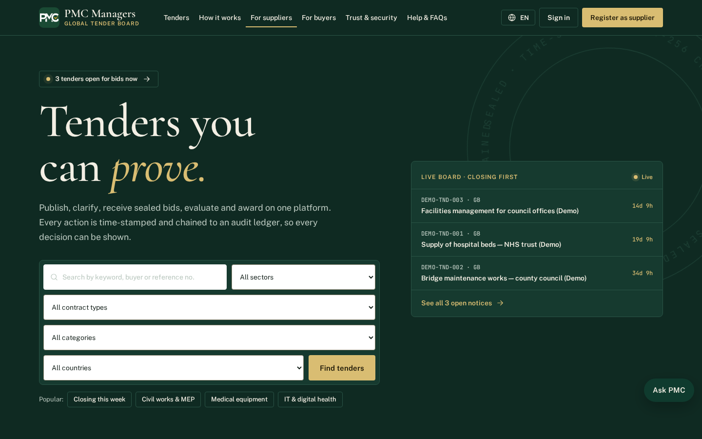
The public front door of PMC Managers. Visitors see what the platform does, the latest live tenders and the main ways in: Find tenders, Register as a supplier and Sign in.
Main actions
• Browse live tenders
• Register as a supplier
• Sign in to your portal

Public tender board
Screen: /tenders
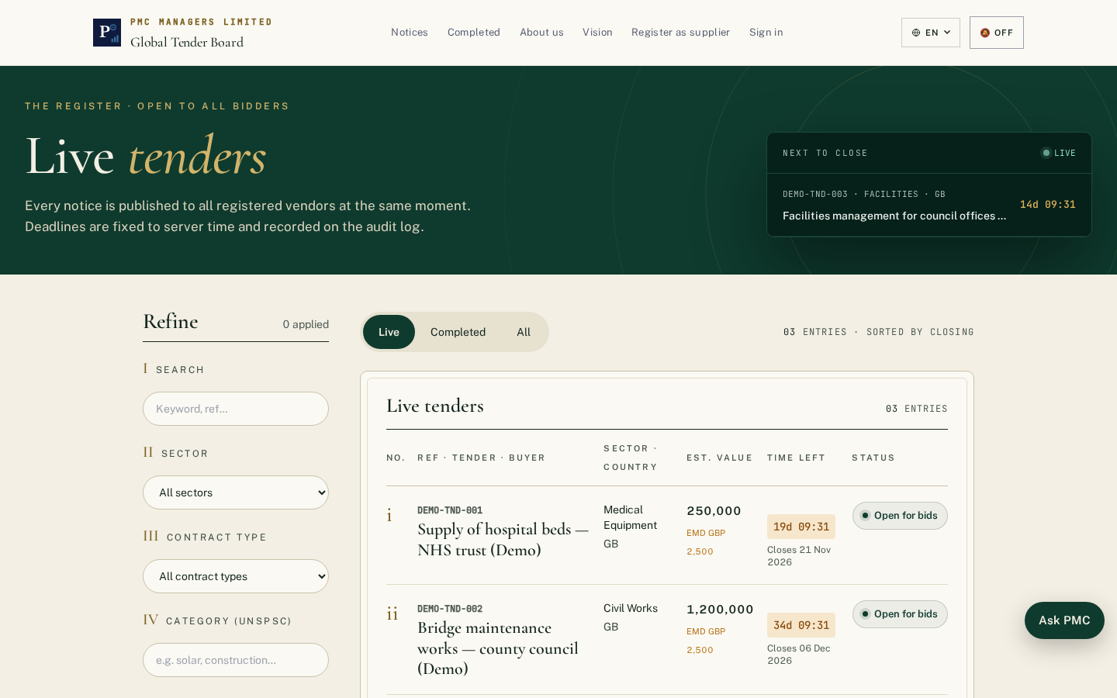
Every published tender with its reference, buyer, category, country and closing date. Anyone can search and filter; bidding needs a verified supplier account.
Main actions
• Search by keyword or reference
• Filter by category, country and closing date
• Open a tender to read the documents

Notice board
Screen: /notices
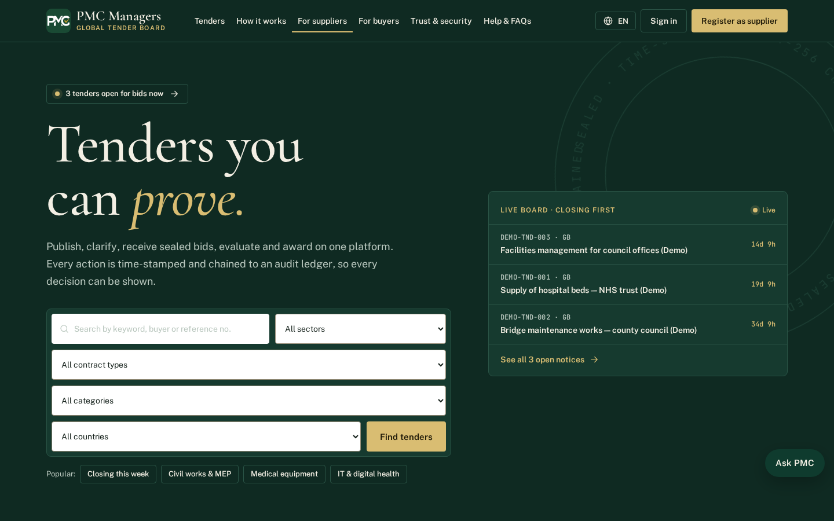
Published notices and corrigenda in date order, so suppliers can see changes to live tenders.
Main actions
• Read a notice
• See corrigenda issued against a tender

For suppliers
Screen: /suppliers
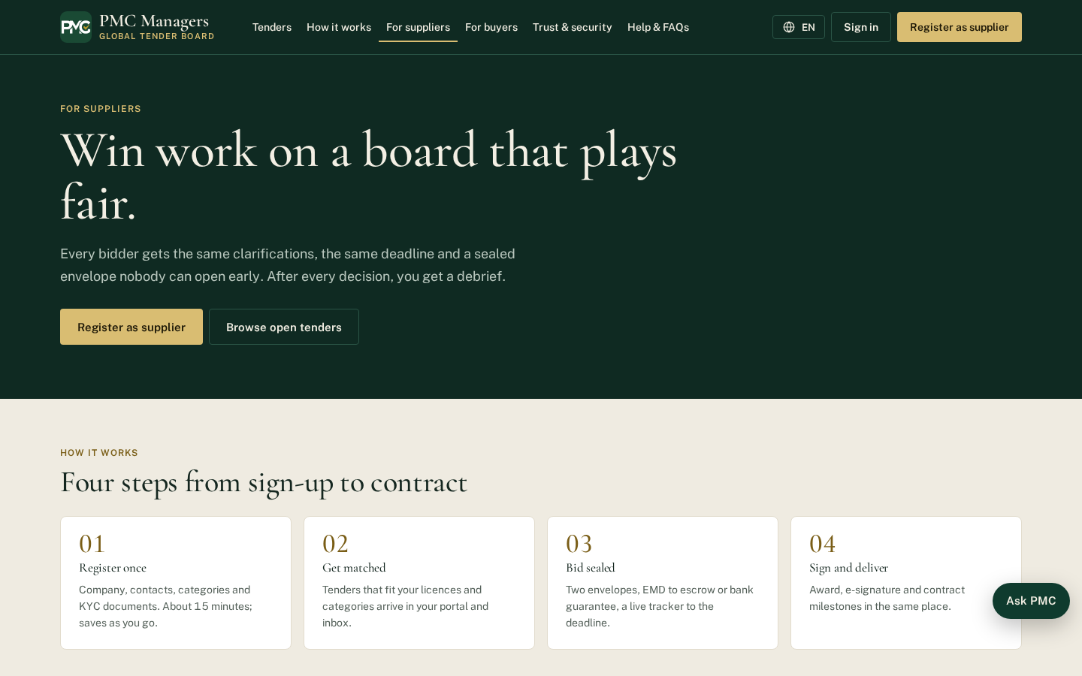
Explains how suppliers register, get verified, find tenders, bid with sealed envelopes and get paid through escrow.
Main actions
• Start supplier registration

For buyers
Screen: /buyers
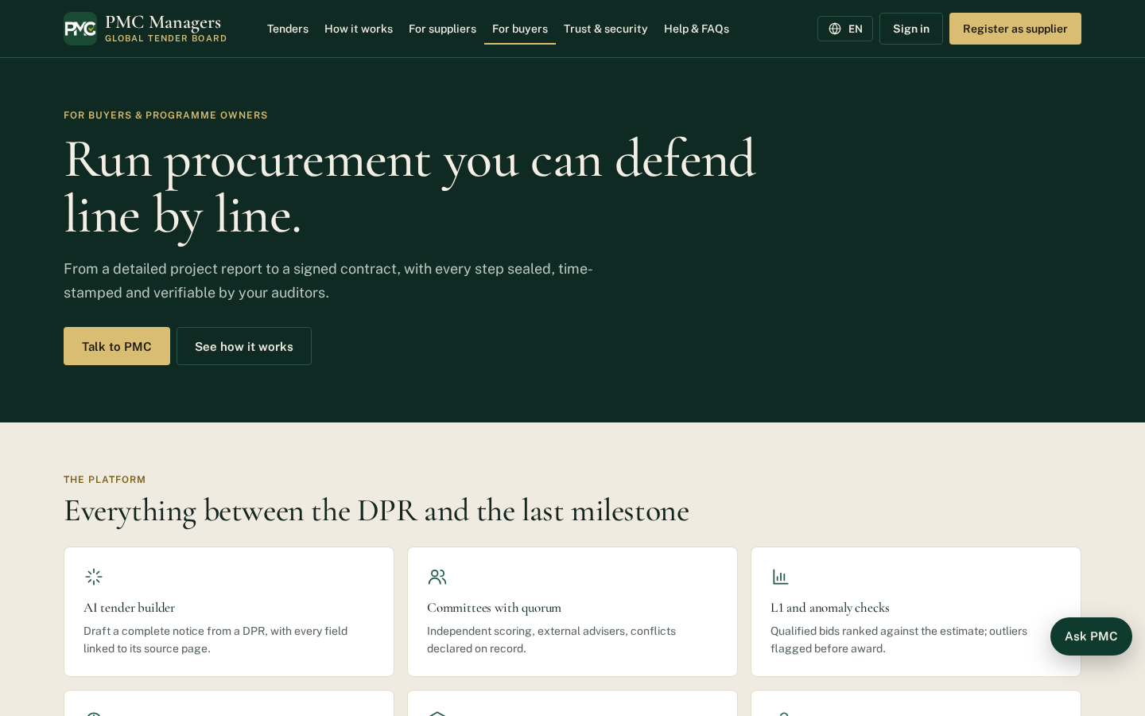
Explains how buyers publish tenders, set criteria, run sealed openings and award with a full audit trail.
Main actions
• Contact PMC to start buying

Sign in
Screen: /login
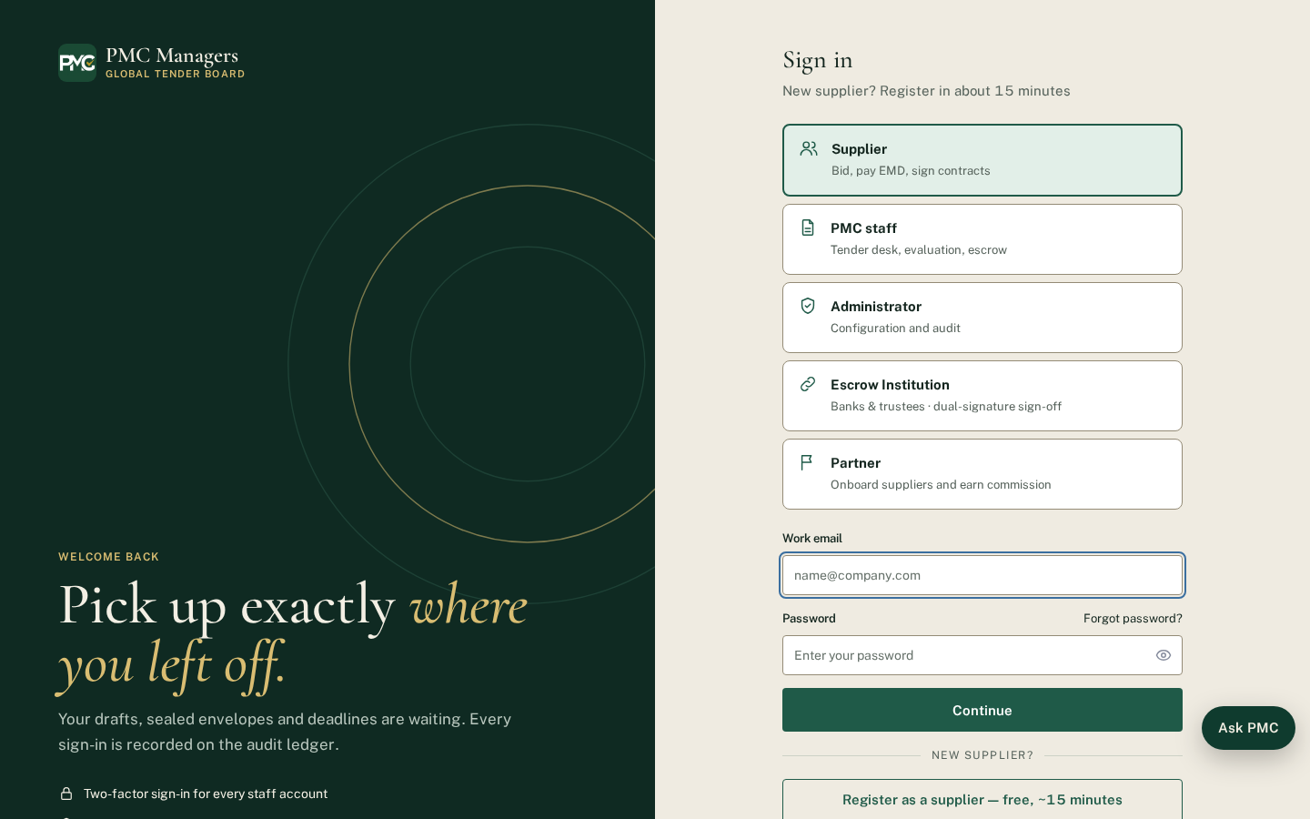
One sign-in page for every user. Choose your role first: Supplier, PMC staff, Admin, Escrow institution or Partner. Each role opens its own portal.
Main actions
• Choose your role
• Enter email and password
• Use Forgot password if needed

Supplier registration
Screen: /register
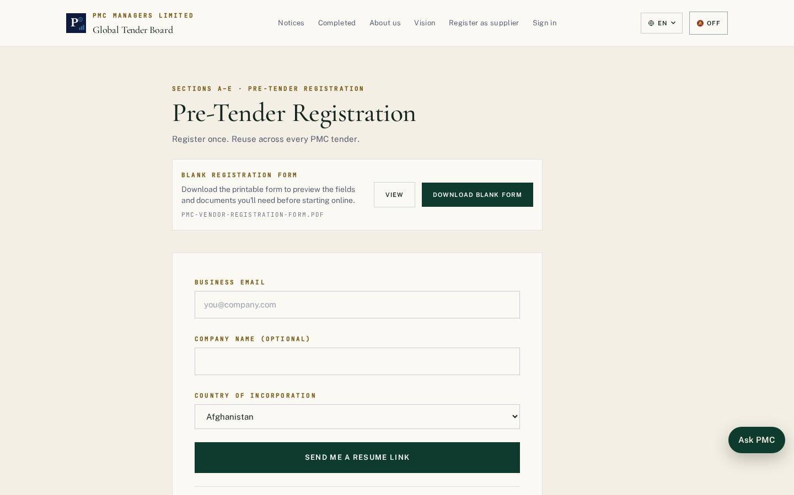
New suppliers create an account with company details. After email verification they complete KYC; PMC checks it before the supplier can bid.
Main actions
• Enter company and contact details
• Verify email
• Complete KYC in the supplier portal

Global tenders
Screen: /tenders/global
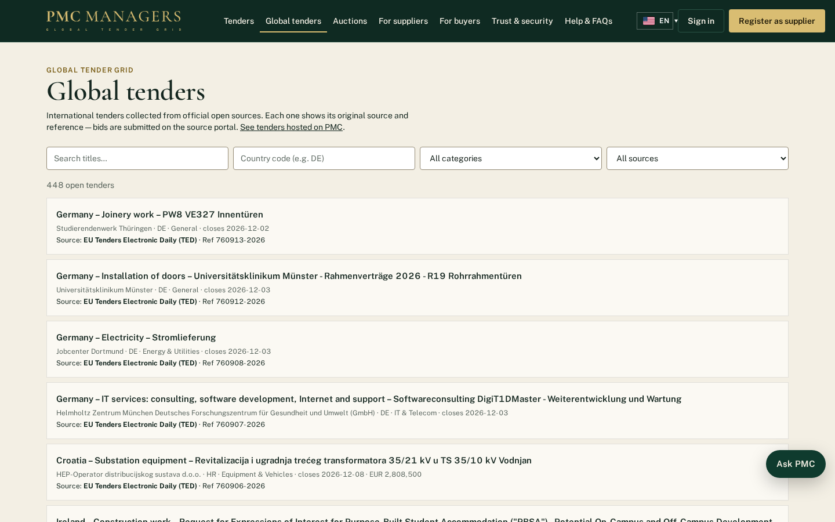
Tenders collected from official public sources (World Bank, EU TED) and licensed providers, with the original source and reference shown on each one.
Main actions
• Search by keyword, country or value
• Open the original source

Supplier directory
Screen: /suppliers/directory
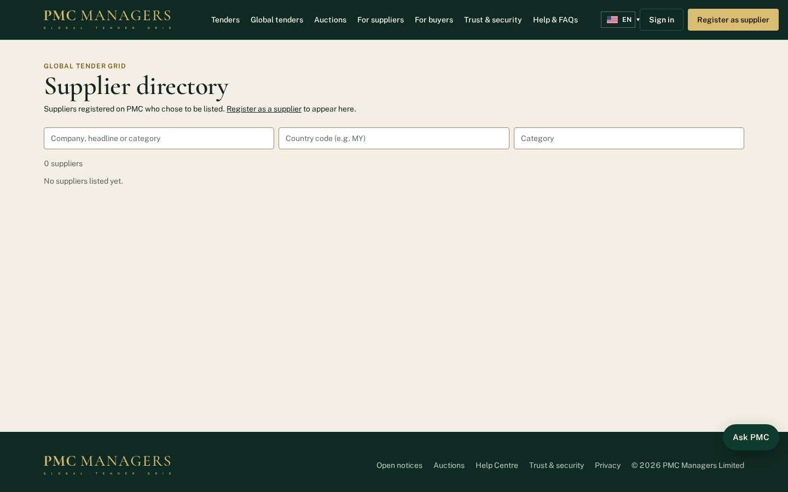
Public list of suppliers who chose to be listed. Featured suppliers appear first.
Main actions
• Search suppliers by category or country
• Open a supplier profile

Consultancy services
Screen: /consultancy
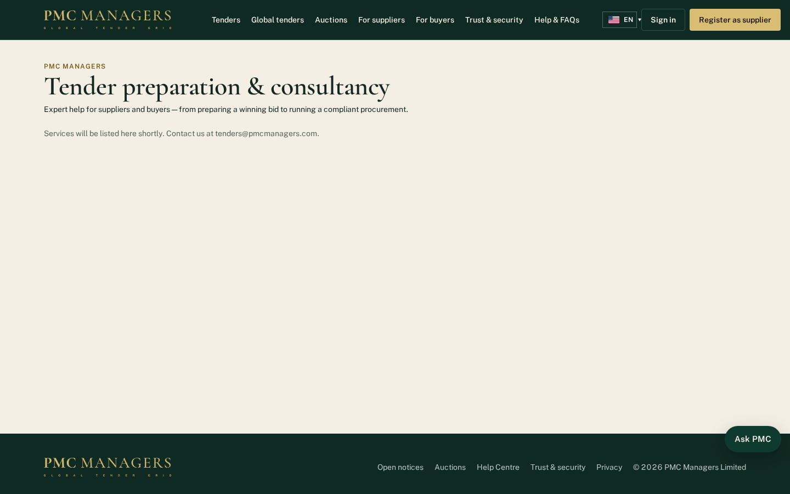
Tender preparation and consultancy services sold by PMC Managers.
Main actions
• Read the services
• Send a request

Buyer application
Screen: /buyers/apply
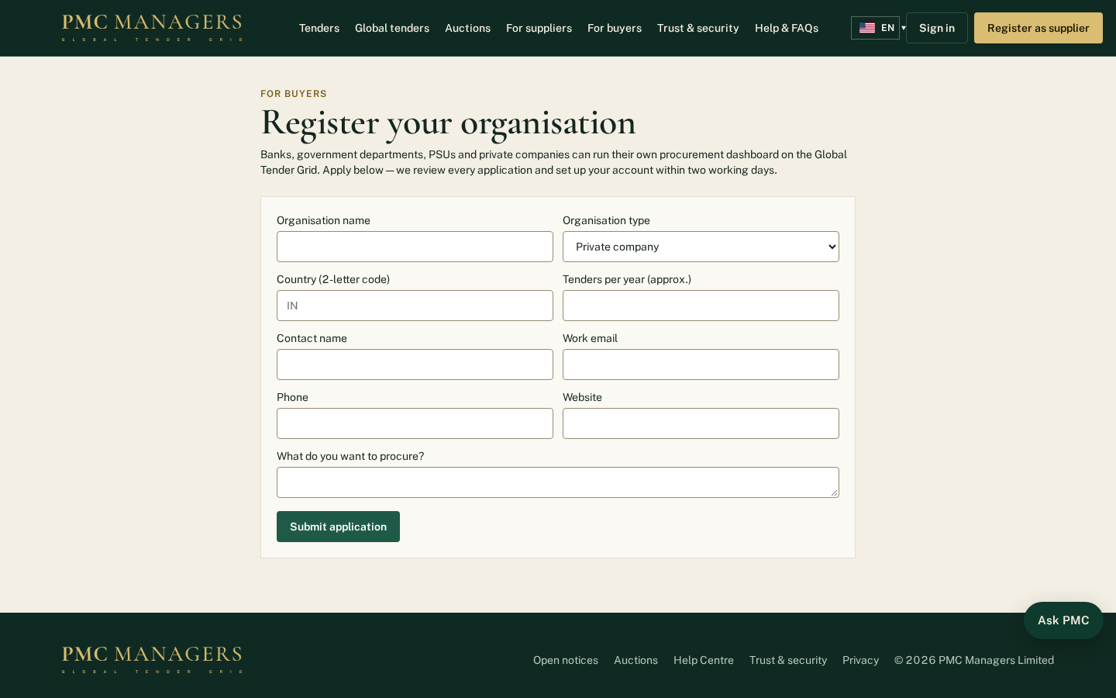
Banks, government departments, PSUs and companies apply to publish their own tenders.
Main actions
• Fill in the organisation details
• Submit the application for PMC approval

Language pages
Screen: /fr
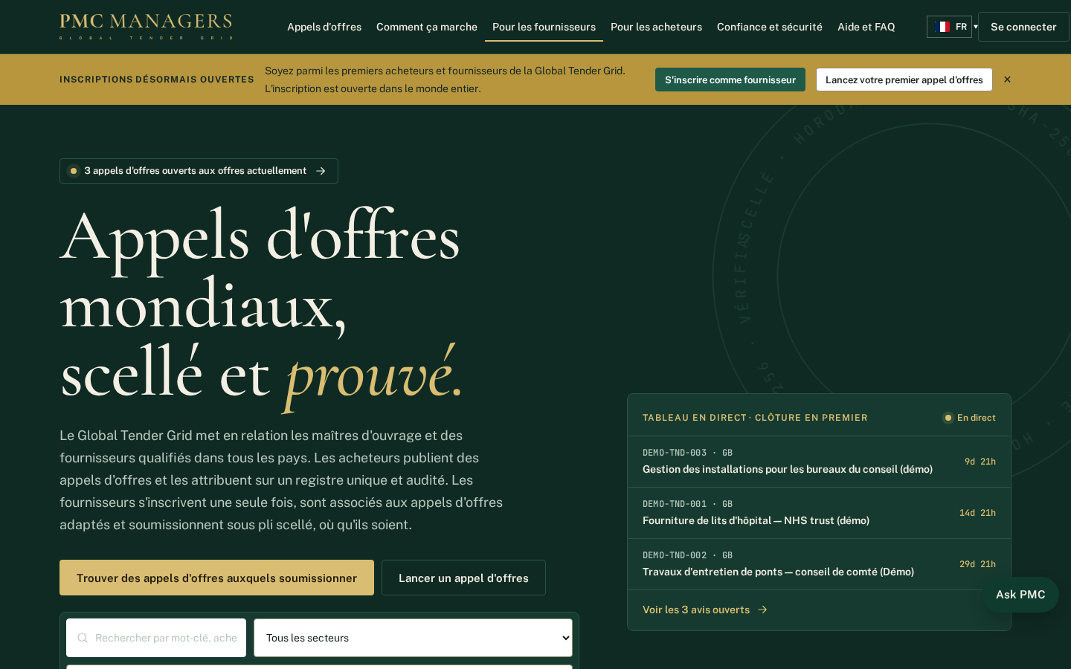
Every public page has its own address in each of the 14 languages, for example /fr for French. The flag button changes the language on any page.
Main actions
• Pick a language from the flag button
• Share a link in that language

Marketplace
Screen: /market
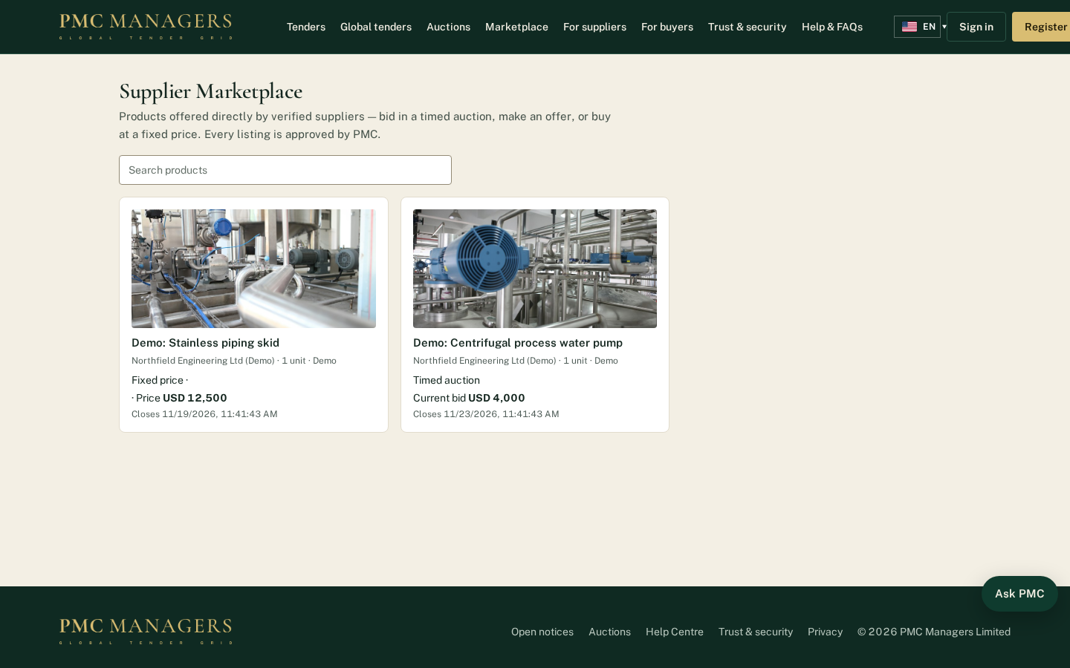
Products offered directly by approved suppliers and checked by PMC, sold by timed auction, best offer or fixed price. Verified buyers bid, offer or buy; each product shows its photos and spec sheets.
Main actions
• Search and open a product
• Bid, make an offer or buy now
• Pay from My bids & purchases

3 · Supplier portal — screen tour

Supplier dashboard
Screen: /vendor
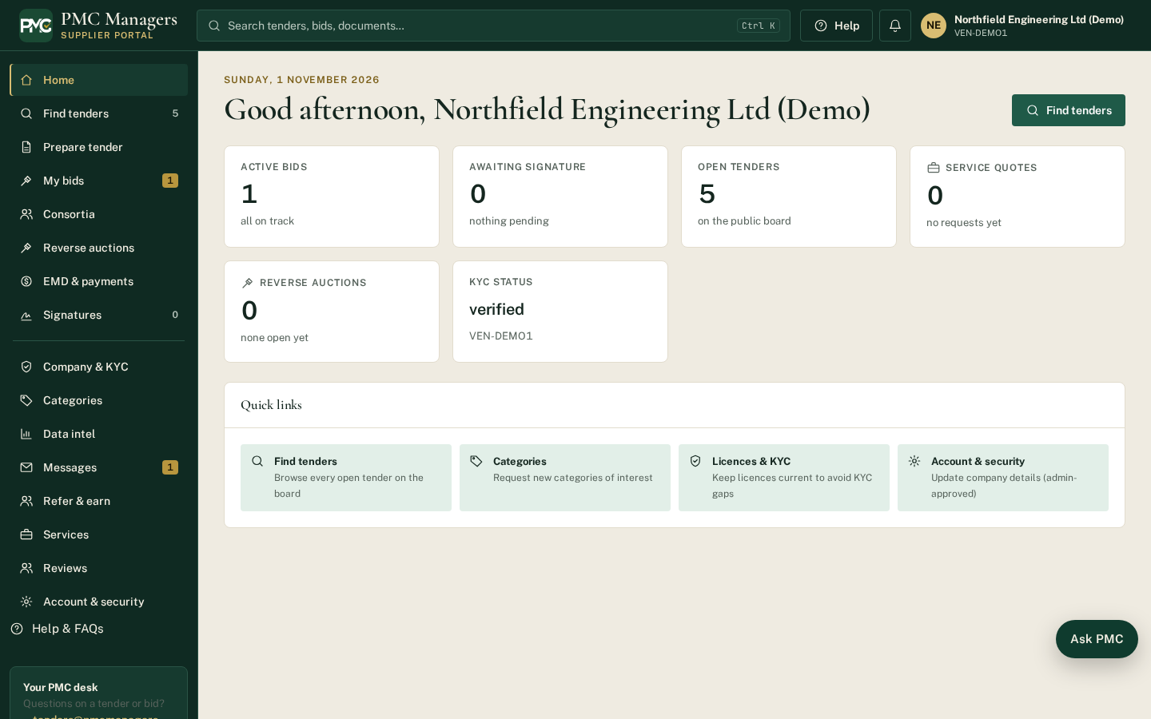
The supplier's home: matching tenders, open bids, notices and messages.
Main actions
• Find tenders
• Continue a bid

Tenders for you
Screen: /vendor/tenders
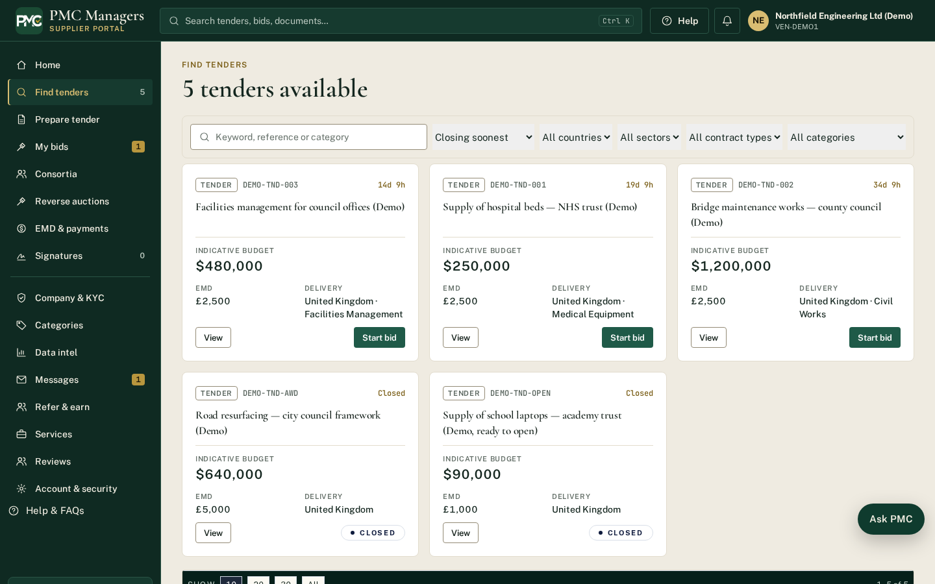
Tenders matching the supplier's categories, with closing dates.
Main actions
• Open a tender
• Start a bid

Prepare a bid
Screen: /vendor/bid/new/DEMO-TND-001
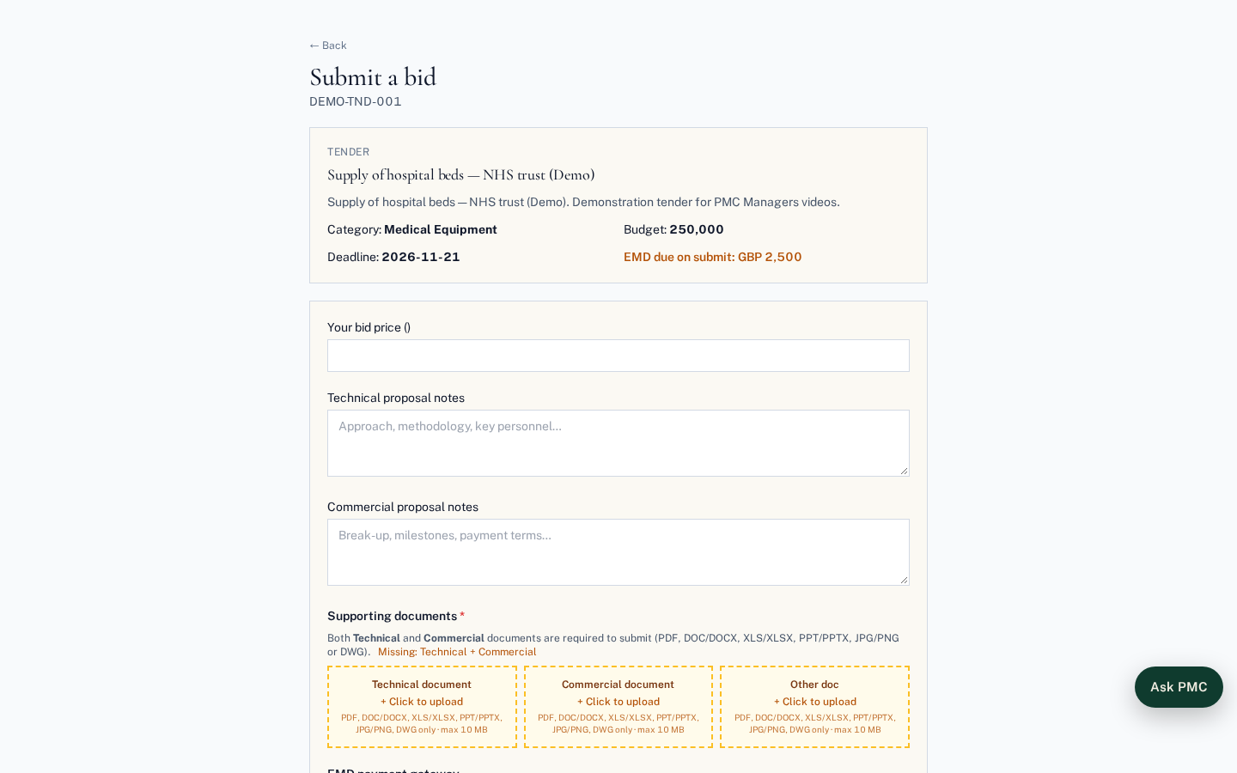
The bid form: technical documents, the Criteria section (each item marked Mandatory or Optional, with the rule for optional criteria), proofs, price and EMD. Everything is sealed when submitted.
Main actions
• Answer every mandatory criterion and attach proofs
• Enter price
• Submit (sealed)

My bids
Screen: /vendor/mybids
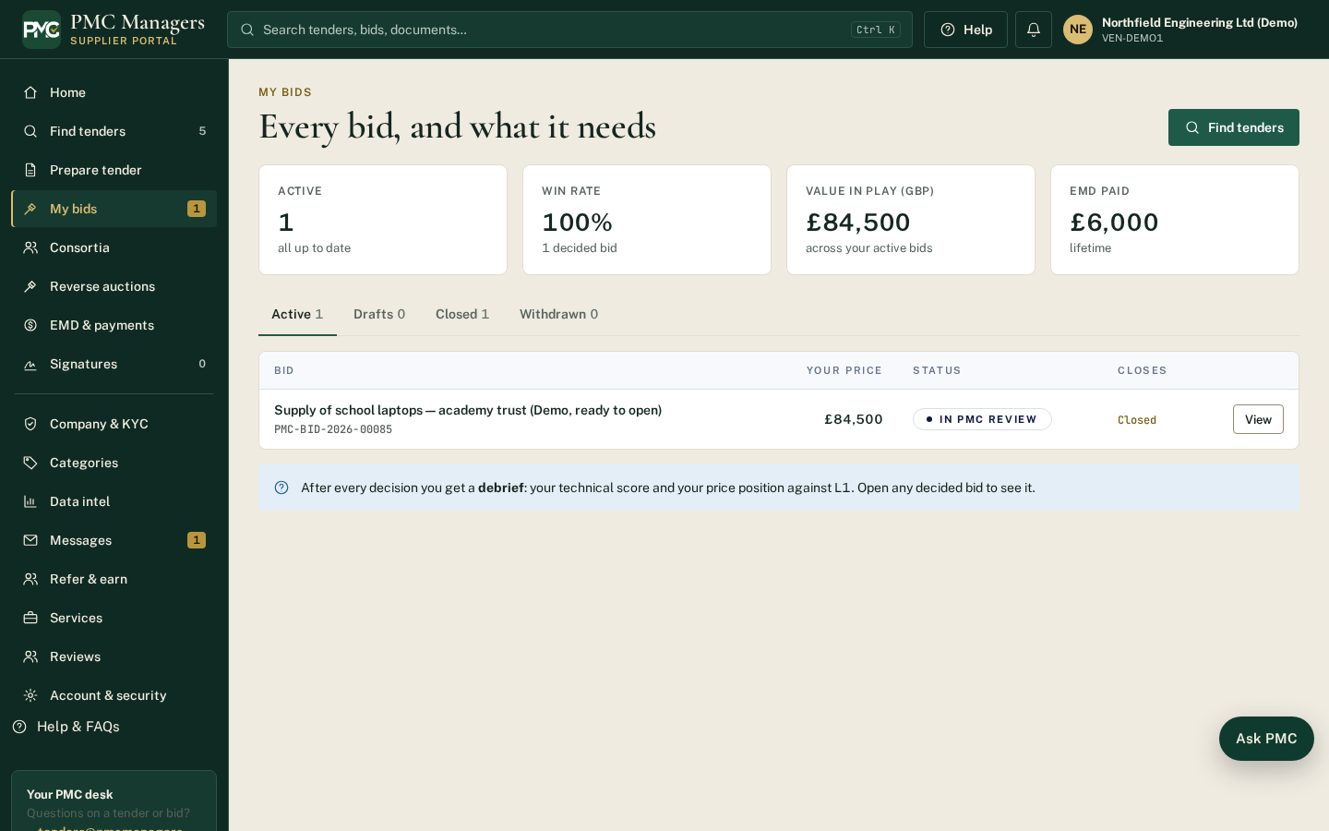
All of the supplier's bids with status, criteria result notices and award documents.
Main actions
• Open a bid workspace
• Read your result notice

Consortia
Screen: /vendor/consortia
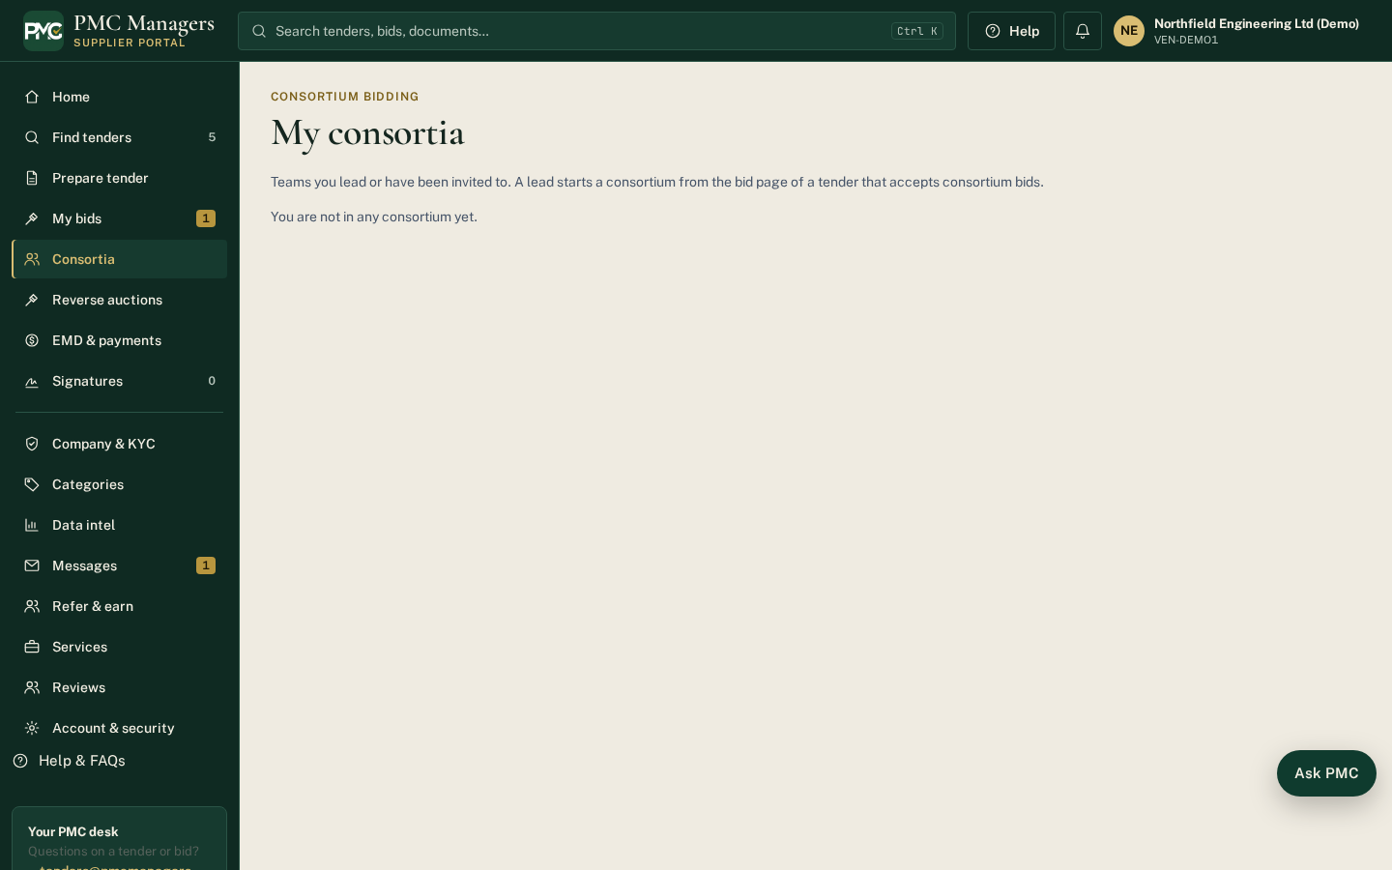
Consortium invitations, teams, shares, agreement signatures and member payouts.
Main actions
• Accept / decline an invitation
• Sign the agreement
• See your payout and bank reference

EMD & payments
Screen: /vendor/emd
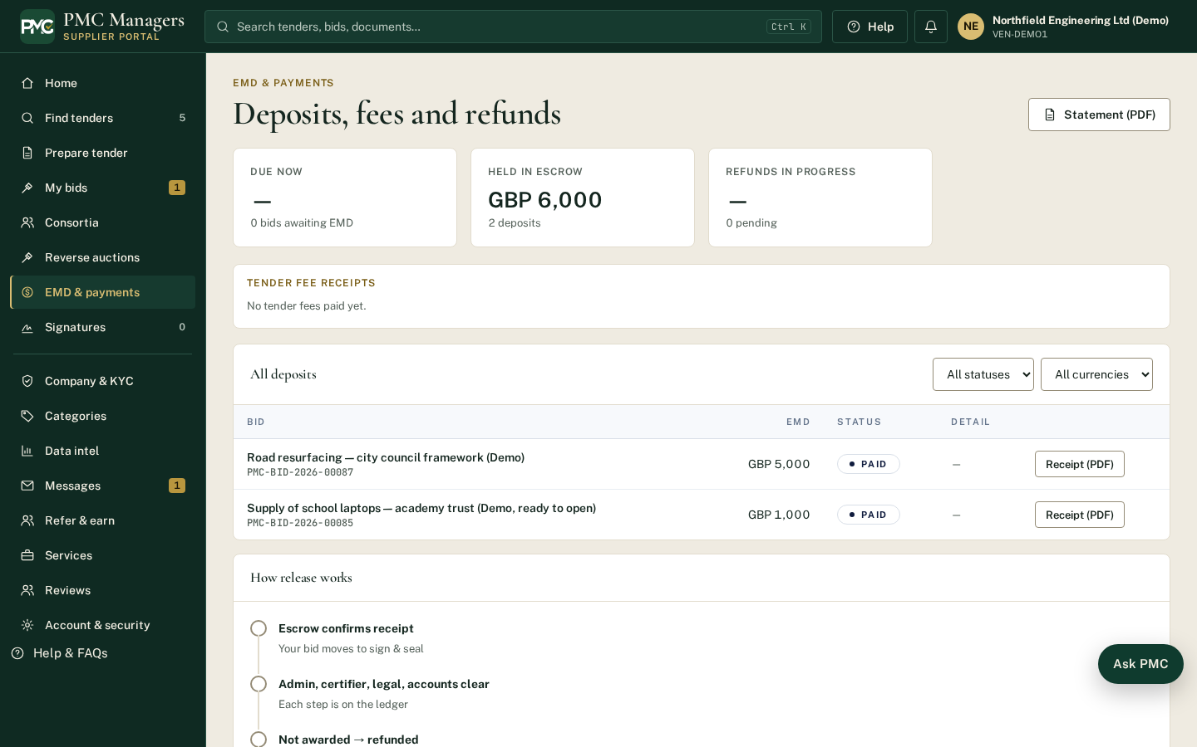
Bid deposits paid into escrow and refunds.
Main actions
• Pay EMD
• Track refunds

Company profile & KYC
Screen: /vendor/company
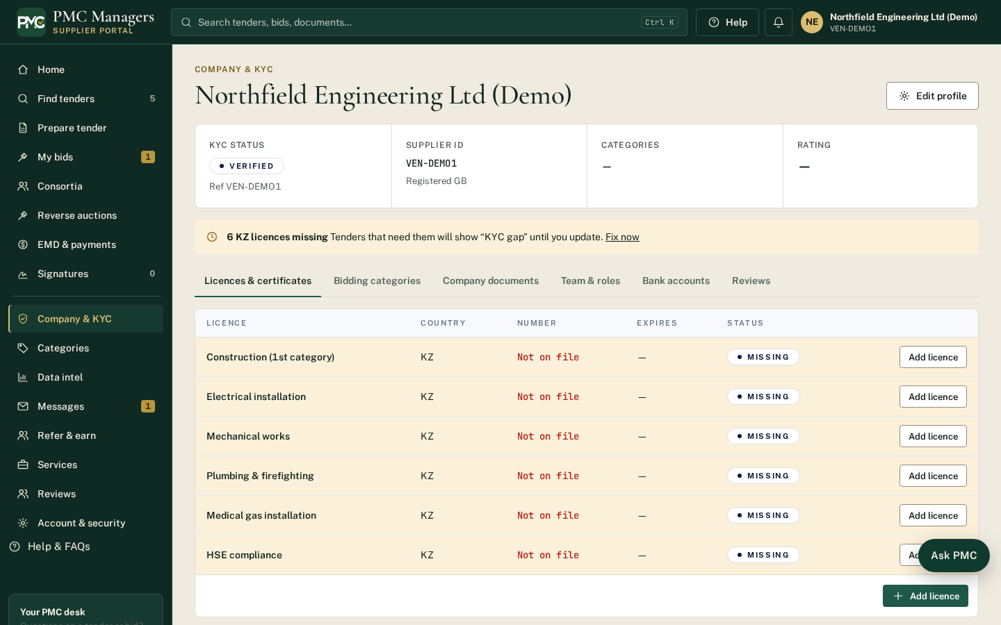
Company details, documents and KYC. Some figures here (like turnover) pre-fill criteria answers.
Main actions
• Update details (changes are reviewed)
• Upload KYC documents

Prepare tender (supplier)
Screen: /vendor/tender-builder
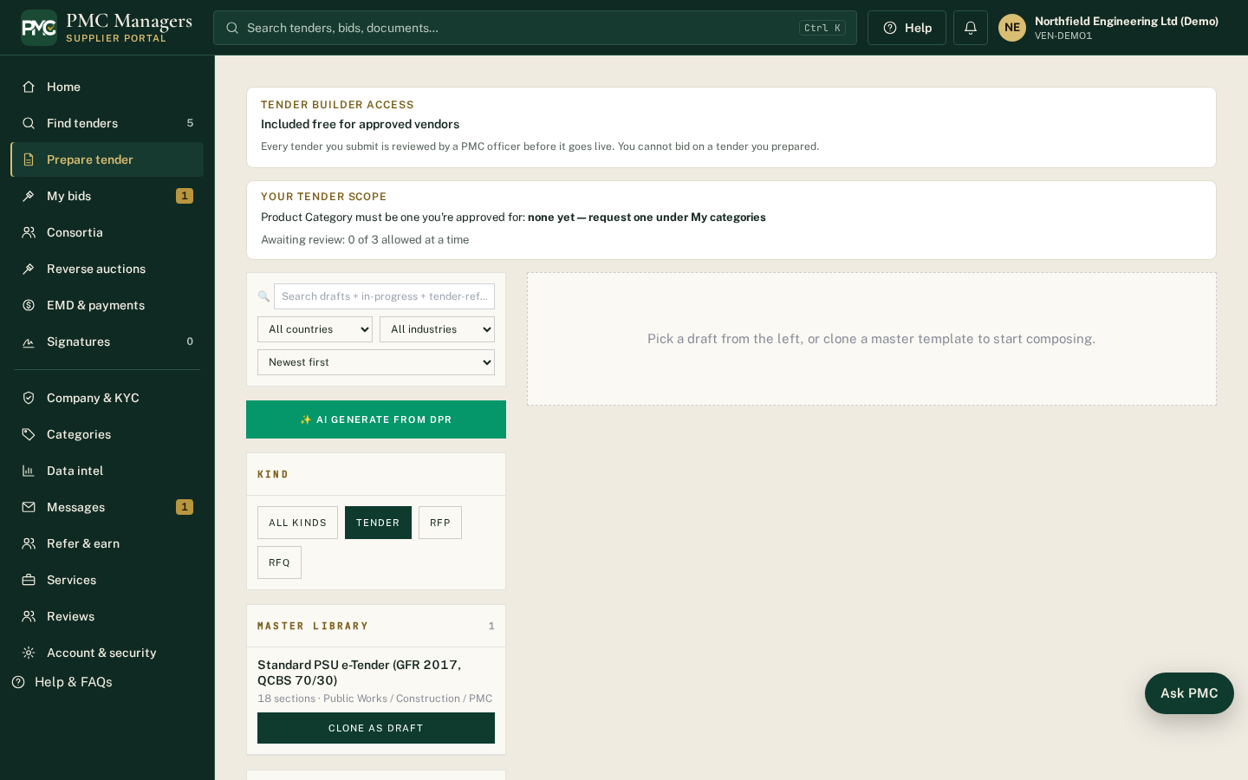
Verified suppliers can prepare tenders for buyers; they go to PMC review before publishing.
Main actions
• Build a tender
• Set criteria
• Submit for review

Alerts
Screen: /vendor/alerts
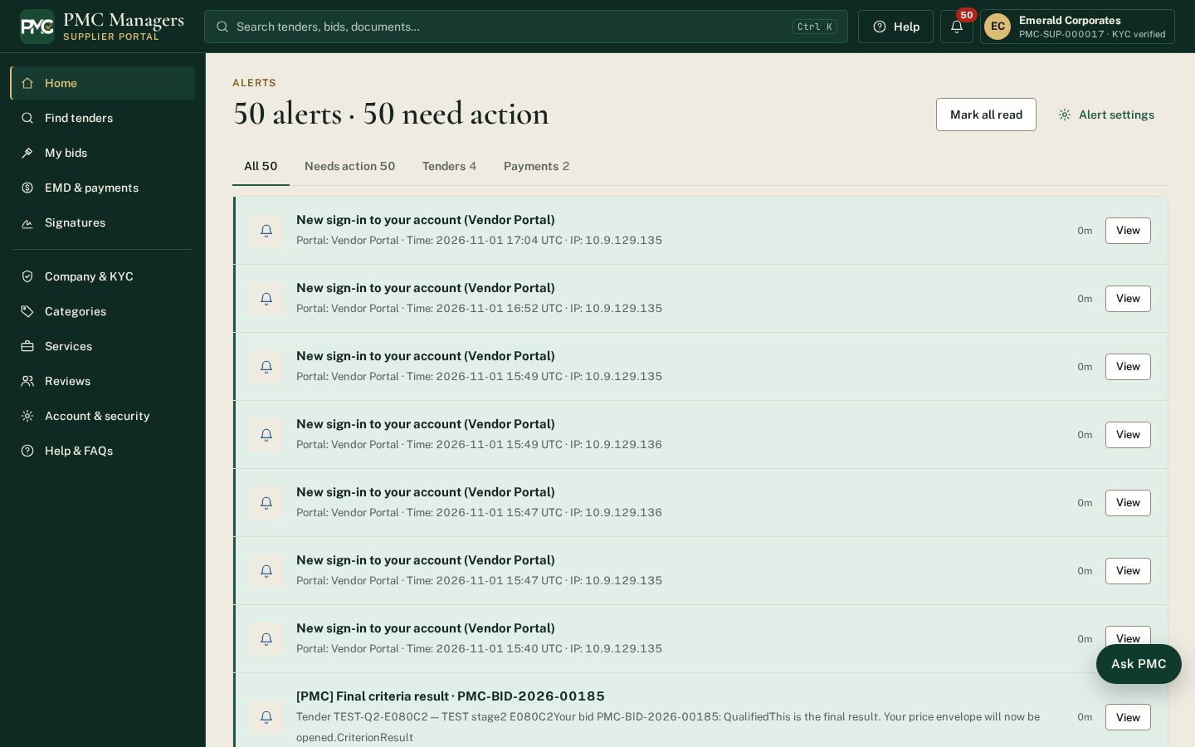
Tender alerts and notifications for the supplier's categories.
Main actions
• Mark as read
• Open the tender

Messages
Screen: /vendor/messages
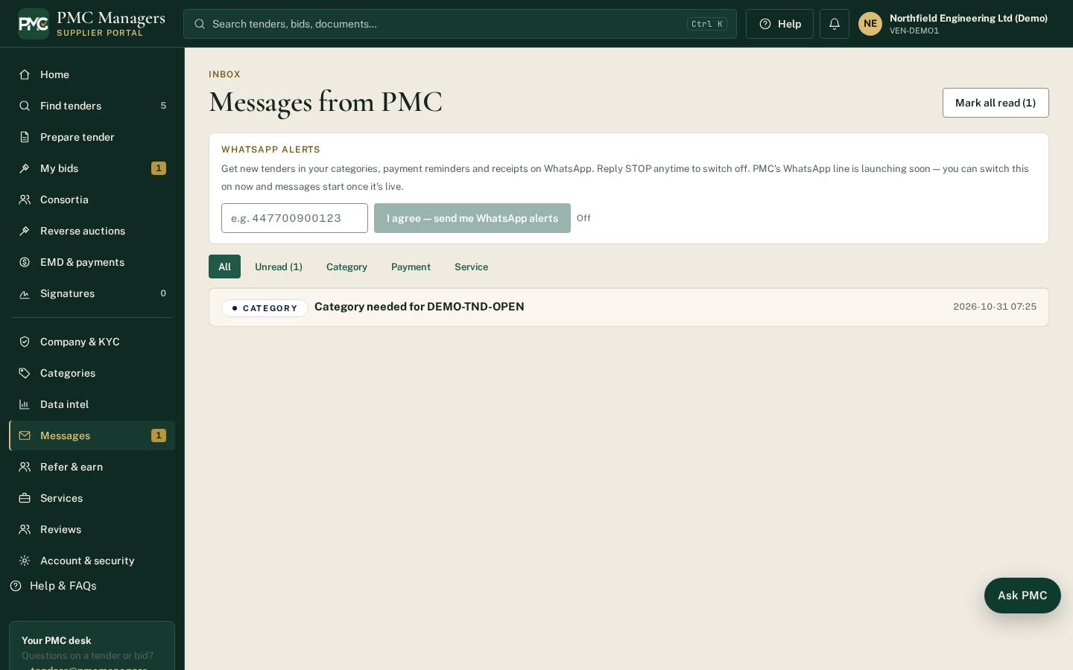
Messages with PMC and buyers, including clarifications.
Main actions
• Reply to a message

Signatures
Screen: /vendor/signatures
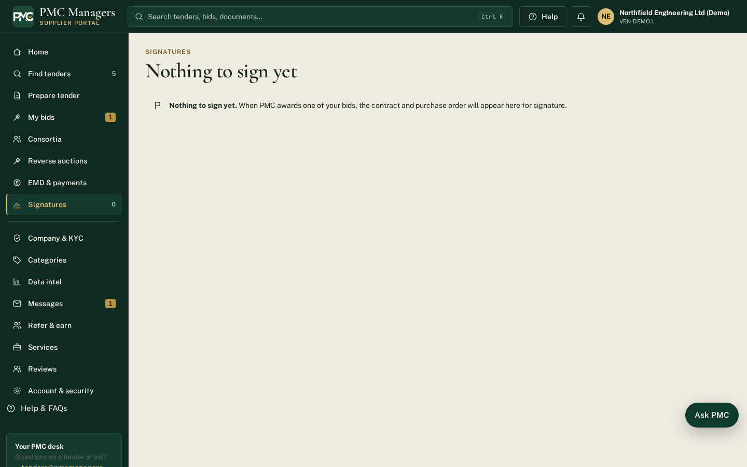
Documents waiting for the supplier's e-signature (agreements, contracts).
Main actions
• Sign a document

Reverse auctions
Screen: /vendor/auctions
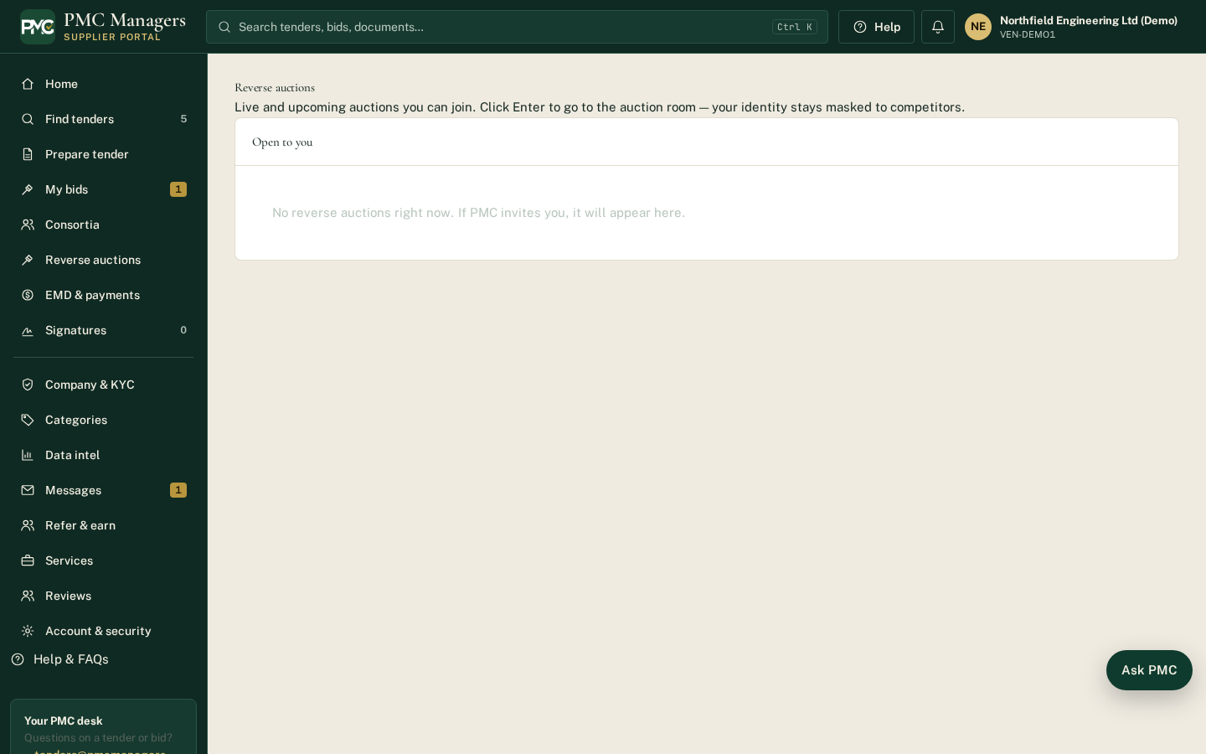
Auctions the supplier is invited to, with live bidding.
Main actions
• Join an auction
• Place a lower bid

Categories
Screen: /vendor/categories
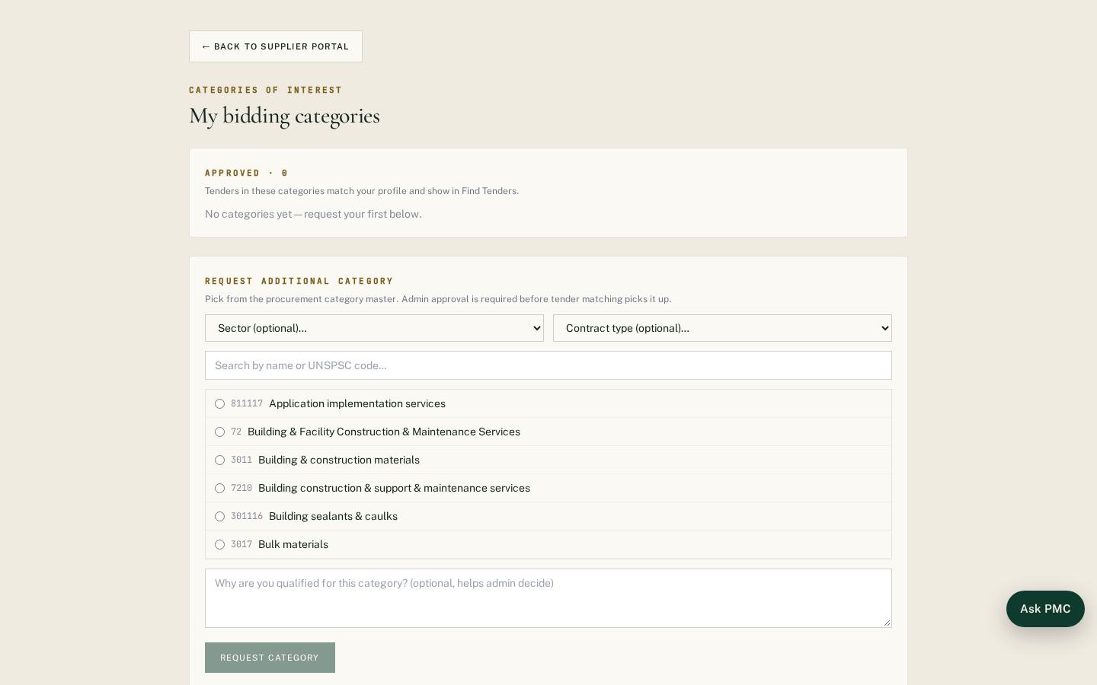
The categories the supplier works in; drives tender matching and alerts.
Main actions
• Request a new category

Account & security
Screen: /vendor/account
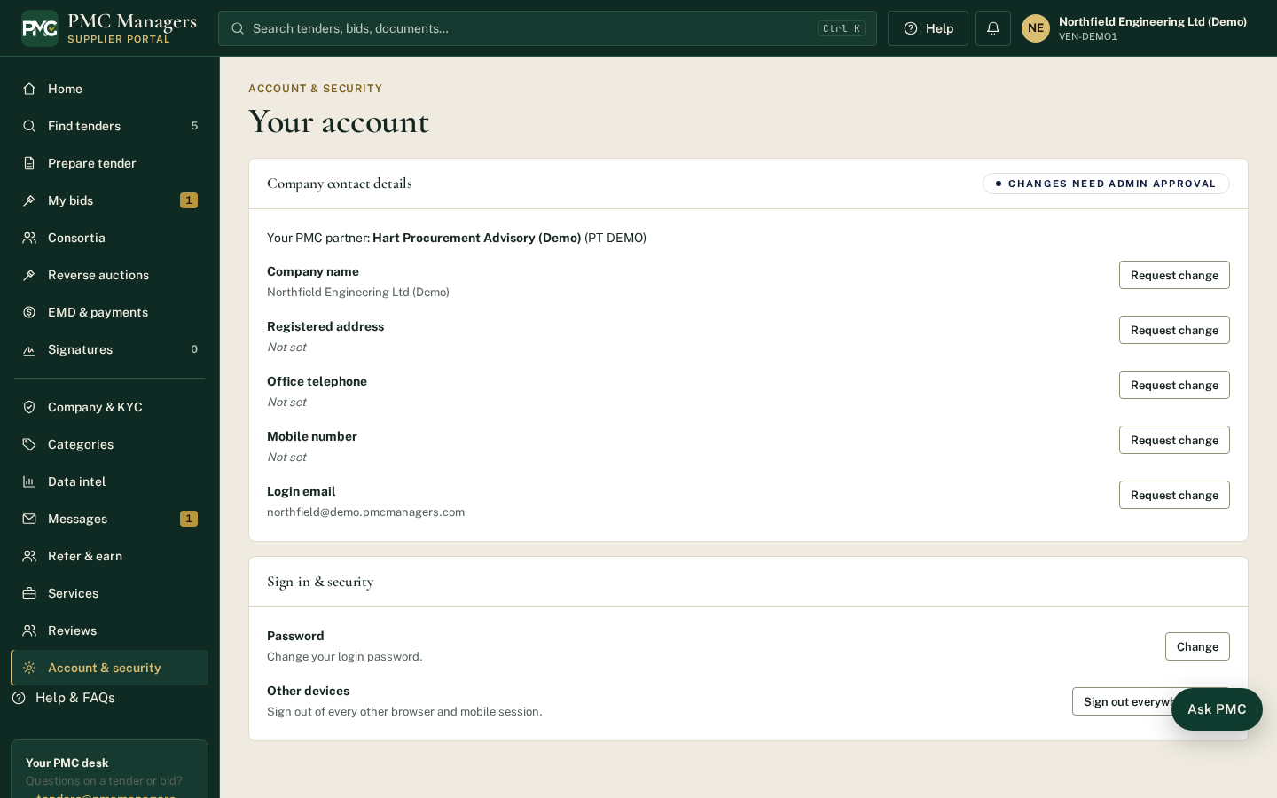
Login email, password, phone and security settings.
Main actions
• Change password
• Update contact details

Sell products
Screen: /vendor/market
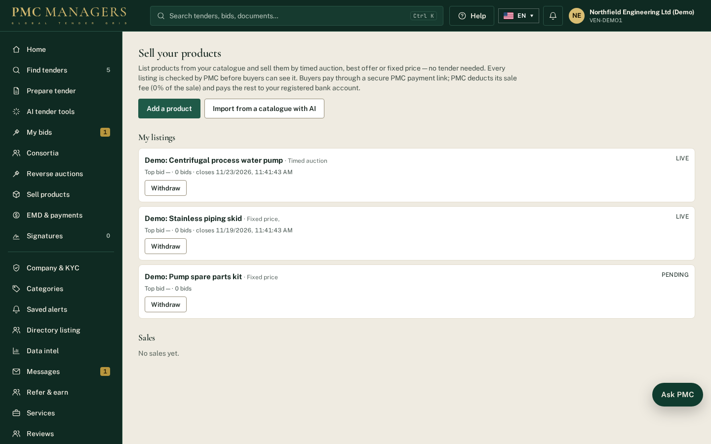
Suppliers add products with photos and PDF spec sheets, choose how to sell each one and submit it for PMC approval.
Main actions
• Add a product
• Upload photos and spec sheets
• Submit for approval

Import from a catalogue with AI
Screen: /vendor/market
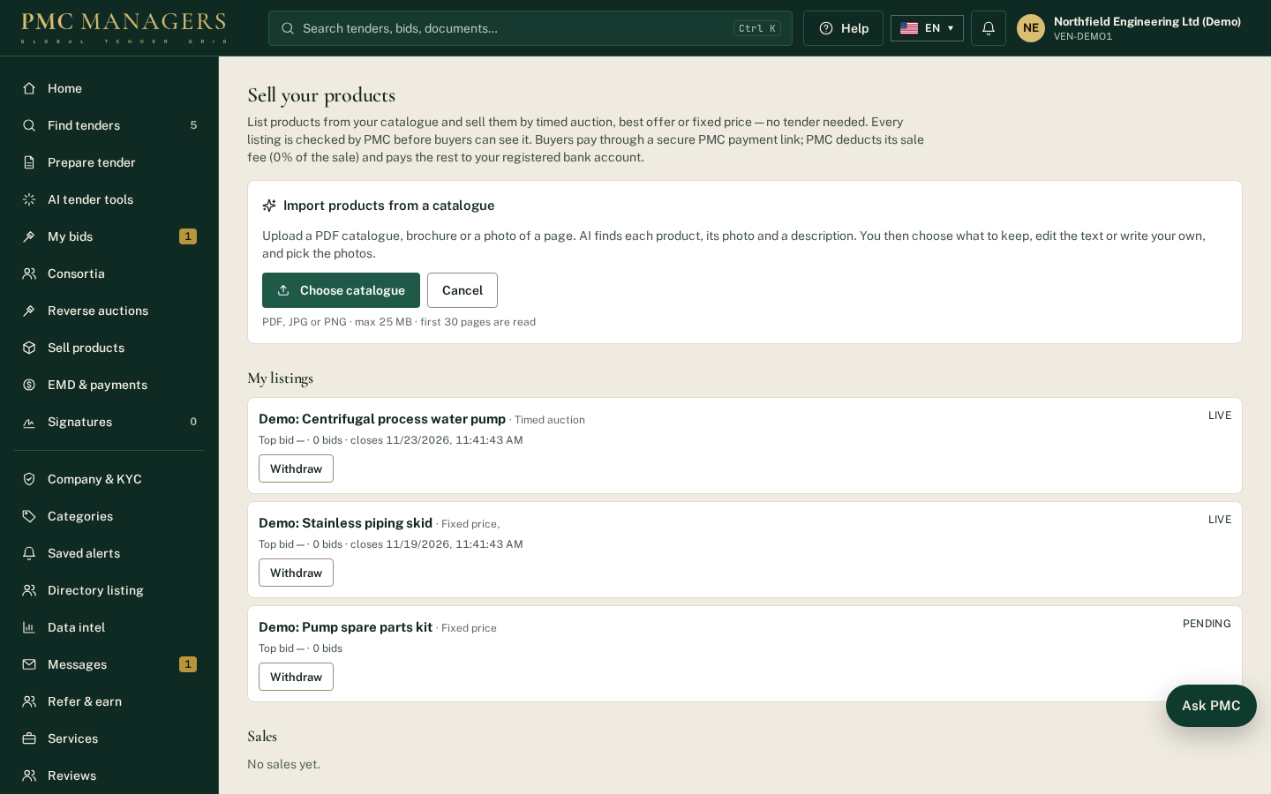
Upload a PDF catalogue, brochure or photo of a page. AI lists each product with its photo, description and specifications; the supplier picks what to keep, edits or writes the text and chooses the photos.
Main actions
• Choose catalogue
• Keep or untick products
• Create draft listings

Sell products — sales & delivery
Screen: /vendor/market
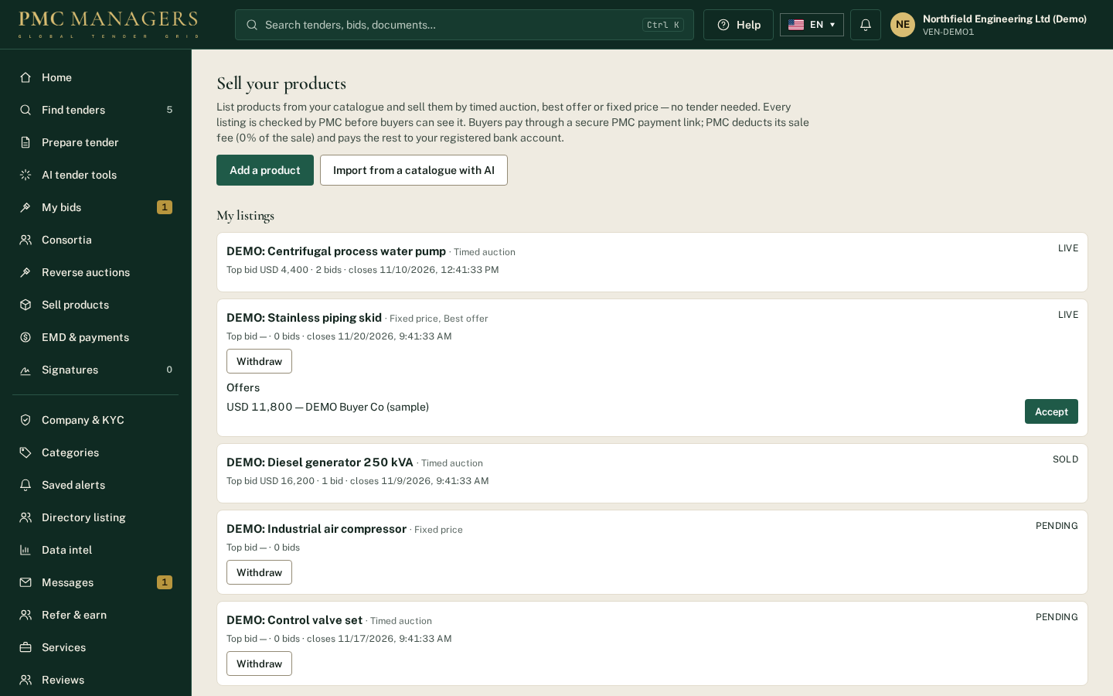
Sold items show the buyer, amount, PMC fee, your net amount, payment and payout status. For paid orders mark Dispatched and Delivered (with a tracking note); the buyer is notified.
Main actions
• Mark dispatched
• Mark delivered

4 · Buyer portal — screen tour

Sign in as a buyer
Screen: /login?role=buyer
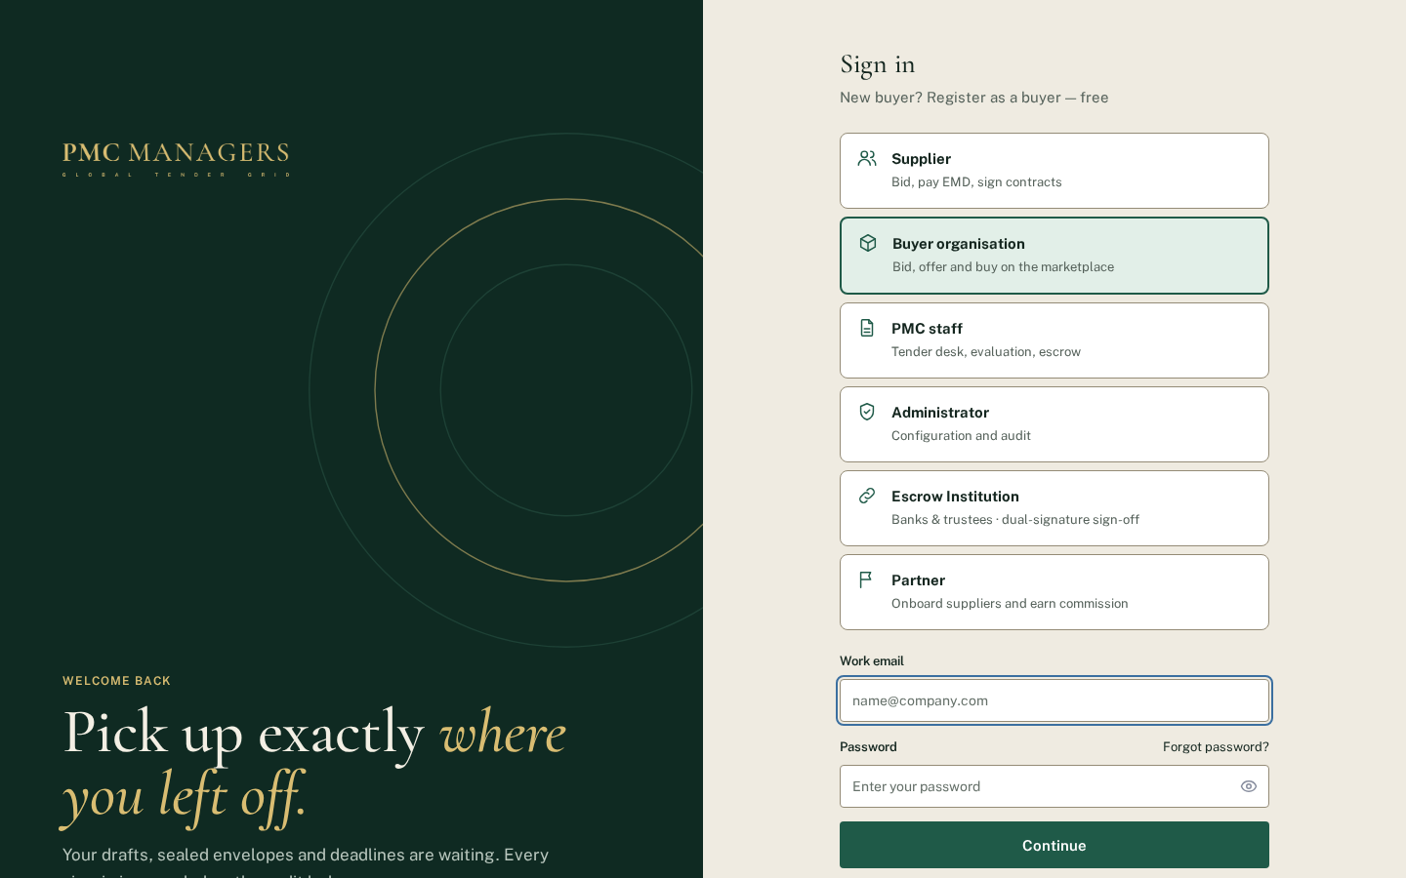
Buyers sign in with the Buyer organisation card. New buyers use 'Register as a buyer — free'. Forgot password also has a Buyer option.
Main actions
• Sign in
• Register as a buyer — free
• Forgot password

Register as a buyer — free
Screen: /buyers/register
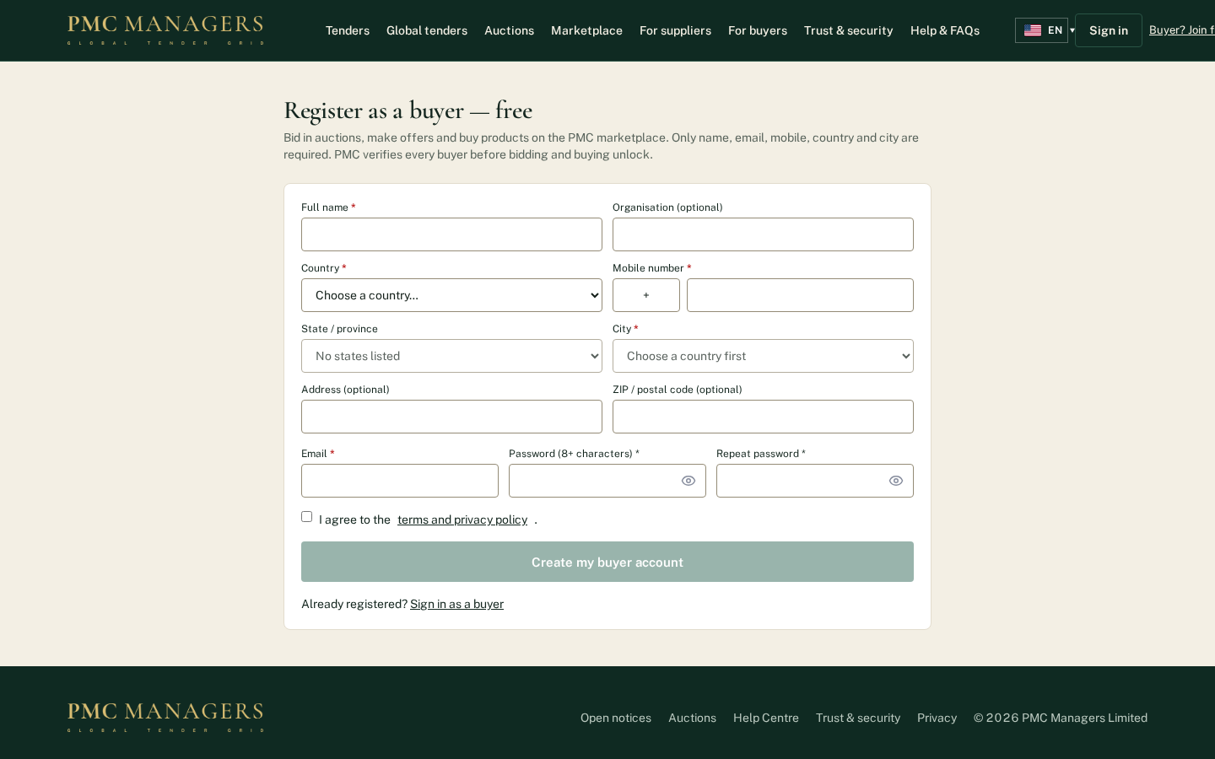
Name, email, mobile, country and city are required; state, address, ZIP and organisation are optional. Country, state, city and phone code come from the PMC masters. The buyer confirms their email, then PMC verifies the account before bidding and buying unlock.
Main actions
• Fill the required fields
• Create my buyer account
• Confirm the email link

Buyer dashboard
Screen: /buyer
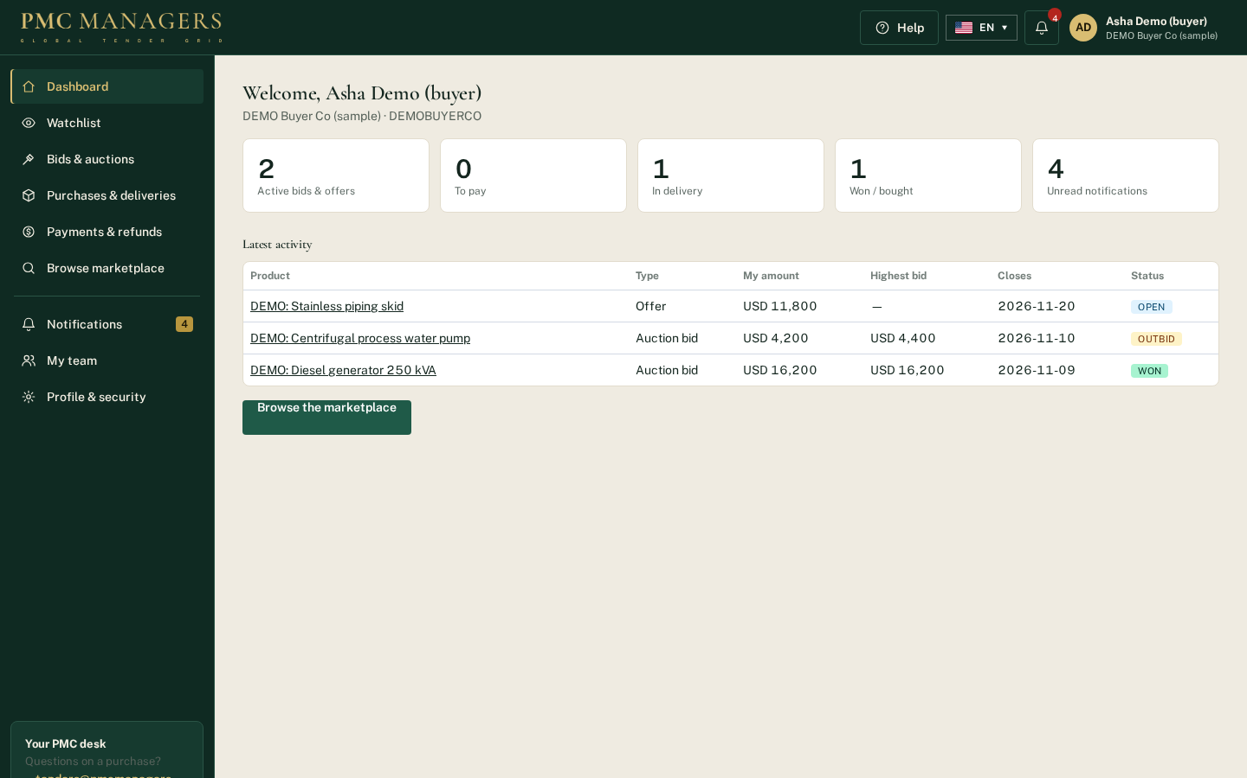
Left sidebar, top header with notification bell and avatar menu, and footer. Tiles show active bids and offers, orders to pay, orders in delivery, wins and unread notifications.
Main actions
• Open a tile
• Browse the marketplace
• Open the avatar menu

Avatar menu
Screen: /buyer
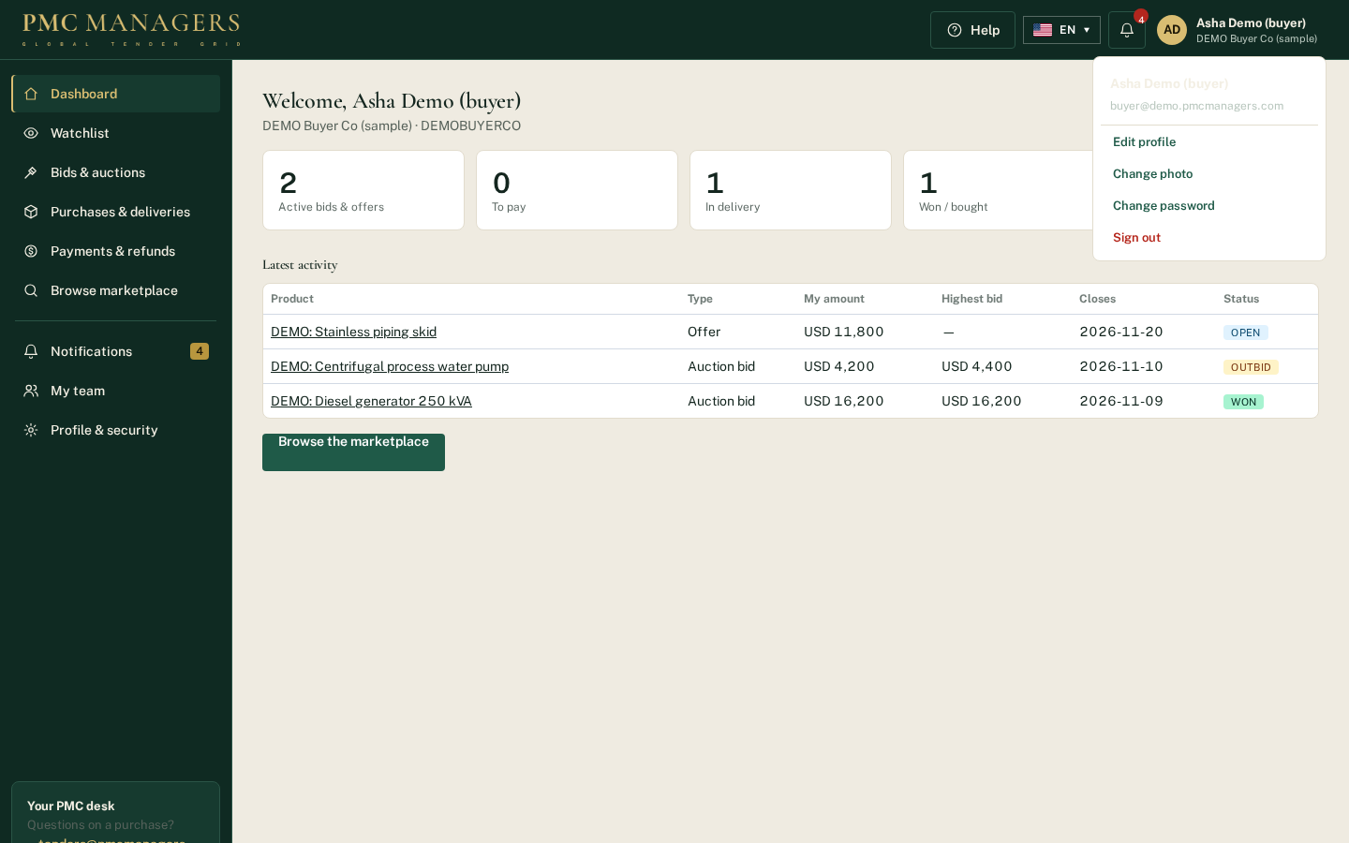
Edit profile, change the profile photo, change password and sign out.
Main actions
• Edit profile
• Change photo
• Change password
• Sign out

Watchlist
Screen: /buyer/watchlist
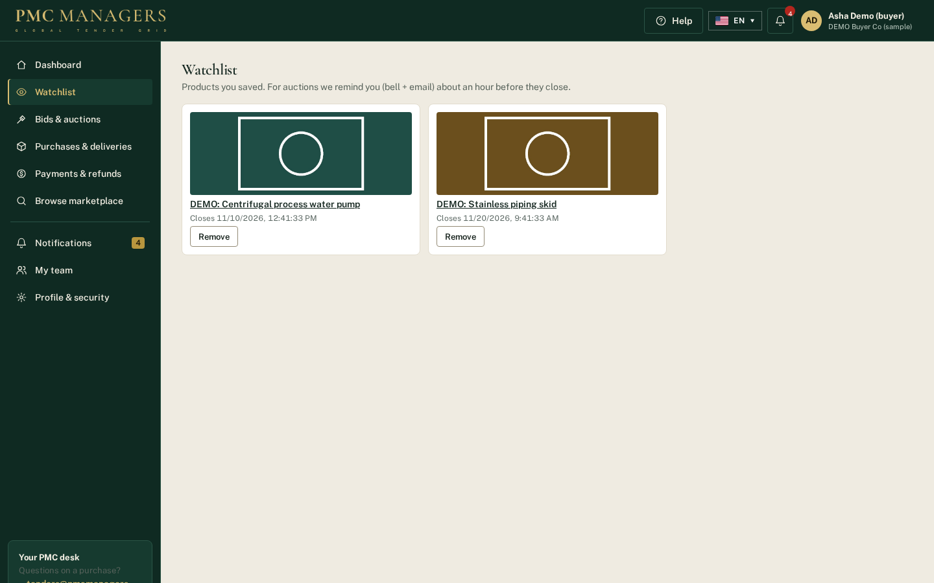
Products the buyer saved with the ♡ Save button. For auctions a reminder (bell + email) is sent about an hour before closing.
Main actions
• Open a product
• Remove from watchlist

Bids & auctions
Screen: /buyer/bids
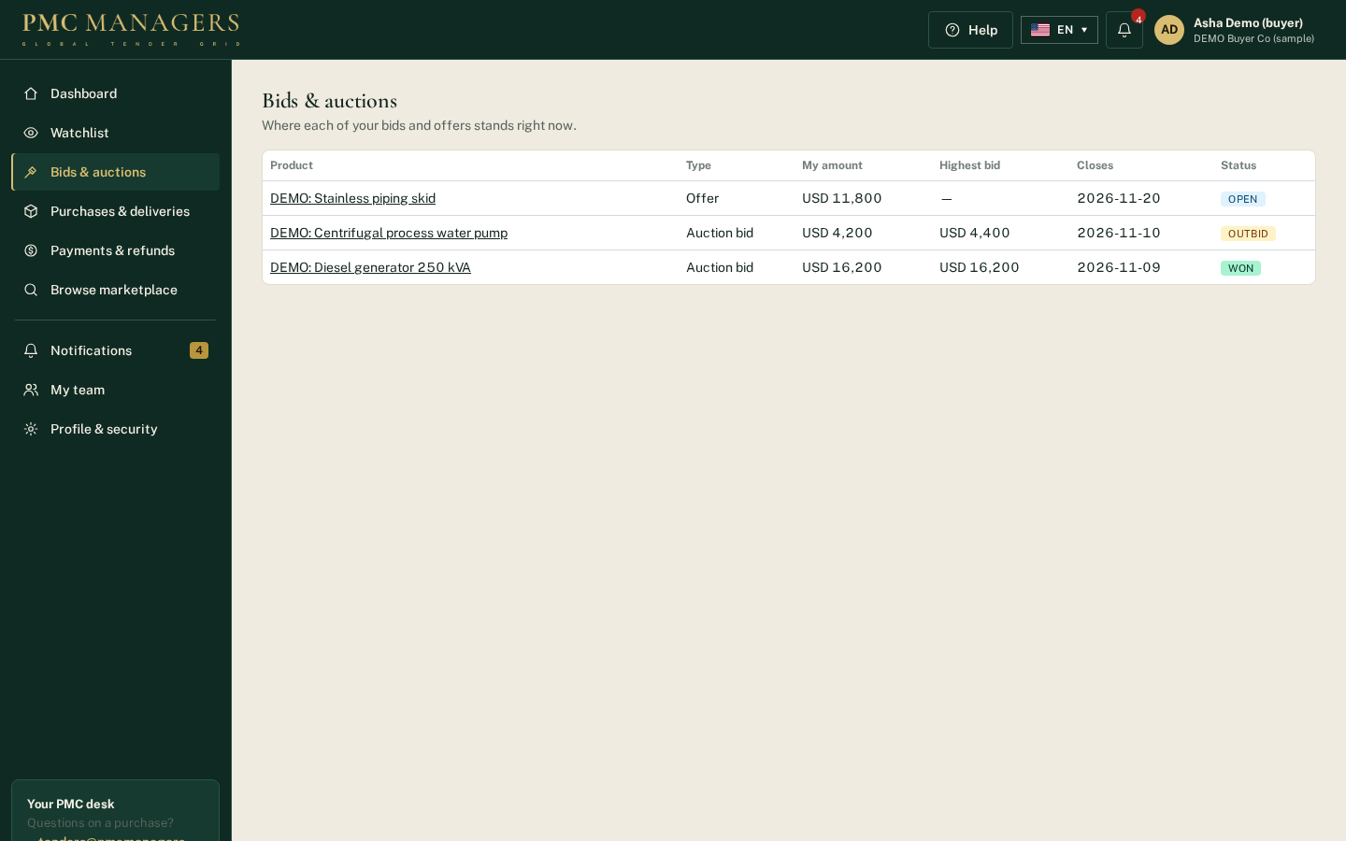
Every bid and offer with its live status: Leading, Outbid, Won, Lost; offers show Open, Accepted or Declined.
Main actions
• Open the product to raise a bid

Purchases & deliveries
Screen: /buyer/orders
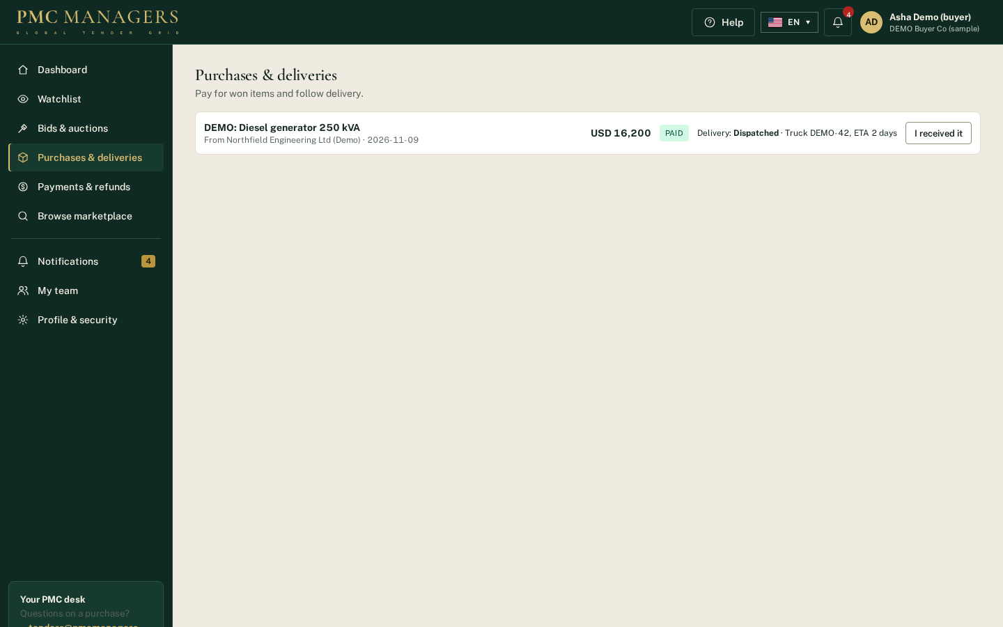
Won and bought items. Pay securely for items awaiting payment, follow the delivery status set by the seller and confirm 'I received it'.
Main actions
• Pay securely
• I received it

Payments & refunds
Screen: /buyer/payments
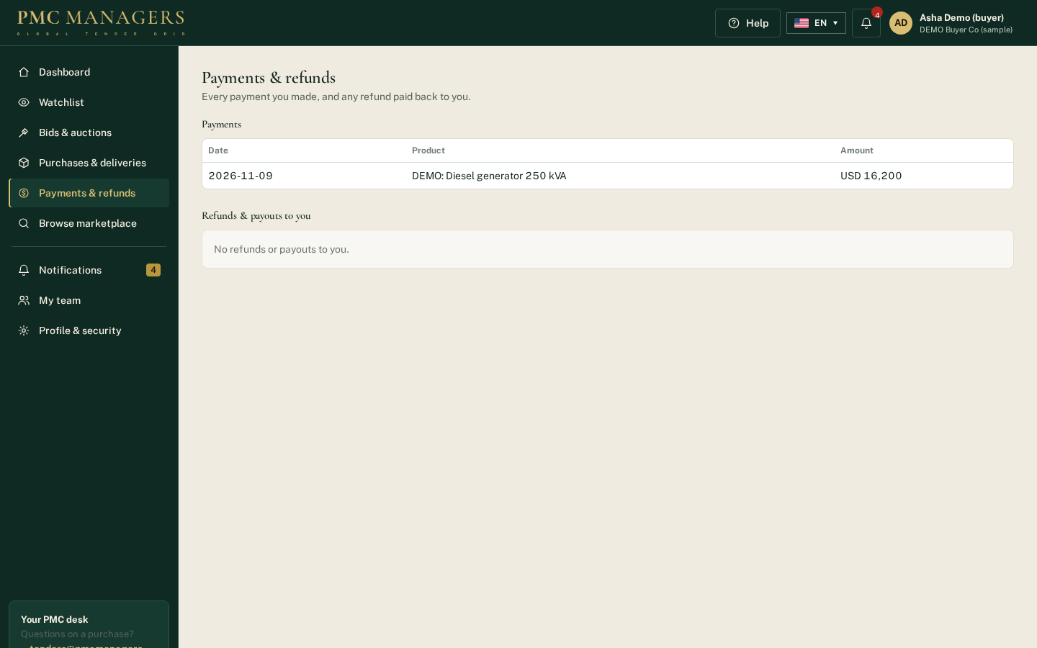
Every payment made and any refund or payout back to the buyer.
Main actions
• Review payments

Notifications
Screen: /buyer/notifications
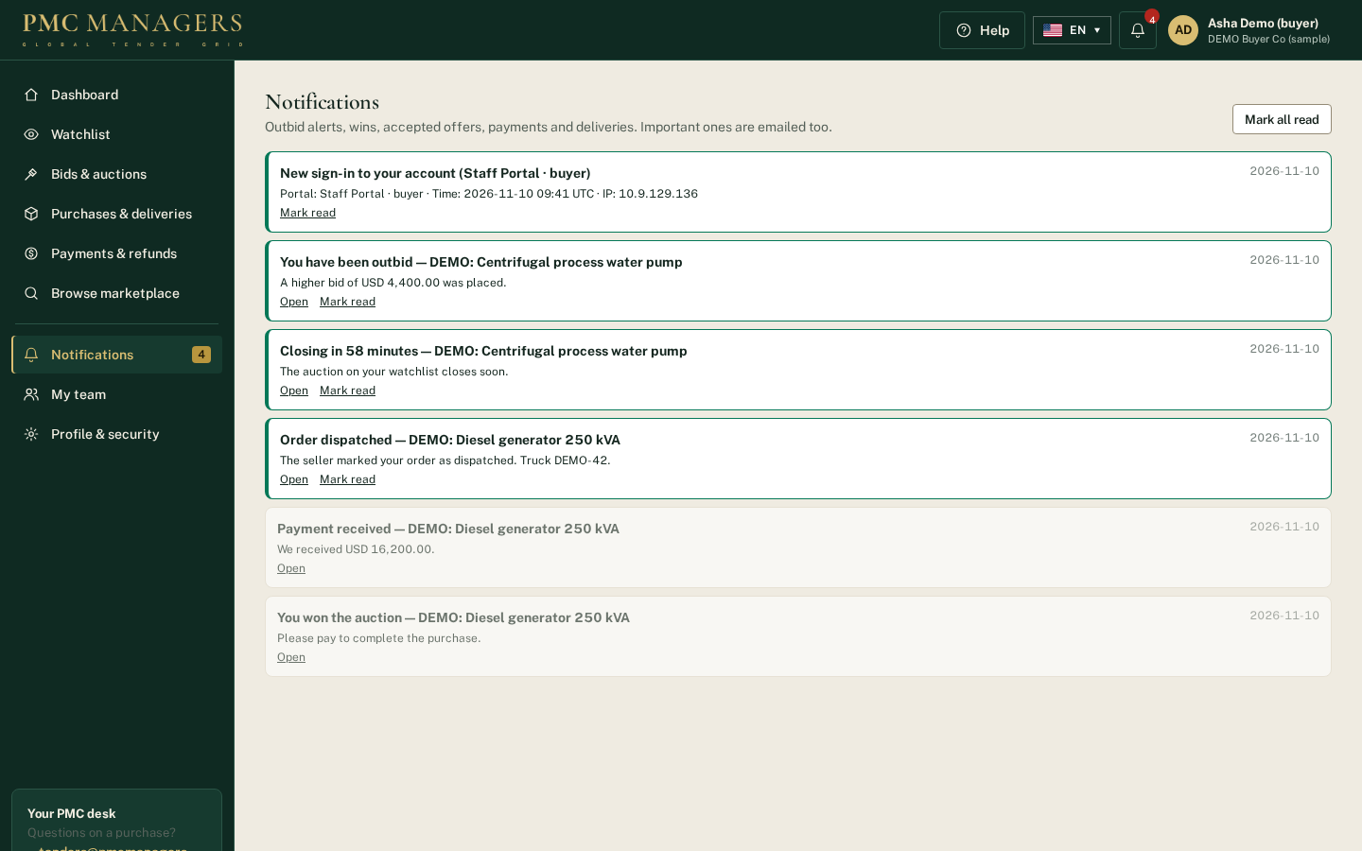
Outbid alerts, closing reminders, wins, accepted offers, payments and deliveries. Important ones are also emailed.
Main actions
• Open
• Mark read
• Mark all read

My team
Screen: /buyer/team
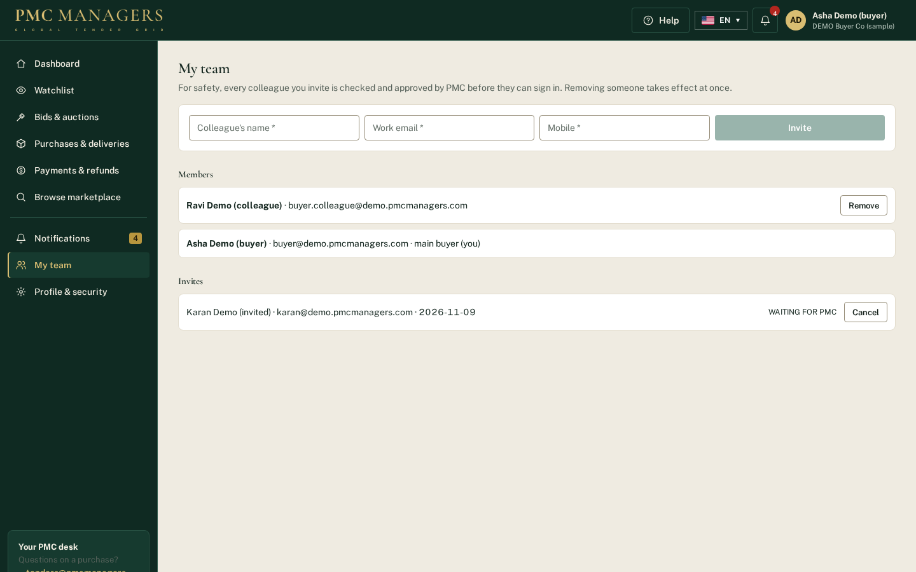
The organisation's main buyer invites colleagues; every invite is approved by PMC before the colleague can sign in. Removing a colleague stops access at once.
Main actions
• Invite a colleague
• Remove a colleague
• Cancel an invite

Profile & security
Screen: /buyer/profile
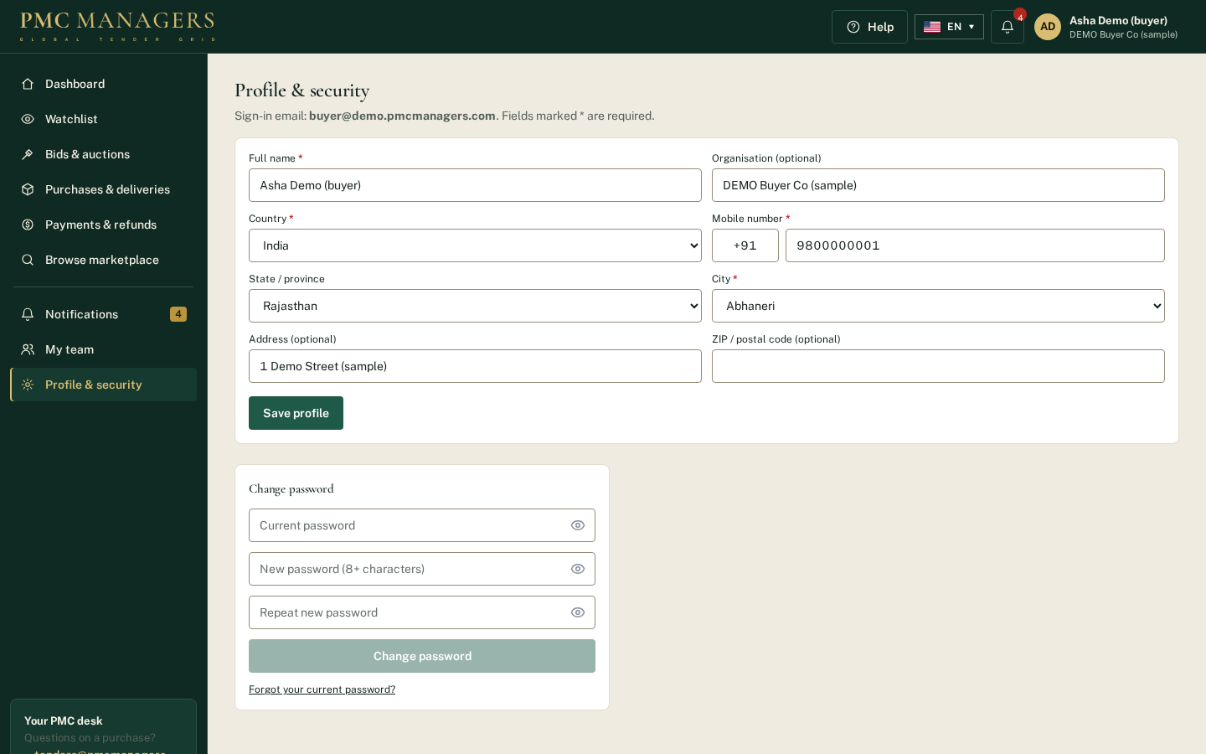
Masters-backed profile (country, state, city, phone code) and password change.
Main actions
• Save profile
• Change password

Marketplace with Save buttons
Screen: /market
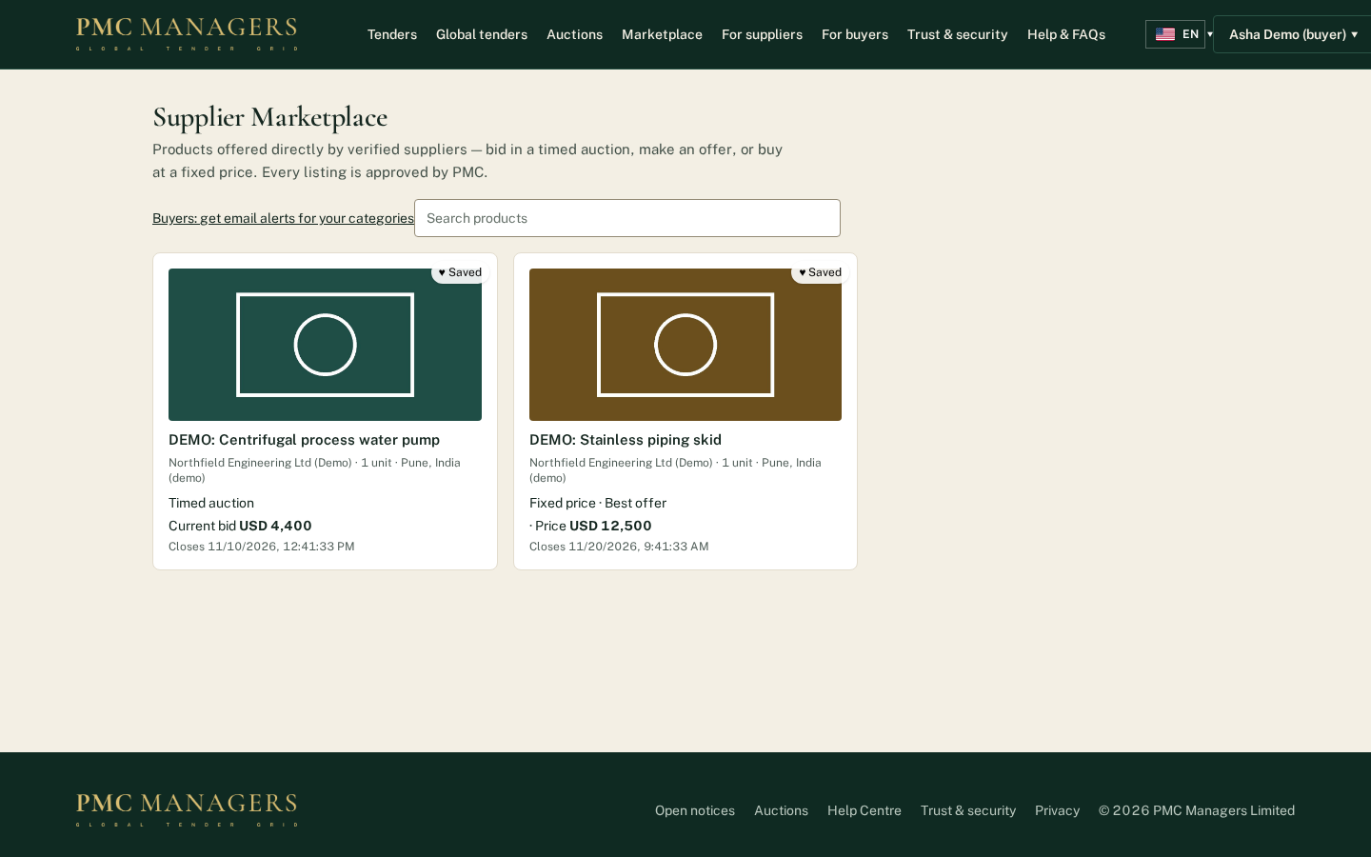
Signed-in buyers see ♡ Save on every product card and their name menu in the site header.
Main actions
• Save a product
• Open a product to bid, offer or buy

5 · Partner portal — screen tour

Partner profile
Screen: /partner/me
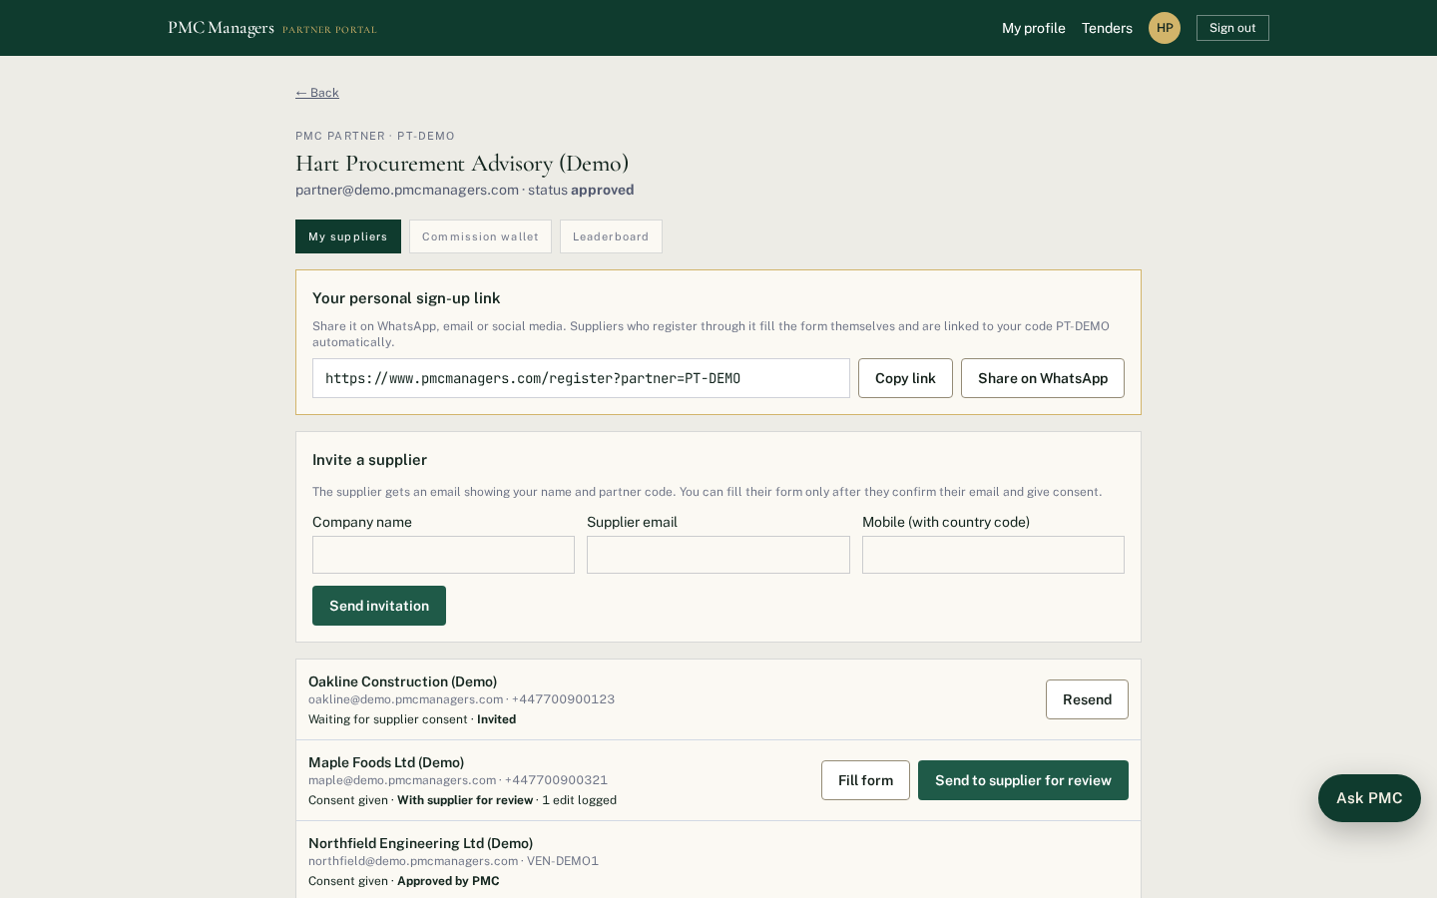
Partners complete four sections (profile, banking, documents, agreement) with a progress bar; the form opens where they left off. After approval they onboard suppliers and see commission.
Main actions
• Complete each section
• Sign the agreement
• Submit for approval

6 · What's new: Supplier Marketplace & AI catalogue import
Suppliers can now sell products directly to verified buyers without running a tender. Every listing is approved by PMC first. Each part below also has a help guide and a video in the Help Centre.

Ways to sell
Sale method | How it works
Timed auction | Starting price, optional hidden reserve, minimum bid step and closing time. The highest bid at closing wins.
Best offer | Buyers send offers until a deadline; the supplier accepts the one they want.
Fixed price | Buy now at the price the supplier sets.

A supplier can switch on any mix of the three for each product and chooses whether only verified buyer organisations, or any verified account, may take part.

Supplier: add products (Sell products)
1. Open Sell products and click Add a product. Enter the details, click Upload photos (up to 12) and Attach spec sheet for PDF datasheets (up to 6).
2. Tick the sale methods and prices, check what you will receive after the PMC fee, then click Submit for approval.

Supplier: import a catalogue with AI
1. Click Import from a catalogue with AI and choose a PDF catalogue, brochure or a JPG/PNG photo of a page (up to 25 MB; the first 30 pages are read).
2. AI reads the file in 1 to 3 minutes and lists every product with its photo, a description, category, unit and specifications. Photos are taken from the PDF, or cut out of the page when the page is a scan or photo.
3. For each product the supplier decides: keep it or untick it; use the AI description (and edit it) or Write my own; add the specifications or not; which photos to keep, add or upload; and whether to attach the catalogue PDF as a spec sheet.
4. Create draft listing(s) saves the chosen products as drafts marked set price & how to sell. A draft cannot be submitted until the supplier opens Edit and sets the sale method and price.
5. AI only uses facts in the document; it never adds prices or certifications. Reading a catalogue is free unless an admin sets a fee for AI catalogue reading in Pricing; a failed reading is never charged.

Admin: approvals, fees and payouts (Marketplace)
1. Every listing waits in Admin → Marketplace. Check the photos, spec sheets and prices, then Approve or Reject with a note.
2. The PMC sale fee is a percentage or a fixed amount, or switched off. It can be waived for one listing when approving it. The listing fee is set in Pricing → fee rules → Marketplace product listing.
3. The buyer pays PMC through a secure Stripe link from My bids & purchases. The order shows the PMC fee and the seller's bank details; the admin pays the balance and clicks Mark seller paid with the transfer reference. Automatic split payouts are not switched on.

Buyers: the public Marketplace
1. Marketplace in the top menu lists approved products with photos, spec sheets, price or current bid and closing time.
2. Verified buyers bid, send an offer or click Buy now; purchases are paid from My bids & purchases by Pay securely.
3. In the iPhone app the buy and pay buttons are hidden; buyers pay on the website.

7 · What's new: Buyer portal, watchlist & buyer teams
Buyers now have their own portal at /buyer, laid out like the supplier portal: left sidebar, top header with a notification bell and avatar menu, and a footer. Only verified buyers can bid or buy.

Becoming a buyer
Route | Steps | Who approves
Register free | Sign in page → Buyer organisation → Register as a buyer — free. Name, email, mobile, country and city are required (from the masters); state, address, ZIP and organisation are optional. Confirm the email link (3 days). | PMC admin in Growth → Buyer applications (only after the email is confirmed)
Apply as an organisation | /buyers/apply form for tender-issuing organisations. | PMC admin; approval emails a 7-day set-password link
Added by PMC | Admin → Growth → Buyer applications → + Add a buyer directly. | Approved at once; sign-in emailed

Buyer portal pages
Page | What the buyer sees
Dashboard | Tiles: active bids & offers, to pay, in delivery, won, unread notifications; latest activity
Watchlist | Products saved with ♡ Save; reminder about an hour before a watched auction closes
Bids & auctions | Status of every bid (Leading, Outbid, Won, Lost) and offer (Open, Accepted, Declined)
Purchases & deliveries | Pay securely, delivery status set by the seller, I received it
Payments & refunds | Payments made and any refunds or payouts back to the buyer
Notifications | Bell list; important events are also emailed
My team | Main buyer invites colleagues (PMC approves each) and removes them (immediate)
Profile & security | Masters-backed profile, photo, change password; forgot password via the sign-in page

Notifications sent to buyers
1. Outbid on an auction.
2. About an hour before a watched auction closes (scheduler every 15 minutes).
3. Auction won, offer accepted or order placed — pay now.
4. Payment received.
5. Order dispatched / delivered (supplier marks it in Sell products → sales).
6. Account verified by PMC.

Security rules
1. Buyer sign-ins can never open PMC admin or staff pages; buyer-organisation admins are not PMC staff.
2. A colleague only gets access after PMC approves the invite; removing a colleague ends every open session.
3. A buyer sees only their own bids, orders, notifications and organisation members.
4. Unconfirmed emails cannot sign in; unverified buyers can browse but not bid or buy.
Sample data in the screenshots is labelled DEMO and is not real business data.

8 · Process flow & data flow diagrams
The same diagrams are in the separate PMC Process & Data Flow Diagrams PDF. Process flows show who acts and in which order; data flows show what information moves between people, processes and data stores (grey).

Process flow 1 — Tender lifecycle
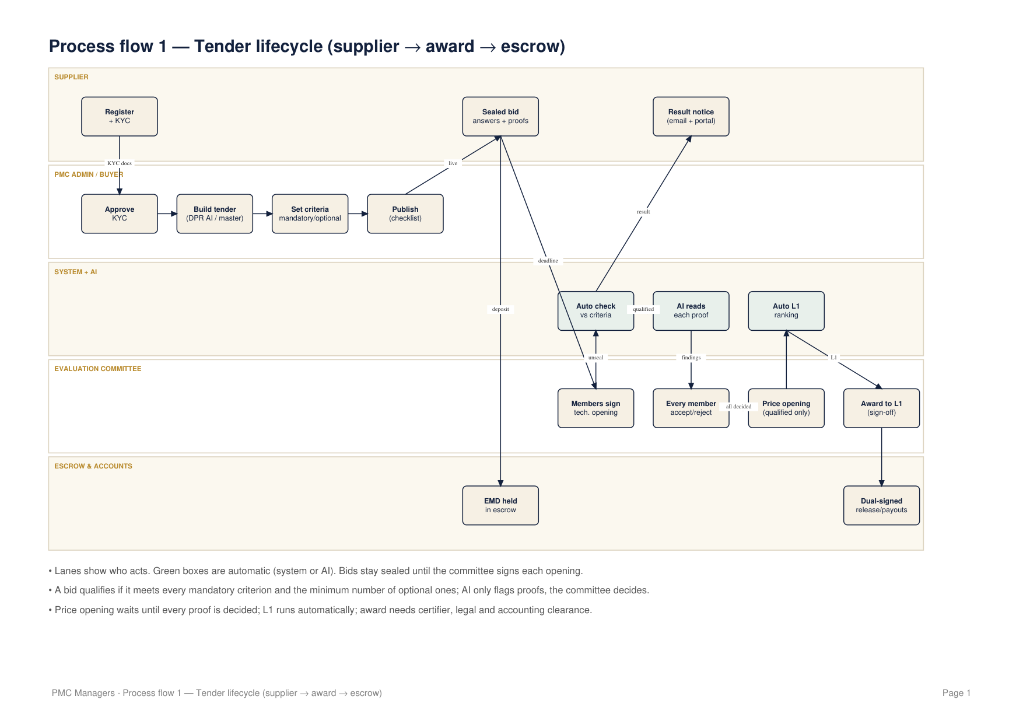

Process flow 2 — Supplier onboarding
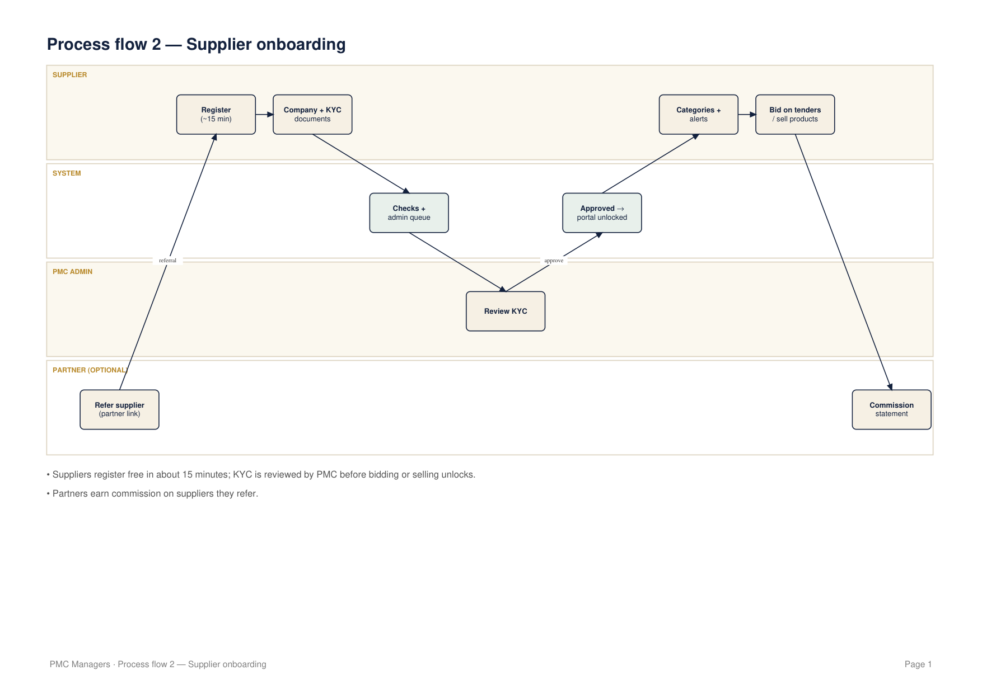

Process flow 3 — Buyer onboarding & team
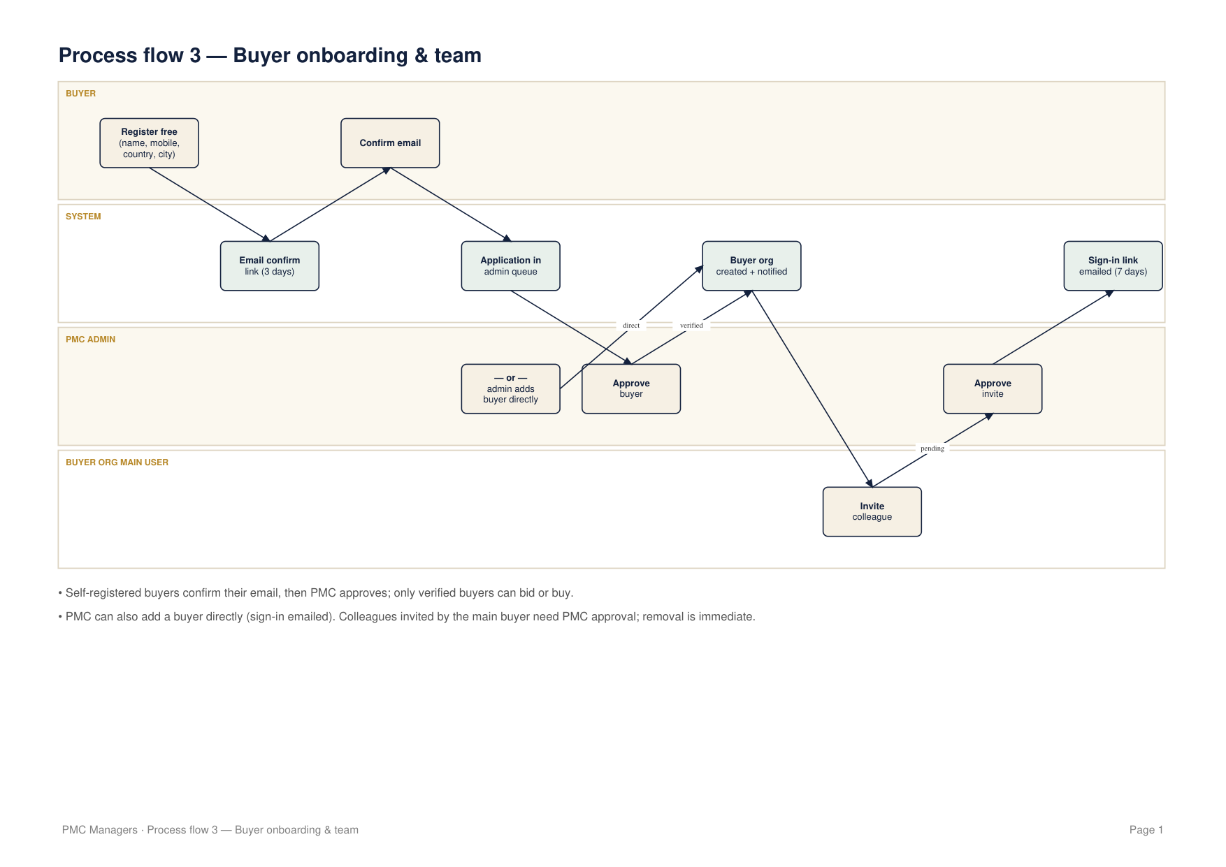

Process flow 4 — Supplier marketplace
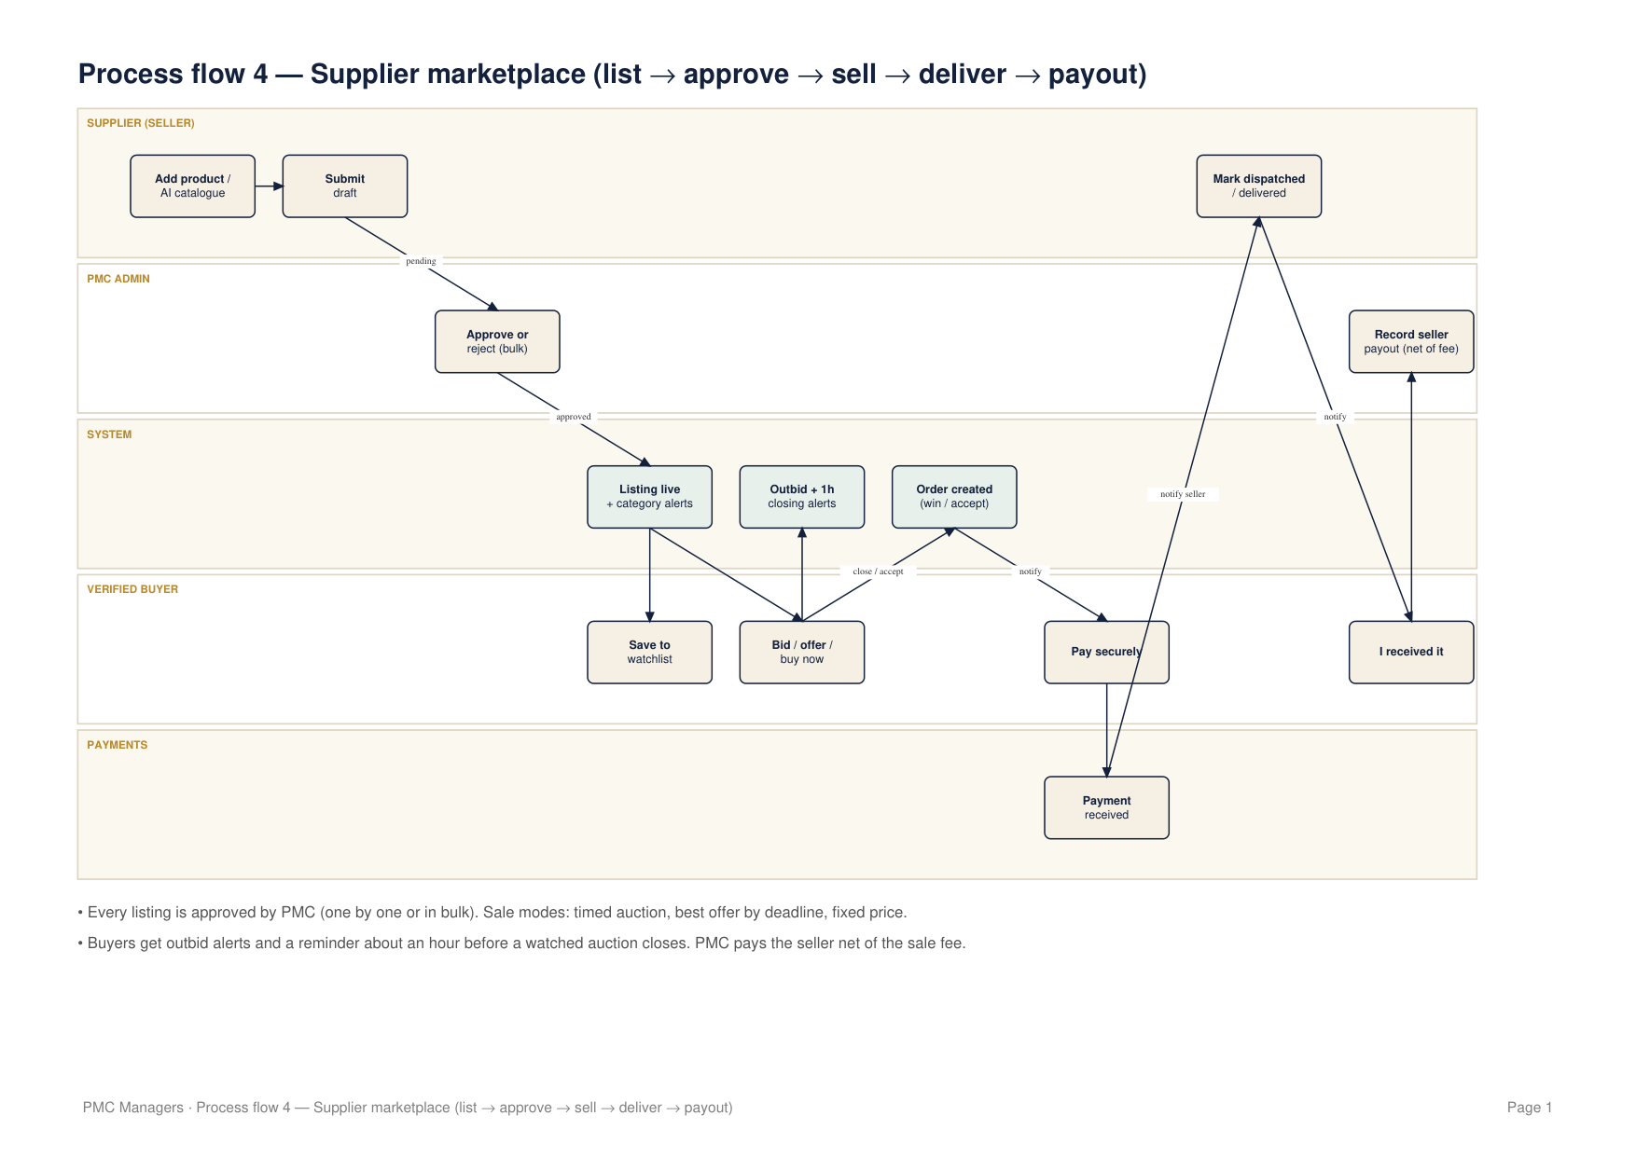

Data flow — Level 0 (context)
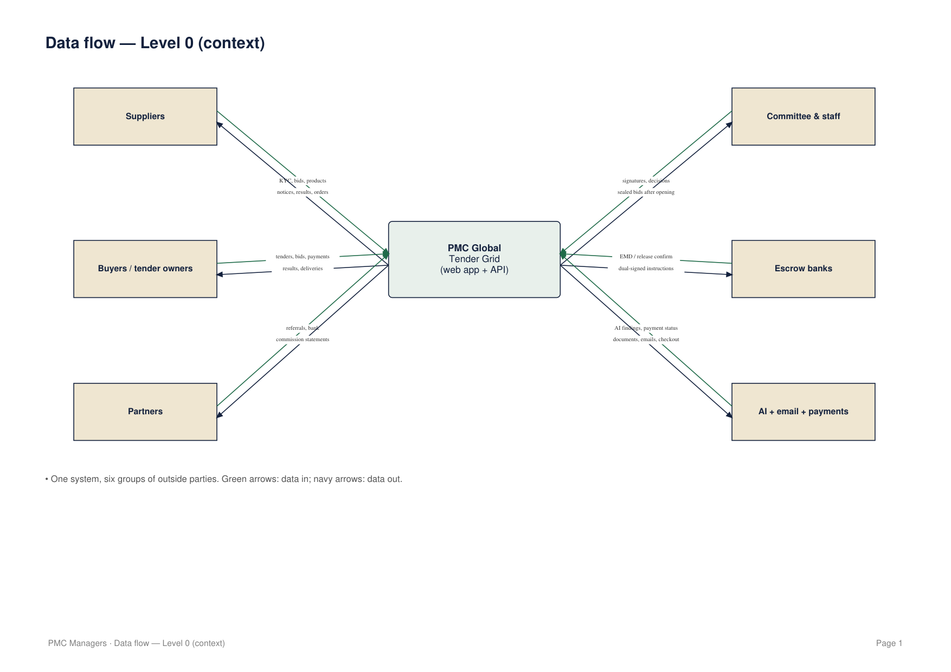

Data flow — Level 1: tendering
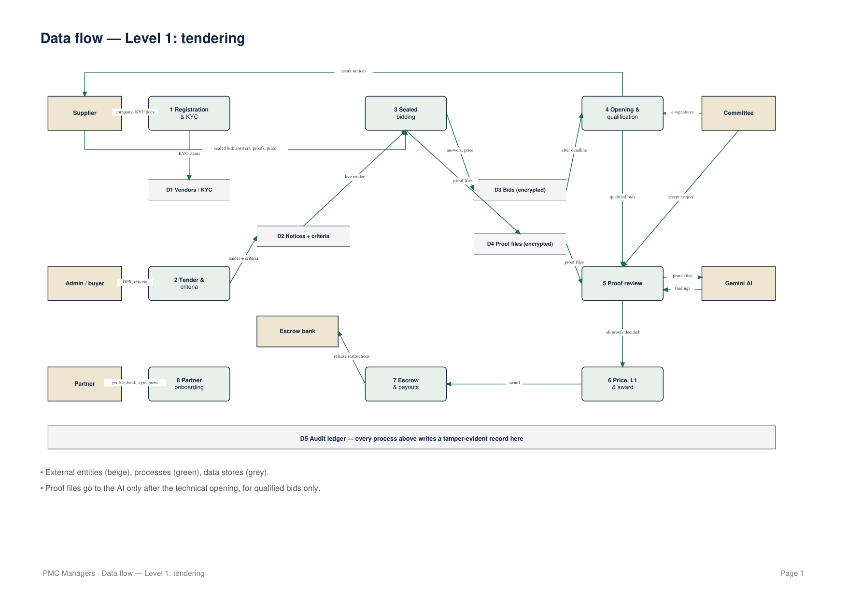

Data flow — Level 1: marketplace & buyer portal
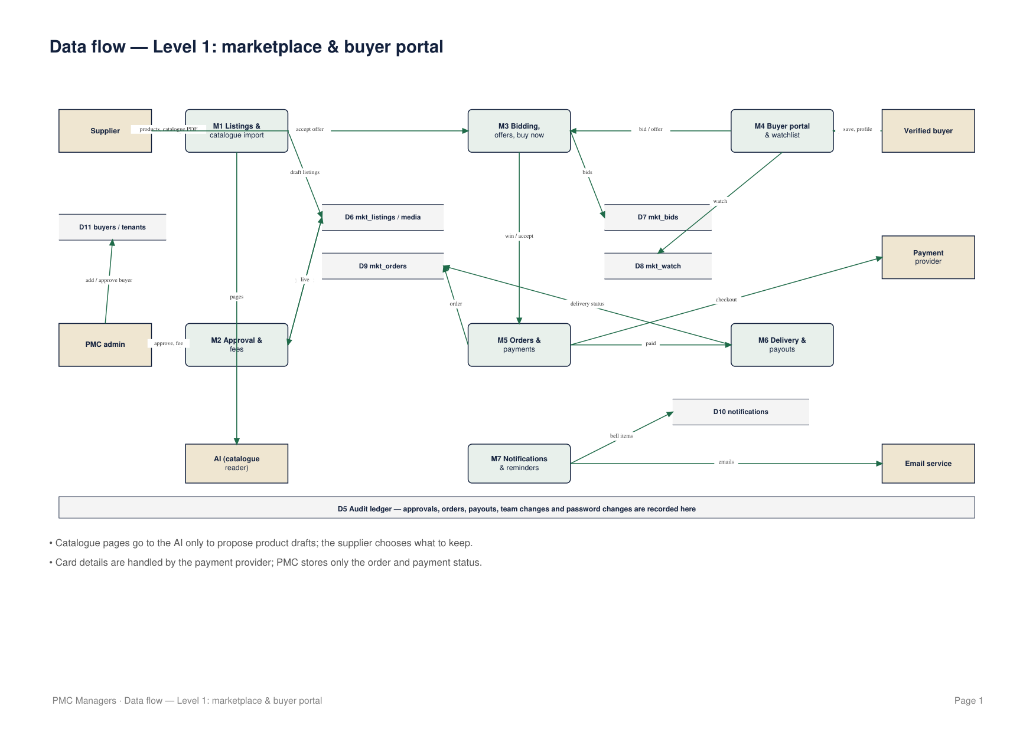

9 · Glossary
Term | Meaning
DPR | Detailed project report used to draft a tender
EMD | Earnest money deposit held in escrow with a bid
L1 | Lowest compliant price among qualified bids
Mandatory criterion | Must be met by every bidder
Optional criterion | Counts toward the minimum number the tender sets
Proof review | AI finding + unanimous committee decision on each proof
Corrigendum | Formal change to a live tender sent to every bidder
Consortium | Registered suppliers bidding together
Sealed bid | Encrypted until the committee signs the opening

