

PMC Managers — Master Training Manual
Complete edition · every portal, screen, process and policy
Issued 10 November 2026 · build v61 · for testing. Screenshots use labelled DEMO sample data.

Contents
- 1 · Platform overview & architecture
- 2 · Roles at a glance
- 3 · Security, audit & data protection
- 4 · Public website — screen tour
- 5 · Supplier portal — screen tour
- 6 · Buyer portal — screen tour
- 7 · Admin console — screen tour
- 8 · Partner portal — screen tour
- 9 · Staff portal — screen tour
- 10 · Deep-dive: Tender builder & AI DPR
- 11 · Deep-dive: Criteria, sealed bids, opening & AI proof review
- 12 · Deep-dive: Price opening, L1, award & escrow
- 13 · Partners, reminders & tracking
- 14 · Troubleshooting playbook
- 15 · Sample workflow — one tender end to end
- 16 · Procurement policy: criteria & qualification
- 17 · Proof review policy (AI + committee)
- 18 · Evaluation & award policy (L1 / weighted)
- 19 · Code of ethics & conflict of interest
- 20 · Data protection, retention & deletion
- 21 · Incident response
- 22 · Complaints, appeals & escalation
- 23 · RACI matrix
- 24 · Templates
- 25 · Service levels
- 26 · What's new: fees, growth tools & languages
- 27 · What's new: Supplier Marketplace & AI catalogue import
- 28 · What's new: Buyer portal, watchlist & buyer teams
- 29 · Process flow & data flow diagrams
- 30 · Glossary

1 · Platform overview & architecture
PMC Managers is a global e-procurement platform: buyers publish tenders, verified suppliers bid with sealed envelopes, an evaluation committee opens, checks and awards, and payments move through escrow — every step recorded in a tamper-evident audit ledger.

Portals
Portal | Address | Who
Public website | / , /tenders, /notices | Anyone
Supplier portal | /vendor | Registered suppliers
Admin console | /admin/e | PMC admins and reviewers
Staff portal | /staff | Committee, escrow, legal, accounting, certifier
Partner portal | /partner/me | Partners who onboard suppliers
Escrow portal | /login?role=escrow | Escrow institutions

Architecture
React single-page app (served from S3 + CloudFront) → FastAPI backend (Docker on AWS Elastic Beanstalk, all routes under /api) → MongoDB. Bid answers, prices and uploaded bid files are encrypted at rest and only decrypted after the committee signs each opening. AI features (DPR tender drafting, criteria reading, proof reading) use Gemini through the platform's AI key. Email goes through the managed email service. Scheduled jobs (reminders, statements, digests) run from the platform scheduler.
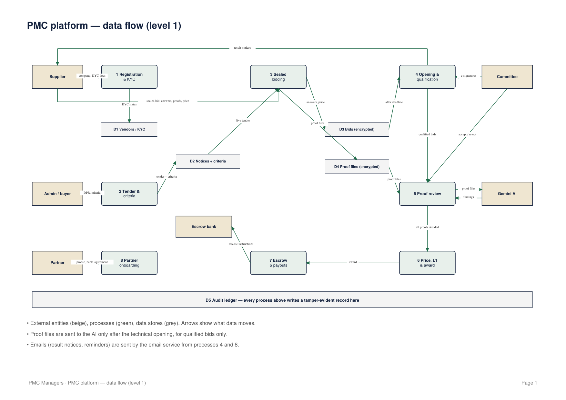

2 · Roles at a glance
Role | Main jobs | Where
Supplier | Register, KYC, bid with criteria proofs, consortium, results, payouts | Supplier portal
Admin | Tenders, criteria, publishing, suppliers, partners, settings | Admin console
Reviewer | Approves supplier-prepared tenders; edits criteria master | Admin console
Committee member | Signs openings, reviews proofs (all must agree), doubts, scores, awards | Bidding ops / Staff portal
Certifier / Legal / Accounting | Sequential bid clearances before award | Staff portal
Escrow agent | EMD, dual-signed releases, payouts | Staff portal / Escrow
Partner | Onboards suppliers, earns commission | Partner portal
Auditor | Reads the audit ledger and reports | Admin console

3 · Security, audit & data protection
1. Sign-in by role with email + password (session cookie + CSRF token on every change).
2. Role-based access: the admin console only admits admin and reviewer; other staff use the staff portal.
3. Sealed bidding: answers, price and bid files are encrypted; nobody (including admins) can open them before the committee signs.
4. Audit ledger: every action is chained with SHA-256; 'Verify chain' re-checks every link.
5. Soft deletion: records are archived, not erased, unless a narrowly scoped deletion is explicitly requested.
6. AI sees proof files only after technical opening and only for qualified bids; AI only flags — people decide.

4 · Public website — screen tour

Home page
Screen: /
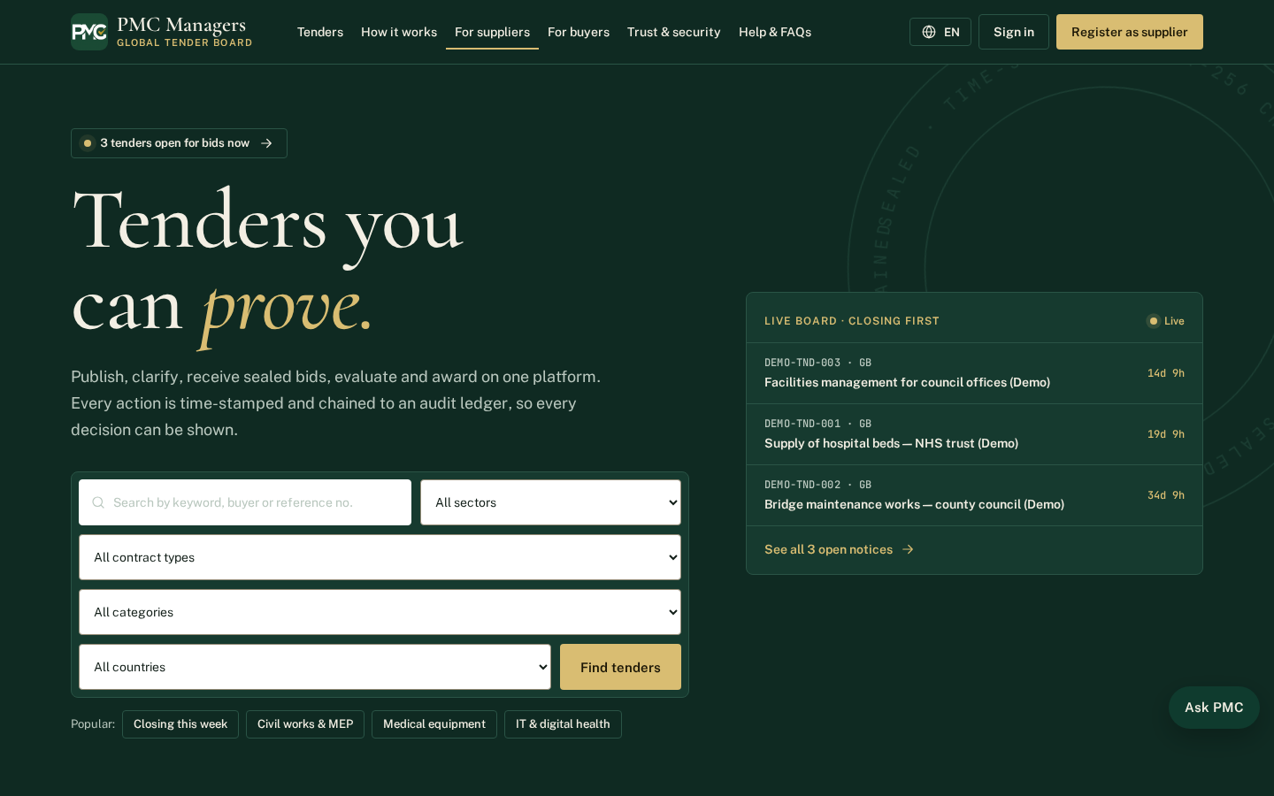
The public front door of PMC Managers. Visitors see what the platform does, the latest live tenders and the main ways in: Find tenders, Register as a supplier and Sign in.
Main actions
• Browse live tenders
• Register as a supplier
• Sign in to your portal

Public tender board
Screen: /tenders
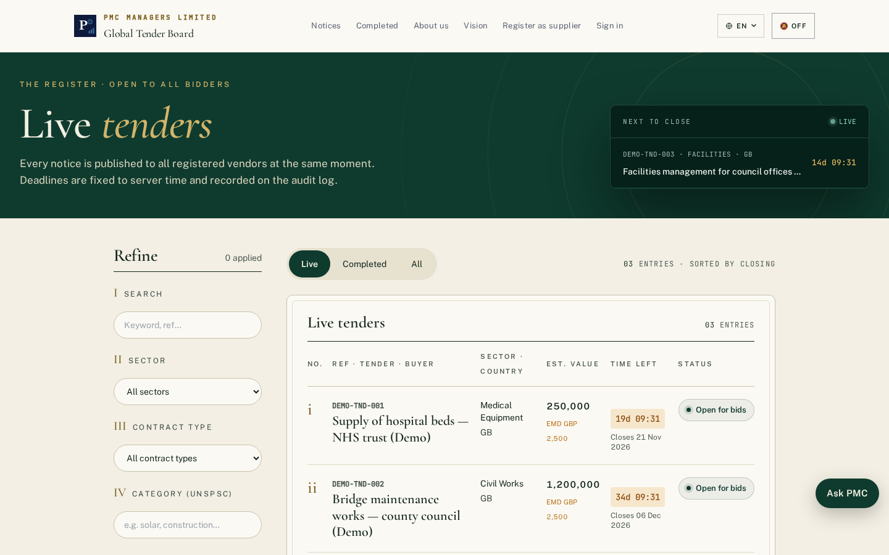
Every published tender with its reference, buyer, category, country and closing date. Anyone can search and filter; bidding needs a verified supplier account.
Main actions
• Search by keyword or reference
• Filter by category, country and closing date
• Open a tender to read the documents

Notice board
Screen: /notices
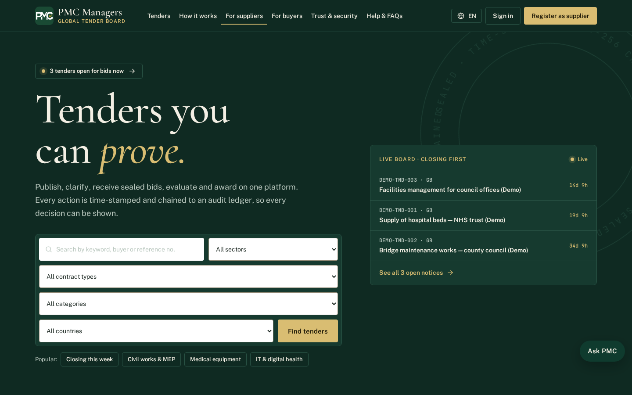
Published notices and corrigenda in date order, so suppliers can see changes to live tenders.
Main actions
• Read a notice
• See corrigenda issued against a tender

For suppliers
Screen: /suppliers
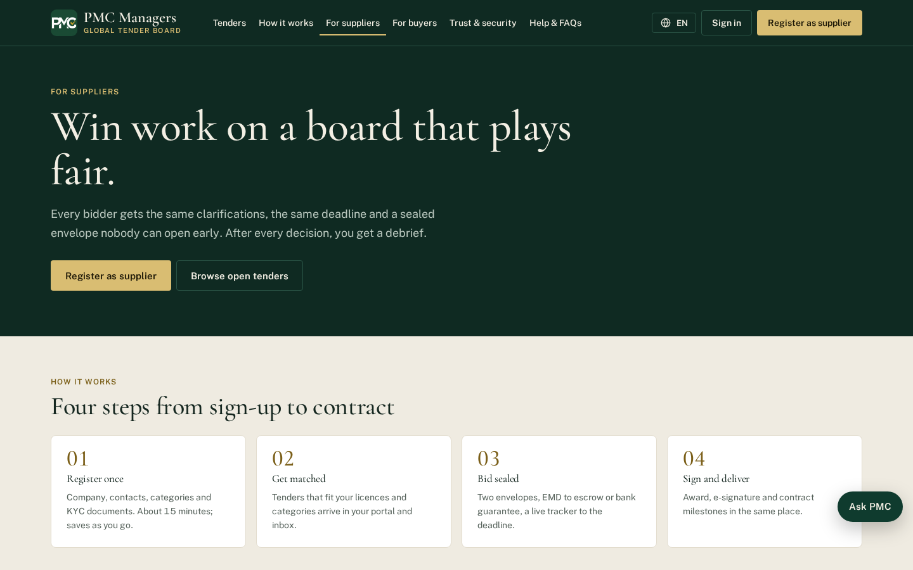
Explains how suppliers register, get verified, find tenders, bid with sealed envelopes and get paid through escrow.
Main actions
• Start supplier registration

For buyers
Screen: /buyers
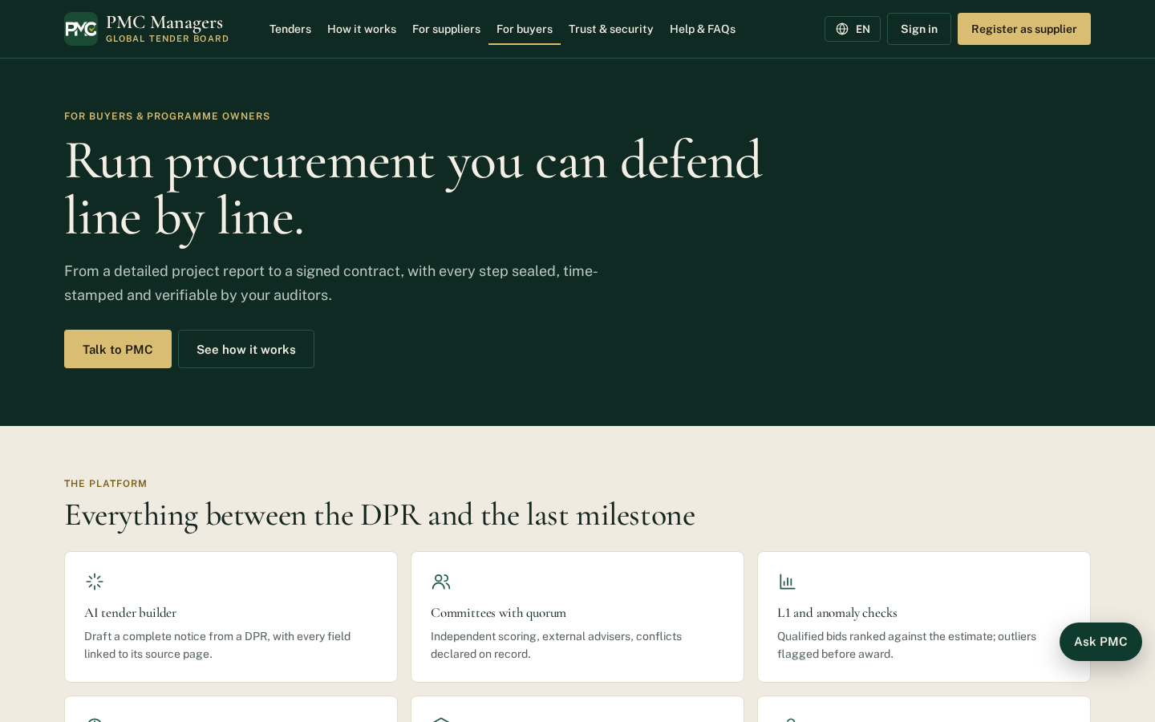
Explains how buyers publish tenders, set criteria, run sealed openings and award with a full audit trail.
Main actions
• Contact PMC to start buying

Sign in
Screen: /login
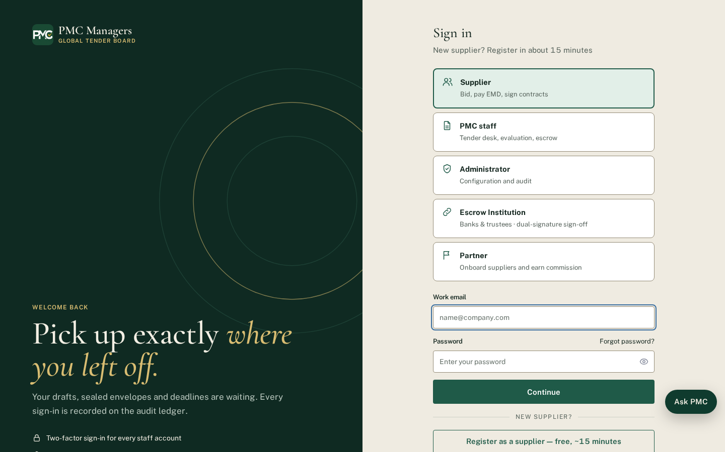
One sign-in page for every user. Choose your role first: Supplier, PMC staff, Admin, Escrow institution or Partner. Each role opens its own portal.
Main actions
• Choose your role
• Enter email and password
• Use Forgot password if needed

Supplier registration
Screen: /register
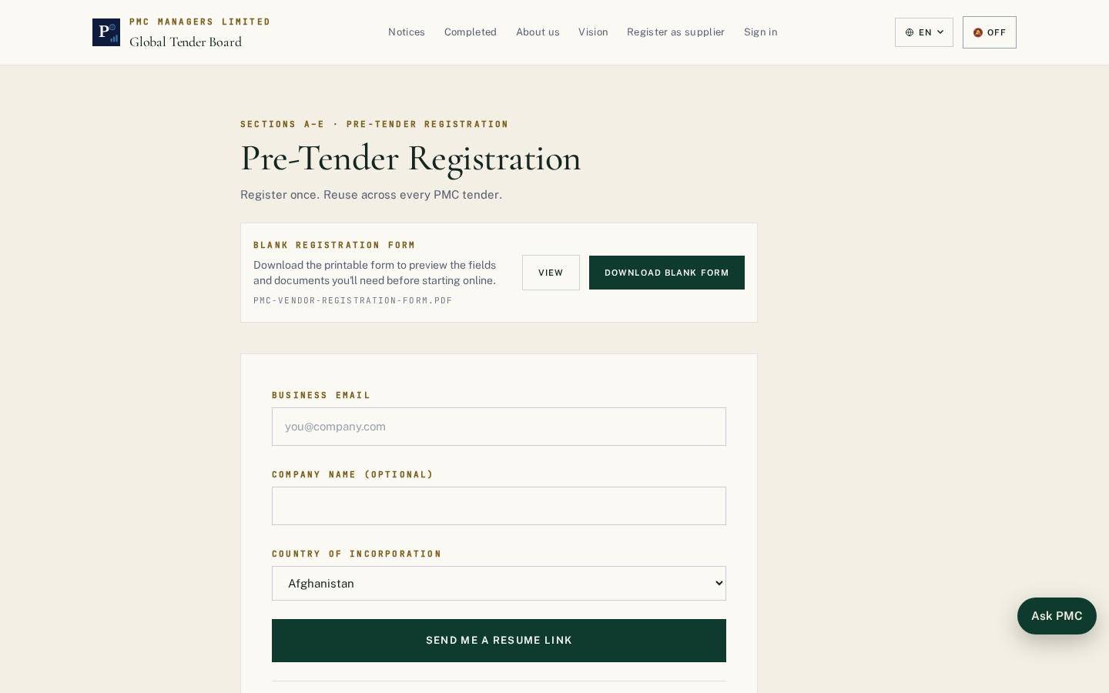
New suppliers create an account with company details. After email verification they complete KYC; PMC checks it before the supplier can bid.
Main actions
• Enter company and contact details
• Verify email
• Complete KYC in the supplier portal

Global tenders
Screen: /tenders/global
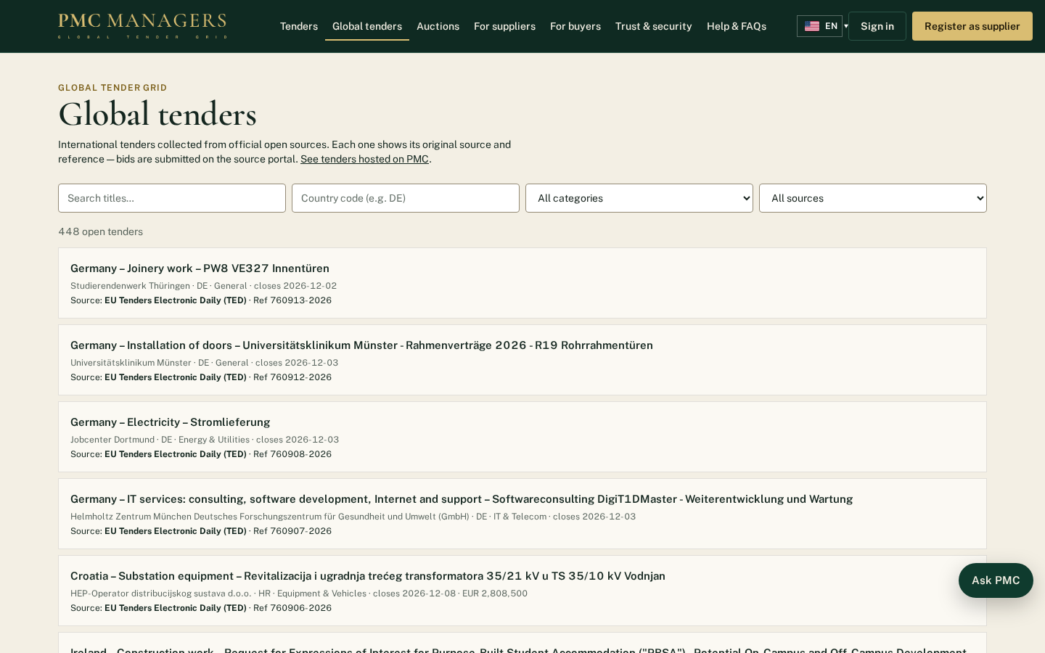
Tenders collected from official public sources (World Bank, EU TED) and licensed providers, with the original source and reference shown on each one.
Main actions
• Search by keyword, country or value
• Open the original source

Supplier directory
Screen: /suppliers/directory
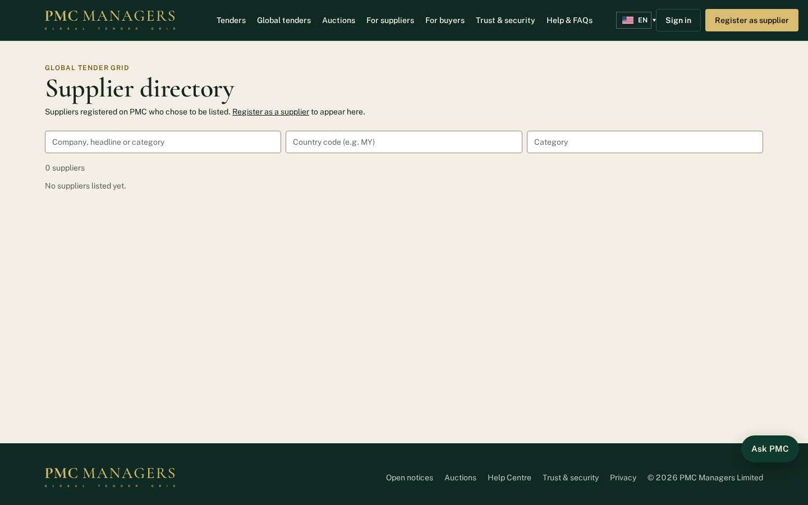
Public list of suppliers who chose to be listed. Featured suppliers appear first.
Main actions
• Search suppliers by category or country
• Open a supplier profile

Consultancy services
Screen: /consultancy
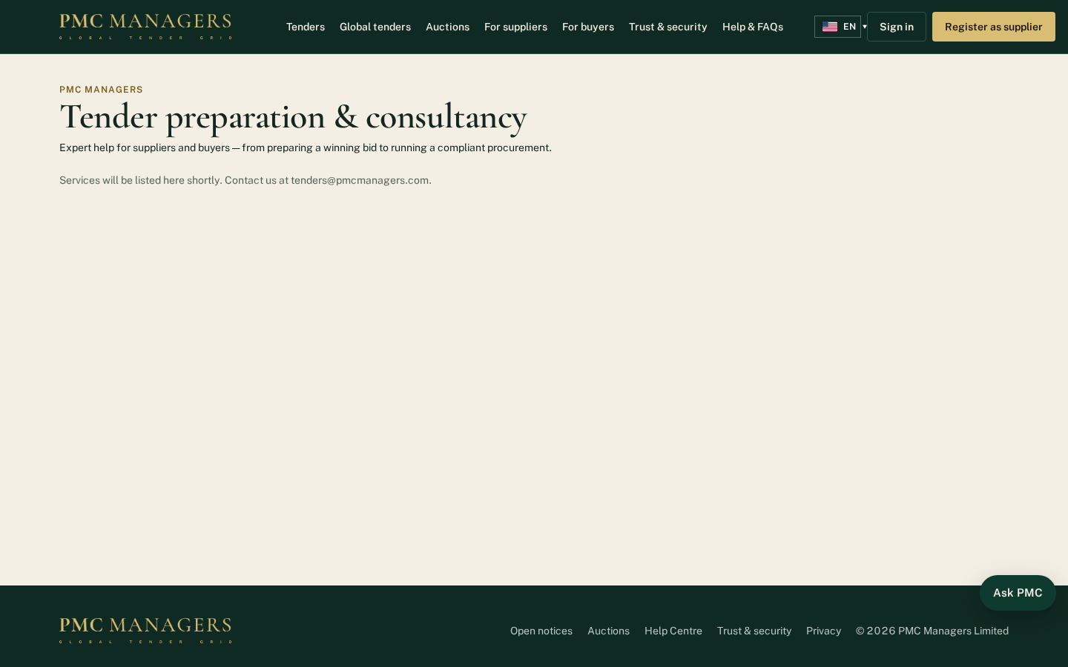
Tender preparation and consultancy services sold by PMC Managers.
Main actions
• Read the services
• Send a request

Buyer application
Screen: /buyers/apply
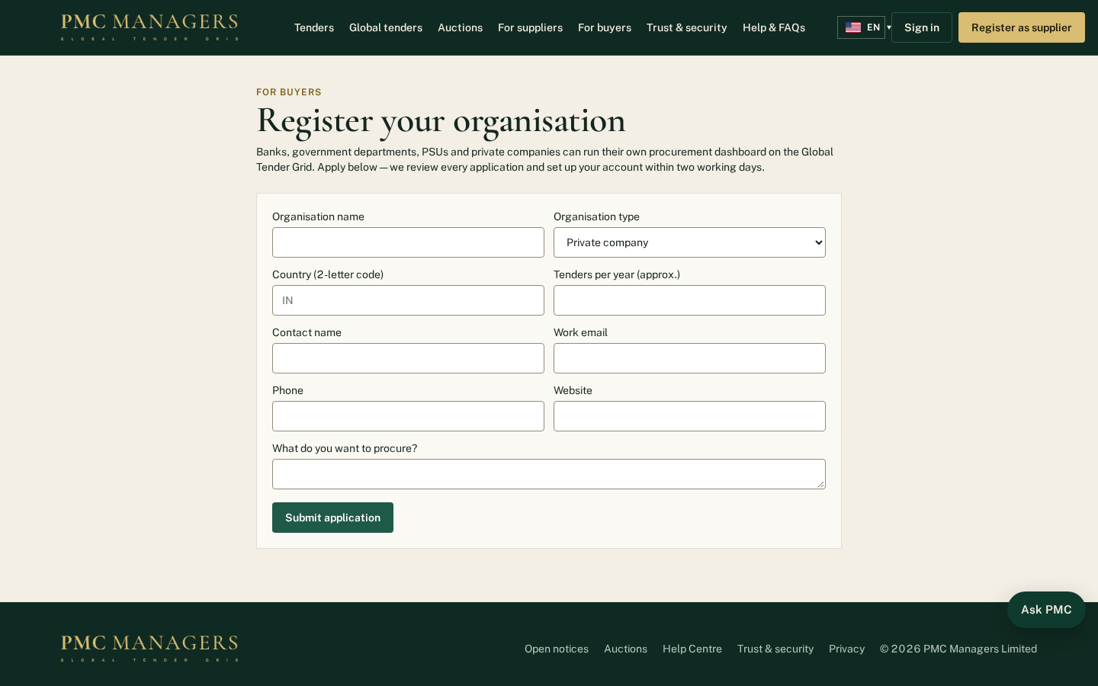
Banks, government departments, PSUs and companies apply to publish their own tenders.
Main actions
• Fill in the organisation details
• Submit the application for PMC approval

Language pages
Screen: /fr
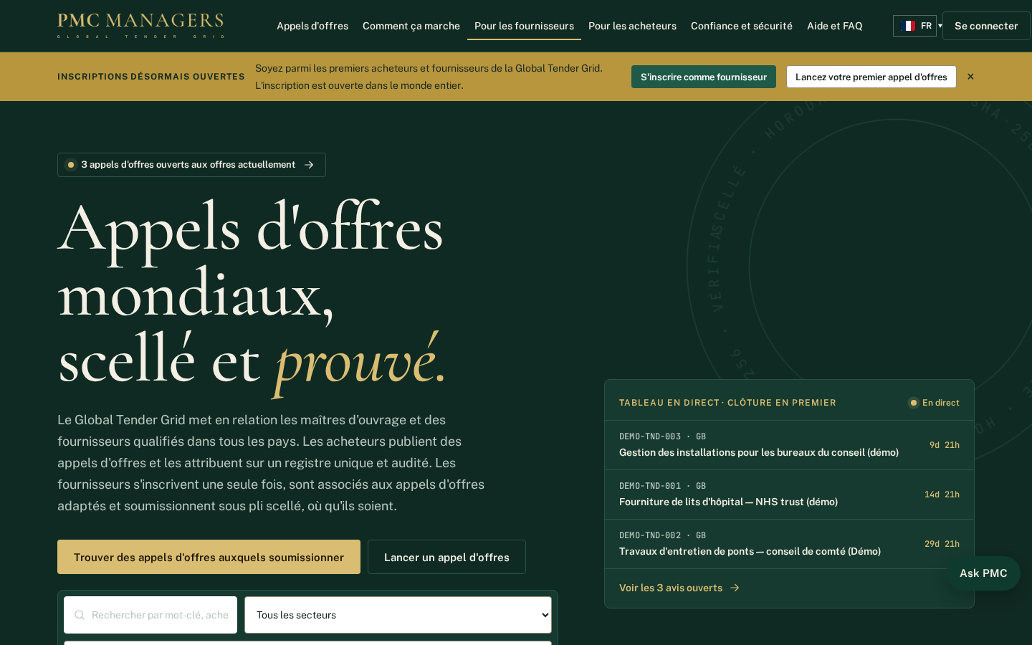
Every public page has its own address in each of the 14 languages, for example /fr for French. The flag button changes the language on any page.
Main actions
• Pick a language from the flag button
• Share a link in that language

Marketplace
Screen: /market
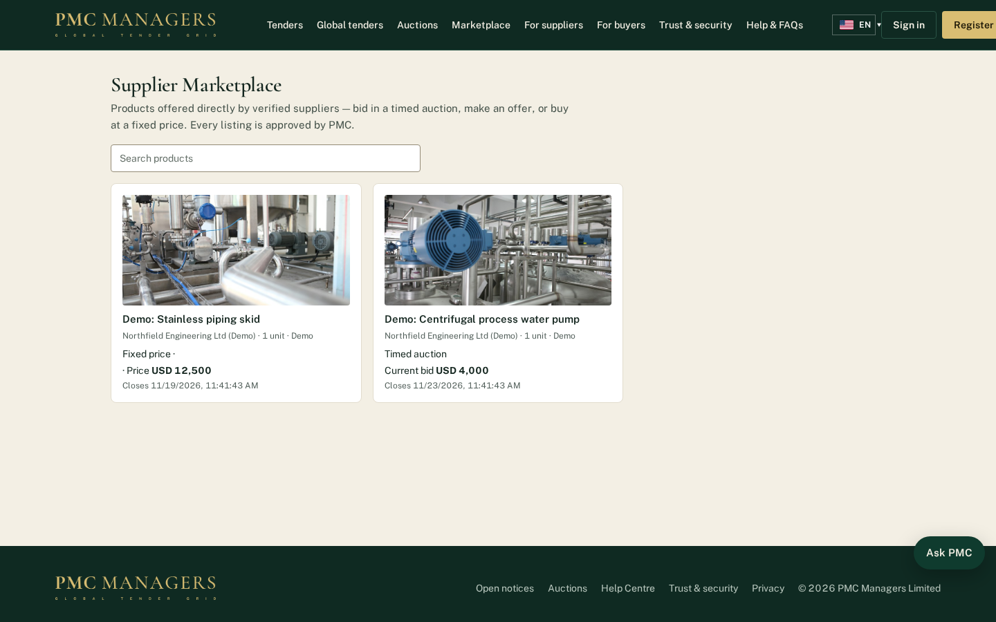
Products offered directly by approved suppliers and checked by PMC, sold by timed auction, best offer or fixed price. Verified buyers bid, offer or buy; each product shows its photos and spec sheets.
Main actions
• Search and open a product
• Bid, make an offer or buy now
• Pay from My bids & purchases

5 · Supplier portal — screen tour

Supplier dashboard
Screen: /vendor
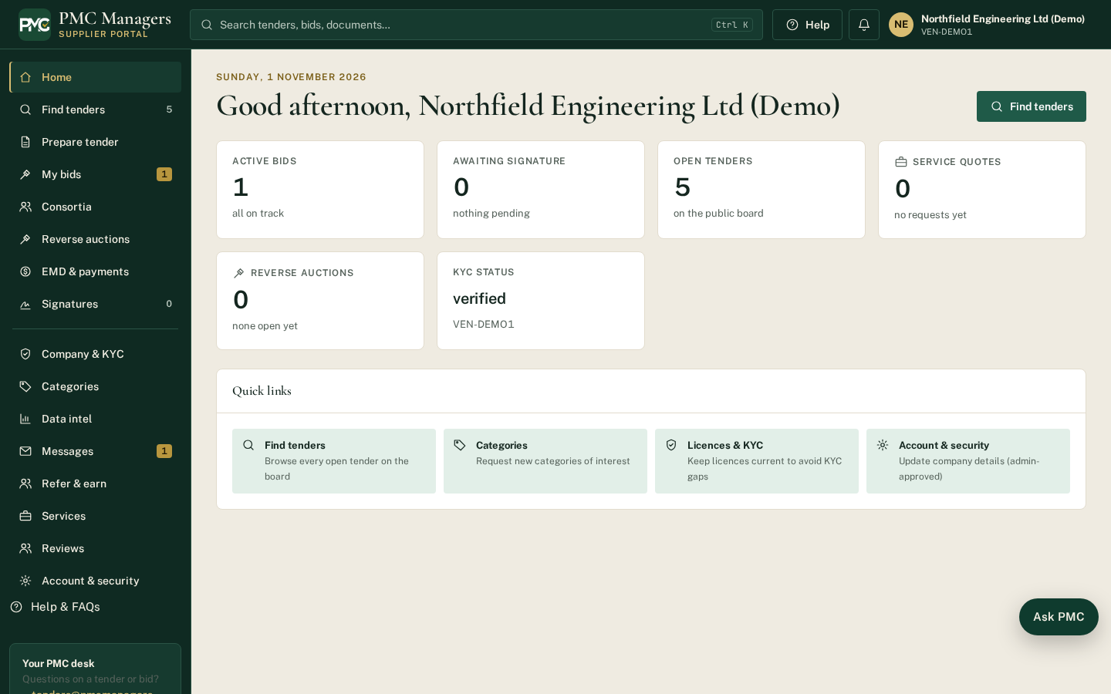
The supplier's home: matching tenders, open bids, notices and messages.
Main actions
• Find tenders
• Continue a bid

Tenders for you
Screen: /vendor/tenders
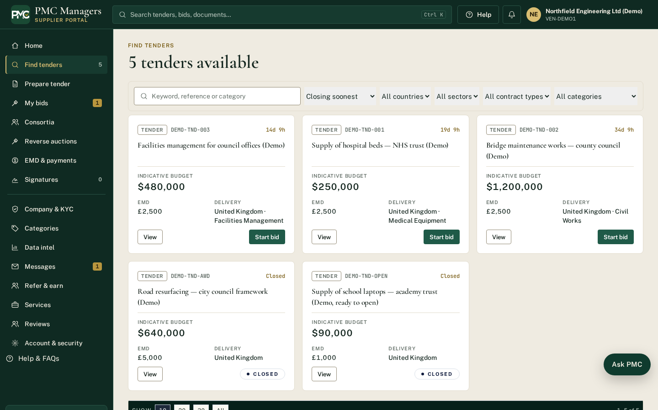
Tenders matching the supplier's categories, with closing dates.
Main actions
• Open a tender
• Start a bid

Prepare a bid
Screen: /vendor/bid/new/DEMO-TND-001
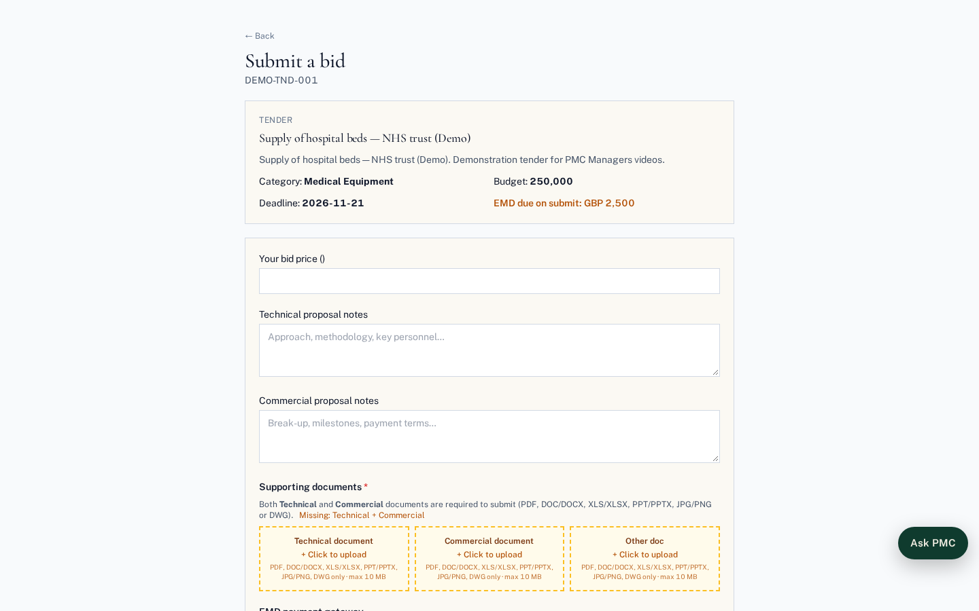
The bid form: technical documents, the Criteria section (each item marked Mandatory or Optional, with the rule for optional criteria), proofs, price and EMD. Everything is sealed when submitted.
Main actions
• Answer every mandatory criterion and attach proofs
• Enter price
• Submit (sealed)

My bids
Screen: /vendor/mybids
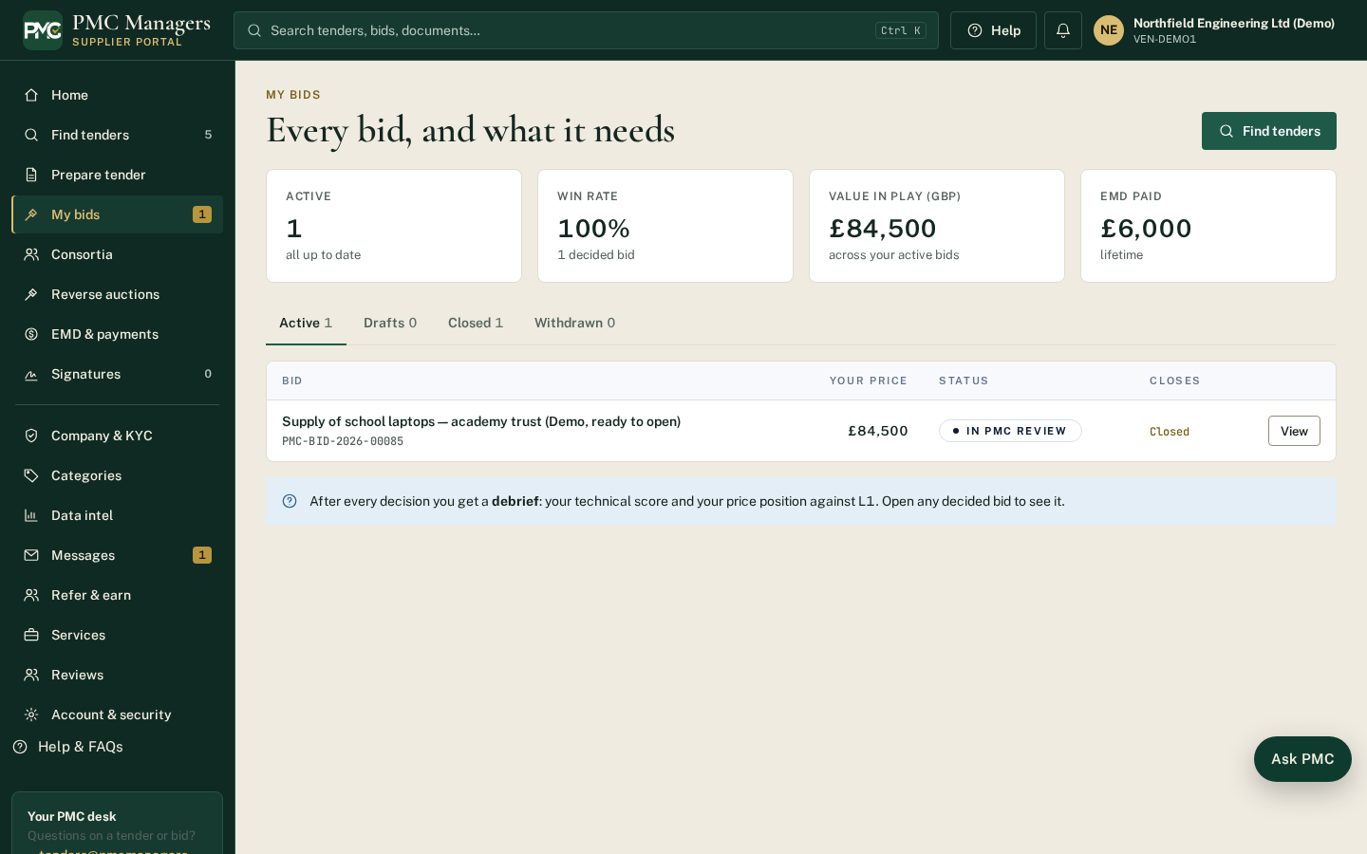
All of the supplier's bids with status, criteria result notices and award documents.
Main actions
• Open a bid workspace
• Read your result notice

Consortia
Screen: /vendor/consortia
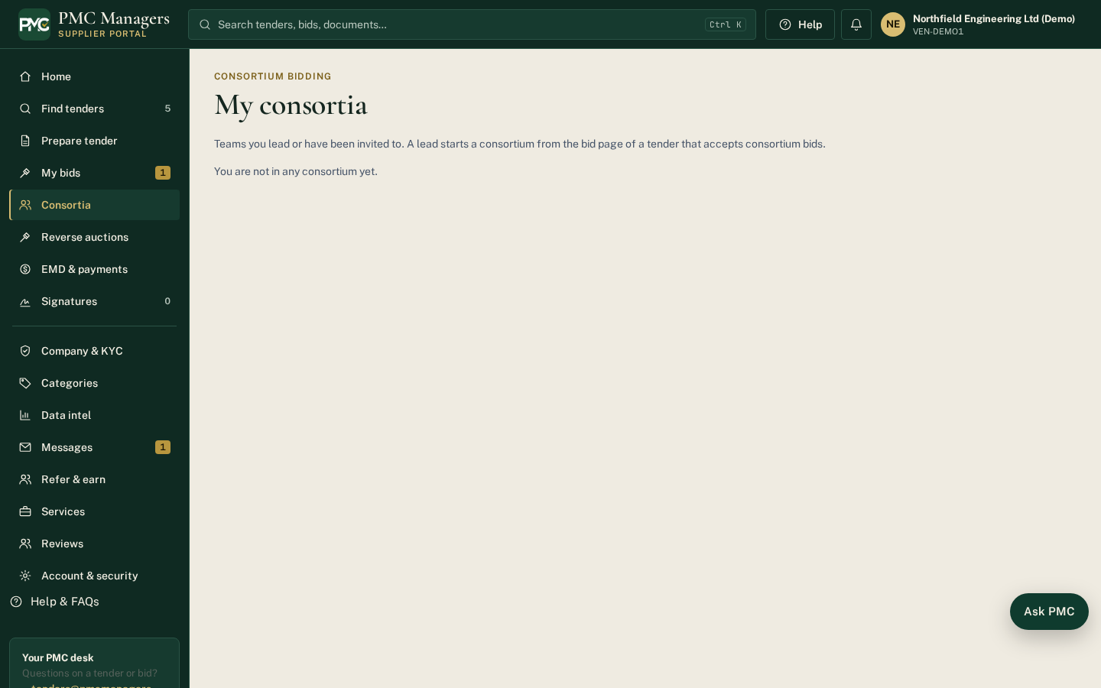
Consortium invitations, teams, shares, agreement signatures and member payouts.
Main actions
• Accept / decline an invitation
• Sign the agreement
• See your payout and bank reference

EMD & payments
Screen: /vendor/emd
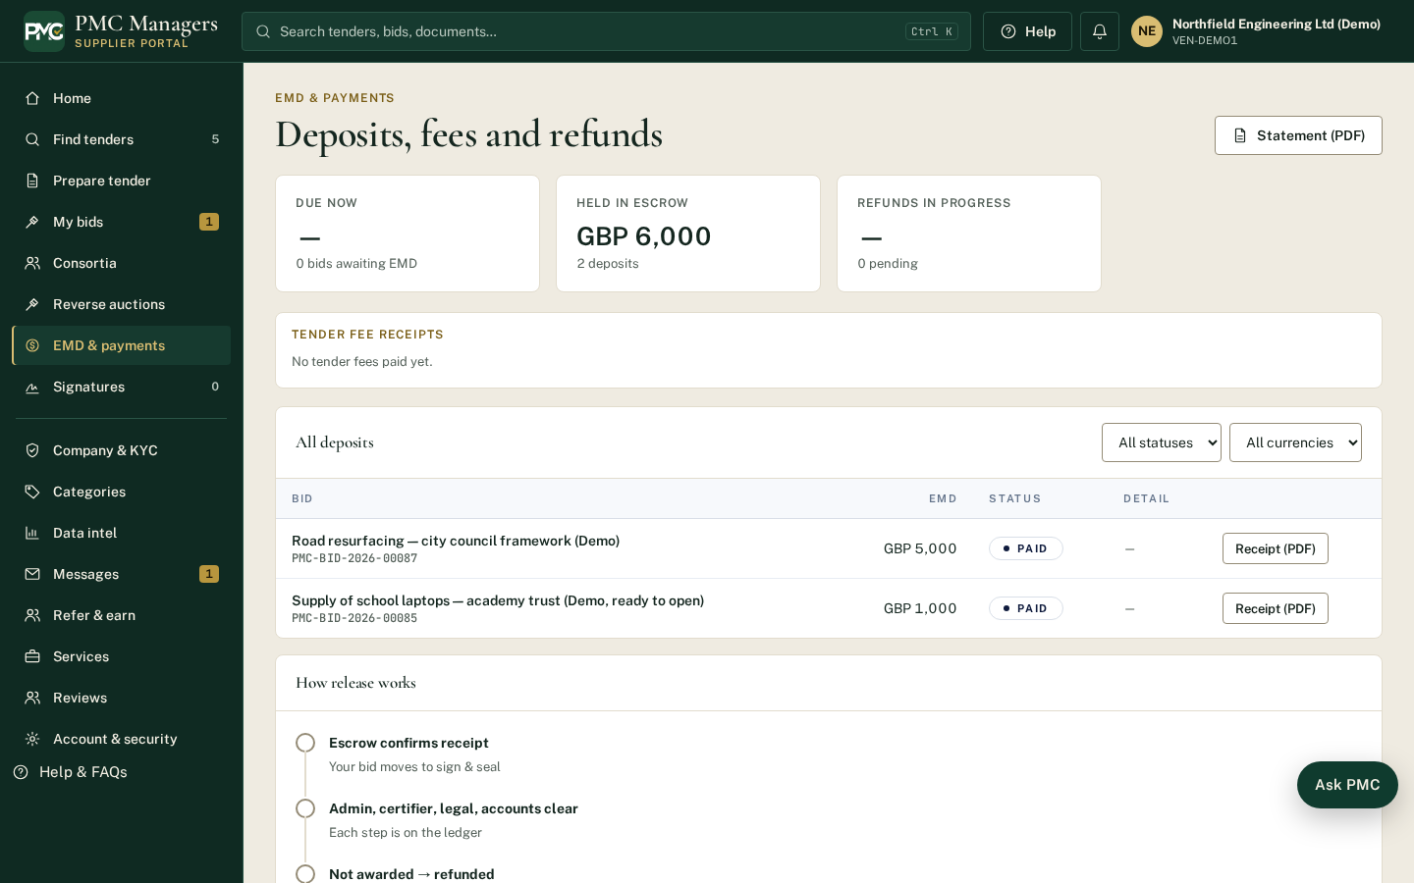
Bid deposits paid into escrow and refunds.
Main actions
• Pay EMD
• Track refunds

Company profile & KYC
Screen: /vendor/company
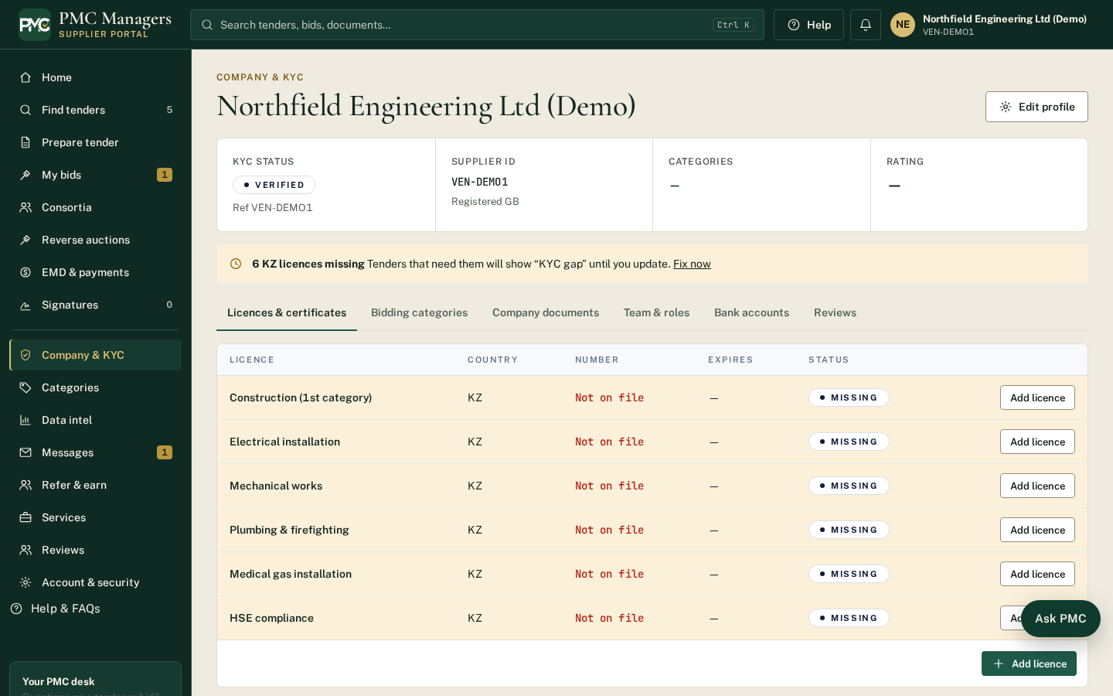
Company details, documents and KYC. Some figures here (like turnover) pre-fill criteria answers.
Main actions
• Update details (changes are reviewed)
• Upload KYC documents

Prepare tender (supplier)
Screen: /vendor/tender-builder
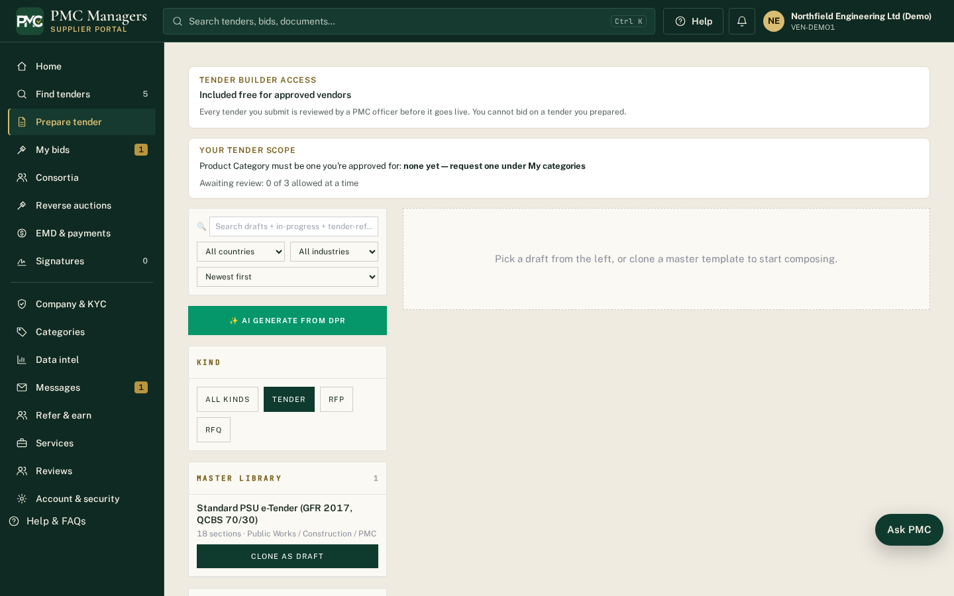
Verified suppliers can prepare tenders for buyers; they go to PMC review before publishing.
Main actions
• Build a tender
• Set criteria
• Submit for review

Alerts
Screen: /vendor/alerts
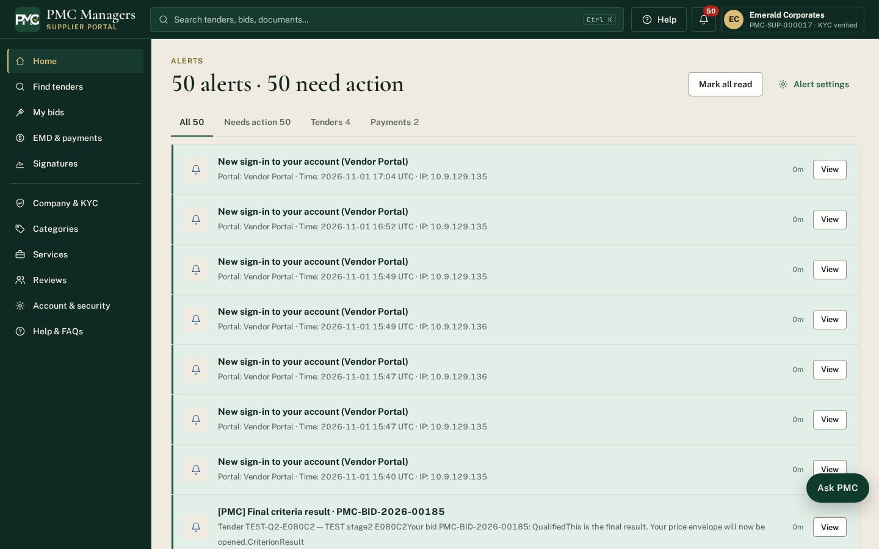
Tender alerts and notifications for the supplier's categories.
Main actions
• Mark as read
• Open the tender

Messages
Screen: /vendor/messages
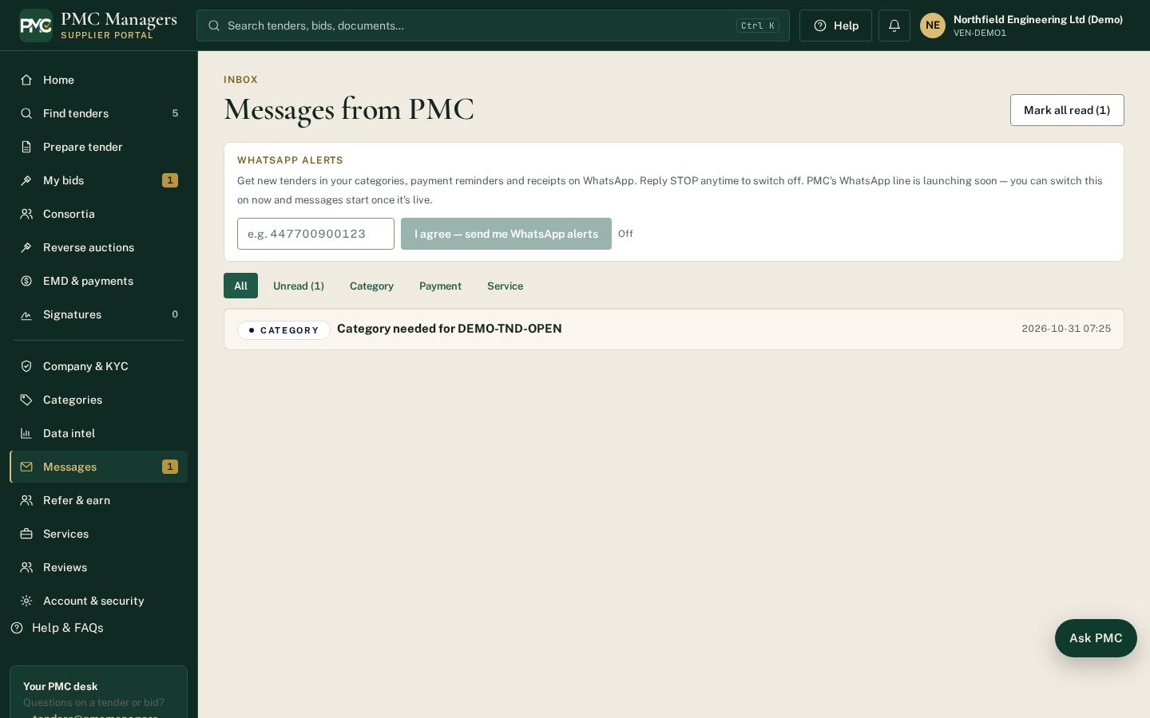
Messages with PMC and buyers, including clarifications.
Main actions
• Reply to a message

Signatures
Screen: /vendor/signatures
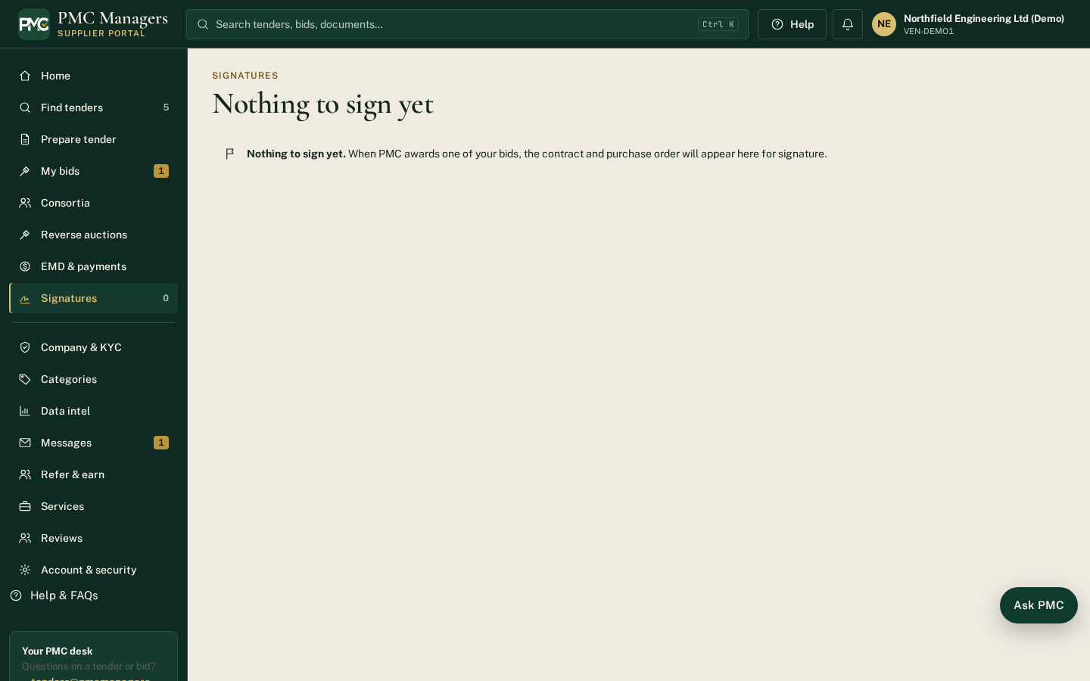
Documents waiting for the supplier's e-signature (agreements, contracts).
Main actions
• Sign a document

Reverse auctions
Screen: /vendor/auctions
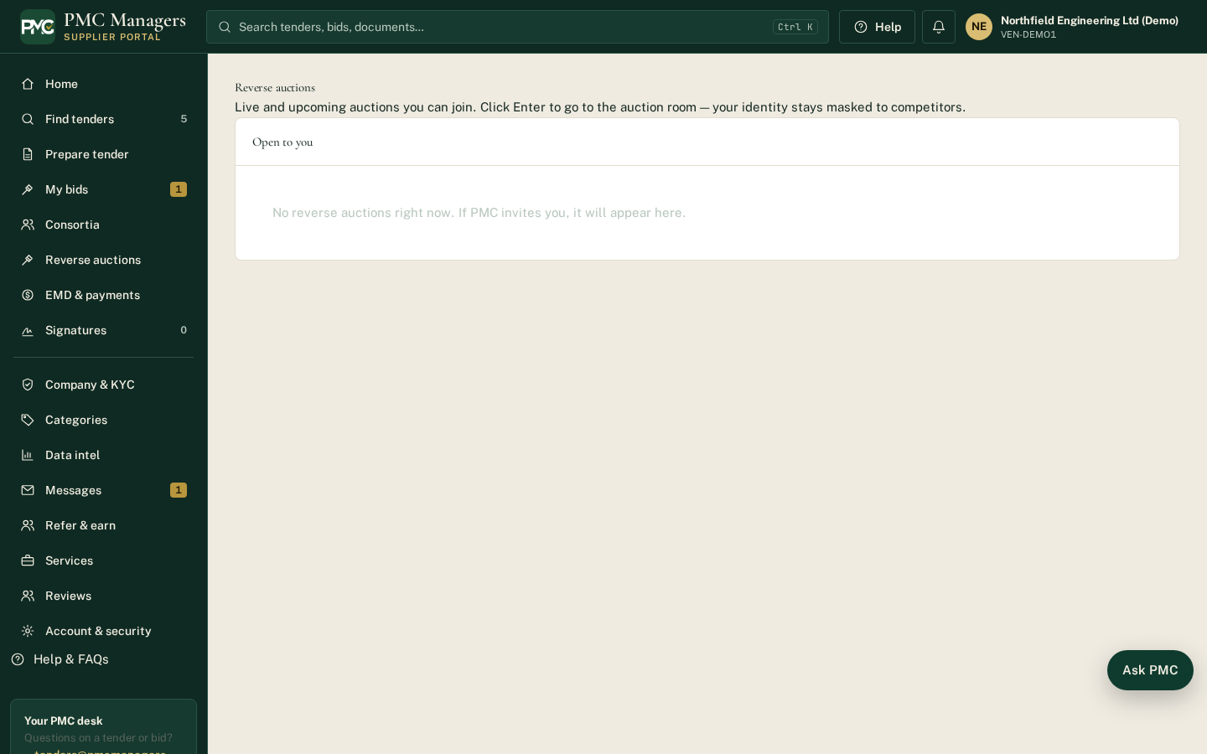
Auctions the supplier is invited to, with live bidding.
Main actions
• Join an auction
• Place a lower bid

Categories
Screen: /vendor/categories
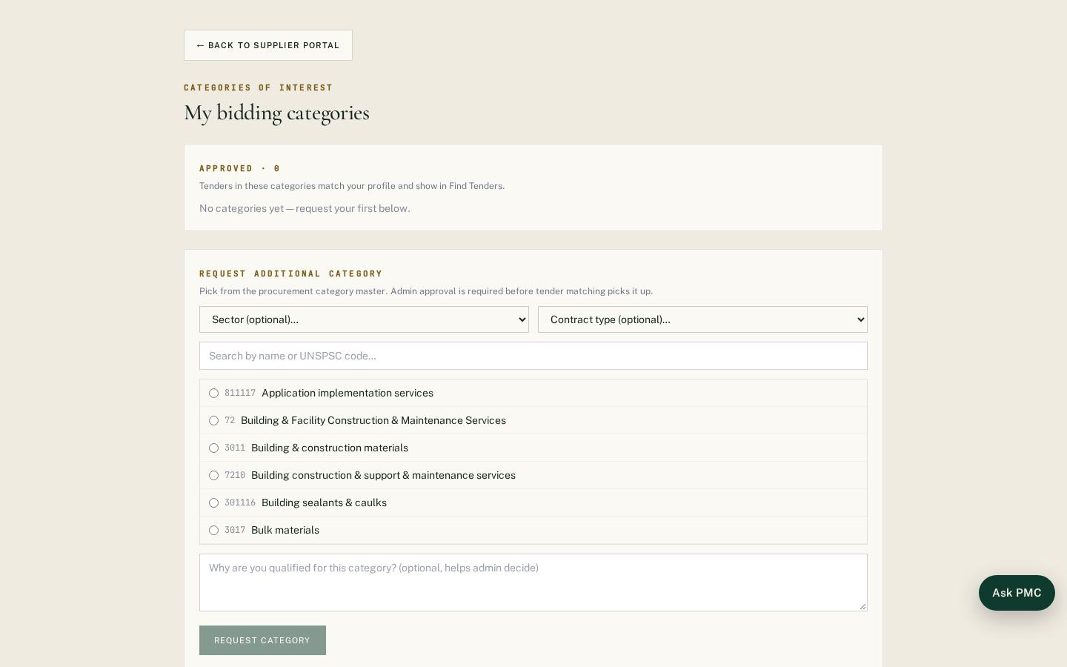
The categories the supplier works in; drives tender matching and alerts.
Main actions
• Request a new category

Account & security
Screen: /vendor/account
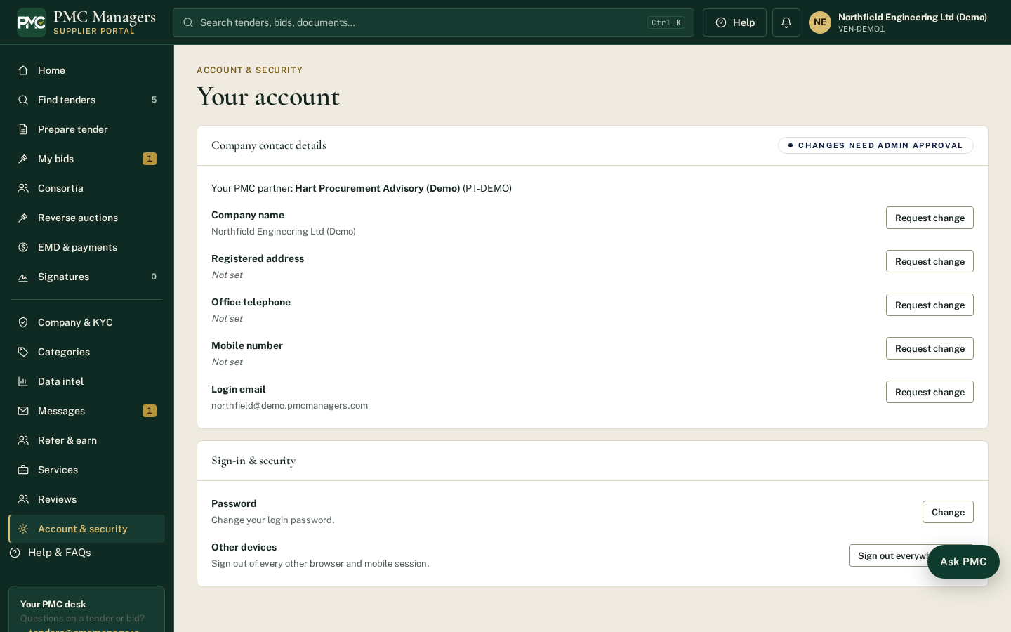
Login email, password, phone and security settings.
Main actions
• Change password
• Update contact details

Sell products
Screen: /vendor/market
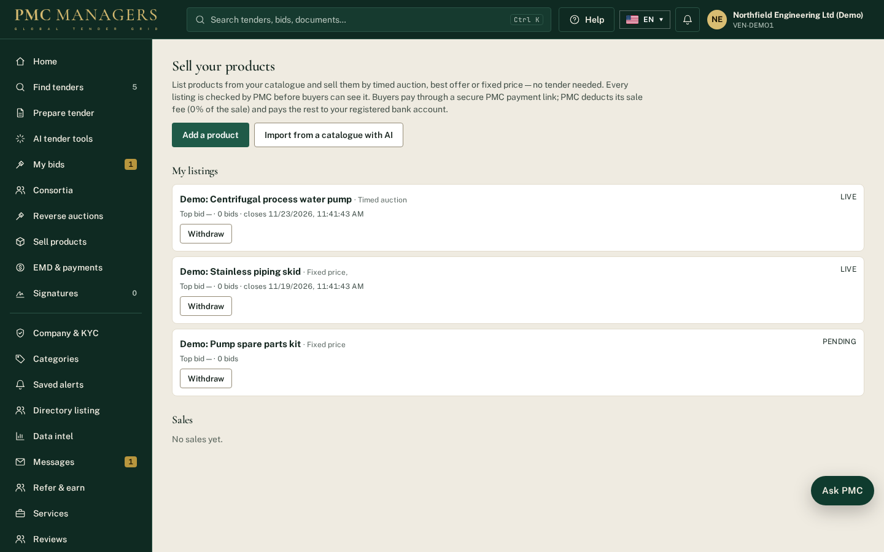
Suppliers add products with photos and PDF spec sheets, choose how to sell each one and submit it for PMC approval.
Main actions
• Add a product
• Upload photos and spec sheets
• Submit for approval

Import from a catalogue with AI
Screen: /vendor/market
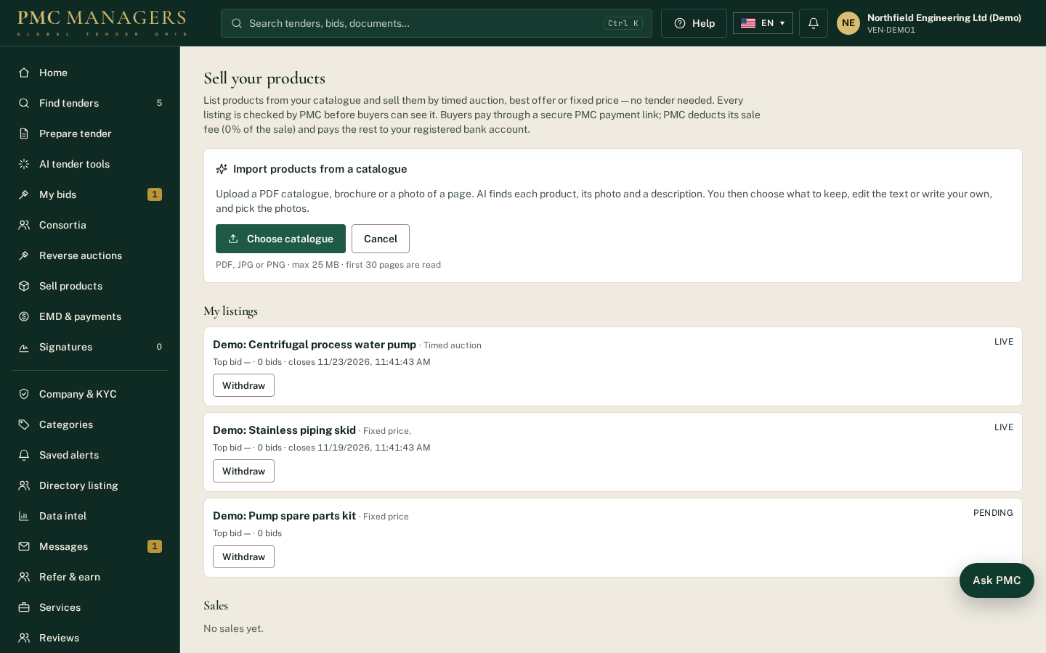
Upload a PDF catalogue, brochure or photo of a page. AI lists each product with its photo, description and specifications; the supplier picks what to keep, edits or writes the text and chooses the photos.
Main actions
• Choose catalogue
• Keep or untick products
• Create draft listings

Sell products — sales & delivery
Screen: /vendor/market
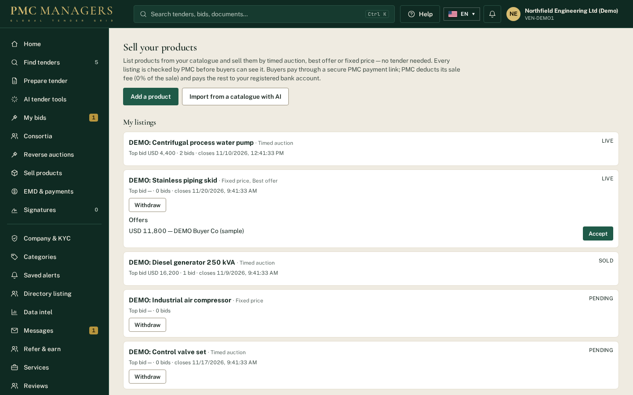
Sold items show the buyer, amount, PMC fee, your net amount, payment and payout status. For paid orders mark Dispatched and Delivered (with a tracking note); the buyer is notified.
Main actions
• Mark dispatched
• Mark delivered

6 · Buyer portal — screen tour

Sign in as a buyer
Screen: /login?role=buyer
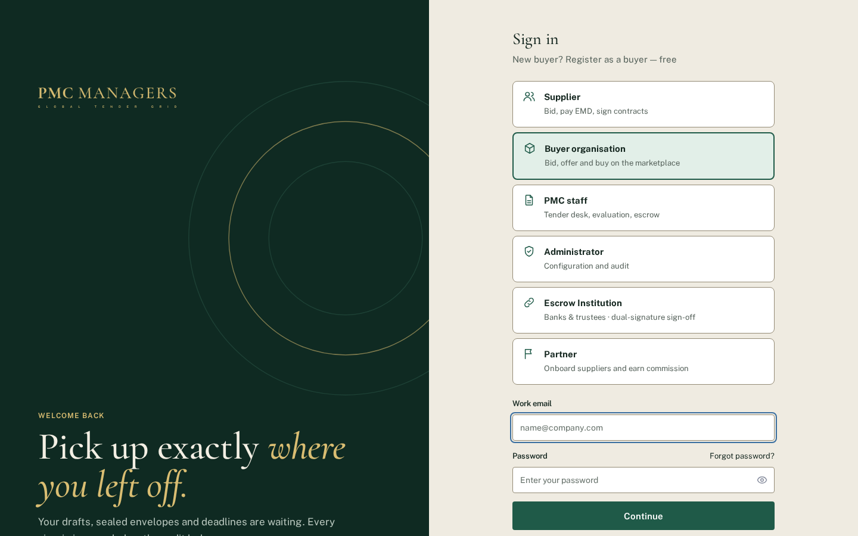
Buyers sign in with the Buyer organisation card. New buyers use 'Register as a buyer — free'. Forgot password also has a Buyer option.
Main actions
• Sign in
• Register as a buyer — free
• Forgot password

Register as a buyer — free
Screen: /buyers/register
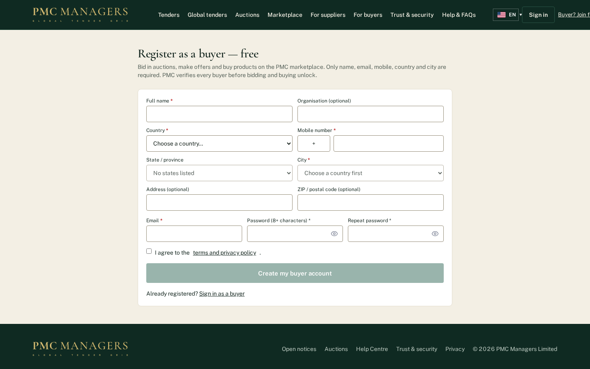
Name, email, mobile, country and city are required; state, address, ZIP and organisation are optional. Country, state, city and phone code come from the PMC masters. The buyer confirms their email, then PMC verifies the account before bidding and buying unlock.
Main actions
• Fill the required fields
• Create my buyer account
• Confirm the email link

Buyer dashboard
Screen: /buyer
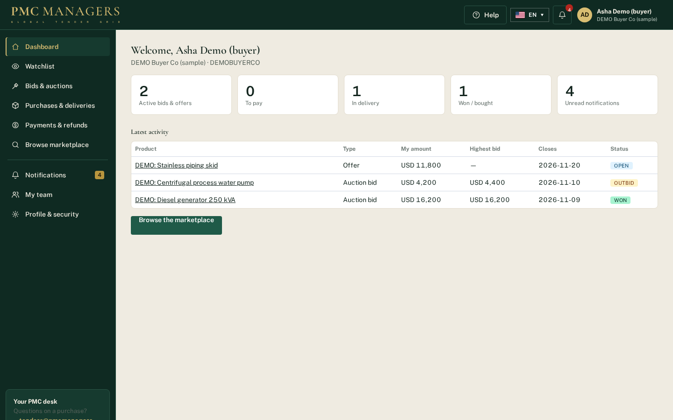
Left sidebar, top header with notification bell and avatar menu, and footer. Tiles show active bids and offers, orders to pay, orders in delivery, wins and unread notifications.
Main actions
• Open a tile
• Browse the marketplace
• Open the avatar menu

Avatar menu
Screen: /buyer
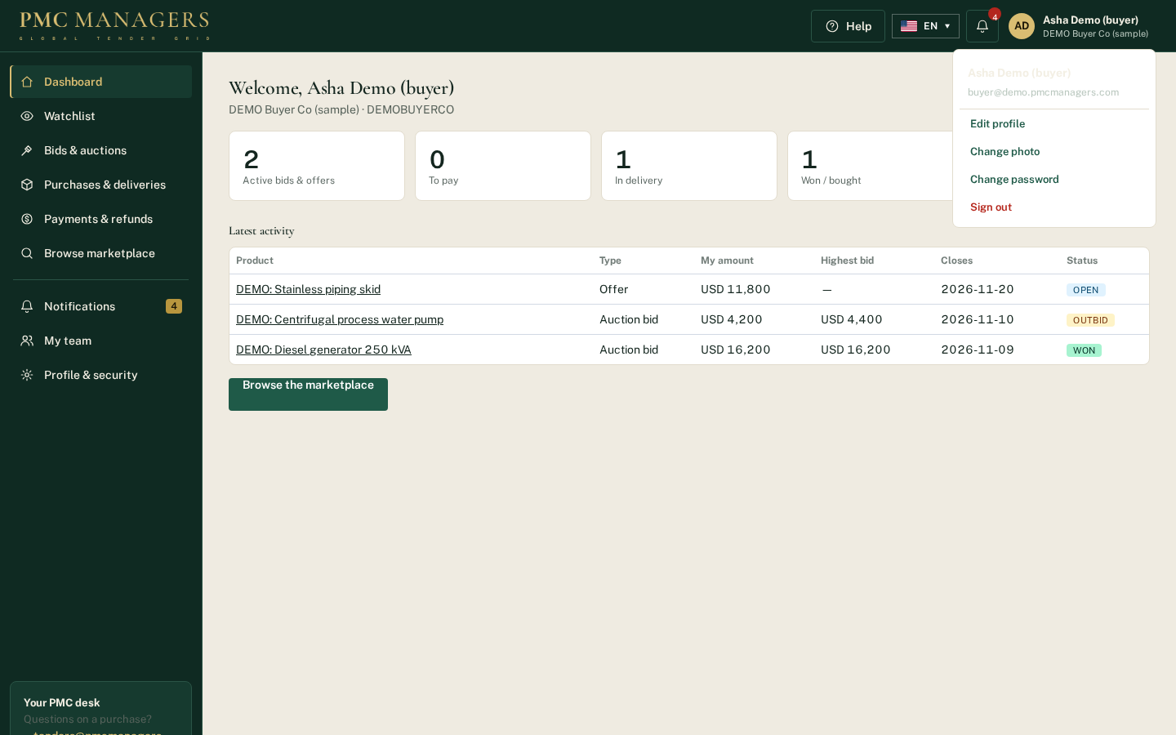
Edit profile, change the profile photo, change password and sign out.
Main actions
• Edit profile
• Change photo
• Change password
• Sign out

Watchlist
Screen: /buyer/watchlist
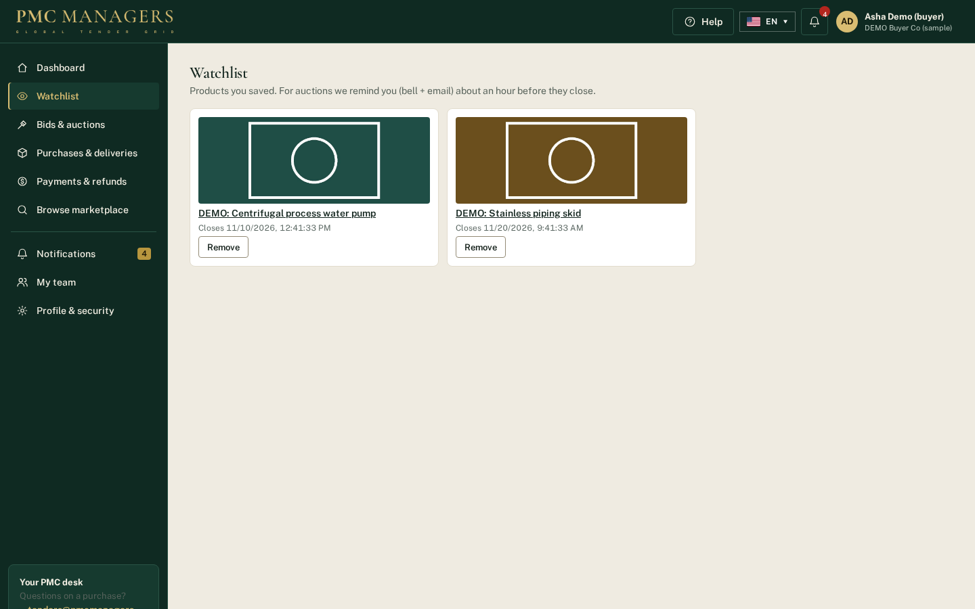
Products the buyer saved with the ♡ Save button. For auctions a reminder (bell + email) is sent about an hour before closing.
Main actions
• Open a product
• Remove from watchlist

Bids & auctions
Screen: /buyer/bids
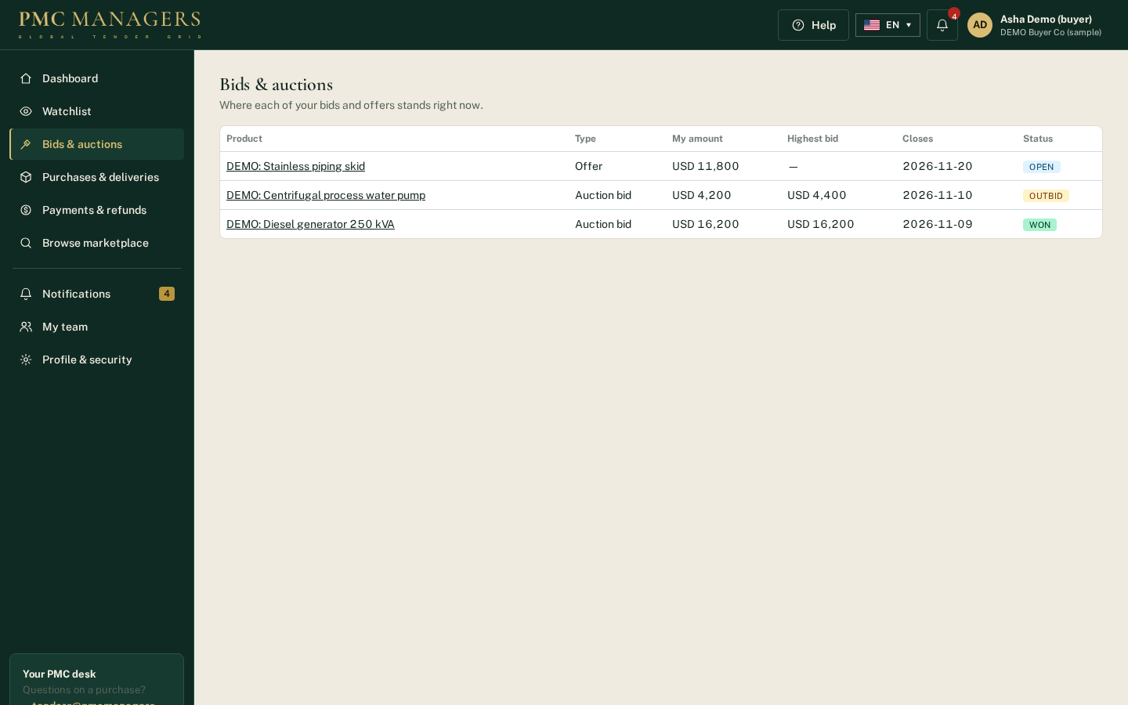
Every bid and offer with its live status: Leading, Outbid, Won, Lost; offers show Open, Accepted or Declined.
Main actions
• Open the product to raise a bid

Purchases & deliveries
Screen: /buyer/orders
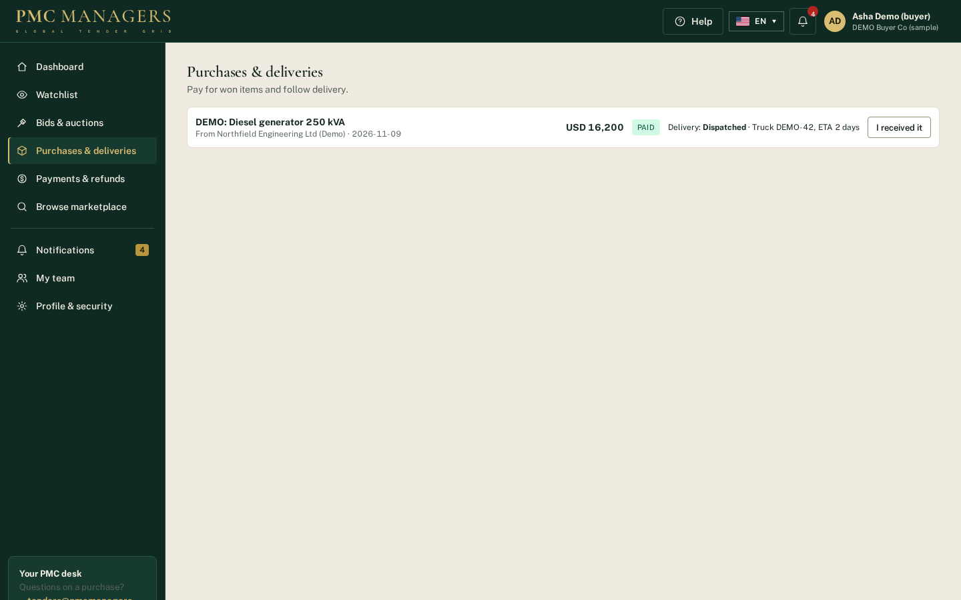
Won and bought items. Pay securely for items awaiting payment, follow the delivery status set by the seller and confirm 'I received it'.
Main actions
• Pay securely
• I received it

Payments & refunds
Screen: /buyer/payments
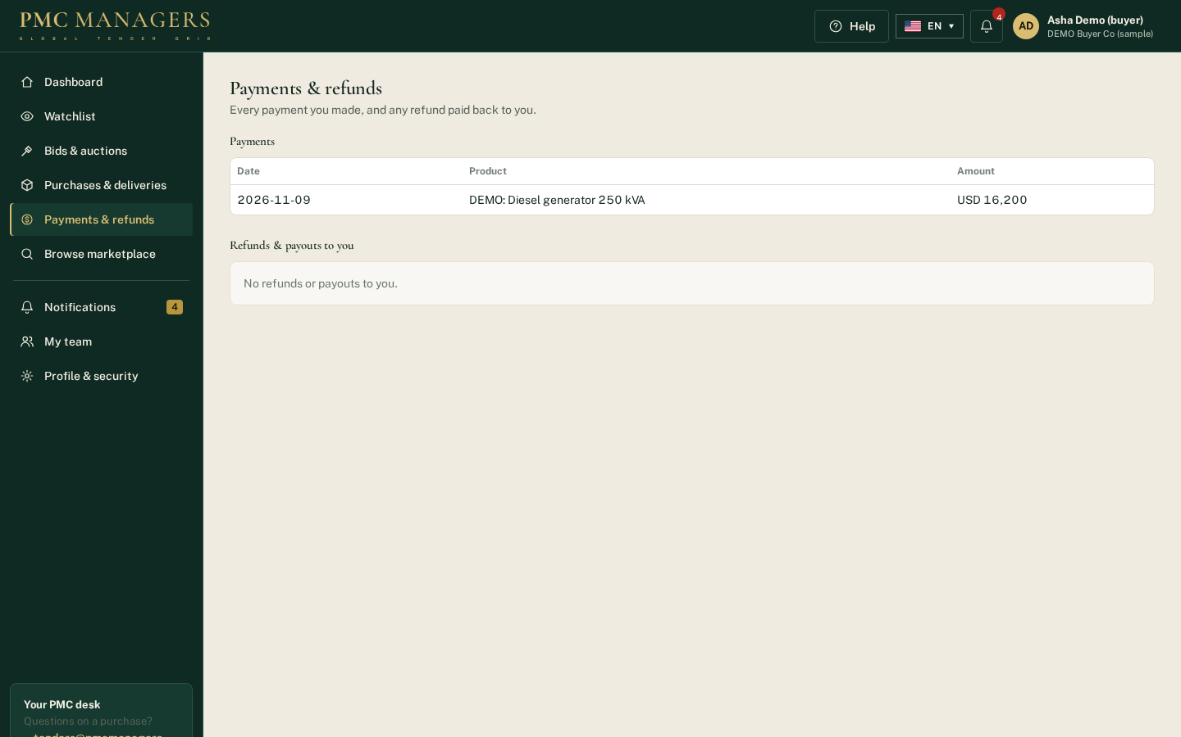
Every payment made and any refund or payout back to the buyer.
Main actions
• Review payments

Notifications
Screen: /buyer/notifications
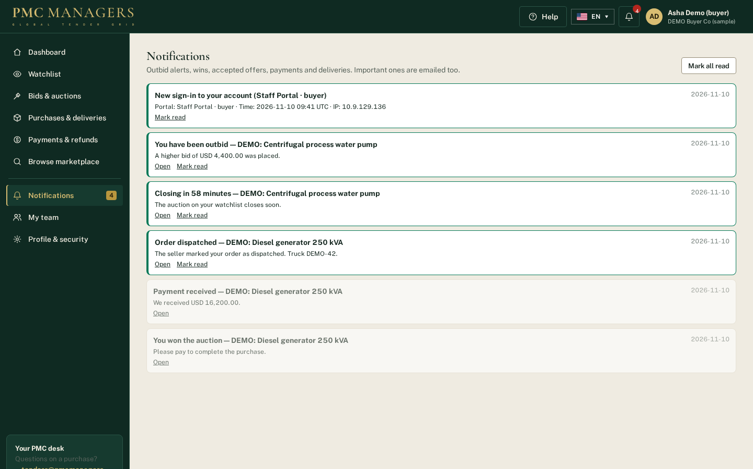
Outbid alerts, closing reminders, wins, accepted offers, payments and deliveries. Important ones are also emailed.
Main actions
• Open
• Mark read
• Mark all read

My team
Screen: /buyer/team
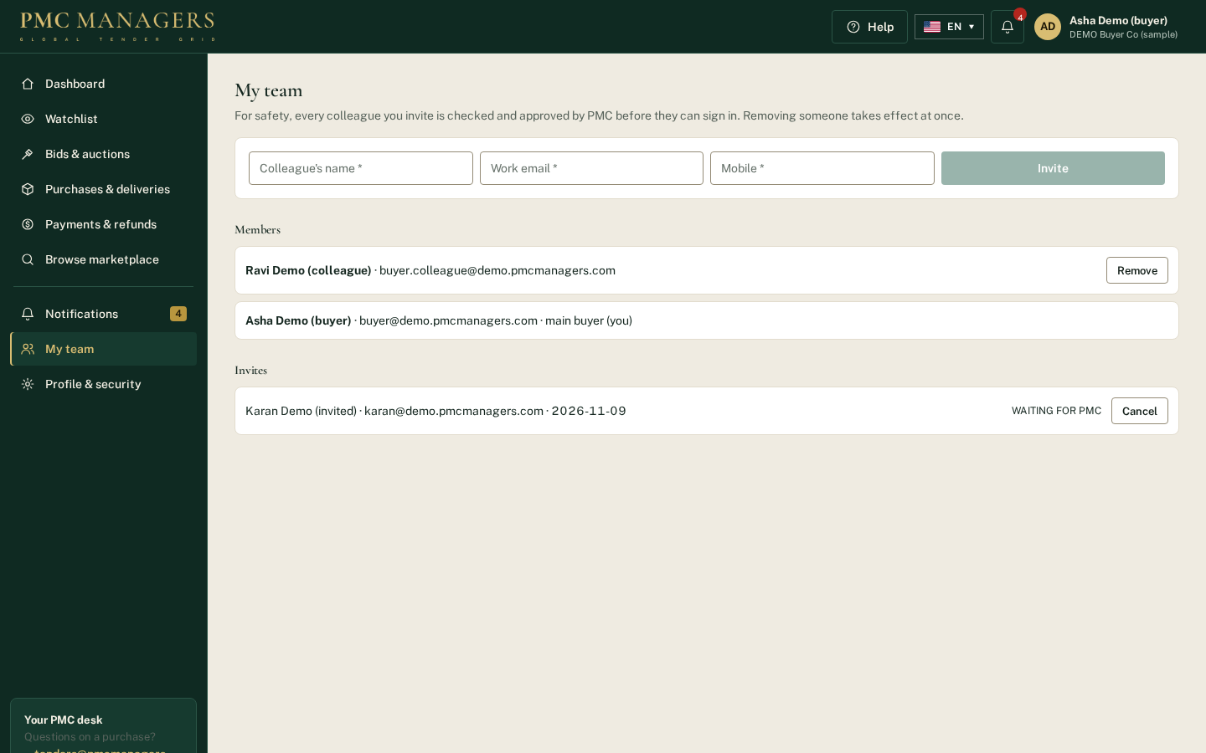
The organisation's main buyer invites colleagues; every invite is approved by PMC before the colleague can sign in. Removing a colleague stops access at once.
Main actions
• Invite a colleague
• Remove a colleague
• Cancel an invite

Profile & security
Screen: /buyer/profile
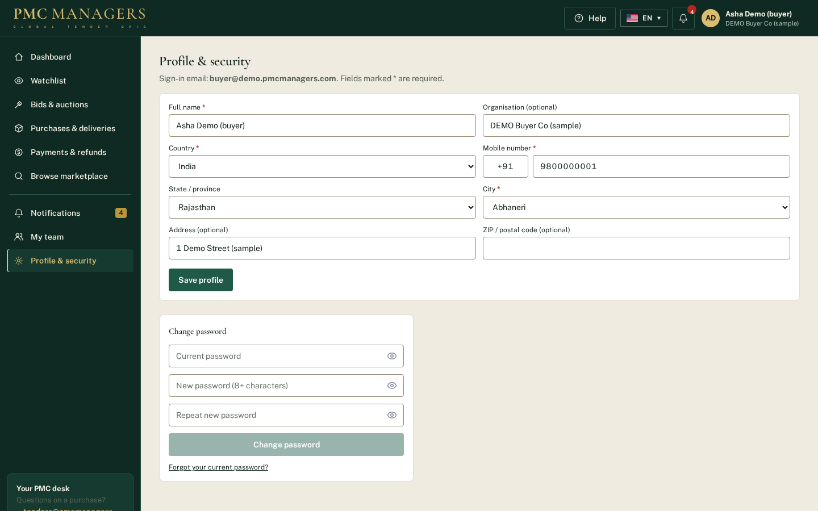
Masters-backed profile (country, state, city, phone code) and password change.
Main actions
• Save profile
• Change password

Marketplace with Save buttons
Screen: /market
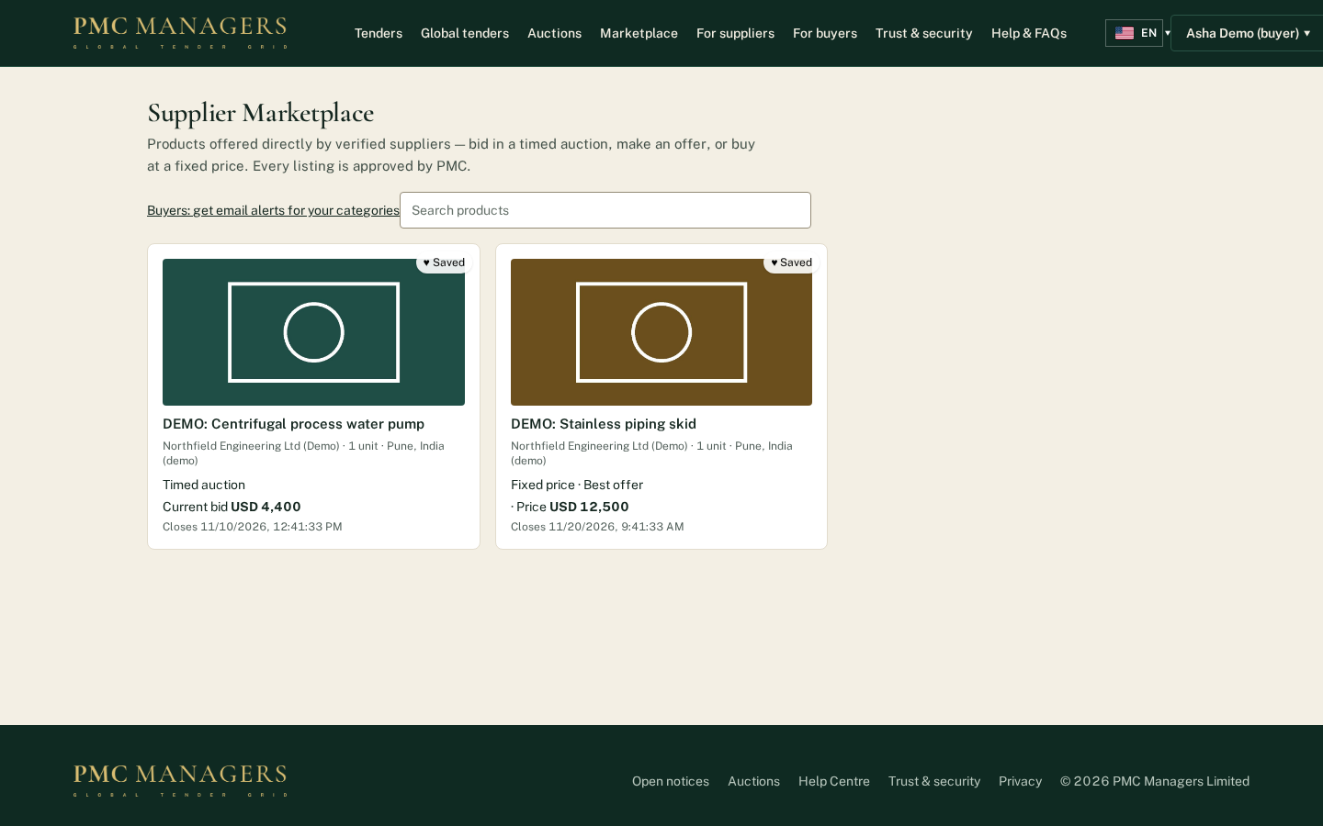
Signed-in buyers see ♡ Save on every product card and their name menu in the site header.
Main actions
• Save a product
• Open a product to bid, offer or buy

7 · Admin console — screen tour

Admin dashboard
Screen: /admin/e/dashboard
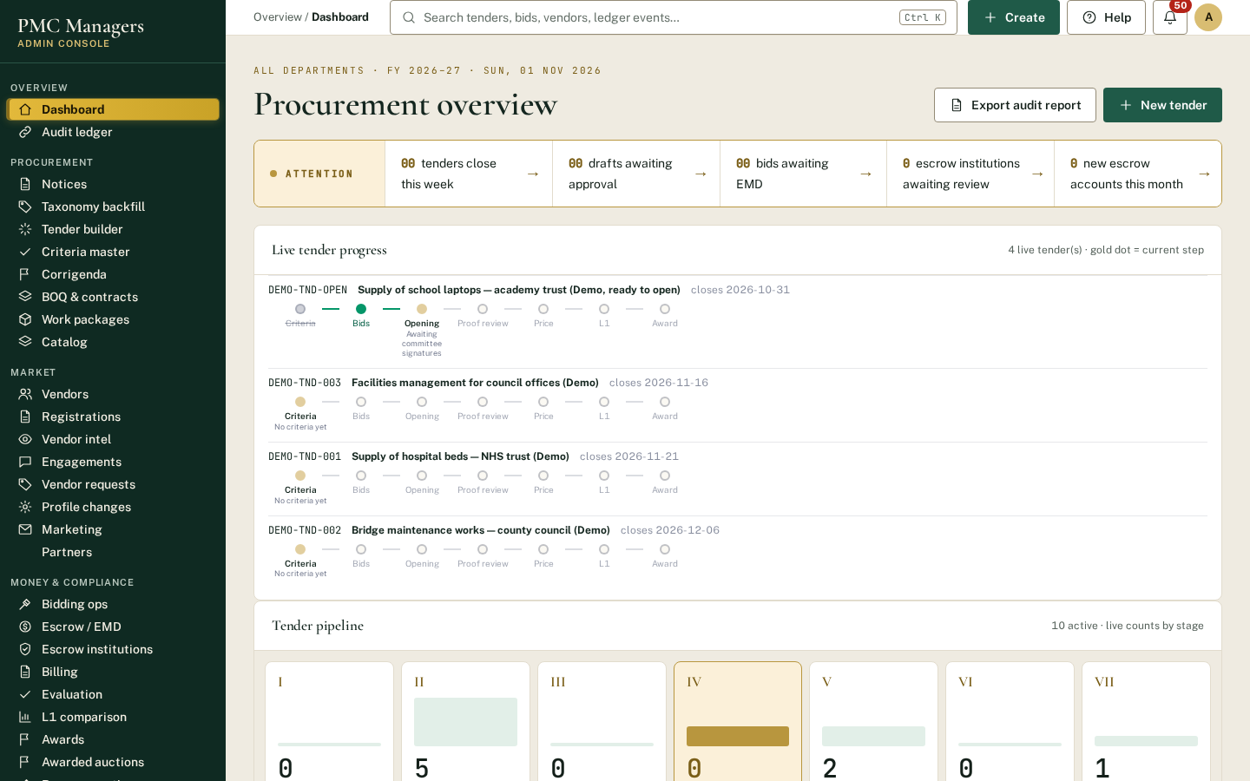
The control room. Attention cards show tenders closing this week, drafts awaiting approval and bids awaiting EMD. 'Live tender progress' shows every live tender's stage line (criteria, bids, opening, proof review, price, L1, award) so stalled tenders stand out.
Main actions
• Click an attention card to jump to the list
• Open a tender from Live tender progress
• Create a new tender

Notices
Screen: /admin/e/notices
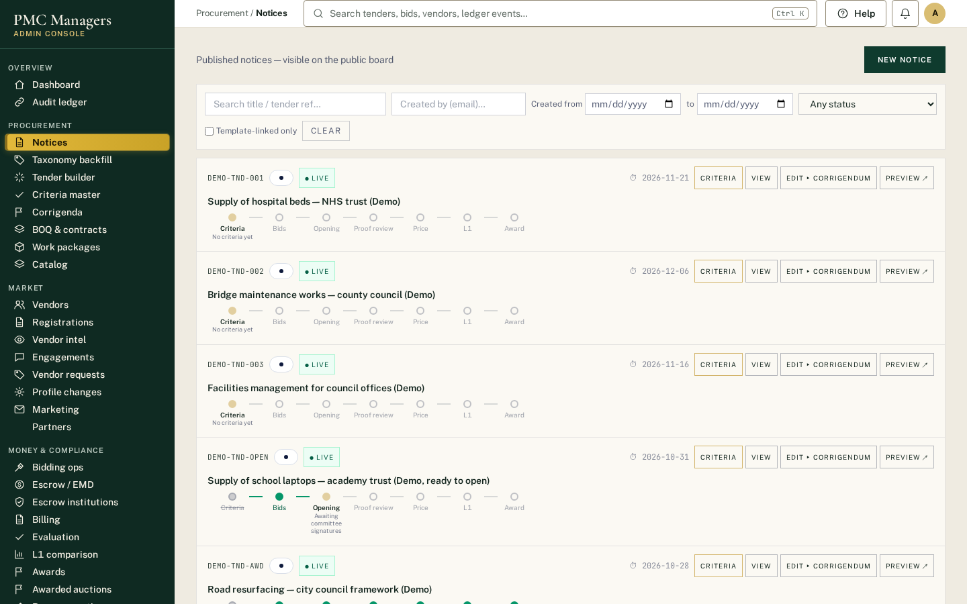
All tenders (draft and live). Each row has the progress tracker, Criteria, View, Edit/Corrigendum and Preview. Draft rows show the 'Ready to publish?' checklist (document, dates, a must-pass criterion) with its own Publish button.
Main actions
• New notice (the Criteria window opens after Create)
• Criteria: set what bidders must meet
• Publish once the checklist is all ticked

Criteria window
Screen: /admin/e/notices
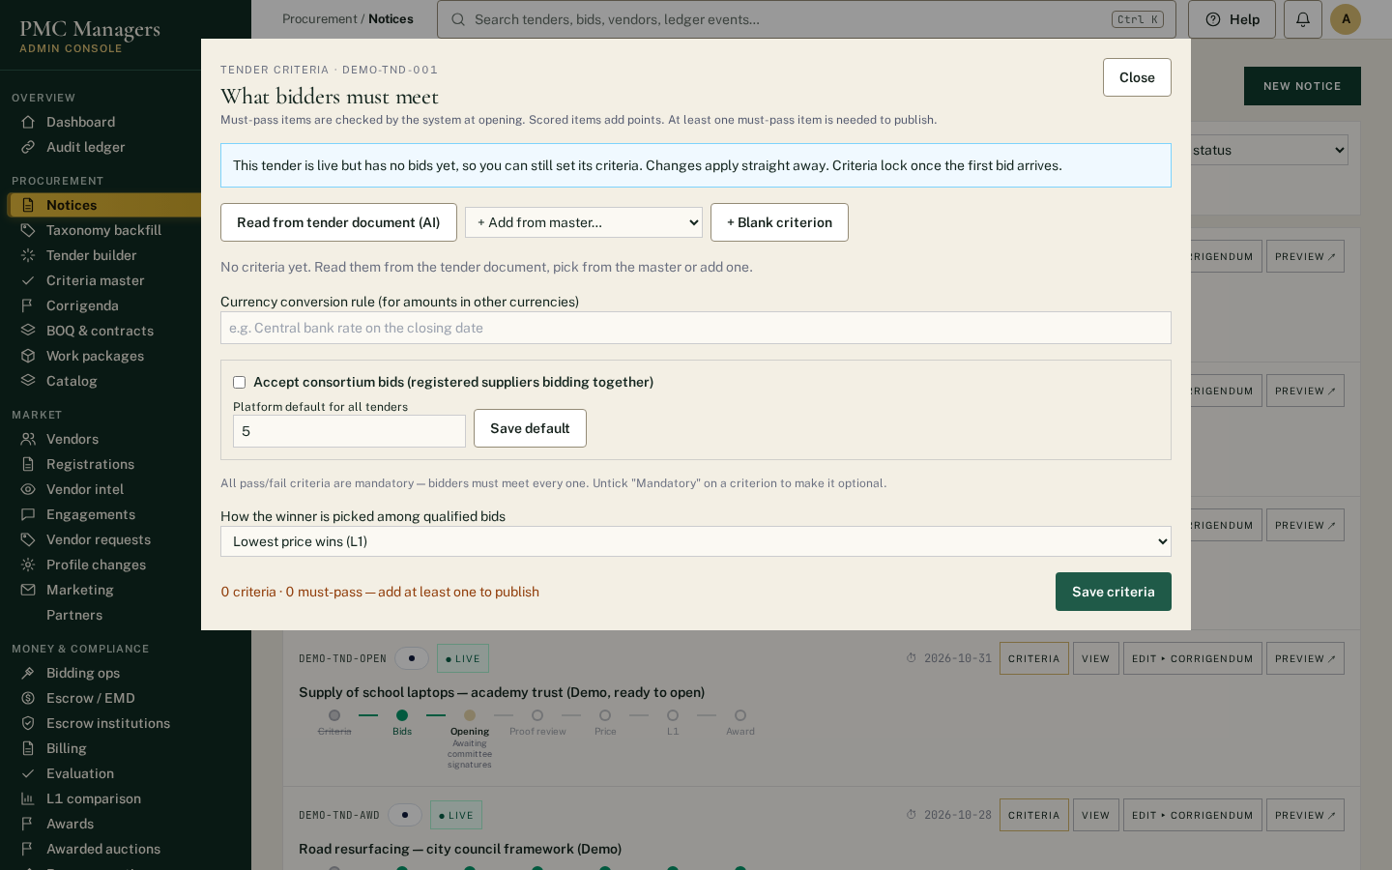
Sets the tender's criteria. Add from the Criteria master or a whole set, read them from the tender document with AI, or add your own. Each criterion is pass/fail or scored, Mandatory or optional, with proof required or not. Also set the minimum optional criteria, consortium rules and how the winner is picked (L1 or weighted).
Main actions
• + Add from master / a criteria set
• Tick Mandatory or leave optional
• Set 'at least N optional criteria'
• Choose L1 or weighted
• Save criteria

Tender builder
Screen: /admin/e/tender-builder
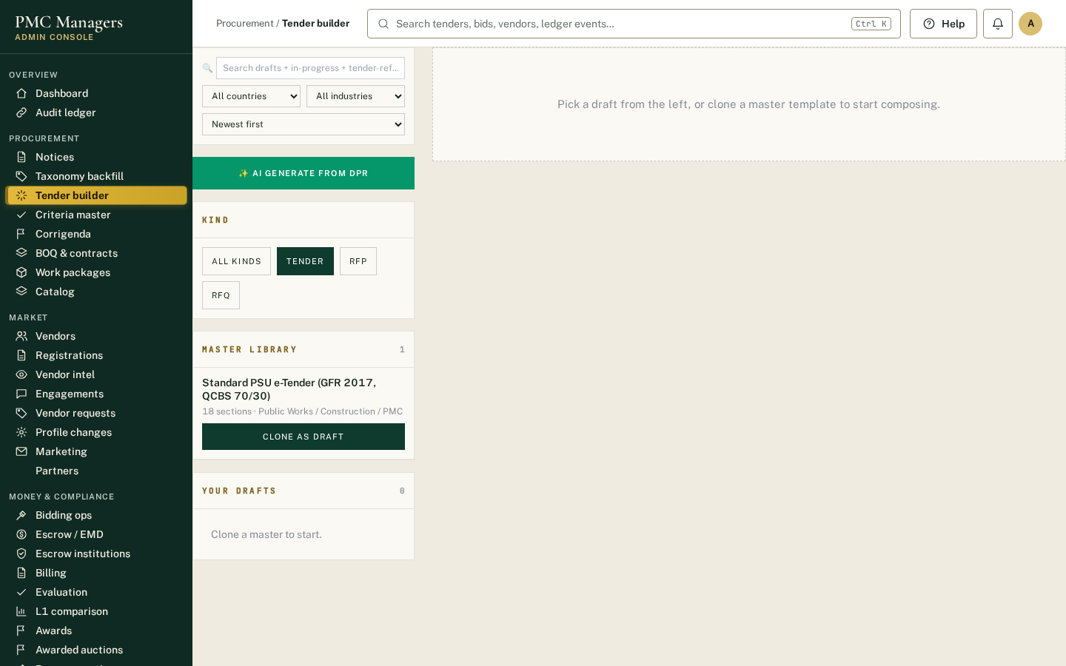
Builds the tender document. Clone a master template or use 'AI generate from DPR' to draft a tender from a project report. Drafts have a Criteria button and 'Create notice' to turn the draft into a notice (criteria come across).
Main actions
• AI generate from DPR
• Clone a master template
• Criteria
• Create notice

Criteria master
Screen: /admin/e/criteria-master
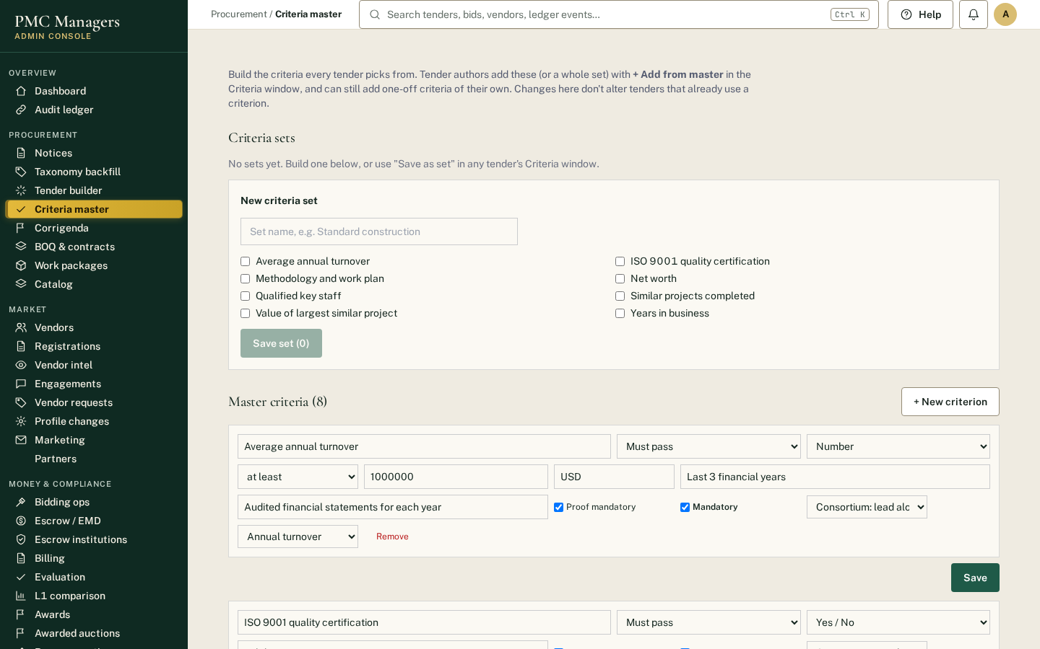
The library every tender picks criteria from. Build master criteria and named sets such as 'Standard construction'. Admins and reviewers can edit; removing archives (nothing is deleted).
Main actions
• + New criterion
• Build a criteria set
• Remove (archive) a criterion or set

Corrigenda
Screen: /admin/e/corrigenda
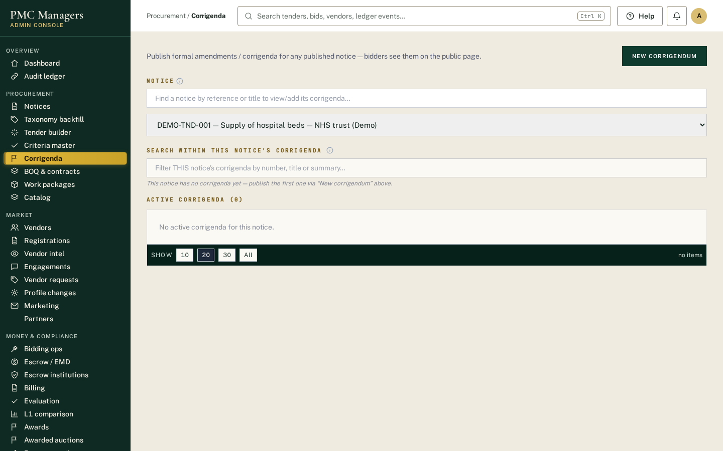
Changes to live tenders. Each corrigendum is dated, described and sent to every bidder and follower.
Main actions
• Issue a corrigendum
• See the history per tender

BOQ & contracts
Screen: /admin/e/boq
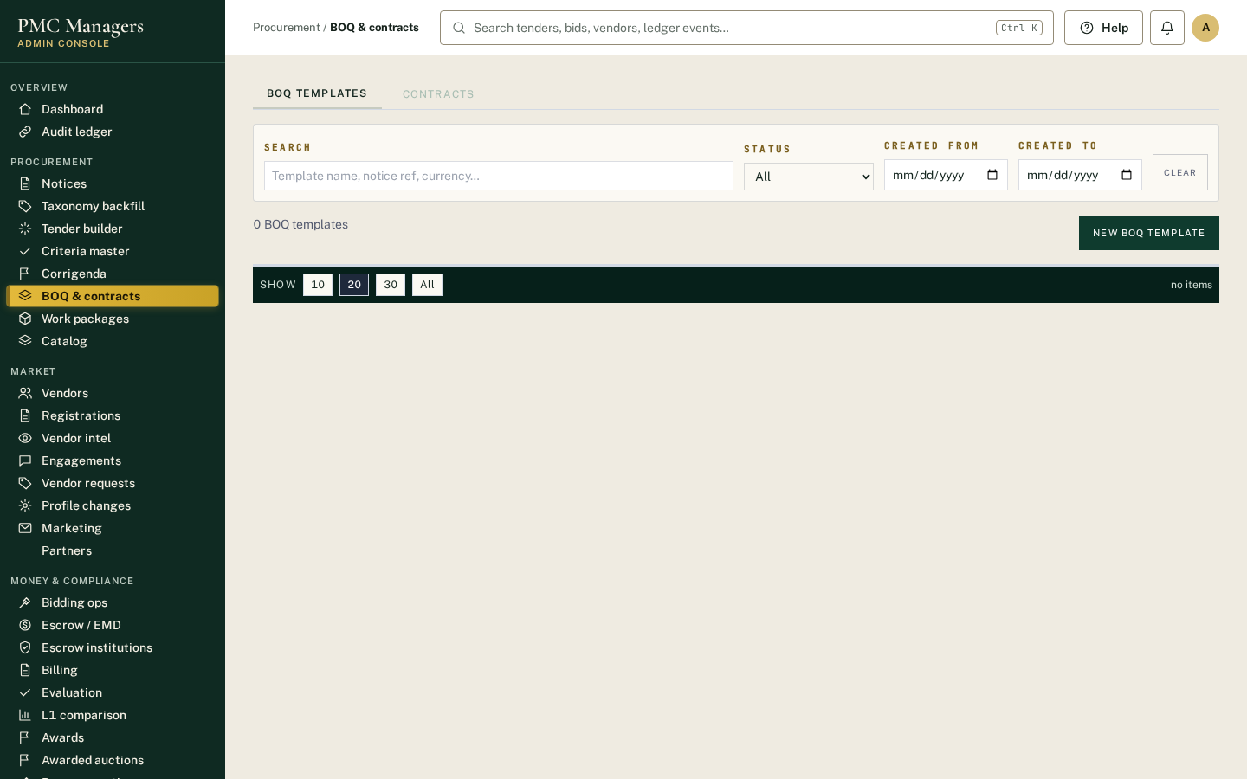
Bills of quantities and contract documents linked to tenders.
Main actions
• Upload or edit a BOQ
• Attach contract documents

Vendors
Screen: /admin/e/vendors
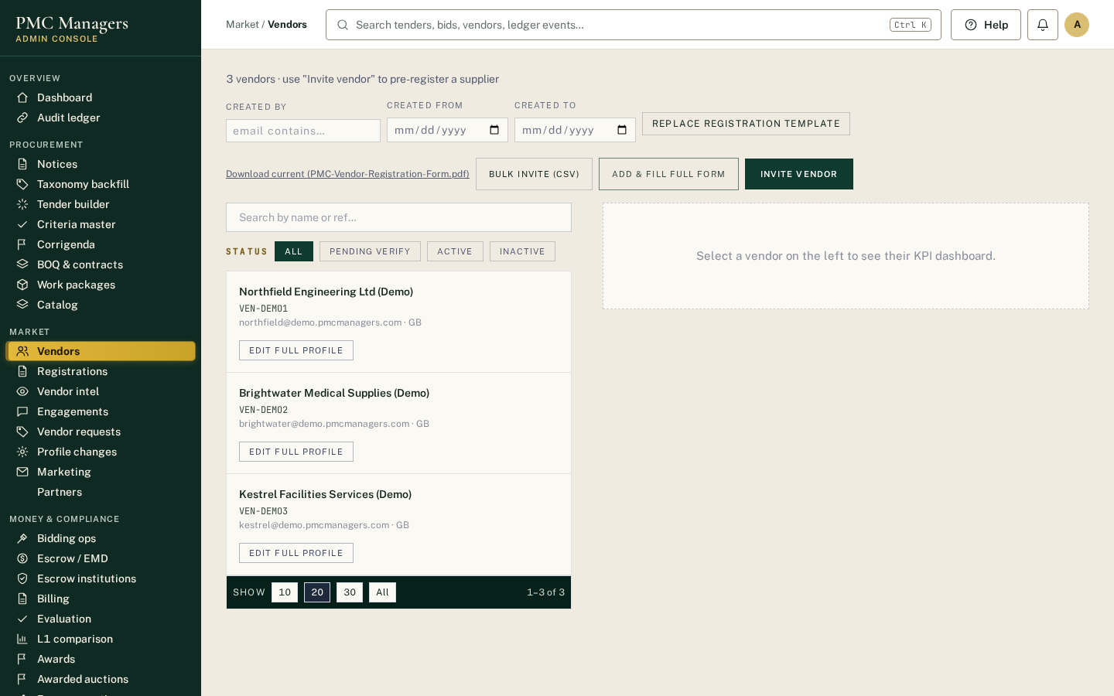
Every registered supplier with KYC status, categories and activity.
Main actions
• Open a supplier profile
• Check KYC status

Registrations
Screen: /admin/e/registrations
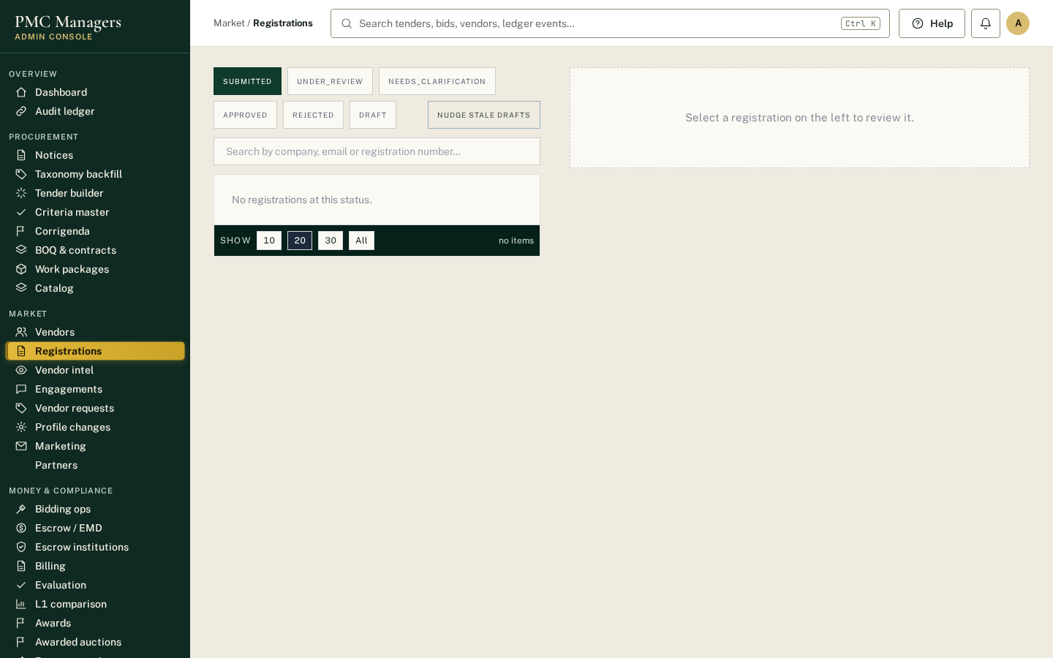
New supplier registrations waiting for KYC review. Approve, ask for clarification or reject with a reason.
Main actions
• Review documents
• Approve / request changes / reject

Partners
Screen: /admin/e/partners
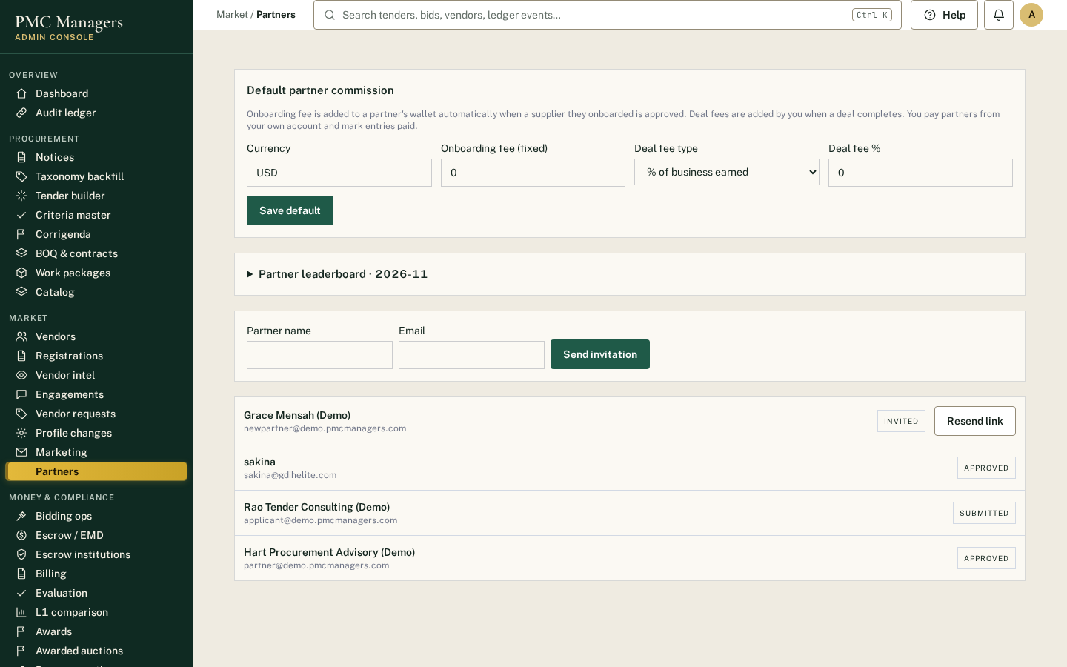
Partners who onboard suppliers and earn commission. Unfinished profiles show 'N of 4 sections complete'. Edit details opens the full 5-section form; resend the invite link; approve.
Main actions
• Invite a partner
• Edit details
• Resend link
• Approve

Bidding ops
Screen: /admin/e/bidding
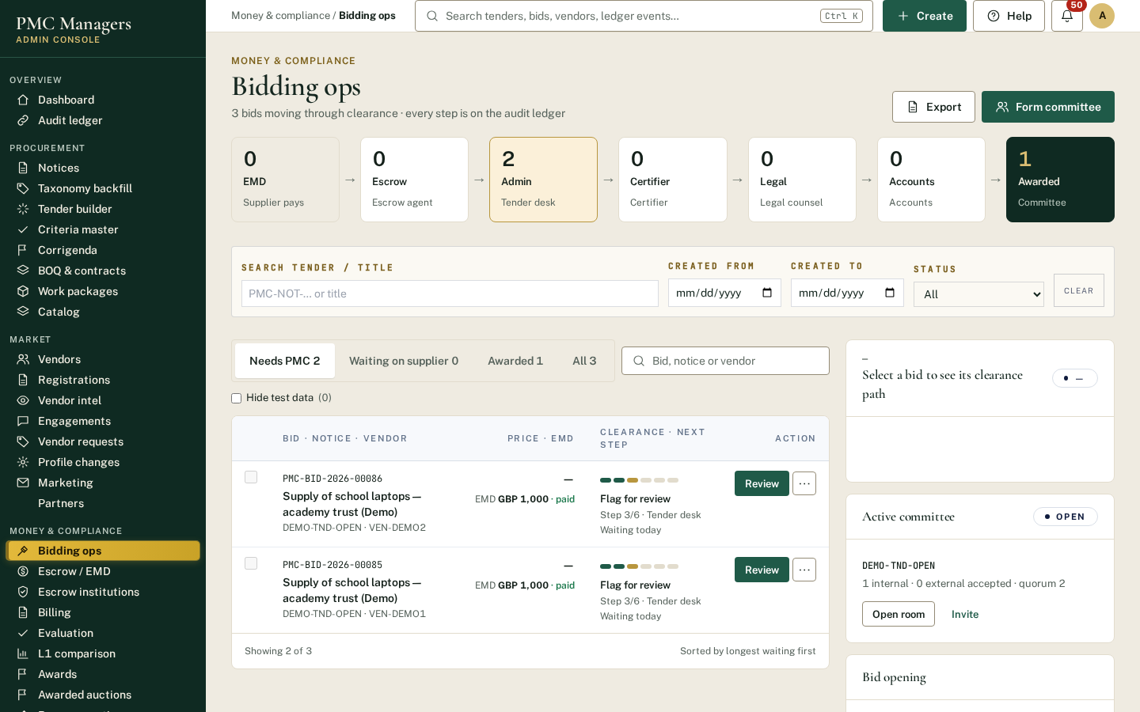
Runs the bid opening. Each tender with a committee shows the opening card: who has signed, blockers, technical opening, the system qualification check with AI proof findings and committee accept/reject, price opening, the automatic L1 ranking and 'Award to L1'.
Main actions
• Committee members approve opening
• Review proofs (accept / reject with comment)
• Raise / resolve a doubt
• Download proof check report
• Award to L1

Escrow / EMD
Screen: /admin/e/escrow
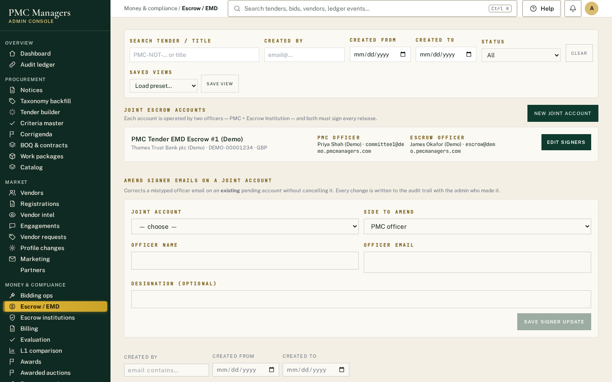
Bid deposits (EMD) and award payments held in escrow, with dual-signed releases and consortium payment instructions.
Main actions
• Confirm EMD received
• Release with two signatures
• Record consortium member payouts and bank references

Evaluation
Screen: /admin/e/evaluation
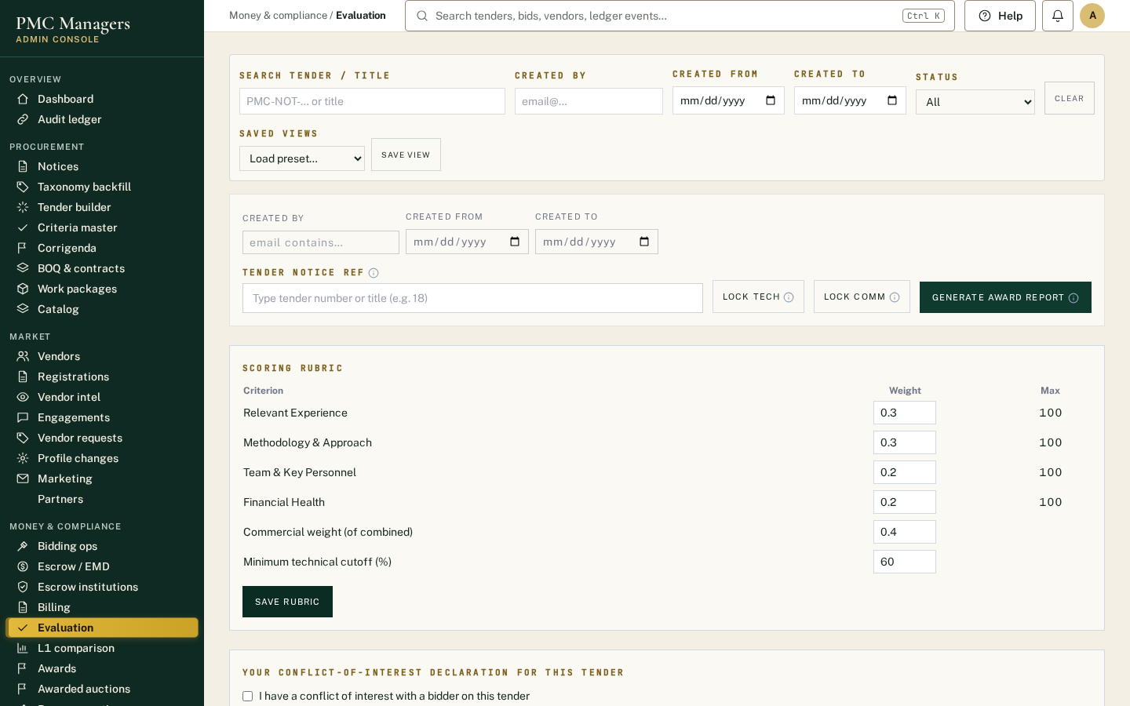
Committee scoring rubric and the Award recommendation report, which follows the tender's rule (L1 or weighted).
Main actions
• Score bids
• Open the award recommendation report

L1 comparison
Screen: /admin/e/l1-award
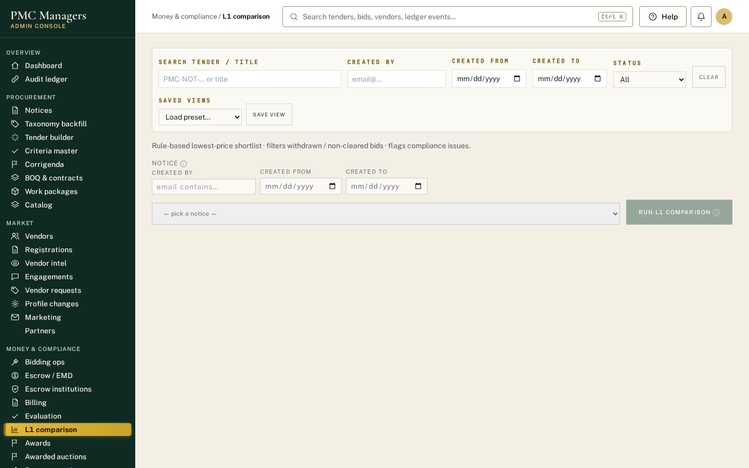
Ranks qualified bids by price (L1, L2, L3) with compliance flags. Runs automatically after price opening and can be re-run here.
Main actions
• Run L1 for a tender
• Check compliance flags

Awards
Screen: /admin/e/awards
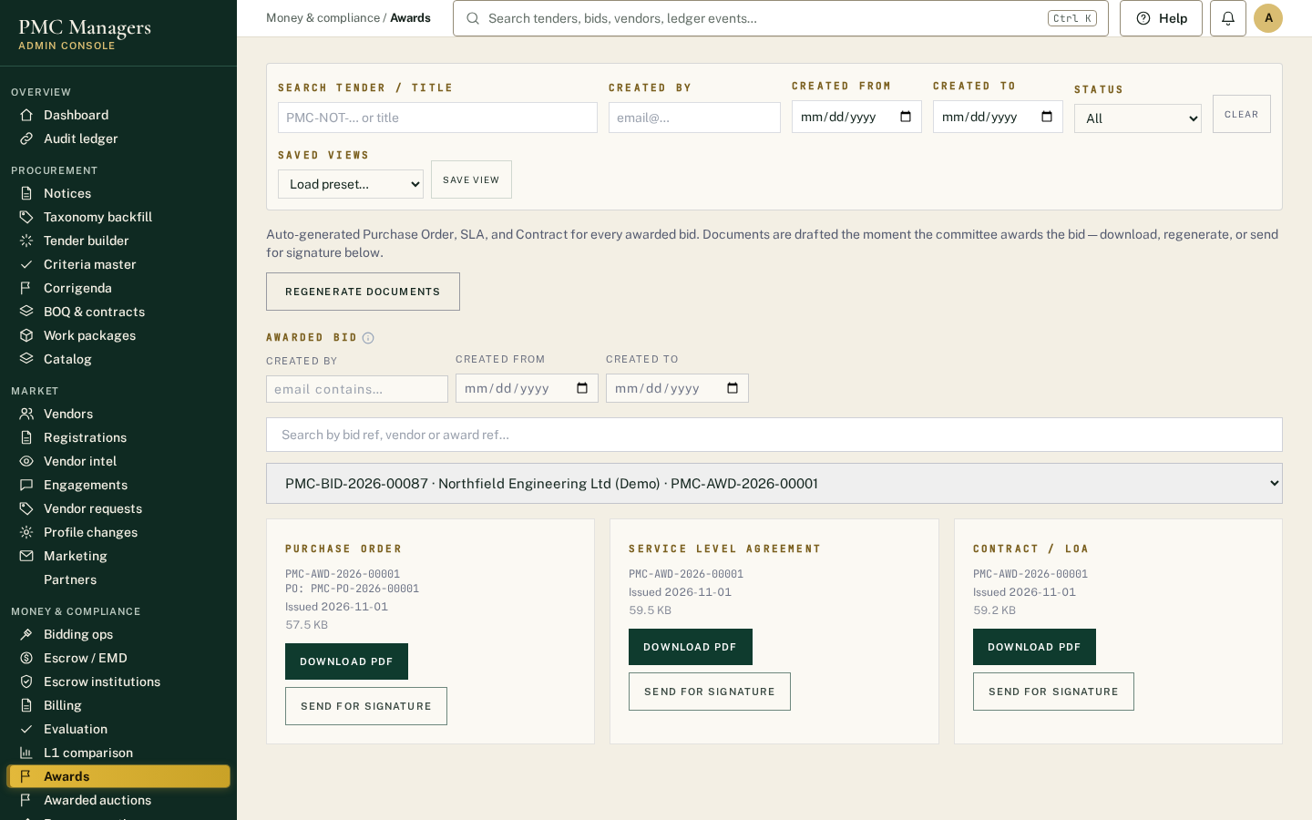
Awarded bids with award letters, contracts and signatures.
Main actions
• Open award letter / contract
• Track signatures

Reverse auctions
Screen: /admin/e/auctions
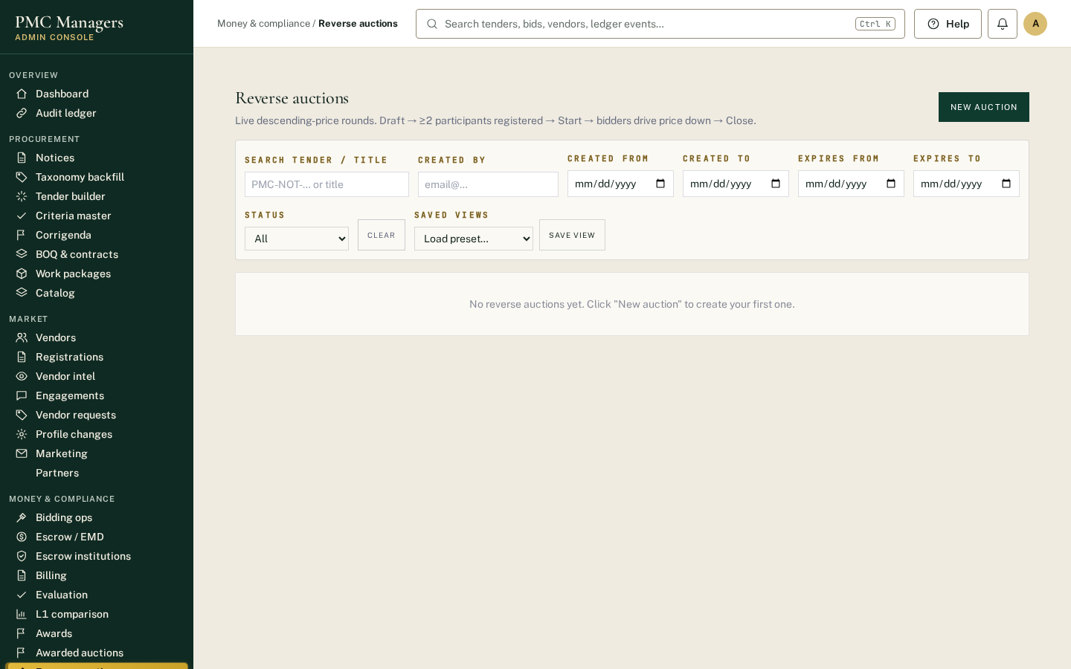
Live reverse auctions where invited suppliers bid prices down within a time window.
Main actions
• Create an auction
• Invite suppliers
• Watch live bids

Permissions
Screen: /admin/e/permissions
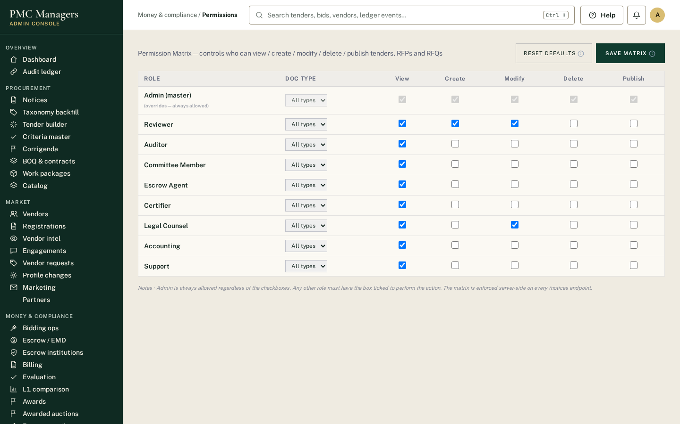
Who can do what. Roles and the approval matrix that decides each bid's sign-off order.
Main actions
• Edit role permissions
• Reset to defaults

Governance & integrity
Screen: /admin/e/governance
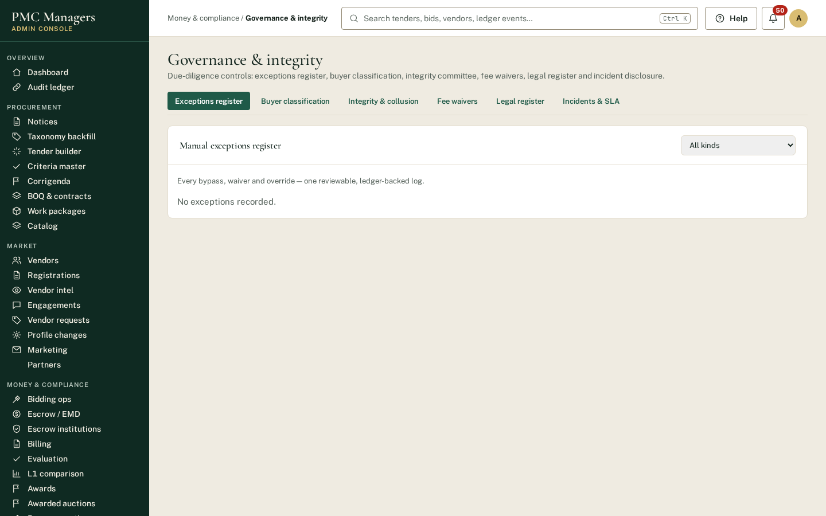
Committees, conflict-of-interest declarations and integrity checks.
Main actions
• Form a committee
• Review declarations

Tender review
Screen: /admin/e/tender-review
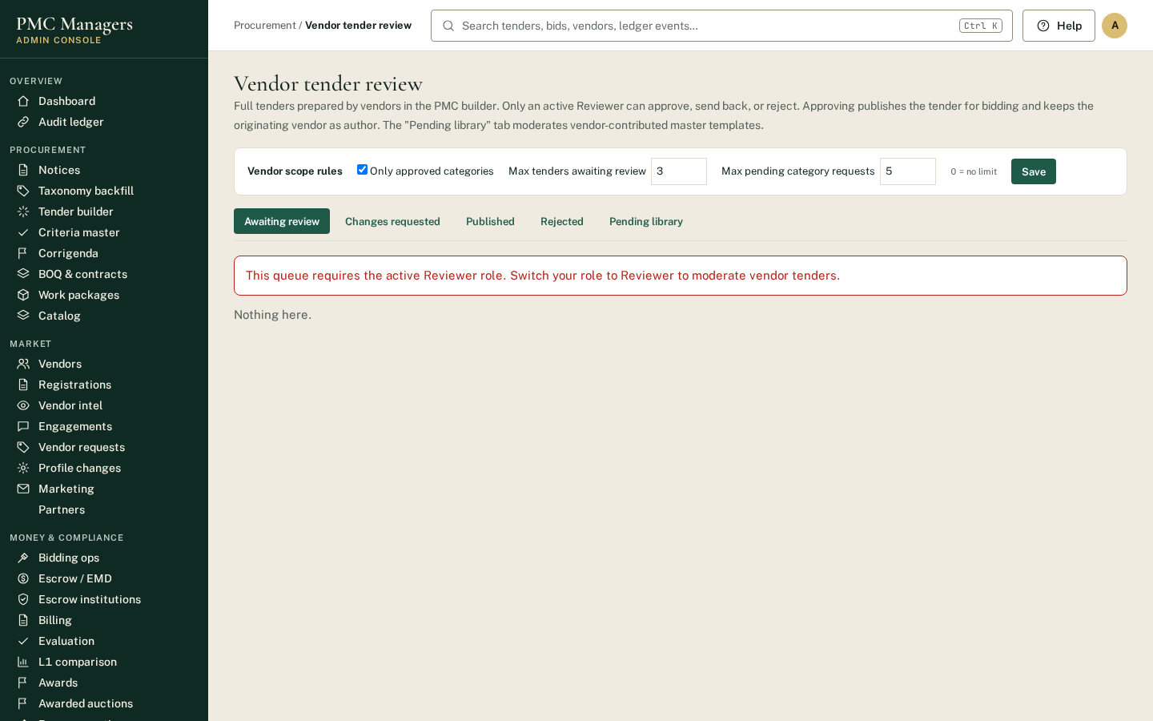
Reviewers approve tenders prepared by suppliers before they can be published.
Main actions
• Approve or send back a supplier-prepared tender

Masters
Screen: /admin/e/masters
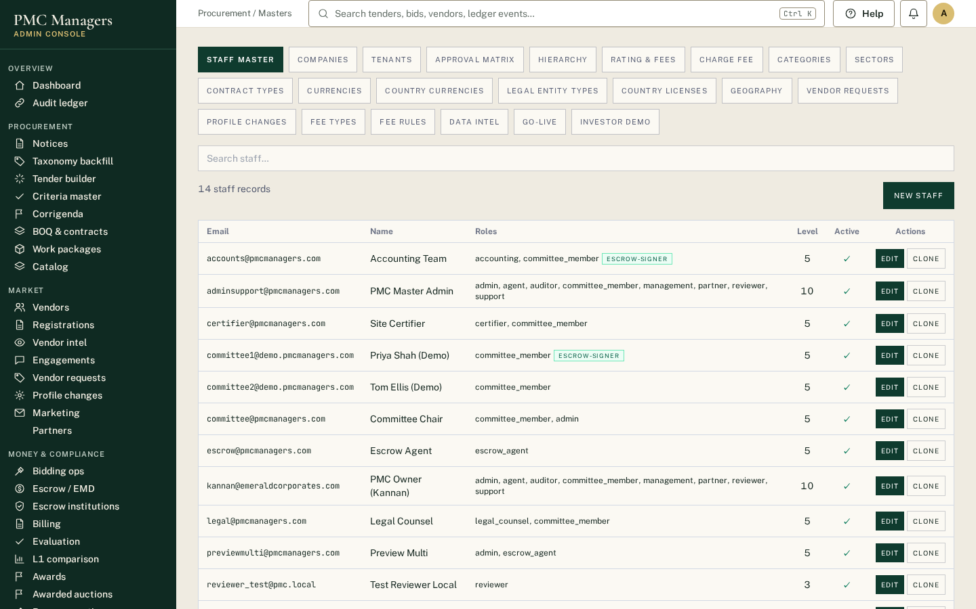
Reference data: staff accounts, categories, countries, currencies and other lists used across the platform.
Main actions
• Add staff
• Edit categories

Audit ledger
Screen: /admin/e/audit
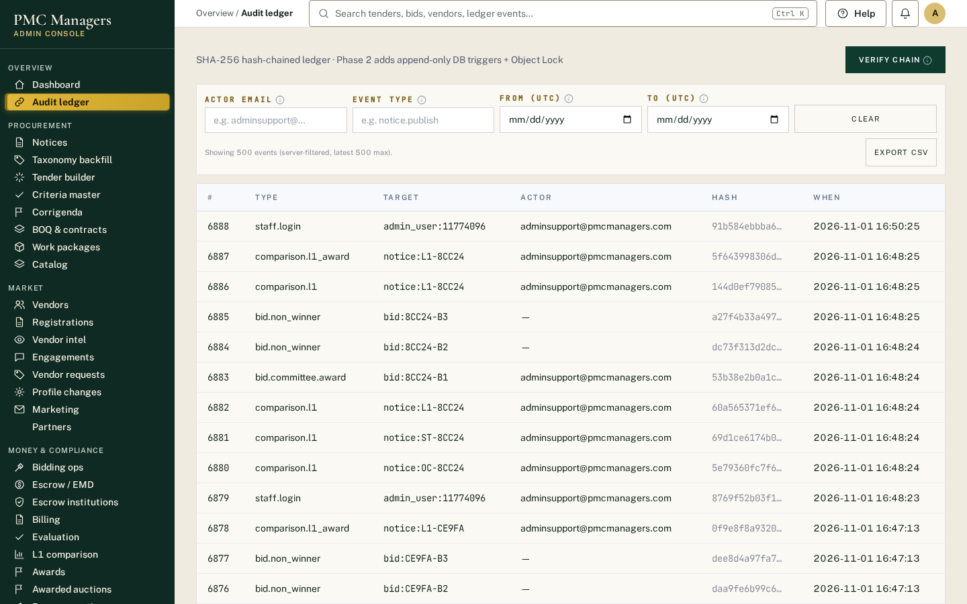
Every action is recorded in a tamper-evident chain. Verify chain re-checks every link.
Main actions
• Search events
• Verify chain
• Export

Billing
Screen: /admin/e/billing
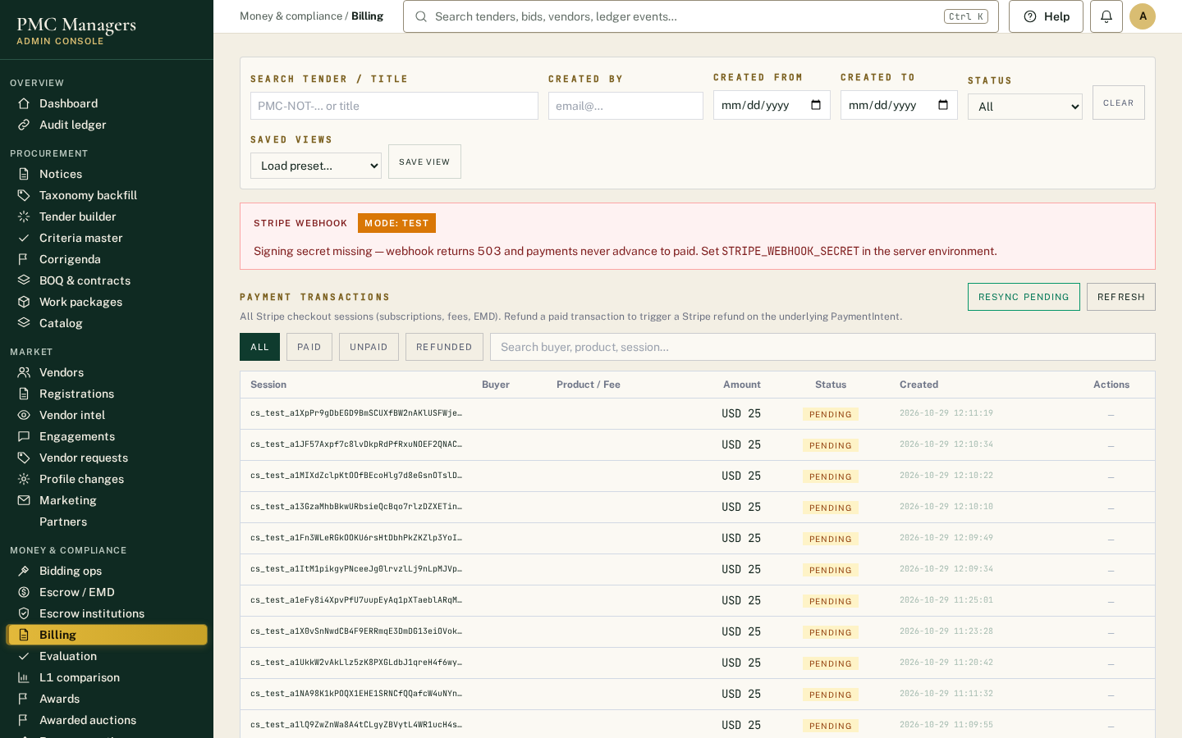
Hosting fees, subscriptions and invoices.
Main actions
• View invoices
• Check payment status

Events & alerts
Screen: /admin/e/events
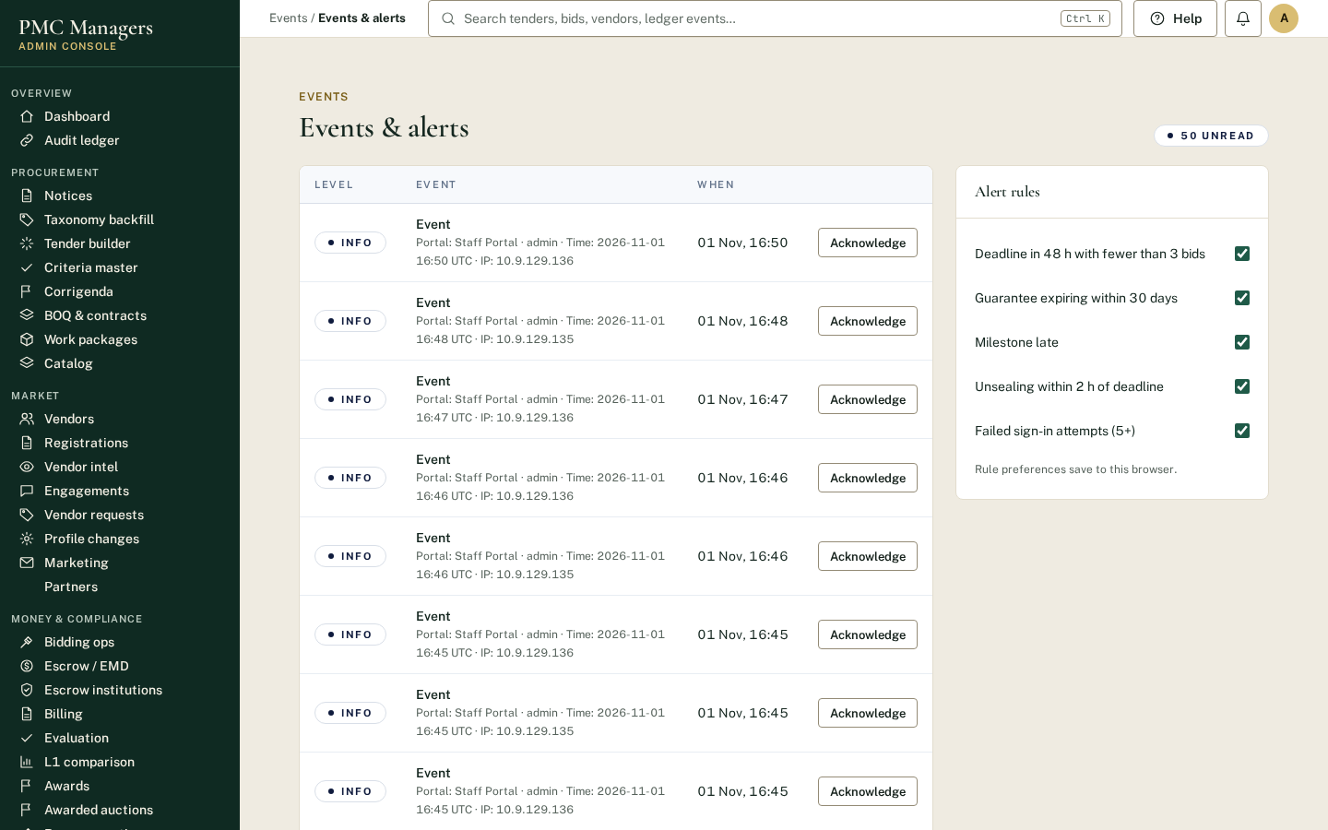
System events and alerts, including scheduled jobs and email delivery.
Main actions
• Review alerts

Taxonomy backfill
Screen: /admin/e/taxonomy-backfill
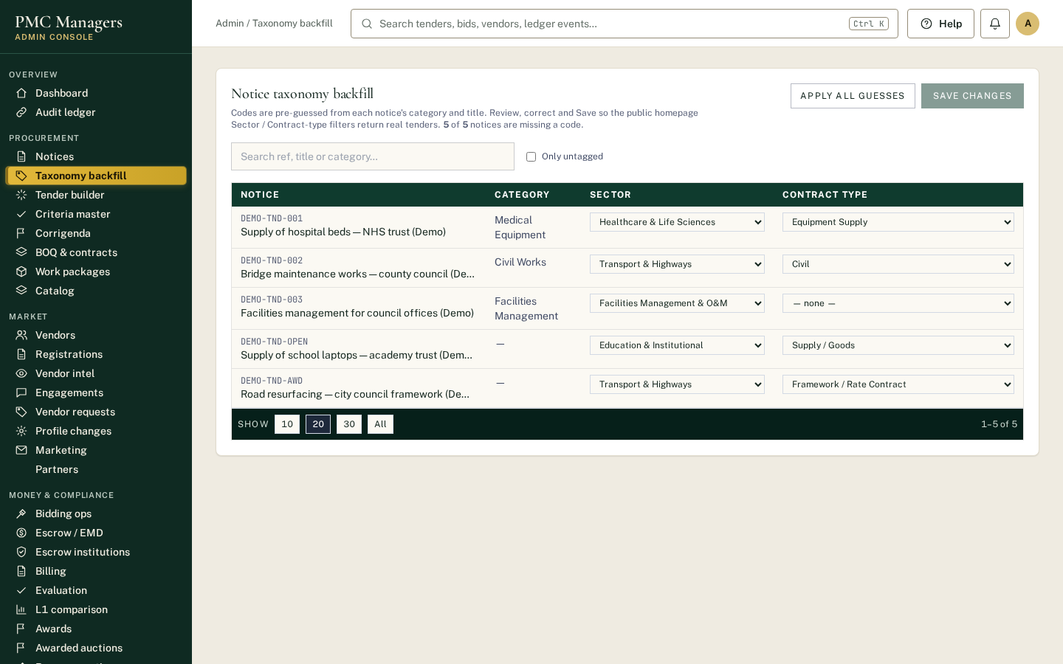
Assigns standard product/service categories (UNSPSC) to older tenders and suppliers so matching and search work everywhere.
Main actions
• Run a backfill
• Review suggested categories

Work packages
Screen: /admin/e/work-packages
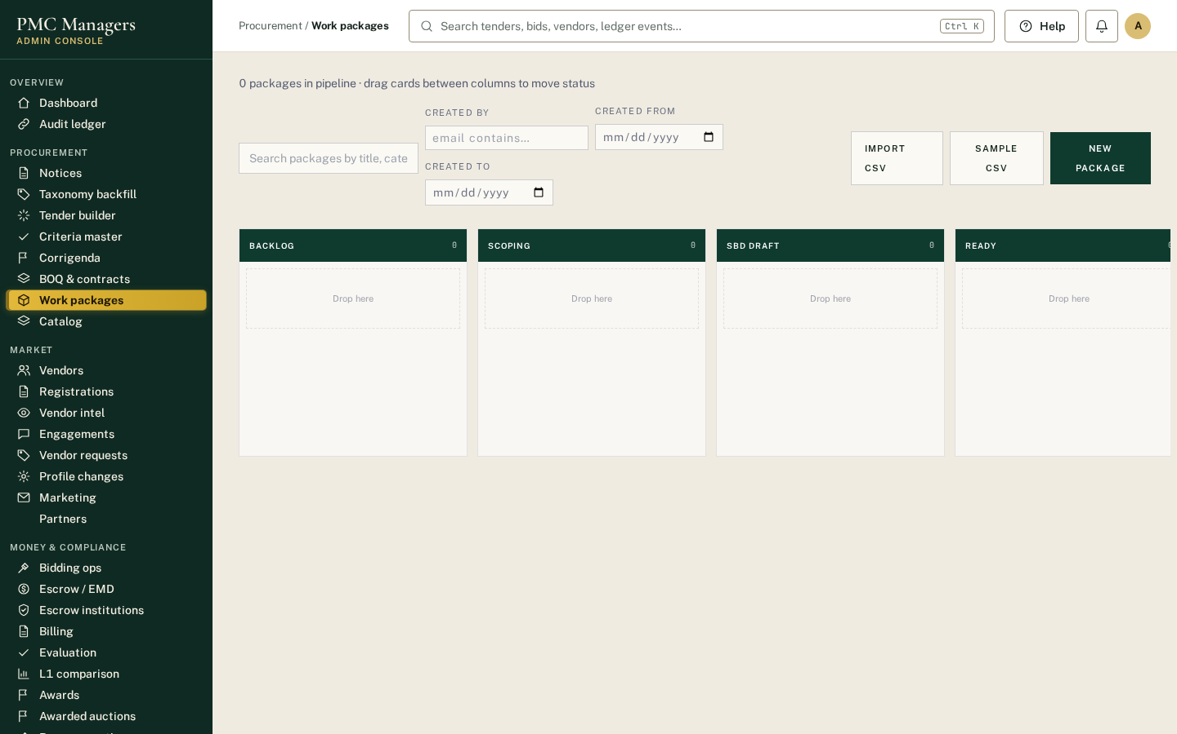
Splits large programmes into packages that can each be tendered separately.
Main actions
• Create a package
• Link it to a tender

Catalog
Screen: /admin/e/catalog
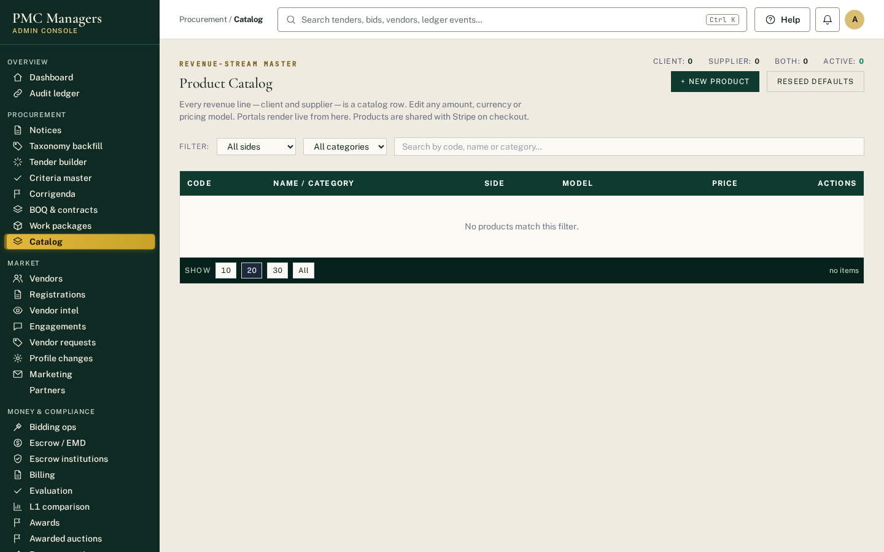
Product and service catalogue used for quick quotes and BOQ lines.
Main actions
• Add catalogue items
• Edit prices

Vendor intel
Screen: /admin/e/vendor-intel
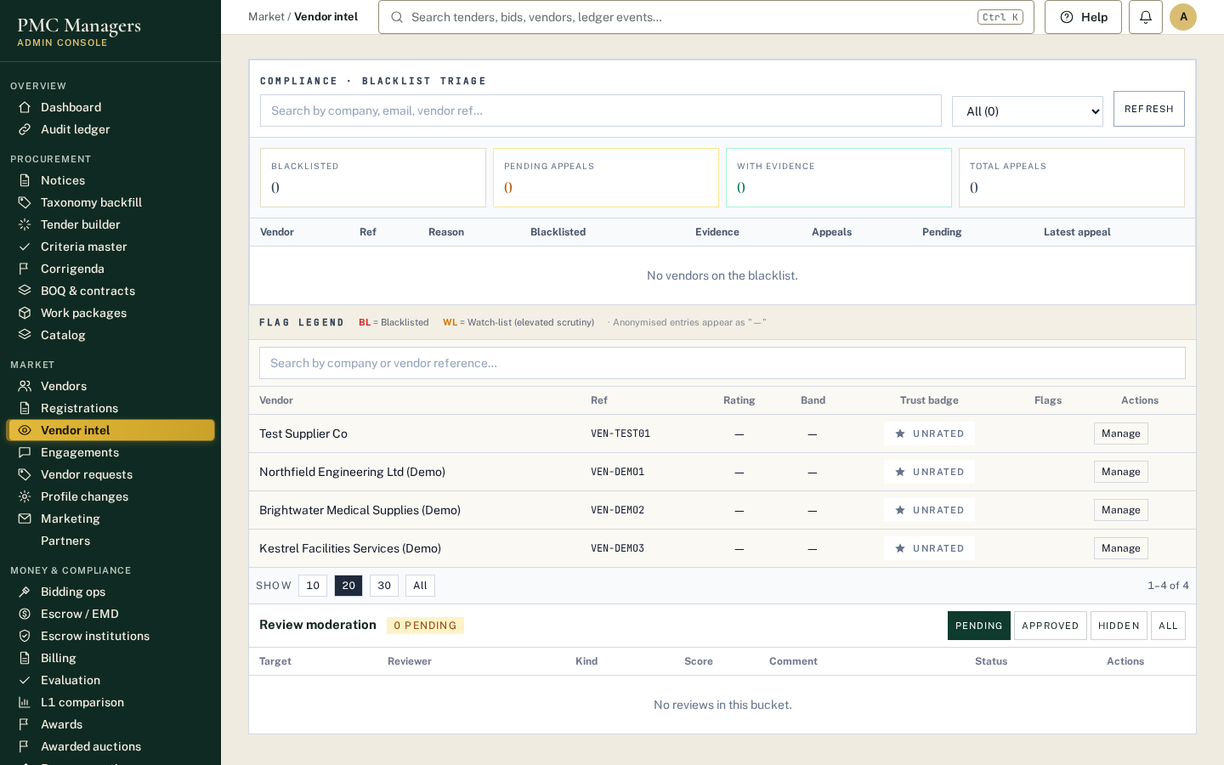
Supplier risk and performance signals: reviews, appeals, debarment checks and history.
Main actions
• Review a supplier's signals
• Handle an appeal

Engagements
Screen: /admin/e/engagements
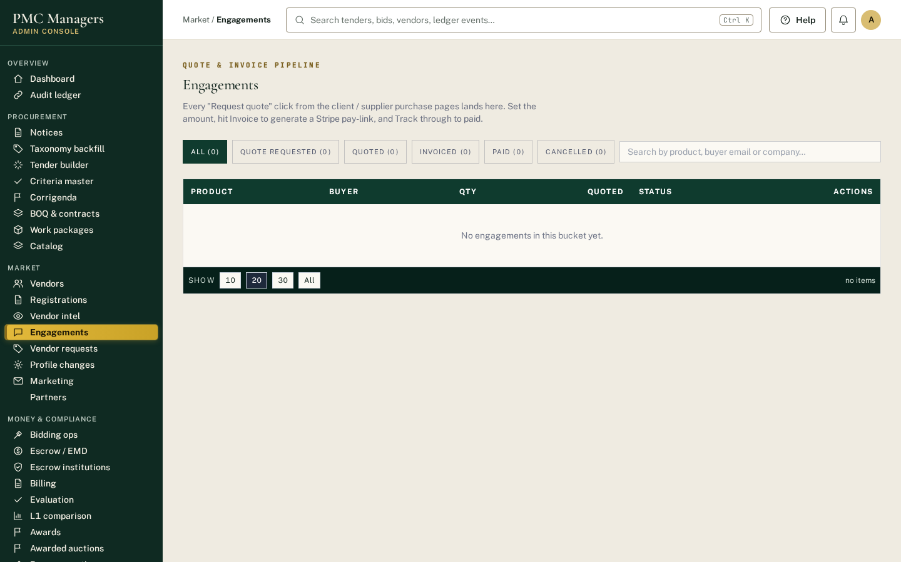
Service engagements and quote requests between buyers and suppliers.
Main actions
• Track an engagement

Vendor requests
Screen: /admin/e/vendor-requests
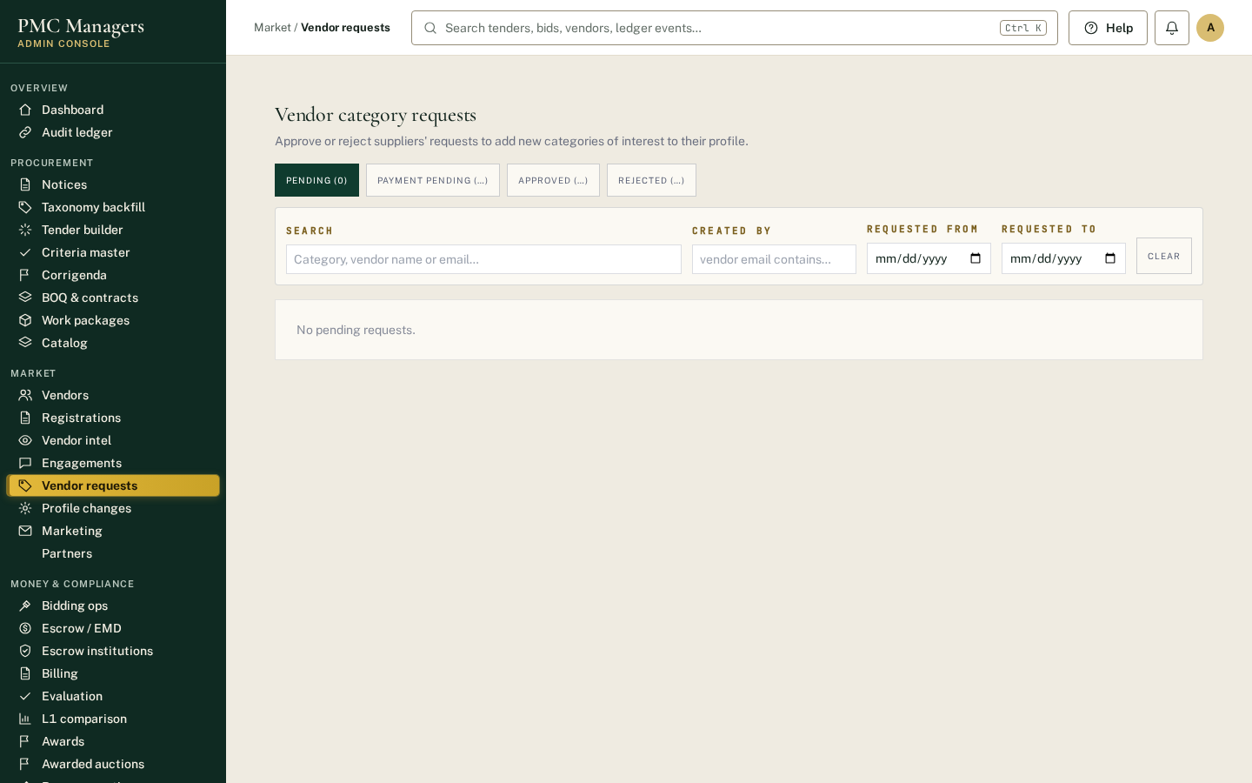
Requests raised by suppliers (category additions, help, corrections) waiting for PMC action.
Main actions
• Respond to a request

Profile changes
Screen: /admin/e/profile-changes
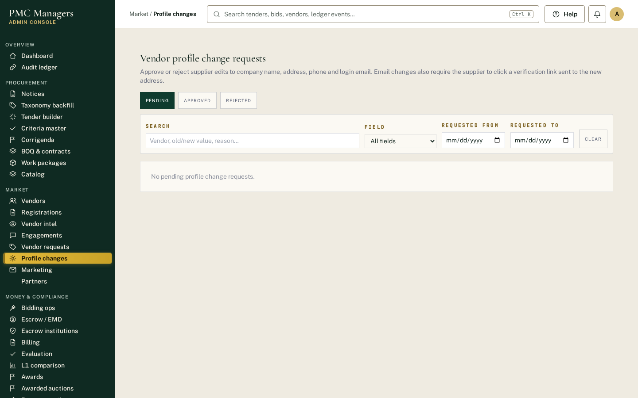
Supplier profile changes (bank, address, directors) that need approval before they take effect.
Main actions
• Approve or reject a change

Marketing
Screen: /admin/e/marketing
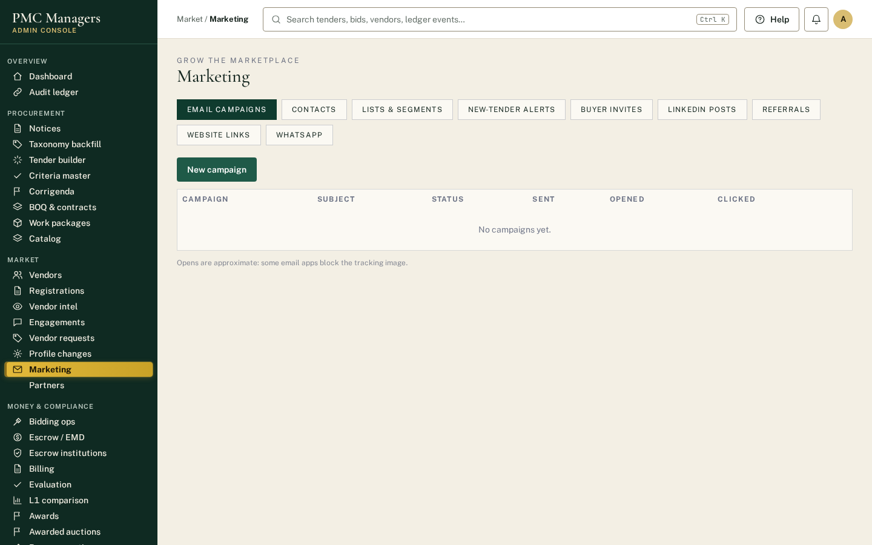
Campaigns, digests and WhatsApp/email outreach to suppliers.
Main actions
• Send a campaign
• View the WhatsApp inbox

Escrow institutions
Screen: /admin/e/escrow-institutions
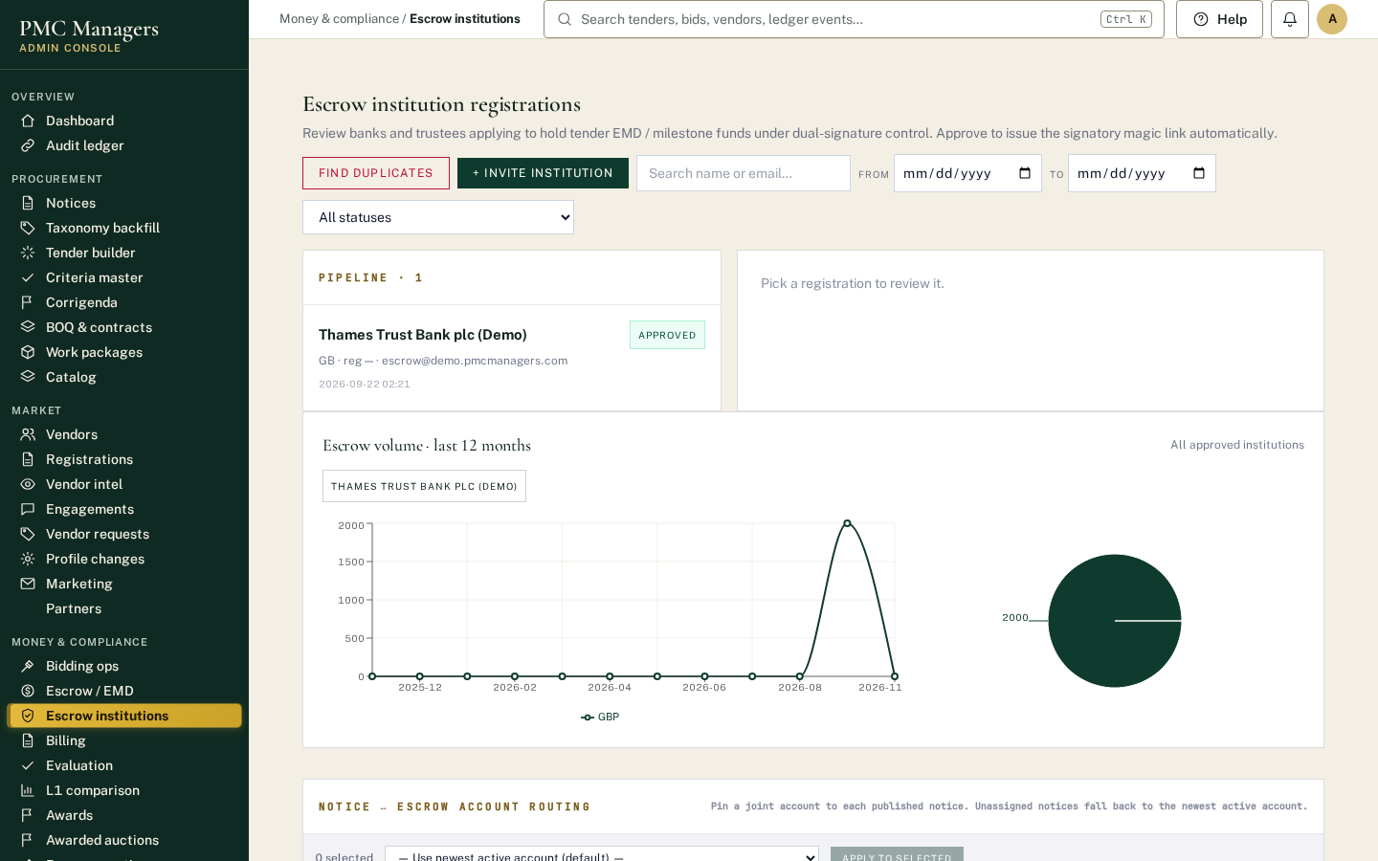
Banks and escrow providers onboarded to hold EMDs and award payments.
Main actions
• Approve an institution
• View accounts

Awarded auctions
Screen: /admin/e/awarded-auctions
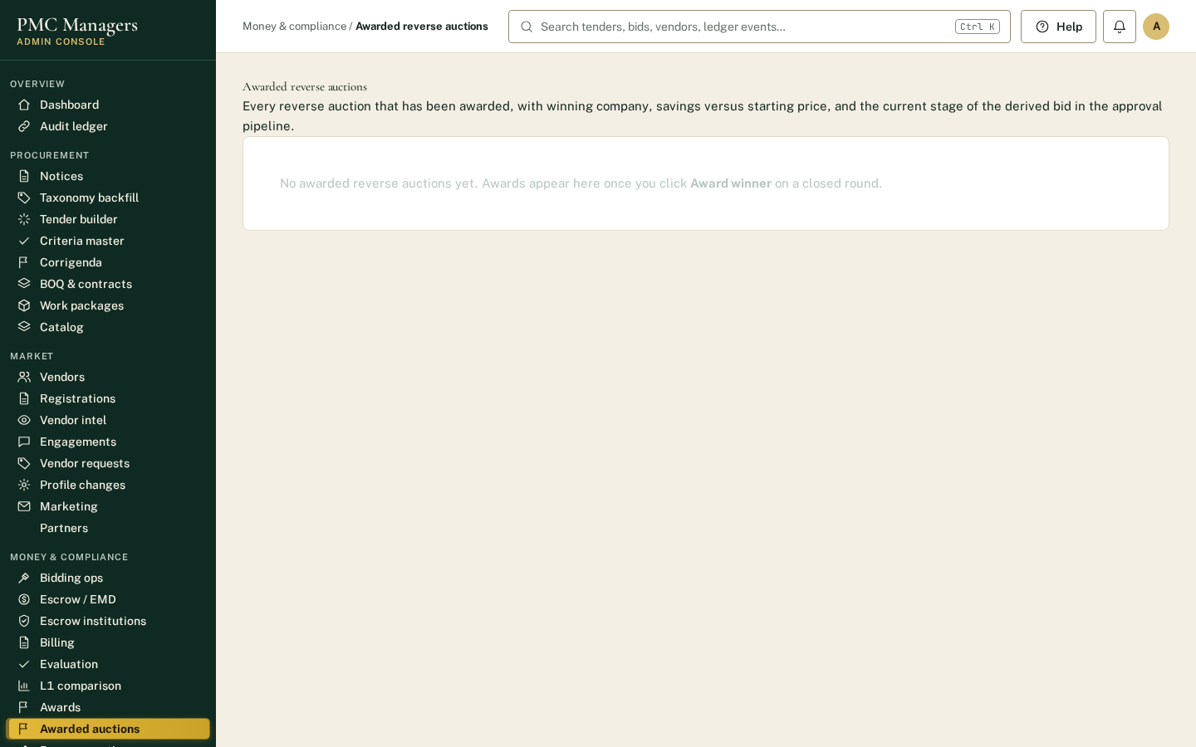
Results of completed reverse auctions and the resulting awards.
Main actions
• Open an awarded auction

DocuSign
Screen: /admin/e/docusign
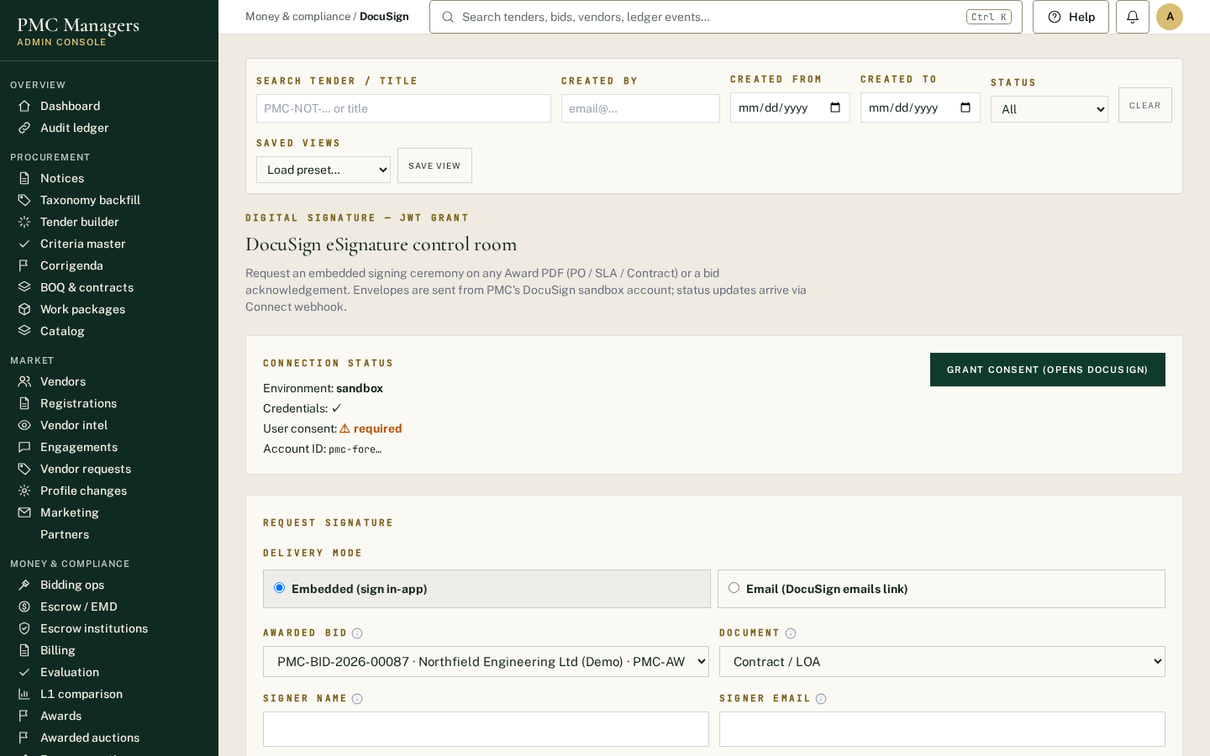
Electronic signature envelopes for award letters and contracts.
Main actions
• Track envelope status

Suggested banks
Screen: /admin/e/suggested-banks
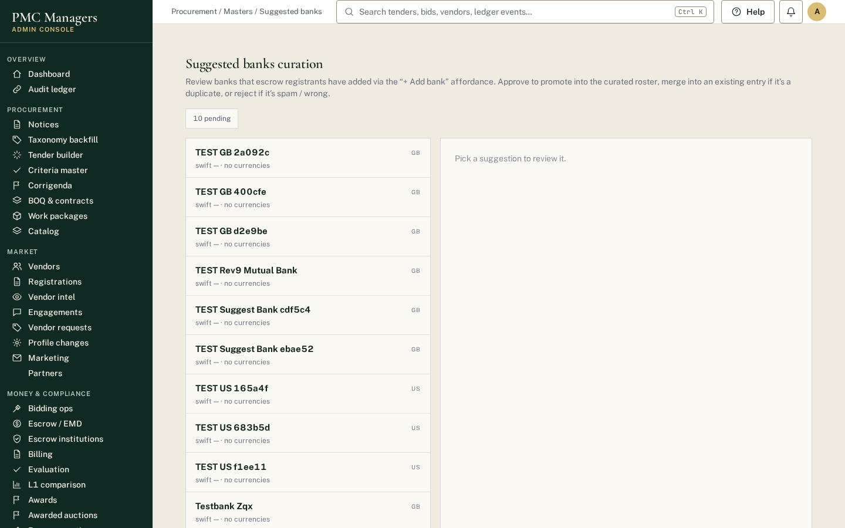
Banks suggested by users to be added as escrow institutions.
Main actions
• Review a suggestion

Stakeholder reports
Screen: /admin/e/stakeholder-reports
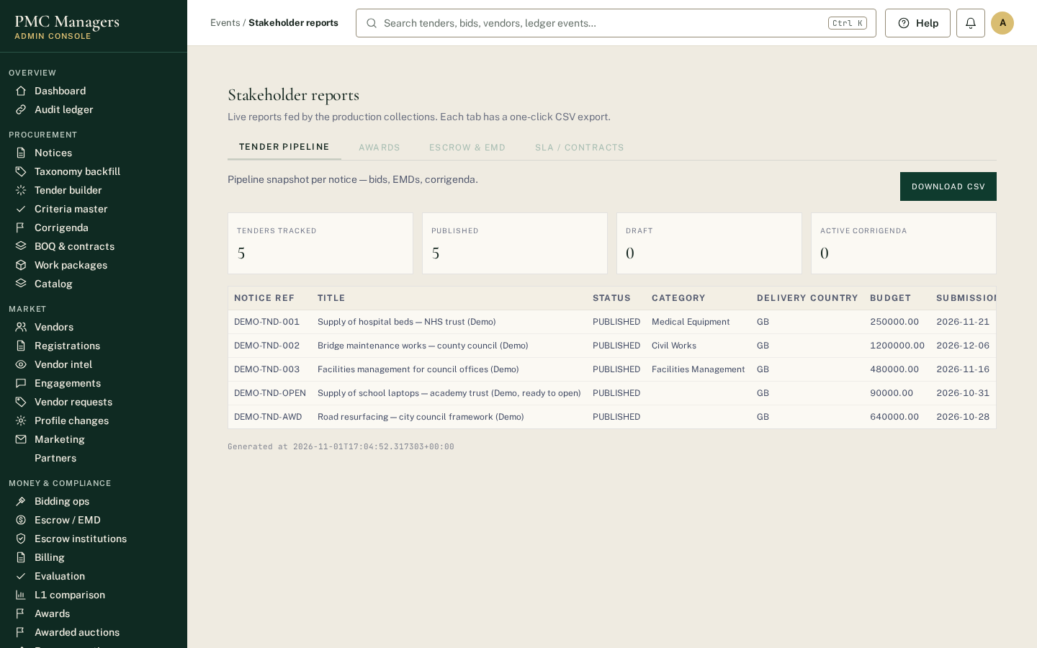
Board and sponsor reports: tender volumes, savings, timelines and compliance.
Main actions
• Generate a report
• Download PDF

Growth tools
Screen: /admin/e/growth
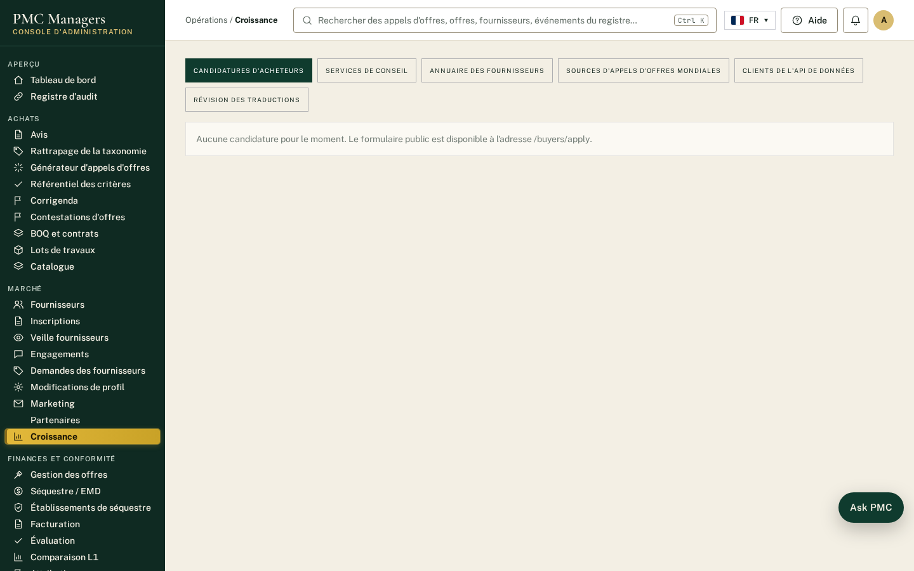
Buyer applications, consultancy services, supplier directory, global tender sources and Data API clients in one screen.
Main actions
• Approve or reject buyer applications
• Feature a supplier
• Fetch tenders from a source
• Create a Data API key

Translation review
Screen: /admin/e/growth?tab=translations
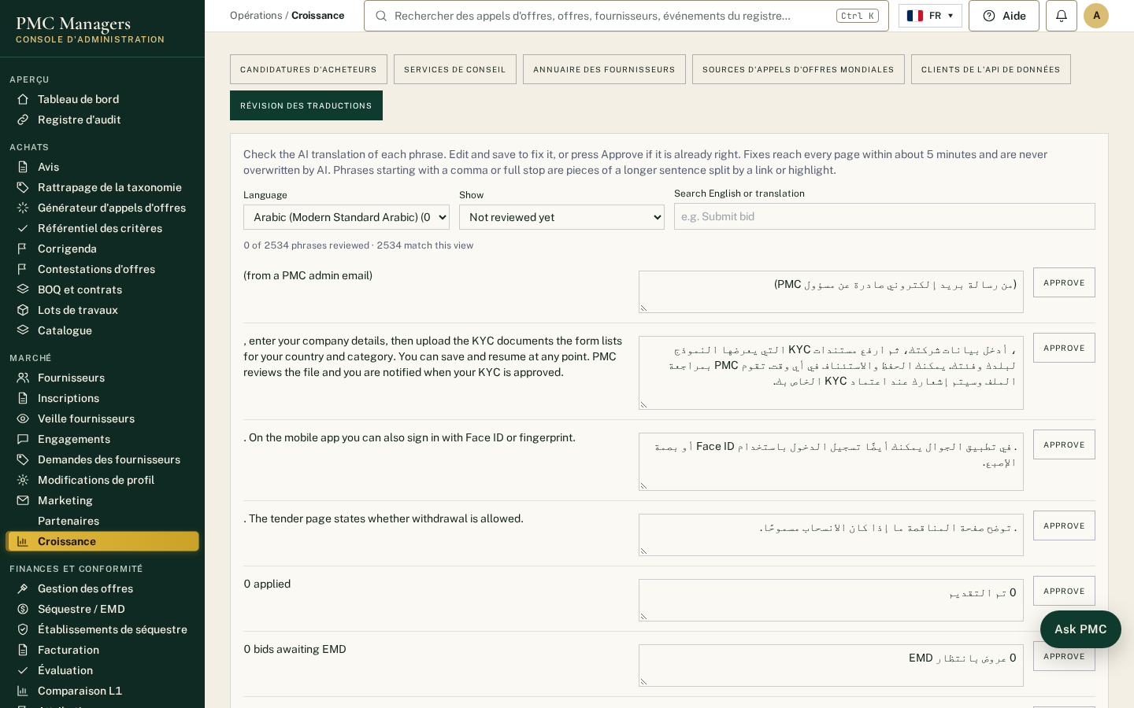
Native speakers check the AI translations used across the portal. Approve correct phrases or save a fix; reviewed phrases are never overwritten by AI.
Main actions
• Approve a translation
• Save a fix

Marketplace approvals
Screen: /admin/e/market
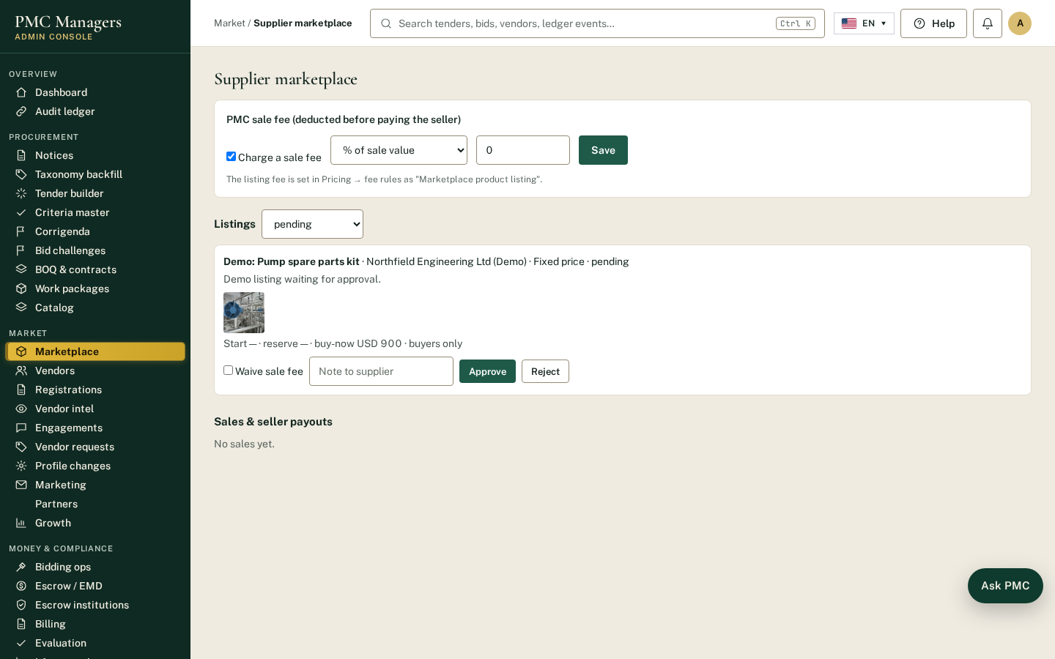
Every supplier listing is approved here before buyers see it. Set the PMC sale fee, waive it for a listing, and record seller payouts.
Main actions
• Approve or reject a listing
• Set the sale fee
• Mark seller paid

Masters and fee rules
Screen: /admin/e/masters
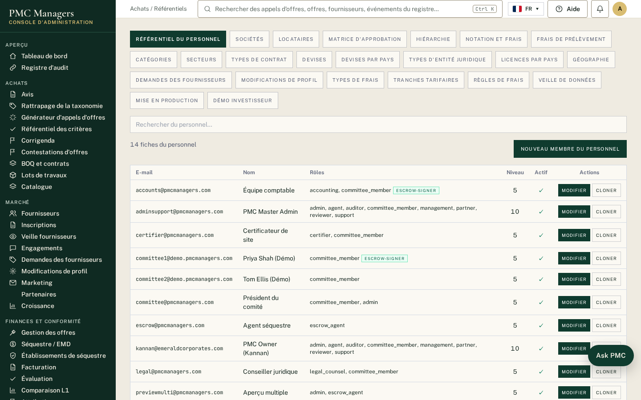
Master lists, including pricing bands (country groups), tier names and fee rules for publishing, bids, awards, AI tools, featured listings and the Data API.
Main actions
• Edit a pricing band
• Change a fee or set it to waived

Buyer applications, direct add & team invites
Screen: /admin/e/growth?tab=buyers
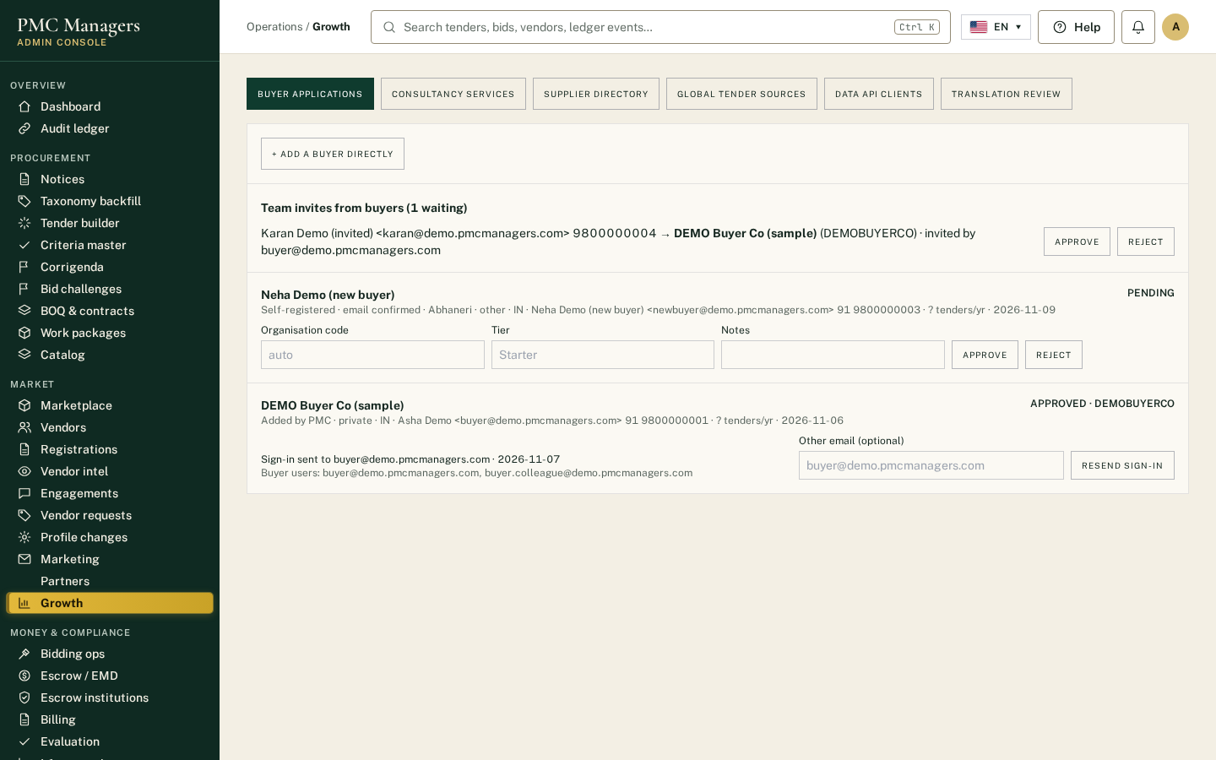
Approve self-registered buyers (after email confirmation) and applications; add a buyer directly (sign-in emailed); approve team invites from buyer organisations; send or resend buyer sign-ins.
Main actions
• Approve / reject
• + Add a buyer directly
• Approve team invite
• Send sign-in

Marketplace approvals (bulk)
Screen: /admin/e/market
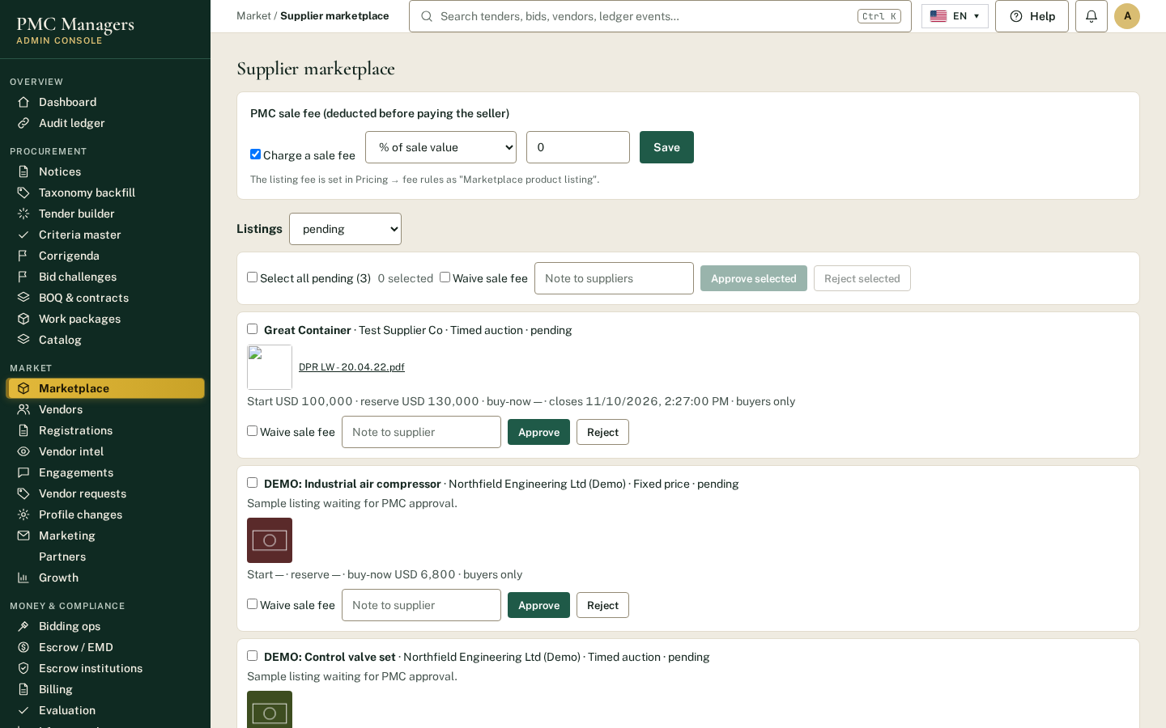
Pending supplier listings can be ticked and approved or rejected together, with one note and an optional fee waiver.
Main actions
• Select all
• Approve selected
• Reject selected

8 · Partner portal — screen tour

Partner profile
Screen: /partner/me
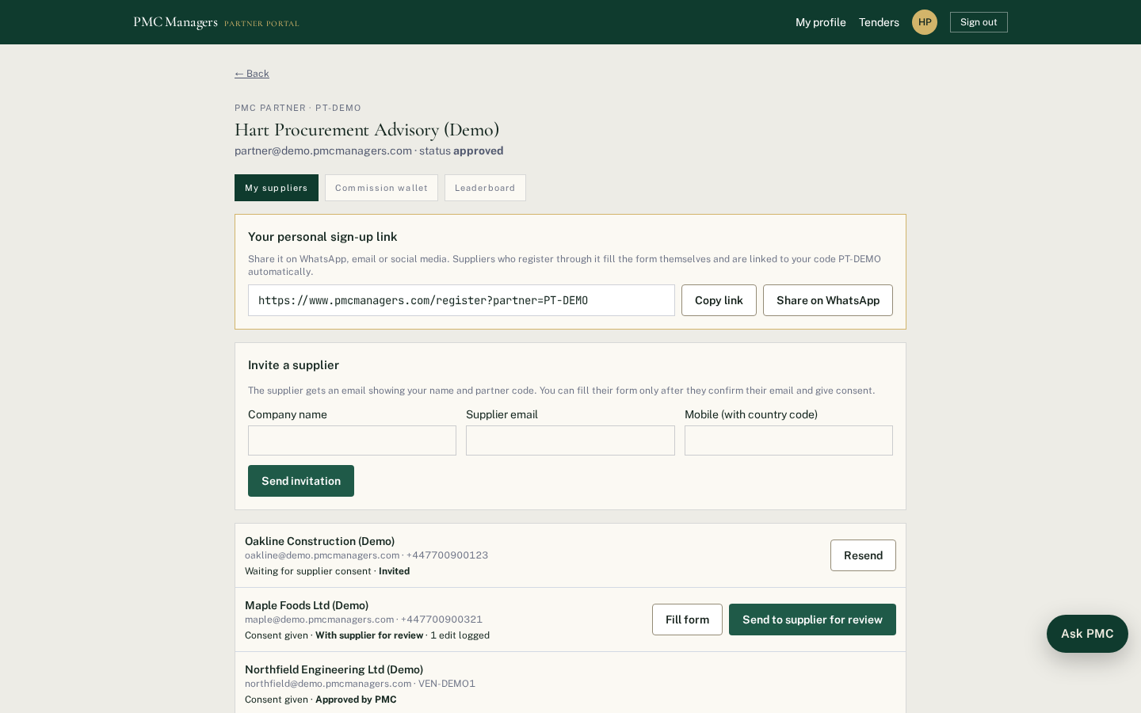
Partners complete four sections (profile, banking, documents, agreement) with a progress bar; the form opens where they left off. After approval they onboard suppliers and see commission.
Main actions
• Complete each section
• Sign the agreement
• Submit for approval

9 · Staff portal — screen tour

Staff portal (committee)
Screen: /staff
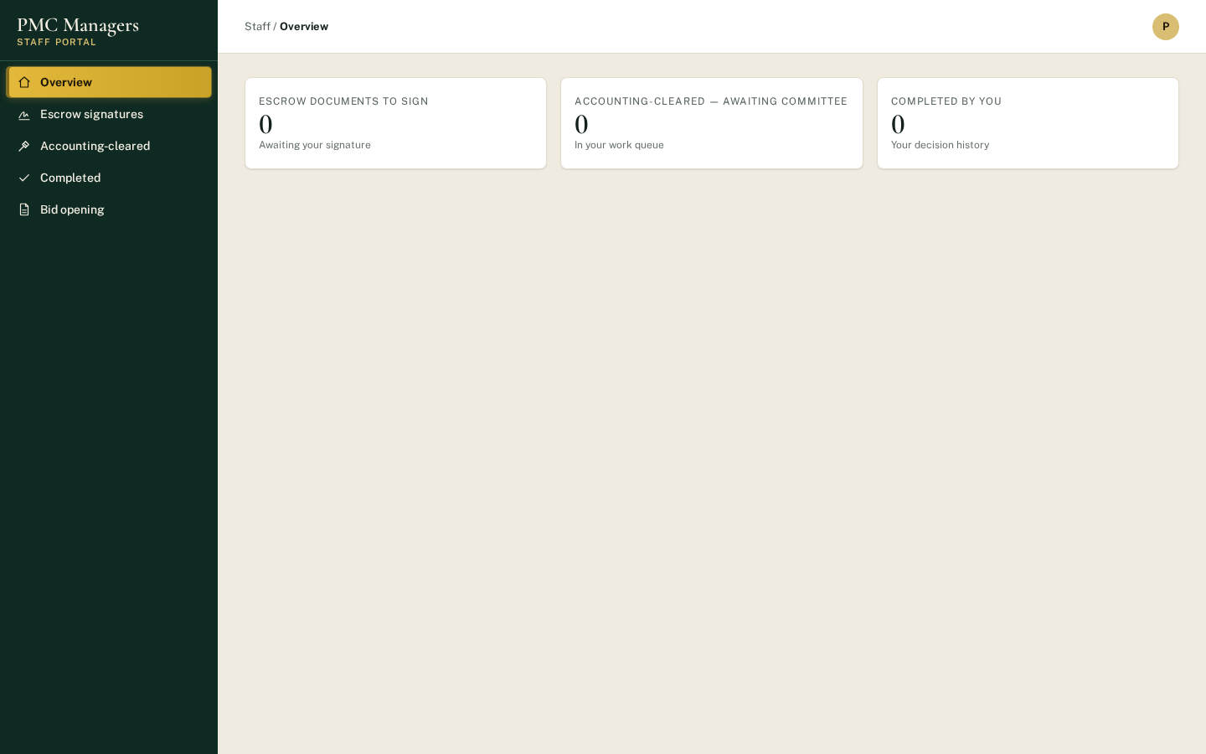
Committee members and other staff see their tasks: tenders to open, proofs to review, bids to sign off and award.
Main actions
• Approve an opening
• Accept / reject proofs
• Award

10 · Deep-dive: Tender builder & AI DPR
1. Tender builder › AI generate from DPR: pick country, a master template (or 'build a brand-new master'), upload up to 3 DPRs (PDF/DOCX/TXT, max 100 MB each).
2. Analyze runs in the background; each file shows progress, extracted headings and missing categories.
3. Create AI-drafted tenders, review every section, then use Criteria and Create notice.
If upload fails with 'status code 413' on AWS, the backend bundle was deployed without the .platform/nginx upload-size setting — redeploy the full backend ZIP (see chapter 13).

11 · Deep-dive: Criteria, sealed bids, opening & AI proof review
1. Criteria come from the Criteria master or saved sets, AI-read from the tender document, or one-off. Each is pass/fail or scored, Mandatory or optional, with proof required or not.
2. Rule: a bid qualifies if it meets every mandatory criterion and at least N of the optional ones (blank = all).
3. Publish needs: main document, future deadline, at least one must-pass criterion (checklist on the draft row). Live tenders without bids can still change criteria.
4. Suppliers must answer mandatory items with proofs; everything is sealed on submit.
5. After the deadline every committee member signs the technical opening; the system checks every bid and emails result notices.
6. AI reads each must-pass proof of qualified bids: Matches / Does not match / Unclear + figure found.
7. Every member accepts or rejects each proof (comment to reject). Mandatory rejection disqualifies; optional rejection disqualifies only below the minimum.
8. Doubts can be raised and resolved with notes. Download the proof check report (PDF) for the file.
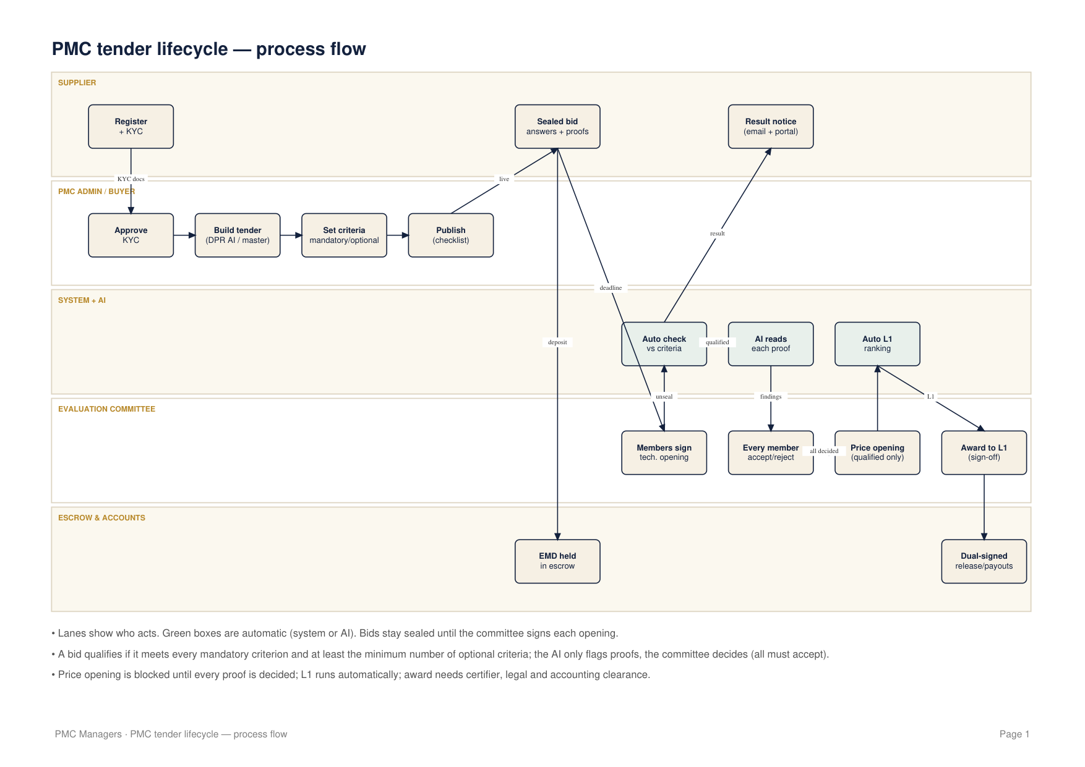

12 · Deep-dive: Price opening, L1, award & escrow
1. Price opening is blocked until every proof is decided; only qualified bids' prices open.
2. L1 ranking runs automatically and shows on the opening card.
3. Award to L1 (committee member, one click + note) requires certifier, legal and accounting clearance on the L1 bid. Weighted tenders use the Award recommendation report.
4. On award: award letter and contract are generated; the winner is emailed 'Congratulations — your bid is awarded'; every other bidder is emailed that the tender went to another supplier, why (criteria failed, disqualified with the committee's note, or their L-rank and the awarded price) and their EMD refund date.
5. Escrow releases need two signatures; consortium awards create per-member payment instructions with bank references and a downloadable payout report.

13 · Partners, reminders & tracking
1. Admin invites a partner; partner completes Profile, Banking, Documents, Agreement (progress bar 'N of 4').
2. Reminder emails go 3 and 7 days after joining if unfinished (daily 09:00 London).
3. Every tender shows a progress line (Criteria → Bids → Opening → Proof review → Price → L1 → Award) on Notices and on the dashboard.

14 · Troubleshooting playbook
Symptom | Likely cause | Fix
Upload fails: status code 413 | Web server body limit on AWS | Redeploy full backend ZIP with .platform
AWS health 'Degraded' | Failing health checks or 5xx | EB › Health › causes; check /health and logs
Old screens after deploy | CloudFront cache | Invalidate /*
Emails not arriving | Email key missing/invalid | Update the email secret and redeploy
Price opening blocked | Proof review or doubt pending | Decide every proof / resolve doubts
Award to L1 refused | L1 bid not cleared | Complete certifier, legal, accounting clearances
Supplier can't submit | Mandatory criterion or proof missing | Answer all mandatory items

15 · Sample workflow — one tender end to end
1. Admin drafts 'Hospital beds supply' from a DPR and adds 3 mandatory + 2 optional criteria (at least 1 optional), L1.
2. Checklist all ticked → Publish.
3. Three suppliers bid; one misses a mandatory proof and cannot submit until fixed.
4. Deadline passes; committee signs; 2 bids qualify, 1 fails (turnover below 500,000) and is notified.
5. AI flags a mismatch on one proof; one member rejects with a comment → that bid is disqualified.
6. Price opening; L1 = remaining bid; clearances done; Award to L1; letters and emails go out; EMDs of others scheduled for refund.

16 · Procurement policy: criteria & qualification
Purpose. Make sure every tender is judged by clear, published criteria applied the same way to every bidder.
Rule | What it means
Published criteria only | Bids are judged only on the criteria shown in the tender. Criteria come from the Criteria master or are added by the tender author and saved before publishing.
Mandatory vs optional | The tender author marks each pass/fail criterion Mandatory (must be met) or optional and sets the minimum number of optional criteria a bidder must meet (blank = all).
At least one must-pass | A tender cannot be published without at least one must-pass criterion (publish checklist).
Changing criteria | Allowed on a live tender only while it has no bids; once a bid arrives criteria lock. Any other change is a corrigendum sent to all bidders.
System decides pass/fail | At technical opening the system compares every answer with the rule. Nobody can override a pass/fail directly; the committee can only raise a logged doubt and decide it.
Consortium rules | Each criterion says whether the lead, the combined members or every member must meet it.

17 · Proof review policy (AI + committee)
Purpose. Check that the documents bidders attach actually support what they declared.
Rule | What it means
Sealed until opening | Proof files are encrypted on upload and cannot be opened by anyone before the committee signs the technical opening.
AI reads, people decide | For qualified bids the AI reads each must-pass proof and records Matches / Does not match / Unclear with the figure found. The AI never passes or fails a bid.
Unanimous acceptance | Every committee member must accept a proof for it to stand. One rejection (with a written comment) fails that proof.
Effect of a rejection | Mandatory proof rejected → bid disqualified. Optional proof rejected → disqualified only if the bid falls below the minimum optional criteria.
Unreadable files | Word/Excel or unreadable scans are marked 'check by hand'; the committee must still open and decide them.
Price opening gate | Price envelopes cannot be opened until every proof on every qualified bid is decided and every doubt resolved.
Record | The proof check report (PDF) is downloaded and kept on the tender file.

18 · Evaluation & award policy (L1 / weighted)
Purpose. Award fairly and transparently to the right bidder.
Rule | What it means
Method set in advance | Each tender states before publishing whether the winner is the lowest compliant price (L1) or weighted technical + price marks.
Only qualified bids ranked | Only bids that passed criteria and proof review have prices opened and are ranked.
Automatic L1 | L1 ranking runs automatically at price opening; compliance flags (e.g. suspiciously low, above budget) are shown for the committee.
Clearances before award | The winning bid must have certifier, legal and accounting clearance before award.
Award to L1 | A committee member awards with one click and a note; the action is recorded in the audit ledger.
Notices to bidders | The winner is congratulated; every other bidder is told why they were not selected (criteria failed, disqualified with the committee's note, or their L-rank and the awarded price) and their EMD refund date.

19 · Code of ethics & conflict of interest
Purpose. Protect the integrity of every tender.
Rule | What it means
Declare conflicts | Committee members declare any interest in a bidder before signing an opening; a conflicted member steps aside.
No contact during evaluation | Committee members do not discuss a live tender with bidders; clarifications go through the platform's messages.
Gifts | No gifts or hospitality from bidders during a tender.
Confidentiality | Bid contents, scores and committee comments are confidential until the award notice.
Reporting | Concerns are raised to the PMC integrity officer; retaliation is prohibited.

20 · Data protection, retention & deletion
Purpose. Handle personal and commercial data lawfully and securely.
Rule | What it means
Minimum data | Collect only what tendering, KYC and payments need.
Encryption | Bid answers, prices and bid files are encrypted at rest; access is by role.
Soft deletion | Records are archived, not erased, to keep the audit trail. Narrow, explicit deletion only on a verified request.
AI processing | Only proof files of qualified bids are sent to the AI, after technical opening, to read the figures.
Secrets | API keys and passwords live only in the server's secret settings — never in documents, chat, email or Git. If one leaks, revoke and replace it immediately.
Retention | Tender records and audit ledger kept for the period required by the buyer's regulations (typically 7 years).

21 · Incident response
Purpose. Act quickly and consistently when something goes wrong.
Step | Owner | Action
1 Detect | Anyone | Report via the help desk or integrity email; note time and screen.
2 Contain | PMC admin | Suspend affected accounts or tender; revoke leaked keys at the provider and replace them in AWS.
3 Assess | PMC admin + IT | Use the audit ledger to see what happened and who was affected.
4 Notify | PMC lead | Tell affected buyers/suppliers; regulators where required (e.g. 72 hours for personal data breaches).
5 Recover | IT | Redeploy clean bundles, verify chain, re-open the tender if needed.
6 Learn | PMC lead | Write a short review and update this manual.

22 · Complaints, appeals & escalation
Purpose. Give bidders a clear route to question a decision.
Stage | Who | Time
Clarification | Bidder asks via messages; PMC replies | 3 working days
Complaint | Bidder writes to PMC within 5 days of the result notice | Acknowledged in 2 days
Review | PMC officer not involved in the tender reviews the record (proof check report, audit ledger) | 10 working days
Appeal | Buyer's appeal body or vendor-intel appeal process | As per buyer rules

23 · RACI matrix
Purpose. Who does what in each tender step.
Activity | Responsible / Accountable | Consulted / Informed
Build tender & criteria | Admin (R), Buyer (A) | Reviewer (C)
Publish | Admin (R/A) | Suppliers (I)
Technical opening | Committee (R), Chair (A) | Suppliers (I)
Proof review | Every committee member (R), Chair (A) | AI (C)
Price opening & L1 | Committee (R/A) | Accounting (I)
Clearances | Certifier, Legal, Accounting (R) | Committee (I)
Award | Committee member (R), Chair (A) | All bidders (I)
Escrow release | Two escrow signatories (R/A) | Accounts (I)

24 · Templates

Committee minutes — technical opening
Tender: ______ Date/time: ______ Chair: ______
Members present and conflict declarations: ______
Bids received: __ Qualified by system: __ Not qualified: __
Proof review decisions (attach proof check report): ______
Doubts raised and resolution: ______
Signatures: ______

Proof rejection comment
Criterion: ______ Bid: ______
What the document shows: ______ What was declared: ______
Reason for rejection: ______

Award notice (L1)
Tender ______ has been awarded to ______ at ______ (lowest compliant price).
Ranking of qualified bids: L1 ______, L2 ______, L3 ______
Bids not qualified and reasons: ______
EMD refunds due by: ______

Corrigendum
Tender: ______ Corrigendum no.: ______ Date: ______
What changes: ______ New deadline (if any): ______
Reason: ______

Clarification reply
Question received: ______ From: (kept anonymous)
Answer (shared with all bidders): ______

25 · Service levels
Purpose. Target response times.
Item | Target
Supplier KYC review | 2 working days
Tender review (supplier-prepared) | 3 working days
Clarification answer | 3 working days
Proof review after technical opening | 5 working days
Award after price opening | 10 working days
EMD refund to losing bidders | 14 days after award
Partner approval | 3 working days

26 · What's new: fees, growth tools & languages
This chapter covers the features added in the latest releases. Each one also has a help guide and a video in the Help Centre.

Pricing bands & fee rules
1. Countries are grouped into pricing bands. Band names, tier names and the fee for each band are edited in Masters → Fee rules; nothing is fixed in code.
2. Before a tender is published, an admin opens Fees on the notice and ticks Charge or Waive for each fee. Publishing is blocked until the fees are confirmed.
3. The award fee rate is set per band (for example 0.30% today, any other rate or waived tomorrow). At publishing the admin also chooses who pays it: the buyer or the supplier.
4. When the award is completed, a Stripe payment link is sent automatically to the payer and is shown to admin accounts for follow-up.
5. Supplier bid fees: for each new supplier the admin decides whether extra categories are charged or waived.
6. Waivers can be approved by the Master Admin, an Admin or a Reviewer. Every decision is audit-logged.

Supplier AI tools & saved alerts
1. AI tender tools: a supplier uploads any tender document (or picks a PMC tender) and gets a summary of eligibility, turnover, experience, EMD, fees, key dates and required documents.
2. Bid readiness check: compares the tender with the company profile and lists missing documents and disqualification risks.
3. Both are charged per use; the price, or a waiver, is set by the admin in Fee rules.
4. Saved alerts: suppliers save keywords, countries, value range and buyers and get matching PMC and global tenders instantly, daily or weekly.

Growth tools (admin → Growth)
Tab | What it does
Buyer applications | Organisations apply at /buyers/apply; approve to create the organisation code, or reject.
Consultancy services | Create the services shown on /consultancy and track each request.
Supplier directory | Feature a supplier for premium visibility in /suppliers/directory.
Global tender sources | Turn sources on or off and fetch tenders (World Bank, EU TED, and a pipe ready for a licensed paid provider).
Data API clients | Issue API keys with daily limits so outside businesses can read tender data.
Translation review | Native speakers approve or correct the AI translations.

Languages
1. The whole portal (public site, supplier portal, admin and staff portals) is available in 14 languages: English, Russian, Kazakh, Simplified Chinese, Traditional Chinese, Spanish, French, German, Hindi, Malay, Bahasa Indonesia, Korean, Japanese and Arabic (right-to-left).
2. The flag button at the top of every page (bottom-left on phones) changes the language. Everything on screen is translated, including tender titles and descriptions.
3. Public pages have their own address per language, for example /fr/buyers, so search engines show the site in each language.
4. Ask PMC answers in the chosen language, help videos have a voice-over in each language, and this manual is published in all 14 languages.
5. Translations are made by AI and checked by native speakers in Growth → Translation review. Reviewed phrases are never overwritten by AI.

27 · What's new: Supplier Marketplace & AI catalogue import
Suppliers can now sell products directly to verified buyers without running a tender. Every listing is approved by PMC first. Each part below also has a help guide and a video in the Help Centre.

Ways to sell
Sale method | How it works
Timed auction | Starting price, optional hidden reserve, minimum bid step and closing time. The highest bid at closing wins.
Best offer | Buyers send offers until a deadline; the supplier accepts the one they want.
Fixed price | Buy now at the price the supplier sets.

A supplier can switch on any mix of the three for each product and chooses whether only verified buyer organisations, or any verified account, may take part.

Supplier: add products (Sell products)
1. Open Sell products and click Add a product. Enter the details, click Upload photos (up to 12) and Attach spec sheet for PDF datasheets (up to 6).
2. Tick the sale methods and prices, check what you will receive after the PMC fee, then click Submit for approval.

Supplier: import a catalogue with AI
1. Click Import from a catalogue with AI and choose a PDF catalogue, brochure or a JPG/PNG photo of a page (up to 25 MB; the first 30 pages are read).
2. AI reads the file in 1 to 3 minutes and lists every product with its photo, a description, category, unit and specifications. Photos are taken from the PDF, or cut out of the page when the page is a scan or photo.
3. For each product the supplier decides: keep it or untick it; use the AI description (and edit it) or Write my own; add the specifications or not; which photos to keep, add or upload; and whether to attach the catalogue PDF as a spec sheet.
4. Create draft listing(s) saves the chosen products as drafts marked set price & how to sell. A draft cannot be submitted until the supplier opens Edit and sets the sale method and price.
5. AI only uses facts in the document; it never adds prices or certifications. Reading a catalogue is free unless an admin sets a fee for AI catalogue reading in Pricing; a failed reading is never charged.

Admin: approvals, fees and payouts (Marketplace)
1. Every listing waits in Admin → Marketplace. Check the photos, spec sheets and prices, then Approve or Reject with a note.
2. The PMC sale fee is a percentage or a fixed amount, or switched off. It can be waived for one listing when approving it. The listing fee is set in Pricing → fee rules → Marketplace product listing.
3. The buyer pays PMC through a secure Stripe link from My bids & purchases. The order shows the PMC fee and the seller's bank details; the admin pays the balance and clicks Mark seller paid with the transfer reference. Automatic split payouts are not switched on.

Buyers: the public Marketplace
1. Marketplace in the top menu lists approved products with photos, spec sheets, price or current bid and closing time.
2. Verified buyers bid, send an offer or click Buy now; purchases are paid from My bids & purchases by Pay securely.
3. In the iPhone app the buy and pay buttons are hidden; buyers pay on the website.

28 · What's new: Buyer portal, watchlist & buyer teams
Buyers now have their own portal at /buyer, laid out like the supplier portal: left sidebar, top header with a notification bell and avatar menu, and a footer. Only verified buyers can bid or buy.

Becoming a buyer
Route | Steps | Who approves
Register free | Sign in page → Buyer organisation → Register as a buyer — free. Name, email, mobile, country and city are required (from the masters); state, address, ZIP and organisation are optional. Confirm the email link (3 days). | PMC admin in Growth → Buyer applications (only after the email is confirmed)
Apply as an organisation | /buyers/apply form for tender-issuing organisations. | PMC admin; approval emails a 7-day set-password link
Added by PMC | Admin → Growth → Buyer applications → + Add a buyer directly. | Approved at once; sign-in emailed

Buyer portal pages
Page | What the buyer sees
Dashboard | Tiles: active bids & offers, to pay, in delivery, won, unread notifications; latest activity
Watchlist | Products saved with ♡ Save; reminder about an hour before a watched auction closes
Bids & auctions | Status of every bid (Leading, Outbid, Won, Lost) and offer (Open, Accepted, Declined)
Purchases & deliveries | Pay securely, delivery status set by the seller, I received it
Payments & refunds | Payments made and any refunds or payouts back to the buyer
Notifications | Bell list; important events are also emailed
My team | Main buyer invites colleagues (PMC approves each) and removes them (immediate)
Profile & security | Masters-backed profile, photo, change password; forgot password via the sign-in page

Notifications sent to buyers
1. Outbid on an auction.
2. About an hour before a watched auction closes (scheduler every 15 minutes).
3. Auction won, offer accepted or order placed — pay now.
4. Payment received.
5. Order dispatched / delivered (supplier marks it in Sell products → sales).
6. Account verified by PMC.

Security rules
1. Buyer sign-ins can never open PMC admin or staff pages; buyer-organisation admins are not PMC staff.
2. A colleague only gets access after PMC approves the invite; removing a colleague ends every open session.
3. A buyer sees only their own bids, orders, notifications and organisation members.
4. Unconfirmed emails cannot sign in; unverified buyers can browse but not bid or buy.
Sample data in the screenshots is labelled DEMO and is not real business data.

29 · Process flow & data flow diagrams
The same diagrams are in the separate PMC Process & Data Flow Diagrams PDF. Process flows show who acts and in which order; data flows show what information moves between people, processes and data stores (grey).

Process flow 1 — Tender lifecycle
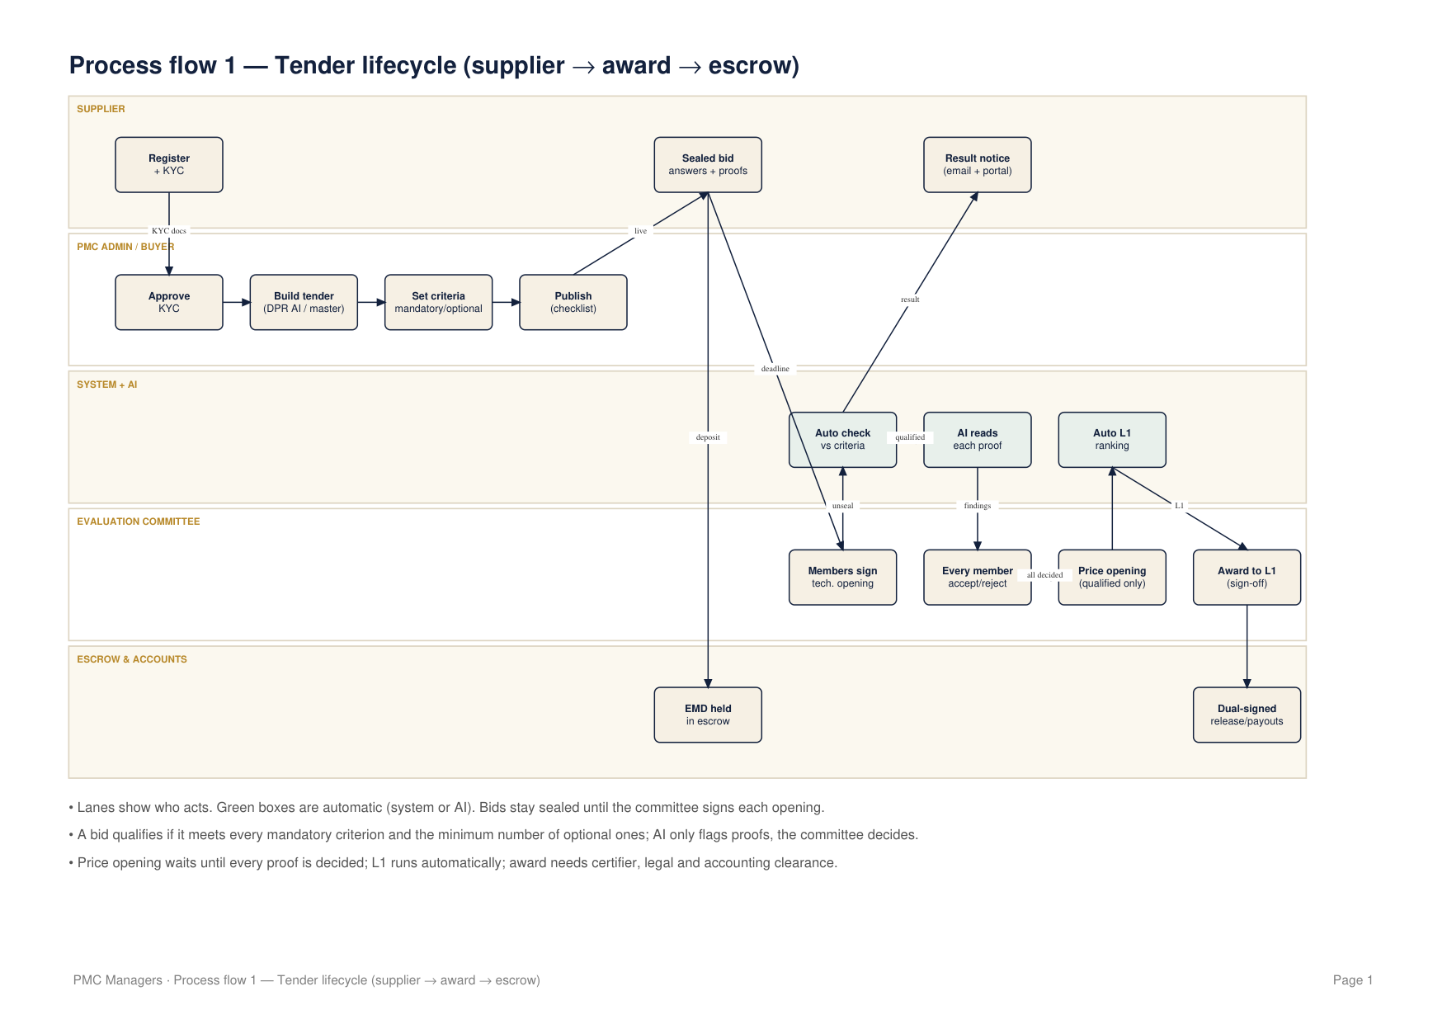

Process flow 2 — Supplier onboarding
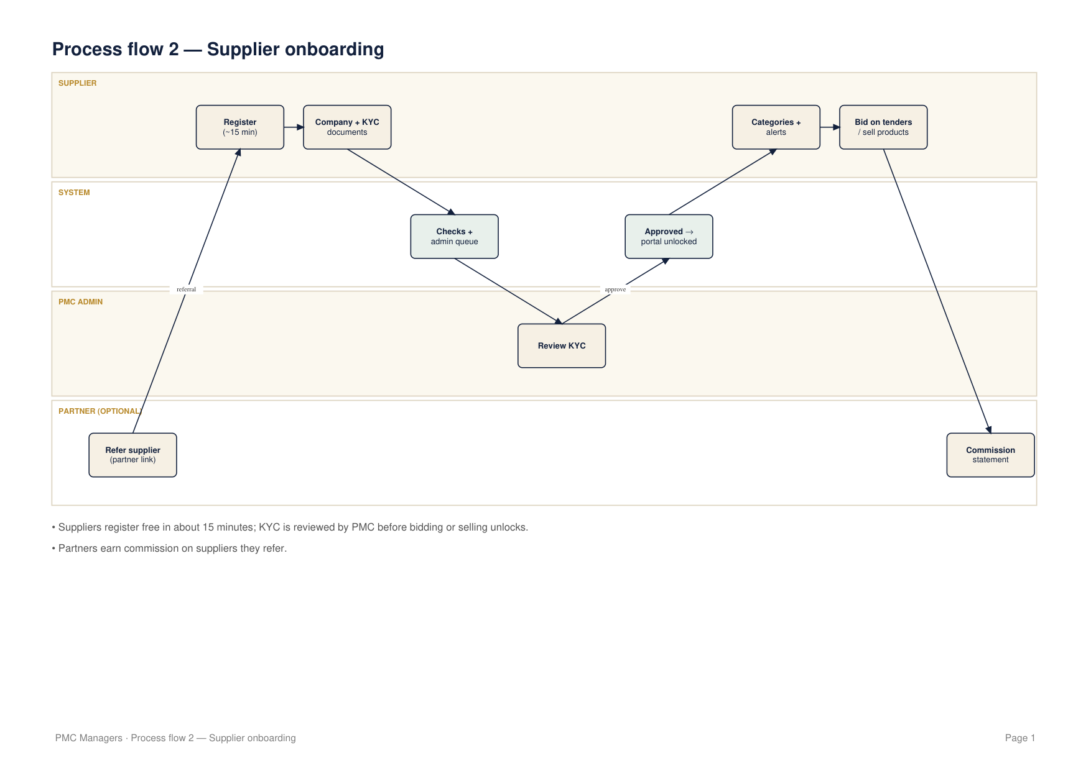

Process flow 3 — Buyer onboarding & team
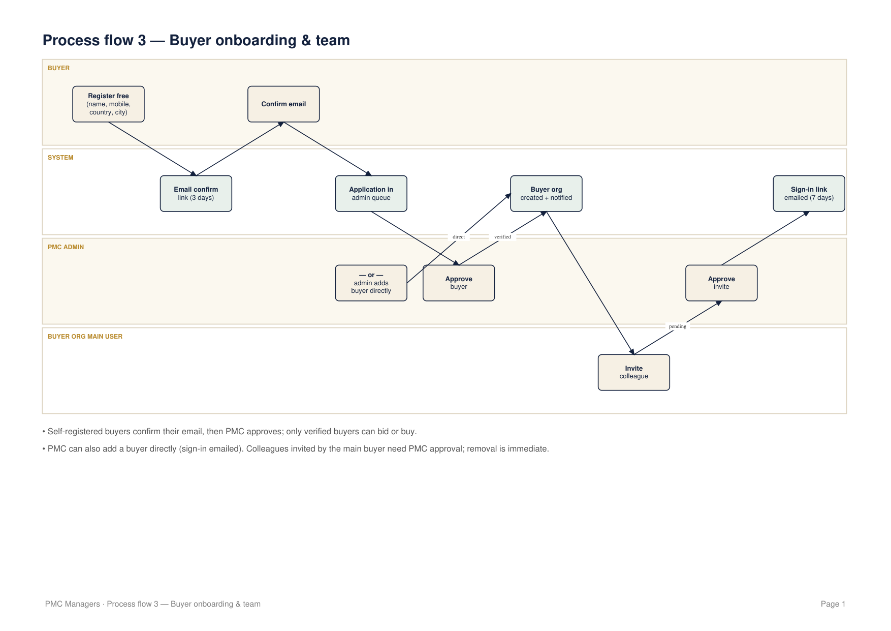

Process flow 4 — Supplier marketplace
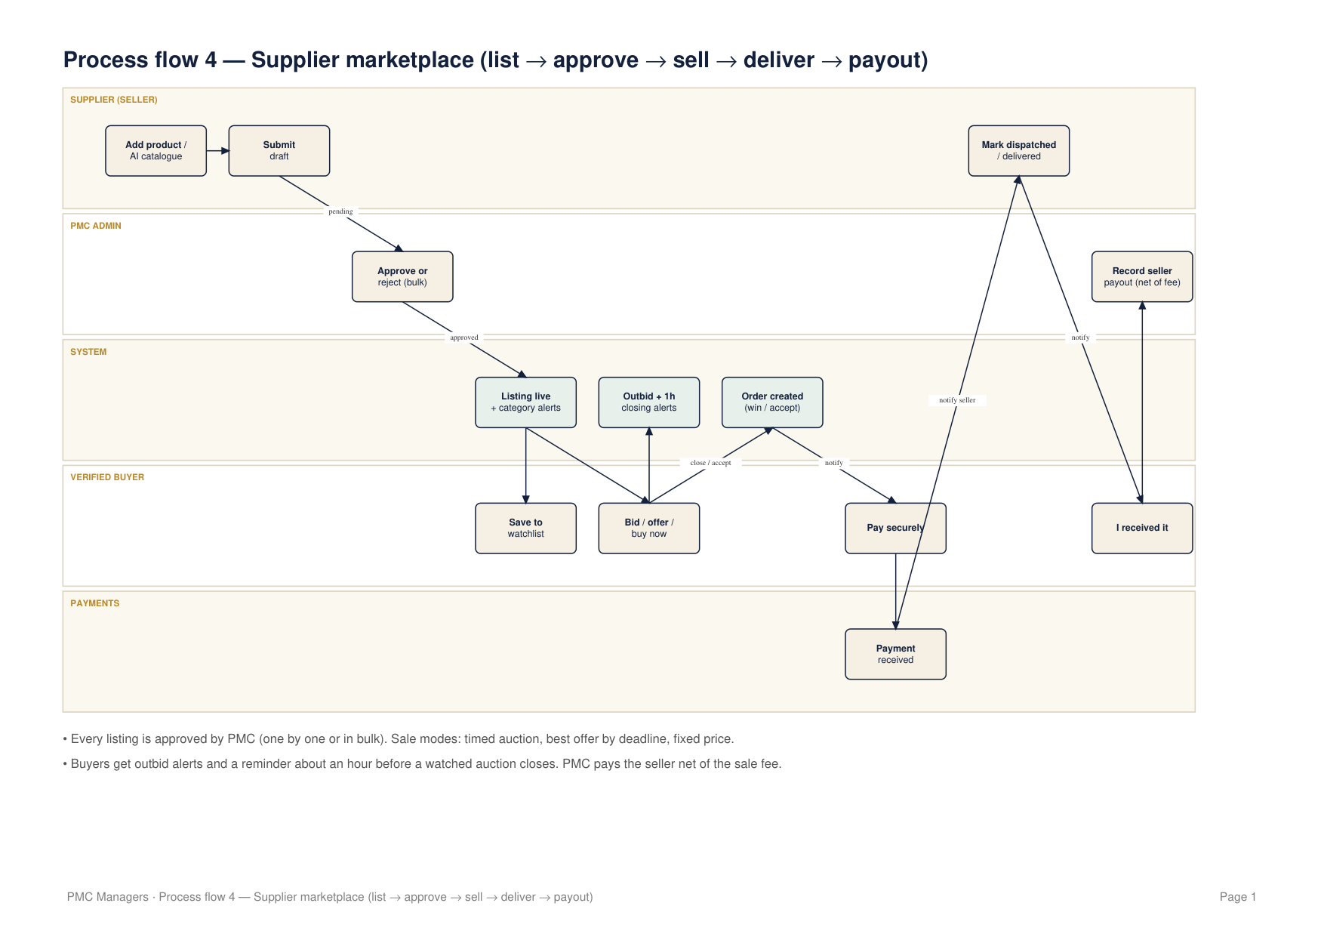

Data flow — Level 0 (context)
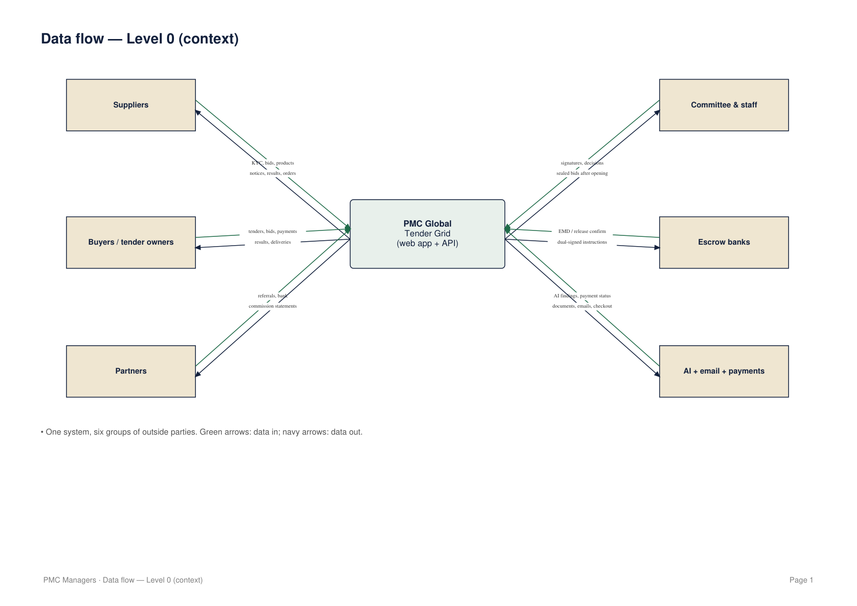

Data flow — Level 1: tendering
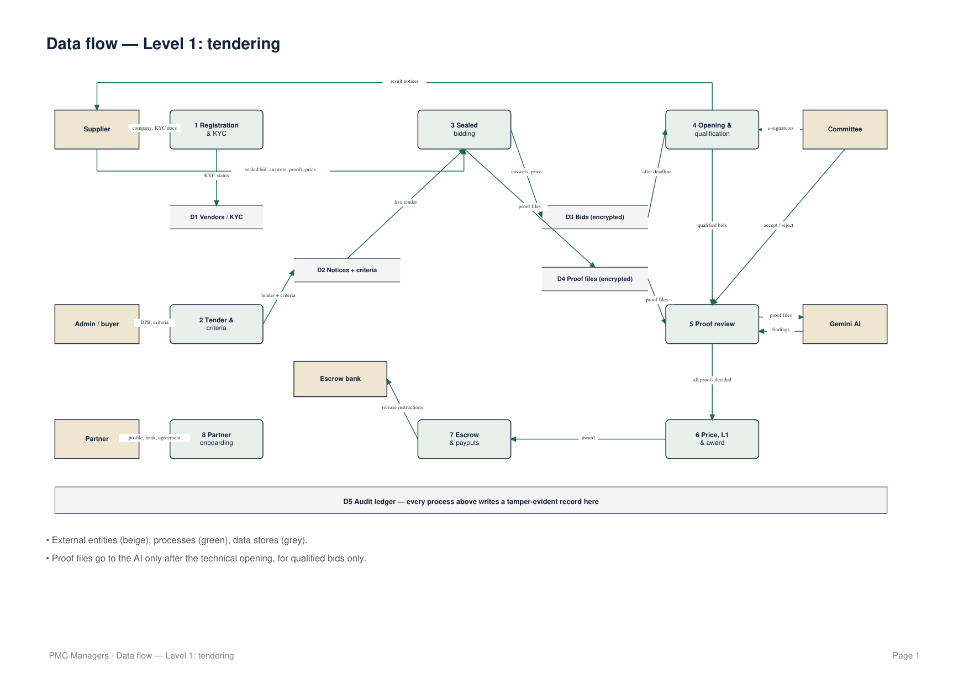

Data flow — Level 1: marketplace & buyer portal
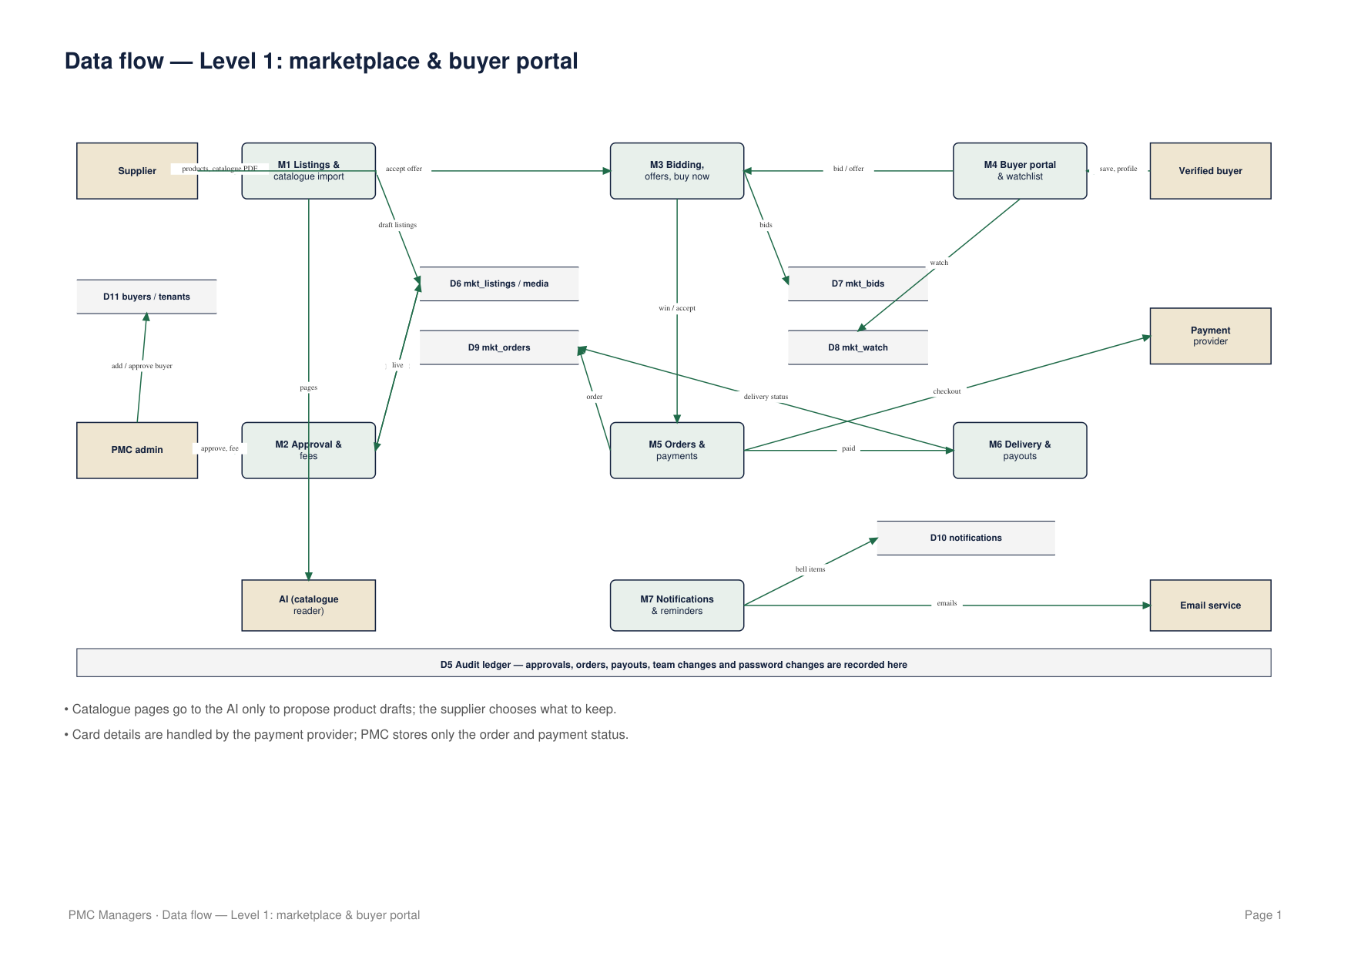

30 · Glossary
Term | Meaning
DPR | Detailed project report used to draft a tender
EMD | Earnest money deposit held in escrow with a bid
L1 | Lowest compliant price among qualified bids
Mandatory criterion | Must be met by every bidder
Optional criterion | Counts toward the minimum number the tender sets
Proof review | AI finding + unanimous committee decision on each proof
Corrigendum | Formal change to a live tender sent to every bidder
Consortium | Registered suppliers bidding together
Sealed bid | Encrypted until the committee signs the opening

