PMC Managers v2 — Master Training Manual
Deep-dive edition · v2 · Operations · QA · Management

Generated September 04, 2026

This document supersedes every earlier PMC training manual (v1 → v3.2 handbook · Screenshot Manual v1 · v1 master manual · every Observation-Response iteration).

Core modules (16) get a deep-dive structure: Screens & fields → Step-by-step tutorial → API reference → Common pitfalls → Expanded QA cases → Governance & KPIs. Non-core modules use the compact layout.

Contents

# | Module | Depth | Audience
1 | Access, Roles & Login | Deep-dive | Ops · QA · Mgmt
2 | Vendor Registration & KYC | Deep-dive | Ops · QA
3 | Notices Admin | Deep-dive | Ops · QA · Mgmt
4 | Corrigenda | Deep-dive | Ops · Mgmt
5 | Tender Builder | Deep-dive | Ops · QA · Mgmt
6 | Bidding Ops · Pipeline | Deep-dive | Ops · QA
7 | Bidding Ops · Committee | Deep-dive | Ops · QA · Mgmt
8 | Reverse Auctions | Deep-dive | Ops · QA
9 | Escrow (EMD) | Deep-dive | Ops · QA · Mgmt
10 | Evaluation & Scoring | Deep-dive | Ops · QA · Mgmt
11 | L1 Comparison | Deep-dive | Ops · QA · Mgmt
12 | Awards & POs | Deep-dive | Ops · QA · Mgmt
13 | DocuSign · Envelope Log | Deep-dive | Ops · QA
14 | BOQ & Contracts | Deep-dive | Ops · QA · Mgmt
15 | Masters · Roles & Permissions | Deep-dive | Ops · QA · Mgmt
16 | Governance Guardrails | Deep-dive | Mgmt · QA
17 | Public Notice Board | Compact | Ops · Mgmt
18 | Registrations Admin | Compact | Ops · Mgmt
19 | Meetings | Compact | Ops · QA
20 | Vendor Intel | Compact | Ops · Mgmt
21 | Product Catalog | Compact | Ops · Mgmt
22 | Engagements (Quotes) | Compact | Ops · QA · Mgmt
23 | Portal Branding | Compact | Ops · Mgmt
24 | Reports · Asked-vs-Delivered | Compact | Mgmt
25 | Stakeholder Reports · G4 | Compact | Mgmt · Ops
26 | Help Requests | Compact | Ops · Mgmt
27 | Audit Log | Compact | Ops · Mgmt
28 | Dashboard · Analytics & Drill-through | Compact | Ops · Mgmt
29 | Sign-out & Exit | Compact | Ops · QA

Chapter 1 · Access, Roles & Login
Every user, every login path, every access rule.
Audience: Ops · QA · Mgmt
OVERVIEW
PMC Managers v2 is a multi-tenant global tender platform. Every user authenticates through the same URL and lands on the console that matches their role. Admin uses HTTPOnly cookie + CSRF double-submit; vendor and public flows use short-lived resume tokens sent by email.

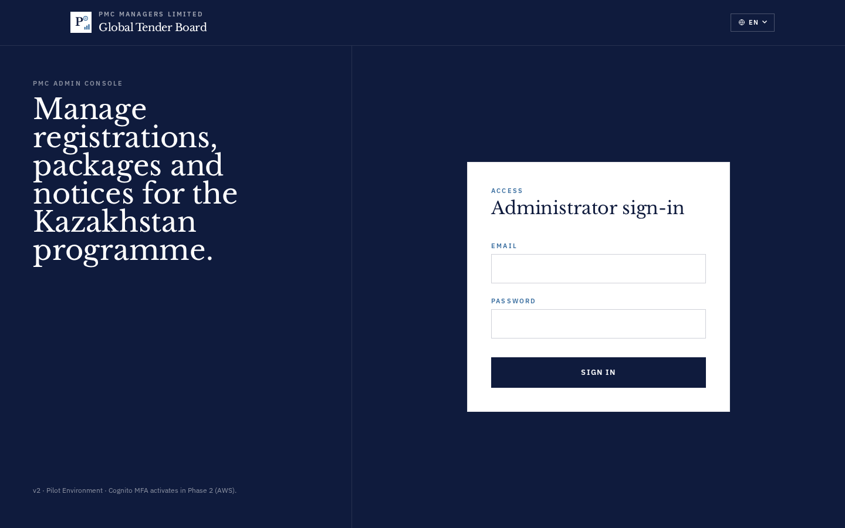
SCREENS & FIELDS
Screen / Field | What it captures / does
/admin/login — admin card | Email + password + a two-line brand kicker. Failed attempts show inline error under the password field. Cookie set on success is Secure + SameSite=Lax + HTTPOnly.
/login — unified | Two-card selector: 'I'm an admin' (opens /admin/login) or 'I'm a vendor' (opens /register or resume flow). The card the user clicks is remembered in localStorage for their next visit.
Top-right avatar menu | Shows the logged-in email, role badge, tenant name, and a Sign-out button. Clicking the avatar reveals 'Profile' + 'Change password'.
STEP-BY-STEP TUTORIAL
Step 1 · Log in as Master Admin
Open https://www.pmcmanagers.com/admin/login → email adminsupport@pmcmanagers.com → password Admin@12345 → Sign in. You land at /admin?tab=analytics within 1s.
Step 2 · Log in as Reviewer / Sub-admin
Same URL, but with a reviewer role account (e.g. madhavi@pmcmanagers.com). Publish checkbox on Notices is grayed out — reviewers save drafts only.
Step 3 · Log in as Vendor
Public site → 'Sign in' → vendor card → email + password → land on /vendor. Vendors only see their own bids and profile.
Step 4 · Change password
Avatar menu → Change password → enter old + new (min 12 chars, 1 upper, 1 digit, 1 symbol) → Save. Session cookie is rotated.
Step 5 · Recover forgotten password
Login card → 'Forgot password' → email address → recover-token email → click link → set new password. Token TTL 30 min.
API REFERENCE
Method | Path | Notes
POST | /api/v1/auth/login | Body {email, password}. 200 sets HTTPOnly cookie 'pmc_admin' + returns {role, email, tenant_id}. 401 on wrong creds. 429 after 5 failed attempts (15 min lockout).
POST | /api/v1/auth/logout | Clears cookie. Always 204.
GET | /api/v1/me | Returns the current admin's identity + role + tenant. Used by every panel to gate UI.
POST | /api/v1/auth/forgot | Body {email}. Always 204 (no email-enumeration leak). If email exists, a recover-token is sent.
POST | /api/v1/auth/reset | Body {token, new_password}. 200 on success + auto-login.
COMMON PITFALLS
- Do NOT store credentials in the URL — session tokens are cookie-only.
- If you see 401 on a specific tab, first hit /api/v1/me to confirm the cookie is still valid before assuming a permission bug.
- Password reset emails only work if the tenant has a Resend key configured. Absence of the email usually means EMAIL_KEY isn't propagated to the Docker container.
QA TEAM · TEST CASES
# | Test step | Expected outcome
1 | Login with wrong password 5 times | 6th attempt returns HTTP 429 with a Retry-After header  data-testid: admin-login-submit
2 | Login with correct credentials | Redirects to /admin within 1s; /api/v1/me returns 200 with role  data-testid: admin-login-submit
3 | Reload after login | Session persists via HTTPOnly cookie; no re-auth needed  data-testid: admin-topbar
4 | Sign out then hit /admin directly | Bounce back to /login; /api/v1/me returns 401  data-testid: admin-logout
5 | Password reset with expired token | HTTP 400 'token expired or invalid'  data-testid: auth-reset
MANAGEMENT · GOVERNANCE · KPIS
- Nine role types: Admin, Reviewer, Escrow, Certifier, Legal, Accounting, Committee, Support, Auditor.
- Access-control merges Permissions Matrix + Hierarchy Level via GET /api/v1/permissions/effective/{role}.
- Level 0 = Admin → Level 3 = Support/Auditor (read-only).
- Every login is audit-logged: actor, IP, user-agent, timestamp.
- Session TTL 12h with sliding renewal on activity; hard-limit 30 days regardless of activity.

Chapter 2 · Vendor Registration & KYC
5-section wizard that captures identity, structure, financials, docs, references.
Audience: Ops · QA
OVERVIEW
Vendors self-register through a 5-section wizard (A Identity, B Structure, C Financials, D Documents, E References). As soon as any field is filled a silent draft is created + a resume link is emailed. Vendors can pause and come back via /register/status with the resume token.

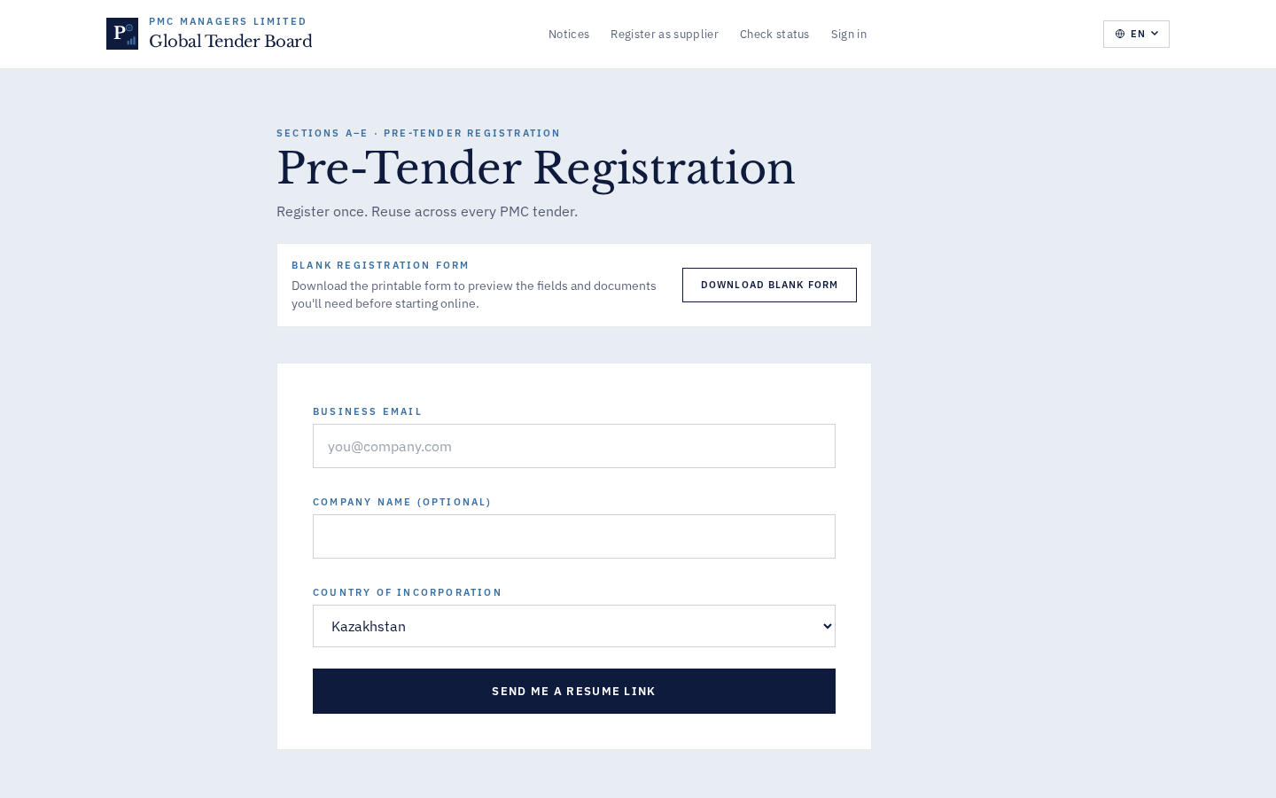
SCREENS & FIELDS
Screen / Field | What it captures / does
Section A · Identity | Company legal name (≥3 chars), primary contact name, primary contact email (RFC-5322), primary contact phone (E.164), country (ISO-3166 alpha-2). Country drives the KYC document catalog in Section D.
Section B · Structure | Legal form (LLC/Pvt Ltd/Public Ltd/Partnership/Sole Prop), incorporation date, number of employees, main office address, subsidiaries table.
Section C · Financials | Last 3 years of revenue (yearly rows), currency, net-profit margin, audited-accounts uploads. Aggregation feeds L1 Comparison technical scoring.
Section D · Documents | Country-specific KYC pack. India: PAN, GST cert, MSME (optional), CIN. UK: Companies House number, VAT cert. Every slot is an optional/required tag.
Section E · References | Up to 3 client references. Each reference is a mini-form: name, company, email, phone, project value. On approval, a reachback email is sent to each reference.
STEP-BY-STEP TUTORIAL
Step 1 · Start a draft
Open /register → Section A → fill company name, contact, email, country → click Save & continue. A resume link email is sent to the primary contact within 30s. The URL bar now shows /register/section-b.
Step 2 · Pause + resume
Close the tab. Email arrives with a 24-char URL-safe resume token. Click it → land on /register/section-b with all fields prefilled.
Step 3 · Upload a KYC doc
Section D → click the PAN slot → pick a PDF ≤10MB → progress bar → 'Uploaded' green tick. File is stored server-side with a UUID reference; the vendor never sees the raw file URL.
Step 4 · Submit for review
Section E → 'Submit for review'. Backend validates every required field; missing fields open a red banner with a jump link. On success, status becomes 'submitted' and admin is notified.
Step 5 · Handle a clarification request
If admin sends a Request-Clarification, vendor receives an email with a note (≥5 chars). Vendor uses the same resume token; the previous submission is retained and augmented.
API REFERENCE
Method | Path | Notes
POST | /api/v1/registrations/start | Body {section_a fields}. Returns {registration_id, resume_token}. Idempotent by primary email.
PATCH | /api/v1/registrations/{id} | Partial update with token in header 'X-Resume-Token'. Merges into the draft.
POST | /api/v1/registrations/{id}/uploads | Multipart file upload. Returns {slot, uuid}. Slot is one of: pan, gst, msme, cin, vat, incorporation, audit_yN, other.
POST | /api/v1/registrations/{id}/submit | Freezes the draft and moves status → 'submitted'.
GET | /api/v1/registrations/status?token=… | Public — returns current stage + reviewer notes.
COMMON PITFALLS
- The resume token in the email is the ONLY way for a vendor to come back. Losing the email means starting over; admin can re-issue via 'Nudge Stale Drafts'.
- KYC docs are country-scoped. A vendor whose country changes mid-registration will see a new document catalog; existing uploads are preserved but tagged 'legacy'.
- Bulk Invite CSV uses primary email as the dedupe key. Duplicate rows return per-row 409 in the response array without aborting the whole import.
QA TEAM · TEST CASES
# | Test step | Expected outcome
1 | Section A missing country | HTTP 400 'country required'; frontend highlights field  data-testid: reg-section-a-submit
2 | Upload 15 MB PDF to KYC slot | HTTP 413 'file too large — max 10 MB'  data-testid: reg-upload-kyc
3 | Paste invalid token at /register/status | Toast 'Token invalid or expired' (Bug 7)  data-testid: status-token
4 | Submit with Section D empty | HTTP 400 with per-slot error array pointing to missing required KYC docs  data-testid: reg-submit
5 | Malformed Bulk Invite CSV row 5 of 20 | 19 rows succeed, row 5 returns 409 in response array  data-testid: vendors-bulk-invite-csv
MANAGEMENT · GOVERNANCE · KPIS
- GDPR-compliant: KYC docs stored server-side with tenant-scoped ACL.
- Draft-to-submitted conversion KPI is on the Vendors card in Stakeholder Reports.
- Rejected registrations require a reason ≥5 chars; the reason is surfaced to the vendor in the outbound email.
- Retention: submitted+approved records retained indefinitely; rejected drafts purged after 90 days.

Chapter 3 · Notices Admin
Create, publish, filter and manage every tender / RFP / RFQ.
Audience: Ops · QA · Mgmt
OVERVIEW
The single source of truth for a live tender. Notices link to a Tender Builder template, drive the public notice board, and gate every downstream flow (bids, escrow, awards). Reviewers save drafts; only Master Admin publishes.

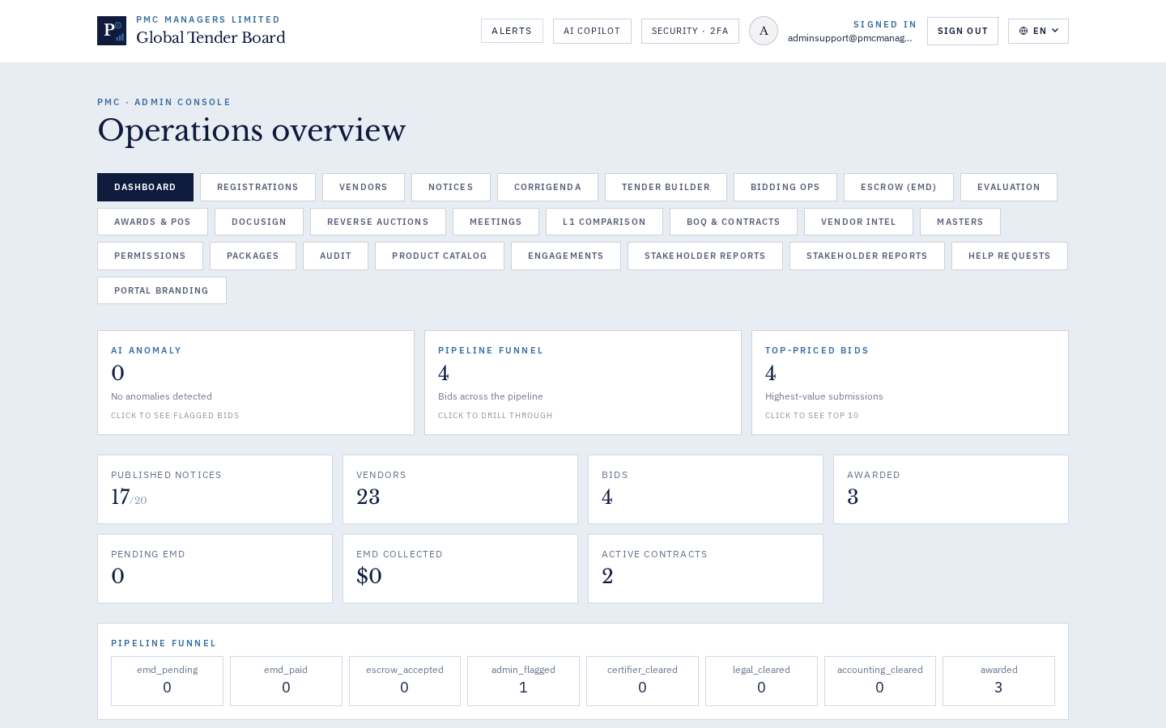
SCREENS & FIELDS
Screen / Field | What it captures / does
New Notice wizard | Title (≥3 chars), Description (≥10 chars), Category, Delivery Country, Submission Deadline, Budget Amount (ge=0), Budget Currency (ISO-4217), Document type (tender/RFP/RFQ), Tender Template link.
Filter bar | Search box (matches title/notice_ref, case-insensitive), Status dropdown (any/published/draft/expired), Template-linked-only toggle, Clear button.
Notice row | Title + notice_ref + budget pill + deadline date on right + template-linked badge. Click opens the detail drawer with bidders, corrigenda, and audit slice.
STEP-BY-STEP TUTORIAL
Step 1 · Create a draft notice
Notices → '+ New notice'. Fill Title 'North-East Highway BOT'. Description ≥10 chars. Category = Construction. Country = IN. Submission deadline = today + 30 days. Budget 500000000 INR. Document type = tender. Save without ticking Publish → status='draft'.
Step 2 · Attach a Tender Builder template
Open the draft → 'Pick template' → search 'GFR 2017 QCBS 70/30' → Attach. tender_template_id now set; badge appears on the row.
Step 3 · Publish (Master Admin only)
Toggle 'Publish immediately' → Save. Status → published, published_at stamped, all subscribed bidders receive notification, public notice board updates within 60s.
Step 4 · Filter to overdue drafts
Status = draft, Search empty. Look at 'Days since created' column — anything >5 days is a candidate for review.
Step 5 · Amend after publish (use Corrigenda)
You cannot edit a published notice. Instead → Corrigenda tab → '+ New' → describe the amendment → optional new deadline → Publish. Notifications go out.
API REFERENCE
Method | Path | Notes
POST | /api/v1/notices | Create draft. reviewer.create=True (Bug 5 fix), so sub-admins can save drafts without 403.
PATCH | /api/v1/notices/{ref} | Partial update. Locked once is_published=true (use corrigenda instead).
POST | /api/v1/notices/{ref}/publish | Requires admin role + publish permission on Notices.
GET | /api/v1/notices?status=&country=&limit= | Public list; admin sees drafts too.
COMMON PITFALLS
- Budget_amount validates ge=0 — negative values return 400 (Bug 4 fix).
- You cannot delete a published notice; only issue corrigenda.
- notice_ref format is `PMC-NOT-YYYY-####`; the sequence is per-tenant per-year.
QA TEAM · TEST CASES
# | Test step | Expected outcome
1 | Publish with budget_amount = -1 | HTTP 400 (NoticeIn validates ge=0)  data-testid: notices-form-submit
2 | Reviewer saves draft | HTTP 200; reviewer.create=True (Bug #5 fix); no 'undefined' toast  data-testid: notices-form-submit
3 | Filter Template-linked only | List narrows to notices with tender_template_id set  data-testid: notices-filter-template-only
4 | Filter status=expired | List narrows to notices where submission_deadline < now()  data-testid: notices-filter-status
5 | Non-admin tries to publish | HTTP 403 'insufficient permissions to publish'  data-testid: notices-publish-checkbox
MANAGEMENT · GOVERNANCE · KPIS
- Every publish is audited: actor + tenant + notice_ref + timestamp.
- KPI: notices-published-per-month per tenant; median time from creation to publish.
- Currency defaults to tenant primary but supports any ISO 4217 code.

Chapter 4 · Corrigenda
Formal amendments to published tenders — every change is auditable.
Audience: Ops · Mgmt
OVERVIEW
Corrigenda re-open the bidder window after a tender is public. Every corrigendum has an auto-number (`PMC-COR-YYYY-####`), a mandatory reason ≥8 chars, and can reset the submission deadline. Withdrawal is capped at 3 per notice.
SCREENS & FIELDS
Screen / Field | What it captures / does
New Corrigendum modal | Parent notice (auto-linked from the Notice detail), Amendment description (≥8 chars), New deadline (optional, must be > now).
Corrigenda list | Per-notice list showing: number, reason snippet, published_at, deadline change, actions (Withdraw, View).
Withdraw dialog | Requires a reason (≥8 chars) captured to audit log.
STEP-BY-STEP TUTORIAL
Step 1 · Issue a corrigendum
Open a published notice → Corrigenda tab → '+ New'. Description: 'Extended submission window from Nov 30 to Dec 14 due to holiday season' (54 chars). New deadline: 2026-12-14. Publish. Bidders receive email + banner on public notice.
Step 2 · Withdraw a corrigendum
Corrigenda row → '✕ Withdraw'. Reason: 'issued in error, correct clause was updated elsewhere' (55 chars). Backend logs to audit. Public list hides the corrigendum but admin can still see it (is_active=false).
Step 3 · Reach the limit
By the 4th corrigendum on the same notice, '+ New' returns HTTP 400 'withdrawal capped at 3 per notice' — pattern is designed to force cleanup + re-publish rather than corrigendum-spam.
API REFERENCE
Method | Path | Notes
POST | /api/v1/corrigenda | Body {notice_ref, description, new_deadline}. Backend validates reason≥8, new_deadline > now.
POST | /api/v1/corrigenda/{id}/withdraw | Body {reason}. reason ≥8 chars enforced.
GET | /api/v1/corrigenda?notice_ref=… | Public sees is_active=true; admin sees all.
COMMON PITFALLS
- Withdrawal reason is captured to audit log AND surfaced in the public 'History' expander on the notice page — write it as if a lawyer will read it.
- The 3-corrigenda cap is a hard limit. If you need more amendments, close the notice and re-publish with a new notice_ref.
QA TEAM · TEST CASES
# | Test step | Expected outcome
1 | Withdraw with 3-char reason | HTTP 400 'reason must be at least 8 characters'  data-testid: corrigenda-withdraw
2 | 4th corrigendum on a notice with 3 | HTTP 400 'withdrawal capped at 3 per notice'  data-testid: corrigenda-create
3 | New deadline in the past | HTTP 400 'new_deadline must be in the future'  data-testid: corrigenda-form-submit
4 | Publish corrigendum | audit_log entry with reason + all subscribed bidders receive email  data-testid: corrigenda-publish
MANAGEMENT · GOVERNANCE · KPIS
- Legal-grade audit: reason text is preserved on the notice record + audit log forever.
- Corrigenda count is a red-flag KPI — high count per notice indicates poor initial drafting; surfaced on Stakeholder Reports / Tenders.

Chapter 5 · Tender Builder
Compose 30+ page tenders from orderable sections + annexures.
Audience: Ops · QA · Mgmt
OVERVIEW
Master templates ship for GFR 2017 QCBS 70/30 (India), FIDIC Red Book (international), and a blank template. Clone a master into a draft, fill each section with the rich editor, attach annexures via drag-drop, preview + export via WeasyPrint. Every save writes a rolling snapshot (max 20) so you can revert. Restore is itself snapshotted (undoable).

SCREENS & FIELDS
Screen / Field | What it captures / does
Left sidebar — Kind tabs + template list | Three tabs: Tender / RFP / RFQ. Each shows the master templates (locked) at the top and drafts below (sortable). Sidebar shows Kind badge, updated_at timestamp, and current version number. Bug 31c fix: switching Kind clears the right pane so you don't accidentally edit a different draft.
Header pane — Basic details | Title, Reference number (auto), Issuing authority, Estimated value + currency, EMD amount, EMD form (bank guarantee / DD / online), Critical dates (issue / pre-bid / submission / opening).
Section editor | Rich editor (bold, italic, lists, block-quote, tables). Each section has an ordering handle, ✨ AI Draft menu, and a lock toggle. Word count in bottom-right.
Annexure uploader | Drag many files at once — filenames auto-match to the numbered annexure slots (annex-VIII_bank.pdf → Annexure VIII, longest-code wins). Preview inline. Right-click → 'Replace' or 'Detach'.
Version history drawer (⟲) | Chronological list of up to 20 snapshots per draft. Each row shows: version #, saved_by, saved_at, section-count. Preview or Restore. Restore creates snapshot v+1 (undoable).
Preview / Export | Preview opens a WeasyPrint HTML render in a modal. Export gives PDF (with DRAFT watermark until published) + DOCX + language-pack switch EN/RU/KK.
STEP-BY-STEP TUTORIAL
Step 1 · Clone a master into a draft
Left column → Kind tab 'Tender' → find 'GFR 2017 QCBS 70/30' master → click Clone. A 'Draft 2026-09-04' appears below the masters. Click to open.
Step 2 · Fill the header
Header pane → Title 'North-East Highway BOT — QCBS 70/30'. Reference: leave auto. Authority: 'NHAI'. Estimated value: 5 000 000 000 INR. EMD: 25 000 000 INR. Bank guarantee. Critical dates: fill the four ISO dates.
Step 3 · Draft Section 1 · Scope of work
Click Section 1 → paste your scope text or click ✨ AI Draft → tone=formal, length=medium → preview → Insert. The AI shows a word-diff so you know exactly what would change if the section already had content.
Step 4 · Bulk-attach annexures
Annexure pane → drag 12 PDFs at once (annex-I_boq.pdf, annex-II_form.pdf, …). System auto-matches based on filename; unmatched files go to an 'unassigned' tray for manual placement. Longest code wins, so 'annex-VIII' beats 'annex-V'.
Step 5 · Reorder sections
Hold the ⋮ handle and drag Section 6 above Section 5. The order number auto-updates. Every section knows its position — Table of Contents regenerates on save.
Step 6 · Snapshot + restore
Save the draft (Cmd+S). Version count → 1. Save again after changing Section 3 — version 2. Open ⟲ drawer → Preview v1 → confirm → Restore. Version 3 appears (restore is itself a snapshot). Original v1 + v2 remain.
Step 7 · Export & watermark
Export → PDF. If the tender is still a draft (or its associated notice is not is_published), a diagonal 'DRAFT — CONFIDENTIAL' watermark is embedded on every page. Watermark disappears when the notice publishes.
Step 8 · Language switch
Export → Language pack: Russian → the labels ('SECTION 1 · SCOPE OF WORK', page footer, ToC) render in Russian. Section body text is NOT translated — that's a copy-writing task.
API REFERENCE
Method | Path | Notes
POST | /api/v1/tender-templates/{master_id}/clone | Returns {draft_id}. Draft inherits the master's sections + annexures + header defaults.
PATCH | /api/v1/tender-templates/{draft_id} | Partial update. Backend snapshots the pre-change state to versions[] with a max of 20 rolling entries.
GET | /api/v1/tender-templates/{draft_id}/versions | Returns the versions[] list oldest→newest.
POST | /api/v1/tender-templates/{draft_id}/restore/{version} | Restore a snapshot. Backend writes a NEW snapshot before the restore so the operation is undoable.
POST | /api/v1/tender-templates/{draft_id}/annexures/bulk | Multipart file batch. Body includes filename-array; backend runs the longest-code auto-match.
POST | /api/v1/tender-templates/{draft_id}/ai-draft | Body {section_id, tone, length}. Returns generated text + a HTML word-diff string the frontend renders.
GET | /api/v1/tender-templates/{draft_id}/export?format=pdf|docx&lang=en|ru|kk | Streams the rendered file with Content-Disposition: attachment.
COMMON PITFALLS
- Snapshots are per-draft. Cloning a master into a new draft resets the version counter to 1.
- AI Draft respects the tenant's Emergent LLM key budget. If the key runs out mid-generation, the response is truncated and the frontend shows an 'AI budget low' banner — top up under Profile → Universal Key.
- Bulk annexure upload dedupes by (annexure_slot, filename). Uploading annex-I.pdf twice replaces the previous file silently — check the History drawer to recover.
- Kind tab switching resets the right pane (Bug 31c). If you had unsaved changes, they are LOST — the sidebar's 'unsaved' dot serves as the reminder.
- Section locking is per-section (not per-user). A locked section can be unlocked by any admin — this is a soft warning, not a hard permission gate.
- PDF export uses WeasyPrint. Very long tables (>1000 rows) may hit the memory limit — split into multiple annexures.
QA TEAM · TEST CASES
# | Test step | Expected outcome
1 | Clone a master and immediately save without edits | Version 1 stamped; snapshot preserves the master's original content  data-testid: tender-clone
2 | Save section body 3 times | Version count = 3; History drawer shows 3 rows with distinct updated_at  data-testid: tender-section-save
3 | Switch Kind tab with unsaved changes | Right pane resets; selectedId cleared; toast warns of unsaved loss (Bug 31c)  data-testid: tender-kind-tab
4 | Bulk upload 5 files matching Annexures I-V | All 5 auto-attach to correct slots; unassigned tray empty  data-testid: tender-annex-bulk
5 | Bulk upload file named 'annex-VIII_stub.pdf' alongside 'annex-V_full.pdf' | annex-VIII goes to slot VIII (longest code wins); annex-V goes to slot V  data-testid: tender-annex-bulk
6 | Restore version 1 after making 5 changes | Content reverts; version 6 is created with 'restored from v1' note  data-testid: tender-restore
7 | Export PDF while linked notice is draft | PDF has diagonal DRAFT watermark on every page  data-testid: tender-export-pdf
8 | Publish the linked notice; re-export PDF | Watermark absent; PDF is 'production' grade  data-testid: tender-export-pdf
9 | AI Draft on a locked section | HTTP 409 'section is locked'; frontend shows red banner  data-testid: tender-ai-draft
10 | Save on the 21st edit | Version 21 replaces version 1 (rolling cap of 20 preserved)  data-testid: tender-section-save
MANAGEMENT · GOVERNANCE · KPIS
- Language pack ships EN / RU / KK labels through WeasyPrint templates.
- Section-level auditor role can veto a section without unlocking the entire draft — writes to audit + notifies drafter.
- KPI: average edit-cycle length per template; teams with > 40 edits per template may need training.
- AI usage per tenant is tracked and charged against the Universal Key budget — Profile → Universal Key → 'View usage' shows a per-day chart.
- Master templates are versioned separately — updating a master does NOT retroactively touch existing drafts.

Chapter 6 · Bidding Ops · Pipeline
Track every bid through the multi-role approval pipeline.
Audience: Ops · QA
OVERVIEW
The pipeline: EMD → Escrow → Admin flag → Certifier → Legal → Accounting → Committee. Each role clears their stage. Stuck bids surface in the daily audit digest. Rejection at any stage requires a note ≥10 chars.

SCREENS & FIELDS
Screen / Field | What it captures / does
Status filter chips | Chips across the top: submitted / emd_paid / admin_flagged / certified / legal_cleared / accounting_ok / committee_approved / awarded / rejected. Multi-select allowed.
Bid row | Vendor + notice_ref + current status pill + price + submitted_at. Click opens the timeline drawer with every stage transition.
Assign Certifier modal | Certifier dropdown (users with role=certifier), date + location, notes ≥5 chars. Creates an inspection record + dispatches an email with signed accept-link.
Reject dialog | Note ≥10 chars; captured to bid.reject_reason + audit log.
STEP-BY-STEP TUTORIAL
Step 1 · Assign a certifier
Bid row (status=admin_flagged) → Assign → pick certifier → set date + location → note ≥5 chars → Save. Certifier receives an email; bid status advances to 'certifier_assigned'.
Step 2 · Advance a bid to Committee
Sequential clears: certifier → Legal (checkbox 'Legal clearance done') → Accounting ('EMD reconciled') → Committee ('Formation complete'). Each is a distinct role.
Step 3 · Reject at accounting stage
Bid → Reject → note '10-char reason for rejection at accounting stage'. Vendor is emailed with the note. Downstream stages disabled.
Step 4 · Handle a stuck bid
Any bid stuck > 7 days at one stage triggers a daily digest email to admin. Open the audit slice via the bid detail drawer to see who to nudge.
API REFERENCE
Method | Path | Notes
POST | /api/v1/bids/{ref}/advance | Body {to_stage, notes}. Requires the role that gates that stage; role gate is defined in Permissions Matrix.
POST | /api/v1/bids/{ref}/reject | Body {reason}. reason ≥10 chars.
POST | /api/v1/bids/{ref}/assign-certifier | Body {certifier_id, date, location, notes}.
GET | /api/v1/bids?status=&notice_ref= | Filter + list.
COMMON PITFALLS
- The stage sequence is strict — you cannot skip from admin_flagged straight to committee_approved. The advance API returns HTTP 400 'invalid stage transition' otherwise.
- Committee stage requires a formed + open committee for the notice (see Committee chapter).
- Reject reason is surfaced verbatim to the vendor — keep it professional.
QA TEAM · TEST CASES
# | Test step | Expected outcome
1 | Reject with 5-char note | HTTP 400 'note must be at least 10 characters'  data-testid: bid-reject
2 | Skip legal_cleared → committee_approved | HTTP 400 'invalid stage transition'  data-testid: bid-advance
3 | Assign certifier without notes | HTTP 400 'notes required'  data-testid: assign-certifier
4 | Advance to committee without a committee | HTTP 400 'form a committee first for this notice'  data-testid: bid-advance
MANAGEMENT · GOVERNANCE · KPIS
- Every stage transition is audited (actor + prev + next + notes).
- KPI: median bid cycle-time (submitted → awarded), per tenant, per category.
- SLA: > 7 days at any single stage triggers daily nudges.

Chapter 7 · Bidding Ops · Committee
Form evaluation committees with chair + members + quorum + external invitees.
Audience: Ops · QA · Mgmt
OVERVIEW
One open committee per notice. Members are picked via checkbox grid. Chair dropdown auto-filters to selected members. Quorum caps at ≤ member count. External invitees receive email invites with signed accept-tokens. Committee can be dissolved with a reason ≥8 chars, and per-invitee 'Resend' buttons regenerate the accept-token (voiding the old one).

SCREENS & FIELDS
Screen / Field | What it captures / does
Committee form | Notice ref (auto from tab), Chair dropdown, Quorum input (max = ticked members), Member checkbox grid (staff + email + role/designation), External invitee sub-form.
Active committees card | Grid of open committees for the current notice. Shows: notice_ref, internal count, quorum, status, external accept/decline/pending counts, action buttons (Dissolve, per-external Resend).
External invitee row | Name + email + designation, status pill (invited/accepted/declined), 'Resend' button if not accepted.
STEP-BY-STEP TUTORIAL
Step 1 · Form a committee
Bidding Ops → Committee tab → New form. Tick 4 members → chair dropdown auto-narrows to those 4 → pick chair. Quorum caps at 4; type 3. Save → committee status='open'.
Step 2 · Add an external invitee
External sub-form → name/email/designation → Add. Multiple invitees can be added before saving the committee. Each gets a URL-safe accept-token.
Step 3 · Dissolve committee
Active committees card → Dissolve button → reason ≥8 chars → OK. Committee status='dissolved' + reason logged to audit. Bids on this notice cannot be scored until a new committee is formed.
Step 4 · Resend a pending invite
External invitee row → Resend. New accept-token generated; old link now returns 404. Email dispatched. Audit entry logged.
API REFERENCE
Method | Path | Notes
POST | /api/v1/committees | Body {notice_ref, chair, member_ids[], quorum, external_invitees[]}. Validates chair ∈ member_ids; quorum ≤ len(member_ids).
POST | /api/v1/committees/close | Body {committee_id, decision, remarks}. decision='dissolved' requires remarks ≥8 chars (v17).
POST | /api/v1/committees/{id}/external/{idx}/resend | Regenerates accept-token; old link invalidated (v17).
GET | /api/v1/committees?notice_ref=&status=open | List filter.
COMMON PITFALLS
- Only ONE open committee per notice at a time. Attempting to form a second returns HTTP 409.
- Dissolving does NOT delete the committee — the record is preserved with status='dissolved' for audit + downstream.
- Resend voids the old accept-token permanently. If the external invitee was mid-clicking the old link, they'll get 404 — coordinate before resending.
QA TEAM · TEST CASES
# | Test step | Expected outcome
1 | Tick 3 members, pick chair from a 4th unpicked staff | Chair dropdown does not offer the 4th; server also enforces chair ∈ members  data-testid: committee-chair
2 | Enter quorum = 10 with 4 members ticked | Input caps at 4 with live hint 'Quorum ≤ 4'  data-testid: committee-quorum
3 | Uncheck a member who is currently chair | chair field auto-clears; save disabled until new chair picked  data-testid: committee-member-check
4 | Dissolve with 6-char reason | HTTP 400 'dissolve reason must be at least 8 characters'  data-testid: committee-dissolve
5 | Resend invite to pending external | New accept-token; old link returns 404; email sent  data-testid: committee-resend
6 | Form 2nd committee on same notice with existing open one | HTTP 409 'a committee already exists for this notice'  data-testid: committee-create-submit
MANAGEMENT · GOVERNANCE · KPIS
- COI check (G2): evaluations.submit_score returns HTTP 400 unless the scorer has recorded a COI declaration for that notice.
- Chair change post-formation is a governance event — audit logs a distinct action.
- KPI: median committee formation → first score < 3 business days.

Chapter 8 · Reverse Auctions
Live reverse-auction rooms with masked bidder identities + anti-manipulation.
Audience: Ops · QA
OVERVIEW
Masked-identity auction (Bidder A/B/C…) with min-decrement, hard price floor, and anti-snipe extension. Draft auctions never expose the public bidder link (G5). Participant validation blocks duplicates + non-registered vendor emails.

SCREENS & FIELDS
Screen / Field | What it captures / does
Auction form | Notice ref, Start time, Duration, Min decrement (currency), Hard price floor, Anti-snipe seconds (extends deadline if bid lands in the final N seconds), Participants (registered vendor emails only).
Live room | Masked leaderboard, bid input, decrement hint, time-remaining timer with red pulse in the last 30s, host controls (Pause/Close).
Post-auction view | Winner, winning price, bid history table, participant reveal (only admin sees real identities).
STEP-BY-STEP TUTORIAL
Step 1 · Draft an auction
Auctions → '+ New' → notice + participants + min_decrement 10 000 + floor 200 000 000 + anti_snipe 30 s. Save → status='draft'. Bidder URL is HIDDEN in the panel; explanatory hint shown.
Step 2 · Go live
Draft row → 'Go live'. status='live'; bidder URL now visible + copy-to-clipboard. Bidders can join the /vendor/auction/:aid room.
Step 3 · Handle a snipe
If a bidder lands a valid bid in the final 30s, deadline extends by 30s. Repeat until 30s elapse with no bid — then auction closes.
Step 4 · Close manually
Host → 'Close' → confirm. Last valid bid becomes winning_price on the linked bid record.
API REFERENCE
Method | Path | Notes
POST | /api/v1/auctions | Create draft.
POST | /api/v1/auctions/{aid}/publish | Draft → live. Backend re-validates participants + generates a signed public URL.
POST | /api/v1/auctions/{aid}/bid | Body {bidder_token, amount}. Backend enforces decrement + floor + not-outside-window.
POST | /api/v1/auctions/{aid}/close | Manual close. Winner + winning_price written to the linked bid.
GET | /api/v1/auctions/{aid}/state | Poll endpoint (frontend polls every 2s).
COMMON PITFALLS
- Draft auctions do NOT show the public link (Bug G5 fix). If you don't see it, check the status pill.
- Participants must be pre-registered vendors — non-registered emails return HTTP 400 at auction creation.
- Anti-snipe extension is per-event: 5 snipe bids in the final 30s extend the deadline 5× (each 30s).
QA TEAM · TEST CASES
# | Test step | Expected outcome
1 | Add duplicate email to participants | HTTP 400 'duplicate participant email'  data-testid: auction-participants
2 | Open draft auction detail | Bidder URL not shown; explanatory text present (G5)  data-testid: auction-bidder-link
3 | Submit bid below floor | HTTP 400 'bid below hard floor'  data-testid: auction-bid-submit
4 | Submit bid decrement < min | HTTP 400 'decrement must be ≥ min_decrement'  data-testid: auction-bid-submit
5 | Close a live auction | status='closed'; winning_price stamped on bid; participants revealed to admin only  data-testid: auction-close
MANAGEMENT · GOVERNANCE · KPIS
- Anti-snipe extends by N seconds if a bid lands in the final N seconds — pure anti-manipulation.
- Winning price is written to the linked bid record for downstream award.

Chapter 9 · Escrow (EMD)
Joint escrow accounts with dual-signature EMD releases.
Audience: Ops · QA · Mgmt
OVERVIEW
Every EMD instrument flows through a joint account operated by one PMC officer + one escrow-institution officer. Both must sign before release (G1). Aging days per transaction; SLA breach flag when > 7 days pending. Reconciliation summary in Stakeholder Reports.

SCREENS & FIELDS
Screen / Field | What it captures / does
Account form | Name, PMC officer (email), Vendor / escrow-institution officer (email), Bank details, Currency. Backend rejects create when pmc_officer.email == vendor_officer.email (G1).
Transactions ledger | Every EMD instrument as a row: bid_ref, amount, state (pending/signed_pmc/signed_vendor/released/refunded/forfeited), aging_days, sla_breach flag.
Sign action | Two signatures required — each side clicks 'Sign my side' and the state advances. Release fires only after BOTH sign.
STEP-BY-STEP TUTORIAL
Step 1 · Create a joint account
Escrow → '+ Account' → PMC officer: alice@pmcmanagers.com; Escrow officer: bob@axisbank.in; Bank: Axis · A/C 1234 · IFSC UTIB0001234; Currency INR. Save. Status='pending'.
Step 2 · Sign the PMC side
Log in as alice → account detail → 'Sign my side' → confirm. Transaction state advances to 'signed_pmc'. Vendor officer receives an email nudge.
Step 3 · Sign the escrow side + release
Log in as bob → same tx → 'Sign my side' → Release. state='released'; escrow account balance updates; audit entry captures both signatures.
Step 4 · Read the aging report
Stakeholder Reports → Escrow tab → header shows total accounts + total tx + SLA breach count. Table shows aging_days per pending tx + sla_breach=true when > 7d.
API REFERENCE
Method | Path | Notes
POST | /api/v1/escrow/accounts | Rejects with HTTP 400 'PMC officer and escrow officer must be different people' when emails match (G1).
POST | /api/v1/escrow/accounts/{id}/transactions | Add a transaction. Body {bid_ref, amount}.
POST | /api/v1/escrow/accounts/{id}/transactions/{txid}/sign | Called by each signer. Backend checks the caller's email matches one of the two officers + which side is being signed.
POST | /api/v1/escrow/accounts/{id}/transactions/{txid}/release | HTTP 409 unless both signatures present.
GET | /api/v1/stakeholder-reports/escrow?format=json|csv | Aging + SLA breach report.
COMMON PITFALLS
- G1 is architecturally enforced — you cannot create an account where both emails match, even by mistake.
- Once released, a transaction cannot be un-released. Refund is a separate transaction that requires both signatures again.
- SLA threshold defaults to 7 days but is tenant-configurable via env var ESCROW_SLA_DAYS.
QA TEAM · TEST CASES
# | Test step | Expected outcome
1 | Create account with same email on both sides | HTTP 400 'PMC officer and escrow officer must be different people' (G1)  data-testid: escrow-account-create
2 | Sign PMC side then click Release without vendor sign | HTTP 409 'awaiting escrow-officer signature'  data-testid: escrow-release
3 | Sign vendor side as PMC officer login | HTTP 403 'you can only sign your own side'  data-testid: escrow-sign
4 | Open Stakeholder Reports / Escrow after 8 days pending | sla_breach=true; header count increments  data-testid: stakeholder-escrow-sla
5 | Release a released transaction again | HTTP 409 'transaction already released'  data-testid: escrow-release
MANAGEMENT · GOVERNANCE · KPIS
- G1 governance: same-login-both-sides is architecturally blocked at account create.
- SLA threshold configurable per tenant (default 7 days).
- KPI: median release cycle-time; SLA breach count per week.

Chapter 10 · Evaluation & Scoring
Committee scoring against per-criterion weighted rubric + COI cross-check.
Audience: Ops · QA · Mgmt
OVERVIEW
Committee members score each bid against the rubric set on the notice. Weighted totals compute live. Every score requires an outstanding COI declaration for that (scorer, notice) tuple — enforcement is HTTP 400 at submit_score (G2).

SCREENS & FIELDS
Screen / Field | What it captures / does
Rubric editor | Criteria list (name, weight 0-100). Weights must sum to 100. Locked at first score.
Score entry form | Bid selector, criteria rows (0-100 each), COI checkbox 'I have no conflict of interest with this bidder on this notice', comments field.
Committee dashboard | Grid of bids × members; each cell shows submitted status or the score. Median → technical score.
STEP-BY-STEP TUTORIAL
Step 1 · Set the rubric
Notice → Evaluation → 'Set rubric'. Criteria: Technical=40, Financial=30, Timeline=20, Prior work=10. Weights sum to 100. Save. Locked at first score.
Step 2 · Declare COI
Committee member → COI tab → 'I have no COI on notice X' → tick + submit. This creates a COI record for (member, notice).
Step 3 · Score a bid
Evaluation panel → pick bid → 4 scores 0-100 → tick COI → Submit. Weighted total computes live. Median across committee members becomes the technical score.
Step 4 · Change your score
Same panel → same bid → edit → resubmit. Old score preserved in audit; only latest per (scorer, bid) counts toward median.
API REFERENCE
Method | Path | Notes
POST | /api/v1/evaluations/rubric | Body {notice_ref, criteria}. Locked after first submitted score.
POST | /api/v1/evaluations/coi | Body {notice_ref, declared:true}. Creates the COI record needed for submit_score to succeed.
POST | /api/v1/evaluations/score | Body {bid_ref, scores{}, comments}. Returns HTTP 400 'COI declaration required' if no COI record (G2).
GET | /api/v1/evaluations/{notice_ref} | Full committee grid + median technical score.
COMMON PITFALLS
- Rubric weights MUST sum to exactly 100. HTTP 400 otherwise.
- Score must be between 0 and 100 per criterion. HTTP 400 outside range.
- COI is per (scorer, notice) — not per (scorer, bid). One declaration per notice is enough.
QA TEAM · TEST CASES
# | Test step | Expected outcome
1 | Score without ticking COI | HTTP 400 'COI declaration required' (G2)  data-testid: eval-submit
2 | Score = 105 | HTTP 400 'score must be between 0 and 100'  data-testid: eval-score-input
3 | Rubric weights sum to 105 | HTTP 400 at rubric save (Bug 56)  data-testid: eval-rubric-save
4 | Edit rubric after first score | HTTP 409 'rubric locked after first score'  data-testid: eval-rubric-save
5 | Non-committee member tries to score | HTTP 403 'not a committee member for this notice'  data-testid: eval-submit
MANAGEMENT · GOVERNANCE · KPIS
- G2 governance: no committee score can be submitted without an existing COI record.
- Rubric is set once per notice and locked at first score.
- KPI: score-dispersion per bid (high dispersion → deliberation needed).

Chapter 11 · L1 Comparison
Rule-based lowest-compliant winner selection (separate from Evaluation scoring).
Audience: Ops · QA · Mgmt
OVERVIEW
Distinct from Evaluation scoring: L1 filters technically-compliant bids and picks the lowest total price. Empty state lists exclusion reasons (technical-not-scored / non-compliant / withdrawn / notice-status).

SCREENS & FIELDS
Screen / Field | What it captures / does
L1 panel | Notice selector → run → ranked list with active-rule badge ('lowest-compliant price wins'). Empty state shows exclusion-reason counts.
Row detail | Vendor, price, technical score, rank, compliance flags.
STEP-BY-STEP TUTORIAL
Step 1 · Run L1 on a closed notice
L1 tab → pick notice → Run. Bids with technical_score ≥ cutoff sort ASC by total_price. Winner is L1.
Step 2 · Diagnose empty state
If empty, panel lists per-reason counts: '3 bids: technical not scored', '2 bids: non-compliant', '1 bid: withdrawn'. Tackle each in the source panel.
API REFERENCE
Method | Path | Notes
POST | /api/v1/l1/run | Body {notice_ref}. Returns {ranked[], excluded_by_reason{}}.
GET | /api/v1/l1/{notice_ref} | Latest run snapshot.
COMMON PITFALLS
- L1 does NOT use committee scoring — it uses the notice's technical cutoff + compliance flags.
- Withdrawn bids are always excluded; there's no override.
QA TEAM · TEST CASES
# | Test step | Expected outcome
1 | Run L1 on notice with all bids under cutoff | Empty state with reason 'non-compliant' count = n  data-testid: l1-empty-state
2 | Run L1 on a not-yet-closed notice | Empty state with reason 'notice status' (bids can still change)  data-testid: l1-panel
3 | Winning row exists | 'RANK 1' badge on the lowest-compliant-price row  data-testid: l1-row-rank
MANAGEMENT · GOVERNANCE · KPIS
- Ranking rule badge shows 'lowest-compliant price wins' — transparency requirement.
- CSV export via /api/v1/stakeholder-reports/awards.csv.

Chapter 12 · Awards & POs
Draft PO, SLA, Contract PDFs on award; regenerate with confirmation + versioning.
Audience: Ops · QA · Mgmt
OVERVIEW
Awarding a bid drafts three PDFs (`PMC-PO-YYYY-#####`, SLA, Contract) all with a diagonal DRAFT watermark until countersigned in DocuSign. Regenerate requires confirmation and pushes {regenerated_at, regenerated_by} into bid.award_regenerations[].

SCREENS & FIELDS
Screen / Field | What it captures / does
Awards panel | Awarded bids table. Columns: bid_ref, PO#, contract value, awarded_at, awarded_by, regen count. Actions: Download PO/SLA/Contract, Regenerate, Send to DocuSign.
Regenerate dialog | Explanation ('this rebuilds the three PDFs in place; the previous copies are lost'), OK/Cancel. Toast on success with timestamp + admin email.
STEP-BY-STEP TUTORIAL
Step 1 · Award a bid
Bidding Ops → bid (status=committee_approved) → 'Award'. Confirmation → OK. status='awarded'; PO/SLA/Contract PDFs drafted; award_ref stamped.
Step 2 · Regenerate
Awards → row → 'Regenerate'. Confirmation dialog explaining the overwrite → OK. Timestamp toast; award_regenerations[] gains an entry.
Step 3 · Send to DocuSign
Row → 'Send to DocuSign' → pick delivery mode (Embedded / Email) → envelope created. Track in DocuSign panel.
API REFERENCE
Method | Path | Notes
POST | /api/v1/bids/{ref}/award | Draft the three PDFs + assign award_ref.
POST | /api/v1/bids/{ref}/award/regenerate | Rebuild in place; append to award_regenerations[].
GET | /api/v1/bids/{ref}/award/{kind} | kind ∈ po|sla|contract. Streams the PDF.
COMMON PITFALLS
- Regenerate is destructive to the previous PDF versions on disk. If you need the old copy, download it first.
- > 3 regenerations on the same bid triggers a governance flag in the audit dashboard.
QA TEAM · TEST CASES
# | Test step | Expected outcome
1 | Award an already-awarded bid | HTTP 409 'bid already awarded'  data-testid: awards-award
2 | Regenerate documents | Confirmation dialog; on OK, toast shows timestamp + admin email; award_regenerations[] gains 1 entry  data-testid: awards-regenerate
3 | Download PO before award | HTTP 404 'award not yet issued'  data-testid: awards-download-po
MANAGEMENT · GOVERNANCE · KPIS
- Every regeneration is a governance event; audit flags > 3 regenerations as suspicious.
- KPI: median time-to-award (committee approval → award).

Chapter 13 · DocuSign · Envelope Log
JWT-Grant DocuSign integration + authoritative-envelope flag.
Audience: Ops · QA
OVERVIEW
PO / SLA / Contract PDFs go out via DocuSign either as Embedded (in-app iframe with one-time signing URL) or Email (hosted signing). Envelope Log per (bid_id, sub_kind) flags the authoritative envelope: status=completed wins, break ties by most recent created_at.

SCREENS & FIELDS
Screen / Field | What it captures / does
Consent card | Shown on first run — 'Grant DocuSign consent' button. One-time browser hop.
Envelope Log table | Columns: bid_ref, kind (award/bid_ack), sub_kind (po/sla/contract), delivery (embedded/email), status, is_authoritative badge, created_at, signer_email.
STEP-BY-STEP TUTORIAL
Step 1 · Grant consent
DocuSign panel → 'Grant DocuSign consent' → sign on DocuSign → return. Consent is stored server-side (1-year TTL).
Step 2 · Send an envelope
Awards → 'Send to DocuSign' → Embedded → confirm. Envelope created; if Embedded, an iframe opens with the signing URL.
Step 3 · Track authoritativeness
Envelope Log → filter bid_id + sub_kind = po. The row with the latest completed status has is_authoritative=true badge.
API REFERENCE
Method | Path | Notes
POST | /api/v1/docusign/consent | One-time consent flow start.
POST | /api/v1/docusign/envelopes | Body {bid_ref, kind, sub_kind, delivery, signer_email}.
GET | /api/v1/envelope-log?bid_id=&kind=&sub_kind= | Returns items with is_authoritative flagged.
POST | /api/v1/docusign/envelopes/{id}/resend | Resend the signing invite.
COMMON PITFALLS
- Consent expires per DocuSign policy (usually 1 year) — Dashboard warns 30 days out.
- Embedded delivery expires the signing URL after 5 minutes — refresh the row if the signer waits too long.
QA TEAM · TEST CASES
# | Test step | Expected outcome
1 | Filter Envelope Log by bid_id + sub_kind | Only relevant envelopes; exactly one has is_authoritative=true  data-testid: envelope-log-filter
2 | Two envelopes both status=completed | The one with later created_at wins is_authoritative  data-testid: envelope-log-row
3 | Send before granting consent | HTTP 400 'DocuSign consent required'  data-testid: docusign-send
MANAGEMENT · GOVERNANCE · KPIS
- Authoritative envelope is the single source of truth for legal downstream — audit ties to that envelope_id.

Chapter 14 · BOQ & Contracts
Bill-of-Quantities templates + Contract lifecycle with export & versioning.
Audience: Ops · QA · Mgmt
OVERVIEW
BOQ templates are imported via Excel (Sl.No | Description | Unit | Quantity | Unit Rate | Remarks). Vendors quote against the template. Only awarded bids can spawn a contract (`PMC-CON-YYYY-####`). Contracts export to CSV + per-contract version timeline (creation, milestone completions, variation orders).

SCREENS & FIELDS
Screen / Field | What it captures / does
BOQ template import | Drag Excel file → column validation → preview → Confirm import. Duplicate detection by (project, description).
Contracts sub-tab | Columns: contract_ref, bid_id, vendor_id, title, value, currency, start/end dates, milestones count, VO count, status. Filter by status/vendor/query.
Version timeline drawer | Events sorted by 'at' ASC: created, milestone_N_completed, variation_order (with reason, amount_delta).
STEP-BY-STEP TUTORIAL
Step 1 · Import a BOQ Excel
BOQ tab → 'Import Excel' → pick file → validation → Confirm. Rows appear as line items on subsequent bids for the linked notice.
Step 2 · Spawn a contract from an awarded bid
Awards → awarded bid → 'Create contract'. Fills defaults from bid; edit title + start/end dates. contract_ref auto-generated.
Step 3 · Add a milestone
Contract detail → Milestones → '+ Milestone'. Order, name, amount, due_date. On completion, mark completed → version event stamped.
Step 4 · Log a variation order
Contract detail → Variation orders → '+ VO'. Reason, amount_delta. Timestamp + by stamped. Value on contract auto-adjusts.
Step 5 · Export CSV
Contracts sub-tab → Filters → Download → CSV downloads with Content-Disposition: attachment.
API REFERENCE
Method | Path | Notes
POST | /api/v1/boqs/import | Multipart Excel.
POST | /api/v1/contracts | Create from awarded bid.
POST | /api/v1/contracts/{id}/milestones | Add / update milestone.
POST | /api/v1/contracts/{id}/variation-orders | Add VO with reason + amount_delta.
GET | /api/v1/contracts-export/list?status=&vendor_id=&q= | Filter + list.
GET | /api/v1/contracts-export/list.csv | CSV dump with same filter params.
GET | /api/v1/contracts-export/{id}/versions | Timeline of events sorted by 'at'.
COMMON PITFALLS
- BOQ Excel column headers must match exactly — case + spacing sensitive.
- Milestone completion is irreversible — treat it as a legal event.
- Variation orders CAN reduce contract value — amount_delta is signed.
QA TEAM · TEST CASES
# | Test step | Expected outcome
1 | Import Excel with missing 'Unit Rate' column | HTTP 400 'missing required column: Unit Rate'  data-testid: boq-import
2 | Export contracts.csv with status=active filter | CSV downloads with matching row count; Content-Disposition header  data-testid: contracts-export-csv
3 | Open version timeline for contract with 2 milestones + 1 VO | 3 events sorted by 'at' ASC  data-testid: contract-versions
4 | Create contract from non-awarded bid | HTTP 400 'bid must be in awarded status'  data-testid: contract-create
MANAGEMENT · GOVERNANCE · KPIS
- Every VO is auditable {at, by, amount_delta, reason}.
- Milestone hit-rate feeds Stakeholder Reports / SLA.

Chapter 15 · Masters · Roles & Permissions
Single source of truth for who can do what (G3 unified).
Audience: Ops · QA · Mgmt
OVERVIEW
Permissions Matrix + hierarchy Level are now unified via GET /api/v1/permissions/effective/{role} (Wave G2). One call returns {role, level, level_label, tabs, actions} — drives menu visibility + button disabled-state everywhere in the console.

SCREENS & FIELDS
Screen / Field | What it captures / does
Permissions matrix | Rows = roles, columns = document types. Each cell has 5 checkboxes: view / create / modify / delete / publish. Save writes updated_at + updated_by.
Effective view drawer | For a picked role, shows: level 0-3, level_label (master/deputy/operator/viewer), tabs[], actions{}, source (matrix_override vs default_tabs).
Staff Master screen | User → Role tags + numeric Level (0-3). Level maps to LEVEL_BY_ROLE fallback if not overridden per user.
STEP-BY-STEP TUTORIAL
Step 1 · Grant Reviewer create-on-notices
Permissions matrix → row 'reviewer' → column 'notices' → tick 'Create' → Save. audit_log entry; updated_at header refreshes.
Step 2 · Inspect effective permissions
GET /api/v1/permissions/effective/reviewer → {level:1, level_label:'deputy', tabs:[…], actions:{view:true, create:true, modify:true, delete:false, publish:false}}.
Step 3 · Add a new staff
Masters → Staff → '+ Staff'. Email + role tags + level. Save.
API REFERENCE
Method | Path | Notes
GET | /api/v1/permissions | Full matrix.
PUT | /api/v1/permissions | Bulk upsert of matrix rows. Body {rows:[{role, doc_type, view, create, modify, delete, publish}]}.
GET | /api/v1/permissions/effective/{role} | Wave G2 · merged view — this is the endpoint every UI panel uses.
GET | /api/v1/permissions/tabs/{role} | Just the tabs[] slice.
COMMON PITFALLS
- Modifying the matrix is real-time — logged-in users see their new permissions on next page-refresh, no re-auth needed.
- Level and matrix are complementary, not conflicting — G2 effective endpoint returns both.
QA TEAM · TEST CASES
# | Test step | Expected outcome
1 | GET /api/v1/permissions/effective/reviewer | Returns level=1, level_label=deputy, tabs and actions  data-testid: permissions-effective
2 | Reviewer tries to publish | HTTP 403 'insufficient permissions to publish'  data-testid: notices-publish-checkbox
3 | Untick Reviewer.create then save | audit_log entry; Reviewer's next Notices create attempt returns 403  data-testid: permissions-save
MANAGEMENT · GOVERNANCE · KPIS
- G3 governance: closed — single access-control endpoint replaces two parallel systems.
- Full audit on matrix mutations.

Chapter 16 · Governance Guardrails
Five architectural controls audited by QA + investor teams.
Audience: Mgmt · QA
OVERVIEW
G1..G5 are the guardrails that turn 'compliance theatre' into real controls. Every one is either an HTTP 400/409 at the API layer OR a UI element that cannot leak sensitive state.
SCREENS & FIELDS
Screen / Field | What it captures / does
G1 · Escrow dual-sig | escrow.create_account rejects same-email-both-sides.
G2 · COI cross-check | evaluations.submit_score requires an existing COI record.
G3 · Access-control unified | /api/v1/permissions/effective/{role} merges tabs + actions + level.
G4 · Stakeholder Reports | Four real reports: tenders / awards / escrow / sla with JSON + CSV.
G5 · Draft auction bidder link | Frontend hides link when status='draft'; server also refuses public GET.
STEP-BY-STEP TUTORIAL
Step 1 · Reproduce G1
curl -XPOST /api/v1/escrow/accounts with pmc_officer.email = vendor_officer.email → expect HTTP 400 'must be different people'.
Step 2 · Reproduce G2
Curl submit_score without a prior COI record → expect HTTP 400 'COI declaration required'.
Step 3 · Reproduce G3
GET /api/v1/permissions/effective/reviewer → verify single payload merges tabs + actions + level.
Step 4 · Reproduce G4
GET /api/v1/stakeholder-reports/{tenders,awards,escrow,sla} → each returns JSON; add ?format=csv for CSV.
Step 5 · Reproduce G5
Create a draft auction → GET the public bidder URL → expect 404 or hidden UI element.
API REFERENCE
Method | Path | Notes
POST | /api/v1/escrow/accounts | G1 — HTTP 400 if same email both sides.
POST | /api/v1/evaluations/score | G2 — HTTP 400 if no COI.
GET | /api/v1/permissions/effective/{role} | G3 — single unified payload.
GET | /api/v1/stakeholder-reports/{name} | G4 — 4 real reports.
GET | /api/v1/auctions/{aid}/public | G5 — 404 when status='draft'.
COMMON PITFALLS
- Guardrails are the pass/fail for investor code review — do NOT weaken them for a UX shortcut.
QA TEAM · TEST CASES
# | Test step | Expected outcome
1 | G1 | HTTP 400 'must be different people'  data-testid: escrow-account-create
2 | G2 | HTTP 400 'COI declaration required'  data-testid: eval-submit
3 | G3 | Single payload with tabs + actions + level  data-testid: permissions-effective
4 | G4 | 4 real reports available JSON + CSV  data-testid: stakeholder-reports-panel
5 | G5 | Draft auction bidder link not rendered  data-testid: auction-bidder-link
MANAGEMENT · GOVERNANCE · KPIS
- Bug tracker v5 · 44 of 52 observations FIXED (85 %).
- Guardrails are the pass/fail for investor code review.

Chapter 17 · Public Notice Board
External entry-point where bidders discover open tenders.
Audience: Ops · Mgmt
OVERVIEW
Public list of every published notice across every tenant. Filters by type, country, category.

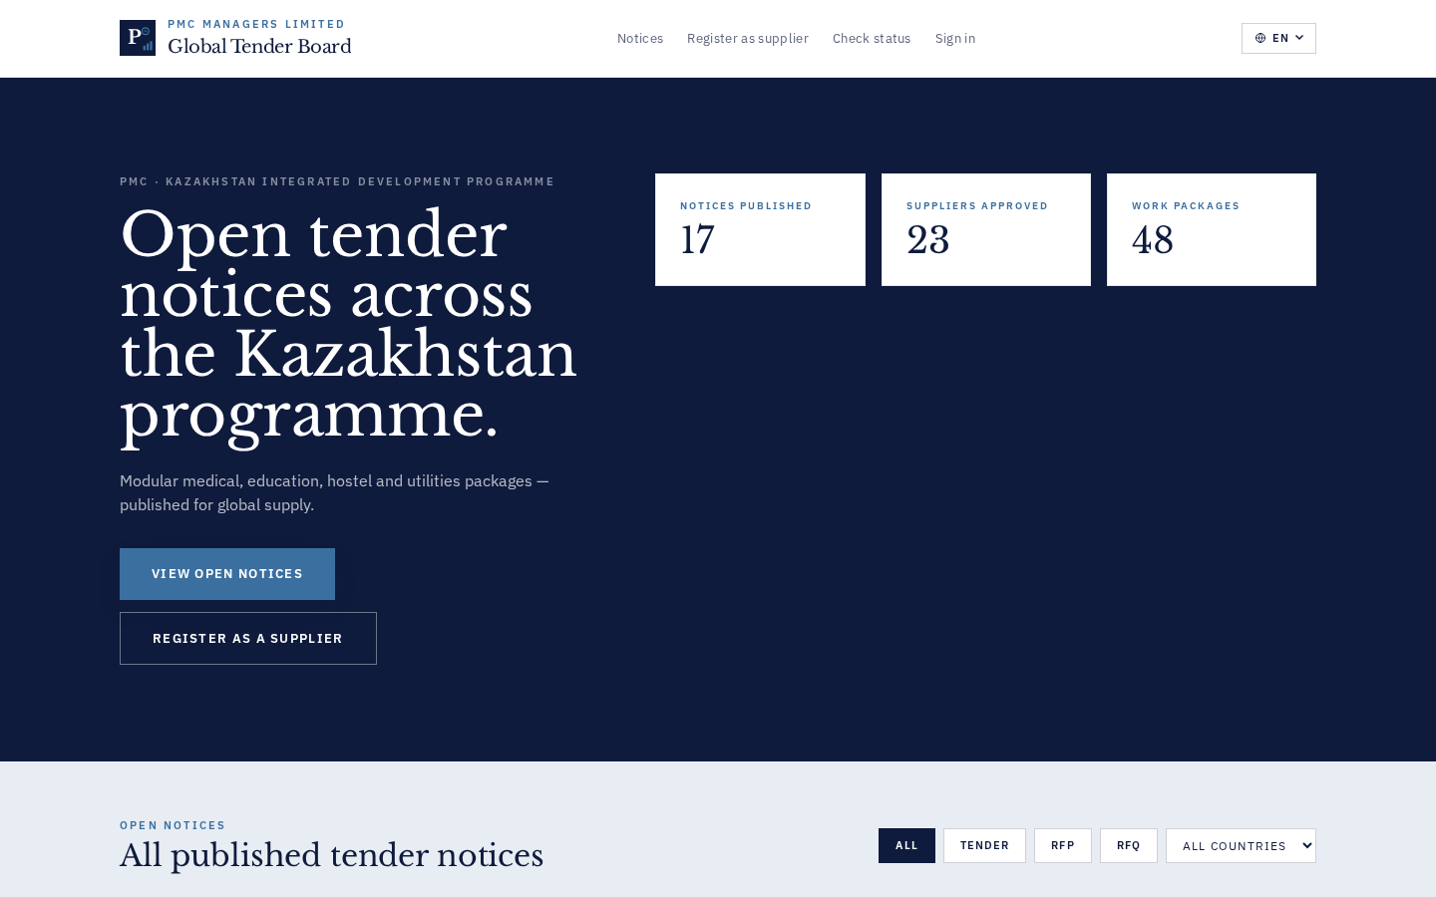
OPERATIONS TEAM · HOW TO USE
- Vendors browse without login.
- Card click → notice detail.
- 'Register interest' → /register.
QA TEAM · TEST CASES
# | Test step | Expected outcome
1 | Load /notices | Only is_published=true render  data-testid: public-notice-card
2 | Filter by country | List narrows in <300ms  data-testid: public-notice-filter-country
MANAGEMENT · GOVERNANCE · KPIS
- Draft notices never public.
- KPI: median time-to-first-bid per notice.

Chapter 18 · Registrations Admin
Review incoming vendors, approve / reject / clarify with reason.
Audience: Ops · Mgmt
OVERVIEW
Admin-side triage of every submitted vendor registration; sorted oldest-first.

OPERATIONS TEAM · HOW TO USE
- Sort by 'Submitted date' (default oldest first).
- Click row → review sections → Approve / Reject / Clarify (reason ≥5 chars).
- Bulk Invite CSV supports pre-loading known vendors.
QA TEAM · TEST CASES
# | Test step | Expected outcome
1 | Approve valid PAN doc | vendor doc + welcome email sent  data-testid: reg-row-approve
2 | Nudge Stale Drafts | 3-branch toast  data-testid: reg-nudge-stale
MANAGEMENT · GOVERNANCE · KPIS
- Aging report; daily digest for > 30-day drafts.
- KPI: median approval turnaround per tenant.

Chapter 19 · Meetings
Schedule Jitsi/Zoom tied to a notice OR marked internal.
Audience: Ops · QA
OVERVIEW
Every meeting either references a notice_ref OR is flagged 'Internal meeting'.

OPERATIONS TEAM · HOW TO USE
- '+ Schedule' → provider + subject + time + invitees.
- Tick 'Internal meeting' to skip notice.
- Otherwise pick notice.
QA TEAM · TEST CASES
# | Test step | Expected outcome
1 | Create without notice_ref and is_internal=false | HTTP 400 (Bug 48b)  data-testid: mtg-create
2 | Tick 'Internal meeting' | Notice dropdown disables + clears  data-testid: mtg-is-internal
MANAGEMENT · GOVERNANCE · KPIS
- Every meeting join is logged with invitee token + timestamp.

Chapter 20 · Vendor Intel
Bulk vendor risk register with BL / WL flags.
Audience: Ops · Mgmt
OVERVIEW
Imported watch-lists + blacklists; alerts committee scorers when a bidder is listed.

OPERATIONS TEAM · HOW TO USE
- Legend: BL=Blacklisted · WL=Watch-list · — = anonymised.
- Add manually or bulk-import CSV.
QA TEAM · TEST CASES
# | Test step | Expected outcome
1 | Score a bid where vendor is on BL | Red BL badge on the bidder card  data-testid: eval-vendor-badge
MANAGEMENT · GOVERNANCE · KPIS
- BL entries block auto-award; committee must override with a reason.

Chapter 21 · Product Catalog
SKU catalog feeding Stripe checkout + price-history log.
Audience: Ops · Mgmt
OVERVIEW
Products drive the public checkout page. Every price change is logged.

OPERATIONS TEAM · HOW TO USE
- '+ Product' → name, price, currency.
- Edit → save → history entry auto-created.
QA TEAM · TEST CASES
# | Test step | Expected outcome
1 | Change price 3 times | price_history[] has 3 entries  data-testid: product-edit-save
MANAGEMENT · GOVERNANCE · KPIS
- KPI: gross checkout revenue per SKU per month.

Chapter 22 · Engagements (Quotes)
Public quote-requests through to invoicing + aging report.
Audience: Ops · QA · Mgmt
OVERVIEW
State machine: quote_requested → quoted → invoiced → paid (or cancelled with reason ≥5).

OPERATIONS TEAM · HOW TO USE
- Public quote lands here.
- Set quoted amount → 'Invoice' generates Stripe checkout link.
- Cancel requires reason ≥5 chars.
QA TEAM · TEST CASES
# | Test step | Expected outcome
1 | Cancel with 3-char reason | HTTP 400 (Bug 35)  data-testid: eng-cancel
2 | GET /engagements/aging/summary | Buckets 0-7/8-30/31-60/61+  data-testid: eng-aging
MANAGEMENT · GOVERNANCE · KPIS
- Aging report drives receivables collection.
- KPI: quote → paid conversion rate.

Chapter 23 · Portal Branding
Tenant-level logo + theme + rolling logo history.
Audience: Ops · Mgmt
OVERVIEW
Every tenant gets primary_color + accent_color + favicon + logo (rolling history max 10).

OPERATIONS TEAM · HOW TO USE
- Upload new logo → history entry auto-created.
- PATCH /api/v1/branding/{tid}/theme with primary/accent colours.
QA TEAM · TEST CASES
# | Test step | Expected outcome
1 | Upload 11 logos sequentially | history[] contains only last 10  data-testid: branding-logo-upload
2 | PATCH primary_color='red' | HTTP 422 'must match #RRGGBB'  data-testid: branding-theme-save
MANAGEMENT · GOVERNANCE · KPIS
- Branding changes audited — no silent tenant re-brand.

Chapter 24 · Reports · Asked-vs-Delivered
Development / scope-completion snapshot for engineering handoff.
Audience: Mgmt
OVERVIEW
'Asked vs delivered' statement + three swim-lane flowcharts (platform/user guide/testing).

OPERATIONS TEAM · HOW TO USE
- 'Snapshot to disk' → 9 files land in /docs/reports/.
- Bug 38 fix: each artefact wrapped in try/except.
QA TEAM · TEST CASES
# | Test step | Expected outcome
1 | POST /reports/snapshot | {ok:true, files:[…9], errors:[]}  data-testid: reports-snapshot
MANAGEMENT · GOVERNANCE · KPIS
- Deliverable for investor code review + eng handoff.

Chapter 25 · Stakeholder Reports · G4
Four operational reports for procurement stakeholders.
Audience: Mgmt · Ops
OVERVIEW
G4 rebuild · Tenders (pipeline) · Awards (PO + value) · Escrow (aging + SLA) · SLA (contracts + milestones).

OPERATIONS TEAM · HOW TO USE
- Tab through 4 reports; each has CSV download.
- Escrow report highlights SLA breach count.
QA TEAM · TEST CASES
# | Test step | Expected outcome
1 | Open Stakeholder Reports / Escrow | aging_days per tx; sla_breach=true > 7d  data-testid: stakeholder-escrow-sla
2 | Download tenders.csv | CSV Content-Disposition: attachment  data-testid: stakeholder-download-csv
MANAGEMENT · GOVERNANCE · KPIS
- Circulate CSV to stakeholders without portal access.

Chapter 26 · Help Requests
Triage inbound support tickets from the public site.
Audience: Ops · Mgmt
OVERVIEW
Public help form drops a ticket with kind + identity + phone + company. Panel shows aging + resolution history.

OPERATIONS TEAM · HOW TO USE
- Sort by aging.
- Update kind, mark resolved, add resolution note.
QA TEAM · TEST CASES
# | Test step | Expected outcome
1 | Public submit with no email | HTTP 400 'email required'  data-testid: help-public-submit
2 | Mark resolved | Row moves to Resolved tab; resolution_at stamped  data-testid: help-resolve
MANAGEMENT · GOVERNANCE · KPIS
- SLA planned: 24h first response (Sales), 72h (Technical).

Chapter 27 · Audit Log
Chronological ledger of every substantive action.
Audience: Ops · Mgmt
OVERVIEW
Every mutation writes to audit_log with {at, actor, action, resource_type, resource_id, payload}.

OPERATIONS TEAM · HOW TO USE
- Sort by 'at' DESC (default).
- Copy row payload to inspect raw event.
QA TEAM · TEST CASES
# | Test step | Expected outcome
1 | Render audit with 10 000 rows | Scrollable; ErrorBoundary NOT triggered  data-testid: admin-audit-panel
MANAGEMENT · GOVERNANCE · KPIS
- Legal-grade: audit log is append-only.
- Filters (actor/type/date) planned for Bucket B.

Chapter 28 · Dashboard · Analytics & Drill-through
Real-time KPIs + click-through to filtered lists.
Audience: Ops · Mgmt
OVERVIEW
AI Anomaly, Pipeline Funnel, Top-Priced Bids — clickable via /dashboard-drill/*.

OPERATIONS TEAM · HOW TO USE
- Click any card to expand a filtered mini-table.
- Click again to collapse.
QA TEAM · TEST CASES
# | Test step | Expected outcome
1 | Click AI Anomaly card | Drill panel with ≤200 rows; empty state 'No AI-flagged bids' if none  data-testid: drill-card-anom
2 | Click Pipeline Funnel | /dashboard-drill/pipeline?status= returns ≤500 rows  data-testid: drill-card-pipe
MANAGEMENT · GOVERNANCE · KPIS
- KPI dashboard is the daily standup screen.
- AI Copilot is advisory — no state change without human sign-off.

Chapter 29 · Sign-out & Exit
Cookie-clear + redirect to public login.
Audience: Ops · QA
OVERVIEW
Sign-out clears the HTTPOnly admin cookie and redirects to /login.

OPERATIONS TEAM · HOW TO USE
- Top-right → 'Sign out'.
QA TEAM · TEST CASES
# | Test step | Expected outcome
1 | Click Sign out | Redirect to /login within 1s; cookie no longer present  data-testid: admin-logout
2 | Direct /admin after sign-out | Bounce to /login; /api/v1/me returns 401  data-testid: admin-logout
MANAGEMENT · GOVERNANCE · KPIS
- Session TTL 12h max; sliding renewal on activity.

Appendix A · Change-log

v2 · Sep 2026
Deep-dive edition · 16 core modules × 6 subsections (Screens / Tutorial / API / Pitfalls / QA / Mgmt) + 13 slim modules. Supersedes v1.
v1 · Sep 2026
Definitive master manual · every module × 4 tracks · supersedes v1..v3.2 handbook + Screenshot Manual v1 + Observation-Response docs.
Backend v17
Committee UX overhaul · Wave-E2 polish · G2 access-control consolidation.
Frontend v20
Committee checkboxes + dissolve + resend · Tender kind-tab reset · status-token toast · Dashboard drill cards.

Appendix B · Guardrails (governance)

- G1 · Escrow dual-signature — HTTP 400 if pmc_officer.email == vendor_officer.email.
- G2 · COI cross-check — HTTP 400 at evaluations.submit_score without a COI declaration.
- G3 · Access-control unified — /api/v1/permissions/effective/{role} merges tabs + actions + Level.
- G4 · Stakeholder Reports — four real reports (Tenders / Awards / Escrow / SLA) JSON + CSV.
- G5 · Draft auction bidder link hidden when status='draft'.
- ErrorBoundary — every route is wrapped; blank screens architecturally impossible.
- Audit — every substantive action writes to audit_log with actor + IP + payload.

