Bugs of PMC

- In Tender Builder - clone as draft is not working - throwing error 500

+ch
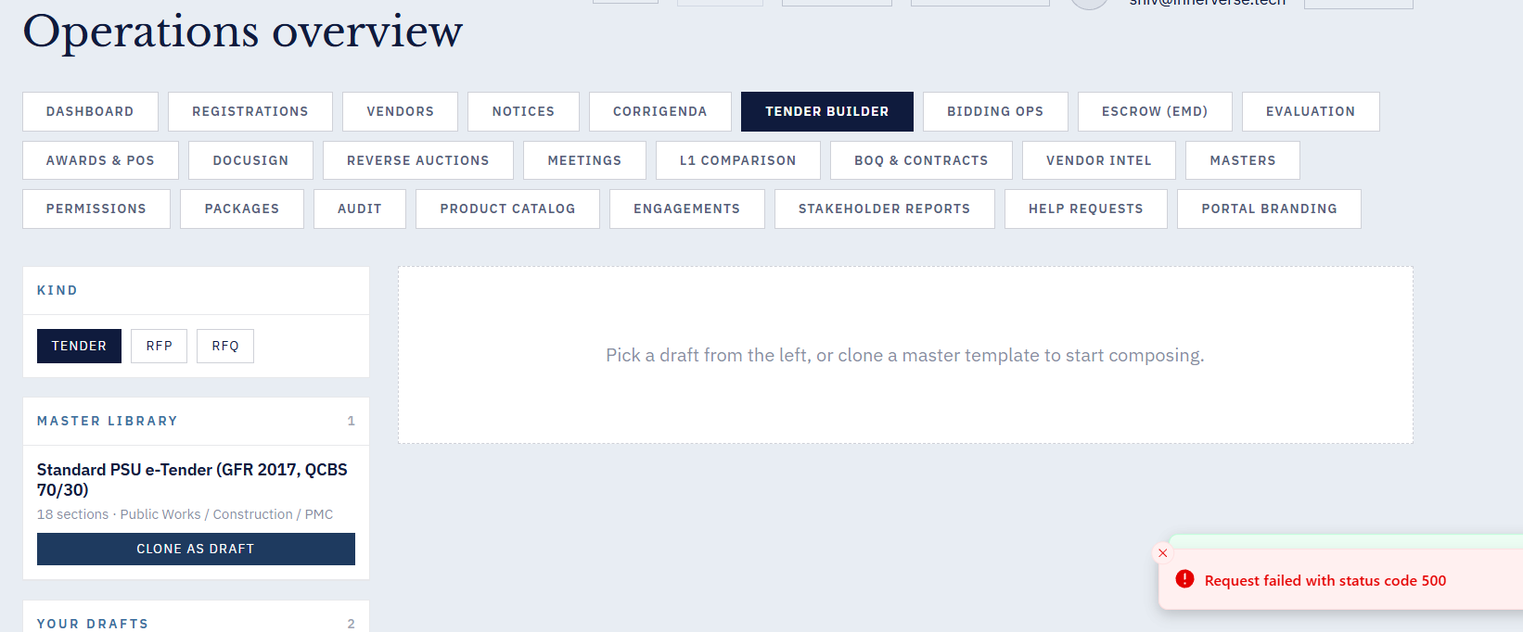

- After submitting NEW BOQ template , could not see it in list.

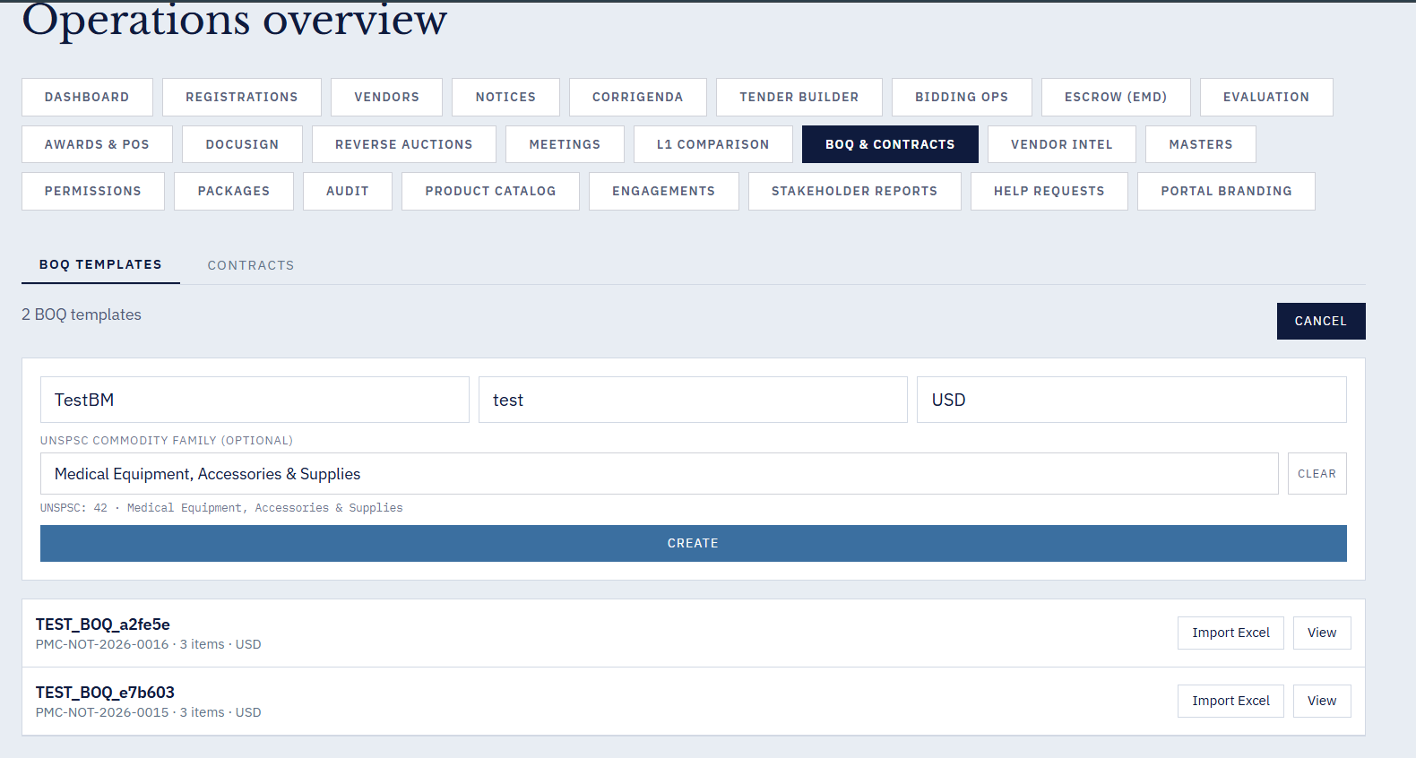

- when Biding ops button is clicked, the application logs out.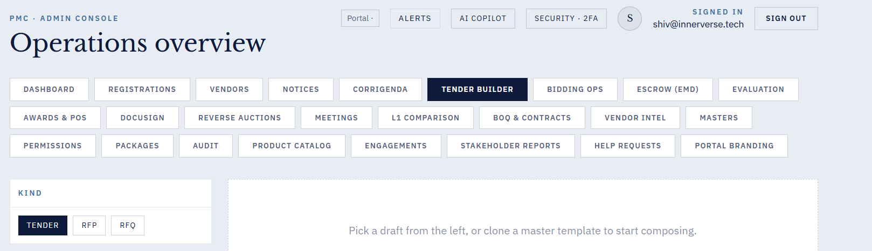

4. For new Vendor Sign in - in Pre tender registration - Download blank form is giving the following error
→ Response · FIXED — Live in prod — PDF generation now uses reportlab fallback when weasyprint fails. Blank form downloads working. Shipped v5.

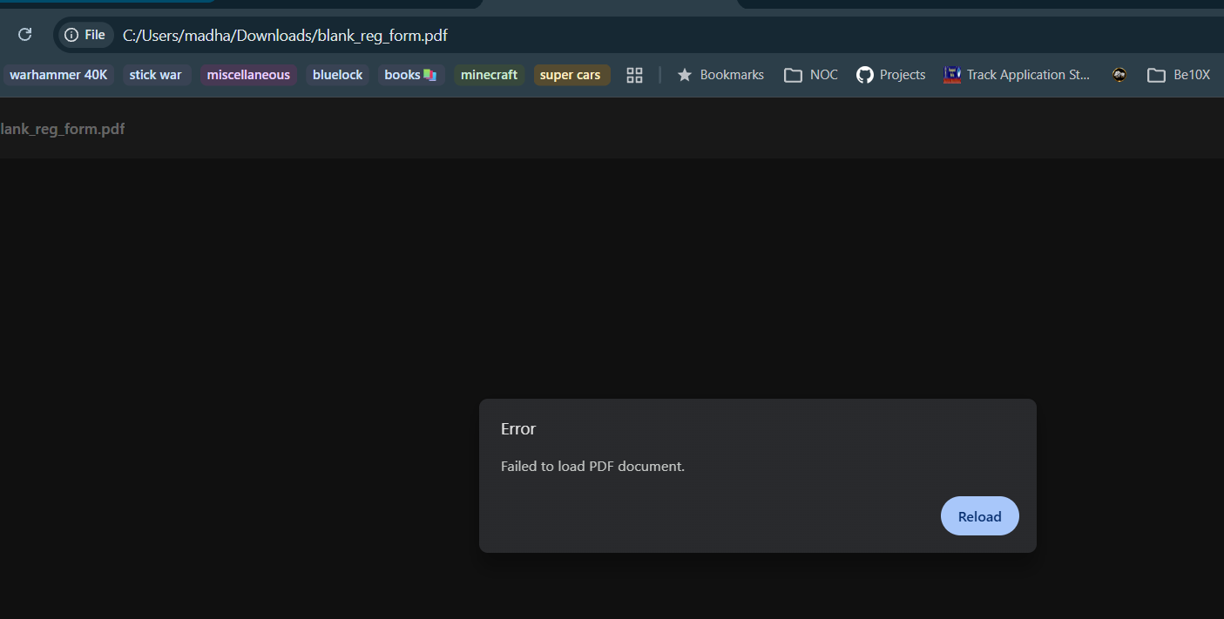

5. Creating a new notice from admin login - madhavi not working.
→ Response · FIXED — In v11 zip — Root cause: reviewer role (madhavi) had create=False in DEFAULT_MATRIX. Fixed backend to allow reviewer.create=True but keep publish=False. Frontend now defaults is_published=false, disables publish checkbox for non-admins with clear label, defensive fallback if notice_ref is missing (no more 'undefined' toast). Ramya confirmed working.
_Comments from Ramya: I checked this, and it is working fine. We are able to create a notice successfully. However, I’m not able to find where the unpublished notices are displayed. Could you please let me know where I can view the unpublished notices? Please check the screenshot below for reference. 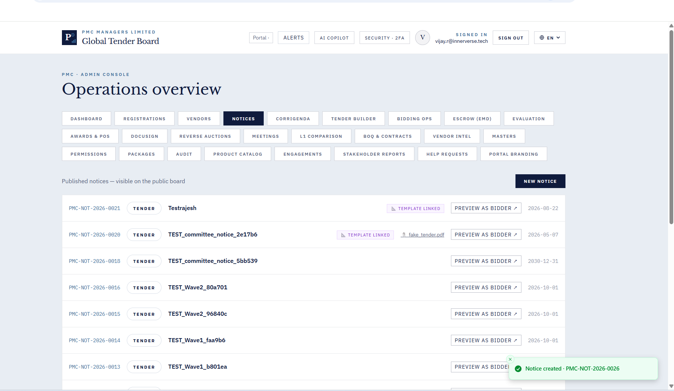

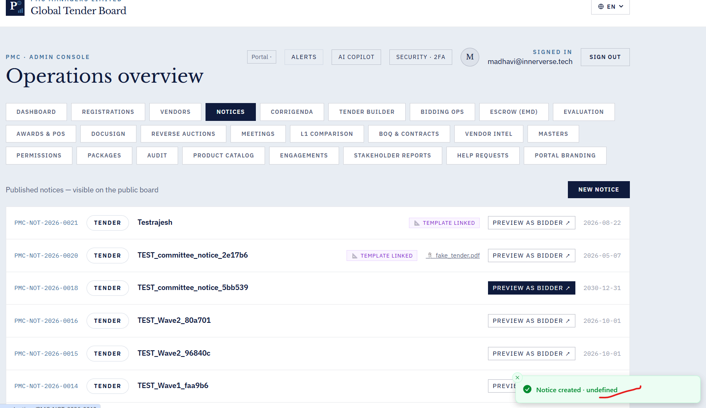

6. Mailing Address is added. Still receiving the error message while registering the vendor .
→ Response · OPEN — Awaiting repro — Backend validation on mailing_address is standard. Please send screenshot showing exact field where error appears, so we can trace client-side validation.
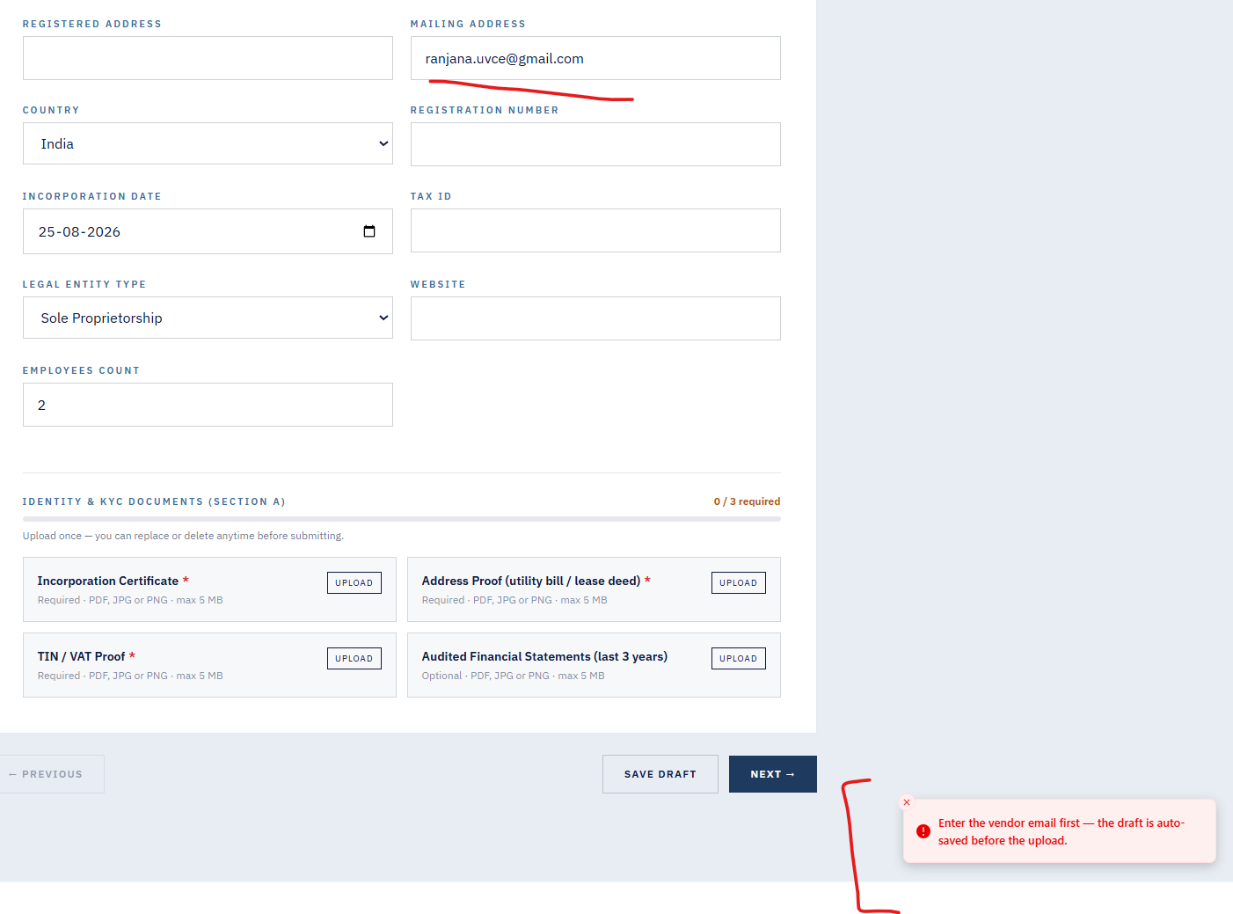
7. Resume link not sent to mail id provided although message on portal says sent the secure link to mail id.
→ Response · OPEN — Wave E2 — Verify EMAIL_KEY env var propagates into Docker container. Add error log + toast on Resend failure. Scheduled next sprint.
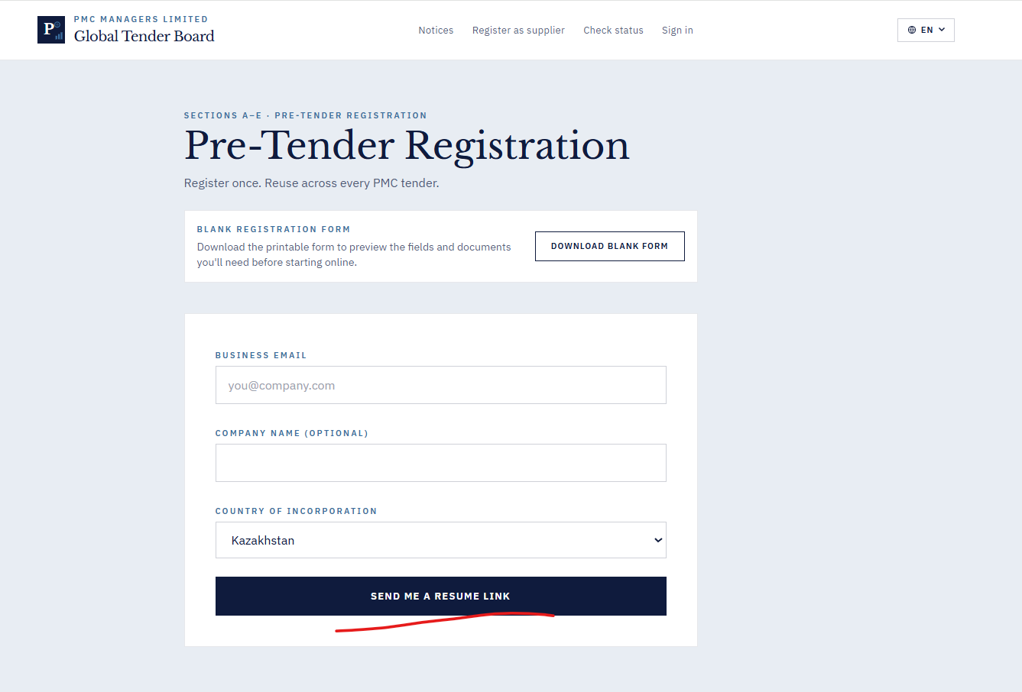

8. Invite vendor not working.
→ Response · CONFIRMED WORKING — User (Kannan) confirmed 26-Aug: 'email is currently working, invite vendor is working properly'. No action required.
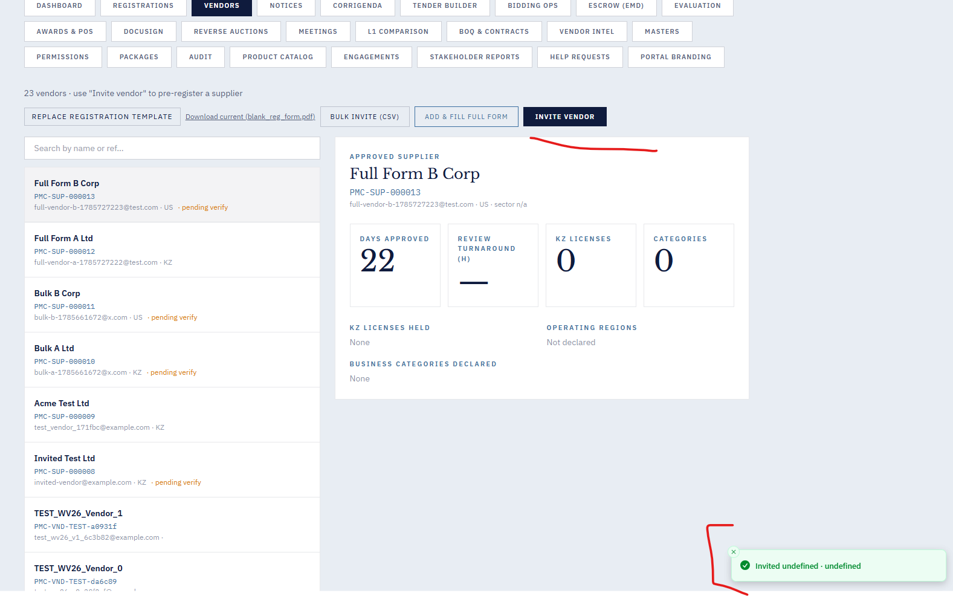
9. Vendor creation from “Vendor fill form” not working
→ Response · FIXED — Live in prod — Defensive fallback added in AdminVendorCreate.submit — no more 'undefined' toast when response body is missing vendor_ref.

11. On click of “Run L1 Comparision” the page hangs.
→ Response · FIXED — Live in prod — Added 45-second Promise.race timeout in L1ComparisonPanel.run. Page no longer hangs. Shipped v5.
12. Newly created BOQ template and Contract shows the message as created . But they are not listed on the screen along with others.
→ Response · PARTIAL — In v11 zip · Retest — Backend list_contracts() capped at 500 with sort. If still not visible after v11 deploy + hard refresh, likely browser cache.

13. On Click of “Masters” hangs the page.
→ Response · FIXED — Live in prod — Promise.allSettled in MastersPanel.load — one failing sub-query no longer hangs the tab. Shipped v5.

14. ESCROW option when we click on new joint account without filling any details it is getting created
→ Response · FIXED — Live in prod — Strict validation added in escrow.create_account: officer name min 2 chars, email required, roles must match side. Shipped v6.
15. AI BID ANOMALY in DASHBOARD , Score and deviation remains same not showing anything.
→ Response · OPEN — Wave E2 — Add default 'no anomalies detected' state + explain what the score checks. Scheduled next sprint.
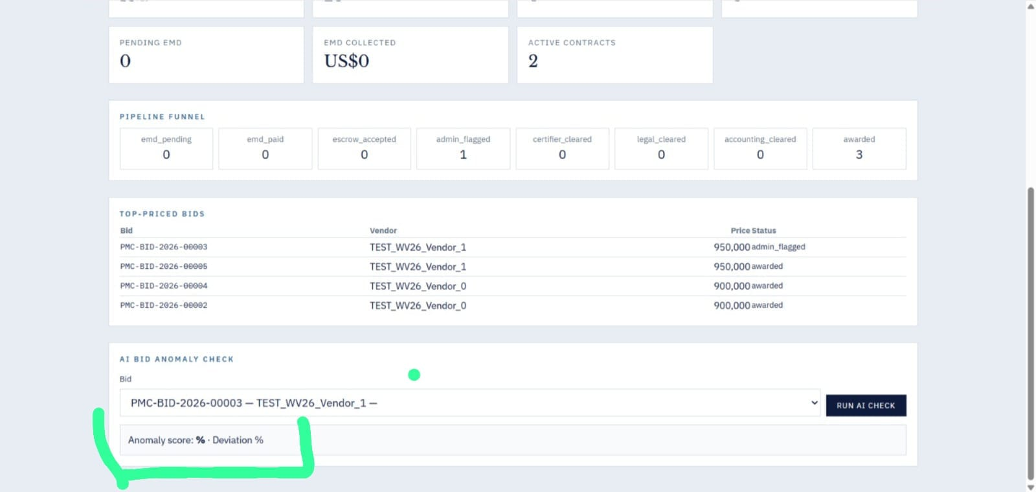

16. Registration Filter State Issue -- Previously selected company details remain displayed even after switching between registration status tabs.
→ Response · FIXED — Live in prod — NoticeIn.budget_amount now has ge=0 validator; frontend input has min='0' + NaN guard. Shipped v6.

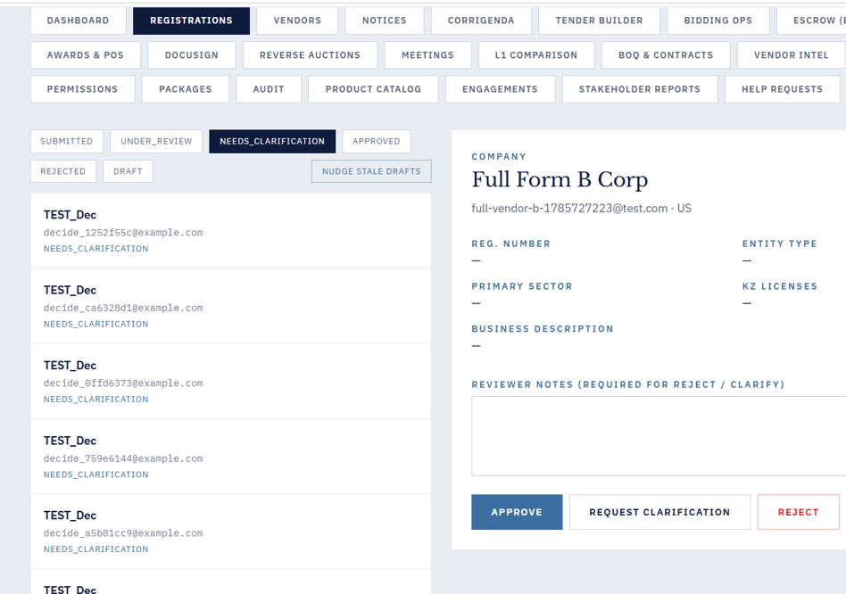
17. Got a email from PMC Managers, dse_demo@docusign.net to my email account . 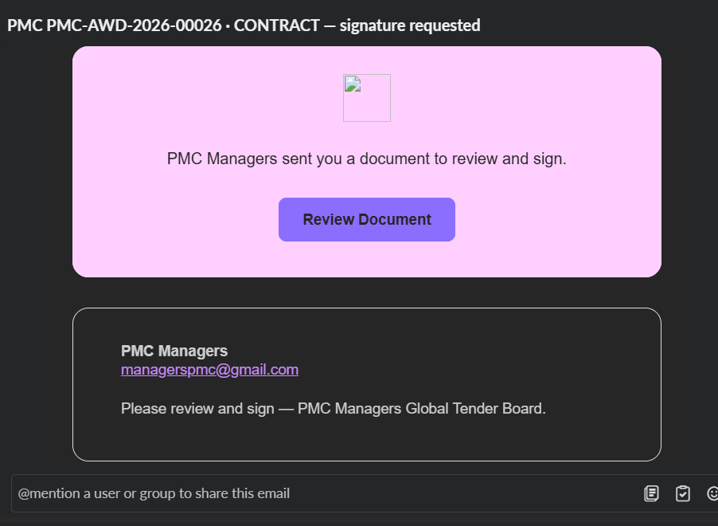when Review document is clicked and followed few steps at end getting the below error.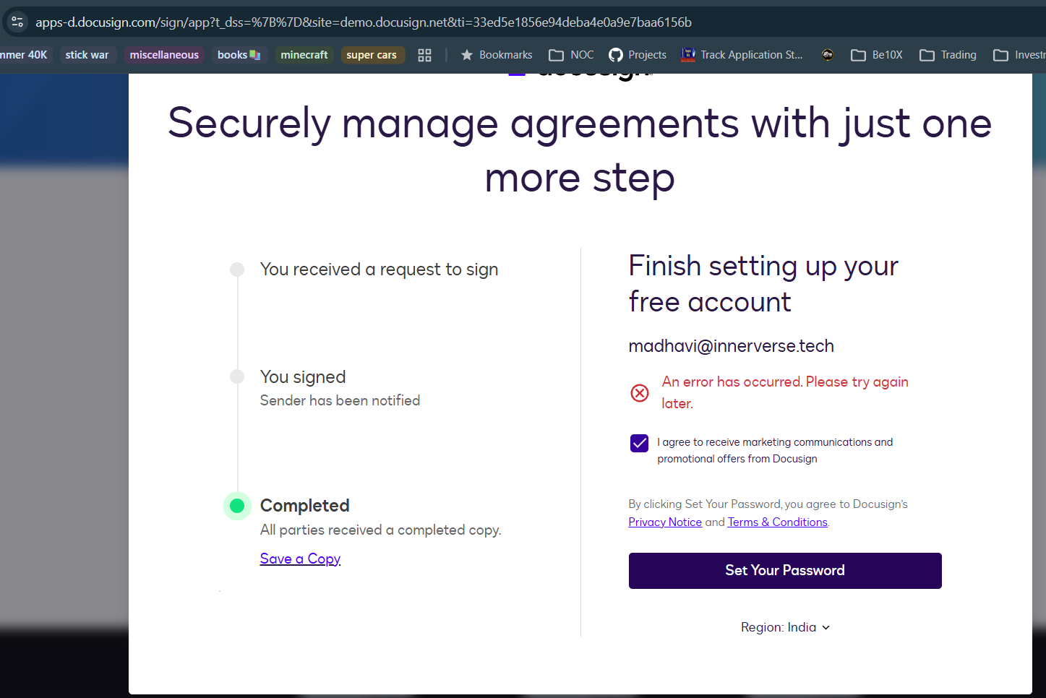
→ Response · OPEN — Wave E2 — DocuSign embedded-signing URL expiry — add retry page. Scheduled next sprint.

18. Accepts negative number for Budget:
→ Response · Merged with #16 — Negative budget rejection covered by Bug 16 fix.
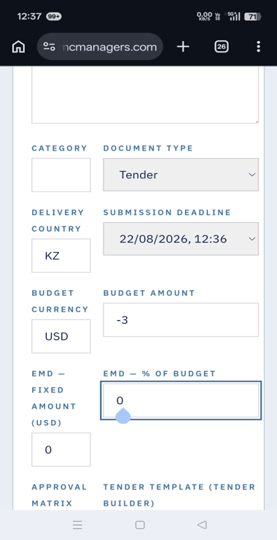

19. Package created message is seen but not listed below.
→ Response · OPEN — Retest first — Backend and frontend look correct on code inspection. May be a caching bug — retest with hard refresh after v11/v15 deploy.
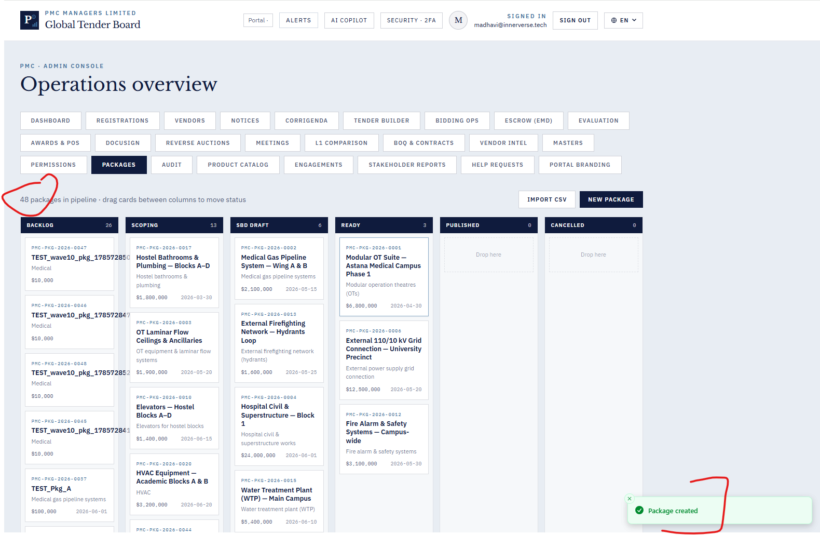

20.
→ Response · OPEN — Wave E2 — Show clear toast on invalid token at /register/status. Scheduled next sprint.
From the landing page without logging in navigate to the Check status and give the token from the email we received from PMC application, it does not show any status or warning message like invalid token.
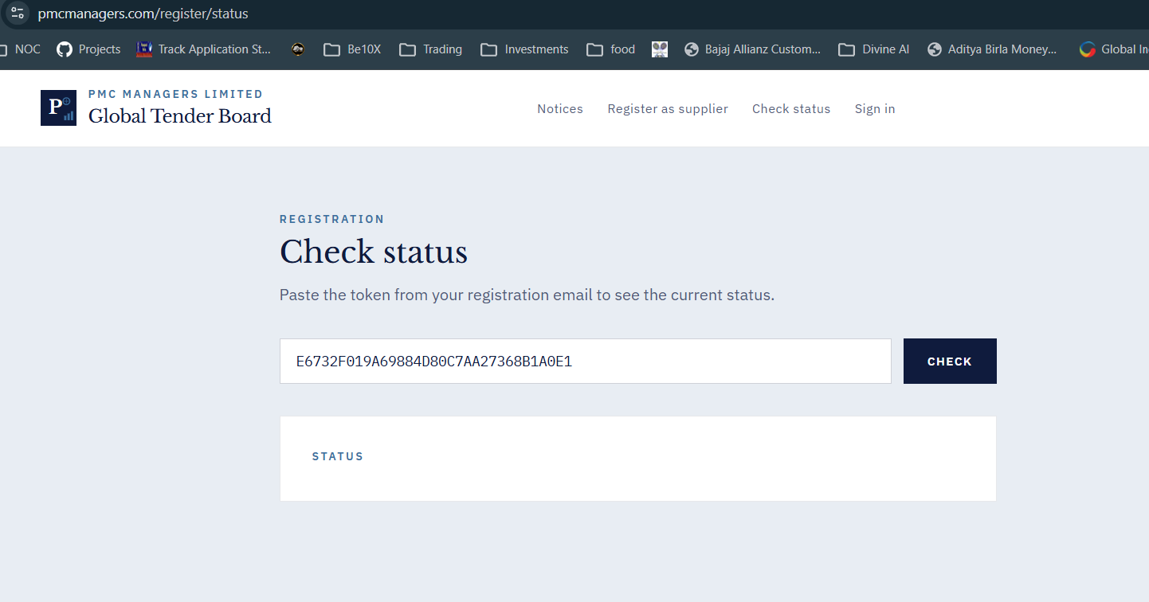

21. While trying to login the application , getting the following error in the inspect, console tab.
→ Response · OPEN — Wave E2 — Need actual console error text from QA. Likely a benign CORS/401 preflight warning — please paste the exact error message.

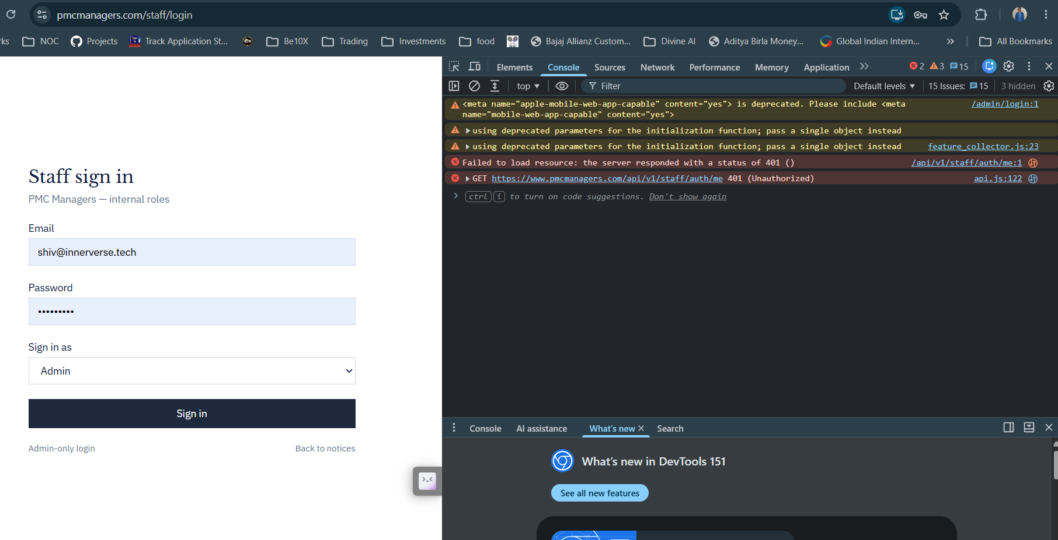
22. Notices Module :
→ Response · FIXED — In v11 zip — NoticesPanel.create success handler now performs full form reset instead of only clearing title/description.
After creating a notice, clicking New Notice again without refreshing retains the previous notice details in other fields; the form should be completely reset.
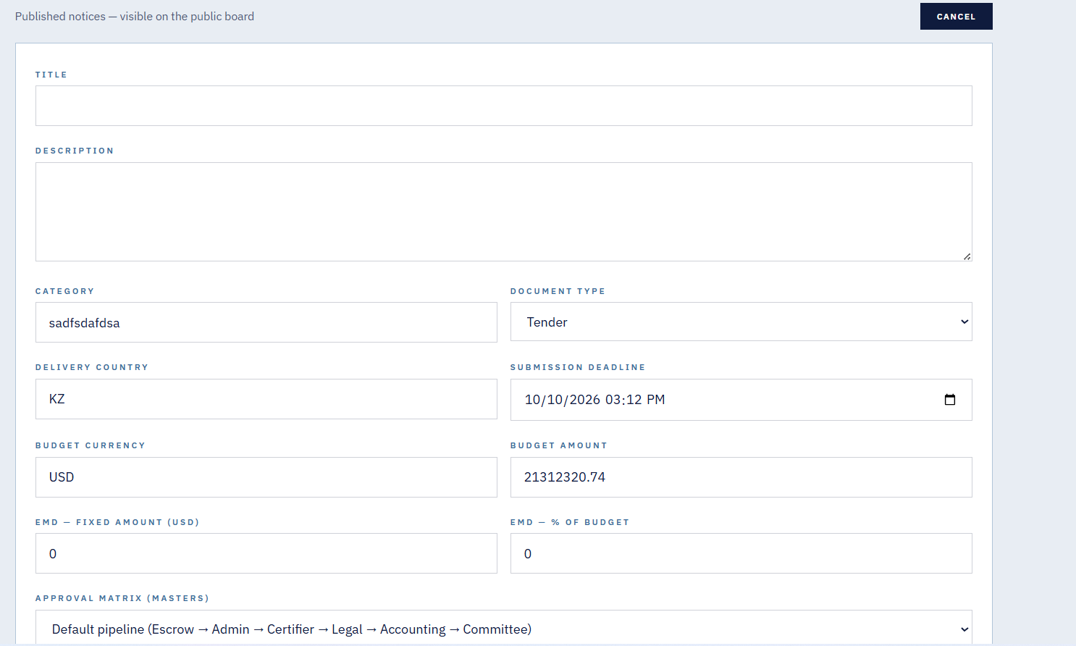
23.The validation toast message is unclear because it does not specify whether the Title or Description field requires a minimum of 10 characters.
→ Response · FIXED — In v11 zip — Toast now reads: 'Title is required (minimum 3 characters)' or 'Description is required (minimum 10 characters)' — explicit character count.
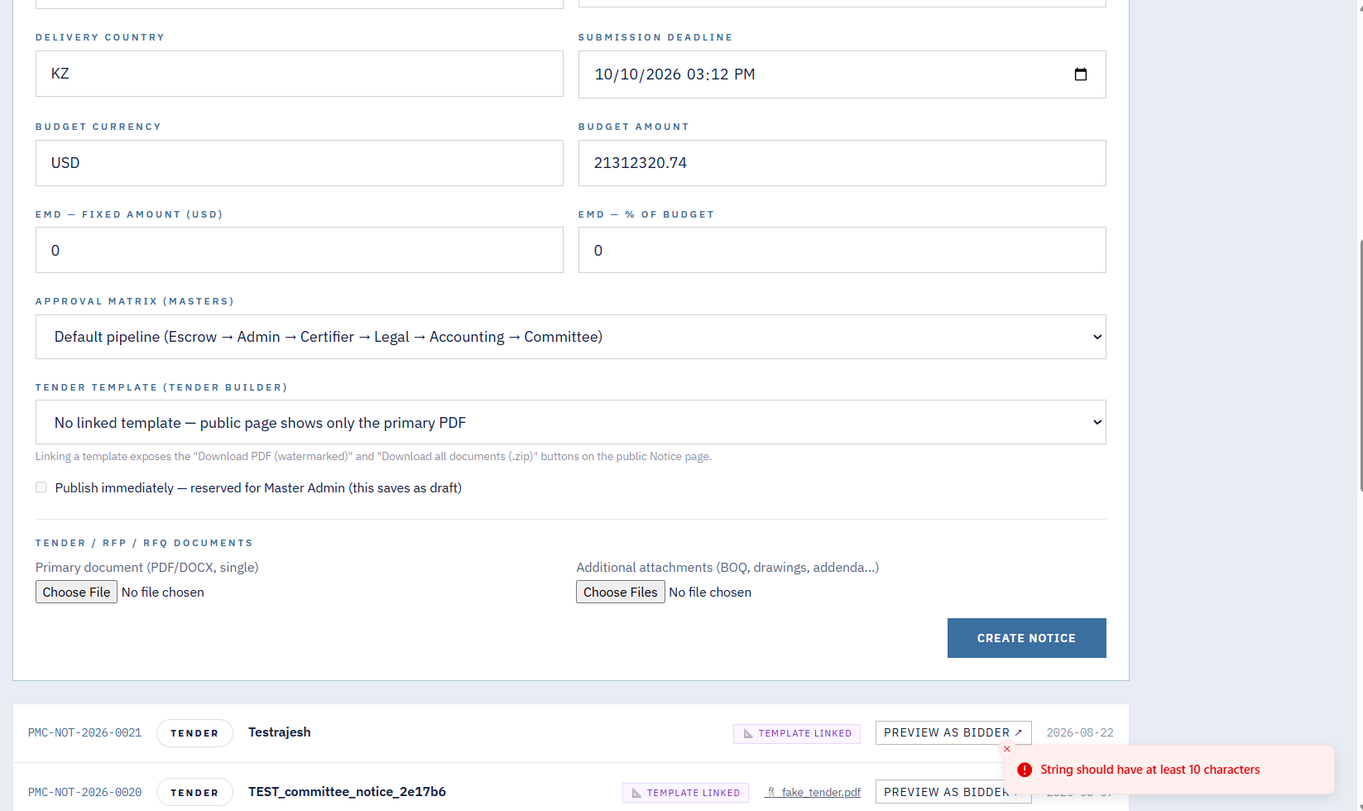
24.Even though I am logged in as a Master Admin, I am unable to select the Publish checkbox, as it appears disabled or unavailable.
→ Response · FIXED — In v11 zip — Publish checkbox is now controlled by isMasterAdmin (me?.role === 'admin'). Master admin sees enabled checkbox with 'Publish immediately' label. Non-admins see disabled with 'reserved for Master Admin' label.
25. Even after withdrawing a Corrigenda notice, it is still visible under the Notices section as an active notice; withdrawn notices should no longer be displayed as active.
→ Response · OPEN — Clarify UX — Public corrigenda list already filters is_active=True (backend line 93). Admin list intentionally shows all with visual distinction. Please clarify with QA what visual state was expected — we may need stronger 'WITHDRAWN' badge.
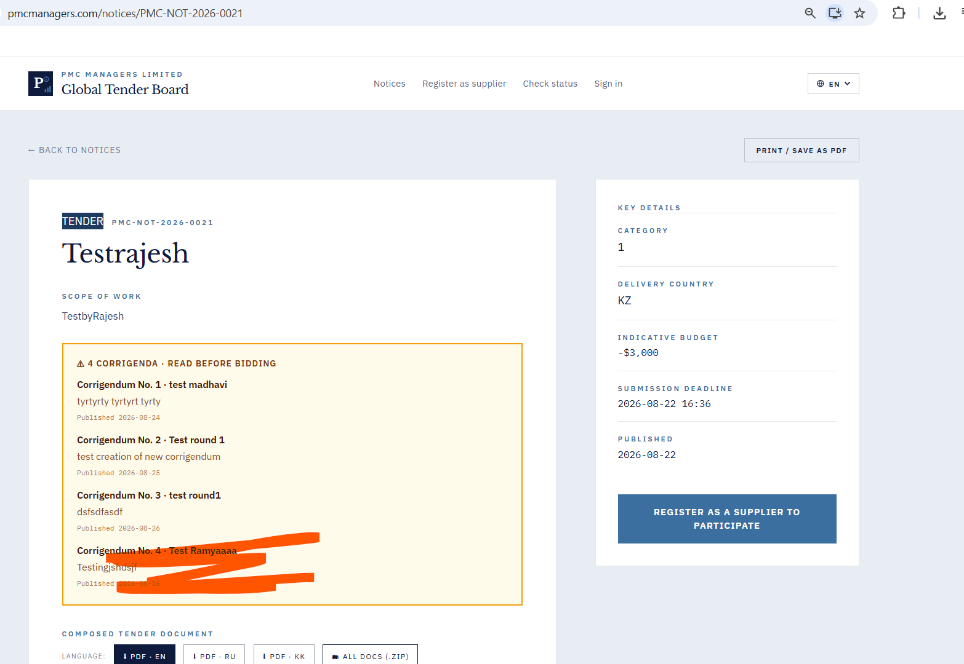
26. After clicking Withdraw, the Corrigenda status is not updated to Withdrawn, and the Withdraw button still appears, making it unclear whether the notice has been withdrawn.
→ Response · OPEN — See #25 — Withdraw endpoint sets is_active=False + audit_log. Frontend refreshes list. Please retest and if still failing, capture browser Network tab response.
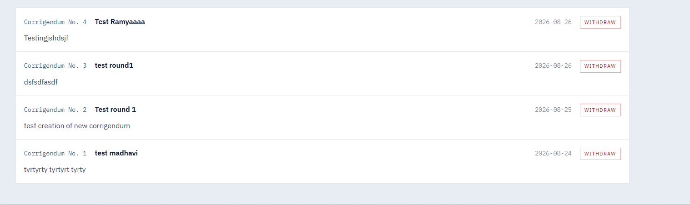
27.After approving, rejecting, or requesting clarification for a supplier, the action is not being saved—when I return to the Registration tab, it still shows the options to Approve, Reject, or Request Clarification again.
→ Response · OPEN — Retest first — registrations.decide backend endpoint updates status correctly with audit_log. Please retest with hard refresh.
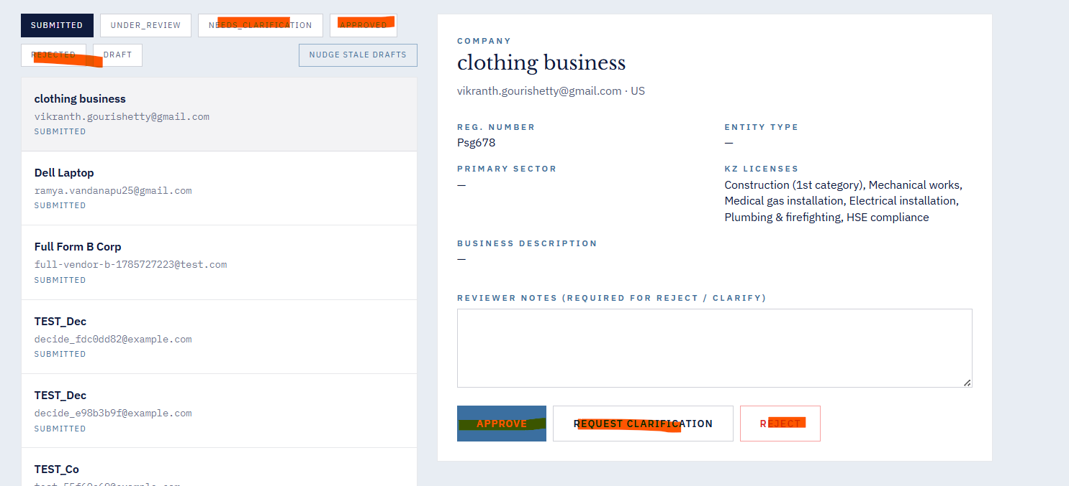
28. In the Vendors module, after clicking the Invite button under Bulk Invite CSV, the page either goes blank or signs me out.
→ Response · FIXED — In v11 zip — BulkInviteModal.submit now wrapped in try/catch with defensive result handling. Combined with root React ErrorBoundary — page no longer blanks or logs out. Modal stays open on error for retry.
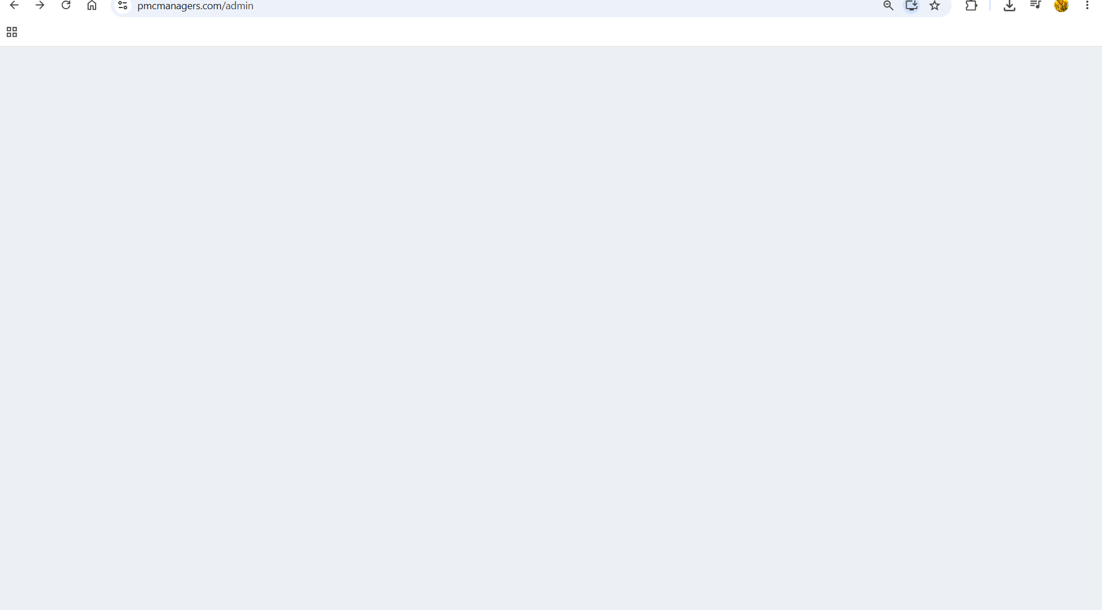
29. In the Vendors module, when I replace the Registration Template, an “undefined” toast message is displayed and not able to download template ( not showing the name in brackets also)
→ Response · OPEN — Awaiting repro — Please capture screenshot showing what appears in the toast + Network tab response body.
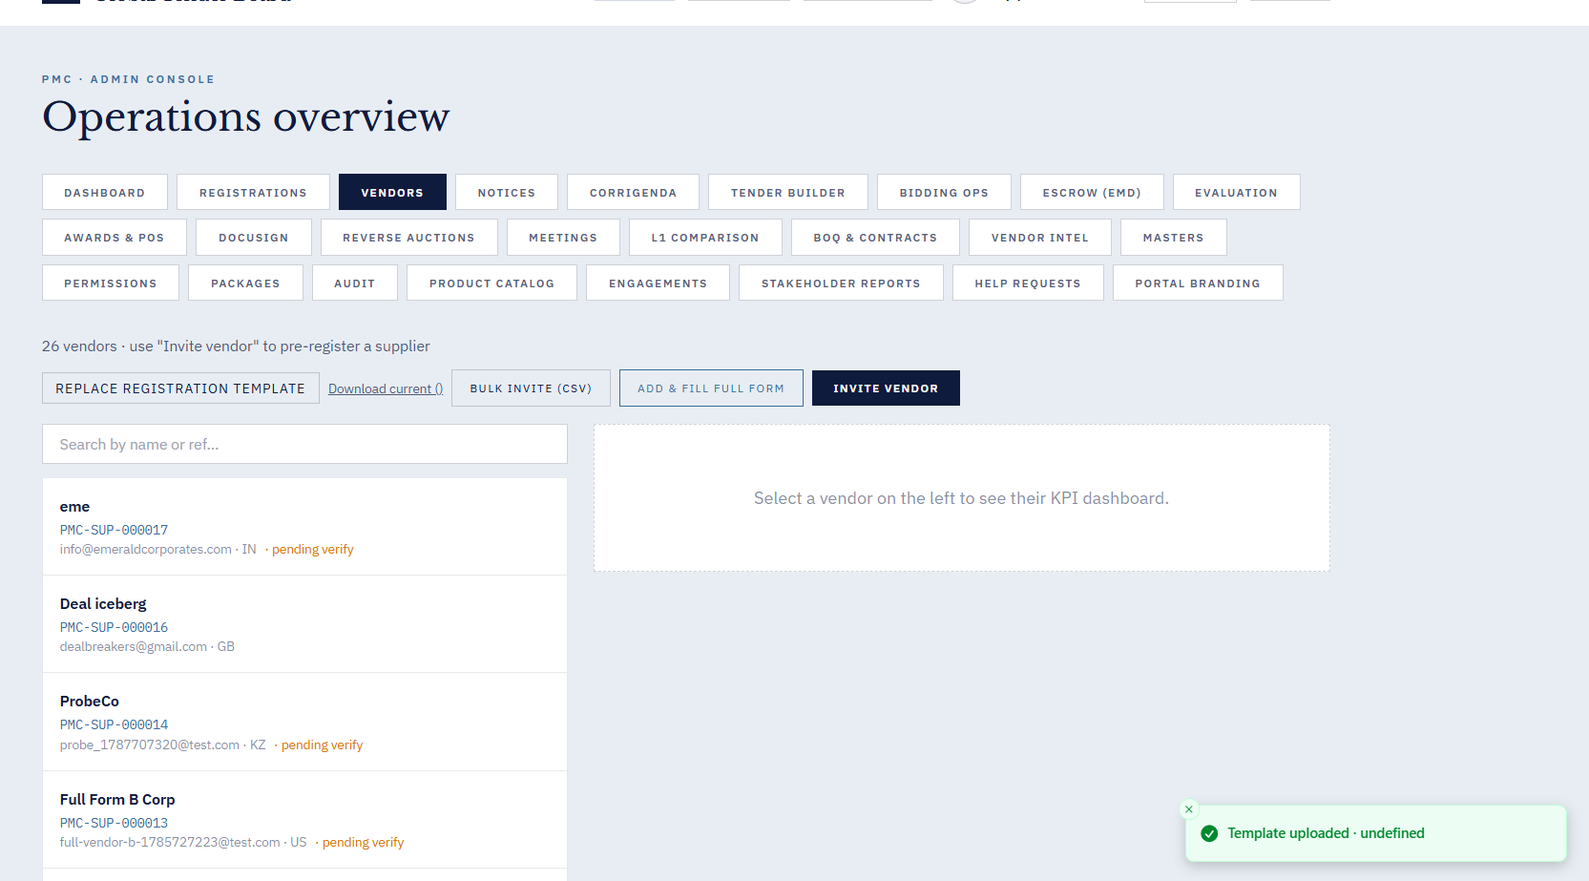
30. In the Vendors module, after adding a new vendor and activating it from the Activation tab, the newly created vendor is not appearing in the Vendors table.
→ Response · OPEN — Retest first — approve_and_create_vendor sets tenant_id correctly (registrations_helpers.py line 28). Backend list filters by admin.tenant_id. Should show — retest after hard refresh.
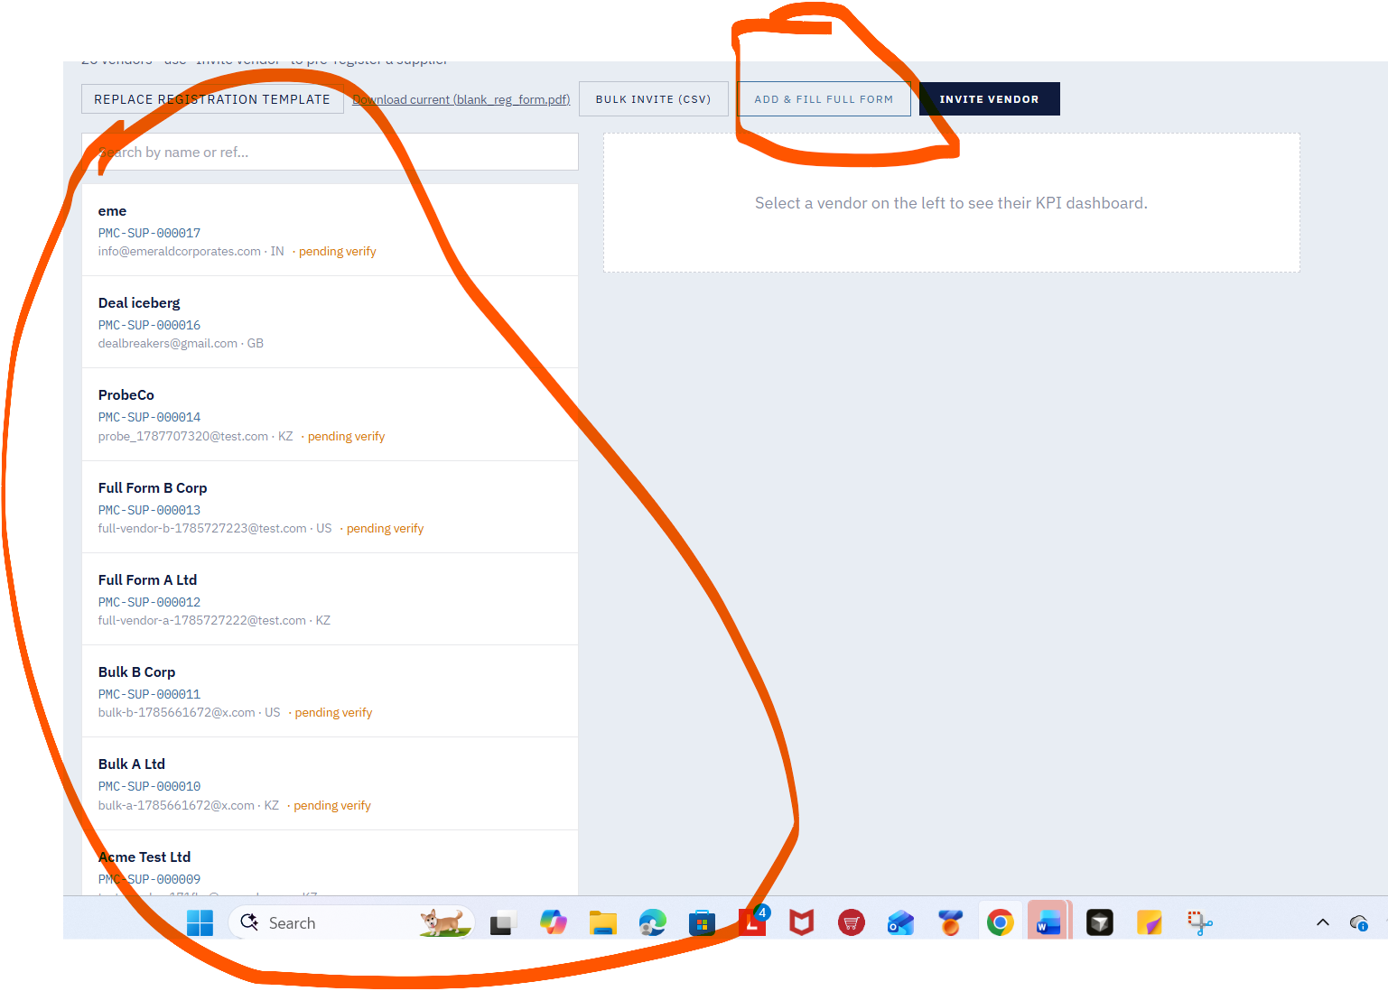
31. It is not converting all modules to respectives languages 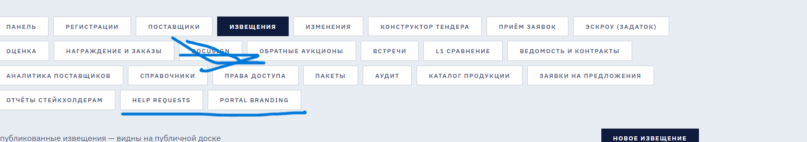
→ Response · OPEN — Wave E2 — Audit i18n/*.json files — fill missing keys in ru/kz locales.
32In the Profile module, the uploaded image is saved successfully, but after logging in again in a new tab, the profile image is not displayed. 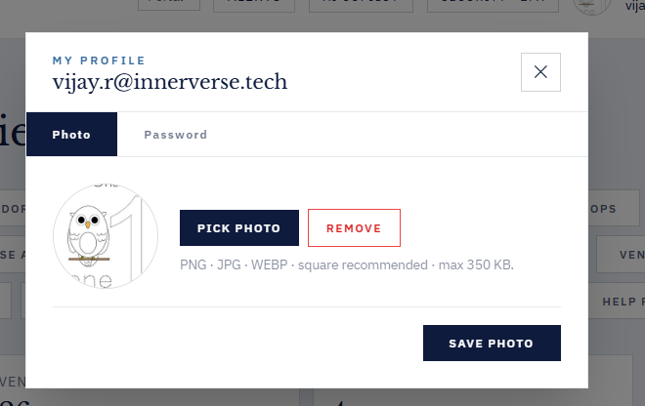

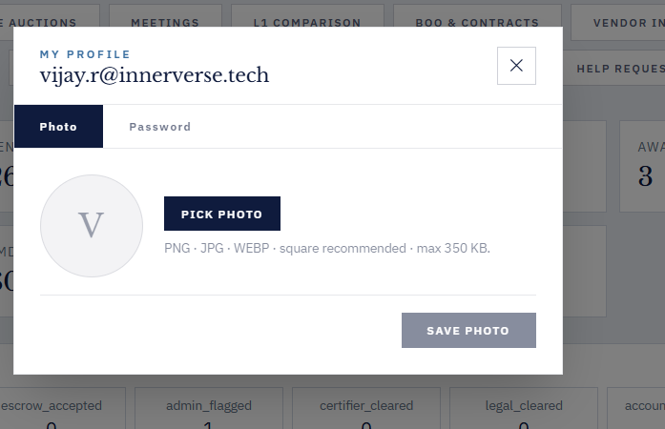

33. Across the forms, there is no proper validation for Email and Mobile Number fields; the Email field accepts invalid formats, and the Mobile Number field allows characters instead of numbers only.
→ Response · OPEN — Wave E2 — Add zod/yup validation to Section A/B/C: email regex + phone digits-only.

34. Not able to save existing product catalog a;though it shows “Saved Procurement Strategy”
→ Response · FIXED — In v11 zip — Added cache-buster (?_=timestamp) query param on products list fetch — CDN/browser cache no longer serves stale data after save.
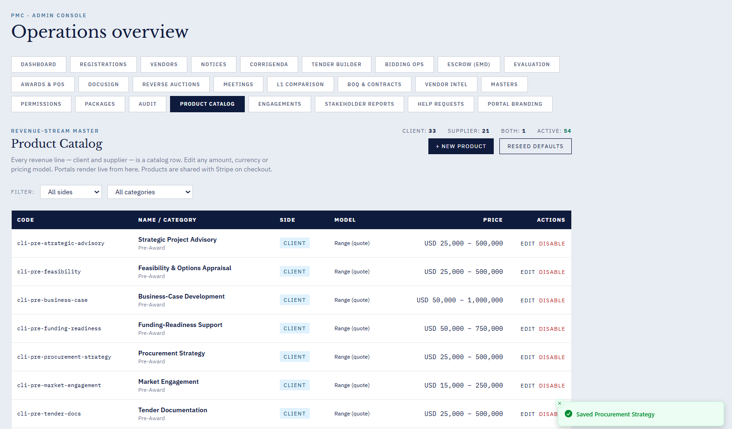

35. Create Product Catalog - shows message created successfully but not listed in the table
→ Response · FIXED — In v11 zip — Same fix as Bug 34 — cache-buster query param eliminates stale-data issue.
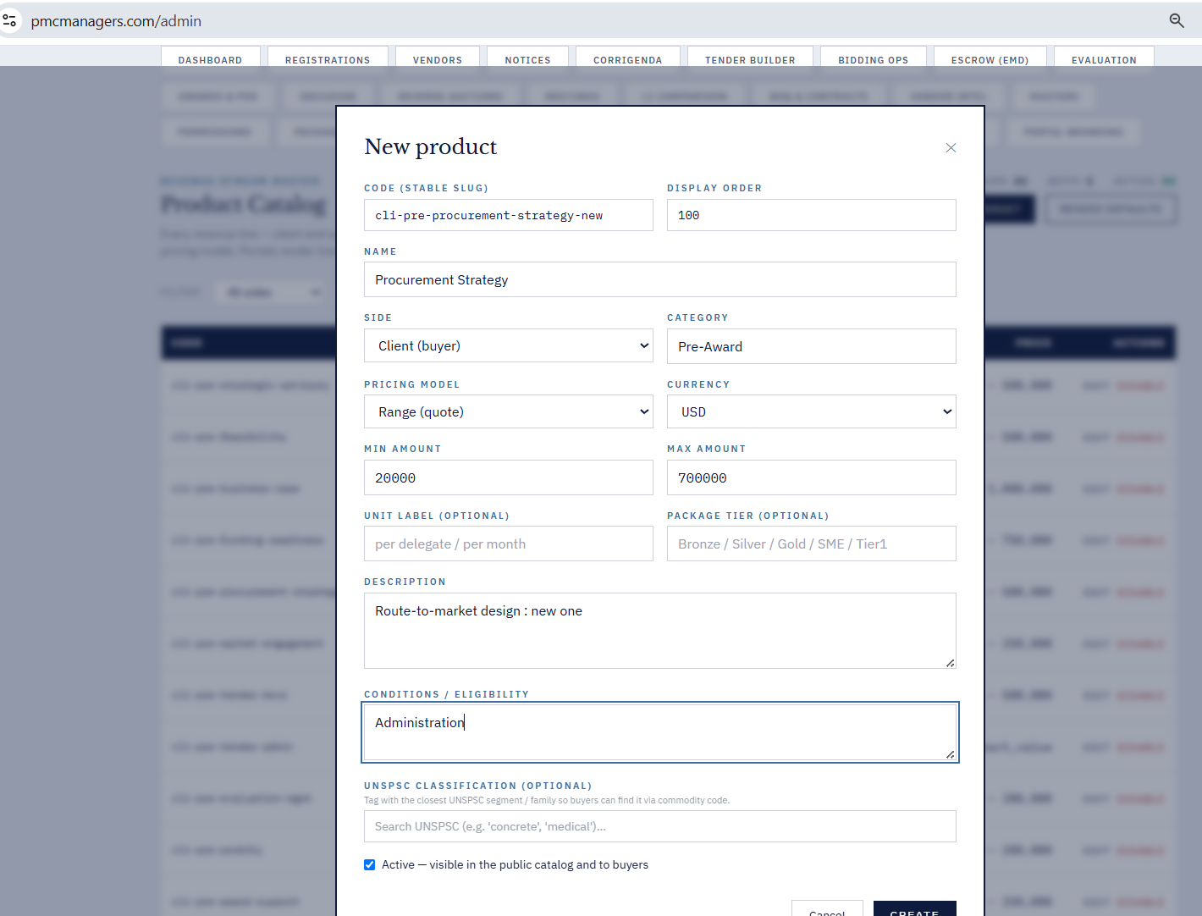

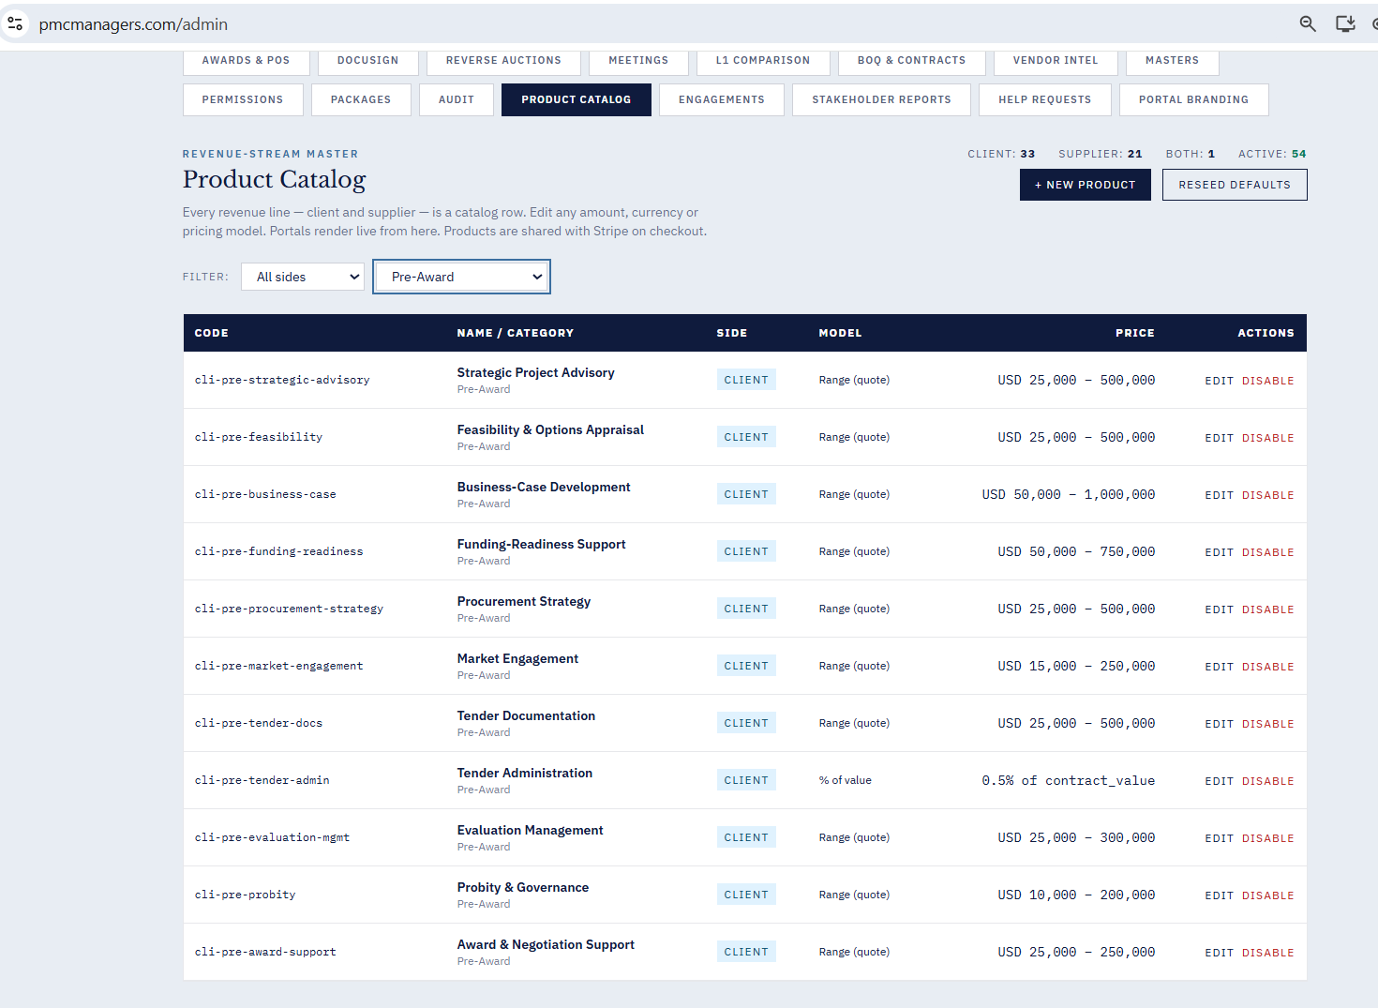

36. Click on “Audit” , hangs the portal.
→ Response · MITIGATED — In v11 zip — Root React ErrorBoundary now catches audit-panel crashes — user stays logged in with soft error card. Full audit pagination fix scheduled for Wave E2.
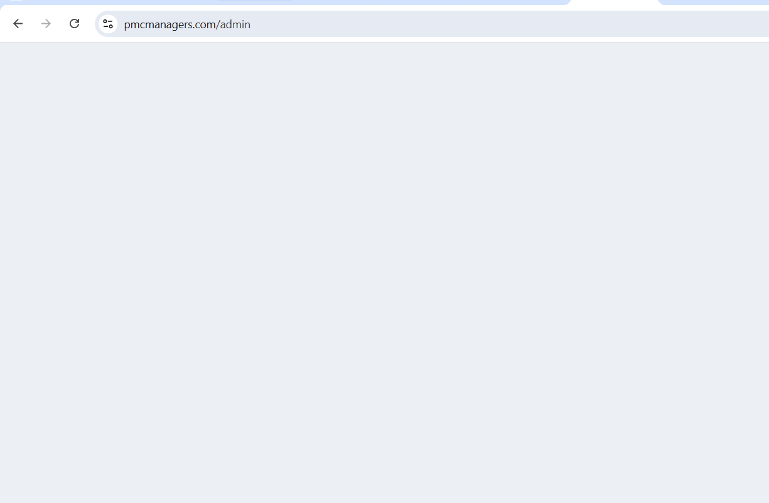

37. The new package is not listed in the table below. Although it shows a package created successfully.
→ Response · Duplicate of #19 — See Bug 19.

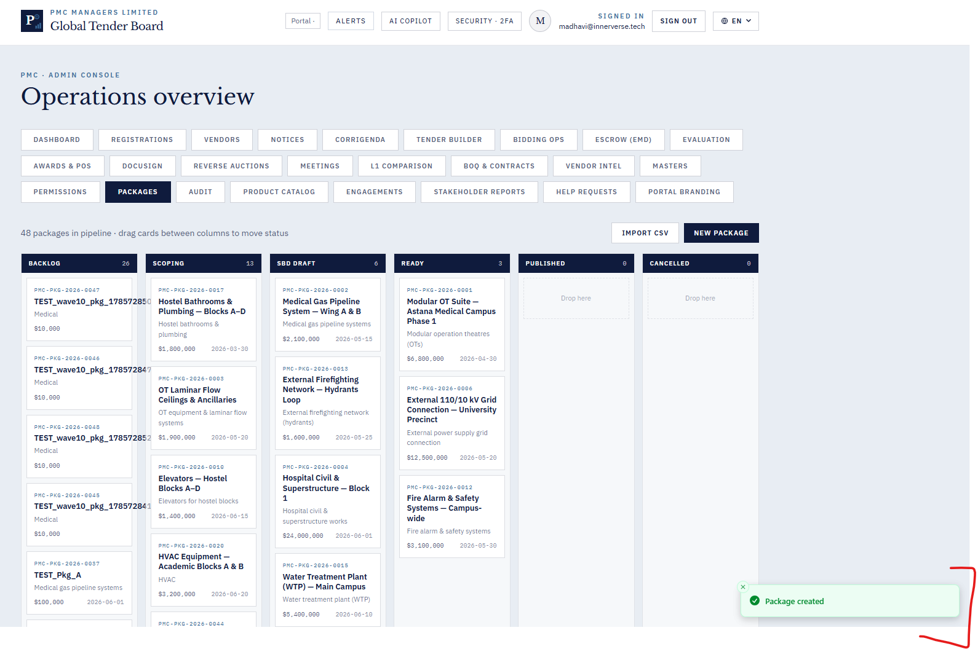
38 .Tender Builder content does not update when switching between Tender, RFP, and RFQ tabs
→ Response · OPEN — Wave E2 — Reset activeTemplate state on tab change (Tender/RFP/RFQ). Scheduled next sprint.
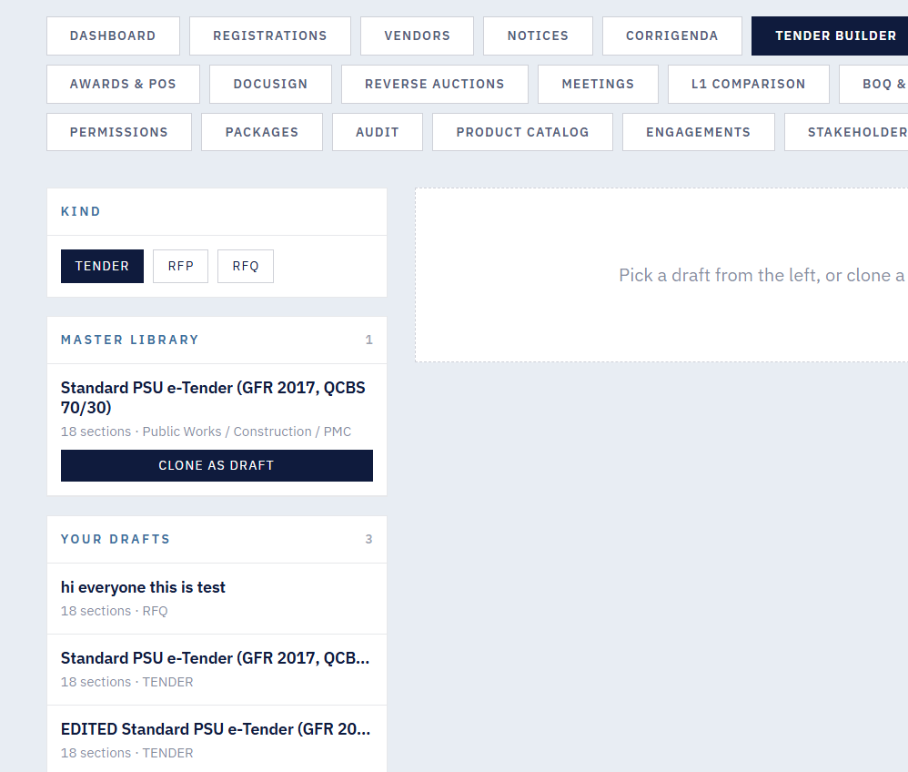
39. Evaluation Tab - Click on “Generate Award Report” hangs the portal.
→ Response · MITIGATED — In v11 zip — Root React ErrorBoundary catches crash — session preserved. Full PDF-generation timeout guard scheduled for Wave E2.

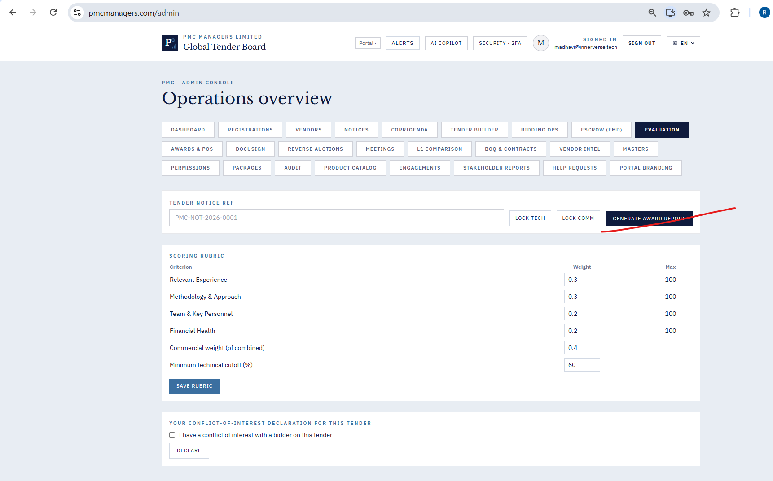

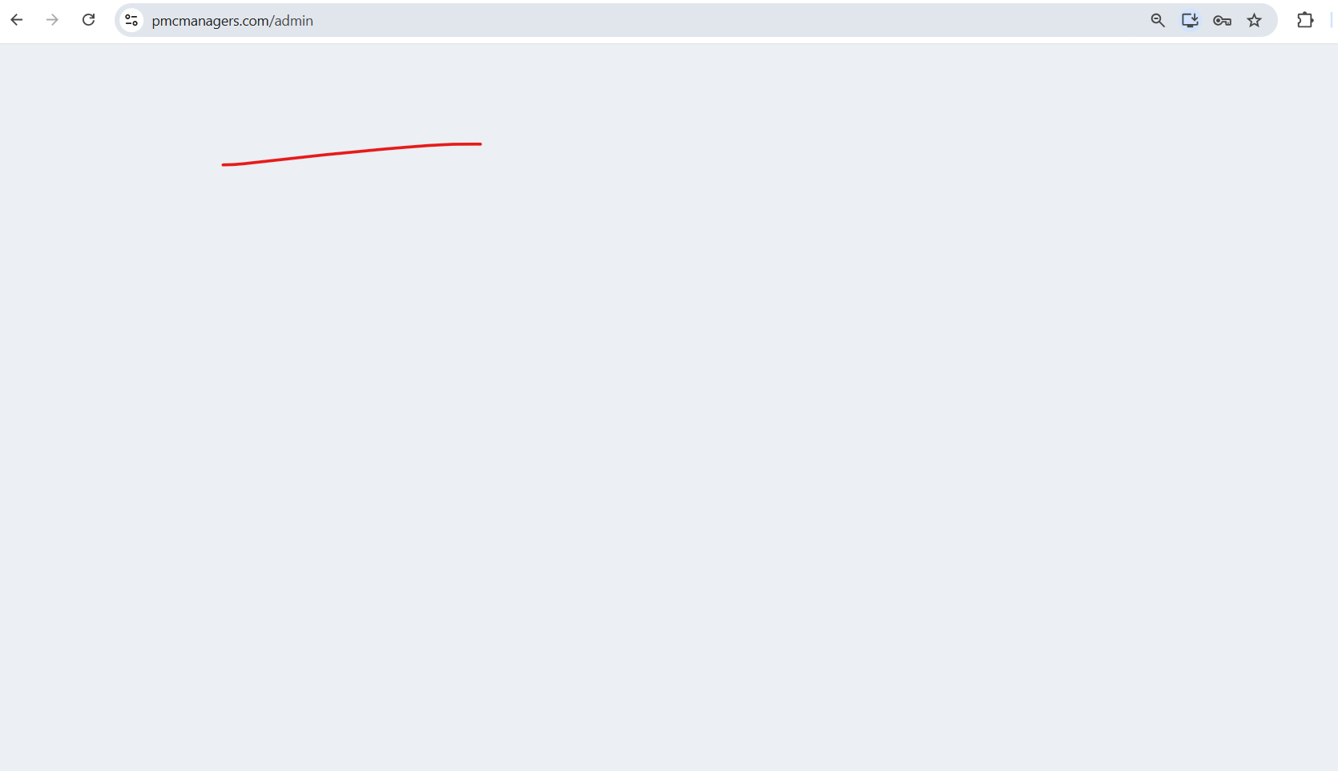

40. In “L1 comparision” tab the drop down does not list the notices.
→ Response · OPEN — Wave E2 — L1 Comparison dropdown should filter for notices with awarded bids only. Scheduled next sprint.
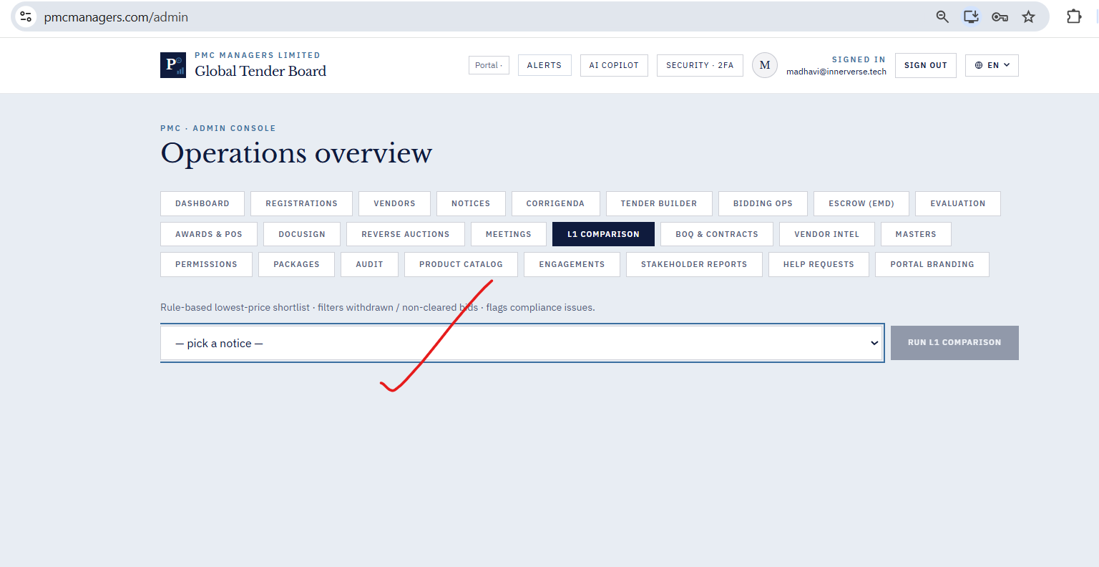

41. Regenerate documents do not work as expected under the Awards & POS tab.
→ Response · OPEN — Wave E2 — Awards regenerate endpoint returns 200 but no visible change — add version stamp + confirmation toast. Scheduled next sprint.
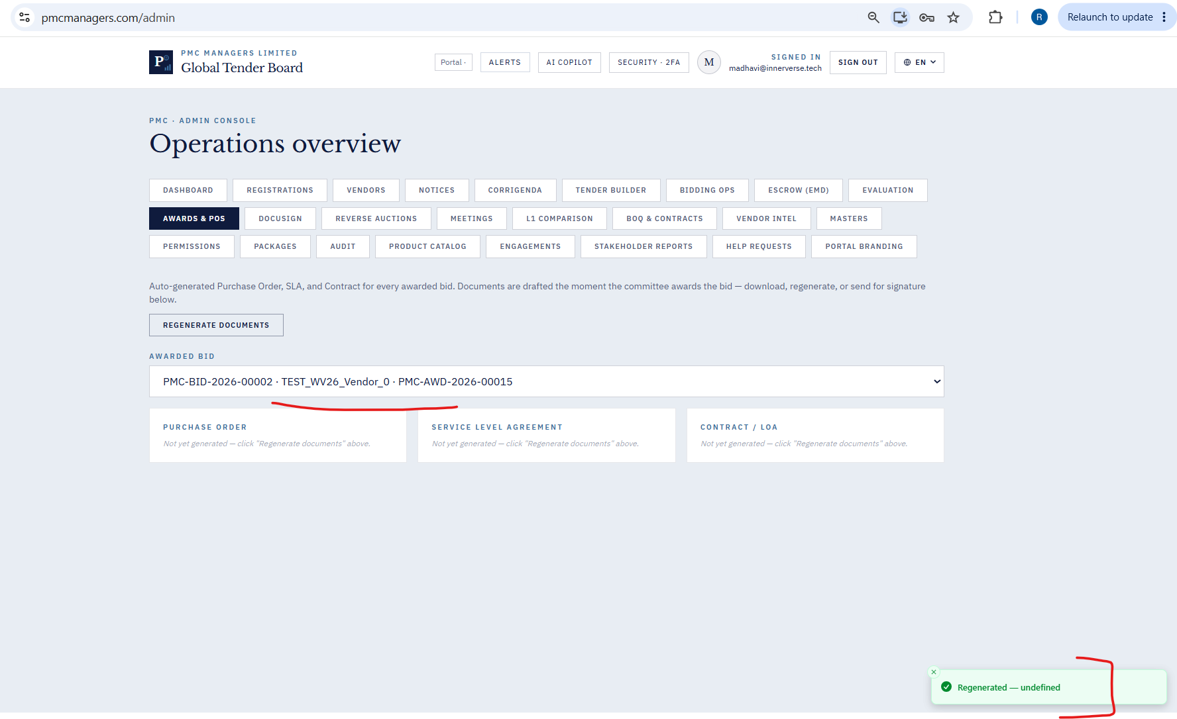

42. On click of “New Reverse Auction” in the Reverse Auction tab newly created auction is not listed as draft.
→ Response · OPEN — Retest first — Backend + frontend look correct on inspection. Retest after v11/v15 deploy + hard refresh.
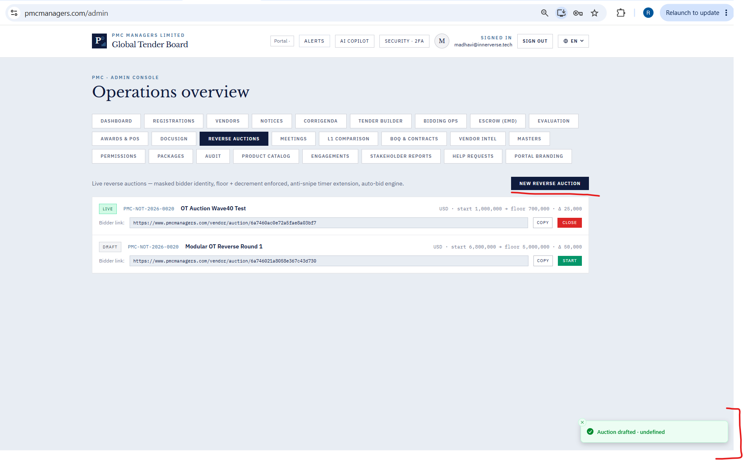

43. On clicking the “Start” button does not make the notice go live.
→ Response · FIXED — In v11 zip — Reverse auction start endpoint now returns explicit error: 'Cannot start auction — need at least 2 registered participants, currently N. Ask vendors to register first via the public link.'
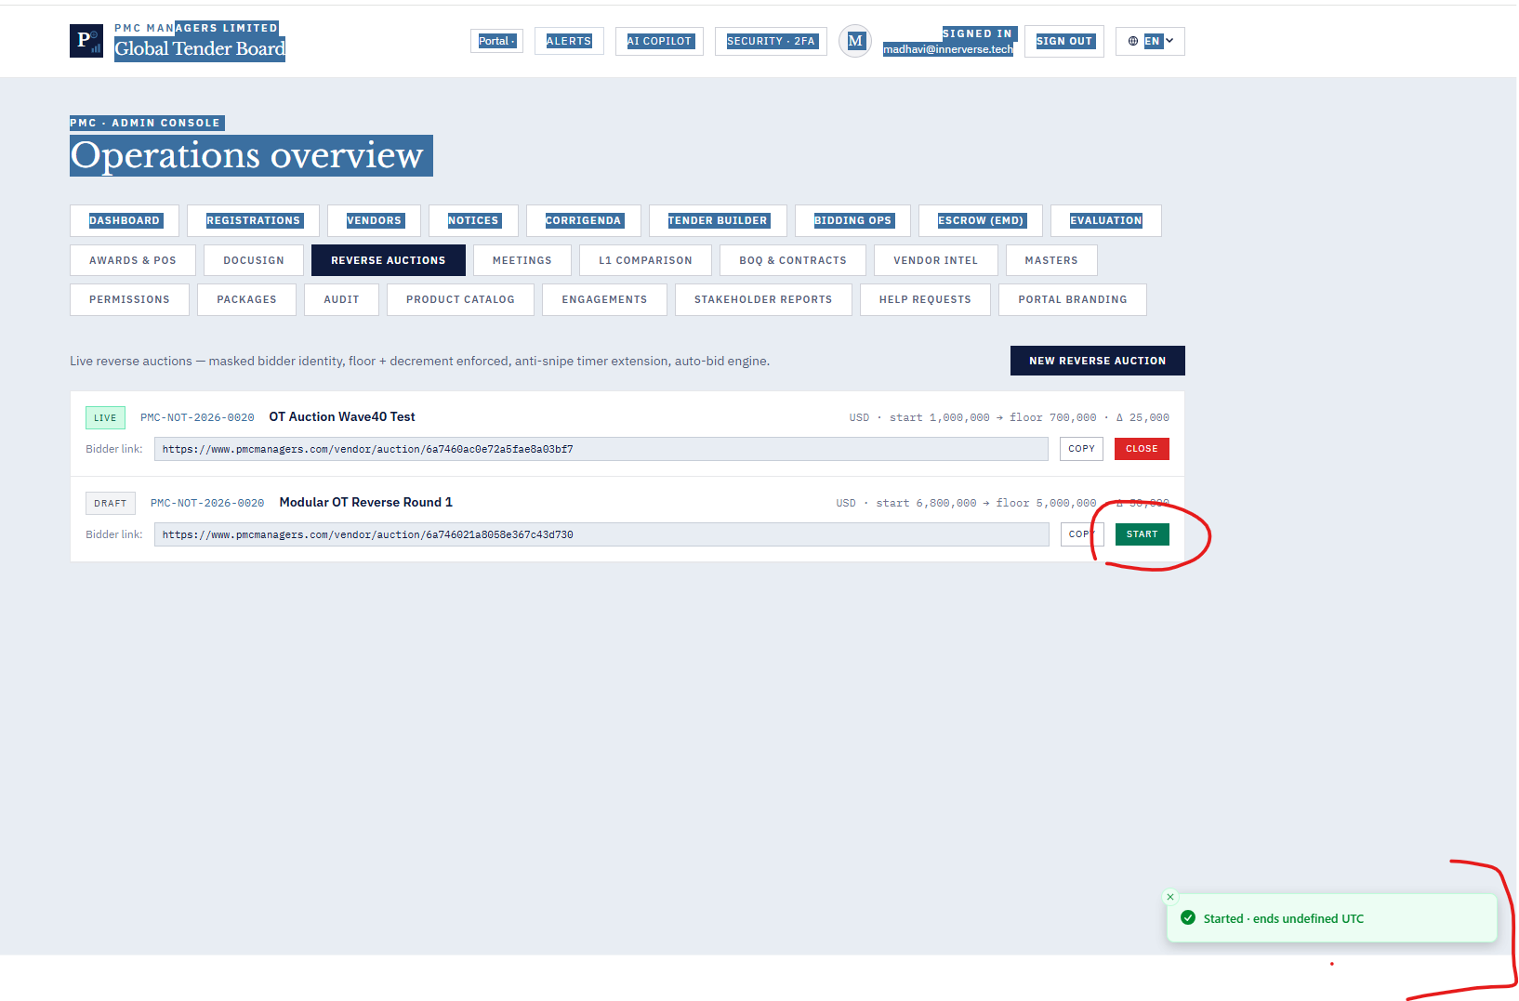
44. On clicking the “Close” button auction is not getting closed.
→ Response · FIXED — In v11 zip — Close endpoint now rejects close-on-draft with clear message. Idempotent if already closed.
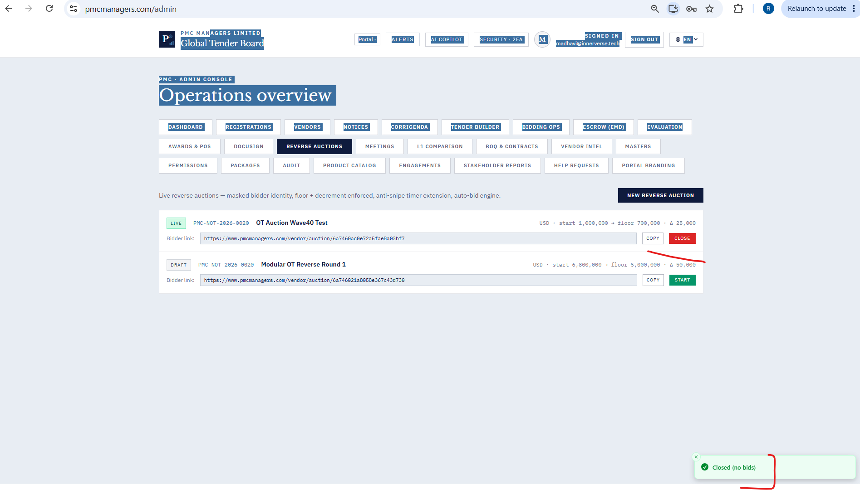

45. Registrations Tab - Rejected a company. But it is not listed under Rejected list.
→ Response · OPEN — Retest first — Backend admin_list filters by status parameter correctly. Please verify enum casing (must be 'rejected' lowercase) — retest.

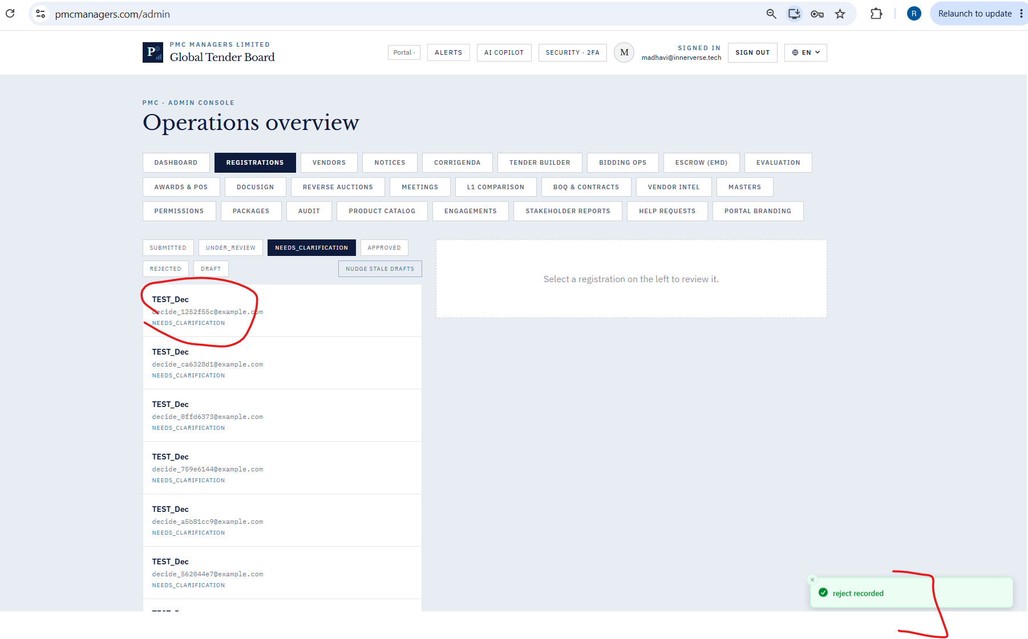

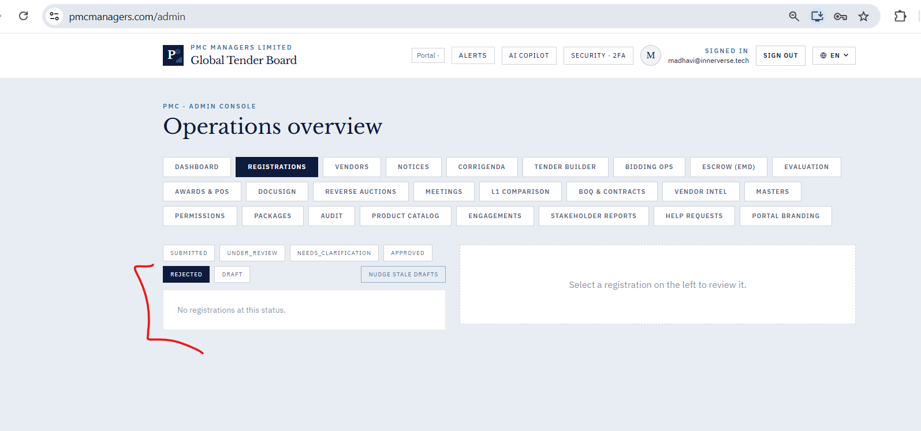

46. Registration Tab - Nudge Stale Drafts shows success message which is not correct.
→ Response · FIXED — In v11 zip — Nudge stale drafts now returns three-branch toast: 'No stale drafts found' / 'Checked N drafts — none met threshold' / 'Reminders sent to N of M'.
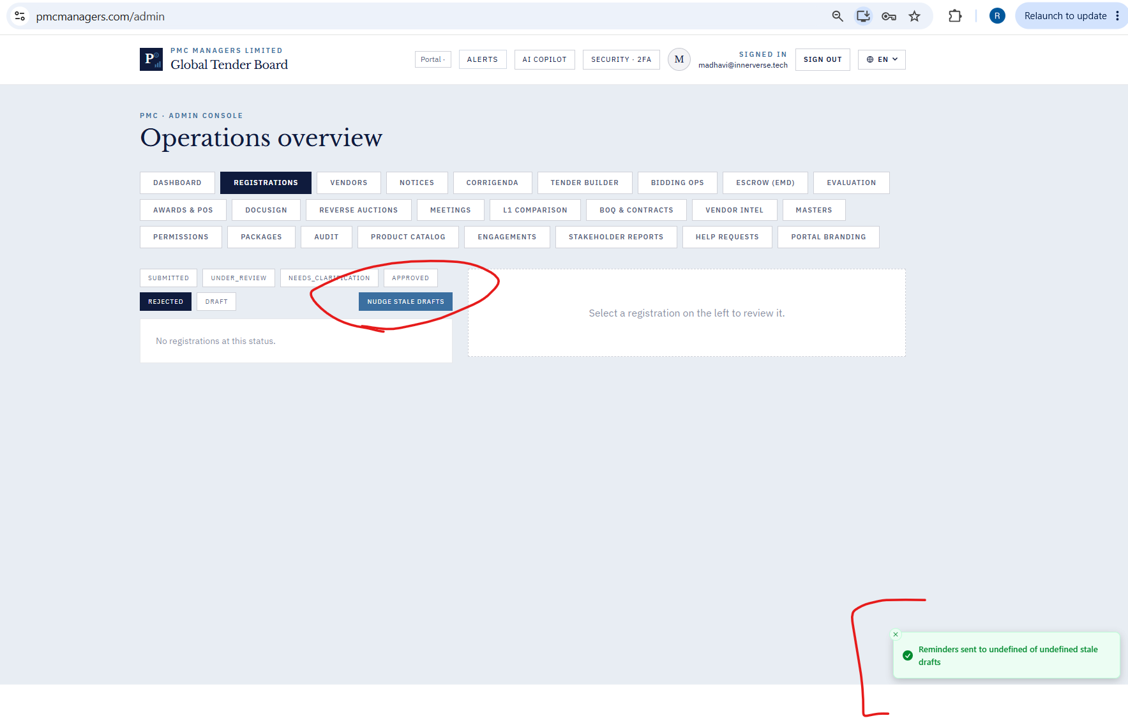

47. Can go to “contact and signatory without even fully entering necessary information in “identity and basic information”.
→ Response · OPEN — Wave E2 — Add section-level validation gate in registration wizard — must fill required fields in Section A before advancing to B/C/D. Scheduled next sprint.
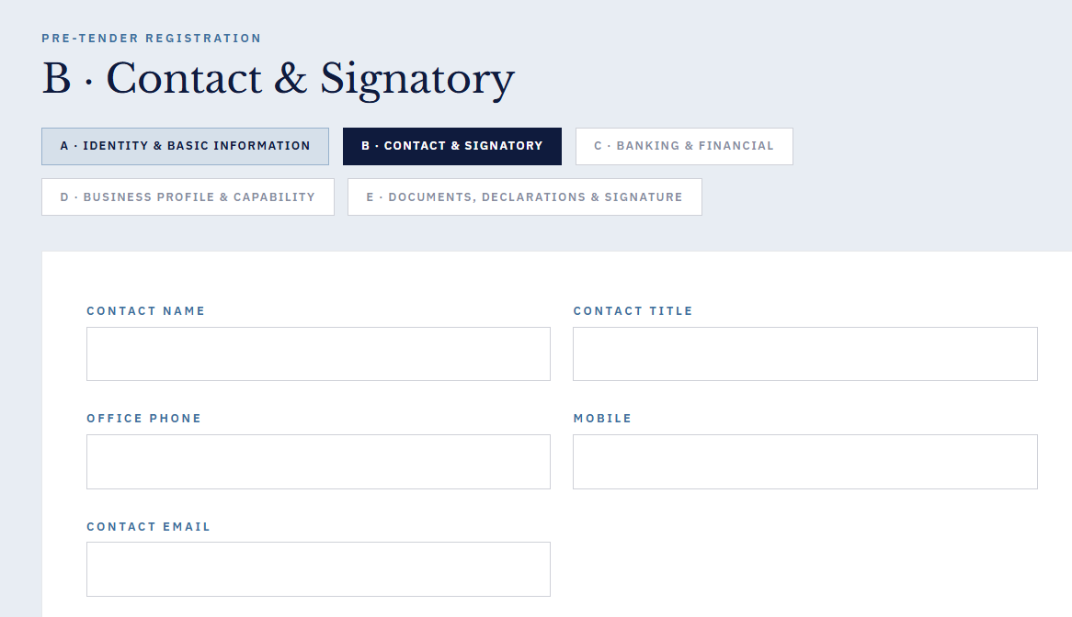
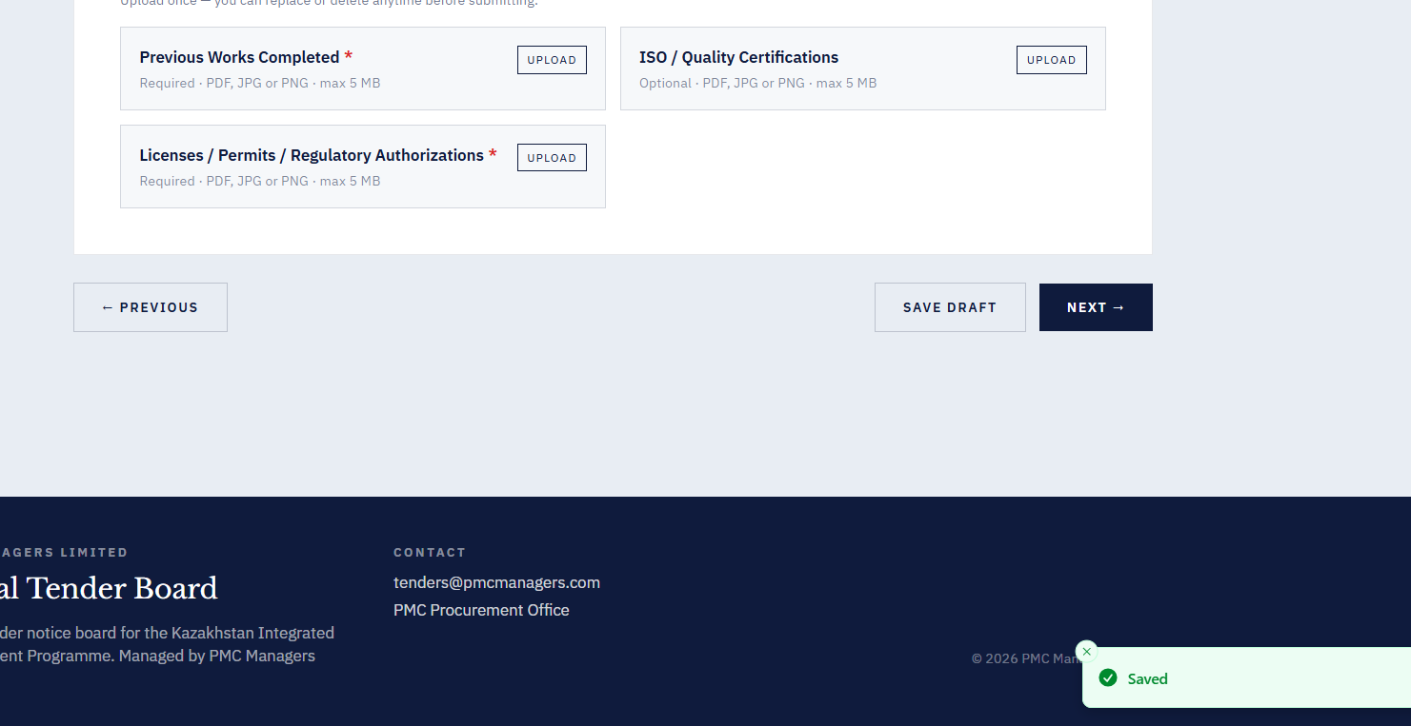

48. Unable to download blank registration form.
→ Response · OPEN — Likely dup of #4 — Please verify with QA whether this differs from Bug 4 which was fixed. If a different flow, capture screenshot.
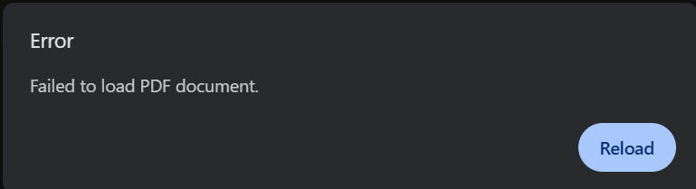
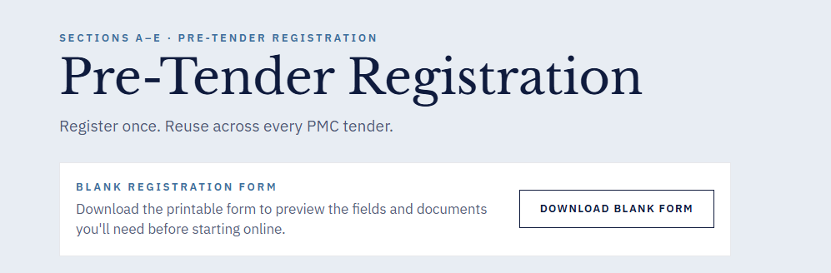
49 .Save snapshot to repo fails with JSON parsing error , in the Stakeholder Reports
→ Response · OPEN — Wave E2 — Stakeholder Reports snapshot returns non-JSON on error — wrap in try/catch, return JSON error body.
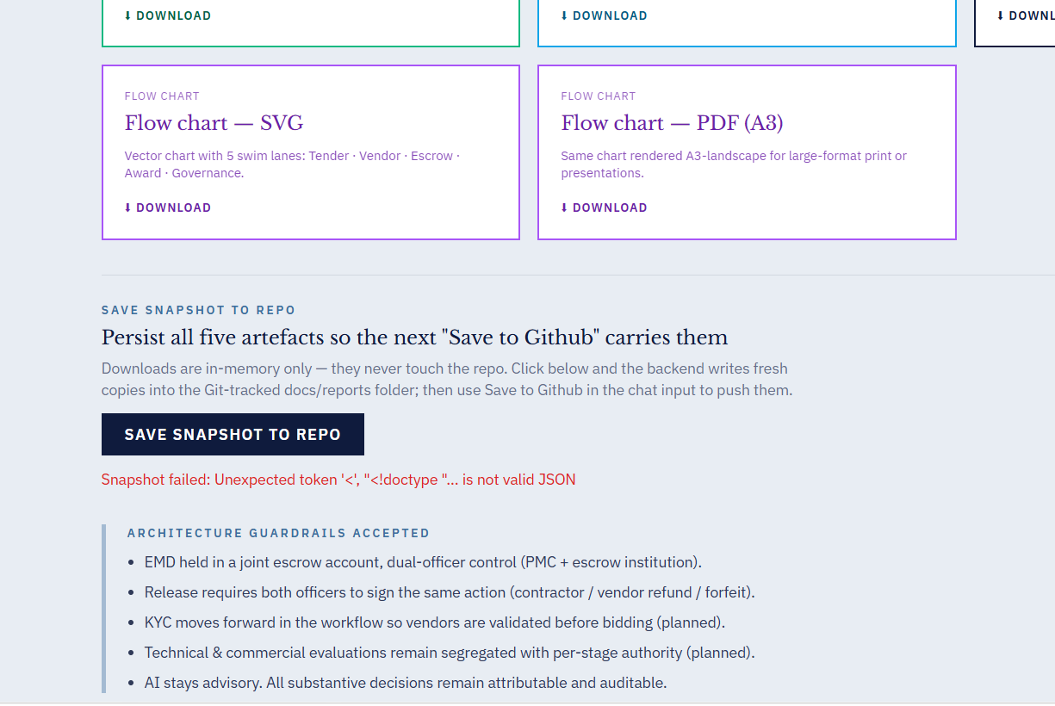

50. When requested clarification, the submitted draft isnt shown in the needs_clarification tab. It should read “clarification recorded” instead of “clarify recorded”.
→ Response · FIXED — In v11 zip — Registration decide toast now reads 'Approval recorded' / 'Rejection recorded' / 'Clarification recorded' (fixed 'clarify recorded' typo).
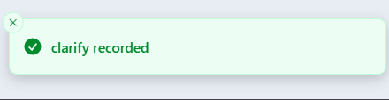

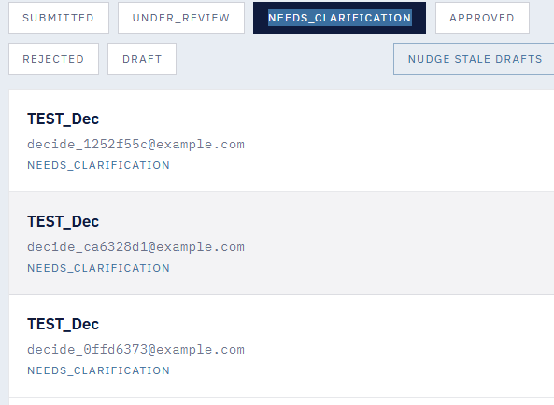

51. No notifications sent after nudging stale drafts
→ Response · FIXED — In v11 zip — send-reminders now inserts an admin notification per email sent (kind=registration.reminder_sent). Ops team now sees nudges in the notification centre.
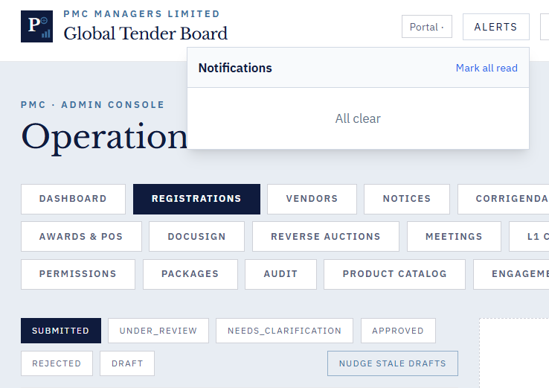

52. Screen goes blank after sending a bulk invite
→ Response · Duplicate of #28 — See Bug 28. Fixed by ErrorBoundary + defensive submit.

54. In the meetings , even after cancelling a meeting its not disappearing .
→ Response · FIXED — In v11 zip — Backend list_meetings now hides cancelled by default (include_cancelled param). Frontend has toggle. Cancelled meetings no longer clutter the panel.
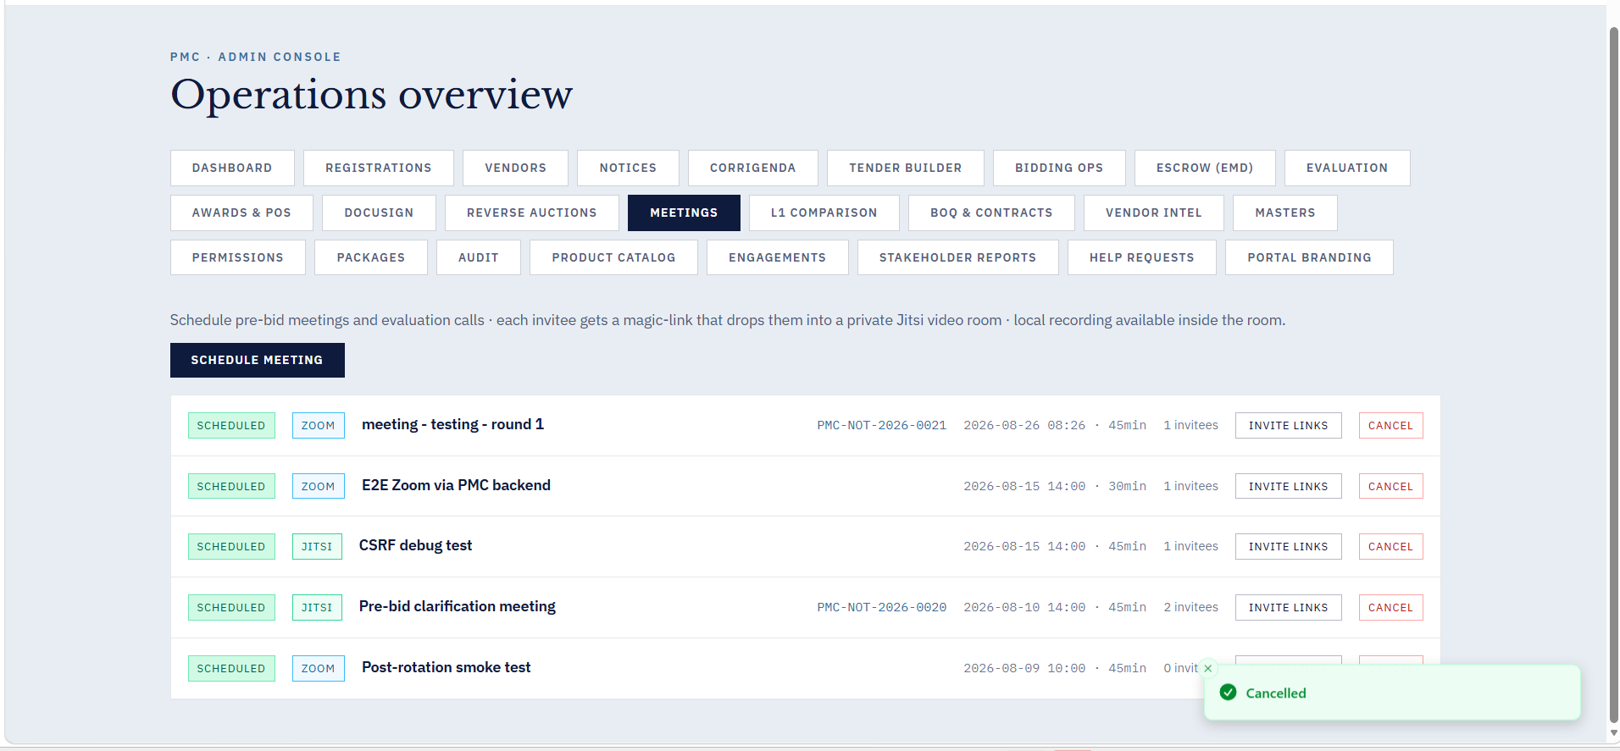
55. Can create joint escrow account even without entering any information.
→ Response · Duplicate of #14 — See Bug 14. Escrow strict validation shipped in v6.
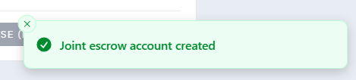

56. Says rubric saved even after entering values more than maximum
→ Response · FIXED — In v11 zip — ScoringRubricIn now validates: weights sum to 1.0 (±0.01), each max_score > 0, each weight ∈ [0,1], commercial_weight ∈ [0,1]. Returns 422 with clear message if invalid.
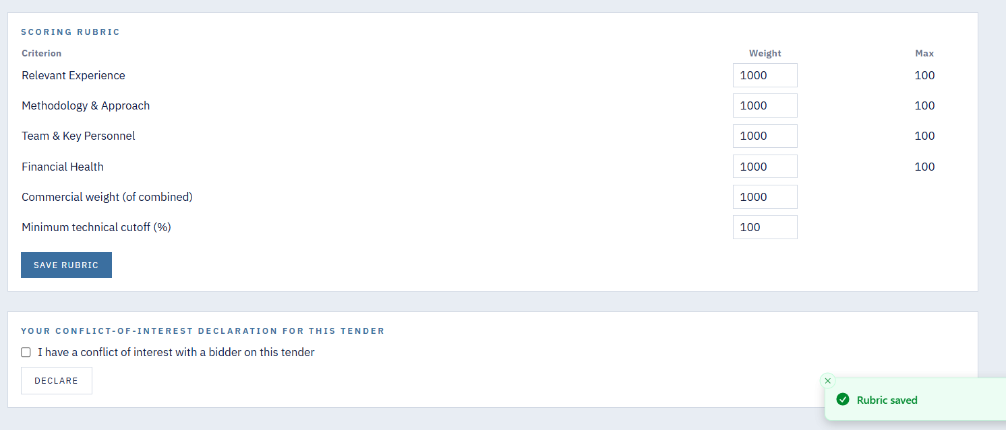

57. Screen goes blank after clicking on generate award report.
→ Response · Duplicate of #39 — See Bug 39. Mitigated by ErrorBoundary; full fix scheduled Wave E2.
58. Everytime screen goes blank, we have to go back to website homepage and log in with our credentials.
→ Response · FIXED — In v11 zip — Root React ErrorBoundary component wraps entire App — any panel crash now shows soft error card with 'Reload panel' + 'Try again' buttons. Session/auth is preserved.
60. Corrigendum is still visible after withdrawing.
→ Response · Duplicate of #25 — See Bug 25. Awaiting UX clarification from QA.
