PMC Managers · v46 Master Training Manual
PMC Managers Limited — Confidential — v46 — Sep 2026

1 · Platform overview & architecture
The PMC platform is a multi-role tender lifecycle engine covering the full path from notice publication → registration → bidding → EMD → evaluation → award → e-signature → invoicing → post-contract audit. Delivered as a React SPA backed by FastAPI + MongoDB with same-origin cookie sessions and CSRF double-submit tokens.

2 · Roles at a glance
Role | Portal | Scope
Admin | /admin | Full control of every module.
Reviewer | /admin | Read-only + evaluation scoring.
Escrow agent | /staff | EMD desk, forfeitures, refunds.
Certifier | /staff | Tender packet sign-off.
Legal counsel | /staff | Contract review, DocuSign envelope owner.
Accounting | /staff | Fee invoicing, refunds, reconciliation.
Committee member | /staff | Evaluation committee voting.
Auditor | /admin (read) | Full audit trail with entity filters.
Support | /staff | Vendor helpdesk, activation resends.
Vendor | /vendor | Bid on notices, manage profile & invoices.

3 · Public visitor journey

1 · Landing page — Kazakhstan programme hero
Public homepage. Shows live counters (Notices Published, Suppliers Approved, Work Packages) and quick paths to browse open tenders or register as a supplier.
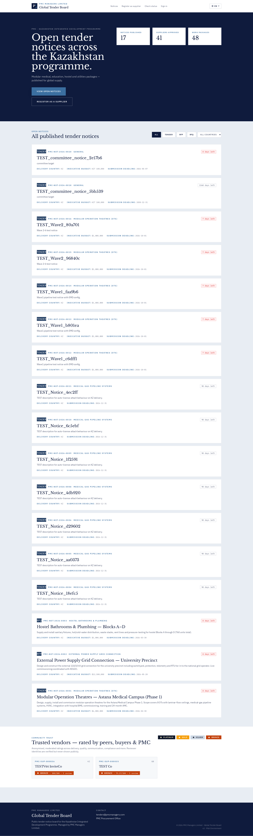
Landing page — Kazakhstan programme hero

Purpose
Front door for every visitor. Establishes brand, states the current programme scope (Kazakhstan Integrated Development), and surfaces three live KPIs pulled from the API in real time.

Fields
- NOTICES PUBLISHED — Count of notices with is_published=True.
- SUPPLIERS APPROVED — Total registered vendor accounts.
- WORK PACKAGES — Modular deliverable packets configured for the programme.
- VIEW OPEN NOTICES — Deep-links to the public tender board.
- REGISTER AS A SUPPLIER — Kicks off the supplier onboarding flow.

Known gotchas
- Counters are live; if they show 0 after a deploy, hard-refresh the browser — CloudFront may still be serving a stale bundle.

2 · Notice board — all published tenders
Filterable list of every published notice: country, category, budget currency, submission deadline, EMD terms, contact.
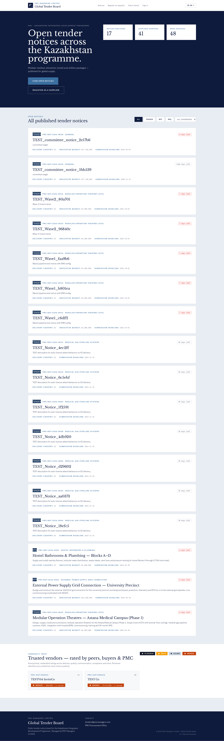
Notice board — all published tenders

Purpose
The public tender board — the primary discovery surface for any prospective bidder. Every notice with `is_published=True` appears here in reverse chronology.

Fields
- Search bar — Fuzzy-match on title, description, country and category.
- Country / category filters — Server-side filters piped through the notices API.
- Row card — Shows submission deadline, budget currency+amount, EMD hint, licence tags. Click to open the detail page.

Known gotchas
- Deadlines are shown in the browser's local timezone.

3 · Notice detail — full tender packet
Selecting any notice opens the public detail view with full description, documents, EMD/tender-fee summary, corrigenda log, Q&A, and download-tender-packet button.
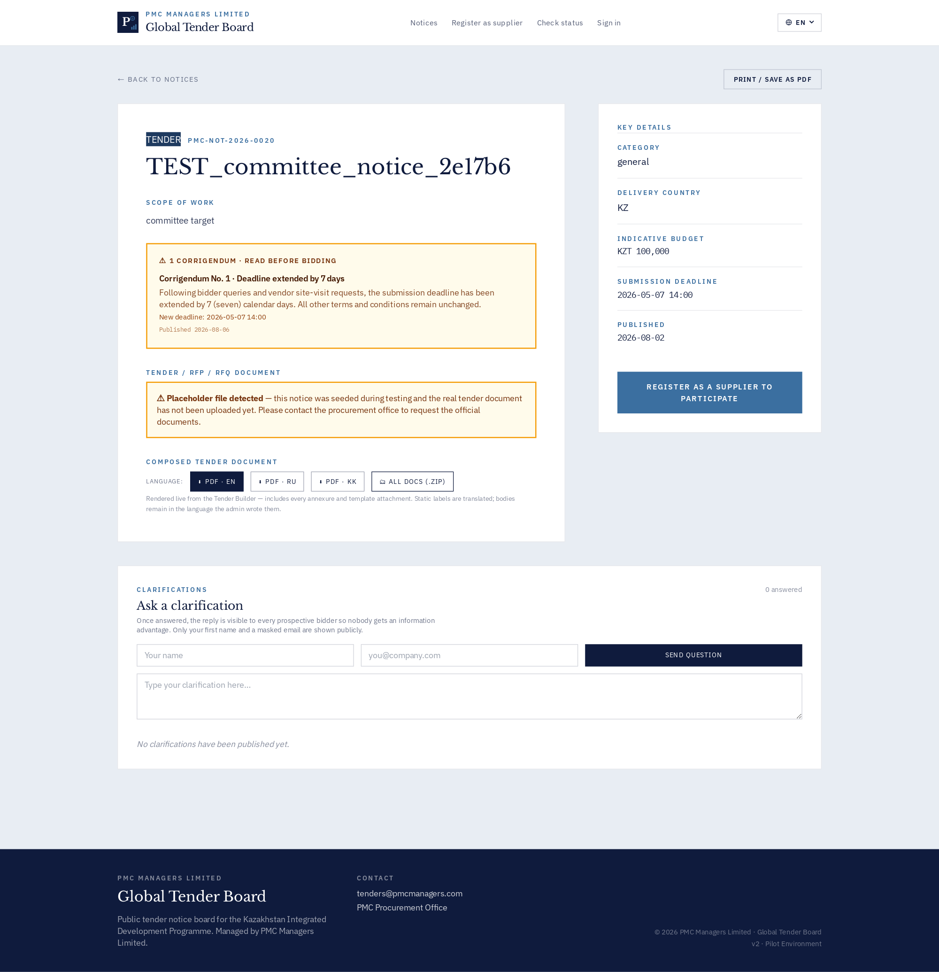
Notice detail — full tender packet

Purpose
Complete tender packet visible to any visitor before login. Every regulatory disclosure lives here.

Fields
- Header block — Title, reference number, publish/submission dates, EMD.
- Primary document / attachments — Signed PDF + supporting files.
- Corrigenda log — Every addendum with author + timestamp.
- Q&A — Public questions once the admin marks an answer visible.
- Bid actions — Visible only once the visitor signs in as a verified vendor.

Known gotchas
- The 'Download tender packet' button assembles a ZIP with the composed PDF + every section attachment on the fly.

4 · Supplier registration
Public 'Register as supplier' onboarding — email/password, company details, country, licences, consent to data processing. Verification email dispatched on submit.
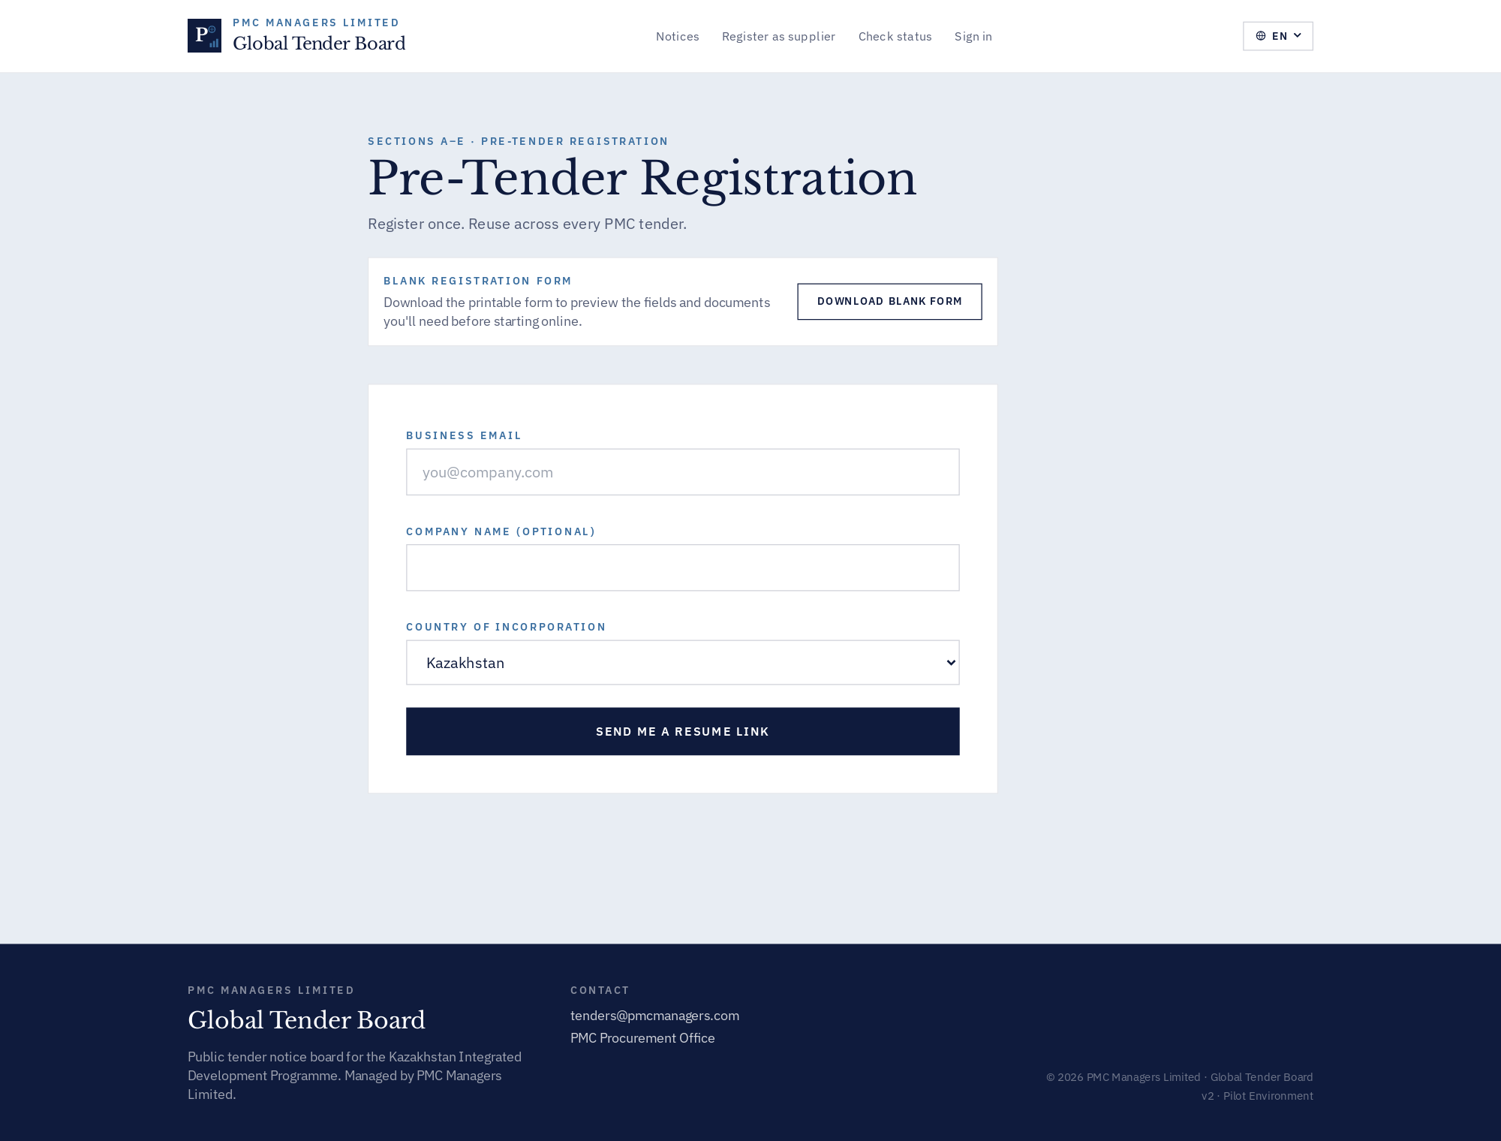
Supplier registration

Purpose
Supplier self-onboarding. Creates the vendor account, then dispatches a verification email that unlocks the vendor portal.

Fields
- Company details — Legal name, country, address, VAT/UBO if applicable.
- Licences — Country-specific dropdown (Kazakhstan uses SK-* licence codes).
- Consent switches — GDPR data-processing + optional marketing opt-in.

Known gotchas
- Emails from Resend can hit spam on first-touch corporate mailboxes; admins can resend from the Registrations queue.

5 · Unified sign-in — Choose your portal
Employees on the left (any staff role), suppliers on the right. Role selector routes admins to /admin and staff to /staff automatically.
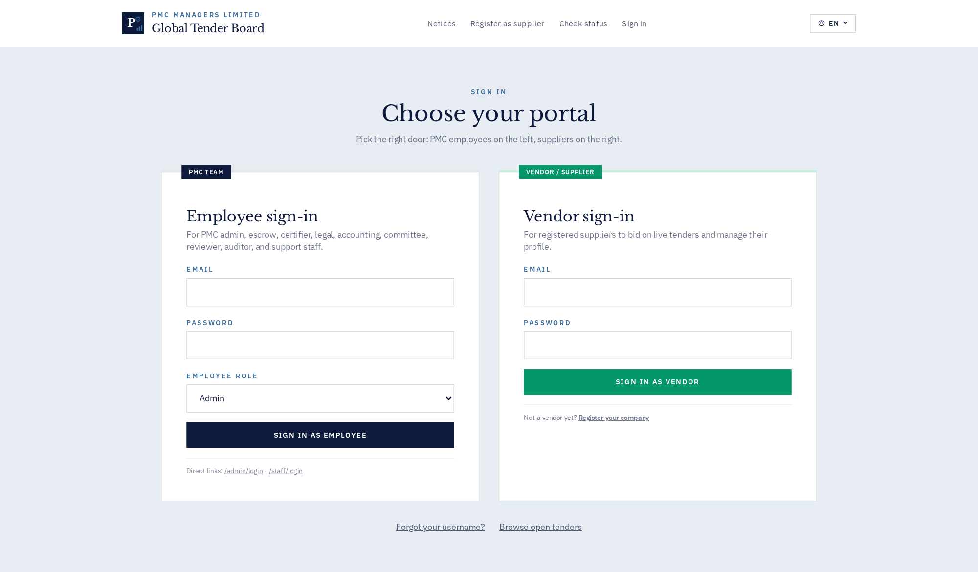
Unified sign-in — Choose your portal

Purpose
Unified 'Choose your portal' entry. Left card = employees (admin, escrow, certifier, legal, accounting, committee, reviewer, auditor, support). Right card = suppliers.

Fields
- EMPLOYEE ROLE dropdown — Determines which staff endpoint the client hits.
- Direct links — /admin/login and /staff/login bypass the picker.

Known gotchas
- MFA/OTP is enforced for admin accounts once configured — the password step will be followed by a code prompt.

4 · Vendor / supplier journey

60 · Vendor sign-in
Dedicated vendor login (also accessible via /login → right card).
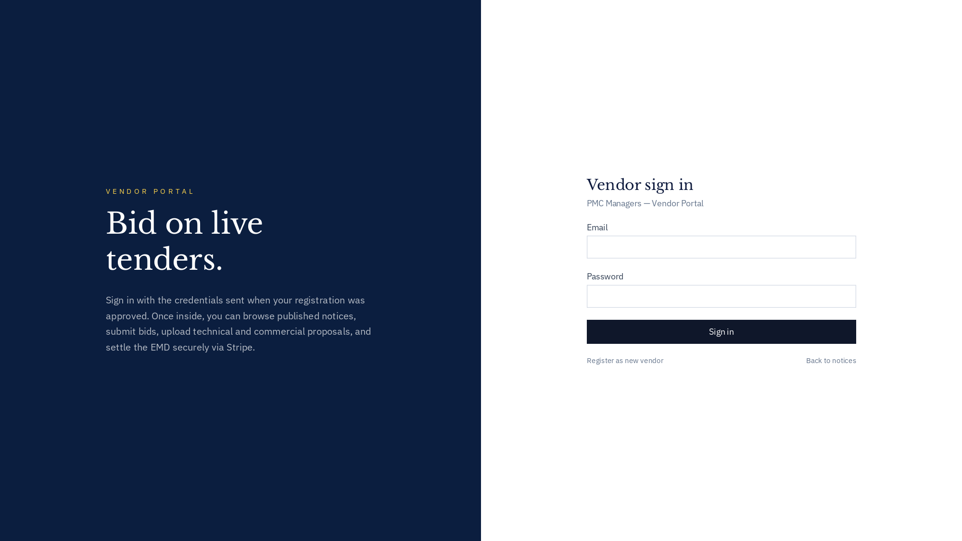
Vendor sign-in

How to use
This screen exposes every action available for its module. Use the InfoDot (ⓘ) next to each label to see the field-level rules — hover it in-app for the full policy text. All destructive actions confirm before applying and every mutation is written to the immutable audit log.

61 · Vendor dashboard landing
Overview of open tenders the vendor may bid on, invoice status, ratings tab, profile & licenses.
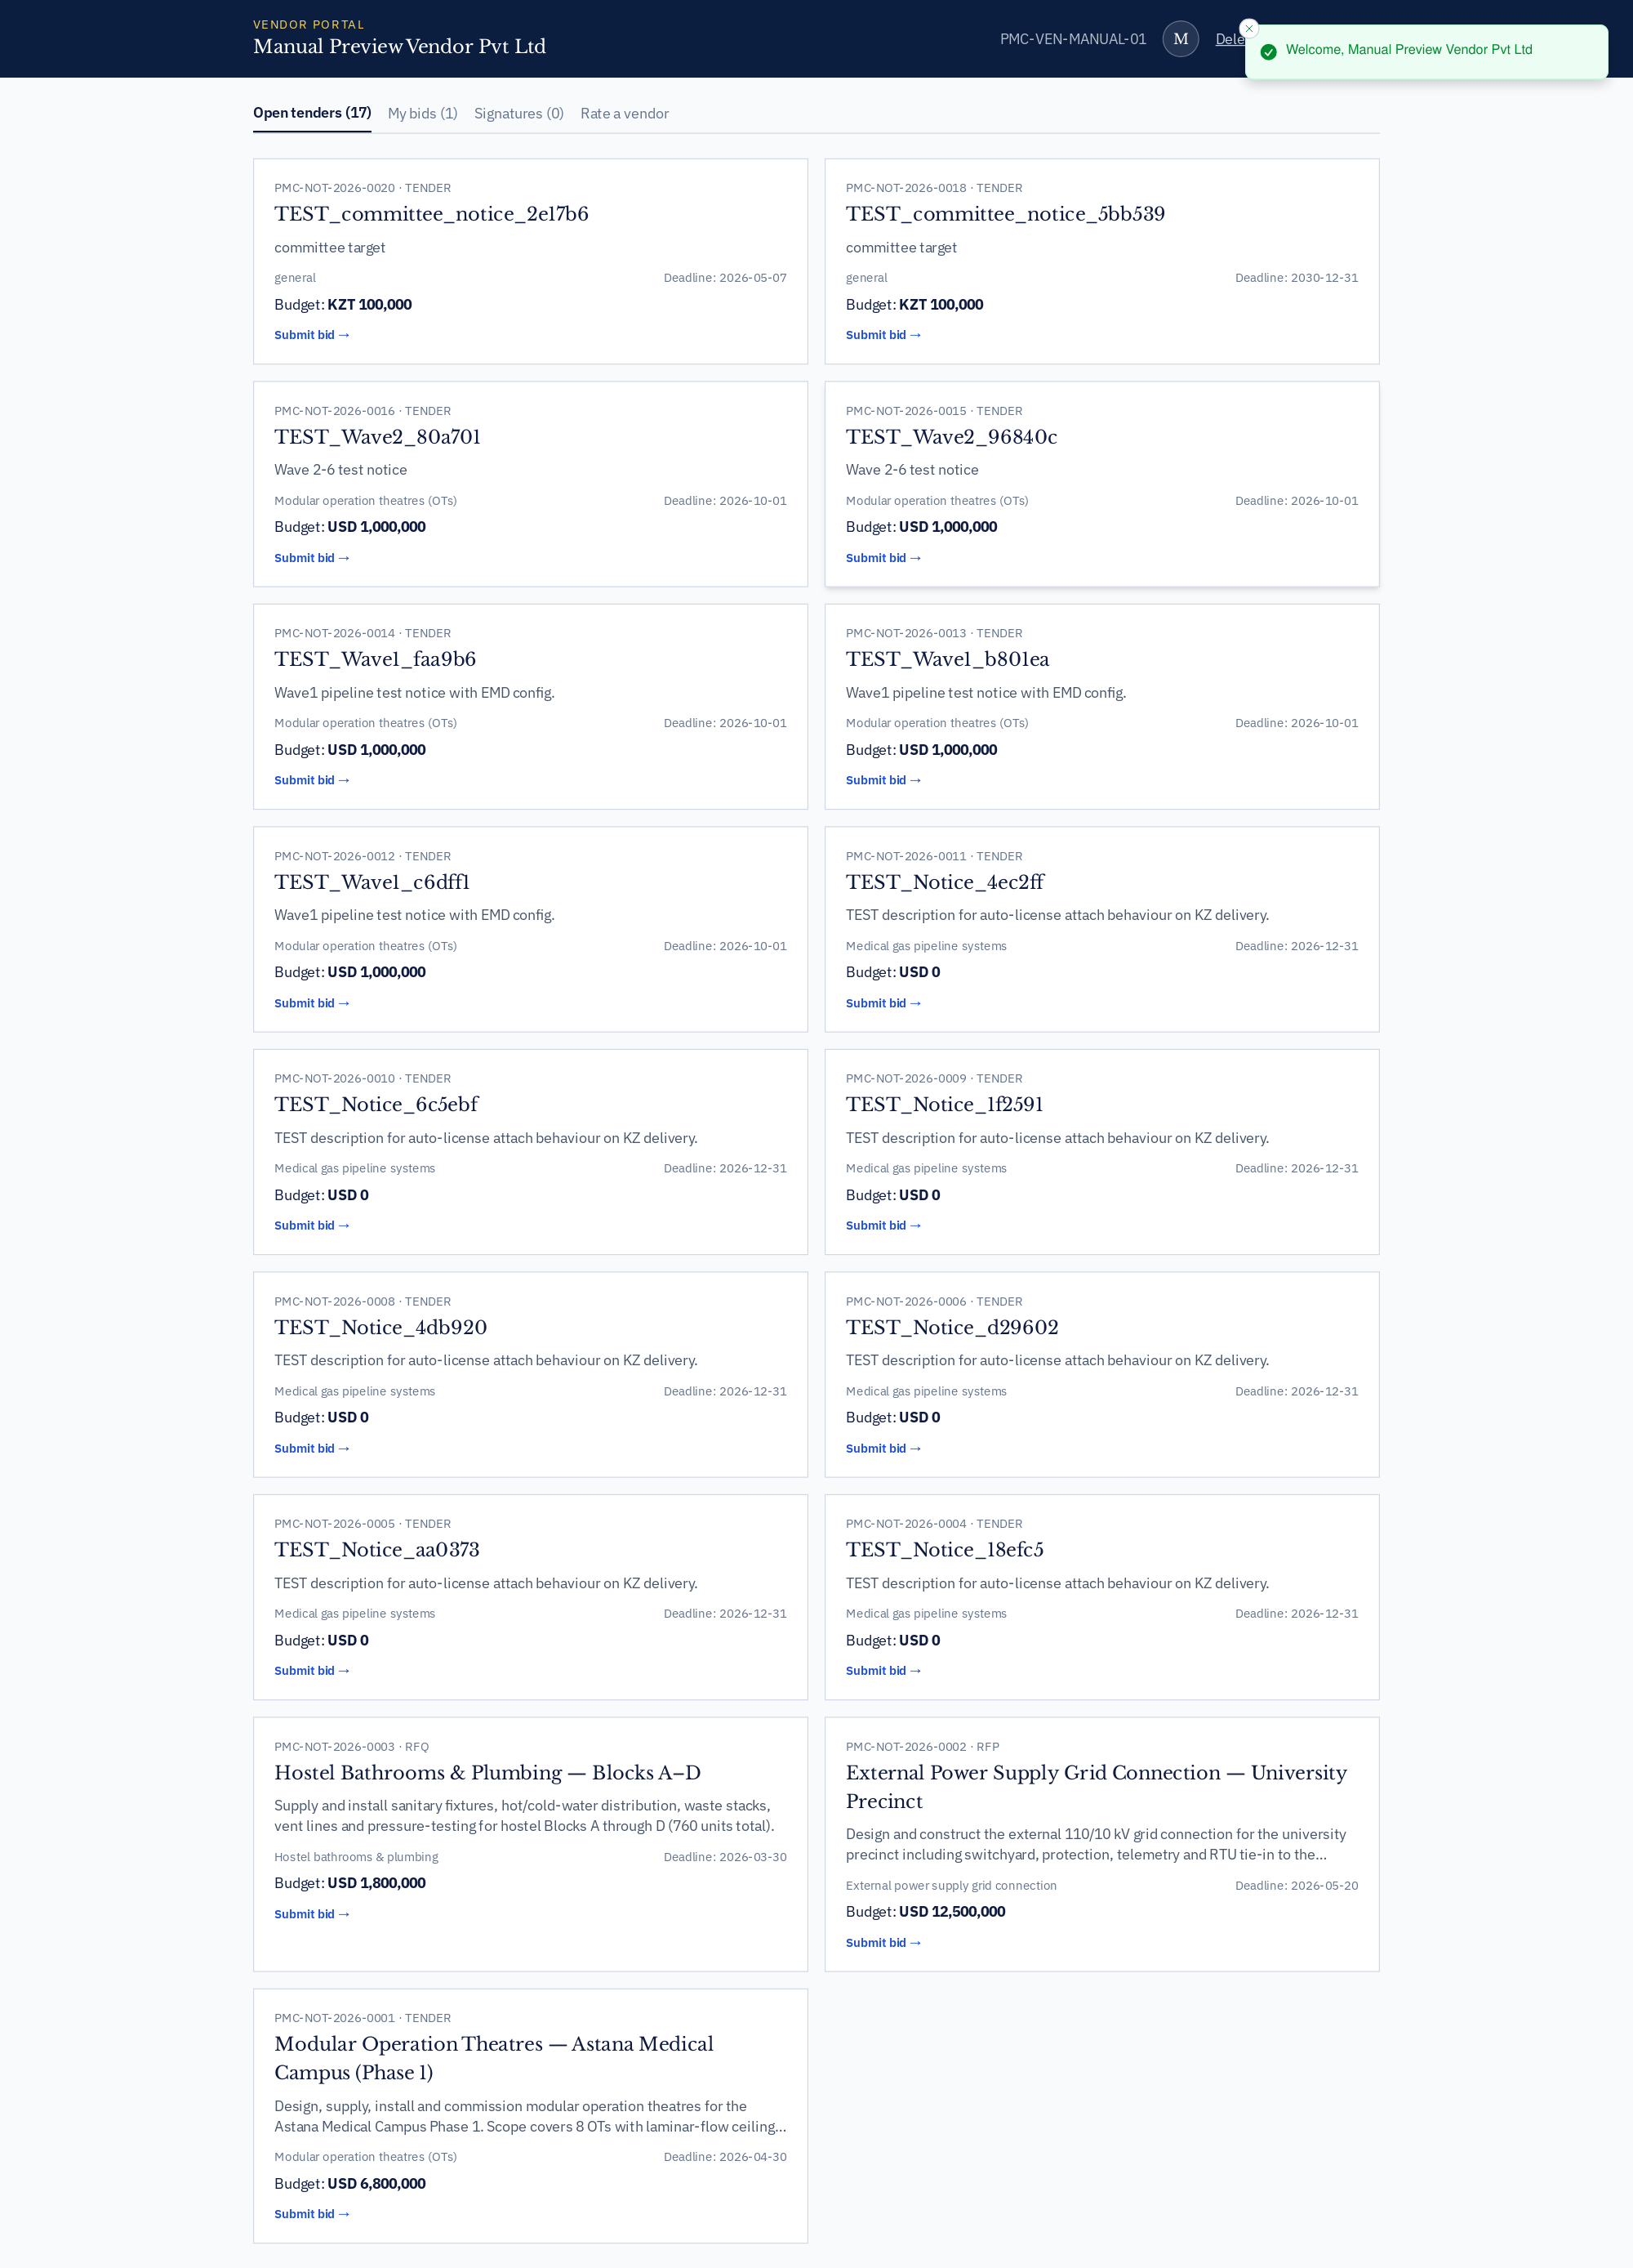
Vendor dashboard landing

How to use
This screen exposes every action available for its module. Use the InfoDot (ⓘ) next to each label to see the field-level rules — hover it in-app for the full policy text. All destructive actions confirm before applying and every mutation is written to the immutable audit log.

5 · Admin console — full 23-tab tour

10 · Admin console landing (Operations Overview)
First screen after admin login — tab strip, environment chip, alerts, AI Copilot shortcut, security/2FA badge.
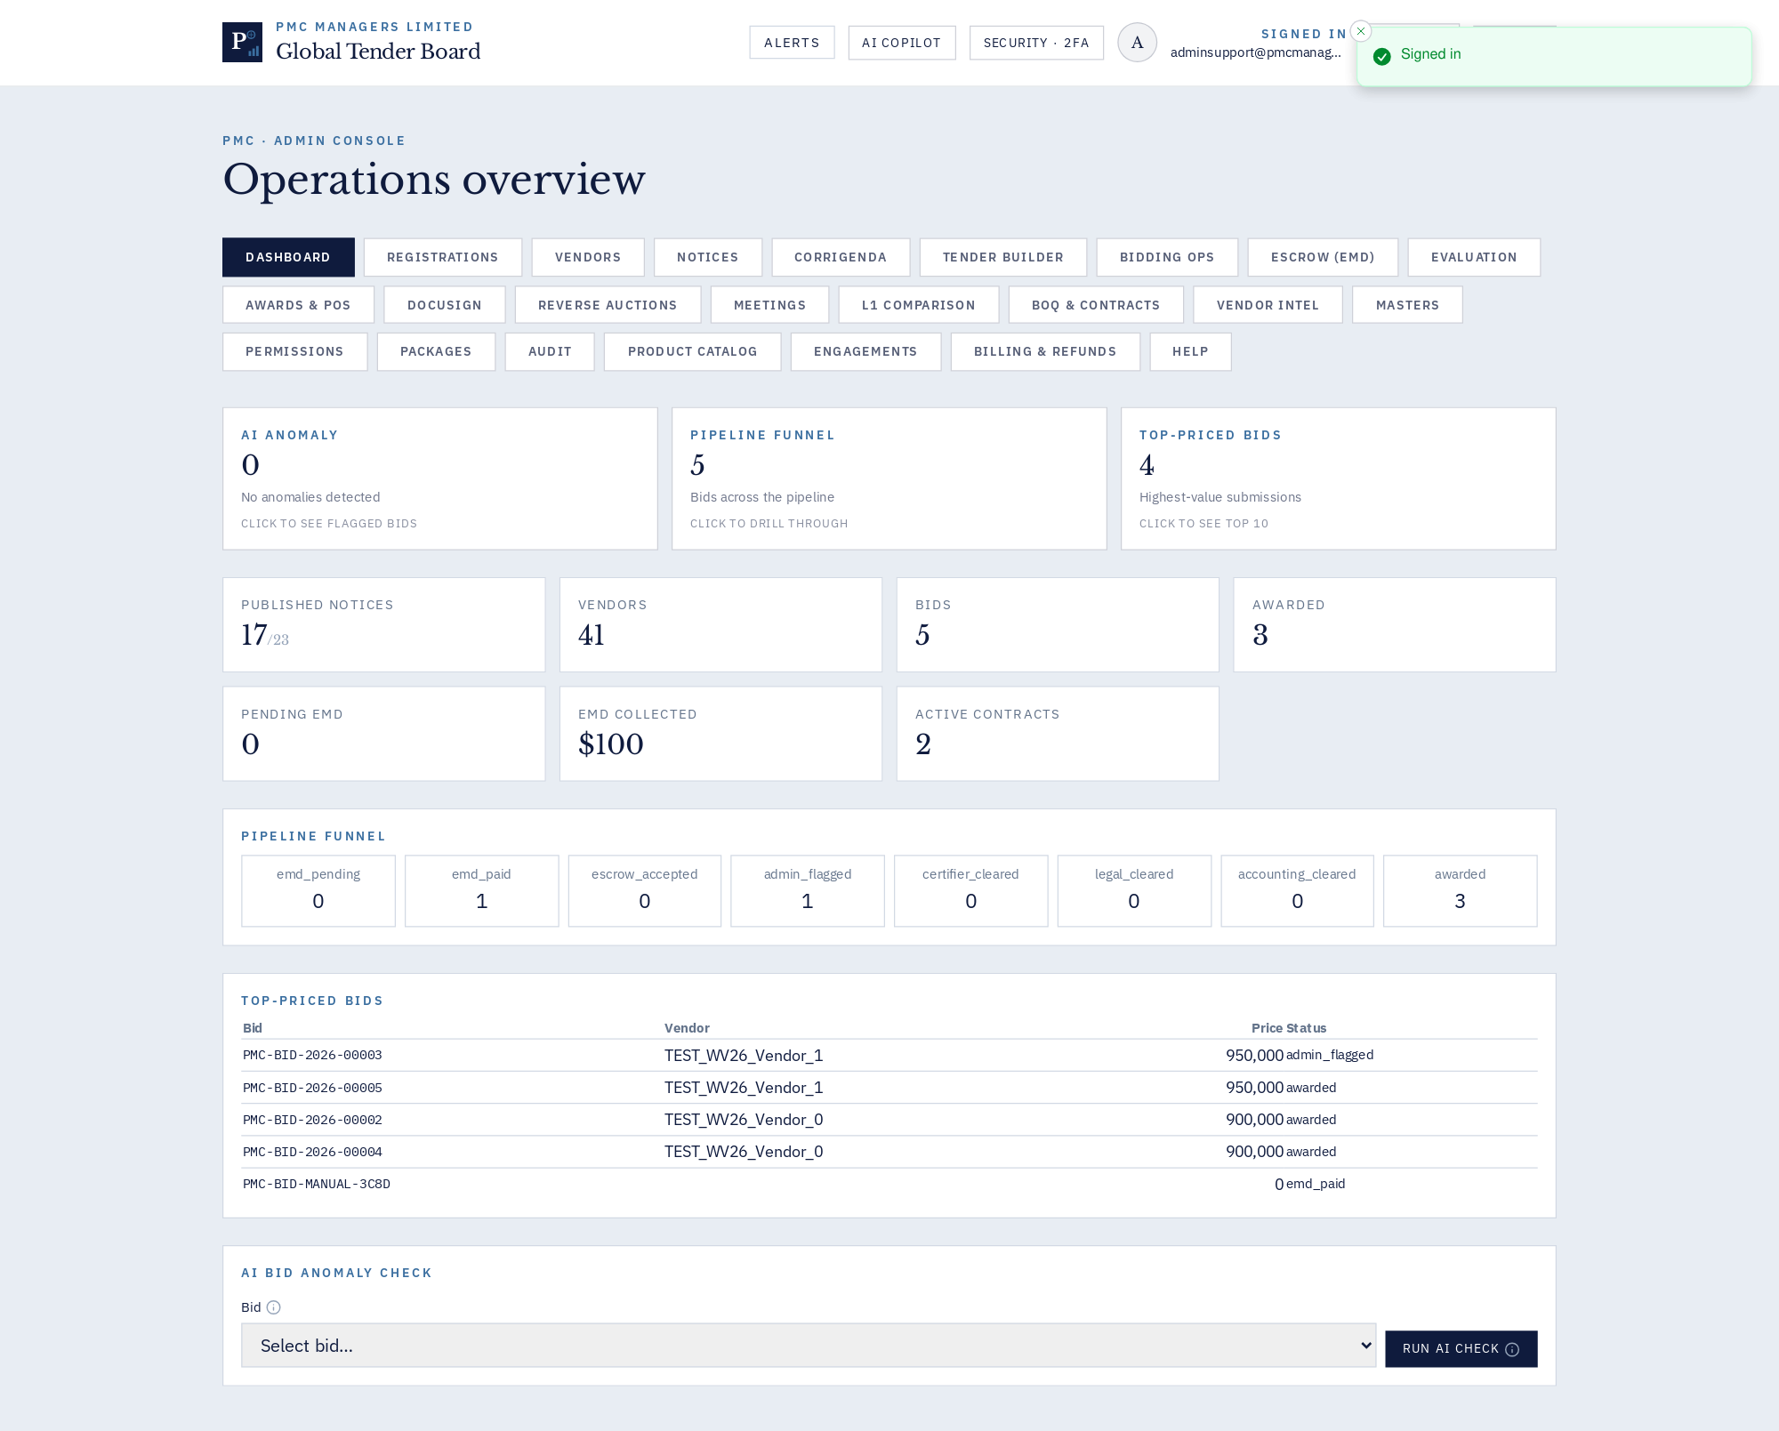
Admin console landing (Operations Overview)

Purpose
Command centre for PMC staff. The header shows environment tenant, MFA + profile shortcuts, alerts, AI Copilot.

Fields
- Tab strip — 23 top-level tabs — see per-tab pages below.
- Environment chip — Which tenant/programme is currently active.
- AI Copilot — In-context question box for procurement policy.

Known gotchas
- Some tabs require role escalation (e.g. Escrow needs escrow_agent).

11 · Admin · Dashboard analytics
KPIs, funnel drills, revenue by module, activity heatmap.
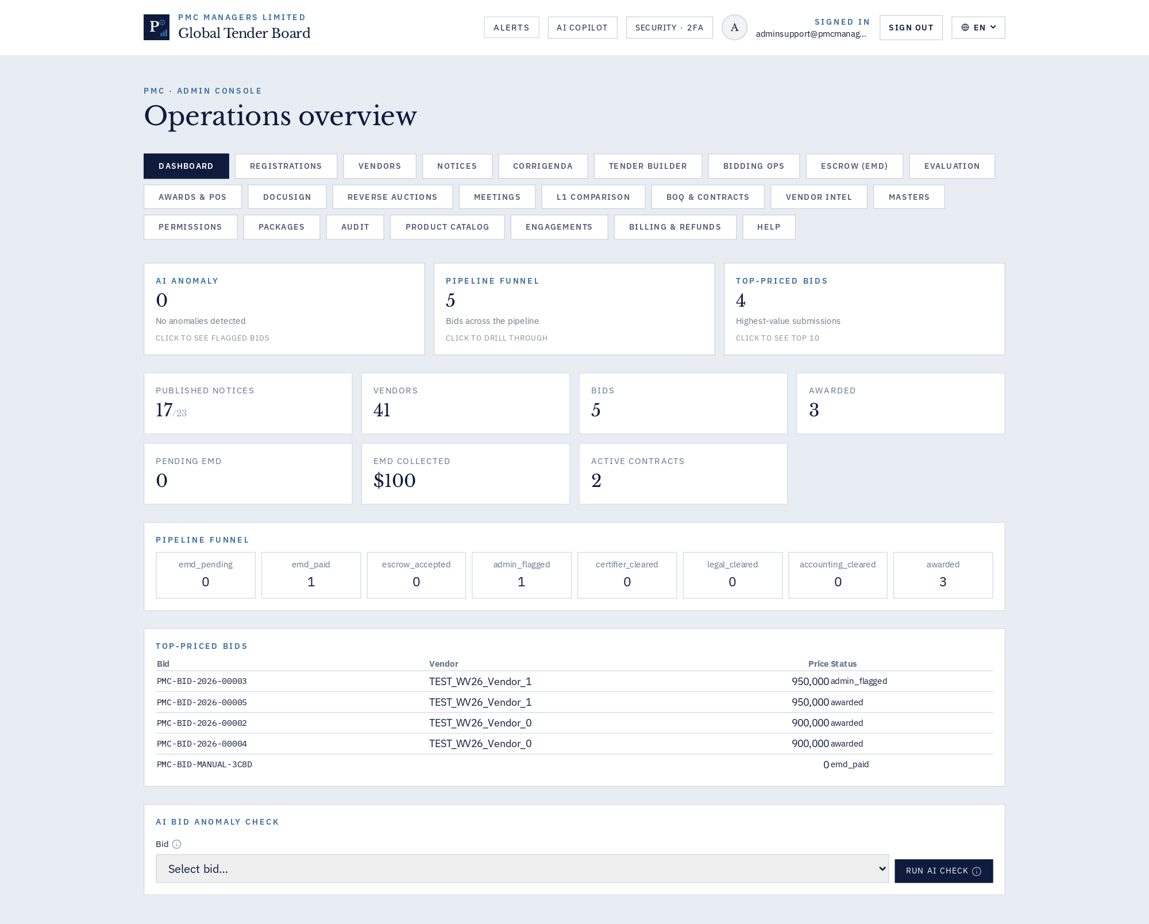
Admin · Dashboard analytics

How to use
This screen exposes every action available for its module. Use the InfoDot (ⓘ) next to each label to see the field-level rules — hover it in-app for the full policy text. All destructive actions confirm before applying and every mutation is written to the immutable audit log.

12 · Admin · Vendor registrations queue
Approve, reject, resend activation, force-activate.
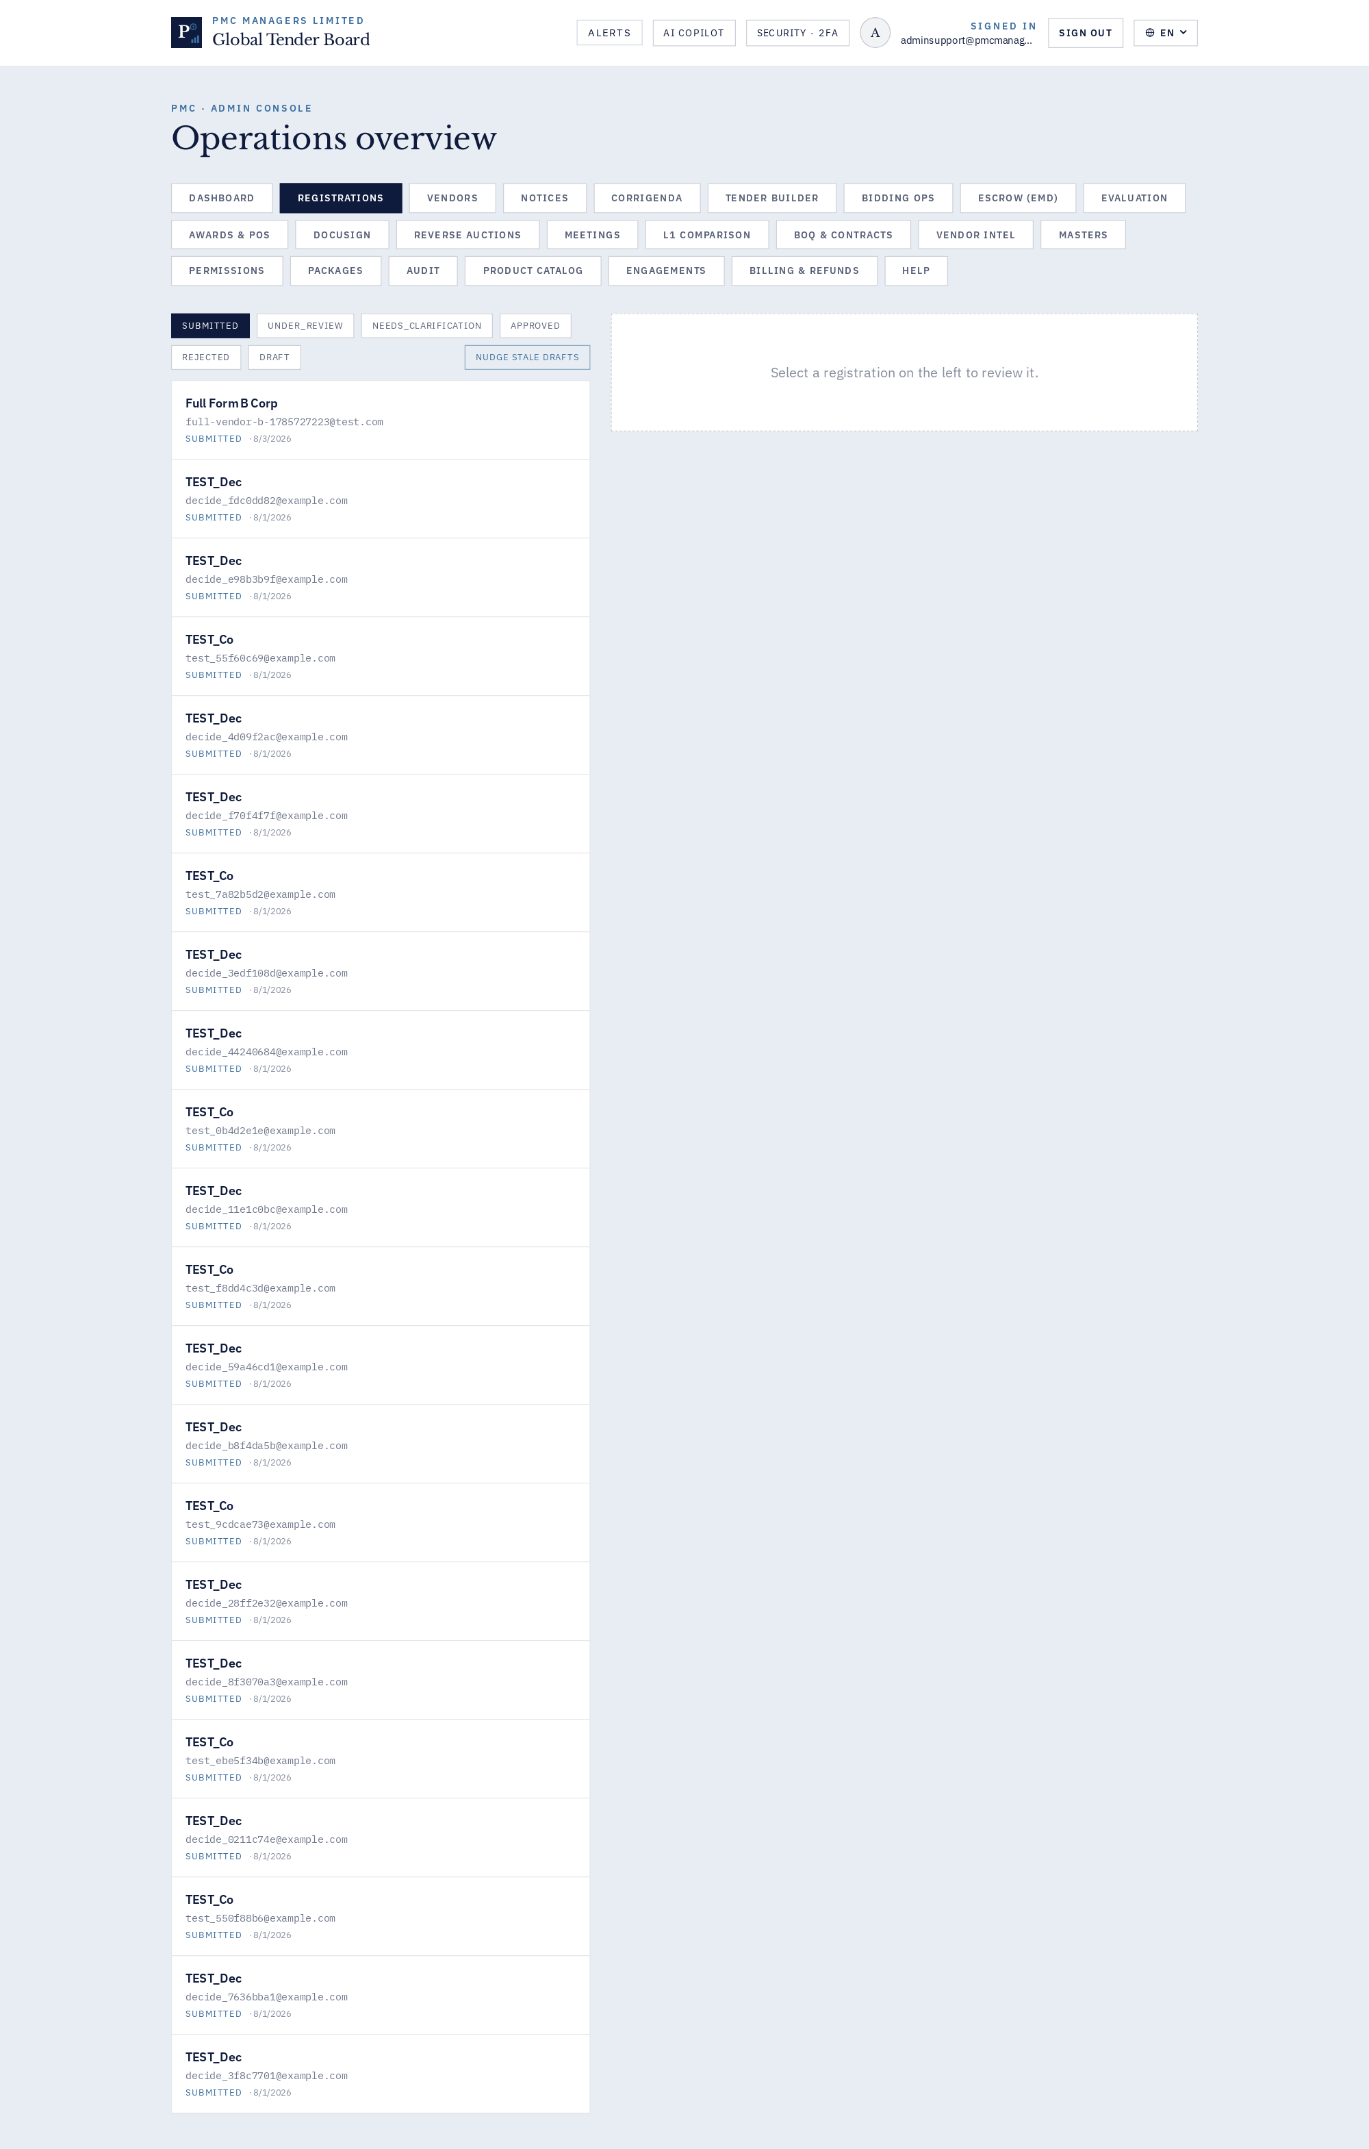
Admin · Vendor registrations queue

How to use
This screen exposes every action available for its module. Use the InfoDot (ⓘ) next to each label to see the field-level rules — hover it in-app for the full policy text. All destructive actions confirm before applying and every mutation is written to the immutable audit log.

13 · Admin · Vendor directory
Full CRUD on suppliers, licenses, compliance, tenants.
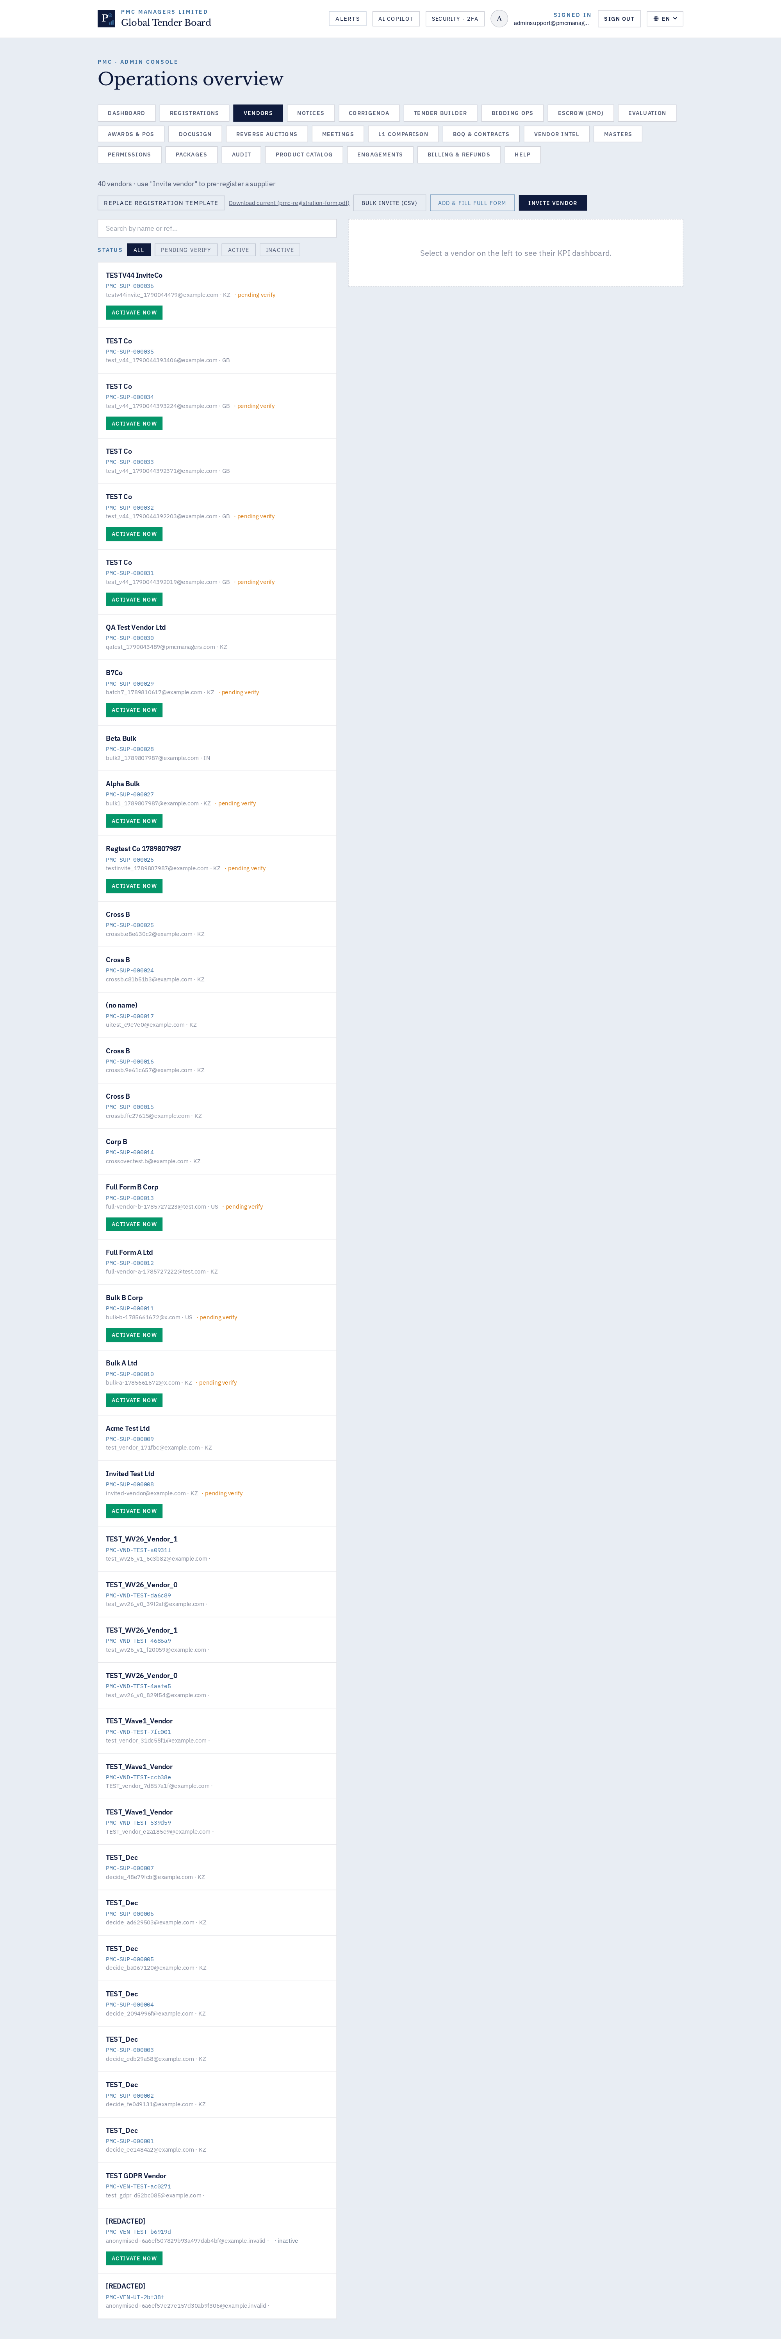
Admin · Vendor directory

How to use
This screen exposes every action available for its module. Use the InfoDot (ⓘ) next to each label to see the field-level rules — hover it in-app for the full policy text. All destructive actions confirm before applying and every mutation is written to the immutable audit log.

14 · Admin · Notices — publish & manage
Create, publish, edit, withdraw, attach documents, EMD.
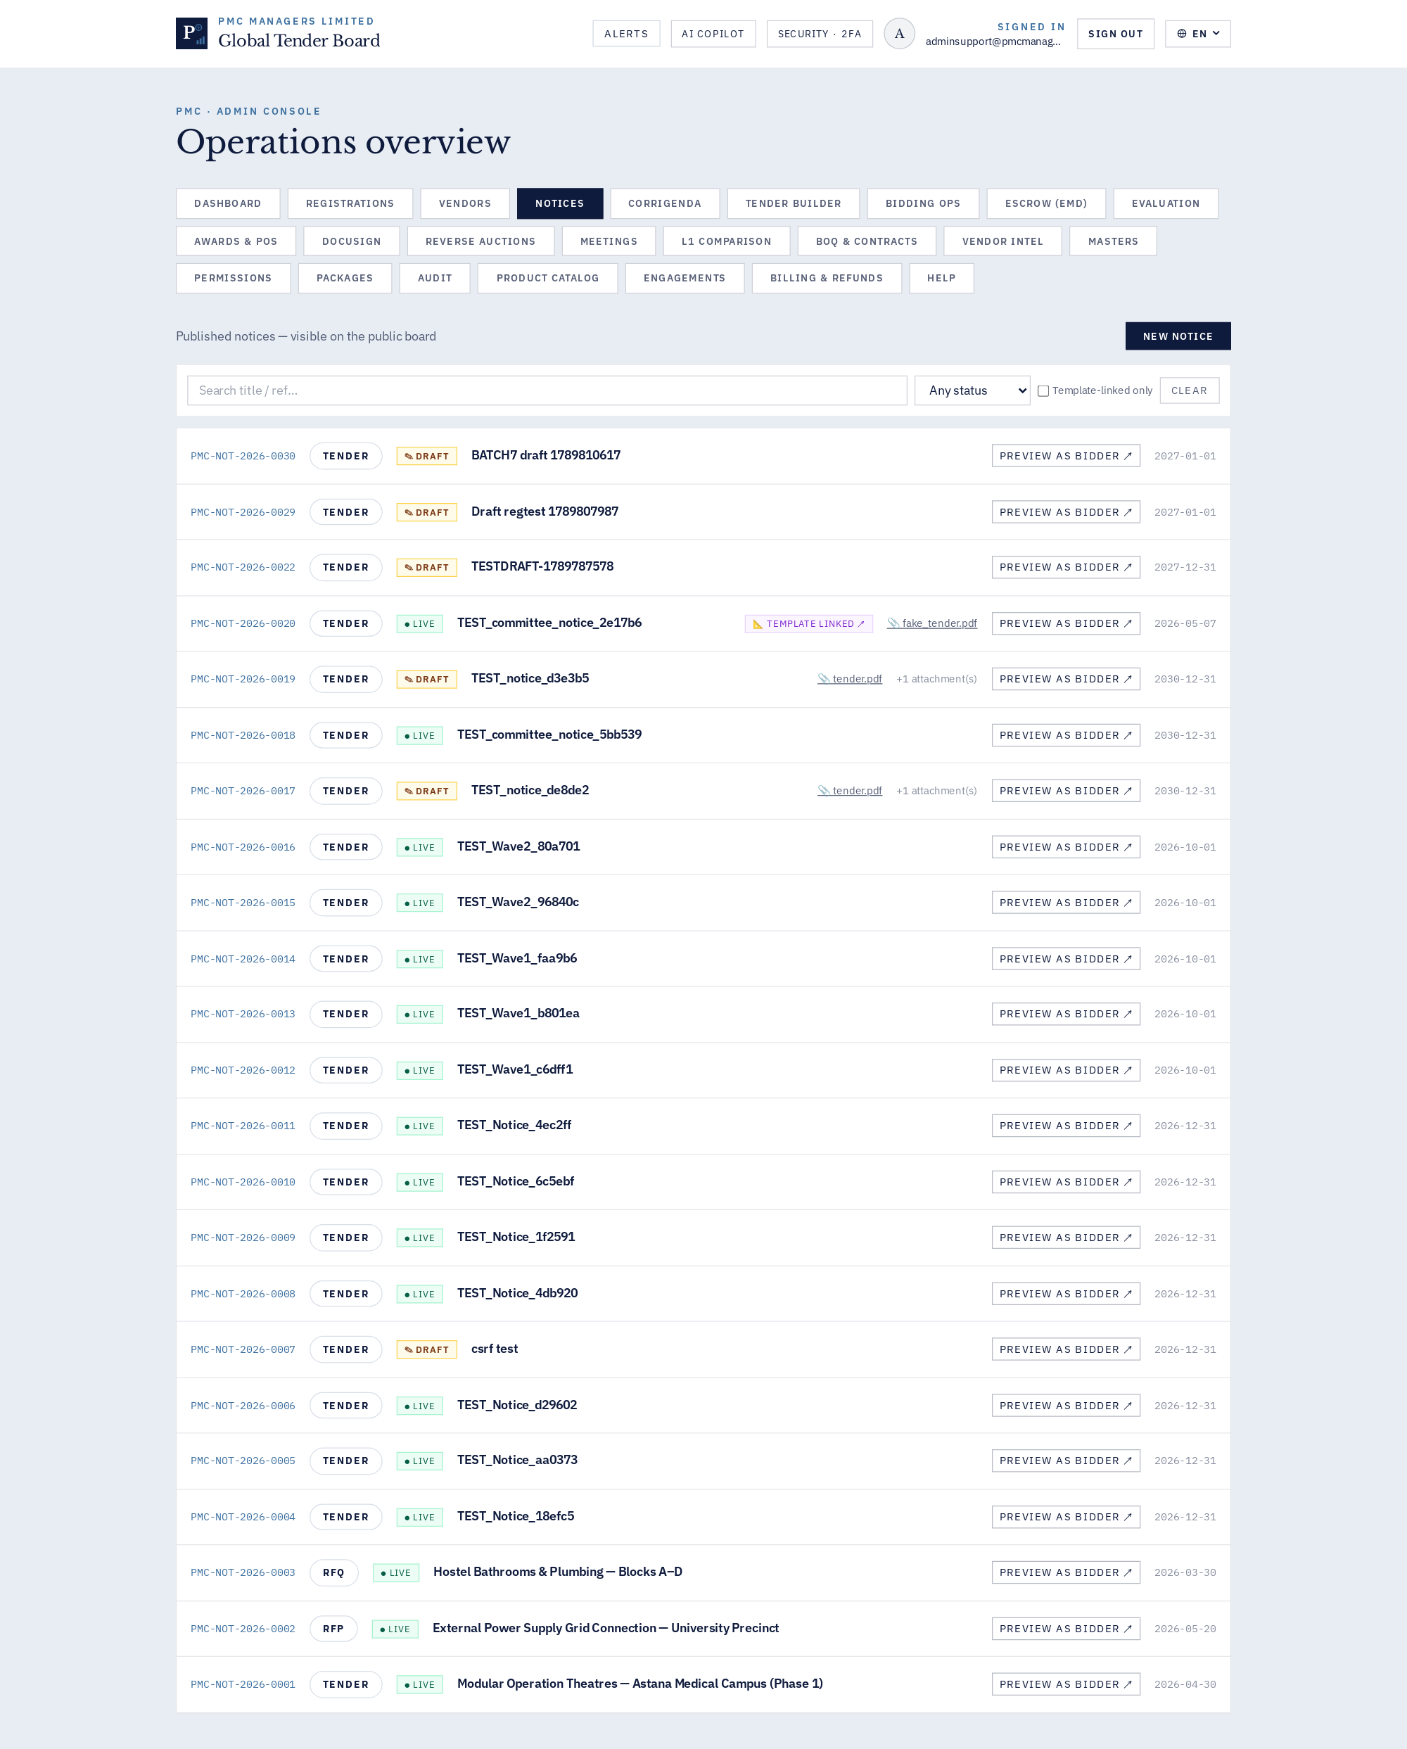
Admin · Notices — publish & manage

How to use
This screen exposes every action available for its module. Use the InfoDot (ⓘ) next to each label to see the field-level rules — hover it in-app for the full policy text. All destructive actions confirm before applying and every mutation is written to the immutable audit log.

15 · Admin · Corrigenda log
Publish addenda/amendments against any live notice.
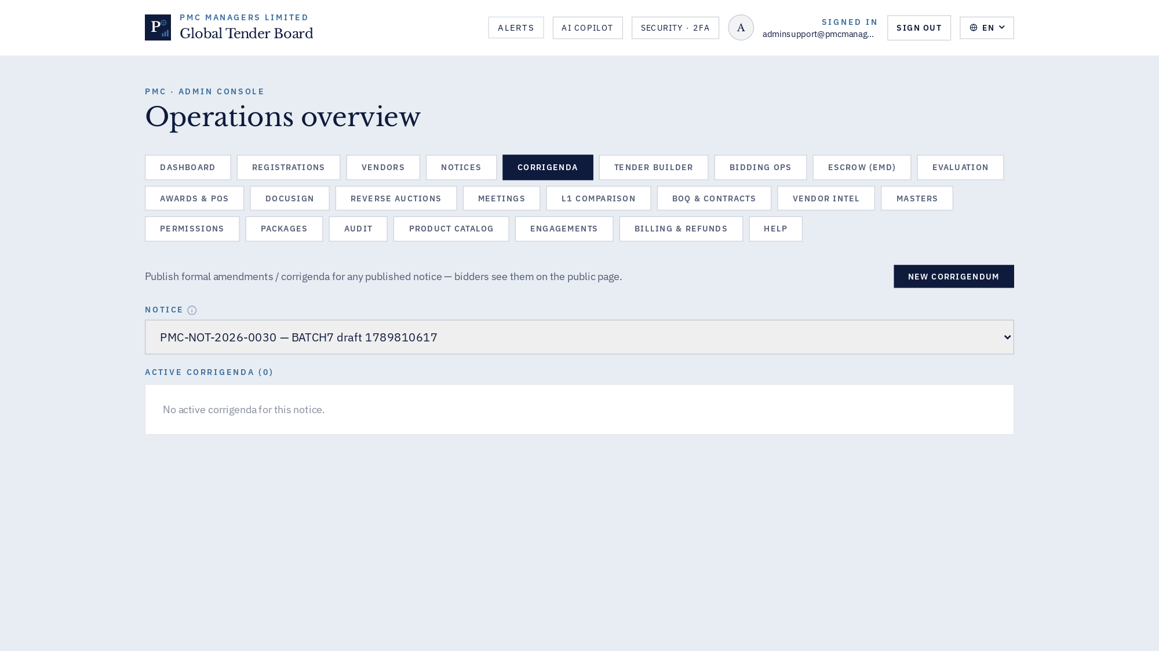
Admin · Corrigenda log

How to use
This screen exposes every action available for its module. Use the InfoDot (ⓘ) next to each label to see the field-level rules — hover it in-app for the full policy text. All destructive actions confirm before applying and every mutation is written to the immutable audit log.

16 · Admin · Tender Builder & DPR AI
Master library, DPR deep-dive, AI Fill All, PDF export.
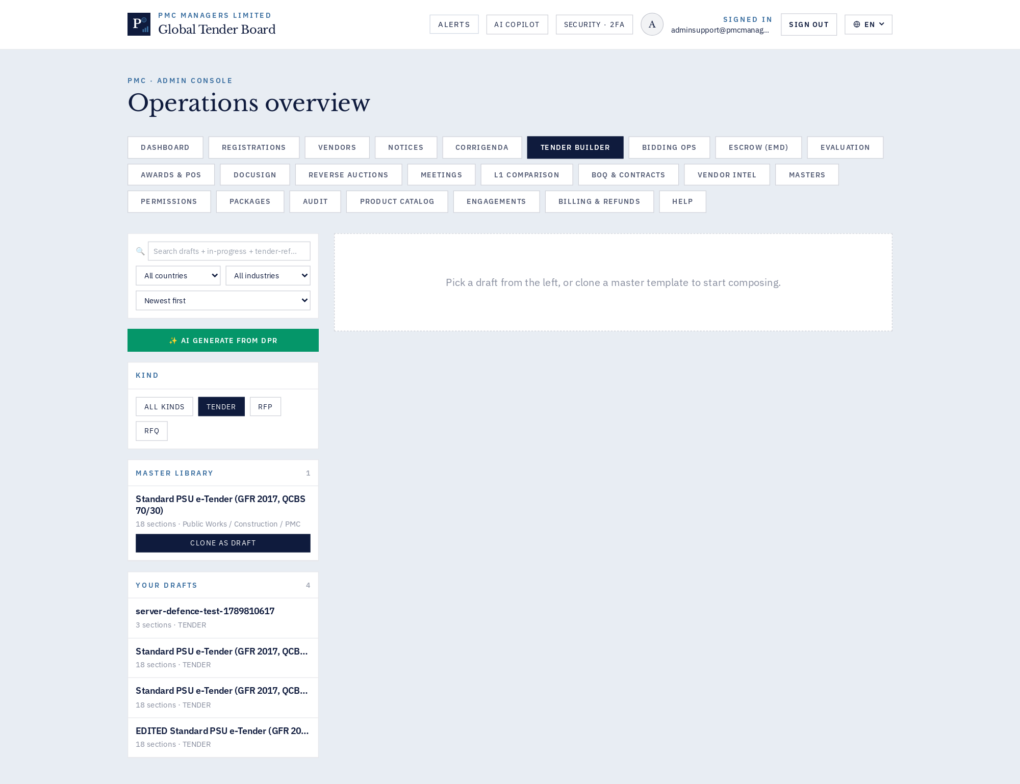
Admin · Tender Builder & DPR AI

How to use
This screen exposes every action available for its module. Use the InfoDot (ⓘ) next to each label to see the field-level rules — hover it in-app for the full policy text. All destructive actions confirm before applying and every mutation is written to the immutable audit log.

17 · Admin · Bidding operations
Bid room, submissions, seal/unseal, timing.
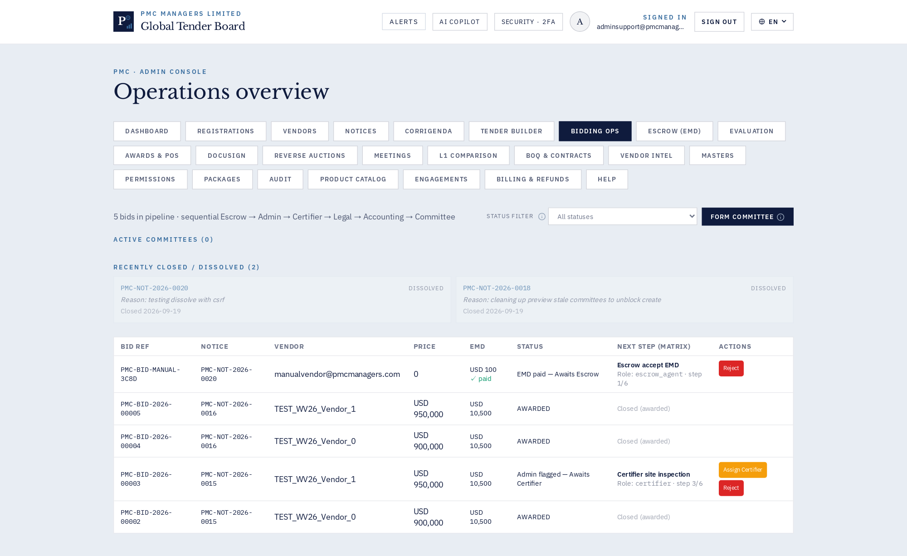
Admin · Bidding operations

How to use
This screen exposes every action available for its module. Use the InfoDot (ⓘ) next to each label to see the field-level rules — hover it in-app for the full policy text. All destructive actions confirm before applying and every mutation is written to the immutable audit log.

18 · Admin · Escrow / EMD desk
EMD receipts, forfeitures, refunds.
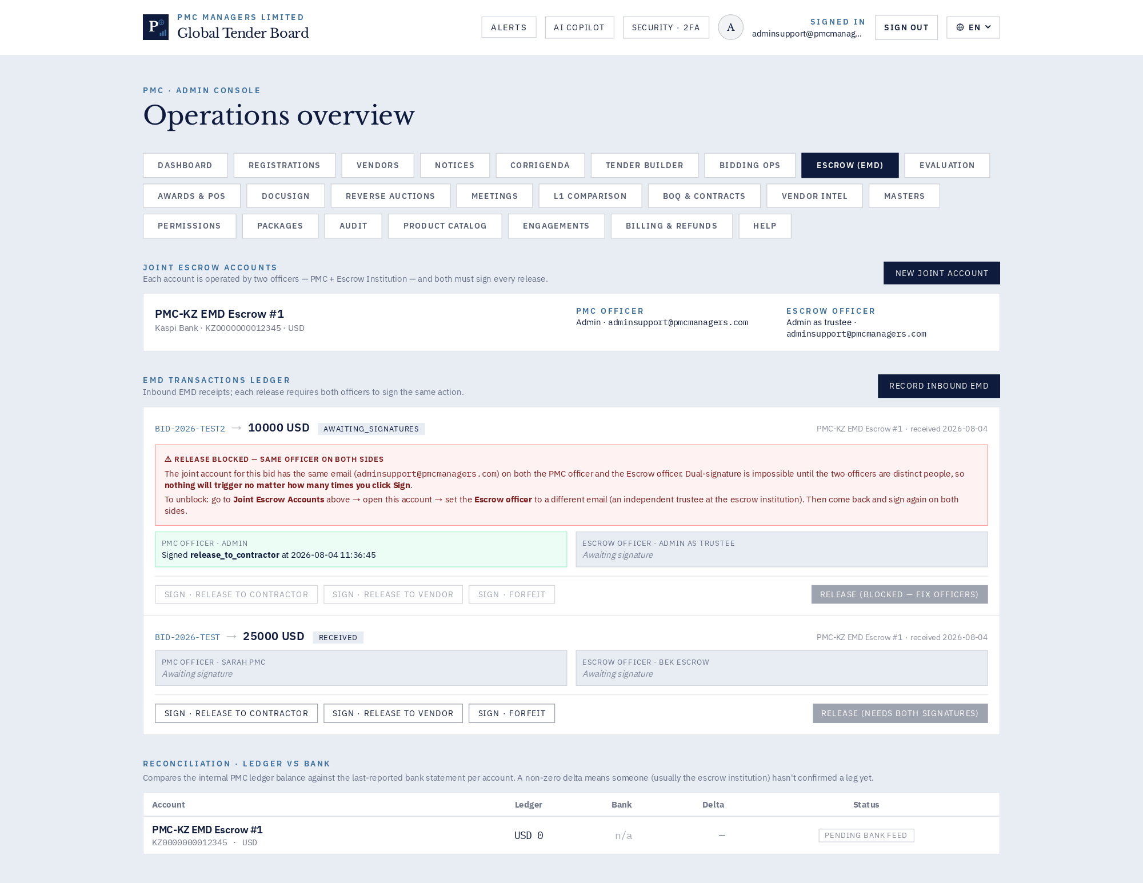
Admin · Escrow / EMD desk

How to use
This screen exposes every action available for its module. Use the InfoDot (ⓘ) next to each label to see the field-level rules — hover it in-app for the full policy text. All destructive actions confirm before applying and every mutation is written to the immutable audit log.

19 · Admin · Evaluation & scoring
Technical + financial scoring, QCBS, L1 comparison.
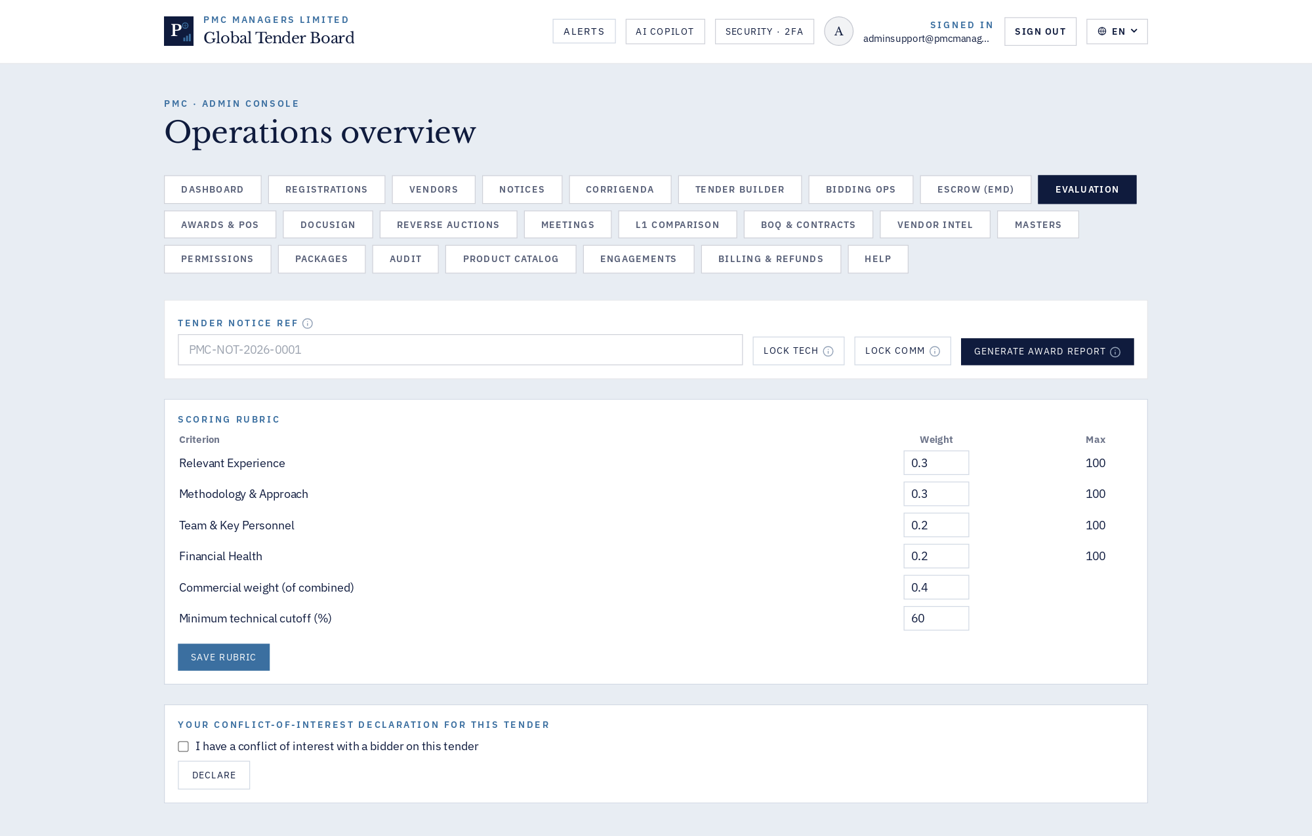
Admin · Evaluation & scoring

How to use
This screen exposes every action available for its module. Use the InfoDot (ⓘ) next to each label to see the field-level rules — hover it in-app for the full policy text. All destructive actions confirm before applying and every mutation is written to the immutable audit log.

20 · Admin · Awards & POs
Letters of award, POs, contract award workflow.
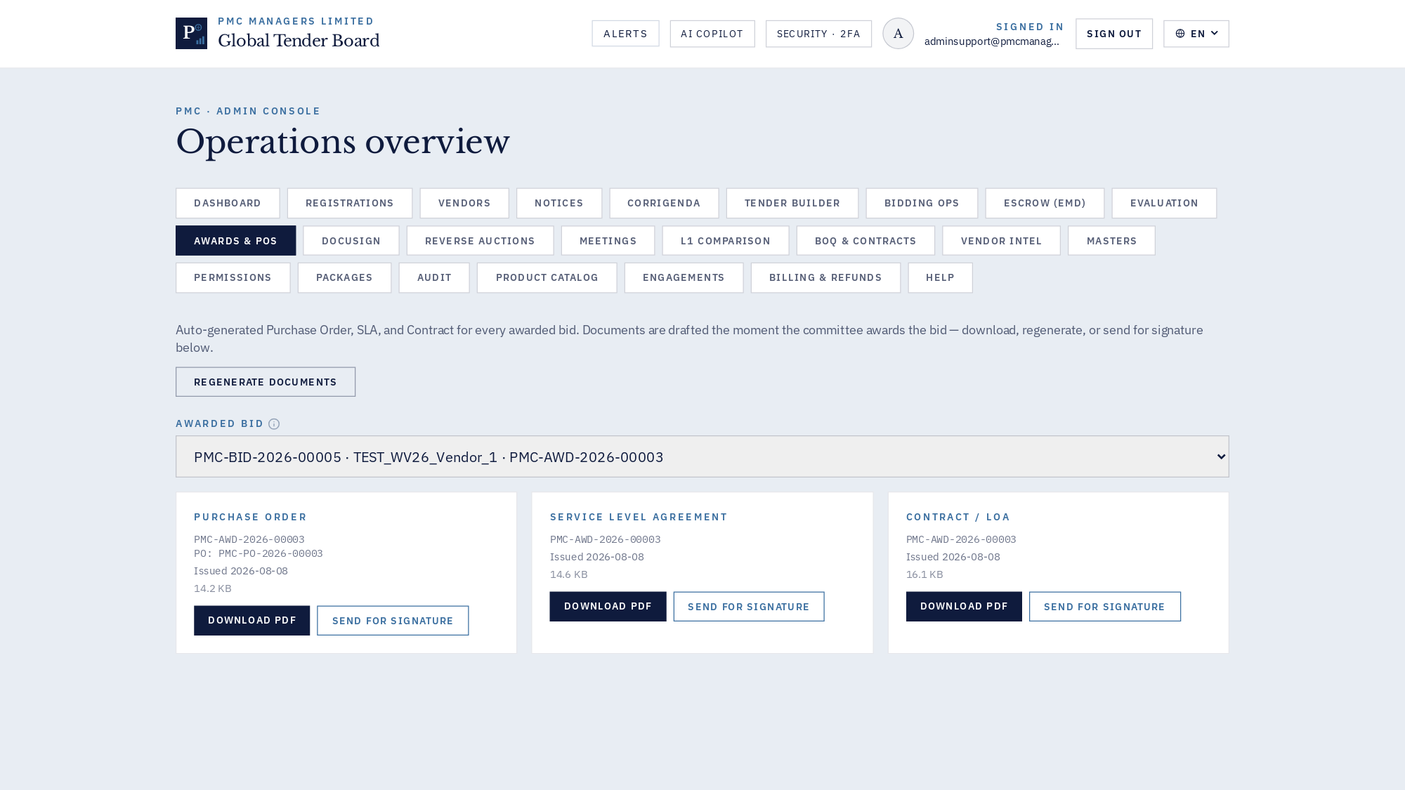
Admin · Awards & POs

How to use
This screen exposes every action available for its module. Use the InfoDot (ⓘ) next to each label to see the field-level rules — hover it in-app for the full policy text. All destructive actions confirm before applying and every mutation is written to the immutable audit log.

21 · Admin · DocuSign contracts
Envelope templates, signer routing, live status.
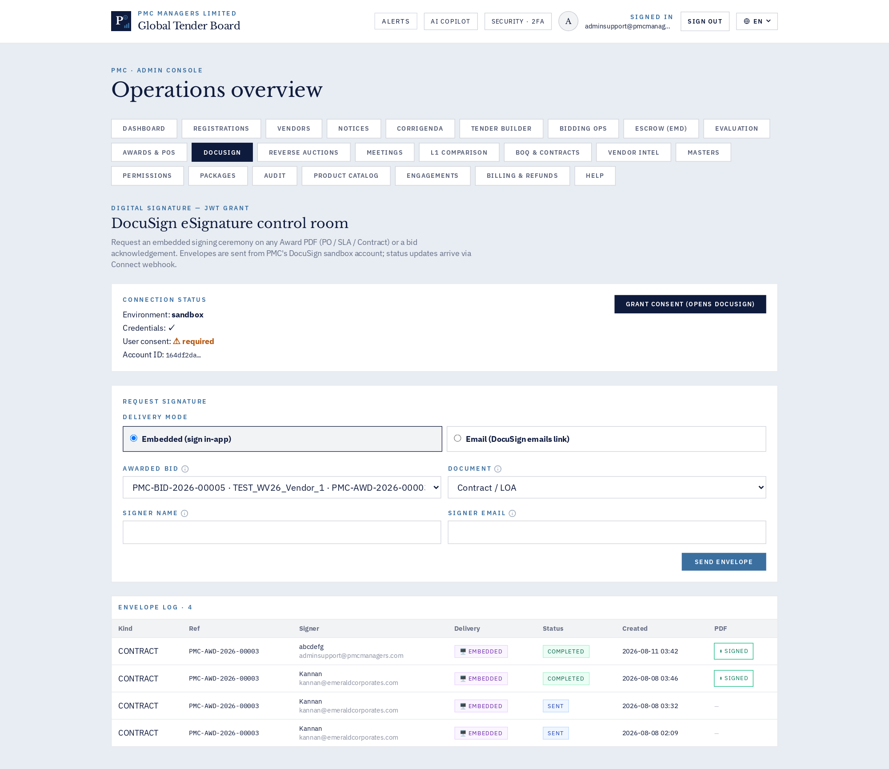
Admin · DocuSign contracts

How to use
This screen exposes every action available for its module. Use the InfoDot (ⓘ) next to each label to see the field-level rules — hover it in-app for the full policy text. All destructive actions confirm before applying and every mutation is written to the immutable audit log.

22 · Admin · Reverse auctions
Live auction rooms, invitations, spectator link.
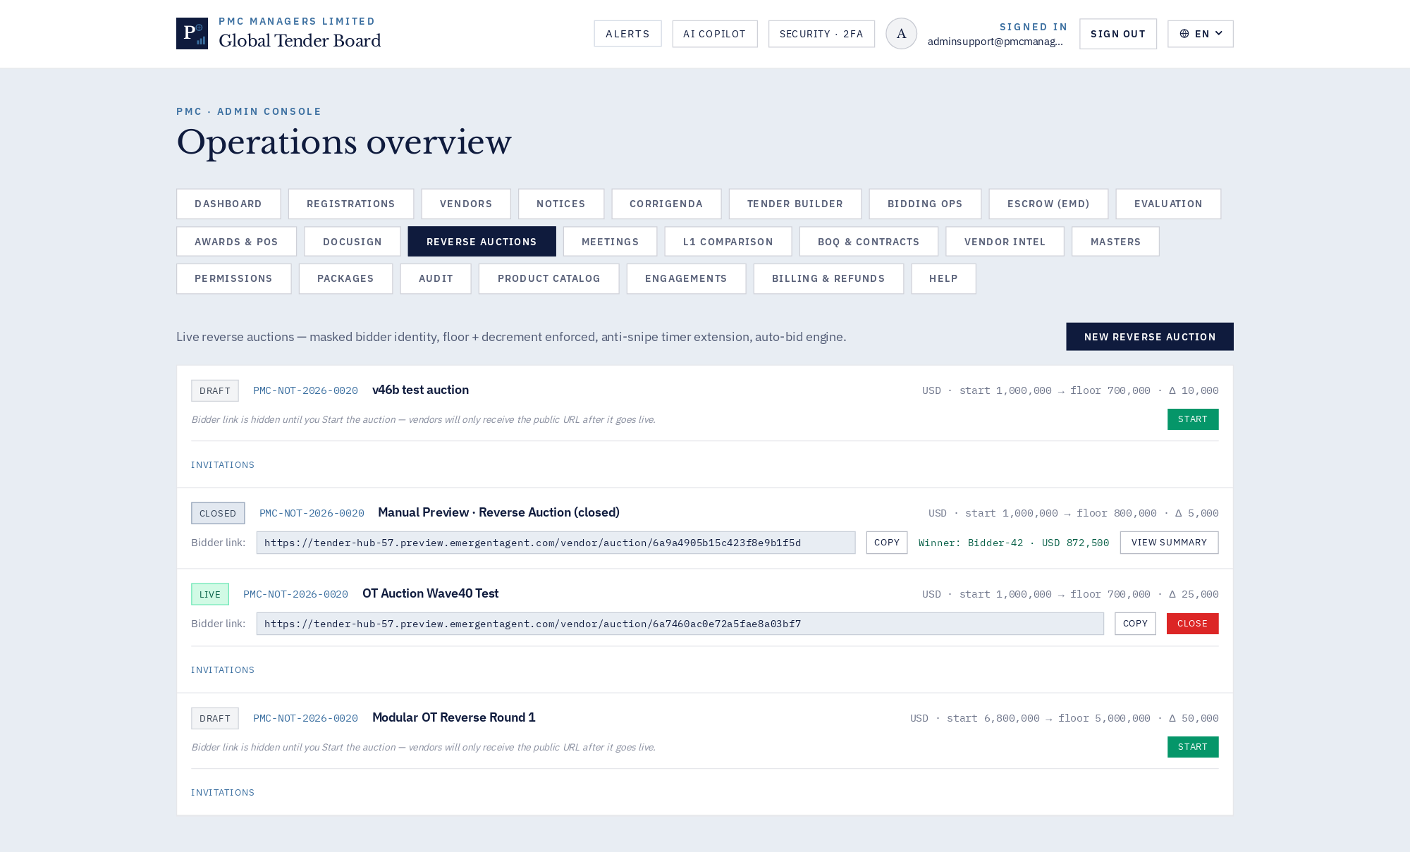
Admin · Reverse auctions

How to use
This screen exposes every action available for its module. Use the InfoDot (ⓘ) next to each label to see the field-level rules — hover it in-app for the full policy text. All destructive actions confirm before applying and every mutation is written to the immutable audit log.

23 · Admin · Pre-bid meetings
Scheduling, Zoom links, minutes, attendance.
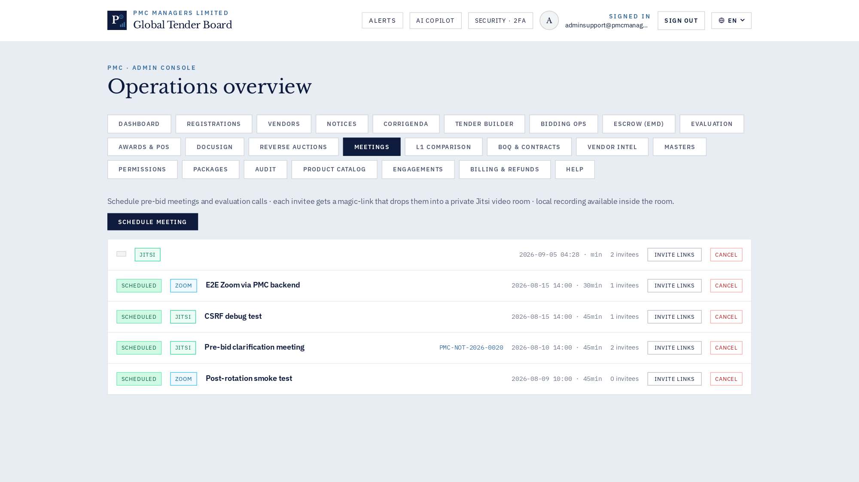
Admin · Pre-bid meetings

How to use
This screen exposes every action available for its module. Use the InfoDot (ⓘ) next to each label to see the field-level rules — hover it in-app for the full policy text. All destructive actions confirm before applying and every mutation is written to the immutable audit log.

24 · Admin · BOQ templates & contracts
Bill of Quantities master + contract line items.
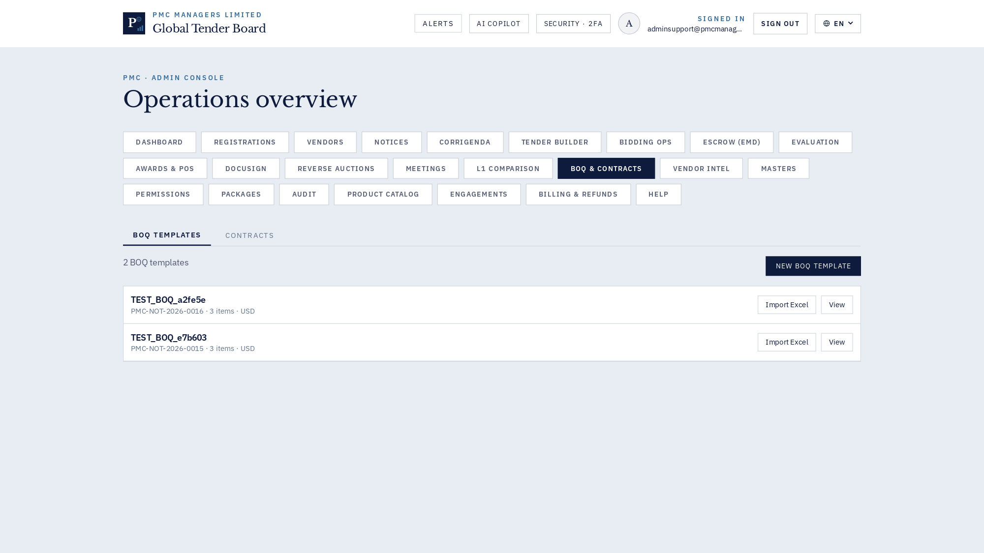
Admin · BOQ templates & contracts

How to use
This screen exposes every action available for its module. Use the InfoDot (ⓘ) next to each label to see the field-level rules — hover it in-app for the full policy text. All destructive actions confirm before applying and every mutation is written to the immutable audit log.

25 · Admin · Vendor intel & ratings
Trust badges, moderation, criteria averages.
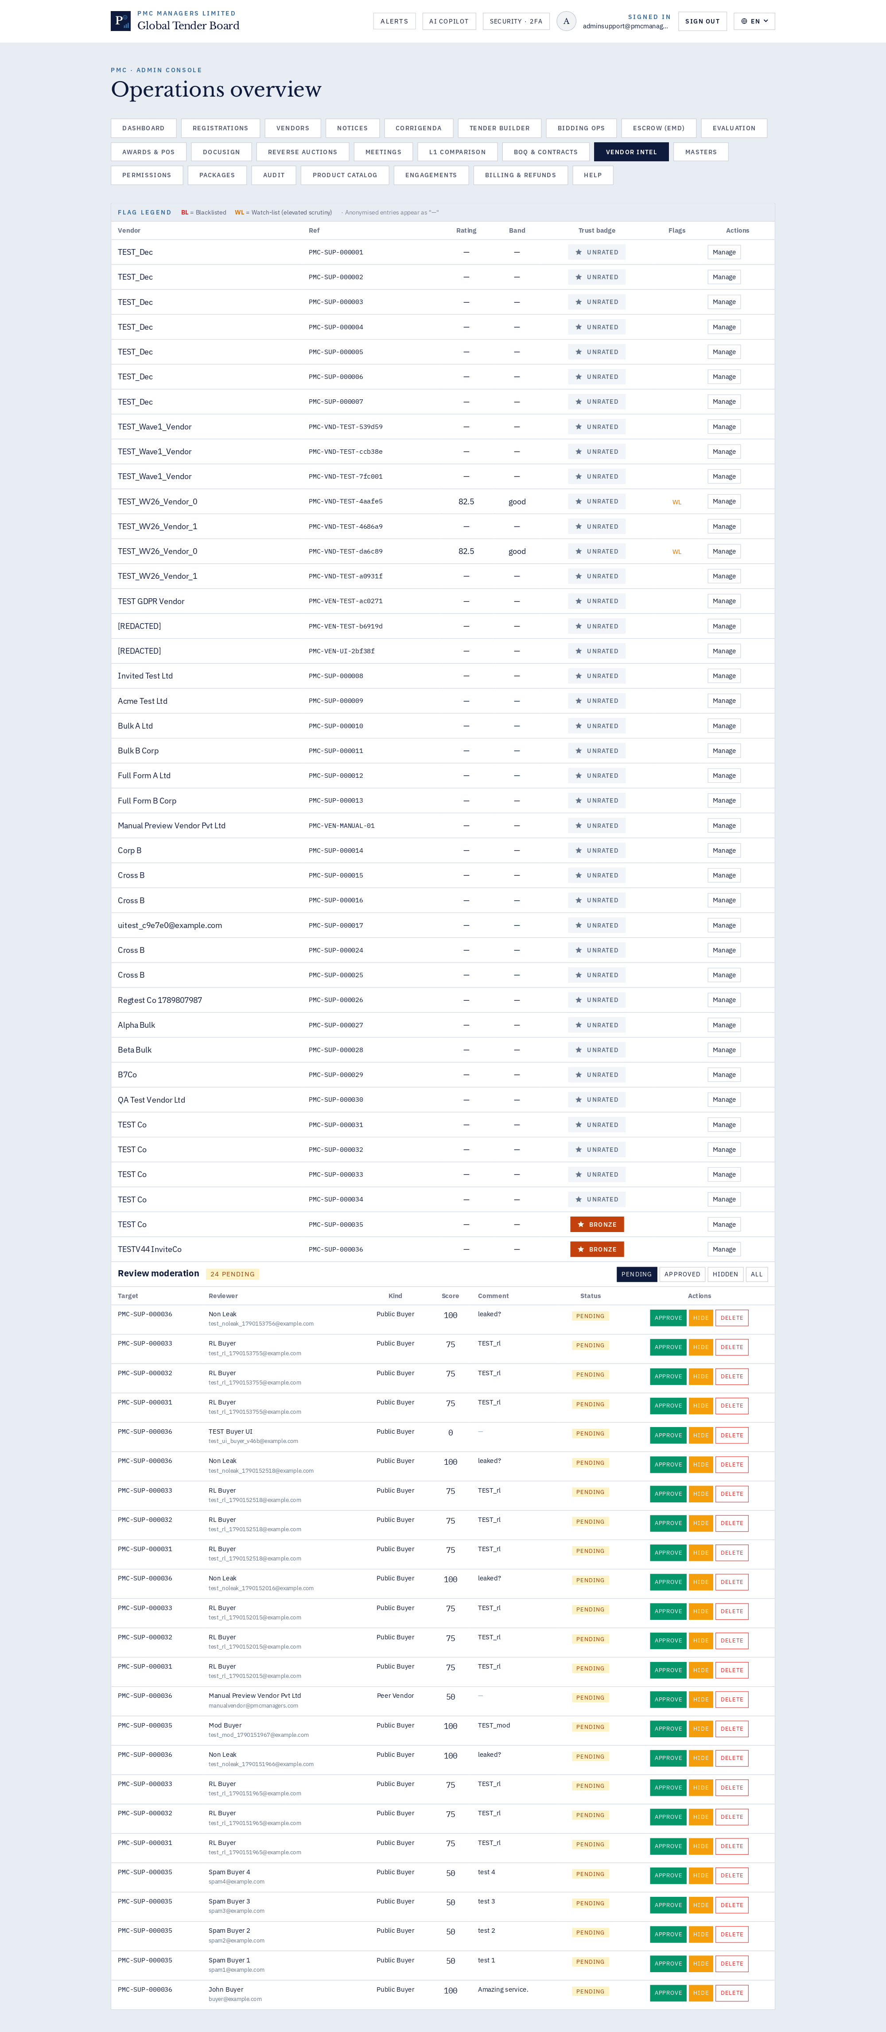
Admin · Vendor intel & ratings

How to use
This screen exposes every action available for its module. Use the InfoDot (ⓘ) next to each label to see the field-level rules — hover it in-app for the full policy text. All destructive actions confirm before applying and every mutation is written to the immutable audit log.

26 · Admin · Masters — fees, roles, EMD
Fee slabs, staff roles, criteria, categories, countries.
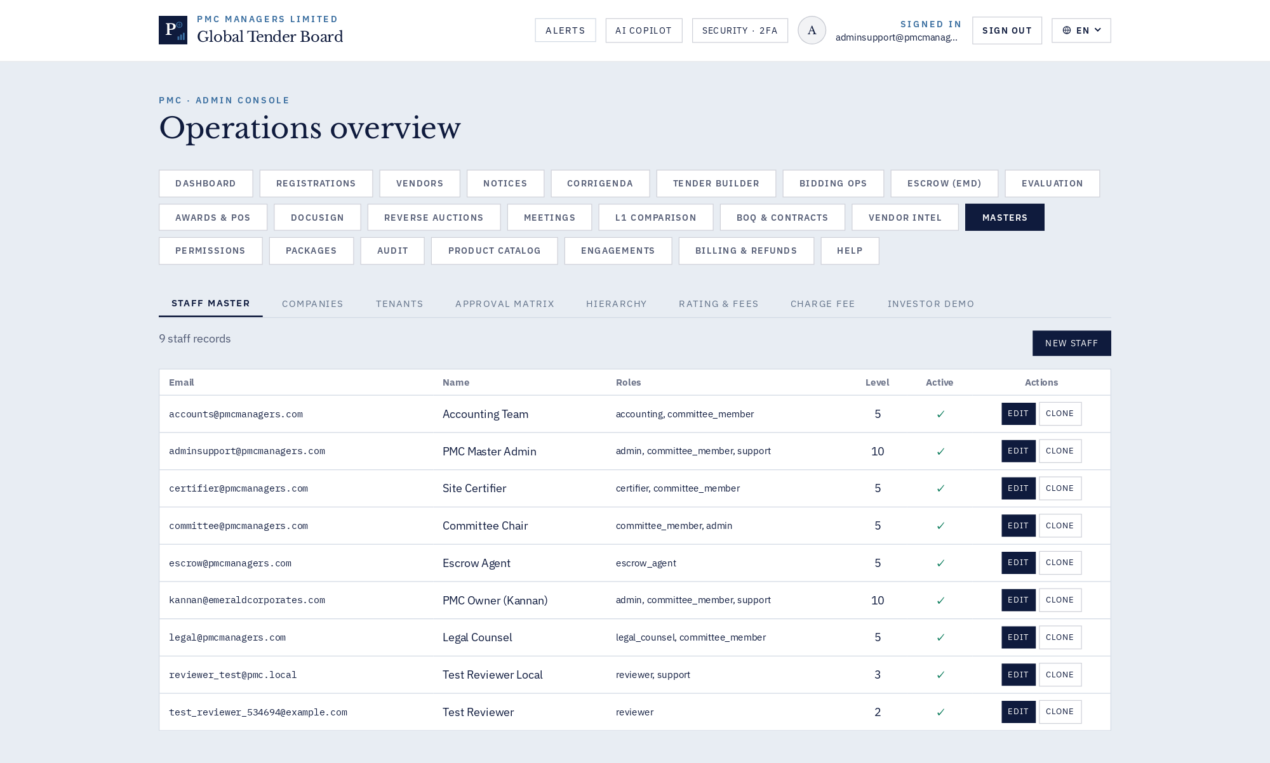
Admin · Masters — fees, roles, EMD

How to use
This screen exposes every action available for its module. Use the InfoDot (ⓘ) next to each label to see the field-level rules — hover it in-app for the full policy text. All destructive actions confirm before applying and every mutation is written to the immutable audit log.

27 · Admin · Roles & permissions
Fine-grained ACL matrix.
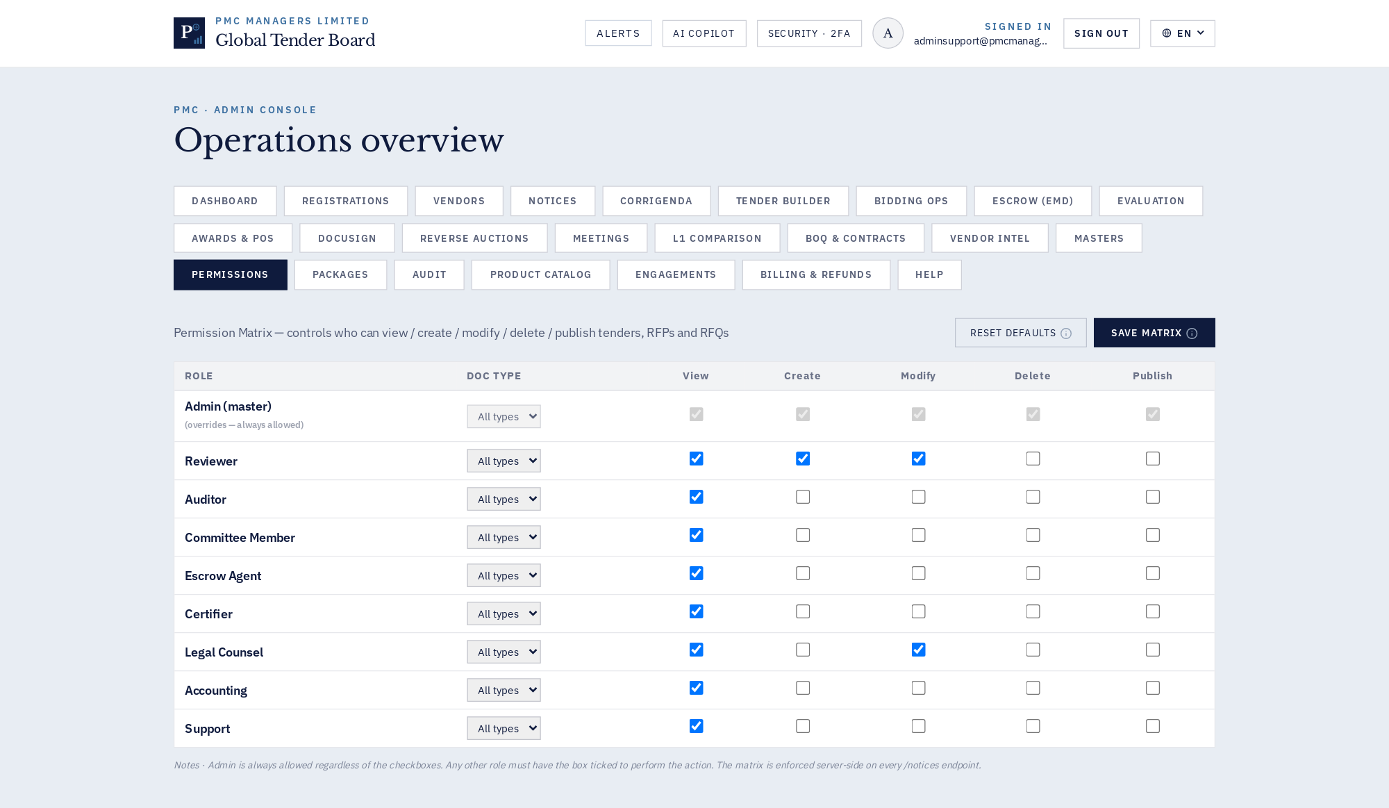
Admin · Roles & permissions

How to use
This screen exposes every action available for its module. Use the InfoDot (ⓘ) next to each label to see the field-level rules — hover it in-app for the full policy text. All destructive actions confirm before applying and every mutation is written to the immutable audit log.

28 · Admin · Work packages
Modular deliverable packages for the KZ programme.
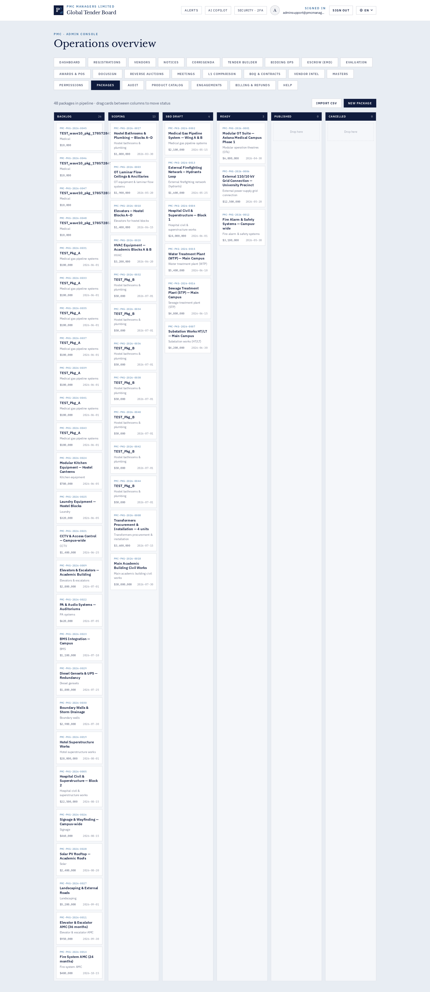
Admin · Work packages

How to use
This screen exposes every action available for its module. Use the InfoDot (ⓘ) next to each label to see the field-level rules — hover it in-app for the full policy text. All destructive actions confirm before applying and every mutation is written to the immutable audit log.

29 · Admin · Audit trail
Immutable action log with entity filters.
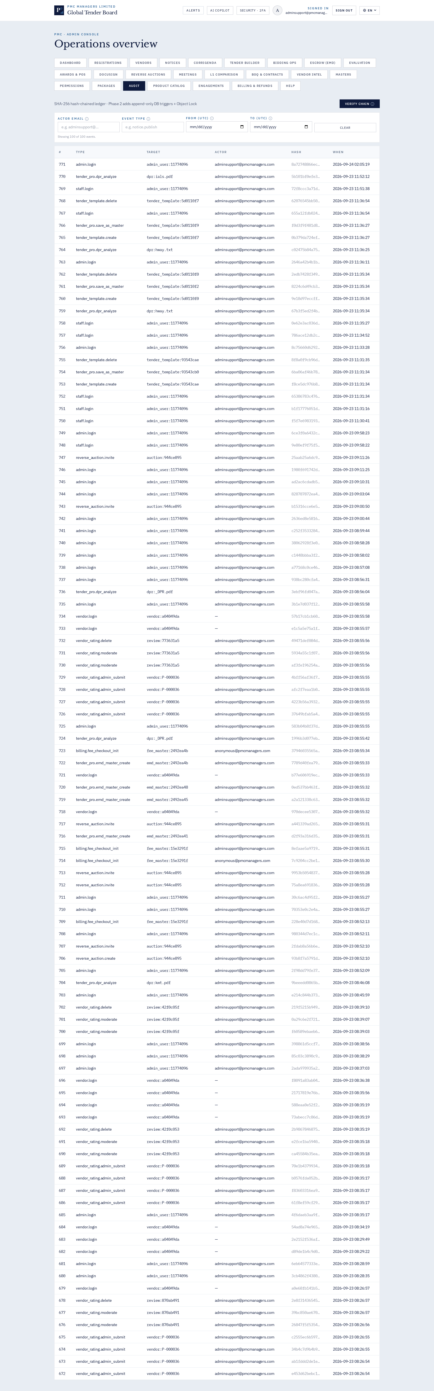
Admin · Audit trail

How to use
This screen exposes every action available for its module. Use the InfoDot (ⓘ) next to each label to see the field-level rules — hover it in-app for the full policy text. All destructive actions confirm before applying and every mutation is written to the immutable audit log.

30 · Admin · Product catalog
UNSPSC-mapped goods catalog.
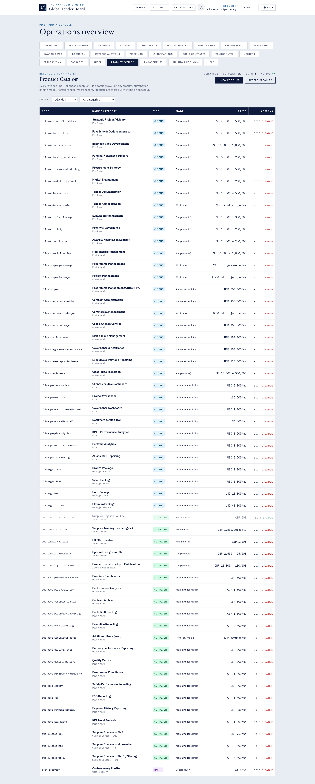
Admin · Product catalog

How to use
This screen exposes every action available for its module. Use the InfoDot (ⓘ) next to each label to see the field-level rules — hover it in-app for the full policy text. All destructive actions confirm before applying and every mutation is written to the immutable audit log.

31 · Admin · Consultant engagements
Retainer engagements, timesheets, invoices.
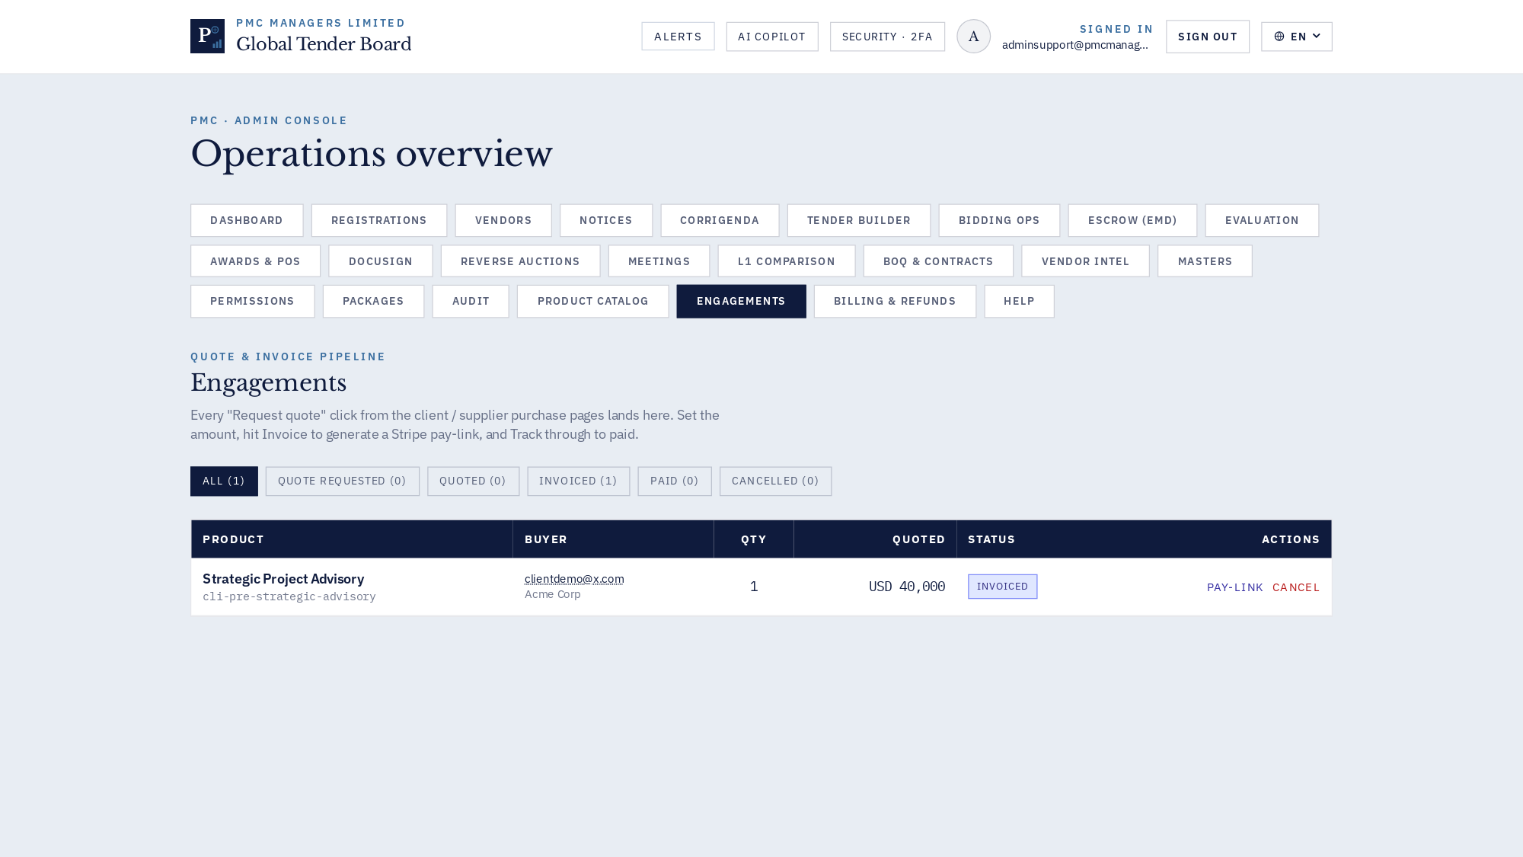
Admin · Consultant engagements

How to use
This screen exposes every action available for its module. Use the InfoDot (ⓘ) next to each label to see the field-level rules — hover it in-app for the full policy text. All destructive actions confirm before applying and every mutation is written to the immutable audit log.

32 · Tender Builder · AI DPR modal (v46g deep-dive)
Country-first DPR ingestion. When the country has no master, admins can borrow one from another country or build a brand-new master. Deep-dive (v46g) discovers 12–30 real chapters from the DPR and drafts each body.
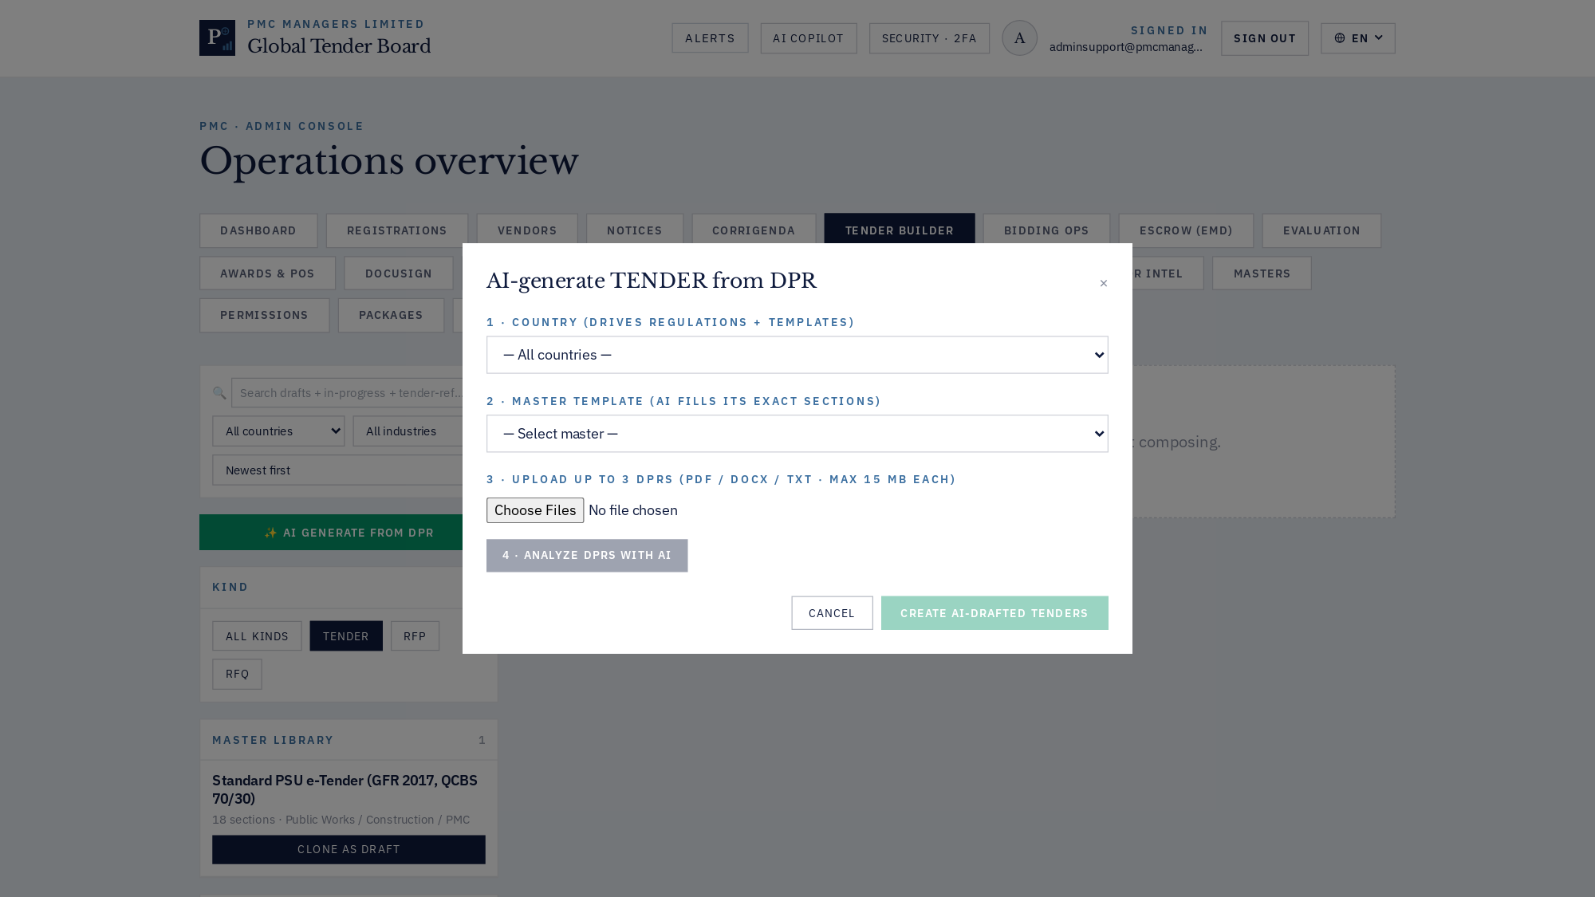
Tender Builder · AI DPR modal (v46g deep-dive)

How to use
This screen exposes every action available for its module. Use the InfoDot (ⓘ) next to each label to see the field-level rules — hover it in-app for the full policy text. All destructive actions confirm before applying and every mutation is written to the immutable audit log.

33 · Tender Builder · No-master options
When the picked country has no saved masters, an amber helper offers two options: (1) borrow a master from another country (all masters listed with country-code prefix), or (2) build a brand-new master from this DPR.
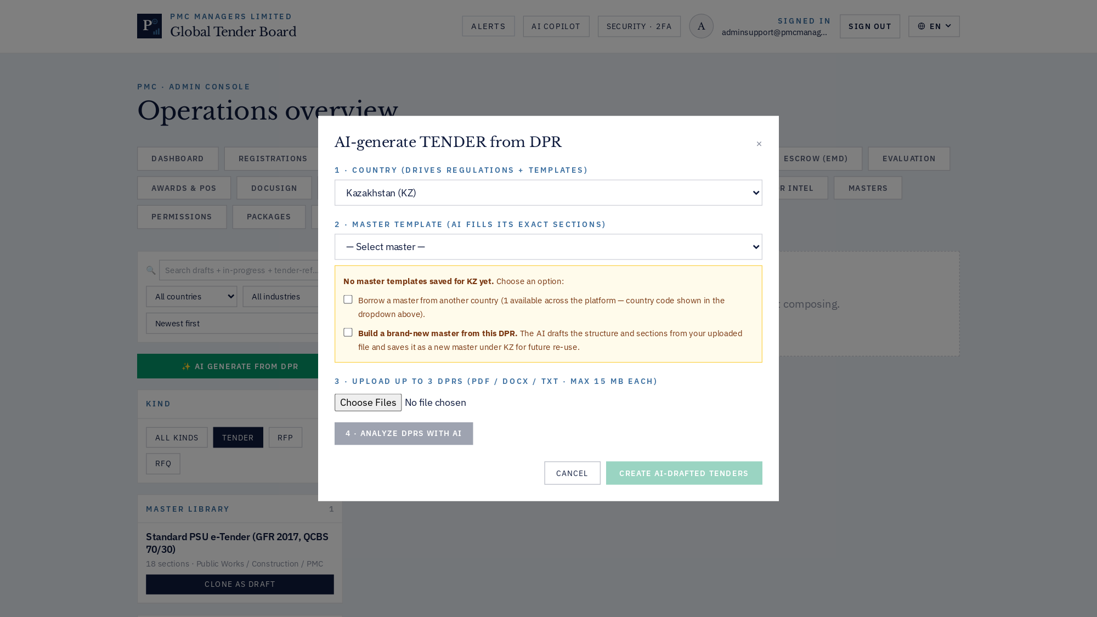
Tender Builder · No-master options

How to use
This screen exposes every action available for its module. Use the InfoDot (ⓘ) next to each label to see the field-level rules — hover it in-app for the full policy text. All destructive actions confirm before applying and every mutation is written to the immutable audit log.

6 · Deep-dive: Tender Builder & AI DPR (v46g)
v46g delivers a two-pass AI ingestion pipeline. Pass 1 extracts the header and discovers 12–30 real chapters from the DPR. Pass 2 drafts each chapter's body in parallel (asyncio semaphore of 6).
On the KMT DPR (1.37 MB, 68 704 chars) the deep-dive produced 26 sections — Executive Summary, Market Analysis, Project Investment, Operating Expense Detail, Projected Operational Results, Fund Requirement, Returns & Scenario Analysis, Installation & Commissioning Schedule, Risk Factors & Mitigation, Financial Statements & Models, Legal & Compliance Requirements, Annexures — each with a 1.2–1.9 KB drafted body. Total LLM time ~34 s.
Country-first flow: pick a country → filter masters → if none exist, borrow one from another country (dropdown shows country-code prefix) or 'Build a brand-new master from this DPR' — the new master persists via /api/v1/tender-pro/templates/{id}/save-as-master.

7 · Tooltip + error-handling system
InfoDot (ⓘ) — used 166 times across 20+ panels; every non-obvious field label has a hover tooltip with policy text.
showApiError / formatApiError — 67 files consume these; every server error surfaces as a sonner toast with the exact backend detail.
ErrorBoundary — mounted at the app root; catches React crashes and renders a graceful fallback with a copyable diagnostic id.

8 · Troubleshooting playbook
Symptom | Root cause | Fix
Landing shows 0 counters | Stale cached bundle | Hard-refresh (Cmd-Shift-R)
'No matching employee' toast | Preview URL baked in prod | Rebuild with REACT_APP_BACKEND_URL=""
DPR returns 5 generic sections | Backend still v46d | Deploy v46g backend
Login OK but /admin bounces | Cross-site cookie blocked | Same-origin /api
413 on large DPR | Nginx body limit | v46d ships 25 MB limit
Login stuck / no network | Stale service worker | v46d self-destruct SW

9 · Glossary
- DPR — Detailed Project Report.
- EMD — Earnest Money Deposit; refundable bid security.
- QCBS — Quality- & Cost-Based Selection (70/30 default).
- Corrigendum — Official post-publication amendment to a notice.
- L1 — Lowest financial bid post-technical qualification.
- BOQ — Bill of Quantities; itemised deliverable+rate schedule.

