PMC Managers v2
Screenshot-based Training & Testing Manual · v1

Walkthrough of every substantive screen in the portal — public landing → tender board → vendor registration → admin login → each admin tab → sign out. Every page shows a live screenshot, a narrative, a step-by-step testing checklist, and the exact data-testid selectors your QA team or Playwright suite can hook into.

Deliver this manual to:
- Trainee operations staff
- External QA / penetration-testing teams
- Investor code-review reviewers

Contents

# | Screen | URL
1 | Public landing page | https://www.pmcmanagers.com/
2 | Public tender board | https://www.pmcmanagers.com/notices
3 | Vendor registration — start | https://www.pmcmanagers.com/register
4 | Vendor registration — check status | https://www.pmcmanagers.com/register/status
5 | Admin login page | https://www.pmcmanagers.com/admin/login
6 | Admin console · Analytics | https://www.pmcmanagers.com/admin?tab=analytics
7 | Admin console · Registrations | https://www.pmcmanagers.com/admin?tab=registrations
8 | Admin console · Vendors | https://www.pmcmanagers.com/admin?tab=vendors
9 | Admin console · Notices | https://www.pmcmanagers.com/admin?tab=notices
10 | Admin console · Corrigenda | https://www.pmcmanagers.com/admin?tab=corrigenda
11 | Admin console · Tender Builder | https://www.pmcmanagers.com/admin?tab=tender-builder
12 | Admin console · Bidding | https://www.pmcmanagers.com/admin?tab=bidding
13 | Admin console · Auctions | https://www.pmcmanagers.com/admin?tab=auctions
14 | Admin console · Escrow | https://www.pmcmanagers.com/admin?tab=escrow
15 | Admin console · Evaluation | https://www.pmcmanagers.com/admin?tab=evaluation
16 | Admin console · Awards | https://www.pmcmanagers.com/admin?tab=awards
17 | Admin console · Boq | https://www.pmcmanagers.com/admin?tab=boq
18 | Admin console · Meetings | https://www.pmcmanagers.com/admin?tab=meetings
19 | Admin console · L1 | https://www.pmcmanagers.com/admin?tab=l1
20 | Admin console · Docusign | https://www.pmcmanagers.com/admin?tab=docusign
21 | Admin console · Vendor Intel | https://www.pmcmanagers.com/admin?tab=vendor-intel
22 | Admin console · Products | https://www.pmcmanagers.com/admin?tab=products
23 | Admin console · Engagements | https://www.pmcmanagers.com/admin?tab=engagements
24 | Admin console · Masters | https://www.pmcmanagers.com/admin?tab=masters
25 | Admin console · Permissions | https://www.pmcmanagers.com/admin?tab=permissions
26 | Admin console · Audit | https://www.pmcmanagers.com/admin?tab=audit
27 | Admin console · Reports | https://www.pmcmanagers.com/admin?tab=reports
28 | Admin console · Stakeholder | https://www.pmcmanagers.com/admin?tab=stakeholder
29 | Admin console · Help | https://www.pmcmanagers.com/admin?tab=help
30 | Admin console · Branding | https://www.pmcmanagers.com/admin?tab=branding
31 | Sign out | post-logout

Step 1 · Public landing page
URL · https://www.pmcmanagers.com/
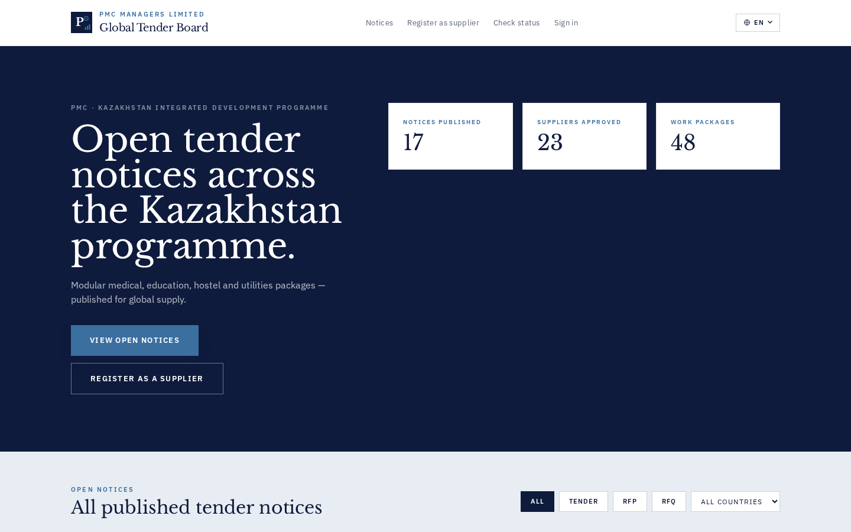
WHAT THIS SCREEN IS FOR
Anyone who lands on the portal domain sees the tender-hub marketing page: brand identity, the four service lanes, and the top-right Sign in / Register CTAs.
TESTING CHECKLIST
# | Test step | Expected outcome
1 | Open the portal root URL in an incognito window | Hero + Notices/Register/Sign-in in top nav render without a horizontal scroll on 375px viewports
2 | Tap the language switcher (EN → RU → KK) | Copy translates immediately; no console errors
PLAYWRIGHT / DATA-TESTID REFERENCES
topbar-brand · nav-notices · nav-register · nav-signin

Step 2 · Public tender board
URL · https://www.pmcmanagers.com/notices
WHAT THIS SCREEN IS FOR
Public list of every published tender/RFP/RFQ across all tenants of the portal.
TESTING CHECKLIST
# | Test step | Expected outcome
1 | Verify at least one PUBLISHED notice appears with title + closing date + budget | Cards render; DRAFT notices are hidden
2 | Click a card to open the Notice Detail | Detail page shows description, deadline, downloads and QA thread
PLAYWRIGHT / DATA-TESTID REFERENCES
public-notice-card

Step 3 · Vendor registration — start
URL · https://www.pmcmanagers.com/register
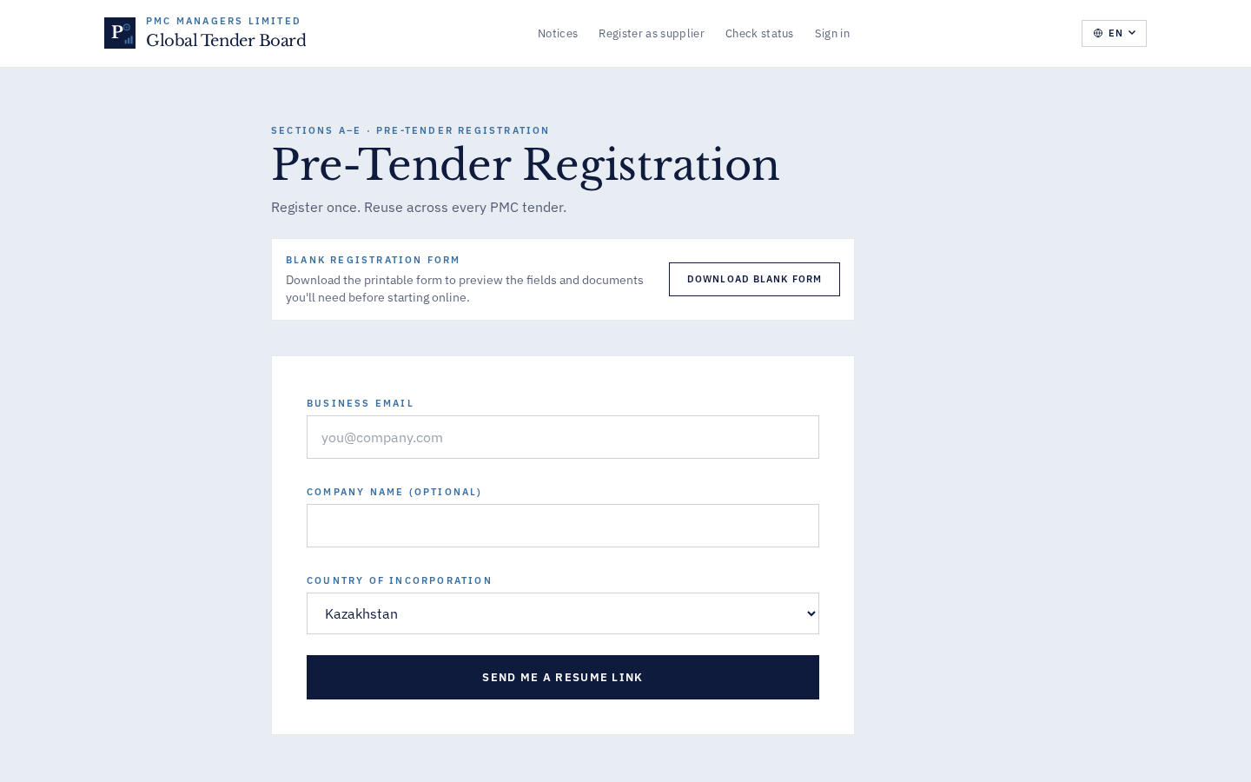
WHAT THIS SCREEN IS FOR
Section A (Identity) is the entry point. As soon as the vendor picks a file for any slot, a silent draft is created so nothing is lost.
TESTING CHECKLIST
# | Test step | Expected outcome
1 | Fill Section A (Company name, contact, email, phone, country) | Continue button unlocks once required fields are valid
2 | Attach a KYC doc to the ID slot | File uploads with progress; a resume-link toast appears
PLAYWRIGHT / DATA-TESTID REFERENCES
reg-section-a · reg-continue

Step 4 · Vendor registration — check status
URL · https://www.pmcmanagers.com/register/status
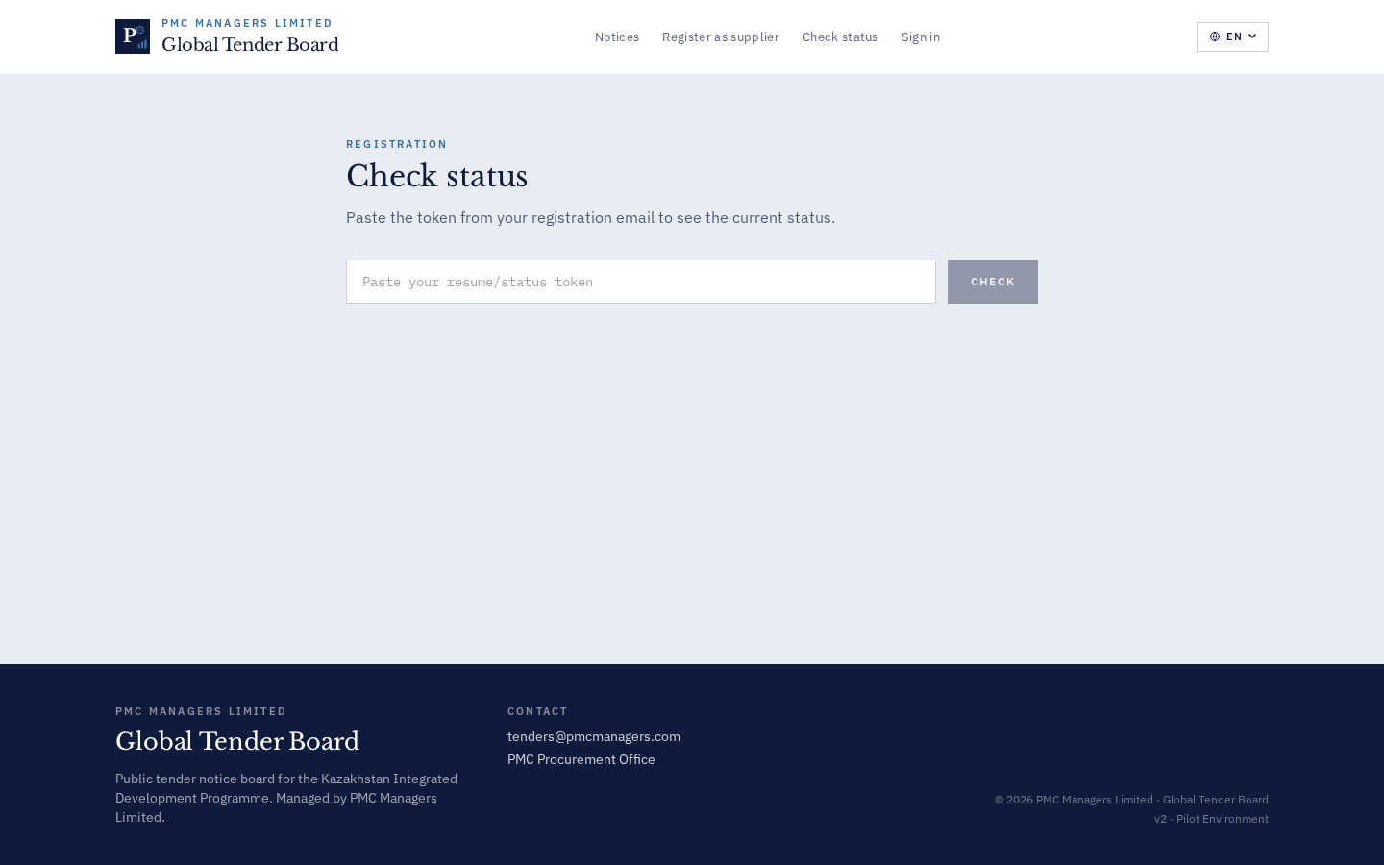
WHAT THIS SCREEN IS FOR
Any vendor with the emailed resume-token can paste it here to see current status without logging in.
TESTING CHECKLIST
# | Test step | Expected outcome
1 | Paste an invalid token | Toast: 'Token invalid or expired — request a new resume link…' (Bug 7 fix)
2 | Paste a valid token | Status card shows stage + reviewer notes + submission timestamp
PLAYWRIGHT / DATA-TESTID REFERENCES
status-token · status-check · status-result

Step 5 · Admin login page
URL · https://www.pmcmanagers.com/admin/login
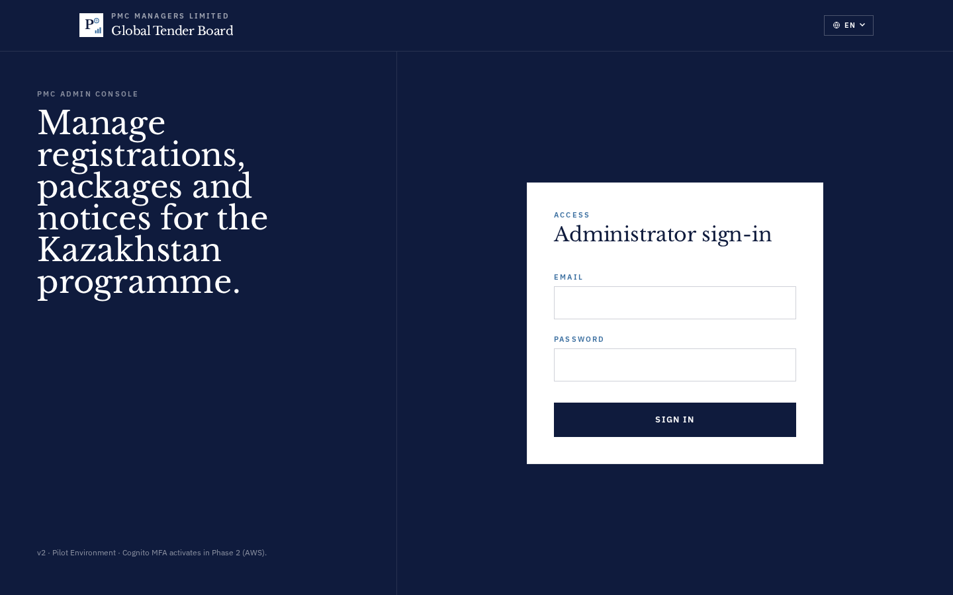
WHAT THIS SCREEN IS FOR
Dedicated admin login. HTTPOnly-cookie based, CSRF double-submit.
TESTING CHECKLIST
# | Test step | Expected outcome
1 | Try login with wrong password | Toast surfaces backend error; no console stack trace
2 | Try login with correct credentials | Redirect to /admin dashboard within 1s
PLAYWRIGHT / DATA-TESTID REFERENCES
admin-login-email · admin-login-password · admin-login-submit

Step 6 · Admin console · Analytics
URL · https://www.pmcmanagers.com/admin?tab=analytics
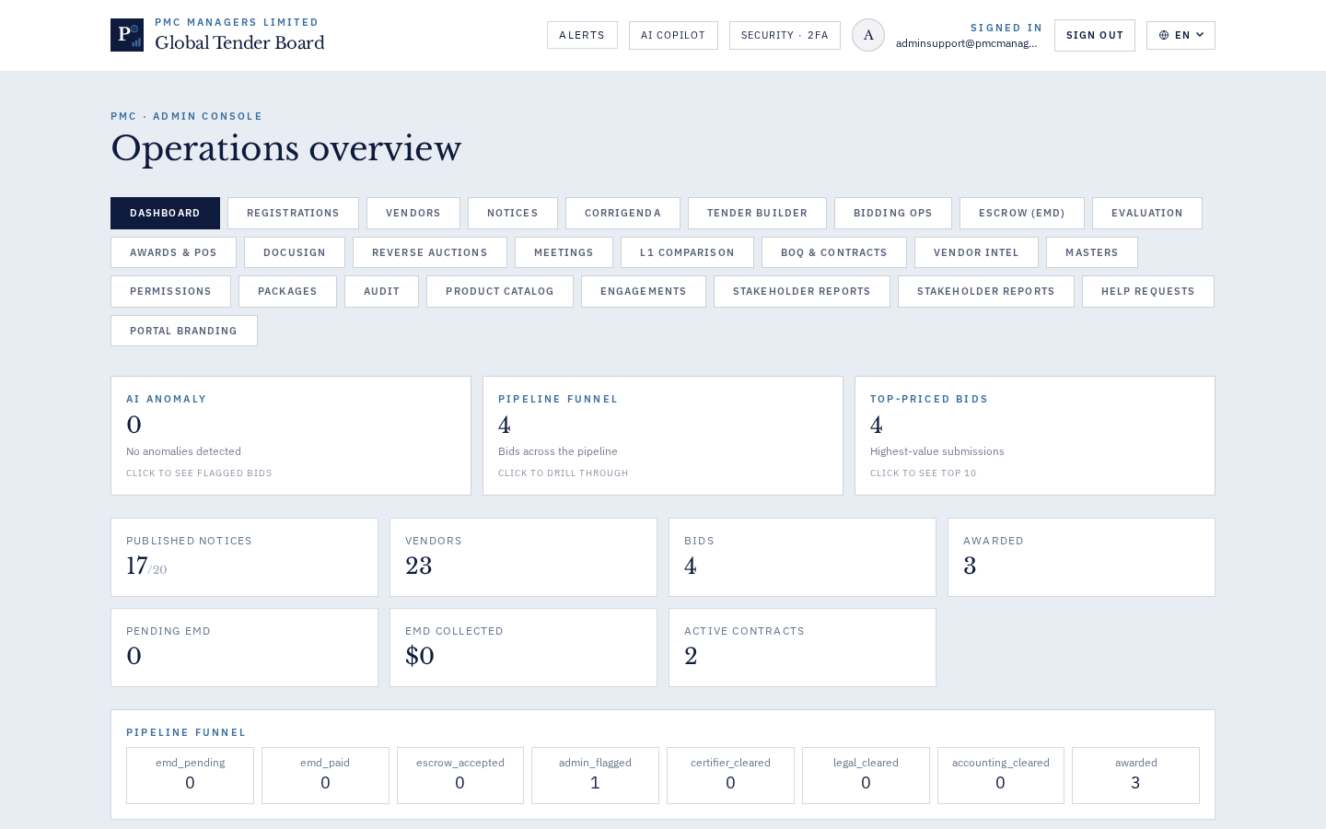
WHAT THIS SCREEN IS FOR
Dashboard · KPIs + AI-Anomaly drill cards
TESTING CHECKLIST
# | Test step | Expected outcome
1 | Click the 'analytics' tab in the admin sidebar | Panel renders within 1s; no white screen; ErrorBoundary NOT triggered
2 | Interact with the primary CTA on the panel | Backend responds; toast confirms success
PLAYWRIGHT / DATA-TESTID REFERENCES
admin-analytics-panel

Step 7 · Admin console · Registrations
URL · https://www.pmcmanagers.com/admin?tab=registrations
WHAT THIS SCREEN IS FOR
Registrations pipeline · draft/submitted/approved
TESTING CHECKLIST
# | Test step | Expected outcome
1 | Click the 'registrations' tab in the admin sidebar | Panel renders within 1s; no white screen; ErrorBoundary NOT triggered
2 | Interact with the primary CTA on the panel | Backend responds; toast confirms success
PLAYWRIGHT / DATA-TESTID REFERENCES
admin-registrations-panel

Step 8 · Admin console · Vendors
URL · https://www.pmcmanagers.com/admin?tab=vendors
WHAT THIS SCREEN IS FOR
Vendors master table + Bulk Invite
TESTING CHECKLIST
# | Test step | Expected outcome
1 | Click the 'vendors' tab in the admin sidebar | Panel renders within 1s; no white screen; ErrorBoundary NOT triggered
2 | Interact with the primary CTA on the panel | Backend responds; toast confirms success
PLAYWRIGHT / DATA-TESTID REFERENCES
admin-vendors-panel

Step 9 · Admin console · Notices
URL · https://www.pmcmanagers.com/admin?tab=notices
WHAT THIS SCREEN IS FOR
Notices · filter bar (search + status + template-only)
TESTING CHECKLIST
# | Test step | Expected outcome
1 | Click the 'notices' tab in the admin sidebar | Panel renders within 1s; no white screen; ErrorBoundary NOT triggered
2 | Interact with the primary CTA on the panel | Backend responds; toast confirms success
PLAYWRIGHT / DATA-TESTID REFERENCES
admin-notices-panel

Step 10 · Admin console · Corrigenda
URL · https://www.pmcmanagers.com/admin?tab=corrigenda
WHAT THIS SCREEN IS FOR
Corrigenda · publish/withdraw with mandatory reason
TESTING CHECKLIST
# | Test step | Expected outcome
1 | Click the 'corrigenda' tab in the admin sidebar | Panel renders within 1s; no white screen; ErrorBoundary NOT triggered
2 | Interact with the primary CTA on the panel | Backend responds; toast confirms success
PLAYWRIGHT / DATA-TESTID REFERENCES
admin-corrigenda-panel

Step 11 · Admin console · Tender Builder
URL · https://www.pmcmanagers.com/admin?tab=tender-builder
WHAT THIS SCREEN IS FOR
Tender Builder · sections + annexures + version history
TESTING CHECKLIST
# | Test step | Expected outcome
1 | Click the 'tender-builder' tab in the admin sidebar | Panel renders within 1s; no white screen; ErrorBoundary NOT triggered
2 | Interact with the primary CTA on the panel | Backend responds; toast confirms success
PLAYWRIGHT / DATA-TESTID REFERENCES
admin-tender-builder-panel

Step 12 · Admin console · Bidding
URL · https://www.pmcmanagers.com/admin?tab=bidding
WHAT THIS SCREEN IS FOR
Bidding Ops · Committee UX overhaul (checkbox grid + dissolve + resend)
TESTING CHECKLIST
# | Test step | Expected outcome
1 | Click the 'bidding' tab in the admin sidebar | Panel renders within 1s; no white screen; ErrorBoundary NOT triggered
2 | Interact with the primary CTA on the panel | Backend responds; toast confirms success
PLAYWRIGHT / DATA-TESTID REFERENCES
admin-bidding-panel

Step 13 · Admin console · Auctions
URL · https://www.pmcmanagers.com/admin?tab=auctions
WHAT THIS SCREEN IS FOR
Reverse Auctions · draft link hidden, participant validation
TESTING CHECKLIST
# | Test step | Expected outcome
1 | Click the 'auctions' tab in the admin sidebar | Panel renders within 1s; no white screen; ErrorBoundary NOT triggered
2 | Interact with the primary CTA on the panel | Backend responds; toast confirms success
PLAYWRIGHT / DATA-TESTID REFERENCES
admin-auctions-panel

Step 14 · Admin console · Escrow
URL · https://www.pmcmanagers.com/admin?tab=escrow
WHAT THIS SCREEN IS FOR
Escrow · joint accounts, dual-signature releases
TESTING CHECKLIST
# | Test step | Expected outcome
1 | Click the 'escrow' tab in the admin sidebar | Panel renders within 1s; no white screen; ErrorBoundary NOT triggered
2 | Interact with the primary CTA on the panel | Backend responds; toast confirms success
PLAYWRIGHT / DATA-TESTID REFERENCES
admin-escrow-panel

Step 15 · Admin console · Evaluation
URL · https://www.pmcmanagers.com/admin?tab=evaluation
WHAT THIS SCREEN IS FOR
Evaluation · rubric + COI cross-check
TESTING CHECKLIST
# | Test step | Expected outcome
1 | Click the 'evaluation' tab in the admin sidebar | Panel renders within 1s; no white screen; ErrorBoundary NOT triggered
2 | Interact with the primary CTA on the panel | Backend responds; toast confirms success
PLAYWRIGHT / DATA-TESTID REFERENCES
admin-evaluation-panel

Step 16 · Admin console · Awards
URL · https://www.pmcmanagers.com/admin?tab=awards
WHAT THIS SCREEN IS FOR
Awards & POs · Regenerate with confirmation + version log
TESTING CHECKLIST
# | Test step | Expected outcome
1 | Click the 'awards' tab in the admin sidebar | Panel renders within 1s; no white screen; ErrorBoundary NOT triggered
2 | Interact with the primary CTA on the panel | Backend responds; toast confirms success
PLAYWRIGHT / DATA-TESTID REFERENCES
admin-awards-panel

Step 17 · Admin console · Boq
URL · https://www.pmcmanagers.com/admin?tab=boq
WHAT THIS SCREEN IS FOR
BOQ & Contracts · export/filter/versions
TESTING CHECKLIST
# | Test step | Expected outcome
1 | Click the 'boq' tab in the admin sidebar | Panel renders within 1s; no white screen; ErrorBoundary NOT triggered
2 | Interact with the primary CTA on the panel | Backend responds; toast confirms success
PLAYWRIGHT / DATA-TESTID REFERENCES
admin-boq-panel

Step 18 · Admin console · Meetings
URL · https://www.pmcmanagers.com/admin?tab=meetings
WHAT THIS SCREEN IS FOR
Meetings · notice-ref required OR 'Internal meeting' tick
TESTING CHECKLIST
# | Test step | Expected outcome
1 | Click the 'meetings' tab in the admin sidebar | Panel renders within 1s; no white screen; ErrorBoundary NOT triggered
2 | Interact with the primary CTA on the panel | Backend responds; toast confirms success
PLAYWRIGHT / DATA-TESTID REFERENCES
admin-meetings-panel

Step 19 · Admin console · L1
URL · https://www.pmcmanagers.com/admin?tab=l1
WHAT THIS SCREEN IS FOR
L1 Comparison · lowest-compliant winner + empty-state reasons
TESTING CHECKLIST
# | Test step | Expected outcome
1 | Click the 'l1' tab in the admin sidebar | Panel renders within 1s; no white screen; ErrorBoundary NOT triggered
2 | Interact with the primary CTA on the panel | Backend responds; toast confirms success
PLAYWRIGHT / DATA-TESTID REFERENCES
admin-l1-panel

Step 20 · Admin console · Docusign
URL · https://www.pmcmanagers.com/admin?tab=docusign
WHAT THIS SCREEN IS FOR
DocuSign · Envelope Log with is_authoritative flag
TESTING CHECKLIST
# | Test step | Expected outcome
1 | Click the 'docusign' tab in the admin sidebar | Panel renders within 1s; no white screen; ErrorBoundary NOT triggered
2 | Interact with the primary CTA on the panel | Backend responds; toast confirms success
PLAYWRIGHT / DATA-TESTID REFERENCES
admin-docusign-panel

Step 21 · Admin console · Vendor Intel
URL · https://www.pmcmanagers.com/admin?tab=vendor-intel
WHAT THIS SCREEN IS FOR
Vendor Intel · BL/WL legend
TESTING CHECKLIST
# | Test step | Expected outcome
1 | Click the 'vendor-intel' tab in the admin sidebar | Panel renders within 1s; no white screen; ErrorBoundary NOT triggered
2 | Interact with the primary CTA on the panel | Backend responds; toast confirms success
PLAYWRIGHT / DATA-TESTID REFERENCES
admin-vendor-intel-panel

Step 22 · Admin console · Products
URL · https://www.pmcmanagers.com/admin?tab=products
WHAT THIS SCREEN IS FOR
Product Catalog · price-change history
TESTING CHECKLIST
# | Test step | Expected outcome
1 | Click the 'products' tab in the admin sidebar | Panel renders within 1s; no white screen; ErrorBoundary NOT triggered
2 | Interact with the primary CTA on the panel | Backend responds; toast confirms success
PLAYWRIGHT / DATA-TESTID REFERENCES
admin-products-panel

Step 23 · Admin console · Engagements
URL · https://www.pmcmanagers.com/admin?tab=engagements
WHAT THIS SCREEN IS FOR
Engagements · aging buckets + cancel reason ≥5 chars
TESTING CHECKLIST
# | Test step | Expected outcome
1 | Click the 'engagements' tab in the admin sidebar | Panel renders within 1s; no white screen; ErrorBoundary NOT triggered
2 | Interact with the primary CTA on the panel | Backend responds; toast confirms success
PLAYWRIGHT / DATA-TESTID REFERENCES
admin-engagements-panel

Step 24 · Admin console · Masters
URL · https://www.pmcmanagers.com/admin?tab=masters
WHAT THIS SCREEN IS FOR
Masters · roles + designations
TESTING CHECKLIST
# | Test step | Expected outcome
1 | Click the 'masters' tab in the admin sidebar | Panel renders within 1s; no white screen; ErrorBoundary NOT triggered
2 | Interact with the primary CTA on the panel | Backend responds; toast confirms success
PLAYWRIGHT / DATA-TESTID REFERENCES
admin-masters-panel

Step 25 · Admin console · Permissions
URL · https://www.pmcmanagers.com/admin?tab=permissions
WHAT THIS SCREEN IS FOR
Permissions Matrix · tab-level RBAC + G2 effective view
TESTING CHECKLIST
# | Test step | Expected outcome
1 | Click the 'permissions' tab in the admin sidebar | Panel renders within 1s; no white screen; ErrorBoundary NOT triggered
2 | Interact with the primary CTA on the panel | Backend responds; toast confirms success
PLAYWRIGHT / DATA-TESTID REFERENCES
admin-permissions-panel

Step 26 · Admin console · Audit
URL · https://www.pmcmanagers.com/admin?tab=audit
WHAT THIS SCREEN IS FOR
Audit · every substantive action
TESTING CHECKLIST
# | Test step | Expected outcome
1 | Click the 'audit' tab in the admin sidebar | Panel renders within 1s; no white screen; ErrorBoundary NOT triggered
2 | Interact with the primary CTA on the panel | Backend responds; toast confirms success
PLAYWRIGHT / DATA-TESTID REFERENCES
admin-audit-panel

Step 27 · Admin console · Reports
URL · https://www.pmcmanagers.com/admin?tab=reports
WHAT THIS SCREEN IS FOR
Reports · Asked-vs-Delivered + flowcharts
TESTING CHECKLIST
# | Test step | Expected outcome
1 | Click the 'reports' tab in the admin sidebar | Panel renders within 1s; no white screen; ErrorBoundary NOT triggered
2 | Interact with the primary CTA on the panel | Backend responds; toast confirms success
PLAYWRIGHT / DATA-TESTID REFERENCES
admin-reports-panel

Step 28 · Admin console · Stakeholder
URL · https://www.pmcmanagers.com/admin?tab=stakeholder
WHAT THIS SCREEN IS FOR
Stakeholder Reports · G4 rebuild (Tenders/Awards/Escrow/SLA)
TESTING CHECKLIST
# | Test step | Expected outcome
1 | Click the 'stakeholder' tab in the admin sidebar | Panel renders within 1s; no white screen; ErrorBoundary NOT triggered
2 | Interact with the primary CTA on the panel | Backend responds; toast confirms success
PLAYWRIGHT / DATA-TESTID REFERENCES
admin-stakeholder-panel

Step 29 · Admin console · Help
URL · https://www.pmcmanagers.com/admin?tab=help
WHAT THIS SCREEN IS FOR
Help Requests · triage from public form
TESTING CHECKLIST
# | Test step | Expected outcome
1 | Click the 'help' tab in the admin sidebar | Panel renders within 1s; no white screen; ErrorBoundary NOT triggered
2 | Interact with the primary CTA on the panel | Backend responds; toast confirms success
PLAYWRIGHT / DATA-TESTID REFERENCES
admin-help-panel

Step 30 · Admin console · Branding
URL · https://www.pmcmanagers.com/admin?tab=branding
WHAT THIS SCREEN IS FOR
Portal Branding · logo history + theme colours
TESTING CHECKLIST
# | Test step | Expected outcome
1 | Click the 'branding' tab in the admin sidebar | Panel renders within 1s; no white screen; ErrorBoundary NOT triggered
2 | Interact with the primary CTA on the panel | Backend responds; toast confirms success
PLAYWRIGHT / DATA-TESTID REFERENCES
admin-branding-panel

Step 31 · Sign out
URL · post-logout
WHAT THIS SCREEN IS FOR
Confirms the user is back on the public login page and the admin cookie has been cleared.
TESTING CHECKLIST
# | Test step | Expected outcome
1 | Click 'Sign out' in the admin header | Redirect to /login within 1s; admin cookie cleared
2 | Try to hit /admin directly in the URL bar | Bounce back to /login (401 on protected endpoints)
PLAYWRIGHT / DATA-TESTID REFERENCES
admin-logout

