PMC Managers v2
User Manual
Version 43 · September 2026
Comprehensive guide — every module, every action, every screen with per-modal screenshots and dense contextual tooltips.

Contents
- Dashboard — Analytics — 1 action(s)
- Notices — 3 action(s)
- Registrations — 2 action(s)
- Vendors — 4 action(s)
- Bidding Ops — 3 action(s)
- Escrow (EMD) — 5 action(s)
- Evaluation — 5 action(s)
- Corrigenda — 2 action(s)
- Tender Builder — 2 action(s)
- Awards & POs — 2 action(s)
- DocuSign — 2 action(s)
- Reverse Auctions — 2 action(s)
- Meetings — 2 action(s)
- L1 Comparison — 1 action(s)
- BOQ & Contracts — 2 action(s)
- Vendor Intel — 2 action(s)
- Masters — 1 action(s)
- Permissions — 1 action(s)
- Packages — 1 action(s)
- Audit — 2 action(s)
- Product Catalog — 1 action(s)
- Engagements — 2 action(s)
- Vendor Portal — 3 action(s)
- Staff Portal — 2 action(s)
- Registration Portal — 2 action(s)
- Public Notice Board — 2 action(s)
- Committee Accept Portal — 2 action(s)
- Escrow Officer Portal — 1 action(s)

Dashboard — Analytics
Surface: admin
URL path: /admin?tab=analytics
Purpose: The Dashboard tab is the Admin's operational overview. It shows the supplier funnel (Draft → Submitted → Approved), open notice counts, bidder engagement metrics, and any SLA breaches across the platform. Owned by the Master Admin; visible to all admin roles.
Prerequisites
- Admin login as any admin role
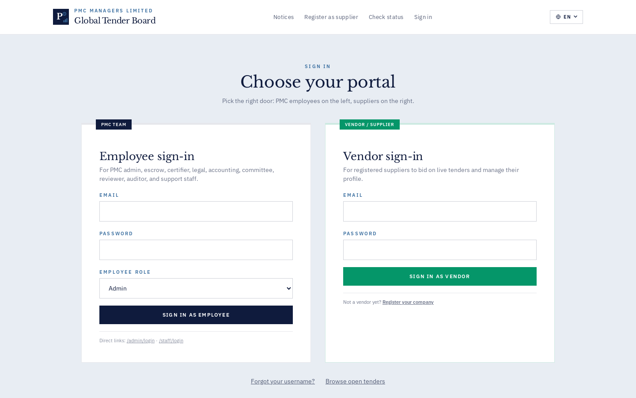

1. Review the supplier funnel
When to use: Weekly review, or before publishing a new tender.
Steps
- Log in via `/login` as an admin.
- Land on `/admin` — you're on the Dashboard tab by default.
- Look at the four KPI tiles at the top: Draft · Submitted · Approved · Rejected.
- Hover any tile to see the 7-day trend arrow.
Expected result: Live counts refresh every 60 seconds. Green arrow = healthy.
Controls & fields
- Refresh: Force-refresh the tiles without a full page reload.
- Time window: 7d / 30d / 90d toggle for trend arrows.
Common errors & fixes
- 0 across all tiles — Tiles all show zero
Fix: Check that at least one registration or notice exists. If yes and tiles are still zero, run `curl /api/v1/meta/public/stats` — a non-zero response confirms the frontend cache is stale (hard-refresh).

Notices
Surface: admin
URL path: /admin?tab=notices
Purpose: The Notices module is where you draft, review, publish, corrigenda, and archive tender notices. Every published notice appears on the public notice board (`/`) and drives all downstream flows: registration, bidding, evaluation, and awards. The Master Admin is the only role that can toggle 'Publish immediately'.
Prerequisites
- Admin login (Master Admin required to publish immediately)
- At least one tender template if using Tender Builder integration
Per-modal screenshots (v43)
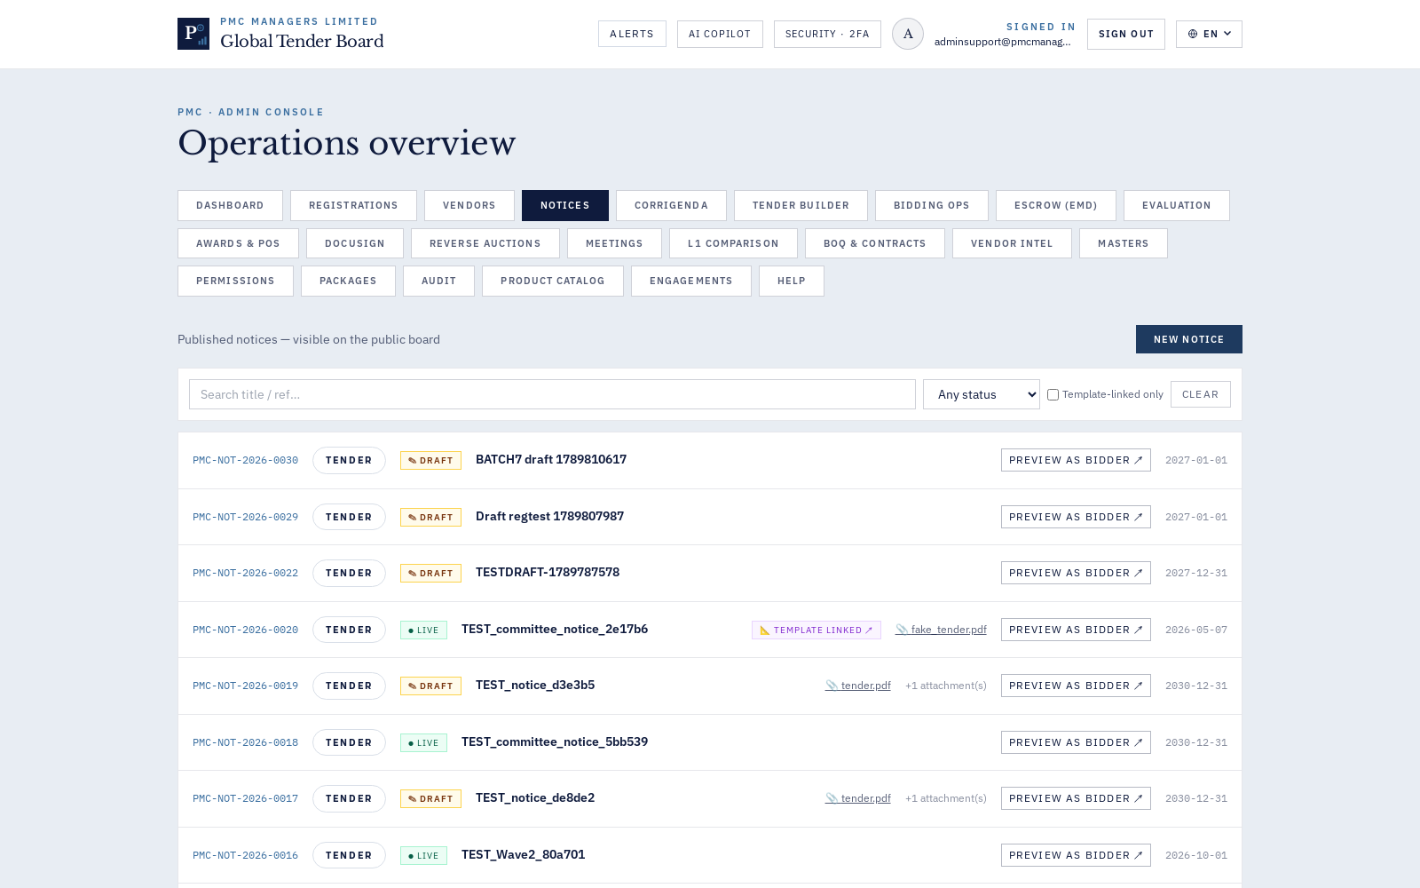
admin-notices-filter-bar
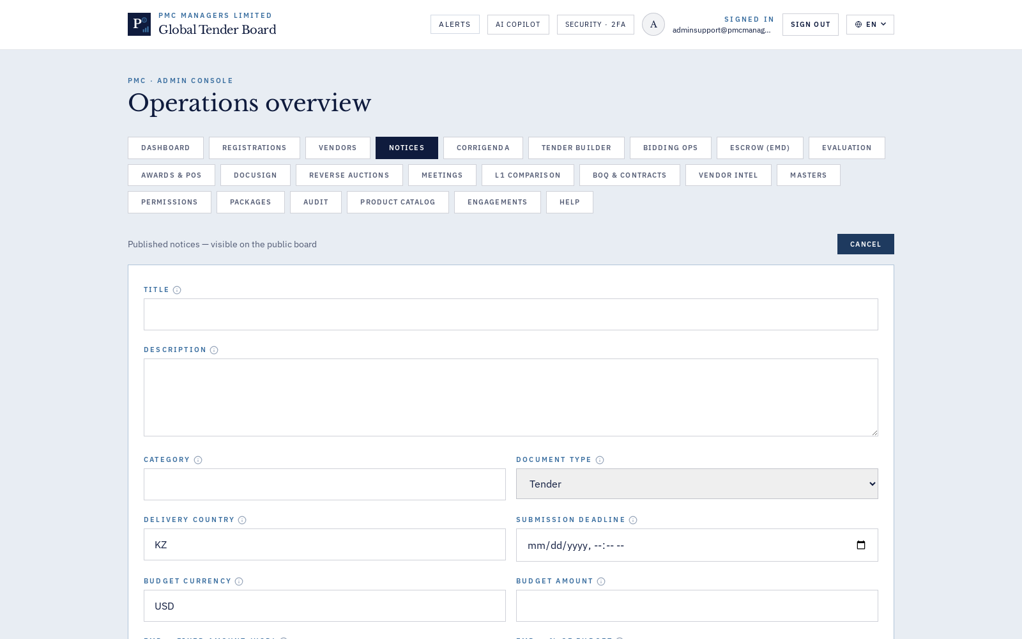
admin-notices-new-form

1. Draft a new tender notice
When to use: You need to publish a new tender, RFP, or RFQ.
Steps
- Click **NEW NOTICE** (top-right of the Notices tab).
- Fill in **Title** (≥ 3 chars) and **Description** (≥ 10 chars).
- Pick the **Type** (tender / rfp / rfq) and **Country**.
- Optionally attach documents via drag-and-drop.
- Tick **Publish immediately** if you are Master Admin — otherwise Save as draft.
- Click **CREATE NOTICE**. A green toast confirms creation.
Expected result: Draft appears in the notices list. If published, notice_ref is generated (e.g. `PMC-NOT-2026-0042`) and it appears on the public board within 30 sec.
Controls & fields
- Title: Public headline. Bug #20: min 3 chars enforced with clear toast.
- Description: Notice body — supports Markdown. Min 10 chars.
- Publish immediately: Bug #21: only enabled for Master Admin (case-insensitive role check tolerates 'master_admin', 'Master Admin', 'MASTER-ADMIN').
- Type: tender · rfp · rfq — drives which registration section is required.
- Country: ISO alpha-2 code (KZ default). Multi-country tenders — leave global.
- Attachments: PDF/DOCX up to 25 MB each. Stored server-side, downloadable from public notice detail page.
Common errors & fixes
- HTTP 422 — Title minimum 3 characters
Fix: Type at least 3 characters into Title.
- HTTP 422 — Description minimum 10 characters
Fix: Description body is required and must be ≥ 10 characters.
- Checkbox disabled — Publish immediately is greyed out
Fix: Your role isn't Master Admin. Save as draft and ask a Master Admin to publish.

2. Review and publish a draft notice
When to use: A reviewer/staff member has left a draft that needs Master Admin sign-off.
Steps
- In the Notices list, filter by status = `draft`.
- Click the draft row to open the detail panel.
- Review title, description, attachments.
- Tick **Publish immediately** and click **UPDATE** — the notice goes live.
Expected result: Row status flips from `draft` → `published`. `Cache-Control: no-store` on `/admin/all` means the list refreshes immediately.
Controls & fields
- Status filter: draft / published / archived. Deep-linkable via `?tab=notices&status=draft`.
Common errors & fixes
- HTTP 403 — You cannot publish this notice
Fix: Reviewer roles cannot publish. Ask Master Admin.

3. Issue a corrigenda on a published notice
When to use: A material change is needed after publication (deadline, scope, EMD amount).
Steps
- Open the Corrigenda tab (adjacent to Notices).
- Click **NEW CORRIGENDA** and pick the parent notice ref.
- Describe the change (min 20 chars — this is a legal amendment).
- Attach the amended clause PDF if any.
- Click **PUBLISH CORRIGENDA**. An email is sent to every registered supplier for that notice.
Expected result: Parent notice detail page gets a red 'CORRIGENDA #1' ribbon that expands to the amendment text. Supplier emails go out via Resend within 60 sec.
Controls & fields
- Parent notice: Dropdown of all published notices — cannot corrigend a draft.
- Amendment body: ≥ 20 chars, required — displayed verbatim to bidders.
Common errors & fixes
- HTTP 409 — Corrigenda cannot be issued on archived notices
Fix: Un-archive the notice first via the Archive filter.

Registrations
Surface: admin
URL path: /admin?tab=registrations
Purpose: Registrations is where reviewers approve, reject, or ask for clarification on supplier registration submissions. Each registration is scoped to a status (submitted / under_review / needs_clarification / approved / rejected / draft) and can carry document attachments. Filter tabs use the reviewer's session state — Bug #15 ensures the previously-selected row clears when you switch tabs.
Prerequisites
- Admin login as `admin` or `reviewer` role

1. Review a submitted registration
When to use: A supplier has completed all 5 sections and clicked Submit.
Steps
- Open **Registrations** tab (`/admin?tab=registrations`).
- The default filter is `submitted` — click any row on the left.
- Right pane shows: company details, entity type, primary sector, KZ licenses, business description, and uploaded documents.
- Click **View** or **Download** on each document to inspect it.
- Fill **Reviewer notes** (required for reject / clarify actions).
- Click **APPROVE**, **REQUEST CLARIFICATION**, or **REJECT**.
Expected result: Toast confirms the action ('Approval recorded' / 'Clarification recorded' / 'Rejection recorded'). Filter auto-switches to the new status tab so you see where the record went.
Controls & fields
- Status filter tabs: submitted · under_review · needs_clarification · approved · rejected · draft. Bug #15: switching clears the selected row.
- Nudge stale drafts: Emails everyone whose draft is > 7 days old. Bug #46: clearer 'Reminders sent to X of Y stale drafts' toast, or 'No stale drafts found' when none match.
- Reviewer notes: Required for reject / clarify — an audit trail entry.
Common errors & fixes
- HTTP 400 — Notes required for this action
Fix: Type a reason in the Reviewer notes textarea before clicking Reject or Request Clarification.
- Uploaded document opens 404 — Document URL returns Not Found
Fix: Attachment was pruned during storage cleanup. Ask the supplier to re-upload.

2. Nudge stale draft applicants
When to use: Weekly hygiene, or before closing a tender that draws a specific supplier segment.
Steps
- Click **NUDGE STALE DRAFTS** (top-right of the Registrations tab).
- The button greys out and text changes to `Sending…`.
- Within ~30 sec a toast appears with the count.
Expected result: Info toast if 0 checked, Warning toast if all checked but none matched threshold, Success toast with count if reminders sent.
Controls & fields
- NUDGE STALE DRAFTS button: Uses `POST /api/v1/registrations/admin/send-reminders`. Threshold: 7 days since last edit.
Common errors & fixes
- HTTP 401 / redirect to login — Session expired mid-nudge
Fix: Log in again and re-click. Reminders are idempotent — no supplier gets nudged twice.

Vendors
Surface: admin
URL path: /admin?tab=vendors
Purpose: Vendors is the approved-supplier directory. From here you invite new vendors (single email or bulk CSV), fill in the full registration form on behalf of an offline supplier, filter by verification/active status, and see per-vendor KPI dashboards (days approved, review turnaround, KZ licenses held, business categories declared).
Prerequisites
- Admin login as `admin` or `staff_admin`
- For Bulk invite: a UTF-8 CSV with columns email,company_name,contact_name,country
Per-modal screenshots (v43)
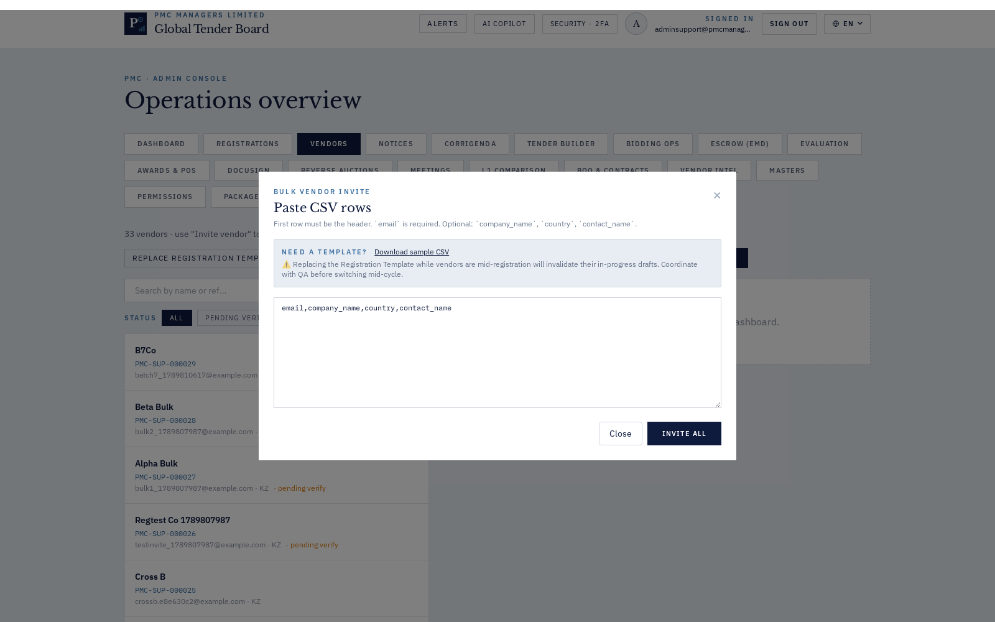
admin-vendors-bulk-invite-modal
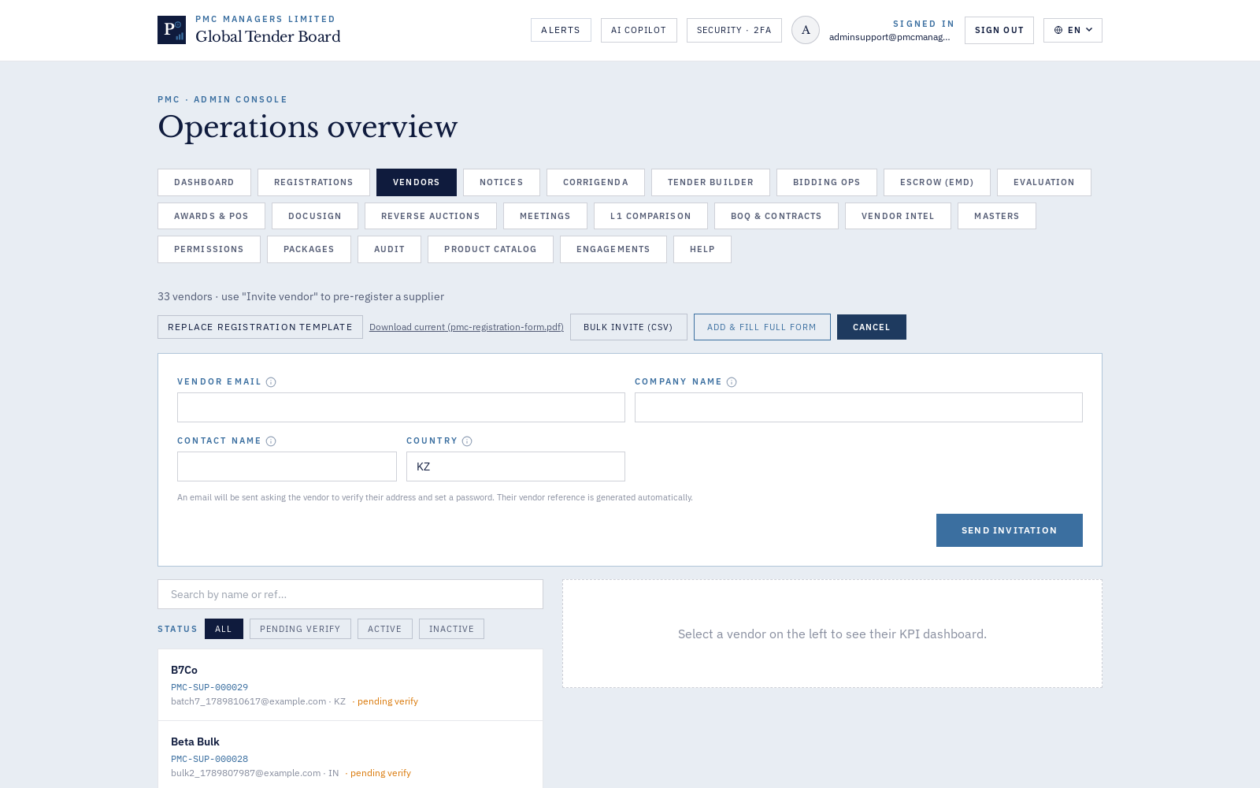
admin-vendors-invite-form
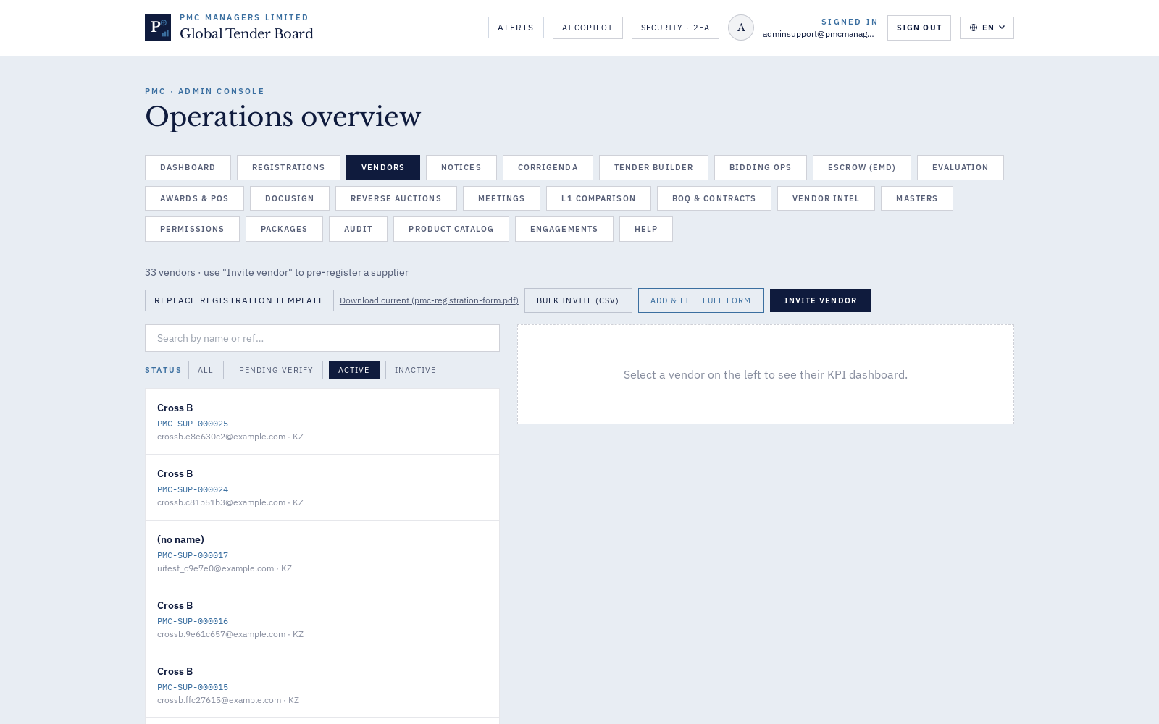
admin-vendors-status-filter-active

1. Invite a single vendor
When to use: You know a supplier by email and want to pre-register them.
Steps
- Click **INVITE VENDOR** (top-right of the Vendors tab).
- Fill vendor email, company name, contact name, and country (default KZ).
- Click **SEND INVITATION**.
Expected result: Success toast with the auto-generated vendor_ref (e.g. `PMC-VEN-2026-0189`). The vendor receives an email via Resend with a magic-link to verify their address and set a password. Row appears in the Vendors list with `pending_verify` badge.
Controls & fields
- Vendor email: Required, RFC-valid. Also becomes the login username.
- Company name: Legal name — shown in the KPI dashboard header.
- Country: ISO alpha-2. KZ default; drives which licenses list applies.
Common errors & fixes
- HTTP 409 — A vendor with this email already exists
Fix: Search for the existing vendor in the list; use Resend invite from the vendor row.
- HTTP 422 — Vendor email invalid
Fix: Emailing standard: `local@domain.tld`.

2. Add and fill the full registration form
When to use: A supplier delivered a paper application; you're transcribing it into the system.
Steps
- Click **ADD & FILL FULL FORM** — you're redirected to `/admin/vendors/new`.
- Fill Section A (company details), B (contacts + signatory), C (business categories), D (KZ licenses), E (bank details + declarations).
- Click **CREATE**. Bug #63: you're redirected to `/admin?tab=vendors` so the new vendor is visible immediately.
Expected result: Toast confirms creation and mode (Active immediately / Verify required). Vendor row appears at the top of the Vendors list.
Controls & fields
- Active immediately: Skips email verification. Use only when the supplier is physically present.
- Send verify email: Standard flow — supplier gets a magic-link email to confirm the address.
Common errors & fixes
- HTTP 409 — Draft with this email already exists
Fix: Bug #76: the frontend resets document_slots + draftId when you change the email. If it still fires, close and re-open the form.

3. Bulk invite vendors via CSV
When to use: You have a list of 10-500 suppliers to onboard at once.
Steps
- Click **BULK INVITE (CSV)**.
- Drag a UTF-8 CSV with columns `email,company_name,contact_name,country`.
- Preview shows the first 5 rows + parse errors (missing columns, invalid emails).
- Click **SEND ALL** — a progress bar shows N/total sent.
Expected result: Modal closes with a summary: `X invited · Y skipped (duplicate) · Z failed (invalid email)`. The Vendors list auto-reloads.
Controls & fields
- CSV upload: UTF-8-BOM tolerant (Bug #8 fixed for Cyrillic company names).
- Send all button: Fires the invites in batches of 20 to respect Resend rate limits.
Common errors & fixes
- HTTP 400 — CSV missing required column 'email'
Fix: Ensure the header row is exactly `email,company_name,contact_name,country`.

4. Inspect a vendor's KPI dashboard
When to use: Diligence check before awarding a contract, or quarterly performance review.
Steps
- Click any row in the Vendors list.
- Right panel loads the KPI dashboard.
- Four tiles: Days approved · Review turnaround (h) · KZ licenses · Categories.
- Below: KZ licenses held (list), Operating regions, Business categories declared.
Expected result: KPI panel refreshes within 500 ms of clicking. Blank tiles for very new vendors — populate after first tender participation.
Controls & fields
- Days approved: Days since the vendor's registration was Approved.
- Review turnaround: Hours between Submitted and Approved decision.
Common errors & fixes
- KPI loading forever — Spinner never resolves
Fix: Vendor might be in `pending_verify` state — KPI is only computed after verification. Check the badge on the row.

Bidding Ops
Surface: admin
URL path: /admin?tab=bidding
Purpose: Bidding Ops manages the multi-stage bid pipeline: EMD receipt → Admin flag → Certifier clearance → Legal → Accounting → Committee vote → Award. It also hosts the bid committee formation flow (internal + external invitees, chairperson, quorum) and the dissolve/re-form workflow.
Prerequisites
- Admin login as `admin` or `committee_member`
- At least one published notice with received EMD
Per-modal screenshots (v43)
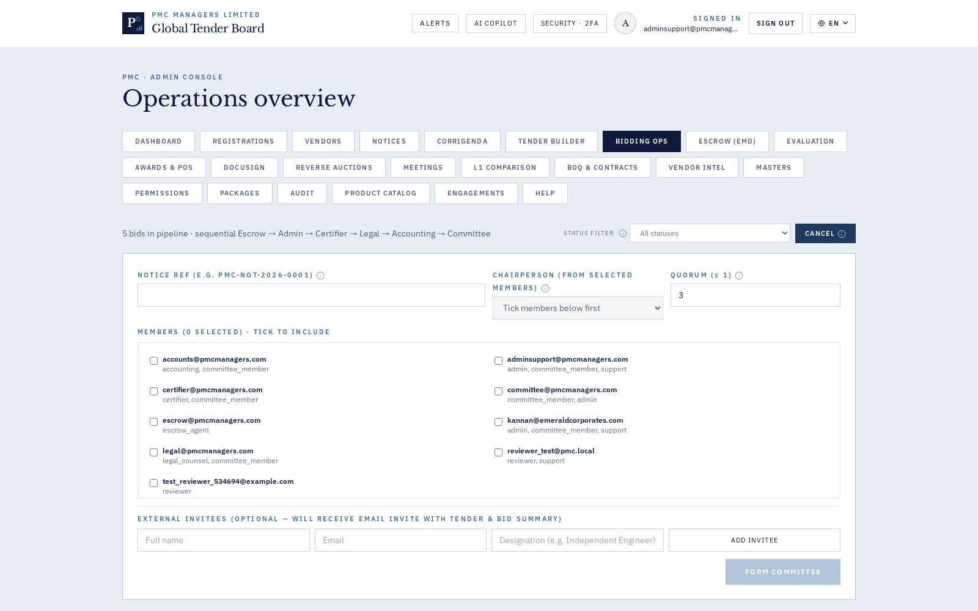
admin-bidding-committee-form

1. Form a bid committee
When to use: A tender has attracted the minimum number of bids and evaluation is ready to start.
Steps
- In the Bidding Ops tab, click **FORM COMMITTEE**.
- Type the notice ref (e.g. `PMC-NOT-2026-0042`).
- Tick internal member checkboxes (admin pool). Chairperson dropdown auto-filters to selected members.
- Set quorum (auto-capped to selected member count).
- Optionally add external invitees (name + email + designation) — they'll receive email invites with a magic-link.
- Click **FORM COMMITTEE**.
Expected result: Success toast: 'Committee formed · N internal member(s) · M external invited by email'. Committee appears under **Active committees** at the top of the panel.
Controls & fields
- Notice ref: Must match an existing notice. One committee per notice at a time.
- Member checkboxes: Tick to include. Chair dropdown intersects with this selection.
- Chairperson: Must be a member. Casts the deciding vote in case of tie.
- Quorum: Minimum votes required to close the committee. ≤ member count.
- External invitee: Bug #9b: dissolve button now sends CSRF token — no more silent 403.
Common errors & fixes
- HTTP 409 — Open committee already exists for this tender
Fix: Dissolve the existing committee first (see Dissolve action below), then re-form.
- HTTP 400 — Missing required fields
Fix: Notice ref, chairperson, and at least one member must all be set. Bug #9d: toast now describes the exact missing field.

2. Dissolve an active committee
When to use: Committee is deadlocked, or the tender itself was cancelled.
Steps
- Locate the committee row under **Active committees**.
- Click **DISSOLVE COMMITTEE**.
- Type a reason (≥ 8 chars) in the prompt.
- Confirm.
Expected result: Success toast: 'Committee dissolved · notice_ref · reason: "..."'. Row moves to **Recently closed / dissolved** section.
Controls & fields
- Dissolve reason: Audit trail entry, ≥ 8 chars. Shown italicised in the closed strip.
Common errors & fixes
- HTTP 403 — CSRF token missing or invalid
Fix: Bug #9b: fixed in v38. If you still see this, hard-refresh Safari to pick up main.95d55513.js.
- HTTP 409 — Committee already closed
Fix: Someone else dissolved it. Refresh the panel.

3. Admin-flag or reject a bid
When to use: A bid has cleared EMD receipt and is awaiting Admin sign-off before moving to Certifier.
Steps
- Scroll to the **Bids** table.
- Filter by status = `emd_paid` (or use the free-text search).
- For each bid, click **FLAG TO CERTIFIER** or **REJECT**.
Expected result: Bid status transitions to `admin_flagged` or `rejected`. Row moves to the corresponding filter section.
Controls & fields
- Status filter: 9-state dropdown covering the full pipeline.
- Assign certifier: Opens a modal to pick a certifier + schedule an inspection.
Common errors & fixes
- HTTP 403 — You cannot decide this bid
Fix: Only `admin` and `staff_admin` roles can flag; reviewers can only view.

Escrow (EMD)
Surface: admin
URL path: /admin?tab=escrow
Purpose: Escrow is the governance-first EMD ledger. Every joint account is jointly operated by two officers (one from PMC, one from the escrow institution) and every release requires BOTH to sign the same action. The panel shows: joint accounts, the transactions ledger, and a reconciliation (ledger vs bank) view. Bug #9c added a red governance banner and 409 backend guard when both officers share the same email — dual-signature is impossible in that state.
Prerequisites
- Admin login as `admin` or `accounting` or `escrow_agent`
- At least one active joint account with DISTINCT emails on each officer
Per-modal screenshots (v43)
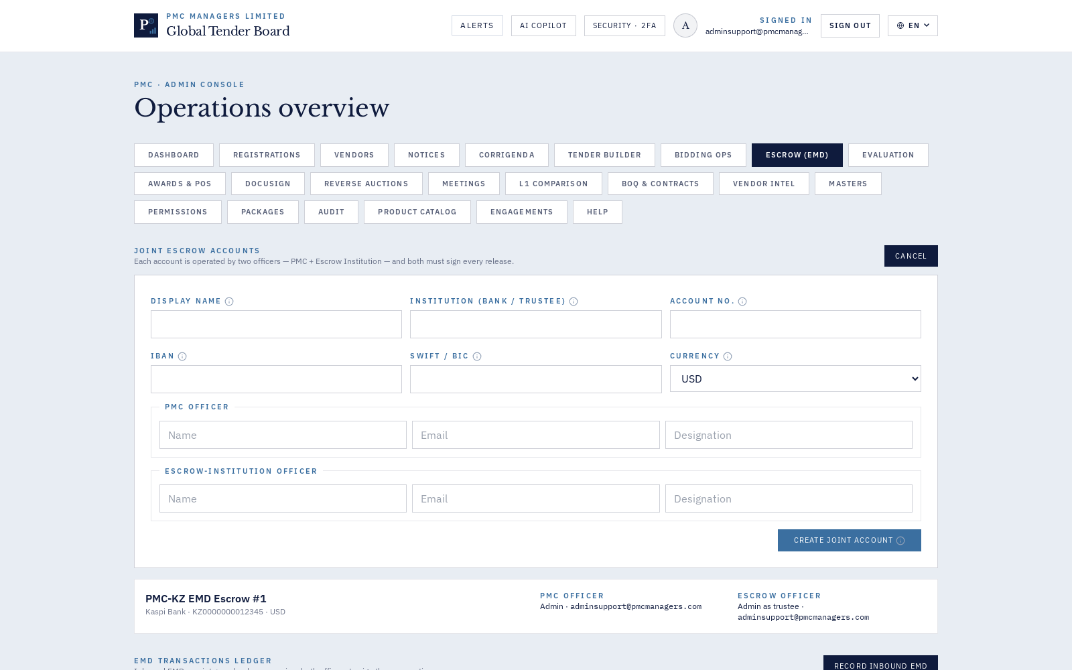
admin-escrow-new-account-form

1. Create a new joint escrow account
When to use: A new escrow relationship is set up with a bank or trustee.
Steps
- Click **NEW JOINT ACCOUNT** (Joint Escrow Accounts section).
- Enter account display name (e.g. 'PMC-KZ Tender EMD Escrow #2').
- Institution name (e.g. 'Kaspi Bank').
- Account number + IBAN + SWIFT + currency (USD/EUR/KZT).
- PMC officer: name + email + designation.
- Escrow officer: name + email + designation. **Must be a different person / different email.**
- Click **CREATE**.
Expected result: Success toast; account card renders under Joint Escrow Accounts.
Controls & fields
- PMC officer email: Represents PMC on the joint control. Must be different from Escrow officer email.
- Escrow officer email: Represents the bank / trustee. Bug #9c: creation refuses same email on both sides.
- Currency: 3-letter ISO. Default USD; KZT for local wires.
Common errors & fixes
- HTTP 400 — PMC officer and Escrow officer must be different people
Fix: Use a distinct email for the escrow officer (a real trustee at the bank, or issue a magic-link via `POST /api/v1/escrow/magic-tokens`).

2. Record an inbound EMD receipt
When to use: The bank confirms a bidder's EMD has landed in the joint account.
Steps
- Click **RECORD INBOUND EMD**.
- Pick the joint account from the dropdown (only active accounts show).
- Enter bid_ref, notice_ref, vendor_ref, amount, currency, bank reference (UTR).
- Click **RECORD RECEIPT**.
Expected result: Transaction row appears in the ledger with status `received`.
Controls & fields
- Bank reference: UTR / SWIFT MT-103 reference — audit trail.
- Amount: > 0 required. Currency must match the account currency.
Common errors & fixes
- HTTP 404 — Active escrow account not found
Fix: Account may have been deactivated. Re-activate it via patch endpoint or create a new one.

3. Sign a release action
When to use: The committee has awarded the contract and the winning bidder's EMD is to be released.
Steps
- Locate the received transaction in the ledger.
- Verify the joint account has DISTINCT emails on both officers — if not, a red governance banner will block this step.
- Click **SIGN · RELEASE TO CONTRACTOR** (or the appropriate action).
- The signature card for your side (PMC or Escrow officer) turns green.
- The other officer must also sign the same action — they use the same button while logged in as their email, or via magic-link if external.
Expected result: Blue info toast: 'Signed as PMC officer — awaiting the Escrow officer. Nothing has been transferred yet.' Once both sides sign, a green success toast: 'Both officers signed — Release is now unlocked.'
Controls & fields
- Sign buttons: Three actions: release_to_contractor · release_to_vendor · forfeit. Bug #9c: disabled if governance broken (same email on both sides).
- Release button: Only fires after both signatures match. Bug #9c: label reads 'RELEASE (BLOCKED — FIX OFFICERS)' when governance broken.
Common errors & fixes
- HTTP 409 — This joint escrow account has the SAME email on both officers ... Nothing has been signed.
Fix: Edit the account and set the Escrow officer to a different email, or issue a magic-link for an external trustee via `POST /api/v1/escrow/magic-tokens`.
- HTTP 409 — Transaction already released_to_contractor
Fix: You can't re-sign a released transaction. Nothing to do.

4. Fire the release once dual-signed
When to use: Both officers have signed the same action.
Steps
- Click **RELEASE (UNLOCKED)** on the transaction row.
- Confirm the release amount + beneficiary in the browser prompt.
Expected result: Green toast: 'Release recorded — ledger closed'. Status flips to `released_to_contractor` / `released_to_vendor` / `forfeited`.
Controls & fields
- Release confirmation: Native confirm() dialog with amount and action — prevents accidental release.
Common errors & fixes
- HTTP 409 — Both officers must sign the same action before release
Fix: Bug #9d: toast now explicitly shows what each side has signed. Ensure both sides picked the same action.

5. Issue a magic-link to an external escrow officer
When to use: The trustee at the bank does not need a full staff account.
Steps
- Currently API-only (no UI form yet).
- ```bash
- curl -X POST https://www.pmcmanagers.com/api/v1/escrow/magic-tokens \
- -b cookies.txt -H "X-CSRF-Token: $CSRF" \
- -H "Content-Type: application/json" \
- -d '{"account_id":"<ACC_ID>","officer_email":"trustee@bank.com"}'
- ```
- Response: `{"token": "...", "portal_url": "/escrow/officer/<token>"}`
- Email the portal_url to the trustee.
Expected result: Trustee opens the URL → sees the pending transactions on their account → clicks Sign — no staff login required.
Controls & fields
- officer_email: Must match one of the two officer emails on the account.
Common errors & fixes
- HTTP 400 — Officer email is not on this joint account
Fix: Update the account first with the trustee's email, then re-issue the token.

Evaluation
Surface: admin
URL path: /admin?tab=evaluation
Purpose: Evaluation covers the technical + commercial scoring of bids by the committee. It manages: rubric setup (weights + minimum technical cutoff), Conflict-of-Interest declaration per evaluator, envelope locking (Tech + Comm cannot be edited after lock), scoring entry, and the final Award Report generation. Bug #49 hardened the rubric validators (weights sum to 1.0, per-criterion 0-1, min-tech 0-100). Bug #52 stops re-scoring after envelope lock.
Prerequisites
- Admin login as `admin`, `committee_member`, or `reviewer`
- At least one committee formed for the notice
- COI declaration submitted by every evaluator
Per-modal screenshots (v43)
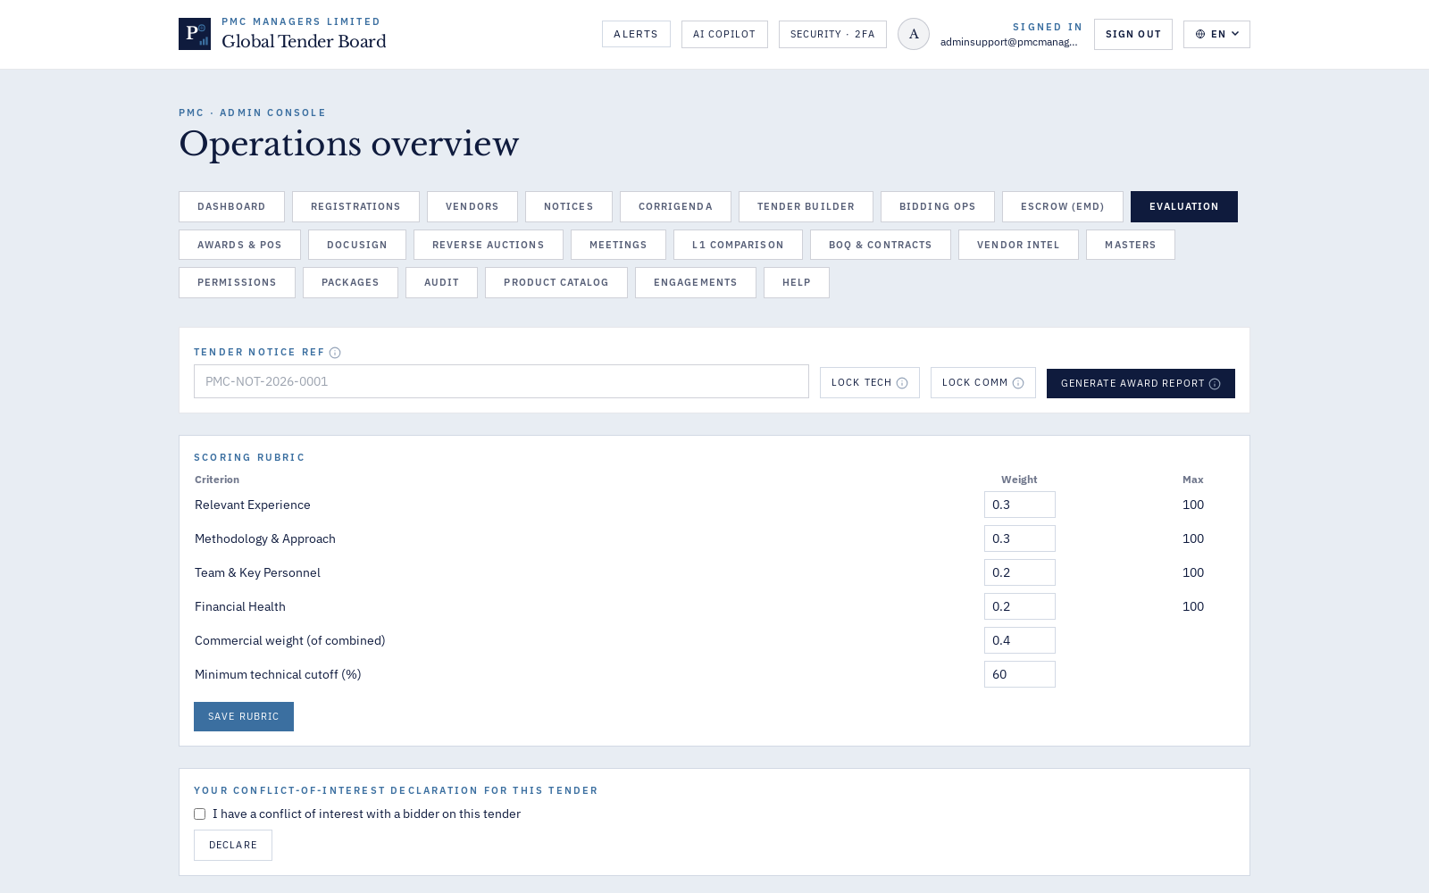
admin-evaluation-idle

1. Set up the scoring rubric
When to use: Immediately after committee formation, before any evaluator signs in.
Steps
- Open the Evaluation tab and enter the notice_ref.
- In the Scoring Rubric card, fill each criterion's **Weight** (0–1). Sum must be exactly 1.00.
- Set the **Commercial weight** (0–1) — controls Tech/Comm split.
- Set the **Minimum technical cutoff** (0–100 percent).
- The **SAVE RUBRIC** button is disabled while any error is shown.
- Click **SAVE RUBRIC**.
Expected result: Green toast. Committee members can now start scoring.
Controls & fields
- Weight (per criterion): 0 ≤ w ≤ 1. Sum must equal 1.00. Bug #49: live validation.
- Max score (per criterion): Server enforces individual scores ≤ max. Bug #49.
- Commercial weight: 0 ≤ cw ≤ 1. Technical gets (1 - cw).
- Minimum technical cutoff: 0 ≤ m ≤ 100. Bids below this are auto-disqualified before commercial opening.
Common errors & fixes
- HTTP 422 — Technical criteria weights must sum to 1.0 (got X.XX)
Fix: Adjust rows so weights sum to 1.00 (100%).
- HTTP 422 — minimum_technical must be between 0 and 100
Fix: Use percent form (60 for 60%, not 0.60).

2. Declare Conflict-of-Interest
When to use: Before scoring any bid on a tender you're evaluating.
Steps
- In the Evaluation tab, click **DECLARE COI**.
- Answer 'Do you have a conflict?' — yes/no.
- If yes: describe the conflict (required).
- Submit.
Expected result: Green toast: 'COI declared'. If declared yes, scoring is blocked for you (backend 403).
Controls & fields
- Has conflict: Boolean — required.
- Details: Required when 'yes' — audit trail.
Common errors & fixes
- HTTP 400 — You must declare Conflict-of-Interest before scoring
Fix: Declare first, then retry scoring.

3. Score a bid
When to use: After rubric + COI + envelope open.
Steps
- Enter bid_id (from Bidding Ops).
- Pick envelope kind: technical or commercial.
- For technical: enter a score per criterion (0 ≤ s ≤ max_score).
- For commercial: enter a single commercial score (0–100).
- Add remarks.
- Click **SUBMIT SCORE**.
Expected result: Green toast. Scores persist and are visible in the Award Report preview.
Controls & fields
- Bid id: Mongo ObjectId. Auto-completed from the Bidding Ops filter.
- Scores per criterion: Backend validates each value is within [0, max_score]. Bug #49.
Common errors & fixes
- HTTP 409 — The technical envelope for <notice> was locked at <timestamp>. Scores can no longer be submitted or edited.
Fix: Bug #52: envelope is locked. Generate the Award Report — you can view saved scores but not edit.
- HTTP 422 — Score for 'X' must be between 0 and 100 (got Y)
Fix: Correct the specific row identified in the error and resubmit.

4. Lock Tech or Commercial envelope
When to use: All evaluators have scored. Lock prevents further edits.
Steps
- In the Evaluation tab, click **LOCK TECHNICAL** or **LOCK COMMERCIAL**.
- Confirm the lock (irreversible).
Expected result: Green toast: 'Envelope locked'. Backend stores locked_at + locked_by. All subsequent score submissions on this envelope return HTTP 409.
Controls & fields
- Lock button: One per envelope. Bug #52: guards score endpoint too.
Common errors & fixes
- HTTP 409 — Envelope already locked
Fix: Nothing to do — proceed to Award Report generation.

5. Generate the Award Report
When to use: After both envelopes are locked and all scores are in.
Steps
- Click **GENERATE AWARD REPORT**.
- The report renders inline: bid-by-bid technical + commercial totals, weighted score, ranking.
- Download as PDF via the print icon.
Expected result: Recommendation row: bid_ref + vendor_name + total_score + rank. Master Admin uses this to trigger the Award step in the Awards & POs panel.
Controls & fields
- Print / PDF: WeasyPrint server-side render — includes audit trail + signatures.
Common errors & fixes
- Missing scores warning — Not all bids have technical + commercial scores
Fix: Return to Score Bid and fill missing rows before generating the final report.

Corrigenda
Surface: admin
URL path: /admin?tab=corrigenda
Purpose: The Corrigenda tab lists every published amendment to any live tender notice. Each corrigenda carries an immutable version number and is emailed to every registered supplier for the parent notice. Only Master Admin can issue corrigenda on archived notices.
Prerequisites
- Admin login
- At least one published notice with the change scope
Per-modal screenshots (v43)
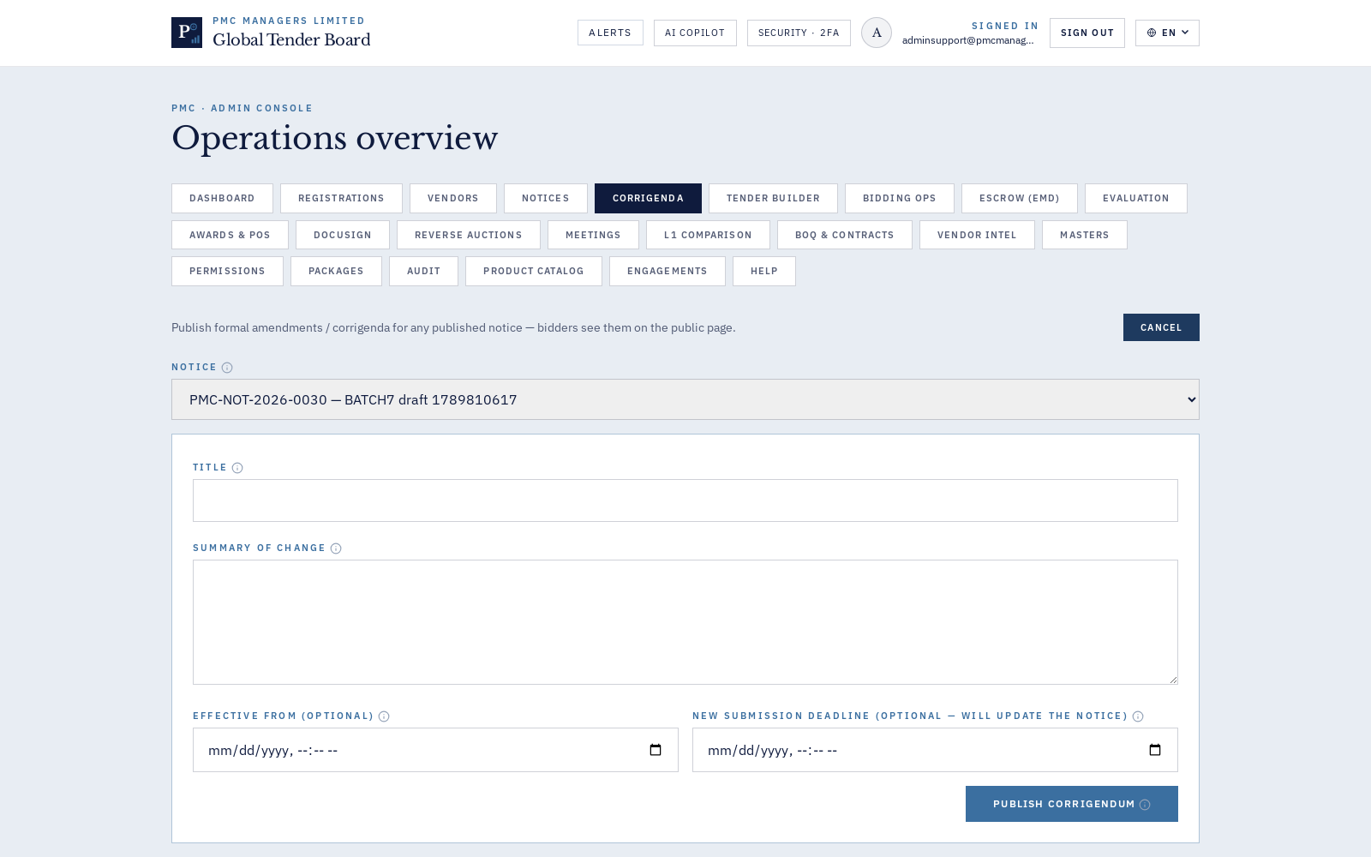
admin-corrigenda-new-form

1. Issue a new corrigenda
When to use: A material change is required after publication (deadline, EMD, scope).
Steps
- Click **NEW CORRIGENDA** (top-right).
- Pick the parent notice from the dropdown (only published notices listed).
- Type the amendment body (≥ 20 chars). Attach the amended clause PDF if any.
- Click **PUBLISH CORRIGENDA**.
Expected result: Corrigenda row appears in the list with version number. Suppliers receive an email within 60 sec via Resend.
Controls & fields
- Parent notice: Only published, non-archived notices.
- Amendment body: Minimum 20 chars. Displayed verbatim to bidders.
- Attachment: PDF/DOCX up to 25 MB — inline preview on public detail.
Common errors & fixes
- HTTP 409 — Cannot corrigend an archived notice
Fix: Un-archive the notice via Notices → Archive filter → Restore.

2. View corrigenda history for a notice
When to use: Verify the amendment trail before an audit.
Steps
- Click any corrigenda row to expand.
- See version, publish date, actor email, amendment body.
Expected result: Complete chronological history renders inline.

Tender Builder
Surface: admin
URL path: /admin?tab=tender-builder
Purpose: Tender Builder is the template-driven notice authoring surface. Templates carry standard clauses, evaluation matrices, and attachment slots. Clone existing templates to keep organisational standards; every edit is version-tracked (Bugs #69–#71 fixed the clone-attachment carryover and cascade-delete).
Prerequisites
- Admin login as `admin` or `staff_admin`
Per-modal screenshots (v43)
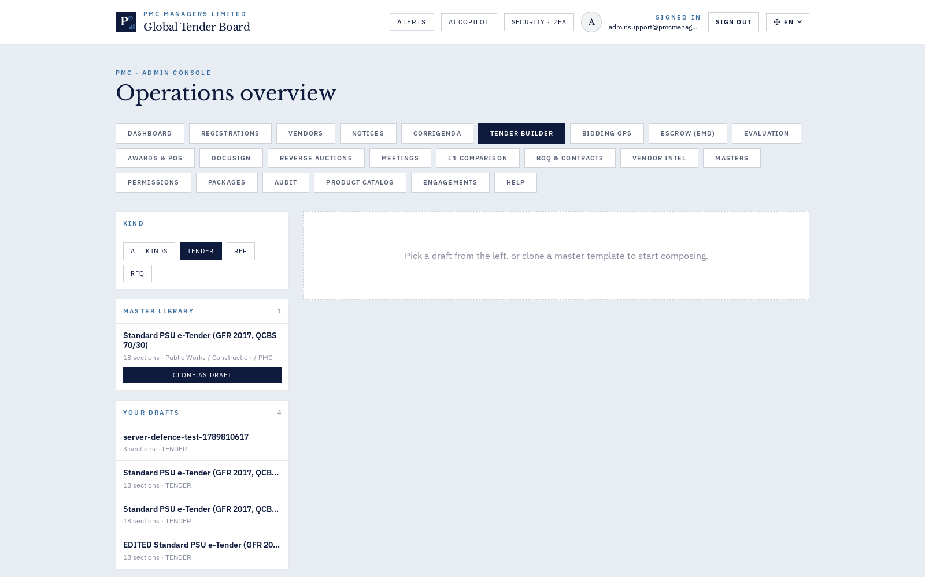
admin-tender-builder-idle

1. Create a new tender template
When to use: Setting up a reusable pattern for a new tender category.
Steps
- Click **NEW TEMPLATE**.
- Fill category, jurisdiction, default clauses.
- Add attachment slots by name (e.g. 'BOQ', 'Bank guarantee').
- Click **SAVE TEMPLATE**.
Expected result: Template appears in the list with version `v1`.
Controls & fields
- Category: Free-form; drives Notice filter.
- Default clauses: Rich-text; appended to every notice using this template.
Common errors & fixes
- HTTP 422 — Template name already exists in this category
Fix: Rename or edit the existing template instead of duplicating.

2. Clone a template
When to use: Kick off a similar tender without redoing setup.
Steps
- Locate template row.
- Click **CLONE**.
- Confirm the clone name.
- Bug #69: attachments are NOT carried over from the source (deliberate) — you re-attach only what's relevant.
Expected result: New template `v1` with cloned clauses appears at the top.

Awards & POs
Surface: admin
URL path: /admin?tab=awards
Purpose: Awards & POs is where the Master Admin issues a formal Contract Award to the recommended bidder and generates the Purchase Order PDF. The Award Report from Evaluation feeds into this tab; the PO PDF is DocuSign-ready (JWT Grant flow) for supplier e-signature.
Prerequisites
- Award Report generated for the notice
- Master Admin role
Per-modal screenshots (v43)
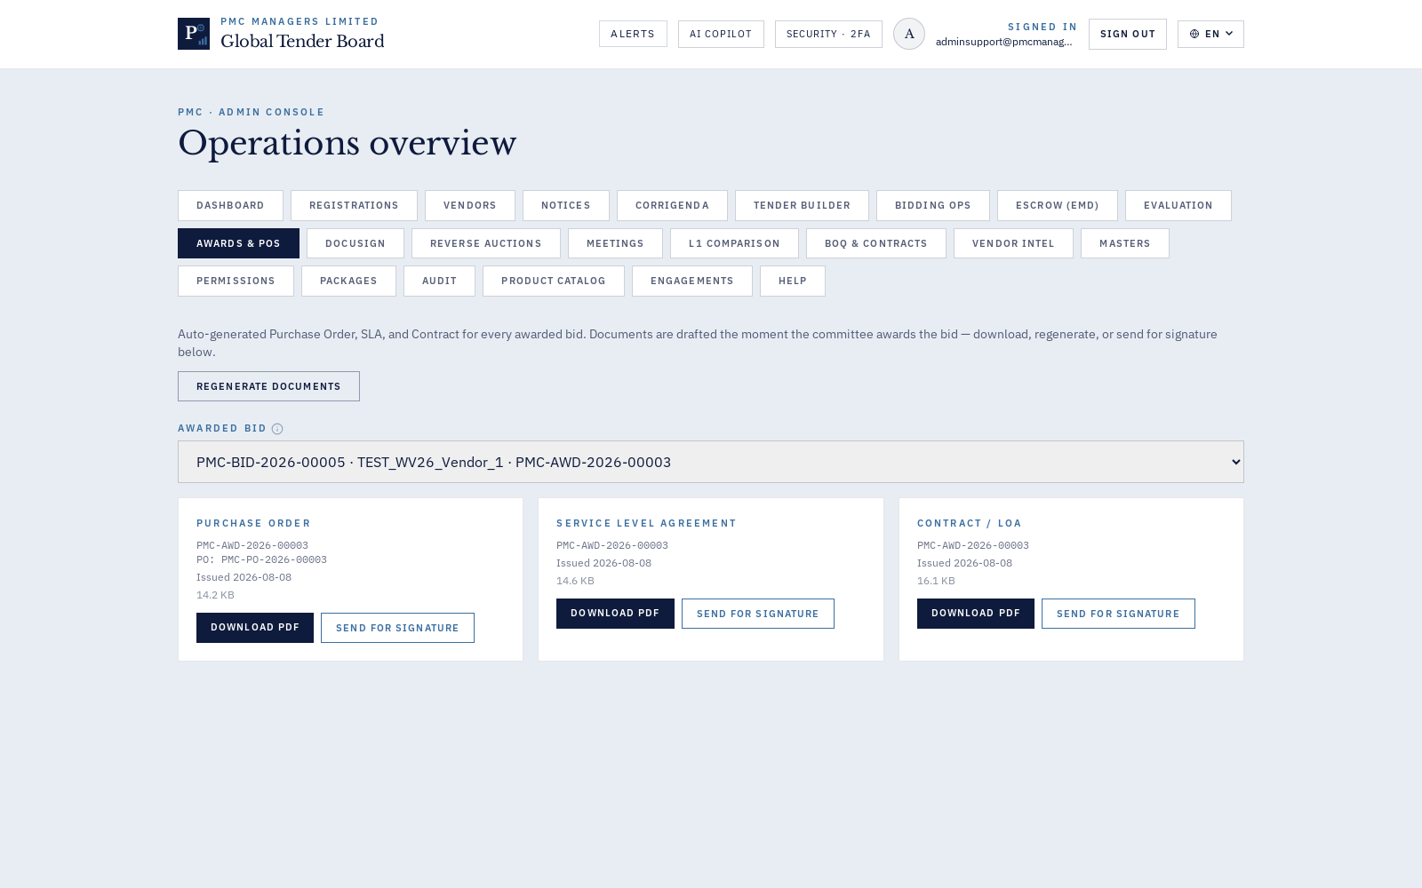
admin-awards-idle

1. Issue a contract award
When to use: The Evaluation panel has produced a signed Award Report.
Steps
- Pick the notice ref.
- Confirm recommended bidder.
- Enter contract value, currency, start & end dates.
- Click **ISSUE AWARD**.
Expected result: Award row created with status `awarded`; PDF generated on the server (WeasyPrint).
Controls & fields
- Contract value: Must be > 0 and match commercial bid within ± 2%.
- Start / End: ISO dates; end > start.
Common errors & fixes
- HTTP 409 — Award already issued for this notice
Fix: One award per notice. Cancel via Legal to re-award.

2. Generate the PO PDF
When to use: After award is issued and terms are locked.
Steps
- Click **GENERATE PO** on the award row.
- Download the PDF or click **SEND TO DOCUSIGN** to route for e-signature.
Expected result: PDF opens in a new tab; DocuSign envelope ID appears when routed.
Common errors & fixes
- HTTP 502 — DocuSign JWT Grant failed
Fix: Check the JWT private key in Secrets Manager hasn't expired; regenerate if needed.

DocuSign
Surface: admin
URL path: /admin?tab=docusign
Purpose: The DocuSign panel lists every envelope routed for e-signature (Contract POs, NDAs, escrow attestations). Uses the JWT Grant OAuth flow — no per-user redirect needed. Envelope status is polled every 5 min from the DocuSign REST API.
Prerequisites
- DocuSign integration key + RSA private key configured
- Admin login
Per-modal screenshots (v43)
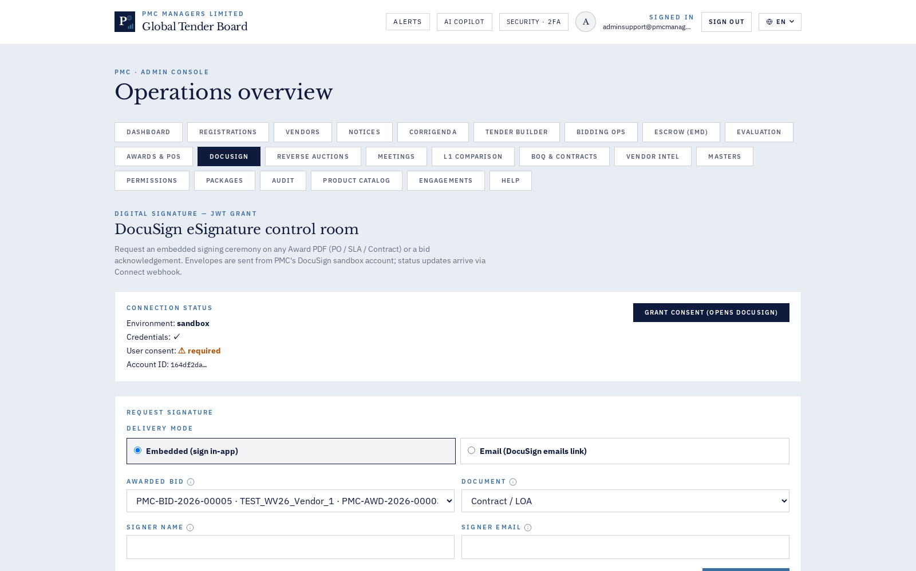
admin-docusign-request-form

1. Resend a stalled envelope
When to use: The signer hasn't opened the email in 48 h.
Steps
- Locate the envelope row (status = sent).
- Click **RESEND**.
- Confirm the new expiry (default +14 d).
Expected result: DocuSign reply toast; row shows updated `resent_at`.
Common errors & fixes
- HTTP 400 — Envelope already completed
Fix: Cannot resend a completed envelope. Look under Archive.

2. Download the signed PDF
When to use: After envelope status = completed.
Steps
- Click **DOWNLOAD SIGNED**.
- PDF streams to your browser.
Expected result: Signed PDF with all signature stamps + audit trail included.

Reverse Auctions
Surface: admin
URL path: /admin?tab=auctions
Purpose: Reverse Auctions hosts live, downward-price bidding rooms. Admins open a room, set the reserve price + step size + duration, invite pre-qualified vendors, and run the session. The room streams bids in real-time via WebSocket.
Prerequisites
- Approved shortlist of bidders
- Admin login
Per-modal screenshots (v43)
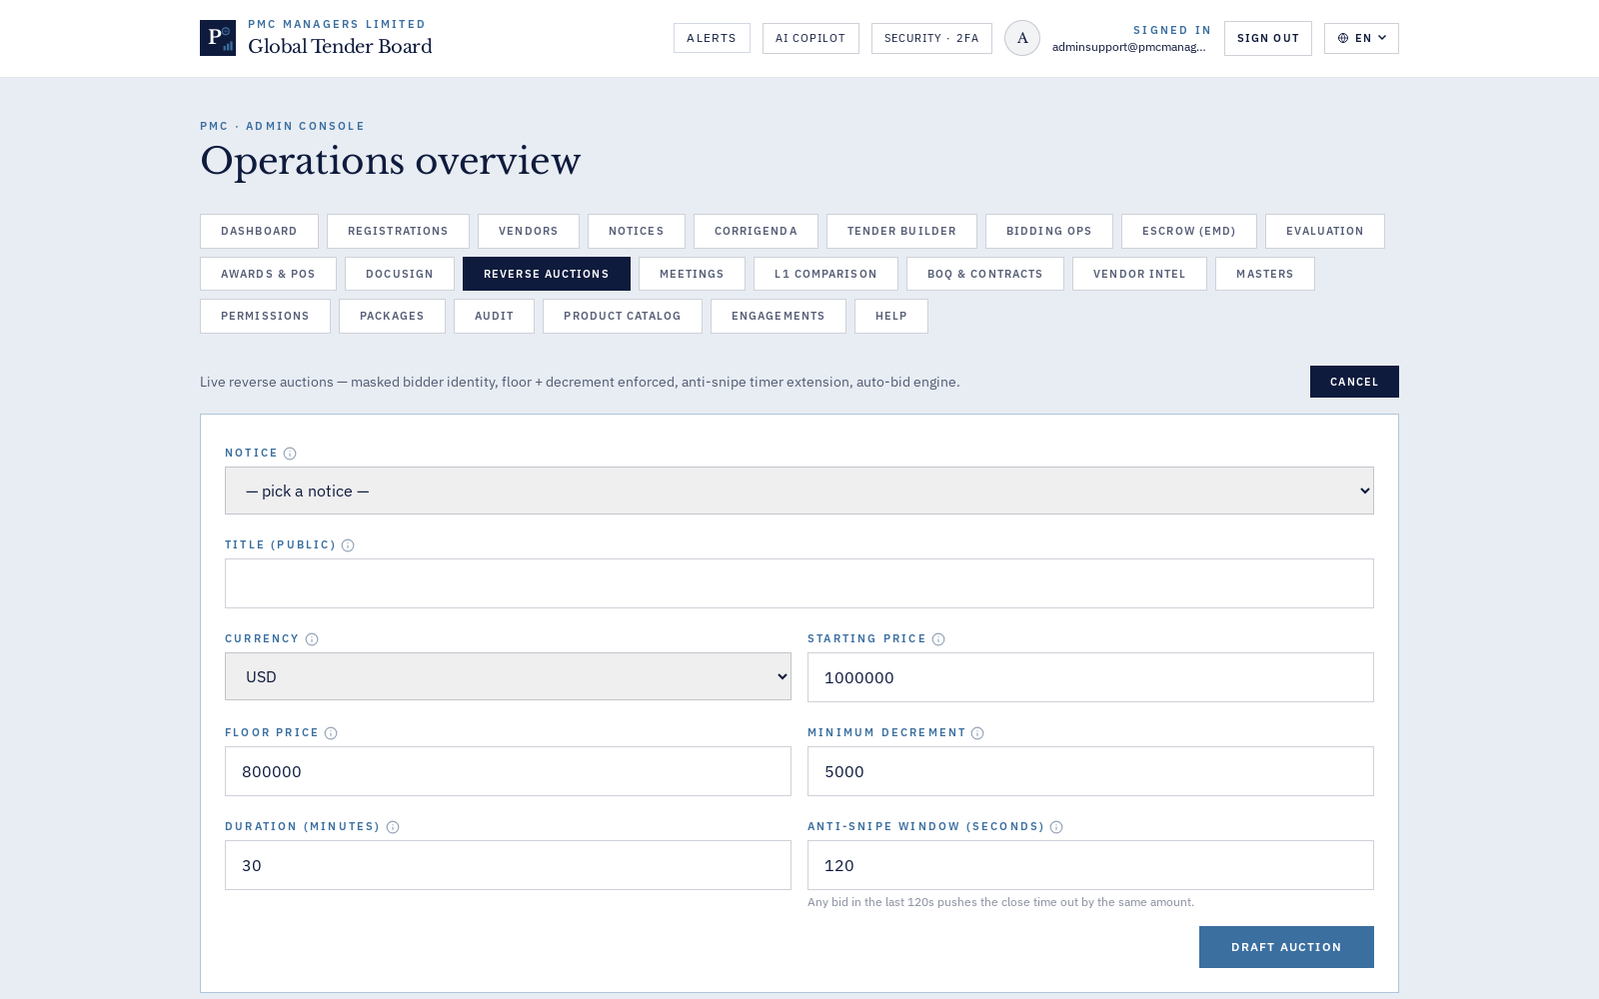
admin-auctions-new-form

1. Open a new auction room
When to use: Post commercial evaluation, when you want to squeeze the final price.
Steps
- Click **NEW ROOM**.
- Enter notice ref, reserve price, step size, duration.
- Pick invited vendors (multi-select).
- Click **OPEN ROOM**.
Expected result: Room appears with status `scheduled` and a shareable joining URL per vendor.
Controls & fields
- Reserve price: Starting cap; bids must be ≤ current best minus step.
- Step size: Minimum decrement between bids.
- Duration: Timer with auto-extension when a bid lands in the last 60 sec.
Common errors & fixes
- HTTP 400 — Reserve must be > 0
Fix: Set a positive reserve price.

2. Close an active room
When to use: Timer expired or you want to end early.
Steps
- Click **CLOSE ROOM**.
- Confirm — final winner is the lowest bid.
- The room state is frozen; export the transcript from **DOWNLOAD LOG**.
Expected result: Status flips to `closed`; audit trail exported as CSV.

Meetings
Surface: admin
URL path: /admin?tab=meetings
Purpose: Meetings schedules pre-bid, technical clarification, and commercial opening calls — auto-creates Zoom join URLs + email invites (via Resend). Each meeting is bound to a notice_ref so the minutes become part of the audit trail.
Prerequisites
- Zoom OAuth app + JWT credentials in Secrets
- Admin login
Per-modal screenshots (v43)
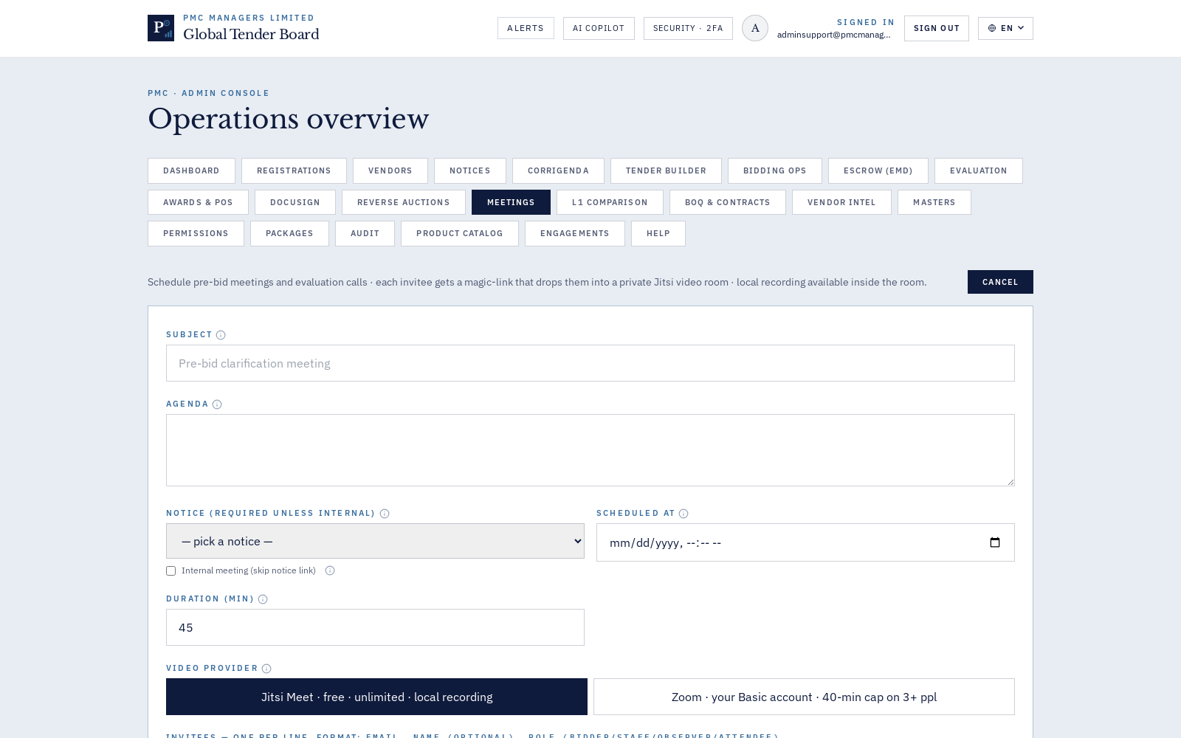
admin-meetings-new-form

1. Schedule a meeting
When to use: Pre-bid clarification session or bid opening.
Steps
- Click **NEW MEETING**.
- Fill title, notice ref, type, start time, duration.
- Add attendees (email list).
- Click **SCHEDULE**.
Expected result: Zoom URL generated; invites go out within 60 sec.
Controls & fields
- Type: pre_bid · technical · commercial · debrief.
Common errors & fixes
- HTTP 502 — Zoom API unauthorised
Fix: Regenerate the Zoom JWT + update Secrets.

2. Attach minutes-of-meeting
When to use: Post-meeting, before archival.
Steps
- Open the meeting row.
- Upload the MoM PDF.
- Click **SAVE**.
Expected result: MoM link appears; audit trail records upload.

L1 Comparison
Surface: admin
URL path: /admin?tab=l1
Purpose: L1 Comparison presents a side-by-side ranked view of all shortlisted bids for a notice: L1 (lowest), L2, L3 with their commercial + technical scores and deviations. Master Admins use this before issuing the award.
Prerequisites
- Commercial envelope opened for the notice
Per-modal screenshots (v43)
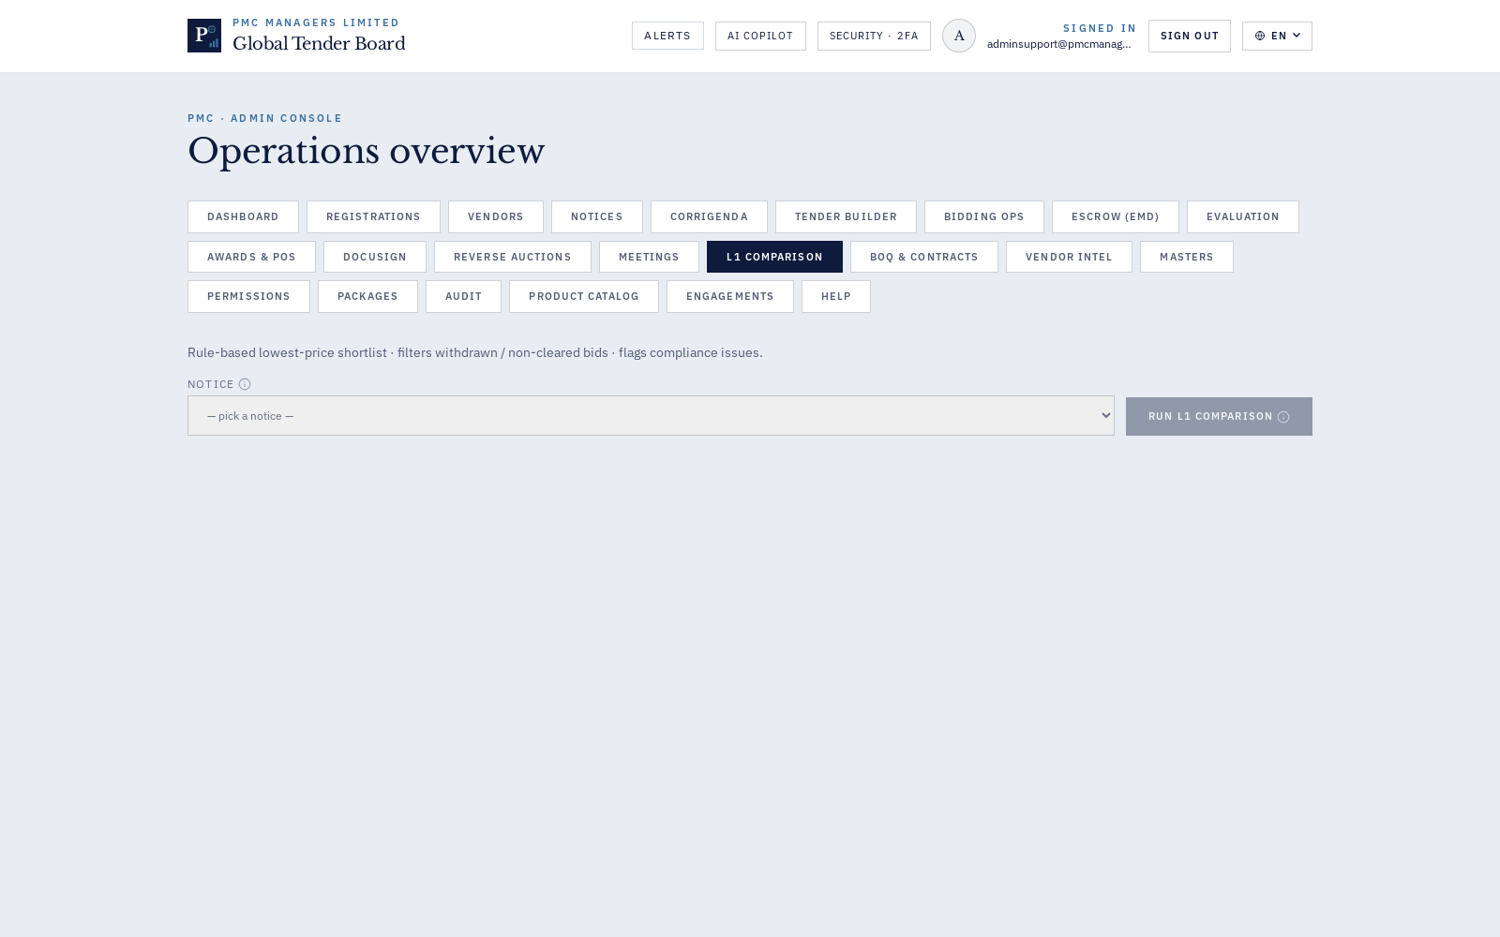
admin-l1-idle

1. Compare shortlisted bids
When to use: Award decision meeting.
Steps
- Enter notice ref.
- The comparison table renders bidders sorted by commercial ascending.
- Click any row to see the full bid details.
Expected result: Table shows: rank, vendor, commercial, technical, weighted, delta vs L1.
Controls & fields
- Export CSV: Download the comparison for the tender file.

BOQ & Contracts
Surface: admin
URL path: /admin?tab=boq
Purpose: The BOQ (Bill of Quantities) editor manages line-item pricing against active contracts. Track quantities, unit rates, variations, and running totals. Used by the Accounting team for progressive certification.
Prerequisites
- Active contract (from Awards)
- Accounting or Admin login
Per-modal screenshots (v43)
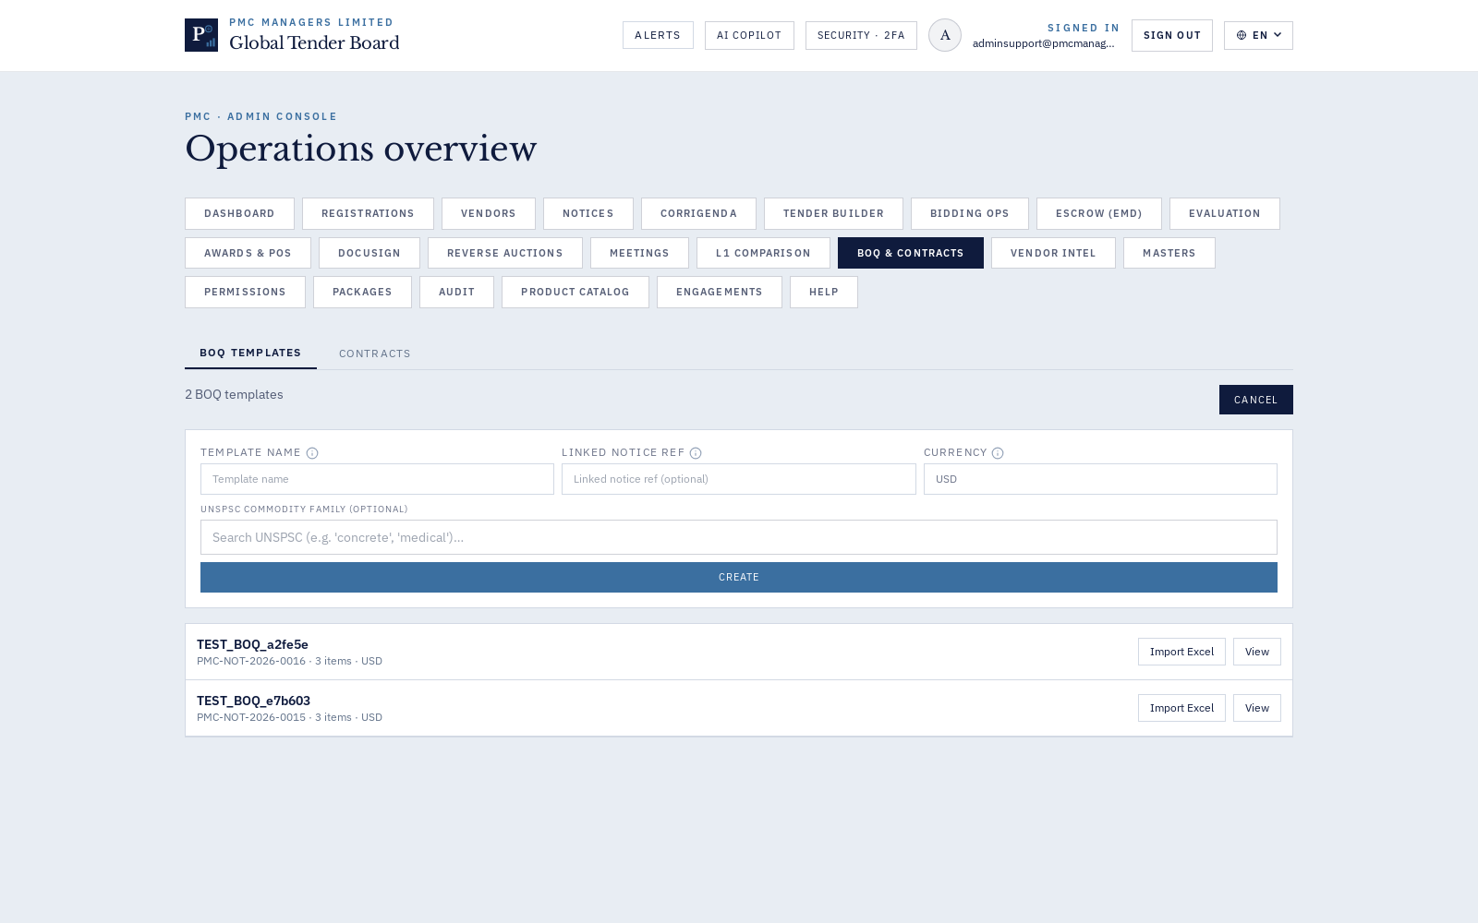
admin-boq-new-template-form

1. Add a BOQ line
When to use: Introducing a new billable item to the contract.
Steps
- Open the contract.
- Click **ADD LINE**.
- Fill item code, description, unit, rate, quantity.
- Click **SAVE**.
Expected result: Line total auto-computes; contract running total updates.
Controls & fields
- Item code: Optional but drives grouping in reports.
Common errors & fixes
- HTTP 422 — Quantity must be >= 0
Fix: Zero is allowed for placeholder lines; negatives are not.

2. Certify a progress claim
When to use: Contractor submits a monthly progress claim.
Steps
- Enter claimed % per line.
- Total certified value auto-calculates.
- Click **CERTIFY** to lock the claim.
Expected result: Certified snapshot stored; contract accrual updates.

Vendor Intel
Surface: admin
URL path: /admin?tab=vintel
Purpose: Vendor Intel provides ratings, watch-list, and blacklist management across the supplier base. Anonymised entries appear as '—' for confidentiality. Bug #84: table wraps in `overflow-x-auto` for mobile viewports.
Prerequisites
- Admin login
Per-modal screenshots (v43)
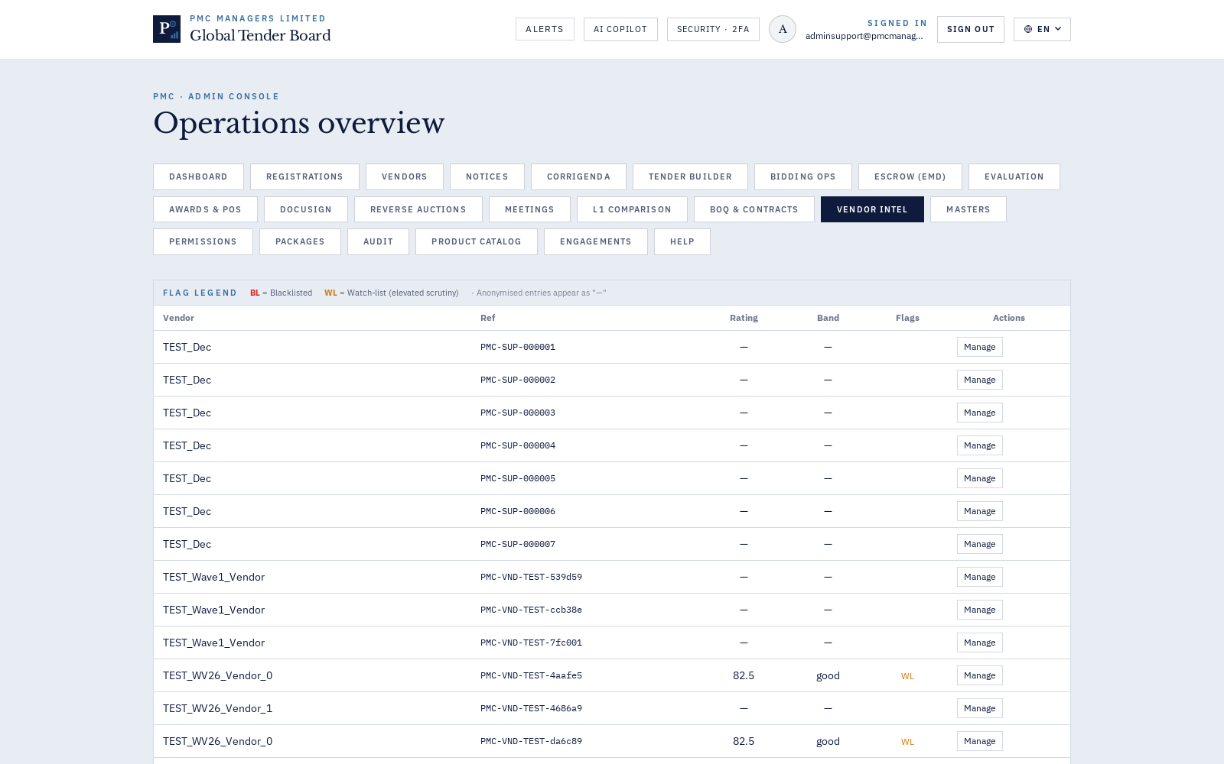
admin-vintel-idle

1. Rate a vendor
When to use: Post-contract review, or after a quality incident.
Steps
- Locate the vendor row.
- Click **MANAGE**.
- Enter score (0–100) and pick a band (A/B/C/D).
- Click **SAVE RATING**.
Expected result: Rating saved; vendor sort order reflects new score.
Controls & fields
- Score: 0-100. Feeds award weightings.
- Band: Grouping label for shortlist filters.

2. Blacklist a vendor
When to use: Serious governance/quality failure.
Steps
- Open the vendor's manage modal.
- Enter a blacklist reason (required).
- Click **BLACKLIST**.
Expected result: Vendor row shows red **BL** flag; blocked from future bidding.
Common errors & fixes
- Reason required — Blacklist reason must be provided
Fix: Type a non-empty reason before submitting.

Masters
Surface: admin
URL path: /admin?tab=masters
Purpose: Masters is the reference-data hub: sectors, entity types, KZ licenses, country meta, currency lists. Changes here cascade immediately to every registration/vendor/notice form.
Prerequisites
- Master Admin login
Per-modal screenshots (v43)
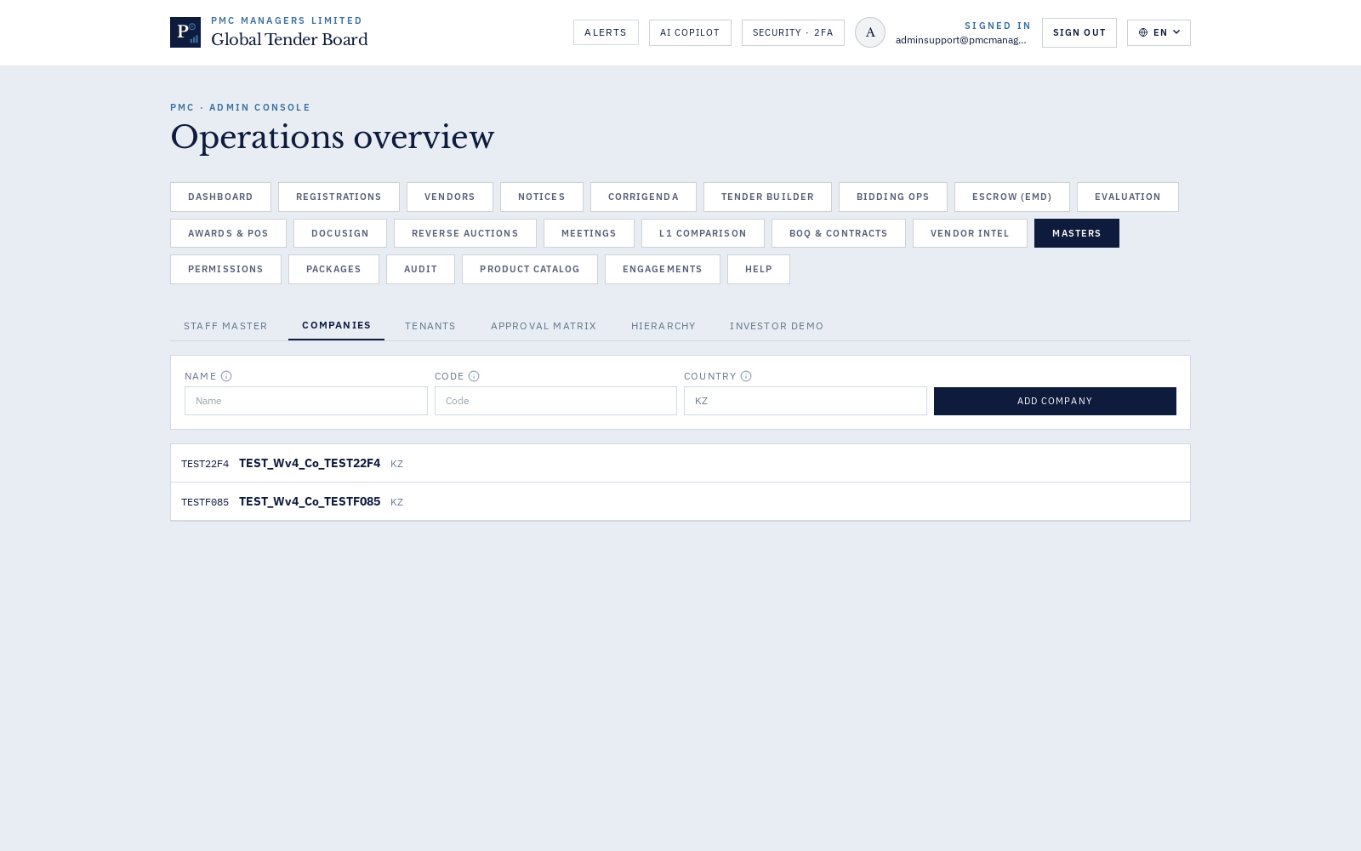
admin-masters-companies
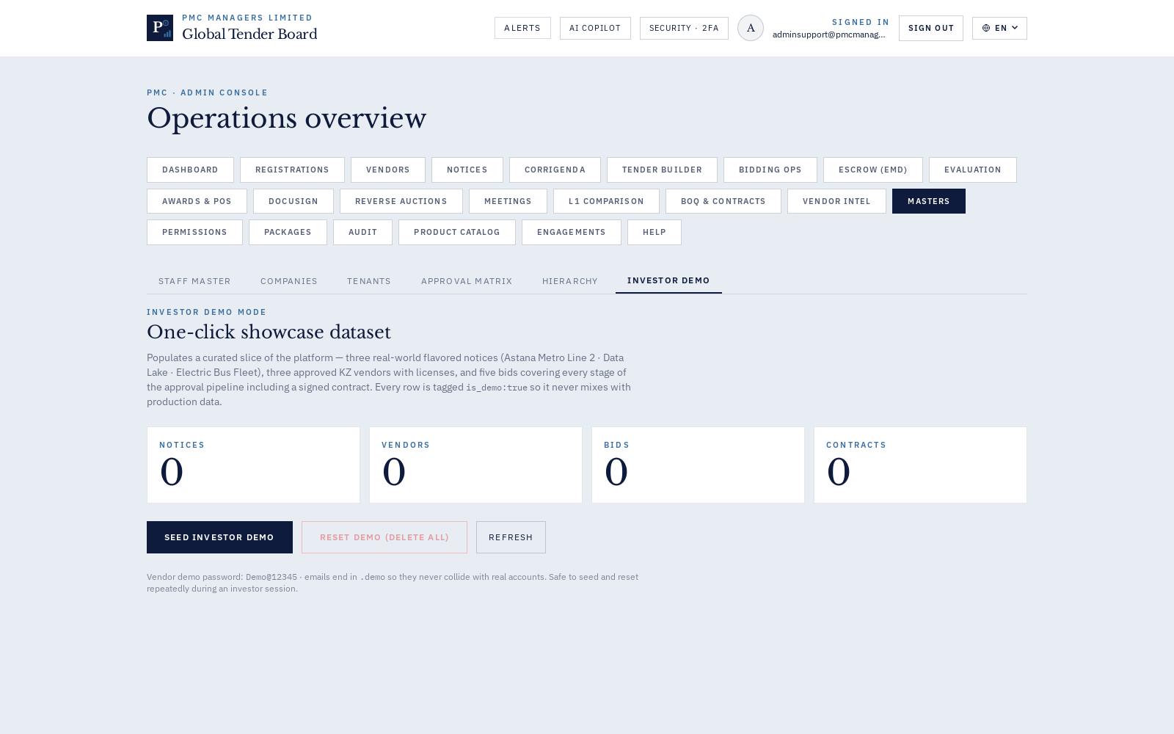
admin-masters-demo
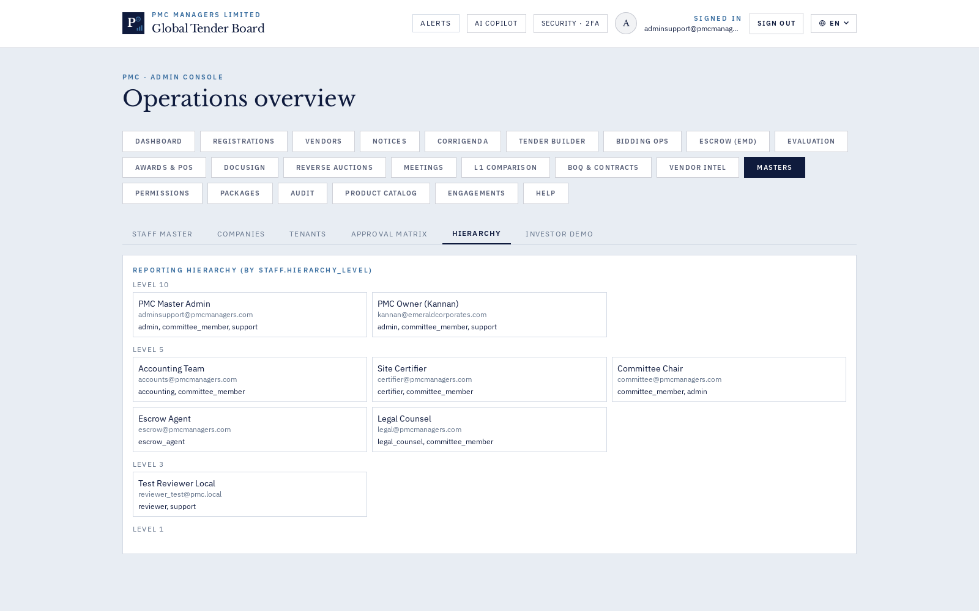
admin-masters-hierarchy
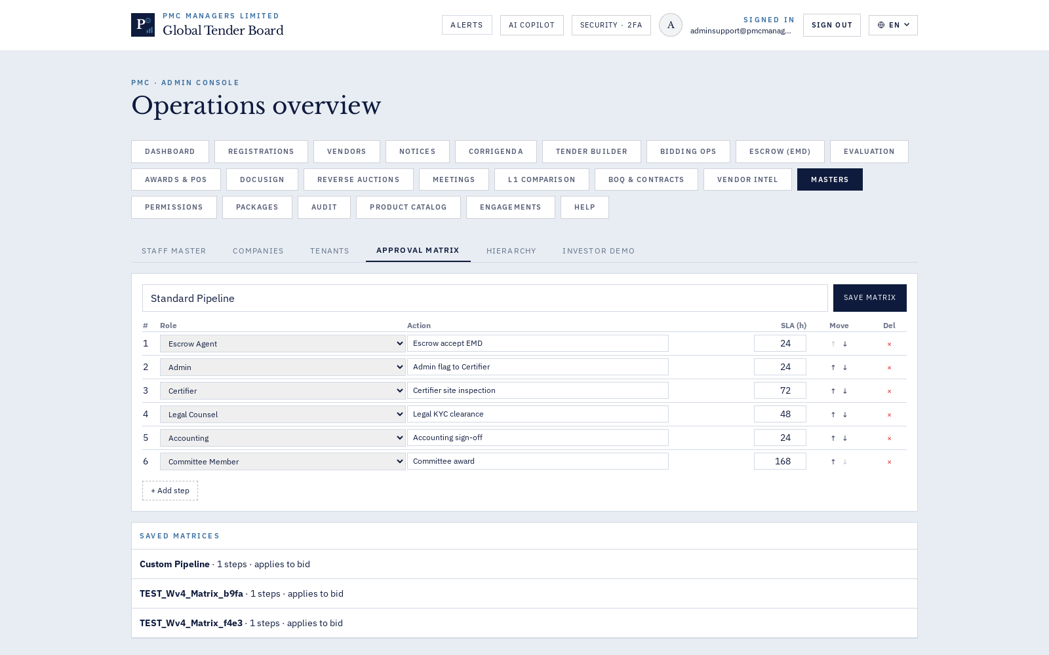
admin-masters-matrix
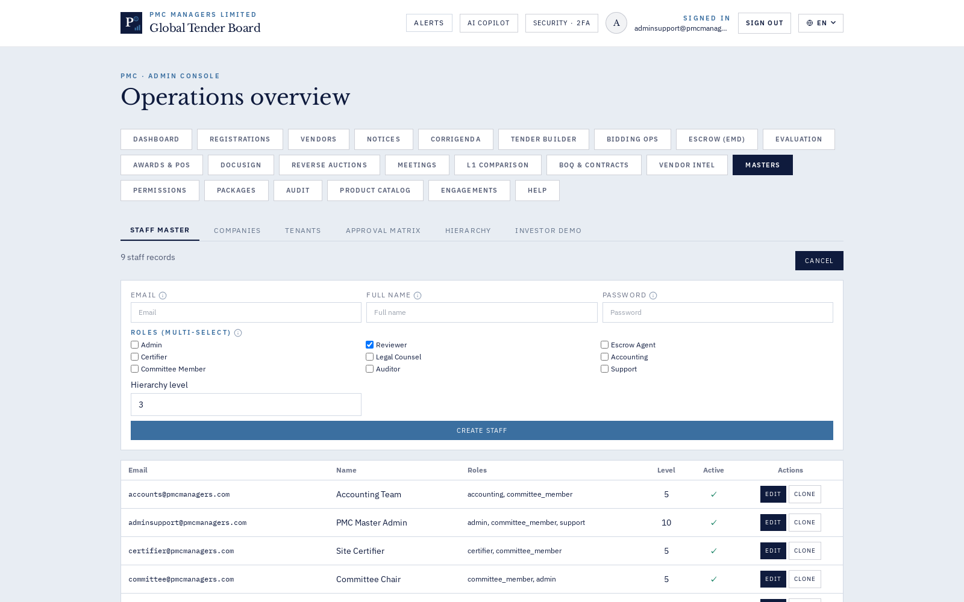
admin-masters-staff-form
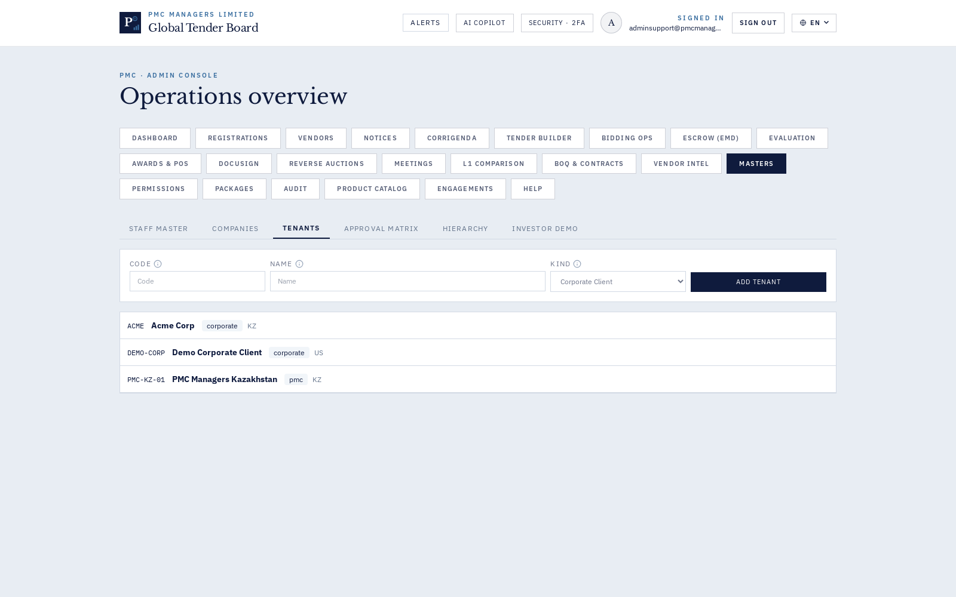
admin-masters-tenants

1. Add a new primary sector
When to use: Onboarding a new industry category.
Steps
- Go to the Sectors sub-tab.
- Click **ADD SECTOR**.
- Enter code, name (EN/RU/KK).
- Save.
Expected result: Sector appears in the dropdowns app-wide.
Common errors & fixes
- HTTP 409 — Sector code already exists
Fix: Codes must be unique. Use ISO codes when possible.

Permissions
Surface: admin
URL path: /admin?tab=permissions
Purpose: Permissions manages the role-to-capability matrix and admin user seats. Roles: admin, master_admin, reviewer, committee_member, certifier, legal, accounting, escrow_agent. Only Master Admin can grant new seats.
Prerequisites
- Master Admin login
Per-modal screenshots (v43)
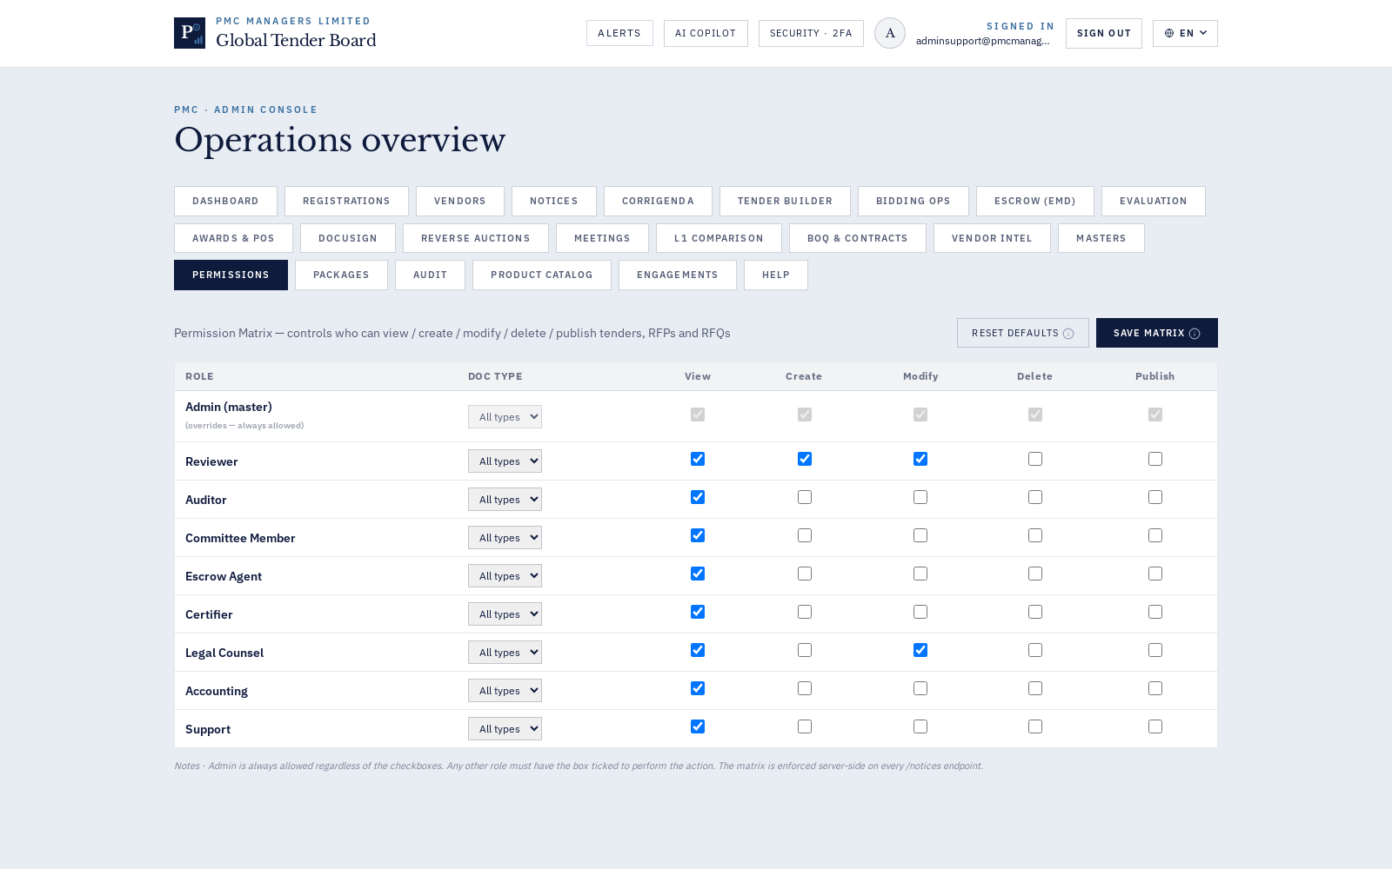
admin-permissions-idle

1. Invite a new admin user
When to use: Onboarding a new PMC operator.
Steps
- Click **INVITE ADMIN**.
- Enter email + choose role.
- Click **SEND INVITE**.
Expected result: Email invite sent via Resend with a magic-link to set password + 2FA.
Common errors & fixes
- HTTP 409 — Admin with this email already exists
Fix: Edit the existing user's role rather than duplicating.

Packages
Surface: admin
URL path: /admin?tab=packages
Purpose: Packages tracks the Kazakhstan Integrated Development Programme work packages — cross-notice roll-up view of budget, timeline, and contractor. Filter by region, sector, status.
Prerequisites
- Admin login
Per-modal screenshots (v43)
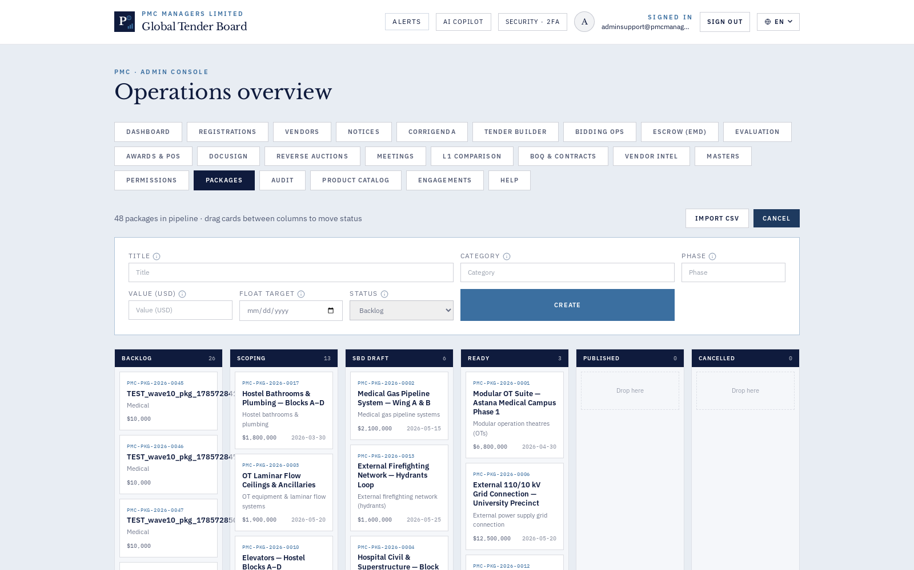
admin-packages-new-form

1. Open a package detail
When to use: Reviewing a package's full lifecycle.
Steps
- Click the package row.
- Right pane shows notices, awards, contractors, budget consumed.
Expected result: Detail view opens instantly.
Controls & fields
- Filters: Region · Sector · Status.

Audit
Surface: admin
URL path: /admin?tab=audit
Purpose: Audit is the immutable, tamper-evident trail of every state-changing action on the platform. Filter by actor email, entity type, entity ID, event kind, or time window. Export to CSV for regulator submissions.
Prerequisites
- Admin login
Per-modal screenshots (v43)
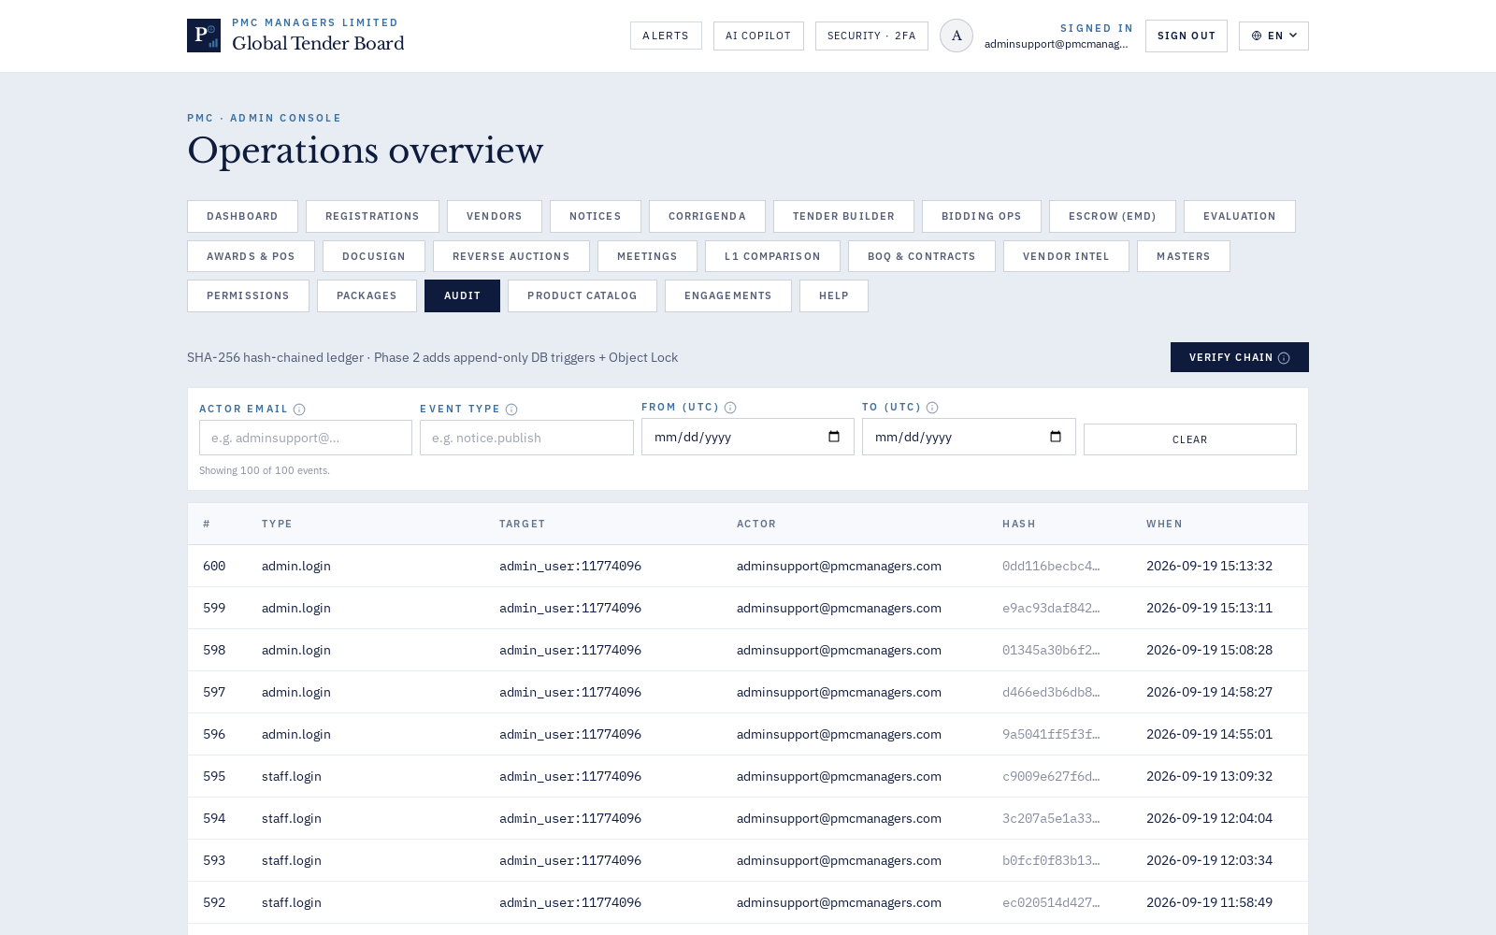
admin-audit-filter-focus

1. Query the audit log
When to use: Investigating a support ticket or preparing an audit response.
Steps
- Set filters (actor, entity, from/to date).
- Click **RUN QUERY**.
- Results paginate at 100 rows.
Expected result: Table populates; each row is expandable to show the diff.
Controls & fields
- Event kind: created · updated · deleted · signed · released · dissolved · ...

2. Export audit log as CSV
When to use: Providing evidence to an external regulator.
Steps
- Set filters.
- Click **EXPORT CSV**.
Expected result: CSV downloads with every filtered row + full diff.

Product Catalog
Surface: admin
URL path: /admin?tab=catalog
Purpose: Product Catalog manages the SaaS product line: subscription tiers, one-off setup fees, add-ons. Every product ties to a Stripe price ID; checkout links can be generated for direct-to-buyer sales.
Prerequisites
- Stripe test/live keys configured
- Master Admin login
Per-modal screenshots (v43)
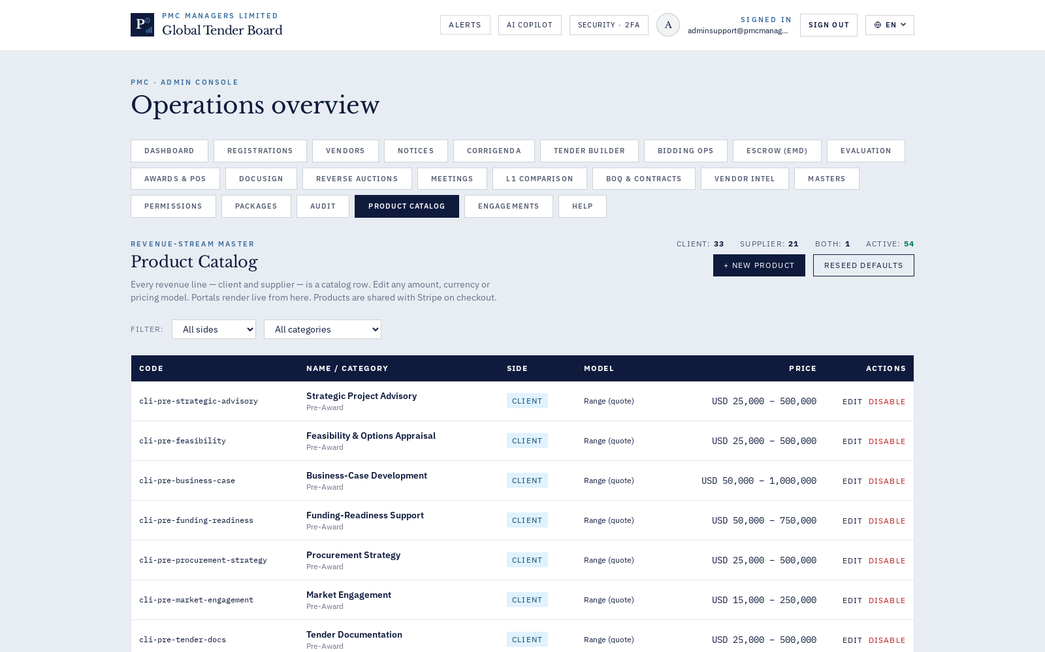
admin-catalog-idle

1. Add a new product
When to use: Launching a new SaaS tier or add-on.
Steps
- Click **NEW PRODUCT**.
- Fill name, description, price, currency.
- Stripe price is auto-created via the API.
- Click **SAVE**.
Expected result: Product visible in the checkout catalog; Stripe price_id captured.
Controls & fields
- Price: Cents. Auto-multiplied for KZT (100x).
- Recurring: One-time · monthly · yearly.
Common errors & fixes
- Stripe 401 — Invalid API key
Fix: Update the STRIPE_API_KEY secret and restart the backend.

Engagements
Surface: admin
URL path: /admin?tab=engagements
Purpose: Engagements is the consulting / advisory quote pipeline. Track leads, sent quotes, signed engagements, and revenue recognition. Feeds the CFO dashboard.
Prerequisites
- Sales/Master Admin login
Per-modal screenshots (v43)
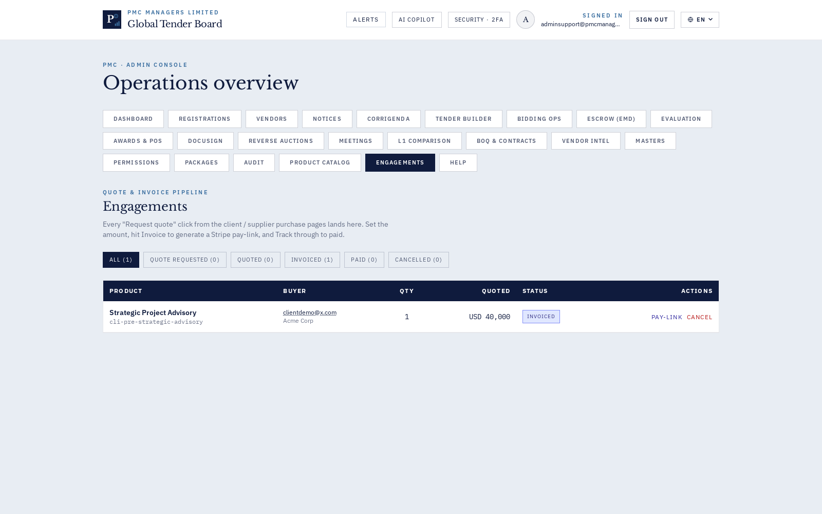
admin-engagements-idle

1. Send a new quote
When to use: Prospect responded to an intro call.
Steps
- Click **NEW QUOTE**.
- Fill client, scope, value, delivery date.
- Click **SEND**.
Expected result: Quote PDF emailed to the client; row appears with status `sent`.
Common errors & fixes
- HTTP 422 — Value must be > 0
Fix: Set a positive quote value.

2. Mark quote as signed
When to use: Client returns the counter-signed quote.
Steps
- Locate row.
- Click **MARK SIGNED**.
- Upload the signed PDF.
Expected result: Status flips to `signed`; revenue schedule created.

Vendor Portal
Surface: vendor
URL path: /vendor
Purpose: The Vendor Portal is the bidder-facing surface. After email verification, vendors browse notices, submit bids (with EMD), e-sign signatures via DocuSign, and export their data (GDPR request). All bidder actions are audit-logged.
Prerequisites
- Verified vendor account

1. Submit a bid
When to use: Notice is open and the vendor is pre-qualified.
Steps
- Log in at `/vendor`.
- Open the notice detail.
- Click **SUBMIT BID**.
- Fill technical + commercial forms.
- Attach documents (technical proposal, priced BOQ, EMD receipt).
- Pay EMD via Stripe checkout (or upload wire receipt).
- Click **SUBMIT**.
Expected result: Bid row appears with status `submitted`. Admin is notified.
Controls & fields
- EMD payment: Stripe or wire. Wire requires reference upload.
- Documents: PDFs only, ≤ 25 MB each.
Common errors & fixes
- HTTP 409 — Bid already submitted for this notice
Fix: One bid per vendor per notice. Withdraw the current bid first if you need to resubmit.

2. Request a GDPR data export
When to use: Vendor exercises data-portability rights.
Steps
- Click **GDPR** in the sidebar.
- Click **REQUEST EXPORT**.
Expected result: Email with a download link arrives within 24 h; ZIP contains all bids + registration + audit.

3. E-sign a contract via DocuSign
When to use: Awarded bidder receives the PO envelope.
Steps
- Click the DocuSign link in the email.
- Review the PO PDF.
- Click **SIGN**.
- Return to the portal — signature status refreshes automatically.
Expected result: Envelope status flips to `completed`. Signed PDF downloadable from the awards tile.

Staff Portal
Surface: staff
URL path: /staff
Purpose: The Staff Portal serves the specialised staff roles: certifier (site inspections), legal (contract review), accounting (invoice posting), escrow_agent (dual-signature releases), committee (evaluation scoring). Each role sees a role-specific dashboard.
Prerequisites
- Staff account with a specialised role

1. Certifier — record an inspection
When to use: Site visit is complete.
Steps
- Log in as certifier at `/staff`.
- Open the assigned inspection card.
- Fill findings (pass/fail per checkpoint).
- Upload photos.
- Click **SUBMIT REPORT**.
Expected result: Bid moves from `certifier_review` to `legal_review`.
Controls & fields
- Checkpoints: Predefined per notice type.

2. Legal — clear a bid
When to use: Certifier report is in, contract review complete.
Steps
- Log in as legal.
- Open the bid.
- Tick the mandatory checklist (T&C compliance, sanctions screening).
- Click **CLEAR**.
Expected result: Bid moves to `accounting_review`.

Registration Portal
Surface: registration
URL path: /register
Purpose: The public Registration Portal walks a supplier through the 5-section onboarding form (Section A → E). Drafts auto-save every 10 seconds; a resume token is emailed so applicants can pick up later. Bug #30 added client-side email + phone regex validators.
Prerequisites
- Public — no login required

1. Start a new registration
When to use: Supplier wants to be listed for tender participation.
Steps
- Open `/register`.
- Enter email + company name.
- Click **START**. A resume token is emailed.
- Fill Section A (company details), B (contacts), C (categories), D (KZ licenses), E (bank + declarations).
- Attach mandatory documents.
- Click **SUBMIT** at the end.
Expected result: Submission appears in Admin → Registrations under `submitted` status.
Controls & fields
- Contact email: Bug #30: inline validation (`name@company.com`).
- Contact phone: Bug #30: digits + `+`/spaces/hyphens, 7–20 chars.
Common errors & fixes
- HTTP 422 — Enter a valid email like name@company.com
Fix: Correct the email format before proceeding.

2. Resume a saved draft
When to use: Applicant closed the browser and wants to continue.
Steps
- Click the resume link in the email (or enter the token at `/register/resume`).
Expected result: Draft opens at the last completed section.
Common errors & fixes
- HTTP 410 — Resume token expired
Fix: Ask Admin to nudge / re-send the resume email from the Registrations panel.

Public Notice Board
Surface: public
URL path: /
Purpose: The public homepage anonymous browsing of open tender notices, filtered by type (tender/rfp/rfq) and country. Each notice card links to a detail page with attachments, Q&A thread, and a call-to-register CTA.
Prerequisites
- Public — no login required

1. Browse open tenders
When to use: Any visitor.
Steps
- Open `/`.
- Filter by type / country using the chip toolbar.
- Click a notice card to open the detail page.
Expected result: Notices list refreshes instantly; detail page shows title, description, attachments, Q&A.
Controls & fields
- Type filter: All · Tender · RFP · RFQ.
- Country filter: ISO alpha-2. Global tenders shown regardless.

2. Ask a public Q&A question
When to use: Prospective bidder needs clarification.
Steps
- Open a notice detail.
- Scroll to the **Q&A** section.
- Enter your question + your email.
- Click **ASK**.
Expected result: Question appears in a moderation queue; Admin reply becomes public.

Committee Accept Portal
Surface: magic
URL path: /committee-accept/
Purpose: External committee invitees (independent experts, industry advisers) accept or decline their invitation without a full staff account. Uses a signed magic-link token; the acceptance is audit-logged.
Prerequisites
- Magic-link URL from Bidding Ops → Form Committee

1. Accept the committee invitation
When to use: Invitee opens the magic-link URL.
Steps
- Click the emailed link.
- Review the committee scope (notice ref, chairperson, other members).
- Click **ACCEPT**.
Expected result: Row on Admin's committee card flips to `accepted`.
Common errors & fixes
- HTTP 410 — Token expired
Fix: Admin re-issues the invite from Bidding Ops → committee card → **Resend**.

2. Decline the invitation
When to use: Invitee has a conflict.
Steps
- Click **DECLINE** and provide a short reason.
Expected result: Row flips to `declined`.

Escrow Officer Portal
Surface: magic
URL path: /escrow/officer/
Purpose: External escrow trustees (bank officers) sign release actions via a signed magic-link — no staff account needed. Introduced in Bug #9c to fix the governance gap where the same email was on both sides of a joint account.
Prerequisites
- Magic-link URL from `POST /api/v1/escrow/magic-tokens`

1. Trustee signs a release
When to use: PMC officer has signed; awaiting trustee.
Steps
- Open the magic-link URL.
- Review the account + pending transaction.
- Click **SIGN · RELEASE TO CONTRACTOR**.
Expected result: PMC officer sees both signatures; Release button unlocks.
Common errors & fixes
- HTTP 409 — This joint escrow account has the SAME email on both officers
Fix: Not applicable via magic-link — Admin must edit the account first (see Escrow module).

Appendix A — Live URLs
- Public notice board: https://www.pmcmanagers.com/
- Registration portal: https://www.pmcmanagers.com/register
- Admin console: https://www.pmcmanagers.com/admin
- Vendor portal: https://www.pmcmanagers.com/vendor
- Staff portal: https://www.pmcmanagers.com/staff

