PMC Managers · v46m Master Training Manual
PMC Managers Limited · Confidential · v46m · September 2026

1 · Platform overview & architecture
This manual is the authoritative operator handbook for the PMC Managers Sovereign Tender Board, version 46m (Sep 2026). It walks every role through every screen with annotated screenshots, field-by-field guidance, known-gotcha callouts, and end-to-end workflow narratives. Use it as the primary onboarding pack for new admins, agents, partners, management, escrow officers and vendors.
1. Platform overview & architecture
2. Roles at a glance (12-role matrix)
3. Security, audit & data-protection
4. Public visitor journey
5. Vendor / supplier journey
6. Admin console — full module tour
7. Deep-dive: Tender Builder & AI DPR (v46l map-reduce)
8. Deep-dive: Evaluation, awards & escrow
9. Deep-dive: Reverse auctions
10. Tooltip, error-handling & offline system
11. Deployment runbook (S3 + CloudFront + EB)
12. Troubleshooting playbook
13. API reference index
14. Release history
15. Glossary & appendix
The PMC platform is a multi-role tender lifecycle engine covering the full path from notice publication → registration → bidding → EMD → evaluation → award → e-signature → invoicing → post-contract audit. It is delivered as a React single-page app backed by a FastAPI service and MongoDB, with same-origin cookie-based sessions and CSRF double-submit tokens.
**Frontend** — React SPA served from S3 + CloudFront. Sovereign navy/gold editorial design system with Libre Baskerville + IBM Plex fonts. Routing via React Router; state via Context (i18n, auth) + local component state.
**Backend** — FastAPI on AWS Elastic Beanstalk (Docker running on 64-bit Amazon Linux 2). All routes prefixed `/api/v1/…`. Auth realm split into admin, staff and vendor with per-realm login endpoints and cookie names.
**Data** — MongoDB via Motor (async driver). Collections include tenants, notices, tender_templates, registrations, vendors, bids, rubrics, scores, evaluations, awards, escrow_transactions, auctions, corrigenda, audits, ratings, engagements, packages, categories, countries, dpr_jobs.
**AI** — Managed AI Gateway (universal LLM key) routed through the integration proxy. Used for DPR ingestion (map-reduce), AI Fill All, anomaly detection and the admin copilot. v46l lifts the 800 KB cap and adds an async worker.
**Storage** — S3 for licences, tender attachments, signed PDFs, archived auction rooms. CloudFront in front for global CDN.
**Notifications** — Resend (email), planned Firebase/APNs (mobile push).
**Payments** — Stripe (test + live keys separated); Kaspi + PayPal on the roadmap.
**E-signature** — DocuSign envelope templates + status webhooks.
**Observability** — Structured logs via Python logging, CloudWatch tail, audit_log() collection for every mutation, immutable time-stamped rows.
| Role | Portal | Scope |
|---|---|---|
| Admin | `/admin` | Full control of every module. |
| Management | `/staff` | Executive dashboards, committee outcomes, escrow financials. |
| Partner | `/staff` | GOC / Bank / Regulator — audit hooks and co-procurement dashboards. |
| Agent | `/staff` | Field-ops — draft tenders, review dossiers, publish corrigenda. |
| Reviewer | `/admin` | Read-only + evaluation scoring. |
| Escrow agent | `/staff` | EMD desk, forfeitures, refunds. |
| Certifier | `/staff` | Tender packet sign-off. |
| Legal counsel | `/staff` | Contract review, DocuSign envelope owner. |
| Accounting | `/staff` | Fee invoicing, refunds, reconciliation. |
| Committee member | `/staff` | Evaluation committee voting. |
| Auditor | `/admin (read)` | Full audit trail with entity filters. |
| Support | `/staff` | Vendor helpdesk, activation resends. |
| Vendor | `/vendor` | Bid on notices, manage profile & invoices. |
**Authentication** — Three cookie realms (admin_session, staff_session, vendor_session). HttpOnly, SameSite=Lax, Secure in production. CSRF double-submit token on every mutating request. Brute-force lockout after 5 failed attempts within 15 minutes.
**Authorisation** — `require_role(*roles)` dependency guards every mutating endpoint. Read endpoints use `current_admin` / `current_staff` / `current_vendor` for realm assertions. Role membership persists in the staff_users / admin_users / vendors collections with a versioned history so ACL changes are auditable.

2 · Roles at a glance
Role | Portal | Scope
Admin | /admin | Full control of every module.
Management | /staff | Executive dashboards, committee outcomes, escrow financials.
Partner | /staff | GOC / Bank / Regulator — audit hooks and co-procurement dashboards.
Agent | /staff | Field-ops — draft tenders, review dossiers, publish corrigenda.
Reviewer | /admin | Read-only + evaluation scoring.
Escrow agent | /staff | EMD desk, forfeitures, refunds.
Certifier | /staff | Tender packet sign-off.
Legal counsel | /staff | Contract review, DocuSign envelope owner.
Accounting | /staff | Fee invoicing, refunds, reconciliation.
Committee member | /staff | Evaluation committee voting.
Auditor | /admin (read) | Full audit trail with entity filters.
Support | /staff | Vendor helpdesk, activation resends.
Vendor | /vendor | Bid on notices, manage profile & invoices.

3 · Security, audit & data-protection
Auth: three cookie realms (admin, staff, vendor). HttpOnly, SameSite=Lax, Secure in production. CSRF double-submit on writes. Brute-force lockout after 5 attempts in 15 minutes.
Authorisation: require_role dependency guards every mutating endpoint.
Audit: every mutation writes to the immutable audits collection with actor + timestamp + JSON payload snapshot.
Data protection: private S3 bucket + pre-signed URLs for legal + licence docs. PII redacted in Auditor-role CSV exports.
Compliance: GDPR consent captured at registration; ESG questionnaire on the vendor profile.

4 · Public visitor journey

1 · Sovereign home — hero + live KPIs
The public landing page. Editorial navy/gold hero with a Libre Baskerville headline, three live KPI cards (Notices Published, Suppliers Approved, Work Packages), and three primary CTAs — View Open Notices, Register as Supplier, and the Portal Gateways link.
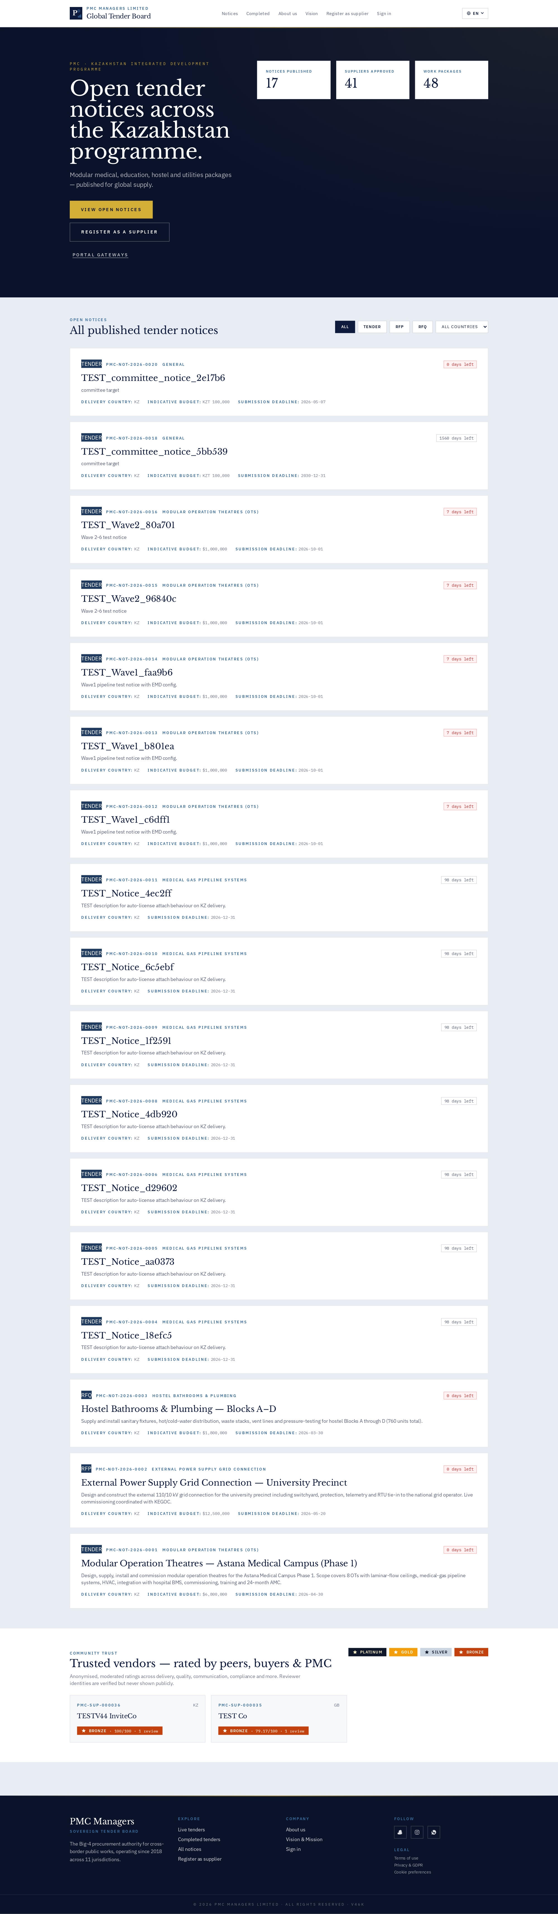

Purpose
The sovereign public entry. Establishes brand authority, states current scope (Kazakhstan Integrated Development), and exposes three live counters and three primary CTAs.

How the workflow unfolds
1) A prospective bidder lands from a Google search or a Snapchat post. 2) The live KPIs prove the platform has real, current activity. 3) They tap 'View Open Notices' to browse tenders or 'Portal Gateways' to sign in to their existing account.

Fields
- Kicker line — 'PMC Managers · Sovereign Gateway' — anchors the brand in an editorial serif register.
- Sovereign hero — Libre Baskerville headline, italic gold accent, IBM Plex Mono kicker — deliberately different from generic SaaS.
- KPI cards — Notices Published / Suppliers Approved / Work Packages — pulled live from /api/v1/meta/public/stats.
- Primary CTAs — View Open Notices (gold button), Register as Supplier (ghost button), Portal Gateways (underline link).

Known gotchas
- Counters cache in CloudFront for 60 s — a fresh notice may take up to a minute to appear.
- The hero background is a radial gold gradient at 8% opacity — do not brighten it or the serif headline loses contrast.

2 · Public notice board
The reverse-chronological list of every published notice. Fuzzy search, country/category filters, deadline chips and per-row EMD hints. This is the primary discovery surface for prospective bidders.
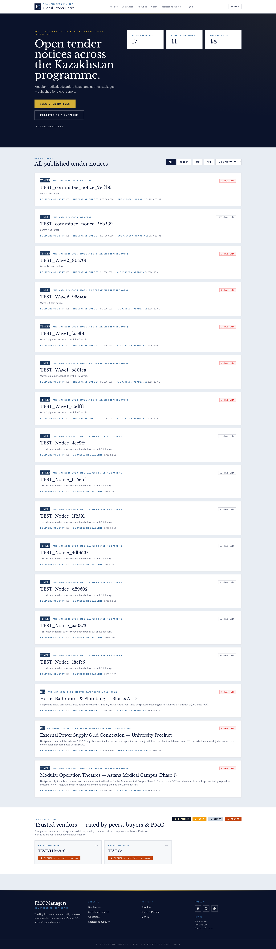

Purpose
The reverse-chronological list of every published notice. Primary discovery surface for bidders and researchers.

How the workflow unfolds
1) Enter a keyword or filter by country / category. 2) Review the card headline, deadline and EMD hint. 3) Click a row to open the full public detail page.

Fields
- Search box — Fuzzy match on title, description, country and category — server side.
- Country / Category filters — Backed by the same masters used in the admin console.
- Deadline chip — Turns red at T-24 h to create urgency.
- EMD hint — Shows the EMD amount or percentage inline so bidders can pre-arrange the deposit.

Known gotchas
- Deadlines display in the visitor's local timezone; the backend stores UTC ISO strings.

3 · Live tenders listing
All tenders currently open for bidding. Same card structure as the notice board with a countdown chip on each card driving urgency.
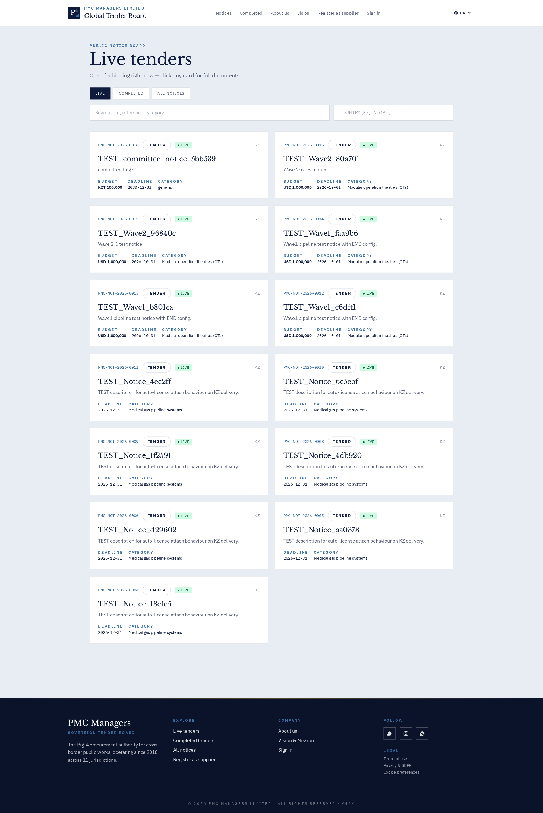

Purpose
Filter of the notice board scoped to tenders currently open for bidding.

How the workflow unfolds
Bidders check this daily; the URL is optimised for RSS and Snapchat spotlight posts.

Fields
- Countdown chip — Live H:MM:SS to submission deadline.
- Awarding authority — Small navy tag on each card.
- EMD hint — Percentage or absolute value inline.

Known gotchas
- If the counter reads 0 despite live data, force a CloudFront invalidation.

4 · Completed tenders
Public archive of every tender that has passed its submission deadline. Awards, final prices and winning bidders are shown once the award is finalised and cleared for publication.
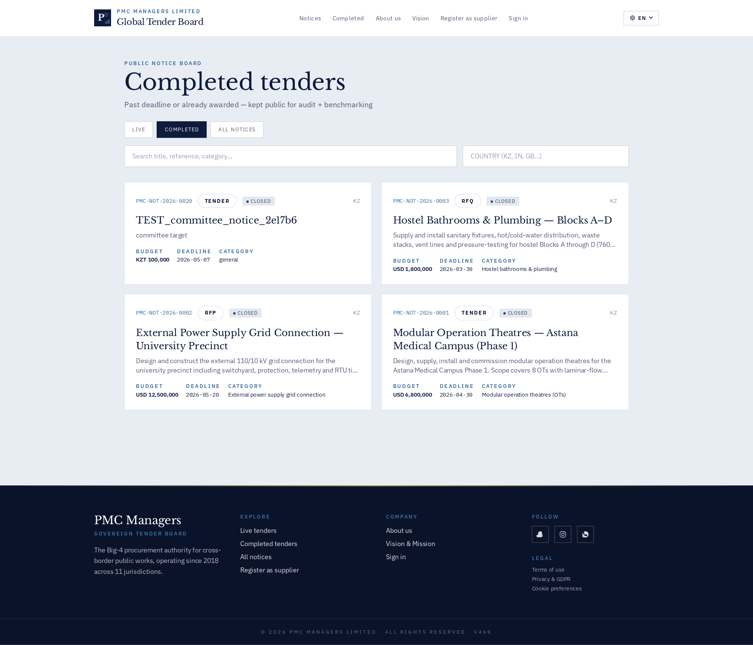

Purpose
Public archive of every tender past its submission deadline.

How the workflow unfolds
Journalists, auditors and inbound partners use this to audit PMC's throughput.

Fields
- Award column — Winning bidder + final price once award is finalised and cleared for publication.
- Signed award PDF — Downloadable letter of award.

Known gotchas
- A tender only appears here after the award is confirmed and legal has flipped the publish flag.

5 · All tenders — unified archive
The combined live + completed archive with a status filter. Used by researchers, auditors, and inbound partners doing due diligence on PMC.
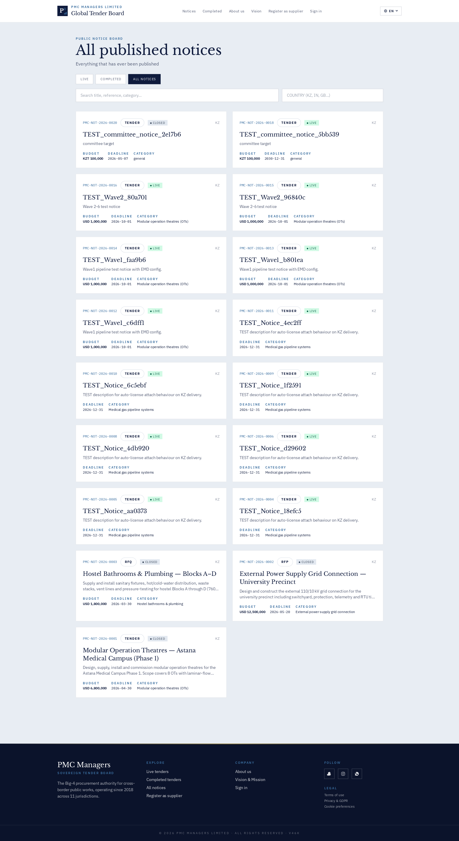

Purpose
The combined live+completed archive with a status filter.

How the workflow unfolds
Used by regulators, auditors and inbound partners doing due diligence on PMC.

Fields
- Status filter — Live / Completed / Cancelled / Withdrawn.
- Column sort — Deadline, budget, publish date, awarding authority.

Known gotchas
- Cancelled tenders keep their audit trail — never delete a notice, always withdraw it.

6 · About Us — company narrative
Editorial About page. Charter, milestones, leadership grid, sector coverage, and press quotes. All copy is content-managed via the notice-board CMS.
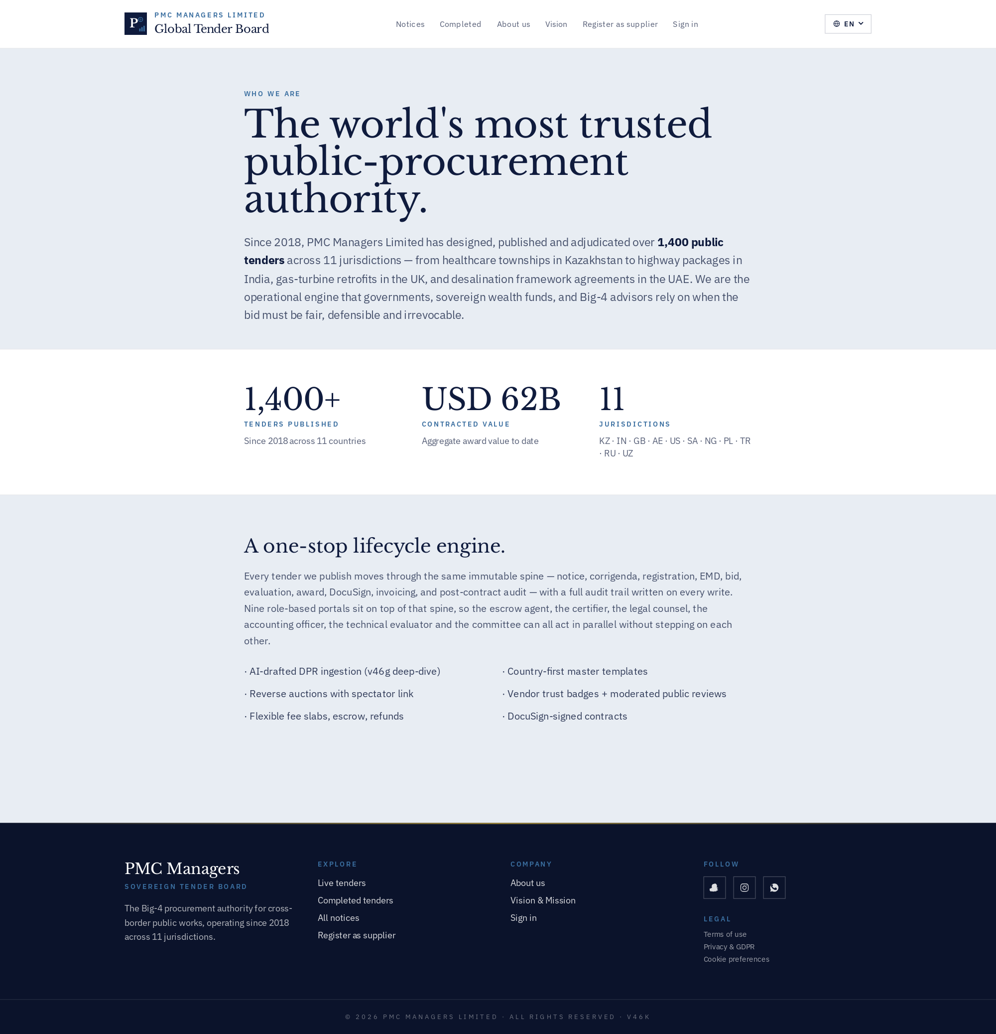

Purpose
Editorial About Us — company narrative, milestones, leadership grid, sector coverage, press quotes.

How the workflow unfolds
Marketing and BD share this URL with prospective GOC/Bank partners; it also drives Snapchat / Instagram profile clicks.

Fields
- Charter — One-paragraph mission statement — content-managed via CMS.
- Milestones — Chronological chips — feed this monthly during releases.
- Leadership grid — Portrait cards with role and short bio.
- Press quotes — Curated third-party validators.

Known gotchas
- Portraits should be square 512×512 PNGs sized ≤ 120 KB — larger images push the fold below the CTA.

7 · Vision & Mission
The strategic doctrine page — Vision, Mission, Values, and the North-Star KPIs the platform is optimised for. Used in tender-committee briefings.
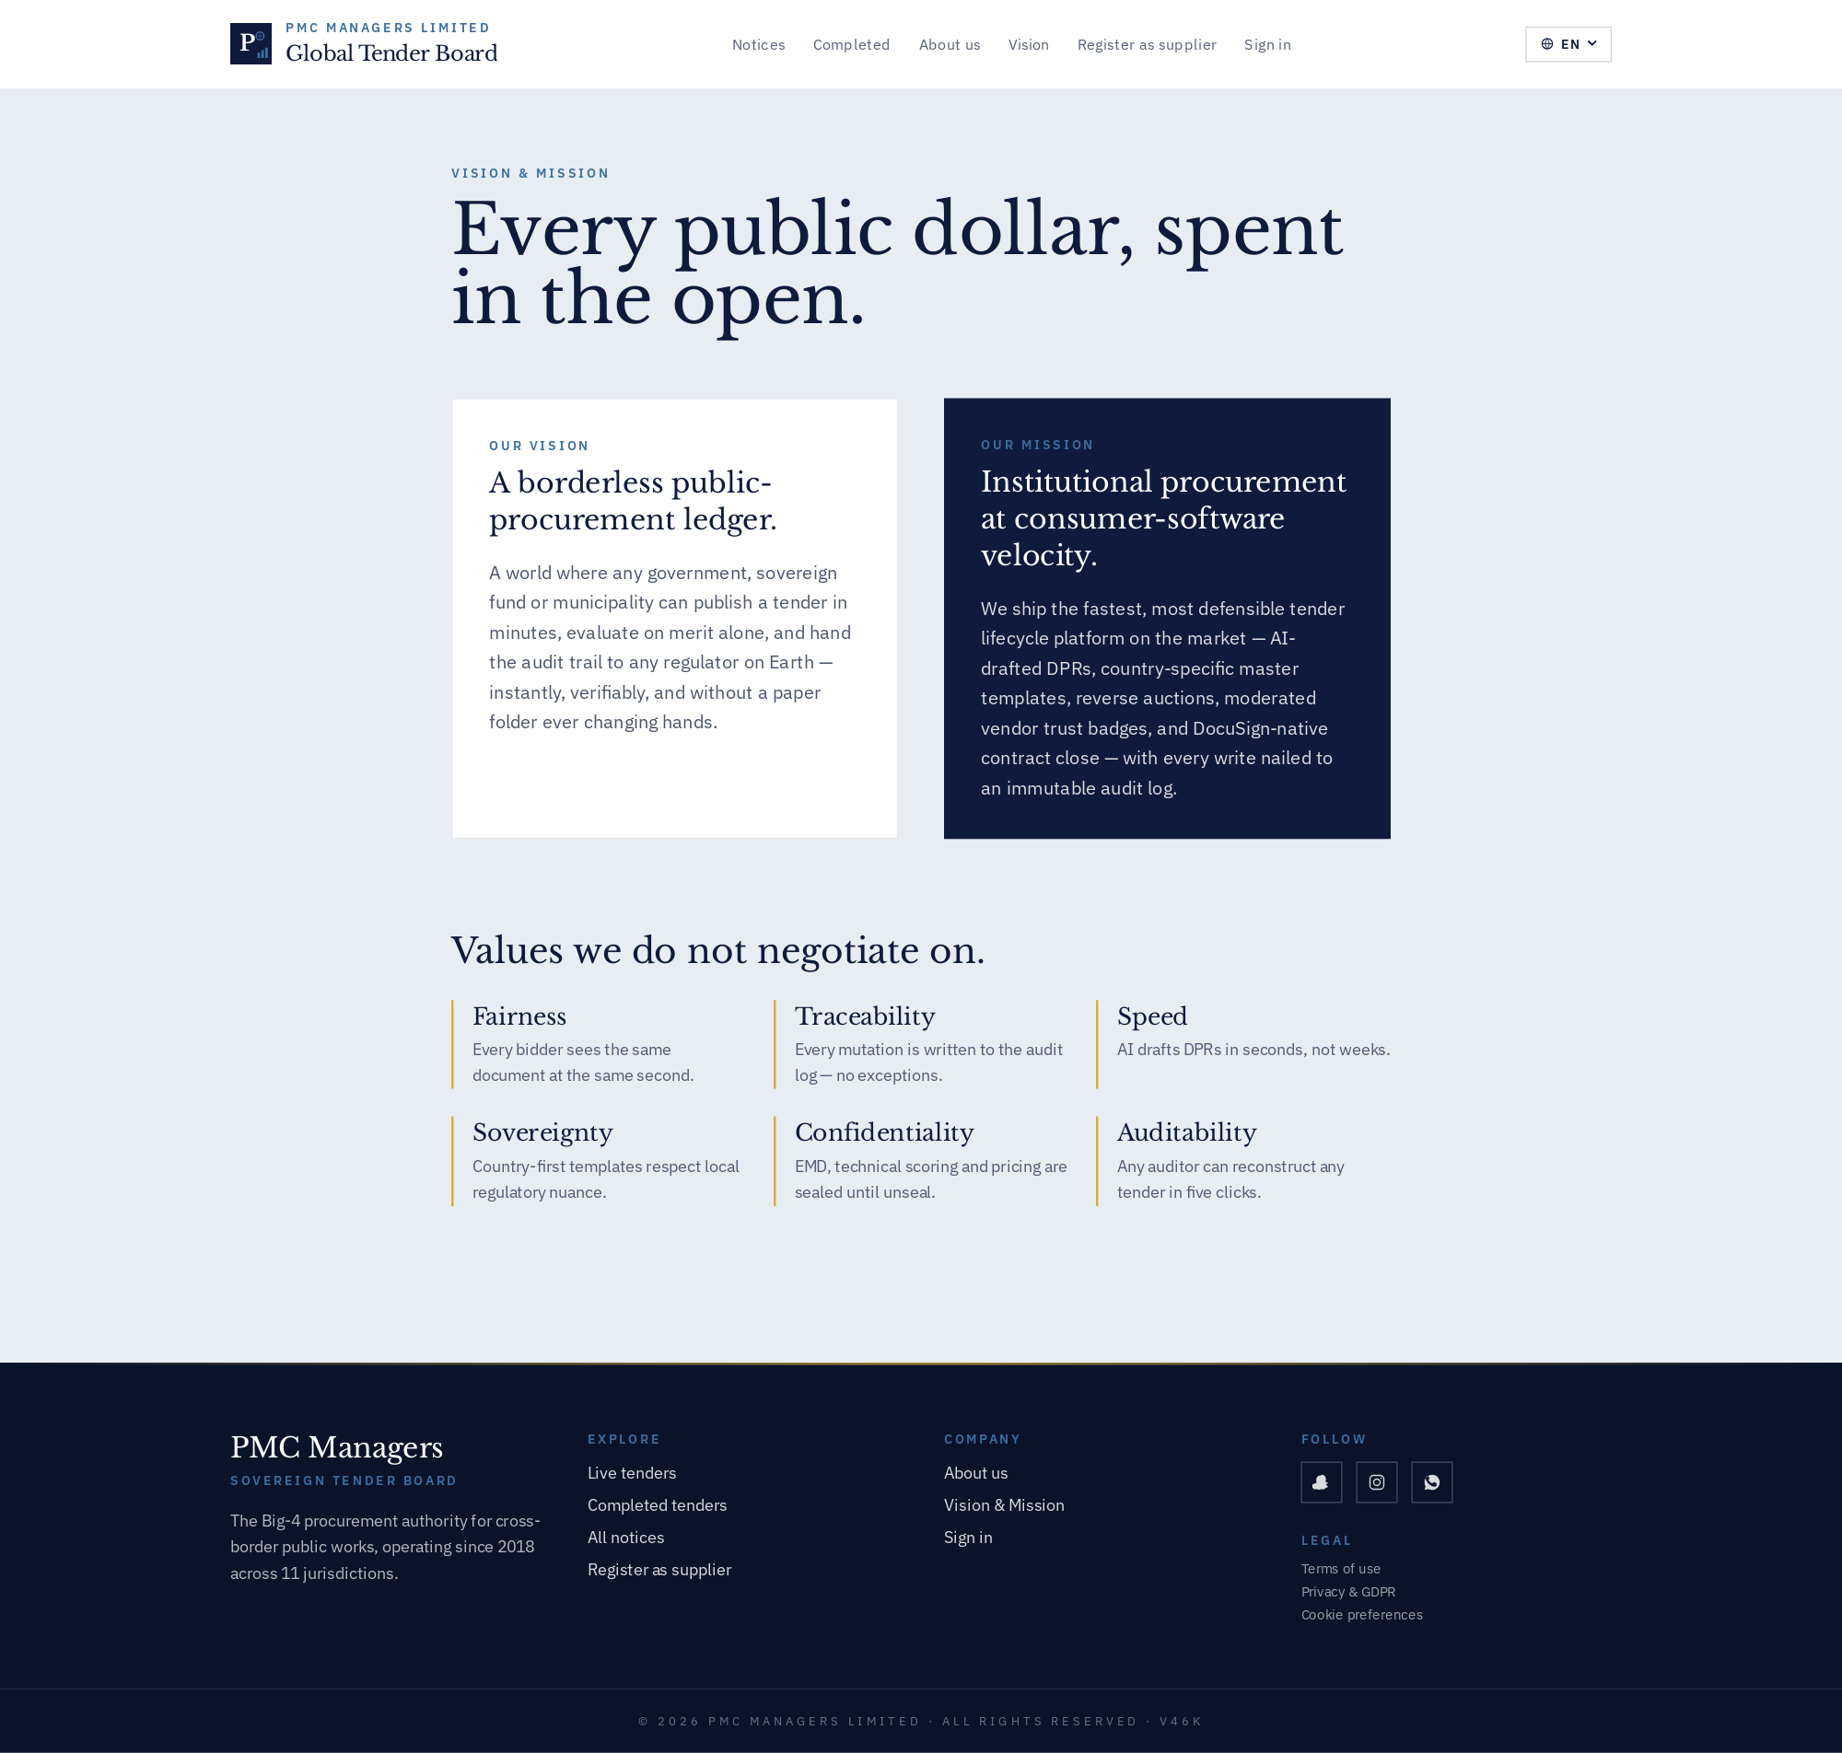

Purpose
The strategic doctrine page — Vision, Mission, Values, North-Star KPIs the platform is optimised for.

How the workflow unfolds
Referenced by the tender committee in every quarterly briefing. Also cited in ESG questionnaires.

Fields
- Vision statement — 10-year direction.
- Mission — 12-month operational focus.
- Values — Three principles used to arbitrate roadmap trade-offs.
- North-star KPIs — Cycle time, dispute rate, EMD-refund SLA, vendor NPS.

Known gotchas
- Whenever the North-Star KPIs change, re-open every tender committee meeting with the delta explained.

8 · Supplier registration — start
Public entry point for vendor self-onboarding. Email, company name, country. A magic link is dispatched via Resend and the bidder resumes the deep intake wizard from that link.
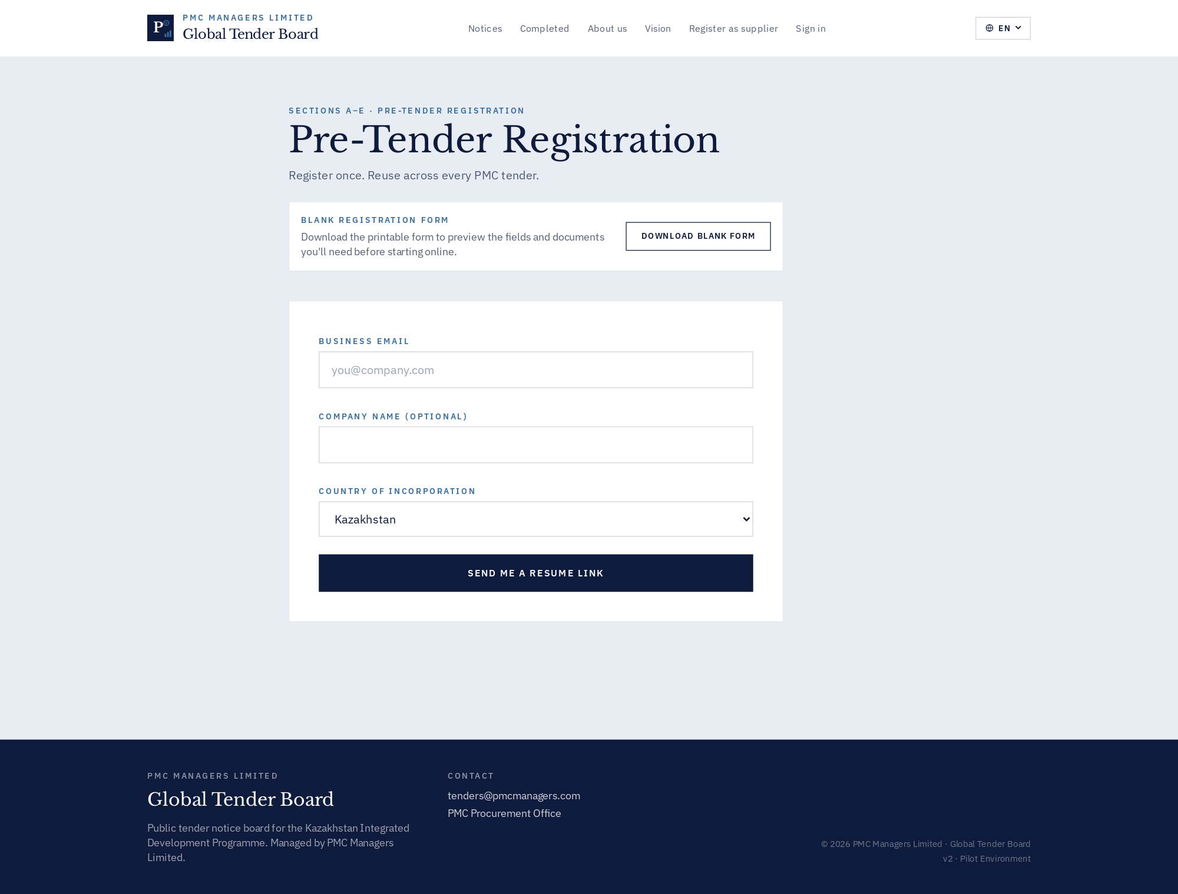

Purpose
Public entry point for vendor self-onboarding.

How the workflow unfolds
1) Bidder submits email + company + country. 2) A Resend magic link is emailed. 3) Bidder clicks the link and lands on RegistrationResume where the 5-step wizard begins.

Fields
- Email — Uniqueness enforced across tenants.
- Company name (optional) — Skipping this delays enrichment but does not block the wizard.
- Country dropdown — Sourced from the platform-wide country master.

Known gotchas
- Resend delivery to first-touch corporate mailboxes can hit spam — admins can resend from the Registrations queue.

9 · Sovereign Gateway — 5-portal picker
Five distinct credentials safeguard PMC. Selecting a card reveals a portal-specific credential form (per-role colour + badge).
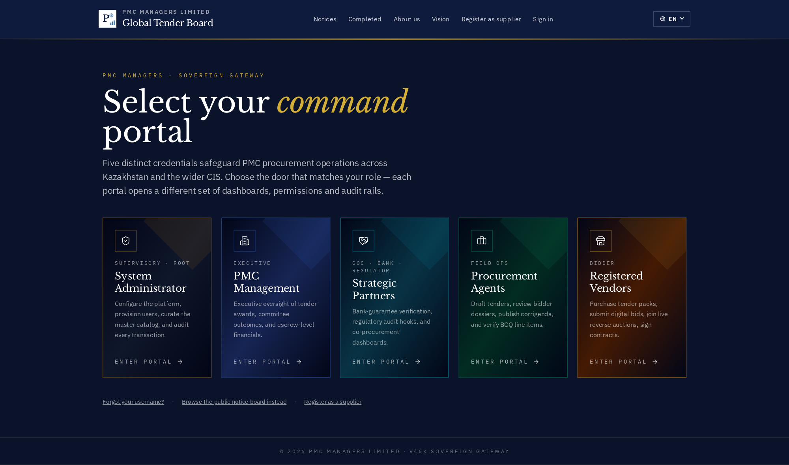

Purpose
The 5-portal Sovereign Gateway — the new single entry point for every human role.

How the workflow unfolds
Users pick the badge matching their role. Each card animates into a portal-specific credential form with the correct colour system, kicker, icon and CTA.

Fields
- System Administrator — Amber ring · SUPERVISORY · ROOT badge.
- PMC Management — Blue ring · EXECUTIVE badge.
- Strategic Partners — Cyan ring · GOC · BANK · REGULATOR badge.
- Procurement Agents — Emerald ring · FIELD OPS badge.
- Registered Vendors — Gold ring · BIDDER badge.

Known gotchas
- Each portal has its own audit-log tag — a single email that owns two roles will show up twice in the audit trail with the portal it entered through.

10 · Admin portal — credential form
The System Administrator portal — colours default to editorial slate + amber badge. Root-level control of the platform: user provisioning, master catalog, audit.
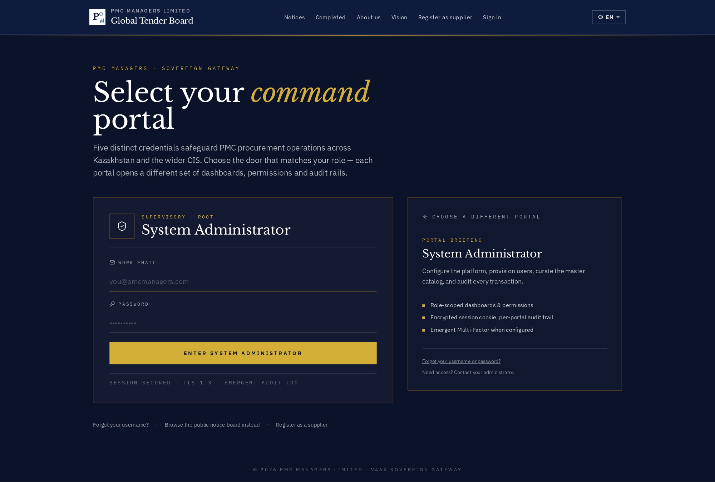

Purpose
Credential form for the Admin portal.

How the workflow unfolds
The credential form uses the portal's colour and badge. Email + password submit into the appropriate auth realm (staff for admin/management/partners/agents, vendor for vendors).

Fields
- Work email — Email that appears in the audit trail.
- Password — 12+ characters; failures trigger the brute-force lockout after 5 attempts.
- Portal briefing (right rail) — Short brief so the user knows they're in the right door.
- Session security note — TLS 1.3 + immutable audit log — cite this in security reviews.

Known gotchas
- MFA is enforced for admin + management once configured — you get a code prompt after the password step.

11 · Management portal — credential form
The PMC Management portal — executive dashboards, committee outcomes and escrow-level financials.
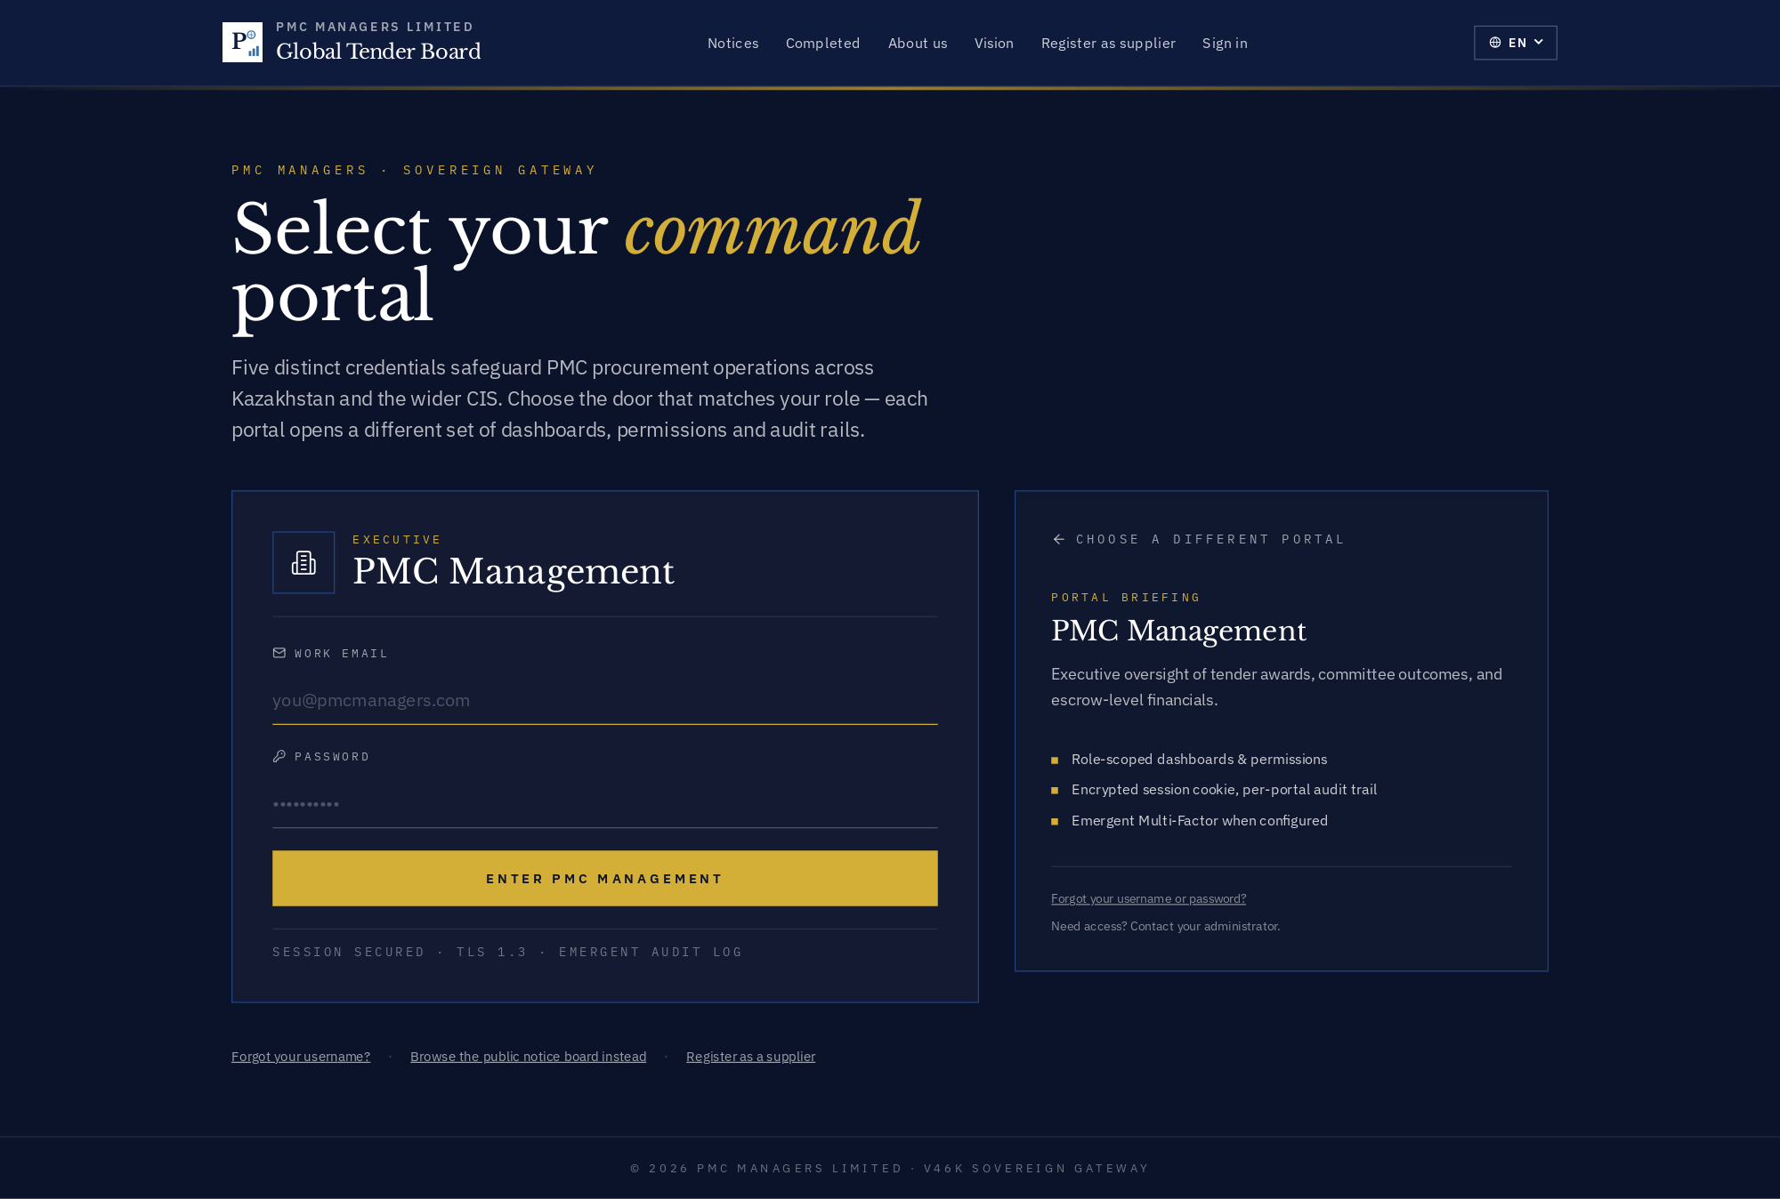

Purpose
Credential form for the Management portal.

How the workflow unfolds
The credential form uses the portal's colour and badge. Email + password submit into the appropriate auth realm (staff for admin/management/partners/agents, vendor for vendors).

Fields
- Work email — Email that appears in the audit trail.
- Password — 12+ characters; failures trigger the brute-force lockout after 5 attempts.
- Portal briefing (right rail) — Short brief so the user knows they're in the right door.
- Session security note — TLS 1.3 + immutable audit log — cite this in security reviews.

Known gotchas
- MFA is enforced for admin + management once configured — you get a code prompt after the password step.

12 · Strategic Partners portal — credential form
For GOC / Bank / Regulator personas — bank-guarantee verification, regulatory audit hooks, co-procurement dashboards.
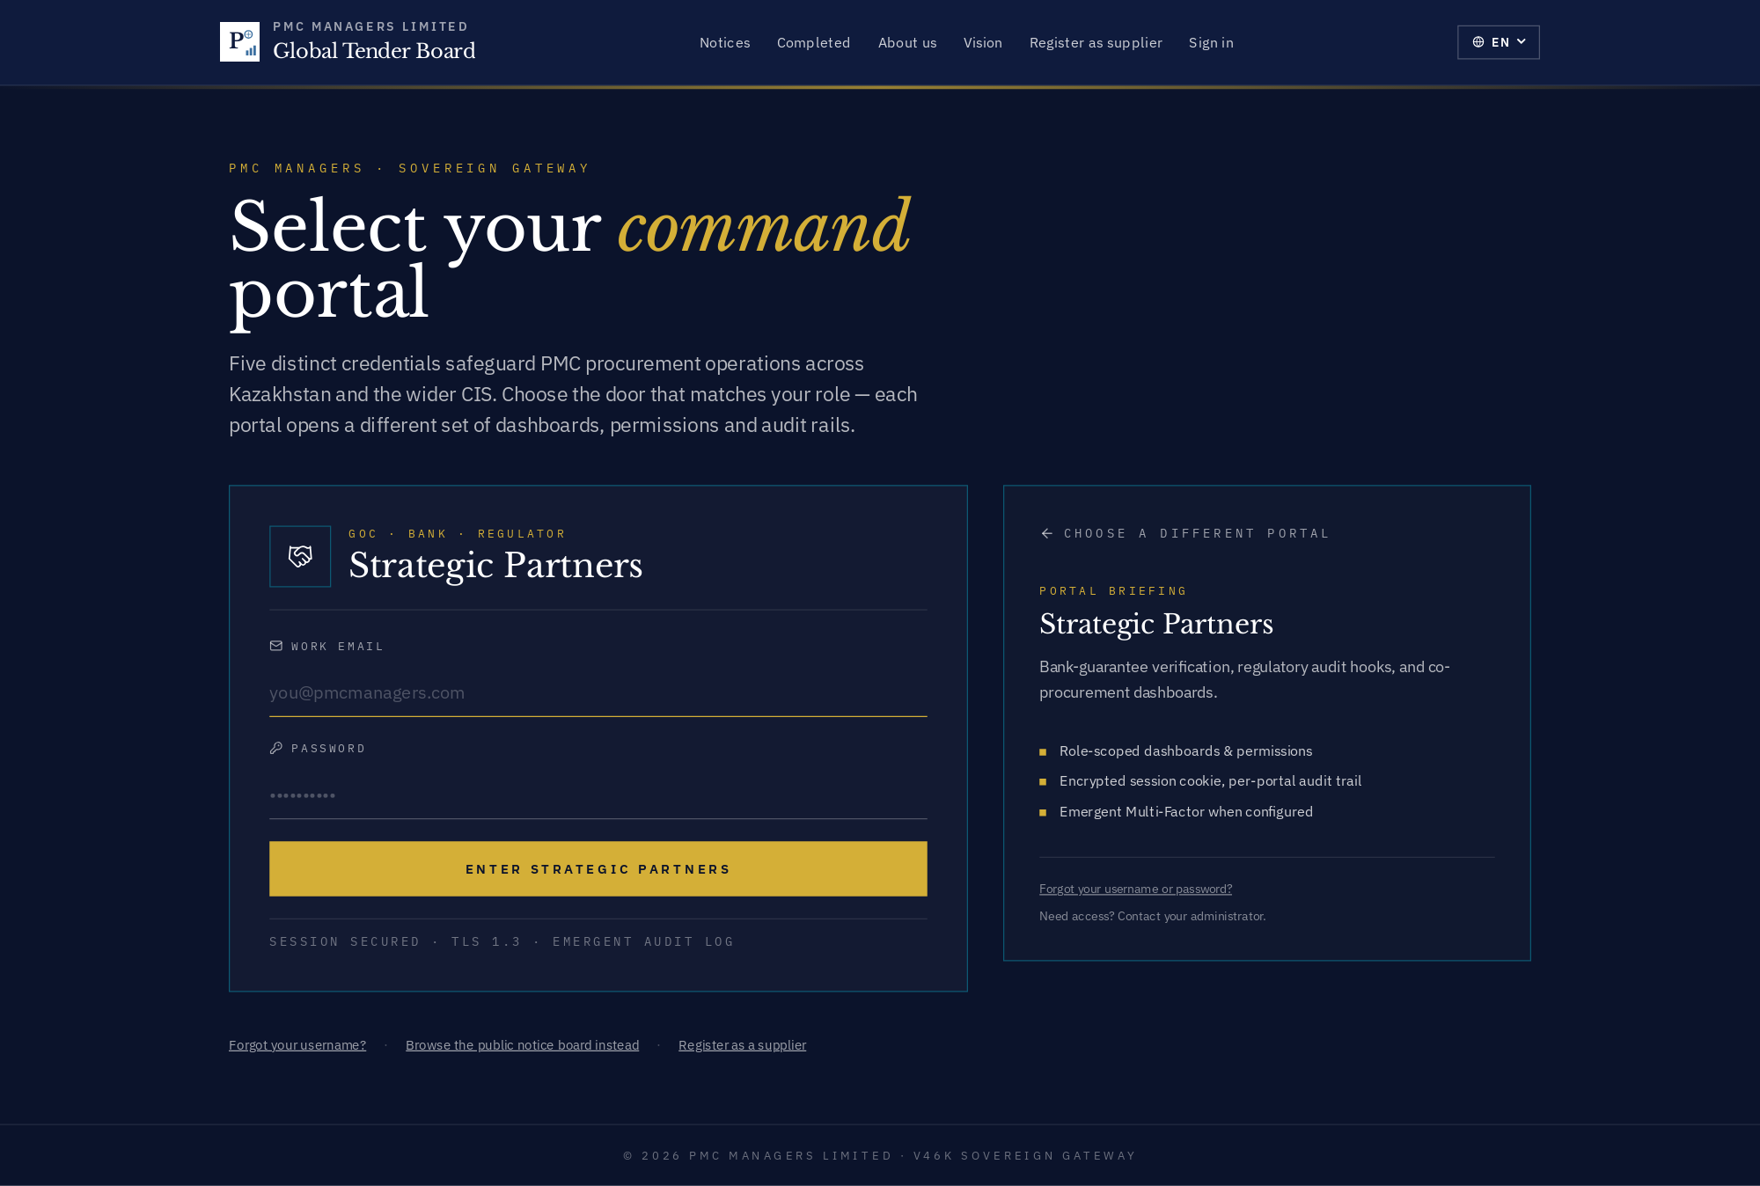

Purpose
Credential form for the Partners portal.

How the workflow unfolds
The credential form uses the portal's colour and badge. Email + password submit into the appropriate auth realm (staff for admin/management/partners/agents, vendor for vendors).

Fields
- Work email — Email that appears in the audit trail.
- Password — 12+ characters; failures trigger the brute-force lockout after 5 attempts.
- Portal briefing (right rail) — Short brief so the user knows they're in the right door.
- Session security note — TLS 1.3 + immutable audit log — cite this in security reviews.

Known gotchas
- MFA is enforced for admin + management once configured — you get a code prompt after the password step.

13 · Procurement Agents portal — credential form
Field-ops portal for procurement agents drafting tenders, reviewing bidder dossiers, publishing corrigenda and verifying BOQ line items.
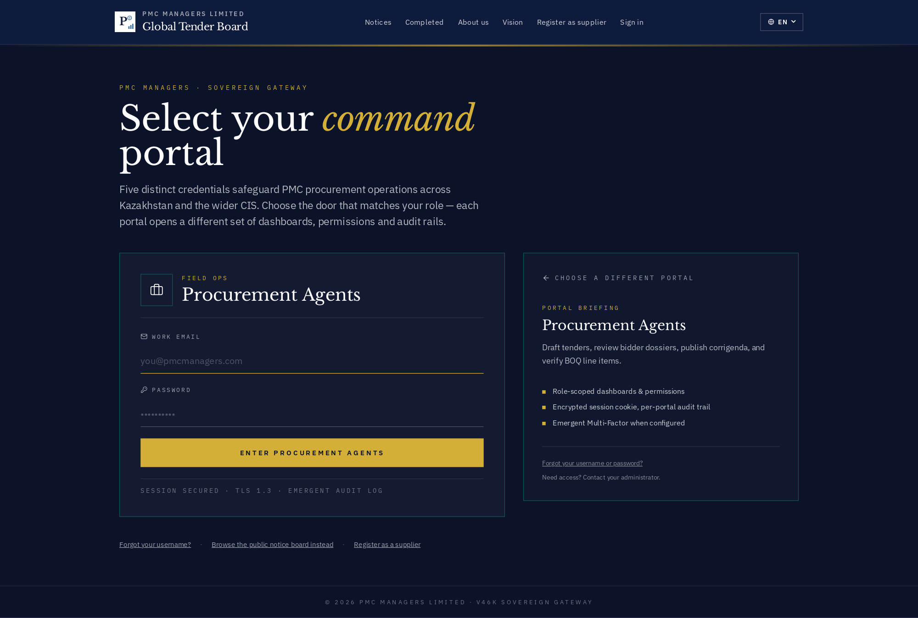

Purpose
Credential form for the Agents portal.

How the workflow unfolds
The credential form uses the portal's colour and badge. Email + password submit into the appropriate auth realm (staff for admin/management/partners/agents, vendor for vendors).

Fields
- Work email — Email that appears in the audit trail.
- Password — 12+ characters; failures trigger the brute-force lockout after 5 attempts.
- Portal briefing (right rail) — Short brief so the user knows they're in the right door.
- Session security note — TLS 1.3 + immutable audit log — cite this in security reviews.

Known gotchas
- MFA is enforced for admin + management once configured — you get a code prompt after the password step.

14 · Registered Vendors portal — credential form
Bidder portal — purchase tender packs, submit digital bids, join live reverse auctions, sign contracts. Gold-accented CTA.
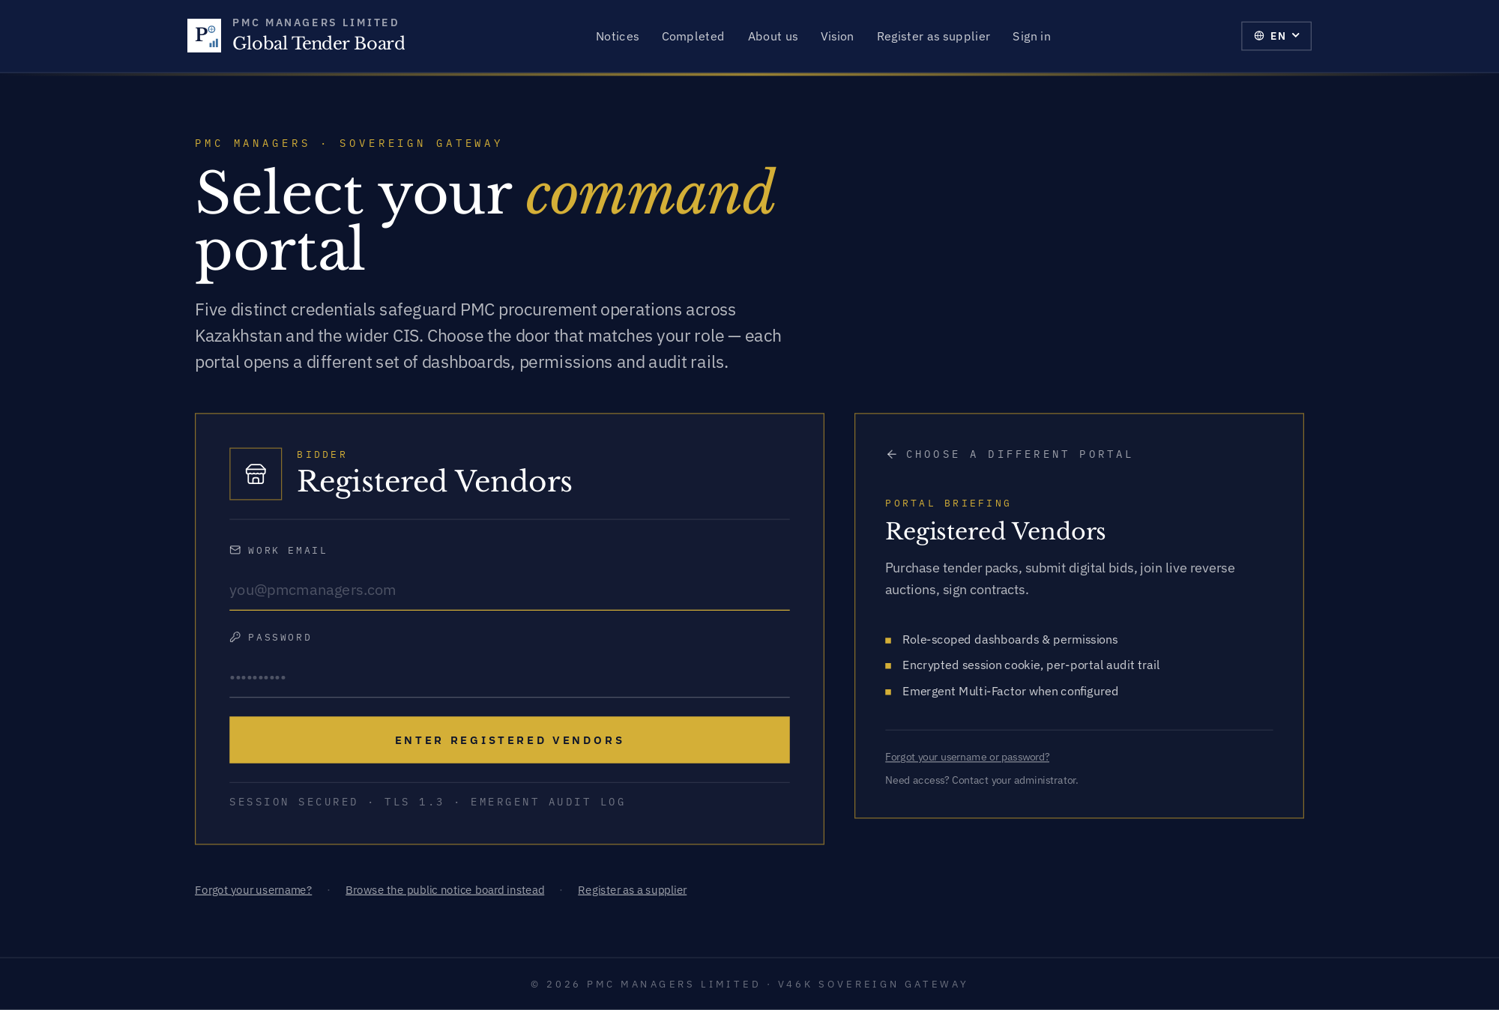

Purpose
Credential form for the Vendors portal.

How the workflow unfolds
The credential form uses the portal's colour and badge. Email + password submit into the appropriate auth realm (staff for admin/management/partners/agents, vendor for vendors).

Fields
- Work email — Email that appears in the audit trail.
- Password — 12+ characters; failures trigger the brute-force lockout after 5 attempts.
- Portal briefing (right rail) — Short brief so the user knows they're in the right door.
- Session security note — TLS 1.3 + immutable audit log — cite this in security reviews.

Known gotchas
- MFA is enforced for admin + management once configured — you get a code prompt after the password step.

5 · Vendor / supplier journey

30 · Vendor landing (post-login)
Vendor dashboard immediately after sign-in. Header shows company + trust badges; body shows open tenders, held EMDs, active auctions.
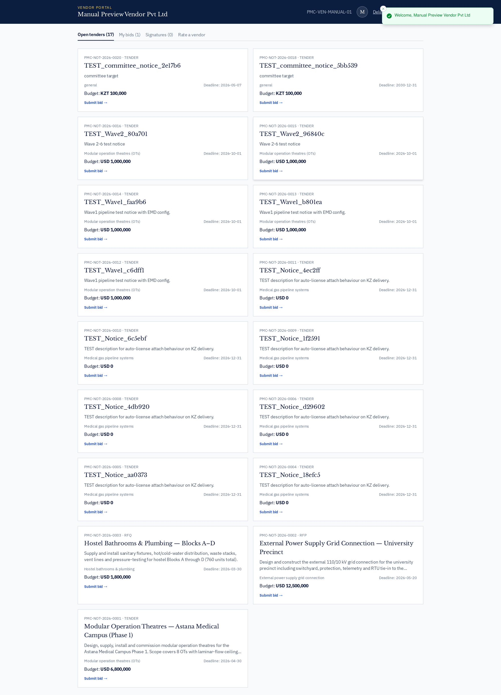

Purpose
Vendor dashboard immediately after sign-in.

How the workflow unfolds
Bidders arrive here after credential submit. Header shows the trust badges, body shows quick paths to open tenders, held EMDs, active auctions, awarded contracts.

Fields
- Trust badges — Aggregate rating badge + certified-supplier chip if applicable.
- Open tenders card — Categories filtered to the vendor's declared industries.
- EMDs held — Total value + release-eligible-date.
- Auctions strip — Live and scheduled reverse-auction rooms.

Known gotchas
- The dashboard refetches on every route change to avoid stale counts.

31 · Vendor · Open tenders
Tenders the vendor may bid on, filtered to declared categories.
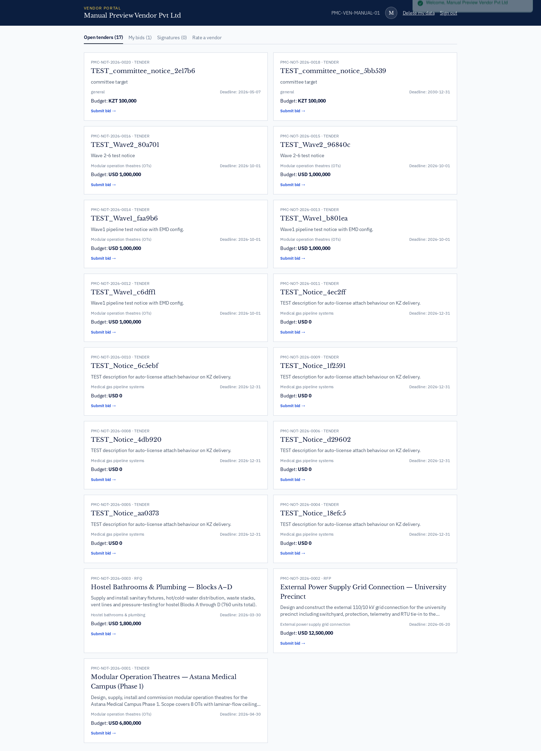

How to use
This screen exposes every action available for its module. Use the InfoDot (ⓘ) next to each label to see the field-level rules — hover it in-app for the full policy text. All destructive actions confirm before applying, and every mutation is written to the immutable audit log.

32 · Vendor · My bids
Every submitted bid with envelope status, score summary and award outcome.
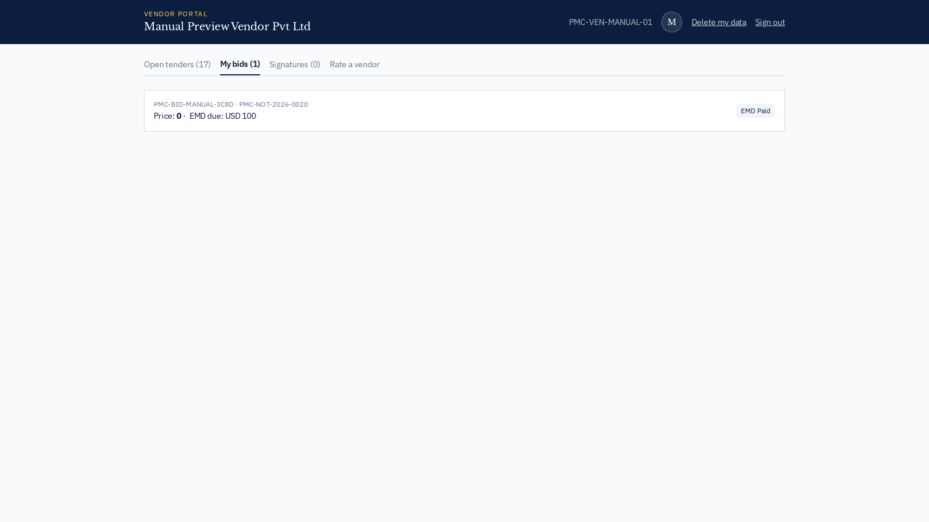

Purpose
My bids — every submitted bid with envelope status, score summary and award outcome.

How the workflow unfolds
Bidders use this to prove submission for legal disputes and to compare pricing against their prior wins.

Fields
- Bid ref — PMC-BID-YYYY-NNNN — anchor for every legal reference.
- Envelope status — Sealed / Unsealed / Under evaluation / Awarded / Rejected.
- Score summary — Technical + commercial weighted score once the envelope is unsealed.
- Award outcome — Won / Runner-up / Not qualified.

Known gotchas
- A rejected bid keeps its EMD until the notice's dispute window closes.

33 · Vendor · Ratings received
Reviews left by admins post-contract with an aggregate trust badge.
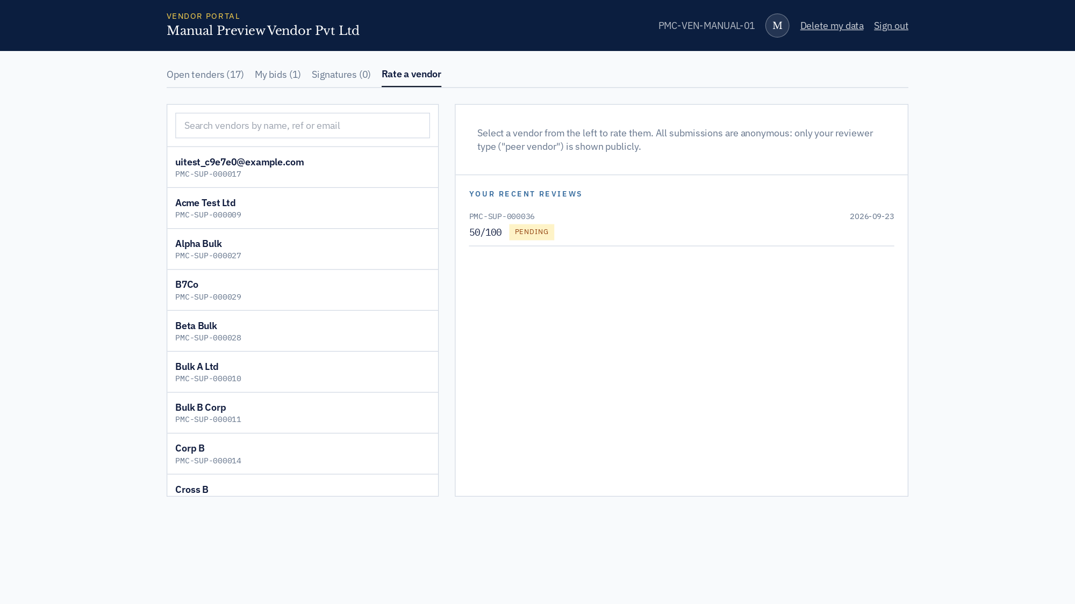

How to use
This screen exposes every action available for its module. Use the InfoDot (ⓘ) next to each label to see the field-level rules — hover it in-app for the full policy text. All destructive actions confirm before applying, and every mutation is written to the immutable audit log.

34 · Vendor · Contract signatures
DocuSign envelopes pending / signed by the vendor.
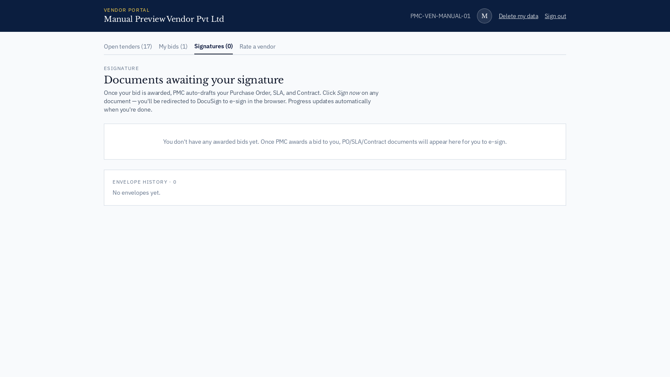

How to use
This screen exposes every action available for its module. Use the InfoDot (ⓘ) next to each label to see the field-level rules — hover it in-app for the full policy text. All destructive actions confirm before applying, and every mutation is written to the immutable audit log.

6 · Admin console — full module tour

50 · Admin console landing (Operations Overview)
First screen after admin login — collapsible sidebar grouped into Overview / Procurement / Market / Money & Compliance / Events, environment chip, AI Copilot shortcut.
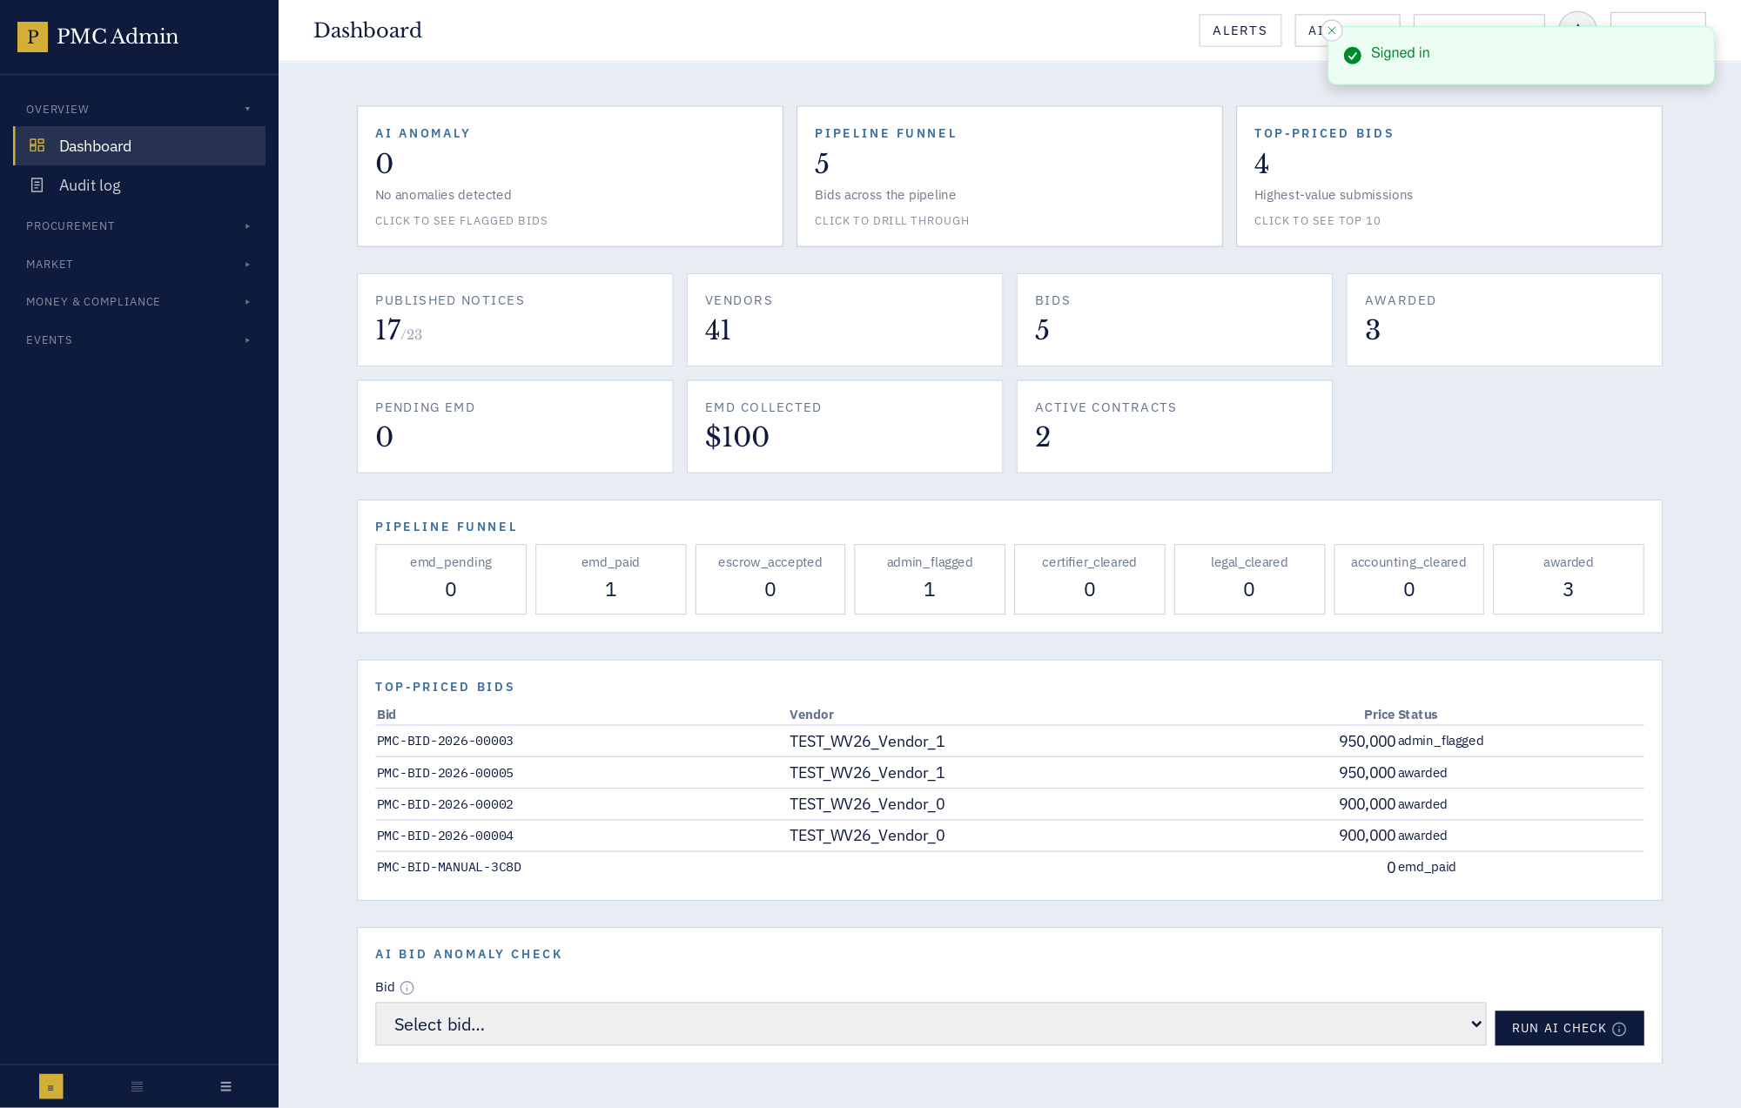

Purpose
Command centre for PMC staff.

How the workflow unfolds
Admin arrives here after sign-in; the collapsible sidebar groups 23 modules into Overview / Procurement / Market / Money & Compliance / Events — matching the mental model of the PMC operations team.

Fields
- Sidebar groups — Overview · Procurement · Market · Money & Compliance · Events.
- Environment chip — Which tenant/programme is active.
- AI Copilot — In-context question box for procurement policy questions.
- Alerts strip — Aging EMDs, publish-ready notices, contract SLA breaches.

Known gotchas
- Some tabs require role escalation (e.g. Escrow needs escrow_agent) — a locked-tab tooltip explains.

52 · Admin · Audit trail
Immutable action log with entity filters.
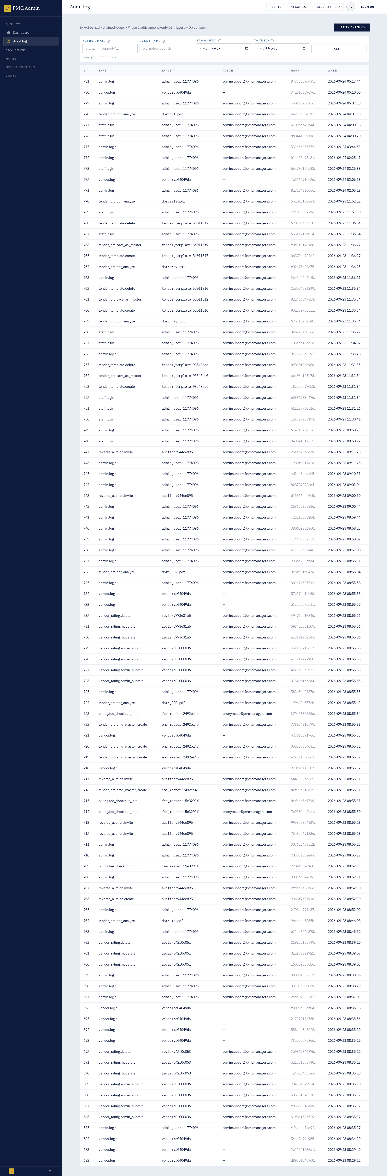

How to use
This screen exposes every action available for its module. Use the InfoDot (ⓘ) next to each label to see the field-level rules — hover it in-app for the full policy text. All destructive actions confirm before applying, and every mutation is written to the immutable audit log.

53 · Admin · Notices — publish & manage
Create, publish, edit, withdraw, attach documents, EMD.
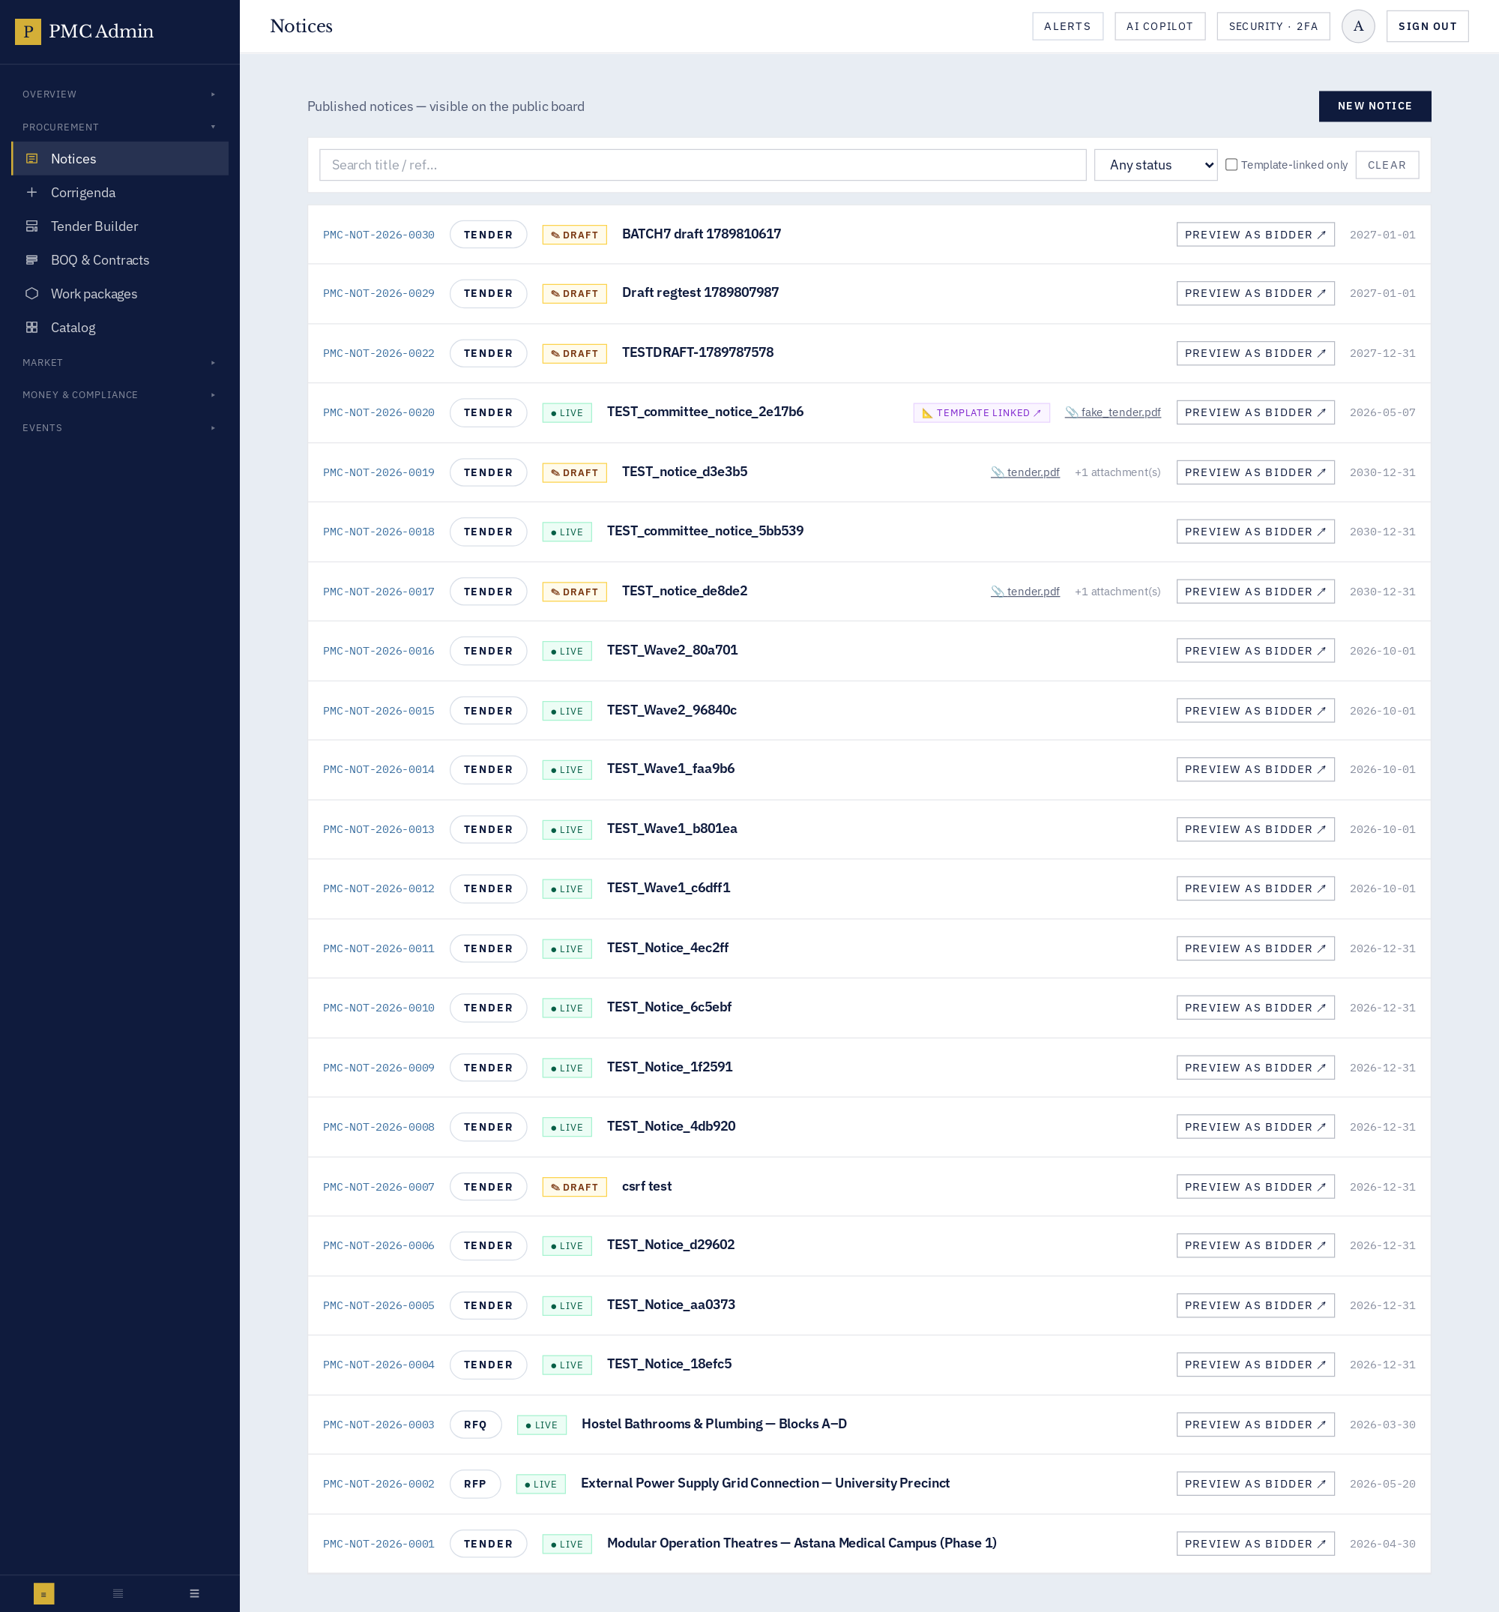

How to use
This screen exposes every action available for its module. Use the InfoDot (ⓘ) next to each label to see the field-level rules — hover it in-app for the full policy text. All destructive actions confirm before applying, and every mutation is written to the immutable audit log.

55 · Admin · Tender Builder & DPR AI
Master library, DPR deep-dive, AI Fill All, PDF export.
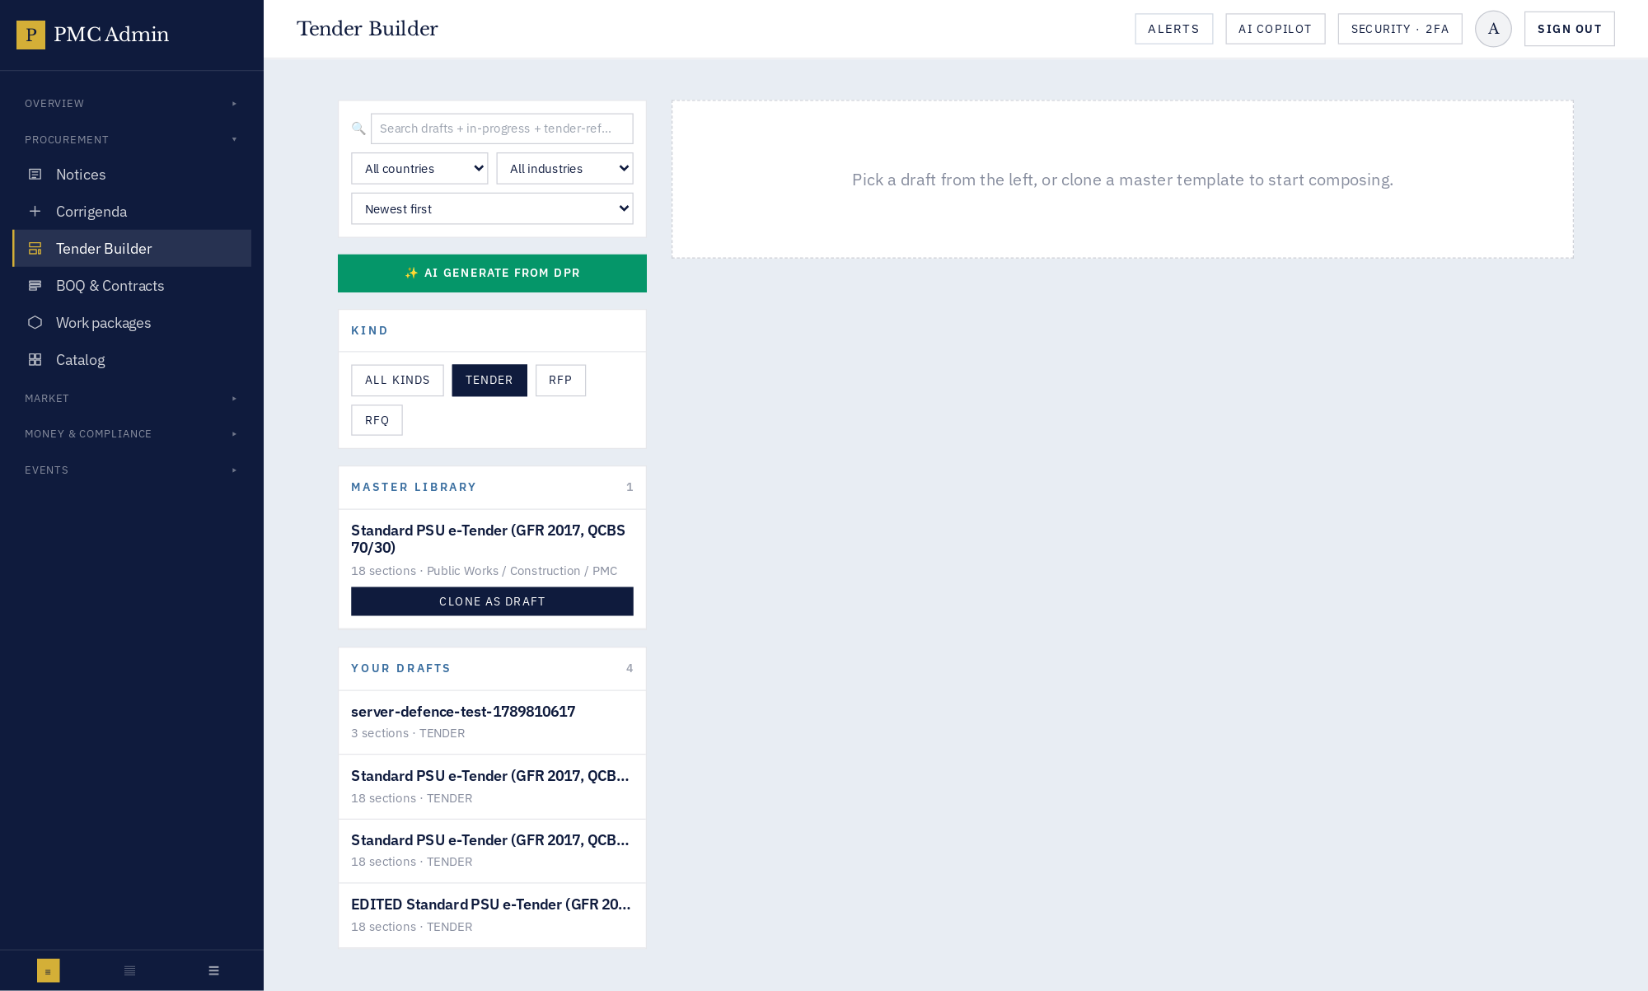

How to use
This screen exposes every action available for its module. Use the InfoDot (ⓘ) next to each label to see the field-level rules — hover it in-app for the full policy text. All destructive actions confirm before applying, and every mutation is written to the immutable audit log.

57 · Admin · Work packages
Modular deliverable packages for the KZ programme.
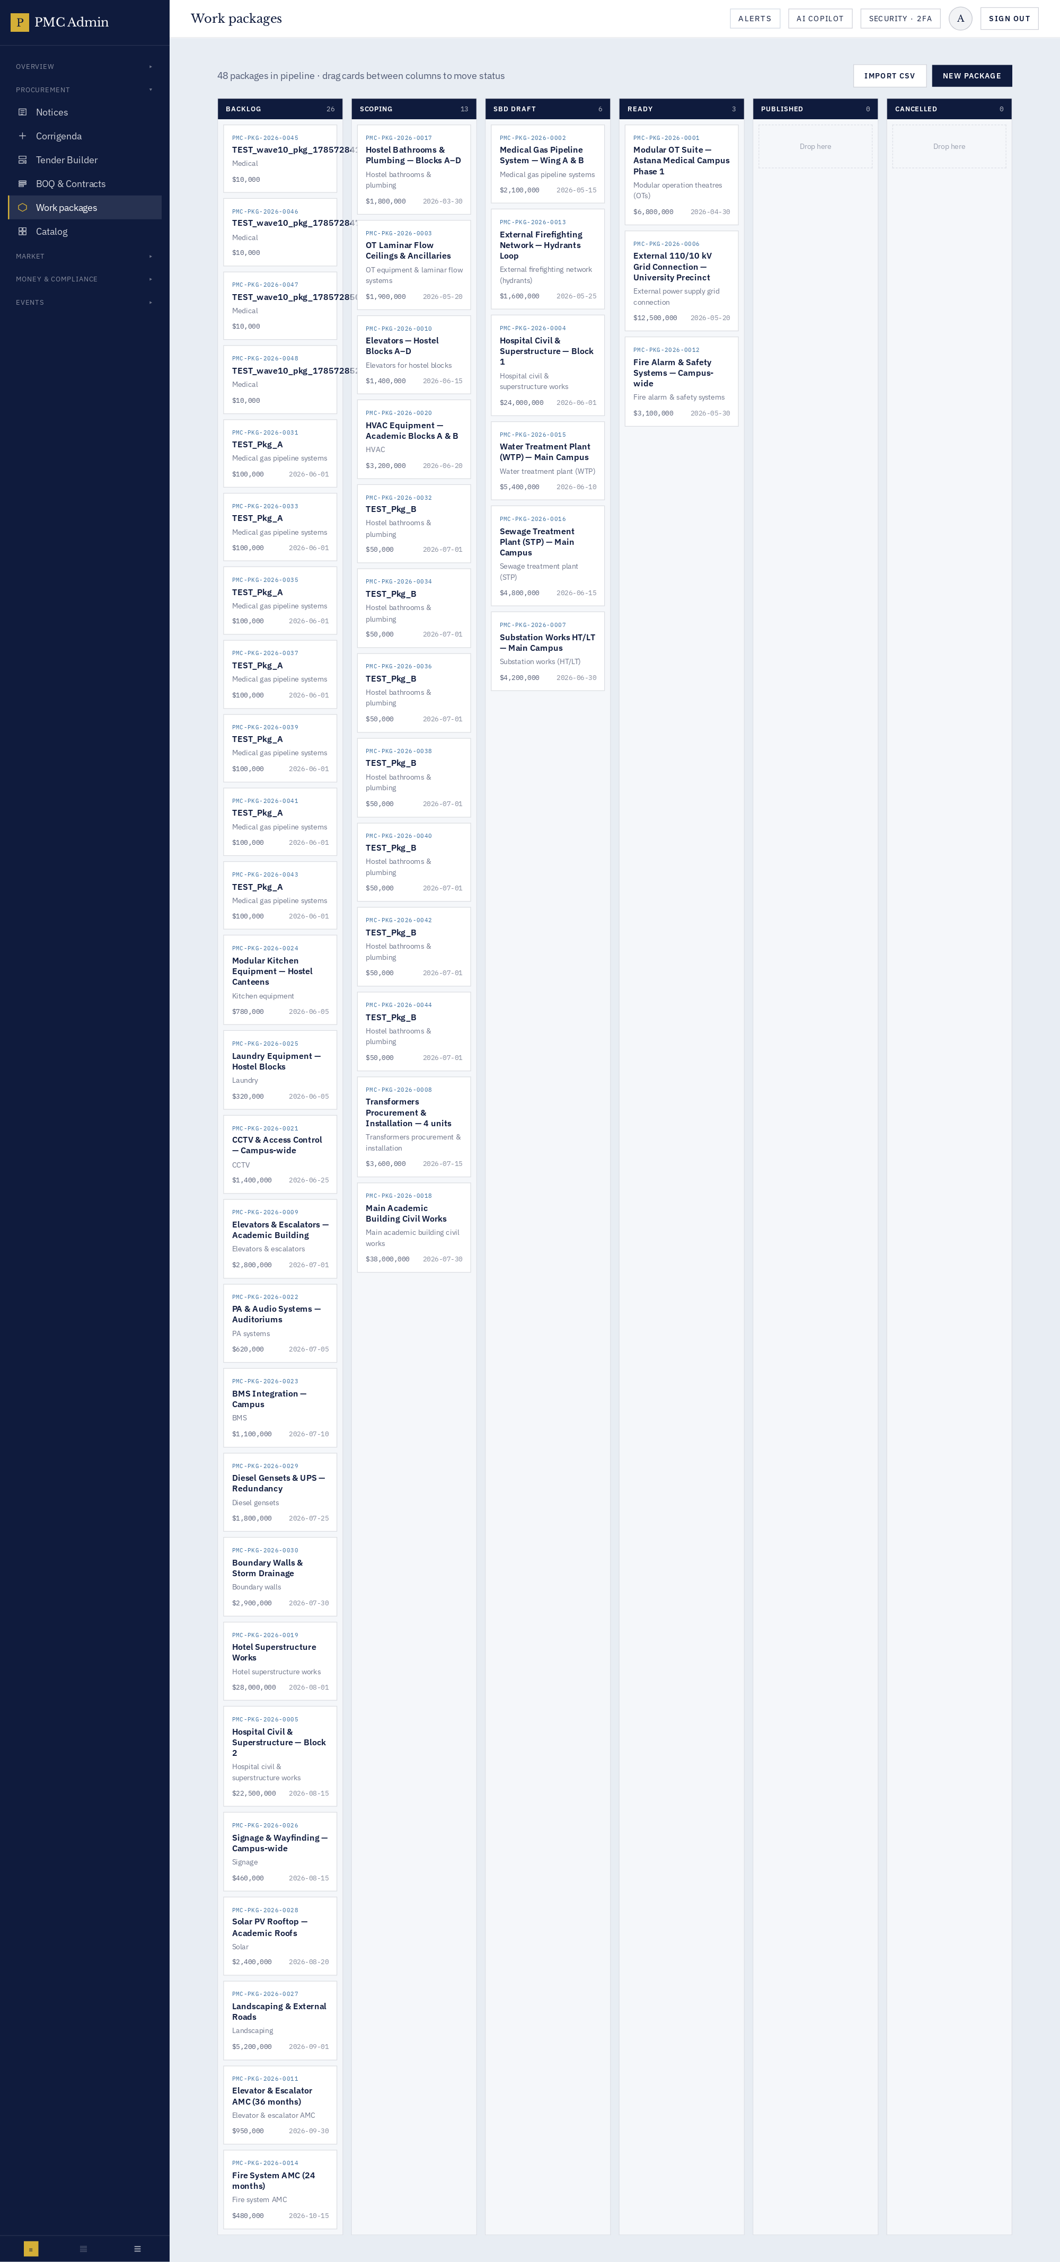

How to use
This screen exposes every action available for its module. Use the InfoDot (ⓘ) next to each label to see the field-level rules — hover it in-app for the full policy text. All destructive actions confirm before applying, and every mutation is written to the immutable audit log.

59 · Admin · Vendor directory
Full CRUD on suppliers, licences, compliance, tenants.
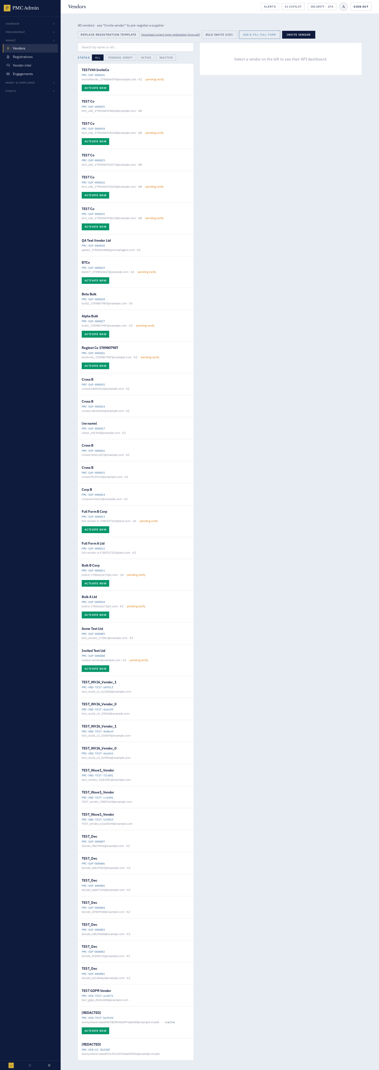

How to use
This screen exposes every action available for its module. Use the InfoDot (ⓘ) next to each label to see the field-level rules — hover it in-app for the full policy text. All destructive actions confirm before applying, and every mutation is written to the immutable audit log.

61 · Admin · Vendor intel & ratings
Trust badges, moderation, criteria averages.
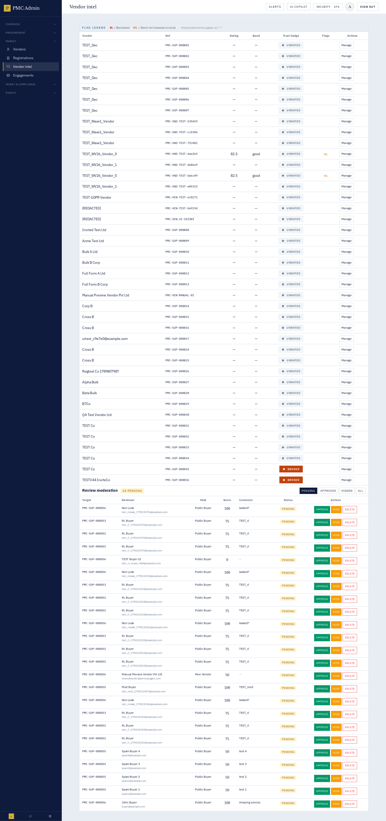

How to use
This screen exposes every action available for its module. Use the InfoDot (ⓘ) next to each label to see the field-level rules — hover it in-app for the full policy text. All destructive actions confirm before applying, and every mutation is written to the immutable audit log.

63 · Admin · Escrow / EMD desk
EMD receipts, forfeitures, refunds.
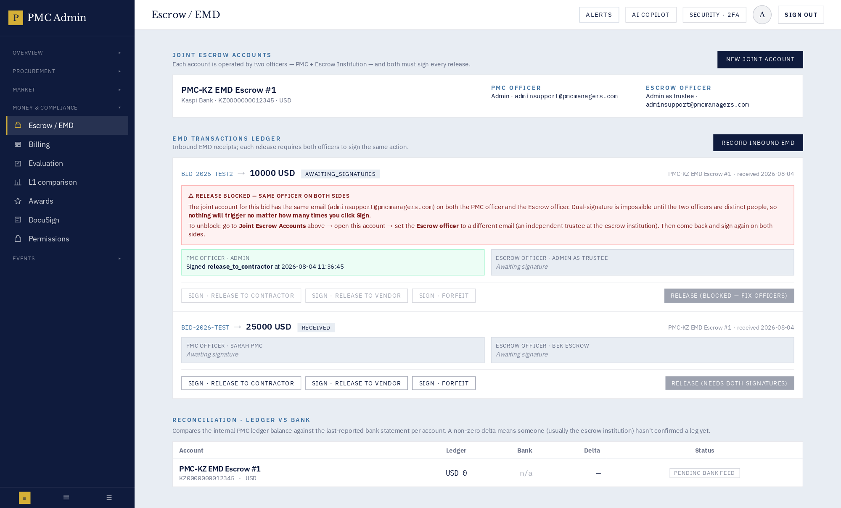

How to use
This screen exposes every action available for its module. Use the InfoDot (ⓘ) next to each label to see the field-level rules — hover it in-app for the full policy text. All destructive actions confirm before applying, and every mutation is written to the immutable audit log.

65 · Admin · Evaluation & scoring
Technical + financial scoring, QCBS, L1 comparison, envelope locking.
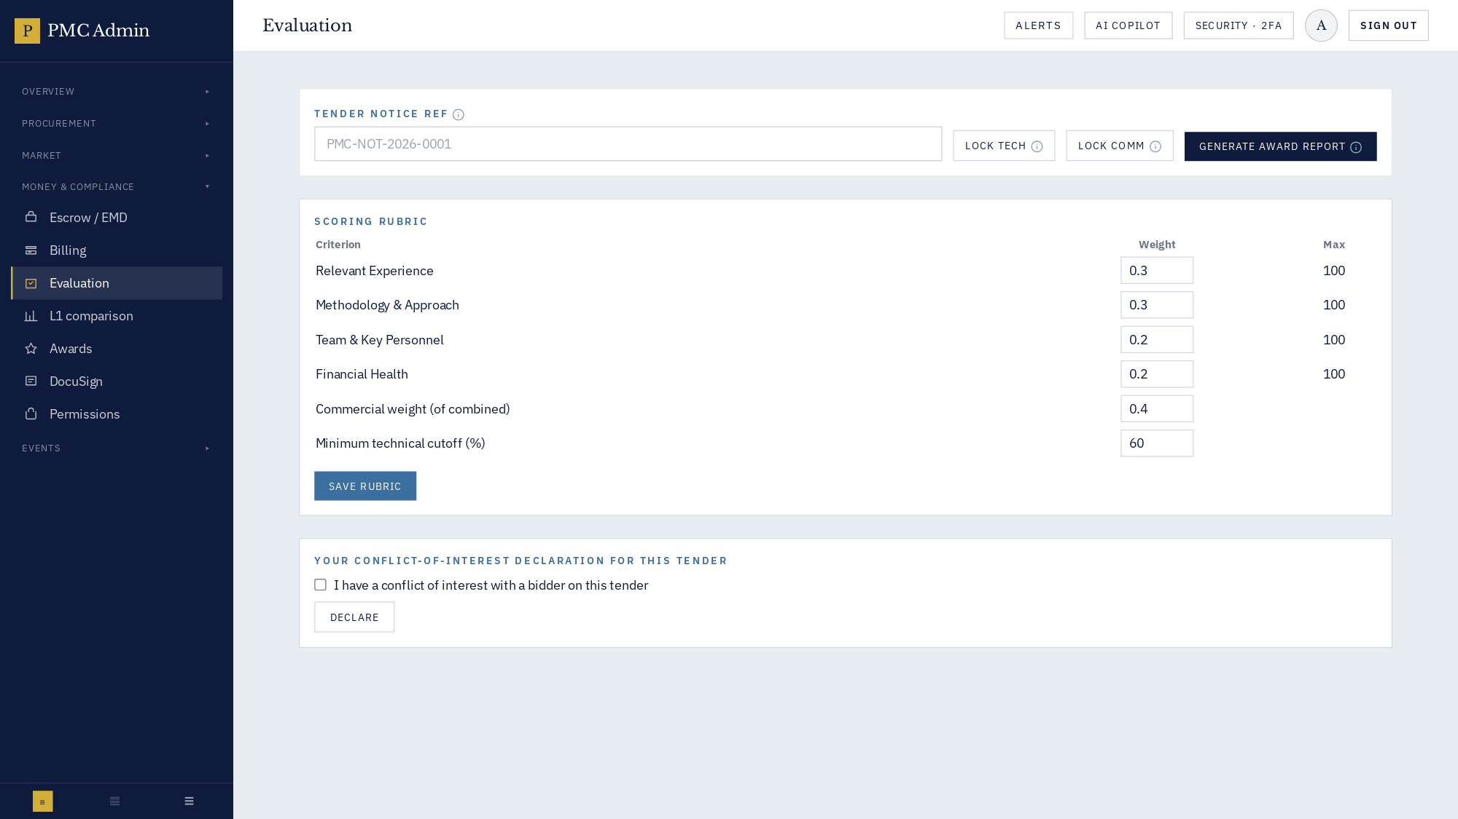

How to use
This screen exposes every action available for its module. Use the InfoDot (ⓘ) next to each label to see the field-level rules — hover it in-app for the full policy text. All destructive actions confirm before applying, and every mutation is written to the immutable audit log.

67 · Admin · Awards & POs
Letters of award, POs, contract award workflow.
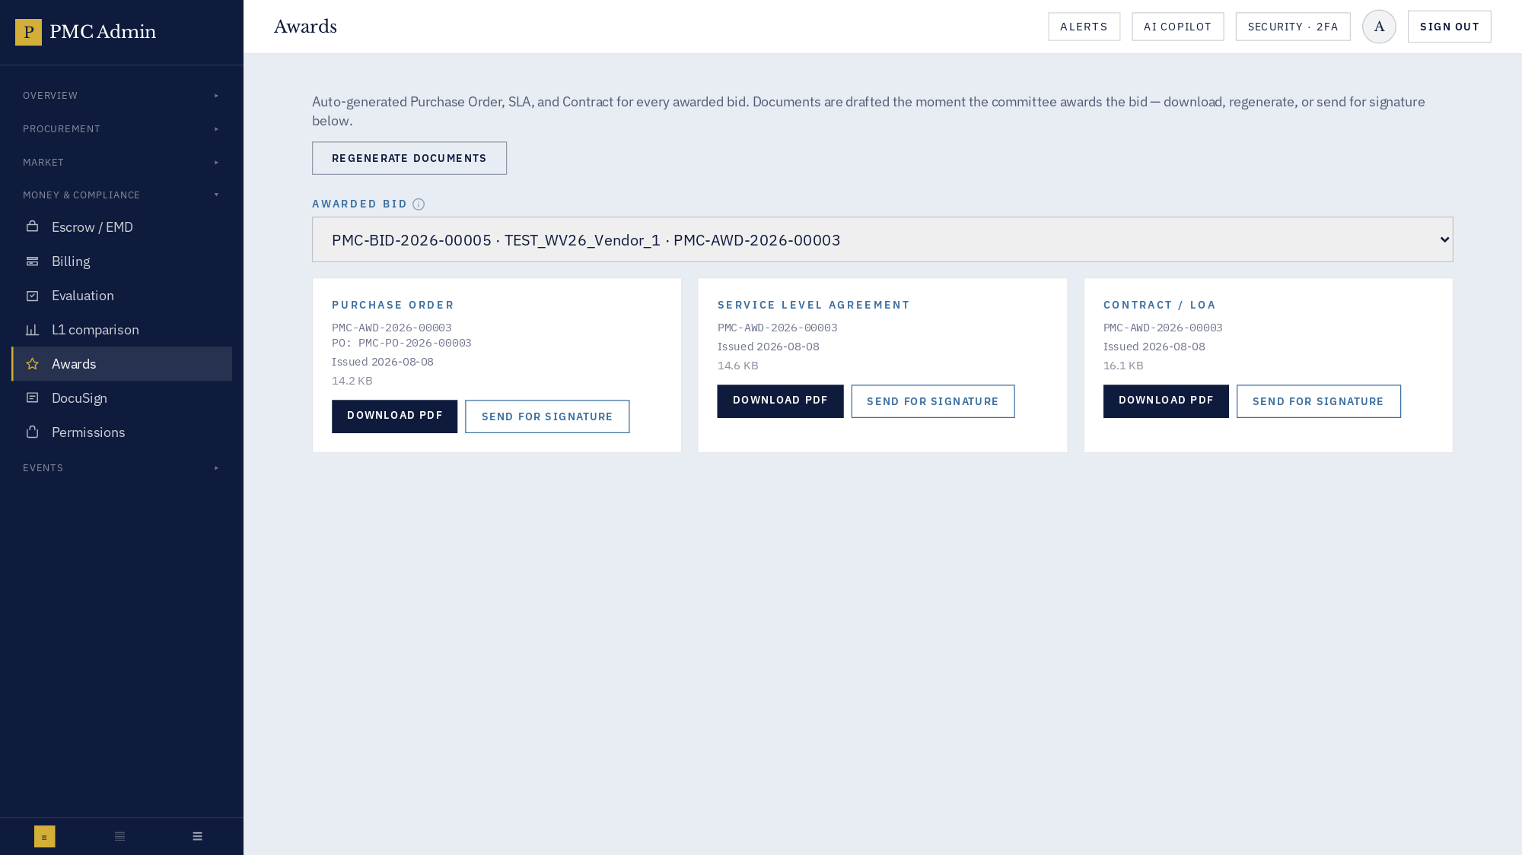

How to use
This screen exposes every action available for its module. Use the InfoDot (ⓘ) next to each label to see the field-level rules — hover it in-app for the full policy text. All destructive actions confirm before applying, and every mutation is written to the immutable audit log.

69 · Admin · Roles & permissions
Fine-grained ACL matrix.
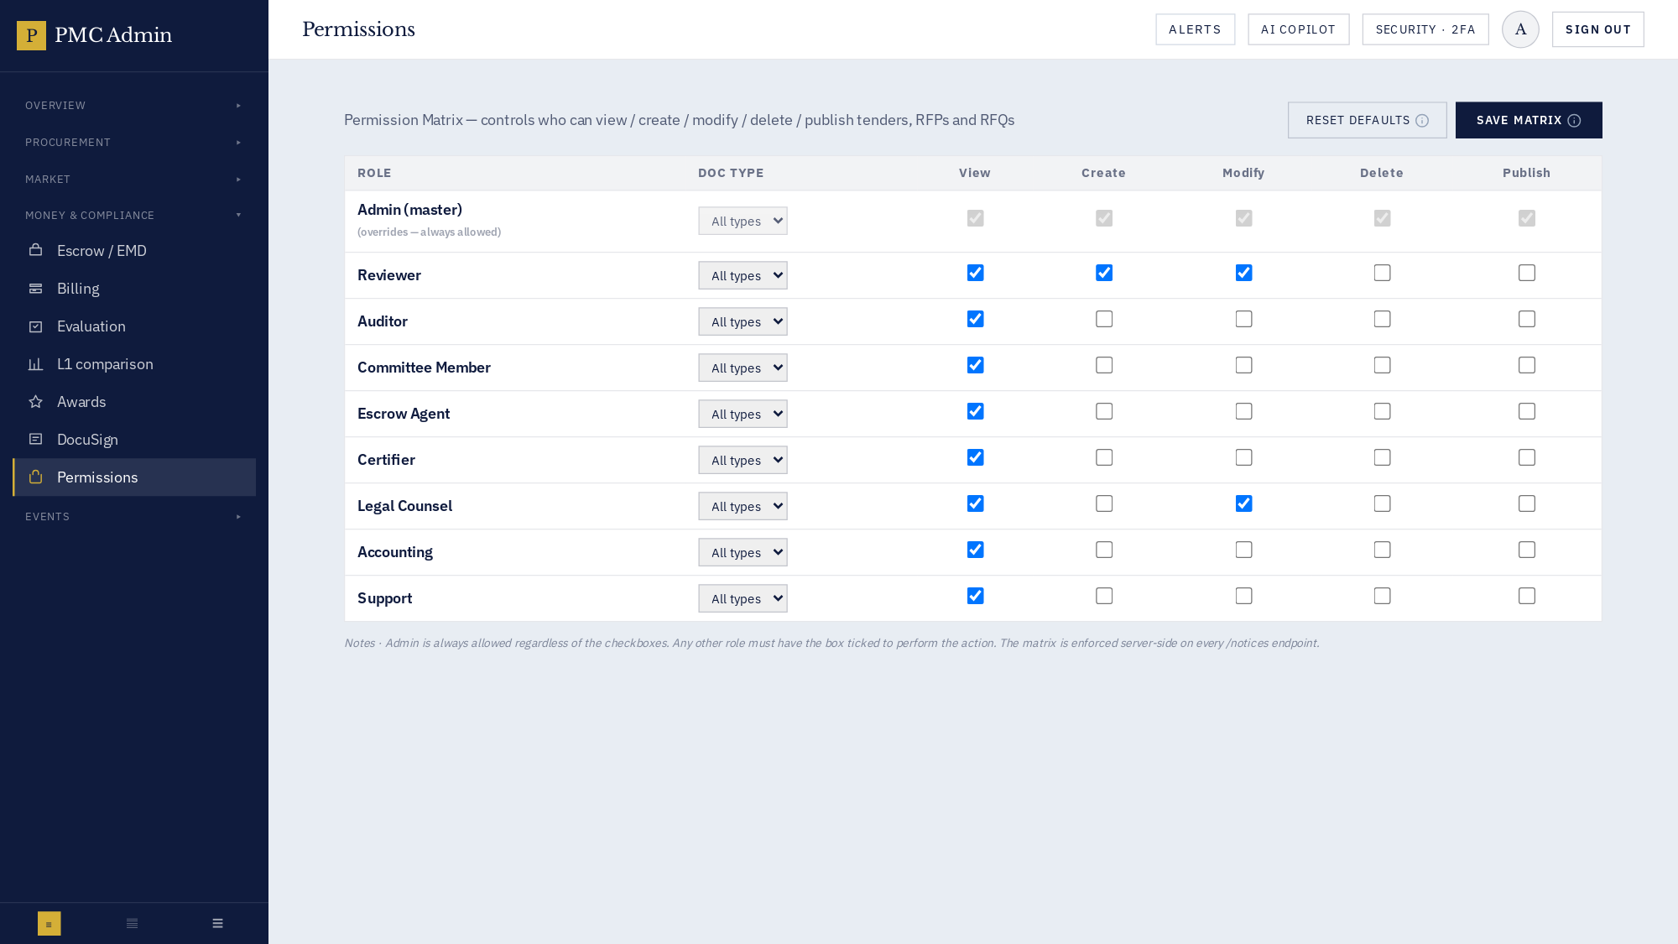

How to use
This screen exposes every action available for its module. Use the InfoDot (ⓘ) next to each label to see the field-level rules — hover it in-app for the full policy text. All destructive actions confirm before applying, and every mutation is written to the immutable audit log.

70 · Admin · Reverse auctions
Live auction rooms, invitations, spectator link.
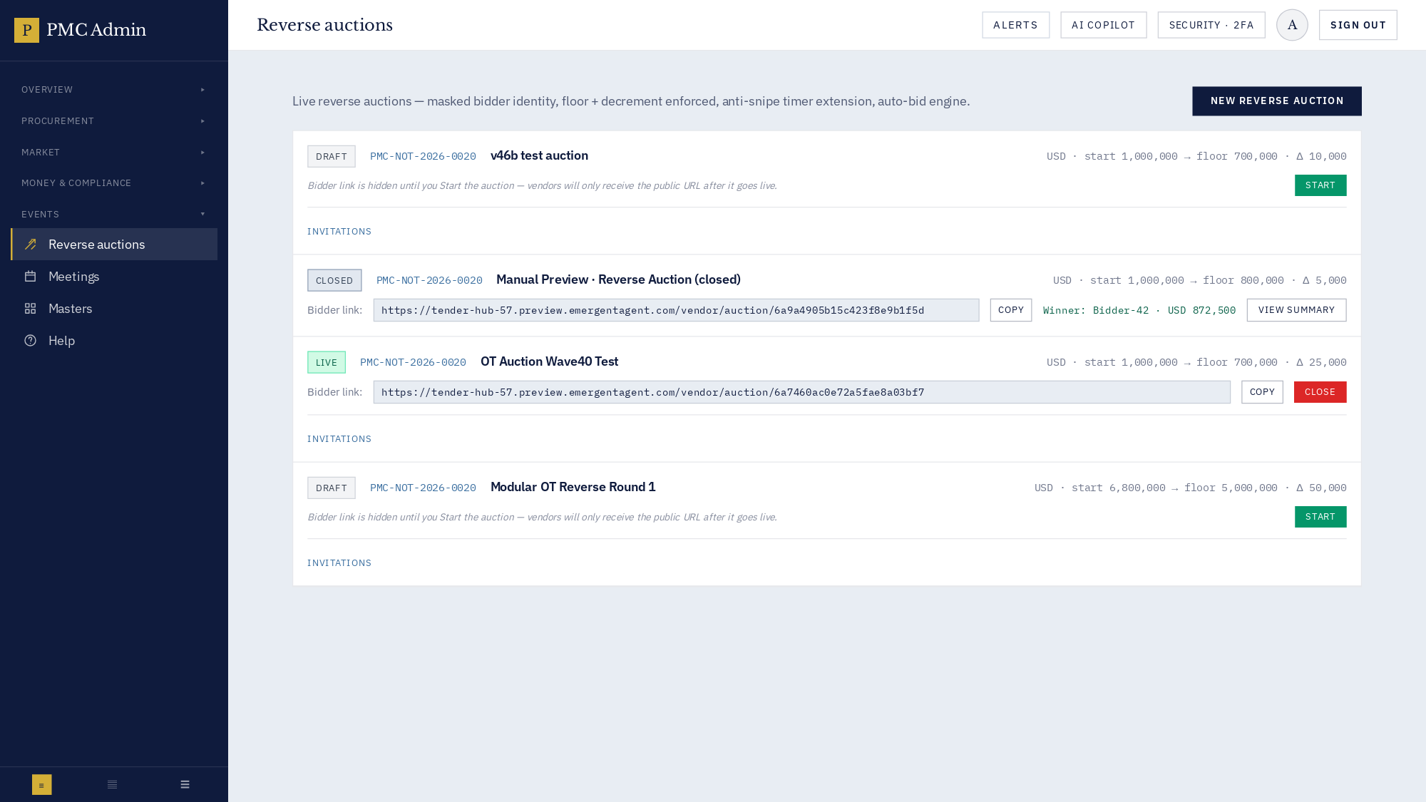

How to use
This screen exposes every action available for its module. Use the InfoDot (ⓘ) next to each label to see the field-level rules — hover it in-app for the full policy text. All destructive actions confirm before applying, and every mutation is written to the immutable audit log.

72 · Admin · Masters — fees, roles, EMD
Fee slabs, staff roles, criteria, categories, countries.
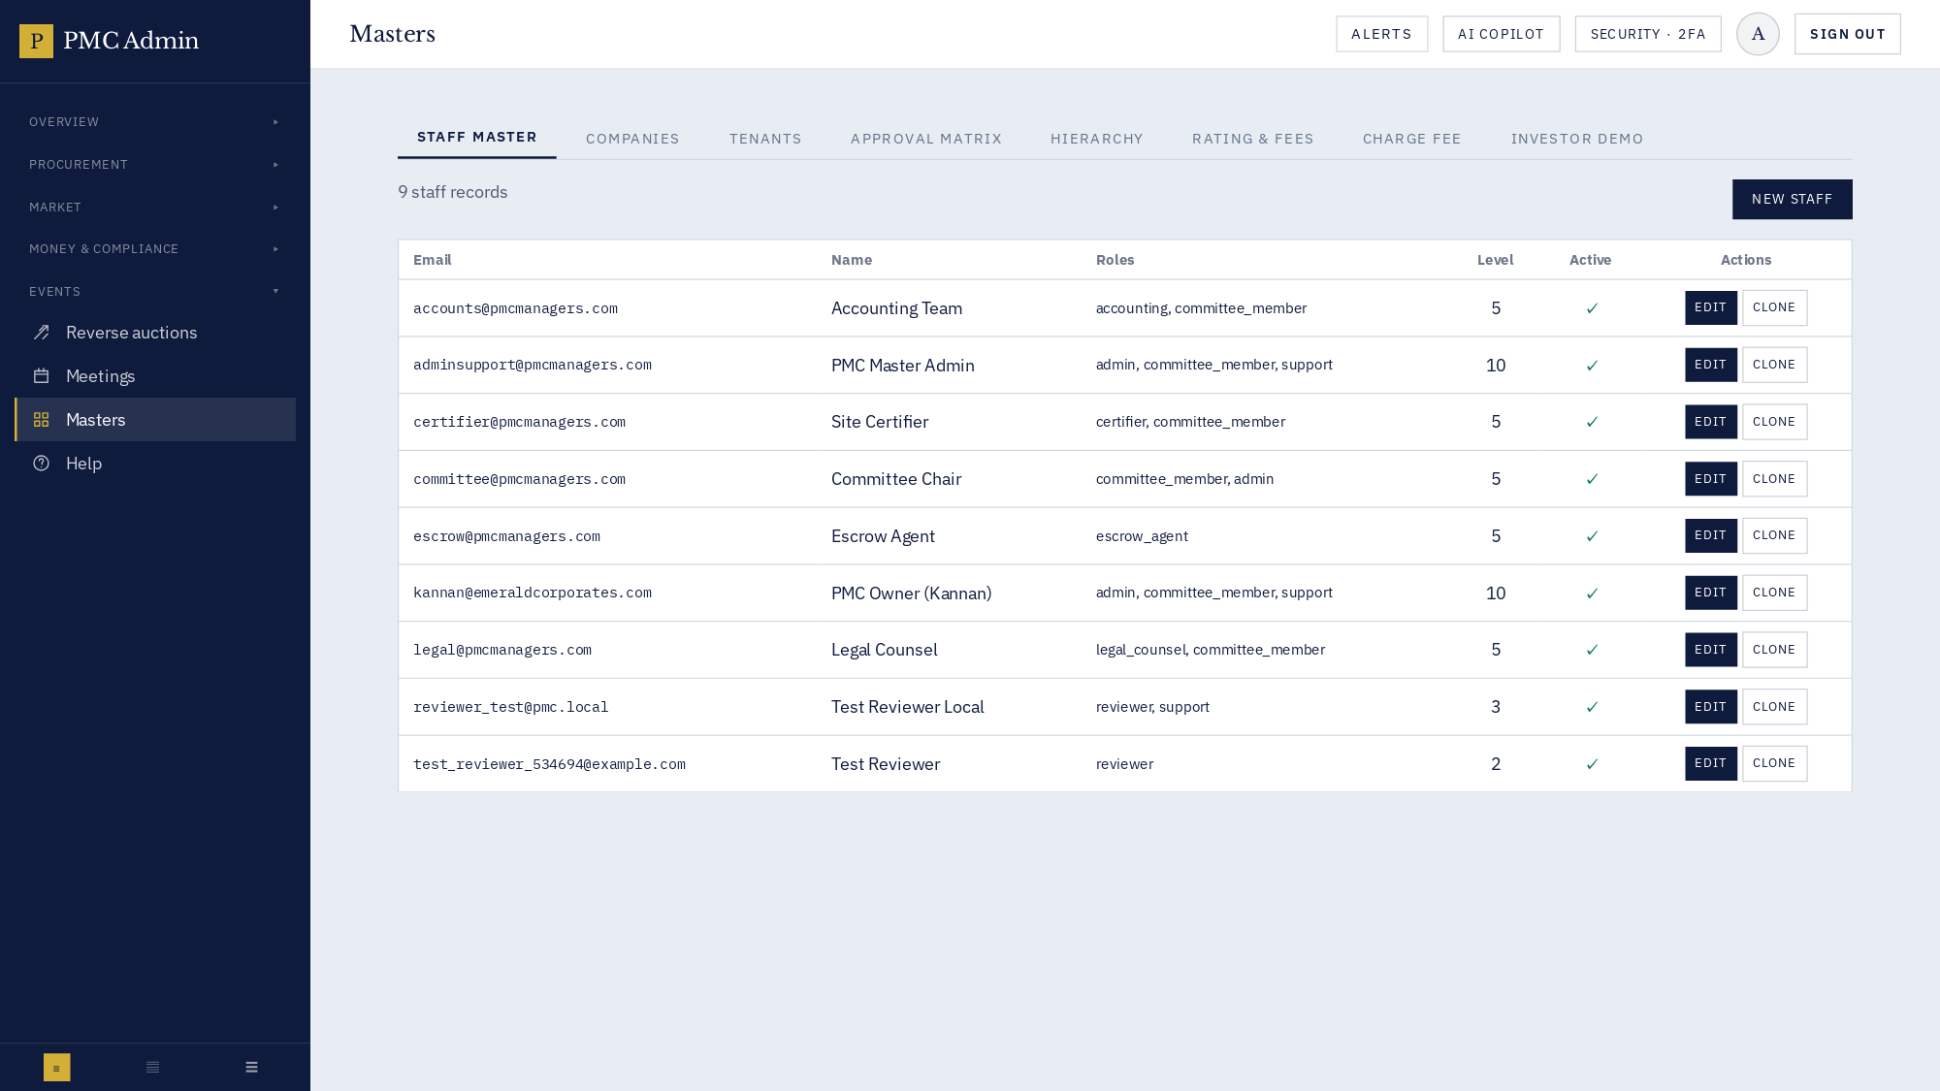

How to use
This screen exposes every action available for its module. Use the InfoDot (ⓘ) next to each label to see the field-level rules — hover it in-app for the full policy text. All destructive actions confirm before applying, and every mutation is written to the immutable audit log.

7 · Deep-dive: Tender Builder & AI DPR (v46l map-reduce)
v46l lifts the 800 KB ceiling and adds a background worker. MAX_CHUNKS 500 (env-overridable). Files ≥ 4 MB auto-route to the async endpoint with a live progress bar. Pass 1a maps every 40 KB chunk (semaphore 4); Pass 1b reduces to a global blueprint (up to 60 sections); Pass 2 drafts each section body in parallel (semaphore 6) with a raw-passage fallback for stubs under 200 chars.

8 · Deep-dive: Evaluation, awards & escrow
Rubric enforces weight 0–1 per criterion, sum ≈ 1.00, commercial 0–1, minimum technical 0–100. v46m locks are one-way; the backend refuses re-lock (409). Awards use QCBS with L1 comparison. Escrow is a two-signer joint-account model with a snapshot on every transaction.

9 · Deep-dive: Reverse auctions
Vendors join with masked aliases, place manual or auto bids with a walk-away floor. Anti-snipe extends auctions on last-minute bids. Public spectator link exposes only masked aliases.

10 · Tooltip, error-handling & offline system
InfoDot (166 uses), showApiError / formatApiError (67 files), ErrorBoundary at the app root; service worker deliberately un-registered.

11 · Deployment runbook (S3 + CloudFront + EB)
Frontend: build with REACT_APP_BACKEND_URL='' so bundle uses same-origin /api. Sync with --exact-timestamps --exclude 'downloads/*'. Invalidate CloudFront /*. Backend: eb deploy --staged --label vXX. Never sync with --delete at bucket root.

12 · Troubleshooting playbook
Symptom | Root cause | Fix
Landing shows 0 counters | Stale CloudFront cache | Invalidate `/*` on CloudFront
'No matching employee' toast | Preview URL baked into prod bundle | Rebuild with `REACT_APP_BACKEND_URL="" yarn build`
DPR returns 5 generic sections | Backend on ≤ v46g | Deploy v46l map-reduce backend
Progress bar stuck at 2% | Async worker crashed | Check `/api/v1/tender-pro/dpr/jobs/{id}` for `error` field
413 on large DPR | nginx body limit | Deploy v46l — `client_max_body_size 200M`
Login OK but /admin bounces | Cross-site cookie blocked | Ensure frontend calls same-origin `/api`
Envelope re-locks silently | Direct API bypasses UI | v46m rejects re-lock with 409
Auction bidder identity leaks | Masked alias not applied | Re-open room; masking is server-side
Refund never reaches vendor | Second signer missed the notification | Check joint-account snapshot on the transaction
Resend email lands in spam | First-touch corporate MX filter | Resend from Registrations queue with a warm-up sender

13 · API reference index
Endpoint | Purpose
`GET /api/v1/meta/public/stats` | Public — landing KPIs.
`GET /api/v1/meta/public/notices` | Public — list notices.
`POST /api/v1/admin/auth/login` | Admin realm login (cookie).
`POST /api/v1/staff/auth/login` | Staff realm login.
`POST /api/v1/vendor/auth/login` | Vendor realm login.
`POST /api/v1/registrations/draft` | Create registration draft.
`POST /api/v1/registrations/submit` | Submit for review.
`POST /api/v1/tender-pro/dpr/analyze-json` | Synchronous DPR analysis (< 4 MB).
`POST /api/v1/tender-pro/dpr/analyze-async` | **v46l** kick off async DPR analysis.
`GET /api/v1/tender-pro/dpr/jobs/{id}` | **v46l** poll async DPR job status.
`POST /api/v1/tender-pro/templates/{id}/save-as-master` | Promote a draft to a reusable master.
`POST /api/v1/evaluations/rubric` | Upsert rubric for a notice.
`POST /api/v1/evaluations/lock-envelope` | **v46m** now refuses re-lock (409).
`GET /api/v1/evaluations/lock-state/{ref}` | **v46m** returns seal timestamps + attribution.
`POST /api/v1/evaluations/score` | Submit a technical or commercial score.
`GET /api/v1/evaluations/award-report/{ref}` | Generate the L1 comparison.
`POST /api/v1/escrow/transactions` | Record an EMD transaction.
`POST /api/v1/auctions/{ref}/bid` | Place an auction bid.
`POST /api/v1/reports/snapshot` | Persist stakeholder-report artefacts to disk.
`GET /api/v1/stakeholder-reports/*` | Tenders / awards / escrow / SLA reports.

14 · Release history
Version | Highlights
v46m | Bug Blitz Round Two — envelope re-lock 409, GET /lock-state, EvaluationPanel sealed banner, AuctionRoom mobile overflow fix.
v46l | Unlimited DPR + async worker (MAX_CHUNKS 500, /dpr/analyze-async, /dpr/jobs/{id}, nginx 200 MB / 300 s, live progress bar).
v46k | Sovereign Redesign — 5-portal Sovereign Gateway, navy/gold editorial home hero, PmcFooter with social icons.
v46j | Map-Reduce DPR first cut (still capped at 800 KB).
v46i | New roles (management/partner/agent), collapsible admin sidebar, editorial public design v1.
v46h | Admin vendor form: per-section Save buttons + search.
v46g | DPR deep-dive first cut (26 sections from KMT).
v46f | Editable tender name + reliable save-as-master.
v46e/d/c/b | Bug blitz first pass — 60+ tracker items fixed.

15 · Glossary
- DPR — Detailed Project Report — the source document the AI ingests to draft a tender pack.
- EMD — Earnest Money Deposit — refundable bid security.
- QCBS — Quality- & Cost-Based Selection — the default 70/30 evaluation weighting.
- L1 — Lowest financial bid post-technical qualification.
- BOQ — Bill of Quantities — itemised deliverable+rate schedule.
- Corrigendum — Official post-publication amendment to a notice.
- LOA — Letter of Award — signed offer letter to the L1 vendor.
- PO — Purchase Order — issued after the LOA is accepted.
- Envelope — A sealed batch of bid data — technical or commercial.
- Trust badge — Bronze / Silver / Gold / Platinum tier surfaced on the public vendor profile.
- Master — A reusable Tender Builder template keyed by country + industry.
- Sovereign Gateway — The v46k 5-portal login picker.
- Async pipeline — The v46l background DPR worker — kicked via /dpr/analyze-async.
- Sealed 🔒 — The v46m evaluation-panel indicator that an envelope is locked.

