HCR Lab book

Error | Solution
Rosaria port connecting: Permission Denied | Give user permissions with:  sudo usermod -a -G dialout $USER  USB converter A is always dev/ttyUSB0  USB converter B is always dev/ttyUSB1
Fixed Frame [map] does not exist  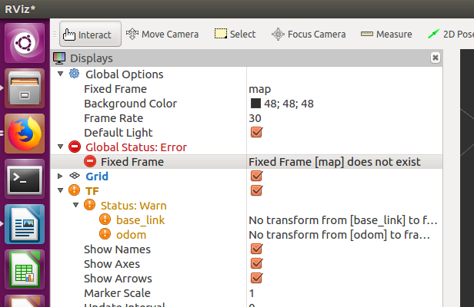 | Change Fixed Frame to odom to see relative robot position. - i.e. use base_link or odom
[ERROR] [1542018038.258268407]: Client [/slam_gmapping] wants topic /RosAria/sonar to have datatype/md5sum [sensor_msgs/LaserScan/90c7ef2dc6895d81024acba2ac42f369], but our version has [sensor_msgs/PointCloud/d8e9c3f5afbdd8a130fd1d2763945fca]. Dropping connection.
[ WARN] [1542018453.430375823]: /use_sim_time set to true and no clock published. Still waiting for valid time... | rosparam set use_sim_time false  Then retyry the rosbag
Errors during catkin_make of cloned package  ####  #### Running command: "make -j4 -l4" in "/home/human/Documents/catkin_ws/build"  ####  make: *** No targets specified and no makefile found. Stop.  Invoking "make -j4 -l4" failed | Make sure you clone the right branch of git repo  git clone -b <branch> <.git url>  OR just use:  apt-get install ros-<ROSVERSION>-<PACKAGE NAAME>  - rospack find pointcloud_to_laserscan  - /opt/ros/kinetic/share/pointcloud_to_laserscan  - Note: stores it in the share folder not the catkin_ws/src folder  Try making a copy of the build and devel folders, deleting the originals and then re-running catkin_make [https://answers.ros.org/question/215173/catkin_make-does-not-compile-all-packages-in-the-workspace/]  If you still get errors like that on the left, go into the /src/ folder and delete the  CmakeCache file  (and the Makefile to be extra safe)  Literally fuck that file
Compilation fail due to file not found  /home/human/Documents/catkin_ws/src/rosaria_client/src/print_state.cpp:7:33: fatal error: rosaria/BumperState.h: No such file or directory  compilation terminated | As you can see in this error it says a file cannot be found, in this case it is because the rosaria_client actually depends on rosaria being installed.  ie.. rosaria is a dependency  You can:  1) Try adding it as a dependency in the: package.xml  2) Try building the dependency first, then run a normal catkin_make [https://answers.ros.org/question/54178/how-to-build-just-one-package-using-catkin_make/ ]  catkin_make --pkg <packageName>  3) Be careful if you have ever run:  catkin_make -DCATKIN_WHITELIST_PACKAGES=  This means that you might have specified to only compile certain packages and may need to reset it’s value to compile everything
You created packages not building | Need to create package.xml and CmakeList.txt files in the folder  http://wiki.ros.org/ROS/Tutorials/catkin/CreatingPackage  Semi-automated way can be seen here:  catkin_create_pkg <Name you want for package> [depend1] [depend2] ..
Your branch is up-to-date with 'origin/movement'.  Changes not staged for commit:  (use "git add <file>..." to update what will be committed)  (use "git checkout -- <file>..." to discard changes in working directory)  (commit or discard the untracked or modified content in submodules)  modified: movement/catkin_ws/src (copy)/rosaria (untracked content)  modified: movement/catkin_ws/src (copy)/rosaria_client (untracked content)  modified: movement/catkin_ws/src (copy)/tutorial_pub_sub (untracked content)  modified: movement/catkin_ws/src/pointcloud_to_laserscan (untracked content)  modified: movement/catkin_ws/src/rosaria (untracked content)  modified: movement/catkin_ws/src/rosaria_client (untracked content)  modified: movement/catkin_ws/src/tutorial_pub_sub (untracked content) | You need to use git submodule add  But we might need to remove the cached folder’s (lister here)  https://stackoverflow.com/questions/12898278/issue-with-adding-common-code-as-git-submodule-already-exists-in-the-index
Error [Param.cc:451] Unable to set value [-nan -nan -nan] for key[size]  gzclient: /build/ogre-1.9-mqY1wq/ogre-1.9-1.9.0+dfsg1/OgreMain/src/OgreNode.cpp:630: virtual void Ogre::Node::setScale(const Ogre::Vector3&): Assertion `!inScale.isNaN() && "Invalid vector supplied as parameter"' failed.  Aborted (core dumped)  [gazebo_gui-3] process has died [pid 17913, exit code 134, cmd /opt/ros/kinetic/lib/gazebo_ros/gzclient __name:=gazebo_gui __log:=/home/human/.ros/log/020ed6e2-ee4e-11e8-a0b3-b88a60621ea2/gazebo_gui-3.log].  log file: /home/human/.ros/log/020ed6e2-ee4e-11e8-a0b3-b88a60621ea2/gazebo_gui-3*.log | Error with Gazebo 7  URDF models that have a 0 size collision box cause some divide be ero errors  Solution detailed here:  https://github.com/ros-simulation/gazebo_ros_pkgs/issues/488  0.001 for example would work instead of 0
[ INFO] [1542904237.101050324, 0.329000000]: Starting GazeboRosSkidSteerDrive Plugin (ns = //)  [spawn_pioneer-4] process has finished cleanly  log file: /home/human/.ros/log/78c8a190-ee72-11e8-8c20-b88a60621ea2/spawn_pioneer-4*.log  libGL error: failed to create drawable | Works best with Nvidia graphics cards  https://answers.ros.org/question/286985/libgl-error-failed-to-create-drawable/  But if you have one and are getting errors, the guy here knows what he is dong:  https://answers.ros.org/question/11148/rviz-in-ros-electric/?answer=16630#post-id-16630
Move robot model in Gazebo with RosaAria | You can’t fam:  https://answers.ros.org/question/257057/using-gazebo-simulator-with-rosaria/  Gazebo doesn’t emulate the robot – instead use this:  https://github.com/MobileRobots/amr-ros-config/blob/master/gazebo/README.md  sudo apt-get install ros-kinetic-rviz-plugin-tutorials  Then in Rviz > Panels > New Panel > Tutorials > Telop  Set the Output Topic to /cmd_vel  Click and drag the cursor to move  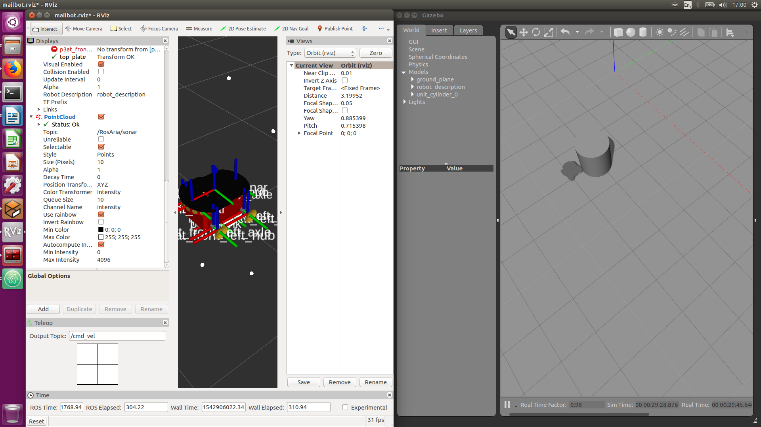Gazebo cannot simulate sensor data though, so would need to look here:  https://github.com/ros-simulation/gazebo_ros_pkgs/blob/melodic-devel/SENSORS.md
Errors in make requiring you to install a new packages  https://github.com/OpenKinect/libfreenect2/issues/36 recompile with "-fpic" error | You must delete the original build folder, then re-run cmake before running make
Random errors with catkin make | Try catkin_make –force-cmake
Kinect stuck on:  [ INFO] [1543087579.335836749]: [Kinect2Bridge::main] waiting for clients to connect | Running:  roslaunch kinect2_bridge kinect2_bridge.launch only starts publishing the topics, it waits for a listener before giving more debug info  So in another terminal run:  rosrun kinect2_viewer kinect2_viewer
[ERROR] [1543165004.686676554]: [Kinect2Bridge::start] Initialization failed!  [FATAL] [1543165004.773585945]: Failed to load nodelet '/kinect2_bridge` of type `kinect2_bridge/kinect2_bridge_nodelet` to manager `kinect2' | This “cannot load the nodelet” error happens all the time , last time this was fixed with a forced-cmake & adding the -fexception definition to the CmakeList for kinect_registration [https://github.com/code-iai/iai_kinect2/issues/377 ].  But also try unplugging usb and replugging and restarting the kinect bridge
Arduino port not showing,  lsusb # shows Arduino  dmesg # states:  [25689.906230] usb 1-7: Not enough bandwidth for new device state.  [25689.906271] usb 1-7: can't set config #1, error -28 | Xbox One Kinect Bandwidth is massive, esnure nothing is runnig that uses that before trying to connect
human@human4:~/Documents/catkin_ws/src$ rosdep install depthimage_to_laserscan/  ERROR: Rosdep cannot find all required resources to answer your query  Missing resource depthimage_to_laserscan/ | Remove the folder seaparator at the end of the command
Rosrun Python files?  Or Shebang line missing gives weird non-python errors.  e.g. cannot get mouse event | https://answers.ros.org/question/56640/calling-a-python-script-with-rosrun/  Make python file execturable:  chmod +x <pythonScriptName>.py  MAKE SURE TH FIRST LINE IS A SHEBANG:  #!/usr/bin/env python  or  #!/usr/bin/env python3  Find the exact location using:  type <name>  e.g. type python3
Rtabmap/odom_info  is published even when visual odometry is set to false | In our case this was due to a roscore that was used and not closed. This roscore stored the settings of the default true visual odometry, turning off visual odomotery didn’t reset the value due to the way the launch fle is coded:  http://official-rtab-map-forum.67519.x6.nabble.com/How-to-disable-visual-odometry-and-use-wheel-odometry-td4687.html

Resources:
http://wiki.ros.org/ROSARIA/Tutorials/How%20to%20use%20ROSARIA
- Rosaria install guide
http://wiki.ros.org/navigation/Tutorials/RobotSetup
- Navigation stack tutorial
http://wiki.ros.org/pointcloud_to_laserscan

http://wiki.ros.org/rtabmap
https://answers.ros.org/question/287670/run-rviz-with-configuration-file-from-launch-file/

http://wiki.ros.org/urdf/Examples
- URDP Examples
sudo apt-get install ros-kinetic-p2os-urdf

https://github.com/ros-perception/pointcloud_to_laserscan/tree/indigo-devel
Process:
- Installed ROS and Rosaria

When you install ros packages with apt-get install, there are stored here:
/opt/ros/kinetic/share/<package name>
e.g.
/opt/ros/kinetic/share/p2os_urdf/

https://answers.ros.org/question/118901/source-catkin_wssrcsetupbash-after-each-reboot/
- If you have multiple robots you can give each workspace a difference alias in the ~/.bashrc

http://wiki.ros.org/rtabmap_ros
- RGB-D Handhelp mapping is good place to start
- For Kinect 2 We used ai_kinect2 before moving to the kinect 1
https://github.com/code-iai/iai_kinect2/tree/master/kinect2_calibration – Callibration steps followed
- For Kinect 1
http://wiki.ros.org/openni_launch/Tutorials/IntrinsicCalibration
Useful: but out of data: http://wiki.ros.org/Robots/evarobot/Tutorials/indigo/Kinect

Some Commands:
# Start Camera:
roslaunch openni_launch openni.launch depth_registration:=true
# Start Mapping
Bold for using Kinect 2
roslaunch rtabmap_ros rtabmap.launch rtabmap_args:="--delete_db_on_start" rgb_topic:=/kinect2/qhd/image_color_rect depth_topic:=/kinect2/qhd/image_depth_rect camera_info_topic:=/kinect2/qhd/camera_info approx_sync:=false
# Start Localisation
roslaunch rtabmap_ros rtabmap.launch localization:=true rgb_topic:=/kinect2/qhd/image_color_rect depth_topic:=/kinect2/qhd/image_depth_rect camera_info_topic:=/kinect2/qhd/camera_info approx_sync:=false

sudo apt-get install ros-kinetic-openni-camera

http://official-rtab-map-forum.67519.x6.nabble.com/Convert-database-to-2D-map-fail-td3243.html
- Convert rtab map database file (.db) to a .yaml map
roscore
rosrun rtabmap_ros rtabmap _database_path:=/home/human/.ros/rtabmap.db
rosrun map_server map_saver map:=proj_map
rosservice call /publish_map 1 1 0

Publish map afterwards:
rosrun map_server map_server map.yaml
Launch file: https://answers.ros.org/question/9379/roslaunch-and-map_server/

Remap using pointcloud to laserscan:
rosrun pointcloud_to_laserscan pointcloud_to_laserscan_node cloud_in:=/RosAria/sonar_pointcloud2

For Jack:
roslaunch mailbot kinectBoot.launch
roslaunch rtabmap_ros rtabmap.launch

Run the depthimage_to_lasescan through the mailbot fakeLaser launch file
Run:
roslaunch rtabmap_ros rtabmap.launch subscribe_scan:=true
And then you can get some laserscan data (!) - defaults to the topic /scan

List what the parameters are of rtapmapping and what they do:
rtabmap --params

VNC Connection (remote controll this boi)
Search for desktop sharing, and open the preferences: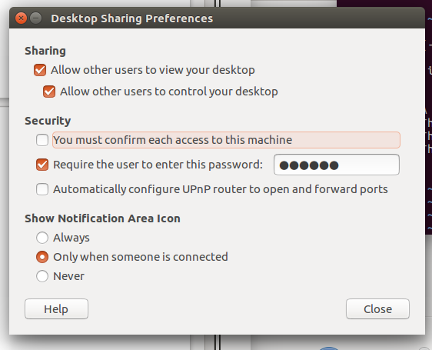

2 commands: first is to turn off encryption (as Window’s viewers don’t support it). Second is to start the vnc on the network interface

gsettings set org.gnome.Vino require-encryption false
gsettings reset org.gnome.Vino network-interface

On your viewer you simply type in the IP address here:
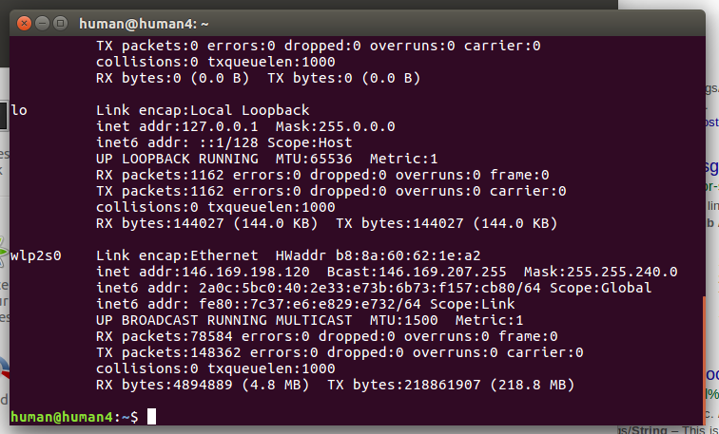

List Usb devices:
ls -l /dev |grep ttyUSB

sudo chmod 666 /dev/ttyUSB2
- grants some extra permissions for read and write for ttyUSB2

roslaunch mailbot boot.launch

roslaunch mailbot teleop.launch

roslaunch mailbot kinectBoot.launch

roslaunch mailbot nav.launch
[ You need to wait 30 seconds for it to publish the map for navigation below]

roslaunch mailbot move_base.launch

rviz
[ Send nav goals ]

move_base.launch: this is the autonomous navigation stuff (amcl)
sonarToScan (set to true, then also change in costmap_common)
base_local_planner_params – velocity limits
costmap_common_params – sensor datas to use & inflation radius, obstacle range (in metres) etc.

Initial settings:
base_local_params.yaml:
max_vel_theta: 0.05

Reduced max_vel_theta to 0.01 since the robot was having violent oscillations while turning due to some sort of resonance.

Goals
508
[ INFO] [1544620773.963365134]: Setting goal: Frame:base_link, Position(0.055, -0.603, 0.000), Orientation(0.000, 0.000, -0.719, 0.695) = Angle: -1.605

509A
[ INFO] [1544620938.035910278]: Setting goal: Frame:base_link, Position(0.103, -0.503, 0.000), Orientation(0.000, 0.000, 0.062, 0.998) = Angle: 0.124

510:
pose:
position:
x: 15.7776464014
y: 21.0028335052
z: 0.0
orientation:
x: 0.0
y: 0.0
z: -0.103211866838
w: 0.994659394237

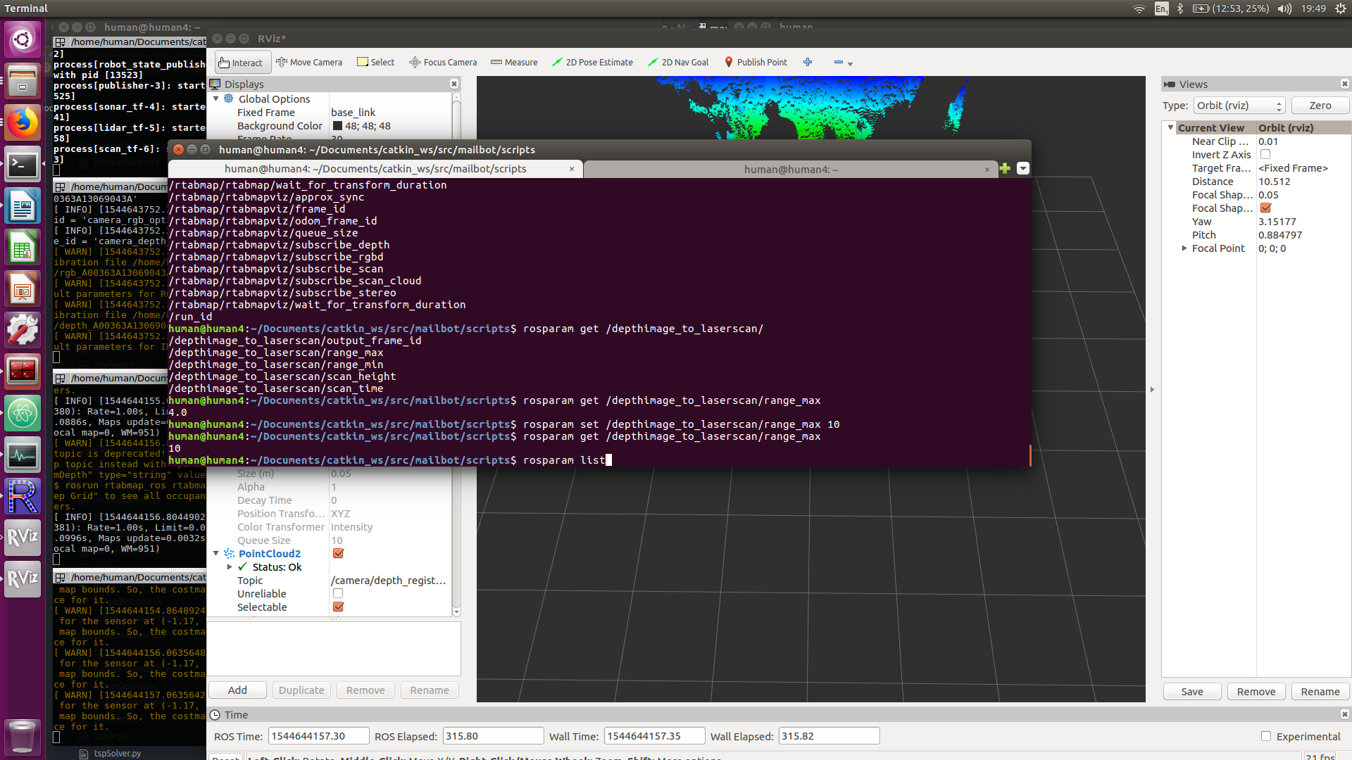
508
x: 22.6627316117
y: 38.4854511374
z: 0.0
orientation:
x: 0.0
y: 0.0
z: 0.978845177561
w: 0.204602342034

507
position:
x: 17.1804963979
y: 26.7939656756
z: 0.0
orientation:
x: 0.0
y: 0.0
z: 0.972850141519
w: 0.231435956899

510
position:
x: 15.4360864006
y: 21.0671653509
z: 0.0
orientation:
x: 0.0
y: 0.0
z: -0.192488682381
w: 0.981299193496
---

