Yo-yo
Sleep / Rest Observations — Photo Record

Prepared 27 May 2026 · Whale Class · Compiled from teacher photo log

This album collects nine photographs taken during the school day between 15 April and 25 May 2026 in which Yo-yo was resting or lying down rather than engaged in classroom work. The photographs are presented in chronological order. The descriptions are drawn from the captioning notes attached to each photograph at the time it was taken.
Five of the nine photographs are from a single day — 25 May 2026 — across the morning and early afternoon. This grouping is the most striking signal in the record and is presented here without interpretation; it is the pattern, not any single image, that the school wishes to discuss with the family.

#1 — 15 April 2026 · Wednesday · 12:07 (Beijing)
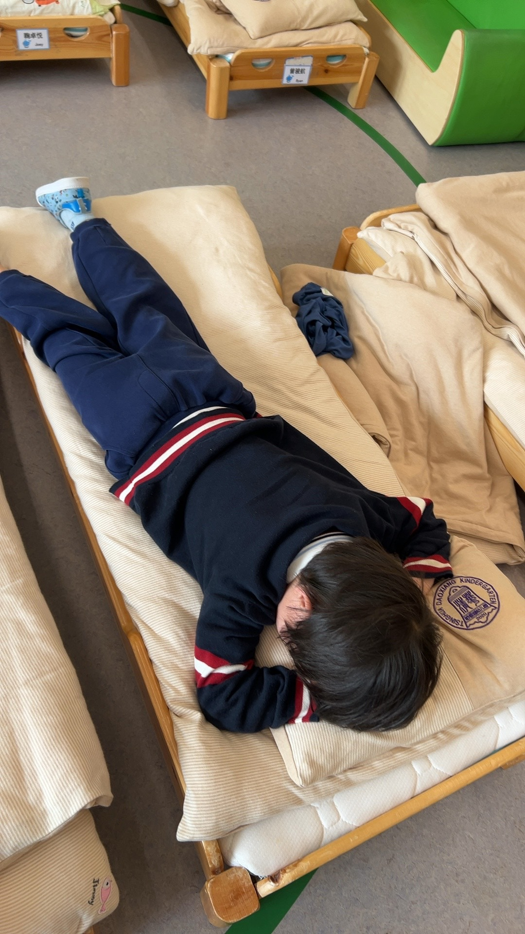
Observation note:
During the school's midday rest period, children are guided to lie quietly on their individual cots to rest and recharge. This child is currently working on building the self-regulation skills needed to settle calmly during rest time. Teachers are observing and gently supporting him in developing restful habits.
Teacher-confirmed

#2 — 13 May 2026 · Wednesday · 11:46 (Beijing)
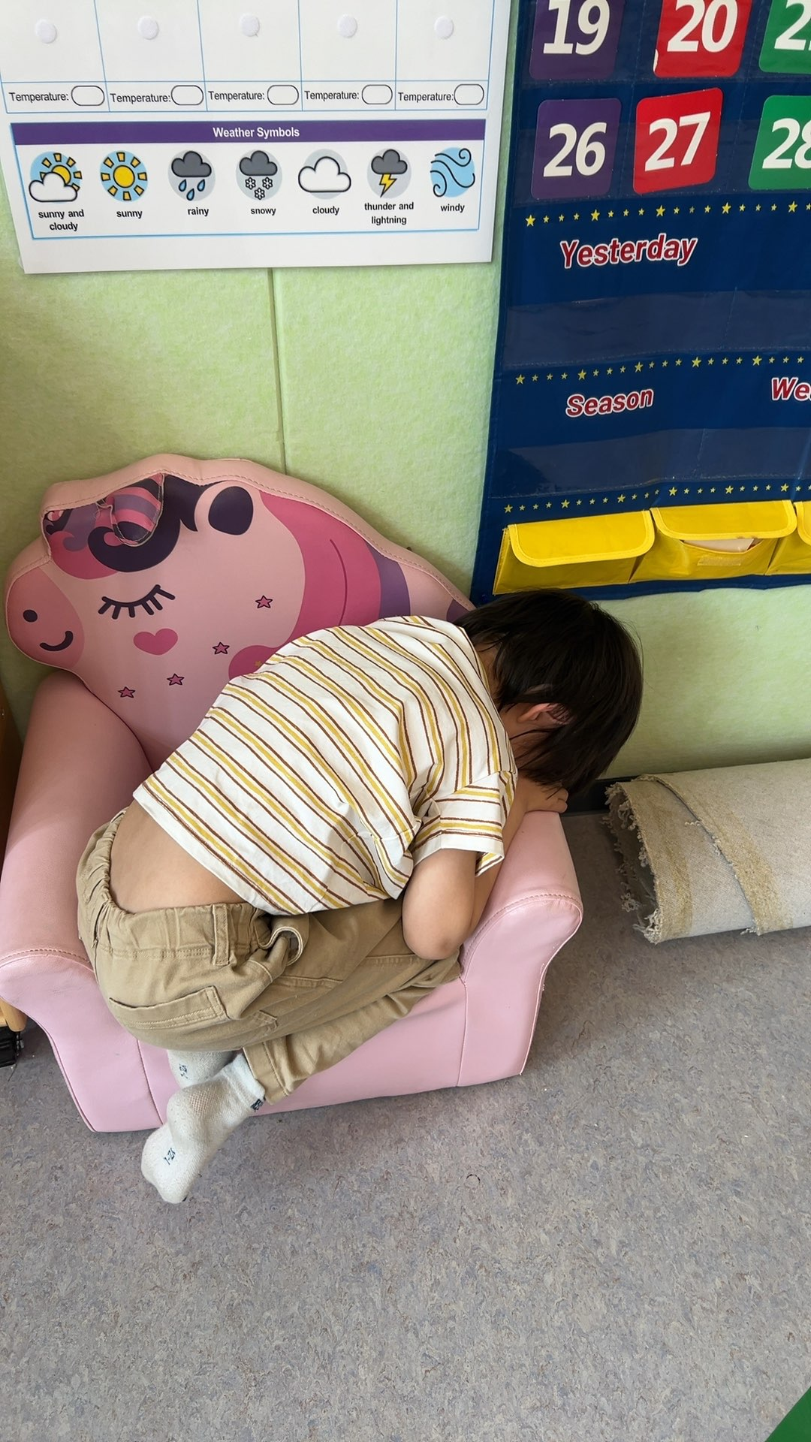
Observation note:
In this moment, your child appears to be taking a quiet break, resting on one of the classroom's soft chairs rather than engaging with a specific learning activity. This is a completely normal part of the school day — young children need moments to recharge, and teachers gently observe and support them as they transition between states of activity and rest.
Pending teacher review

#3 — 13 May 2026 · Wednesday · 14:44 (Beijing)
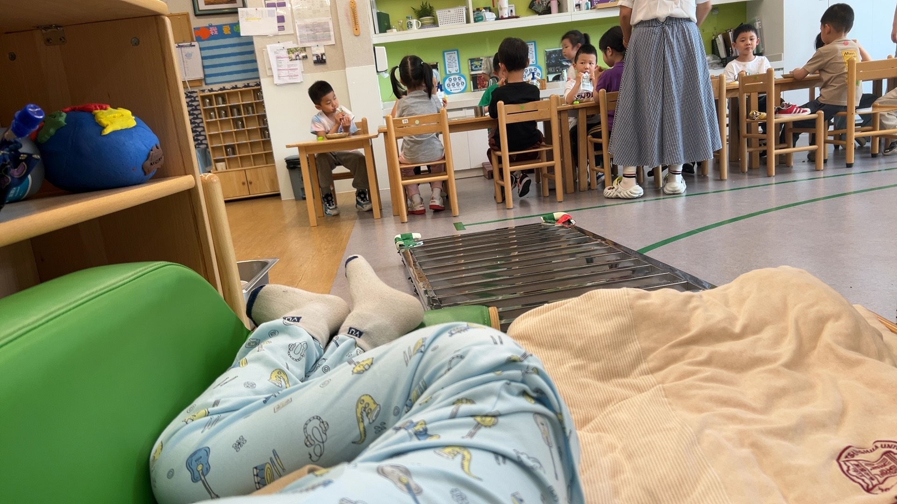
Observation note:
Your child is having a rest period in the classroom, lying on a soft padded mat in a quiet corner while other children continue their work nearby. This is a normal and important part of the daily rhythm — young children need moments of stillness and physical recovery woven into their day. The classroom environment supports this by having a dedicated, comfortable rest space that feels safe and calm even while the room around them hums with gentle activity.
Pending teacher review

#4 — 22 May 2026 · Friday · 11:55 (Beijing)
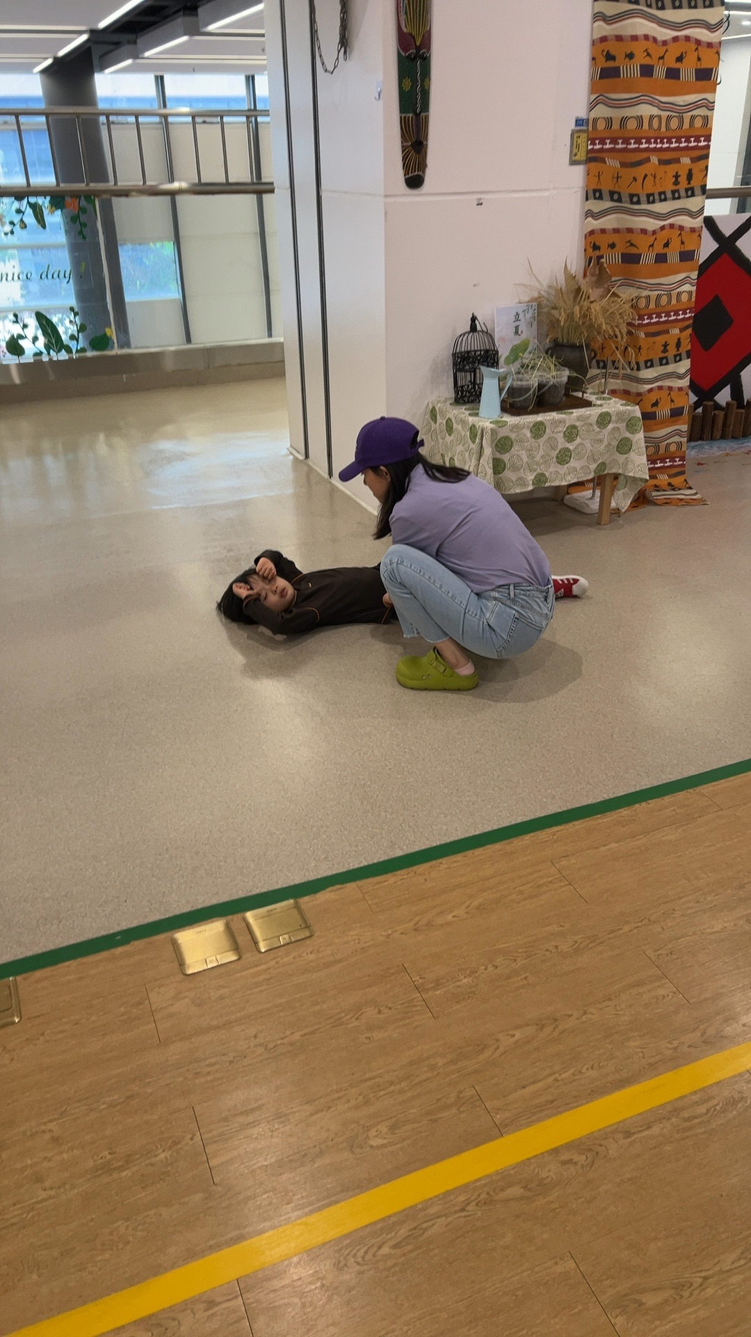
Observation note:
An adult is crouching beside a child who is lying flat on a beige/tan floor mat. The child's hands are resting at their sides with empty hands—no materials are being actively manipulated. The child is positioned horizontally on the floor surface with no objects or trays in front of them. This is a floor-based interaction with no educational materials visible on the child's immediate work surface.
Teacher-confirmed

#5 — 25 May 2026 · Monday · 09:12 (Beijing)
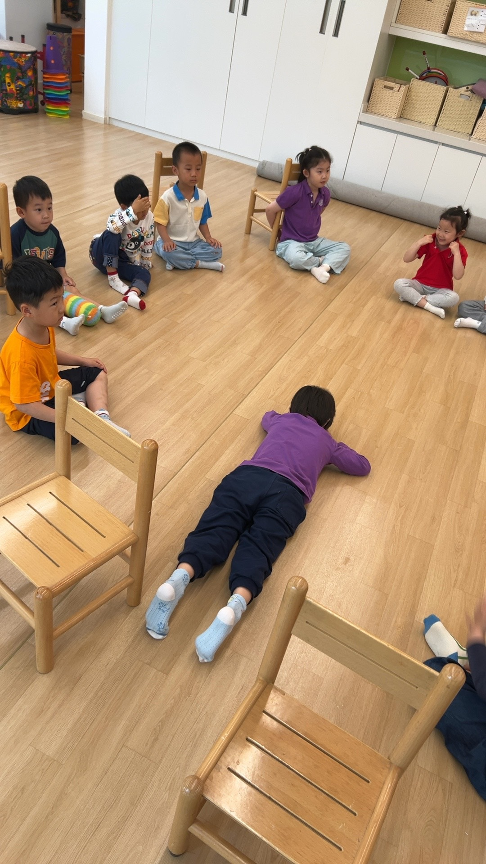
Observation note:
This is a group activity on a wooden floor, not a individual child work at a table or mat. The child in the purple jacket lying prone on the floor has their hands and body positioned flat against the wood surface, but they are not actively manipulating any materials or objects. Several other children are seated around the floor in a circle formation, also without materials directly in front of them. Wooden chairs are visible at the edges of the setup. No individual work materials, trays, or learning objects are present on the child's immediate work surface.
Teacher-confirmed

#6 — 25 May 2026 · Monday · 09:47 (Beijing)
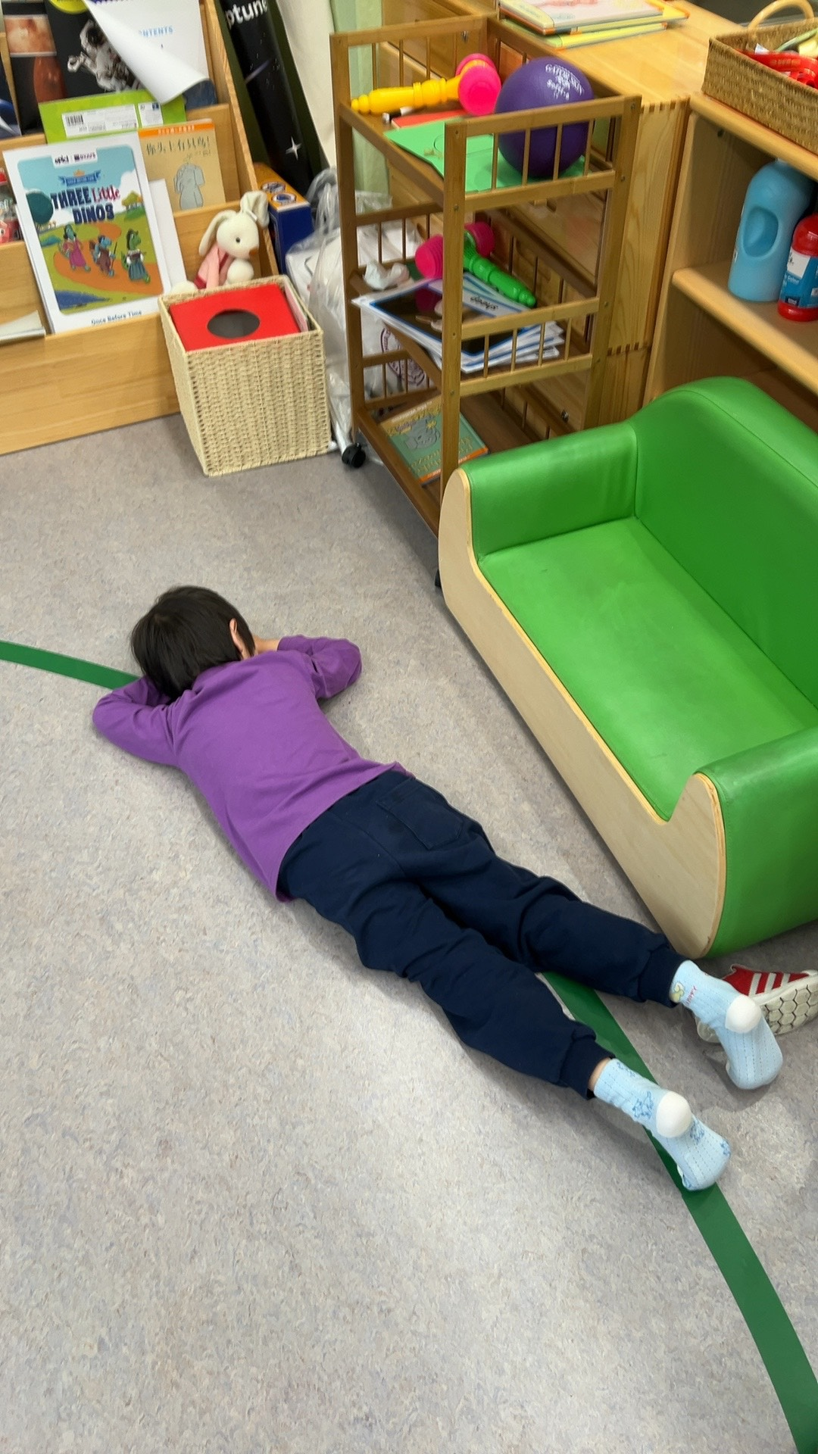
Observation note:
The child is lying prone on a gray floor mat with empty hands resting at their sides. There are no materials directly in front of them or on their work surface—the child is not actively engaged with any objects at this moment. A green tape line is visible on the floor near the child's body, and a green and cream-colored fabric cushion or seat is positioned to the right side of the mat.
Teacher-confirmed

#7 — 25 May 2026 · Monday · 10:04 (Beijing)
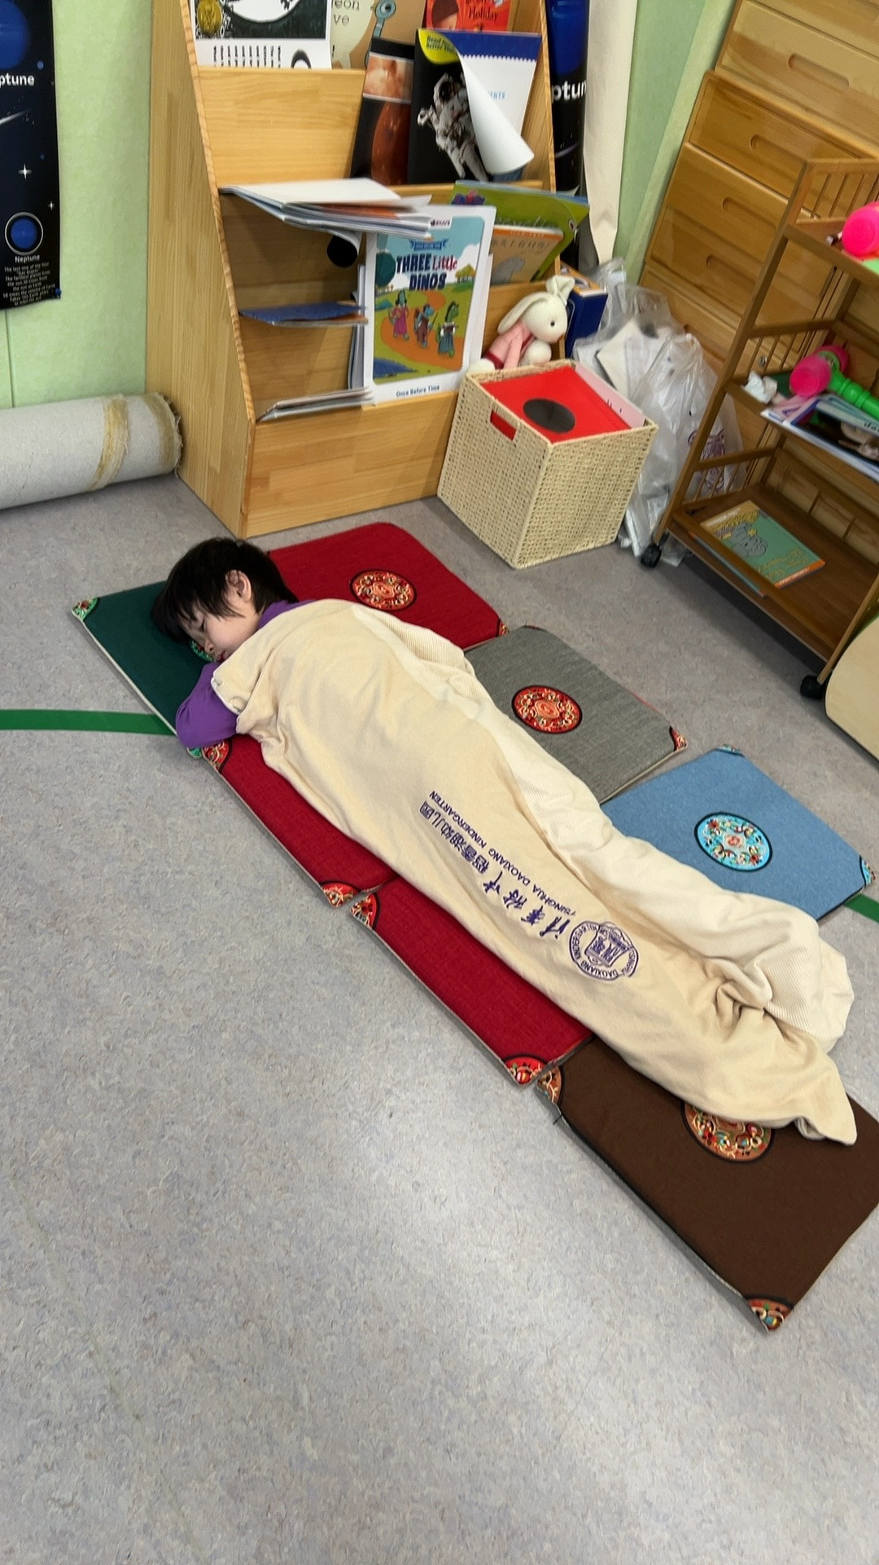
Observation note:
The child is lying down on a long mat made of segments of colored fabric (green, purple, red, gray, and blue sections) arranged in a horizontal line on the floor. The child is covered with a cream-colored fabric blanket or cloth. Small decorative ornaments with patterned designs are placed at intervals on the mat around the child's body. The child's hands are not actively engaged with any materials—they are resting while the child lies still on the mat.
Teacher-confirmed

#8 — 25 May 2026 · Monday · 11:00 (Beijing)
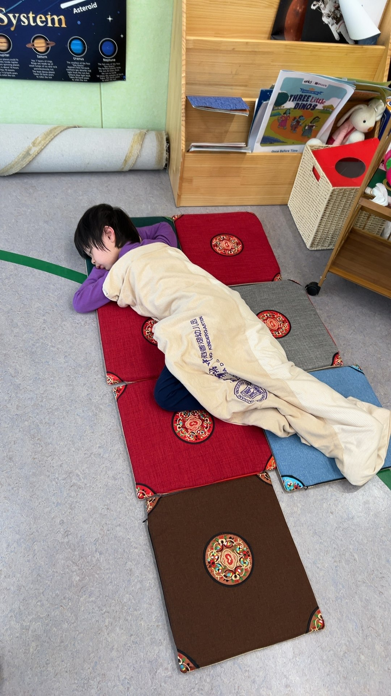
Observation note:
The child is lying prone on a sequence of fabric mats arranged in a line on the floor. Their hands are not actively manipulating any materials—they are resting at their sides as they recline on the mats. The mats are made of rigid fabric (wool or cotton blend) in different colors: red, brown, and blue, each with decorative embroidered circular medallions in the corners. The mats are arranged end-to-end in a continuous sequence on the gray classroom floor. No other materials are on the child's immediate work surface.
Teacher-confirmed

#9 — 25 May 2026 · Monday · 15:49 (Beijing)
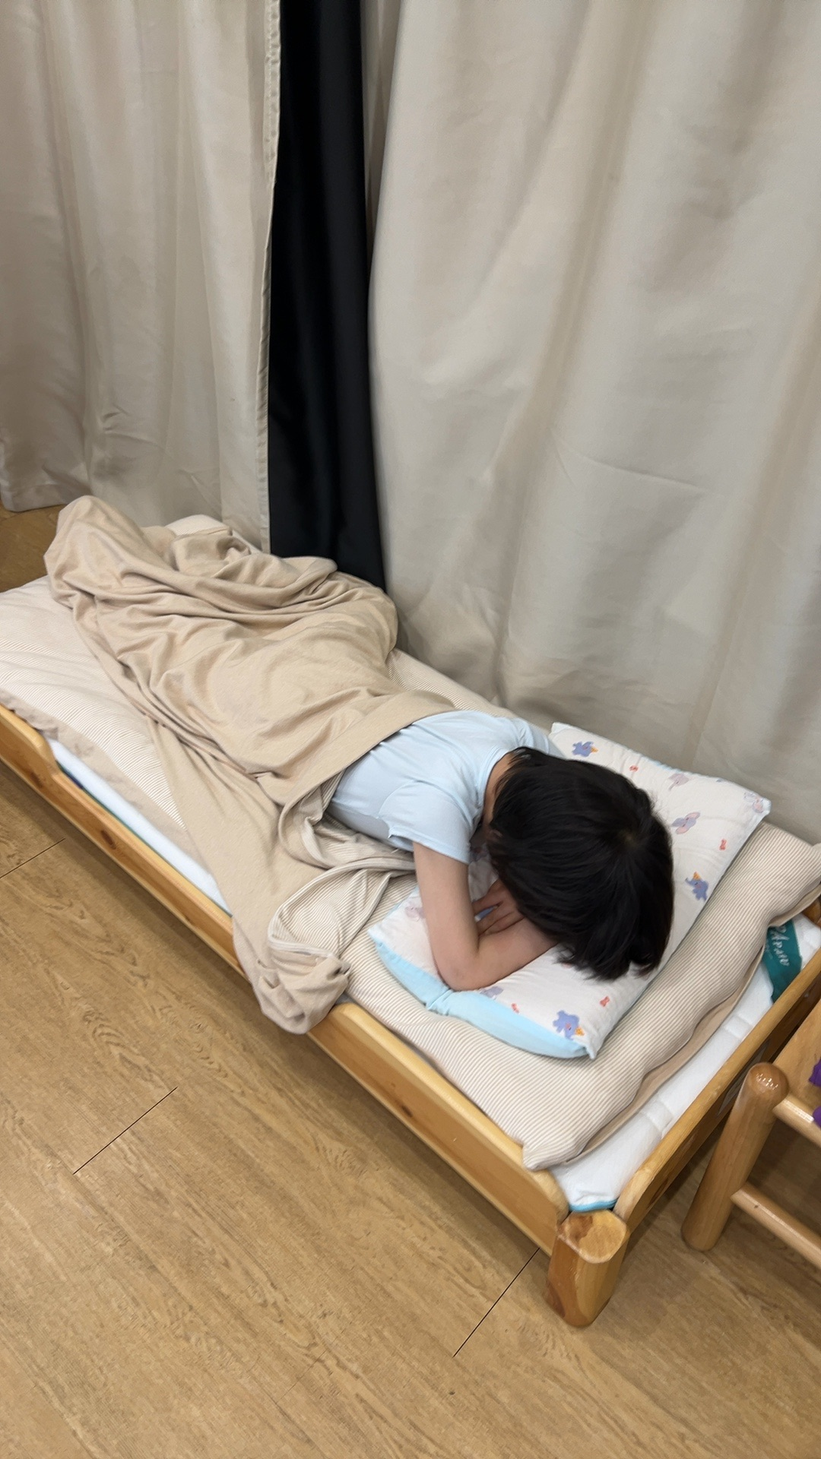
Observation note:
The child is lying on a wooden bed frame with their head resting on a pillow printed with small colored shapes (blue and red). They are covered with a beige/tan fabric blanket and appear to be resting or sleeping, with no materials or active work in hand. The bed has a white quilted mattress pad beneath the bedding, and beige and black fabric curtains hang behind the bed.
Teacher-confirmed

Summary
Nine photographs over forty days. Date distribution:
- 15 April 2026: 1 observation
- 13 May 2026: 2 observations
- 22 May 2026: 1 observation
- 25 May 2026: 5 observations

This album is for internal use in preparing for the meeting with Yo-yo's mother. It is not intended to be shown to her unprompted. If she asks for specifics, individual photographs can be shared one at a time in the context of the conversation. The full record exists; the conversation does not need to.

