Trevor Beaty

Assignment 2.3

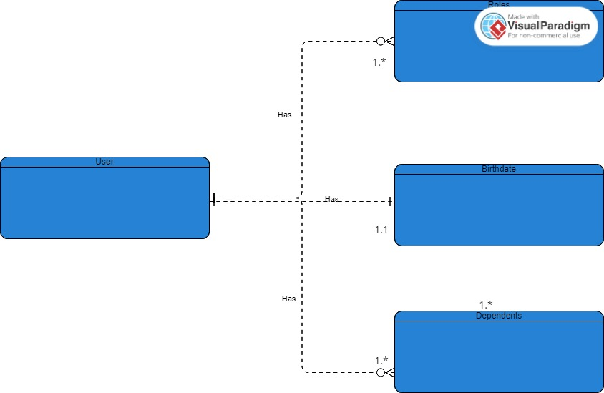

**NoSQL:**

{

“user”:

“roles”: [

{

“role 1”:

“role 2”:

“role 3”:

}

]

{

“birthdate:”:

}

{

“dependents:”: [

{

“dependent a”:

“dependent b”:

“dependent c”:

}

]

}