Trevor Beaty

4/6/24

Assignment 3.2

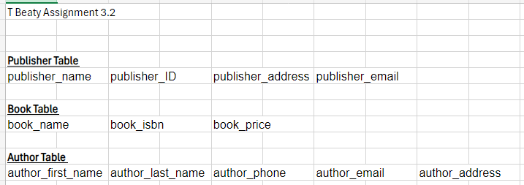

In my 3NF format i created three data tables and then put them in the order that I considered the primary data/key followed by the data that depends on that. None of the data holds lacks a primary key as the first item in each row fits that. Then, there are no instances of multiple values, and all the data can be uniquely assigned from there into each data spot.