Trevor Beaty

Assignment 5.2

4/11/24

One function to be used is the INNER JOIN function. Using this function takes two tables and if they share a value then the two tables can be joined so that that value becomes one and the rest of the data is on the one table as well. If you were keeping a table of customers' orders and another table of the price for customers' orders you could inner join them based on Customer as the alias and then the data of what they order, and the table will be combined into one table.

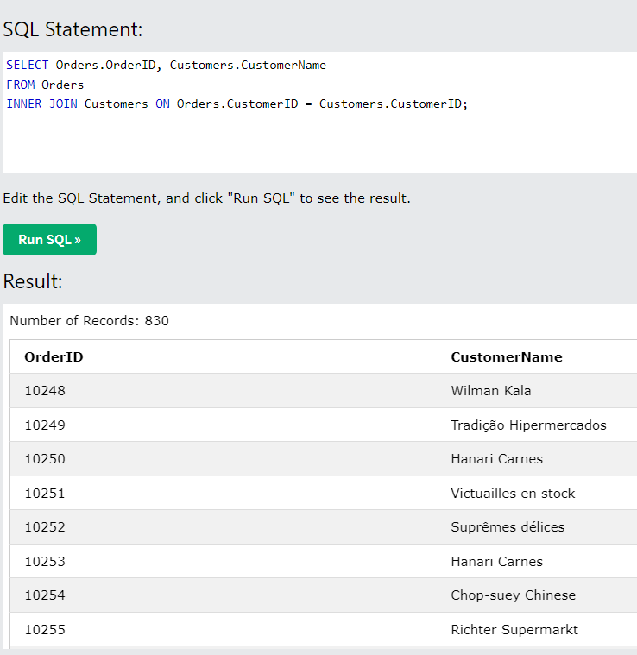

The HAVING function helps you specify the data needs to meet, or have, a certain criterion for it to be included in the data table. An example of this could be a table that has customer IDs, customer orders and customer totals. Then we specify totals having more than 15, meaning the customer spends more than 15 dollars. The alias could be TopSpender and the table shows their id and total.

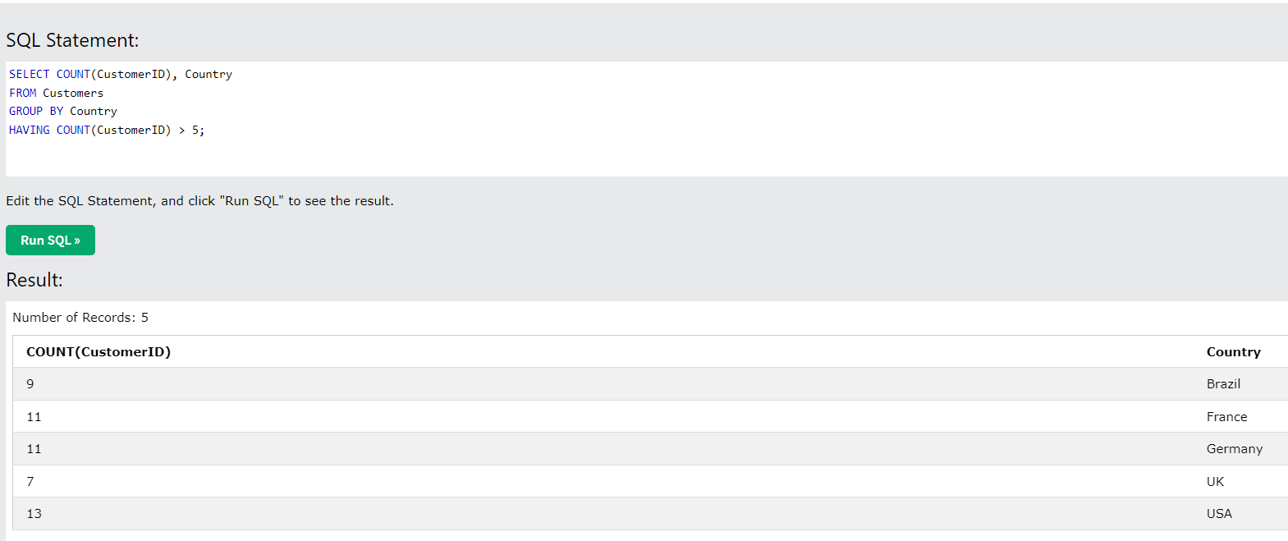

One more function that can be used with MySQL is EXISTS. This allows the user to test if a a criterion is true, meaning it does exist, and then returns the table of items that comes back true to the criteria. An example could be taking a table of customers, their orders, how frequently they order it and their order total. Then using exists you can test to see under the alias AmtOrdered how many times a product is ordered by customers.

