Trevor Beaty

Module 6.2

4/19/24

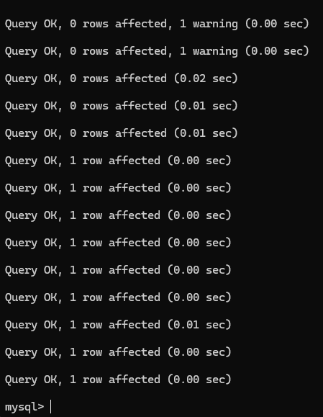

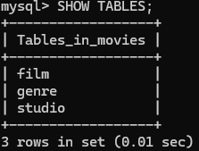

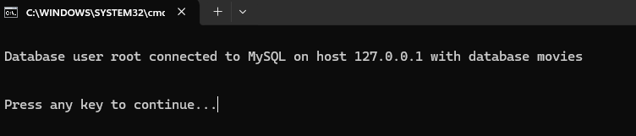

https://github.com/TreeB51/csd-310