- Which of the following best defines opportunity cost?
- It is the cost of producing those goods most desired by a given economy.
- It is the cost of the input mix that will lead to the greatest rate of growth for a given company.
- It is the amount of one product that must be given up in order to produce an additional unit of another product.
- It is the use of the least-cost method of production.
- It is the cost of labor used in the production process.

- Which of the following explains why a production possibilities curve is often represented as concave (bowed out) from the origin?
- The law of demand
- The law of supply
- Constant returns to scale
- Decreasing opportunity cost
- Increasing opportunity cost

- Assume that consumers consider popcorn and pretzels to be substitutes. A significant decrease in the supply of popcorn will affect the pretzel market by
- increasing the demand for pretzels and therefore the supply of pretzels
- increasing the demand for pretzels and therefore the price of pretzels
- decreasing the demand for pretzels and therefore the price of pretzels
- increasing the supply of pretzels and therefore the price of pretzels
- decreasing the supply of pretzels and therefore the price of pretzels

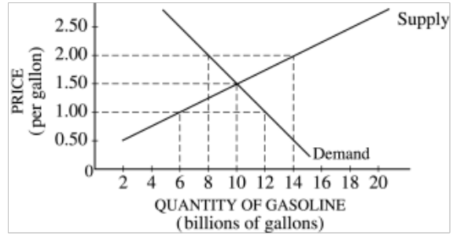

- In the market depicted in the diagram above, if the government imposes a price ceiling of $1.00 per gallon on gasoline, which of the following will result?
- A surplus of 6 billion gallons
- A shortage of 6 billion gallons
- A surplus of 12 billion gallons
- A shortage of 12 billion gallons
- Neither a surplus nor a shortage, because the price ceiling would not be effective

- Assume that Clark spends his entire income on the purchase of two goods, X and Y. If his income and the prices of good X and Y all double, Clark will
- double the purchase of goods X and Y
- buy more of good X and less of good Y
- buy less of good X and more of good Y
- buy less of both goods X and Y
- buy the same amounts of goods X and Y

- Suppose that a firm begins to hire workers for a newly completed plant with a fixed amount of machinery. As the firm hires additional workers, one would expect the marginal product to
- fall initially, but eventually rise
- rise initially, but eventually fall
- rise consistently due to diminishing return
- rise consistently due to the advantages of specialization
- rise consistently due to economies of scale

- In the short run, which of the following costs must continuously decrease as output produced increases?
- Total variable cost
- Total fixed cost
- Average variable cost
- Average fixed cost
- Average total cost

Questions 8-9 refer to the graph below.

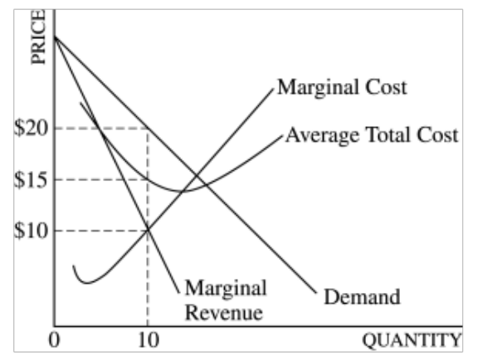

- If the firm produces 10 units of output, its economic profits will equal
- 0
- $50
- $100
- $150
- $200

- Which of the following is most likely to occur if the firm increases production beyond 10 units?
- Consumers would be willing to purchase more than 10 units at the price of $20 per unit.
- The firm would definitely experience a loss.
- The firm would have to lower its price to sell more than 10 units.
- The firm’s average cost of production would initially increase.
- The firm’ s profits would increase.

- Which of the following statements about a constant-cost perfectly competitive industry in long-run equilibrium must be true?
- An increase in demand will cause no change in the long-run equilibrium price.
- An increase in demand will cause no change in the long-run equilibrium quantity.
- The long-run supply curve is upward sloping.
- The long-run supply curve is perfectly inelastic.
- The total cost of production remains the same as output increases.

- In which of the following market structures do firms recognize their mutual interdependence?
- Oligopoly
- Monopoly
- Perfect competition
- Unregulated natural monopoly
- Monopsony

- Assume that a profit-maximizing firm is perfectly competitive in both the output and the factor markets and is at its long-run equilibrium. The firm’s output is 100 units, its total revenue is $600.00, and the fixed cost of production is $50.00. Based on this information, which of the following is true for the firm?
- Its marginal cost is $5.50, and its average total cost is $5.50.
- Its marginal cost is $5.50, and its average variable cost is $5.50.
- Its marginal cost is $6.00, and its average total cost is $5.50.
- Its marginal cost is $6.00, and its average fixed cost is $5.50.
- Its marginal cost is $6.00, and its average variable cost is $5.50.

- Businesses employ workers from city neighborhoods and rural areas. These workers are perfect substitutes and cannot relocate in the short run. The government offers businesses a wage subsidy if they hire workers from city neighborhoods. What is the effect of the subsidy on the wage rate of rural workers and on the total hours they work?
 | Wage Rate of Rural Workers | Total Hours Worked by Rural Workers
(A) | Increase | Decrease
(B) | No change | Increase
(C) | No change | Decrease
(D) | Decrease | Decrease
(E) | Decrease | No change

- A per-unit tax on pollution produced by a firm will affect the firm’s output and pollution levels in which of the following ways?
 | Output | Pollution
(A) | Increase | Increase
(B) | Increase | Decrease
(C) | Decrease | Increase
(D) | Decrease | Decrease
(E) | No change | No change

- Which of the following will most likely lead to a more equal distribution of income?
- More regressive national sales tax
- More progressive income taxes
- An increase in the high school dropout rate
- An increase in structural unemployment
- An increase in earnings for owners of capital

- Assume both Italy and Greece produce only two goods: wine and olive oil. If Italy holds a comparative advantage in the production of wine, then which of the following statements is NOT true?
  - Italy must hold an absolute advantage in the production of wine.
  - Greece holds a comparative advantage in the production of olive oil.
  - Italy’s opportunity cost of producing one additional unit of wine is lower than Greece’s.
  - Greece’s opportunity cost of producing one additional unit of olive oil is lower than Italy’ s.
  - If trade is open between them, these countries have an incentive to trade.

- Following a prolonged power outage, the price of flashlights normally increases significantly. If cities had passed laws prohibiting price increases for flashlights, during power outages such laws would most likely
  - make flashlights more available
  - create a shortage of flashlights
  - shift the demand curve for flashlights to the right
  - shift the supply curve for flashlights to the left
  - have no effect on the availability of flashlights

Questions 18-19 are based on the diagram below, which shows the effect of a unit tax placed on a good.

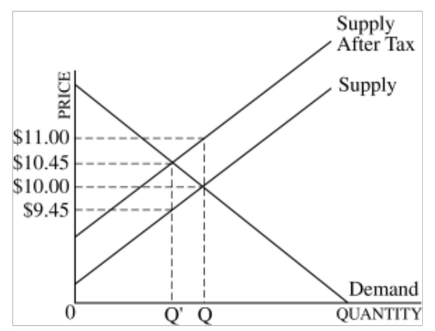

- What is the price paid by consumers and the net price received by producers after the tax is paid?
 | Paid by  Consumers | Received by  Producers
(A) | $11.00 | $10.45
(B) | $11.00 | $10.00
(C) | $10.45 | $10.00
(D) | $10.45 | $9.45
(E) | $10.00 | $9.45

- According to the diagram, what is the dollar amount of the unit tax?
  - $0.00
  - $0.45
  - $0.55
  - $1.00
  - $1.45
- According to the law of diminishing marginal utility, which of the following is true?
  - Total satisfaction decreases as more units of a good are consumed.
  - The additional satisfaction received from consuming extra units of a good decreases as consumption of the good increases.
  - The additional satisfaction received from consuming extra units of a good decreases as consumption of the good decreases.
  - The additional satisfaction received from consuming extra units of a good increases as consumption of the good increases.
  - When marginal utility is decreasing, total utility is decreasing.

- Within the range of market demand, which of the following is consistent with the conditions of a natural monopoly?
  - Long-run total cost decreases as output increases.
  - Long-run average total cost remains constant as output increases.
  - Long-run average total cost decreases as output increases.
  - Marginal cost exceeds average cost.
  - Setting price equal to marginal cost will maximize profits.

- A farmer grows wheat using two inputs: labor and land whose prices are constant. If she doubles her inputs, she finds that the quantity of wheat produced more than doubles. Therefore, it must be true that in this output range her long-run average total cost curve is
  - upward sloping
  - downward sloping
  - horizontal
  - vertical
  - U-shaped

- A constant-cost, perfectly competitive gadget industry is in long-run equilibrium. An increase in the number of consumers of gadgets will most likely result in
  - higher short-run and long-run prices for gadgets
  - reduced short-run profits, followed by the exit of some firms
  - an upward shift in all short-run cost curves, followed by a higher long-run price for gadgets
  - a higher short-run price for gadgets, followed by an increase in the quantity produced
  - a decrease in the demand for gadgets, followed by a decrease in the supply of gadgets

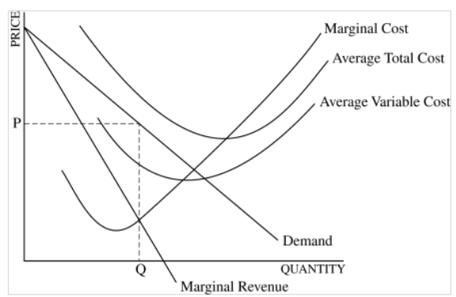

- The profit-maximizing firm depicted in the graph above should
  - exit if conditions do not improve in the long run
  - produce the output that minimizes average total cost
  - increase price to maximize profits
  - increase output to maximize profits
  - use less capital and more labor to reduce cost
- If the average variable cost of producing 5 units of a good is $100 and the average variable cost of producing 6 units is $150, then the marginal cost of increasing output from 5 to 6 units is
  - $50
  - $250
  - $300
  - $400
  - $500

Questions 26-27 are based on the following table, which shows the relationship between the number of workers and coal output (in tons per day).

Number of Workers | Total Output of Coal
0 | 0
1 | 25
2 | 44
3 | 60
4 | 70
5 | 75

- How many workers would the coal company want to hire if the price of coal were competitively priced at $5 per ton and the wage rate were $40 per day?
  - 5
  - 4
  - 3
  - 2
  - 0

- The marginal physical product of the second worker is
- 19
- 22
- 25
- 44
- 75

- Instead of being employed at a printing company at a salary of $25,000 per year, Sally starts her own printing firm. Rather than renting a building that she owns to someone else for $10,000 per year, she uses it as the location for her company. Her costs for workers, materials, advertising, and energy during her first year are $125,000. If the total revenue from her printing company is $155,000, her total economic profit is
  - -$5,000
  - $5,000
  - $20,000
  - $30,000
  - $120,000

- If the production of a good generates a positive externality, the government can increase allocative efficiency by
  - taxing the producer of the good
  - subsidizing the producer of the good
  - prosecuting firms that produce the good without proper permits
  - setting a price ceiling to encourage production of the good
  - setting a price floor to discourage production of the good

- Which of the following is the best example of a pure public good?
- Electricity from a public utility
- Mail delivery service by the post office
- Social Security payments
- National defense
- Imported oil
UNITS OF MANUFACTURED GOODS AND SERVICE GOODS PRODUCED USING ONE HOUR OF LABOR
Country | Manufactured Goods | Service Goods
A | 100 units | 300 units
B | 75 units | 150 units

- According to the information in the table above, which of the following statements is true if both countries have the same number of workers?
  - Country A has both an absolute and a comparative advantage in manufactured goods.
  - Country A has an absolute advantage in manufactured goods but a comparative advantage in service goods.
  - Country B has a comparative advantage in service goods but no absolute advantage in either good.
  - Country A has an absolute advantage in service goods but a comparative advantage in manufactured goods.
  - Country B has an absolute advantage in manufactured goods, but without more information, it is not possible to tell in which product it has a comparative advantage.

- Which of the following would most likely result in a decrease in the equilibrium price of oranges?
  - The weather during this orange-growing season is not as good as it was last year.
  - The price of apples, a substitute for oranges, is higher this year than last year.
  - New studies suggest that oranges contain traces of cancer-causing substances due to pesticide residue.
  - A tree-killing fungus spreads through orange orchards across the country.
  - Firms in the orange industry launch an effective advertising campaign.
- If a severe drought destroys a significant portion of the peanut crop and peanut farmers’ revenues increase, which of the following is true over the observed range of prices?
  - The demand for peanuts must be unit price elastic.
  - The demand for peanuts must be price elastic.
  - The demand for peanuts must be price inelastic.
  - The supply of peanuts must be price inelastic.
  - The supply of peanuts must be price elastic.

- Promoters of a rock group know that if they charged $8 a ticket, 400 people would buy tickets for a concert, and if they charged $4 a ticket, 800 people would buy tickets. Over this price range, the demand for the concert tickets for the rock group is
  - Elastic
  - Inelastic
  - unit elastic
  - perfectly elastic
  - perfectly inelastic

- Assume that people like onions on their hamburgers. If the supply of hamburgers decreases, the demand for onions will most likely
  - remain unchanged because hamburgers and onions are different goods
  - increase because hamburgers and onions are substitutes
  - increase because hamburgers and onions are complements
  - decrease because hamburgers and onions are complements
  - decrease because hamburgers and onions are substitutes
- If labor is the only variable input in the production process, the short-run marginal cost curve is upward sloping because which of the following occurs as more and more labor is added?
  - Output decreases, and thus marginal cost increases.
  - Output increases, and thus marginal cost increases.
  - Output increases at an increasing rate, and thus the cost of producing each additional unit of output increases.
  - Output increases at a decreasing rate, and thus the cost of producing each additional unit of output increases.
  - Output increases at a decreasing rate, and thus the cost of producing each additional unit of output decreases.

- At a firm’s current rate of output, the marginal cost is $65, the average variable cost is $35, the average fixed cost is $30, and the product price is $65. Which of the following statements is true for the firm?
  - Economic profits are zero because marginal revenue equals marginal cost.
  - Economic profits are negative because total revenue is less than total cost.
  - Economic profits are positive because total revenue is greater than total cost.
  - Economic profits are negative because price is greater than average variable cost.
  - Economic profits are zero because price equals average total cost.

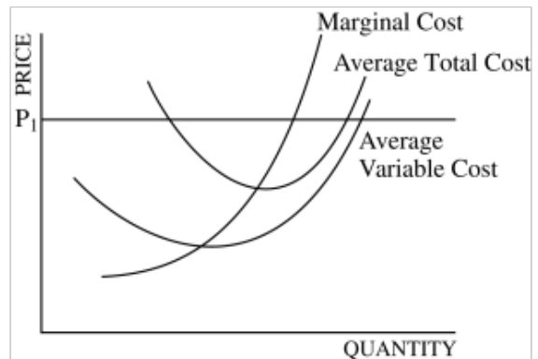

- The graph above shows the short-run cost curves of a firm in a perfectly competitive market. Which of the following are true at the firm’s profit- maximizing output level?
- Price exceeds average total cost.
- Economic profits are zero.
- Marginal cost equals average total cost.
- New firms are likely to enter the market in the long run.
  - I and II only
  - I and III only
  - I and IV only
  - II, III, and IV only
  - I, II, III, and IV

- Which of the following best describes an oligopolistic market?
  - Many sellers with identical products and no barriers to entry
  - Many sellers, each with a clearly differentiated product, and no barriers to entry
  - A few competing sellers with similar products and high barriers to entry
  - A few competing sellers of identical products and no barriers to entry
  - No competition among sellers and high barriers to entry
- The payoff matrix below shows the per-unit profits associated with the production strategies of two utility companies, UA and UB. Each firm has two choices: to reduce production by 10 percent or by 20 percent. The first entry in each cell indicates the profits to UA, and the second, the profits to UB.

 |  | UB
 |  | Reduces Production by 20 Percent | Reduces Production by 10 Percent
UA | Reduces Production by 20 Percent | $150, $150 | $50, $250
UA | Reduces Production by 10 Percent | $250, $50 | $100, $100

Based on the information, and assuming no cooperation, which of the following statements is true?
- Neither company has a dominant strategy.
- Both companies have an incentive to reduce production by 10%.
- Both companies have an incentive to reduce production by 20%.
- Only UA has an incentive to reduce production by 20%.
- Only UB has an incentive to reduce production by 20%.

- In order to minimize short-run losses, a profit-maximizing firm will necessarily shut down production under which of the following conditions?
  - Total revenue is less than total cost.
  - Marginal cost is greater than average total cost.
  - Marginal cost is less than marginal revenue.
  - Average revenue is less than average variable cost.
  - Average revenue is less than average total cost.

- An increase in the effective minimum wage will have less of an impact on employment if the demand for labor is
  - a derived demand
  - decreasing
  - relatively elastic
  - relatively inelastic
  - unit elastic

- If a firm employs only labor and capital in its production process, which of the following best describes the optimal combination of inputs for the firm in the long run?
  - The marginal product per dollar spent on labor is equal to the marginal product per dollar spent on capital.
  - The marginal product of labor is equal to the marginal product of capital.
  - The total product of labor is equal to the total product of capital.
  - The marginal product of labor and capital are both zero.
  - All marginal products are equal to all average products.
- Most economists argue that a monopoly is inefficient because it
  - has no incentive to minimize its costs
  - produces too little output and sets a price above marginal cost
  - earns too much profit by charging consumers any price it wants
  - produces too much output and thus wastes scarce resources
  - usually produces unsafe products if not regulated by government

PERCENTAGE OF INCOME RECEIVED, 2010
Quintile | Before Taxes and Transfers | After Taxes and Transfers
Lowest 20% | 1.1 | 5.1
Second 20% | 7.9 | 11.1
Third 20% | 15.5 | 16.5
Fourth 20% | 24.7 | 23.8
Highest 20% | 50.7 | 43.5

- The table above shows the distribution of income in Country X in 2010 before and after taxes and transfer payments. Which of the following can be concluded about the effect of the government’s tax and transfer policies on income distribution in Country X?
  - The distribution of income is significantly less equal after accounting for the impact of government policies.
  - The distribution of income is about the same after accounting for the impact of government policies.
  - The largest gainers from government policies are the third and fourth quintile groups.
  - The only quintile to benefit from government policies is the lowest quintile.
  - The major transfer of income is from the highest quintile to the two lowest quintiles.

- After graduating from high school, Peggy Smith decided to enroll in a two-year program at the local community college rather than to accept a job that offered a salary of $12,000 per year. If the annual tuition and fees are $4,600, the annual opportunity cost of attending the community college is
  - $4,600
  - $7,400
  - $12,000
  - $16,600
  - $24,000

- In which of the following situations is a good NOT scarce?
  - Consumers give up nothing to obtain more of the good.
  - Consumers can purchase as much of the good as they want at its current market price.
  - Large quantities of the good are available in the marketplace.
  - There is a surplus of the good at some positive price.
  - There is a shortage of the good at some positive price.

- Suppose that the market supply curve for shoes is upward sloping and the market demand curve is downward sloping. How will the imposition of a sales tax on shoes affect the consumer surplus, the producer surplus, and the total surplus?
 | Consumer  Surplus | Producer  Surplus | Total  Surplus
(A) | Decrease | Decrease | Decrease
(B) | Decrease | Increase | Increase
(C) | Decrease | Increase | Decrease
(D) | Increase | Decrease | Decrease
(E) | Increase | Increase | Increase

- At her current level of consumption, a consumer is willing to pay up to $1.50 for a bottle of water and up to $1,500 for a diamond ring because the
  - total utility of diamond rings is greater than the total utility of water
  - total utility of water is less than the marginal utility of a diamond ring
  - marginal utility of a bottle of water is less than the marginal utility of a diamond ring
  - marginal utility of a bottle of water is greater than the marginal utility of a diamond ring
  - consumer is irrational and does not understand that water is more important than a diamond

- If a firm’s production process exhibits economies of scale, which of the following will occur when the firm’s output increases?
  - Its short-run average total costs will rise.
  - Its long-run average total costs will rise.
  - Its long-run average total costs will fall.
  - Its short-run total costs will fall.
  - Its long-run total costs will fall.

- Which of the following helps explain why the demand curve for a normal good is downward sloping?
  - The income and substitution effects move the quantity demanded in the same direction.
  - The income effect moves the quantity demanded in the opposite direction of the substitution effect.
  - The income effect dominates the substitution effect.
  - The substitution effect dominates the income effect.
  - With an increase in income, the consumer decreases consumption of the good.

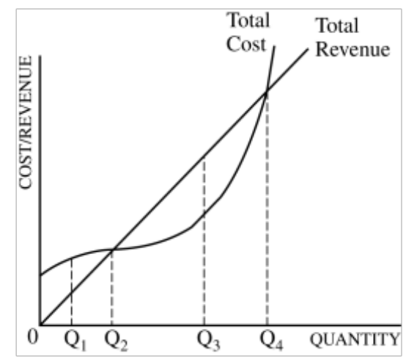

- The graph above shows the total revenue and total cost curves for a firm in which type of market structure and what is the profit-maximizing quantity?
 | Market Structure | Quantity
(A) | Monopoly | Q₂
(B) | Monopoly | Q₃
(C) | Perfect Competition | Q₁
(D) | Perfect Competition | Q₃
(E) | Perfect Competition | Q₄

- If total revenue is increasing as output increases, marginal revenue is always
  - equal to average revenue
  - less than average revenue
  - increasing
  - decreasing
  - greater than zero

- Let P = price, MR = marginal revenue, MC = marginal cost, and ATC = average total cost. In monopolistic competition, which of the following most accurately describes the long-run equilibrium conditions for a firm?
  - P > ATC, MR = MC, and P > MC
  - P > ATC, MR > MC, and P = MC
  - P = ATC, MR = MC, and P > MC
  - P = ATC, MR = MC, and P = MC
  - P = ATC, MR > MC, and P > MC
- In a perfectly competitive free market economy, a wage gap between two workers can be explained by differences in all of the following EXCEPT their
  - years of schooling
  - occupations
  - marginal products
  - marginal revenue products
  - tastes for luxury goods

- Firm XYZ produces and sells corn in a perfectly competitive market and hires its workers in a perfectly competitive labor market. Which of the following best describes the demand curve for XYZ’s corn and XYZ’s demand curve for labor?
 | Demand for XYZ’s Corn | XYZ’s  Labor Demand
(A) | Horizontal | Horizontal
(B) | Horizontal | Downward sloping
(C) | Horizontal | Vertical
(D) | Downward sloping | Downward sloping
(E) | Downward sloping | Horizontal

- A monopolistically competitive firm advertises in order to
  - shift the demand curve for its product to the left
  - make the demand for its product less price elastic
  - make its product more similar to its competitors’
  - increase its positive externalities
  - reduce the industry’s barriers to entry

- A profit-maximizing firm should hire an input up to the point at which
  - marginal physical product equals marginal revenue product
  - marginal revenue equals marginal factor cost
  - marginal revenue product equals marginal revenue
  - marginal revenue product equals marginal factor cost
  - marginal physical product equals marginal factor cost

Questions 59-60 refer to the diagram below, which shows a market’s cost and revenue curves.

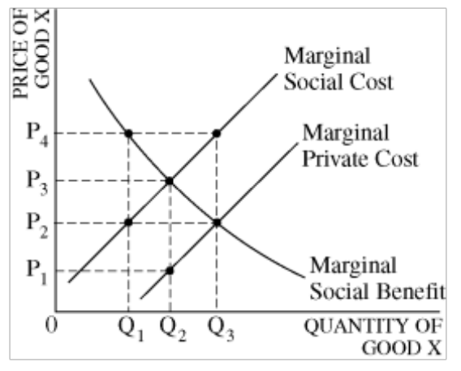
- The socially optimal quantity and the per-unit tax that will achieve the socially optimal quantity are which of the following?
 | Socially  Optimal Quantity | Per-Unit Tax
(A) | Q₁ | P₄ – P₂
(B) | Q₂ | P₃ – P₂
(C) | Q₃ | P₄ – P₂
(D) | Q₂ | P₃ – P₁
(E) | Q₃ | P₃ – P₂

- Given the position of the marginal social cost curve, one can conclude that the
  - private cost of producing good X exceeds the social cost of production at all levels of output
  - production of good X creates a negative externality
  - production of good X occurs in an imperfectly competitive market
  - market quantity, Q₃, is the socially optimal quantity
  - free market will produce too little of good X

Answer Key

- C
- E
- B
- B
- E
- B
- D
- B
- C
- A
- A
- E
- D
- D
- B
- A
- B
- D
- D
- B
- C
- B
- D
- A
- D
- B
- A
- A
- B
- D
- B
- C
- C
- C
- D
- D
- E
- C
- C
- B
- D
- D
- A
- B
- E
- D
- A
- A
- C
- C
- A
- D
- E
- C
- E
- B
- B
- D
- D
- B

