FUNCTIONAL DESIGN SPECIFICATION

RPGManager

Project Number | 876567476453
Project Name | RPGManager
Author | Michał Kurzyński
Last Updated | 7/11/26 17:12 [auto-date]
Version Number | 0.6
Status | Draft
Solution Owner | Dawid Ireno

Changes and Reviews

Time  Stamp | Editor or  Reviewer | Organization Unit | Change  Scope
0.1 | Michał Kurzyński | RPLogistics | Primary draft based on negotiations with customer
0.2 | Michał Kurzyński | RPLogistics | Fixed Indexing issues within document
0.3 | Michał Kurzyński | RPLogistics | Added mising informations based on negotiation with customer
0.4 | Michał Kurzyński | RPLogistics | Added Database model
0.5 | Michał Kurzyński | RPLogistics | Added GUI prototypes screenshots
0.6 | Michał Kurzyński | RPLogistics | Added Github repo adress

1. Introduction 4
1.1. Purpose 4
1.2. Terminology 4
1.3. Related Documents 4
1.4. Required Skills 4
2. Client Summary 5
2.1. Executive Summary of Solution 5
2.1.1. Introduction 5
2.1.2. System Functionality Summary 5
3. Assumptions 6
4. Constraints 6
5. Database Design 6
5.1. Data Model 6
6. Function Design 7
6.1. Connection between server and clients 7
6.1.1. Description 7
6.1.2. Performance Issues 7
6.1.3. Use Cases Referenced 7
6.1.4. Trigger 7
6.1.5. Pre-Condition 7
6.2. Role Playing game session team database 7
6.2.1. Description 7
6.2.2. Performance Issues 7
6.2.3. Use Cases Referenced 7
6.2.4. Trigger 7
6.2.5. Pre-Condition 8
6.3. Session Chat 8
6.3.1. Description 8
6.3.2. Performance Issues 8
6.3.3. Use Cases Referenced 8
6.3.4. Trigger 8
6.3.5. Pre-Condition 8
6.4. Interface for hosting additional subapplications 8
6.4.1. Description 8
6.4.2. Performance Issues 8
6.4.3. Use Cases Referenced 9
6.4.4. Trigger 9
6.4.5. Pre-Condition 9
7. Look and Feel / User Experience 10
8. Issues and Questions 12

Introduction

Purpose
RPG-manager is a software built to easen Game Masters of Roleplaying session management of their teams in online manner. It should provide database for all teamrelated data possibility of hide or show some information for specific player, text-chat functionality and a “paint” tab as a tool for game master to help describe things for players.

Terminology

Term | Definition
Game Master | Manager of Role-Playing game session – he describes events and places to players and decide wether player actions succeed or not. He will be using server application
Player | User of client application

Related Documents

Document Name | Date | Author | Version
RFC793 | September 1981 | Information Sciences Institute University of Southern California | N/A
WPF documentation | N/A | Infragistics | N/A

Required Skills

The following skill sets are required to complete this development:
Skill | Level Required | Comments
C# programming | semi-advanced
graphics | basic
Network programming | semi-advanced

Client Summary

Executive Summary of Solution

Introduction
Appliaction will be split into two variants – server and client. Client appliaction can register and/or login to specific “servers” to view what character bound to account used during registration process knows, posses etc. Also being logged in is required for attending at session when it starts. Connection between all clients and server will be ciphered. Server-side application will also create on first launch database in which it will store all players' data alongside with tags who can view what and also with each session log and both game masters and players notes. If on startup server application will not find on predefined destination any database files it will promt for creating new database

System Functionality Summary

The system will comprehensively support...
 | Function | Description
 | Connection between server and clients | TCP ciphered connection between single server and multiple clients
 | Role Playing game session team database | Database containing all information needed/gathered during role playing session
 | Session Chat | Chat used to actually play the session
 | Interface for hosting additional subapplications | Usefull tool for possible future extension – primarily used to host a painting program to help the game master visualise items or places to players

Assumptions

Assumption
Both server and all players have to have stable internet connection
Game Master have to have enought space on hard drive to contain database of session

Constraints

Constraint
GUI made using technology: WPF Infragistics
TCP ciphered connection
C# based programming
EF 6 Code First ORM
Github repository: https://github.com/Trejden/RPGManager/

Database Design
Database design coming in next document update

Data Model

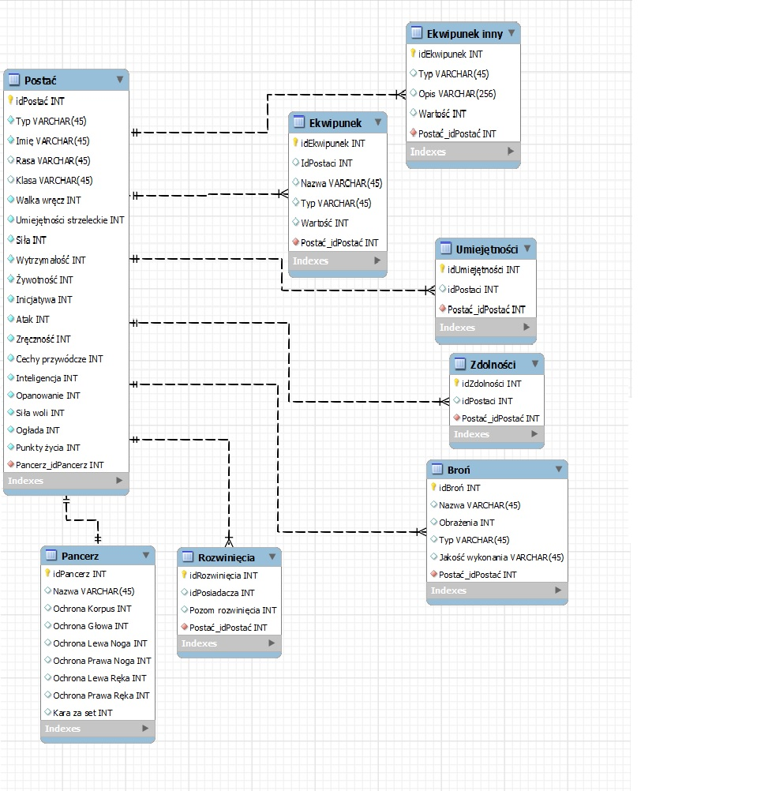Pic 5.1 Database model

Function Design

Connection between server and clients

Description

Clients also known as “players” will be able to connect to the server hosted by game master of apropriate role playing game session via TCP ciphered connection

Performance Issues

Requires internet connection ciphering and deciphering process may slow down communication

Use Cases Referenced

W.I.P.

Trigger

Manually on clients side

Pre-Condition

Internet connection

Role Playing game session team database

Description

All informations about team inventory character charts etc. of all players will be stored within database on server side

Performance Issues

Requires moderate amoun of free hdd space – longer sessions will create more data and hence database may grow in size.
Also when all clients want to access data they did not accessed during current log session it may consume decent amount of internet connection transfer speed because of sending big chunks of data multiple times to multiple clients.

Use Cases Referenced

W.I.P.

Trigger

Automatically on server side

Pre-Condition

Internet connection

Session Chat

Description

When all players needed will connect to the server Game Master will be able to launch session chat.
Chat will be separeted by tabs: global individual between game master and players and will also give possibility to game master to create additional tabs giving possibility to talk between him and phew of players without knowledge of the others
in every chat tab there will be indicator who if anyone is currently typing any message and also with agreement from GM players willbe able to edit or delete last of their messages

Performance Issues
Detecting who is writing and positng information on that may require processing time, this connected also with other traffic on session network (queries from database for example) may slow down communication speed.

Use Cases Referenced

W.I.P.

Trigger

manually on server side

Pre-Condition

Internet connection and at least one player connected to the server

Interface for hosting additional subapplications

Description

The appliaction will be provided with interface for hosting subaplications.
In primary release the interface will be used to host a painting window to ease game master describing things that may be difficult to describe in words. The interface can be also used with other subappliactions in later releases

Performance Issues
Hosting multiple subapplication may influence overal program efficiency on slower units.

Use Cases Referenced

W.I.P.

Trigger

Automatically on both sides

Pre-Condition

Internet connection

Look and Feel / User Experience
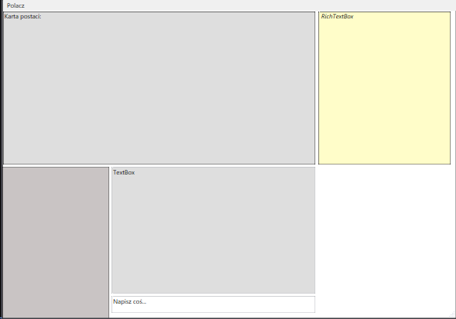pic 7.1 Client UI prototype

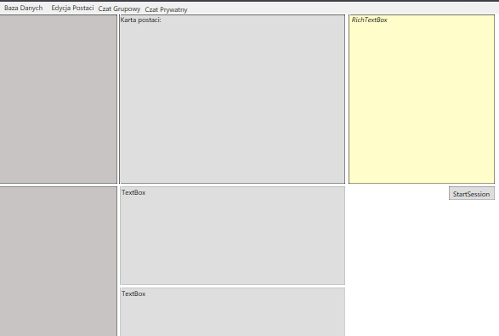Pic 7.2 server side UI prototype

Issues and Questions

Issue/Question | Status | Priority | Date Resolved | Solution/Answer

