

Capstone Project Report
Report 3 – Software Requirement Specification

– September 2026 –

Table of Contents

Status: Draft for Review 1 (Week 4), revised 2026-09-25. This revision fills the template end to end except the Screens Flow and Screen Descriptions (§3.1.2, §3.1.3), which follow the screen design work of W5 to W7 and are written for the Final SRS at Review 2 (Week 8).
Provisional requirements. Requirements whose source carries (P) rest on the leader’s Recorded answers for modules not yet specified (clarification questions 30 to 73). They are in force for this document and are re-confirmed at each module’s own specification interview.
Structure follows the SEP490 template Report3_Software Requirement Specification.docx. Section numbers of the Review 1 draft are kept so later reports can cite them.
Project code: FA26SE159 · Group code: GFA26SE55 · Supervisor: Đặng Ngọc Minh Đức

I. Project Report

1. Status Report
Item | Status on 2026-09-25
This document | Review 1 draft revised: 58 use cases with specifications, 112 functional requirements in EARS, measurable NFRs, 37 business rules, 31 exception scenarios, conceptual ERD and five state machines
Main Flow implementation | None of MF-01 to MF-05 is implemented. Every Implementation and Tested cell in §5.1 and §5.2 is therefore empty
Specifications | gateway-sync has requirements, design and tasks. The other modules are template stubs
Screens | No screen design exists yet. Screens Flow and Screen Descriptions are written at W8

2. Team Involvements
Lanes are the assigned areas of responsibility (roadmap §5.1). This table records assignment for this document, not a claim of completed work.
Member | Code | Main Flow owned | SRS areas assigned
Đỗ Đăng Khoa | KhoaDD | MF-02 | Overall structure and review; §3.6 Gateway and Synchronization; §4.1 External Interfaces
Nguyễn Bá Tân | TanNB | MF-01 | Document owner; §2 User Requirements; §3.4 Booking and Rental; §3.5 Trips; §5.2 Exception Scenarios
Trần Khải Hoàng | HoangTK | MF-03 | §3.7 Incident Management; incident state machine
Nguyễn Ngọc Long | LongNN | MF-04 | §3.8 Real-Time Monitoring; §3.1.4 Screen Authorization
Lâm Phi Long | LongLP | MF-05 | §3.2 Identity and Access; §3.9 Billing

3. Issues/Suggestions
# | Issue | Owner | Action
1 | Map sovereignty acceptance test: the check was done by inspection, but no screenshots are filed. BR-24 and its test stay open | KhoaDD, LongNN | File the screenshots over Hoàng Sa and Trường Sa before Review 1
2 | Requirements marked (P) rest on Recorded answers | Module owners | Re-confirm at each module’s specification interview; update this document
3 | No availability target is set for the platform (§4.2.7) | KhoaDD | Decide before the Final SRS
4 | Report 1 and the PMP still describe a two-stage gateway and four peer roles | KhoaDD | Align them with this document before Review 1

II. Software Requirement Specification

Record of Changes
Date | A*M, D | In charge | Change Description
2026-09-17 | A | Nguyễn Bá Tân | Initial draft for Review 1: overview, actors, use cases, feature tree, NFRs, business rules
2026-09-25 | M | Đỗ Đăng Khoa, Nguyễn Bá Tân | Template completed: Part I; Level-0 context diagram; actor model with Guest and Staff sub-roles; use case diagrams per Main Flow; UC-27 to UC-58 added and all 58 specified; include corrections on UC-11 and UC-13; functional requirements in EARS (§3.2 to §3.10); screen authorization; conceptual ERD; five state machines; external interfaces corrected to the stock MQTT topics; security, availability and notification NFRs; BR-03 and BR-04 revised, BR-25 to BR-37 added; messages, glossary and traceability matrix
*A - Added M - Modified D - Deleted

1. Product Overview
Vietnamese trekking routes such as Tà Năng to Phan Dũng, Tả Liên Sơn and Bạch Mộc Lương Tử run through cellular dead zones lasting several days. During Summer 2026 the team built TrekLink firmware, a LoRa mesh for ESP32 devices forked from Meshtastic, in four hardware variants. It sends device-level SOS by button, gesture or IMU fall detection, followed by a position beacon, and reports position and telemetry over the mesh. It is inherited and extended, not rebuilt.
Two operational gaps remain, and neither the firmware nor any existing product closes them.
Field events are lost. There is no store-and-forward path between the mesh and a backend. The node’s own uplink queue holds 16 events in RAM and discards the oldest first, so during an outage the single SOS text frame is the first event dropped.
A device-level SOS triggers nothing beyond a local radio alert. There is no fleet, rental or trip management and no structured incident workflow. Agencies coordinate emergency response by phone and messaging app, with no audit trail, across concurrent trips.
TrekLink Operations Platform is a responsive web application and gateway system that closes both. It delivers every field event from the trail to the cloud exactly once, including events generated during connectivity loss; it turns each SOS episode into one auditable incident that a named person owns and closes; and it manages the device fleet, rentals and trips around it.
A system with platform seams. TrekLink is built as a single-tenant operations system for one trekking agency. What it offers beyond a single system is a set of extension seams, each already decided:
Seam | What it allows | Decision
Ingress adapters | A new field transport (node MQTT, basecamp bridge, phone app proxy) plugs in without touching ingestion | D-007
Business parameters as configuration | Fees, thresholds, windows and map provider change at run time, without a release | D-015
Stock Meshtastic compatibility | Any stock Meshtastic client and app keeps working with TrekLink devices | D-019
Extensible Staff sub-roles | New staff roles, for example Manager, are added as data | Clarification Q33
What “Smart” refers to in the registered title: SOS and automatic fall detection, the offline fallback with its priority queue, the append-only audit logs, and watchdogs such as staleness and escalation checks. No AI or machine-learning component is claimed.
Positioning. Consumer satellite messengers (Garmin inReach, SPOT, Zoleo) solve field communication but are closed, individual-use, and have no agency-side rental or incident layer. Generic IoT fleet platforms (AWS IoT Core, Azure IoT Hub, Balena) have no LoRa mesh integration and no store-and-forward design for intermittent field connectivity. IT incident tools (Jira Service Management, PagerDuty, Opsgenie) have mature ticket lifecycles but no path from a physical SOS broadcast to a ticket.
Target users: trekking agencies operating in areas without cellular coverage: their operators, field guides, administrators and customers.

1.1 Context Diagram
The system is one process. Around it are its five human actors, the TrekLink devices on the mesh, and three external services. See Figure 1. The Gateway Bridge is inside the boundary: the team builds it, and it is part of process 0. Payment is an internal sandbox module and therefore not an external entity. Each arrow label reads “into the system / out of the system”; the table after the figure lists every flow in full.
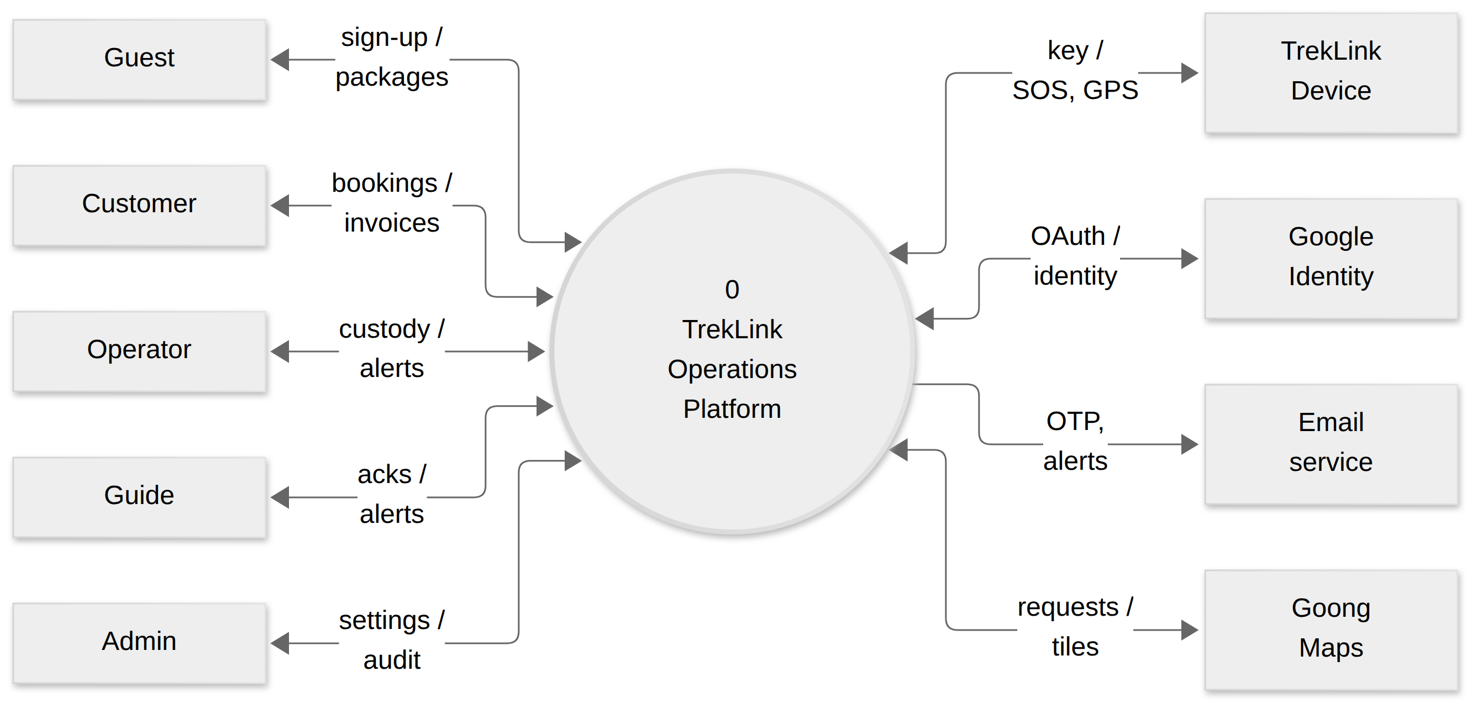
Figure 1: Context Diagram, drawn as a Level-0 data flow diagram: the system as one process, every external entity, and the data each flow carries. Placement: inline, 159.0 x 74.9 mm, labels at 8.01 pt.
External entity | Flow into the system | Flow out of the system
Guest | Package queries, sign-up details | Package list, OTP prompt
Customer | Bookings, payments, cancellations, agreement signatures | Confirmations, agreement PDF, invoices, refunds
Operator | Confirmations, allocations, provisioning, check-out and check-in, inspections, incident actions | Booking queue, fleet state, live map, incident alerts, reports
Guide | Handover confirmation, trip start and end, missing-device reports, acknowledgements, notes | Assigned trips, own-trip map, incident alerts
Admin | Accounts and roles, business parameters, pricing, device catalogue | Audit logs, system health
TrekLink Device | SOS, position and telemetry packets over the mesh | Fleet channel key at provisioning
Google Identity | Identity assertion | OAuth request
Email service | (none) | OTP, password reset and incident email
Goong Maps | Vector tiles and style | Tile requests, from the browser

1.2 The five Main Flows
The product is built, tested and demonstrated as five Main Flows fixed with the supervisor (D-016). Their swimlane diagrams are in §3.1.1.
MF | Name | Owner | Priority | What it delivers
MF-01 | Booking → Rental → Trip Preparation | TanNB | High | A customer’s booking becomes a provisioned device in a Guide’s hands
MF-02 | Field Data → Offline Gateway → Cloud Synchronization | KhoaDD | Highest | Every field event reaches the cloud exactly once, in priority order
MF-03 | SOS → Incident → Emergency Response | HoangTK | Highest | One SOS episode becomes one owned, audited incident
MF-04 | Real-Time Trip Monitoring | LongNN | High | One live picture of trips, devices and incidents, scoped by role
MF-05 | Return → Inspection → Billing → Maintenance | LongLP | Medium | The rental closes, the money settles, the device returns to service or leaves it
E7 (DevOps) and E8 (Research and Evaluation) are cross-cutting epics and are deliberately not Main Flows.

1.3 Delivery stages of MF-02
MF-02’s offline guarantee is delivered in three stages, all in permanent scope (D-005, D-018, D-020). The MF-02 swimlane (Figure 17) draws the buffer in the gateway lane; the stages below state where each buffer actually sits.
Stage | Where the buffer is | What it covers
A | None: the node publishes straight to MQTT over its own Wi-Fi | The first increment. No offline guarantee
B | On the device: a durable, priority-ordered queue in the firmware | Survives outages and reboots for that node’s own events. Built first
C | At basecamp: the Gateway Bridge’s SQLite queue, fed by a tethered node | Aggregates the whole local mesh. Browser-first form (D-020)

2. User Requirements

2.1 Actors
# | Actor | Type | Description | Main Flows
1 | Guest | Primary, human | Anonymous visitor. Browses packages, registers | MF-01
2 | Customer | Primary, human | Books packages, pays, signs the agreement, views own history. Never returns devices directly | MF-01, MF-05
3 | Staff | Abstract, human | Generalizes Operator, Guide and Admin. Sub-roles are data and can be extended | all
4 | Operator | Primary, human (Staff) | Bookings, allocation, provisioning, agreements, check-out and check-in, inspection, billing, incident coordination | MF-01, MF-03, MF-04, MF-05
5 | Guide | Primary, human (Staff) | Leads the trek, confirms handover, starts and ends the trip, collects devices, acknowledges and reports in the field. Sees only assigned trips | MF-01, MF-03, MF-04, MF-05
6 | Admin | Primary, human (Staff) | Accounts and roles, device catalogue, pricing, business parameters, audit logs, system health. Holds every Operator permission | all
7 | TrekLink Device | Secondary, system | ESP32 LoRa node on inherited firmware. Emits SOS, position and telemetry | MF-02, MF-03, MF-04
8 | Gateway Bridge | Secondary, system (inside the boundary) | Normalizes mesh packets, buffers them, publishes to MQTT | MF-02, MF-03, MF-04
9 | Scheduler | Secondary, system | Time-triggered checks: hold expiry, staleness, escalation | MF-01, MF-03, MF-04, MF-05
10 | Google Identity | External system | OAuth sign-in for Customers | MF-01
11 | Email service | External system | OTP, password reset and incident email | MF-01, MF-03
12 | Goong Maps | External system | Vector tiles and styles for the live map (D-012) | MF-04
Role generalization. Operator, Guide and Admin specialize Staff. Admin is Staff with privileges and holds every Operator permission. The Guide’s reads are limited to assigned trips on the server. See Figure 2.
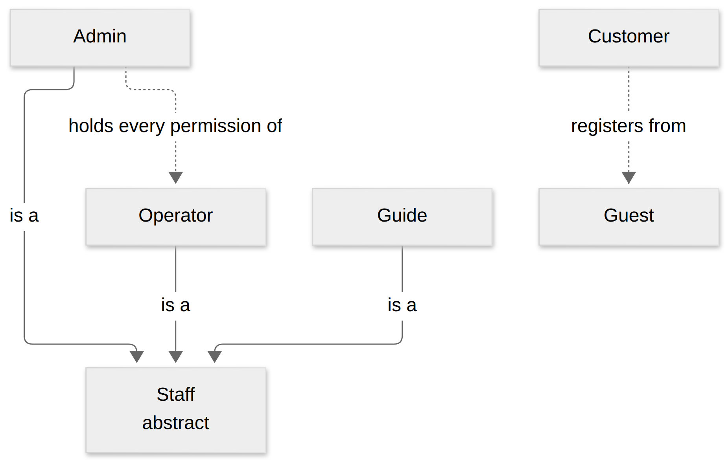
Figure 2: Actor generalization. Operator, Guide and Admin specialize the abstract Staff actor; Admin also holds every Operator permission. Placement: inline, 159.0 x 106.7 mm, labels at 11.64 pt.

2.2 Use Cases

2.2.1 Diagram(s)
One diagram per Main Flow, with MF-01, MF-03 and MF-05 each split in two for legibility, plus one diagram for the administration and access use cases every flow shares. See Figure 3, Figure 4, Figure 5, Figure 6, Figure 7, Figure 8, Figure 9, Figure 10 and Figure 11.
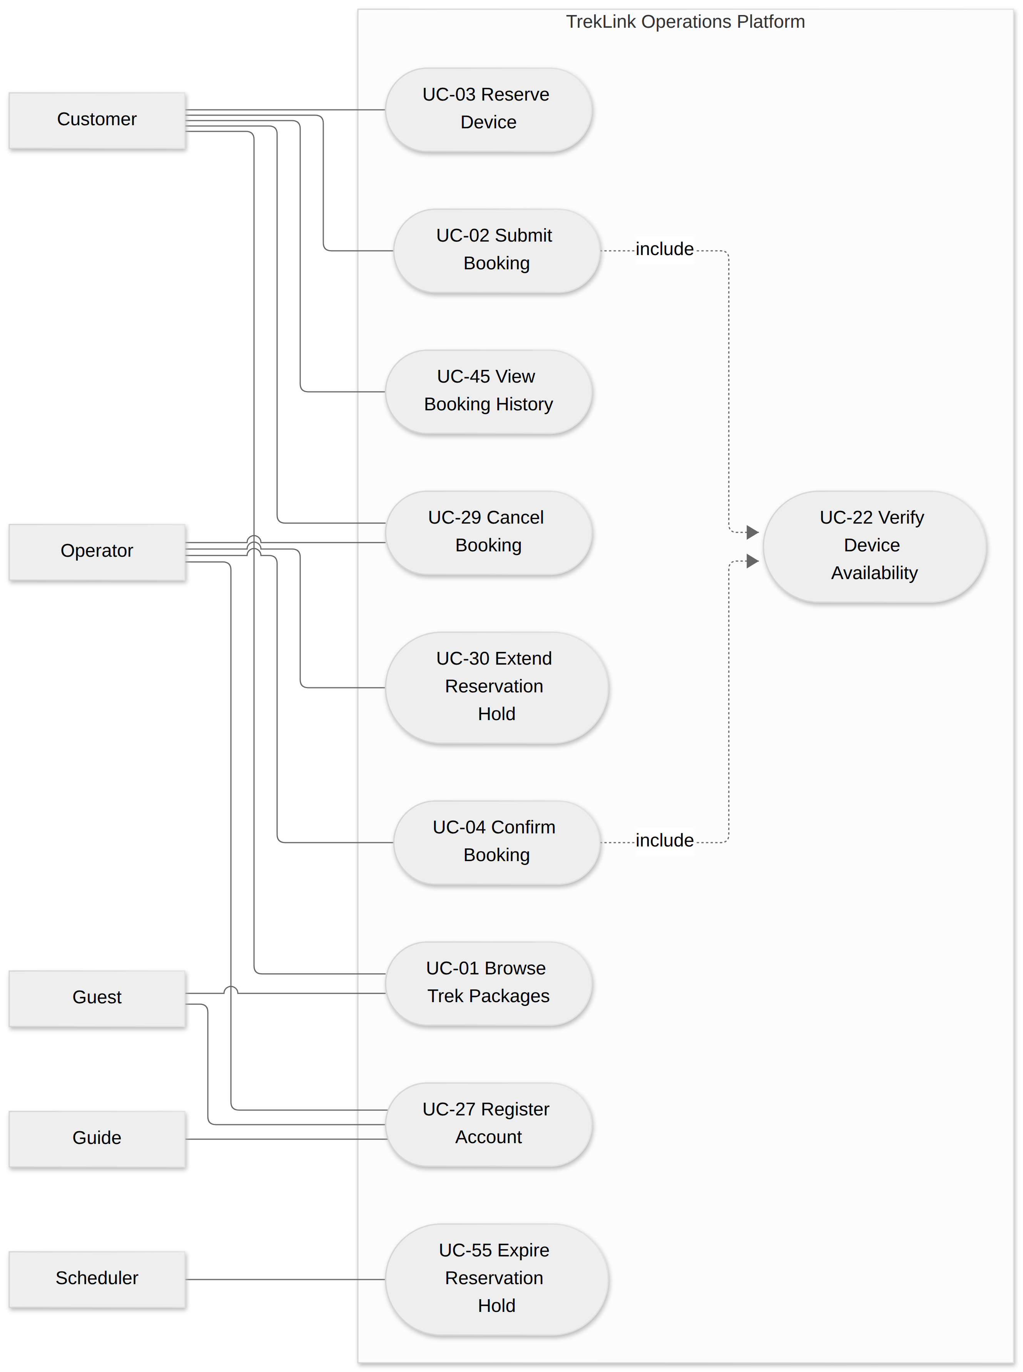
Figure 3: MF-01 use cases, part 1 of 2: browsing, booking and holds. Placement: inline, 156.6 x 225.0 mm, labels at 7.95 pt.
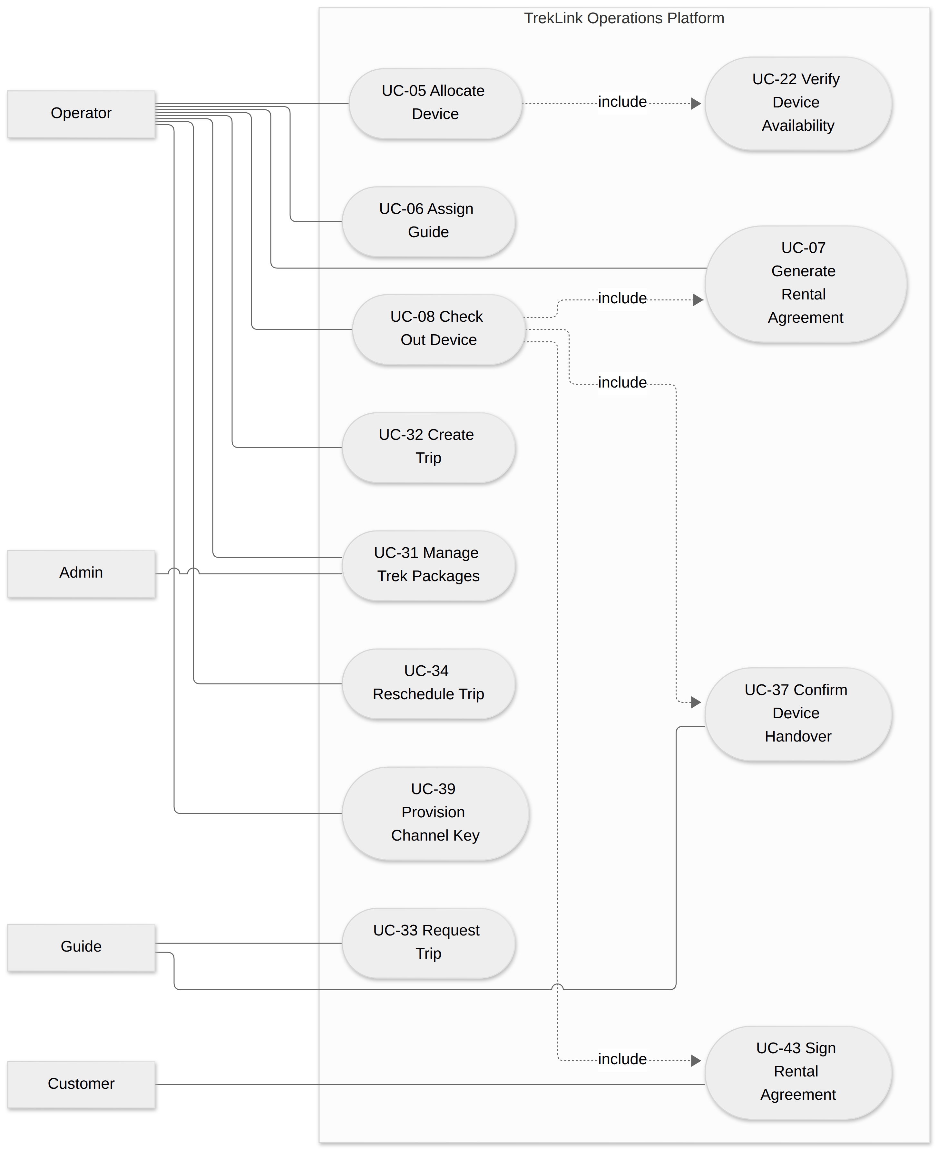
Figure 4: MF-01 use cases, part 2 of 2: trip set-up, allocation, agreement and check-out. Placement: inline, 159.0 x 203.9 mm, labels at 7.38 pt.
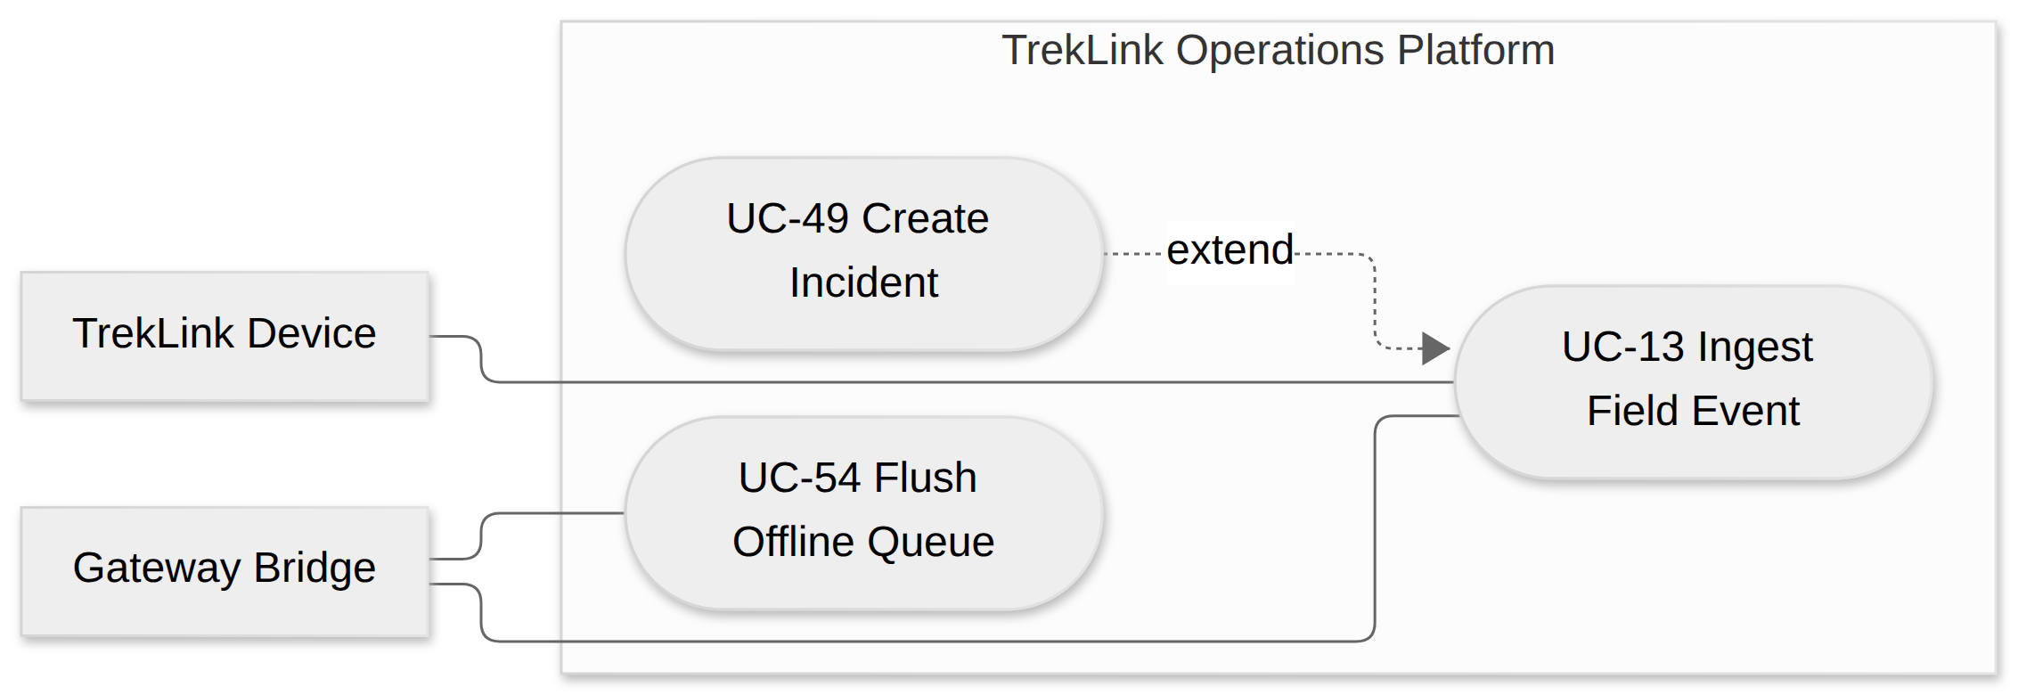
Figure 5: MF-02 use cases: ingestion, offline flush and the extension point into incident creation. Placement: inline, 159.0 x 54.2 mm, labels at 9.46 pt.
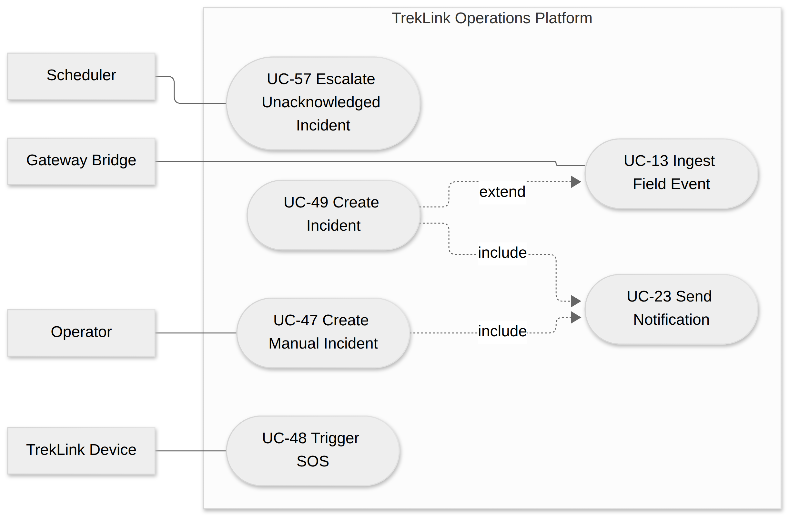
Figure 6: MF-03 use cases, part 1 of 2: SOS, incident creation, manual incidents and escalation. Placement: inline, 159.0 x 106.1 mm, labels at 8.61 pt.
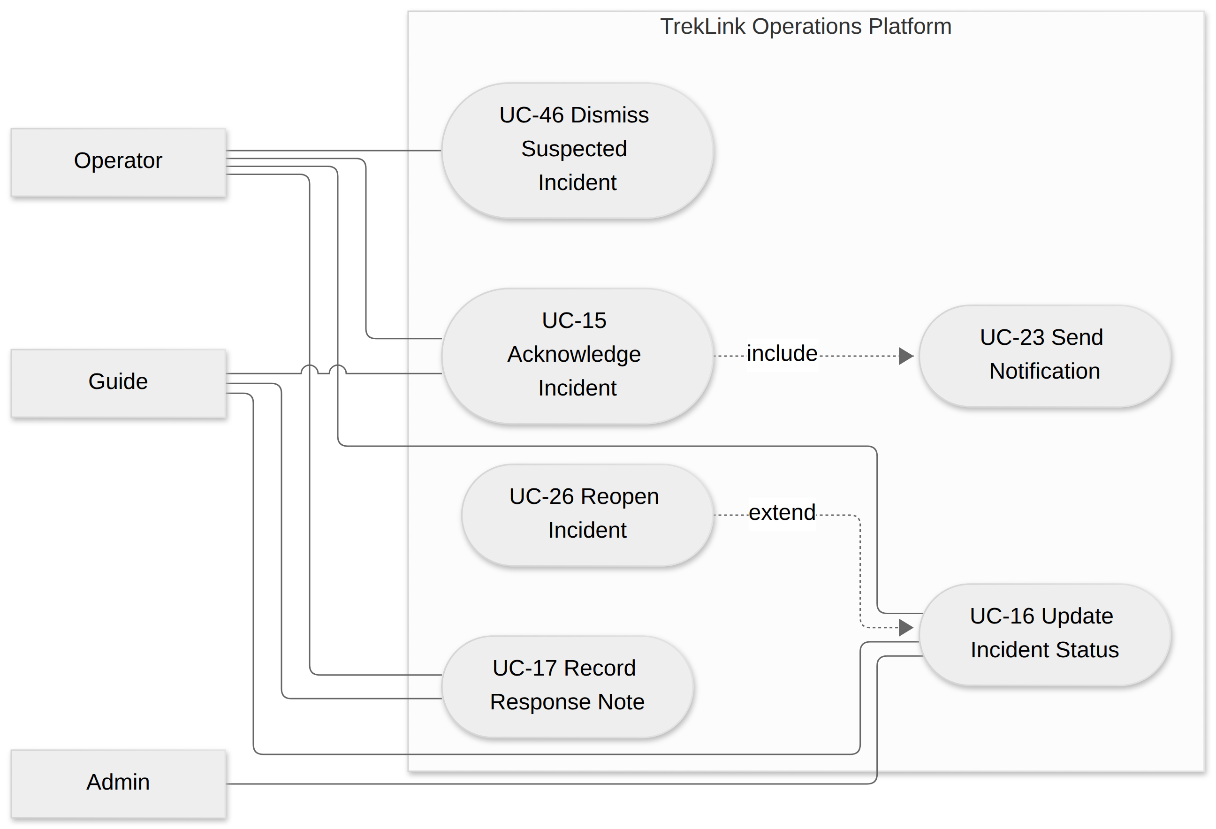
Figure 7: MF-03 use cases, part 2 of 2: acknowledgement, status updates, notes, reopen and dismissal. Placement: inline, 159.0 x 109.1 mm, labels at 8.01 pt.
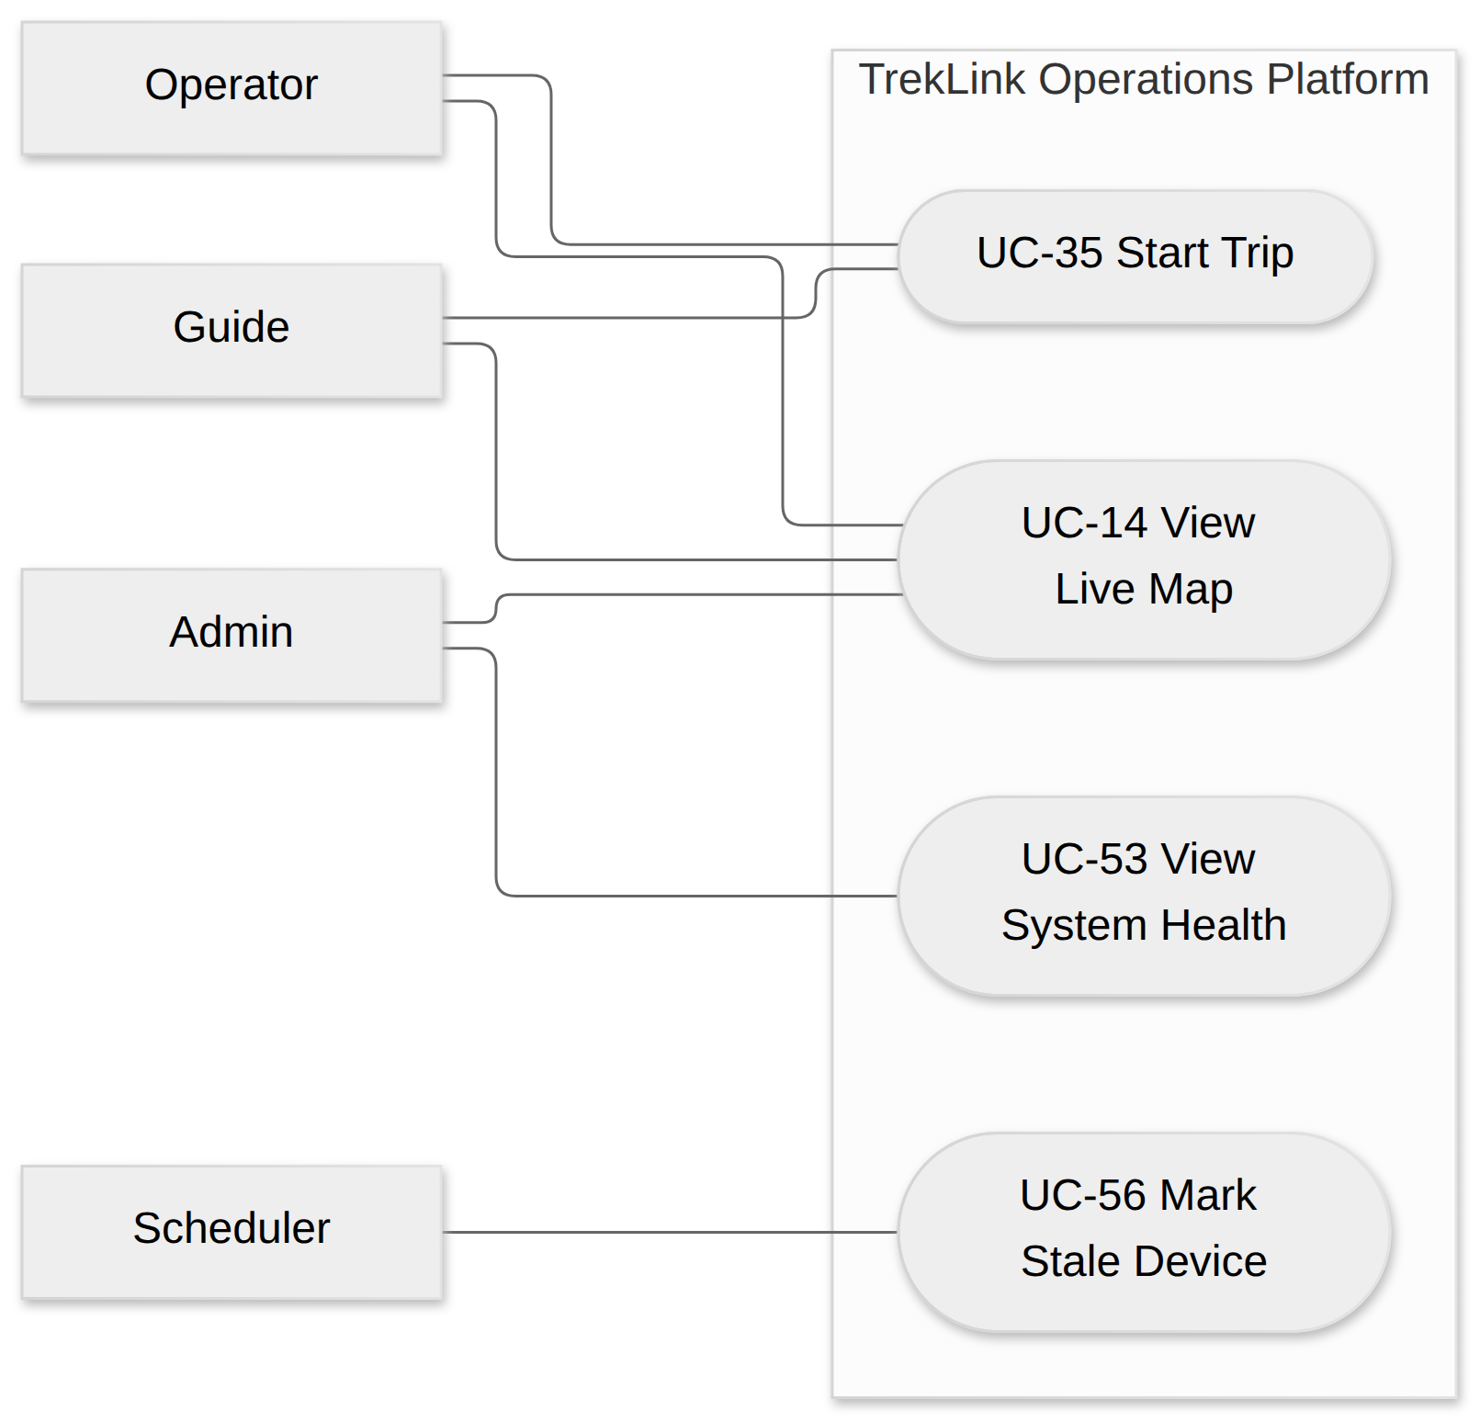
Figure 8: MF-04 use cases: live monitoring, trip start, staleness and system health. Placement: inline, 159.0 x 158.1 mm, labels at 13.45 pt.
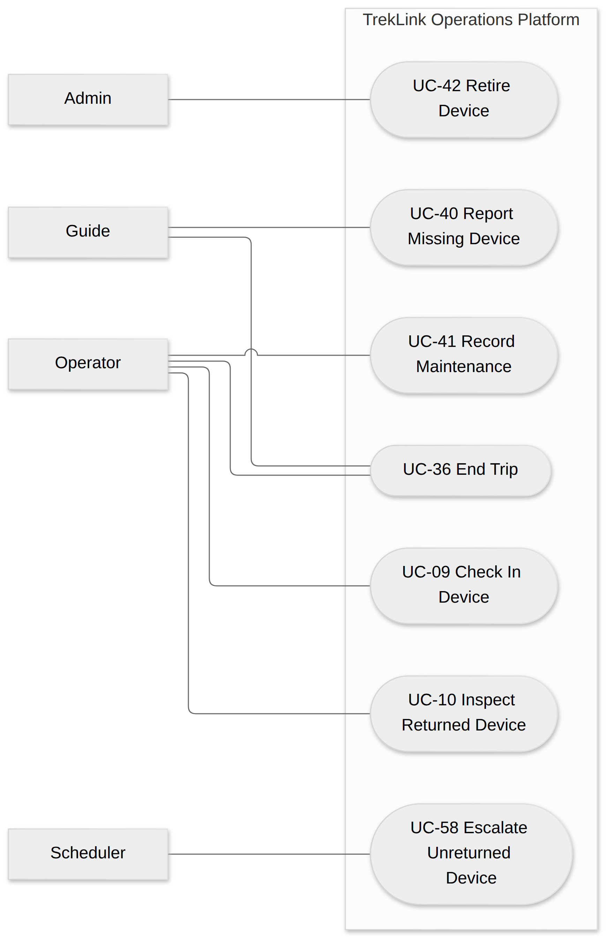
Figure 9: MF-05 use cases, part 1 of 2: trip end, return, inspection and device disposition. Placement: inline, 141.7 x 225.0 mm, labels at 10.82 pt.
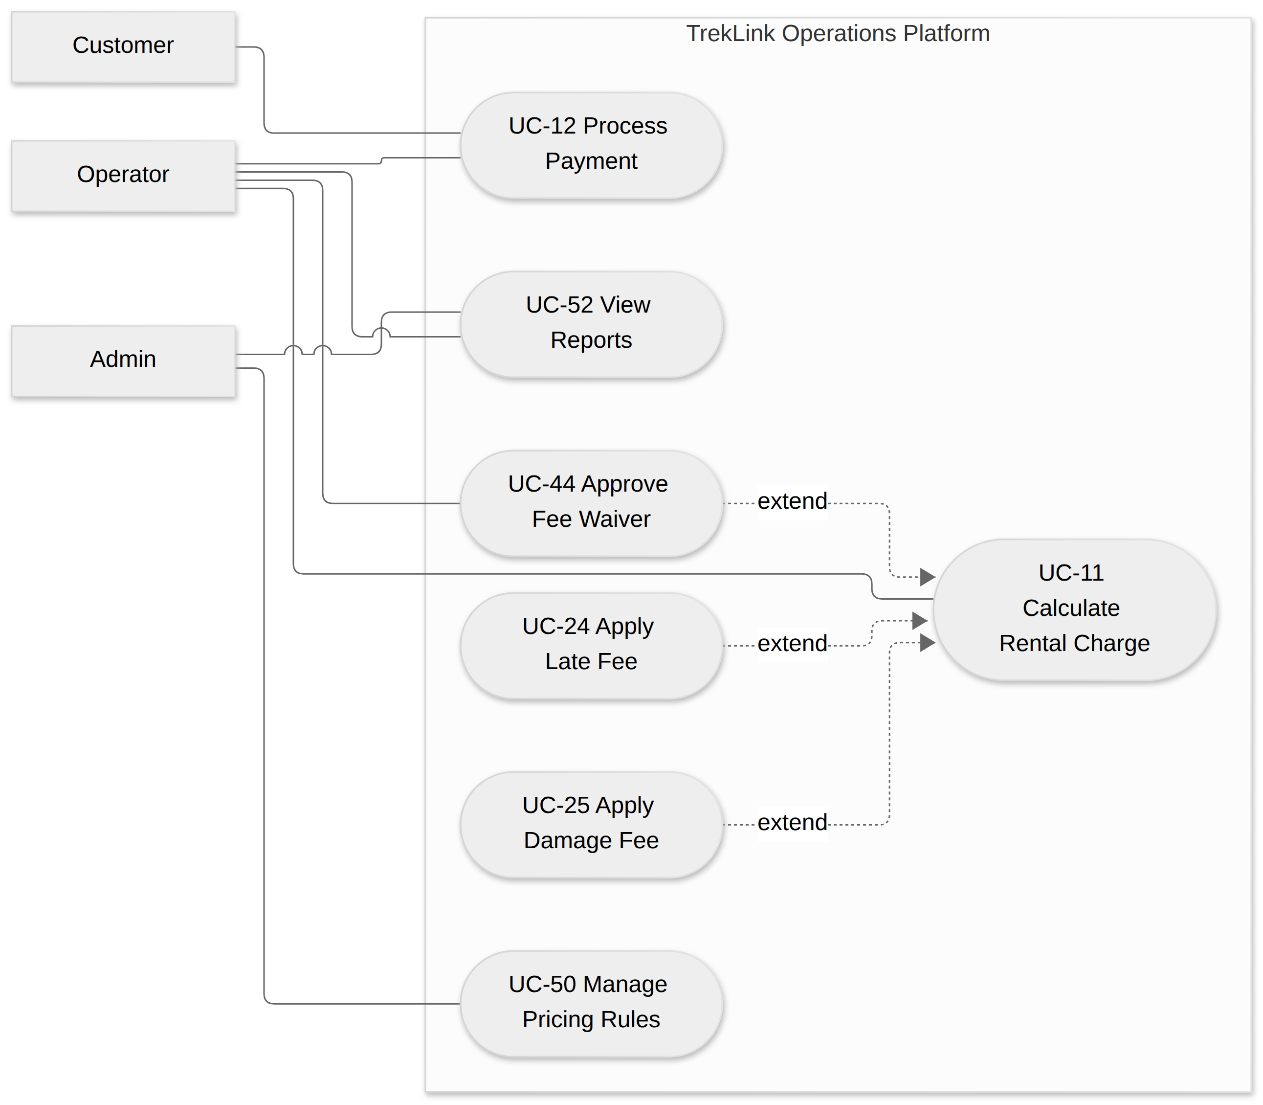
Figure 10: MF-05 use cases, part 2 of 2: charging, fees, waiver, payment and reports. Placement: inline, 159.0 x 144.2 mm, labels at 8.17 pt.
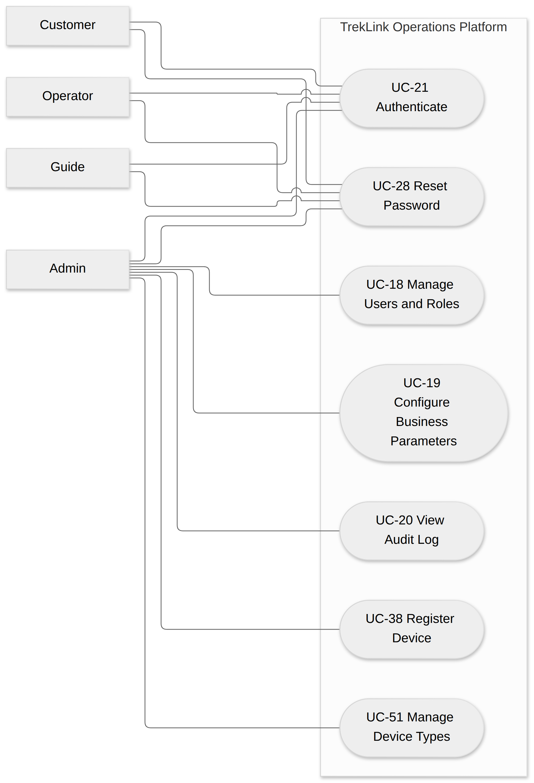
Figure 11: Administration and access use cases, shared across all Main Flows. Placement: inline, 143.0 x 225.0 mm, labels at 9.80 pt.
How include and extend are used. An included use case always runs as part of its base: Submit Booking, Confirm Booking and Allocate Device always verify availability; Check Out Device always generates the agreement, captures the signature and takes the Guide’s handover confirmation; Create Incident always sends the notification, and Acknowledge Incident always pushes the acknowledgement to the other responders. An extending use case runs only when its condition holds: Apply Late Fee when the device came back late, Apply Damage Fee when the inspection recorded damage, Approve Fee Waiver when a waiver above the threshold is requested, Reopen Incident when beacons arrive after resolution, and Create Incident when an ingested event is an SOS or crosses the cadence threshold. Two relationships of the Review 1 draft were inverted and are corrected here: Ingest Field Event no longer includes Send Notification, because most field events notify nobody; Calculate Rental Charge no longer includes Inspect Returned Device, because inspection is the Operator’s own use case and precedes the charge. Generalization is used only between actors.

2.2.2 Descriptions
UC-01 to UC-26 keep the Review 1 numbering. UC-27 to UC-58 are added in this revision.
ID | Use Case | Actors | Main Flow | Use Case Description
UC-01 | Browse Trek Packages | Guest, Customer | MF-01 | List active trek packages with route, duration and price, filterable, without an account.
UC-02 | Submit Booking | Customer | MF-01 | Request a trip on a package for chosen dates and group size; the booking enters review.
UC-03 | Reserve Device | Customer | MF-01 | Hold a device for the booking while the form is completed; the hold expires if unused.
UC-04 | Confirm Booking | Operator | MF-01 | Review a submitted booking and confirm or reject it, seeing device and guide conflicts first.
UC-05 | Allocate Device | Operator | MF-01 | Bind specific physical devices to a confirmed booking or rental for the trip’s time window.
UC-06 | Assign Guide | Operator | MF-01 | Assign one or more Guides to a trip whose dates do not overlap their other assignments.
UC-07 | Generate Rental Agreement | Operator | MF-01 | Produce the rental agreement PDF from the booking, allocation and pricing data.
UC-08 | Check Out Device | Operator | MF-01 | Hand the allocated devices to the Guide; the rental becomes Active and devices Rented.
UC-09 | Check In Device | Operator | MF-05 | Receive devices back from the Guide at trip end; returned devices become Returned.
UC-10 | Inspect Returned Device | Operator | MF-05 | Record condition, accessories and battery of a returned device, with any damage report.
UC-11 | Calculate Rental Charge | Operator | MF-05 | Compute base charge, late fee and damage fee, apply the deposit, and issue the invoice.
UC-12 | Process Payment | Customer, Operator | MF-01, MF-05 | Pay into sandbox escrow at confirmation, then settle the balance or refund at return.
UC-13 | Ingest Field Event | Gateway Bridge | MF-02 | Accept a normalized mesh event, deduplicate it by eventId, persist it and route it by kind.
UC-14 | View Live Map | Operator, Guide, Admin | MF-04 | See live device positions, battery, last-seen and incidents, scoped by role on the server.
UC-15 | Acknowledge Incident | Operator, Guide | MF-03 | Take ownership of a Detected incident; the first acknowledgement fixes the MTTA timestamp.
UC-16 | Update Incident Status | Operator, Admin, Guide | MF-03 | Move an incident through In Progress, Resolved and Closed with a note on each step.
UC-17 | Record Response Note | Guide, Operator | MF-03 | Append a field or coordination note to an incident’s audit trail.
UC-18 | Manage Users and Roles | Admin | cross-cutting | Create, deactivate and assign roles to accounts; maintain the Staff sub-role list.
UC-19 | Configure Business Parameters | Admin | cross-cutting | Change a registered business parameter at run time and see the change take effect.
UC-20 | View Audit Log | Admin | cross-cutting | Read the append-only authentication, device, incident and configuration audit trails.
UC-21 | Authenticate | Customer, Operator, Guide, Admin | cross-cutting | Log in, renew the session silently and log out.
UC-22 | Verify Device Availability | (included) | MF-01 | Check that enough allocatable devices exist for the requested window, under a row lock.
UC-23 | Send Notification | (included) | MF-03 | Push an incident alert or acknowledgement over WebSocket, and alerts by email, to the Guide and online Staff.
UC-24 | Apply Late Fee | (extends UC-11) | MF-05 | Add an itemized late fee when check-in is after the agreed return time plus grace.
UC-25 | Apply Damage Fee | (extends UC-11) | MF-05 | Add an itemized damage fee derived from the inspection’s damage report.
UC-26 | Reopen Incident | (extends UC-16) | MF-03 | Return a Resolved incident to In Progress when new beacons arrive from the same episode.
UC-27 | Register Account | Guest, Operator, Guide | MF-01 | Create a Customer account by Google OAuth or email OTP, or on the customer’s behalf.
UC-28 | Reset Password | Customer, Operator, Guide, Admin | cross-cutting | Reset a forgotten password by email OTP; an Operator may trigger it without seeing it.
UC-29 | Cancel Booking | Customer, Operator | MF-01 | Cancel a booking before check-out, releasing devices and applying the cancellation policy.
UC-30 | Extend Reservation Hold | Operator | MF-01 | Extend or disable the device hold on a Staff or Guide booking.
UC-31 | Manage Trek Packages | Operator, Admin | MF-01 | Create, edit and deactivate trek packages without changing confirmed bookings.
UC-32 | Create Trip | Operator | MF-01 | Create a dated trip from a package and prepare it for booking and provisioning.
UC-33 | Request Trip | Guide | MF-01 | Ask Staff to author a trip; the request becomes a Draft trip for an Operator.
UC-34 | Reschedule Trip | Operator | MF-01 | Move or cancel a trip before it starts, revalidating allocations and assignments.
UC-35 | Start Trip | Operator, Guide | MF-04 | Mark the group departed; the trip becomes Ongoing and its devices In-Field.
UC-36 | End Trip | Operator, Guide | MF-05 | Mark the trip Finished after the Guide has collected every device from the customers.
UC-37 | Confirm Device Handover | Guide | MF-01 | Complete the readiness checklist and confirm the devices received at check-out.
UC-38 | Register Device | Admin | cross-cutting | Enter a new physical device with its hardware version and firmware version.
UC-39 | Provision Channel Key | Operator | MF-01 | Load the fleet’s custom LoRa channel key onto a device before its first check-out.
UC-40 | Report Missing Device | Guide | MF-05 | Report a device the Guide could not collect back from a customer.
UC-41 | Record Maintenance | Operator | MF-05 | Move a device into Maintenance with a reason, and back to Available when repaired.
UC-42 | Retire Device | Admin | MF-05 | Take a device permanently out of service, keeping its full history.
UC-43 | Sign Rental Agreement | Customer | MF-01 | Sign the agreement on the web; the signature is stamped into the PDF.
UC-44 | Approve Fee Waiver | Operator | MF-05 | Approve a fee waiver above the threshold, as a staff member other than the inspector.
UC-45 | View Booking History | Customer | MF-01, MF-05 | See own bookings, rentals, agreements, deposits, invoices and payment status.
UC-46 | Dismiss Suspected Incident | Operator | MF-03 | Close a cadence-inferred incident judged a false alarm, with a dismissal reason.
UC-47 | Create Manual Incident | Operator | MF-03 | Open an incident for an emergency reported by phone or message, with no device SOS.
UC-48 | Trigger SOS | TrekLink Device | MF-03 | Broadcast an SOS by button, gesture or fall detection, followed by a position beacon.
UC-49 | Create Incident | (extends UC-13) | MF-03 | Open one Incident for a new SOS episode or a cadence anomaly, or append to the open one.
UC-50 | Manage Pricing Rules | Admin | MF-05 | Define base rates, deposit tiers, late-fee and damage-fee schedules for new agreements.
UC-51 | Manage Device Types | Admin | cross-cutting | Maintain the catalogue of device types, hardware versions and firmware versions.
UC-52 | View Reports | Admin, Operator | MF-03, MF-05 | View and export device utilization and incident response-performance reports.
UC-53 | View System Health | Admin | MF-04 | See gateway connectivity, queue depth per tier and audit-log volume across the system.
UC-54 | Flush Offline Queue | Gateway Bridge | MF-02 | On reconnection, publish buffered events in strict priority order, resuming after a drop.
UC-55 | Expire Reservation Hold | Scheduler | MF-01 | Release a device hold that lapsed before the booking was submitted.
UC-56 | Mark Stale Device | Scheduler | MF-04 | Flag a device or gateway silent beyond its threshold as stale.
UC-57 | Escalate Unacknowledged Incident | Scheduler | MF-03 | Re-notify when an incident stays Detected beyond the auto-escalation timeout.
UC-58 | Escalate Unreturned Device | Scheduler | MF-05 | Escalate a rental whose device is still out past the non-return grace period.

2.2.3 Use Case Specifications
Message codes (MSGnn) refer to §5.3; rule codes (BR-nn) to §5.1; exception codes (Enn-n) to §5.2.

UC-01 Browse Trek Packages
Field | Content
Actors | Guest, Customer
Main Flow | MF-01
Description | List active trek packages with route, duration and price, filterable, without an account.
Trigger | Guest or Customer opens the package catalogue
Precondition | At least one package is active
Postcondition | None; read-only
Normal flow | 1. The actor opens the catalogue.2. The system lists active packages with route, duration and base price.3. The actor filters by route, duration or price range and opens a package.
Alternatives and exceptions | - No package matches the filter: MSG01.- Inactive packages are never listed (US-024).
Requirements | FR-AUTH-14

UC-02 Submit Booking
Field | Content
Actors | Customer
Main Flow | MF-01
Description | Request a trip on a package for chosen dates and group size; the booking enters review.
Trigger | Customer selects Book on a package
Precondition | Customer is authenticated; package active
Postcondition | Booking in Sent; hold converted into a pending reservation
Normal flow | 1. The system creates the booking in Start and starts the device hold (UC-03).2. The Customer enters dates and group size, at most 6 fields per step.3. The system validates dates, group size and device availability (UC-22).4. The Customer submits; the booking moves to Sent for Operator review.
Alternatives and exceptions | - Hold lapses before submit: booking Expired (UC-55), MSG14.- Dates overlap an existing allocation: rejected with the conflict named (E01-5), MSG12.- Group size outside package limits: MSG02.
Relationships | include UC-22
Business rules | BR-01, BR-25, BR-26
Requirements | FR-AUTH-14, FR-BOOK-01, FR-BOOK-15

UC-03 Reserve Device
Field | Content
Actors | Customer
Main Flow | MF-01
Description | Hold a device for the booking while the form is completed; the hold expires if unused.
Trigger | Booking created in Start
Precondition | An allocatable device exists for the window
Postcondition | One device held for the Customer for the hold duration
Normal flow | 1. The system reserves one device count for the booking under a row lock.2. The hold timer starts at the configured duration.
Alternatives and exceptions | - Last device taken concurrently: the loser sees MSG11 and the booking stays without a device (E01-1).- A Customer booking requests more than one device: rejected, MSG13.
Business rules | BR-01, BR-26, BR-27
Requirements | FR-BOOK-02, FR-BOOK-03, FR-BOOK-05

UC-04 Confirm Booking
Field | Content
Actors | Operator
Main Flow | MF-01
Description | Review a submitted booking and confirm or reject it, seeing device and guide conflicts first.
Trigger | Operator opens a Sent booking
Precondition | Booking in Sent
Postcondition | Booking Pending (confirmed) or Rejected
Normal flow | 1. The system shows the booking with device availability (UC-22) and eligible Guides for the dates.2. The Operator confirms; the booking moves to Pending and the Customer is notified.
Alternatives and exceptions | - No eligible Guide or too few devices: conflict shown before confirm, confirm disabled (E01-4).- Operator rejects with a mandatory reason: booking Rejected, reservation released, MSG16.
Relationships | include UC-22
Business rules | BR-02
Requirements | FR-BOOK-04, FR-BOOK-06, FR-BOOK-15

UC-05 Allocate Device
Field | Content
Actors | Operator
Main Flow | MF-01
Description | Bind specific physical devices to a confirmed booking or rental for the trip’s time window.
Trigger | Operator allocates devices to a confirmed booking or a rental
Precondition | Booking Pending, or rental Created without a booking
Postcondition | Allocation records for each device; devices Reserved when the window is the next one
Normal flow | 1. The Operator selects devices from the allocatable list.2. The system checks state, hardware version accepted by the trip, and window overlap in one transaction.3. The system shows the battery advisory or warning where it applies.4. The system saves the allocations.
Alternatives and exceptions | - Device in Maintenance or Retired: MSG17 (US-014).- Window overlaps another allocation of the same device: MSG12.- Hardware version not accepted by the trip: MSG18.- Battery below the advisory or warning level: MSG19 or MSG20; allocation still allowed.
Relationships | include UC-22
Business rules | BR-01, BR-04, BR-05, BR-28, BR-29
Requirements | FR-DEV-01, FR-DEV-04, FR-DEV-05, FR-DEV-06, FR-DEV-07, FR-BOOK-02, FR-BOOK-08

UC-06 Assign Guide
Field | Content
Actors | Operator
Main Flow | MF-01
Description | Assign one or more Guides to a trip whose dates do not overlap their other assignments.
Trigger | Operator assigns Guides to a trip
Precondition | Trip in On Prepare or On Booking
Postcondition | Guide assignments saved and visible on each Guide’s view
Normal flow | 1. The Operator selects users holding the Guide sub-role.2. The system checks each Guide has no overlapping trip and saves the assignment.
Alternatives and exceptions | - Selected user is not a Guide: MSG21.- Guide already assigned to an overlapping trip: MSG12.
Business rules | BR-02
Requirements | FR-TRIP-04

UC-07 Generate Rental Agreement
Field | Content
Actors | Operator
Main Flow | MF-01
Description | Produce the rental agreement PDF from the booking, allocation and pricing data.
Trigger | Operator generates the agreement for a confirmed, allocated booking or rental
Precondition | Allocations exist; pricing rule in force
Postcondition | Rental Created with an unsigned agreement PDF
Normal flow | 1. The system composes the agreement from booking, allocation and pricing data.2. The system renders the PDF and records the generation in the audit log.
Alternatives and exceptions | - Agreement already signed: changes create an addendum, never an edit (US-030).
Business rules | BR-30
Requirements | FR-BOOK-08, FR-BOOK-09, FR-BOOK-16, FR-BILL-10

UC-08 Check Out Device
Field | Content
Actors | Operator
Main Flow | MF-01
Description | Hand the allocated devices to the Guide; the rental becomes Active and devices Rented.
Trigger | Operator starts check-out with the Guide present
Precondition | Agreement signed (UC-43); deposit paid (UC-12); each device provisioned (UC-39)
Postcondition | Rental Active; devices Rented; booking Completed; trip On Start when all rentals are out
Normal flow | 1. The system verifies signature, deposit and provisioning.2. The Guide confirms the device list and checklist (UC-37).3. The system moves each device Reserved to Rented through the FSM guard.
Alternatives and exceptions | - Deposit not paid: MSG22.- Agreement unsigned: MSG23.- Device not provisioned with the fleet key: MSG24.- Guide’s confirmed list differs: mismatch flagged for the Operator (US-033).
Relationships | include UC-07, include UC-43, include UC-37
Business rules | BR-05, BR-30, BR-31
Requirements | FR-DEV-01, FR-DEV-05, FR-DEV-13, FR-BOOK-08, FR-BOOK-11, FR-BOOK-16

UC-09 Check In Device
Field | Content
Actors | Operator
Main Flow | MF-05
Description | Receive devices back from the Guide at trip end; returned devices become Returned.
Trigger | Guide brings the devices back
Precondition | Rental Active or Escalated; trip Finished or ending
Postcondition | Returned devices Returned; check-in timestamp recorded; rental Returned when all are back
Normal flow | 1. The Operator scans or selects each device presented by the Guide.2. The system records the check-in time and moves each device to Returned.
Alternatives and exceptions | - A device is missing: it stays In-Field and flagged; the Guide reports it (UC-40).- A customer tries to return a device directly: refused, devices return only through the Guide (Q71).
Business rules | BR-05, BR-32
Requirements | FR-DEV-01, FR-BOOK-13, FR-BOOK-16

UC-10 Inspect Returned Device
Field | Content
Actors | Operator
Main Flow | MF-05
Description | Record condition, accessories and battery of a returned device, with any damage report.
Trigger | Operator inspects a Returned device
Precondition | Device Returned
Postcondition | Inspection result saved; damage report attached when damaged
Normal flow | 1. The Operator records condition, accessories and battery.2. Where damaged, the Operator attaches a damage report with severity and evidence.3. The Operator marks the device serviceable or not.
Alternatives and exceptions | - Device fails inspection without any incident on the trip: still sent to Maintenance (E05-6).
Business rules | BR-33
Requirements | FR-DEV-14

UC-11 Calculate Rental Charge
Field | Content
Actors | Operator
Main Flow | MF-05
Description | Compute base charge, late fee and damage fee, apply the deposit, and issue the invoice.
Trigger | All devices of a rental are inspected
Precondition | Rental Returned; inspections complete
Postcondition | One immutable invoice itemizing base, late and damage charges
Normal flow | 1. The system computes the base charge from the agreement’s pricing terms.2. Late fee (UC-24) and damage fee (UC-25) are added when their conditions hold.3. The deposit is applied first; the balance or refund is computed.4. The system issues the invoice once per rental.
Alternatives and exceptions | - Damage fee exceeds the deposit: deposit consumed, balance invoiced, never a negative refund (E05-5).- Fee waiver requested above the threshold: requires UC-44.
Business rules | BR-17, BR-20, BR-21
Requirements | FR-BOOK-16, FR-BILL-01, FR-BILL-04, FR-BILL-05, FR-BILL-06

UC-12 Process Payment
Field | Content
Actors | Customer, Operator
Main Flow | MF-01, MF-05
Description | Pay into sandbox escrow at confirmation, then settle the balance or refund at return.
Trigger | Customer pays at confirmation, or balance or refund is due at return
Precondition | Booking Pending, or invoice issued
Postcondition | Payment Paid or Failed with the sandbox flag set
Normal flow | 1. The system creates a sandbox payment in Pending.2. The Customer completes the mock payment; an Operator records it for a rental without a booking.3. The system moves the payment to Paid and updates the booking or rental.
Alternatives and exceptions | - Payment fails: Failed, balance stays outstanding and visible, rental not closed (E05-4), MSG25.
Business rules | BR-19, BR-34
Requirements | FR-BILL-05, FR-BILL-07, FR-BILL-09, FR-BILL-10, FR-BILL-12

UC-13 Ingest Field Event
Field | Content
Actors | Gateway Bridge
Main Flow | MF-02
Description | Accept a normalized mesh event, deduplicate it by eventId, persist it and route it by kind.
Trigger | A normalized event reaches the backend over MQTT
Precondition | Gateway Bridge or node uplink connected to the broker
Postcondition | Event persisted exactly once and routed, or discarded as a duplicate
Normal flow | 1. The ingress adapter decodes the stock Meshtastic topic payload into the canonical envelope.2. The system derives eventId = sha256(nodeNum : packetId).3. Inside one transaction the system inserts the event under a unique index on eventId.4. The system routes the event: SOS and cadence anomalies to UC-49, positions and telemetry to monitoring.
Alternatives and exceptions | - Duplicate eventId: no-op, audit row marks it duplicate (E02-2).- Malformed payload: logged raw, counted, dropped; the loop continues (E02-4).
Business rules | BR-06
Requirements | FR-DEV-08, FR-EVT-01, FR-EVT-02, FR-EVT-07, FR-EVT-10, FR-EVT-11, FR-EVT-12, FR-EVT-13, FR-EVT-15, FR-MON-05

UC-14 View Live Map
Field | Content
Actors | Operator, Guide, Admin
Main Flow | MF-04
Description | See live device positions, battery, last-seen and incidents, scoped by role on the server.
Trigger | Operator, Guide or Admin opens the monitoring dashboard
Precondition | Actor authenticated
Postcondition | None; read-only live view
Normal flow | 1. The system opens one authenticated WebSocket connection.2. The server subscribes the connection only to the trips the role may see.3. The map renders markers by status with battery and last-seen, beside the incident queue.
Alternatives and exceptions | - Guide requests another Guide’s trip: denied on the server (E04-5), MSG26.- WebSocket drops: visible reconnecting state, resync on reopen (E04-3).- Map provider unreachable: map error state, device and incident panels keep working (E04-6).
Business rules | BR-13, BR-15, BR-16, BR-24
Requirements | FR-AUTH-03, FR-TRIP-12, FR-MON-01, FR-MON-02, FR-MON-03, FR-MON-04, FR-MON-05, FR-MON-06, FR-MON-07, FR-MON-08, FR-MON-09, FR-CFG-03

UC-15 Acknowledge Incident
Field | Content
Actors | Operator, Guide
Main Flow | MF-03
Description | Take ownership of a Detected incident; the first acknowledgement fixes the MTTA timestamp.
Trigger | Actor selects Acknowledge on a Detected incident
Precondition | Incident Detected; actor is an Operator or the trip’s assigned Guide
Postcondition | Incident Acknowledged; MTTA timestamp fixed by the server
Normal flow | 1. The actor presses Acknowledge, optionally adding a note: one step, at most 2 fields.2. The system performs Detected to Acknowledged and records actor, role, time and note.
Alternatives and exceptions | - Two actors acknowledge at once: first write wins; the second sees the state and who acknowledged (E03-3), MSG27.- The other party acknowledges later: recorded in the audit trail without a transition.
Relationships | include UC-23
Business rules | BR-10, BR-11
Requirements | FR-AUTH-03, FR-INC-02, FR-INC-03, FR-INC-05

UC-16 Update Incident Status
Field | Content
Actors | Operator, Admin, Guide
Main Flow | MF-03
Description | Move an incident through In Progress, Resolved and Closed with a note on each step.
Trigger | Actor changes an incident’s status
Precondition | Incident not Closed
Postcondition | Incident in the new state, one audit row per transition
Normal flow | 1. The actor selects the next state and enters the required note.2. The system checks the transition table and the actor’s authority and saves the transition.
Alternatives and exceptions | - Illegal transition: MSG28.- Guide attempts Resolved or Closed: denied, MSG26.- New beacons arrive after Resolved: UC-26 applies.
Business rules | BR-10, BR-11, BR-12
Requirements | FR-AUTH-03, FR-AUTH-15, FR-TRIP-08, FR-INC-02, FR-INC-07, FR-INC-08

UC-17 Record Response Note
Field | Content
Actors | Guide, Operator
Main Flow | MF-03
Description | Append a field or coordination note to an incident’s audit trail.
Trigger | Actor adds a note to an incident
Precondition | Incident exists and is not Closed
Postcondition | Note appended to the audit trail, attributed by role
Normal flow | 1. The actor writes the note.2. The system appends it with actor, role and server time.
Alternatives and exceptions | - Attempt to edit or delete an earlier entry: no such operation exists (BR-11).
Business rules | BR-11
Requirements | FR-INC-04, FR-INC-13

UC-18 Manage Users and Roles
Field | Content
Actors | Admin
Main Flow | cross-cutting
Description | Create, deactivate and assign roles to accounts; maintain the Staff sub-role list.
Trigger | Admin opens account management
Precondition | Admin authenticated
Postcondition | Account created, deactivated or re-roled; change audited
Normal flow | 1. The Admin lists accounts by role and active flag.2. The Admin creates a Staff account, changes a sub-role, or deactivates an account.3. Deactivation revokes the account’s refresh tokens immediately.
Alternatives and exceptions | - Non-Admin attempts a role change: MSG26.
Business rules | BR-14, BR-35
Requirements | FR-AUTH-09, FR-AUTH-10, FR-AUTH-13, FR-AUTH-15

UC-19 Configure Business Parameters
Field | Content
Actors | Admin
Main Flow | cross-cutting
Description | Change a registered business parameter at run time and see the change take effect.
Trigger | Admin edits a business parameter
Precondition | Parameter registered in the Configuration Matrix
Postcondition | New value in force without a redeploy; change audited
Normal flow | 1. The Admin selects a parameter and enters a new value.2. The system validates type and range, saves it and records the change.3. Dependent behaviour uses the new value from the next evaluation.
Alternatives and exceptions | - Value out of range: MSG02.
Business rules | BR-23
Requirements | FR-CFG-01, FR-CFG-02, FR-CFG-03

UC-20 View Audit Log
Field | Content
Actors | Admin
Main Flow | cross-cutting
Description | Read the append-only authentication, device, incident and configuration audit trails.
Trigger | Admin opens the audit log
Precondition | Admin authenticated
Postcondition | None; read-only
Normal flow | 1. The Admin filters by trail, actor and date range.2. The system lists entries; no edit or delete exists.
Business rules | BR-11
Requirements | FR-AUTH-11, FR-INC-04, FR-CFG-02

UC-21 Authenticate
Field | Content
Actors | Customer, Operator, Guide, Admin
Main Flow | cross-cutting
Description | Log in, renew the session silently and log out.
Trigger | User opens the sign-in page, or a token expires
Precondition | Account active
Postcondition | Session with an access token and a rotating refresh token, or signed out
Normal flow | 1. The user signs in with username or linked email and password, or with Google.2. The system issues a short-lived access token and a refresh token.3. The client renews silently; logout revokes the refresh token.
Alternatives and exceptions | - Invalid credentials: MSG09, without saying which field was wrong.- Refresh token reused after rotation: whole token family revoked, re-login forced.
Business rules | BR-14
Requirements | FR-AUTH-01, FR-AUTH-05, FR-AUTH-06, FR-AUTH-07, FR-AUTH-11

UC-22 Verify Device Availability
Field | Content
Actors | (included)
Main Flow | MF-01
Description | Check that enough allocatable devices exist for the requested window, under a row lock.
Trigger | Included by UC-02, UC-04 and UC-05
Normal flow | 1. The system counts allocatable devices for the window, excluding Maintenance, Retired and overlapping allocations, under a row lock.
Business rules | BR-01
Requirements | FR-BOOK-02

UC-23 Send Notification
Field | Content
Actors | (included)
Main Flow | MF-03
Description | Push an incident alert or acknowledgement over WebSocket, and alerts by email, to the Guide and online Staff.
Trigger | Included by UC-49, UC-47 and UC-15
Normal flow | 1. The system persists the incident first, then pushes over WebSocket to the assigned Guide and all online Operators and Admins, and sends email.2. Clients offline at the time reconcile on reconnect (E03-7).
Requirements | FR-INC-11

UC-24 Apply Late Fee
Field | Content
Actors | (extends UC-11)
Main Flow | MF-05
Description | Add an itemized late fee when check-in is after the agreed return time plus grace.
Trigger | Extends UC-11 when check-in is later than the agreed return time plus grace
Normal flow | 1. The system computes the late fee from the configured rate and adds it as its own invoice line (E05-1).
Relationships | extend UC-11
Business rules | BR-18
Requirements | FR-BILL-02

UC-25 Apply Damage Fee
Field | Content
Actors | (extends UC-11)
Main Flow | MF-05
Description | Add an itemized damage fee derived from the inspection’s damage report.
Trigger | Extends UC-11 when an inspection carries a damage report
Normal flow | 1. The system computes the damage fee from the damage-fee schedule and links it to the damage report (E05-2).
Relationships | extend UC-11
Business rules | BR-17
Requirements | FR-BILL-03

UC-26 Reopen Incident
Field | Content
Actors | (extends UC-16)
Main Flow | MF-03
Description | Return a Resolved incident to In Progress when new beacons arrive from the same episode.
Trigger | Extends UC-16 when beacons of the same episode arrive after Resolved
Normal flow | 1. The system moves the incident Resolved to In Progress, records the reopen with its cause, and notifies (E03-6).
Relationships | extend UC-16
Business rules | BR-12
Requirements | FR-INC-06

UC-27 Register Account
Field | Content
Actors | Guest, Operator, Guide
Main Flow | MF-01
Description | Create a Customer account by Google OAuth or email OTP, or on the customer’s behalf.
Trigger | Guest selects Register, or an Operator or Guide creates an account for a customer
Precondition | Email not already registered
Postcondition | Active Customer account
Normal flow | 1. The Guest signs up with Google OAuth, or with an email verified by OTP.2. The system derives the username from the email local part and creates the Customer account.3. Alternative flow: a Guide verifies the customer by phone or message, then an Operator or Guide creates the account.
Alternatives and exceptions | - Email already registered: MSG10.- OTP expired or wrong: MSG08.- Derived username taken: the system appends a numeric suffix.
Business rules | BR-35, BR-36
Requirements | FR-AUTH-02, FR-AUTH-04

UC-28 Reset Password
Field | Content
Actors | Customer, Operator, Guide, Admin
Main Flow | cross-cutting
Description | Reset a forgotten password by email OTP; an Operator may trigger it without seeing it.
Trigger | User selects Forgot password, or an Operator triggers a reset for a verified customer
Precondition | Account exists
Postcondition | Password changed; reset token consumed
Normal flow | 1. The system sends a single-use, time-limited OTP to the registered email.2. The user enters the OTP and a new password; the system stores only its hash.
Alternatives and exceptions | - Unknown email: the same response as a known one, revealing nothing.- Expired or used token: MSG08, nothing changes.- An Operator never sees or sets the password; the reset goes to the registered email only.
Business rules | BR-36
Requirements | FR-AUTH-08

UC-29 Cancel Booking
Field | Content
Actors | Customer, Operator
Main Flow | MF-01
Description | Cancel a booking before check-out, releasing devices and applying the cancellation policy.
Trigger | Customer or Operator cancels a booking
Precondition | Booking in Start, Sent or Pending
Postcondition | Booking Cancelled; devices released; refund or fee applied
Normal flow | 1. The actor requests cancellation.2. The system computes the cancellation fee: none within the free window after payment, otherwise the configured percentage of the rental fee.3. The system refunds the escrow minus the fee and releases the allocations.
Alternatives and exceptions | - After check-out: cancellation not offered; the trip-end flow applies.
Business rules | BR-03
Requirements | FR-BOOK-07, FR-BOOK-14, FR-BOOK-15

UC-30 Extend Reservation Hold
Field | Content
Actors | Operator
Main Flow | MF-01
Description | Extend or disable the device hold on a Staff or Guide booking.
Trigger | Operator edits the hold on a Staff or Guide booking
Precondition | Booking in Start
Postcondition | Hold extended or disabled
Normal flow | 1. The Operator extends the hold by a duration or disables it.2. The system records the change.
Alternatives and exceptions | - Customer booking: extension not available (Q59).
Business rules | BR-27
Requirements | FR-BOOK-05

UC-31 Manage Trek Packages
Field | Content
Actors | Operator, Admin
Main Flow | MF-01
Description | Create, edit and deactivate trek packages without changing confirmed bookings.
Trigger | Operator or Admin edits the package catalogue
Precondition | Actor authorized
Postcondition | Package saved; confirmed bookings keep their agreed terms
Normal flow | 1. The actor enters route, duration, base price, device requirements and limits.2. The system saves the package with an active flag.
Alternatives and exceptions | - Editing a package with confirmed bookings: those bookings keep their terms (US-023).
Business rules | BR-30
Requirements | FR-TRIP-11

UC-32 Create Trip
Field | Content
Actors | Operator
Main Flow | MF-01
Description | Create a dated trip from a package and prepare it for booking and provisioning.
Trigger | Operator creates a trip, or opens a Guide’s trip request
Precondition | Package exists
Postcondition | Trip in Draft
Normal flow | 1. The Operator selects a package and dates and sets guides-per-trip and accepted hardware versions.2. The system creates the trip in Draft, then On Prepare when the Operator starts provisioning.
Business rules | BR-28
Requirements | FR-DEV-04, FR-TRIP-01, FR-TRIP-03, FR-TRIP-10

UC-33 Request Trip
Field | Content
Actors | Guide
Main Flow | MF-01
Description | Ask Staff to author a trip; the request becomes a Draft trip for an Operator.
Trigger | Guide requests a trip
Precondition | Guide authenticated
Postcondition | Trip request visible to Operators
Normal flow | 1. The Guide enters package, dates and group details.2. The system records the request for an Operator (UC-32).
Requirements | FR-TRIP-02

UC-34 Reschedule Trip
Field | Content
Actors | Operator
Main Flow | MF-01
Description | Move or cancel a trip before it starts, revalidating allocations and assignments.
Trigger | Operator reschedules or cancels a trip
Precondition | Trip in any state before Ongoing
Postcondition | Trip dates changed with allocations revalidated, or trip Cancelled with bookings refunded per policy
Normal flow | 1. The Operator enters new dates.2. The system revalidates device allocations and Guide assignments for the new window.
Alternatives and exceptions | - A device or Guide conflicts in the new window: listed for the Operator to resolve.- Trip cancelled: bookings cancelled and refunded per BR-03; allocations released.
Business rules | BR-01, BR-03
Requirements | FR-BOOK-07, FR-TRIP-03, FR-TRIP-05

UC-35 Start Trip
Field | Content
Actors | Operator, Guide
Main Flow | MF-04
Description | Mark the group departed; the trip becomes Ongoing and its devices In-Field.
Trigger | Operator or assigned Guide starts the trip
Precondition | Trip On Start; all rentals Active
Postcondition | Trip Ongoing; its devices In-Field
Normal flow | 1. The actor selects Start Trip.2. The system moves the trip to Ongoing and each device Rented to In-Field.
Business rules | BR-05
Requirements | FR-DEV-01, FR-TRIP-03, FR-TRIP-06

UC-36 End Trip
Field | Content
Actors | Operator, Guide
Main Flow | MF-05
Description | Mark the trip Finished after the Guide has collected every device from the customers.
Trigger | Operator or Guide ends the trip
Precondition | Trip Ongoing or Emergency
Postcondition | Trip Finished; missing devices listed
Normal flow | 1. The Guide collects every device from the customers.2. The actor selects End Trip; the system moves the trip to Finished.
Alternatives and exceptions | - Devices missing: the Guide reports them (UC-40) before or after ending.
Business rules | BR-32
Requirements | FR-TRIP-03, FR-TRIP-07

UC-37 Confirm Device Handover
Field | Content
Actors | Guide
Main Flow | MF-01
Description | Complete the readiness checklist and confirm the devices received at check-out.
Trigger | Guide opens the handover step at check-out
Precondition | Check-out in progress
Postcondition | Guide confirmation recorded with time and account
Normal flow | 1. The system shows the allocated devices, battery advisories and the readiness checklist.2. The Guide verifies each device and confirms.
Alternatives and exceptions | - Device fails the Guide’s check: handover rejected for that device, device to Maintenance, Operator re-allocates (E01-3).- Battery below the warning level: the Guide must confirm manual verification (BR-04).
Business rules | BR-04, BR-31
Requirements | FR-DEV-05, FR-BOOK-11, FR-BOOK-12, FR-TRIP-09

UC-38 Register Device
Field | Content
Actors | Admin
Main Flow | cross-cutting
Description | Enter a new physical device with its hardware version and firmware version.
Trigger | Admin registers a new unit
Precondition | Device type exists in the catalogue
Postcondition | Device Available
Normal flow | 1. The Admin enters device ID, device type, hardware version and firmware version.2. The system creates the device in Available with empty telemetry.
Alternatives and exceptions | - Device ID exists: MSG10.
Business rules | BR-05
Requirements | FR-DEV-02

UC-39 Provision Channel Key
Field | Content
Actors | Operator
Main Flow | MF-01
Description | Load the fleet’s custom LoRa channel key onto a device before its first check-out.
Trigger | Operator provisions a device
Precondition | Device registered
Postcondition | Device marked provisioned with the fleet channel key
Normal flow | 1. The Operator loads the fleet key onto the device using the provisioning tool.2. The system records that the device is provisioned; the key itself is never shown again or logged.
Business rules | BR-31
Requirements | FR-DEV-13

UC-40 Report Missing Device
Field | Content
Actors | Guide
Main Flow | MF-05
Description | Report a device the Guide could not collect back from a customer.
Trigger | Guide reports a device not recovered
Precondition | Device allocated to the Guide’s trip
Postcondition | Missing report open; rental flagged
Normal flow | 1. The Guide selects the device and describes the circumstances.2. The system flags the rental and notifies Operators.
Alternatives and exceptions | - Device found later: the Operator checks it in normally (UC-09).
Business rules | BR-22
Requirements | FR-DEV-09

UC-41 Record Maintenance
Field | Content
Actors | Operator
Main Flow | MF-05
Description | Move a device into Maintenance with a reason, and back to Available when repaired.
Trigger | Operator moves a device to or from Maintenance
Precondition | Device Available or Returned (to enter); Maintenance (to leave)
Postcondition | Device Maintenance with a record, or back to Available
Normal flow | 1. The Operator enters a reason and an optional expected return date.2. When repaired, the Operator returns the device to Available.
Alternatives and exceptions | - Unrepairable: the Admin retires it (UC-42).
Business rules | BR-05, BR-33
Requirements | FR-DEV-01, FR-DEV-10

UC-42 Retire Device
Field | Content
Actors | Admin
Main Flow | MF-05
Description | Take a device permanently out of service, keeping its full history.
Trigger | Admin retires a device
Precondition | Device not on an active allocation
Postcondition | Device Retired, terminal; history retained
Normal flow | 1. The Admin selects Retire and a reason.2. The system moves the device to Retired.
Alternatives and exceptions | - Active allocation exists: MSG29.
Business rules | BR-05, BR-22
Requirements | FR-DEV-01, FR-DEV-09, FR-DEV-11, FR-DEV-12

UC-43 Sign Rental Agreement
Field | Content
Actors | Customer
Main Flow | MF-01
Description | Sign the agreement on the web; the signature is stamped into the PDF.
Trigger | Customer opens the agreement at check-out
Precondition | Agreement generated
Postcondition | Agreement signed; signature stamped into the PDF
Normal flow | 1. The Customer reviews the PDF and draws a signature.2. The system stamps the signature into the PDF and records the signing.
Alternatives and exceptions | - Customer without an account: the Operator or Guide captures the signature on the staff device (S9-Q21).
Business rules | BR-30
Requirements | FR-BOOK-10

UC-44 Approve Fee Waiver
Field | Content
Actors | Operator
Main Flow | MF-05
Description | Approve a fee waiver above the threshold, as a staff member other than the inspector.
Trigger | A waiver above the threshold is requested
Precondition | Invoice pending; waiver requested
Postcondition | Waiver approved or refused
Normal flow | 1. An Operator who did not inspect the device reviews and approves or refuses the waiver.
Alternatives and exceptions | - Approver is the inspector: refused, MSG30 (E05-7).
Relationships | extend UC-11
Business rules | BR-21
Requirements | FR-BILL-08

UC-45 View Booking History
Field | Content
Actors | Customer
Main Flow | MF-01, MF-05
Description | See own bookings, rentals, agreements, deposits, invoices and payment status.
Trigger | Customer opens My bookings
Precondition | Customer authenticated
Postcondition | None; read-only
Normal flow | 1. The system lists the Customer’s own bookings and rentals in reverse order, with agreement, deposit, invoice and payment status.
Alternatives and exceptions | - A Customer requests another customer’s record: MSG26.
Business rules | BR-37
Requirements | FR-AUTH-12

UC-46 Dismiss Suspected Incident
Field | Content
Actors | Operator
Main Flow | MF-03
Description | Close a cadence-inferred incident judged a false alarm, with a dismissal reason.
Trigger | Operator dismisses a Suspected incident
Precondition | Incident Detected with confidence Suspected
Postcondition | Incident Closed with the dismissal recorded
Normal flow | 1. The Operator selects Dismiss and a dismissal reason, one step.2. The system performs Detected to Closed and writes the audit row.
Alternatives and exceptions | - The SOS text frame arrives late: the incident is upgraded to Confirmed in place and dismissal is no longer offered (US-088).
Business rules | BR-09, BR-11
Requirements | FR-INC-02, FR-INC-09

UC-47 Create Manual Incident
Field | Content
Actors | Operator
Main Flow | MF-03
Description | Open an incident for an emergency reported by phone or message, with no device SOS.
Trigger | Operator opens an incident by hand
Precondition | Operator authenticated
Postcondition | Incident Detected, marked Staff-initiated
Normal flow | 1. The Operator enters the report, optionally linking a device or trip.2. The system creates the incident and notifies (UC-23).
Relationships | include UC-23
Business rules | BR-10
Requirements | FR-INC-10

UC-48 Trigger SOS
Field | Content
Actors | TrekLink Device
Main Flow | MF-03
Description | Broadcast an SOS by button, gesture or fall detection, followed by a position beacon.
Trigger | Button, 3-second gesture, or fall detection after its pre-alarm countdown
Precondition | Device powered, on the mesh
Postcondition | SOS position and text packets broadcast; beacon running
Normal flow | 1. The device sends a position packet, then the SOS - ... text once.2. The device beacons its position every 5 s for the first minute, then every 30 s (FGT §2).
Alternatives and exceptions | - Text frame lost over RF: the backend infers a Suspected episode from beacon cadence (E03-1).- Cancel on the device: stops the local alarm only; nothing is transmitted (FGT §2).
Business rules | BR-08, BR-09

UC-49 Create Incident
Field | Content
Actors | (extends UC-13)
Main Flow | MF-03
Description | Open one Incident for a new SOS episode or a cadence anomaly, or append to the open one.
Trigger | Extends UC-13 when an event is an SOS text or crosses the cadence threshold
Normal flow | 1. If an open incident exists for that device within the correlation window, the system appends the event to it.2. Otherwise it creates one Incident in Detected with confidence Confirmed (SOS text) or Suspected (cadence), linked to device, trip and eventId, and includes UC-23.3. An SOS from a device with no active trip still creates the incident, flagged unassigned (E03-4).
Relationships | include UC-23, extend UC-13
Business rules | BR-08, BR-09
Requirements | FR-EVT-05, FR-EVT-06, FR-EVT-11, FR-EVT-16, FR-INC-01

UC-50 Manage Pricing Rules
Field | Content
Actors | Admin
Main Flow | MF-05
Description | Define base rates, deposit tiers, late-fee and damage-fee schedules for new agreements.
Trigger | Admin edits pricing
Precondition | Admin authenticated
Postcondition | Rule saved; applies to new agreements only
Normal flow | 1. The Admin sets base rates per package, device type or pack, deposit tiers, late-fee and damage-fee schedules.
Alternatives and exceptions | - Rule change never alters a signed agreement (US-067).
Business rules | BR-17, BR-18, BR-23
Requirements | FR-BILL-11

UC-51 Manage Device Types
Field | Content
Actors | Admin
Main Flow | cross-cutting
Description | Maintain the catalogue of device types, hardware versions and firmware versions.
Trigger | Admin edits the device type catalogue
Precondition | Admin authenticated
Postcondition | Catalogue updated
Normal flow | 1. The Admin adds or edits a device type with hardware version and firmware version.
Alternatives and exceptions | - Deleting a type that has devices: refused, MSG29.
Requirements | FR-DEV-03

UC-52 View Reports
Field | Content
Actors | Admin, Operator
Main Flow | MF-03, MF-05
Description | View and export device utilization and incident response-performance reports.
Trigger | Admin or Operator opens Reports
Precondition | Actor authorized
Postcondition | None; read-only, CSV export available
Normal flow | 1. The actor chooses a report and date range.2. The system derives it from rental, device and incident audit data.
Requirements | FR-BILL-13

UC-53 View System Health
Field | Content
Actors | Admin
Main Flow | MF-04
Description | See gateway connectivity, queue depth per tier and audit-log volume across the system.
Trigger | Admin opens System Health
Precondition | Admin authenticated
Postcondition | None; read-only
Normal flow | 1. The system shows each gateway’s last sync, queue depth per tier and retry count, and audit-log volume.
Business rules | BR-15
Requirements | FR-EVT-14, FR-MON-04, FR-MON-10

UC-54 Flush Offline Queue
Field | Content
Actors | Gateway Bridge
Main Flow | MF-02
Description | On reconnection, publish buffered events in strict priority order, resuming after a drop.
Trigger | Uplink returns after an outage
Precondition | Queue holds unsent events
Postcondition | Every queued event published once, in order
Normal flow | 1. The gateway publishes events ordered by priority tier, then by queue sequence.2. A row is marked flushed only after the broker acknowledges it.
Alternatives and exceptions | - Uplink drops mid-flush: unacknowledged rows stay queued; flush resumes from the head (E02-1).- Queue reached its bound during the outage: P3 shed first, never P0, and logged (E02-5).
Business rules | BR-07
Requirements | FR-EVT-02, FR-EVT-03, FR-EVT-04, FR-EVT-08, FR-EVT-09, FR-EVT-10

UC-55 Expire Reservation Hold
Field | Content
Actors | Scheduler
Main Flow | MF-01
Description | Release a device hold that lapsed before the booking was submitted.
Trigger | Hold timer lapses
Precondition | Booking in Start
Postcondition | Booking Expired; device released
Normal flow | 1. The system releases the held device and moves the booking to Expired.
Business rules | BR-27
Requirements | FR-BOOK-05, FR-BOOK-15

UC-56 Mark Stale Device
Field | Content
Actors | Scheduler
Main Flow | MF-04
Description | Flag a device or gateway silent beyond its threshold as stale.
Trigger | Scheduled check
Precondition | Device or gateway has reported before
Postcondition | Stale flag set; markers age visibly
Normal flow | 1. The system flags each device and gateway silent beyond its configured threshold, keeping last-seen visible.
Business rules | BR-15
Requirements | FR-MON-03, FR-MON-04

UC-57 Escalate Unacknowledged Incident
Field | Content
Actors | Scheduler
Main Flow | MF-03
Description | Re-notify when an incident stays Detected beyond the auto-escalation timeout.
Trigger | Scheduled check
Precondition | Incident Detected
Postcondition | Escalation notification sent
Normal flow | 1. The system re-notifies Operators and Admins when an incident stays Detected past the auto-escalation timeout.
Requirements | FR-INC-12

UC-58 Escalate Unreturned Device
Field | Content
Actors | Scheduler
Main Flow | MF-05
Description | Escalate a rental whose device is still out past the non-return grace period.
Trigger | Scheduled check
Precondition | Rental Active past the agreed return time
Postcondition | Rental Escalated
Normal flow | 1. When a device is still out past the non-return grace period, the system moves the rental to Escalated and notifies Operators.2. After the Operator records the loss, the device is retired with a loss record and the rental can close.
Business rules | BR-22
Requirements | FR-DEV-09, FR-BOOK-16

3. Functional Requirements

3.1 System Functional Overview
The functional scope, decomposed as a feature tree in four parts for legibility. See Figure 12, Figure 13, Figure 14 and Figure 15.
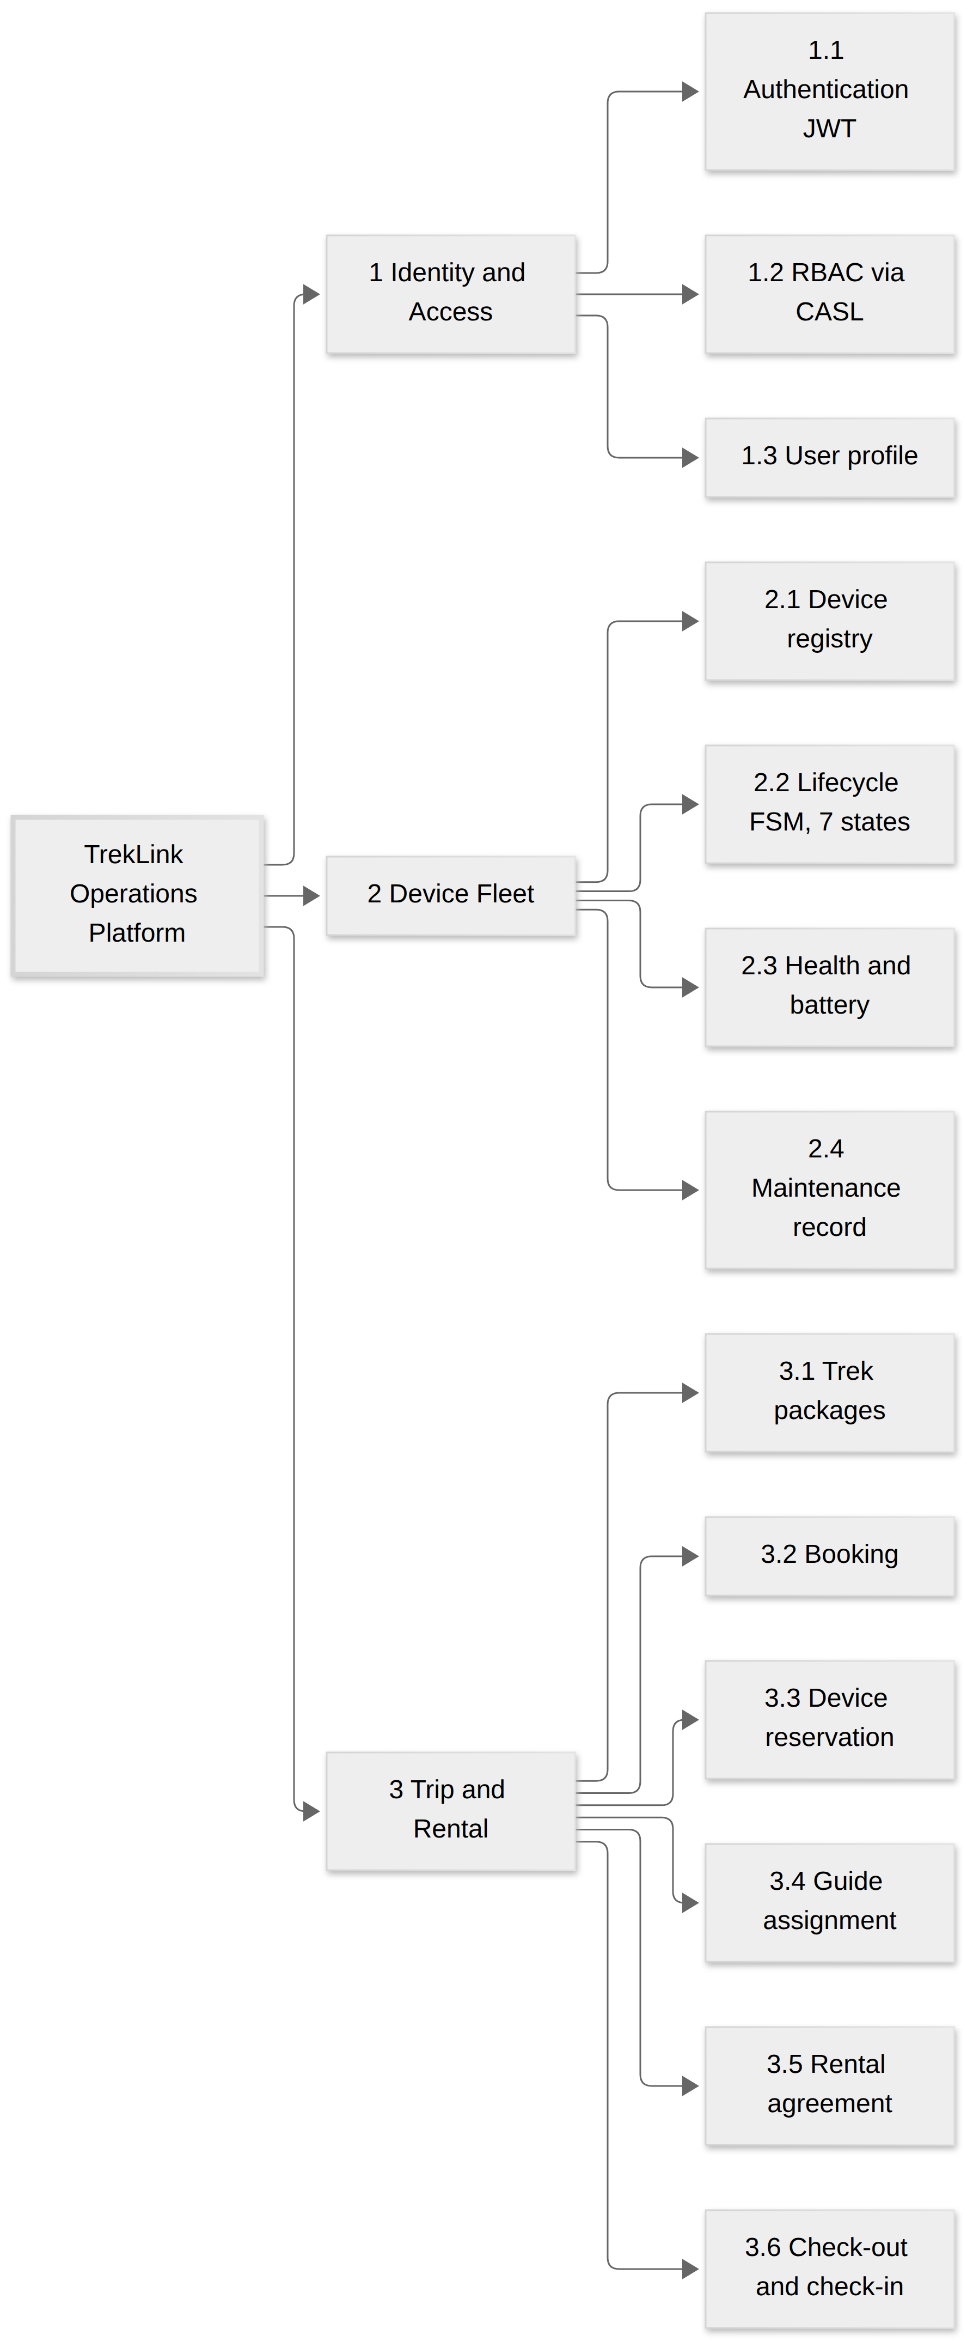
Figure 12: Feature Tree, part 1 of 4: Identity and Access, Device Fleet, Trip and Rental. Placement: inline, 91.9 x 225.0 mm, labels at 7.01 pt.
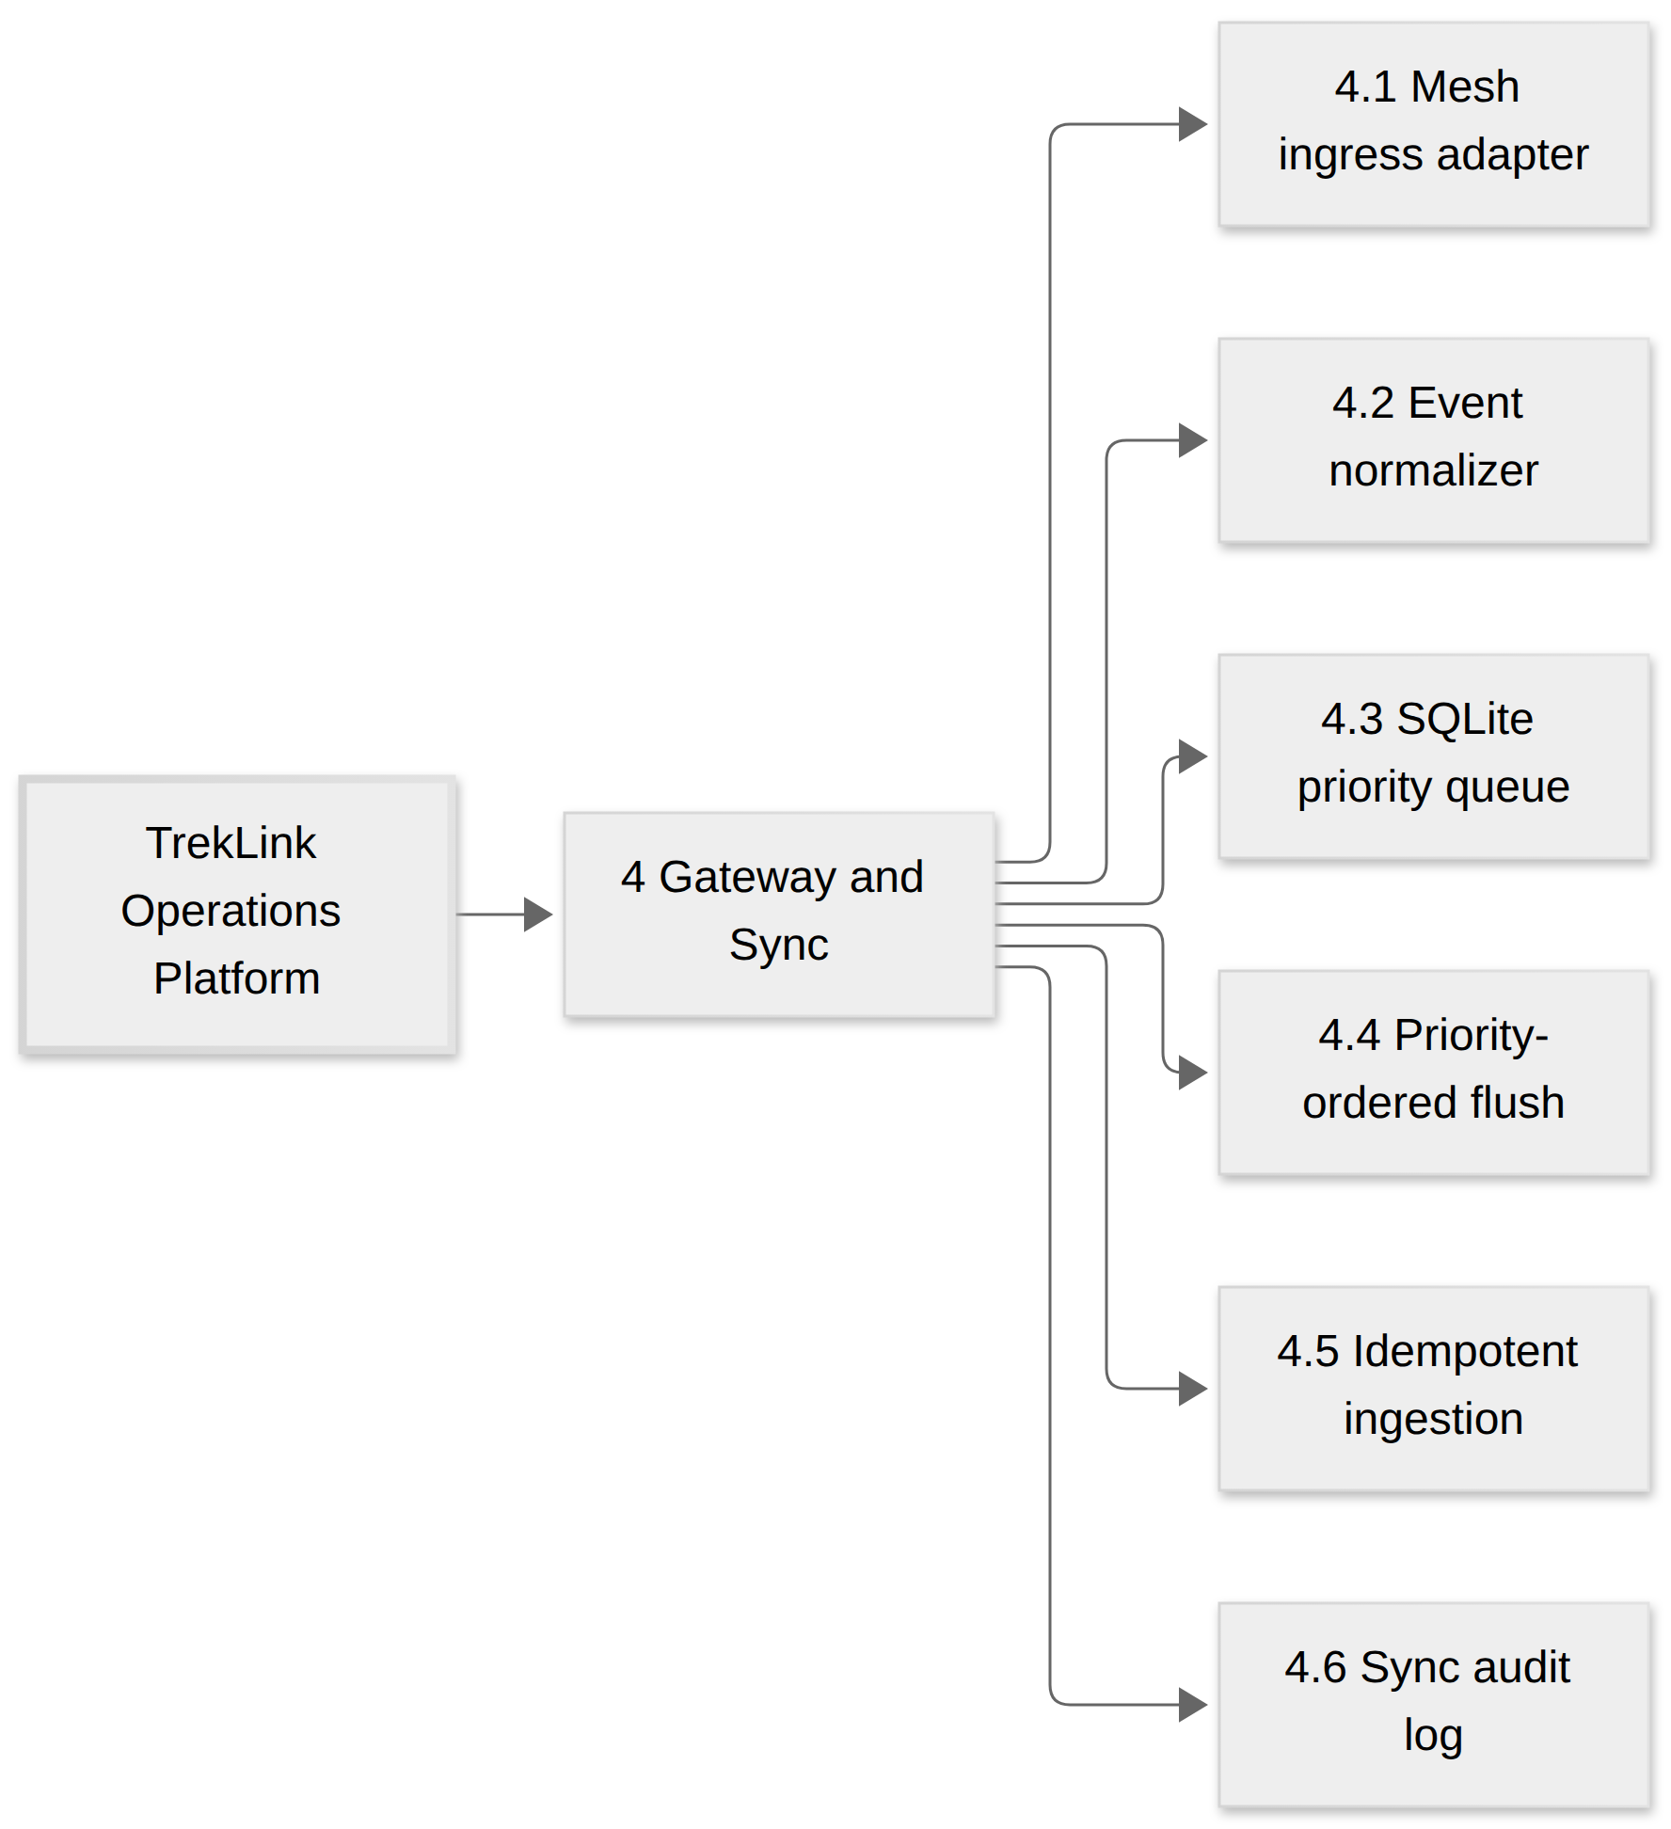
Figure 13: Feature Tree, part 2 of 4: Gateway and Sync. Placement: inline, 159.0 x 186.9 mm, labels at 12.18 pt.
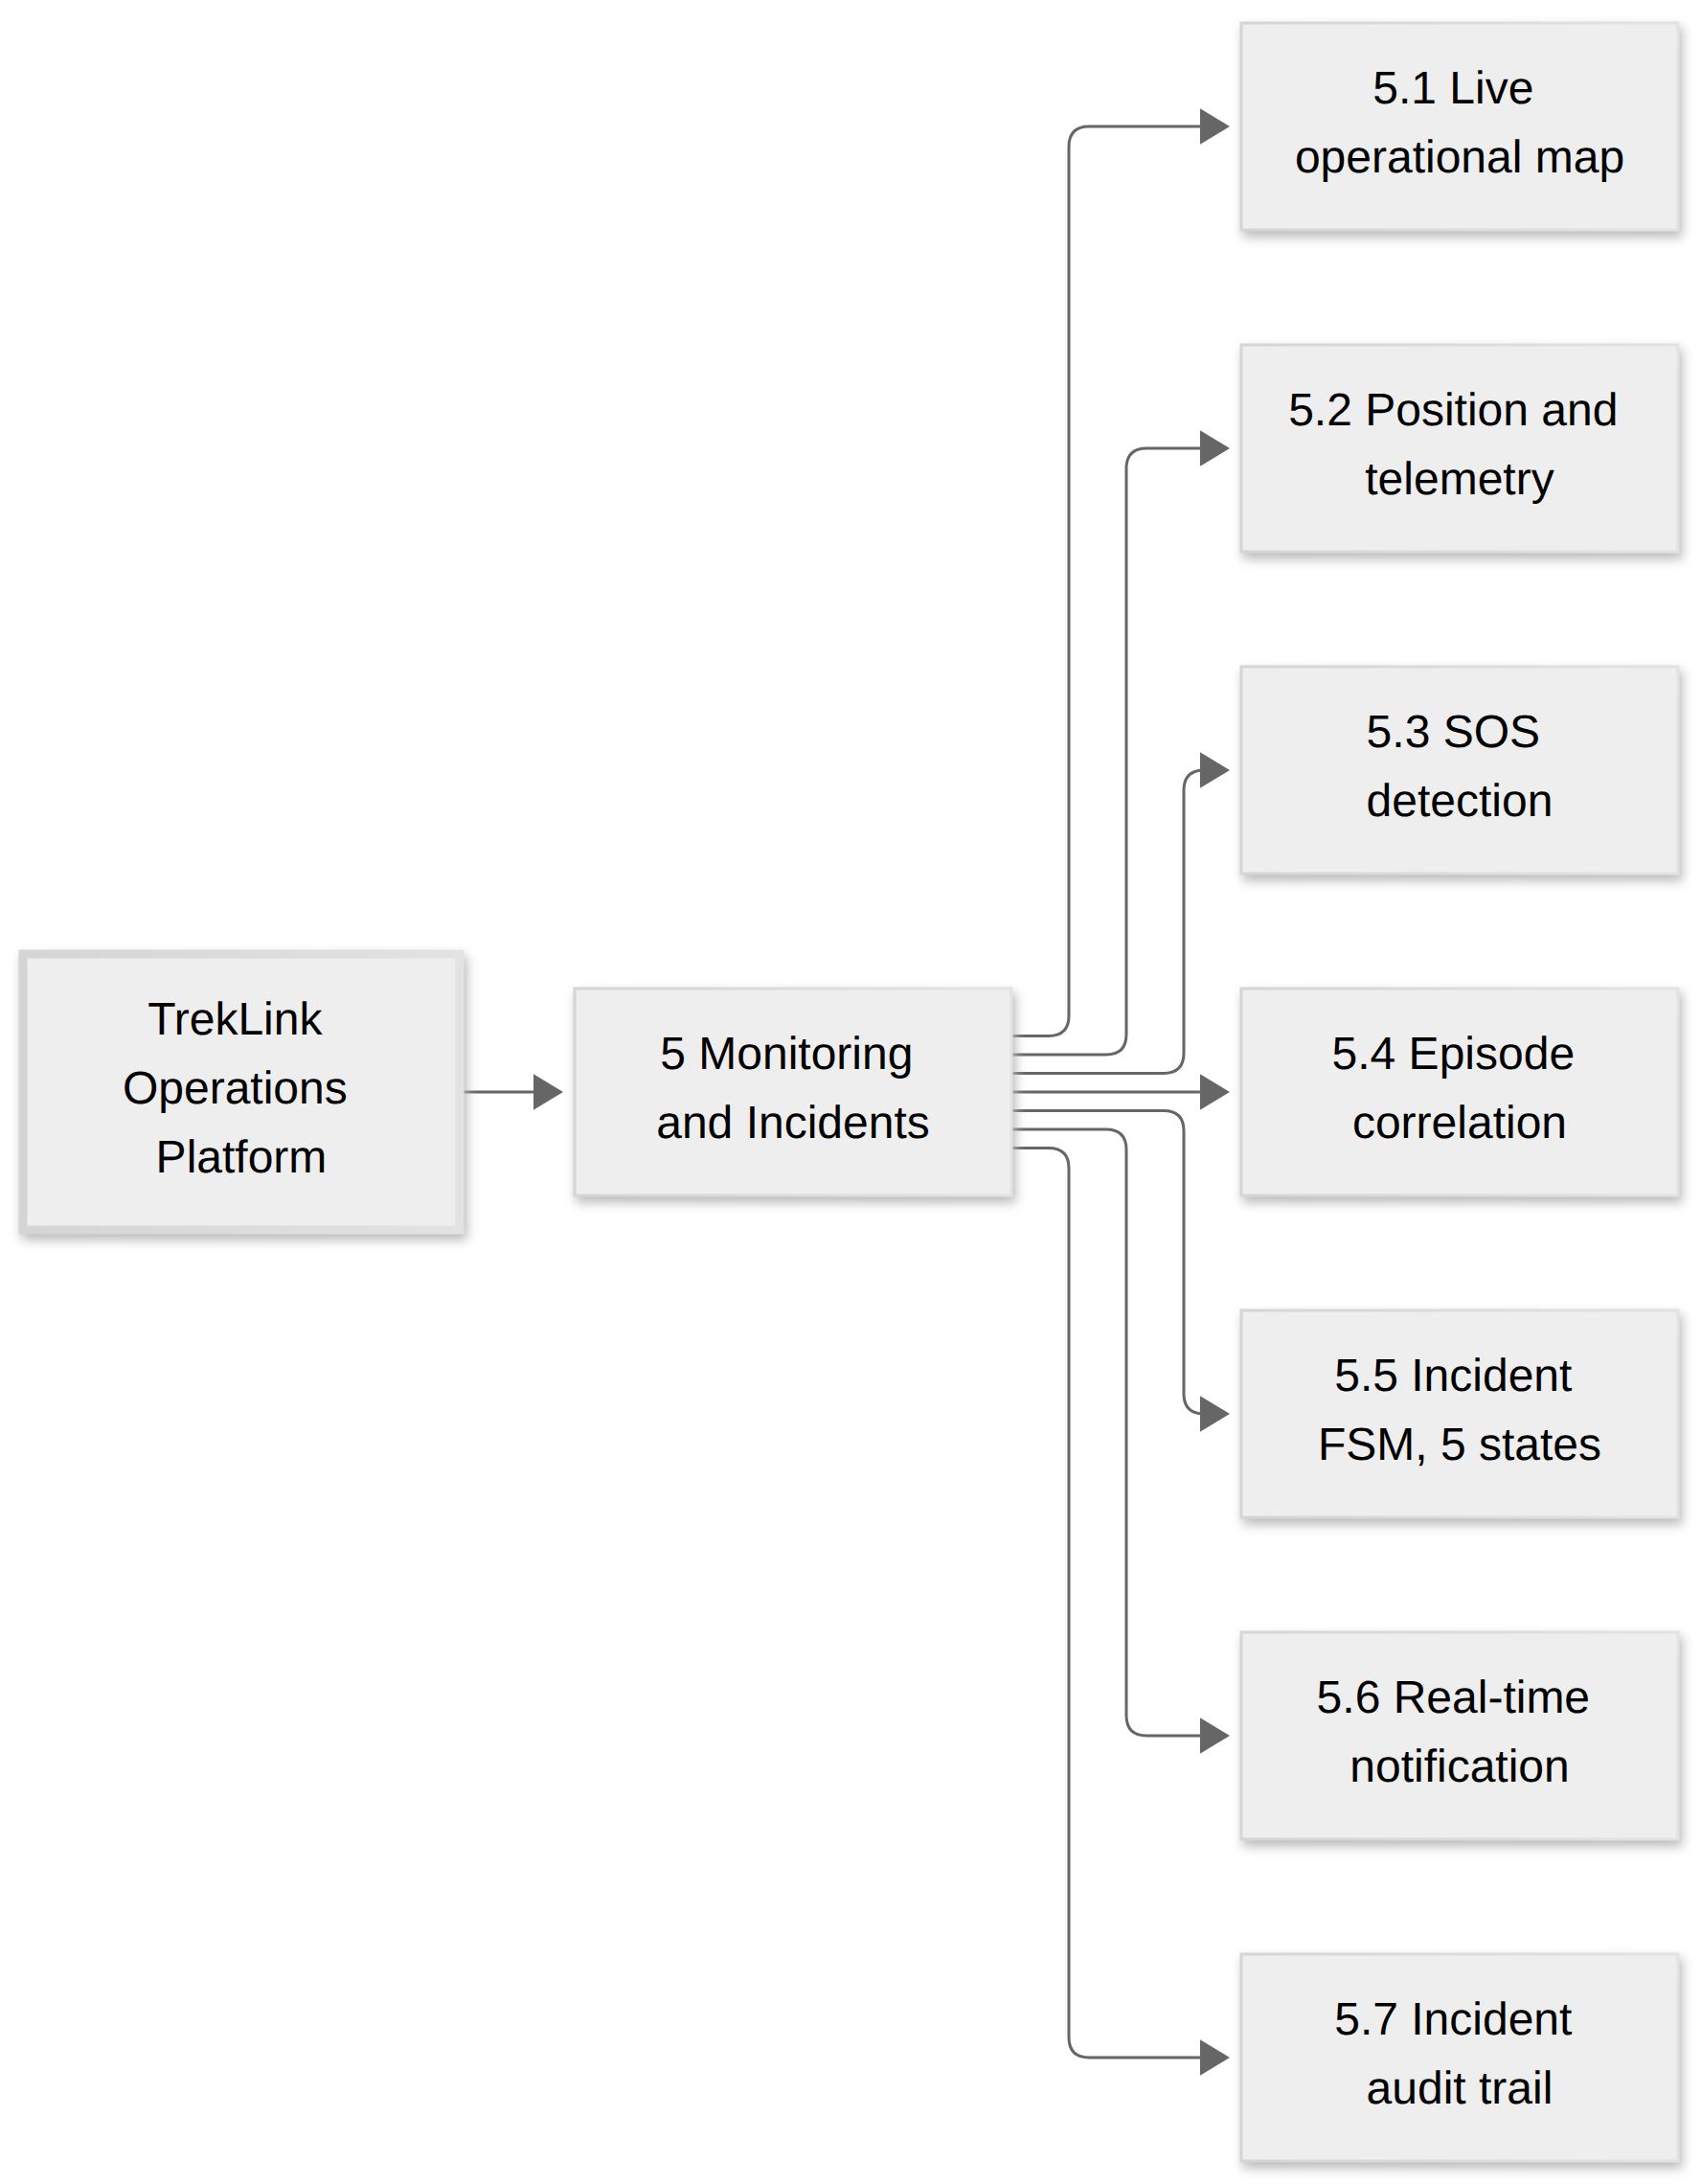
Figure 14: Feature Tree, part 3 of 4: Monitoring and Incidents. Placement: inline, 159.0 x 210.6 mm, labels at 12.18 pt.
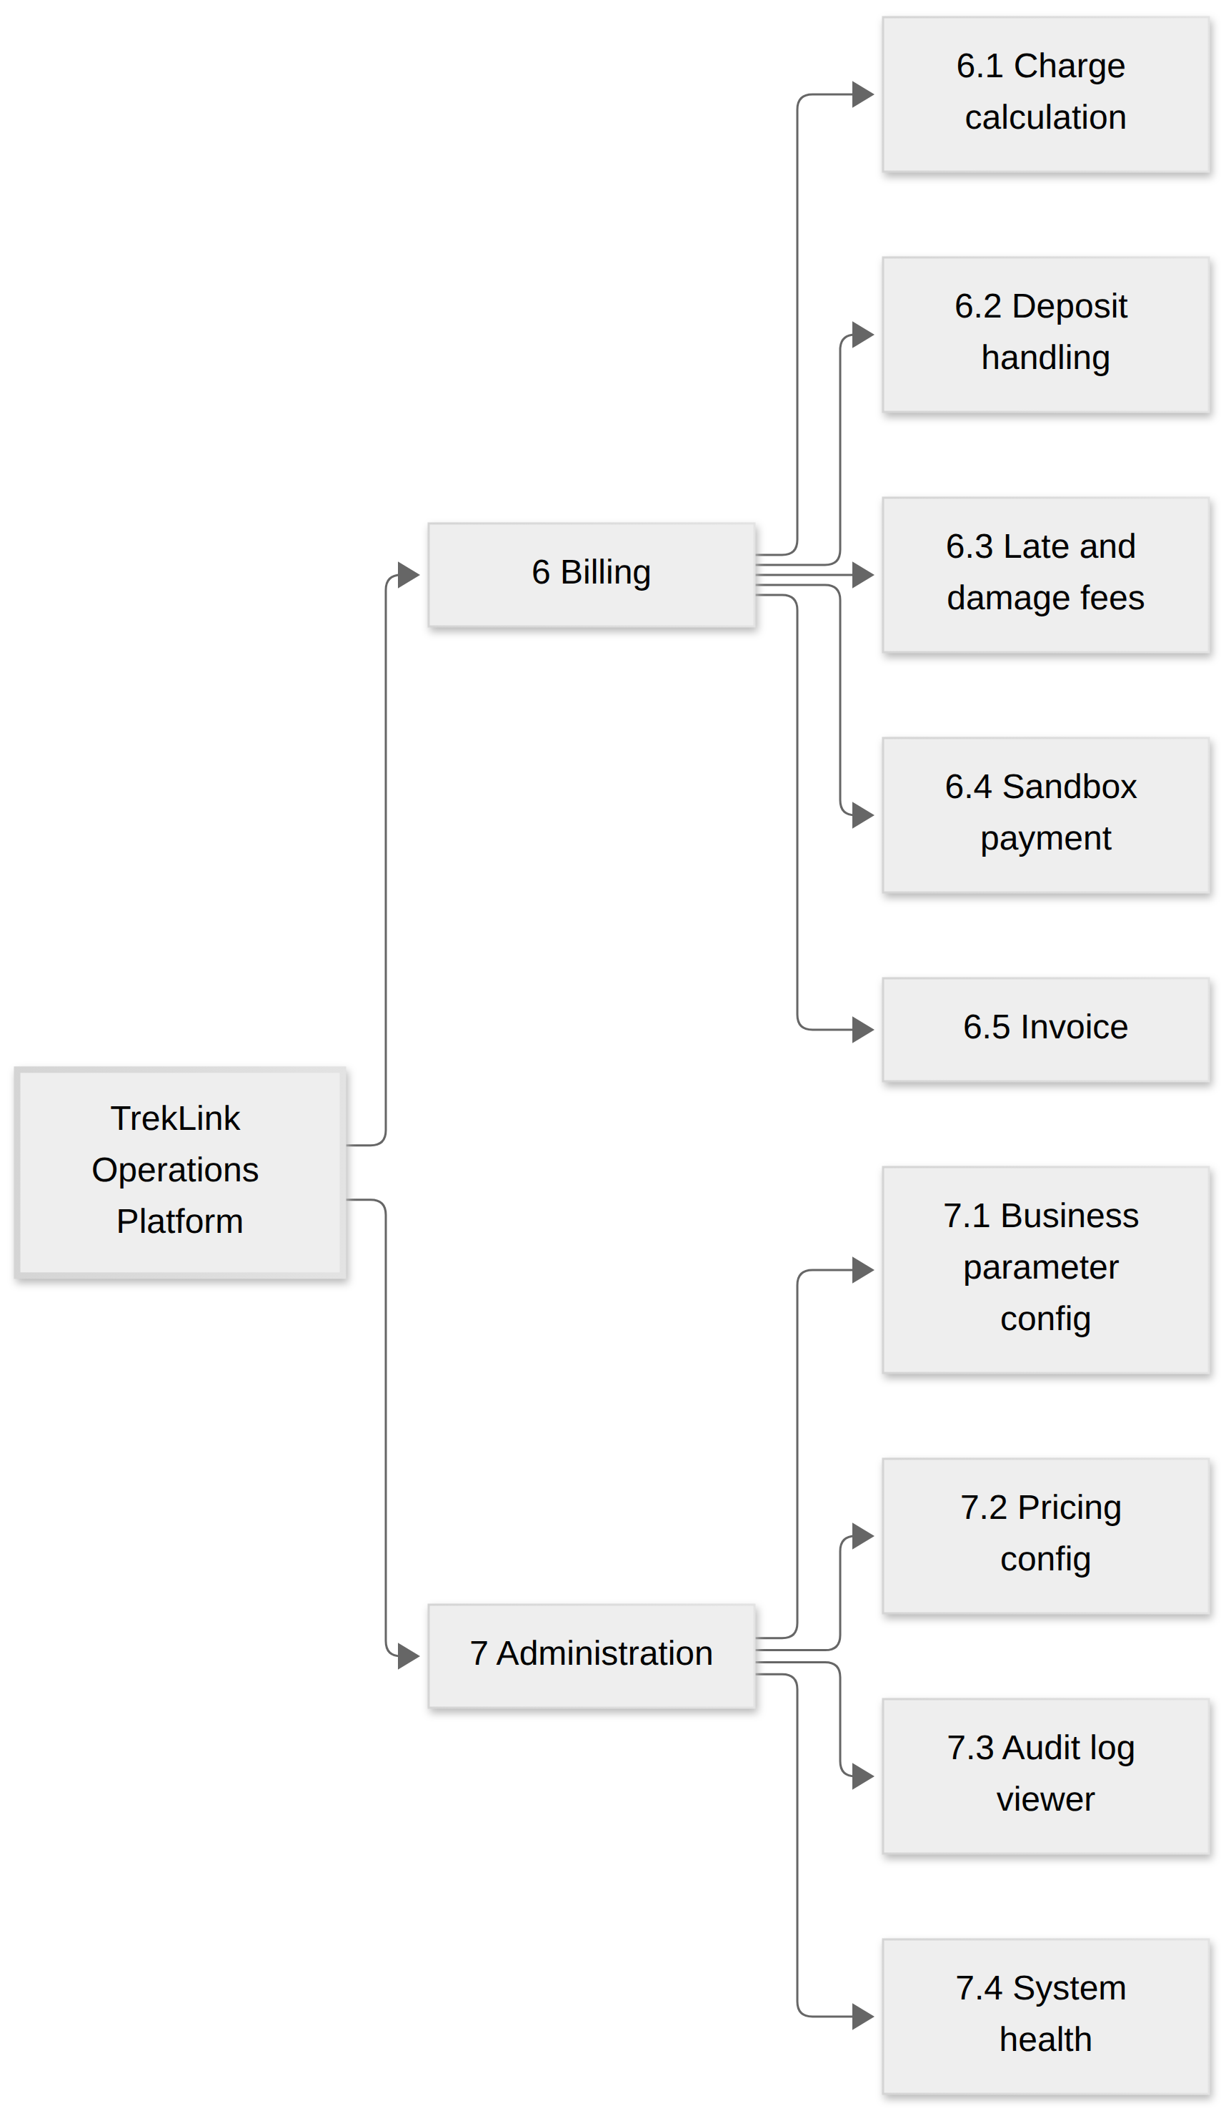
Figure 15: Feature Tree, part 4 of 4: Billing and Administration. Placement: inline, 130.8 x 225.0 mm, labels at 10.37 pt.

3.1.1 Main Flows
Each Main Flow is a swimlane, one lane per actor, with the flow running down the page. The lanes say “Staff” where this document says Operator. See Figure 16, Figure 17, Figure 18, Figure 19 and Figure 20.
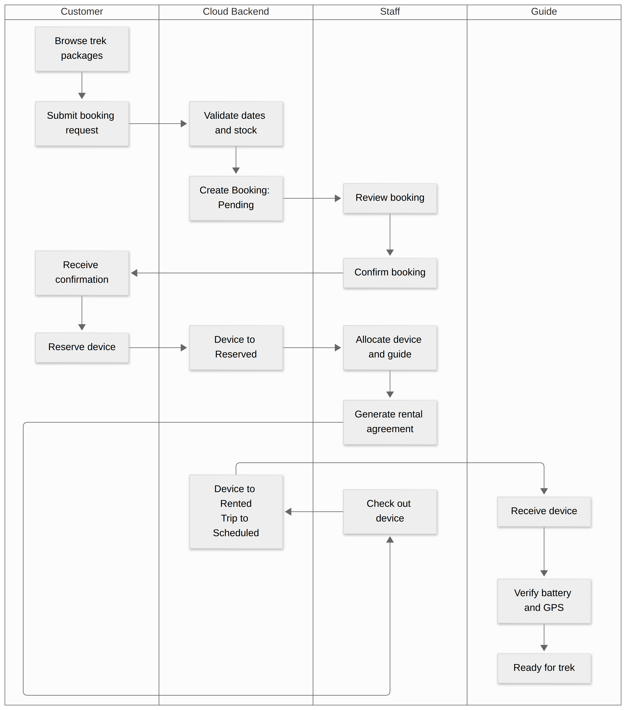
Figure 16: MF-01 Booking to Rental to Trip Preparation. Lanes are actors; the flow runs top to bottom. Placement: inline, 159.0 x 195.0 mm, labels at 7.04 pt.

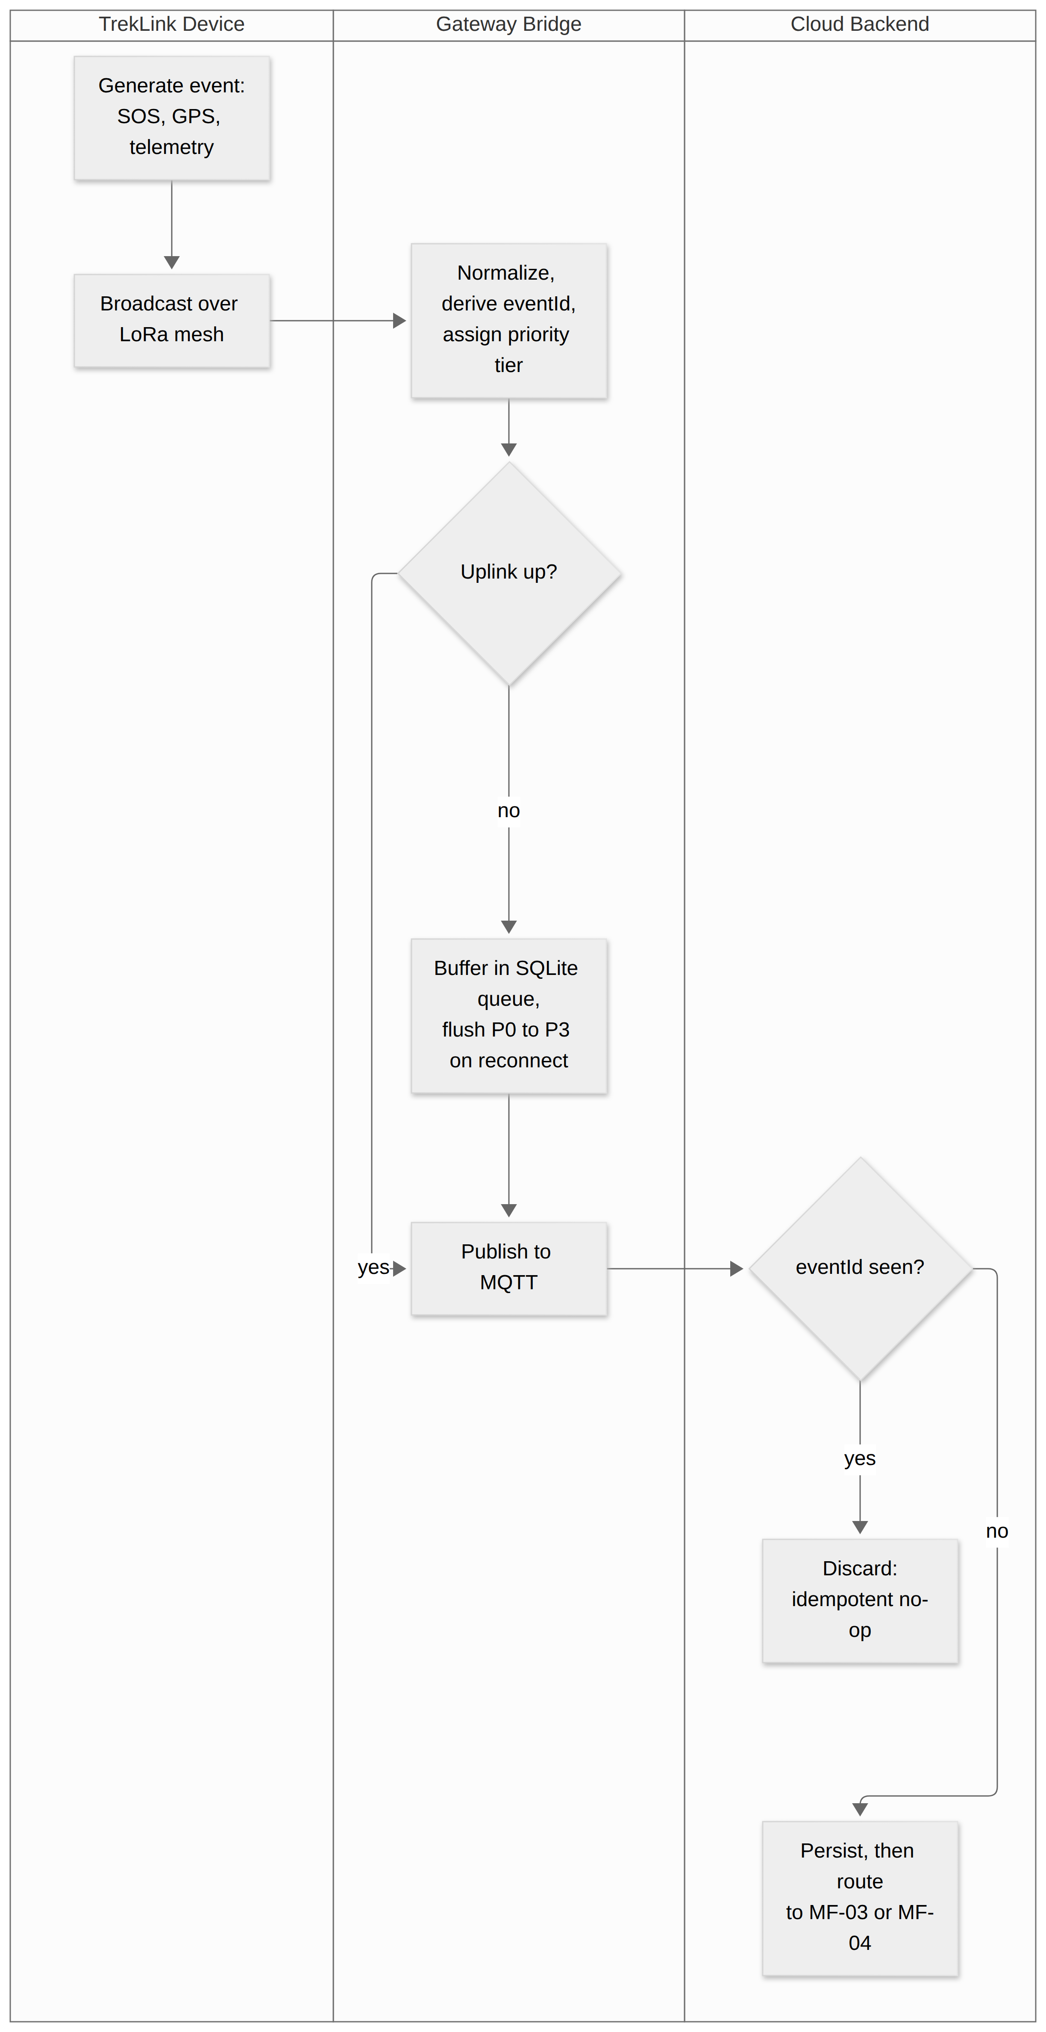
Figure 17: MF-02 Field Data to Offline Gateway to Cloud Synchronization. The buffer sits on the no branch: events generated while the uplink is down are held and flushed in priority order. Placement: full-page plate, 117.5 x 235.0 mm, labels at 6.53 pt.

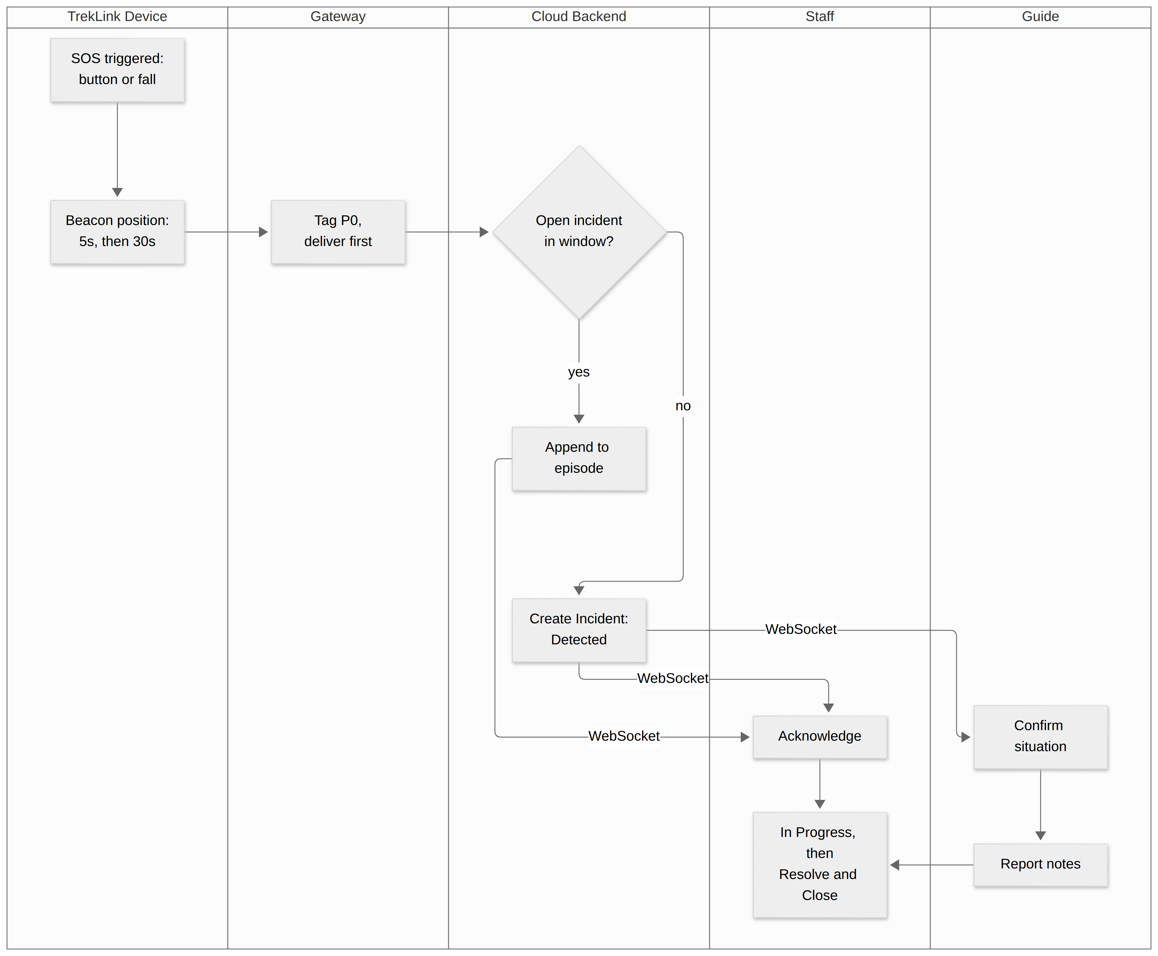
Figure 18: MF-03 SOS to Incident to Emergency Response. The decision node is what makes one SOS episode produce exactly one Incident. Placement: full-page plate, 159.0 x 134.2 mm, labels at 5.45 pt.

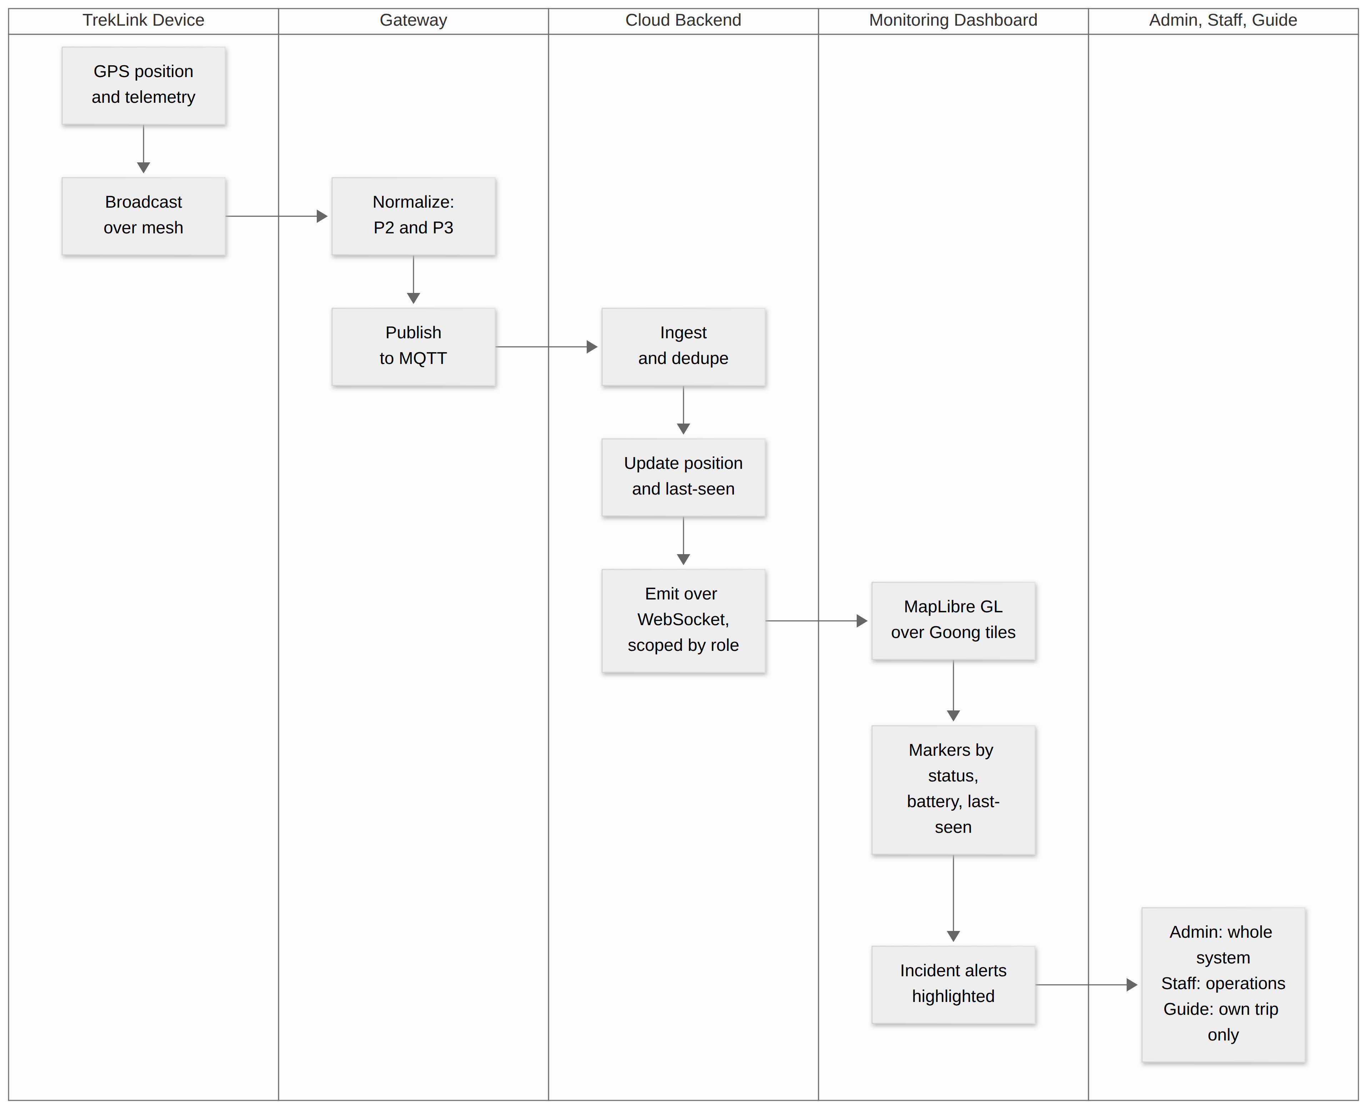
Figure 19: MF-04 Real-Time Trip Monitoring. Role scoping is applied server-side at the WebSocket emit, not in the browser. Placement: full-page plate, 159.0 x 135.1 mm, labels at 5.65 pt.

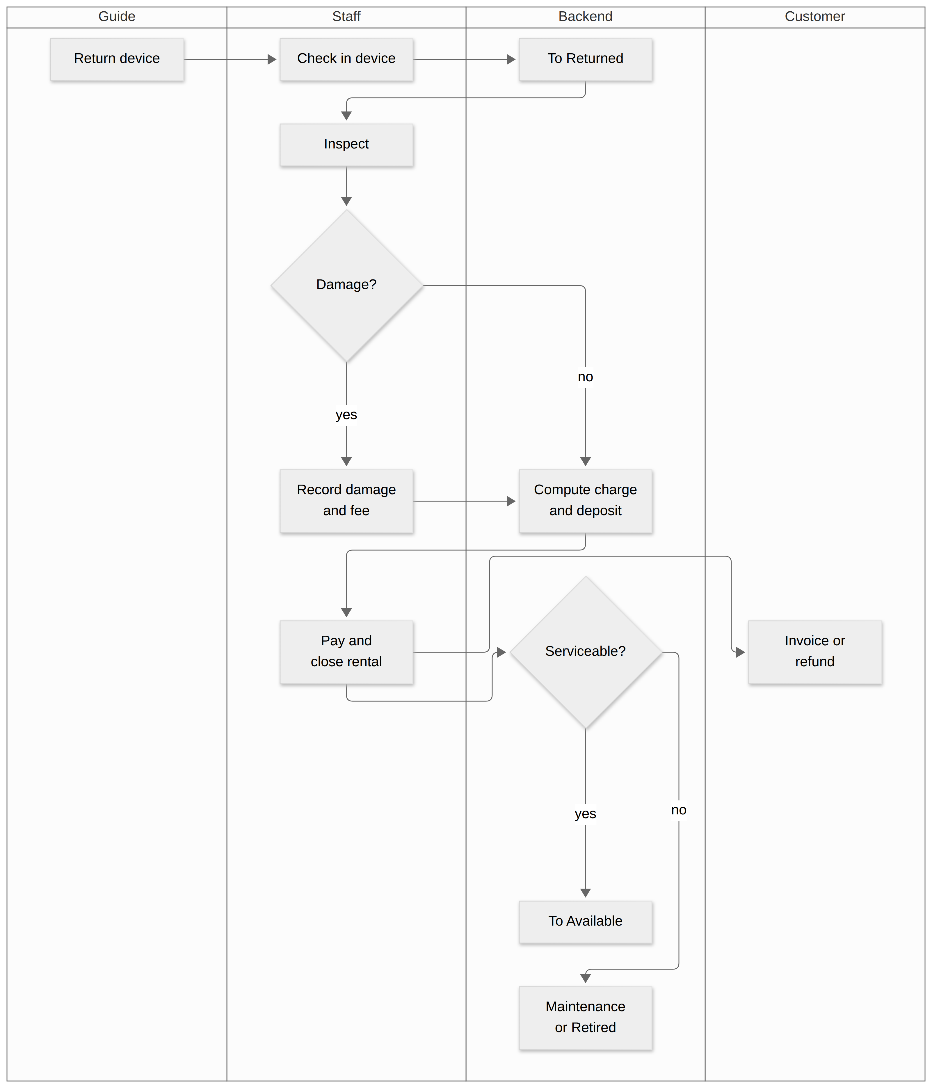
Figure 20: MF-05 Return to Inspection to Billing to Maintenance. Placement: full-page plate, 159.0 x 192.6 mm, labels at 6.75 pt.

3.1.2 Screens Flow
Deferred to the Final SRS (Review 2, Week 8). No screen design exists yet; a screens flow written now would describe screens the software later contradicts.

3.1.3 Screen Descriptions
Deferred to the Final SRS (Review 2, Week 8), for the same reason as §3.1.2.

3.1.4 Screen Authorization
Functions rather than screens, because screens are designed at W5 to W7. An X grants the function; own limits it to the actor’s own records; assigned limits it to trips the Guide is assigned to. Every row is enforced on the server (FR-AUTH-01, NFR-SEC-03).
Function | Guest | Customer | Operator | Guide | Admin
Browse packages (UC-01) | X | X | X | X | X
Register account (UC-27) | X |  | X | X | X
Submit booking, reserve device (UC-02, UC-03) |  | X | X | X | X
Cancel booking (UC-29) |  | own | X |  | X
Confirm or reject booking (UC-04) |  |  | X |  | X
Manage packages (UC-31) |  |  | X |  | X
Create, reschedule, cancel trip (UC-32, UC-34) |  |  | X |  | X
Request trip (UC-33) |  |  |  | X
Allocate device, assign Guide (UC-05, UC-06) |  |  | X |  | X
Provision channel key (UC-39) |  |  | X |  | X
Generate agreement, check out, check in (UC-07, UC-08, UC-09) |  |  | X |  | X
Sign agreement (UC-43) |  | own | capture | capture
Confirm handover, report missing device (UC-37, UC-40) |  |  |  | assigned
Start and end trip (UC-35, UC-36) |  |  | X | assigned | X
Inspect, record maintenance (UC-10, UC-41) |  |  | X |  | X
Approve fee waiver (UC-44) |  |  | X, not the inspector |  | X, not the inspector
Pay (UC-12) |  | own | record |  | record
View bookings, invoices (UC-45) |  | own | X |  | X
View live map (UC-14) |  |  | X | assigned | X
Acknowledge incident (UC-15) |  |  | X | assigned | X
Move incident to In Progress (UC-16) |  |  | X | assigned | X
Resolve or close incident (UC-16) |  |  | X |  | X
Dismiss suspected, create manual incident (UC-46, UC-47) |  |  | X |  | X
Record response note (UC-17) |  |  | X | assigned | X
Register and retire device, manage types (UC-38, UC-42, UC-51) |  |  |  |  | X
Manage users and roles (UC-18) |  |  |  |  | X
Configure parameters, pricing (UC-19, UC-50) |  |  |  |  | X
View audit log, system health (UC-20, UC-53) |  |  |  |  | X
View reports (UC-52) |  |  | X |  | X

3.1.5 Non-Screen Functions
Functions with no user interface, driven by ingestion or by time.
# | Feature | System Function | Description
1 | Gateway and Sync | Event ingestion (UC-13) | Decode stock topic payloads, derive eventId, deduplicate, persist, route by kind
2 | Gateway and Sync | Local queueing | Classify P0 to P3 and persist before any network attempt; bounded, sheds P3 first
3 | Gateway and Sync | Priority-ordered flush (UC-54) | On reconnect, publish by tier then queue sequence; mark flushed on broker acknowledgement
4 | Gateway and Sync | Gateway health reporting | Queue depth per tier, last sync time, oldest retry count
5 | Incidents | Episode correlation (UC-49) | Append an SOS event to the open incident inside the correlation window, or create one
6 | Incidents | Cadence-anomaly detection (UC-49) | Raise a Suspected incident when N positions arrive within window W
7 | Incidents | Notification fan-out (UC-23) | WebSocket and email to the Guide and online Staff after the incident is persisted
8 | Incidents | Auto-escalation (UC-57) | Re-notify when an incident stays Detected past the timeout
9 | Monitoring | Staleness marking (UC-56) | Flag devices and gateways silent beyond their thresholds
10 | Monitoring | Role-scoped push | Emit position, telemetry and incident updates only to subscribers allowed to read them
11 | Booking | Hold expiry (UC-55) | Release a lapsed device hold; booking to Expired
12 | Billing | Non-return escalation (UC-58) | Move a rental to Escalated after the non-return grace period
13 | Billing | Invoice generation | One immutable, itemized invoice per rental once inspections complete
14 | Device (firmware) | On-device durable queue (Stage B) | Hold the node’s own events in priority order across outages and reboots; see §4.1.4

3.1.6 Entity Relationship Diagram
A conceptual model of the eight core entities, in two parts that share Device and Trip. The diagrams show keys and cardinality; the entity table lists the other attributes the requirements depend on. The physical schema follows in the SDD. See Figure 21 and Figure 22.
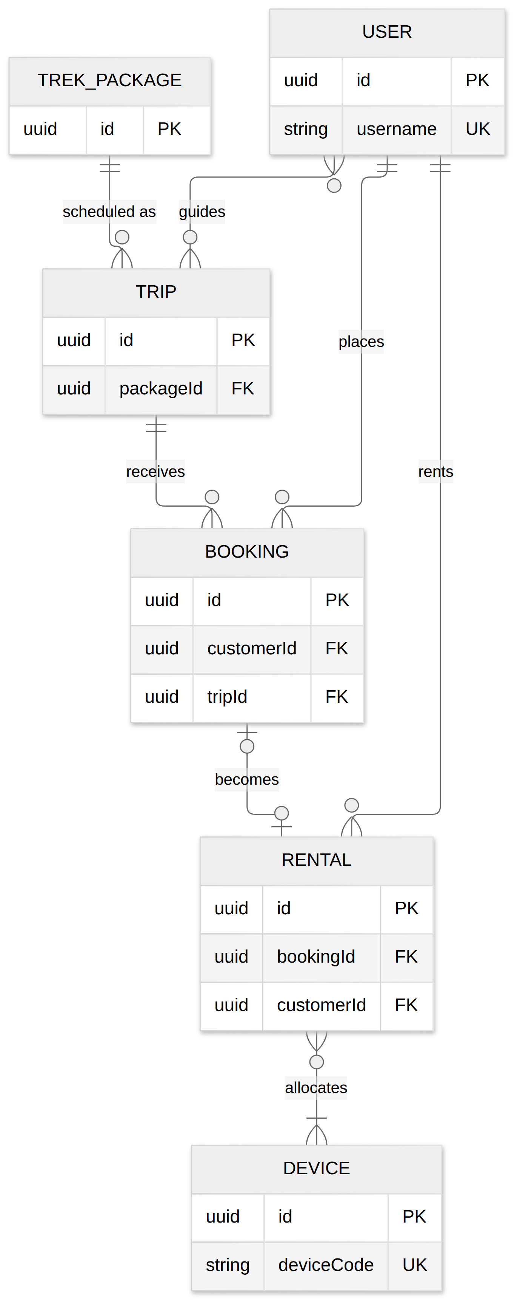
Figure 21: Conceptual ERD, part 1 of 2: accounts, packages, trips, bookings, rentals and devices, with primary, unique and foreign keys and cardinality. Placement: inline, 92.1 x 225.0 mm, labels at 7.79 pt.
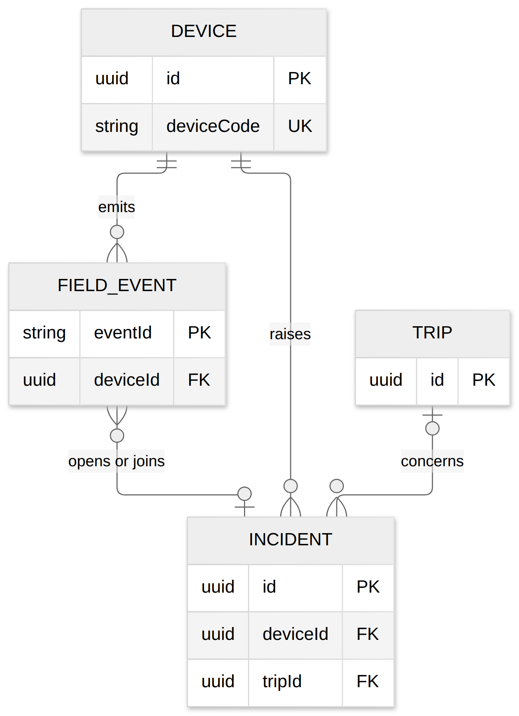
Figure 22: Conceptual ERD, part 2 of 2: devices, field events, incidents and trips. Placement: inline, 159.0 x 209.2 mm, labels at 12.86 pt.
Entities Description
# | Entity | Description
1 | User | Any account. Username is the login key; subRole is Customer or a Staff sub-role (Operator, Guide, Admin, extensible); soft-deleted, isActive flag
2 | Trek Package | A sellable route with duration, base price, device requirements and an active flag
3 | Trip | A dated run of a package, with its state, guides-per-trip setting and accepted hardware versions
4 | Booking | A Customer’s request on a trip, with its state and device hold expiry
5 | Rental | The agreement and custody record from check-out to settlement. Exists with or without a booking
6 | Device | A physical TrekLink unit, with its physical state, hardware version, provisioning flag, battery and last-seen time
7 | Field Event | One ingested mesh event keyed by eventId, with kind and priority tier
8 | Incident | One SOS episode or manual report, with state, detection confidence and the timestamps behind MTTA and MTTR
Supporting entities, not drawn: Allocation (device, rental and time window; resolves the Rental to Device many-to-many), Trip Guide (trip to Guide assignment), Incident Transition (append-only audit of incident state changes), Device Transition, Damage Report, Maintenance Record, Payment, Invoice, Pricing Rule, Gateway, Configuration Parameter, Role and Permission, and the authentication and synchronization audit logs.

3.1.7 State Machines
Five entities have lifecycles. The device and incident machines are named graded deliverables. See Figure 23, Figure 24, Figure 25, Figure 26 and Figure 27. State names with a space (In-Field, In Progress, On Prepare) are drawn with an underscore.
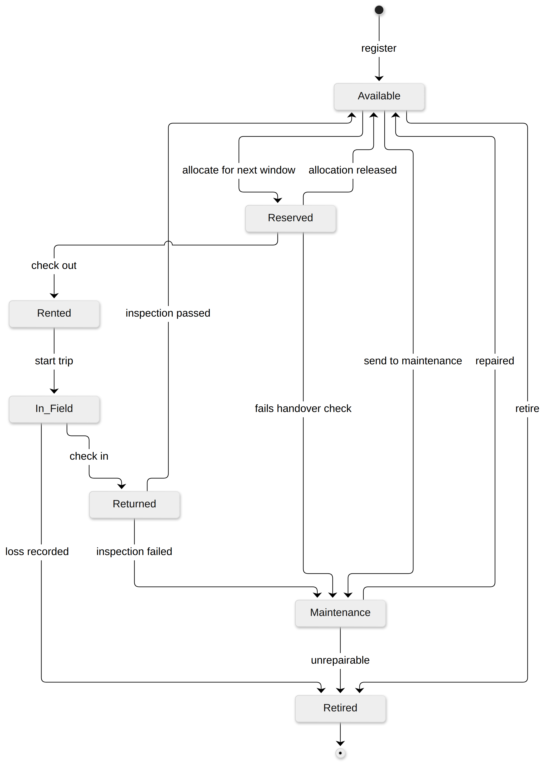
Figure 23: Device lifecycle state machine, seven states. The state is the device’s physical condition; future commitments are Allocation records. Placement: inline, 159.0 x 202.5 mm, labels at 7.97 pt.
A device can be allocated to a future trip while it is still In-Field on the current one: the future commitment is an Allocation record with a non-overlapping window, and the device enters Reserved only when that window is next.
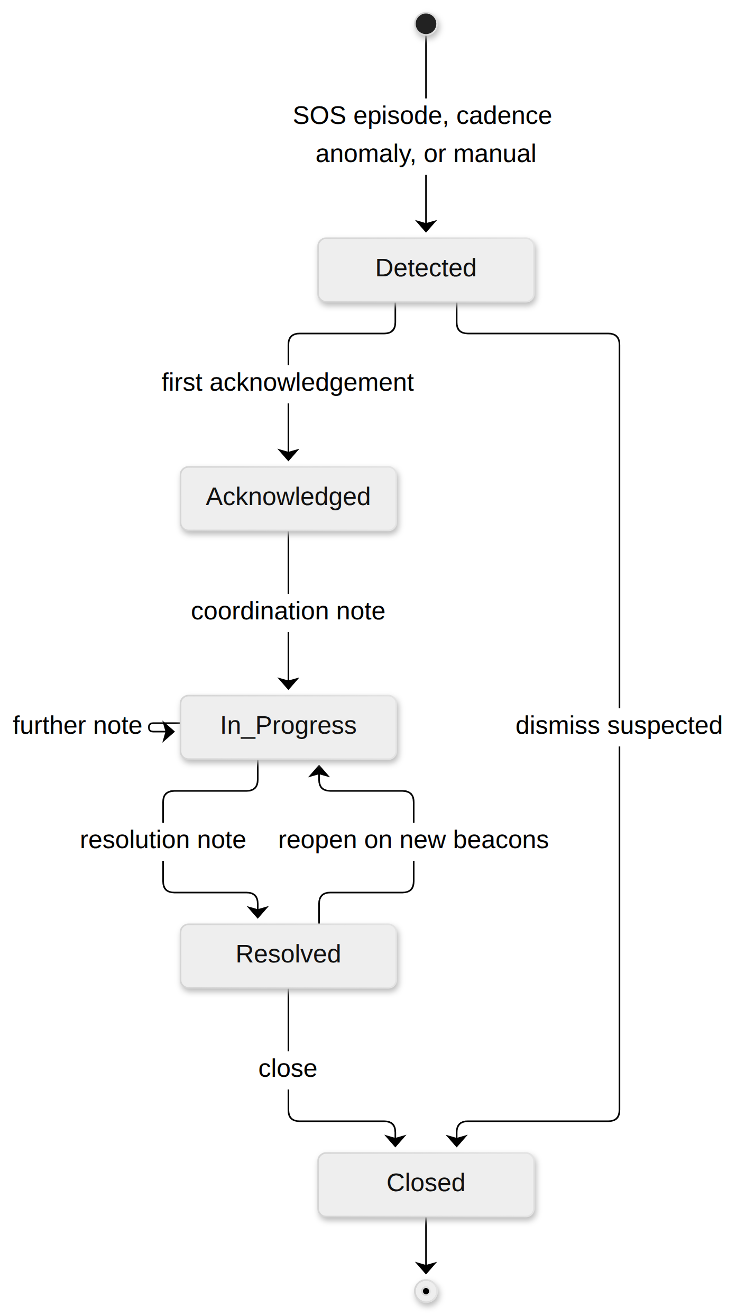
Figure 24: Incident lifecycle state machine, five states, with the reopen and suspected-dismissal transitions. Placement: inline, 137.0 x 225.0 mm, labels at 12.32 pt.
Detection confidence (Confirmed, Suspected) is an attribute of the incident. A late SOS text frame upgrades a Suspected incident to Confirmed in place.
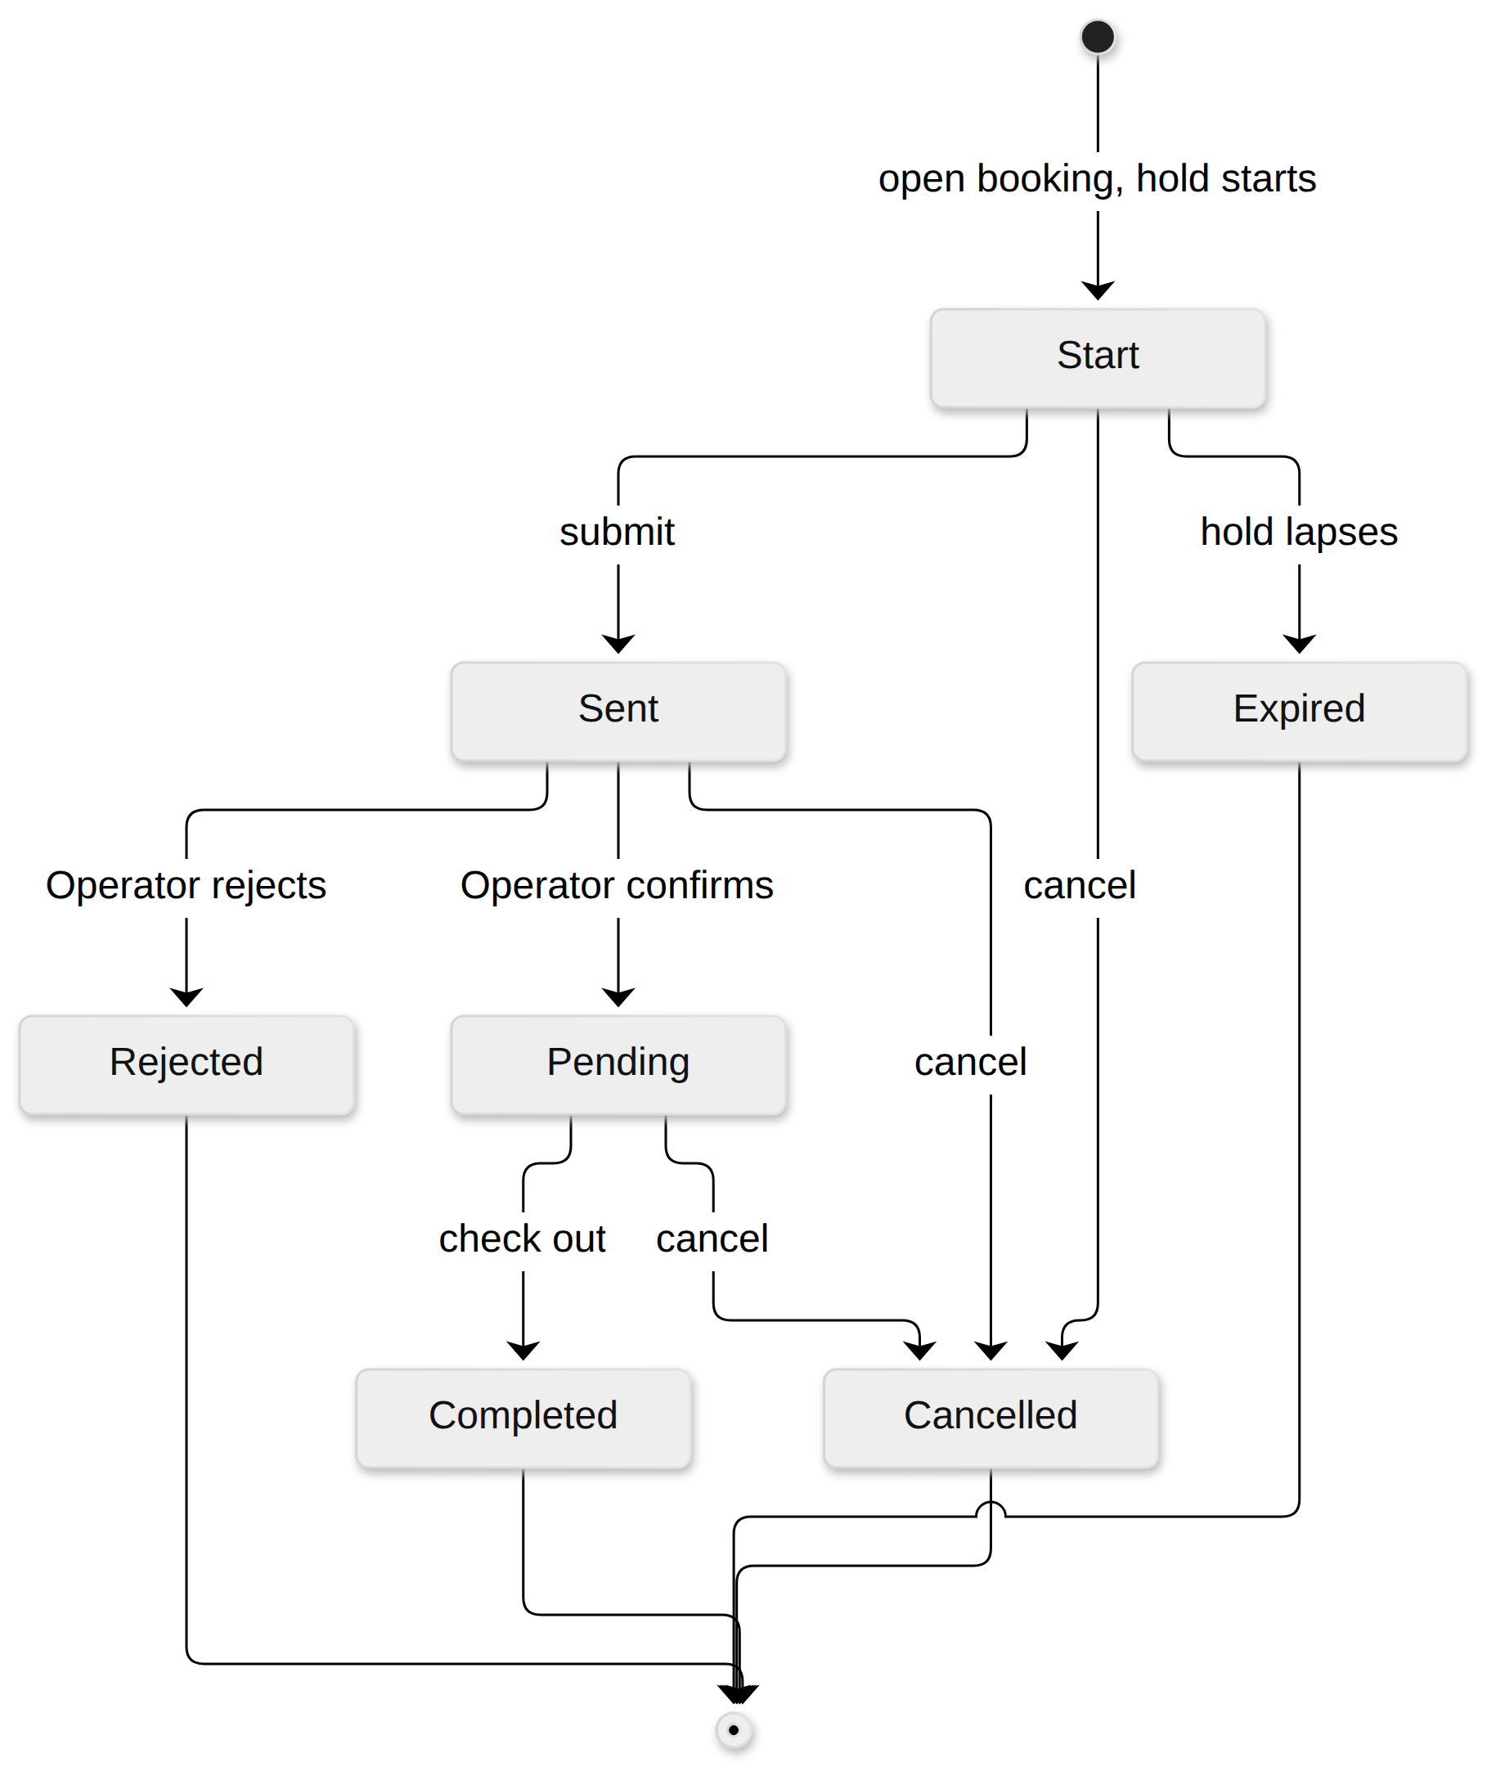
Figure 25: Booking state machine. Placement: inline, 159.0 x 194.2 mm, labels at 11.84 pt.
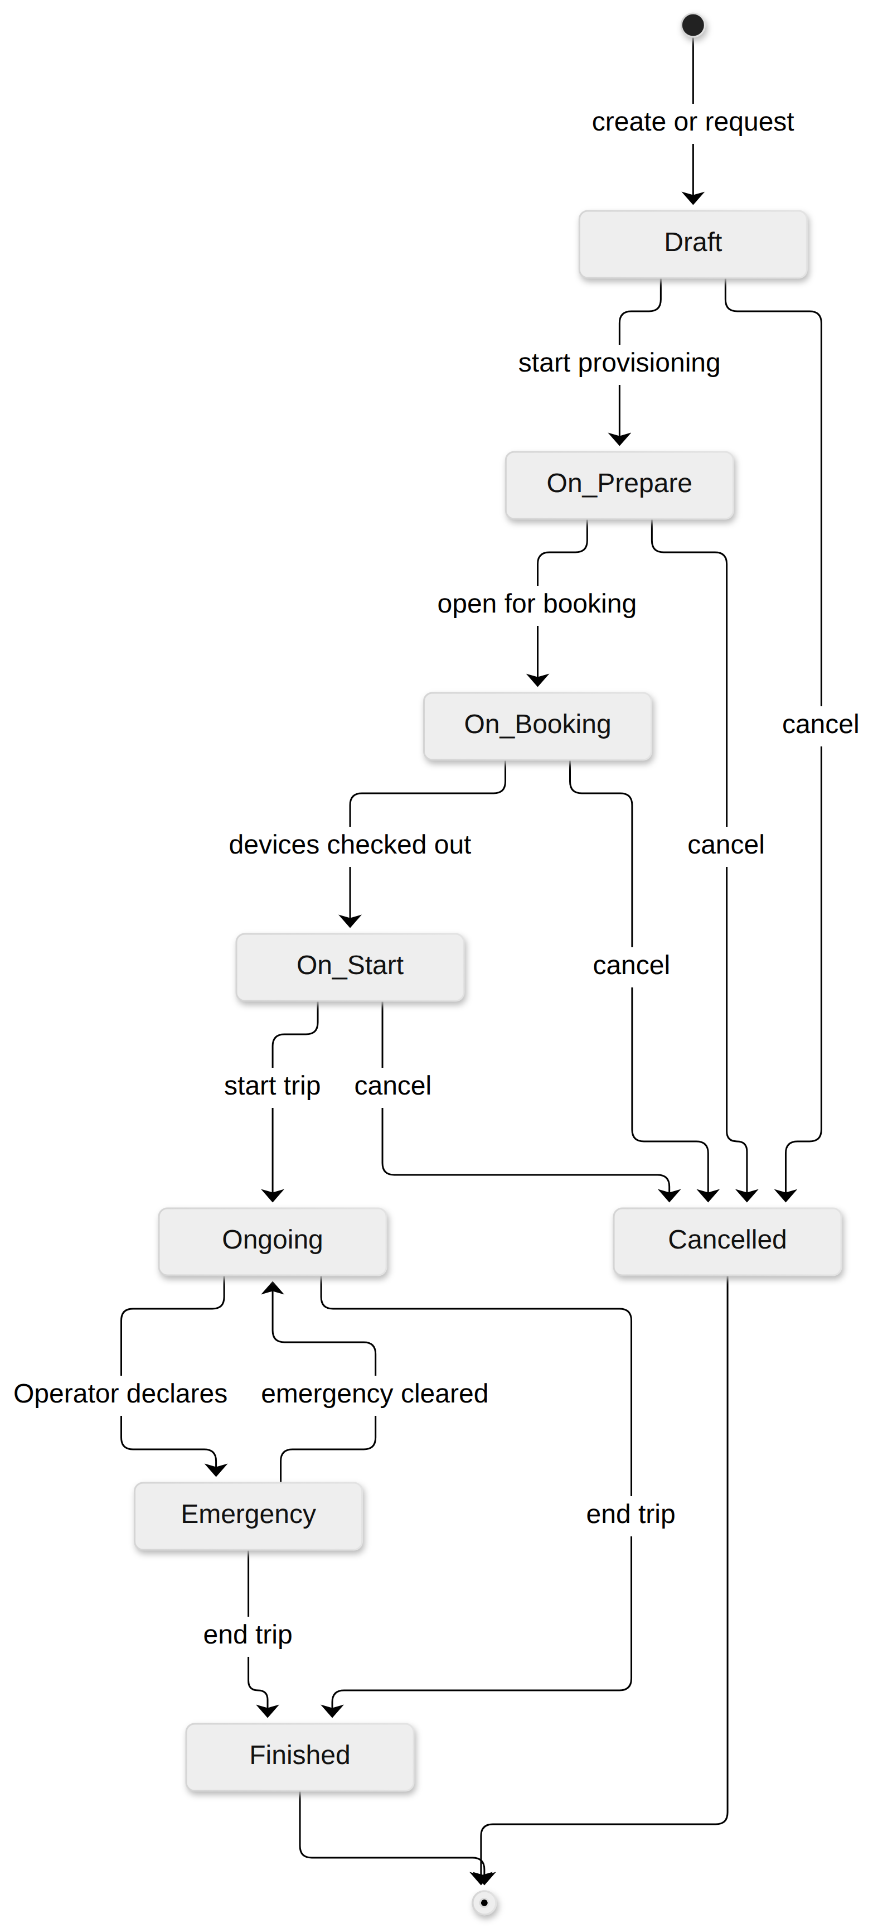
Figure 26: Trip state machine. Placement: inline, 110.5 x 225.0 mm, labels at 8.86 pt.
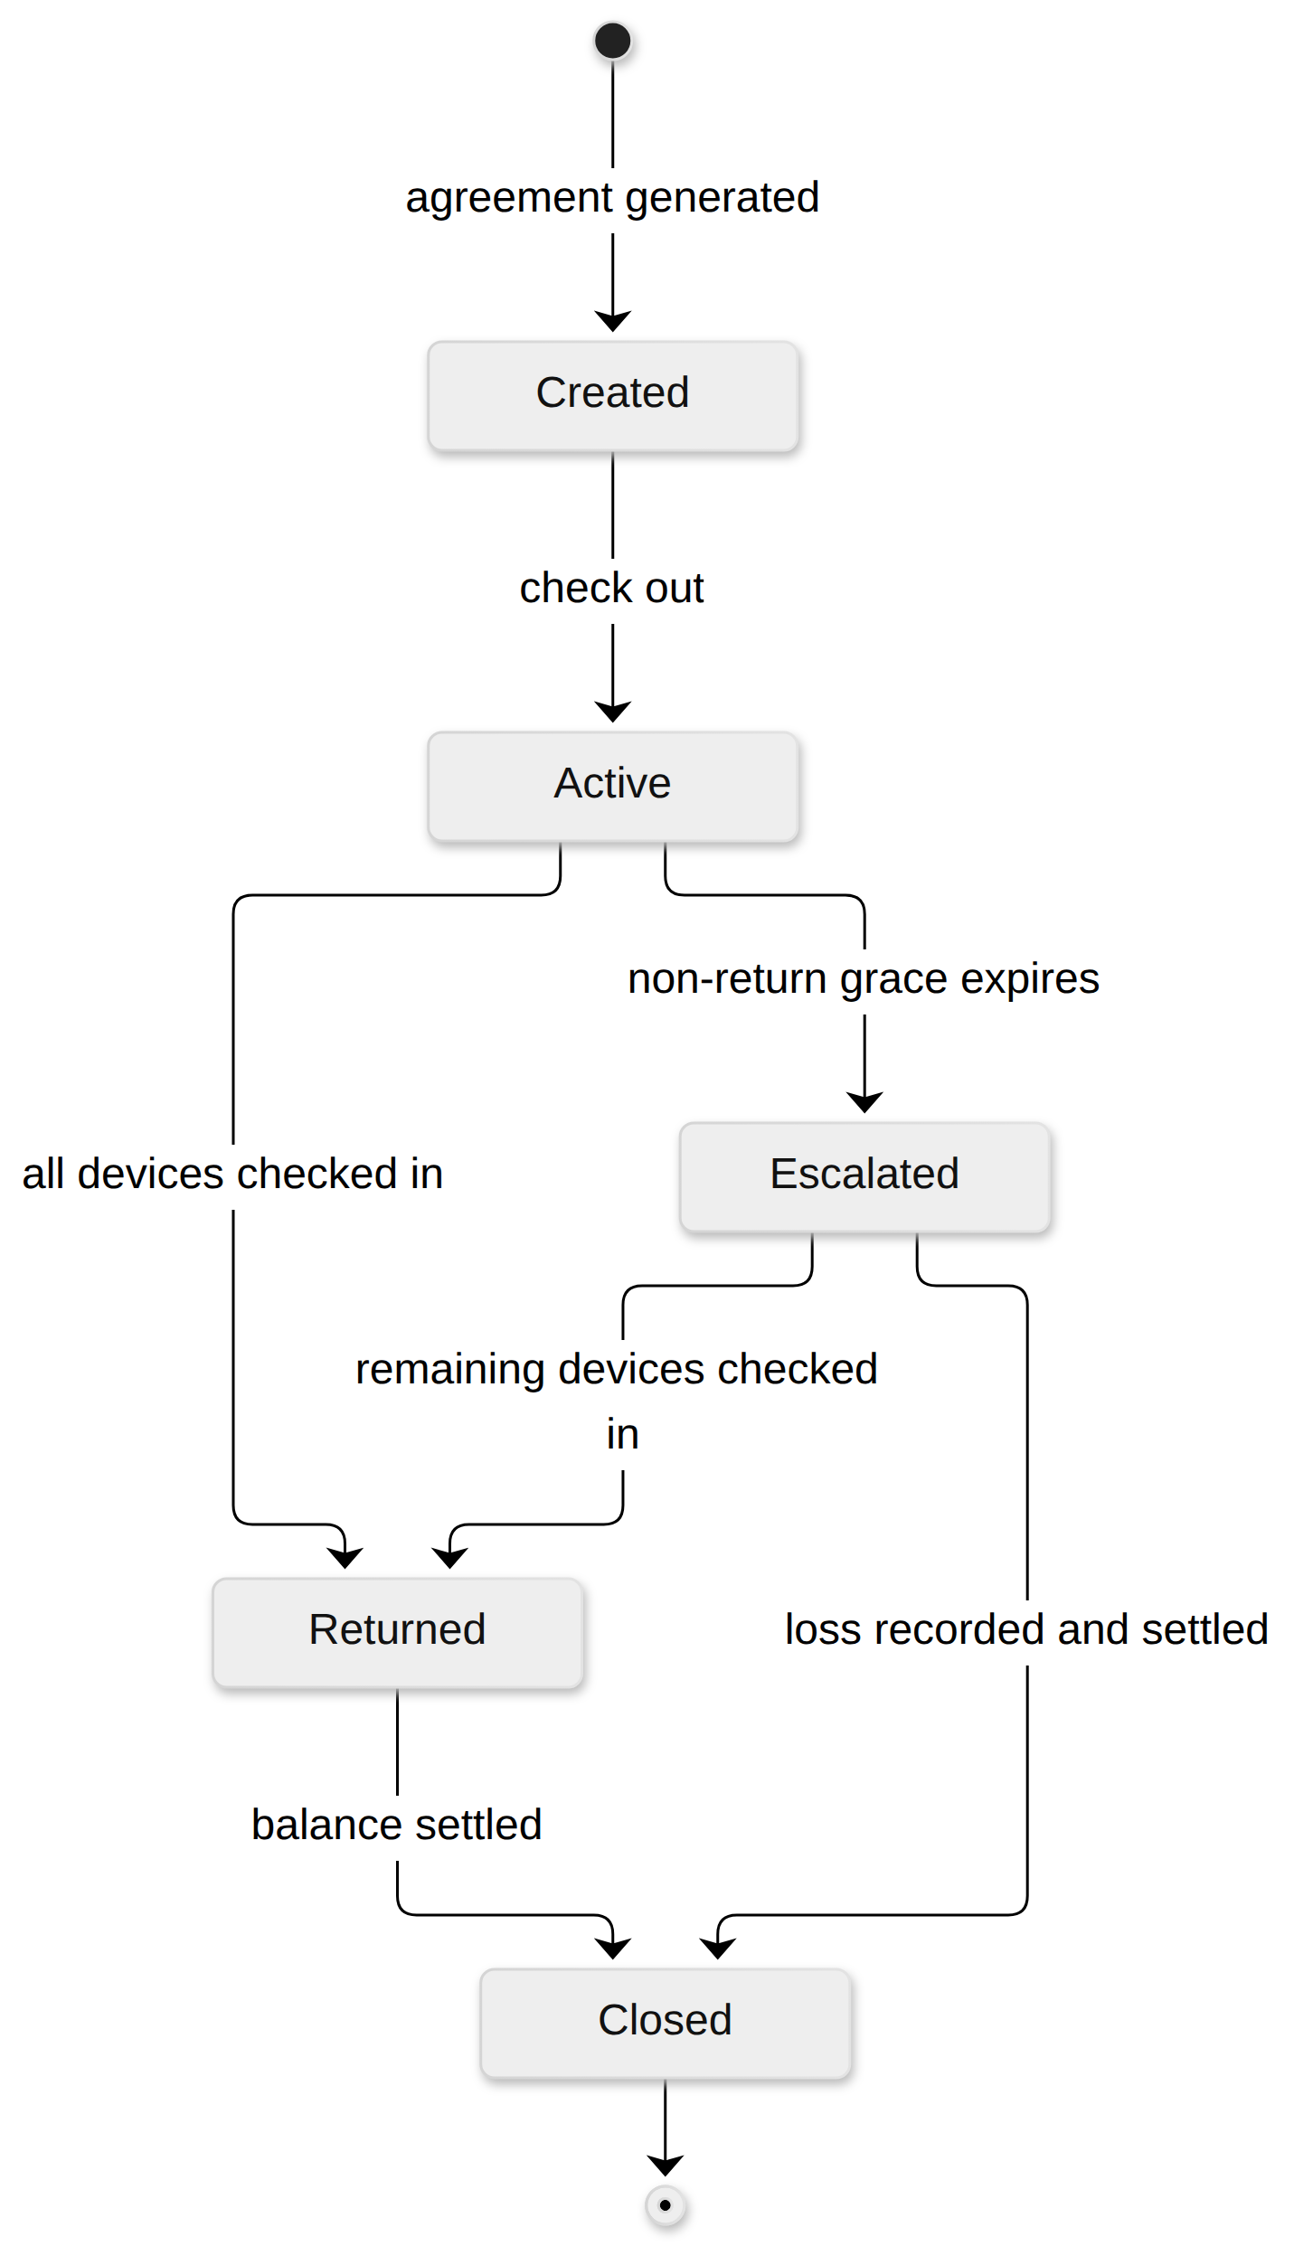
Figure 27: Rental state machine. Placement: inline, 136.5 x 225.0 mm, labels at 12.21 pt.

3.2 Identity and Access
Accounts, sessions, roles and the server-side scoping every other feature relies on.
ID | Requirement (EARS) | Use Cases | Main Flow | Source
FR-AUTH-01 | WHEN a mutating request is received, the system SHALL require both a valid JWT and a CASL policy that permits the action, and SHALL return 401 or 403 in the standard envelope otherwise. | UC-21 | cross-cutting | US-008, BR-14
FR-AUTH-02 | WHEN a Guest registers with Google OAuth or with an email verified by OTP, the system SHALL create an active Customer account whose username is the email local part, with a numeric suffix where that username is taken. | UC-27 | MF-01 | Q31, Q41 (P)
FR-AUTH-03 | WHILE a Guide is authenticated, the system SHALL restrict every read of trips, devices, positions and incidents, over REST and WebSocket, to trips assigned to that Guide. | UC-14, UC-15, UC-16 | MF-03, MF-04 | US-037, US-038, E04-5
FR-AUTH-04 | WHERE a customer has no account, the system SHALL let an Operator or a Guide create the Customer account on the customer’s behalf after identity verification. | UC-27 | MF-01 | Q31 (P)
FR-AUTH-05 | WHEN valid credentials are submitted, the system SHALL issue a short-lived access token and a refresh token; IF credentials are invalid, THEN the system SHALL return 401 without revealing which field was wrong. | UC-21 | cross-cutting | US-003
FR-AUTH-06 | WHEN a valid refresh token is presented, the system SHALL issue a new access token and rotate the refresh token; IF a rotated refresh token is reused, THEN the system SHALL revoke the whole token family. | UC-21 | cross-cutting | US-005
FR-AUTH-07 | WHEN a user logs out, the system SHALL revoke the presented refresh token immediately. | UC-21 | cross-cutting | US-006
FR-AUTH-08 | WHEN a password reset is requested, the system SHALL send a single-use, time-limited OTP to the registered email only and SHALL respond identically for unknown emails; an Operator SHALL be able to trigger a reset and SHALL NOT be able to view or set the password. | UC-28 | cross-cutting | US-007, Q35 (P)
FR-AUTH-09 | The system SHALL store roles, Staff sub-roles and permissions as data, and a permission change SHALL take effect on the next request without a redeploy. | UC-18 | cross-cutting | US-001, Q33 (P), S9-Q2
FR-AUTH-10 | WHEN an Admin deactivates an account, the system SHALL set isActive to false and reject that account’s refresh tokens immediately. | UC-18 | cross-cutting | US-009, Q45 (P)
FR-AUTH-11 | The system SHALL record every authentication event (login, logout, failed attempt, reset) with actor, event type, IP and UTC timestamp, append-only, and SHALL NOT store an attempted password in any form. | UC-20, UC-21 | cross-cutting | US-004, Q46 (P)
FR-AUTH-12 | WHILE a Customer is authenticated, the system SHALL restrict that Customer’s reads of bookings, rentals, agreements and invoices to records the Customer owns. | UC-45 | MF-01, MF-05 | US-039, US-070
FR-AUTH-13 | WHEN a record is deleted, the system SHALL mark it deleted and retain it, except where hard deletion is specified for that record type. | UC-18 | cross-cutting | Q36 (P)
FR-AUTH-14 | The system SHALL let a Guest browse active packages without an account, and SHALL require an account to submit a booking. | UC-01, UC-02 | MF-01 | Q30 (P)
FR-AUTH-15 | The system SHALL grant an Admin every permission of an Operator in addition to the administration functions. | UC-16, UC-18 | cross-cutting | S9-Q2

3.3 Device Fleet
Registration, the device lifecycle, allocation windows, provisioning and maintenance.
ID | Requirement (EARS) | Use Cases | Main Flow | Source
FR-DEV-01 | The system SHALL change device state only through the transition table of the 7-state device FSM, SHALL reject any other change with 409, and SHALL write an append-only audit row for each transition. | UC-05, UC-08, UC-09, UC-35, UC-41, UC-42 | MF-01, MF-05 | US-013, BR-05
FR-DEV-02 | WHEN an Admin registers a device with a unique device ID, a device type, a hardware version and a firmware version, the system SHALL create it in Available; IF the device ID exists, THEN the system SHALL reject it with 409. | UC-38 | cross-cutting | US-012, Q49 (P)
FR-DEV-03 | The system SHALL let an Admin maintain device types with hardware and firmware versions, and SHALL refuse to delete a type that has registered devices. | UC-51 | cross-cutting | US-011
FR-DEV-04 | WHERE a trip restricts accepted hardware versions, the system SHALL reject allocation of a device whose hardware version the trip does not accept. | UC-05, UC-32 | MF-01 | Q50 (P)
FR-DEV-05 | WHEN a device below the advisory battery level is allocated or checked out, the system SHALL show a charge-before-departure advisory; IF the level is below the warning level, THEN the system SHALL require the Operator or Guide to confirm manual verification. The system SHALL NOT block allocation or check-out on battery level. | UC-05, UC-08, UC-37 | MF-01 | Q52 (P), S9-Q28, BR-04
FR-DEV-06 | WHILE a device is in Maintenance or Retired, the system SHALL reject any allocation referencing it, inside the same transaction as the allocation write. | UC-05 | MF-01 | US-014
FR-DEV-07 | The system SHALL allow one device to hold several allocations whose time windows do not overlap, and SHALL reject an allocation whose window overlaps an existing one for that device. | UC-05 | MF-01 | Q53 (P), S9-Q4, E01-5
FR-DEV-08 | WHEN a telemetry or position event is ingested, the system SHALL update the device’s battery, last-seen time and last position, and SHALL discard a reading older than the stored last-seen time. | UC-13 | MF-02, MF-04 | US-017
FR-DEV-09 | IF a device remains unreturned beyond the non-return grace period, THEN the system SHALL move its rental to Escalated, and WHEN an Operator records the loss, the system SHALL move the device to Retired with a loss record. | UC-58, UC-40, UC-42 | MF-05 | BR-22, E05-3, S9-Q27
FR-DEV-10 | WHEN an Operator moves a device to Maintenance, the system SHALL require a reason, accept an optional expected return date, and keep the device unallocatable until it is moved back to Available. | UC-41 | MF-05 | US-018
FR-DEV-11 | WHEN an Admin retires a device, the system SHALL set the terminal state Retired without deleting the device or its history; IF the device has an active allocation, THEN the system SHALL reject the retirement. | UC-42 | MF-05 | US-020
FR-DEV-12 | The system SHALL present a read-only chronological history per device of allocations, rentals, incidents, damage and maintenance, each entry with actor, event type and UTC time. | UC-42 | MF-05 | US-022, Q54 (P)
FR-DEV-13 | The system SHALL block check-out of a device not yet provisioned with the fleet channel key, and SHALL never display, return or log the key after it is entered. | UC-39, UC-08 | MF-01 | D-021, Q51 (P)
FR-DEV-14 | WHEN an Operator attaches a damage report to a Returned device, the system SHALL store description, severity and evidence reference permanently and SHALL leave the device state unchanged. | UC-10 | MF-05 | US-019

3.4 Booking and Rental
From a Customer’s booking through the agreement, check-out and check-in.
ID | Requirement (EARS) | Use Cases | Main Flow | Source
FR-BOOK-01 | WHEN a Customer submits a booking, the system SHALL validate package, dates and group size against the package limits and SHALL move the booking from Start to Sent. | UC-02 | MF-01 | US-025, S9-Q25
FR-BOOK-02 | The system SHALL let a device be committed to at most one booking or rental for any overlapping time window, using a row-level lock, and the losing request SHALL receive an unavailable result without an oversell. | UC-03, UC-05, UC-22 | MF-01 | BR-01, E01-1, Q58 (P)
FR-BOOK-03 | WHEN a Customer creates a booking, the system SHALL reserve exactly one device; WHERE the booking is made by a Guide or an Operator, the system SHALL allow several devices up to the package limit. | UC-03 | MF-01 | US-026, Q57 (P)
FR-BOOK-04 | The system SHALL allow an Operator to confirm a booking only when enough allocatable devices and an eligible Guide exist for its dates, and SHALL show any conflict before confirmation. | UC-04 | MF-01 | BR-02, E01-4
FR-BOOK-05 | WHEN a Customer booking enters Start, the system SHALL hold its device for the configured hold duration and SHALL move the booking to Expired and release the device when the hold lapses; WHERE the booking is a Staff or Guide booking, an Operator SHALL be able to extend or disable the hold. | UC-03, UC-30, UC-55 | MF-01 | Q59 (P), S9-Q25
FR-BOOK-06 | WHEN an Operator rejects a booking, the system SHALL require a reason, move the booking to Rejected and release its reservation. | UC-04 | MF-01 | US-027
FR-BOOK-07 | WHEN a booking is cancelled, the system SHALL refund the escrow in full within the configured free-cancellation window after payment, and otherwise SHALL retain the configured percentage of the rental fee, not of the trip fee; the booking SHALL move to Cancelled and its devices SHALL be released. | UC-29, UC-34 | MF-01 | BR-03, Q60 (P), E01-2
FR-BOOK-08 | The system SHALL let an Operator or Guide create a rental without a booking for a customer provisioned by Staff or a Guide. | UC-05, UC-07, UC-08 | MF-01 | Q55 (P)
FR-BOOK-09 | WHEN an Operator generates a rental agreement, the system SHALL compose it from booking, allocation and pricing data as a PDF, and SHALL make it immutable once check-out begins, recording later changes as an addendum. | UC-07 | MF-01 | US-030, Q62 (P)
FR-BOOK-10 | WHEN a rental agreement is signed, the system SHALL stamp the drawn signature into the PDF, record the signing in the audit log and mark the agreement signed. | UC-43 | MF-01 | Q62 (P), S9-Q21
FR-BOOK-11 | WHEN check-out completes, the system SHALL require a signed agreement, a paid deposit, provisioned devices and the Guide’s handover confirmation, SHALL move each device Reserved to Rented, the rental to Active and the booking to Completed. | UC-08, UC-37 | MF-01 | US-031, US-032, US-033, S9-Q25, S9-Q27
FR-BOOK-12 | IF the Guide’s confirmed device list differs from the allocated list, THEN the system SHALL flag the mismatch and hold check-out until an Operator resolves it. | UC-37 | MF-01 | US-033
FR-BOOK-13 | WHEN check-in completes, the system SHALL record the check-in time, move each presented device to Returned, keep any device not presented In-Field and flagged, and accept devices only from the Guide or an Operator. | UC-09 | MF-05 | US-034, Q71 (P)
FR-BOOK-14 | The system SHALL let an Operator disable a Customer booking or transfer it to Guide provisioning when the Customer breaches the terms. | UC-29 | MF-01 | Q59 (P)
FR-BOOK-15 | The system SHALL change booking state only through the booking FSM (Start, Sent, Pending, Completed, Expired, Rejected, Cancelled) and SHALL reject any other change. | UC-02, UC-04, UC-29, UC-55 | MF-01 | Q56 (P), S9-Q25
FR-BOOK-16 | The system SHALL change rental state only through the rental FSM (Created, Active, Returned, Closed, Escalated) and SHALL reject any other change. | UC-07, UC-08, UC-09, UC-11, UC-58 | MF-01, MF-05 | S9-Q27

3.5 Trips and Packages
The trip lifecycle, Guide assignment and the package catalogue.
ID | Requirement (EARS) | Use Cases | Main Flow | Source
FR-TRIP-01 | WHEN an Operator creates a trip from a package and dates, the system SHALL create it in Draft with its guides-per-trip setting and accepted hardware versions. | UC-32 | MF-01 | Q65, Q68 (P)
FR-TRIP-02 | WHEN a Guide requests a trip, the system SHALL record the request for an Operator to author as a trip. | UC-33 | MF-01 | Q65 (P)
FR-TRIP-03 | The system SHALL change trip state only through the trip FSM (Draft, On Prepare, On Booking, On Start, Ongoing, Finished, Cancelled, Emergency) and SHALL reject any other change. | UC-32, UC-34, UC-35, UC-36 | MF-01, MF-04, MF-05 | Q66 (P), S9-Q5, S9-Q26
FR-TRIP-04 | WHEN an Operator assigns a Guide, the system SHALL accept only users holding the Guide sub-role and SHALL reject an assignment that overlaps another trip of that Guide. | UC-06 | MF-01 | US-029, Q44 (P)
FR-TRIP-05 | WHEN a trip is rescheduled before Ongoing, the system SHALL revalidate its allocations and Guide assignments for the new window and list every conflict; WHEN it is cancelled, the system SHALL cancel its bookings under FR-BOOK-07 and release its allocations. | UC-34 | MF-01 | Q72 (P)
FR-TRIP-06 | WHEN an Operator or the assigned Guide starts a trip in On Start, the system SHALL move it to Ongoing and each of its devices Rented to In-Field. | UC-35 | MF-04 | S9-Q4, S9-Q26, US-032
FR-TRIP-07 | WHEN an Operator or Guide ends a trip, the system SHALL move it to Finished and list every device not yet checked in. | UC-36 | MF-05 | Q71 (P)
FR-TRIP-08 | The system SHALL let only an Operator move an Ongoing trip to Emergency, and SHALL flag, without transition, a trip that has an open incident. | UC-16 | MF-03 | S9-Q5
FR-TRIP-09 | The system SHALL require the assigned Guide to complete the configured readiness checklist before check-out completes. | UC-37 | MF-01 | Q73 (P)
FR-TRIP-10 | The system SHALL track each trip participant by device, by customer account or by booking. | UC-32 | MF-01 | Q69 (P)
FR-TRIP-11 | WHEN a trek package is created or edited, the system SHALL store route, duration, base price, device requirements and an active flag, and SHALL leave confirmed bookings on their agreed terms. | UC-31 | MF-01 | US-023, Q70 (P)
FR-TRIP-12 | WHILE a Guide is authenticated, the system SHALL show that Guide’s assigned trips with roster and allocated devices. | UC-14 | MF-01, MF-04 | US-037, US-010

3.6 Gateway and Synchronization
Getting every field event to the cloud exactly once and in priority order.
ID | Requirement (EARS) | Use Cases | Main Flow | Source
FR-EVT-01 | WHEN a field event is ingested, the system SHALL derive eventId = sha256(nodeNum : packetId), insert it under a database unique index inside the same transaction as its side effects, and treat a repeated eventId as a no-op. | UC-13 | MF-02 | BR-06, US-050, D-006, E02-2
FR-EVT-02 | WHEN the gateway parses a mesh event, it SHALL classify it P0 (SOS), P1 (incident location), P2 (GPS) or P3 (telemetry) and persist it to its local queue before any network attempt. | UC-13, UC-54 | MF-02 | US-044, US-043
FR-EVT-03 | WHEN the uplink is restored, the gateway SHALL flush queued events ordered by priority tier and then by queue sequence, so that every P0 event is sent before any P1, P2 or P3 event. | UC-54 | MF-02 | BR-07, US-048
FR-EVT-04 | The gateway SHALL mark a queued event flushed only after the broker acknowledges it; IF the uplink drops mid-flush, THEN unacknowledged events SHALL stay queued and the flush SHALL resume from the queue head. | UC-54 | MF-02 | US-047, E02-1
FR-EVT-05 | WHEN an SOS event arrives for a device with an open incident inside the correlation window, the system SHALL append it to that incident; otherwise the system SHALL create exactly one new incident. | UC-49 | MF-03 | BR-08, E03-2, E03-5
FR-EVT-06 | WHEN a device’s position events reach the configured count N within window W, the system SHALL raise a Suspected incident at lower confidence. | UC-49 | MF-03 | BR-09, E03-1, D-007
FR-EVT-07 | IF a payload cannot be decoded, THEN the system SHALL log it raw, count it, drop it and continue without blocking the queue head. | UC-13 | MF-02 | E02-4
FR-EVT-08 | WHILE the gateway queue is at its configured bound, the gateway SHALL shed P3 events first and SHALL never shed P0, logging every shed event. | UC-54 | MF-02 | E02-5
FR-EVT-09 | WHEN the gateway restarts with a non-empty queue, it SHALL retain every queued event and SHALL NOT mint a new eventId for any of them. | UC-54 | MF-02 | E02-3
FR-EVT-10 | The system SHALL order events by queue sequence and priority, never by wall-clock comparison across hosts, and SHALL treat a device rx_time of 0 as unknown. | UC-13, UC-54 | MF-02 | E02-6, FGT §3
FR-EVT-11 | WHEN a text event is decoded, the system SHALL test the SOS - FALL DETECTED prefix before the SOS - prefix and SHALL classify both as SOS. | UC-13, UC-49 | MF-02, MF-03 | FGT §2
FR-EVT-12 | The system SHALL accept events from the stock Meshtastic MQTT topics <root>/2/json/... and <root>/2/e/... through ingress adapters that produce one canonical event envelope. | UC-13 | MF-02 | D-007, D-019, FGT §4
FR-EVT-13 | The system SHALL write one append-only synchronization audit row per ingestion attempt, recording acceptance or duplicate rejection. | UC-13 | MF-02 | US-051
FR-EVT-14 | The system SHALL report per gateway the queue depth for each tier, the last sync time and the retry count of the oldest queued event. | UC-53 | MF-02, MF-04 | US-049
FR-EVT-15 | IF an incoming eventId is already queued or flushed at the gateway, THEN the gateway SHALL discard it without re-inserting. | UC-13 | MF-02 | US-045
FR-EVT-16 | WHEN a late SOS text frame matches an open Suspected incident, the system SHALL upgrade that incident to Confirmed in place. | UC-49 | MF-03 | US-088

3.7 Incident Management
Turning an SOS episode into one owned, audited incident.
ID | Requirement (EARS) | Use Cases | Main Flow | Source
FR-INC-01 | WHEN an incident is created, the system SHALL link it to the originating device, trip and eventId; IF the device has no active trip, THEN the system SHALL still create it and flag it unassigned. | UC-49 | MF-03 | US-057, E03-4
FR-INC-02 | The system SHALL change incident state only through the 5-state incident FSM, and each transition SHALL record actor ID and role, UTC server time and note. | UC-15, UC-16, UC-46 | MF-03 | BR-10, US-054
FR-INC-03 | WHEN an Operator or the trip’s assigned Guide acknowledges a Detected incident, the system SHALL perform Detected to Acknowledged with the server timestamp used for MTTA; a later acknowledgement by the other party SHALL be recorded without a transition. | UC-15 | MF-03 | US-060, US-063, S9-Q7
FR-INC-04 | The system SHALL keep the incident audit trail append-only and SHALL expose no operation that edits or deletes an entry. | UC-17, UC-20 | MF-03 | BR-11, US-059
FR-INC-05 | IF two actors acknowledge the same incident concurrently, THEN the first write SHALL win and the second actor SHALL be shown the current state and the acknowledging actor. | UC-15 | MF-03 | E03-3
FR-INC-06 | WHEN beacons of the same episode arrive after Resolved, the system SHALL move the incident back to In Progress and record the reopen; WHEN they arrive after Closed, the system SHALL open a new incident. | UC-26 | MF-03 | BR-12, E03-6, S9-Q6
FR-INC-07 | WHEN an incident moves to In Progress, the system SHALL require a non-empty note and SHALL accept the change only from an Operator, an Admin or the assigned Guide. | UC-16 | MF-03 | US-061, S9-Q7
FR-INC-08 | WHEN an incident moves to Resolved or Closed, the system SHALL require a resolution note for Resolved, accept the change only from an Operator or Admin, and use the Resolved timestamp for MTTR. | UC-16 | MF-03 | US-062, S9-Q7
FR-INC-09 | WHEN an Operator dismisses a Suspected incident, the system SHALL perform Detected to Closed in one step with a dismissal reason and write an audit row marking a false positive. | UC-46 | MF-03 | US-088, S9-Q6
FR-INC-10 | WHEN an Operator creates an incident by hand, the system SHALL create it in Detected, optionally linked to a device or trip, and mark it Staff-initiated. | UC-47 | MF-03 | US-064
FR-INC-11 | WHEN an incident is created, the system SHALL persist it first and then push a notification over WebSocket to the assigned Guide and all online Operators and Admins within 2 seconds, and send an email; clients offline at that time SHALL reconcile on reconnect. | UC-23 | MF-03 | US-058, E03-7, S9-Q9
FR-INC-12 | IF an incident stays Detected beyond the configured auto-escalation timeout, THEN the system SHALL send an escalation notification to Operators and Admins. | UC-57 | MF-03 | 05-main-flows MF-03 parameters
FR-INC-13 | WHEN a Guide or Operator submits a response note, the system SHALL append it to the incident’s audit trail attributed by role. | UC-17 | MF-03 | US-063

3.8 Real-Time Monitoring
The live operational picture and its failure states.
ID | Requirement (EARS) | Use Cases | Main Flow | Source
FR-MON-01 | The system SHALL render the live map with MapLibre GL over the configured Goong Maps style, with markers styled by device status. | UC-14 | MF-04 | US-055, D-012
FR-MON-02 | The system SHALL deliver live position, telemetry and incident updates over one authenticated WebSocket connection per client, subscribed on the server only to the trips the caller’s role may read. | UC-14 | MF-04 | US-053, 05-main-flows MF-04
FR-MON-03 | WHILE a device has been silent beyond the configured stale threshold, the system SHALL display it as stale with its last-seen time. | UC-14, UC-56 | MF-04 | BR-15, E04-1, US-056
FR-MON-04 | WHILE a gateway has not synced beyond the configured gateway-stale threshold, the system SHALL show its connectivity indicator as stale on the main dashboard. | UC-14, UC-53, UC-56 | MF-04 | US-065, E04-2
FR-MON-05 | IF a position lies outside the configured bounds or implies an implausible jump, THEN the system SHALL reject it, log it and not plot it. | UC-13, UC-14 | MF-04 | BR-16, E04-4
FR-MON-06 | WHEN the browser loses the WebSocket, the system SHALL show a reconnecting indicator, reconnect automatically and resynchronize state on reopen. | UC-14 | MF-04 | E04-3
FR-MON-07 | IF the map provider is unreachable or rejects the key, THEN the system SHALL show a map error state and keep the device and incident panels working. | UC-14 | MF-04 | E04-6
FR-MON-08 | The system SHALL show battery percentage and relative last-seen time on each device marker. | UC-14 | MF-04 | US-056
FR-MON-09 | The system SHALL show active incidents in a panel beside the map, filterable by status, highlighting non-closed incidents, with Suspected ones visually distinct. | UC-14 | MF-03, MF-04 | US-066, US-088
FR-MON-10 | The system SHALL show Admins a system health view of every gateway’s connectivity and audit-log volume by trail. | UC-53 | MF-04 | US-073

3.9 Billing
Charges, deposits, sandbox payment and invoices.
ID | Requirement (EARS) | Use Cases | Main Flow | Source
FR-BILL-01 | WHEN a rental’s inspections complete, the system SHALL compute the charge as base rate plus late fee plus damage fee minus deposit, applying the deposit before any balance is charged. | UC-11 | MF-05 | BR-17
FR-BILL-02 | WHEN check-in is later than the agreed return time plus the configured grace period, the system SHALL compute a late fee at the configured rate as its own invoice line. | UC-24 | MF-05 | BR-18, US-035, E05-1
FR-BILL-03 | WHEN an inspection carries a damage report, the system SHALL compute a damage fee from the configured damage-fee schedule and link it to that report. | UC-25 | MF-05 | US-036, E05-2
FR-BILL-04 | WHEN charges are computed, the system SHALL issue exactly one immutable invoice per rental itemizing base, late and damage charges, with corrections only as documented adjustments. | UC-11 | MF-05 | US-068
FR-BILL-05 | The system SHALL refuse to move a rental to Closed while a payment balance is outstanding. | UC-11, UC-12 | MF-05 | BR-19, E05-4
FR-BILL-06 | IF the damage fee exceeds the deposit, THEN the system SHALL consume the deposit and invoice the remainder, and SHALL never produce a negative refund. | UC-11 | MF-05 | BR-20, E05-5
FR-BILL-07 | The system SHALL process payments through an internal sandbox with states Pending, Paid and Failed, mark every transaction sandbox: true, label it as sandbox in the API and the UI, and let only the billing module change payment state. | UC-12 | MF-01, MF-05 | US-069, S9-Q22
FR-BILL-08 | WHEN a fee waiver above the configured threshold is requested, the system SHALL require approval by a staff member other than the inspector of that device. | UC-44 | MF-05 | BR-21, E05-7
FR-BILL-09 | WHEN a Customer booking is confirmed, the system SHALL collect rental fee and deposit into sandbox escrow; WHERE a rental has no booking, an Operator SHALL record the payment. | UC-12 | MF-01 | S9-Q8, Q60 (P)
FR-BILL-10 | The system SHALL compute the deposit from the configured tier for the plan, pack, device quantity and device version. | UC-07, UC-12 | MF-01 | Q61 (P)
FR-BILL-11 | The system SHALL let an Admin configure base rates per package, device type and pack, discounts, deposit tiers and fee schedules, and SHALL apply a change only to agreements generated after it. | UC-50 | MF-05 | US-067, Q63 (P)
FR-BILL-12 | IF a payment fails, THEN the system SHALL keep the balance outstanding and visible to the Customer and Operators and SHALL write no partial settlement state. | UC-12 | MF-05 | E05-4
FR-BILL-13 | The system SHALL provide device-utilization and incident response-performance reports over a selectable date range, derived from existing records and exportable as CSV, with MTTA and MTTR computed from the incident audit trail. | UC-52 | MF-03, MF-05 | US-071, US-072

3.10 Configuration
Business parameters held as configuration (D-015).
ID | Requirement (EARS) | Use Cases | Main Flow | Source
FR-CFG-01 | The system SHALL read every business parameter registered in the Configuration Matrix from configuration, and a change SHALL take effect without a redeploy. | UC-19 | cross-cutting | D-015, BR-23
FR-CFG-02 | WHEN a business parameter changes, the system SHALL record the old value, new value, actor and UTC time in an append-only audit trail. | UC-19, UC-20 | cross-cutting | Q46 (P)
FR-CFG-03 | The system SHALL hold the map provider, style URL, key and default viewport in configuration. | UC-19, UC-14 | MF-04 | D-012, D-015

4. Non-Functional Requirements

4.1 External Interfaces

4.1.1 User interfaces
ID | Requirement
NFR-UI-01 | The web client SHALL be responsive and usable on a mobile browser, because Guides work from a phone at the trailhead
NFR-UI-02 | Every API response SHALL use the envelope { result, isSuccess, statusCode, message } (D-002), and the client SHALL show message rather than a raw error
NFR-UI-03 | Sandbox payments SHALL be labelled as sandbox wherever they appear

4.1.2 Hardware interfaces
Interface | Direction | Protocol | Notes
Device to device | Both | LoRa, Meshtastic packet format | Inherited firmware. SOS rides stock TEXT_MESSAGE_APP and POSITION_APP; no custom PortNum exists (FGT §1, §6)
Device to basecamp host (Stage C) | Device to host | Web Serial or Web Bluetooth, Chromium browsers only | D-020. iOS has no browser path; an iPhone Guide uses the stock Meshtastic app path
Device to phone app | Both | Bluetooth LE, stock Meshtastic app with MQTT proxy | Must keep working unmodified (D-019)

4.1.3 Software and communication interfaces
Interface | Direction | Protocol | Notes
Node or Gateway Bridge to broker | Outbound | MQTT, QoS 1 | Stock topics <root>/2/e/<channelId>/<nodeId> (ServiceEnvelope) and <root>/2/json/... (JSON). The JSON envelope carries no packet priority, so the platform does not rely on it (FGT §4, D-019)
Broker to backend | Inbound | MQTT over TLS, per-gateway API key | At-least-once delivery; duplicates removed by eventId (D-021)
Backend to web client | Both | HTTPS REST and Socket.io WebSocket | One authenticated socket per client; subscriptions scoped by role on the server
Browser to map provider | Outbound | HTTPS | Goong Maps tiles and style, fetched by the browser. The key is browser-visible and restricted by referer allowlist and rate limit (D-012)
Backend to Google Identity | Both | OAuth 2.0 over HTTPS | Customer sign-in
Backend to email service | Outbound | SMTP or HTTPS API | OTP, reset and incident email

4.1.4 Interface requirements on the device firmware
The platform depends on the following behaviour of the TrekLink firmware. They are requirements on the firmware work in scope under D-008 and D-019, specified in treklink-firmware/specs/onboard-queue/.
ID | Requirement
NFR-IF-01 | The device SHALL hold its own events in a durable, priority-ordered queue that survives an uplink outage and a reboot, and SHALL shed routine telemetry before any SOS event (Stage B, D-018)
NFR-IF-02 | Firmware changes SHALL keep the stock publish topics and payload shapes and SHALL keep stock Meshtastic app pairing working (D-019)
NFR-IF-03 | Each device SHALL use the fleet’s custom channel key on its primary channel, replacing the published default key (D-021)

4.2 Quality Attributes

4.2.1 Reliability
ID | Requirement
NFR-REL-01 | WHEN the uplink is available, the system SHALL deliver a field event from gateway to cloud within 5 seconds
NFR-REL-02 | WHEN connectivity is restored after a loss of 30 seconds to 30 minutes, the system SHALL deliver at least 99 % of events generated during the loss, measured over at least 20 trials per condition
NFR-REL-03 | WHEN the same event is delivered repeatedly, the system SHALL create exactly one Incident and exactly one notification. Verified by a 10× replay producing 0 duplicates
NFR-REL-04 | WHEN a queued backlog is flushed on reconnection, the system SHALL flush all P0 events before any P2 or P3 event, with at least 99 % ordering compliance
NFR-REL-05 | WHILE the uplink is unavailable, queued events SHALL survive a restart of the process or device holding them: the device queue (Stage B) and the basecamp queue (Stage C)
NFR-REL-06 | IF a malformed packet is received, THEN the system SHALL log it, count it, and continue processing without interrupting the ingestion loop

4.2.2 Performance
ID | Requirement
NFR-PERF-01 | The system SHALL respond to at least 95 % of API requests within 300 ms at 50 concurrent users
NFR-PERF-02 | The system SHALL accept at least 20 simultaneous gateway submissions with 0 loss and 0 duplication
NFR-PERF-03 | The system SHALL support at least 50 devices across concurrent trips without architectural change
NFR-PERF-04 | WHEN an incident is created, the system SHALL push its notification to connected clients within 2 seconds under normal load (US-058)

4.2.3 Security
ID | Requirement
NFR-SEC-01 | Every mutating endpoint SHALL require both an authenticated session and an authorization policy check
NFR-SEC-02 | Passwords SHALL be stored only as bcrypt hashes; plaintext SHALL never be persisted or logged, and no staff member SHALL be able to view a password
NFR-SEC-03 | Authorization SHALL be enforced server-side. Hiding a control in the user interface SHALL NOT be treated as access control
NFR-SEC-04 | The incident, device, authentication and configuration audit trails SHALL be append-only; no entry may be edited or deleted
NFR-SEC-05 | No credential or secret SHALL appear in source. Where a credential is necessarily exposed to the browser, it SHALL be restricted by referer allowlist and rate limit
NFR-SEC-06 | The broker hop SHALL be protected by TLS and a per-gateway API key (D-021)
NFR-SEC-07 | The fleet channel key SHALL be treated as a recovery-critical secret: never committed, never printed in a document or log, with an escrowed copy (D-021)
NFR-SEC-08 | Records SHALL be soft-deleted, except where hard deletion is specified for a record type (Q36, provisional)

4.2.4 Usability
ID | Requirement
NFR-USE-01 | Any multi-step flow SHALL complete in at most 4 steps, with at most 6 fields per step (06-frontend-conventions.md §3)
NFR-USE-02 | Incident acknowledgement SHALL be a single step with at most 2 fields, because every added step adds seconds to the mean time to acknowledge (06-frontend-conventions.md §3)
NFR-USE-03 | The interface SHALL meet WCAG 2.1 AA: logical tab order, visible focus indication, keyboard operation of every interactive control
NFR-USE-04 | The interface SHALL be usable on a mobile browser
NFR-USE-05 | A device that has not reported recently SHALL be displayed as stale with its last-seen time, never as a marker frozen at an old position with no indication
NFR-USE-06 | Times SHALL be shown in the viewer’s timezone, defaulting to UTC+7 (Q37, provisional)

4.2.5 Maintainability and Configurability
ID | Requirement
NFR-CFG-01 | No business parameter SHALL appear as a literal in source. Each SHALL be configurable and SHALL be demonstrable as changeable at run time
NFR-CFG-02 | Every configurable parameter SHALL be registered in the Configuration Matrix with its current value, location and demonstration path
NFR-MNT-01 | Backend modules SHALL NOT access another module’s repositories or entities directly

4.2.6 Legal and Compliance
ID | Requirement
NFR-LEG-01 | Map imagery SHALL fully and correctly depict Vietnamese national sovereignty, including the Hoàng Sa and Trường Sa archipelagos. Publishing a map that does not is prohibited by Nghị định 174/2026/NĐ-CP, Điều 93 khoản 3 điểm a
NFR-LEG-02 | The system SHALL collect only personal data it uses operationally. Identity documents SHALL NOT be collected
NFR-LEG-03 | Third-party data sources SHALL be attributed: Goong Maps (IMAP JSC) for tiles, Meshtastic (GPL-3.0) for the firmware base
NFR-LEG-04 | The product SHALL state that it is an operations and coordination tool and does not replace official search-and-rescue channels

4.2.7 Availability
ID | Requirement
NFR-AVL-01 | (needs check) No availability target has been set for the hosted platform. It is decided before the Final SRS; see Part I, issue 3
NFR-AVL-02 | A backend or uplink outage SHALL NOT lose field events buffered on devices or at basecamp; delivery resumes on recovery (NFR-REL-02, NFR-REL-05)

5. Requirement Appendix

5.1 Business Rules
Each rule names the requirement that states it, where it is implemented and how it is tested. Implementation has not begun, so the module column states the planned home and no rule is marked implemented.
BR ID | Business Rule | Requirement | Implementation | Test Case
BR-01 | A device may be committed to at most one booking or rental for any overlapping time window | FR-BOOK-02 | rentals, transactional reserve with row lock | TC-01 concurrent reserve
BR-02 | A booking cannot be confirmed without enough allocatable devices and an eligible Guide | FR-BOOK-04 | rentals, trips | TC-02
BR-03 | Cancellation is free within the configured window after payment (default 10 minutes), with instant escrow refund; after it, the configured percentage of the rental fee (default 5 %) is retained, never a share of the trip fee (provisional) | FR-BOOK-07 | billing, config-driven | TC-03
BR-04 | Battery level never blocks allocation or check-out. Below the advisory level (default 90 %) the system advises charging; below the warning level (default 50 %) the Operator or Guide confirms manual verification. The Guide is responsible for the manual check and for charging | FR-DEV-05 | devices | TC-04
BR-05 | Device state transitions follow the 7-state FSM; no transition may be skipped | FR-DEV-01 | devices, FSM guard | TC-05 state matrix
BR-06 | Every field event is persisted at most once, keyed on eventId | FR-EVT-01 | gateway-sync, unique index | TC-06 10× replay ⇒ 0 duplicates
BR-07 | On reconnection, all P0 events flush before any P1, P2 or P3 | FR-EVT-03 | gateway queue ordering | TC-07 ordering compliance ≥99 %
BR-08 | An SOS episode from one device within the correlation window yields exactly one Incident | FR-EVT-05 | incidents, episode correlation | TC-08 beacon storm
BR-09 | Beacon cadence above the configured threshold raises a Suspected incident | FR-EVT-06 | incidents, cadence anomaly | TC-09 discriminator loss
BR-10 | Incident transitions follow the 5-state FSM; each records actor, timestamp and note | FR-INC-02 | incidents, FSM and audit | TC-10
BR-11 | The incident audit trail is append-only; no entry may be edited or deleted | FR-INC-04 | incidents, DB constraint | TC-11
BR-12 | Beacons after resolution reopen the Incident; beacons after closure open a new one | FR-INC-06 | incidents | TC-12
BR-13 | A Guide may read only their assigned trips’ devices, positions and incidents | FR-AUTH-03 | auth, CASL policy, server-side | TC-13 cross-trip access denied
BR-14 | Every mutating endpoint requires both a JWT guard and a policy check | FR-AUTH-01 | auth | TC-14
BR-15 | A device silent beyond the stale threshold is displayed as stale with its last-seen time | FR-MON-03 | monitoring | TC-15
BR-16 | Positions outside plausible bounds or with implausible jumps are rejected and logged | FR-MON-05 | monitoring, validation | TC-16
BR-17 | Rental charge = base rate + late fee + damage fee − deposit; the deposit applies before any balance | FR-BILL-01 | billing | TC-17
BR-18 | Late fee accrues at the configured rate after the configured grace period | FR-BILL-02 | billing, config-driven | TC-18
BR-19 | A rental may not be closed while a payment balance is outstanding | FR-BILL-05 | billing | TC-19 payment failure
BR-20 | Damage fee above the deposit produces an invoiced balance, never a negative refund | FR-BILL-06 | billing | TC-20
BR-21 | A fee waiver above the configured threshold must be approved by someone other than the inspector | FR-BILL-08 | billing, separation of duty | TC-21
BR-22 | A device not returned within the configured grace period escalates the rental and, once the loss is recorded, is retired with a loss record | FR-DEV-09 | devices, rentals | TC-22
BR-23 | No business parameter is a source literal; each is configurable and demonstrable | NFR-CFG-01, FR-CFG-01 | all modules and the Configuration Matrix | TC-23 live change demo
BR-24 | Map tiles come from a provider that correctly depicts Vietnamese sovereignty | NFR-LEG-01 | frontend, config-driven provider | TC-24 sovereignty screenshot check. Open: no screenshots filed yet
BR-25 | Browsing needs no account; submitting a booking does (provisional) | FR-AUTH-14 | auth, trips | TC-25
BR-26 | A Customer booking reserves exactly one device; a Guide or Operator booking may hold several (provisional) | FR-BOOK-03 | rentals | TC-26
BR-27 | A Customer’s device hold lasts the configured duration (default 10 minutes); only Staff or Guide bookings may have the hold extended or disabled (provisional) | FR-BOOK-05 | rentals, scheduler | TC-27 hold expiry
BR-28 | A trip may restrict the hardware versions it accepts; every version, v1 included, is registrable (provisional) | FR-DEV-04 | devices, trips | TC-28
BR-29 | One device may hold several allocations whose windows do not overlap (provisional) | FR-DEV-07 | devices, rentals | TC-29 overlap rejected
BR-30 | An agreement is generated from recorded data, is immutable once check-out begins, and a pricing or package change never alters a signed agreement | FR-BOOK-09, FR-BILL-11, FR-TRIP-11 | rentals, billing | TC-30
BR-31 | A device must carry the fleet channel key before its first check-out, and the Guide must confirm handover | FR-DEV-13, FR-BOOK-11 | devices, rentals | TC-31
BR-32 | Devices come back only through the Guide or an Operator, never from a customer directly (provisional) | FR-BOOK-13 | rentals | TC-32
BR-33 | A device’s serviceability is decided by inspection, independent of the trip’s incident history; manual verification overrides telemetry | FR-DEV-10, FR-DEV-14 | devices | TC-33
BR-34 | Payments are sandbox only; no real funds move and no card data is collected | FR-BILL-07 | billing | TC-34
BR-35 | The username is the login key, derived by default from the email local part (provisional) | FR-AUTH-02 | auth | TC-35
BR-36 | Staff may trigger a password reset but never view or set a password; the reset goes to the registered email only (provisional) | FR-AUTH-08 | auth | TC-36
BR-37 | A Customer reads only their own bookings, rentals, agreements and invoices | FR-AUTH-12 | auth, CASL | TC-37

5.2 Exception Scenarios
Every Main Flow carries at least one. Entries marked ✦ cover the five situations the faculty guidance names as most often missing: payment failing part-way, two users acting simultaneously, a user cancelling after approval, data outside plausible range, and one role attempting another role’s action. Scenarios E01-2, E01-3 and E05-3 are updated for the revised booking, device and rental lifecycles.
ID | Main Flow | Scenario | Expected behaviour | Requirement | Impl | Tested
E01-1 ✦ | MF-01 | Two customers reserve the last device at once | Row lock; loser told unavailable; never oversold | FR-BOOK-02 | ☐ | ☐
E01-2 ✦ | MF-01 | Cancel after confirmation, before check-out | Booking Cancelled, devices released, fee per BR-03 | FR-BOOK-07 | ☐ | ☐
E01-3 | MF-01 | Device fails the Guide’s handover check | Handover rejected for that device, device to Maintenance, Operator re-allocates | FR-BOOK-12, FR-DEV-10 | ☐ | ☐
E01-4 | MF-01 | No Guide available | Conflict shown before confirmation | FR-BOOK-04 | ☐ | ☐
E01-5 | MF-01 | Booking window overlaps an existing allocation | Rejected, conflict identified | FR-DEV-07 | ☐ | ☐
E02-1 | MF-02 | Uplink drops mid-flush | Only acknowledged rows marked flushed; resume from head | FR-EVT-04 | ☐ | ☐
E02-2 | MF-02 | Duplicate packet delivery | Unique eventId ⇒ no-op. 10× replay ⇒ 0 duplicates | FR-EVT-01 | ☐ | ☐
E02-3 | MF-02 | Gateway or device restarts with queued events | Durable queue survives; no new eventIds minted | FR-EVT-09, NFR-REL-05 | ☐ | ☐
E02-4 | MF-02 | Malformed packet | Logged, counted, dropped; loop never crashes | FR-EVT-07 | ☐ | ☐
E02-5 | MF-02 | Queue exceeds bound in a long outage | Shed P3 first, never P0; policy configurable; logged | FR-EVT-08 | ☐ | ☐
E02-6 | MF-02 | Clock skew between hosts | Order by queue sequence and priority, not wall clock | FR-EVT-10 | ☐ | ☐
E03-1 | MF-03 | SOS text frame lost over RF | Cadence anomaly raises Suspected at lower confidence | FR-EVT-06 | ☐ | ☐
E03-2 | MF-03 | Dozens of beacons in one episode | Appended to the open Incident; one fall ⇒ one Incident | FR-EVT-05 | ☐ | ☐
E03-3 ✦ | MF-03 | Two staff acknowledge simultaneously | First write wins; second sees current state and actor | FR-INC-05 | ☐ | ☐
E03-4 | MF-03 | SOS from a device with no active trip | Incident still created, flagged unassigned | FR-INC-01 | ☐ | ☐
E03-5 | MF-03 | Repeat trigger after window expiry | New Incident; the window never splits or merges an episode | FR-EVT-05 | ☐ | ☐
E03-6 | MF-03 | Beacons arrive after resolution | Incident reopens to In Progress; reopen recorded | FR-INC-06 | ☐ | ☐
E03-7 | MF-03 | WebSocket down when the SOS lands | Record persisted regardless; client reconciles on reconnect | FR-INC-11 | ☐ | ☐
E04-1 | MF-04 | Device goes silent | Marker ages to stale with explicit last-seen | FR-MON-03 | ☐ | ☐
E04-2 | MF-04 | Gateway offline | Per-gateway connectivity indicator turns stale, visibly | FR-MON-04 | ☐ | ☐
E04-3 | MF-04 | Browser loses the WebSocket | Auto-reconnect, state resync, visible indicator | FR-MON-06 | ☐ | ☐
E04-4 ✦ | MF-04 | Implausible position or coordinate jump | Rejected at validation, logged, not plotted | FR-MON-05 | ☐ | ☐
E04-5 ✦ | MF-04 | Guide requests another Guide’s trip | Server-side denial; data never reaches the client | FR-AUTH-03 | ☐ | ☐
E04-6 | MF-04 | Map provider unreachable or key rejected | Visible error state; device and incident panels still work | FR-MON-07 | ☐ | ☐
E05-1 | MF-05 | Device returned late | Late fee itemized on the invoice, never folded into a total | FR-BILL-02 | ☐ | ☐
E05-2 | MF-05 | Device returned damaged | Damage recorded with evidence; deposit applied first | FR-BILL-03, FR-DEV-14 | ☐ | ☐
E05-3 | MF-05 | Device never returned | Rental Escalated after grace; device retired with a loss record | FR-DEV-09 | ☐ | ☐
E05-4 ✦ | MF-05 | Payment fails part-way | Rental stays open; balance visible; no partial state written | FR-BILL-12, FR-BILL-05 | ☐ | ☐
E05-5 | MF-05 | Damage fee exceeds deposit | Deposit consumed, balance invoiced; never a negative refund | FR-BILL-06 | ☐ | ☐
E05-6 | MF-05 | Fails inspection with no incident on the trip | Still to Maintenance; condition independent of incident history | FR-DEV-10 | ☐ | ☐
E05-7 ✦ | MF-05 | Inspector also approves the fee waiver | Refused above the configured threshold | FR-BILL-08 | ☐ | ☐

5.3 Application Messages List
Every error message says what happened and what the user can do next, and never shows a stack trace or an internal identifier. Texts are English; the platform is not localized.
# | Message code | Message Type | Context | Content
1 | MSG01 | In line | A list or search returns nothing | No results match your filters.
2 | MSG02 | In red, under the field | Required field empty or value out of range | {field} is required. / {field} must be between {min} and {max}.
3 | MSG03 | Toast | A record is saved | Saved.
4 | MSG04 | Toast | Booking submitted | Booking sent. We will confirm it shortly.
5 | MSG05 | Toast | Booking confirmed, sent to the Customer | Your booking is confirmed. Complete payment to secure it.
6 | MSG06 | Toast | Check-out complete | Check-out complete. {n} devices issued to {guide}.
7 | MSG07 | Toast | Check-in complete | Check-in complete. {n} of {m} devices returned.
8 | MSG08 | In red, under the field | OTP or reset token wrong, expired or used | This code is invalid or has expired. Request a new one.
9 | MSG09 | In line | Sign-in fails | Incorrect username or password. Please try again.
10 | MSG10 | In red, under the field | Email or device ID already registered | {value} is already registered.
11 | MSG11 | Dialog | Last device taken by a concurrent booking | That device is no longer available. Choose other dates or try again.
12 | MSG12 | Dialog | Window overlaps an existing allocation or assignment | {item} is already committed from {start} to {end}.
13 | MSG13 | In line | Customer booking asks for more than one device | Customer bookings include one device. Contact a Guide for group bookings.
14 | MSG14 | Dialog | Device hold lapsed | Your device hold expired. Start the booking again.
15 | MSG15 | Toast | Booking cancelled | Booking cancelled. Refund: {amount}. Fee retained: {fee}.
16 | MSG16 | Toast, to the Customer | Booking rejected | Your booking was not accepted: {reason}.
17 | MSG17 | In line | Device in Maintenance or Retired | This device cannot be allocated while it is {state}.
18 | MSG18 | In line | Hardware version not accepted by the trip | This trip does not accept {version} devices.
19 | MSG19 | Banner, amber | Battery below the advisory level | Battery {pct} %. Charge before departure.
20 | MSG20 | Dialog | Battery below the warning level | Battery {pct} %. Confirm you have checked and will charge this device.
21 | MSG21 | In line | Assigning a user without the Guide sub-role | Only Guides can be assigned to a trip.
22 | MSG22 | In line | Check-out without a paid deposit | The deposit is not paid yet.
23 | MSG23 | In line | Check-out without a signed agreement | The rental agreement is not signed yet.
24 | MSG24 | In line | Device not provisioned with the fleet key | Provision this device before check-out.
25 | MSG25 | Dialog | Sandbox payment failed | Payment failed. Nothing was charged. The balance remains due.
26 | MSG26 | Full-page notice | Action or record outside the caller’s permission | You do not have access to this.
27 | MSG27 | Toast | Incident already acknowledged by someone else | {actor} acknowledged this incident at {time}.
28 | MSG28 | In line | Illegal state transition | This incident cannot move from {from} to {to}.
29 | MSG29 | Dialog | Retire or delete blocked by a dependency | This cannot be removed while it has active {dependency}.
30 | MSG30 | Dialog | Fee waiver approver is the inspector | A different staff member must approve this waiver.
31 | MSG31 | Banner, red, pulsing | New incident pushed to the client | SOS: {device} on {trip}, {time}.
32 | MSG32 | Banner | WebSocket reconnecting | Reconnecting. Live data is paused.
33 | MSG33 | Panel | Map provider unreachable | The map is unavailable. Device and incident lists are still live.

5.4 Other Requirements
Assumptions
- The demonstration fleet uses v2, v3 and v4 hardware. v1 compiles the MQTT module out at build time (FGT §5) and is outside the demonstration set, though registrable in the product.
- A basecamp machine with intermittent internet hosts the Stage C gateway during field trials.
- Physical device availability limits the scale of radio testing; simulation supplements it and is never presented as evidence of radio reliability.
Constraints
- Fifteen weeks, five part-time members.
- The mesh firmware is inherited. Targeted enhancement is in scope; rearchitecting the mesh stack is not (D-008). Firmware changes are additive and keep stock behaviour (D-019).
- Payment is sandbox only.
- Map data comes from a provider that satisfies NFR-LEG-01.
- One tenant.
Out of scope: native mobile applications, production payment processing, route or trail recommendation and route drawing, localization of the operations system, hardware certification, multi-tenancy. The public landing page is a separate deliverable outside this specification.

5.5 Glossary
Term | Meaning
Allocation | A commitment of one device to one rental for a time window
Episode | All packets of one SOS occurrence from one device inside the correlation window
eventId | sha256(nodeNum : packetId), the idempotency key of a field event (D-006)
EARS | Easy Approach to Requirements Syntax: WHEN, WHILE, IF THEN, WHERE and ubiquitous SHALL patterns
Fleet channel key | The custom pre-shared key on the devices’ primary LoRa channel (D-021)
Gateway Bridge | The team-built software that normalizes mesh packets, queues them and publishes to MQTT
Main Flow (MF) | One of the five supervisor-specified end-to-end flows that organize delivery (D-016)
MTTA, MTTR | Mean time to acknowledge and mean time to resolve an incident, measured for RQ3
P0 to P3 | Priority tiers: SOS, incident location, GPS position, telemetry
Provisional (P) | A requirement resting on a Recorded answer, re-confirmed at its module interview
Stage A, B, C | The three MF-02 delivery stages: node uplink, on-device queue, basecamp bridge (D-018)
Stale | A device or gateway silent beyond its configured threshold
Suspected incident | An incident inferred from beacon cadence because the SOS text frame was lost
Source codes used in the requirement tables: US-nnn is a backlog story; Qnn is a clarification answer of 22 September 2026; S9-Qn is a clarification answer of 25 September 2026; D-nnn is a decision register entry; Enn-n is an exception scenario; FGT is the firmware ground truth.

5.6 Traceability Matrix
Main Flow to use case to functional requirement. Use cases shared by several flows appear under each.
Main Flow | Use Case | Functional Requirements
MF-01 | UC-01 Browse Trek Packages | FR-AUTH-14
MF-01 | UC-02 Submit Booking | FR-AUTH-14, FR-BOOK-01, FR-BOOK-15
MF-01 | UC-03 Reserve Device | FR-BOOK-02, FR-BOOK-03, FR-BOOK-05
MF-01 | UC-04 Confirm Booking | FR-BOOK-04, FR-BOOK-06, FR-BOOK-15
MF-01 | UC-05 Allocate Device | FR-DEV-01, FR-DEV-04, FR-DEV-05, FR-DEV-06, FR-DEV-07, FR-BOOK-02, FR-BOOK-08
MF-01 | UC-06 Assign Guide | FR-TRIP-04
MF-01 | UC-07 Generate Rental Agreement | FR-BOOK-08, FR-BOOK-09, FR-BOOK-16, FR-BILL-10
MF-01 | UC-08 Check Out Device | FR-DEV-01, FR-DEV-05, FR-DEV-13, FR-BOOK-08, FR-BOOK-11, FR-BOOK-16
MF-01 | UC-12 Process Payment | FR-BILL-05, FR-BILL-07, FR-BILL-09, FR-BILL-10, FR-BILL-12
MF-01 | UC-22 Verify Device Availability | FR-BOOK-02
MF-01 | UC-27 Register Account | FR-AUTH-02, FR-AUTH-04
MF-01 | UC-29 Cancel Booking | FR-BOOK-07, FR-BOOK-14, FR-BOOK-15
MF-01 | UC-30 Extend Reservation Hold | FR-BOOK-05
MF-01 | UC-31 Manage Trek Packages | FR-TRIP-11
MF-01 | UC-32 Create Trip | FR-DEV-04, FR-TRIP-01, FR-TRIP-03, FR-TRIP-10
MF-01 | UC-33 Request Trip | FR-TRIP-02
MF-01 | UC-34 Reschedule Trip | FR-BOOK-07, FR-TRIP-03, FR-TRIP-05
MF-01 | UC-37 Confirm Device Handover | FR-DEV-05, FR-BOOK-11, FR-BOOK-12, FR-TRIP-09
MF-01 | UC-39 Provision Channel Key | FR-DEV-13
MF-01 | UC-43 Sign Rental Agreement | FR-BOOK-10
MF-01 | UC-45 View Booking History | FR-AUTH-12
MF-01 | UC-55 Expire Reservation Hold | FR-BOOK-05, FR-BOOK-15
MF-02 | UC-13 Ingest Field Event | FR-DEV-08, FR-EVT-01, FR-EVT-02, FR-EVT-07, FR-EVT-10, FR-EVT-11, FR-EVT-12, FR-EVT-13, FR-EVT-15, FR-MON-05
MF-02 | UC-54 Flush Offline Queue | FR-EVT-02, FR-EVT-03, FR-EVT-04, FR-EVT-08, FR-EVT-09, FR-EVT-10
MF-03 | UC-15 Acknowledge Incident | FR-AUTH-03, FR-INC-02, FR-INC-03, FR-INC-05
MF-03 | UC-16 Update Incident Status | FR-AUTH-03, FR-AUTH-15, FR-TRIP-08, FR-INC-02, FR-INC-07, FR-INC-08
MF-03 | UC-17 Record Response Note | FR-INC-04, FR-INC-13
MF-03 | UC-23 Send Notification | FR-INC-11
MF-03 | UC-26 Reopen Incident | FR-INC-06
MF-03 | UC-46 Dismiss Suspected Incident | FR-INC-02, FR-INC-09
MF-03 | UC-47 Create Manual Incident | FR-INC-10
MF-03 | UC-48 Trigger SOS | covered by the including or extended use case
MF-03 | UC-49 Create Incident | FR-EVT-05, FR-EVT-06, FR-EVT-11, FR-EVT-16, FR-INC-01
MF-03 | UC-52 View Reports | FR-BILL-13
MF-03 | UC-57 Escalate Unacknowledged Incident | FR-INC-12
MF-04 | UC-14 View Live Map | FR-AUTH-03, FR-TRIP-12, FR-MON-01, FR-MON-02, FR-MON-03, FR-MON-04, FR-MON-05, FR-MON-06, FR-MON-07, FR-MON-08, FR-MON-09, FR-CFG-03
MF-04 | UC-35 Start Trip | FR-DEV-01, FR-TRIP-03, FR-TRIP-06
MF-04 | UC-53 View System Health | FR-EVT-14, FR-MON-04, FR-MON-10
MF-04 | UC-56 Mark Stale Device | FR-MON-03, FR-MON-04
MF-05 | UC-09 Check In Device | FR-DEV-01, FR-BOOK-13, FR-BOOK-16
MF-05 | UC-10 Inspect Returned Device | FR-DEV-14
MF-05 | UC-11 Calculate Rental Charge | FR-BOOK-16, FR-BILL-01, FR-BILL-04, FR-BILL-05, FR-BILL-06
MF-05 | UC-12 Process Payment | FR-BILL-05, FR-BILL-07, FR-BILL-09, FR-BILL-10, FR-BILL-12
MF-05 | UC-24 Apply Late Fee | FR-BILL-02
MF-05 | UC-25 Apply Damage Fee | FR-BILL-03
MF-05 | UC-36 End Trip | FR-TRIP-03, FR-TRIP-07
MF-05 | UC-40 Report Missing Device | FR-DEV-09
MF-05 | UC-41 Record Maintenance | FR-DEV-01, FR-DEV-10
MF-05 | UC-42 Retire Device | FR-DEV-01, FR-DEV-09, FR-DEV-11, FR-DEV-12
MF-05 | UC-44 Approve Fee Waiver | FR-BILL-08
MF-05 | UC-45 View Booking History | FR-AUTH-12
MF-05 | UC-50 Manage Pricing Rules | FR-BILL-11
MF-05 | UC-52 View Reports | FR-BILL-13
MF-05 | UC-58 Escalate Unreturned Device | FR-DEV-09, FR-BOOK-16
Cross-cutting | UC-18 Manage Users and Roles | FR-AUTH-09, FR-AUTH-10, FR-AUTH-13, FR-AUTH-15
Cross-cutting | UC-19 Configure Business Parameters | FR-CFG-01, FR-CFG-02, FR-CFG-03
Cross-cutting | UC-20 View Audit Log | FR-AUTH-11, FR-INC-04, FR-CFG-02
Cross-cutting | UC-21 Authenticate | FR-AUTH-01, FR-AUTH-05, FR-AUTH-06, FR-AUTH-07, FR-AUTH-11
Cross-cutting | UC-28 Reset Password | FR-AUTH-08
Cross-cutting | UC-38 Register Device | FR-DEV-02
Cross-cutting | UC-51 Manage Device Types | FR-DEV-03

