sorting algorithms

advantages and disadvantages

# Bubble Sort

Bubble sorting algorithm is one of the most common sorting algorithms. It works by repeatedly swapping adjacent elements that weren’t in order until the list of items is in sequence. (Shown in Appendix A) A good way to explain bubble that a found “You can imagine that on every step big bubbles float to the surface and stay there. At the step, when no bubble moves, sorting stops” (*Bubble Sort*. Retrieved from algolist, 2009).

The main advantage of bubble sort is easy to implement and easy to understand. Therefore, it’s mainly suitable for teaching but not really for real-life applications. The disadvantage bubble sort is the fact that it can’t deal with list containing huge numbers of items this is due to it requiring n -squared processing steps for every n number of elements to be sorted.

# Pancake Sort

Pancake sort idea is to sort a disordered stack of pancakes in order of size by using a spatula to insert at any point in the stack and use it to flip all pancakes above it.

# References

algolist. (2009). *Bubble Sort*. Retrieved from algolist: http://www.algolist.net/Algorithms/Sorting/Bubble_sort

Stack Overflow Contributors. (n.d.). *Pancake Sort Basic Information*. Retrieved from riptutorial: https://riptutorial.com/algorithm/example/24754/pancake-sort-basic-information

Wandy, J. (2018, June 27). *The Advantages & Disadvantages of Sorting Algorithms*. Retrieved from sciencing: https://sciencing.com/the-advantages-disadvantages-of-sorting-algorithms-12749529.html

# Appendix

## Appendix A – Bubble Sort

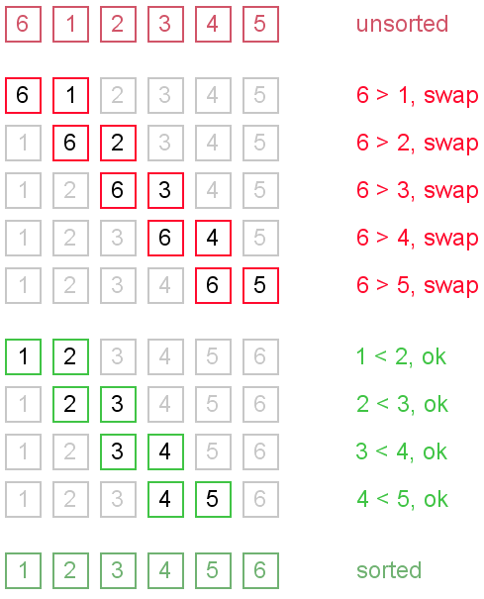

Bubble Sort. Retrieved from algolist: http://www.algolist.net/Algorithms/Sorting/Bubble_sort

## Appendix A –Pancake Sort

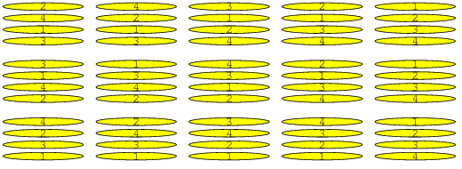

Stack Overflow Contributors. Retrieved from sciencing: https://sciencing.com/the-advantages-disadvantages-of-sorting-algorithms-12749529.html