David Mead

Period 2

**Number 5**

After testing 500 randomly generated states:

about 53.8% of them were solvable

the average length of the solution paths was 11 moves

the longest solution path required 30 moves

**Number 6**

Start state: 086547231

Path length: 31

Solution: L, D, D, R, R, U, U, L, L, D, R, D, L, U, R, R, U, L, L, D, R, D, L, U, R, D, R, U, U, L, L

**Number 7**

If there is not available path, they both recognize that near immediately because of the parity test. Otherwise, BFS finds the shortest path relatively quickly (around 2-4 seconds), and DFS finds a much longer path (sometimes over 100,000 moves long) in a much longer time (15-20 seconds)

**Number 9 and 10**

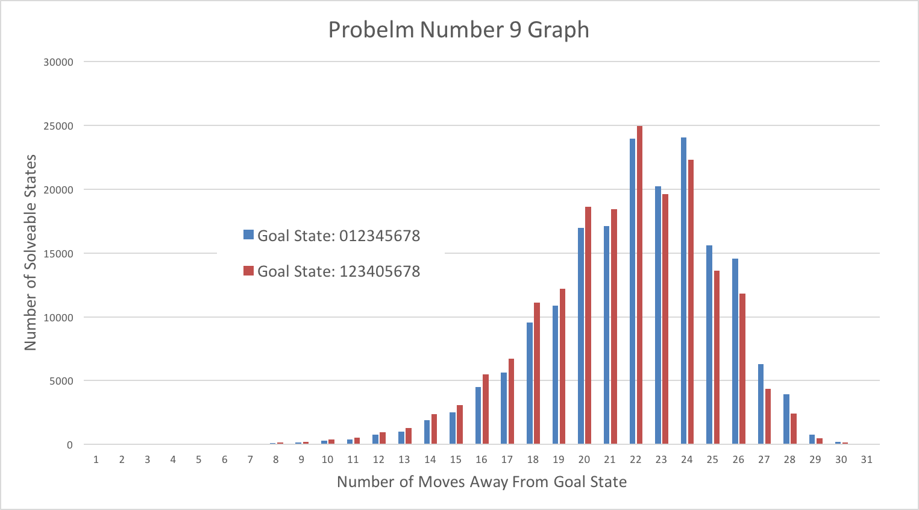

This graph shows that the distribution of path lengths to reach goal state 1 (“012345678”) and goal state 2 (“123405678”) are roughly equal. This makes sense as these goal states are both just two nodes in a graph of all possible (solvable) game states, so they will likely have roughly equal numbers of nodes at equal distances away from them. One difference between the two distributions is that the 2nd goal state has a higher number of low-length solution paths. I would say that this is because goal state 2 can be approached from 4 directions (up, down, left, or right) compared to goal state 1 which can only be approached from 2 directions (up or left). As a result, it is typically quicker to reach goal state 2 than goal state 1.