David Mead

Period 2

Connect 4

All it is in terms of AI is a minimax with alpha-beta pruning (copied over from my Othello) and a heuristic calculated by the difference in red and black’s maximum length connections + a random number to make it looked cooler against random (i.e. if red has 4 in a row and black has 2 in a row, the score is 2 + random.random())

It was kinda disappointing because I spent like 2 hours getting all the modeling and animations working and then it finally came time to make an AI and it took all of 7 minutes before neither me nor my brother could beat the AI…

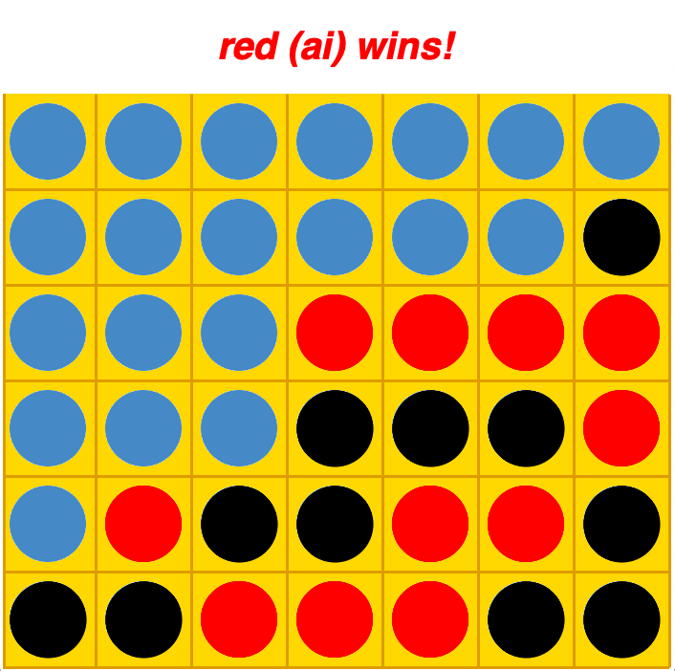If you have time, change the ‘animate’ variable just above the main() function to true and make sure you have the png I submitted in the same folder and it will have an interactive tkinter canvas you can play on by clicking on the columns to drop.