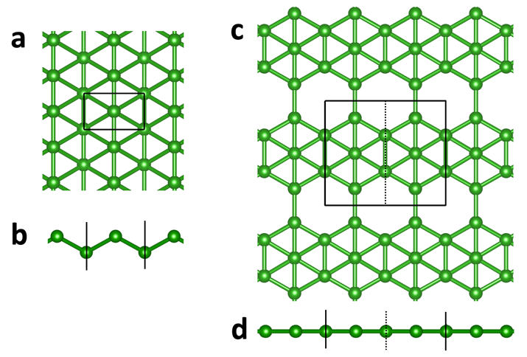

**Figure 1**. Atomic structure of two boron allotropes. (a, b) Top and side views of 2-atom unit cell. (c, d) Top and side views of 5-atom unit cell (dashed line), solid line encloses 2x1 supercell used in this work.

Unit cell sizes

|  |  |  |
| --- | --- | --- |
|  | 2-atom | 5-atom |
| *a* (Å) x-axis | 2.829 | 2.892 |
| *b* (Å) y-axis | 1.606 | 4.995 |
| $d_{z}$ (Å) z-axis | 0.828 | 0.0 |

Simulation cell thickness is 20 Å.

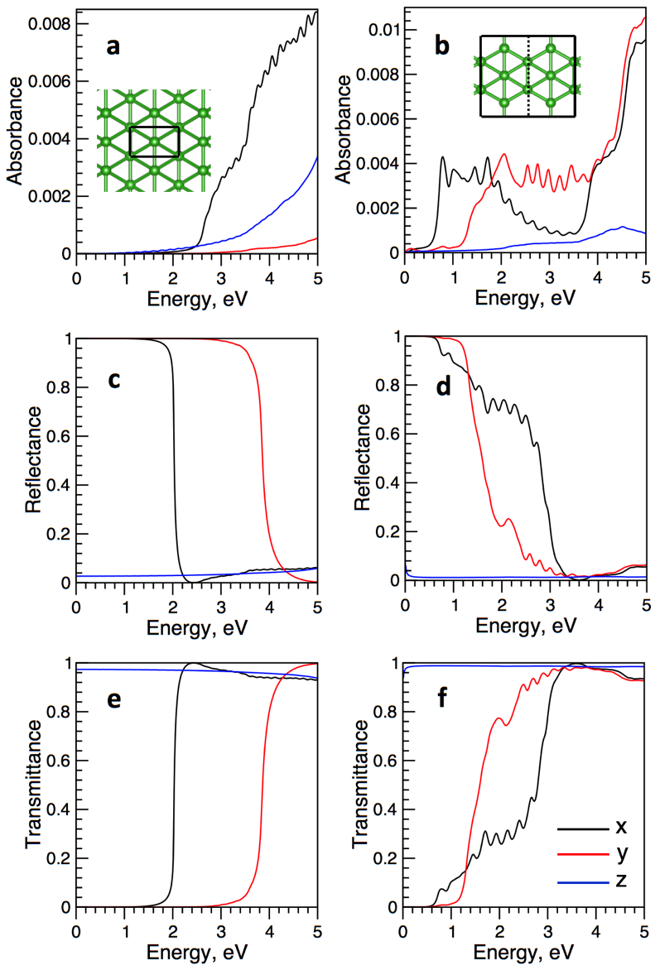

**Figure 3**. RPA absorbance, reflectance, and transmittance of two-atom (a, c, e) and 10-atom (b, d, e) boron allotropes.

**Equations from Ref. below**

Bernardi, M., Palummo, M. & Grossman, J. C. Extraordinary Sunlight Absorption and One Nanometer Thick Photovoltaics Using Two-Dimensional Monolayer Materials. *Nano Lett.* **13,** 3664–3670 (2013).

Absorbance A, reflectance R, and transmittance T, perpendicular dimension of the supercell *L*.

$$A=\frac{ω}{c}{Lε}_{2}$$

$$R=\frac{{(1-n)}^{2}+k^{2}}{{(1+n)}^{2}+k^{2}}$$

$$A+R+T=1$$

$$n=\sqrt{\frac{\sqrt{ε_{1}^{2}+ε_{2}^{2}}+ε_{1}}{2}}$$

$$k=\sqrt{\frac{\sqrt{ε_{1}^{2}+ε_{2}^{2}}-ε_{1}}{2}}$$

$$ε_{1}=n^{2}-k^{2}$$

$$ε_{2}=2nk$$

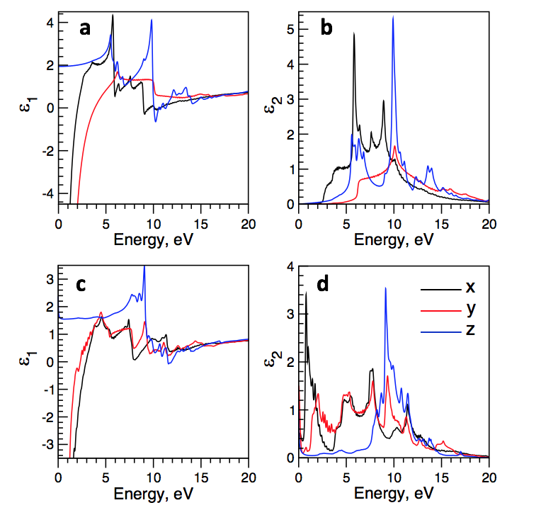

**Figure X**. Complex dielectric function of 2-atom (a, b) and 5-atom (c, d) supercells.