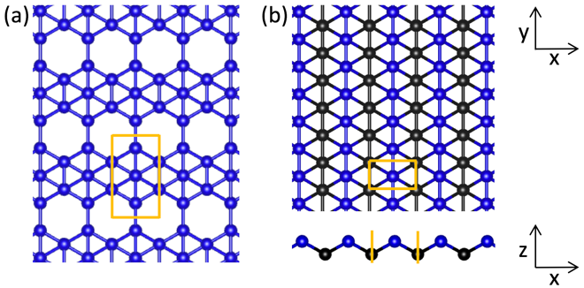

**Figure 1**. Atomic structure of two boron allotropes.

Simulation cell thickness is 12 Å.

**Equations**

Absorbance A, reflectance R, and transmittance T, perpendicular dimension of the supercell *L*. Absorbance formula is taken from this reference: Bernardi, M., Palummo, M. & Grossman, J. C. Extraordinary Sunlight Absorption and One Nanometer Thick Photovoltaics Using Two-Dimensional Monolayer Materials. *Nano Lett.* **13,** 3664–3670 (2013).

$$A=\frac{ω}{c}{Lε}_{2}$$

$$R=\frac{{(1-n)}^{2}+k^{2}}{{(1+n)}^{2}+k^{2}}$$

$$A+R+T=1$$

$$n=\sqrt{\frac{\sqrt{ε_{1}^{2}+ε_{2}^{2}}+ε_{1}}{2}}$$

$$k=\sqrt{\frac{\sqrt{ε_{1}^{2}+ε_{2}^{2}}-ε_{1}}{2}}$$

$$ε_{1}=n^{2}-k^{2}$$

$$ε_{2}=2nk$$