**DJANGO PROJECT MIGRATION**

**PRE-REQUISITE:**

* “Python” must be installed locally in the system.

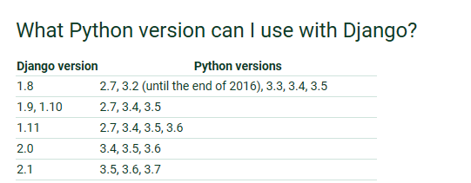

* Check whether “pip” command is working.
* Must be aware of creating “virtualenv” to use Django.

**PUSHING FILES FROM LOCAL SYSTEM TO GITHUB:**

* Complete project setup using **‘virtualenv’.** Then,navigate to the root folder and create **“requirements.txt”** file.

$ pip freeze > requirements.txt

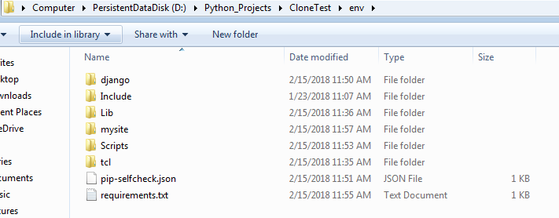

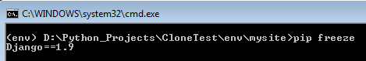

“Requirements.txt” is useful for running the project in another PC by installing the dependencies inside the requirement file.

* Create git repository from parent folder (before the ‘env’ setup folder).

$ git init

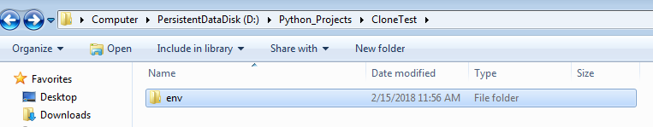

* Add all the files to the staging area of git using below command.

$ git add *

* Commit the files in git repository.

$ git commit -m "Commit message"

* Create a new repository in “https://github.com” with your account.

Note: Don’t initialize the readme file.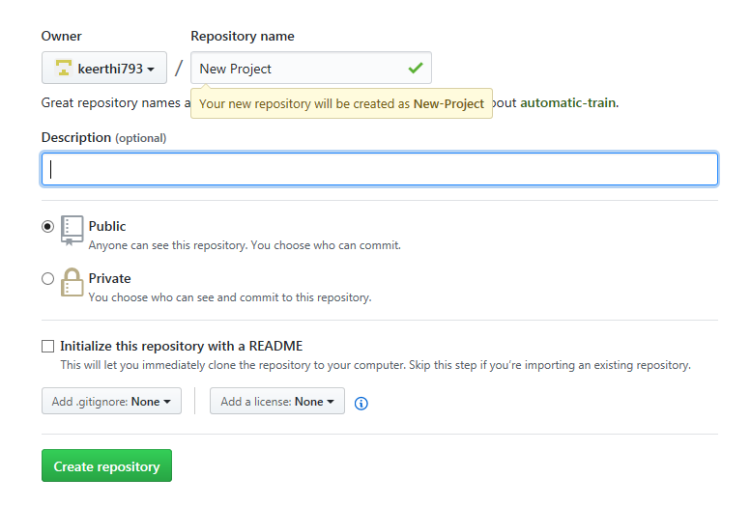

* Add the newly created repository in github as a remote location to the current project folder repository.

$ git remote add origin <https://github.com/keerthi793/New-Project.git>

Take url from the github repo as follows:



* Push the local project files to github using the below command.

$ git push -u origin master

**CLONNING DJANGO PROJECT TO USE IN OTHER SYSTEM:**

* Copy github url as below:

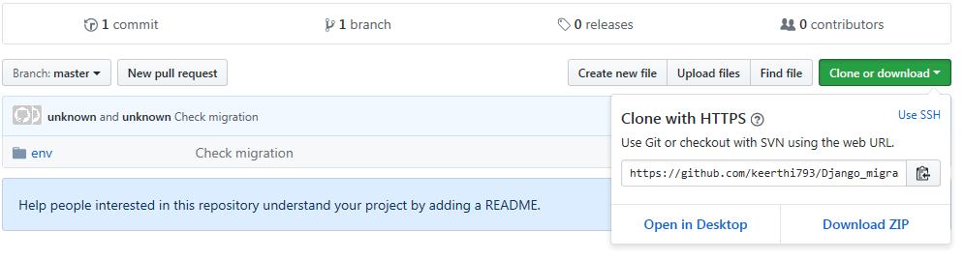

* Clone the project to the local folder.

$ git clone <https://github.com/keerthi793/Django_migration.git>

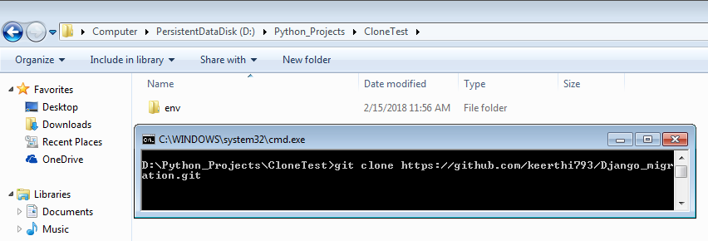

* Activate the “virtualenv” in the cloned folder.
* Navigate to the “environment” folder and run.

$ pip install -r requirements.txt

This will install all the dependencies of the project, if any.

* Finally, we shall work in Django project as usual.