To test it:

1. First make sure you’ve followed the steps in “README.txt”;
2. Open browser(preferably Chrome) and enter the IP address and port number (you should see them in you console once you successfully run the program), you should see something like this;

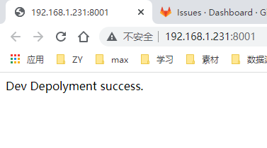

1. Then you can commute with the APIs, using any RESTful API test tools like Postman or MeterSphere.

APIs available:

1. POST: “/file_upload”:

In request body, add a file(not zip file or folder) with the parameter name “files”.

(Screen Shots may differ from what you actually see depending on what software you are using)

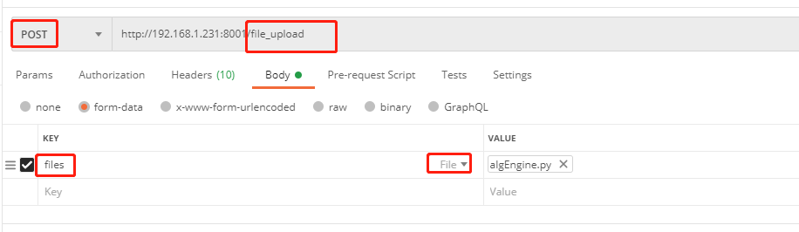

The expected output should be something like below(actual output depends on the file content):

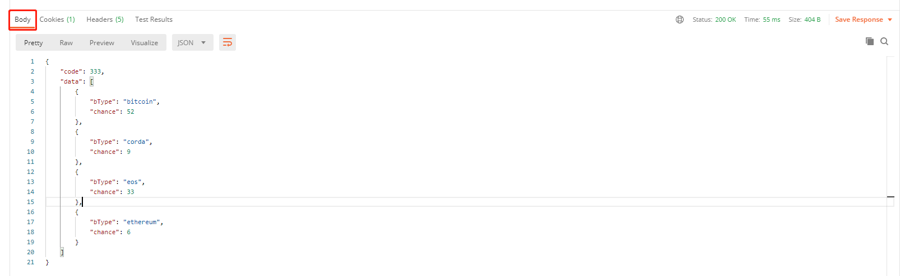

1. POST: “/files_upload”

Basically the same except that you have to upload a zipped folder.

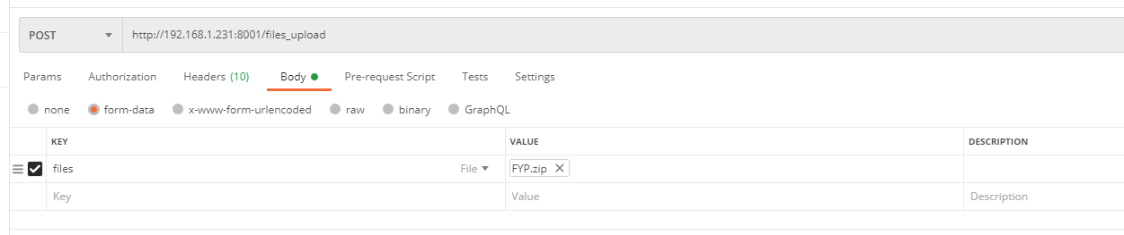

The expected would be in the same format:

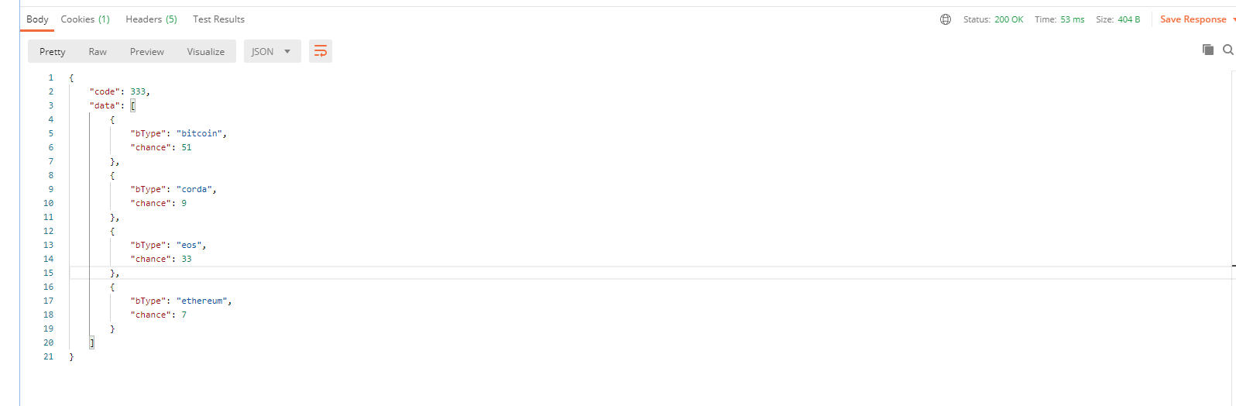

Extra Note:

There is a Postman config included with this file, named “FYP.postman_collection.json” you can easily import from and skip the configuration process, so all you need to do is choose what you want to upload and click “Send”.