**WEB DESIGN & INTERACTIVE MEDIA | MR GUINAN** Principles of Design: Practice



**Directions:** Looking at the pictures below define what element of design fits best with each.

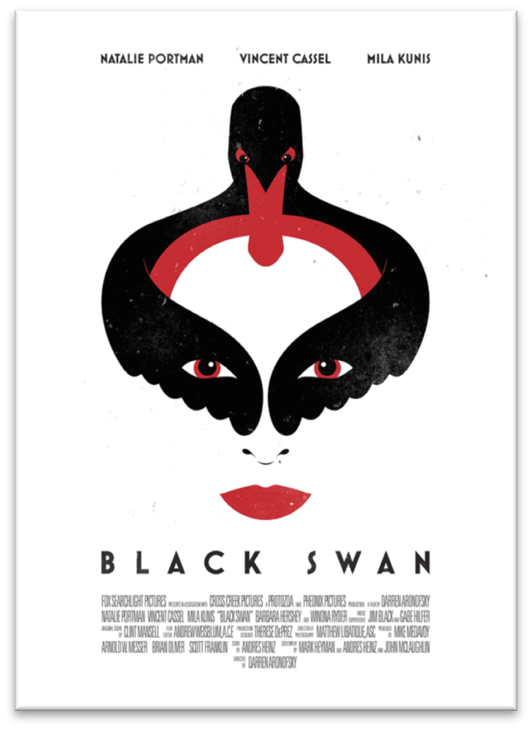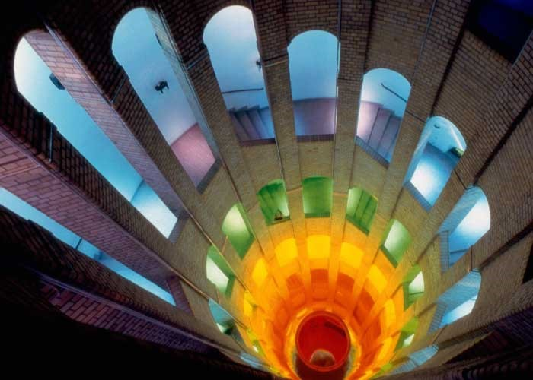

__color, forma___________________ _________simetria, color, espacio, ley del cierre _______

 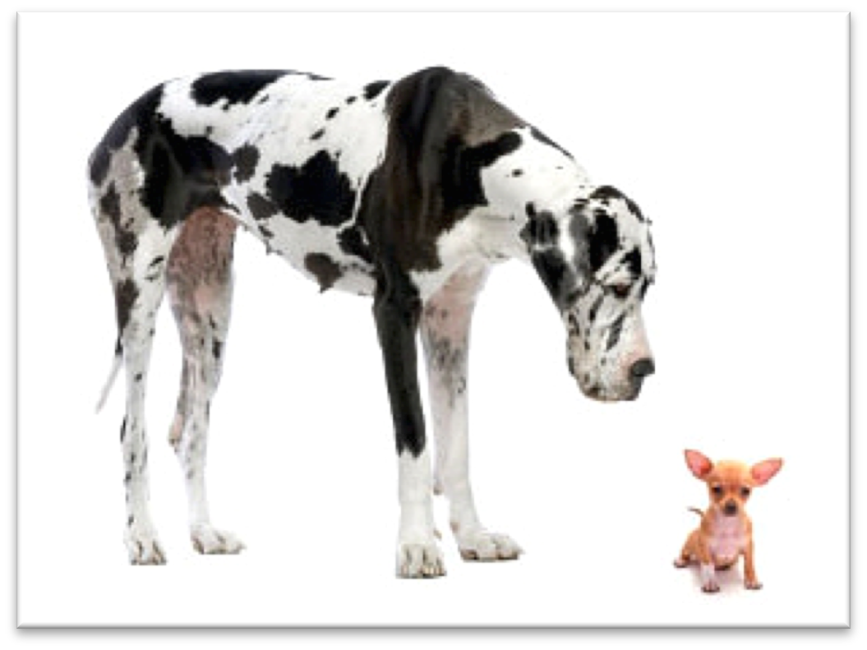

__________value, color, _____________ _________________asimetria, _____________________

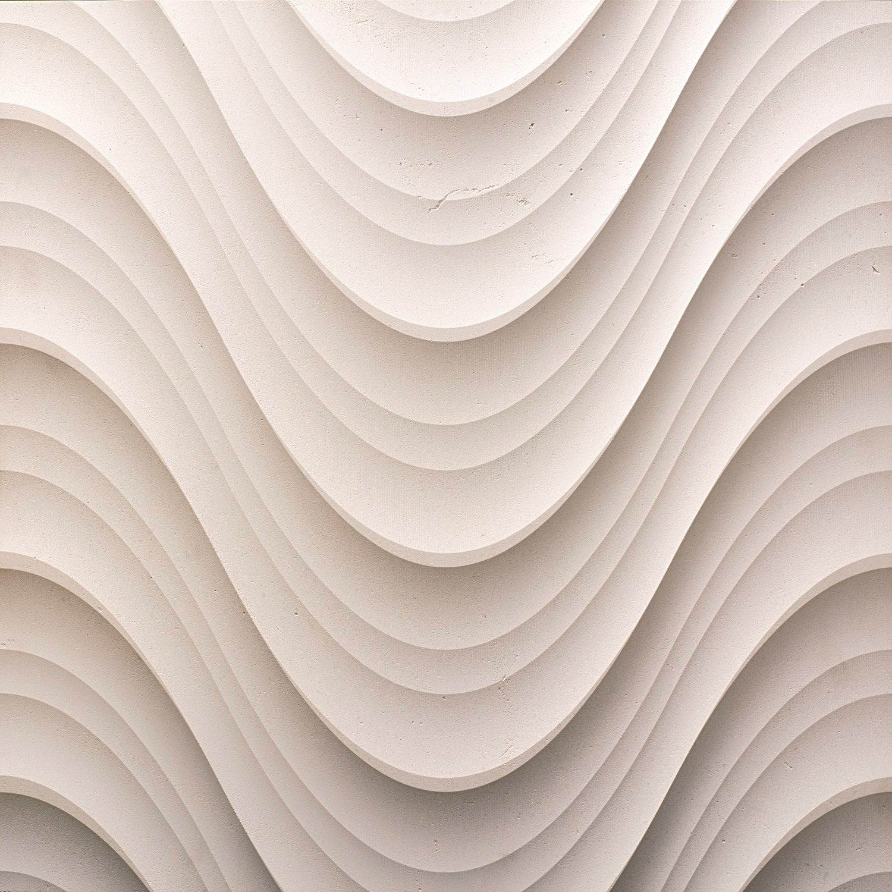

____________________forma, color______________________________ ______________________lineas, textura_________________

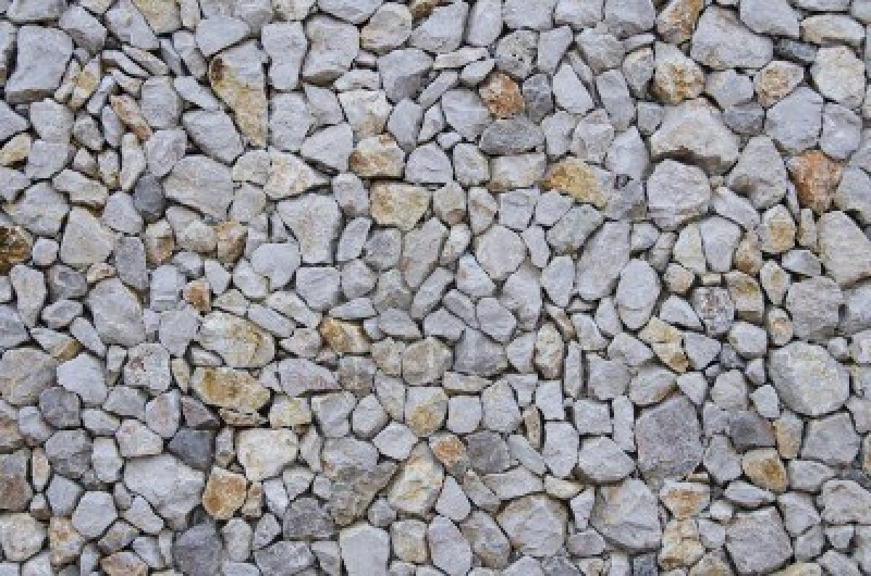 textura

_______________________________________________________



T

he E

lements of Design

:

Li

ne

Color

Shape

Size

Value

Texture

Space