**WEB DESIGN & INTERACTIVE MEDIA | MR GUINAN** Principles of Design: Practice



**Directions:** Looking at the pictures below define what principle of design fits best with each.

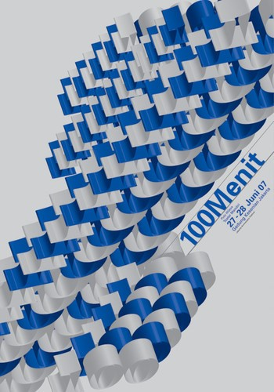

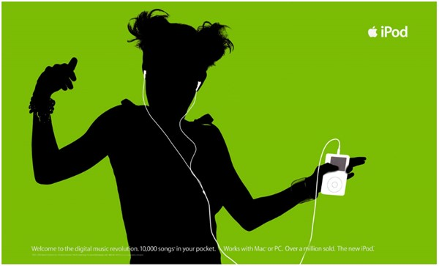

_______________________contraste_________________________

__balance, movimiento, repetición___ley de cierre, de proximidad

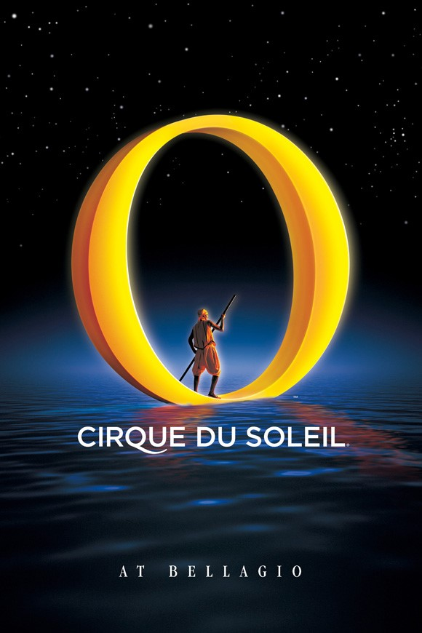

______énfasis, constraste, simetrico, alineado______

_______ley de la gestal figura-fondo, unicidad, alineamiento, balance_

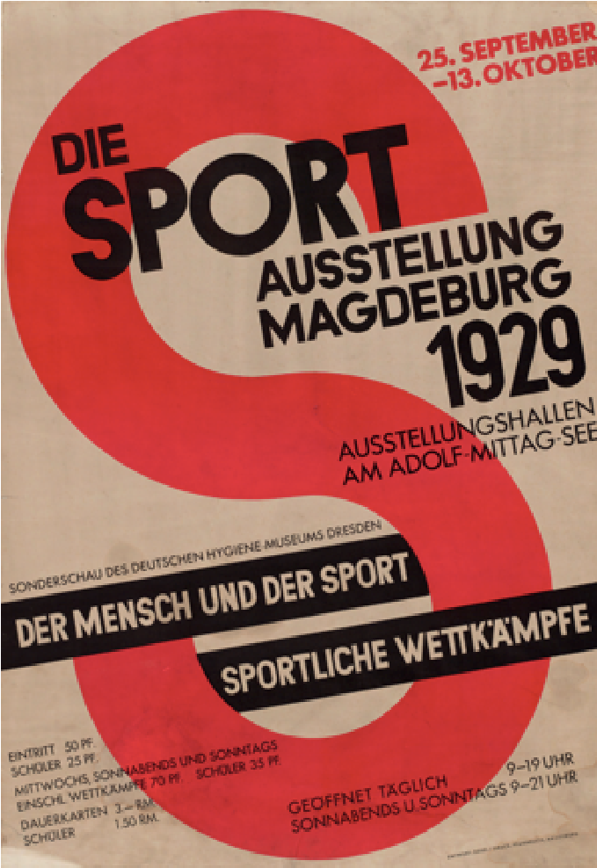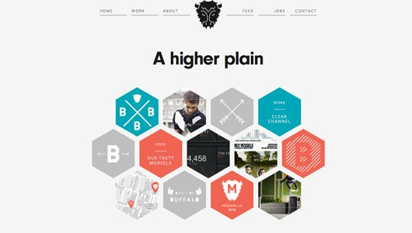

__proximidad, balance, repetición, unicidad___

contraste, énfasis

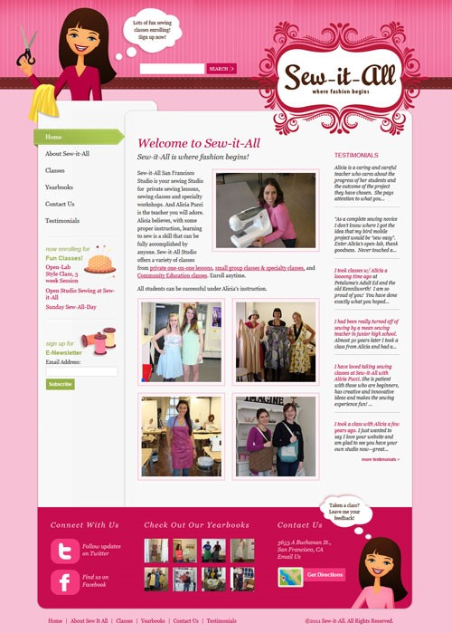 ________________________________________

___________alineamiento, unicidad__

________________contraste, énfasis _______