# Deep Learning for Computer Vision

# Homework #2

**經濟四 李品樺 B07303024**

Collaborators: None

**Problem 1**

**1. Perform PCA on training set. Plot mean face and first four eigenfaces.**

* Divide the dataset into two partitions, which are training set and testing set. Select first nine picture of each class as the training set, the last picture of each class as the testing set. Then, we create labels for training set and testing set for further usage.
* Read the image using **cv2**. Note that we read the images into **grayscale by passing a flag=0** in the cv2.imread method, and change them into numpy array
* Calculate the mean face value using **mean** method of numpy array, reshape it into original size so as to write the image using **cv2.imwrite**
* Subtract the original training image by the mean face value
* Using PCA function from **sklearn** and fit the result from previous step
* The eigenfaces can be obtained by selecting **components_** which is an attribute of the fitting result
* Since the values obtained are negative, we need to normalize them to the scale of (0,255) as below:

a = 255/(np.max(eigenfaces, axis=1) - np.min(eigenfaces, axis=1))

a = np.expand_dims(a, -1)

b = -a*np.expand_dims(np.min(eigenfaces,axis=1), -1)

eigenfaces = (eigenfaces*a + b).reshape(360, 56, 46)

* Finally, reshape them back to original size, and save the images

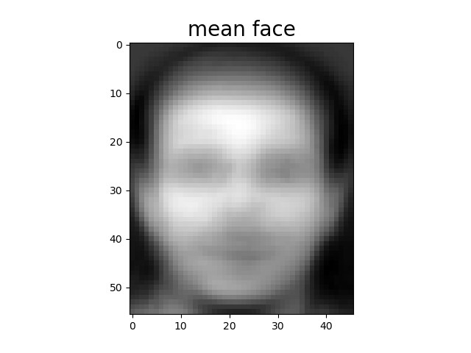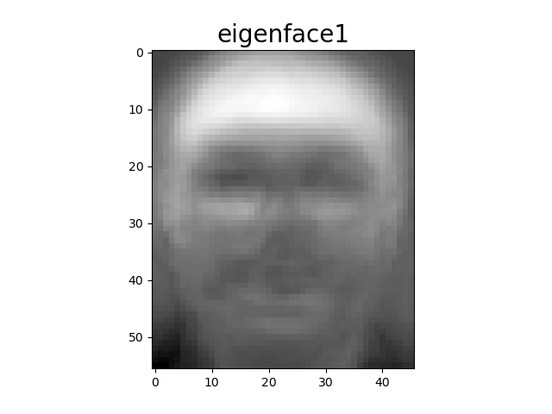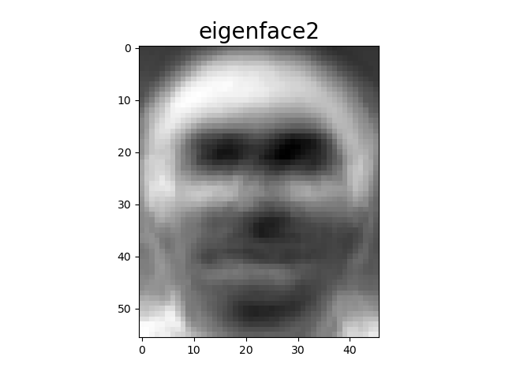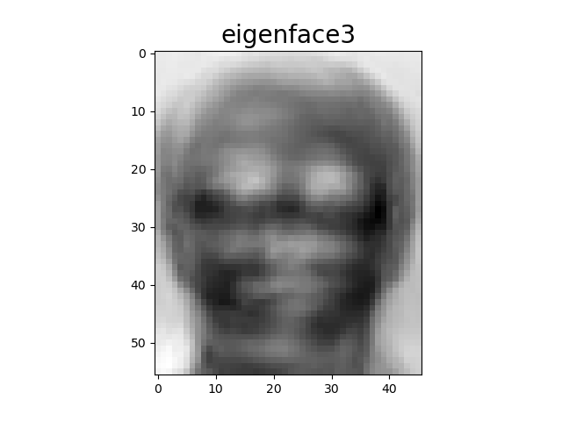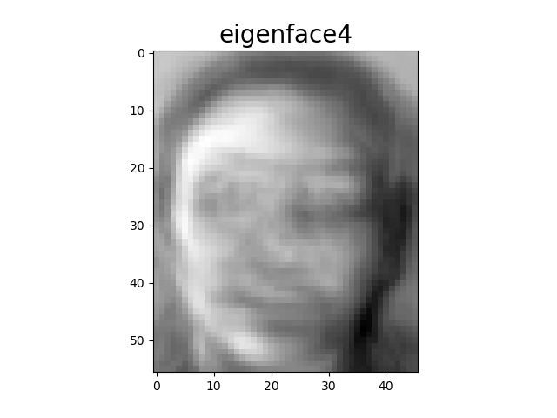

* Reference:
  + [Scikit learn - PCA](https://scikit-learn.org/stable/modules/generated/sklearn.decomposition.PCA.html?highlight=pca#sklearn.decomposition.PCA)
  + [GeekforGeeks - Face Recognition using PCA Implementation](https://www.geeksforgeeks.org/ml-face-recognition-using-pca-implementation/)

**2. Project person8 image1 onto the PCA eigenspace.**

**Reconstruct this image using the first n= 3,50,170,240,345 eigenfaces.**

* Read the given image and subtract it by the mean face
* Fit the subtracted result with the PCA model
* Use the transform method of PCA to get the projected value
* Using first n eigenfaces, reconstruct the image by doing matrix multiplication of the projected result and the eigenfaces in the previous problem
* Reconstructed images are obtained by adding mean face to the multiplication result
* The reconstructed images are shown below:

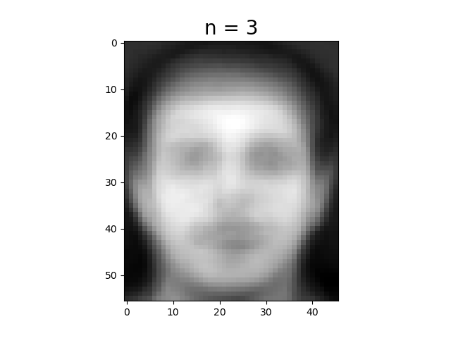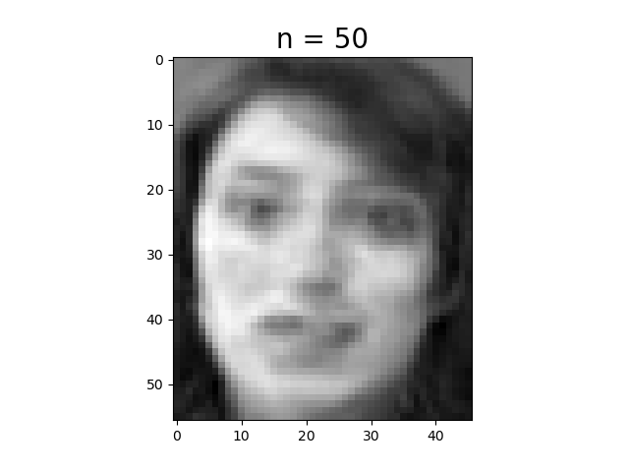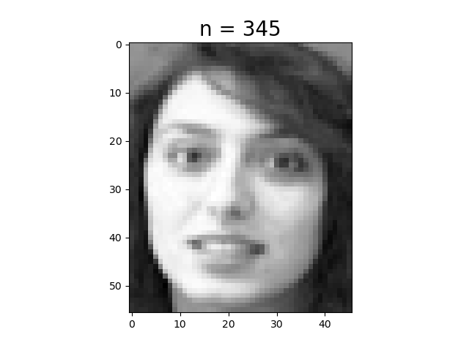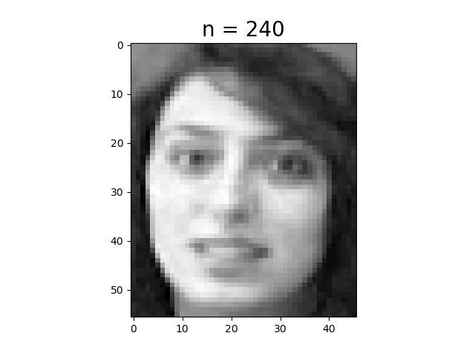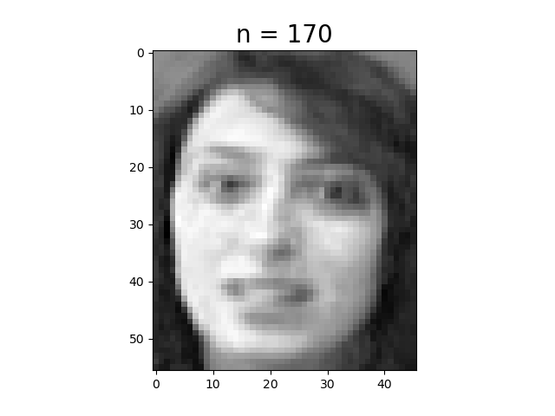

* Reference:
  + [Face Recognition with Eigenfaces – Python Machine Learning](https://pythonmachinelearning.pro/face-recognition-with-eigenfaces/)

**3. Compute the mean squared error (MSE) between the reconstructed image and the original image.**

* Subtract the original image and the reconstructed result pixel-wise, square the value and compute the mean. The result is shown in the table below.
* As we observe from the table, using more eigenfaces (i.e. larger n), the reconstructed mean squared error is less.

|  |  |
| --- | --- |
| n | MSE |
| 3 | 1566.347198469649 |
| 50 | 134.03183261341115 |
| 170 | 39.84704055061051 |
| 240 | 21.477817770862064 |
| 345 | 3.042216175564436 |

**4. Apply the k-nearest neighbors algorithm to classify the testing set images. etermine the best k and n values by 3-fold cross-validation.**

* First, perform PCA on the training set for further usage
* Set k as the parameter in **KNeighborsClassifier** model from sklearn, project the training set onto the n dimensions, then use the classifier to vote for the predicted result.
* We use **cross_val_score** function from sklearn to implement 3-fold cross validation. Set the parameter cv as 3 and scoring as "accuracy"
* Choose **k =1, n=50** for hyperparmeter since the accuracy is the highest of all
* The validation result is shown as the screenshot below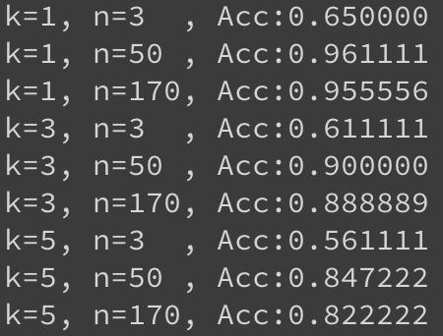
* Reference:
  + [Scikit learn - CrossValidation](https://scikit-learn.org/stable/modules/cross_validation.html#computing-cross-validated-metrics)
  + [Scikit learn - Nearest Neighbors](https://scikit-learn.org/stable/modules/neighbors.html#nearest-centroid-classifier)
  + [DataCamp - KNN Classification using Scikit-learn](https://www.datacamp.com/community/tutorials/k-nearest-neighbor-classification-scikit-learn)

**5. Report the recognition rate of the testing set using the hyperparameter choice in 4.**

* Subtract testing set by mean face value, perform PCA transform to reduce dimension
* Set k as 1 for **KNeighborsClassifier**
* Fit the classifier with projected training set and the training label
* Compute the recognition rate using projected testing set and testing label with the method **KNeighborsClassifier**.**score**
* **Recognition rate: 92.5%**