|  |  |
| --- | --- |
| **Das genie**  *Personal Artificial Intelligence Bot* | **Das genie**: Abstract  *Das Genie is a Trained Bot for Basic Questions & Commands. Responding and Speaking Ability Corresponding to Orders. Listening Ability to be implemented in the mere future to enhance Das Genie*  Author: Kaustav Dutta  **Course: Applied Artificial Intelligence Mentor: Dr. Simon Ziegler** |

# Introduction

**DasGenie** is a personal bot that is still in the development phase. The main Features of this bot is that it responds to Commands & Queries (like a Genie), thus corresponds to be your helping hand in numerous occasions.

Currently, DasGenie only responds to Textual Queries which it also saves for future learning and self-growth. In Future, the Listening to Vocal Queries & Commands would be implemented with Peripheral (External) Computer Interaction with Arduino Uno or Raspberry Pi modules.

# Processes

1. Understanding Packages

Python Packages found from [PyPi](https://pypi.org/) are quite helpful when trying to implement or build a project in python. The Chatterbot package in pypi was really helpful while building DasGenie; while, Pttsx3 was helpful for Text-Speech conversion; whereas, Speech-Recognition helps in (as the name suggests) in understanding the User Spoken Input.

1. Implemented Required Feathers of the Packages

Chatterbot package was used to Train DasGenie with the multiple Corpus prepared with Conversations & Responses. Different Voice textures provided in System to be the Mouth of DasGenie. Training Corpus prepared as per the model, which provides progressive learning with Testing Data stored in local database.

1. Tuned and Trained the Bot

Corpus Data was generated with Numerous Testing and Tuning of the Processes above. DasGenie was trained with all kinds of data feed of conversations (only a few conversation corpuses added in the project). AS discussed, DasGenie learns from the conversations once installed and run.

1. Prepared Proper Training Corpus

Training Corpus was generated from various sources and personal conversations with DasGenie to increase the learning scope. Training Corpus files are simple Text files fed on DasGenie initialization.

1. Test and Packed DasGenie

Testing with multiple scenarios and circumstances throughout the Development Process. Application Packaging was done with Pyinstaller and NSIS tool.

# Packages

1. Chatterbot IO Adaptors
2. Chatterbot
   1. Bot Training,
   2. Bot Learning,
   3. Bot Testing,
   4. Bot Conversation Corpus
3. Pyttsx3
4. SpeechRecognition

# Application

1. **DasGenie** folder package is required, which can be used in either ways
   1. Download the DasGenie zip and unzip at desired location. 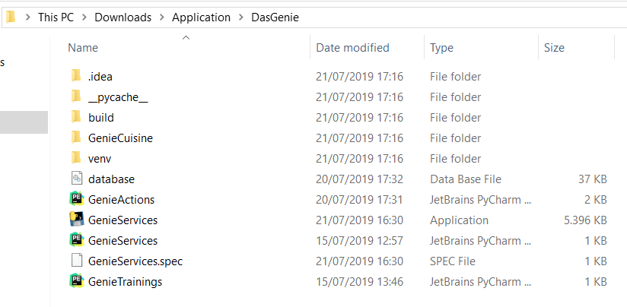
   2. Run the **DasGenie.exe** file, which creates a folder at your desired Location. Can be found in this [DasGenie-ApplicationStarter](https://github.com/kaustavdutta1989/DasGenie/tree/master/ApplicationStarter) Folder or clone the Updated Code from [DasGenie-GitHub](https://github.com/kaustavdutta1989/DasGenie/tree/master/ApplicationStarter) Folder

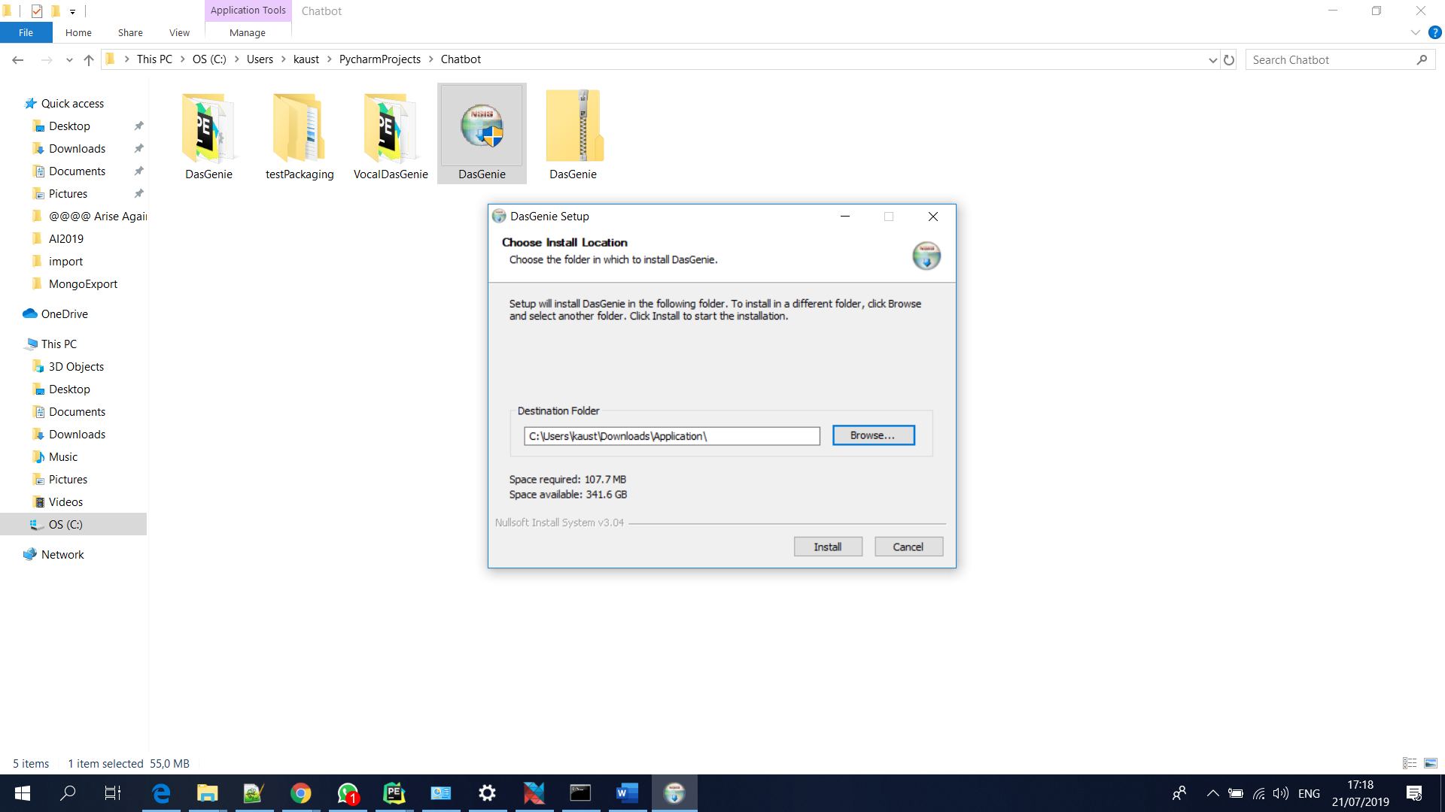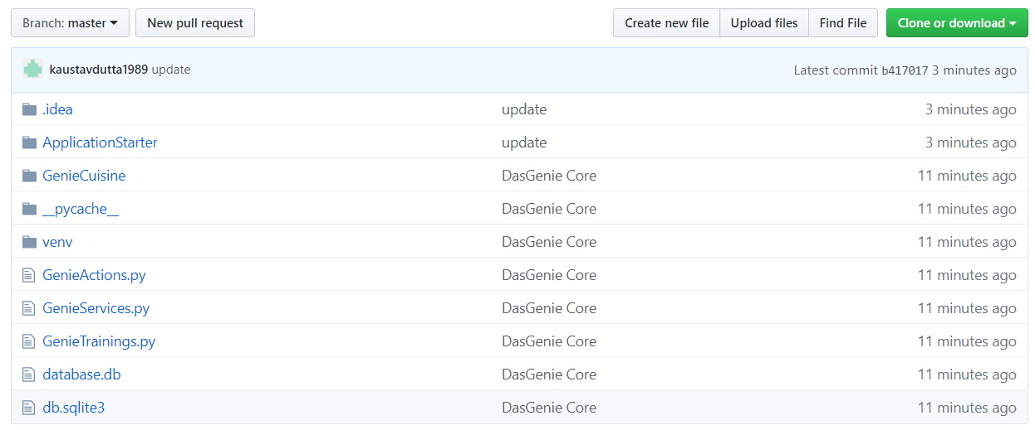

1. Open Command Prompt at Default Location:
   1. Install Python, if not already (Recommended Python 3.5.X)
   2. Update Pip: **python -m pip install --upgrade pip**
   3. Dependency Library: **pip install chatterbot-io-adapters**
   4. Dependency Library: **pip install chatterbot**
   5. Dependency Library: **pip install pyttsx3**
   6. Dependency Library: **pip install speechrecognition**
2. Change Command Prompt Directory to the **DasGenie** folder and run the Python File **GenieTrainings**. This one time training feeds her with all kinds of Conversation Corpuses. **Run this file only once to train the bot.**

Command: **python GenieTrainings.py**

1. Same Command Prompt Directory of **DasGenie** folder and run the Python File **GenieServices**.

**This is the File which will start the Services of DasGenie and keeps listening to you until you ask her to rest.**

Even if you exit the Services, you can resume the services using the same command, you can skip the training and get DasGenie service, directly.Command: **python GenieServices.py**

1. Here you are… **DasGenie** will answer your **Questions** and **Commands**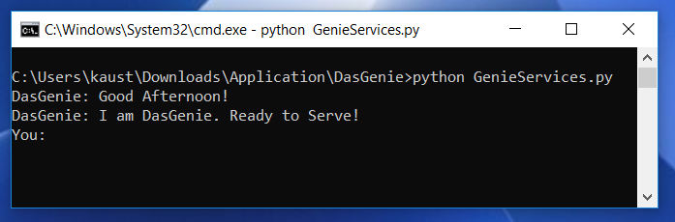
2. **DasGenie** can be *Rested with the Commands* **Bye, Exit, Chao.**
3. Training Corpus is being built for **DasGenie** as your Conversations are being recorded and learnt from, by Her.

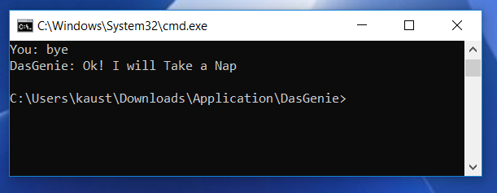

# References

1. <https://pypi.org/project/ChatterBot/>
2. <https://pypi.org/project/pyttsx3/>
3. <https://pypi.org/project/chatterbot-io-adapters/>
4. <https://pypi.org/project/SpeechRecognition/>
5. GitHub Link: <https://github.com/kaustavdutta1989/DasGenie>

# Conclusion

DasGenie is a Growing bot for multiple usage scoping from Information sharing to IOT implementations. Though the hurdles and complexities are high, the motivation for DasGenie is more. Hopefully, DasGenie grows into a wonderful assistant.

**Thanking You!!!**