**MySql知识体系总结（2021版）**

<https://blog.csdn.net/guorui_java/article/details/118558095?utm_medium=distribute.pc_feed.none-task-blog-hot_rank_bottoming-19.nonecase&depth_1-utm_source=distribute.pc_feed.none-task-blog-hot_rank_bottoming-19.nonecase>

<https://blog.csdn.net/nfzhlk/article/details/78878156?spm=1001.2101.3001.6650.8&utm_medium=distribute.pc_relevant.none-task-blog-2%7Edefault%7EBlogCommendFromBaidu%7Edefault-8-78878156-blog-79635067.pc_relevant_default&depth_1-utm_source=distribute.pc_relevant.none-task-blog-2%7Edefault%7EBlogCommendFromBaidu%7Edefault-8-78878156-blog-79635067.pc_relevant_default&utm_relevant_index=15>

# 自动化测试之数据库初始化

# 使用Sql生成测试数据

<https://blog.csdn.net/aisuocuo6821/article/details/101829111?spm=1001.2101.3001.6650.3&utm_medium=distribute.pc_relevant.none-task-blog-2%7Edefault%7EBlogCommendFromBaidu%7Edefault-3-101829111-blog-79635067.pc_relevant_default&depth_1-utm_source=distribute.pc_relevant.none-task-blog-2%7Edefault%7EBlogCommendFromBaidu%7Edefault-3-101829111-blog-79635067.pc_relevant_default&utm_relevant_index=6>

# python脚本将txt文本转为sql并简单校验数据

<https://blog.csdn.net/weixin_42768584/article/details/106274388?utm_medium=distribute.pc_relevant.none-task-blog-2~default~baidujs_title~default-0-106274388-blog-104724158.pc_relevant_default&spm=1001.2101.3001.4242.1&utm_relevant_index=3>

# Python 读取文本文件到sql server

<https://blog.csdn.net/weixin_45432202/article/details/103198934?spm=1001.2101.3001.6650.2&utm_medium=distribute.pc_relevant.none-task-blog-2%7Edefault%7ECTRLIST%7ERate-2-103198934-blog-106274388.pc_relevant_paycolumn_v3&depth_1-utm_source=distribute.pc_relevant.none-task-blog-2%7Edefault%7ECTRLIST%7ERate-2-103198934-blog-106274388.pc_relevant_paycolumn_v3&utm_relevant_index=4>

# txt 转成mysql\_请问txt文件怎么转换成SQL数据库文件

<https://blog.csdn.net/weixin_39820588/article/details/113207720?spm=1001.2101.3001.6650.7&utm_medium=distribute.pc_relevant.none-task-blog-2%7Edefault%7EBlogCommendFromBaidu%7Edefault-7-113207720-blog-50681105.pc_relevant_default&depth_1-utm_source=distribute.pc_relevant.none-task-blog-2%7Edefault%7EBlogCommendFromBaidu%7Edefault-7-113207720-blog-50681105.pc_relevant_default&utm_relevant_index=10>

# Python脚本批量生成SQL语句

<https://zuozewei.blog.csdn.net/article/details/83004726?spm=1001.2101.3001.6650.6&utm_medium=distribute.pc_relevant.none-task-blog-2%7Edefault%7EBlogCommendFromBaidu%7Edefault-6-83004726-blog-104724158.pc_relevant_default&depth_1-utm_source=distribute.pc_relevant.none-task-blog-2%7Edefault%7EBlogCommendFromBaidu%7Edefault-6-83004726-blog-104724158.pc_relevant_default&utm_relevant_index=10>

# python：执行.sql文件生成表和数据

<https://blog.csdn.net/LIFENG0402/article/details/122627708?spm=1001.2101.3001.6650.2&utm_medium=distribute.pc_relevant.none-task-blog-2%7Edefault%7ECTRLIST%7Edefault-2-122627708-blog-104724158.pc_relevant_default&depth_1-utm_source=distribute.pc_relevant.none-task-blog-2%7Edefault%7ECTRLIST%7Edefault-2-122627708-blog-104724158.pc_relevant_default&utm_relevant_index=5>

# python如何解析复杂sql，实现数据库和表的提取

# <https://blog.csdn.net/birdflyinhigh/article/details/87883043?spm=1001.2101.3001.6650.9&utm_medium=distribute.pc_relevant.none-task-blog-2%7Edefault%7EBlogCommendFromBaidu%7Edefault-9-87883043-blog-124348772.pc_relevant_default&depth_1-utm_source=distribute.pc_relevant.none-task-blog-2%7Edefault%7EBlogCommendFromBaidu%7Edefault-9-87883043-blog-124348772.pc_relevant_default&utm_relevant_index=16>

# 什么是SQL脚本？及作用和命令

# [https://blog.csdn.net/S0001100/article/details/106408024?ops\_request\_misc=%257B%2522request%255Fid%2522%253A%2522165308416016781818768693%2522%252C%2522scm%2522%253A%252220140713.130102334..%2522%257D&request\_id=165308416016781818768693&biz\_id=0&utm\_medium=distribute.pc\_search\_result.none-task-blog-2~all~sobaiduend~default-1-106408024-null-null.142^v10^control,157^v4^control&utm\_term=sql+%E8%84%9A%E6%9C%AC&spm=1018.2226.3001.4187](https://blog.csdn.net/S0001100/article/details/106408024?ops_request_misc=%257B%2522request%255Fid%2522%253A%2522165308416016781818768693%2522%252C%2522scm%2522%253A%252220140713.130102334..%2522%257D&request_id=165308416016781818768693&biz_id=0&utm_medium=distribute.pc_search_result.none-task-blog-2~all~sobaiduend~default-1-106408024-null-null.142%5ev10%5econtrol,157%5ev4%5econtrol&utm_term=sql+%E8%84%9A%E6%9C%AC&spm=1018.2226.3001.4187)

# [https://blog.csdn.net/w1123900645/article/details/82894052?ops\_request\_misc=%257B%2522request%255Fid%2522%253A%2522165308416016781818768693%2522%252C%2522scm%2522%253A%252220140713.130102334..%2522%257D&request\_id=165308416016781818768693&biz\_id=0&utm\_medium=distribute.pc\_search\_result.none-task-blog-2~all~baidu\_landing\_v2~default-4-82894052-null-null.142^v10^control,157^v4^control&utm\_term=sql+%E8%84%9A%E6%9C%AC&spm=1018.2226.3001.4187](https://blog.csdn.net/w1123900645/article/details/82894052?ops_request_misc=%257B%2522request%255Fid%2522%253A%2522165308416016781818768693%2522%252C%2522scm%2522%253A%252220140713.130102334..%2522%257D&request_id=165308416016781818768693&biz_id=0&utm_medium=distribute.pc_search_result.none-task-blog-2~all~baidu_landing_v2~default-4-82894052-null-null.142%5ev10%5econtrol,157%5ev4%5econtrol&utm_term=sql+%E8%84%9A%E6%9C%AC&spm=1018.2226.3001.4187)

# <https://blog.csdn.net/qq_35661171/article/details/121782454?ops_request_misc=&request_id=&biz_id=102&utm_term=sql%20%E8%84%9A%E6%9C%AC&utm_medium=distribute.pc_search_result.none-task-blog-2~all~sobaiduweb~default-3-121782454.nonecase&spm=1018.2226.3001.4187>

# 

<https://blog.csdn.net/promsing/article/details/112793260?spm=1001.2101.3001.6650.4&utm_medium=distribute.pc_relevant.none-task-blog-2%7Edefault%7ECTRLIST%7ERate-4-112793260-blog-115213031.pc_relevant_antiscanv2&depth_1-utm_source=distribute.pc_relevant.none-task-blog-2%7Edefault%7ECTRLIST%7ERate-4-112793260-blog-115213031.pc_relevant_antiscanv2&utm_relevant_index=9>

<https://blog.csdn.net/weixin_43167418/article/details/103308917?utm_medium=distribute.pc_relevant.none-task-blog-2~default~baidujs_baidulandingword~default-5-103308917-blog-115213031.pc_relevant_antiscanv2&spm=1001.2101.3001.4242.4&utm_relevant_index=8>

<https://blog.csdn.net/qq_31905135/article/details/106492671?utm_medium=distribute.pc_relevant.none-task-blog-2~default~baidujs_baidulandingword~default-4-106492671-blog-115213031.pc_relevant_antiscanv2&spm=1001.2101.3001.4242.3&utm_relevant_index=7>

<https://blog.csdn.net/znyyjk/article/details/52717336?spm=1001.2101.3001.6650.3&utm_medium=distribute.pc_relevant.none-task-blog-2%7Edefault%7ECTRLIST%7ERate-3-52717336-blog-115213031.pc_relevant_antiscanv2&depth_1-utm_source=distribute.pc_relevant.none-task-blog-2%7Edefault%7ECTRLIST%7ERate-3-52717336-blog-115213031.pc_relevant_antiscanv2&utm_relevant_index=6>

<https://blog.csdn.net/u011991249/article/details/64519945?spm=1001.2101.3001.6650.2&utm_medium=distribute.pc_relevant.none-task-blog-2%7Edefault%7ECTRLIST%7ERate-2-64519945-blog-115213031.pc_relevant_antiscanv2&depth_1-utm_source=distribute.pc_relevant.none-task-blog-2%7Edefault%7ECTRLIST%7ERate-2-64519945-blog-115213031.pc_relevant_antiscanv2&utm_relevant_index=5>

<https://blog.csdn.net/Yanmengya123/article/details/121012737?spm=1001.2101.3001.6650.3&utm_medium=distribute.pc_relevant.none-task-blog-2%7Edefault%7ECTRLIST%7ERate-3-121012737-blog-64519945.pc_relevant_antiscanv2&depth_1-utm_source=distribute.pc_relevant.none-task-blog-2%7Edefault%7ECTRLIST%7ERate-3-121012737-blog-64519945.pc_relevant_antiscanv2&utm_relevant_index=6>

**数据库初始化脚本**

[详细介绍MySQL中的数据类型](https://blog.csdn.net/qq_43459116/article/details/124135318?utm_medium=distribute.pc_relevant.none-task-blog-2~default~baidujs_baidulandingword~default-0-124135318-blog-51284106.pc_relevant_default&spm=1001.2101.3001.4242.1&utm_relevant_index=3" \t "_blank)

# SQL数据完整性

**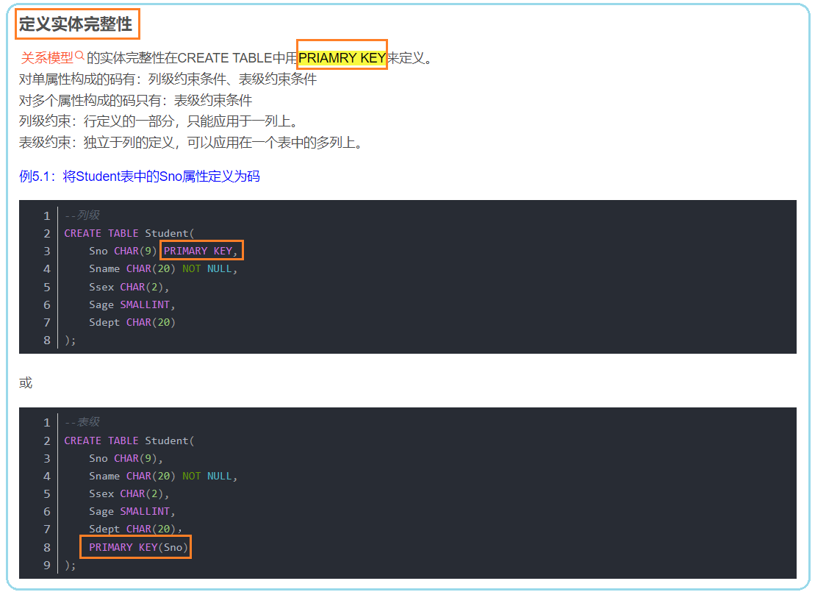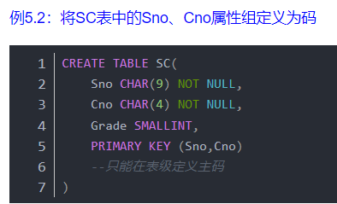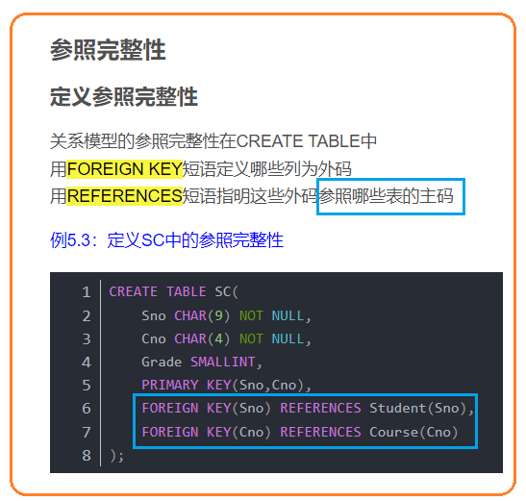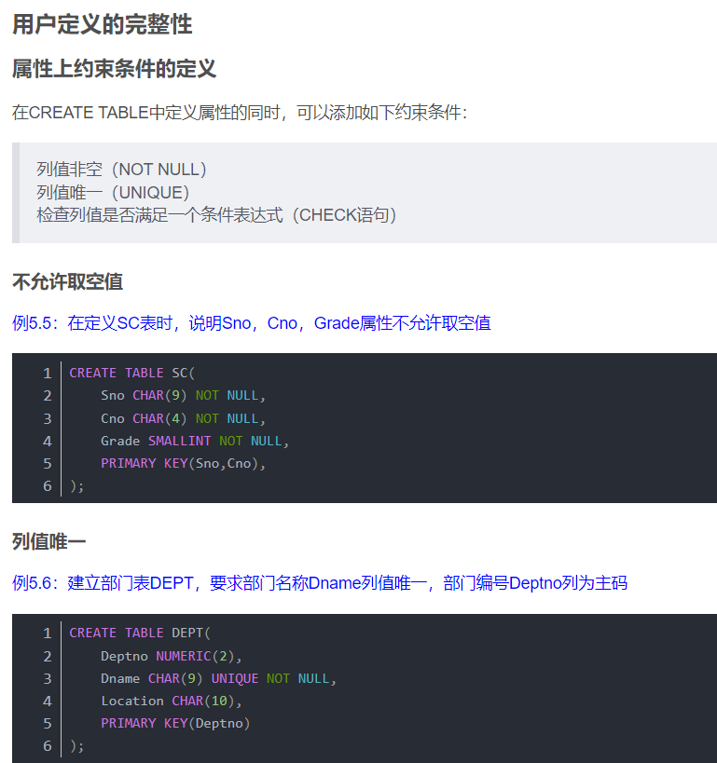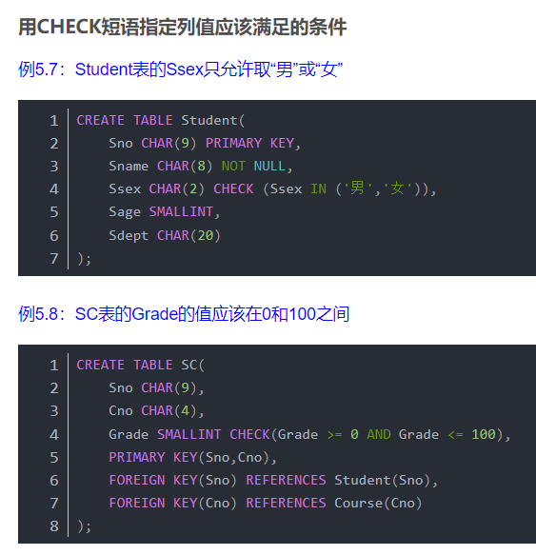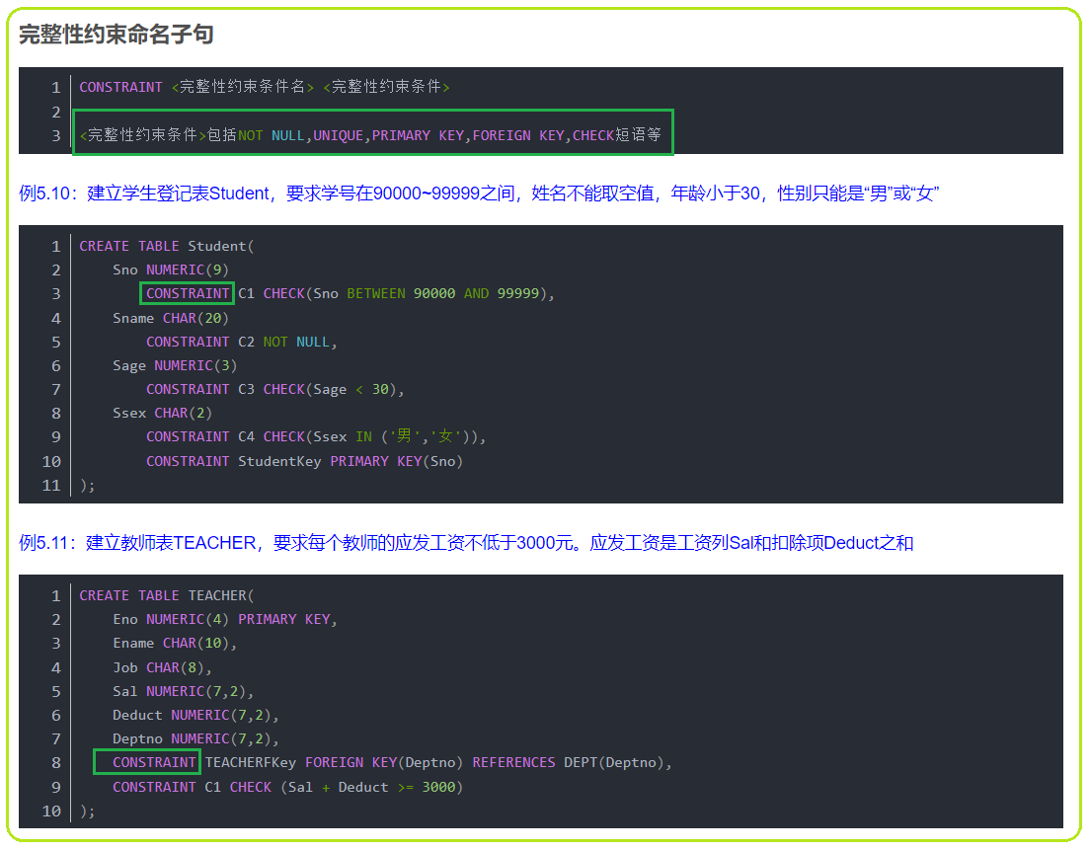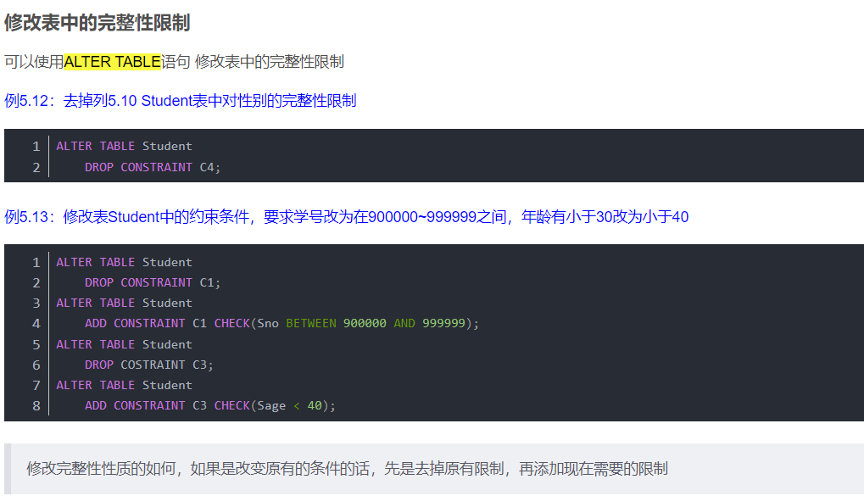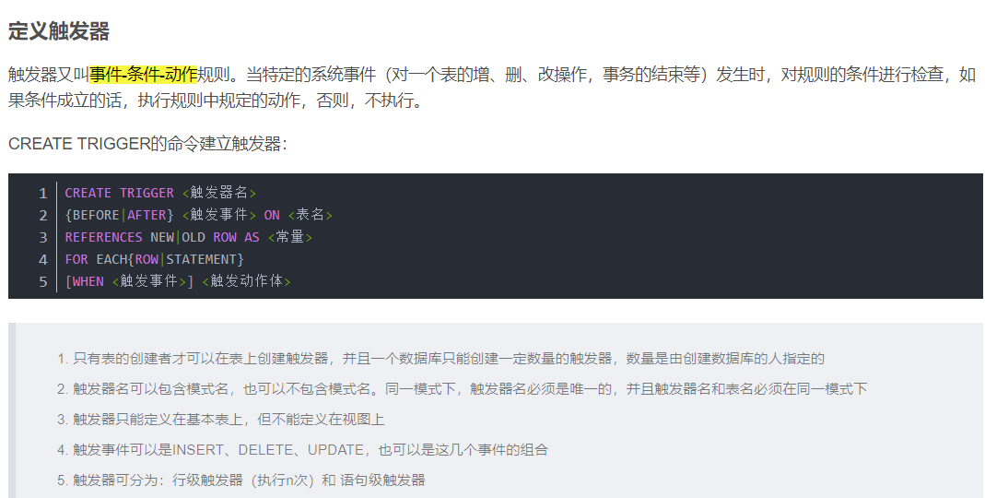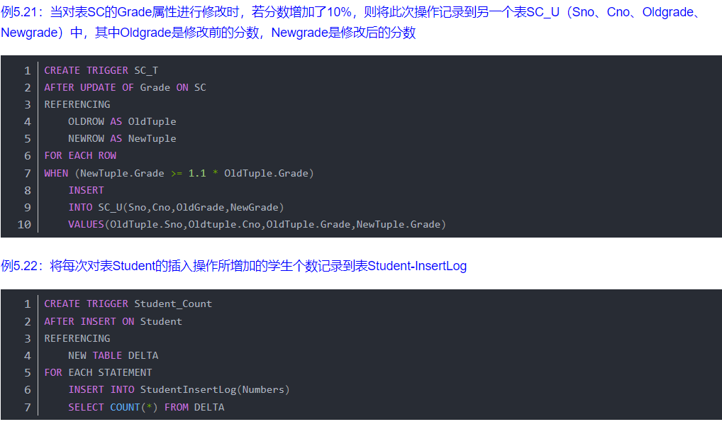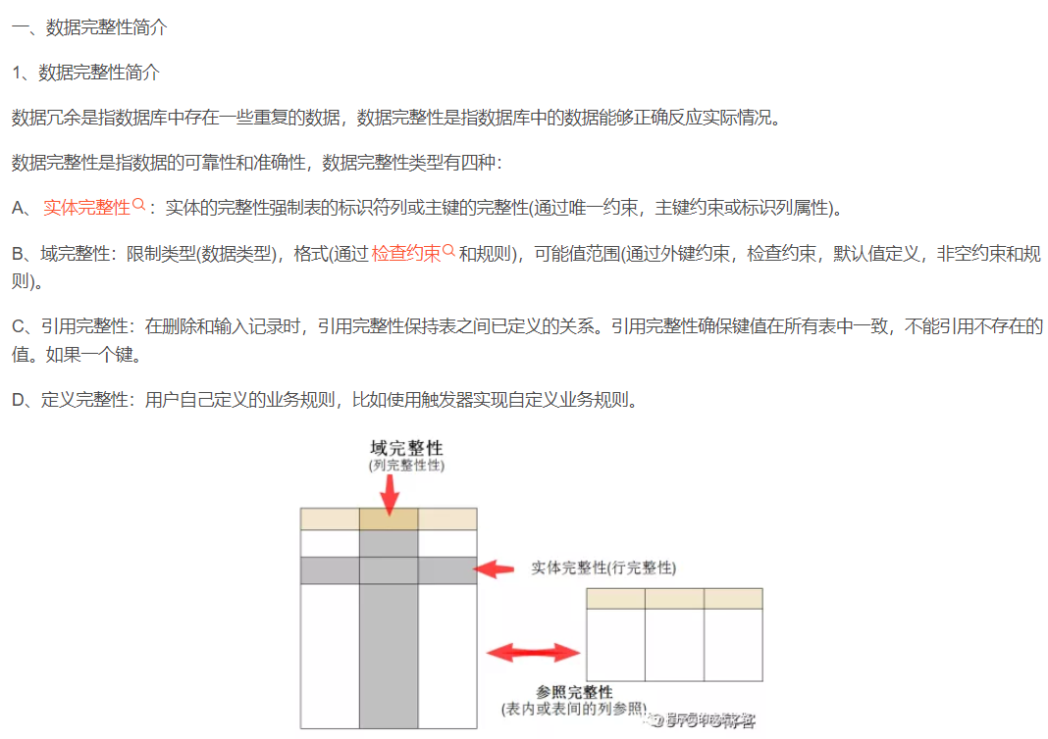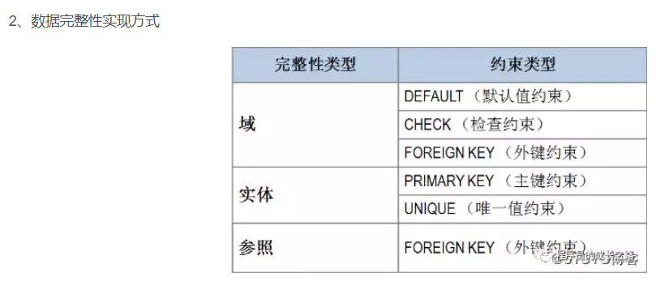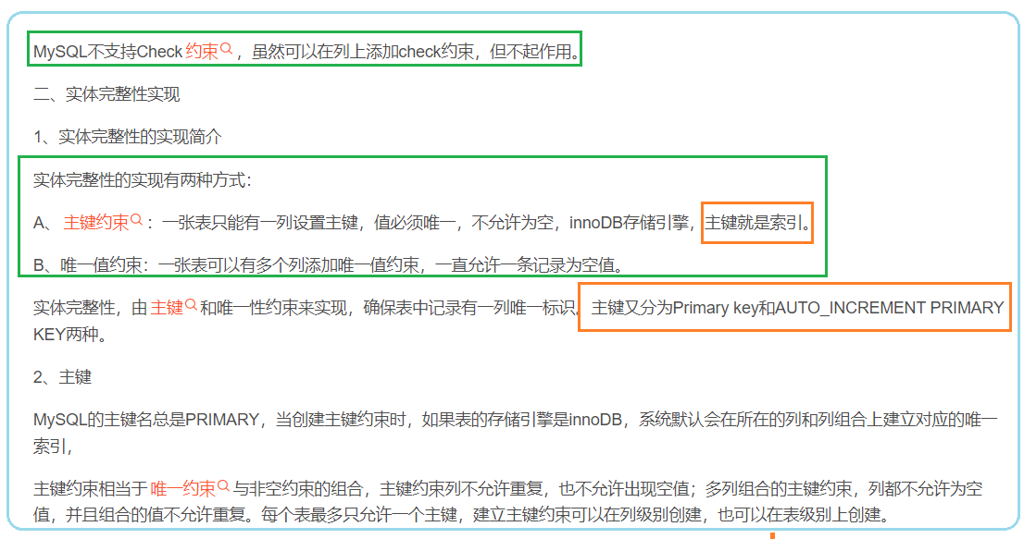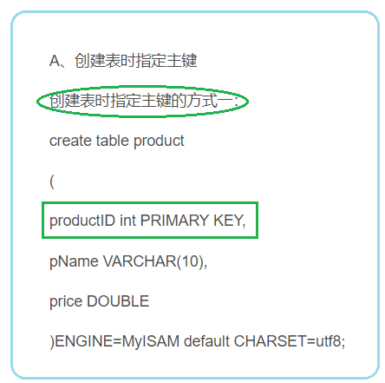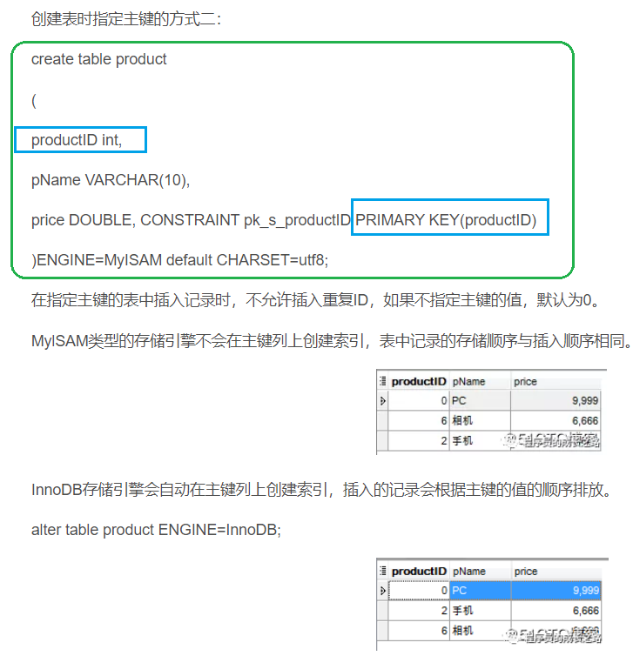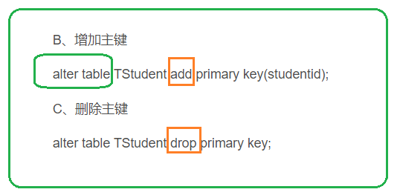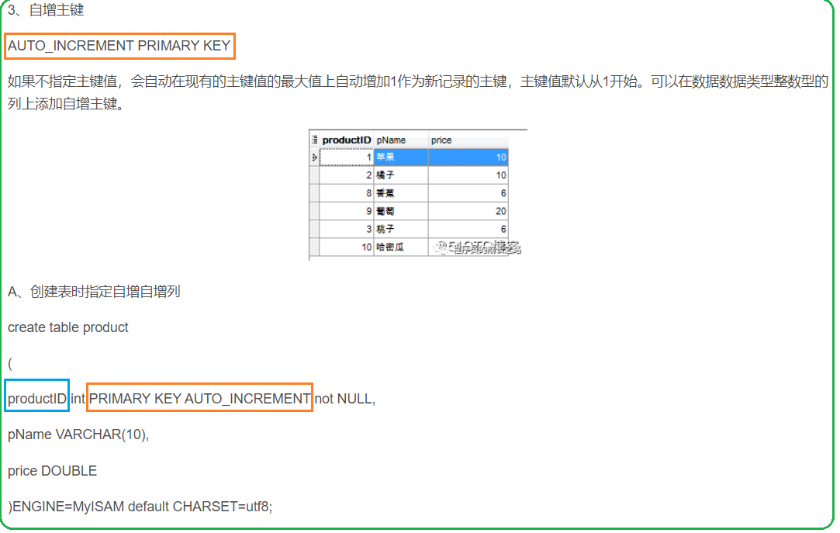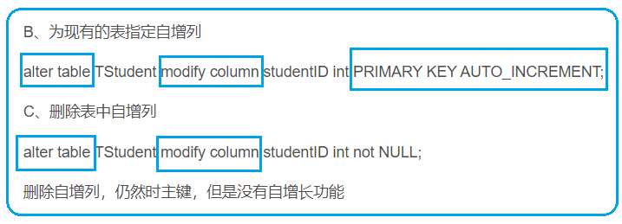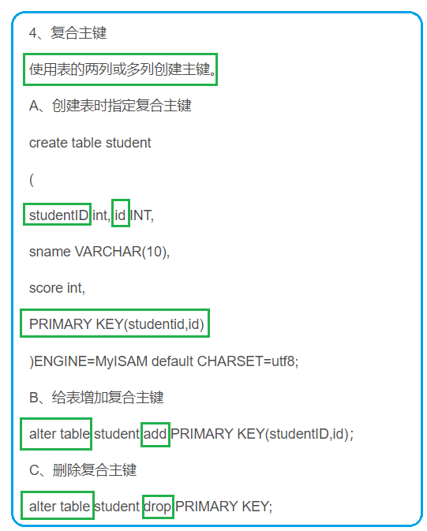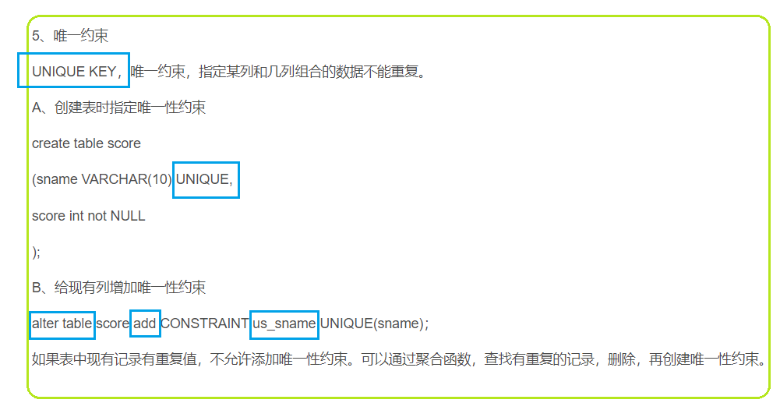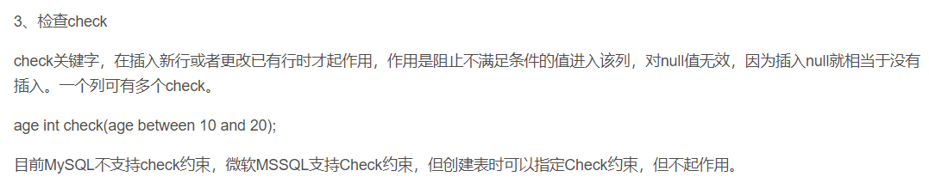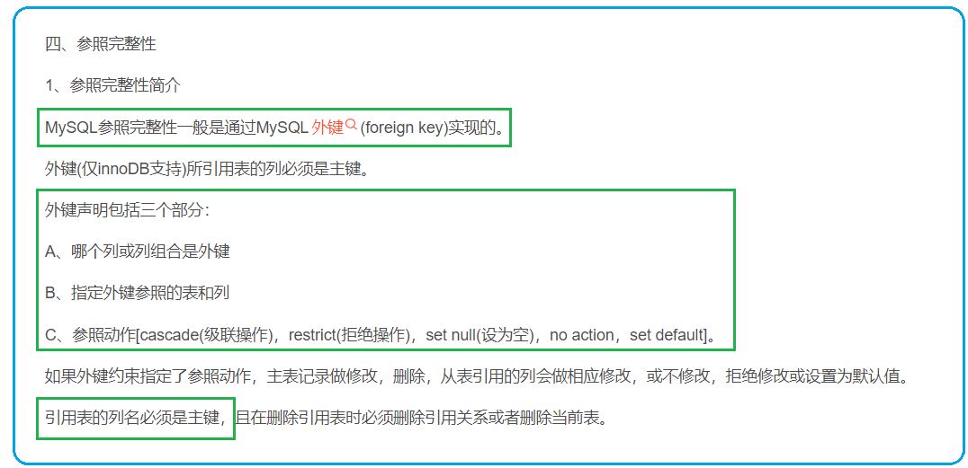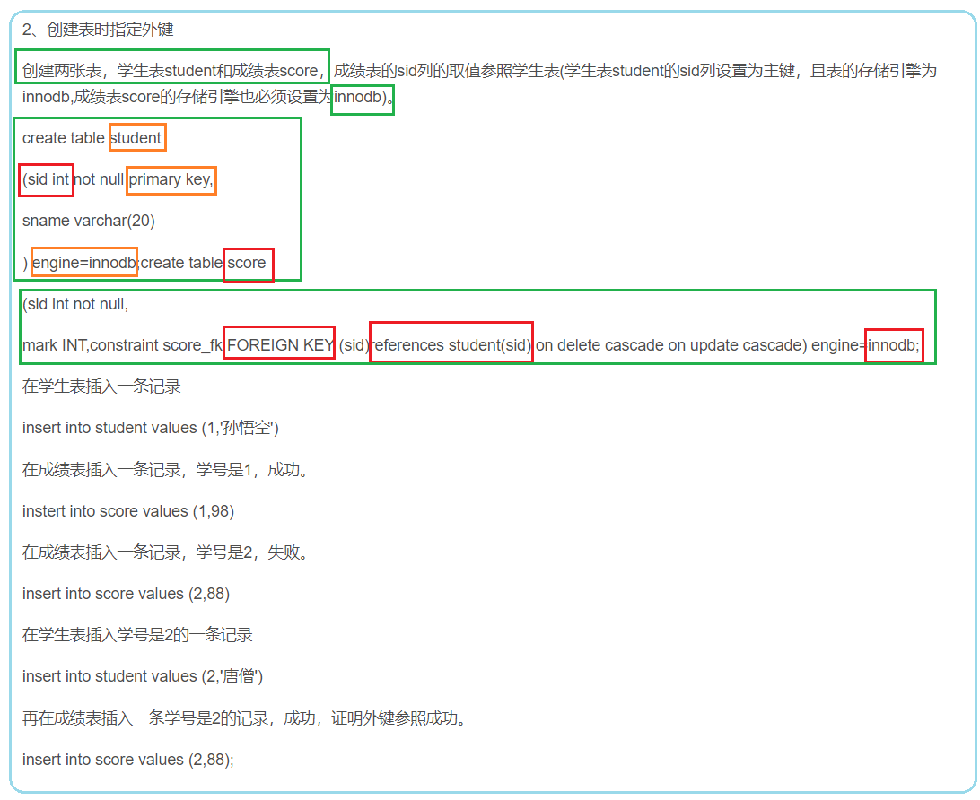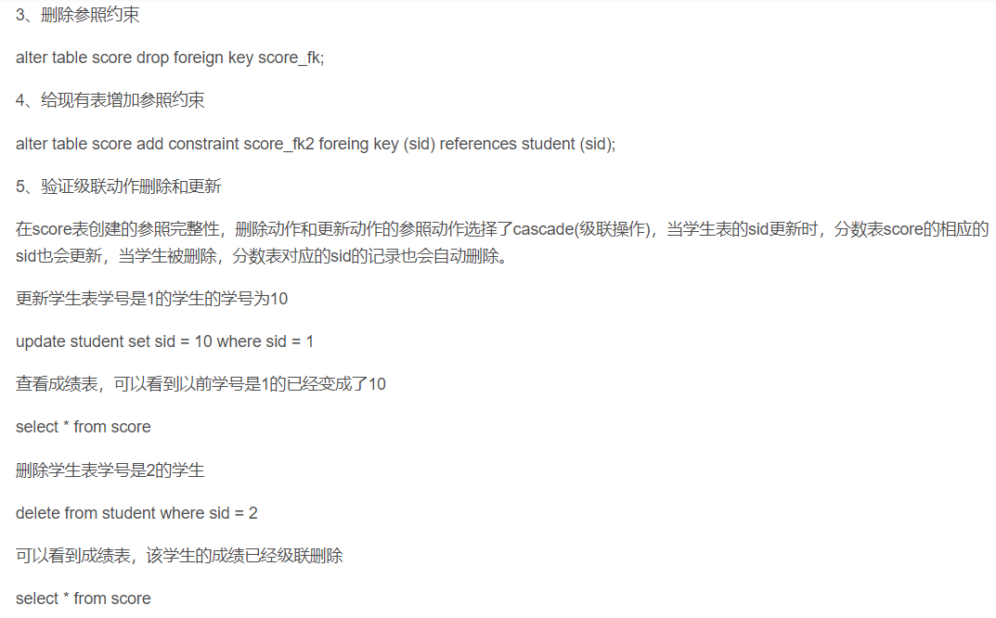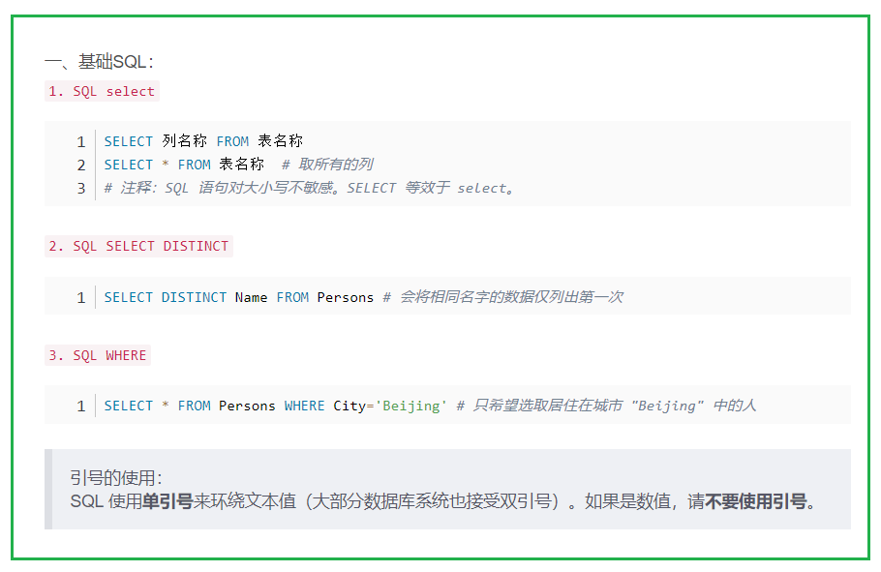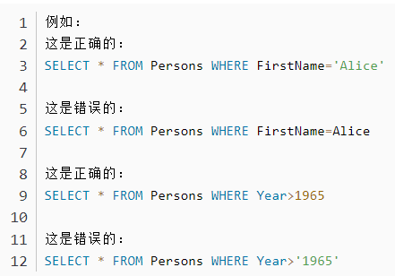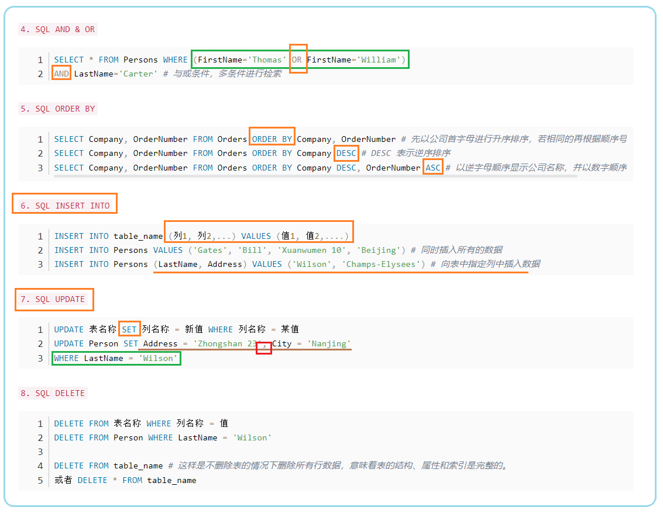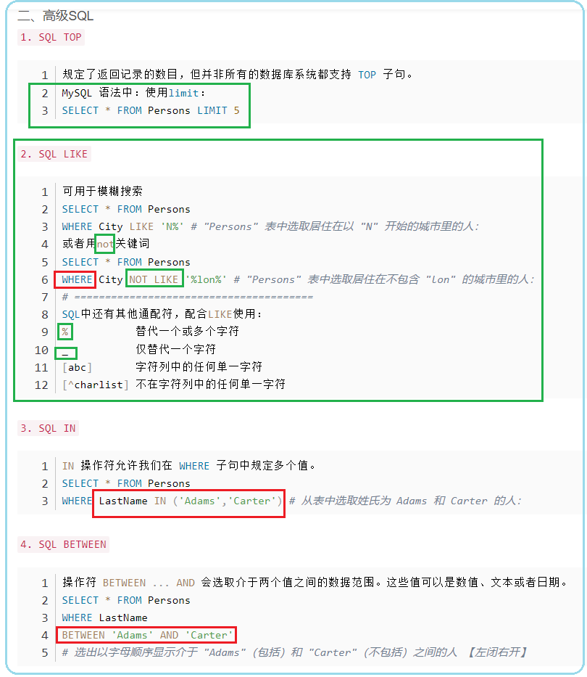**<https://forms.office.com/r/80ixi5dMK2>

**

