<https://rmm.datto.com/help/en/Content/1INTRODUCTION/Infrastructure/Overview.htm>

**About Remote Monitoring and Management (RMM)**

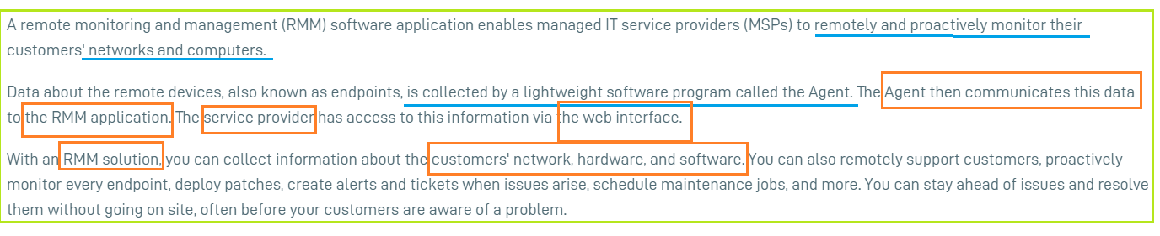Datto RMM consists of **two separate applications**: the web interface and the Agent.

[[Closed](https://rmm.datto.com/help/en/Content/1INTRODUCTION/Infrastructure/Overview.htm)Web interface](https://rmm.datto.com/help/en/Content/1INTRODUCTION/Infrastructure/Overview.htm)

[[Open](https://rmm.datto.com/help/en/Content/1INTRODUCTION/Infrastructure/Overview.htm)Agent](https://rmm.datto.com/help/en/Content/1INTRODUCTION/Infrastructure/Overview.htm)

The **Agent** is a lightweight software program **installed on devices** that support Agent installation. It also acts as a go-between for network devices that do not support Agent installation but that can be managed using **SNMP**. The Agent collects data on the devices and **communicates it to the Web Portal**. It can also execute a variety of actions on the remote device, such as the following:

* Audit the installed hardware and software
* **Proactively monitor the device**
* Deploy software, patches, and updates
* Enable the remote takeover of devices that have the Agent installed

Some of these tasks are accomplished in the **Agent Browser**, an application launched from the Agent icon in the system tray or from the Web Portal. It contains multiple tools to take control of a remote device.

**More interest how agent communicate with server?**

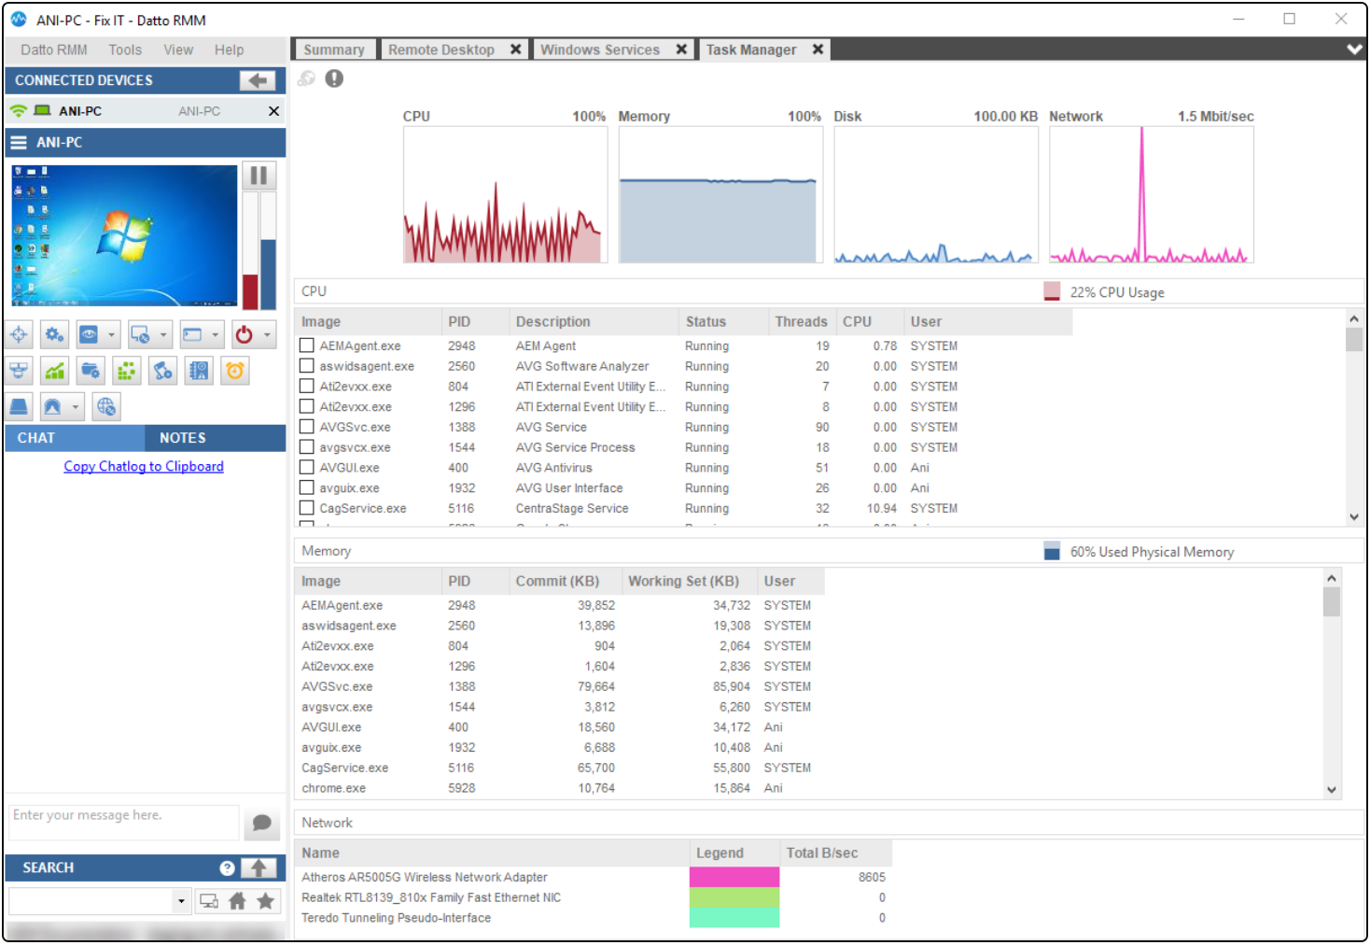In the Agent Browser, you can:

* Take a screenshot of a remote device or open a remote takeover tool like RDP, VNC, or Splashtop
* Open a Command Shell and add and edit registry items on the remote device
* Control Windows Services on the remote device
* Wake up, shut down, or restart the remote device
* Monitor resources such as CPU or memory in real time
* Manage files
* View event logs
* View drive information
* Deploy the Datto RMM Agent to devices on the remote network

The Agent allows you to diagnose and to fix many issues remotely, often in the background without the user being aware of it.

**The Datto RMM Agent and Agent Browser**

**About the Agent**

The Datto **RMM Agent** is a **lightweight software program installed on a device** that supports Agent installation. The Agent gathers up-to-date information about the device's health and status and communicates it to the **Web Portal**.

Having the necessary information ready in the **Web Portal**, the Datto RMM administrator can use the **Agent** to proactively monitor the devices, deploy patches, push out policies, create alerts and tickets, execute scripts, run scheduled jobs, or even enable a remote connection to these devices. While the Agent facilitates the connection to another device, the **connection is established through the Agent Browser** that can be launched from the Agent or the **Web Portal**. Remote takeover can be initiated from either the Web Portal or the Agent Browser. Refer to [Remote Actions](https://rmm.datto.com/help/en/Content/4WEBPORTAL/Devices/DeviceLists.htm#Remote_Actions) (Web Portal) and [List of Agent Browser tools](https://rmm.datto.com/help/en/Content/5AGENT/AgentBrowserTools.htm#List_of_Agent_Browser_tools).

For more information about the Agent and Agent types, refer to [Datto RMM Agent](https://rmm.datto.com/help/en/Content/5AGENT/Agent.htm) and [Managed and OnDemand Agents](https://rmm.datto.com/help/en/Content/4WEBPORTAL/Devices/ManagedOndemandAgent.htm).

For information about devices and deployment options, refer to [Devices](https://rmm.datto.com/help/en/Content/4WEBPORTAL/Devices/DEVICES.htm).

**About the Agent Browser**

IMPORTANT  The Agent Browser is only available for **Managed Agents** on **Microsoft Windows** devices. OnDemand Agents and operating systems other than Windows do *not* have an Agent Browser.

In order to establish a **connection between two devices**, both the device you are connecting *from* and the device you are connecting *to* need to have an Agent installed, but the connection will be established through the Datto RMM **Agent Browser**. If you would like to connect to a device that cannot have an Agent installed, **the Agent Browser will use a Network Node** to establish the connection.

The **Agent Browser** is launched from the Datto RMM Agent or the Datto RMM **Web Portal**. Once a connection has been set up to a remote device, a variety of tasks can be executed on the endpoint. The Agent Browser allows you to diagnose and fix many issues remotely, and often in the background, without the user being aware of it. You can connect to more than one device at the same time, that is, you can have multiple sessions open in the Agent Browser.

Among others, the Agent Browser allows you to:

* Take a screenshot of the endpoint or open a remote takeover tool
* Open a command shell on the remote device or access its Service Manager, Task Manager, File Manager, Registry Editor, or Event Viewer
* **Shut down or restart the remote device**
* Deploy an Agent to devices on the remote network and wake up those devices
* Run quick jobs on the remote device

While the Agent Browser is only available for Managed devices on Windows operating system, it can connect to Managed and OnDemand devices on **Windows, macOS, and Linux** operating systems, with varying options available to each. You can also initiate a browser connection, a direct connection, or a custom tunnel connection to devices managed by a Network Node device. Refer to [List of Agent Browser tools](https://rmm.datto.com/help/en/Content/5AGENT/AgentBrowserTools.htm#List_of_Agent_Browser_tools).

<https://rmm.datto.com/help/en/Content/5AGENT/AgentBrowser.htm>

## About Datto RMM Agent

<https://rmm.datto.com/help/en/Content/5AGENT/Agent.htm#Configure_the_Agent_and_Agent_Browser>

# Agent Browser tools

<https://rmm.datto.com/help/en/Content/5AGENT/AgentBrowserTools.htm>

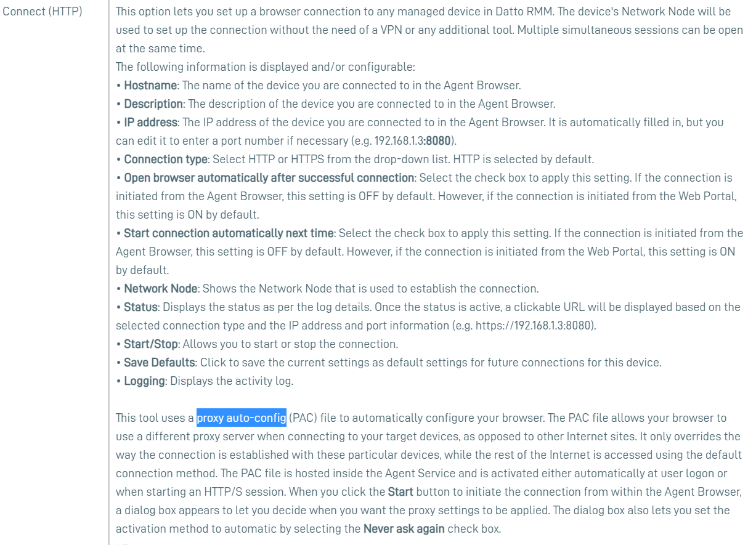

# Agent Browser tools

<https://rmm.datto.com/help/en/Content/5AGENT/AgentBrowserTools.htm#Connect_(HTTP)>

# Agent Browser

<https://rmm.datto.com/help/en/Content/5AGENT/AgentBrowser.htm>

**Devices**

<https://rmm.datto.com/help/en/Content/4WEBPORTAL/Devices/DEVICES.htm>

## About devices

Devices are the endpoints that are managed in your Datto RMM account. All devices are associated with a site. When you become a Datto RMM partner, and every time you onboard a new customer, one of your first tasks is to **add the devices you want to manage to your Datto RMM account**. There are a number of different deployment methods and management options. The exact method of how you add devices to your sites depends on the device type.

## Methods for adding devices to your sites

### Agent installation

This method works for devices that have an operating system. The devices become visible in the Web Portal once the Datto RMM Agent is installed on them. You can install the Agent on the following device types: **servers**, **desktops**, and **laptops**. Refer to [Installing the Datto RMM Agent on servers, desktops, and laptops](https://rmm.datto.com/help/en/Content/4WEBPORTAL/Devices/ServersLaptopsDesktops/DEPLOYAGENT.htm).

https://rmm.datto.com/help/en/Content/4WEBPORTAL/Devices/ServersLaptopsDesktops/DEPLOYAGENT.htm

For detailed information about the Datto RMM Agent, refer to [Datto RMM Agent](https://rmm.datto.com/help/en/Content/5AGENT/Agent.htm). There are two types of the Agent that differ in functionality: Managed and OnDemand. Which one is deployed depends on the type of site the device is associated with. For more information, refer to [Managed and OnDemand Agents](https://rmm.datto.com/help/en/Content/4WEBPORTAL/Devices/ManagedOndemandAgent.htm).

The Datto RMM Agent is specific to the operating system of the device it is installed on. For a feature comparison, refer to [Features of Windows, macOS, and Linux Agents](https://rmm.datto.com/help/en/Content/5AGENT/AgentFeatureComparison.htm).

1. <https://rmm.datto.com/help/en/Content/4WEBPORTAL/Devices/AddDeviceManually.htm#Downloading_or_emailing_the_Agent_installer>
2. 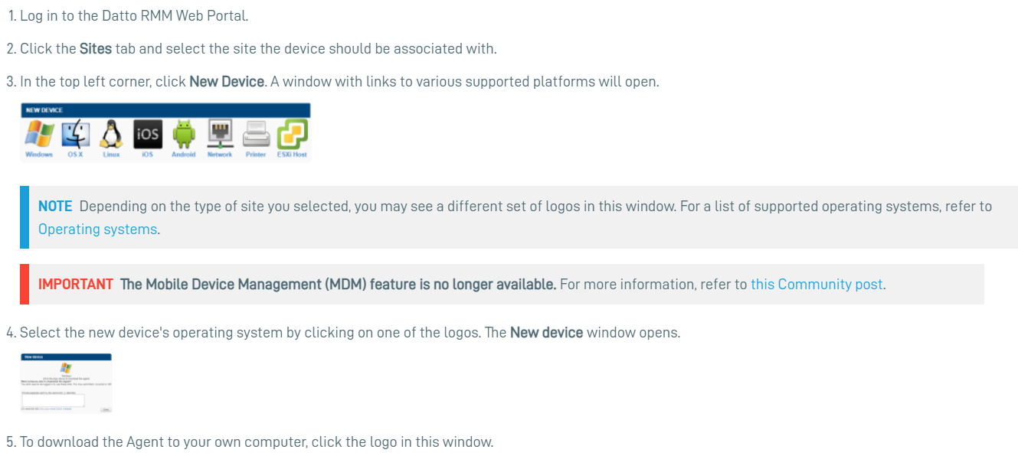To install the Agent on a computer, you (or your end user) must double-click on **the executable file** (named **AgentSetup_<sitename>.exe**). The installer is silent so you will not see any progress bar or indicator.  
   For detailed instructions for each supported operating system, refer to the following topics:

## Services, dependencies, and folders (Windows, macOS, Linux)

Agent data is stored in **\Program Files[ (x86)]\CentraStage** and **\ProgramData\CentraStage**.

The following services are installed:

* **Datto RMM Agent Service** (CagService): For more information, refer to [Datto RMM Agent](https://rmm.datto.com/help/en/Content/5AGENT/Agent.htm).
* **uvnc_service** (for remote takeover using VNC or Web Remote): Only installed if VNC is allowed on the device. For more information, refer to [VNC Settings](https://rmm.datto.com/help/en/Content/2SETUP/AccountSettings/AccountSettings.htm#VNC_Settings).

The following process runs in every user session to show the tray icon and to interact with users: **gui.exe**.

**Managing your device using SNMP**

If you cannot install an Agent on your device, e.g. on a switch, router, UPS, printer, ESXi device, or any device that does not have an operating system, a Network Node device can manage it for you.

* **Network devices and printers**: Refer to [Managing and monitoring SNMP-enabled network devices and printers](https://rmm.datto.com/help/en/Content/4WEBPORTAL/Devices/NetworkDevicesPrinters/ManageMonitorSNMPDevices.htm).
* **ESXi devices**: Refer to [Managing and monitoring ESXi devices](https://rmm.datto.com/help/en/Content/4WEBPORTAL/Devices/ESXiDevices/ManageMonitorESXiDevices.htm).

# **Managing and monitoring SNMP-enabled network devices and printers**

There are times when you would like to manage and monitor certain devices but you cannot install a Datto RMM Agent on them. For example, you may want to know when the data transfer rate of a switch port goes over a certain threshold, or if the battery in your UPS starts discharging, or whether you need to change your printer's toner. In instances when Agent installation is not possible, **a fully Managed Network Node device can connect to and manage your device** using Simple Network Management Protocol (SNMP).

This document is not intended to be a comprehensive SNMP theory tutorial; however, it offers the following:

* It details the **Network Node requirements** for SNMP monitoring.
* It provides some **background information** for SNMP monitoring in Datto RMM.
* It walks you through the process of **adding an SNMP-enabled device as a Managed device to your account**.
* It also mentions **how to monitor your SNMP devices** and refers you to the appropriate topic in the Datto RMM Help.

If you are not familiar and comfortable with the concepts, terminology, and technology around SNMP, we strongly recommend some background reading before you start with SNMP monitoring. There are a number of useful guides on the subject but here are a few examples that we've looked at and liked:

Through snmp one can retrieve information about network devices like routers, printers, hubs or even normal computers. **The information that can be retrieved through snmp** is endless. Some examples of the type of information that can be retrieved through snmp are :

* System up time
* CPU usage level
* Disk usage level
* Network settings etc.

Not only information can be retrieved but also these network devices can be configured with new values through snmp. Despite being simple in its design and approach, its the sheer power of this protocol that makes its popular network management protocol today.

### **SNMP system design**

A computer network system that uses SNMP for network management consists of the three fundamental components :

1. **The SNMP manager** : It is a software that usually runs on the machine of network administrator or any human manager managing the computer network.
2. **The SNMP agent** : It is a **software** that usually runs on the network node that is to be monitored. This node could be a printer, router etc.
3. **The SNMP MIB** : MIB stands for Management information base. This component makes sure that the data exchange between the manager and the agent remains structured.

SNMP stands for Simple Network Management Protocol.  It is a standard way of monitoring hardware and software from nearly any manufacturer, from Juniper, to Cisco, to Microsoft, Unix, and everything in between. SNMP requires only a couple of basic components to work: a management station, and an agent.

First, a **management station** is required.  The management station is simply software that collects information from your network.  Most management stations will **poll your network** for information regularly. Management stations range from the very simple to highly complex.

Simple software is usually very feature-limited, but can be freely available and easy to configure.  For example, the [free SolarWinds Network Device Manager](http://www.solarwinds.com/register/registrationb.aspx?Program=991&c=70150000000P9IB&CMP=BIZ-TAD-NMS-DOWNLOADS-NDM-DL-HMPG) that was recently released.

On the other hand, complex systems can manage your entire network. They will also do things like generate reports, perform inventory, and **send email or SMS text** alerts when systems fail.  Networkmanagementsoftware.com recently reviewed [SolarWinds Network Performance Monitor](https://www.networkmanagementsoftware.com/solarwinds-orion-npm-10-1-review), – an excellent management solution.

Second, **the hardware or software that you want to monitor must have an agent running**.  **The agent collects information, and then sends it to the monitoring station when polled**. **Agents can also send notification to the management station without being polled, for example if an error is detected**.

Agents are usually built-in to your network hardware and software – they simply need to be enabled and configured.

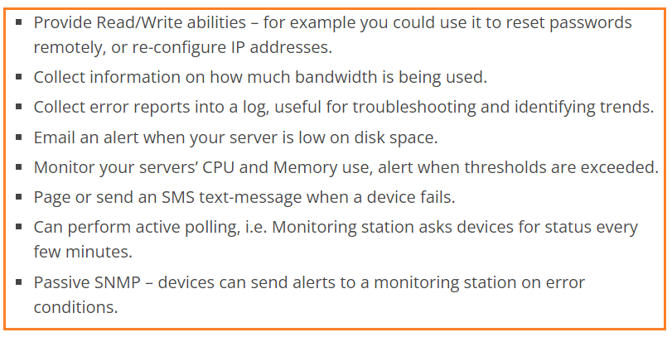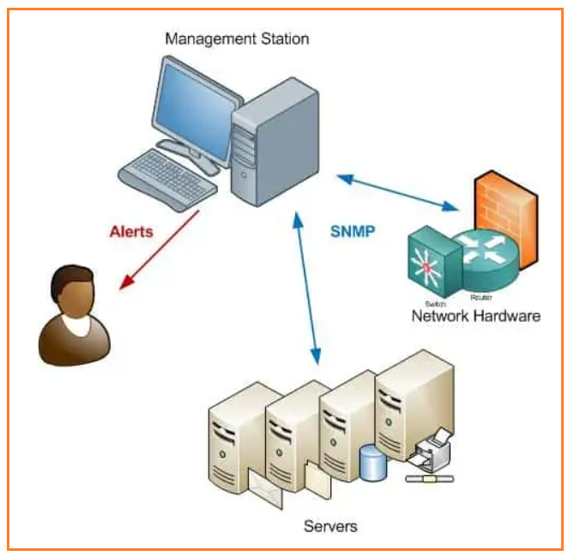

**Datto RMM API**

<https://rmm.datto.com/help/en/Content/2SETUP/APIv2.htm>

The API implements OAuth 2.0 that is an industry-standard protocol for authorization. **OAuth 2.0 uses access tokens** issued by an **authorization server**, which are used to access protected API resources subsequently. **API access tokens expire after 100 hours**. After this period, a new token must be requested or an HTTP **status code of 401** (Unauthorized) will be returned by any requests attempted. For more information on the OAuth 2.0 protocol.

**Request Rate Limiting**

Requests to the API are limited **to 600 requests within the past 60 seconds**. When 90% of the request quota is exceeded, a one-second delay is introduced in the request response.

EXAMPLE  For example, if 100 requests are made in a one-second period, plus a further 500 requests 59 seconds later, the request count at 61 seconds would be 500. As 60 seconds have passed since the original 100 requests were made, they are no longer included in the count.

The request count is calculated across the Datto RMM account rather than on a per-user basis. If multiple users have API access, the total number of requests for all users is counted against the account rate limit.

If the rate limit is breached, further requests will return an HTTP **status code 429** (Too Many Requests) until the count falls below 600 within 60 seconds. If this occurs, it is recommended to wait 60 seconds before making further requests to ensure the count has returned to zero.

IMPORTANT  Persistent requests made after breaching the rate limit will trigger an **HTTP status code 403 (Forbidden)**, and the originating IP will be blocked temporarily. In the event of this occurrence, it is recommended to wait 5 minutes before attempting any further requests.

The API needs to be enabled for the entire Datto RMM account first. An **API Key and an API Secret Key** must then be generated for 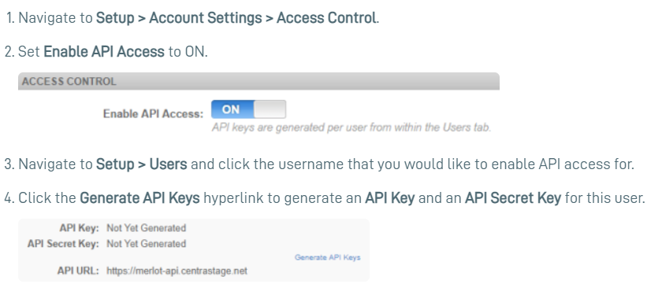that requires API access.

NOTE  Any active user can have access to the API. Inactive users cannot access the API even if API keys have been generated.

IMPORTANT  When making requests to the API, user security level restrictions are ignored, allowing full access to all areas of the Datto RMM account.

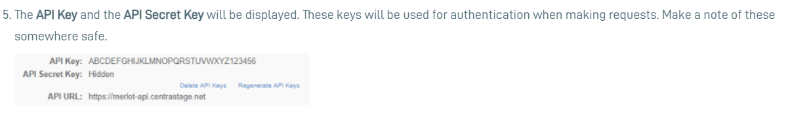

IMPORTANT  The **API Secret Key** will be hidden for security reasons after navigating away from this page. It will not be possible to retrieve it again. You can, however, regenerate API keys at any time by returning to the page and clicking **Regenerate API Keys**. This **will invalidate any keys previously generated**. Similarly, clicking **Delete API Keys** will revoke access altogether.

