**Remotely controlling a device through a web browser**

<https://docs.bmc.com/docs/bcm126/en/remotely-controlling-a-device-through-a-web-browser-738019345.html>

In addition to the classic remote control feature through the BCM console, 12.6 release enables administrators to remote control devices through a web browser. This browser-based technology to remote control devices does not require you to run the BCM java console on the device.

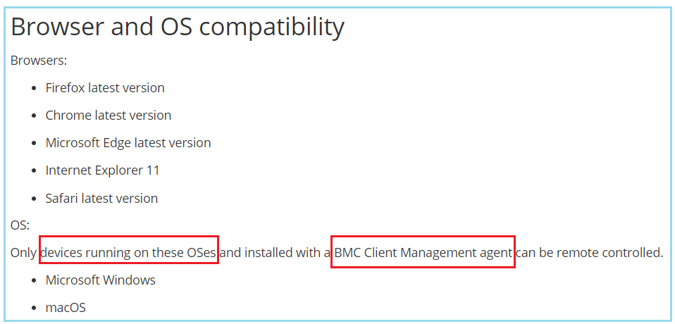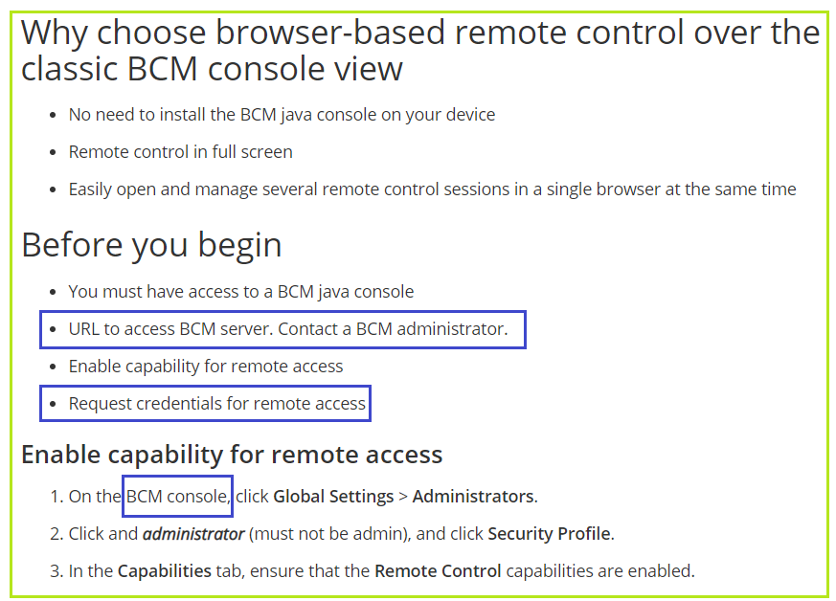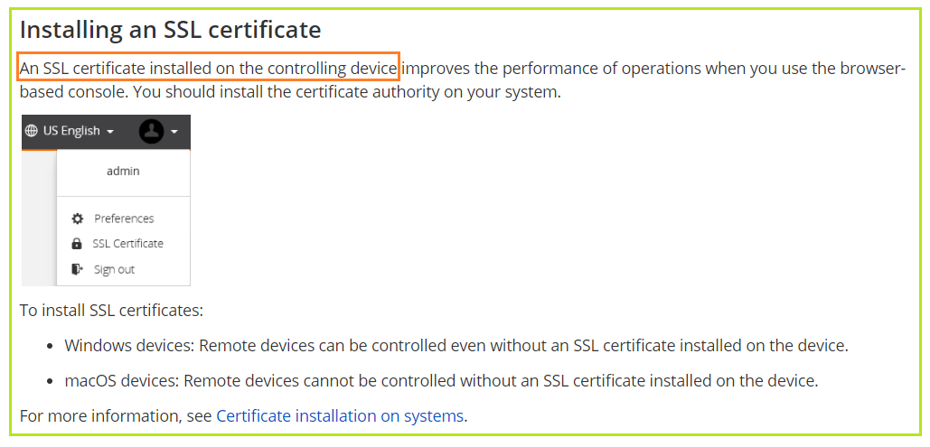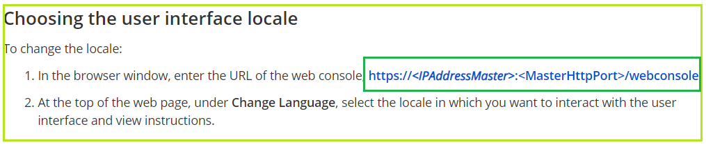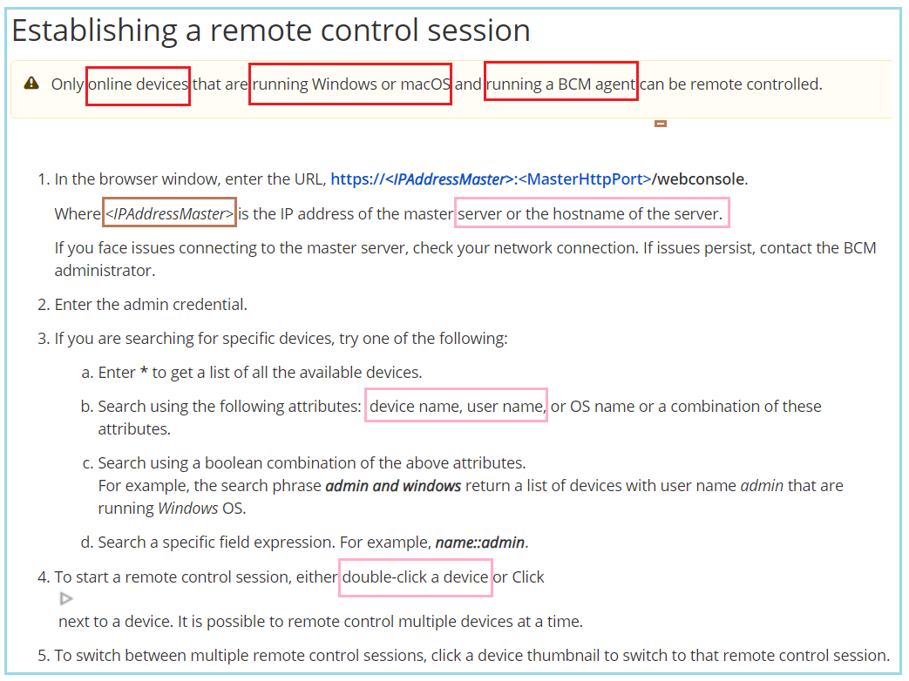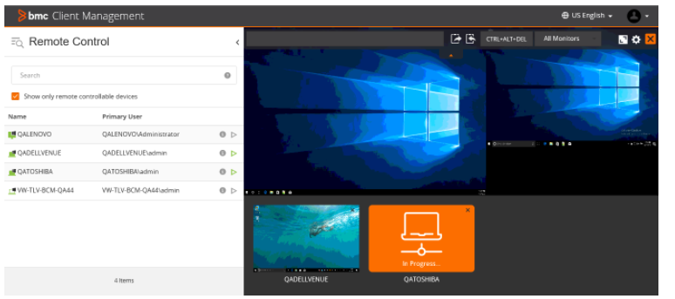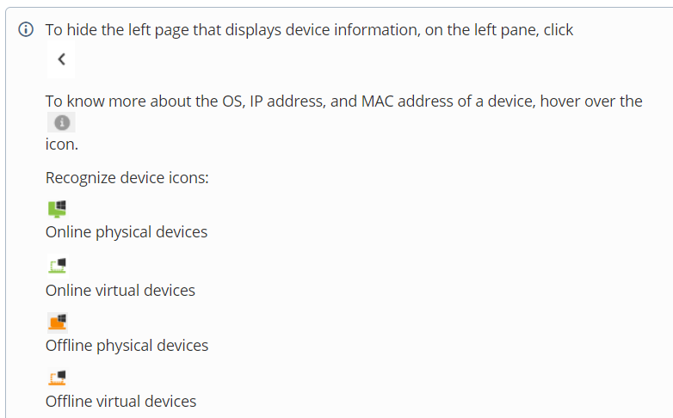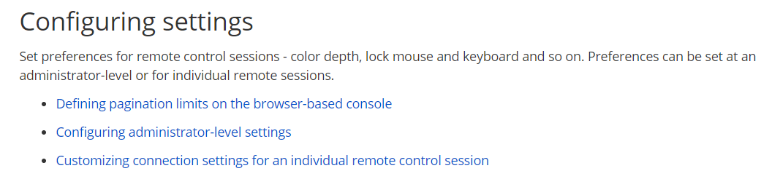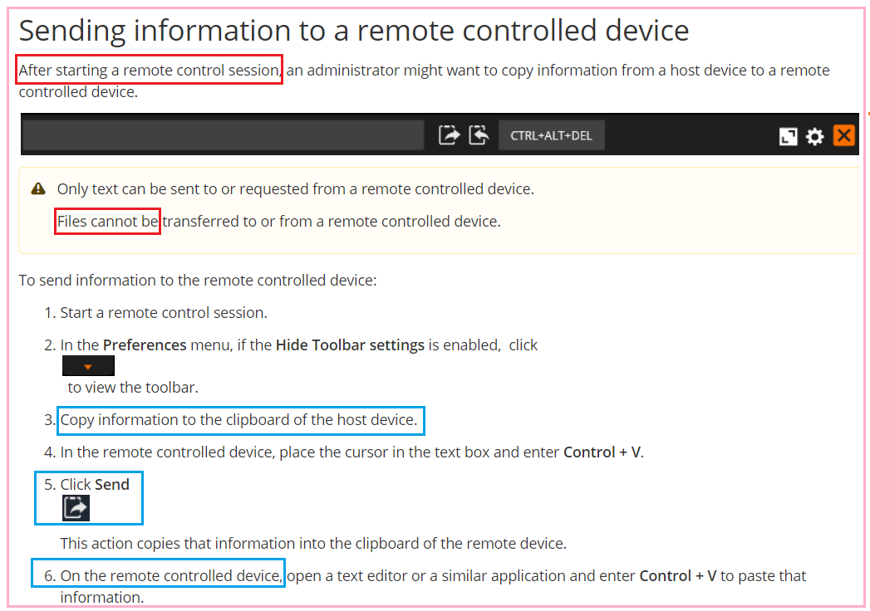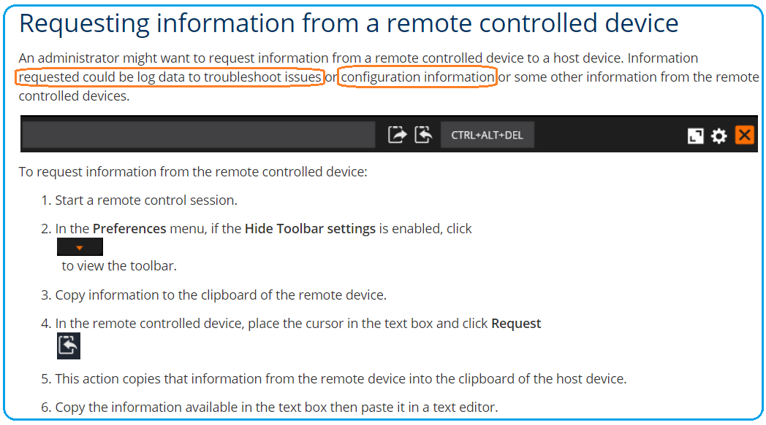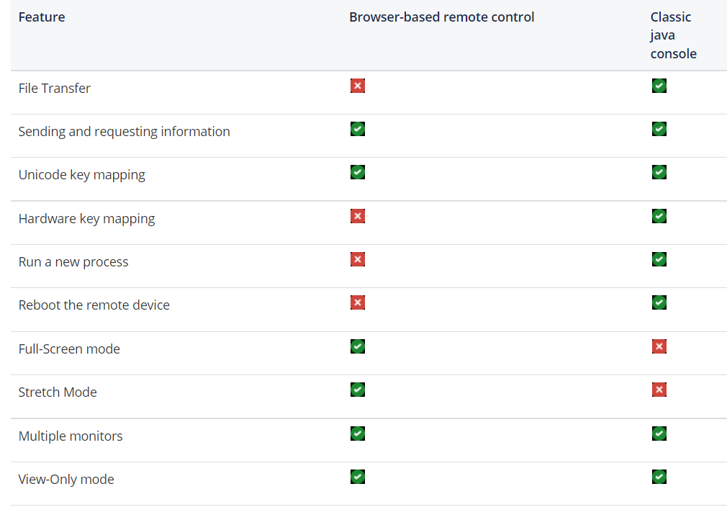

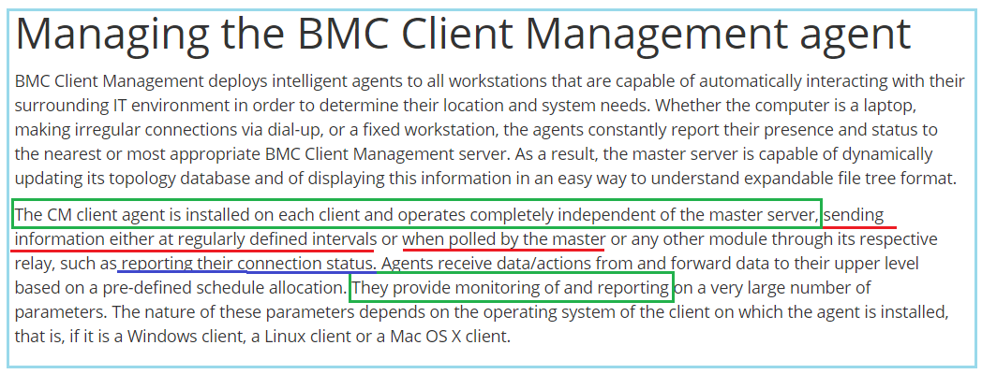

<https://docs.bmc.com/docs/bcm126/en/managing-the-bmc-client-management-agent-738019718.html>

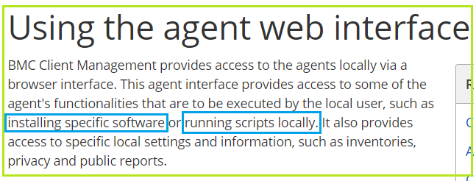https://docs.bmc.com/docs/bcm126/en/using-the-agent-web-interface-738019744.html

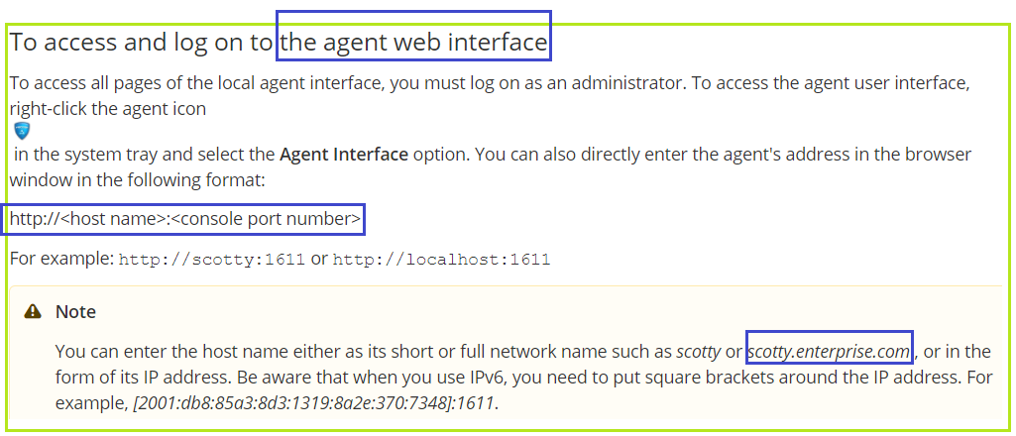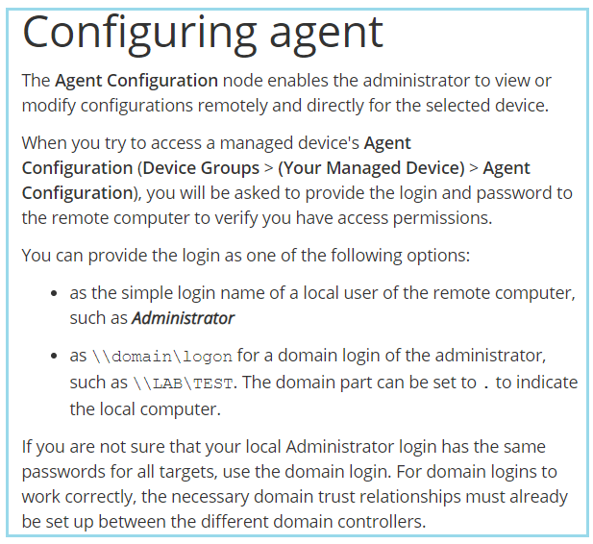https://docs.bmc.com/docs/bcm126/en/configuring-agent-738019740.html

# https://docs.bmc.com/docs/bcm126/en/elements-of-the-agent-interface-pages-738019571.htmlhttps://docs.bmc.com/docs/bcm126/en/chilli-in-the-agent-interface-738019569.html

# Tags and parameters

<https://docs.bmc.com/docs/bcm126/en/tags-and-parameters-738019570.html>

# Reviewing and testing REST Web APIs

<https://docs.bmc.com/docs/bcm126/en/reviewing-and-testing-rest-web-apis-738019556.html>

# Managing reports

<https://docs.bmc.com/docs/bcm126/en/managing-reports-738019419.html>

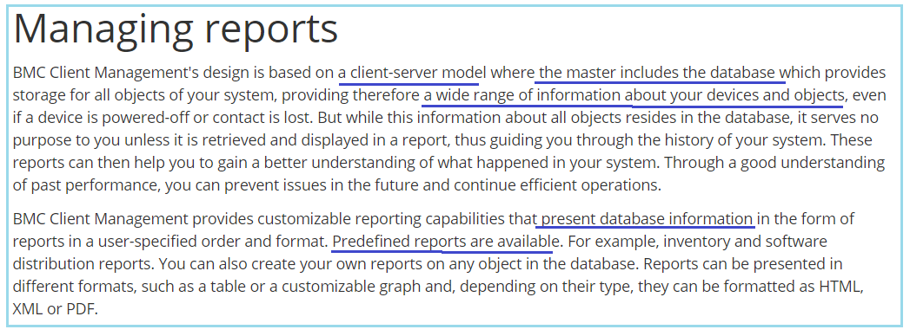

# Agent Configuration steps

<https://docs.bmc.com/docs/bcm126/en/agent-configuration-steps-738017927.html#AgentConfigurationsteps-ManualFileUpload>