Nemo Network Benchmarking Solution

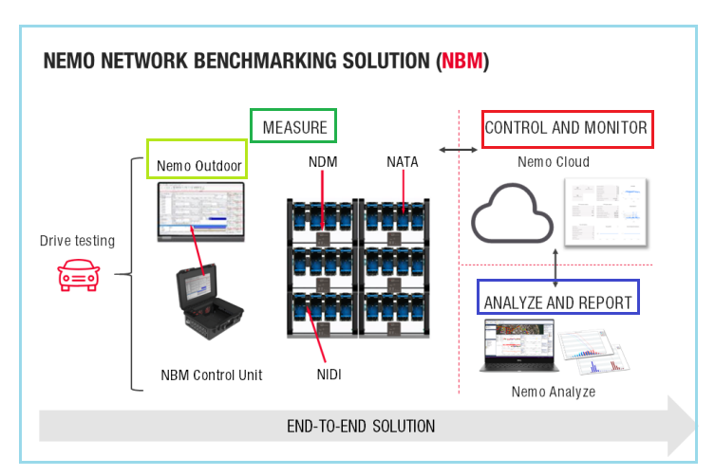

**Create an end-to-end automated data processing environment by combining NBM with Nemo Analyze and Nemo Cloud**

All tests are run by Nemo Active Testing Application on the test devices reflecting real end-user quality of experience. By combining Nemo Network Benchmarking Solution with Nemo Cloud and Nemo Analyze, you can create an **end-to-end automated data processing environment** from the collection of measurement data to analytics and reporting. View the results as a NPS score that compares the quality of mobile networks and visualizes the quality of experience (QoE) that the end users perceive when running common applications inside a phone with real use cases in different environments.

Nemo Cloud Remote Monitoring Solution

<https://www.keysight.com/us/en/product/NTC00000A/nemo-cloud-remote-monitoring-solution.html>

#### Centralized, web-based service for remote control and management of measurement fleets

* Centralized, web-based service for remote control and management of measurement fleets
* Connects Nemo products, measurement and analysis processes, and data feeds into one end-to-end solution streamlining operations
* Improved product lifecycle efficiency with fleet monitoring and management, project management, and post-processing and analytics
* Customers can interact seamlessly with their fleet of measurement products
* Centralized control and storage enable direct online management of data while users can easily and effectively share information between solutions
* Turn-by-turn navigation enables users to remotely create and monitor measurement route plans

#### Moving from post-processing to a more real-time process creates more efficient operations

* State-of-the-art dashboard visualizing changes in real time
* Follow measurement fleets in real time
* Avoid failures in measurement campaigns by being able to react immediately to issues

#### Versatile online usage

* Online inventory management
* Real-time monitoring
* Threshold-based alerting in monitoring
* Script creation in the cloud
* Remote management of measurement log files
* Centralized product and fleet control
* File sharing between measurement units
* Fully automated KPI alerts

#### Cloud-based monitoring and control of measurement fleet

Nemo Cloud is a centralized, web-based service for remote control and management of measurement fleets. Nemo Cloud connects Nemo products, measurement and analysis processes, and data feeds into one end-to-end solution streamlining operations and related OPEX.  
  
Nemo Cloud provides real-time control and monitoring of measurement product fleets as well as improved responsiveness of measurement projects in the field. The centralized product and fleet control together with online inventory management give customers the tools to get more out of their measurement resources and product portfolio.

# Nemo 5G RAN Analytics Web-Based Automated Processing and Reporting Solution

* 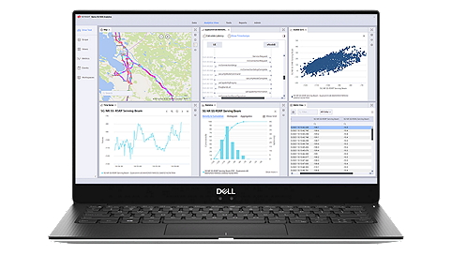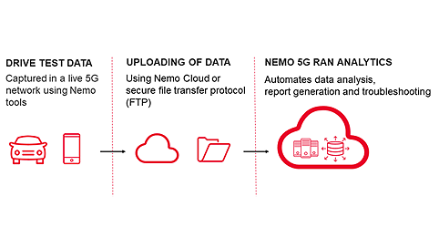

[1](https://www.keysight.com/us/en/product/NTR00000A/nemo-5g-ran-analytics-web-based-automated-processing-and-reporting-solution.html#1)[2](https://www.keysight.com/us/en/product/NTR00000A/nemo-5g-ran-analytics-web-based-automated-processing-and-reporting-solution.html#2)

[Data Sheet](https://www.keysight.com/us/en/assets/3121-1310/technical-overviews/Nemo-5G-RAN-Analytics.pdf)

Nemo 5G RAN Analytics is a centralized, web-based data management platform for enterprise-level analytics and reporting that allows you to access your data anytime, anywhere.

## **HIGHLIGHTS**

#### Ensure high Quality-of-Service (QoS) and minimize subscriber churn through effective analysis of your 5G wireless network with a fully automated processing, reporting, and data analytics platform

**Centralized data management**

* **Central data repository** for all files and reports. All data processed into a single database​.
* **Web-based access**. No client installation required.

**Workflow automation**

* Fully automated setup for multiple data processing and reporting workflows

#### End-to-end integration with Nemo Cloud

#### **Seamless integration with Nemo Cloud platform for automated data processing and reporting​**

#### **Near real-time, web-based drilldown analytics and diagnostics**

**Machine learning/artificial intelligence (ML/AI) driven analytics**

#### **ML/AI ready framework for proactive detection, monitoring, and predictive analytics**

#### **Guided optimization to enable fast root cause analysis**

**Reporting**

#### **Create, manage and distribute reports across your organization**

#### **Powerful built-in report designer**

**Nemo 5G RAN Analytics for automated enterprise-level RAN data analytics and reporting**

Nemo 5G RAN Analytics is a centralized, web-based data management platform for enterprise-level analytics and reporting that allows you to access your data anytime, anywhere. **Available as Software as a Service (SaaS),** it provides automated RAN data analytics and reporting and is an ideal solution for network operators handling large amounts of data. With the advanced reporting module, you can easily create, manage, and distribute custom reports across the organization in addition to having access to a full suite of off-the-shelf analytics reports.

**Streamline your entire data flow from the field to reports**

Nemo 5G RAN Analytics automates and streamlines the entire data flow from the field **to informative dashboards** and reports for the relevant stakeholders. **Together with Nemo Cloud and Nemo data collection tools**, Nemo 5G RAN Analytics offers an automated end-to-end solution from the collection of RAN data and project monitoring to data processing and reporting.

**Enable proactive ML-based problem detection, monitoring, and analytics**

The automated, ML-based anomaly and problem detection and monitoring capabilities of Nemo 5G RAN Analytics assist operators and service providers throughout the entire 5G life cycle. The intuitive user interface with synchronized and interactive views provides a consistent troubleshooting and analytics environment for all users, which reduces the chances of missing important problems.