10/12/21

2/13/22, 8/10/22

https://firebase.google.com/docs

* The **Firebase console** lets you upload an app and initiate testing from anywhere. See [Test with the Firebase console](https://firebase.google.com/docs/test-lab/ios/firebase-console) for instructions on using this tool.

<https://console.firebase.google.com/>

<https://developer.bigfix.com/rest-api/gettingstarted.html>

<https://developer.bigfix.com/rest-api/examples/>

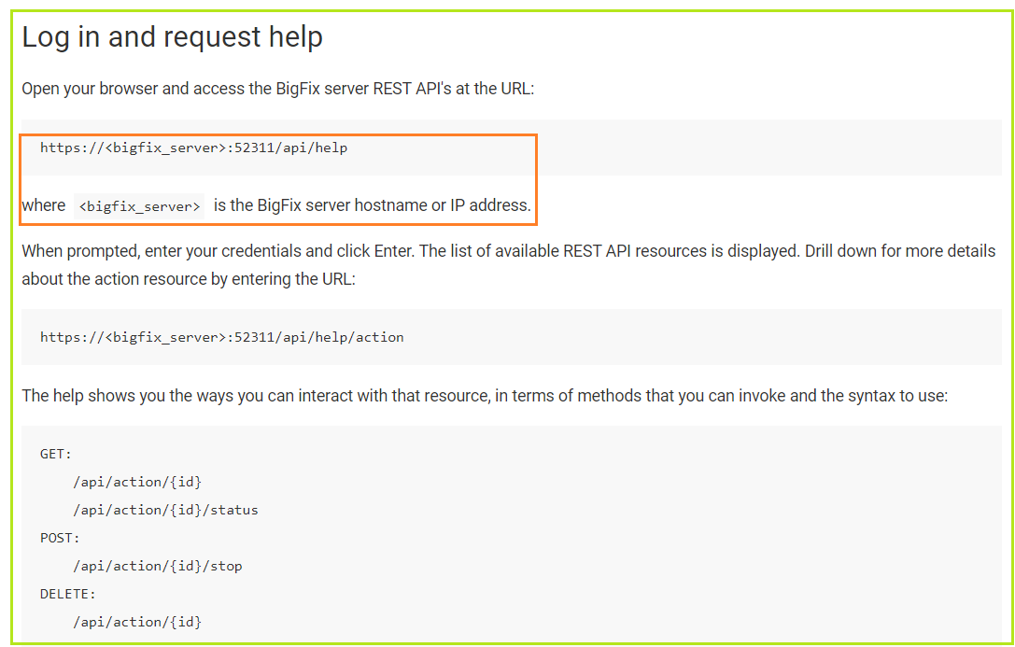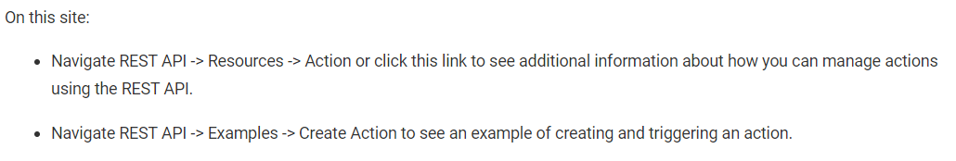

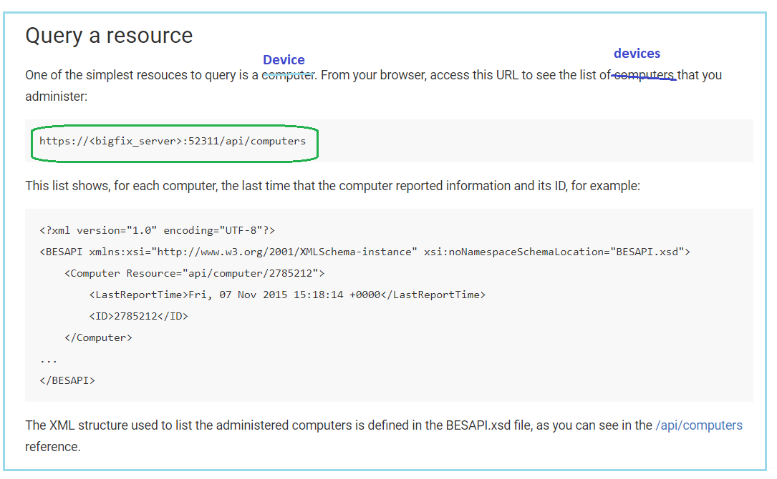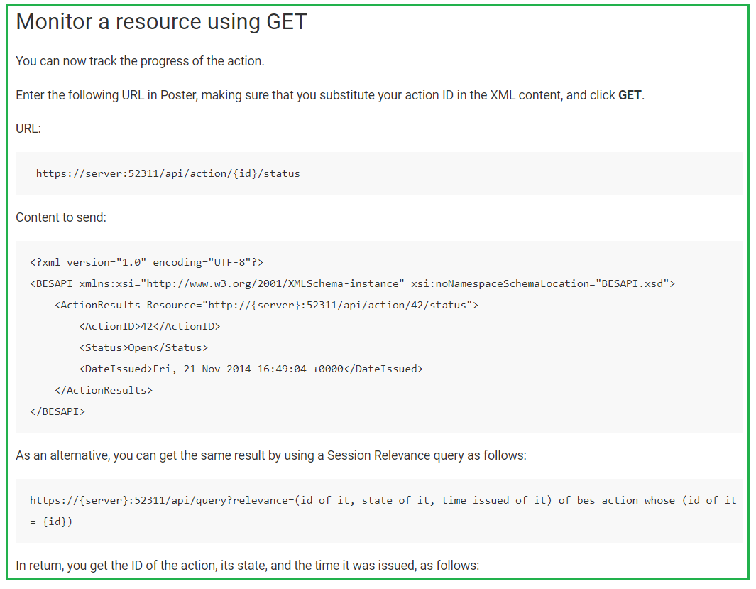**https://help.hcltechsw.com/bigfix/10.0/platform/Platform/Config/c_restapi_https_registry_set.html**

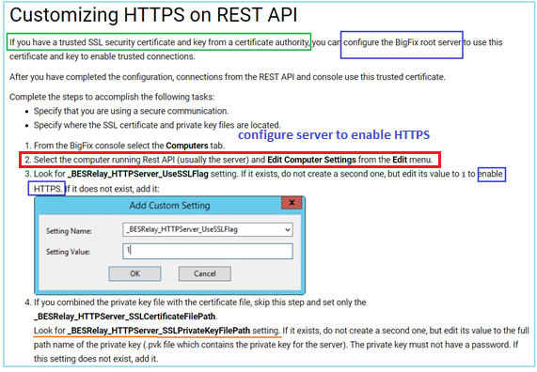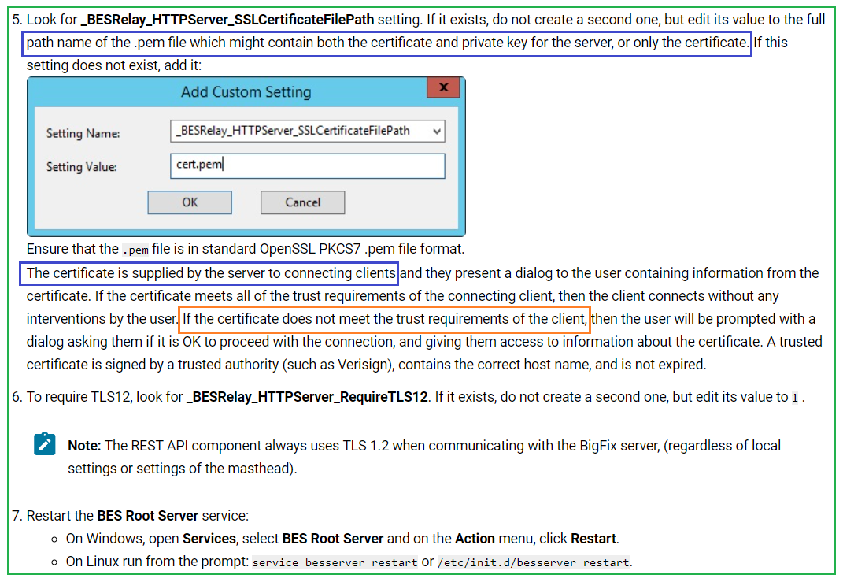

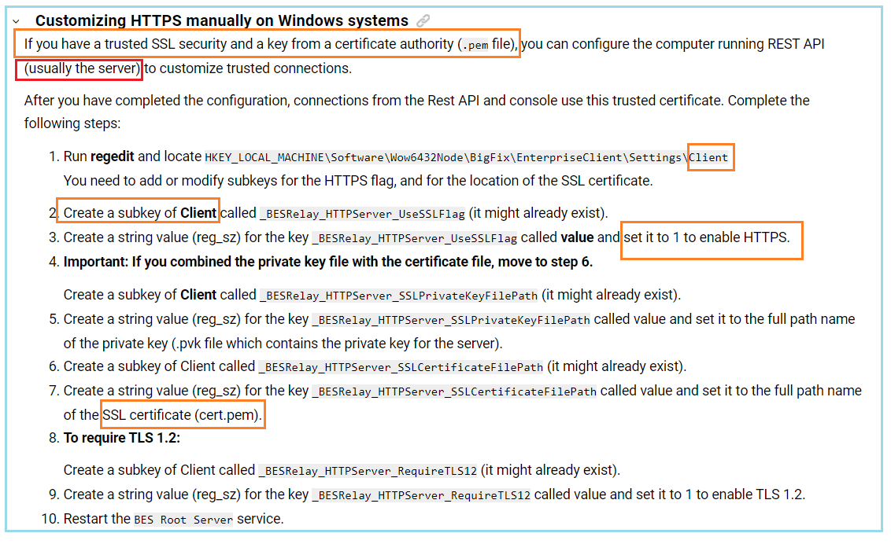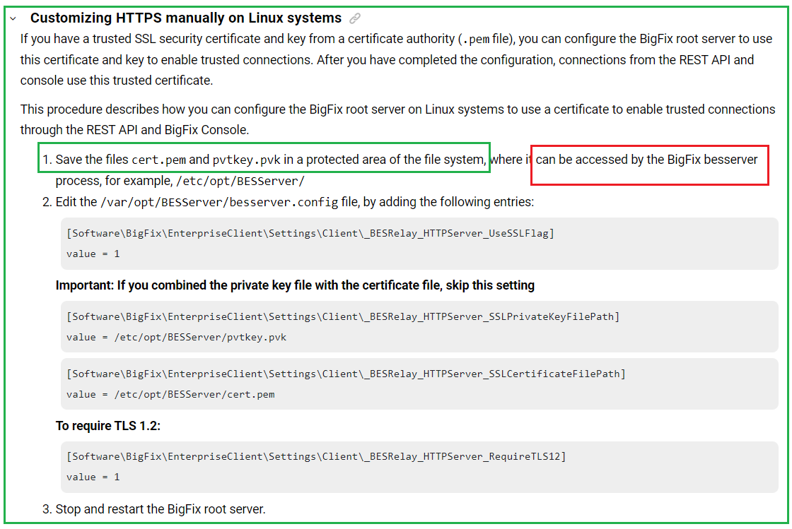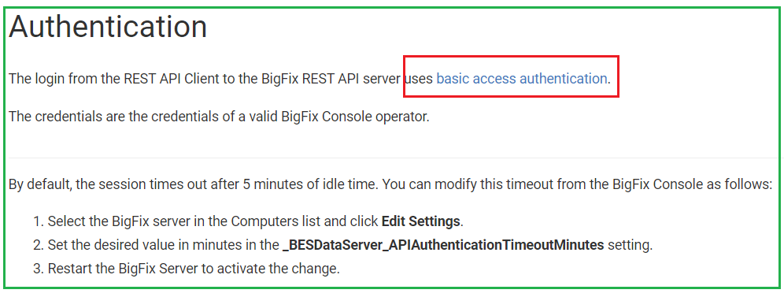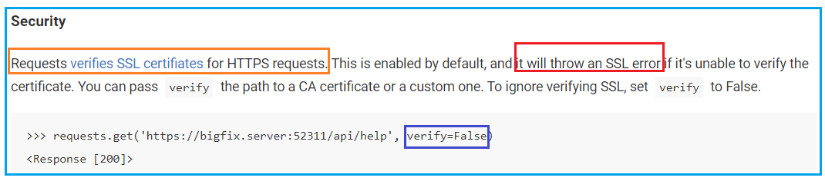

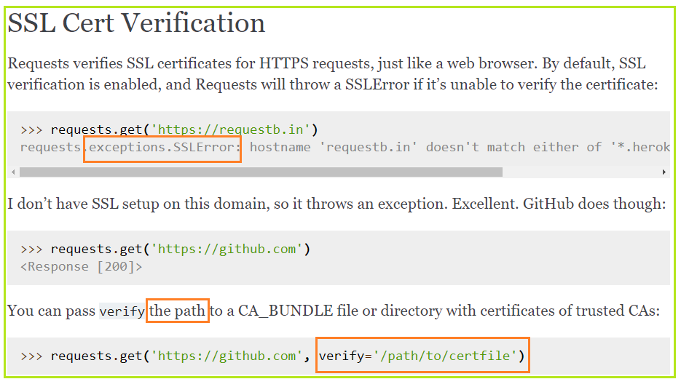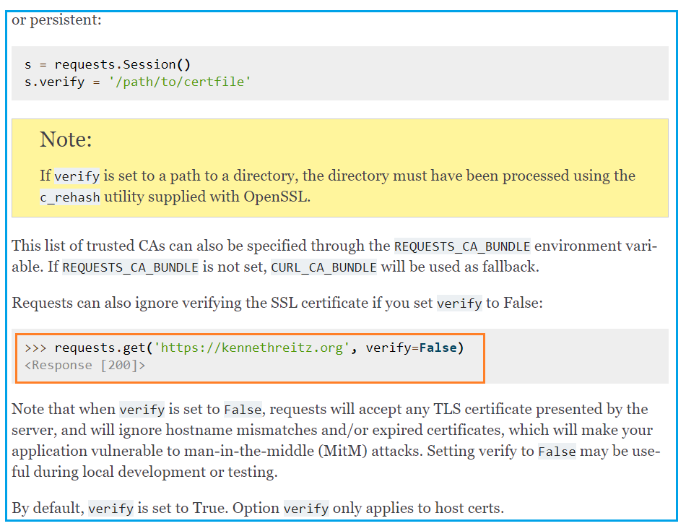

Learn about Release & Monitor products

<https://firebase.google.com/docs/release>

Firebase Test Lab

<https://firebase.google.com/docs/test-lab>

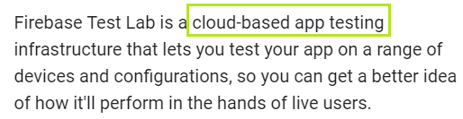

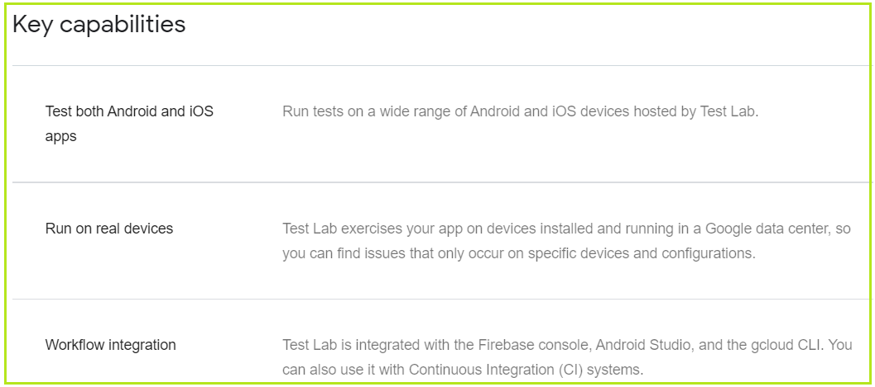

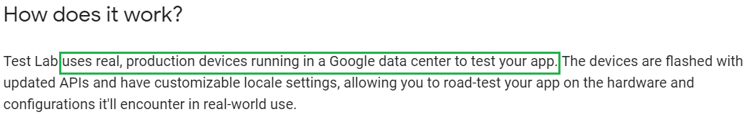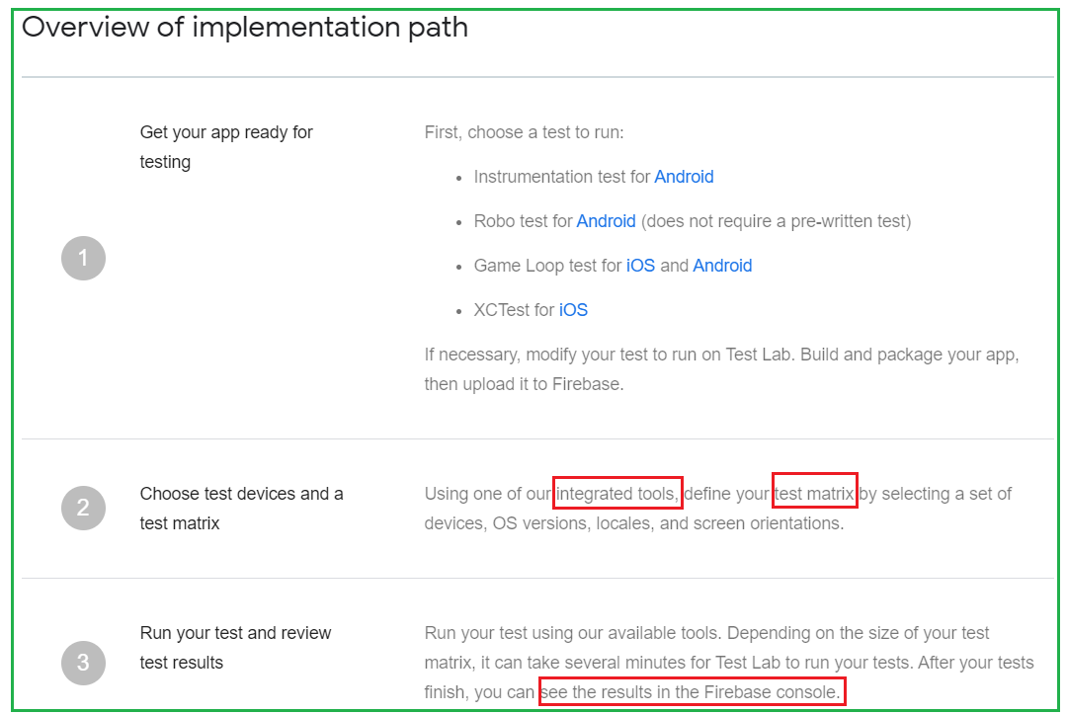

Install Agents on Android Devices

<https://success.vipre.com/endpoint-server-onboarding/endpoint-server-install-android-agent>

## Install Agents on iOS Devices

<https://success.vipre.com/endpoint-server-onboarding/endpoint-server-install-ios-agent>

install an agent to ios device

## ****Step 1****: Prepare your test for uploading to Test Lab

You can run the following tests with Test Lab. Note that all test types can run up to a maximum of 45 minutes on physical devices, and any uncaught exception will cause a test failure.

* **XCTest (including XCUITests)**: A unit test you've written using the [XCTest framework](https://developer.apple.com/documentation/xctest). Visit [Create an XCTest](https://firebase.google.com/docs/test-lab/ios/run-xctest) for instructions on modifying an XCTest to run with Test Lab.
* **Game Loop test**: A test that uses a "demo mode" to simulate player actions in gaming apps. This is a fast and scalable way to verify that your game performs well for users. When you choose to run a Game Loop test, you can:
  + Write tests native to your game engine.
  + Avoid writing the same code for different UIs or testing frameworks.
  + Optionally create multiple loops to run in a single test execution. You can also organize loops by using labels so you can keep track of them and re-run specific loops.

Visit [Run a Game Loop test](https://firebase.google.com/docs/test-lab/ios/run-game-loop-test) for instructions on how to run your test in Test Lab.

## ****Step 2****: Choose a tool to run your test

You can choose the following tools to run your test with:

* The **Firebase console** lets you upload an app and initiate testing from anywhere. See [Test with the Firebase console](https://firebase.google.com/docs/test-lab/ios/firebase-console) for instructions on using this tool.
* The **gcloud command line interface (CLI)** enables you to run tests from the command line interactively, and is also well suited for scripting as part of your automated build and testing process. See [**Test with the gcloud** CLI](https://firebase.google.com/docs/test-lab/ios/command-line) for instructions on using this tool.
* Before testing on real devices, run your test **locally on a simulator** to make sure it behaves as intended. See [Test locally](https://firebase.google.com/docs/test-lab/ios/test-locally) for instructions.

## ****Step 3****: Specify testing devices

With Test Lab, you can run your test against your app on a wide range of iOS devices and models hosted in a Google data center. To learn more, see [Available devices.](https://firebase.google.com/docs/test-lab/ios/available-testing-devices)

## ****Step 4****: Review test results

Regardless of how you initiate your tests, all your test results are managed by Test Lab and can be viewed online.

The **test result summary** is automatically stored and can be viewed in the Firebase console. It contains the most relevant data for your test, including test case-specific videos, screenshots, the number of tests that passed, failed, or got flaky results, and more.

The **raw test results** contain test logs and app failure details, and is automatically stored in a Google Cloud bucket. If you specify a bucket, you are responsible for the cost of the storage. If you don't specify a bucket, Test Lab creates one for you for free.

For more details, see [Analyze Firebase Test Lab Results.](https://firebase.google.com/docs/test-lab/analyzing-results)

## Device cleanup

Google takes the security of your app data very seriously. We follow industry-standard best practices to remove app data and reset system settings for physical devices after every test run to ensure that they are ready to run new tests. For devices that we can flash with a custom recovery image, we go one step further by flashing these devices between test runs.

For the virtual devices used by Test Lab, device instances are deleted after they are used so that each test run uses a new virtual device instance.

## IP addresses used by Test Lab devices

All network traffic generated by Test Lab devices originates from the following [IP address blocks](https://en.wikipedia.org/wiki/Classless_Inter-Domain_Routing#CIDR_notation). Note that you can also access this list by using the gcloud beta firebase test ip-blocks list command in the gcloud CLI. The list is updated periodically (once per year on average).

|  |  |
| --- | --- |
| **Platform and device type** | **CIDR IP address block** |
| Android and iOS physical devices | 108.177.6.0/23  70.32.147.112/28 (added 03-2020)  74.125.122.32/29 (added 04-2020)  108.177.29.80/28 (added 04-2020)  216.239.44.24/29 (added 04-2020) |
| Android virtual devices | 34.68.194.64/29 (added 11-2019)  34.69.234.64/29 (added 11-2019)  34.73.34.72/29 (added 11-2019)  34.73.178.72/29 (added 11-2019)  35.192.160.56/29  35.196.166.80/29 |

Firebase Android Codelab - Build Friendly Chat

<https://firebase.google.com/codelabs/firebase-android#0>

Get started with Firebase Test Lab from the Firebase Console

<https://firebase.google.com/docs/test-lab/ios/firebase-console>

Firebase Crashlytics

<https://firebase.google.com/docs/crashlytics>

Firebase App Distribution

<https://firebase.google.com/docs/app-distribution>

<https://www.youtube.com/watch?v=scfOk5SgrKU>