<https://blog.csdn.net/qq_44663072/article/details/115978070?spm=1001.2101.3001.6661.1&utm_medium=distribute.pc_relevant_t0.none-task-blog-2%7Edefault%7ECTRLIST%7Edefault-1-115978070-blog-122211779.pc_relevant_aa&depth_1-utm_source=distribute.pc_relevant_t0.none-task-blog-2%7Edefault%7ECTRLIST%7Edefault-1-115978070-blog-122211779.pc_relevant_aa&utm_relevant_index=1>

<https://blog.csdn.net/weixin_46745811/article/details/122290452?spm=1001.2101.3001.6650.8&utm_medium=distribute.pc_relevant.none-task-blog-2%7Edefault%7EBlogCommendFromBaidu%7Edefault-8-122290452-blog-115978070.pc_relevant_default&depth_1-utm_source=distribute.pc_relevant.none-task-blog-2%7Edefault%7EBlogCommendFromBaidu%7Edefault-8-122290452-blog-115978070.pc_relevant_default&utm_relevant_index=13>

<https://blog.csdn.net/Michaelyq1229/article/details/115311459?spm=1001.2101.3001.6650.7&utm_medium=distribute.pc_relevant.none-task-blog-2%7Edefault%7EBlogCommendFromBaidu%7Edefault-7-115311459-blog-115978070.pc_relevant_default&depth_1-utm_source=distribute.pc_relevant.none-task-blog-2%7Edefault%7EBlogCommendFromBaidu%7Edefault-7-115311459-blog-115978070.pc_relevant_default&utm_relevant_index=12>

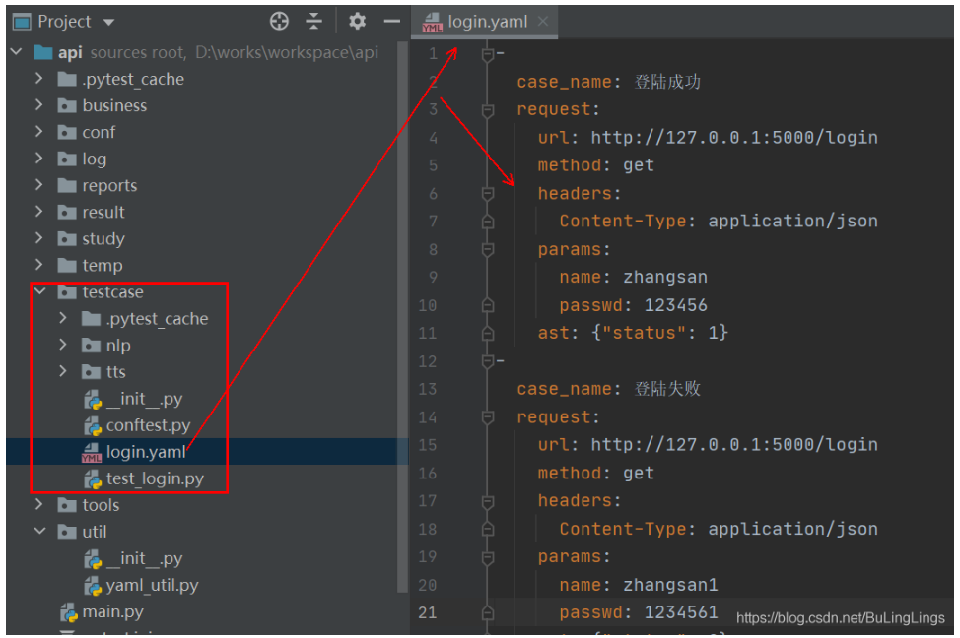 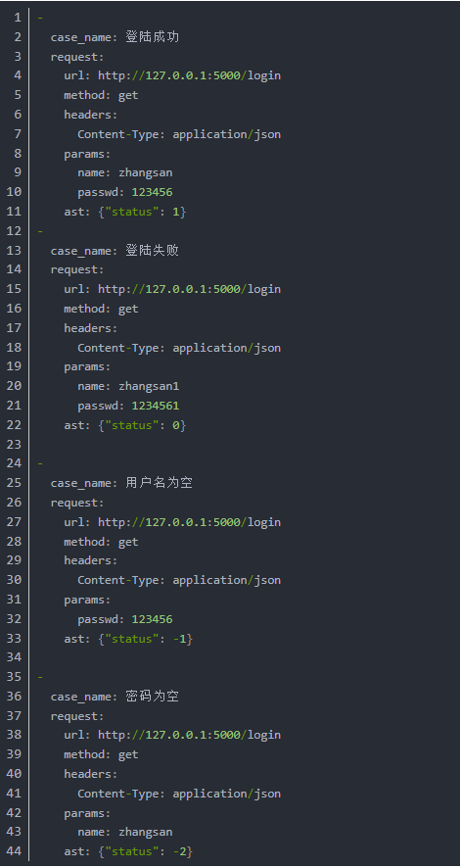 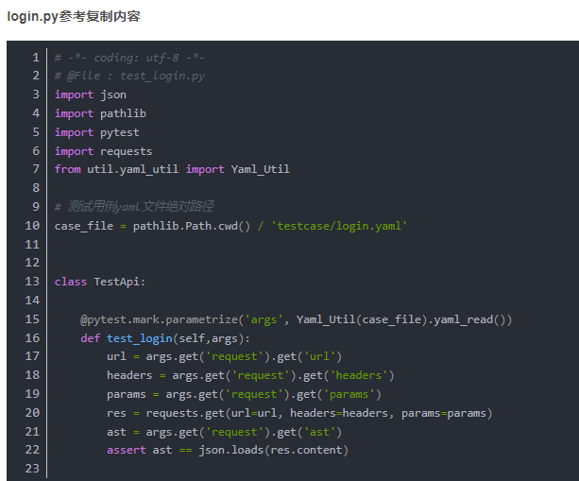 <https://blog.csdn.net/qq_27371025/article/details/118435918?utm_medium=distribute.pc_relevant.none-task-blog-2~default~baidujs_baidulandingword~default-0-118435918-blog-119703845.pc_relevant_default&spm=1001.2101.3001.4242.1&utm_relevant_index=2>

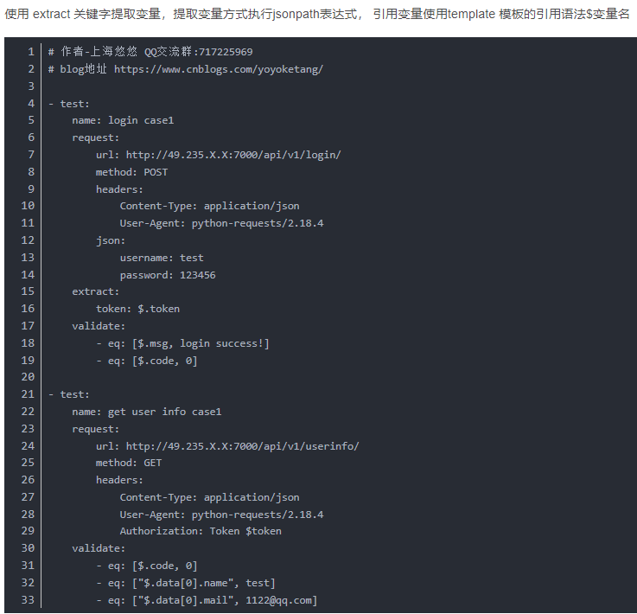

<https://blog.csdn.net/weixin_44999591/article/details/121145076?spm=1001.2101.3001.6650.6&utm_medium=distribute.pc_relevant.none-task-blog-2%7Edefault%7EBlogCommendFromBaidu%7Edefault-6-121145076-blog-115978070.pc_relevant_default&depth_1-utm_source=distribute.pc_relevant.none-task-blog-2%7Edefault%7EBlogCommendFromBaidu%7Edefault-6-121145076-blog-115978070.pc_relevant_default&utm_relevant_index=11>

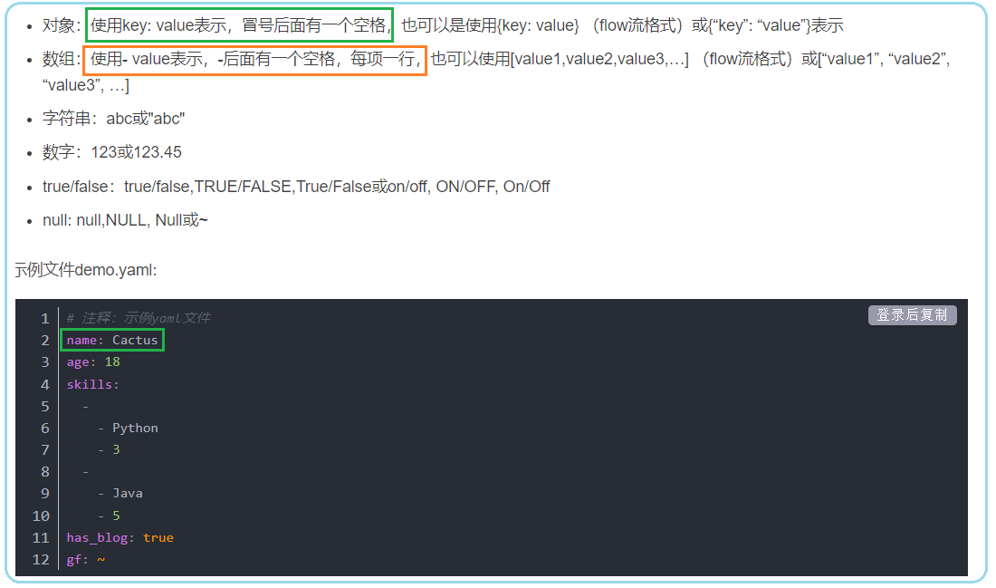 <https://blog.csdn.net/weixin_45589713/article/details/108546385?spm=1001.2101.3001.6650.1&utm_medium=distribute.pc_relevant.none-task-blog-2%7Edefault%7ECTRLIST%7Edefault-1-108546385-blog-121145076.pc_relevant_default&depth_1-utm_source=distribute.pc_relevant.none-task-blog-2%7Edefault%7ECTRLIST%7Edefault-1-108546385-blog-121145076.pc_relevant_default&utm_relevant_index=2>

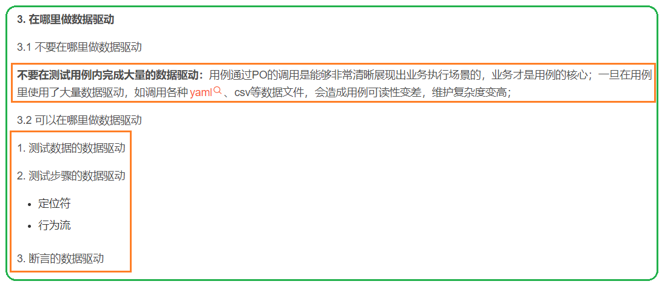 <https://blog.csdn.net/u010452967/article/details/117750469?utm_medium=distribute.pc_relevant.none-task-blog-2~default~baidujs_utm_term~default-4.pc_relevant_default&spm=1001.2101.3001.4242.3&utm_relevant_index=7>