Pytest framework

5/28, 6/1/21, 10/27/22

**Pytest selenium testing**

**Pytest rest API testing**

# **JSON vs YAML**

https://levelup.gitconnected.com/json-vs-yaml-6aa0243aefc6

<https://paiml.com/docs/home/books/testing-in-python/chapter07-pytest-fixtures/>

<https://www.programcreek.com/python/example/81420/pytest.fixture>

<https://semaphoreci.com/community/tutorials/testing-python-applications-with-pytest>

<https://www.lambdatest.com/blog/end-to-end-tutorial-for-pytest-fixtures-with-examples/>

<https://www.codestudyblog.com/cnb11/1124181049.html>

<https://www.seanh.cc/2017/02/12/advanced-fixtures/>

<https://smarie.github.io/python-pytest-harvest/advanced_usage/>

<https://www.automationlaboratories.com/python/fixtures-in-pytest-automation-laboratories/>

[**https://metareal.blog/en/post/2020/04/25/useful-pytest-fixtures-to-help-you-improve-legacy-code/**](https://metareal.blog/en/post/2020/04/25/useful-pytest-fixtures-to-help-you-improve-legacy-code/)

[**https://martinheinz.dev/posts/**](https://martinheinz.dev/posts/)

**https://docs.python.org/3/library/functools.html#functools.lru_cache**

[**https://github.com/pytest-dev/pytest/issues/6374**](https://github.com/pytest-dev/pytest/issues/6374)

[**https://miguendes.me/3-ways-to-test-api-client-applications-in-python**](https://miguendes.me/3-ways-to-test-api-client-applications-in-python)

[**https://towardsdatascience.com/testing-best-practices-for-machine-learning-libraries-41b7d0362c95**](https://towardsdatascience.com/testing-best-practices-for-machine-learning-libraries-41b7d0362c95)

[**https://www.programmersought.com/article/68147317398/**](https://www.programmersought.com/article/68147317398/)

[**https://www.programmersought.com/**](https://www.programmersought.com/)

[**https://www.programmersought.com/article/7374804551/**](https://www.programmersought.com/article/7374804551/)

### Pytest + allure + jenkins generates beautiful test reports

[**https://www.programmersought.com/article/69875291699/**](https://www.programmersought.com/article/69875291699/)

**6/3/21**

[**https://www.programmersought.com/search**](https://www.programmersought.com/search)

[**https://www.programmersought.com/article/35594509590/**](https://www.programmersought.com/article/35594509590/)

* [**https://blog.csdn.net/songlh1234/article/details/84317617?utm_medium=distribute.pc_relevant.none-task-blog-2%7Edefault%7EBlogCommendFromMachineLearnPai2%7Edefault-3.control&depth_1-utm_source=distribute.pc_relevant.none-task-blog-2%7Edefault%7EBlogCommendFromMachineLearnPai2%7Edefault-3.control**](https://blog.csdn.net/songlh1234/article/details/84317617?utm_medium=distribute.pc_relevant.none-task-blog-2%7Edefault%7EBlogCommendFromMachineLearnPai2%7Edefault-3.control&depth_1-utm_source=distribute.pc_relevant.none-task-blog-2%7Edefault%7EBlogCommendFromMachineLearnPai2%7Edefault-3.control)
* [**https://download.csdn.net/download/weixin_39841365/11510989?utm_medium=distribute.pc_relevant.none-task-download-2%7Edefault%7EBlogCommendFromMachineLearnPai2%7Edefault-2.control&depth_1-utm_source=distribute.pc_relevant.none-task-download-2%7Edefault%7EBlogCommendFromMachineLearnPai2%7Edefault-2.control**](https://download.csdn.net/download/weixin_39841365/11510989?utm_medium=distribute.pc_relevant.none-task-download-2%7Edefault%7EBlogCommendFromMachineLearnPai2%7Edefault-2.control&depth_1-utm_source=distribute.pc_relevant.none-task-download-2%7Edefault%7EBlogCommendFromMachineLearnPai2%7Edefault-2.control)
* [**https://luanpeng.blog.csdn.net/article/details/79457867?utm_medium=distribute.pc_relevant.none-task-blog-2%7Edefault%7EBlogCommendFromBaidu%7Edefault-9.control&depth_1-utm_source=distribute.pc_relevant.none-task-blog-2%7Edefault%7EBlogCommendFromBaidu%7Edefault-9.control**](https://luanpeng.blog.csdn.net/article/details/79457867?utm_medium=distribute.pc_relevant.none-task-blog-2%7Edefault%7EBlogCommendFromBaidu%7Edefault-9.control&depth_1-utm_source=distribute.pc_relevant.none-task-blog-2%7Edefault%7EBlogCommendFromBaidu%7Edefault-9.control)
* [**https://blog.csdn.net/weixin_43360384/article/details/89032190?utm_medium=distribute.pc_relevant.none-task-blog-baidujs_baidulandingword-9&spm=1001.2101.3001.4242**](https://blog.csdn.net/weixin_43360384/article/details/89032190?utm_medium=distribute.pc_relevant.none-task-blog-baidujs_baidulandingword-9&spm=1001.2101.3001.4242)
* [**https://blog.csdn.net/weixin_35564059/article/details/113314192?utm_medium=distribute.pc_relevant.none-task-blog-baidujs_baidulandingword-8&spm=1001.2101.3001.4242**](https://blog.csdn.net/weixin_35564059/article/details/113314192?utm_medium=distribute.pc_relevant.none-task-blog-baidujs_baidulandingword-8&spm=1001.2101.3001.4242)
* [**https://blog.csdn.net/songlh1234/article/details/84317617?utm_medium=distribute.pc_relevant.none-task-blog-2%7Edefault%7EBlogCommendFromMachineLearnPai2%7Edefault-3.control&depth_1-utm_source=distribute.pc_relevant.none-task-blog-2%7Edefault%7EBlogCommendFromMachineLearnPai2%7Edefault-3.control**](https://blog.csdn.net/songlh1234/article/details/84317617?utm_medium=distribute.pc_relevant.none-task-blog-2%7Edefault%7EBlogCommendFromMachineLearnPai2%7Edefault-3.control&depth_1-utm_source=distribute.pc_relevant.none-task-blog-2%7Edefault%7EBlogCommendFromMachineLearnPai2%7Edefault-3.control)
* [**https://blog.csdn.net/u011541946/category_6788788_1.html**](https://blog.csdn.net/u011541946/category_6788788_1.html)
* [**https://blog.csdn.net/baynkbtg/article/details/82971575?utm_medium=distribute.pc_relevant.none-task-blog-baidujs_baidulandingword-0&spm=1001.2101.3001.4242**](https://blog.csdn.net/baynkbtg/article/details/82971575?utm_medium=distribute.pc_relevant.none-task-blog-baidujs_baidulandingword-0&spm=1001.2101.3001.4242)

**Project_list**

[**https://www.programmersought.com/article/75528077144/**](https://www.programmersought.com/article/75528077144/)

* **Jenkens**
* [**https://www.programmersought.com/article/51847596914/**](https://www.programmersought.com/article/51847596914/)
* [**https://www.programmersought.com/article/89048200965/**](https://www.programmersought.com/article/89048200965/)
* [**https://www.programmersought.com/article/11864295034/**](https://www.programmersought.com/article/11864295034/)
* [**https://www.programmersought.com/article/58947895601/**](https://www.programmersought.com/article/58947895601/)
* [**https://www.programmersought.com/article/27818278502/**](https://www.programmersought.com/article/27818278502/)
* [**https://www.programmersought.com/article/58947895601/**](https://www.programmersought.com/article/58947895601/)
* [**https://www.programmersought.com/article/18665825318/**](https://www.programmersought.com/article/18665825318/)
* [**https://www.programmersought.com/article/47486766379/**](https://www.programmersought.com/article/47486766379/)
* [**https://www.programmersought.com/article/90598237604/**](https://www.programmersought.com/article/90598237604/)
* [**https://www.programmersought.com/article/98248333508/**](https://www.programmersought.com/article/98248333508/)
* [**https://www.programmersought.com/article/48518438429/**](https://www.programmersought.com/article/48518438429/)
* [**https://www.programmersought.com/article/90143416436/**](https://www.programmersought.com/article/90143416436/)
* [**https://www.programmersought.com/article/43345824919/**](https://www.programmersought.com/article/43345824919/)
* [**https://www.programmersought.com/article/58947895601/**](https://www.programmersought.com/article/58947895601/)
* [**https://www.programmersought.com/article/86618437898/**](https://www.programmersought.com/article/86618437898/)
* **Pytest framework**
* **interface automation framework (Pytest+request+Allure)**
* [**https://www.programmersought.com/article/33377309172/**](https://www.programmersought.com/article/33377309172/)
* **pytest+yaml+allure interface automated testing framework**
* [**https://www.programmersought.com/article/48956553079/**](https://www.programmersought.com/article/48956553079/)
* **Requests+pytest+allure interface automated test steps**
* [**https://www.programmersought.com/article/41785614899/**](https://www.programmersought.com/article/41785614899/)

### Pytest+Allure+jsonpath+xlrd+excel, supports Restful interface specification

* [**https://www.programmersought.com/article/57457398216/**](https://www.programmersought.com/article/57457398216/)

# **Pytest Automation Test Framework**

* [**https://www.programmersought.com/article/86618437898/**](https://www.programmersought.com/article/86618437898/)
* **Pytest Request**
* [**https://www.programmersought.com/article/13538108909/**](https://www.programmersought.com/article/13538108909/)
* **Automated testing based on pytest framework**
* [**https://www.programmersought.com/article/4321960107/**](https://www.programmersought.com/article/4321960107/)

### Automated test development practice based on Pytest framework

* https://www.programmersought.com/article/89836092087/
* **API test**

### Python + Requests + Pytest + Excel + Allure (2) Interface Automation Test

* **(**[**https://www.programmersought.com/article/45618056961/**](https://www.programmersought.com/article/45618056961/)**)**

### Interface automation request + pytest

* [**https://www.programmersought.com/article/88257301490/**](https://www.programmersought.com/article/88257301490/)

### Requests Interface Test (Request + Pytest + Allure + excel)

* [**https://www.programmersought.com/article/10358320349/**](https://www.programmersought.com/article/10358320349/)
* **Selenium pytest**

### **Selenium Page Object Model**

Each page has a page class, defining elements locator and operations for these elements or certain functionality.

Base class includes all common functions of selenium ops.

* [**https://www.programmersought.com/article/85987570593/**](https://www.programmersought.com/article/85987570593/)
* [**https://www.programmersought.com/article/4934338788/**](https://www.programmersought.com/article/4934338788/)
* [**https://blog.csdn.net/haoxun06/article/details/104383331**](https://blog.csdn.net/haoxun06/article/details/104383331)
* [**https://blog.csdn.net/fei347795790/article/details/88980656?utm_medium=distribute.pc_relevant_download.none-task-blog-baidujs-1.nonecase&depth_1-utm_source=distribute.pc_relevant_download.none-task-blog-baidujs-1.nonecase**](https://blog.csdn.net/fei347795790/article/details/88980656?utm_medium=distribute.pc_relevant_download.none-task-blog-baidujs-1.nonecase&depth_1-utm_source=distribute.pc_relevant_download.none-task-blog-baidujs-1.nonecase)
* [**https://blog.csdn.net/u011541946/category_6788788_1.html**](https://blog.csdn.net/u011541946/category_6788788_1.html)

### Selenium automated testing Pytest framework combat

* <https://www.programmersought.com/article/14756340517/>

### Appium+Python+pytest automated testing framework

* <https://www.programmersought.com/article/72214996554/>
* **Selenium automated testing framework use**
* [**https://www.programmersought.com/article/97245689471/**](https://www.programmersought.com/article/97245689471/)

### Selenium webdriver Automation basics

* <https://www.programmersought.com/article/30051939600/>
* [https://www.programmersought.com/article/**71081958461**/](https://www.programmersought.com/article/71081958461/)
* [**https://www.programmersought.com/article/3468338597/**](https://www.programmersought.com/article/3468338597/)
* Selenium techniques
* Wait/switch
* <https://www.programmersought.com/article/23392659839/>
* Basics of selenium
* <https://www.programmersought.com/article/92965117712/>

**https://blog.csdn.net/liudinglong1989/article/details/106206212?ops_request_misc=&request_id=&biz_id=102&utm_term=pytest%25E5%258F%2582%25E6%2595%25B0%25E5%258C%2596&utm_medium=distribute.pc_search_result.none-task-blog-2~all~sobaiduweb~default-4-106206212.first_rank_v2_pc_rank_v29**

1. **Pytest**

Pytest is a python based testing **framework**, which is used to write and execute test codes. In the present days of REST services, pytest is mainly used for API testing even though we can use pytest to write simple to complex tests, i.e., we can write codes to test API, database, UI, etc.

## Advantages of Pytest

* Pytest can **run multiple tests in parallel**, which reduces the execution time of the test suite.
* Pytest has its own way to **detect the test file and test functions** automatically, if not mentioned explicitly.
* Pytest allows us to **skip** a subset of the tests during execution.
* Pytest allows us to run a subset of the entire test suite.
* Pytest is free and open source.

Running pytest without mentioning a filename will run all files of format **test_*.py** or **\*_test.py** in the current directory and subdirectories. Pytest automatically identifies those files as test files. We **can** make pytest run other filenames by explicitly mentioning them.

* Pytest requires the **test function names to start with test**. Function names which are not of format **test\*** are not considered as test functions by pytest. We **cannot** explicitly make pytest consider any function not starting with **test** as a test function.

pytest command will execute all the files of format **test_\*** or **\*_test** **in the current directory and subdirectories.**

To execute the tests from a specific file, use the following syntax −

pytest <filename> -v

1. **Fixture**

* We can think of fixtures as resources. You need to configure these resources before your test cases are executed. You need to release resources after execution. For example, a fixture of type module is suitable for operations that many test cases only need to be executed once.
* The fixture also provides parameterization to select different parameters based on configuration and different components.
* The main purpose of the fixture is to provide a reliable and repeatable way to run the most basic test content. For example, when testing the function of a website, **each test case must be logged in and logged out**, and the fixture can be used only once, otherwise each test case has to be done in two steps and is redundant.

pytest fixtures are functions attached to the tests which **run before** the test function is executed. Fixtures are a set of resources that have to be set up before and cleaned up once the Selenium test automation execution is completed

A fixture function defined inside a test file has a scope within the test file only. We cannot use that fixture in another test file. To make a fixture available to multiple test files, we have to define the fixture function in a file called conftest.py. **conftest.py** is explained in the next chapter.

@pytest.fixture()  
def before():  
 print('\nbefore each test')  
  
  
def test_1(before):  
 print('test_1()')  
  
  
def test_2(before):  
 print('test_2()')

Output:

before each test  
test_1()  
.  
before each test  
test_2()

With the default parameters for ‘pytest.fixture()’, **the fixture is going to be called for every test that names the fixture in it’s parameter list**.

1. **Fixture example**

import pytest  
  
def is_even(n: int) -> bool:  
 *"""Returns True if n is even."""* print("\nfunction--is_even is called")  
 return n % 2 == 0  
  
  
@pytest.fixture()  
def two():  
 print("\nfixture two() is called")  
 return 2  
  
@pytest.fixture()  
def four():  
 return 4  
  
# def test_four_is_even(four):  
# """Asserts that four is even"""  
# assert is_even(four)  
#  
def test_two_is_even(two):  
 *"""Asserts that two is even"""* assert is_even(two)  
  
def test_not_call_fixture_directly(two):  
 assert 1 == 1  
  
  
def test_call_fixture_directly(two):  
 print(two)  
 assert two == 2

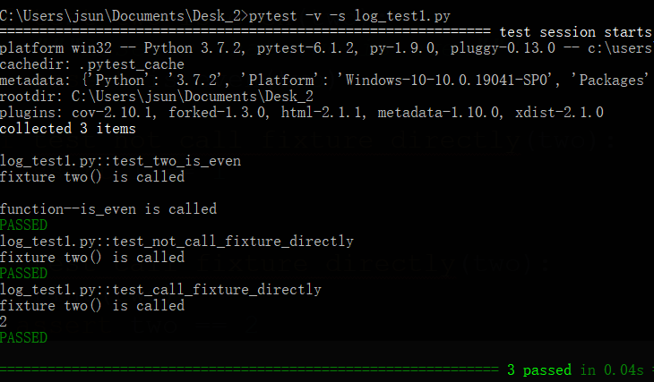

**passing a fixture as argument in a parameterized test doesn't work**

import pytest  
  
def is_even(n: int) -> bool:  
 *"""Returns True if n is even."""* return n % 2 == 0  
  
  
@pytest.fixture()  
def one():  
 return 1  
  
@pytest.fixture()  
def three():  
 return 3  
  
  
#passing a fixture as argument in a parameterized test doesn't work  
@pytest.mark.parametrize(  
 "a, b",  
 [  
 (one, four),  
 (two, three),  
 ],  
)  
def test_multiply_is_even(a, b):  
 *"""Assert that an odd number times even is even."""* assert is_even(a * b)

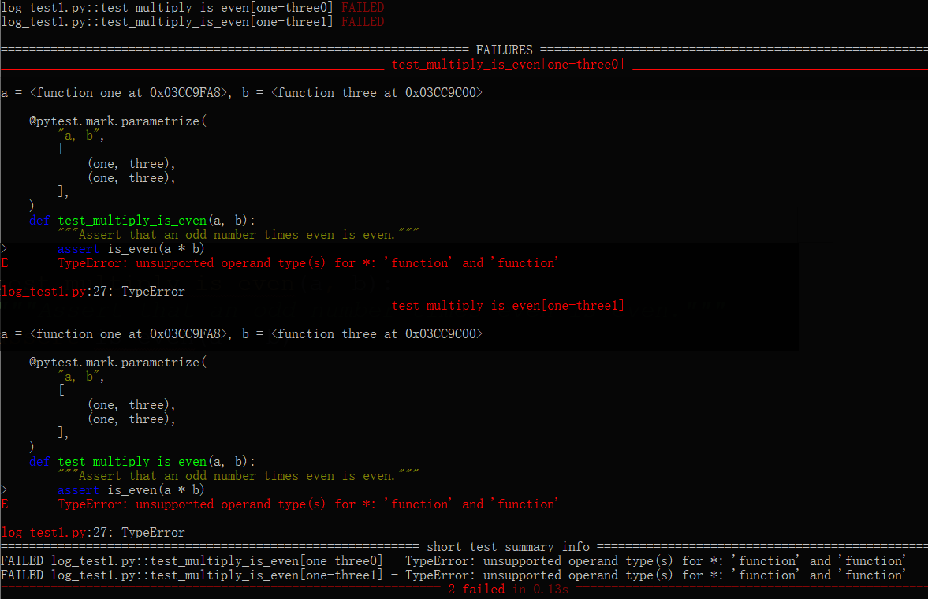

1. **Ex 2**

To make that possible, we have two alternatives. The first one is using request.getfixturevalue, which is available on pytest. This function dynamically runs a named fixture function.

import pytest  
  
@pytest.fixture(params=[1, 2])  
def one(request):  
 return request.param  
  
@pytest.mark.parametrize('arg1,arg2', [  
 ('val1', pytest.lazy_fixture('one')),  
])  
def test_func(arg1, arg2):  
 assert arg2 in [1, 2]

import pytest  
import pytest-lazy-fixture  
  
def is_even(n: int) -> bool:  
 *"""Returns True if n is even."""* return n % 2 == 0  
  
  
@pytest.fixture()  
def one():  
 return 1  
  
@pytest.fixture()  
def three():  
 return 3  
  
# @pytest.mark.parametrize(  
# "a, b",  
# [  
# (one, three),  
# (one, three),  
# ]  
# )  
# # def test_multiply_is_even(a, b):  
# # """Assert that an odd number times even is even."""  
# # assert is_even(a * b)  
# def test_multiply_is_even_request(a, b, request):  
# """Assert that an odd number times even is even."""  
# a = request.getfixturevalue(a)  
# b = request.getfixturevalue(b)  
# assert is_even(a * b)  
  
  
# pip install pytest-lazy-fixture  
@pytest.mark.parametrize(  
 "a, b",  
 [  
 (pytest.lazy_fixture(("one", "four"))),  
 # same as (pytest.lazy_fixture(("two", "three")))  
 (pytest.lazy_fixture("two"), pytest.lazy_fixture("three")),  
 ],  
)  
def test_multiply(a, b):  
 *"""Assert that an odd number times even is even."""* assert is_even(a * b)

1. **Three ways to use a fixture**
2. **name it** from the test.

@pytest.fixture()  
def **before**():  
 print('\nbefore each test')  
  
  
def test_1(**before**):  
 print('test_1()')  
  
  
def test_2(**before**):  
 print('test_2()')

1. **usefixtures decorator**  
   You can mark a test or a test class with ‘pytest.mark.usefixtures()’ and include a list of fixtures to be used with the test or class of tests.  
   This is especially convenient when dealing with test classes.  
   It also is useful when converting unittest classes to use pytest fixtures.  
   I’ll give an example shortly.

@pytest.fixture()  
def before():  
 print('\nbefore each test')  
  
  
@pytest.**mark.usefixtures("before")**   
def test_1():  
 print('test_1()')  
  
@pytest.mark.usefixtures("before")   
def test_2():  
 print('test_2()')

class Test:  
 @pytest.mark.usefixtures("before")  
 def test_1(self):  
 print('test_1()')  
  
 @pytest.mark.usefixtures("before")  
 def test_2(self):  
 print('test_2()')

@pytest.fixture()  
def before():  
 print('\nbefore each test')  
  
  
@pytest.mark.usefixtures("before")  
class Test:  
 def test_1(self):  
 print('test_1()')  
  
 def test_2(self):  
 print('test_2()')

1. **autouse**

@pytest.fixture(**scope**='function', **params**=None, **autouse**=False)  
def before(**request**):  
 print('\nbefore()')  
 return None

1. **Return value**
2. Returning some data from a fixture

**@pytest.fixture()  
def some_data():  
 data = {'foo':1, 'bar':2, 'baz':3}  
 return data**  
  
def test_foo(**some_data**):  
 assert **some_data['foo']** == 1

1. Returning a database object

@pytest.fixture()  
def cheese_db(request):  
 print('\n[setup] cheese_db, connect to db')  
 # code to connect to your db   
 a_dictionary_for_now = {'Brie': 'No.', 'Camenbert': 'Ah! We have Camenbert, yessir.'}  
 def fin():  
 print('\n[teardown] cheese_db finalizer, disconnect from db')  
 request.addfinalizer(fin)  
 return a_dictionary_for_now  
  
def test_cheese_database(cheese_db):  
 print('in test_cheese_database()')  
 for variety in cheese_db.keys():  
 print('%s : %s' % (variety, cheese_db[variety]))  
  
def test_brie(cheese_db):  
 print('in test_brie()')  
 assert cheese_db['Brie'] == 'No.'   
  
def test_camenbert(cheese_db):  
 print('in test_camenbert()')  
 assert cheese_db['Camenbert'] != 'No.'

The ‘fin’ function is acting as the ‘teardown’ for the fixture.  
There’s nothing special about the name.

**The finalizer is called after all of the tests that use the fixture????**.  
If you’ve used [parameterized fixtures](https://pythontesting.net/framework/pytest/pytest-fixtures-nuts-bolts/#params), the finalizer is called between instances of the parameterized fixture changes.

Since the default scope is "function", the [cheese db example](https://pythontesting.net/framework/pytest/pytest-fixtures-nuts-bolts/#cheese_example) will open and close the db for every test.

**[setup] cheese_db, connect to db**  
in test_cheese_database()  
Camenbert : Ah! We have Camenbert, yessir.  
Brie : No.  
.  
**[teardown]** **cheese_db finalizer, disconnect from db**  
  
[setup] cheese_db, connect to db  
in test_brie()  
.  
**[teardown]** cheese_db finalizer, disconnect from db  
  
[setup] cheese_db, connect to db  
in test_camenbert()  
.  
**[teardown]** cheese_db finalizer, disconnect from db

Change the scope to “module”, the [teardown] will only run once for all the tests.

import pytest  
  
  
@pytest.fixture(scope="module")  
def cheese_db(request):  
 print('\n[setup] cheese_db, connect to db')  
 # code to connect to your db   
 a_dictionary_for_now = {'Brie': 'No.', 'Camenbert': 'Ah! We have Camenbert, yessir.'}  
 def fin():  
 print('\n[teardown] cheese_db finalizer, disconnect from db')  
 request.addfinalizer(fin)  
 return a_dictionary_for_now  
  
def test_cheese_database(cheese_db):  
 print('in test_cheese_database()')  
 for variety in cheese_db.keys():  
 print('%s : %s' % (variety, cheese_db[variety]))  
  
def test_brie(cheese_db):  
 print('in test_brie()')  
 assert cheese_db['Brie'] == 'No.'   
  
def test_camenbert(cheese_db):  
 print('in test_camenbert()')  
 assert cheese_db['Camenbert'] != 'No.'

C:\Users\jsun\Documents\Desk_2>python -m pytest log_test.py -v -s

collected 3 items  
  
log_test.py::test_cheese_database  
**[setup]** **cheese_db, connect to db**  
in test_cheese_database()  
Brie : No.  
Camenbert : Ah! We have Camenbert, yessir.  
**PASSED**  
log_test.py::test_brie in test_brie()  
**PASSED**  
log_test.py::test_camenbert in test_camenbert()  
**PASSED**  
**[teardown]** **cheese_db finalizer, disconnect from db**

### **Scope**

Scope controls how often a fixture gets called. The default is "function".  
Here are the options for scope:

|  |  |
| --- | --- |
| **function** | Run once per test |
| **class** | Run once per class of tests |
| **module** | Run once per module |
| **session** | Run once per session |

1. **Parameterizing Tests**

import pytest  
  
@pytest.mark.parametrize("num,output",[(1,11),(2,22),(3,35),(4,44)])  
def test_multiplication_11(num, output):  
 assert 11*num == output

import pytest  
import requests  
  
@pytest.mark.parametrize('endpoint', [  
 "https://www.google.it",  
 "https://www.google.com"  
])  
def test_parametrized(endpoint):  
 *"""  
 this will create two tests, one for every value of the endpoint parameter  
 """* print("checking : " + endpoint)  
 assert requests.get(endpoint).status_code == 200  
  
@pytest.fixture(scope="session")  
def get_endpoints():  
 return [  
 "https://www.google.it",  
 "https://www.google.com"  
 ]  
  
def test_using_fixture(get_endpoints):  
 *"""this will assert the result of the fixture"""* assert get_endpoints == [  
 "https://www.google.it",  
 "https://www.google.com"  
 ]  
  
#ERROR: parametrize can't pass fixture  
# @pytest.mark.parametrize('endpoint', get_endpoints)  
# def test_parametrizing_using_fixture(endpoint):  
# """  
# this should load data from get_endpoints fixture and pass every value of  
# get_endpoints as endpoint value  
# """  
# print("checking : " + endpoint)  
# assert requests.get(endpoint).status_code == 200

import pytest  
import requests  
  
  
  
@pytest.fixture(scope = "session", params = [  
 "https://www.google.it",  
 "https://www.google.com"  
])  
def endpoint(request):  
 return request.param  
  
  
def test_parametrizing_using_fixture(endpoint):  
 print("checking : " + endpoint)  
 assert requests.get(endpoint).status_code == 200

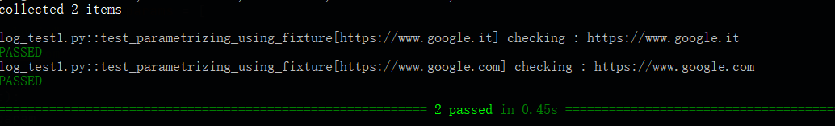

1. **Grouping the test**

Pytest allows us to use markers on test functions. Markers are used to set various features/attributes to test functions. Pytest provides many inbuilt markers such as xfail, skip and parametrize. Apart from that, users can create their own marker names. Markers are applied on the tests using the syntax given below −

@pytest.mark.<markername>

**pytest -m <markername> -v**

**pytest -m great -v**

import pytest  
@pytest.mark.great  
def test_greater():  
 num = 100  
 assert num > 100  
  
@pytest.mark.great  
def test_greater_equal():  
 num = 100  
 assert num >= 100  
  
@pytest.mark.others  
def test_less():  
 num = 100  
 assert num < 200

# **Stop Test Suite after N Test Failures**

1. **Stop the test suite after N test failures.**

In a real scenario, once a new version of the code is ready to deploy, it is first deployed into **pre-prod/staging environment**. Then a test suite runs on it.

The code is qualified for deploying to production only if the test suite passes. If there is test failure, whether it is one or many, the code is not production ready.

Therefore, what if we want to stop the execution of test suite soon after n number of test fails. This can be done in **pytest** using **maxfail**.

The syntax to stop the execution of test suite soon **after n number of test fails** is as follows –

pytest **--maxfail=<num>**

import pytest  
import math  
  
def test_sqrt_failure():  
 num = 25  
 assert math.sqrt(num) == 6  
  
def test_square_failure():  
 num = 7  
 assert 7*7 == 40  
  
def test_equality_failure():  
 assert 10 == 11

C:\Users\jsun\Documents\Desk_2>python -m pytest log_test1.py -v -s **--maxfail=2**

========================================================== test session starts ===========================================================

platform win32 -- Python 3.7.2, pytest-6.1.2, py-1.9.0, pluggy-0.13.0 -- C:\Users\jsun\AppData\Local\Programs\Python\Python37-32\python.exe

cachedir: .pytest_cache

metadata: {'Python': '3.7.2', 'Platform': 'Windows-10-10.0.19041-SP0', 'Packages': {'pytest': '6.1.2', 'py': '1.9.0', 'pluggy': '0.13.0'}, 'Plugins': {'cov': '2.10.1', 'forked': '1.3.0', 'html': '2.1.1', 'metadata': '1.10.0', 'xdist': '2.1.0'}}

rootdir: C:\Users\jsun\Documents\Desk_2

plugins: cov-2.10.1, forked-1.3.0, html-2.1.1, metadata-1.10.0, xdist-2.1.0

collected 3 items

log_test1.py::test_sqrt_failure FAILED

log_test1.py::test_square_failure FAILED

================================================================ FAILURES ================================================================

___________________________________________________________ test_sqrt_failure ____________________________________________________________

def test_sqrt_failure():

num = 25

> assert math.sqrt(num) == 6

E assert 5.0 == 6

E +5.0

E -6

log_test1.py:6: AssertionError

__________________________________________________________ test_square_failure ___________________________________________________________

def test_square_failure():

num = 7

> assert 7*7 == 40

E assert 49 == 40

E +49

E -40

log_test1.py:10: AssertionError

======================================================== short test summary info =========================================================

FAILED log_test1.py::test_sqrt_failure - assert 5.0 == 6

FAILED log_test1.py::test_square_failure - assert 49 == 40

!!!!!!!!!!!!!!!!!!!!!!!!!!!!!!!!!!!!!!!!!!!!!!!!!!!!!!! **stopping after 2 failures** !!!!!!!!!!!!!!!!!!!!!!!!!!!!!!!!!!!!!!!!!!!!!!!!!!!!!!!!

=========================================================== 2 failed in 0.13s ============================================================

1. **Xfail/Skip Tests**

Now, consider the below situations −

* A test is not relevant for some time due to some reasons.
* **A new feature is being implemented** and we already added a test for that feature.

In these situations, we have the option to **xfail** the test or skip the tests.

Pytest will execute the xfailed test, **but it will not be considered as part failed or passed tests.** Details of these tests will not be printed even if the test fails (remember pytest usually prints the failed test details). We can xfail tests using the following marker –

**@pytest.mark.xfail**

Skipping a test means that the test will not be executed. We can skip tests using the following marker −

**@pytest.mark.skip**

Later, when the test becomes relevant we can remove the markers.

import pytest  
@pytest.mark.xfail  
@pytest.mark.great  
def test_greater():  
 num = 100  
 assert num > 100  
  
@pytest.mark.xfail  
@pytest.mark.great  
def test_greater_equal():  
 num = 100  
 assert num >= 100  
  
@pytest.mark.skip  
@pytest.mark.others  
def test_less():  
 num = 100  
 assert num < 200

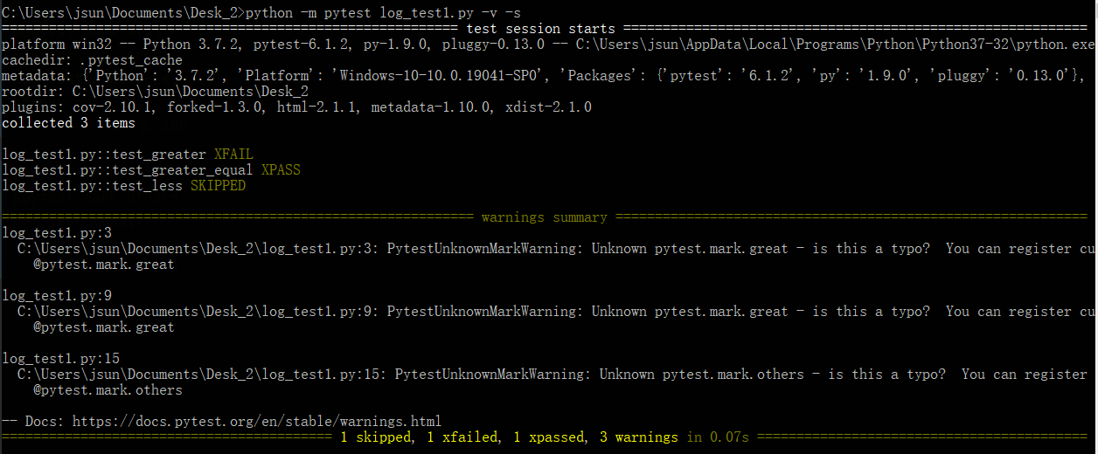

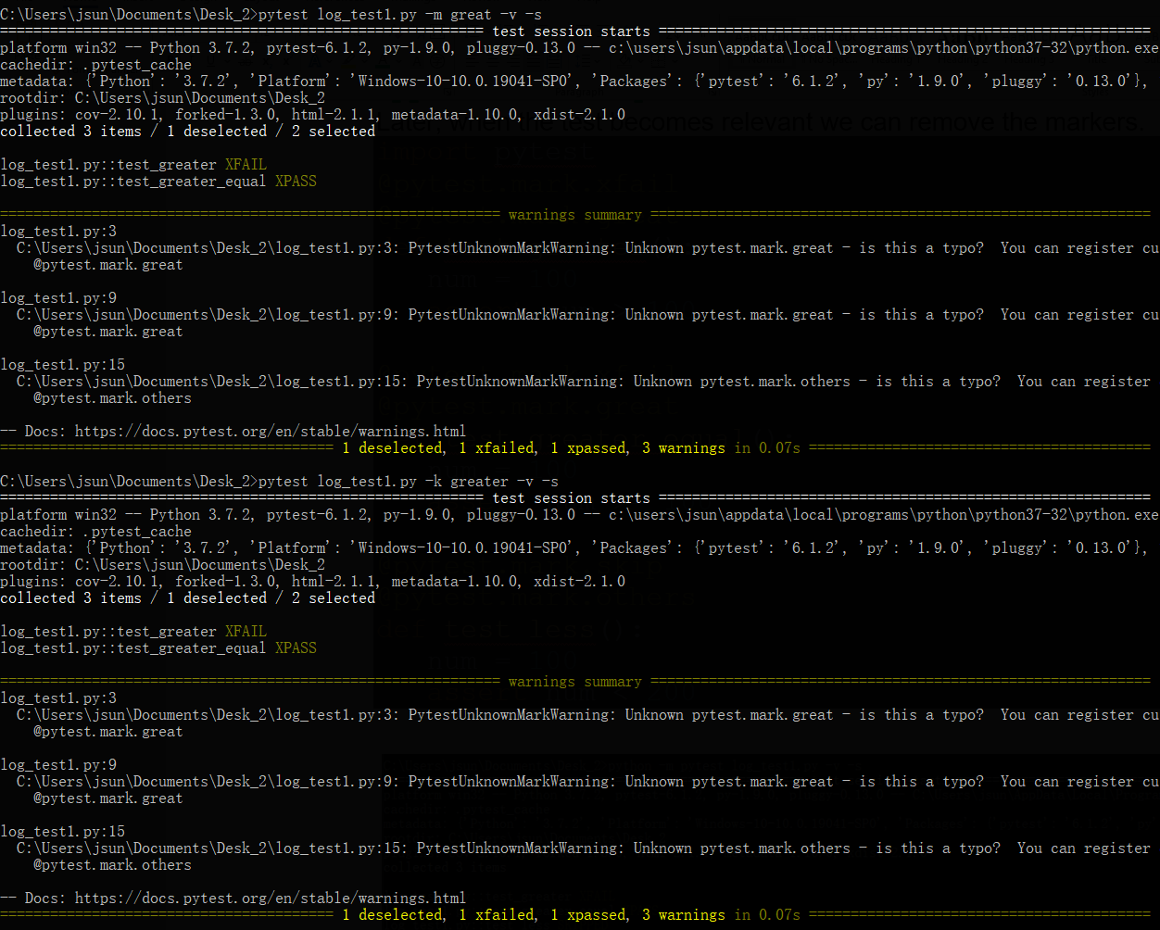

1. **Run test in Parallel**

By default, **pytest runs tests in sequential order**. In a real scenario, a test suite will have a number of test files and each file will have a bunch of tests. This will lead to a large execution time. To overcome this, pytest provides us with an option to run tests in parallel.

For this, we need to first install the pytest-xdist plugin.

Install pytest-xdist by running the following command −

**pip install pytest-xdist**

**pytest -n 3**

-n <num> runs the tests by using multiple workers, here it is 3.

1. **Test Execution Results in XML**

We can generate the details of the test execution in an xml file. This xml file is mainly useful in cases where we have a dashboard that projects the test results. In such cases, the xml can be parsed to get the details of the execution.

We will now execute the tests from test_multiplcation.py and generate the xml by running

pytest test_multiplication.py -v **--junitxml="result.xml"**

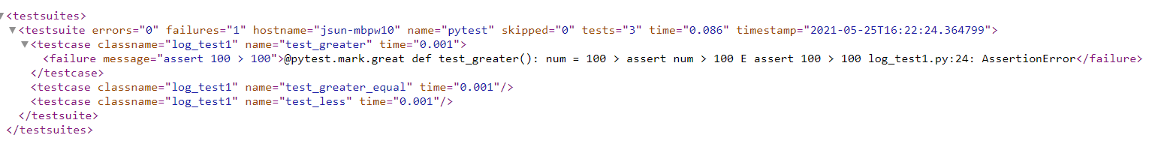

1. **Pytest HTML report**

* The difference between pytest and unittest is that pytest comes with a plug-in for generating test reports, download the plug-in for generating test reports from pytest,
* pip install pytest-html
* pytest -s -v log_test.py –html=report.html

import pytest  
class Testmethod:  
 @pytest.mark.parametrize(('name','age'),[("Xiao Ming",18),('Li Lei',20),('Han Meimei',25)])  
 def test_a(self,name,age):  
 print( f"{name} is {age} old")

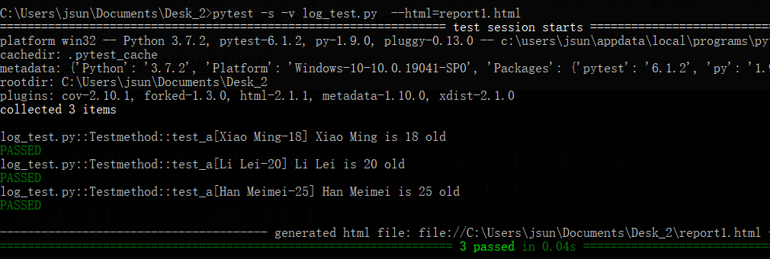

1. **pytest-rerunfailures: Retry mechanism**

The pytest framework also provides an error retry mechanism, which is not available in unittest. When one of our use cases fails, it may be caused by environmental or network problems. With the retry mechanism, it will retry!

Open the computer terminal cmd and enter: pip install **pytest-rerunfailures**

Open the terminal in pycharm and run the following command:  
pytest -s test_one.py --html=report.html --**rerun**s 1 --reruns-delay 1

–Reruns 1 refers to the number of retries, followed by the value is the number of retries, –reruns-delay 1 refers to the interval between retries, when it fails, how long to wait for the next retry, followed The unit of data is seconds. Try again every second, we can see the results of the operation:

1. **Custom pytest running rules: pytest.ini**

Students can notice that every time we run, we need to output a long list of commands on the console. If we need to execute multiple files, wouldn’t it be troublesome to do this every time? So let's explain how to customize the running rules of pytest.

First, we need to create a new .ini file (configuration file) in the path where the test file is currently stored, for example, we create a new pytest.ini (can be a non-current path, for standardization and management, we try to put it under a path)

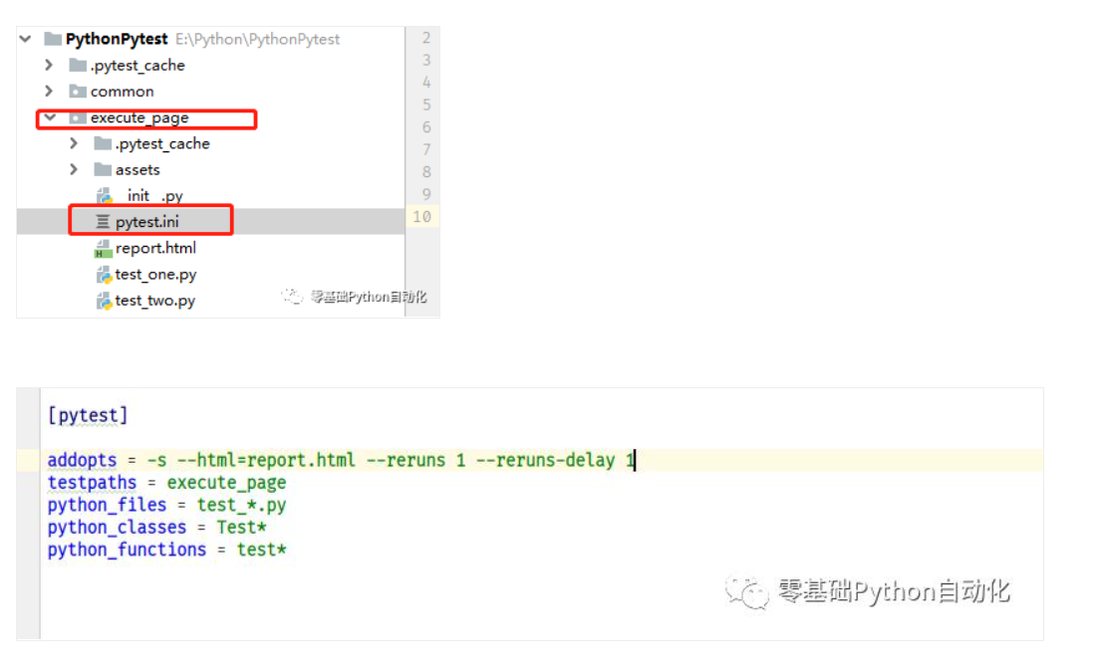

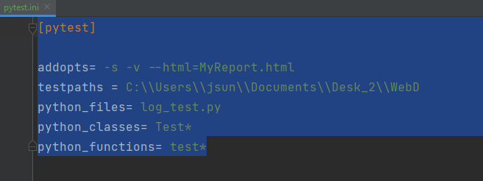

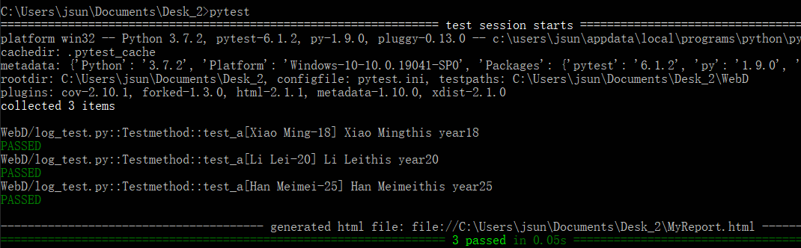

1. **Warnings and disable-warnings**

Disabling warnings summary

Although not recommended, you can use the --disable-warnings command-line option to suppress the warning summary entirely from the test run output.

Disabling warning capture entirely[¶](https://docs.pytest.org/en/6.2.x/warnings.html#disabling-warning-capture-entirely)

This plugin is enabled by default but can be disabled entirely in your pytest.ini file with:

**[pytest]**

addopts = -p no:warnings

Or passing -p no:warnings in the command-line. This might be useful if your test suites handles warnings using an external system.

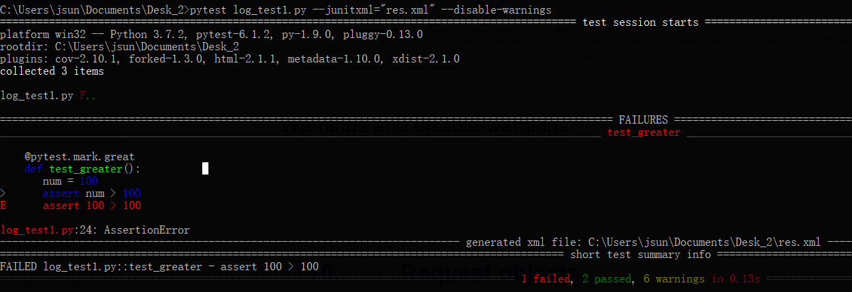

1. **Pytest Exceptions**

Let’s imagine that we have a function that checks for some keys in a dictionary. If a key is not present, it should raise a KeyError. As you can see, this is very generic and doesn’t tell the users much about the error. We can make it cleaner by raising custom exceptions, with different messages depending on the field.

* Check if an exception is raised in pytest.

import pytest  
  
  
class MissingCoordException(Exception):  
 *"""Exception raised when X or Y is not present in the data."""*class MissingBothCoordException(Exception):  
 *"""Exception raised when both X and Y are not present in the data."""*def sum_x_y(data: dict) -> str:  
 # code doesn't handle when there is an exception  
 return data["x"] + data["y"]  
  
def sum_x_y_2(data: dict) -> str:  
 if "x" not in data and "y" not in data:  
 raise MissingBothCoordException("Both x and y coord missing.")  
 return data["x"] + data["y"]  
  
def test_divide_by_zero():  
 assert 1/0 == 0  
  
def test_sum_x_y_missing_both1():  
 data = {"irrelevant": 1}  
 with pytest.raises(MissingBothCoordException):  
 sum_x_y(data)  
  
def test_sum_x_y():  
 data = {"irrelevant": 1}  
 with pytest.raises(MissingBothCoordException):  
 sum_x_y_2(data)

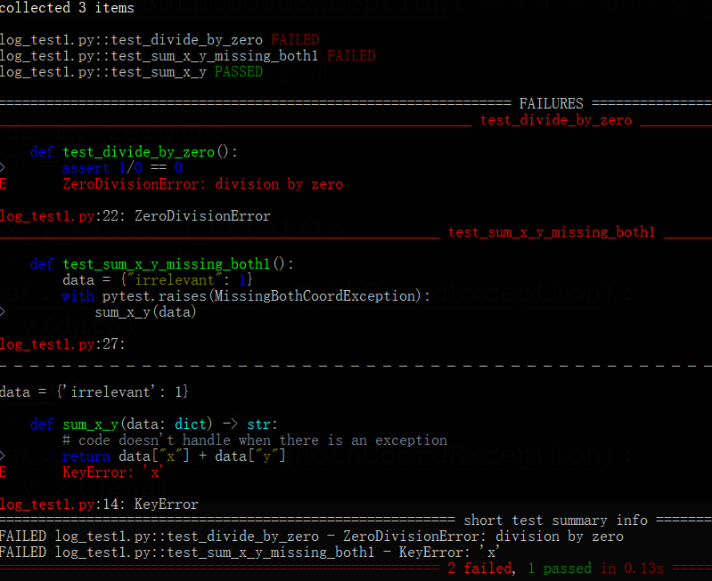

* **Assert Exception error message and type**
* import pytest  
    
    
  class MissingCoordException(Exception):  
   *"""Exception raised when X or Y is not present in the data."""*class MissingBothCoordException(Exception):  
   *"""Exception raised when both X and Y are not present in the data."""*def sum_x_y(data: dict) -> str:  
   if "x" not in data and "y" not in data and "extra" not in data:  
   raise MissingBothCoordException("Both X and Y coord missing.")  
   if "x" not in data:  
   raise MissingCoordException("The Y coordinate is not present in the data.")  
   if "y" not in data:  
   raise MissingCoordException("The Y coordinate is not present in the data.")  
   return data["x"] + data["y"]  
    
  def test_sum_x_y_has_x_missing_coord():  
   data = {"extra": 1, "y": 2}  
   with pytest.raises(MissingCoordException) as exc:  
   sum_x_y(data)  
   assert "The X coordinate is not present in the data." in str(exc.value)

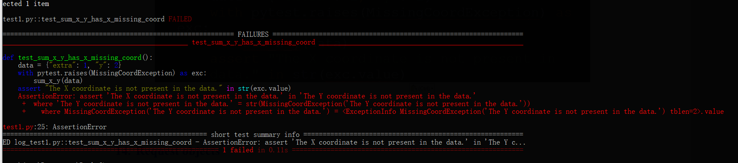

* **How to Assert That NO Exception Is Raised**

The last section in this tutorial is about yet another common use case: how to assert that no exception is thrown. One way we can do that is by using a try / except. If it raises an exception, we catch it and assert False.

import pytest  
  
  
class MissingCoordException(Exception):  
 *"""Exception raised when X or Y is not present in the data."""*class MissingBothCoordException(Exception):  
 *"""Exception raised when both X and Y are not present in the data."""*def sum_x_y(data: dict) -> str:  
 if "x" not in data and "y" not in data and "extra" not in data:  
 raise MissingBothCoordException("Both X and Y coord missing.")  
 if "x" not in data:  
 raise MissingCoordException("The Y coordinate is not present in the data.")  
 if "y" not in data:  
 raise MissingCoordException("The Y coordinate is not present in the data.")  
 return data["x"] + data["y"]  
  
def test_sum_x_y_works():  
 data = {"extra": 1, "y": 2, "x": 1}  
  
 try:  
 sum_x_y(data)  
 except Exception as exc:  
 assert False, f"'sum_x_y' raised an exception {exc}"

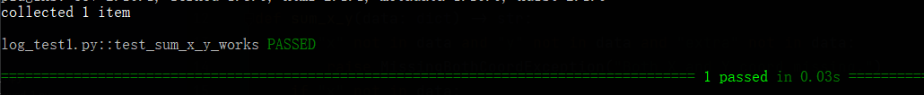

import pytest  
  
  
class MissingCoordException(Exception):  
 *"""Exception raised when X or Y is not present in the data."""*class MissingBothCoordException(Exception):  
 *"""Exception raised when both X and Y are not present in the data."""*# def sum_x_y(data: dict) -> str:  
# if "x" not in data and "y" not in data and "extra" not in data:  
# raise MissingBothCoordException("Both X and Y coord missing.")  
# if "x" not in data:  
# raise MissingCoordException("The Y coordinate is not present in the data.")  
# if "y" not in data:  
# raise MissingCoordException("The Y coordinate is not present in the data.")  
# return data["x"] + data["y"]  
  
def sum_x_y(data: dict) -> str:  
 if "x" not in data and "y" not in data and "extra" not in data:  
 raise MissingBothCoordException("'extra field and x / y coord missing.")  
 if "x" not in data:  
 raise MissingCoordException("The X coordinate is not present in the data.")  
 if "y" not in data:  
 raise MissingCoordException("The Y coordinate is not present in the data.")  
 raise ValueError("Oh no, this shouldn't have happened.")  
 return data["x"] + data["y"]  
  
def test_sum_x_y_works():  
 data = {"extra": 1, "y": 2, "x": 1}  
  
 try:  
 sum_x_y(data)  
 except Exception as exc:  
 assert False, f"'sum_x_y' raised an exception {exc}"

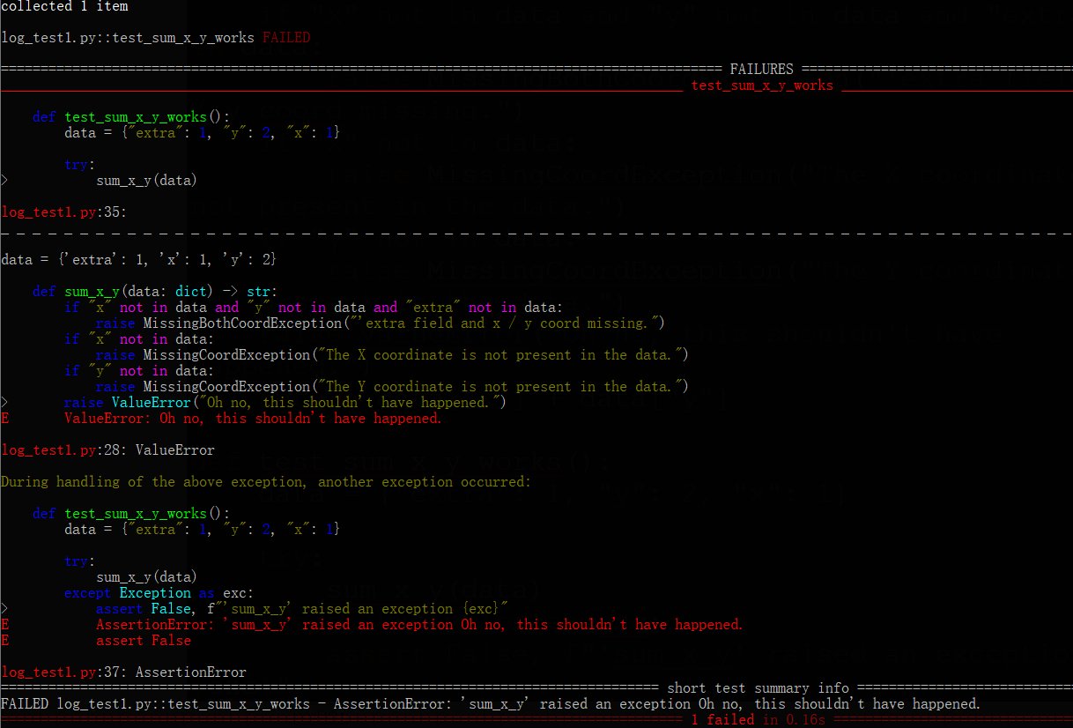

1. **Request objects**

### Pytest fixture request parameter

In the [cheese db example](https://pythontesting.net/framework/pytest/pytest-fixtures-nuts-bolts/#cheese_example), the fixture includes a request parameter. You need the request parameter to a fixture to add a finilizer.

However, it has other uses too.

In the example below, I’m showing the use (well, printing stuff) of some of the items

@pytest.fixture()  
def my_fixture(request):  
 print('\n-----------------')  
 print('fixturename : %s' % request.fixturename)  
 print('scope : %s' % request.scope)  
 print('function : %s' % request.function.__name__)  
 print('cls : %s' % request.cls)  
 print('module : %s' % request.module.__name__)  
 print('fspath : %s' % request.fspath)  
 print('-----------------')  
  
 if request.function.__name__ == 'test_three':  
 request.applymarker(pytest.mark.xfail)  
  
def test_one(my_fixture):  
 print('test_one():')  
  
class TestClass():  
 def test_two(self, my_fixture):  
 print('test_two()')  
  
def test_three(my_fixture):  
 print('test_three()')  
 assert False

**#**

import pytest  
user_list=['wangxiao','zhangxiao']  
pwd_list=['123456','123']  
@pytest.fixture(scope="module")  
def input_user(request):  
 user=request.param  
 print ("User name:% s"% user)  
 return user  
@pytest.fixture(scope="module")  
def input_pwd(request):  
 pwd = request.param  
 print ("Password:% s"% pwd)  
 return pwd  
@pytest.mark.parametrize("input_user",user_list,indirect=True)  
@pytest.mark.parametrize("input_pwd",pwd_list,indirect=True)  
def test_login(input_user,input_pwd):  
 print(input_user,input_pwd)  
**if __name__=='__main__':  
 pytest.main(['-v','-s', 'log_test.py'])**

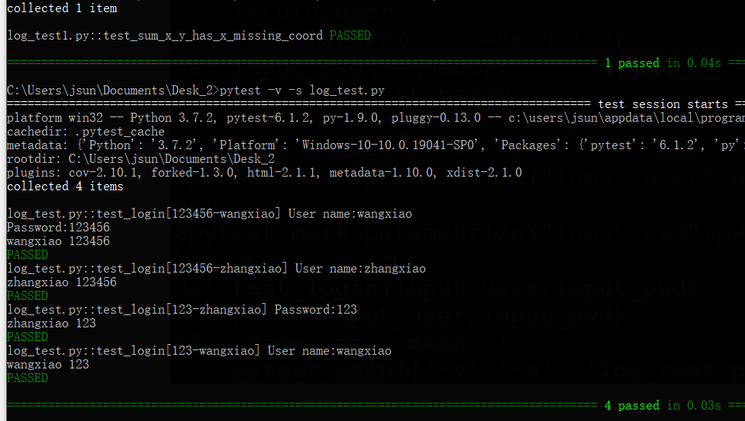

import pytest  
  
user_list = [('wangxiao', '123'), ('chengzi', '123456')]  
  
  
@pytest.fixture(scope="module")  
def login(request):  
 user = request.param  
 pwd = request.param  
 print("User name:% s, password:% s" % (user, pwd))  
 return user, pwd  
  
  
@pytest.mark.parametrize("login", user_list, indirect=True)  
def test_login(login):  
 print(login)  
  
  
if __name__ == '__main__':  
 pytest.main(['-s', 'log_test.py'])

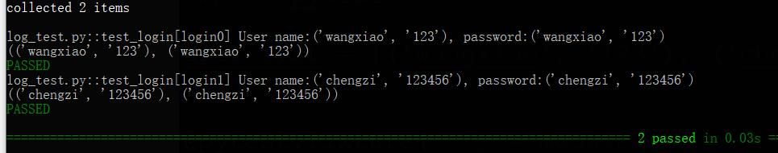

#

List of [1,2,3] is called one at a time

import pytest  
  
@pytest.fixture(params=[1, 2, 3])  
def need_data(request): # incoming parameter request system package parameter  
 return request.param # Take a single value in the list, the default value  
  
class Test_ABC:  
  
 def test_a(self, need_data):  
 print("------->test_a")  
 # Assertion  
 assert need_data != 3

# need_data return an int, not a list  
  
if __name__ == '__main__':  
 pytest.main(["-s", "-v", "log_test.py"])

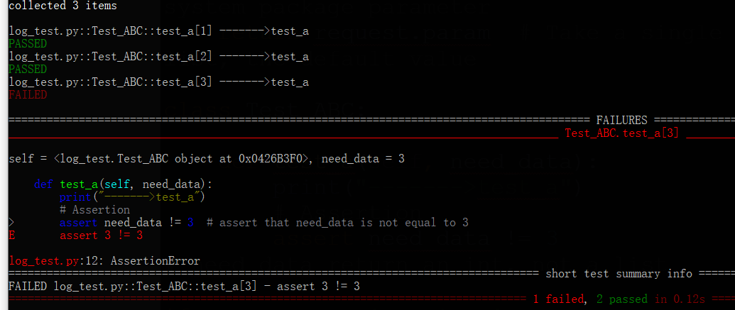

import pytest  
# Test account data  
test_user = ["admin1", "admin2"]  
test_password = ["11111", "22222"]  
  
@pytest.fixture(params=test_user)  
def input_user(request):  
 user = request.param  
 print('Login account:',user)  
 return user  
  
@pytest.fixture(params=test_password)  
def input_password(request):  
 password = request.param  
 print('login password:',password)  
 return password  
  
# When the same function uses multiple fixtures, these fixtures will be combined to test each situation  
def test_login(input_user,input_password):  
 print(f"Test data user-> {input_user}, password-> {input_password}")

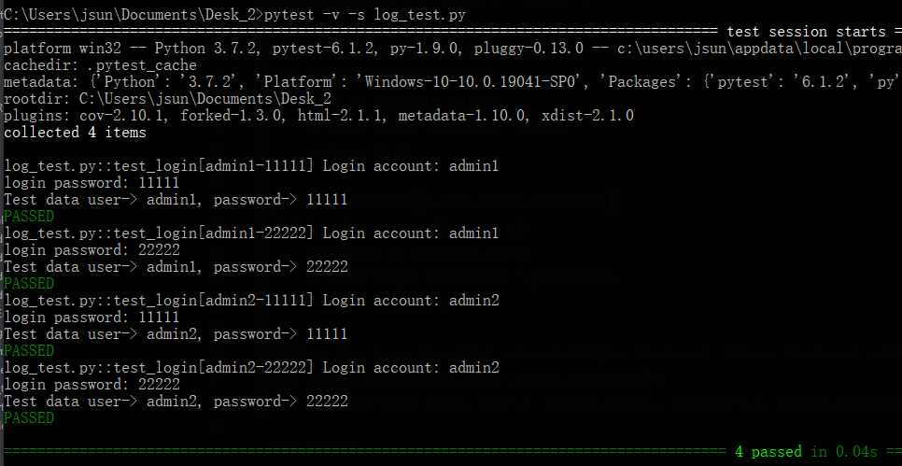

### Implement setup and teardown

We can use conftest.py to implement setup for test cases, then we can also implement the similar function of teardown.

We can use **yield** to fulfill

# conftest.py  
  
  
import pytest  
  
info = {"username": "root", "password": "mysql"}  
  
@pytest.fixture(scope='module')  
def login_ini():  
 # Establish a database link  
 db = pymysql.connect(host="127.0.0.1", user=info['username'], password=info['password'], database='school')  
 cursor = db.cursor()  
  
 # Use execute() method to execute SQL query  
 cursor.execute("select s_name from student")  
 # Get all the data  
 data = cursor.fetchall()  
 print(data)  
  
 # Get disconnected database connection  
 # Use yield to achieve the similar function of teardown. That is, execute the content behind yield after the test function is executed  
 # yield login_ini  
 # You can write a yield directly without writing others  
 yield  
 cursor.close()  
 db.close()  
 print("Disconnected")  
  
def test_login(login_ini):  
 print('Query the database successfully')  
  
def test_2(login_ini):  
 print('test*****')  
  
  
# collected 1 item  
  
# test_fix_setup.py (('Zhao Lei',), ('Money and electricity',), ('Sun Feng',), ('Li Yun',), ('Zhou Mei',), ('Wu Lan',), ('Zheng Zhu',), ('Wang Ju',))  
# Query the database successfully  
# .Test*****  
# .Disconnect  
#  
# ============================================================ 2 passed in 0.04s ========

# id

* ids: A list of string ids. Each id corresponds to a parameter and is part of the test id. If no id is provided, they will automatically generate an identifier from the parameter.

# conftest.py  
  
import pytest  
  
  
@pytest.fixture(ids=['look', 'see', 'watch'], params=[1, 2, 3])  
def common_login(request):  
 yield request.param  
  
# test_account_login.py  
  
import pytest  
  
@pytest.mark.usefixtures('common_login')  
class TestUserLogin:  
  
 def test_01_user_login(self):  
 assert 1 == 1  
  
  
if __name__ == '__main__':  
 pytest.main(['-v', '-s', 'log_test.py'])

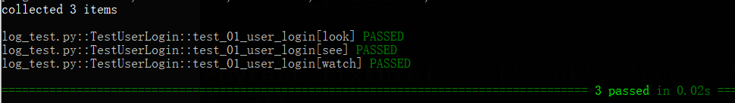

* Give fixture a name
* # conftest.py  
    
  import pytest  
    
  @pytest.fixture(name='XXX', params=[1, 2, 3])  
  def common_login(request):  
   yield request.param  
    
  # test_account_login.py  
    
  import pytest  
  @pytest.mark.usefixtures('XXX')  
  class TestUserLogin:  
    
   def test_01_user_login(self):  
   assert 1 == 1  
    
    
  if __name__ == '__main__':  
   pytest.main(['-v', '-s', 'log_test.py'])

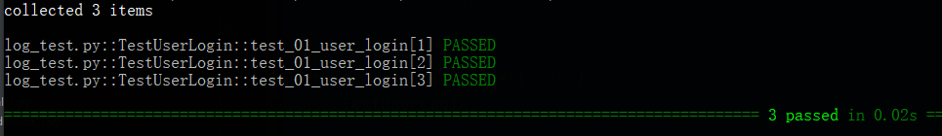

* pytest supports multiple methods in a complete test parameters:

1) .pytest.fixture (): function at the level parameters of the fixture

2) @ pytest.mark.parametrize:. Permit parametric function or class level, there is provided a plurality of specific test argument function or class / fixture set.

3_.pytest_generate_tests: can implement your own custom dynamic parameterization schemes or expansion.

import pytest  
import requests  
  
par_to_test = [{  
 "case": "serach a word :haha",  
 "headers": {},  
 "querystring": {  
 "wd": "hah"  
 },  
 "payload": {},  
 "expected": {  
 "status_code": 200  
 }  
},  
 {  
 "case": "serach a word2 :kuku",  
 "headers": {},  
 "querystring": {  
 "wd": "kuku"  
 },  
 "payload": {},  
 "expected": {  
 "status_code": 200  
 }},  
  
 {  
 "case": "serach a word3 :xiaoyulaoshi",  
 "headers": {},  
 "querystring": {  
 "wd": "xiaoyulaoshi"  
 },  
 "payload": {},  
 "expected": {  
 "status_code": 200  
 }}  
]  
  
  
@pytest.fixture(params=par_to_test)  
def class_scope(request):  
 return request.param  
  
  
def test_baidu_search(class_scope):  
 url = "https://www.baidu.com"  
 r = requests.request("GET", url, data=class_scope["payload"], headers=class_scope["headers"],  
 params=class_scope["querystring"])  
 assert r.status_code == class_scope["expected"]["status_code"]

import requests  
import pytest  
  
  
class TestV2exApiWithParams(object):  
 domain = 'https://www.v2ex.com/'  
  
 @pytest.fixture(params=['python', 'java', 'go', 'nodejs'])  
 def lang(self, request):  
 return request.param  
  
 def test_node(self, lang):  
 path = 'api/nodes/show.json?name=%s' % (lang)  
 url = self.domain + path  
 res = requests.get(url).json()  
 assert res['name'] == lang  
 # assert 0  
  
if __name__ == "__main__":  
 pytest.main(['-s', '-v', 'log_test.py'])

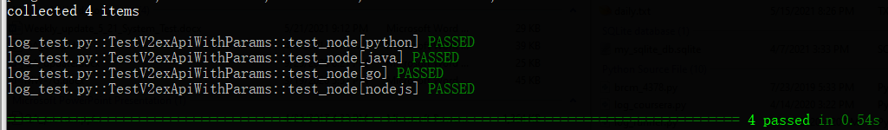

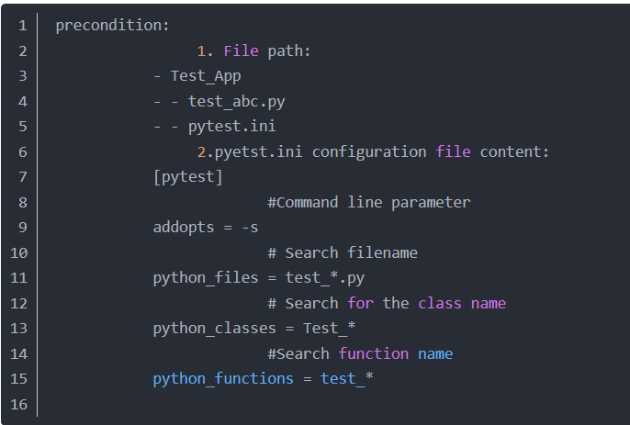

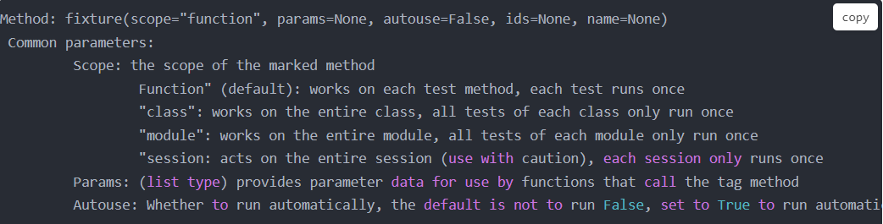

* fixture ex
* import pytest  
  @pytest.fixture()  
  def myfixture():  
   print("\n[fixture] Start half myfixture")  
   yield  
   print("\n[fixture] End the second half.")  
    
    
  class Test_firstFile():  
    
   def test_one(self, myfixture):  
   print("execution test_one")  
   assert 1 + 2 == 3  
    
   def test_two(self):  
   print("\nexecution test_two")  
   assert 1 == 1  
    
   def test_3(self, myfixture):  
   print("execution test_3")  
   assert 1 + 2 == 3  
    
  if __name__ == "__main__":  
   pytest.main(["-s", '-v', "log_test.py"])  
   # pytest.main(["--setup-show", "-s", '-v' "log_test.py"])

import pytest  
@pytest.fixture()  
def myfixture():  
 print("\n[fixture] Start half myfixture")  
 yield  
 print("\n[fixture] End the second half.")  
  
  
class Test_firstFile():  
  
 def test_one(self, myfixture):  
 print("execution test_one")  
 assert 1 + 2 == 3  
  
 def test_two(self):  
 print("\nexecution test_two")  
 assert 1 == 1  
  
 def test_3(self, myfixture):  
 print("execution test_3")  
 assert 1 + 2 == 3  
  
if __name__ == "__main__":  
 # pytest.main(["-s", '-v', "log_test.py"])  
 pytest.main(["**--setup-show**", "-s", '-v' "log_test.py"])  
#

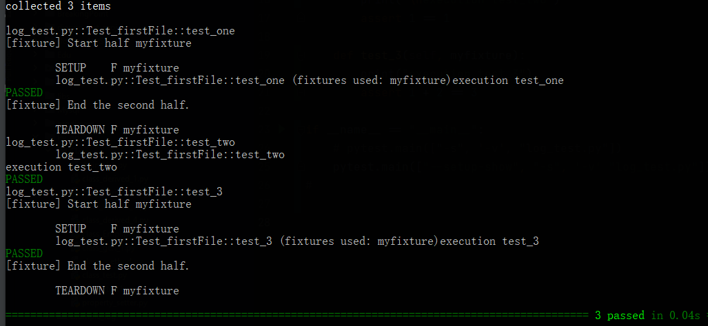

#

import requests  
import pytest  
  
paramsdata = [{'data':{"accesstoken":"b0219c3d-b675-4749-82a5-bda469c8cf0e1","title":"What did your uncle eat today","tab":"ask","content":"fhjdshjgrurehdjhjdfgdsg"},  
 'headers':{},  
 'status_code':200,  
 'payload':{}},  
 {'data':{"accesstoken": "b0219c3d-b675-4749-82a5-bda469c8cf0e1", "title": "What did your second uncle eat today", "tab": "job", "content": "fhjdshjgrurehdjhjdfgdsg"},  
 'headers': {},  
 'status_code': 200,  
 'payload': {}},  
 {'data':{"accesstoken": "b0219c3d-b675-4749-82a5-bda469c8cf0e1", "title": "What did your auntie eat today", "tab": "ask", "content": "fhjdshjgrurehdjhjdfgdsg"},  
 'headers': {},  
 'status_code': 200,  
 'payload': {}  
}]  
  
@pytest.fixture(params=paramsdata)  
def class_scope(request):  
 return request.param  
def test_001(class_scope):  
 url='http://39.107.96.138:3000/api/v1/topics'  
 respone=requests.post(url,data=class_scope['data'],headers=class_scope['headers'])  
 try:  
 assert respone.status_code==class_scope['status_code']  
 except Exception as e:  
 print(respone.text)  
 raise e  
  
if __name__ == '__main__':  
 pytest.main(['-s','test_api.py'])

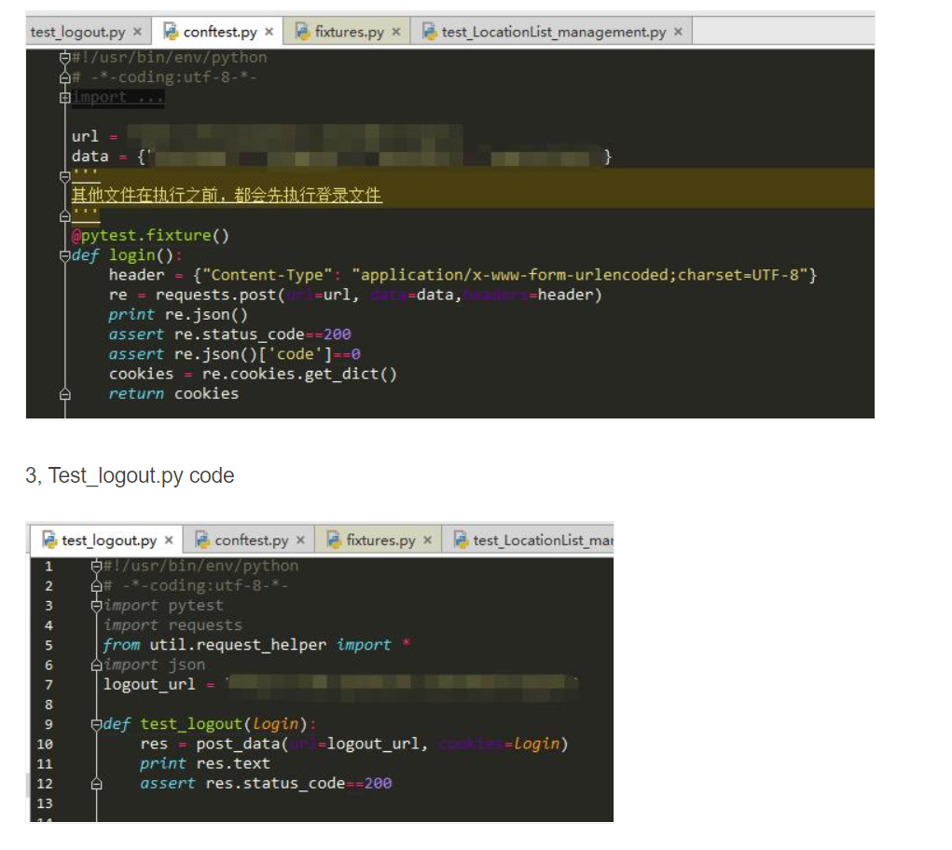

import requests  
import pytest  
  
paramsdata = [{'data':{"accesstoken":"b0219c3d-b675-4749-82a5-bda469c8cf0e1","title":"What did your uncle eat today","tab":"ask","content":"fhjdshjgrurehdjhjdfgdsg"},  
 'headers':{},  
 'status_code':200,  
 'payload':{}},  
 {'data':{"accesstoken": "b0219c3d-b675-4749-82a5-bda469c8cf0e1", "title": "What did your second uncle eat today", "tab": "job", "content": "fhjdshjgrurehdjhjdfgdsg"},  
 'headers': {},  
 'status_code': 200,  
 'payload': {}},  
 {'data':{"accesstoken": "b0219c3d-b675-4749-82a5-bda469c8cf0e1", "title": "What did your auntie eat today", "tab": "ask", "content": "fhjdshjgrurehdjhjdfgdsg"},  
 'headers': {},  
 'status_code': 200,  
 'payload': {}  
}]  
  
@pytest.fixture(params=paramsdata)  
def class_scope(request):  
 return request.param  
def test_001(class_scope):  
 url='http://39.107.96.138:3000/api/v1/topics'  
 respone=requests.post(url,data=class_scope['data'],headers=class_scope['headers'])  
 try:  
 assert respone.status_code==class_scope['status_code']  
 except Exception as e:  
 print(respone.text)  
 raise e  
  
if __name__ == '__main__':  
 pytest.main(['-s','test_api.py'])

1. **Selenium**

### What is a framework?

A framework is a **reusable design of a whole or part of a system**, represented by a set of abstract components and methods of interaction between component instances; a framework is a reusable design component that specifies the architecture of the application, clarifies the entire design, the dependencies between the collaborative components, the assignment of responsibility and the control flow, represented as a set of abstract classes and their instances. A method of collaboration that provides a contextual relationship for component reuse. Therefore, large-scale reuse of component libraries also requires a framework. A framework is a reusable design that is expressed by a set of abstract classes and their collaboration between instances [Johnson 98]. This definition defines the framework from the perspective of the connotation of the framework.

1. **Why build an automated test framework?**

The development of automated testing is usually determined by the needs of automated testing. This demand mainly includes:

* Automated testing is easier to implement. The point is that it is convenient for you to write test scripts. A good automated testing framework is for people who don't know the technology and can write automated test scripts.
* **Solve problems with automated test scripts** such as exception handling and scene recovery.
* Testing is easy to maintain. A good framework can reduce the manpower and resources you put into management and maintenance.
* **Reusability**. One of the meanings of the framework is that it can be reused. So in the framework, you can implement some common functions to simplify the script development process.
* Beautiful and easy to read test report. For Selenium, the test report it produces is based on test scripts, and there is no such report based on the test set, so if you want, the test framework can be implemented.
* Its strength lies in **iterative iteration**, and its value is based on **long-term regression testing** to ensure long-term stable version updates of the tested products.
* With regard to the entry point for automated testing, it is usually necessary to have the basic conditions for introducing automated testing after a complete system test.

### Page Object Model (POM) Design Principle

The Page Object design pattern is one of the best design patterns for the Selenium automated test project, **emphasizing the separation of test/test cases, logic, data, and drivers**.

Page Object mode is a **test design pattern** in Selenium. **It mainly designs each page as a Class**, **which contains the elements** (buttons, input boxes, titles, etc.) that need to be tested in the page, so that it can be passed in the Selenium test page. **Calling the page class to get the page element**, this cleverly avoids the need to change the test page code when the page element id or position changes. **When the page element id changes, you only need to change the properties of the page in the test page Class**.

Its benefits are as follows:

* Centrally manage element objects
* Centrally manage public methods within a page
* Easy maintenance in the later stage
* If you change the UI of any page, we don’t need to change any test cases, we only need to change the code in the page object (only in one place). Many other tools that use selenium follow the page object model.
* The POM model requires all functions/reusable components on a page to be written into a class file. Now let’s say, for example, we design 4 pages, which are the homepage, login page, account creation and password forgotten page, etc.
* Follow Google wiki page object  
  "In the UI of a web application, the area of ​​testing and interaction. The page object simply models these objects as objects in the test code. This reduces the amount of repeated code, If the UI changes, the fix only needs to be applied in one place.  
    
  For the above page, we will create the classes homepage.class, LoginPage.class, CreateAccountPage.class and ForgotPasswordPage.class. In each class, we will identify and write page-specific reusable methods.
* 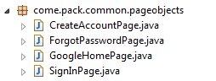
* Now our homepage is the Google page, we can navigate to other pages by clicking any link on the Google page. When we navigate to other pages, we need to return to that page object. Otherwise, the current page object is returned, because this operation cannot navigate to another page represented by other page objects.  
    
  POM model provides the following advantages.  
  1. Separate test code from page code (such as locators) (or if you use a UI layout diagram).  
  2. The services or operations provided by the page have only one repository, rather than being scattered in each test case
* In both cases, any modifications required due to UI changes are made in one place.

Example:

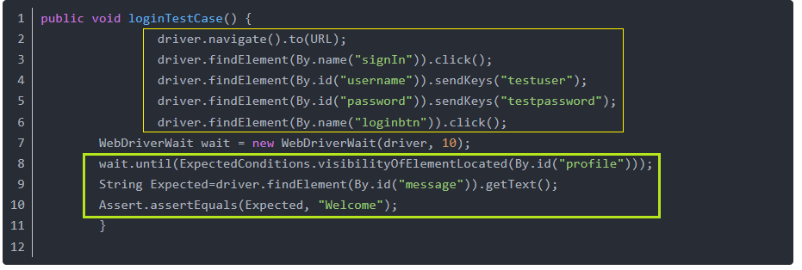

If you observe the above test, there is no separation between the test and the test locator. If this is the case, if the user interface changes in the future, the changes must be made in multiple places. It will also become difficult to determine the chance of these locators as locators being used in multiple tests.

We will try to rewrite the above example by implementing the page object model:

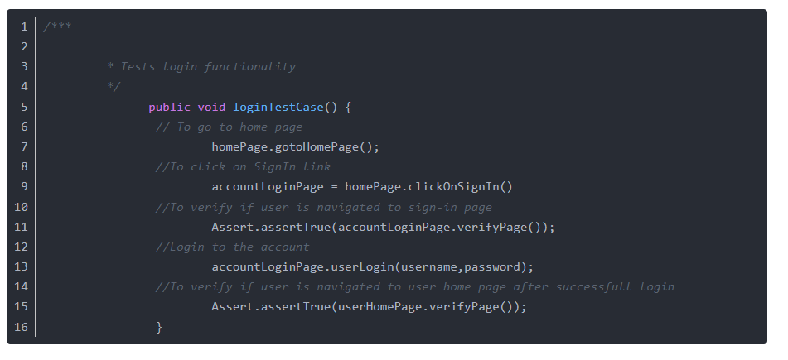

In the above test, we did not use any locators. It is completely separated by driver.findelement, etc., exceptions, codes without static values, etc. We will work with methods defined in multiple pages. Based on the test, we will navigate to the required pages and access these page methods.

### **Object of Page Object Automation Framework**

**https://www.programmersought.com/article/4934338788/**

1. WebDriver package

* Here is the package code for Selenium, the basic package code after the package is completed.

1. Page base class

* A basic Page class is designed so that all pages inherit, which identifies the basic and public functions of a sub page class.

1. Sub Pages(s) subclass

* The specific page class defines the functionality of a particular page.

1. Tests class

* This section describes the specific test cases.

1. Define Test Suite

* Multiple test cases are added to a Test Suite and executed together.

1. Define Test Runner

* Design the test Runner, **Run** the entire test, and **Generate** an HTML test report for the test results, and send out **Email Notifications with report**.

1. Define the main entry for the test

* Define the main entry class for the test, the entry to the code

